NASM Certified Personal Trainer

The NASM Certified Personal Trainer Credential 4

Defining Health and Disease 7

Evidence of muscular dysfunction and increased injury 21

The Healthcare Continuum 23

Certified Fitness Professionals 25

Scope of practice and Code of Conduct 26

NASM Code of Professional Conduct 27

Fitness industry employment landscape 29

Sales and marketing 50

Marketing 56

Four p's of marketing 60

Continuing education 62

The role of psychology in fitness and wellness 65

Common barriers to exercise 71

Psychological benefits of exercise 87

Introduction to behavioural coaching 91

Determinants of participation in exercise 95

The Stages of Change Model 96

Importance of effective communication skills 101

Motivational interviewing 106

Strategies to enhance exercise adherence 110

The initial session 121

Basic and applied sciences and nutritional concepts 125

Nervous system 126

Skeletal system 140

Muscular system 165

The cardiorespiratory system 178

The cardiovascular system 178

The respiratory system 193

The endocrine system 201

The digestive system 210

Introduction to Human Movement Science 216

Biomechanics 217

Functional anatomy of muscles 233

Muscular force 238

Stretch-shortening cycle 240

Muscular systems of the body 244

Muscular leverage and Arthrokinematics 250

Motor behaviour 254

Introduction to exercise metabolism and bioenergetics 259

Bioenergetics and metabolism 259

Energy and mechanical work 264

Daily energy needs 279

Nutrition 283

Trending protein research 298

Structure of Carbohydrates 300

Micronutrients and hydration 315

Nutrition strategies 327

Food labels 332

Goal-based nutrition strategies 341

Sports performance strategies 347

Supplements 349

Expectations of the Certified Personal Trainer 384

Assessments 385

Preparticipation screening 386

Fitness assessment protocols 399

Anthropometry and body composition measurements 405

Cardiorespiratory assessments 420

Postural, Movement, and Performance Assessments 432

Observing dynamic posture 443

Single-Leg Squat Starting Position (Figure 12-12) 452

Single-Leg Squat Movement (Figure 12-13) 452

Pushing Assessment Movement (Figure 12-16) 455

Performance assessments 462

Implementing Fitness Assessments 469

Integrated Training and the OPT Model 476

Acute variables of training 482

The Optimum Performance Training Model 488

Flexibility training 494

Cardiorespiratory fitness training 541

Postural considerations in cardiorespiratory training 567

Core Training 569

Performance 580

Five kinetic chain checkpoints 588

Floor Bridge 589

Essential concepts of balance 598

Plyometric training 622

Speed, Agility, and Quickness training 640

Resistance training 658

Acute variables of training 671

Tuck Jump 726

Program design 729

The Optimum Performance Training Model 733

Stabilization level of the OPT model 739

Phase 1 Stabilization Endurance Training 740

Strength level of OPT model 752

Phase 2 Strength Endurance Training 753

Phase 3 Muscular Development Training 753

Phase 4 Maximal Strength Training 754

Power 760

Applying the OPT model 764

Resistance training modalities 771

Proprioceptive modalities 795

Chronic health conditions and special populations 805

Age considerations 806

Obesity 815

Diabetes 821

Hypertension 826

Coronary Heart Disease 831

Osteoporosis 836

Arthritis 841

Cancer 845

Exercise and pregnancy 848

Chronic lung disease 852

Intermittent claudication and peripheral arterial disease 855

We live in an increasingly automated society that requires less and less physical activity from people each day. With each passing year, technological advancements continue to make our lives easier. Sedentary lifestyles and convenience-focused diets continue to fuel elevated rates of obesity and related chronic health conditions, keeping the need for scientifically educated fitness professionals at an all-time high. Alongside other practitioners in the greater allied health industry, Certified Personal Trainers represent a powerful force for change, helping clients improve their fitness for long-lasting health and happiness. Congratulations on taking the first step toward becoming an NASM Certified Personal Trainer.

# The NASM Certified Personal Trainer Credential

The National Academy of Sports Medicine (NASM) personal training credential provides the scientific foundation necessary to begin an exciting career as a fitness professional. However, earning the NASM personal training credential is only the beginning. A successful career as a fitness professional requires ongoing and continued growth as the fitness industry continues to evolve. Adhering to the most current, research-supported training and coaching principles helps ensure that fitness professionals can safely and effectively change the lives of their clients for the better.

The state of knowledge within the personal training field is growing at a rapid rate. According to Buckminster Fuller’s Knowledge Doubling Curve, human knowledge doubles approximately every century. In the medical field, knowledge doubles every few months (Densen, 2011). Because staying physically fit and eating healthy is one of the best forms of preventive medicine, it is essential that fitness professionals stay current and continue to learn. The fitness industry is a vast landscape full of misinformation and social media trends; however, it is also full of amazing new techniques and methodologies that drive human performance forward. For that reason, fitness professionals need to be open to new ideas and be able to differentiate facts from fads to design safe, effective, and results-oriented programs for their clients.

**Evidence-based practice**

The focus on scientific principles makes NASM’s systems and methodologies safe and effective for any client working toward any fitness goal. Understanding these principles requires fundamental knowledge of human anatomy and physiology, kinesiology, fitness assessments, fitness program design, and coaching techniques that help change behavior. To that end, NASM recommends that all fitness professionals maintain a focus on evidence-based practice to attain the highest levels of success.

Evidence-based practice is the conscientious use of current best evidence in making decisions about client care. It is defined as any practice (medical or nonmedical) that relies on scientific evidence for guidance and decision-making (Titler, 2008), which means paying attention to what the scientific research is saying, not whatever the current social media trend happens to be. Practices that are not evidence-based may rely more on tradition, intuition, or other unproven methods that cannot be effectively quantified or qualified through the scientific process. There are three fundamental components of evidence-based practice: developing individual professional expertise, staying current on the best sources of external evidence (e.g., peer-reviewed research), and prioritizing client values and expectations (Figure 1-1).

For the fitness professional, applying best external evidence represents using relevant research that has been conducted using sound research methods (i.e., peer-reviewed research published in scientific journals). Individual professional expertise refers to the fitness professional’s accumulated education, experience, and practical skills. Client values and expectations are the unique preferences, concerns, goals, and expectations brought by each client to a personal training session. It is the unending integration of these three components that defines a Certified Personal Trainer’s practice as evidence-based.

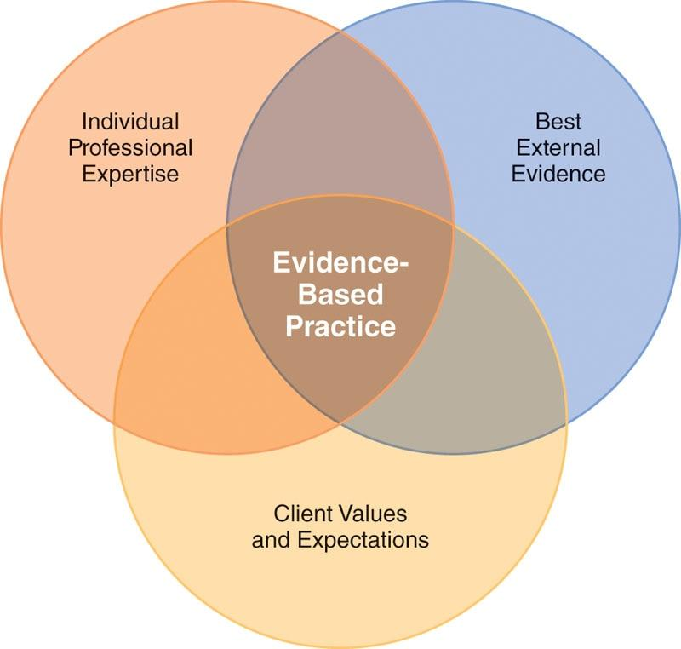

Peer-reviewed research is an essential component of the evidence-based practice model. Peer-reviewed research is defined as “a process of subjecting an author’s scholarly work, research, or ideas to the scrutiny of others who are experts in the same field.”

Peer-reviewed publications act as filters to ensure that only high-quality research is published in reputable journals by determining the validity, significance, and originality of the study (Kelly et al., 2014, p. 227).

## 

**Integrated training and the OPT model**

The NASM proprietary approach to exercise training, the Optimum Performance Training (OPT) model (Figure 1-2), was developed with evidence-based practice as a core guiding philosophy. The OPT model is backed by scientific research (Distefano et al., 2013) and has been successful for many types of clients, including those seeking weight loss or improvements in health, strength, muscle mass, or athletic performance.

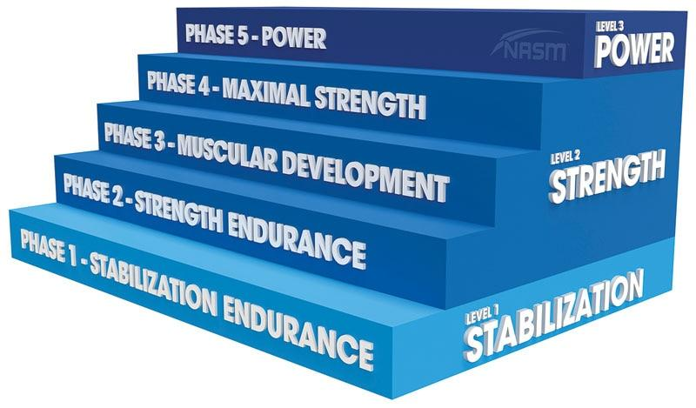

**Figure 1-2**The OPT model

Exercise training programs need to address all components of health-related physical fitness while using scientifically recognized training principles. Unfortunately, some training programs are not based on sound principles and guidelines. Instead, they rely solely on the experience of celebrities, fitness enthusiasts, or athletes who do not possess a formal education or background in exercise science. It is vital for exercise programs to be rooted in science and to address the needs of the whole person in a holistic manner.

For example, the condition of a person’s musculoskeletal system is directly related to the potential risk of injury; the more deconditioned a person is, the greater the risk of injury becomes. It is important to note that deconditioned does not simply mean that a person gets out of breath when climbing a flight of stairs or that they are overweight. Being deconditioned is a state in which a person may have a combination of muscle imbalances, poor flexibility, insufficient endurance, or limited joint stability. All of these conditions can greatly inhibit the ability of the human body to produce proper movement and can eventually lead to injury.

The personal training industry continues to grow dramatically, especially regarding the ability of fitness professionals to work with individuals with chronic health conditions or musculoskeletal impairments. While athletes do represent a portion of a fitness professional’s typical clientele, many clients who seek out personal training services are physically inactive and deconditioned.

To address the many physical and physiological needs of a client, an optimally designed fitness program should follow an integrated (i.e., comprehensive) approach. An integrated approach to exercise represents the inclusion of the following forms of training:

* Flexibility and mobility
* Core strength and stability
* Cardiorespiratory (cardio)
* Balance
* Plyometrics
* Speed, agility, and quickness
* Resistance.

NASM addressed the need for this integrated approach to training by developing the OPT model. The OPT model used in conjunction with evidence-based practice provides an exceptional pathway for designing safe and effective exercise programs. The advantage of the OPT model is that it is flexible, so it can be applied to any client with any fitness need in nearly any environment.

**The global state of health**

The current global state of health is a complex subject with many moving pieces, including factors that are often beyond the control of the individual, such as genetics, access to health care, access to preventive medicine, natural disasters, socioeconomic status, and the built (i.e., human-made) environment. Despite the many challenges of achieving good health, individuals do have a significant amount of control over their health and well-being. For example, becoming more physically active and eating healthy foods are two simple steps within almost any person’s grasp that have immediate benefits toward improving overall health (Centers for Disease Control and Prevention, 2020a).

Whether or not individuals choose to engage in healthy habits is still a personal decision. However, helping individuals start and motivating clients to succeed are two of the most valuable and rewarding aspects of being a fitness professional. Preventive efforts, including exercise and physical activity, to reduce morbidity and mortality are underutilized around the world by virtually every segment of the population. Fitness professionals have a tremendous opportunity to make a positive impact in this area.

### Defining Health and Disease

The World Health Organization (WHO) functions as the international public health agency of the United Nations and is focused on the development and promotion of international public health and well-being efforts. The WHO can be thought of as the world’s public health department. The WHO (1948) defines health as “a state of complete physical, mental, and social well-being, and not merely the absence of disease or infirmity.”

Health is not a static condition, but rather an ever-changing condition due to the human body’s continual need to adjust internal and external situations, changes in physiology, or changing environments (Figure 1-3) (Misselbrook, 2014). The human body is uniquely designed to respond to stress and, if necessary, make necessary changes to maintain optimal health and physiological functioning. This process is called homeostasis, in which the human body continually strives to maintain a relatively stable equilibrium in relation to the surrounding environment and the regular tasks it is required to perform.

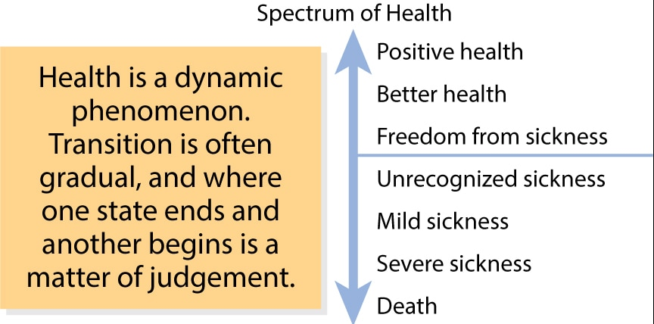

**Figure 1-3**The spectrum of health

A general definition of *disease* includes any abnormal condition that negatively affects the structure or function of a part of the body. Diseases can affect one area of the body or they can be systemic, affecting every part of the body (i.e., various forms of cancer). There are two basic types of disease: chronic, or noncommunicable (i.e., not contagious), disease and acute disease. Acute disease accounts for conditions like getting sick from the flu virus, while the WHO (2018a) defines chronic disease as follows:

TRAINING TIP

Health is a dynamic and ever-changing process. As you work with clients, ask them where they think they are on the spectrum presented in Figure 1-3 and then compare it against your objective observations. Use this information to help guide your approach to designing individualized training programs, or to determine if your client should be referred to a medical professional.

*Noncommunicable diseases (NCDs), also known as chronic diseases, tend to be of long duration and are the result of a combination of genetic, physiological, environmental and behaviors factors. The main types of NCDs are cardiovascular diseases (like heart attacks and stroke), cancers, chronic respiratory diseases (such as chronic obstructive pulmonary disease and asthma) and diabetes.*

STRETCH YOUR KNOWLEDGE

**Acute Versus Chronic Disease**  
An acute medical event or disease is any medical condition that occurs suddenly and can be treated and healed in a short period of time. For example, an isolated bout of bronchitis is an acute medical condition that is easily treated with antibiotics and rest, and typically resolves in a week or so. However, if left untreated, the condition could progress to more serious chronic problems.

A chronic disease is a medical condition that persists for a long duration or cannot be cured altogether, typically lasting for 3 months or more. Chronic diseases generally cannot be prevented by vaccines or cured by medications, nor do they just disappear over time. For example, individuals with a long history of smoking are prone to acute bouts of bronchitis, which can and often do progress toward chronic bronchitis.

It is important for fitness professionals to keep in mind that a wide range of chronic diseases can be avoided by two simple things: eating a healthy diet and taking part in regular exercise to stay physically fit. Someone who is primarily sedentary, is deconditioned, and eats a diet mainly consisting of junk food will be far more likely to develop a chronic disease than someone who follows a healthy diet and stays regularly active (CDC, 2020a, 2020b).

The leading causes of death in the world today are classified as chronic diseases and conditions (Figure 1-4) (World Health Organization, 2018b). Coronary artery disease, a specific type of heart disease, is the leading cause of death in both men and women. While public health efforts and the availability of better medical treatments have lowered the rates of death from chronic diseases in the past few decades, the fact remains that numerous chronic diseases are highly preventable by simply living an active and healthy lifestyle. In fact, research has shown that the two overwhelmingly leading preventable causes of death in modern society are smoking tobacco and being either overweight or obese (Danaei et al., 2009) (Figure 1-5).

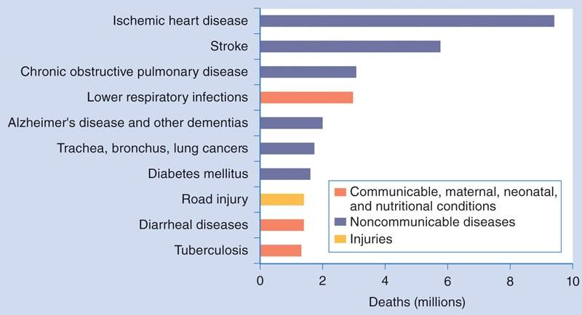

**Figure 1-4** Leading causes of death

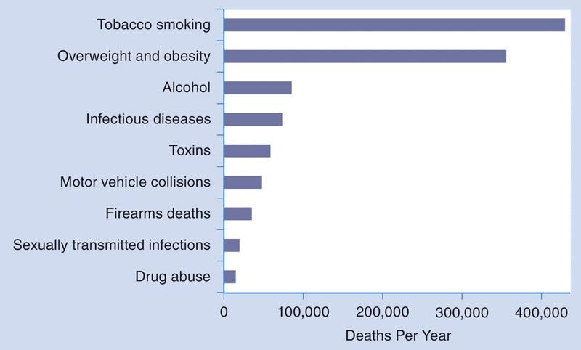

**Figure 1-5** Preventable causes of death

**Physical inactivity and its relationship to chronic disease**

The global impact of chronic disease is staggering, from both an economic and a human standpoint. Chronic diseases including heart disease, cancer, and diabetes are the leading causes of death and disability in the United States as well as in many locations across the globe. Besides loss of life and quality of life through disability associated with chronic disease, the annual healthcare costs in the United States alone are more than $3 trillion and growing. Furthermore, 90% of the nation’s healthcare expenditures are applied toward treating individuals with chronic and mental health conditions (Misselbrook, 2014).

STRETCH YOUR KNOWLEDGE

A sedentary lifestyle is one of the biggest causes of developing a chronic health condition, but roughly 3 in 4 adults and more than 80% of adolescents do not meet recommended physical activity guidelines. Regardless of whether someone has a chronic disease, getting active can go a long way toward improving health and quality of life (U.S. Department of Health and Human Services, 2018). The Healthy People 2020 initiative from the U.S. Department of Health and Human Services (2014) and similar programs around the globe have been diligently working to change that statistic by partnering with legislators and government institutions to provide the public with more access to activity-friendly environments, such as parks, bike lanes, and walking trails so people can get more active.

Sadly, in most cases, the obvious signs of chronic disease go unnoticed until it is often too late. Although secondary prevention (i.e., treating chronic health conditions after they become apparent) is a viable and highly recommended approach, primary prevention (i.e., treating before the conditions develop) is still the preferred goal. For example, regular physical activity and exercise are important in both primary and secondary prevention of chronic disease. Regular physical activity, as measured by aerobic conditioning and aerobic fitness, is perhaps the strongest overall predictor of death, disability, and disease (Blair, 2009).

From another perspective, individuals who maintain their cardiovascular fitness levels across their life span are two to four times less likely to develop heart disease, or die prematurely from it (Reimers et al., 2012). Encouragement of regular participation in physical activity and exercise is an essential part of preventing and managing chronic disease worldwide. If one were to consider the overall negative impact of physical inactivity on global health and the economy, such as lost wages and increased cost of health care, one of the most readily available and cost-effective interventions would be to get people moving on a regular basis. In fact, in the United States, around $117 billion in yearly healthcare costs can be attributed to people not getting enough physical activity in their daily lives, and this amount is likely to keep rising (Centers for Disease Control and Prevention, 2019). But the United States is not alone; physical inactivity is a global problem that must not be ignored (Figure 1-6) (Hallal et al., 2012).

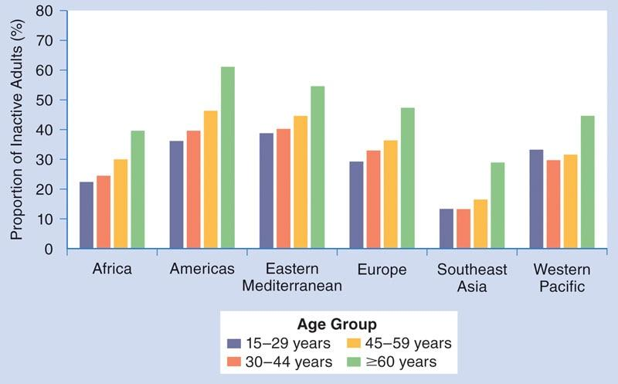

**Figure 1-6** Prevalence of physical inactivity worldwide

Chronic diseases are among the most prevalent and costly health conditions in the United States (Raghupathi & Raghupathi, 2018) and globally as well. In a study conducted by Harvard University in partnership with the World Economic Forum, it was estimated that chronic disease will be responsible for a global economic loss of roughly $47 trillion by the year 2030 (Bloom et al., 2011). The global impact is staggering, and individuals at all levels of society are impacted by the growing prevalence of chronic diseases and associated risk factors.

CRITICAL

With so many in the greater population dealing with one or more chronic health conditions, it is essential for fitness professionals to be familiar with the most common conditions. Regular exercise and healthy lifestyle changes can greatly improve the quality of life for people with chronic conditions; however, fitness professionals should always ensure that affected individuals have received clearance to exercise by a doctor or other licensed healthcare provider before beginning a new fitness regimen.

### 

**Overweight and obesity**

The terms *overweight* and *obesity* refer to a body weight that is greater than what is considered normal or healthy. In both cases, an individual is carrying excess body fat that may negatively impact their health; however, obesity is more severe and has numerous significant health risks associated with it. Being overweight or obese greatly increases the risk of developing a chronic disease, such as musculoskeletal disorders, diabetes, cancer, hypertension (high blood pressure), high cholesterol, and heart disease (GBD 2015 Obesity Collaborators, 2017; World Health Organization, 2018c).

For adults, the general measure used internationally for defining overweight and obesity is body mass index (BMI), which is a simple comparison of a person’s height to their weight. It is calculated by either dividing a person’s weight in kilograms by the square of the person’s height in meters or dividing body weight in pounds by the square of the height in inches and multiplying by 703.

* Metric formula: BMI = weight (kg) ÷ [height (m)]2
* Imperial formula: BMI = 703 × weight (lb) ÷ [height (in.)]2

The BMI classifications for overweight and obese are found in Table 1-1 (Nuttall, 2015).

TABLE 1-1 BMI Classification

|  |  |  |
| --- | --- | --- |
| **BMI** | **Disease Risk** | **Classification** |
| < 18.5 | Increased | Underweight |
| 18.5–24.9 | Low | Healthy weight |
| 25.0–29.9 | Increased | Overweight |
| 30.0–34.9 | High | Obese |
| 35.0–39.9 | Very high | Obesity II |
| ≥ 40.0 | Extremely high | Obesity III |

Obesity, due to poor diet and physical inactivity, is perhaps the most challenging of the public health problems faced today. When including the amount of people who are overweight as well as those who are obese, not only have current numbers already reached unprecedented levels but the rate at which both are annually increasing in most developing regions is substantial. The global public health implications of overweight and obesity are staggering and seem to become worse every year; between 1980 and 2015, obesity rates have more than doubled in more than 70 countries, with more than 600 million adults and 100 million children now classified as obese worldwide (not including the even greater number classified as overweight) (GBD 2015 Obesity Collaborators, 2017; Hruby & Hu, 2015).

But there is good news. Overweight and obesity represent the one area of public health where fitness professionals can make a significant positive impact. By coaching clients to change behaviors, get more active, and follow healthy eating guidelines, the health risks of being overweight or obese can be reduced.

Certified Personal Trainers are in a unique position to help their clients not only lose weight but also keep it off for the long term. According to a key study by the National Weight Control Registry (the largest ongoing study of people who have maintained successful weight loss in the United States), the majority of participants (90%) who reported consistently exercising an average of 1 hour per day maintained a significant weight loss over a period of several years (Ogden et al., 2012).

CRITICAL

BMI provides the most practical measurement of overweight and obesity because it is the same for both sexes and for all ages of adults. When analyzing large populations, BMI is both a valid and reliable tool to estimate overweight and obesity levels.

However, BMI is not a substitute for more precise, objective measurements of body fat composition when examining people on an individual basis. For example, elite athletes with very high levels of lean muscle mass can be mistakenly classified as obese by BMI alone, even though they may have very little body fat. For that reason, calculating BMI is just a starting point, and other body composition assessments should be considered with clients who are on a weight loss journey.

**Heart disease**

*Cardiovascular diseas*e is a broad term describing numerous problems of the heart and blood vessels and includes conditions such as strokes, heart attacks, heart failure, heart valve problems, and arrhythmias. The most common root cause of these conditions is ischemic heart disease (Benjamin et al., 2017). Ischemic heart disease is characterized by the narrowing of coronary arteries, which supply blood and oxygen to the heart, and is what is most commonly being referred to when discussing heart disease.

Atherosclerosis (Figure 1-7) is the process by which plaque is formed in the arteries, leading to reduced blood flow to the heart or brain. Atherosclerosis is the most common type of heart disease that can directly result in heart attacks and strokes. It is usually caused by the presence of a combination of risk factors, such as tobacco use, obesity, physical inactivity, harmful use of alcohol or drugs, high blood pressure, high cholesterol, type 2 diabetes, chronic stress, and poor diet.

While chronic disease as a whole is extremely costly for every population around the globe, the proportion due to heart disease alone is staggering; it is the number one cause of death, accounting for more loss of life than any other chronic disease (Finegold et al., 2013). However, it is also highly preventable. Studies have consistently demonstrated that individuals who maintain their aerobic fitness through regular and sustained exercise over the course of their lifetimes reduce their risk for developing heart disease (Brunjes et al., 2017; Kokkinos, 2012; Warburton et al., 2006).

In addition, for those diagnosed with a heart condition, habitual exercise appears to reduce the risk of additional cardiac events—including heart attacks—and is an important component of secondary prevention (Darden et al., 2013).

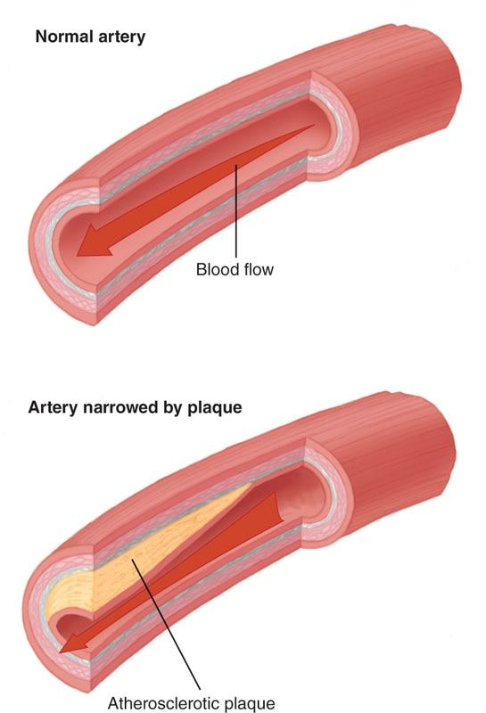

**Figure 1-7** Atherosclerosis

Exercise also promotes positive physiological changes, such as encouraging the heart’s arteries to dilate (i.e., open) more readily, which improves blood flow (Bruning & Sturek, 2015). The overall impact of physical activity and exercise on reducing the risk of heart disease is significant and dramatic; regardless of the presence or absence of ischemic heart disease and existing risk factors, every adult should be encouraged to participate in regular exercise over the course of their lifetime (Agarwal, 2012).

HELPFUL HINT

Exercise Versus Physical Activity  
Exercise is a structured and planned form of human movement to elicit a physical adaptation, such as weight loss or improved endurance or strength. Examples of exercise include weight lifting, cycling, running, or swimming. Exercise programs can occur in a gym setting or outside and can also be performed alone or in a group setting.

Physical activity refers to movement that expends energy, such as walking, yardwork, recreational sports, or playtime. Physical activity can be categorized as continuous or intermittent and can be performed across a wide range of intensity levels, from walking a dog to vigorously shoveling snow after a storm. Physical activity is not typically structured or planned, rather, it represents natural movement throughout a person’s day.

**Hypertension**

Hypertension, specifically, is one of the primary risk factors for heart disease and stroke (World Health Organization, 2019). Hypertension is categorized by a blood pressure greater than 120/80 (systolic/diastolic) millimeters of mercury (mm Hg) (Hernandez-Vila, 2015). Fitness professionals need to promote awareness of hypertension and encourage clients to modify risk factors, such as poor diet, lack of physical activity, and tobacco use.

STRETCH YOUR KNOWLEDGE

Systolic blood pressure (SBP) is the pressure in arteries and other blood vessels when the heart is beating or contracting. It is the first (top) number recorded.

Diastolic blood pressure (DBP) is the pressure in arteries and other blood vessels when the heart is at rest or between beats; it is the second (bottom) number recorded.

Blood pressure is classified as follows:

* Normal (healthy): Less than 120/80 mm Hg
* Elevated: Systolic between 120 and 129 and diastolic less than 80 mm Hg
* Stage 1 hypertension: Systolic between 130 and 139 or diastolic between 80 and 89 mm Hg
* Stage 2 hypertension: Systolic 140 or higher or diastolic 90 mm Hg or higher

Hypertensive crisis: Systolic greater than 180 and/or diastolic greater than 120 mm Hg (Whelton et al., 2018)

Scientific evidence indicates that the risk of cardiovascular complications not only doubles when systolic and diastolic blood pressure are chronically above normal levels, but also increases proportionally with age (Prospective Studies Collaboration, 2002). Updated guidelines that use more conservative definitions of high blood pressure are designed to increase awareness earlier and promote healthy behaviors aimed at preventing hypertension and controlling it if a diagnosis has been reached (Whelton et al., 2018).

A helpful method for every individual to keep blood pressure at healthy levels is regular exercise. Exercise has been shown to improve factors linked to cardiovascular health, resulting in lower blood pressure (Nam, 2011). Additionally, a fiber-rich diet with plenty of vegetables, whole grains, and fruit significantly helps reduce blood pressure (Siervo et al., 2015). Other evidence-based practice recommendations to reduce and control blood pressure include learning stress-reduction techniques and avoiding both smoking and excessive alcohol use.

Becoming more physically active can lower systolic blood pressure by an average of 4–9 mm Hg (Carpio-Rivera et al., 2016). For individuals diagnosed with hypertension, the typical approach to treatment is a combination of overall lifestyle modification (e.g., smoking cessation, diet improvement, and increased physical activity) and medication. Planned exercise alone is typically insufficient for acutely lowering and controlling hypertension. However, when looking at the bigger picture, exercise also helps lower and control body weight, improve blood flow, and reduce stress and anxiety, all of which have a positive impact on reducing and controlling blood pressure in the long run (Moraes-Silva et al., 2017).

**Cholesterol**

Elevated total cholesterol (medically referred to as dyslipidemia) is a major cause of disease burden in both the developed and developing world. Chronically elevated cholesterol levels increase the risks of heart disease and stroke (CDC, 2020c; Park et al., 2018). Cholesterol is a waxy substance found in blood that is made up of a combination of protein and fatty acids, known as a lipoprotein. When a healthy, balanced diet is consumed, the human body produces all of its own necessary cholesterol. The human body needs cholesterol to build healthy cells, carry products in the blood, and support the nervous system.

Chronically high cholesterol can develop fatty deposits in blood vessels and can increase a person’s risk for heart disease (Nelson, 2013). Although it serves a vital bodily function, cholesterol should be frequently monitored to promote health and prevent disease, because it is a major component of the plaque that leads to atherosclerosis.

STRETCH YOUR KNOWLEDGE

**“Good” and “Bad” Cholesterol**  
There are two main types of cholesterol in the body: low-density lipoprotein (LDL) and high-density lipoprotein (HDL). LDL cholesterol, sometimes referred to as “bad cholesterol,” tends to increase the risk of cardiovascular disease (Nelson, 2013). LDLs, specifically, are the form of cholesterol that makes up the plaque that clogs arteries. Ideally, LDL levels should be less than 100 milligrams per deciliter (mg/dL) (O’Keefe et al., 2004).

HDL cholesterol, on the other hand, is sometimes referred to as “good cholesterol.” It does not have the tendency to clog arteries like LDL cholesterol does and, in fact, actually helps remove some LDL cholesterol from the body. To help reduce the risk of heart disease, in conjunction with lowering LDL levels below 100 mg/dL, HDL levels should typically be kept around 60 mg/dL (Grundy et al., 2018; U.S. Department of Health and Human Services, 2001).

Exercise has been shown to help reduce high cholesterol; however, researchers are not entirely sure about the optimal frequency, duration, and intensity of exercise to improve cholesterol levels (Mann et al., 2014). Being overweight tends to increase the amount of LDL cholesterol in the body, which increases the risk of heart disease.

The use of exercise to help reduce weight and control blood sugar levels will likely result in favorable reductions in LDL cholesterol levels and, therefore, overall heart disease risk. Conversely, studies have shown that individuals who regularly partake in high-intensity exercise can raise their HDL cholesterol to heart-healthy levels (Wang & Xu, 2017).

**Diabetes**

Diabetes is a disease that impacts the body’s ability to properly metabolize carbohydrates, specifically glucose, the simplest carbohydrate form that is used directly by the cells to produce energy. There are a few types of diabetes, such as type 1 and type 2, and each impacts the body’s physiology differently. With type 1 diabetes, the pancreas does not make enough insulin (or none at all), which is a hormone that helps transport glucose into cells to be used for energy. Without insulin, glucose in the blood (i.e., blood sugar) can rise to dangerous levels, causing numerous health complications. Type 1 diabetes is typically genetic and is not something a person can actively prevent. However, regular exercise can help people with type 1 diabetes considerably improve their blood glucose management and quality of life (American Diabetes Association, 2020).

With type 2 diabetes, the body still produces insulin; however, it is not used properly by the cells. When excess carbohydrates (specifically sugar) are chronically consumed in the diet, high levels of insulin need to be produced to help regulate blood sugar. When excess insulin continually tries to deliver glucose to cells when they already have more than they can use, cells stop responding to it. This state is called insulin resistance. Once cells have become insulin resistant, a person is said to have developed type 2 diabetes. Regulating blood sugar can become very difficult for these individuals, which may lead to uncontrolled blood sugar levels and a wide variety of health complications.

The global economic impact of diagnosing and treating diabetes—especially type 2—is extremely high, as is the human cost of increased disability and premature mortality, making diabetes the seventh leading cause of death around the world (Kharroubi & Darwish, 2015). Regular physical activity and exercise is vital in the prevention and treatment of diabetes, especially type 2 (American Diabetes Association, 2020). Obesity is one of the primary indicators for a person to develop type 2 diabetes; therefore, exercise combined with diet and lifestyle changes to help lose weight can have a dramatic impact in improving the health of individuals who have been diagnosed.

**Cancer**

Simply put, cancer is a disease where cells in the body grow abnormally, often creating tumors that can grow aggressively and damage the body. Cancer can occur in virtually every part of the body, such as muscle tissue, internal organs, bones, the blood, and the brain. There are more than 100 different types of cancer identified, caused by numerous factors ranging from lifestyle choices like smoking tobacco and eating overly processed meats to acute DNA damage from exposure to radiation (National Cancer Institute, 2015). Cancer can affect people of all ages but is most common in older adults; about 76% of all cancers are diagnosed in individuals 55 years or older (Centers for Disease Control and Prevention et al., 2019). On the bright side, it is estimated that around 30–50% of cancers can be prevented by avoiding risk factors and implementing existing evidence-based prevention strategies (Bray et al., 2018). Two of those prevention strategies are taking part in regular exercise and eating a healthy diet.

Exercise can play a significant role in the prevention of many types of cancers; in particular, being physically active can reduce the overall risk of cancer in general. Evidence indicates that even those currently undergoing cancer treatments can increase daily physical activity sessions over the course of 1 month (Segal et al., 2017).

In addition to increasing physical activity, all of these activities can significantly reduce cancer risk: avoiding tobacco use, losing excess weight, eating a diet rich in fresh fruits and vegetables, and limiting alcohol consumption.

**Respiratory disease**

Chronic obstructive pulmonary disease (COPD) is an umbrella term for chronic respiratory dysfunctions that are characterized by increased breathlessness, airflow limitation, and accelerated decline of lung function. These symptoms are not fully reversible and significantly limit activities of daily living for those who are diagnosed. Emphysema and chronic bronchitis are examples of COPD. By 2030, COPD is estimated to become the third leading cause of death worldwide (Quaderi & Hurst, 2018).

Individuals with COPD often have several accompanying chronic health conditions. Consequently, they often have lower health-related quality of life, which in itself is an independent predictor of hospitalizations and mortality (Janssen et al., 2011). Once diagnosed, COPD is not considered curable; rather, it is medically managed over a person’s life span. However, lifestyle modification and increased physical activity can have positive effects for individuals with a chronic respiratory condition. Specifically, light aerobic exercise involving large muscle groups is recommended to help improve the ability to use oxygen; brisk walking daily can be one of the best forms of exercise for people with COPD (Bender et al., 2016).

**Stress**

The world we live in is becoming more and more complex, fueled by rapid change and the need to constantly respond and adapt to it. In the face of 24-hour news cycles, social media, and increased demands for productivity, stress is on the rise. According to the Global Organization for Stress, most of the world is affected by stress and stress-related complications (deVries & Wilkerson, 2003). Stress levels in the workplace are rising, with 6 in 10 workers in all major global economies reporting that their workplace-related stress is increasing (Birhanu et al., 2018). And that workplace stress is taking its toll, with stress-related illnesses rising in turn among all segments of the population (Fink, 2016). Constant unmanaged stress and anxiety is harmful to both the body and mind and may elevate the risk for chronic disease (Yaribeygi et al., 2017).

However, regular physical activity and exercise have been shown to help control and manage stress and anxiety (Rebar et al., 2015). Any form of physical activity or exercise can act as a powerful stress release and is perhaps the “best medicine” to help relieve stress. One way regular exercise helps reduce stress is by the brain releasing endorphins that are associated with pain reduction and feelings of increased well-being and happiness. Additionally, the ability of exercise to help lower and control heart rate and blood pressure makes it an important countermeasure to stress and anxiety. For those reasons, the role of physical activity and exercise in helping to relieve and control stress is extensive and convincing (Stults-Kolehmainen & Sinha, 2014).

## Evidence of muscular dysfunction and increased injury

Skeletal muscle development and maintenance is vital to ensure optimal health and well-being across the life span of all individuals. Skeletal muscle tissue accounts for a significant amount of overall body mass and supports freedom of movement within the environment. In addition to the increased risk and occurrence of chronic diseases, too much sitting and physical inactivity can also cause dysfunction in our body’s muscular and skeletal systems, which can lead to an increased risk of injury and instances of low-back, shoulder, and neck pain (Law & Sluka, 2017; Owen et al., 2010; Thorp et al., 2011).

**Foot and ankle dysfunction**

Foot and ankle injuries can severely limit and impact normal activities of daily living (Chinn & Hertel, 2010). Two of the most common issues at the foot and ankle complex include ankle sprains and plantar fasciitis. An ankle sprain occurs when a person’s ankle is rolled, twisted, or turned, which results in the stretching or tearing of the ligaments that hold the bones of the ankle together and connect it to the foot and the lower leg. Plantar fasciitis involves inflammation of the tissue on the bottom of the foot that connects the heel bone to the toes (i.e., the plantar fascia) and often results in chronic heel pain.

The feet and ankles support the entire body; as a result, impairments to the foot and ankle complex may cause dysfunction to other regions of the body such as the knees, hips, or lower back (Menz et al., 2013; Riskowski et al., 2013). Additionally, if someone has previously injured their ankle, there is a far greater risk of injuring it again if work has not been done to properly condition it back to a strong and stable place (Fulton et al., 2014). This makes it highly important for fitness professionals to monitor the posture of their clients’ feet and ankles during exercise so they can better develop proper movement patterns.

**Knee dysfunction**

Knee pain is a common complaint that can affect anyone regardless of age or level of physical activity. Possible causes of knee pain include arthritis, acute (sudden onset) injuries, and overuse (repetitive) injuries. Arguably, three of the most common knee injuries include patellar tendonitis, anterior cruciate ligament (ACL) tears, and medial collateral ligament (MCL) tears. Some forms of chronic knee pain are also associated with being overweight or obese and a lack of regular physical activity (Frilander et al., 2016).

It is important for fitness professionals to have a basic understanding of proper knee alignment and posture, as well as ways to monitor exercise technique to minimize the risk of injury. Many common types of knee injuries and disorders can be prevented with proper exercise technique, supportive footwear, and modifications to exercise and physical activity as necessary. Regular flexibility and strength training plans with the inclusion of a comprehensive warm-up component can help significantly reduce the incidence of knee injuries (Park et al., 2018).

**Lumbo-pelvic-hip complex dysfunction**

The lumbo-pelvic-hip complex (LPHC) is made up of the lumbar spine (low-back area), pelvis, abdomen, and hip musculoskeletal structures and is commonly referred to as “the core.” The LPHC is an important anatomical structure because it connects the upper and lower halves of a person’s body. Increasing strength and stability of the LPHC is important for improvements in health, sports performance, and prevention of injuries because an unstable core limits the ability of the limbs to properly produce force and predisposes an individual to back or hip pain (De Blaiser et al., 2018; Granacher et al., 2013; Hewett et al., 2005; Richardson et al., 2002). In fact, nearly 80% of adults experience some form of low-back pain at least once during their lifetime (Nam, 2011). As such, fitness professionals must have working knowledge of the muscles that make up the core and design fitness programs that increase core stability and strength.

**Shoulder dysfunction**

Shoulder pain is a common occurrence, especially as the body ages. Simple, routine movements, such as taking out the trash, getting dressed, or reaching for something overhead, can often cause discomfort when the shoulder joints are in a deconditioned state. Shoulder pain and injuries are also quite common in sports and weight training, especially during overhead lifting. Shoulder problems may be due to the instability of the shoulder joint or impingement of the soft tissue or bony structures of the shoulder, known as shoulder impingement syndrome (Mitchell et al., 2005).

Because so many functional movements involve the shoulders, fitness professionals must have a working knowledge of their muscles and structures. A regular routine of upper-body flexibility and properly implemented strength training can help reduce the risk of shoulder injuries. In addition, fitness professionals should ensure clients perform high-intensity exercises correctly and only engage in training programs that are suitable for their individual abilities, goals, and objectives; for example, aggressive swinging pull-ups and hammer swing exercises can be dangerous for individuals without advanced levels of shoulder fitness already in place (Summitt et al., 2016).

**Head and neck dysfunction**

Headaches and neck pain are common ailments, and poor posture of the head and neck are often the cause. Much of the time, poor head and neck posture is due to extended periods looking at computer screens or mobile phones. For example, *text neck* is a growing phenomenon that researchers are investigating to identify whether habitual use of cell phones influences neck pain (Gustafsson et al., 2017; Xie et al., 2016). Placing the head in a constant state of flexion (looking downward) affects many of the muscles of the neck area and may cause neck soreness.

Forward head posture is another common cause of head and neck pain. Jutting the head forward increases the workload for many of the muscles attached to the cervical spine (upper spine area), which has the job of stabilizing the head. Over time, forward head posture can lead to dysfunction of the neck area as the body tries to adapt and find efficient ways to raise the head for straight-ahead vision. Forward head posture can be seen in office workers and other individuals who routinely work in front of a computer and naturally tend to migrate the head toward the screen when trying to focus (Nejati et al., 2015; Szeto et al., 2002).

Exercise has been shown to be beneficial for individuals exhibiting forward head posture, especially for the reduction of lingering neck discomfort (Sheikhhoseini et al., 2018). Many people who seek the services of a fitness professional are habitual mobile phone users or office workers who spend most of their day working on a computer. Consequently, fitness professionals should monitor the position of their clients’ head and neck during exercise to minimize the risk of injury and help train proper posture and movement patterns.

# The Healthcare Continuum

The healthcare continuum (Figure 1-8) represents a systematic way to view the healthcare industry through various entry points (i.e., why health care is needed), types of care provided (i.e., which professional to choose), and the intended outcomes (i.e., what the individual wants to accomplish). The healthcare continuum describes the spectrum of preventive, acute (immediate), and long-term healthcare needs. For example, admittance to the emergency room for an injury would be acute care, whereas training with a fitness professional would be classified as preventive.

All in all, the healthcare continuum allows for a clear understanding of which components of health and wellness require a licensed medical provider and which ones are completely within an individual’s control. No longer is health care strictly related to going to the doctor when one is sick or injured; the modern interpretation represents a dynamic process with the goal of improving and extending total quality of life by combining professional care with elevated levels of self-care.

Certified Personal Trainers are a vital part of the healthcare continuum because they can become instrumental in people’s lives as a form of preventive care to help prevent illness or injury. Additionally, they can also help clients improve their health through exercise—after receiving a medical professional’s clearance—after experiencing injury or being diagnosed with an illness.

This makes it important for Certified Personal Trainers to network with a wide variety of allied health professionals so that any client question or concern can be referred to the right expert.

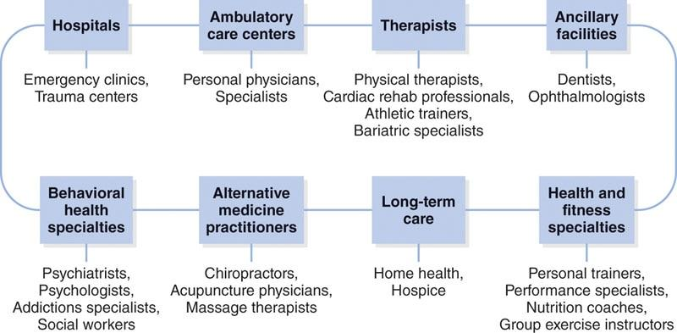

**Figure 1-8** The healthcare continuum

**Allied health professionals**

In many cases, fitness professionals are the bridge between licensed healthcare providers and clients. Certified Personal Trainers serve an important role in helping develop and implement safe and effective training programs alongside other healthcare providers. It is important for fitness professionals to develop a working knowledge of the types of healthcare professionals they may work with in the future. Networking with other allied health professionals can be vital in building a thriving fitness business, because each can refer to the other for their respective services and build a community their clients can trust. Certified Personal Trainers will often network with the following allied health professionals:

* *Physical therapists*. A physical therapist is a practitioner who is educated in many areas of physical rehabilitation. Physical therapists can work in many settings such as hospitals, rehabilitation centres, nursing homes, schools, and fitness or sports conditioning facilities to help individuals return to regular activity following an injury.
* *Athletic trainers*. An athletic trainer often works alongside physicians, emergency medical technicians, and other healthcare providers to help diagnose and treat injuries. Many athletic trainers work with sports teams as part of the sports medicine staff; however, athletic trainers can also work in a variety of fitness-related settings or schools.
* *Chiropractors*. A chiropractor is a licensed healthcare professional who primarily deals with conditions relating to spinal alignment. Chiropractors use manual manipulation of the vertebrae to help alleviate nervous system dysfunction because all nerves in the body connect to the spinal cord.
* *Registered dietitian nutritionists*. Registered dietitian nutritionists are food and nutrition experts who have met specific academic and professional requirements and passed the required national certification exam. These professionals provide nutritional advice, therapy, and counseling to a wide range of clients or patients, often specializing in nutritional therapy for the treatment and management of chronic disease. Registered dietitian nutritionists can work in many settings such as hospitals, nursing homes, schools, and fitness or sports conditioning facilities.
* *Licensed massage therapists*. Licensed massage therapists are professionals who practice massage therapy and are licensed to therapeutically manipulate the muscles and other soft tissues of the body through physical touch. Licensed massage therapists can work in a variety of settings, such as rehabilitation centers, fitness or sports performance facilities, and luxury resorts and spas, or work as an independent contractor.

## Certified Fitness Professionals

Fitness professionals include Certified Personal Trainers, group fitness instructors, and strength and conditioning coaches. A Certified Personal Trainer is an individual with specific knowledge of fitness and exercise science who has passed a credentialling exam offered by a national certifying organization. They screen clients to ensure safety and make recommendations for exercise programming and other lifestyle changes. Also, Certified Personal Trainers help motivate clients by setting goals and providing feedback and accountability and recommendations for progression or alternate workouts.

A group fitness instructor is a fitness professional who teaches, leads, and motivates individuals through large-group exercise classes. They have various levels of knowledge, training, and education necessary to provide safe instruction across various class formats and settings.

Group fitness instructors typically hold a certification in group exercise or a more specific area of expertise (e.g., indoor cycling, aerobic dance, Pilates, or yoga). A group fitness instructor’s scope of practice is traditionally limited to apparently healthy individuals, because clients rarely, if ever, take part in fitness assessments prior to attending a group class.

A strength and conditioning coach is a fitness professional with advanced knowledge, training, and experience in designing and implementing strength and conditioning programs for competitive athletes. The majority of strength and conditioning coaches hold an undergraduate degree in a field related to exercise science, one or more national certifications, and considerable hands-on experience working with athletes. They can work with athletes of all ages and abilities, from youth to elite professional athletes.

**Role of the certified personal trainer**

While entry-level Certified Personal Trainers are fitness professionals who work with apparently healthy clients, additional training, education, and experience enable many to become qualified to work with a wider range of clients, including those with chronic diseases who have been medically cleared to exercise. Certified Personal Trainers generally work one-on-one with clients or in small groups and objectively measure clients’ strengths and weaknesses with a variety of fitness, posture, and body composition assessments. From those assessments, they go on to design safe and effective exercise programs to help their clients reach their health, wellness, or fitness goals.

Certified Personal Trainers are also involved in educating their clients in other areas of wellness, including general health information and basic nutritional guidance that better enables them to reach their goals. It is important for Certified Personal Trainers to take time to evaluate their clients’ lifestyle habits, both inside and outside of the gym, and apply proven coaching techniques that help their clients change unhealthy behaviours for the long term. This way, Certified Personal Trainers can ensure they are doing everything possible to help their clients meet their goals.

Additionally, Certified Personal Trainers must recognize their own areas of expertise and tailor their practice accordingly. If a Certified Personal Trainer suspects that one of their clients has a medical condition that could prevent the client from safe participation in an exercise program, the Certified Personal Trainer must refer that client to the appropriate licensed healthcare professional for evaluation and clearance.

## Scope of practice and Code of Conduct

Simply put, scope of practice represents all the things a given professional can do within the legal boundaries of their job title. Certain jobs have strict regulation by law, such as medical doctors or lawyers, while others are more vaguely left up to individual interpretation. Furthermore, scope of practice for a given profession frequently varies from country to country or region to region. What might be allowed openly in one area could be completely prohibited by simply stepping over a border

Sometimes, professions that do not have their own specific governmental regulation can have their scope of practice defined through their association to other adjacent fields. Fitness professionals fall in this category. While there is no specific legal registration and regulation surrounding working as a Certified Personal Trainer in the United States and many developed countries around the world, other allied health professions have stringent rules, which prohibit Certified Personal Trainers from performing certain health-related activities. For example, in many regions, nutritional therapy can legally only be provided by a registered dietitian nutritionist or licensed healthcare providers; while in others, no licensure is required, and anyone can offer professional nutritional advice. This makes it highly important for all fitness professionals to not only understand their own scope of practice but also fully understand the scopes for adjacent allied health professionals and stay current on all local laws and regulations that pertain to providing health and wellness services to the public.

**Certified Personal Trainer’s scope of practice**

Certified Personal Trainers are fitness professionals who perform individualized assessments and design safe, effective, scientifically based, and individualized exercise and conditioning programs for clients who present with no medical or special needs, or who have been medically cleared for exercise. They provide guidance to help clients achieve their personal health, fitness, and performance goals via the implementation of exercise programs, general nutritional information, and suggestions for lifestyle modification. They hold a current emergency cardiac care (cardiopulmonary resuscitation) certification and respond appropriately during emergency situations. Certified Personal Trainers do not diagnose or treat areas of pain or disease, and they refer clients to other healthcare professionals when appropriate. NASM Certified Personal Trainers abide by NASM’s Code of Professional Conduct at all times.

### NASM Code of Professional Conduct

NASM has established a code of ethics and guidelines to protect the public and the profession. Candidates are expected and Certified Professionals are required to agree to and follow the NASM Code of Professional Conduct.

#### **Professionalism**

Each Certified Professional must provide optimal professional service and demonstrate excellent client care in their practice. Each Certified Professional must:

1. Abide fully by the NASM Code of Professional Conduct; conduct themselves in a manner that merits the respect of the public, other colleagues, and NASM
2. Treat each colleague and client with the utmost respect and dignity
3. Not make false or derogatory assumptions concerning the practices of colleagues and clients
4. Use appropriate professional communication in all verbal, nonverbal, and written transactions
5. Provide and maintain an environment that ensures client safety that, at a minimum, requires that the Certified Professional must:

* Not diagnose or treat illness or injury unless for basic first aid or if the Certified Professional is legally licensed to do so and is working in that capacity at that time
* Not train clients with a diagnosed health condition unless the Certified Professional has been specifically trained to do so, is following procedures prescribed and supervised by a valid licensed medical professional, or is legally licensed to do so and is working in that capacity at that time
* Not begin to train a client prior to receiving and reviewing a current health-history questionnaire signed by the client
* Hold a current cardiopulmonary resuscitation and automated external defibrillator certification from a NASM-approved provider at all times

1. Refer the client to the appropriate medical practitioner when, at a minimum, the Certified Professional:
   * Becomes aware of any change in the client’s health status or medication
   * Becomes aware of an undiagnosed illness, injury, or risk factor
   * Becomes aware of any unusual client pain and/or discomfort during the training session that warrants professional care, in which case the Certified Professional will immediately discontinue the session
2. Refer the client to other healthcare professionals when nutritional and supplemental advice is requested unless the Certified Professional has been specifically trained to do so or holds a credential to do so and is acting in that capacity at the time
3. Maintain a level of personal hygiene appropriate for a health and fitness setting
4. Wear clothing that is clean, modest, and professional
5. Remain in good standing and maintain current certification status by acquiring all necessary continuing education requirements

#### **Confidentiality**

Each Certified Professional must respect the confidentiality of all client information. In their professional role, the Certified Professional must:

1. Protect the client’s confidentiality in conversations, advertisement, and any other arena unless otherwise agreed on by the client in writing or when necessary due to a medical occurrence or when legally required
2. Protect the interest of clients who are minors by law or unable to give voluntary consent by securing the legal permission of the appropriate third party or guardian
3. Store and dispose of client records in a secure manner.

#### **Legal and ethical**

Each Certified Professional must comply with all legal requirements within the applicable jurisdiction. In their professional role, the Certified Professional must:

1. Obey all local, state, federal, and provincial laws, regulations, and professional rules
2. Accept complete responsibility for their actions
3. Maintain accurate and truthful records
4. Respect and uphold all existing copyright, trademark, and intellectual property right laws

NASM may revoke or otherwise take action with regard to the certification of an individual who is or has been convicted of, plead guilty to, or plead nolo contendere (no contest) to a felony or misdemeanor or has been found through a legal process to have been negligent or responsible for injury or harm in performing in their professional capacity or has misrepresented their qualifications to provide services, including opinions or advice, to the public.

#### **Business practice**

Each Certified Professional must practice with honesty, integrity, and lawfulness. In their professional role, the Certified Professional must:

1. Maintain adequate liability insurance
2. Maintain adequate and truthful progress notes for each client
3. Accurately and truthfully inform the public of services rendered and their qualification to render such services
4. Honestly and truthfully represent all professional qualifications and affiliations
5. Advertise in a manner that is honest and dignified, and represent services that can be delivered without the use of provocative and/or sexual language and/or pictures
6. Maintain accurate financial, contract, appointment, and tax records including original receipts for a minimum of 4 years
7. Comply with all local, state, federal, and provincial laws and employer rules regarding harassment and discrimination, including sexual harassment.

## Fitness industry employment landscape

The fitness industry is experiencing enormous growth all around the world. In the United States, for example, the demand for “fitness trainers and instructors” (the broad job category for all fitness professionals) could grow to 402,000 jobs by the year 2028, and that is just within the domestic American health club market (Bureau of Labor Statistics, 2019). Because this growth is seen in other parts of the world as well, this strong outlook for fitness industry employment continues to grow. Fitness professionals have the option to work for a variety of employers or to work for themselves, effectively running their own business. Subsequently, successful fitness professionals should always adopt a lifetime-learner mentality, always seeking to improve their knowledge and skills.

**Importance of education and certification**

The profession of personal training can trace its origins to the 1970s when bodybuilders and athletes were hired to help clients develop a muscular appearance. Soon after, commercial health clubs realized that they could create an entirely new revenue stream by offering personal training services to members. As the personal training profession grew, earning a personal training credential became increasingly important. The purpose of a personal training credential is to ensure that individual job candidates can demonstrate the ability to perform the tasks required for a specific job category.

Current-day Certified Personal Trainers are now responsible for designing exercise programs that integrate all systems of the body using a variety of exercises that improve balance and coordination, core strength, overall movement quality, and health. The function of a Certified Personal Trainer has evolved from simply improving aesthetic appearance to helping clients improve their overall quality of life by designing exercise programs for weight loss, injury prevention, athletic performance, and function improvement for activities of daily living. This creates employment opportunities for fitness professionals who have the knowledge, skills, and abilities to create customized exercise programs.

A Certified Personal Trainer credential can help an individual begin a career in the fitness industry; however, as fitness professionals progress through their careers, it will be necessary to pursue continuing education to develop advanced skills that meet the needs of a wider variety of clients, such as those with chronic health conditions (e.g., heart disease, type 2 diabetes, osteoporosis) or musculoskeletal dysfunction (e.g., limited flexibility and poor movement quality).

STRETCH YOUR KNOWLEDGE

A National Academy of Sports Medicine (NASM) Certified Personal Trainer beginning their career should be prepared to design exercise programs for people of all ages and generations, specifically:

* Generation Z (post-Millennials): born after the year 1997
* Millennials: born between the years 1981 and 1996
* Generation X: born between the years 1965 and 1980
* Baby Boomers: born between the years 1946 and 1964
* Silent Generation: born between the years 1925 and 1945

As adults progress through the human life span, their abilities change, and it will be necessary to adjust exercise programs accordingly (Mora & Valencia, 2018). This creates the need for fitness professionals to pursue continuing education to ensure they develop the skills to meet the needs of a changing clientele.

**Employment opportunities**

After earning the credential, the next step is deciding the best employment option that provides for a stable income with a schedule to accommodate a comfortable work–life balance. From working in a large health club to training clients in their own homes, Certified Personal Trainers have several different options to establish a practice with consistent clients.

One choice a fitness professional must make is whether to work as a direct employee of an organization or as an independent contractor. A second choice is to start a business that could include working with clients in their homes, running group workout programs in a local park (with the appropriate permits), or investing the money to open a studio. Finally, as technology is evolving, there are now numerous options for offering fitness training services online.

No matter which avenue of fitness employment is selected, it can take time to acquire clients and build a solid book of business that provides a steady source of income.

Even if a fitness professional has the goal of starting a business or opening a fitness studio, beginning a fitness career by working as an employee at a commercial health club could help establish the foundational skills necessary for long-term success. Even when working in a health club or studio as a direct employee, a fitness professional is essentially running their own business when serving the members of that facility, because the fitness professional’s own expertise and commitment to providing a quality service is on display, which directly impacts the fitness professional’s reputation and personal brand. A fitness professional who begins a career working for an employer will learn important business and customer service skills that will be useful if they do eventually make the decision to start a business.

Commercial health clubs

As of 2019, the global health club industry is reported to include more than 210,000 facilities serving more than 180 million members (International Health, Racquet & Sportsclub Association, 2019). The goal of the International Health, Racquet and Sportsclub Association, which actively promotes the health club industry, is to have more than 230 million health club members worldwide by the year 2030, creating a tremendous amount of employment opportunities for fitness professionals. In short, more health club members create a demand for more Certified Personal Trainers. As a result, the decision to work in a health club could establish the foundation for a financially and personally rewarding career.

Health clubs can be local, regional, national, or even international with locations in multiple countries. Additionally, commercial health clubs can be operated within a corporate structure where a central office oversees operations or as individual franchise affiliates where each location is owned independently (Table 2-1). This is important to consider, because a franchise with a local owner will probably be operated differently than a large, publicly traded chain of health clubs. Even if the goal is to one day open a private facility, it is a good idea for fitness professionals to begin their careers in a commercial facility, because it is essentially on-the-job training for operating a fitness business.

TABLE 2-1 Types of Health Clubs

| **Category** | **Description** |
| --- | --- |
| Low-cost | In recent years, these types of health clubs have exploded in popularity. These facilities offer a low-price membership, often including very few amenities other than access to exercise equipment. Access to amenities or programs, such as group fitness classes, small group workout programs, or personal training, costs extra, if the services are offered at all. Additionally, many low-cost clubs will have 24/7 key card access for members instead of employing a front-desk staff. |
| Mid-market | Health clubs in this category provide all features of low-cost clubs with additional amenities like higher-end locker rooms, snack and supplement sales, and group fitness workouts included in the price of membership. In addition, these health clubs often have multiple locations that can be accessed with the same level of membership. |
| Premium | Health clubs in this category typically feature multiple group-fitness studio options like indoor cycling, mind–body, and traditional group fitness programs. They also frequently provide a selection of high-end amenities like towels and complimentary personal hygiene products, cafes to provide post workout nutrition, pools, full-service spas and salons, sports courts, and in-house childcare services. The price point for a membership at premium clubs varies considerably based on location, the company, and the level of desired facility access. Oftentimes, these clubs sell family packages to help keep things more affordable. |
| Nonprofit | Many nonprofit organizations, such as the YMCA, operate fitness facilities. They then use the revenue from the fitness programs and memberships to cover operational costs, improve the facilities, and fund a wide range of community-based initiatives. However, the term nonprofit can be slightly misleading; while these organizations may not generate profits for a private owner or corporation, they still require fitness professionals to generate revenue no differently than they do at for-profit clubs. |

Certified Personal Trainers could be considered among the most important employees in a health club because they come in direct contact with club members on a daily basis and help them achieve the results they desire. The primary business of a health club is to sell and retain memberships. With that in mind, an employer has a vested interest in seeing Certified Personal Trainers succeed, because the more members who purchase personal training services, the more revenue is generated for the company.

As a direct employee, a fitness professional is often paid an hourly rate when working a scheduled shift on the fitness floor, an additional amount when delivering a personal training session to a client, and various bonuses based on the amount of personal training sold or the number of personal training sessions delivered. In most employment models, a fitness professional can earn anywhere from 40% to 70% of what the client pays the club for the individual training session.

Independent professionals

Another option for working as a Certified Personal Trainer is the independent contractor model in which a fitness professional contracts their services to one or more health clubs or training studios. As independent contractors, fitness professionals will pay either a per-client or monthly fee to a facility to be able to use that location, essentially becoming customers of the facility themselves. Additionally, independent fitness professionals can train clients at their homes or in public spaces like parks and athletic fields (Table 2-2).

TABLE 2-2 Employment Options for Independent Contractors

| **Employment Option** | **Description** |
| --- | --- |
| Studio or health club | Fitness professionals pay rent to use a facility as long as they have their own liability insurance and adhere to established guidelines and operating procedures. |
| Traveling to client’s home | A fitness professional will travel to a client’s home to provide services. This service could also include access to a facility if the client lives in a housing development with a fitness centre. |
| Online coaching | There are different options for delivering training services online, which could include selling prepackaged programs, providing coaching to a group of remote clients with similar goals like preparing for a marathon, or providing personalized services like remote one-on-one coaching. |
| Organizational wellness | Employers may contract with a fitness professional to provide fitness classes to help employees stay healthy and disease free. This service will require liability insurance to use an employer’s facility. |

Working as an independent contractor allows a fitness professional to establish their own pay rates and earn the entire amount. However, keep in mind, this ultimately means a fitness professional is responsible for paying all the operational costs, such as fees to use a facility, marketing for new clients, continuing education, and benefits such as health care, time off, and automated income tax withholding. At first, it may seem tempting to work as an independent contractor because of the ability to earn more per session; however, when considering all of the costs and other administrative factors, it can be highly challenging for new fitness professionals. Certified Personal Trainers who train independently need savvy skills in sales, marketing, and business operations to ensure costs and profits are managed wisely.

Different facilities will have different arrangements for how fitness professionals can rent space, but generally, any fitness facility that allows independent contractors to meet with clients will require a formal agreement, including a monthly payment for the ability to rent space at that facility. It may be tempting to simply pay for a gym membership and offer personal training services directly to other club members, but that is “training under the table” and is considered a form of theft. A health club may prosecute fitness professionals for shoplifting or trespassing if they are caught. This violates the NASM Code of Professional Conduct and could also lead to the loss of the fitness professional's personal training credential. When entering into a contract with a facility, fitness professionals should make sure that all expectations from the manager or owner are clearly identified and communicated in writing.

TRAINING TIP

There are many factors to consider before a fitness professional makes the choice to work as an independent contractor, including the following:

When searching for a facility to rent space, fitness professionals should pay close attention to how the staff treats existing members. It can be difficult to market personal training services in facilities that do not provide an exceptional service experience.

If the plan is to work directly with clients in their homes, a fitness professional should take the time to research the local market to see if it can support that business. Costs such as gasoline, vehicle maintenance, and time driving place to place should also be considered.

A fitness professional should identify marketing expenses required to attract clients. It takes a lot of time and effort to develop a marketing strategy that can attract a steady stream of customers.

A fitness professional should budget for purchasing liability insurance. When working for an employer, a fitness professional is covered under an employer’s liability insurance. However, when working as an independent contractor, fitness professionals must purchase their own liability insurance to protect their personal assets in case of a lawsuit.

Small group training

From providing a more affordable price point for coach-led workouts, to a more enjoyable participant experience, a number of factors have led to the growth of group workouts, also called small group training or group personal training. Traditional group exercise classes, such as dance aerobics and indoor cycling, can include upward of 30 or more participants. Conversely, group personal training programs feature workouts for smaller groups of individuals who can be coached by an individual fitness professional. There are a number of branded fitness studios offering a variety of group training concepts ranging from high-intensity interval training (HIIT) sessions and boot camps to custom group workouts for special populations (e.g., older adults, youths). Because group personal training requires a different skill set than leading a single individual through a workout, fitness professionals are encouraged to pursue additional education to develop the necessary communication and coaching skills to lead group training programs.

Online fitness coaching

There are numerous fitness consumers who are motivated to exercise on their own, but they need the guidance of a fitness professional to know what to do. This creates the perfect opportunity for online coaching programs. Online coaching is a completely new business model of delivering personal fitness services that has evolved over the past decade.

Just like in-person personal training, different models exist for how online fitness coaching can be delivered to clients. Two of the most common models include selling predesigned workout programs or offering personalized workouts based on specific needs.

Some online coaches will meet with and coach clients through workouts using a camera-based app, while other online coaches may simply create a number of preformatted programs and market them through a social media channel. Additionally, some fitness professionals may provide a hybrid service where they meet with a client in person to conduct an assessment and design the initial exercise program but then may provide ongoing coaching and program maintenance remotely through an online platform. This hybrid model, specifically, can be leveraged by all working fitness professionals to maintain consistent interaction with clients who do not purchase multiday-per-week training packages, helping to boost accountability and adherence to the program.

TRAINING TIP

Certified Personal Trainers have a lot in common with stock brokers and real estate agents. Once an individual earns a license to sell stocks or real estate, it is merely the foundation of their career—it is up to the individual broker or agent to generate all of their own respective business. Earning the NASM personal training credential is a foundational step of a possibility-rich career. However, it is up to each individual fitness professional to generate their own book of business for long-term success, no matter which employment model is selected.

**Career development**

Personal training can be a rewarding career in terms of both helping others to change their lives and earning a good living. Many fitness professionals pursue careers in the fitness industry because they are passionate about helping others, not because they enjoy the minutiae of administrating staff policies or managing expense reports. However, at some point in almost every fitness professional’s career, there will be the consideration about whether or not to apply for a promotion to club management because it can provide a consistent salary and be a great step for long-term career growth.

Every place of employment is different; so, before making the decision to take on an expanded role at a company, fitness professionals need to carefully consider whether it will provide long-term career satisfaction. Moving into management can quickly shift the focus of a fitness career from directly helping people to overseeing business tasks. For some, that is an expected consequence of career development; but for others, it can mean a departure from the very reason they chose to earn a CPT credential.

Fitness manager

A fitness manager’s duties include maintaining a staffing schedule, providing mentorship to fitness professionals, and holding regular meetings with the entire fitness team, all while still responding directly to member needs when necessary. For fitness professionals with the long-term goal of opening a facility, working as a fitness manager will inherently teach many of the necessary business and managerial skills required for running a successful operation. Fitness managers are paid in salary with bonuses for reaching performance goals.

General manager

Often promoted from a department manager position, a general manager is responsible for all business operations of the club, from sales to repairs and maintenance. They oversee multiple departments and individual employees. General managers are often paid a salary with bonuses for achieving specific performance metrics. Depending on the company structure, opportunities for advancement into regional, divisional, and national corporate management roles may also exist. Moving into higher roles of management will typically require advanced education in both the fitness and business fields.

Facility owner

One of the benefits of becoming a Certified Personal Trainer is the relatively low cost for starting a business when compared to many other industries. In its simplest form, the initial start-up costs for an entry-level personal training business are for the certification exam, liability insurance, appropriate business licenses (as applicable by locale), marketing costs, and a few pieces of easily transportable exercise equipment.

Fitness professionals can start a business working with clients in their homes or public spaces, and then eventually grow to a point where it is financially viable to invest in and open a physical location. There are different models for this, including opening a franchise, starting a business from scratch, or purchasing an existing fitness facility. Some owners may be very involved in the business and work as the general manager of the facility, while other owners may invest in a business and pay a manager to conduct the operations. With so many options to consider, a fitness professional’s entrepreneurial spirit is what will truly determine if individual business ownership is the right path to choose.

Adjacent careers

In addition to working directly with clients, a personal training credential can serve as the foundation for an alternative career path. The following are a list of potential opportunities for fitness professionals interested in growing their careers in a different direction than traditional club management and operations. It is important to note, however, that many of these options will require additional education, such as completing a bachelor’s or even a master’s degree.

* Master Instructor
  + Works directly with equipment companies or fitness education organizations to teach workshops that provide attendees with continuing education. This often requires formal education like a degree in an exercise-related field, as well as the participation in a formal selection process to become a trusted representative of a company.
* Writer or Blogger
  + Writes fitness-related content that is relevant to specific demographics for online resources or print magazines. Independent bloggers can earn money via ad revenue on their website, while a more common option is to be paid per article to write content for health clubs, equipment companies, or other fitness-related businesses. This requires effective written communication skills and the ability to identify interesting content that is relevant to a specific audience. Additionally, credibility and a solid professional reputation need to be crafted before moving into the content creation world.
* Strength and Conditioning Coach
  + Designs, implements, and coaches workout programs for the specific purpose of improving athletic performance. Strength and conditioning coaches are typically employed by sports organizations or universities and can work with youth, high school, college, recreational, and even professional athletes. Working in this capacity for a university or professional team often requires an advanced degree, fitness industry certification, and internship completion.
* Social Media Influencer
  + Represents and promotes specific products or brands on various social media platforms in exchange for sponsorship. This requires not only an established, professional reputation within the fitness industry and beyond but also the ability to develop, produce, and distribute interesting, engaging content that is relevant to a specific audience and can attract followers to drive brand growth. This is a highly competitive space. Typically, successful fitness influencers will have already earned their platform via previous achievements in athletics or by first building a clientele comprised of high-profile celebrities.
* College or Trade School Instructor
  + Teaches fitness curricula at an accredited college or trade school. This always requires an advanced degree, such as a master’s of science or PhD. Additional training and credentialing in learning theory and instructional design may also be needed to effectively teach at this level.

**Resume writing**

Aspiring fitness professionals need to understand the importance of a well-written resume submitted to hiring managers or business owners. A resume should be a short, outlined presentation of an individual’s ability to contribute to a particular type of organization. In short, it should highlight an entire life, not just work (Schultze, 2010). A new Certified Personal Trainer may not have any specific experience working in the fitness industry, but it is important to highlight other skills and job experiences that can easily transfer.

Selling personal training services to health club members and exhibiting excellent customer service are critical functions of a fitness professional’s job duties. To earn the interview, it is important for applicants to show hiring managers that they are comfortable with customer service and the sales process. Therefore, when writing a resume, fitness professionals should feature any and all professional experience that relates to sales and customer service. For example, if an applicant has experience working as a server in a restaurant, then it is important to highlight that specific work experience because it demonstrates the ability to approach customers and upsell additional products like appetizers or desserts.

HELPFUL HINT

When writing a resume, fitness professionals should highlight how previous jobs have provided the experience in customer service that they need to be successful. To stand out, they should describe personal activities that are interesting and will catch a reader’s attention (Schultze, 2010).

The resume should be:

Creative. It should provide an accurate employment history in the most creative way. “Word-smithing” the descriptions of previous work experience could help a candidate stand out to a potential employer.

Organized. The resume is a representation of the job seeker. It should be well structured with a consistent flow of information that shows an attention to detail. The use of action verbs will highlight accomplishments at previous jobs.

Unconventional. The resume should feature experience related to a fitness professional. For example, working as a counselor in a youth camp shows the ability to lead large groups of people.

Vulnerable. The fitness professional should be honest and show the ability to learn and grow in a position by highlighting both successes and failures.

A professional resume should be limited to one or two pages and can be written in different formats either to feature chronological work experience or to identify specific skills aligned to the jobs where those skills were developed. The common advice is to have a one-page resume; however, if an individual has a tremendous amount of work experience, a two-page resume is acceptable. Whether a resume is one or two pages, it should highlight how an individual’s previous work experience provides them with the skills to be an effective fitness professional (Figure 2-1). An online search about how to write a professional resume can provide the most current and effective ways to structure a resume to attract a potential employer’s attention.

| **Component** | **Description** |
| --- | --- |
| Name, address, email address, and phone number | Percy Trainer 1234 Main Street Anytown, USA percytrainer@email.com (555) 555-5555  Applicants should use their most up-to-date street address, email address, and phone number. It is also important to use a professional email address that includes a clear naming structure. Using email addresses that involve slang or unrelated terminology should be avoided. |
| Social media accounts | LinkedIn: Percy Trainer Facebook: Percy Trainer Instagram: @PercyTrainerFitness  Many prospective employers will review an applicant’s social media accounts. Before applying for jobs, applicants should review all social media accounts and remove or hide. |
| Summary | An NASM-Certified Personal Trainer, with the ability to design exercise programs that get results and deliver excellent customer service skills, seeking to apply my years of experience in retail management toward being a personal trainer for ABC Health Clubs.  Resumes should provide a brief one- or two-sentence review of top skills along with a statement of interest in the open position. |

|  |  |
| --- | --- |
| Work experience | The Retail Outlet 2005 - Current  2015–Current General Manager Manage all operations for a large retail establishment resulting in $80,000 a month in sales. Three-time winner of General Manager of the Quarter. Promoted from Assistant Manager.  2012–2015 Assistant Manager Organized staff schedule and supervised employees. Promoted from Shift Leader.  2009–2012 Shift Leader Responsible for supervising cash register employees during work shift. Promoted from Cashier.  2005–2009 Cashier Perform general duties related to customer service and collecting payment for customer orders.  Even if it is not specifically relevant to working as a fitness professional, it is important to show a consistent employment history. Moreover, this is where an applicant can feature skills that carry over to the fitness industry. Such skills might be managing a budget or customer service, and demonstrating leadership skills, such as being promoted or given responsibility as a supervisor. Special awards or recognition like Employee of the Month or highest-producing salesperson should be called out. Potential employers want applicants that know how to go above and beyond the basic expectations of a job. |
| Education | NASM Certified Personal Trainer - earned in 2019  California State University 2012 Bachelor of Science in Business Administration  Anytown High School 2006 General studies  Applicants should list their personal training credential along with any other formal education like trade school, community college, four-year university, or postgraduate work. Again, it is not necessary that the education be specifically relevant to the fitness industry; the purpose is to show the ability to learn and follow through with completing an education program. |
| Other interests | Volunteer - Anytown Red Cross Volunteer on a monthly basis to help the Red Cross serve meals to those in need.  Anytown High School Varsity Basketball, 2-year starter, state champions 2005  Applicants should identify nonwork experience like being an athlete, which can be relevant for showing that an applicant can successfully work as a member of a team, or volunteer work, which demonstrates the ability to manage time and shows that an applicant takes an interest in being of service to others. |

**Job search and interviewing**

The purpose of the resume is to market a candidate’s skills to obtain an in-person interview with the hiring manager. The interview then becomes the step where an applicant presents their skills to a potential employer as a solution that can help improve business. Working as a fitness professional in most commercial health clubs is both a sales-based and customer service-oriented business, and the interview is the first opportunity a prospective fitness professional has to demonstrate their sales and customer-service skills with the hiring manager. But before securing an interview, it is important for aspiring fitness professionals to know where to look for potential employment.

**Where to look for a job**

When it comes time for the job search, most online employment websites include job postings of companies looking to hire Certified Personal Trainers. In addition to using employment websites, aspiring job candidates should go directly to the websites of any potential employers to learn about their hiring process. Furthermore, another search tactic can be to drive around the town where employment is desired and identify potential facilities. In addition to a resume, most employers will require a candidate to complete an employment application on the company website to initiate the hiring process. But it is always a good idea for the candidate to also visit in person whenever possible to personalize the process for a greater chance of success.

Once the application is complete, there may be an initial screening process, such as a pre-interview questionnaire or a telephone interview to see if applicants meet the basic qualifications the employer has identified as being essential for success before offering an in-person interview.

**Attire**

Even though the standard uniform for a fitness professional is exercise clothing, when visiting a potential employer to inquire about job opportunities, it is necessary to dress in professional business attire. Wearing traditional business clothing shows a potential employer that a job candidate takes the opportunity seriously and understands the importance of professionalism.

When interviewing for the position, it will be equally necessary to wear professional business attire to demonstrate respect for the professional nature of the job. Even though fitness professionals work in an informal environment where they may have to demonstrate a variety of different exercises, they are still delivering a professional service and should dress like a professional when interviewing for a position. Once hired, most fitness businesses will provide specific uniform guidelines to ensure consistent, high-quality customer service.

TRAINING TIP

When working as a fitness professional, avoid wearing muscle shirts or clothes that are too tight or overly revealing. Instead, wear tasteful workout attire. Implement proper, professional grooming standards, such as combing hair or pulling it back and wearing minimal cologne, perfume, or jewelry. Consider it from the client’s perspective: a client may not be interested in working with a fitness professional who is disheveled or poorly groomed or one who is wearing clothes that are inappropriate for a professional setting.

**The interview**

The interview is a formal process that enables job candidates to display their personality, convey their work ethic, and discuss aspects of their job history beyond what is on their resume. It is also an opportunity for job candidates to learn more about the business, its practices and processes, and its culture.

At an interview, it will be important to focus on the conversation and answer all questions with as much clarity and honesty as possible. There is nothing wrong with saying, “I don’t know,” when it comes to a technical question. It is much better to be honest and truthful than to evade the issue and make up things. The primary purpose of the interview is to identify the candidate’s ability to communicate effectively and function as a member of the team. During the interview, a candidate should discuss how their previous work experience can benefit the employer, as well as share any relevant information that demonstrates the ability to successfully function as a member of a team. The following guidelines should be used to maximize success during an interview.

**Pre-interview**: Read the job description several times prior to the interview to become familiar with the position and its responsibilities.

* Research the company in advance by visiting its website.
* Practice answering potential interview questions prior to the actual interview.
* Prepare at least three questions in advance to ask the interviewer.

**Interview**: Wear professional business attire.

* Bring a padfolio, a professional looking pen, and extra copies of a resume.
* Arrive 15 minutes early.
* Be well groomed and avoid excessive makeup, flashy jewelry, and extreme hairstyles.
* When introduced, shake the interviewer’s hand and look them in the eye (unless the culture in that country does not favor this behavior).
* Ask thoughtful, open-ended questions about potential job responsibilities and the culture of the business.
* Answer interview questions clearly and concisely, using good examples.
* Practice good posture; sit up straight, and don’t slouch.

**How to follow up**

It is an excellent idea to follow up after the interview with a thank you email or even a handwritten note. Writing an email or handwritten note to thank an interviewing manager for their time shows that a candidate is serious about the opportunity and interested in employment with the company. In the thank-you message, the candidate should make sure to reference specific aspects that may have been discussed during the interview, such as the potential for career advancement or options provided by the employer for continuing education. A well-written thank-you note can often make the difference and help an individual earn the job opportunity, especially when several people are interviewing for the same position.

TRAINING TIP

Even when working as a direct employee, fitness professionals should still behave as if they are running a personal business. Many employers require fitness professionals to set monthly production goals and then develop a business plan to help achieve those goals. Acting like a business owner when working for an employer can help a fitness professional establish a foundation for long-term career success. There are many factors to consider prior to making a commitment to an employer, including the following:

During the interview process, ask the potential employer about specific procedures for marketing and selling personal training. Many employers offer an onboarding process that teaches new fitness professionals how to conduct business in the facility, especially when it comes to the sales process. The interview process can help identify which employers offer the best options for career growth.

Identify facilities that attract specific client demographics such as older adults, athletes, or women only. Aspiring fitness professionals who desire to work with a specific population and develop a specialty niche can become successful by working in these facilities.

Uncover the flow of business throughout the day. A suburban facility may be busiest in the mornings before work; during the day because of stay-at-home parents, retirees, and high school kids; and in the evening after traditional work hours. An urban location will experience the highest volume of visits in the morning before work, during lunch time, and right after work, with periods of extremely slow time in between. Identify the busiest times of day for a prospective employer and then plan on being available to work with clients at those times.

Consider the daily commute. Be realistic about the costs and time associated with a daily trip to and from work, especially if planning on training clients first thing in the morning or late evenings.

Ask the interviewer about additional benefits, such as health insurance, paid time off, continuing education, and retirement savings through a 401(k) account. When deciding about employment, fitness professionals should consider the entire benefits package and not just the per-session compensation or hourly pay rate. Many employers in the fitness industry will offer professional development and education for their staff when first beginning employment and over the course of a career.

Research the reputation of the company. As employees, fitness professionals represent the facility, but they should keep in mind that the employer represents the employee as well. Fitness professionals should determine if their values are aligned with a prospective employer. For example, does the fitness facility emphasize providing remarkable customer service, rewarding employee successes, or maintaining a professional yet relaxed environment?

**A day in the life of a Certified Personal Trainer**

There are only a few specific times of day when most clients have the free time to meet with a fitness professional. While there are exceptions, most potential clients are generally available in the morning before work, during their lunch hour, and after work. In most markets, the popular times for clients to work with Certified Personal Trainers are from 5 a.m. to 9 a.m., 12 p.m. to 2 p.m., and 4 p.m. to 8 p.m. However, given the nature of the modern economy where many people work nontraditional jobs or have the freedom to work from home, it is becoming increasingly possible to meet with clients at all times of the day.

As fitness professionals takes on more clients, there will be many demands for their time (Figure 2-2). To establish a healthy work–life balance, it is important for a fitness professional to set and follow specific working hours. Being available at all hours might seem important when starting a personal training business, but fitness professionals should keep in mind that overextending oneself can lead to poor customer service and burnout. It is important to set guidelines for availability and adhere to them.

A Sample Day in the Life of an NASM Certified Personal Trainer

| **Time** | **Activity** |
| --- | --- |
| 5:00–6:00 a.m. | Wake up, get dressed, and commute to work |
| 6:00–9:00 a.m. | Train morning clients before they head to work |
| 9:00–10:00 a.m. | Roam the floor, clean equipment, and greet guests at the front desk |
| 10:00–11:00 a.m. | Personal workout time, includes filming for daily fitness tip on social media |
| 11:00–11:45 a.m. | Lunch |
| 11:45 a.m.–2:00 p.m. | Coach group workouts for lunchtime clients |
| 2:00–3:00 p.m. | Administrative time: client communication, program design for clients, and completion of any necessary paperwork |
| 3:00–4:00 p.m. | Break |
| 4:00–6:30 p.m. | Train evening clients |
| 6:30 p.m. | End of work day |

In an effort to reduce the number of hours worked, while also increasing the amount of money earned, many Certified Personal Trainers are learning how to coach group workouts.

Group workout programs often base compensation on the number of participants; the more people in a group workout, the more money that professional can earn per hour. Coaching group workouts during times when the most clients are available is one way for fitness professionals to increase income while also improving work–life balance.

**Operations**

Working as a Certified Personal Trainer includes numerous business tasks in addition to directly training clients, such as reviewing assessment or intake forms, preparing invoices and collecting payments, developing or updating exercise programs, making follow-up phone calls, writing emails, or sending text messages to schedule and confirm appointments. Managing a day’s operations tasks takes time, but it is highly necessary to keep new prospects coming in and existing clients coming back.

Employers also typically require specific duties to be performed around the facility when a fitness professional is not working with clients. These duties could include circulating on the fitness floor to provide assistance to all members, cleaning gym equipment, putting away equipment left out by members, working external events (health conferences, street markets), or helping the membership team at the front desk.

When working with clients, fitness professionals should establish specific hours that they are available to see clients and adhere to this schedule for consistency. It is important to begin and end client sessions or group workouts on time so that one session or group workout does not overlap with another. Clients pay for a set amount of time; if the client is late, the session should still end on time and not run into the next. For independent fitness professionals traveling to different locations to lead workouts, it will be necessary to factor in commute times and plan for traffic.

**Guidelines for uncompromising customer service**

A major focus of daily operations in the fitness world is customer service. It is important to remember that customers return because they feel valued—like they are a part of something special. There are many reasons why individuals join a health club, such as improving health and overall well-being, managing a healthy body weight, providing activities for the family, or simply feeling more comfortable in their own skin. However, there are only two primary reasons why members and clients continue to return:

1. They have learned how to enjoy exercise and are experiencing the results they want.
2. The service they receive is highly enjoyable, and the facility provides a sense of community.

The fitness industry is part of the service industry. When an individual invests in a health club membership, they are paying for access to the facility and the services provided by the employees. If a Certified Personal Trainer fails to deliver a high level of service to clients, then attracting and retaining clients becomes very challenging. It is important to note that clients have many different demands for their time. This means the most successful Certified Personal Trainers are the ones who can adapt accordingly to each individual’s communication preferences and coaching needs. A client could hire a Certified Personal Trainer for many reasons, but the services that clients are actually paying for and expect include the following:

* Accountability. Many clients want to be held accountable for their exercise goals and prefer to be contacted, especially after missing a session. Fitness professionals should allow no more than 24 hours to pass before contacting a client after a missed session. This demonstrates a level of service that can help ensure the client adheres to the program.
* Support. Wearing exercise clothes or exercising in a public area can be intimidating for many people and hiring a Certified Personal Trainer can help certain individuals build confidence to exercise. Fitness professionals should always seek to create a positive environment where clients feel proper support and encouragement for pursuing their exercise goals.
* Feedback and guidance. One of the most important benefits of working with a fitness professional is receiving the proper instruction for the exercises required to reach specific goals as well as the guidance for how to follow and make progress in a long-term exercise program.
* Results. Clients want to know that their exercise program is producing the desired outcome. The most effective way to evaluate progress is by conducting various fitness assessments. Fitness assessments allow a fitness professional to have a specific, methodical, and consistent way to gather data about a client’s progress every few weeks.

Existing and potential clients will always expect those minimum levels of service. If they are not met, then it is likely that clients will take their business elsewhere or, in certain cases, quit exercising altogether. If the expectations are exceeded, however, clients are more likely to return and may also refer their friends or loved ones. When it comes to long-term clientele development, even the best marketing and sales techniques are never as powerful as direct client referrals. Client referrals are a powerful strategy to gain more clients and keep a steady stream of business.

Fitness professionals also need to realize that whether they are working with clients in a health club, leading a group through an outdoor workout, or posting a video on social media, they are always being watched by others. For example, a member on a piece of cardio equipment watching a fitness professional work with another client will always make a variety of judgments based on personal observations. If the member observes that the fitness professional is distracted or acting unprofessionally, then that individual will most likely avoid opting for personal training services. However, fitness professionals who are attentive, communicate clearly, and provide encouragement and motivation will be noticed favorably by other members in the facility. Being professional and caring is one of the best forms of advertising for future clients.

TRAINING TIP

Fitness professionals should always be seeking to improve their customer service skills. Providing remarkable customer service increases the likelihood that clients will adhere to their exercise program. In his book, How to Win Friends and Influence People, sales and management expert Dale Carnegie (1936) identified important tips for how to deliver an exceptional service to all clients in any industry:

Smile. People feel appreciated and tend to smile back when a professional smiles first.

Say hello and look people in the eye. Unless the culture views eye contact as threatening, this is a great way to create an instant connection with people.

Listen. Actively listen and encourage others to talk about themselves.

Act as if you are the owner of your own business. Even if you work for someone else, your daily actions should reflect the values of the business.

Introduce yourself and ask for the individual’s name. Make sure to use their name in conversation.

Talk in terms of the other person’s interests. This can help build understanding and find areas of common interests.

**Safety procedures**

From a minor injury like spraining an ankle to a severe medical emergency like cardiac arrest, it is important that all fitness professionals who work in a facility are prepared to handle a variety of emergencies and unexpected situations. Therefore, it is important for fitness professionals to be familiar with all facility safety procedures, such as where emergency equipment is located, how to perform cardiopulmonary resuscitation (CPR), and how to use an automated external defibrillator (AED) device. Each fitness business will have its own unique safety procedures, which should be clearly explained during employee onboarding.

If a Certified Personal Trainer is contracting space from various facilities, it is important to ask about each facility’s safety policies and procedures in case of an emergency. Fitness professionals who travel to work in clients’ homes or lead outdoor conditioning programs need to establish their own robust safety guidelines and should always have the necessary first aid equipment to be able to handle any unexpected injuries that could occur during the course of a workout session, including investing in an AED device. It is highly recommended that independent fitness professionals seek additional first aid certification on top of the CPR and AED certification required of all Certified Personal Trainers. Additionally, before working with clients independently, personal liability insurance must be purchased and maintained, and it is also suggested that fitness professionals work with a legal professional to develop a client consent form as an additional level of protection.

## Sales and marketing

Clients seek the services of a fitness professional because they have a problem that needs solving. Their problems may include difficulty losing weight, lowering their blood pressure or cholesterol, or improving their strength and stamina necessary to make the varsity basketball team. Fitness professionals offer clients solutions by using exercise as their tool of choice. It is through this collaborative effort that clients aim to be become better versions of themselves.

These services cannot occur without the sales process. Building a successful personal training career requires the ability to close a sale, which can be one of the most challenging aspects of the profession. It is one of the most important skill sets that fitness professionals need to learn and practice. In particular, Certified Personal Trainers must become comfortable with the sales process such as presenting prices for personal training session packages and asking potential clients for the sale. After all, without the sales process, fitness professionals are not able to help their clients reach their health, wellness, or fitness-related goals. These two functions are linked and dependent on each other.

**Sales**

The term *salesperson* sometimes generates a negative image, but the reality is that ethical sales techniques are rooted in helping others. When people ask about personal training services, they are really looking for advice and guidance from an expert who can help them achieve specific results through exercise. Selling personal training services is about asking a client to make a commitment to an exercise program to improve their own health, wellness, and fitness. In that light, selling becomes the process of educating potential clients about how an exercise program, catered to their individual needs, will help them achieve their goals. Fitness consumers have an interest in getting results from their workout programs, and fitness professionals who feel confident presenting their services as a solution will be most successful in the sales process.

Introduction to the sales process

For Certified Personal Trainers to have a successful career, they must be comfortable asking potential clients to purchase training sessions, which requires the ability to become comfortable with the sales process. There are specific stages of the sales process:

1. Identifying a customer’s needs
2. Communicating solutions for their needs
3. Making the sale by asking for a financial commitment to solving their needs (Gitomer, 2015)

The process of designing an exercise program is based on assessing a fitness need that the program can solve. The ethical sales process is no different; it is about assessing the client’s needs and delivering solutions. Many fitness professionals enter the profession because they sincerely want to help people, and being a true sales professional empowers that desire. A sales professional is one who educates consumers on how they will benefit from a product or service offered.

When the sales process is performed correctly, there is no pressure placed on the customer to force a decision. A sales professional guides the conversation by asking the customer several open-ended questions. These questions help a sales professional learn about a customer’s wants, needs, fears, and desires. Using this information, a salesperson can then accurately communicate potential solutions to the customer. Sales professionals understand that the success of their career is based on the ability to help customers find the solutions they want and need and will be ethical and honest in all communications.

Prospecting and lead generation

Prospecting for new clients is an integral part of every fitness professional’s working day. Without meeting new people and developing a pipeline of potential clients, even the most skilled Certified Personal Trainer will fail in their career. Without that pipeline, client needs will never be uncovered, and personal training programs will never be sold.

Prospects are potential sales leads that can be converted to paying clients. They are not just random people off the street; rather, they are individuals who the fitness professional has already identified as being potentially interested in fitness services. Prospects can be identified in a few ways:

1. Asking for referrals from existing clients
2. Working the floor to meet as many facility members as possible and building rapport
3. Obtaining warm leads provided by the member and/or sales department
4. Answering inquiries from social media and other marketing streams

To continue receiving warm leads, health clubs will commonly offer one or more complimentary personal training sessions to new members when they sign up. This creates a low-pressure opportunity for Certified Personal Trainers to demonstrate their expertise and market their services to an already captive audience. This is an additional benefit of working in a large health club, because many commercial health clubs may sell dozens to a few hundred new memberships per month. Each new member is a potential client for the fitness professionals working at the facility.

In these types of facilities, the management team will have a system for distributing new member information among the fitness staff. However, every facility is different, and warm leads from new member sales should not be expected or relied on. Fitness professionals must always build rapport with the existing membership base and demonstrate their professionalism every day, viewing new member complimentary sessions as a bonus to the lead generation process.

Generating sales leads outside of the health club environment becomes a little more challenging because it is up to the fitness professional to develop and distribute all branding and marketing materials to uncover potential clients. One highly recommended tactic is to net-work with other service-based businesses in the area that also cater to a health-conscious clientele. Doctor’s offices, physical therapy clinics, massage therapy studios, chiropractic offices, and weight-loss centers are all service-based professional businesses that cater to consumers who may also see the value in working with a Certified Personal Trainer. Complementary service-based businesses can be identified through the local chamber of commerce or other business networking groups. Then, it all comes back to the same task that fitness professionals perform on the floors of health clubs every day: building rapport and uncovering a prospect’s fitness needs.

TRAINING TIP

When working the floor, it is important to get to know as many health club members as possible; however, it is equally important to not be too pushy or aggressive. This can be accomplished by keeping the atmosphere light and pleasant. The goal is simple: make a quick introduction, learn the name of the prospect, start building rapport, and then step away without mentioning anything related to sales. Then, as you have repeated interactions with the prospective client, fitness needs can be naturally uncovered, and solutions can be presented without ever having to “sell.”

Building rapport

Rapport represents the building of a relationship based on open communication and trust. Building rapport with clients requires the ability to communicate with honesty and make friendly, personal connections. Every interaction with a member or client is a chance to establish rapport and develop a relationship with a potential client. This makes it important for fitness professionals to always smile; be outgoing and friendly; ask for people’s names and use them in conversation; and uncover each prospect’s unique likes, wants, and needs. Then personal stories and life experiences can be related to those of the client in order to build a connection that leads to trust and professional respect.

Many successful Certified Personal Trainers focus new conversations on the prospect’s family, hobbies, and their desire to change their life for the better before ever discussing how an exercise program can help meet those needs. If the fitness professional is sincere in these interactions by working to build the relationship first, the sales process can become natural and automatic. Potential clients want to understand how their needs, wants, and desires are going to be satisfied. When a Certified Personal Trainer can demonstrate their value and uncompromising customer service in advance, the only decision the prospect has left is when to schedule the first appointment. Successful fitness professionals do not need to “sell” a client on anything; instead, they need to take the time to understand how each potential client wants to make lifestyle changes through exercise and demonstrate that they have what it takes to provide support and motivation for the long-term.

Forecasting

Forecasting is financial goal setting and helps determine how many prospects a fitness professional needs to interact with on a daily basis to keep a consistent client pipeline flowing. It is important for a fitness professional to set financial goals to measure progress and success. Setting a salary goal can help a fitness professional identify how many client sessions they will need to deliver to achieve that goal. This is especially important when considering a life as an independent fitness professional. If a Certified Personal Trainer is unable to accurately set and then meet monthly revenue goals while working for an employer, then it is not likely that they will be successful running a facility that requires maintaining a far more complicated budget, including rent, professional liability insurance, repairs to the facility, and any overhead costs such as compensation for employees.

Asking for the sale

Buying decisions are primarily emotionally driven, and the decision to invest in sessions with a Certified Personal Trainer might be extremely emotional (Ahmad et al., 2019; Kemp et al., 2018). Potential clients may be dealing with a vast array of feelings such as fear, anxiety, or inadequacy, so part of the fitness sales process is about taking the time to uncover those feelings. For example, a doctor may have advised a client to lose weight and lower blood pressure to avoid the risk for a heart attack or stroke. That is a heavy emotional load to consider, but one a Certified Personal Trainer may be able to help with. It is only after presenting the solutions to uncovered problems that a fitness professional should ask the client for a sale.

After demonstrating one’s ability to help solve a client’s fitness problems, the first step in asking for the sale involves presenting various purchasing options. Each client will place a different level of value on fitness services and will also have unique time and budgetary constraints. For that reason, it serves a fitness professional well to provide a “good, better, and best” package scheme, with price points that can appeal to a broad range of individuals. In this way, there is a solution available for everyone, from busy executives to stay-at-home parents to retirees on a fixed budget.

TRY THIS

Use some basic math to determine the number of personal training sessions needed per day to meet an annual income goal:

1. Set a goal for total annual income: $________

2. Divide that annual number by 50 to determine income needed to be earned per week:

Annual income goal ÷ 50 = $________ weekly income goal*

*50 is used instead of 52 to provide the fitness professional with 2 weeks of vacation per year.

3. Divide the number for the weekly income goal by the pay rate earned per training session:

Weekly income goal ÷ Per session rate = _______ number of weekly sessions needed to meet annual income goal

4. Divide the number of weekly sessions by the number of work days per week to determine how many sessions are needed each day to support the annual income goal:

Sessions per week ÷ Days of work per week = _______ number of daily sessions to meet the annual income goal

5. A common rule of thumb is that an average of 10% of initial prospects will close on a sale and convert to a client. With that in mind, multiply the number of sessions per day by 10 to uncover how many prospects need to be interacted with daily to keep the client pipeline full enough to support annual income goals:

Sessions per day × 10 = ______ number of prospects to interact with each work day

Health clubs typically offer preset packages of personal training sessions or a monthly subscription that provides a specific number of personal training sessions for a flat fee. For example, a health club may offer a prepaid package of 20, one-hour personal training sessions, or it could offer 4 sessions per month for a monthly subscription fee. The subscription model is becoming increasingly popular due to the affordability it provides. Only the most affluent of clients will be able to pay for large training packages up front, so a smaller monthly fee can be much more comfortable to budget for.

Fitness professionals working for themselves or as independent contractors will need to decide how to structure the services they want to sell. Because of this, considerable research needs to be performed to uncover competitor rates in the surrounding area. If numerous competing facilities charge similar rates, independent fitness professionals need to set their rates accordingly while still remaining competitive.

When asking for the sale, fitness professionals should present all of the available price points and allow potential clients a little time to receive the information. Clients need to be the one to choose the program that works best for them so that they feel empowered in the decision- making process. Some input can be provided to help guide their decision, such as, “If we meet two times a week, I feel comfortable I can help you meet your goal in 10 weeks. But if we meet three days per week, you will be able to reach your goal even faster!” This educates clients about prices and expectations for results. It is perfectly fine if a client is happy with the lowest level package, because once a client is signed, every training becomes an opportunity to keep building rapport, demonstrating professionalism, and tracking the client’s progress.

## Marketing

Once performance goals are set and a fitness professional knows how much work to perform to earn a specific amount of income, it will be necessary to market fitness services to potential clients. Marketing is the process of promoting a service for the purpose of communicating the features, advantages, and benefits of personal training to potential clients.

Many health clubs will have dedicated marketing departments that handle most of this effort; however, even in the biggest commercial health clubs, all fitness professionals are still responsible for building and maintaining their own clientele. Whether working for a health club or as an independent contractor, it will be necessary to at least develop a personal marketing plan to communicate with potential clients and help bring them into the gym. Fitness professionals just starting their career should realize that it could take as long as 3 to 6 months of work to develop a full client schedule.

For fitness professionals in charge of promoting their own services, their marketing should solve a problem; specifically, it should tell a story about how a service (or product) can enhance customers’ lives. Marketing should communicate the benefits of working with a Certified Personal Trainer to help potential clients meet their health and fitness goals. For example, if a Certified Personal Trainer is working in a suburban location with a large percentage of stay-at-home parents or older adults, then the Certified Personal Trainer needs to determine effective methods of communicating with those specific audiences. In this case, a Certified Personal Trainer with the experience of being a parent could market to the stay-at-home parents, whereas another with specific education in working with special populations could focus on working with older adults. Just as prospecting requires the uncovering of individual fitness needs, greater marketing efforts for the independent fitness professional need to uncover and solve for fitness needs of an entire community and surrounding population.

It might be helpful for a fitness professional to identify their unique selling proposition (USP). A USP could be traits or skills that allow one fitness professional to stand out from others by featuring services that are unique or different. When high-intensity workout programs were first introduced, the USP was that doing extreme workouts in a short period of time was a different way to exercise that produced results not offered by other methods. Examples of USPs that a fitness professional might use include:

* Specializing in working with active adults aged 55 years and older
* Focusing on weight-loss clients to help them learn how to use physical activity for long-term health and body composition improvement
* Training athletes to improve their sport-specific performance.

TRY THIS

Coaching Group Workouts

Teaching group fitness classes can be an effective marketing tactic for a Certified Personal Trainer. It allows for the promotion of personal training services to a group of consumers who are already committed to achieving results. Earning an additional certification as a group fitness instructor can open an entire new world of potential clients.

**Building value and a brand**

A brand tells a story and creates an identity for a product or service (Ries & Ries, 2004). The value of creating a brand identity is that it establishes a top-of-mind presence, which means that a specific brand name immediately comes to mind when a consumer thinks about a generic product category. A fitness professional can create a brand featuring a style of program design, such as body building or endurance training, or build a brand around a category of equipment, like training specifically with kettlebells.

As most sales are based on emotional decision-making, creating a brand to define the quality of personal training services that a client can expect is an important step in establishing an emotional connection with a client. A Certified Personal Trainer who invests the time to develop a specific brand for their service can help prepare clients for what to expect during the personal training experience.

TRY THIS

Identify your favorite brands of fitness programs or products that are currently popular and think about how each brand identity helps improve the popularity of the product.

Besides working with a specific type of clientele or type of equipment, another way to establish a brand is through personality or the specific method by which the workout experience is delivered. There are key differences, for example, between a drill instructor-type fitness professional who barks no-nonsense orders and someone who is more nurturing and supportive of everyone’s emotional needs. There are plenty of people who enjoy each, creating the opportunity for a fitness professional to build a brand that is directly tied to their own unique personality and coaching style. One Certified Personal Trainer may establish a brand of being the toughest workout in the city, while another fitness professional establishes a brand where even the most deconditioned individuals feel welcomed. Regardless of which type of brand is selected, one of the most effective methods of establishing a brand identity is by simply delivering on the promise of service.

**Using a swot analysis to build a brand**

To develop a full schedule, fitness professionals should take the time to identify a specific group of potential clients who can benefit from their personal training services (target demographic). A SWOT analysis can be used to identify areas of strength that can be used for building a brand and establishing a USP while also identifying opportunities for professional growth and development. SWOT stands for Strengths, Weaknesses, Opportunities, and Threats:

**Strengths**: Identify the strengths and competitive advantages including education, skills, abilities, or work experience with a specific population. Examples of strengths might be education, certifications earned; the name or location of employer, which itself may have a strong brand identity; or experience working with a particular type of client. The strengths can ultimately help identify the professional traits to develop a brand identity.

**Weaknesses**: Identify any and all weaknesses; be honest and thorough, the more honestly a fitness professional can assess their weakness, the more opportunities for growth can be identified. Examples of weaknesses might be unfamiliarity with specific types of clients such as elite athletes, being uncomfortable with the sales process, or overall lack of fitness industry experience.

**Opportunities**: Identify the opportunities for developing new professional skills or expanding into new business opportunities, such as being able to coach group workout programs. Weaknesses can be turned into opportunities; for example, the lack of education in a specific area of exercise science is actually an opportunity to take a continuing education workshop to gain the necessary knowledge to work with a specific type of client.

**Threats**: Identify all of the threats that might impact a fitness professional’s business. Examples of threats are the general economic climate, the number of other fitness professionals working in a health club, or competitors who plan on growing or expanding into the marketplace. In some cases, threats are due to external forces that cannot be controlled (such as an economic recession), while in other cases they can be turned into opportunities for new business.

Table 2-3 shows what a SWOT analysis for an entry-level Certified Personal Trainer in a large urban market might look like.

|  |  |
| --- | --- |
| Strengths | NASM personal training credential  Internship at recreation center during college conducting assessments and designing exercise programs for other students  Interest in helping clients with lifestyle and weight management issues; successful at helping clients adhere to exercise programs for weight loss |
| Weaknesses | Not confident in asking clients for money  Need to learn more about marketing and sales  Not certified to teach group exercise classes |
| Opportunities | Take a workshop to learn more about sales and marketing for fitness professionals  Work for a large health club operator in town that attracts 100-plus new members per month; see 6 to 10 new members a week to conduct assessments and introduce them to the facility  Learn how to coach group workouts to expand opportunities to work with club members |
| Threats | Competition from the other health clubs and training studios in the immediate area  Low consumer confidence in the current economic climate  Limited space to train clients when club is crowded |

### Four p's of marketing

A marketing plan should identify business opportunities and how to attract business in a specific market environment. For a health club employee, a market could simply be the members at the health club; for an independent Certified Personal Trainer, it could be all of the residents in a specific neighborhood or households in a community. The marketing plan will help determine the most effective way to promote the services offered by the Certified Personal Trainer, which will differ based on the specific market the Certified Personal Trainer is working in. To help simplify the process, fitness professionals should consider the Four P's of marketing, also known as the marketing mix: product, price, promotion, and place. A marketing plan should address the Four P's by:

* Communicating the benefits of using a *product*
* Identifying a competitive *price* of the service
* Determining how the service will be *promoted*
* Selecting the *place* or method of distribution (Westwood, 2016)

Table 2-4 outlines what a Four P's marketing plan could look like for an independent personal trainer.

| **Marketing Plan: Jane Doe’s Epic Personal Training** |
| --- |
| Product: Jane Doe’s Epic Personal Training  Jane offers in-home personal training services to women who want to learn how to strength train safely and effectively.  Price: Jane charges clients a flat monthly rate based on whether clients want one, two, or three sessions per week of live personal training (4, 8, or 12 times a month).  Place: Jane offers in-home personal training in a specific neighborhood of a large city, including apartments and offices that have workout facilities where Jane can work with her clients.  Promotion: Jane starts a blog and social media feed to focus on strength training advice for women to grow her business. She also relies on word-of-mouth referrals from existing clients. |

**Social media**

From one point of view, each of the various social media platforms appears as if it was designed specifically for fitness professionals. Social media platforms like Instagram, Facebook, Snapchat, Twitter, and YouTube allow fitness professionals to share information with countless numbers of potential clients—but only if promoted the right way. The short video formats are perfect for fitness professionals who want to provide a brief demonstration of a specific exercise, an entire workout, or a more detailed explanation about how to perform a challenging movement.

Social media is changing the way many fitness professionals do business by being able to advertise online coaching services to a much wider audience than could ever be reached by simply working in a health club. For example, social media platforms allow fitness professionals to post exercise or workout videos that can then be used to market online personal training services. Theoretically, this means that a fitness professional could potentially develop and work with an entire client list without ever stepping foot in a gym.

An important recommendation for fitness professionals who want to use social media to promote their business is to maintain separate accounts: one to share public information for potential clients and coworkers and a different account to share personal information with friends and family members. When sharing personal activities outside of work, a Certified Personal Trainer should be consistent with a fit and healthy lifestyle, but it is still a good idea to keep business and personal lives separate.

**Industry events and networking**

Another way to market a fitness business is by attending fitness-industry events like conferences, trade shows, or workshops and networking with other like-minded fitness professionals. Remember that some fitness professionals may prefer to work with a specific population of clients, so getting to know those specialized individuals can open doors for professional collaboration. Each can refer clients to others based on their respective, unique skill sets. In this scenario, instead of competing, each fitness professional’s business becomes elevated, and all succeed.

Another benefit of attending industry events is that many are also marketed to fitness consumers and other members of the general public, creating opportunities to market services to a wide audience. Health fairs and fitness expos provide good opportunities for Certified Personal Trainers to attend events where a number of consumers are interested in learning more about exercise.

Additionally, instead of simply attending as a participant, fitness professionals can often volunteer at industry events for even closer access to industry leaders. Working at an event also provides numerous learning opportunities without having to pay the expensive event fees. In addition, many events that offer continuing education units will provide them at no cost to the volunteers who staff the event.

**Email campaigns**

There are numerous online platforms and websites designed for the purpose of creating and managing email lists. As fitness professionals build a business using an email list service, they can communicate directly with potential and existing clients. Email campaigns can be set up to distribute important information or to promote a sale on personal training programs. Most health club employers will currently be using email campaigns to communicate directly with club members, and it can benefit a Certified Personal Trainer to inquire about how to contribute content to better market services directly to club members. For independent fitness professionals, using an automated email service can be a highly beneficial tool to generate business.

## Continuing education

As a career in fitness progresses, it will be important to pursue additional education necessary to develop the skills and abilities to serve a wider range of client types. The most successful fitness professionals know the value of being lifetime learners, and they live with the mentality that the more they know, the more there is to learn. The fitness industry is constantly evolving, with new research happening every day that potentially changes the way we think about the human body. Because of this, Certified Personal Trainers— similar to other allied health professionals—must remember that earning the CPT credential is only the start of a lifetime of professional development. The critical importance for working fitness professionals to stay current with the industry’s ever-growing body of knowledge means that NASM requires all Certified Personal Trainers to complete a specific amount of continuing education every 2 years to keep their certifications active and valid.

**Requirements**

NASM awards continuing education units (CEUs) at the rate of 0.1 per contact hour of training. For example, if a continuing education activity is approved by the recertification department for 0.5 CEUs, that activity is expected to take around 5 hours to complete. To keep the NASM personal training credential active and valid, NASM requires its fitness professionals to complete 1.9 CEUs—roughly 19 hours of continued education—every 2 years. Additionally, because it is a strict requirement for certification, a final 0.1 unit is awarded for the renewal of a fitness professional’s CPR/AED certification. All in all, this makes for a total requirement of 2.0 CEUs every 2 years.

A total of 2.0 CEUs is required to renew the NASM personal training credential every 2 years: 1.9 CEUs from continuing education efforts and 0.1 CEU from renewing a CPR/AED certification.

**Opportunities**

The two most popular methods of earning CEUs are by attending live events, such as workshops or conferences, or by completing online education courses. Online CEUs can be earned by participating in live webinars or completing an online self-study course on a specific topic. Digital learning opportunities allow fitness professionals to learn at their own pace and often allow for a greater in-depth analysis of the learning materials. However, in-person workshops and conferences allow for invaluable networking opportunities and the ability to learn directly from professionals who are leading the industry. Different individuals have different learning preferences, so it is up to each fitness professional to identify the sources of continuing education that work best for their specific needs.

**Trade shows**

Conferences, conventions, and trade shows are traditionally multiday events that feature a variety of workshop topics and speakers. Quite often, attending just one annual conference or trade show can provide an entire renewal cycle of CEUs (1.9), making conferences and trade shows cost-effective means of recertifying. Typically, a sign-up sheet will be provided at the beginning of the event, and as fitness professionals attend educational sessions and lectures, they account for their attendance on it, often requiring a signature of the presenter as proof. As technology advances, this method is beginning to be replaced with mobile, digital solutions that make accounting for trade show CEUs much easier. When the event is over, the completed attendance sheet—or copy of the digital attendance record—can be uploaded to the recertification portal as proof of earning the associated CEUs.

**Workshops**

Workshops provide the opportunity to earn CEUs by getting hands-on with a specific subject, exercise programming technique, or new piece of equipment. A variety of health clubs, certifying organizations including NASM, and equipment companies frequently offer workshops on a number of different topics. Once a fitness professional has identified a specific education need, a simple internet search for “fitness workshops near me” can help identify potential opportunities. As with trade shows, third-party workshops require documented proof of attendance.

**Online CEUs and specialisations**

There are a variety of options for earning CEUs online, including participating in webinars, completing specially designed CEU courses, or earning an advanced specialization. Online continuing education courses vary in terms of depth, rigor, and price. Some courses may be short and inexpensive and offer a small amount of CEUs (0.1–0.3). Other courses, including advanced specializations, can be worth up to 1.9 CEUs and teach topics in great detail. Topics of online continuing education courses can include nutrition, corrective exercise, performance enhancement, behavior change, or special populations.

**College courses and industry contributions**

Many higher learning institutions, such as community colleges, allow area residents to take single classes that can then be evaluated by the certifying agency and approved for CEUs. Typically, any higher education course in exercise science, kinesiology, anatomy, physical education, exercise physiology, or nutritional science can be submitted for CEUs. Values will depend on how many contact hours of instruction the course contained.

Additionally, after a trusted professional reputation has been built in the fitness industry, experienced fitness professionals can convert their industry contributions into CEUs for recertification. Industry contributions include writing articles for respected fitness magazines, creating content for fitness education programs, speaking at conferences, and presenting webinars. Because these can all be considered contributions that drive the industry forward, NASM and other certifying agencies recognize the effort involved and can provide CEUs on a case-by-case basis.

**Acquired skills and benefits**

As previously mentioned, earning the NASM personal training credential is only the starting point of a fitness career. Continuing education programs provide additional learning opportunities about exercise program design to meet the needs of the extensive variety of clients a fitness professional can expect to encounter over the course of a career. As a Certified Personal Trainer progresses through their career, it will be important to focus on educational opportunities that not only satisfy the biannual recertification requirement but also function to drive that career forward.

Working with niche populations

Certain niche populations, such as youth athletes, active aging adults, and pre- and postnatal women, have special needs from an exercise program. Continuing education resources provide the learning opportunities for topics that can then be applied to niche client populations, helping to considerably expand a fitness professional’s book of business. Continuing education is like a toolbox: the more opportunities fitness professionals pursue, the more tools they have in their toolbox for a wide variety of situations. Acquiring the necessary knowledge and skills to work with niche populations empowers a Certified Personal Trainer to work with more people than someone who only has a foundational credential.

Increased pay

When working for a commercial facility, one frequent benefit of completing continuing education is a higher pay rate, specifically when an advanced specialization or an additional certification is earned. Many facilities have tiered compensation programs, where a new Certified Personal Trainer typically earns a base rate when training clients. However, once an advanced specialization or additional certification is earned, that same fitness professional can be advanced to a higher tier and earn more per session. This can often compound, so that fitness professionals with numerous specializations or certifications end up earning far more than fitness professionals with only one certification. And for the independent fitness professional, the ability to cater to niche populations not only increases the number of clients one can work with but also allows the individual to potentially charge more per session.

# The role of psychology in fitness and wellness

The role of psychology in fitness and wellness is extremely important. It can deal with several topics, including the way exercise participation affects someone’s mood in both the short and the long term, the effect of weight loss on self-esteem, the motivations to become physically active, and how social influences affect overall exercise behaviour. One of the most important things about psychology and its relationship with fitness and wellness is the role it plays in the behavioural change process. Since an alarming number of people don’t participate in regular physical activity, there is an ongoing need for interventions that address behavioural change, specifically in helping people transition from a sedentary lifestyle to an active one.

Generally speaking, psychology influences the decision to either be physically active or not active on any given day. People must value and prioritize exercise in the midst of busy lifestyles, including demands from family, work, and other competing interests, such as leisure time. Exercise participation is influenced by several factors, including motivation, goals, barriers, self-confidence, and a variety of social influences. When working with someone who is new to exercise or returning to exercise, behavioural change can be guided by the fitness professional finding out why these clients want to participate now and what has stopped them in the past. Uncovering this information will help ensure an exercise program can be tailored to the specific needs of each client, with an additional understanding of the challenges faced by clients regarding exercise adherence.

The role of psychology can also extend to some clinical issues, such as exercise addiction or poor body image issues associated with eating disorders, which are beyond the scope of practice for a Certified Personal Trainer. Overall, fitness professionals can better serve their clients by using many tools related to psychology. In particular, excellent communication skills should be practiced, because both listening and explaining are critically important in making sure that an accurate exchange of information has taken place.

STRETCH YOUR KNOWLEDGE

Communication is a very important aspect of psychology; the right questions need to be asked and answers need to be heard. Other important aspects of communication are nonverbal cues, which can include body language, body position, overall appearance, eye contact, tone of voice, facial expressions, and gestures. Nonverbal cues are very powerful because if a person’s nonverbal cues indicate that they are not interested or are bored or defensive, regardless of what is being said, then it is likely that a message hasn’t been effectively conveyed or received.

**The science of psychology**

Psychology is an area of science that focuses on people; in particular, it is focused on how the mind and feelings may influence different behaviours. Psychology examines the relationships between brain functionality and human behavior and the environmental effect on behaviour (American Psychological Association, 2019). The people who specialize in the science of psychology are either psychologists or psychiatrists. These licensed individuals are highly educated and trained to observe behaviours, listen to patients, and help people adjust their behaviours or cope with a variety of situations.

Psychologists and psychiatrists are employed in many areas such as the healthcare industry, educational settings, counselling, law enforcement, and even athletics. They can work as consultants to different industries with an interest in human behaviour, or with individuals struggling with mental health issues such as depression or anxiety, or an athlete who has difficulty focusing. All fitness professionals need to remain within their scope of practice; they should not attempt to diagnose, assess, or analyse an individual with mental illness as only a qualified medical professional can do, such as a psychologist or psychiatrist. However, some aspects of psychology may be helpful when working with people who are trying to change behaviours. Having a firm understanding of a client’s concerns and reasons for wanting to exercise will go a long way toward providing excellent service to clients.

GETTING TECHNICAL

Psychologists and psychiatrists have similar duties, because both professionals are focused on counselling individuals with mental illness. The main difference is the type of education obtained by each professional and the ability to prescribe medications. Depending on the country, psychologists have earned at minimum a master’s degree and, in most cases, a doctorate and can assess patients with mental illness, but they are limited to treating with psychotherapy in most cases. By contrast, a psychiatrist has a medical degree, is trained in general medicine, and has completed a four-year residency in psychiatry. After obtaining a medical degree, a psychiatrist can also prescribe medications in addition to administering psychotherapy.

There are countless subtopics within the field of psychology including clinical, developmental, social, health, and sport and exercise psychology (American Psychological Association, 2019). Sport and exercise psychology focuses on aspects such as understanding participants’ motives and barriers to physical activity, ways the environment affects exercise behavior, social influences on exercise, psychological benefits of exercise, and the psychological factors that affect long-term exercise adherence. Applying some of the psychological principles associated with successful behavioral change will help clients adjust to a more active lifestyle.

CRITICAL

Fitness professionals should be aware of the psychological variables that affect behavioral change, such as motivation and social influence, but should never attempt to counsel individuals with mental disorders. Only trained and licensed healthcare professionals (e.g., physicians, psychiatrists, psychologists) are qualified to treat these individuals.

**Motivation**

In the context of psychology and behavioural change, motivation is a term used to describe the intensity and direction of someone’s effort, whereas *intensity* refers to the amount of effort expended, and *direction* refers to whether or not someone seeks out a behaviour (Weinberg & Gould, 2019c). In general, individuals who seek out a certain behaviour typically put forth an effort toward success, therefore intensity and direction are often related. For example, if someone has a strong desire to lose weight, they will be drawn toward behaviours, such as regular exercise and diet modification, and will likely put forth an intense effort to achieve results.

Understanding the motivation to exercise is an area of interest for most fitness professionals, because it allows for a personalized approach when coaching clients toward their goals. Research has shown that motives differ between populations. For example, men and women tend to have different motivations to exercise than do younger versus older adults. Differences in motivation may also be observed based on culture, socioeconomic status, or the surrounding environment. It is important to assess motivation on an individual basis because it can vary greatly. Also, motivation is a dynamic variable, meaning it can change both in the short and the long term.

Someone may start an exercise program to lose weight, but as participation continues, the motives may shift to include reducing stress, increasing strength, or developing camaraderie with other exercisers. Motivation can also change abruptly based on receiving information, such as a newly revealed health concern, or an upcoming event like a wedding or family reunion. Sometimes motivation comes instantaneously from the fitness professional; for example, if a client is feeling tired and therefore not putting in a typical effort, words of encouragement from the fitness professional can inspire motivation to increase intensity and effort.

When people are not motivated to do something, it is referred to as amotivation. When people are amotivated to exercise, they may not participate at all, or they will participate by only going through the motions without any intensity or belief in the positive outcomes that exercise may yield. For example, some clients may be exercising only because a significant other or a physician said they must be more active, otherwise they are amotivated to exercise. In such in-stances, it is important to dig deeper to try and help the client realize the value in participating, or at least believe in possible outcomes, to help establish some motive that can be used as a building block.

When comparing active and inactive people, it’s not surprising that a mixture of motives exists with active individuals, who tend to be more motivated by physical fitness, improved psychological health, enjoyment, appearance, mastery of skills, and social interactions (Aaltonen et al., 2013). With the knowledge that active individuals have a variety of motives, fitness professionals can help clients determine their personal motivations about exercise and help shape their exercise program.

When learning about a client’s motivations, a fitness professional should be aware of two categories: (1) extrinsic motivation and (2) intrinsic motivation (Figure 3-1). People are not motivated exclusively by one or the other and will likely have motives represented by each. Either way, it is important to understand the difference between the two and when they may overlap.

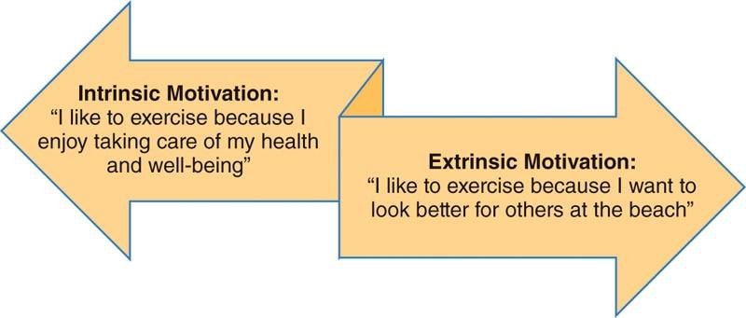

**Figure 3-1** Intrinsic versus extrinsic motivation

Extrinsic motivation

Extrinsic motivation focuses on doing an activity for some type of recognition, such as earning a trophy or award; it relies on looking forward to something if a specific behaviour is achieved. Rewards can be large or small but should match the achievement. For example, exercising 3 days a week for 1 month could be rewarded with a new pair of shoes, whereas completing a marathon that required months of training might be rewarded with a vacation.

Extrinsic motivation to exercise may come in the form of social recognition, rewards from competitions, or the improvement of physical appearance. Achieving rewards brings about a sense of satisfaction that may not come from the day-to-day exercise routine. The concern with an emphasis on extrinsic motivation is that it may not sustain exercise adherence because once a reward is achieved, there may not be any further incentive to continue, therefore long-term exercise participation will likely be associated with some level of intrinsic motivation.

Intrinsic motivation

Intrinsic motivation has received more attention because it relates to long-term exercise adherence; it is described as the motivation that comes from within a person. In contrast to extrinsic motivation, it is not about rewards but more about pursuing activities that are interesting or meaningful to that individual. Intrinsically motivated individuals enjoy the process and see value in the journey. People who are intrinsically motivated to exercise likely enjoy being physically active and appreciate all the physical and psychological benefits that exercise can bring. Intrinsic motivation may include exercising for stress relief, increasing energy, and finding new ways to be challenged physically.

This type of motivation has also been associated with people who strongly identify with exercise, where there is a satisfaction that comes from regular participation (Ntoumanis et al., 2018). Individuals who are intrinsically motivated to exercise will likely experience some enjoyment with regular participation, which may be due to a genetic predisposition toward intrinsic motivation (Caldwell Hooper et al., 2014). Also, for intrinsic motivation to occur, people need to have knowledge and some ability to make choices about how to proceed. It has been demonstrated that when people are engaged in the process of changing their behaviors, they are more successful in achieving outcomes.

For example, a physical activity intervention revealed that individuals who were specifically exposed to information on intrinsic motivation were more active and more intrinsically motivated after 12 months compared with a group who received standardized information (Silva et al., 2010). Additionally, when individuals were guided to identify the importance of exercise for them and their confidence in their abilities to exercise, they were enabled to choose tailored exercise plans to be physically active. Further, they remained more active over time compared to a group that was not provided the same level of interaction (Friederichs et al., 2015).

GETTING TECHNICAL

Intrinsic motivation is strongly rooted in the self-determination theory, which is a commonly used theory of behavioral change. It proposes that people will implement change when they feel (1) competent, which is mastering tasks or skills; (2) a sense of belonging to other people, which is referred to as relatedness; and (3) a sense of autonomy, which is feeling a sense of control over their actions and goals (Ryan & Deci, 2000).

There are situations when motives are both extrinsic and intrinsic. Some examples include times when individuals are extrinsically motivated to avoid failure but the desire to avoid failure is related to their overall self-esteem or when individuals want to lose weight because they know they will be healthier and feel more energized. Regardless of the reason(s) why someone is motivated to exercise, it is crucial to understand individual motives, and reassess motives over time, to provide a tailored program that continues to meet the needs of the client.

HELPFUL HINT

When trying to differentiate between the two types of motivation, just remember that intrinsic motivation is something that comes from within and is considered internal to a person. Extrinsic motivation is something that is external to the person.

### 

Understanding how motivation differs

Motivation to exercise will be unique to everyone; however, understanding how motivation may differ for certain demographics may be useful when establishing and growing a client base. While there are always exceptions, younger adults tend to be motivated by competitive situations, a feeling of being part of a social group, or the improvement of physical appearance. As people age, motives shift toward more health-related variables such as lowering blood pressure or avoiding other chronic health conditions (Kulavic et al., 2013).

Motivation also plays a role in the types of exercise that people seek out: extrinsically motivated people seek opportunities that emphasize physical transformation or competition, and intrinsically motivated people tend to seek opportunities focused on health and wellness (Brown et al., 2017). Therefore, learning what motivates individuals will go a long way toward providing them with the opportunities they prefer, which will ultimately lead to client satisfaction.

STRETCH YOUR KNOWLEDGE

Helping clients determine their motivation to exercise can go beyond simply asking them why they want to participate. Validated surveys are available that can be distributed to help clients objectively identify motives. One of these surveys is the Exercise Motivation Inventory-2 (Markland & Ingledew, 1997). This survey identifies 14 subscales of possible motives with higher scores on any given motive indicating its potential importance to an individual. The Exercise Motivation Inventory-2 survey can be found by performing a quick internet search. It is designed for exercisers and nonexercisers alike, making it ideal for new and existing clients. Another benefit of using an objective scale is that it will be easier to reassess motives over time, since motivation to exercise may change for some people. Tracking these changes will help fitness professionals adjust their personal programs.

## Common barriers to exercise

Despite the overwhelming evidence showing that regular exercise is associated with many physical and psychological benefits, barriers to participation are often cited by sedentary or infrequently active individuals. Barriers to exercise are common for nearly everyone at one time or another due to busy lifestyles that include family responsibilities, work obligations, and social commitments. In fact, barriers are often in direct competition with motivations to exercise. A barrier is anything that prevents someone’s ability to exercise, whether it is a one-time or regular occurrence.

Some barriers are physical, such as illness, injury, lack of transportation, or a lack of a safe place to exercise. Other barriers are based in perception, such as the belief of not having enough time or energy to exercise. People with perception barriers may feel like they are physical, and in some situations they can be (e.g., a single parent balancing a career and raising children), but many can be addressed with better time-management skills and setting a daily priority on health.

The role of the fitness professional is to help clients determine their personal barriers and help them strategize ways to overcome them. Clients also need to have a plan to deal with unexpected barriers that may occur, such as needing to stay late at work, forgetting to pack workout attire, or not having childcare. Barriers will be a constant battle for some, so helping clients determine their personal barriers and how to overcome them will help with overall exercise adherence.

Barriers will also change as people age and as responsibilities shift. For example, young adults may not have children or significant job responsibilities; as people age, demands on their time may shift after having children and taking on more responsibilities at work. Women, in particular, have indicated that parenthood is a major barrier to exercise; its significance grew along with an increasing number of children (El Ansari & Lovell, 2009). By contrast, older adults may be facing barriers such as health issues, availability of appealing facilities, and cost of participation (Gray et al., 2016). Fitness professionals should check in frequently with their clients to reassess barriers and strategize ways to overcome them.

**Time**

Time is often cited as a barrier against many healthy behaviors, including exercise, proper food intake, and overall stress management. Balancing work, family, social obligations, healthy eating, and regular exercise comes as a challenge for most people. Fitness professionals can help individuals manage their time by finding ways to prioritize exercise. It is often stated that everyone has the same 24 hours in a day and that exercise simply needs to be a higher priority. While this is technically true, it is helpful to assess exactly how time is spent and determine the amount of physical activity that can realistically occur when setting attainable goals and managing expectations for results.

Time is often a top barrier to exercise, which is evident among adults of all ages (Ashton et al., 2015; Kulavic et al., 2013). When someone is new to exercise, finding time to participate on a regular basis is one of the toughest challenges, especially when other activities may have to be limited. People have competing interests, and oftentimes, they find value in doing something other than exercise. For example, most people value their jobs because their job provides the income they need to sustain their lifestyle; therefore, time spent working is easily justified. Many individuals also have responsibilities to a significant other or children, or they provide care for other family members. Additionally, people value their social interactions and time spent simply relaxing.

One way to overcome the perceived barrier of a lack of time is to help clients address their approach to time management. Some ways to reclaim time for exercise can include rearranging schedules so that exercise becomes more of a priority. Committing to exercise as the first activity in the morning or immediately after work is one way for clients to put exercise ahead of competing activities. The fitness professional should help clients identify areas of life where there is no room for adjusting the schedule and then design a program that maximizes a client’s real ability to commit. When lack of time continues to be a barrier to physical activity, overall goals and the timeline to reach those goals need to be reassessed.

TRAINING TIP

Whenever clients are unsure about their specific barriers, ask them to keep a log of how their time is spent over the course of a week. This will help identify their average sleep patterns and time dedicated to working, childcare, household chores, meal preparation, exercise, and leisure activities, such as watching television, spending time on a computer, reading, or just relaxing. By seeing a snapshot of an average week, it becomes easier to identify areas of improvement for time management so that priorities like exercise are always on the schedule.

**Unrealistic goals**

Setting goals is an important aspect of working with clients so that expectations are both realistic and somewhat challenging. New exercisers often fall into the trap of setting unrealistic goals and then becoming frustrated when goals are not met. Unrealistic goals can be anything from expecting to see extreme weight loss results in a short amount of time to completing a marathon before even attempting a 5K race. Goals need to have some flexibility so that adjustments can be made based on progress. Additionally, they need to be progressive so that smaller achievements along the way can help guide the client toward long-term goals.

When goals are unrealistic, they can become a barrier by causing frustration and disappointment. Young males indicated unrealistic goals were a barrier to exercise due to perceived expectations of a young male’s physical ability. For example, if they attempt to exhibit a certain level of fitness and do not succeed, then goals are viewed as unrealistic, and they give up (Ashton et al., 2015). If an individual believes that they are not making sufficient progress, the exerciser may start to feel defeated and eventually discontinue the practice of exercise. The fitness professional has the expertise to assist clients with setting realistic outcome goals, such as appropriate body fat reduction or strength increases, but it is also important to set realistic and achievable process goals, like being physically active for a certain number of days per week or reaching a certain number of active minutes each day (Table 3-1).

| **Goal Type** | **Example** |
| --- | --- |
| Outcome goal | Place in top 10 in a 10K race |
| Process goal | Jog for 45 minutes, starting at 6:30 a.m. Monday–Friday |

Goals can become unrealistic when they are not objective, when too many goals are set at one time, when goals are not adjusted, and when people are forced to set goals (Weinberg & Gould, 2019a). These pitfalls can be avoided by setting specific goals and avoiding vague statements like “get more fit” or “be more active.” When people are new to goal setting, fitness professionals should limit them to one to two short-term goals in the beginning. Also, they should explain to clients that adjusting goals, both up and down, is part of the process, so that changes are not viewed as failures. Finally, they should not force clients to set goals if they are resistant. Helping clients set realistic goals will go a long way toward setting them up for success.

**Lack of social support**

Social support refers to the intentional actions taken by people to assist others in achieving a specific behavior. A lack of social support can make it difficult for some people to participate in regular exercise, depending on the types of support that they need. People who do not have support may not be able to overcome other barriers to exercise, or they simply cannot participate regularly. Individuals without social support may lack the following advantages:

* Encouragement to participate in exercise
* Someone who can discuss the challenges of exercise
* Transportation to a fitness facility
* The ability to find accurate information on health and fitness
* An exercise partner.

**Social physique anxiety**

Social physique anxiety is when individuals feel anxiety about their physical appearance or are insecure about how they look to others or how they believe others perceive their body (Hart et al., 1989; Portman et al., 2018). Fitness facilities are places where individuals who have never felt anxious about their appearance might suddenly feel physically inadequate. Reasons for this issue may be due to the social comparison they believe is taking place or the specific attire that many people wear during exercise, including tight-fitting clothes and/or clothing with minimal coverage.

Individuals with social physique anxiety may make comments similar to the following statements:

* I’ll start working out when I lose a little weight.
* I would work out, but I don’t have anything comfortable to wear.
* I feel self-conscious working out in front of people.
* I feel like everyone is staring at me.

Any comments that suggest a person’s discomfort with the way they may be viewed may indicate some level of social physique anxiety.

Social physique anxiety may prove a difficult barrier to overcome because it can also be related to body image issues. Some ways to overcome this barrier include matching clients to types of exercise that can be done outside of a fitness facility or using discreet areas of a facility to train clients. It should also be emphasized that clients should wear comfortable clothing and that activities that require specific attire, such as swimming or water aerobics, are optional.

It is known that, in general, women experience higher levels of social physique anxiety compared to men; however, men experience some level of it as well (Chu et al., 2008; Hagger & Stevenson, 2010; McLester et al., 2018). Social physique anxiety has also been found to be lower with individuals who have a lower body mass index (Ersöz et al., 2016; McLester et al., 2018). When social physique anxiety is a barrier to exercise, fitness professionals should make an effort to provide alternative ways to participate and use care when integrating individuals into more mainstream options (Figure 3-2).

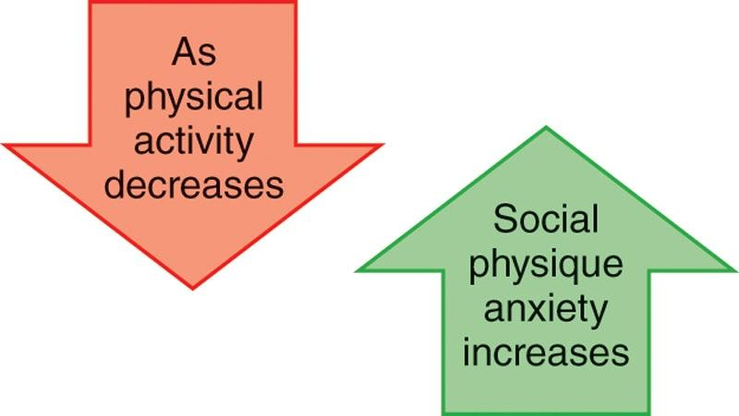

**Figure 3-2** Inverse relationship between social physique anxiety and physical activity

**Convenience**

Convenience in life is something that nearly everyone prefers, and convenience to exercise is no different. Most people will avoid an inconvenient activity, whether the inconvenience includes the time it will take, the distance to get there, the attire that is required, or the cost to participate. For example, if a fitness facility is located on the way to or from work, it may be viewed as convenient; however, other factors should be considered if people are exercising before work, such as locker rooms or proximity to home. Convenience will be subjective, meaning that two people may view the same factor in different ways. Driving 5 miles to a facility may not bother one person, whereas someone else may see it as highly inconvenient and, therefore, a barrier.

Many clients will travel for what they view as exceptional experiences such as a specialty group exercise class, clean facilities with current equipment, or the ability to work with a specific fitness professional. One way to help clients overcome this barrier is to provide excellent customer service, which includes individualized exercise programming. Another way to help clients maximize their physical activity is to help them identify ways for them to exercise at home, during a lunch hour, or in between other responsibilities. The bottom line is that there are always options available to make exercise possible for those who want to participate.

**Ambivalence**

Ambivalence happens when someone has mixed feelings about a situation. There is usually a positive and negative component to the way something is perceived. When it comes to exercise, people may believe that it is an overall good idea, but it will cut into time spent with family, at work, or at social gatherings. People who are ambivalent about exercise might easily find excuses as to why it just won’t fit into their lifestyle. Informing clients about all the benefits of exercise and the negative effects of sedentary living on the overall quality of life may be a good place to start. However, ambivalent people may be aware of the benefits but also struggle with the drastic way in which regular exercise may affect other aspects of their life. When people see both sides of an argument, they can often weigh the pros and cons along with assessing the benefits versus the effort it will take or what must be sacrificed to participate. For ambivalent clients, it will be necessary to probe further to find out the other significant barriers and also what might motivate them to take action.

TRY THIS

Take some time to identify barriers that prevent participation in exercise and strategize ways to personally overcome these barriers. This will allow you to relate to the struggles that clients face while providing solutions. Clients will appreciate that they are not the only ones facing barriers and will benefit from the personal connection.

**Social influences on exercise**

There are a number of possible social influences on overall exercise behavior, which vary among individuals. Determining which social influences are meaningful to a client will help explain the role that these influences might play in terms of exercise behavior. In general, influence means having an effect over the behavior of a person or group. Social influences are constantly present in exercise behavior, and these influences can lead individuals both toward and away from structured exercise. It is important to recognize that not all social influences are positive, and in such cases, they become a barrier to overcome. Social support has two main components: who or what is providing the support and what type of support is being provided. Support from family and friends may seem like the most likely source, but it can come from anyone, including coworkers, healthcare providers, fitness professionals, or fellow exercisers.

Social influences have also grown well beyond personal interactions, with people using social media for inspiration, information, and support. Social media can provide several outlets for people who may not have a supportive face-to-face network. For example, some people maintain blogs, websites, or a social media platform where they track their fitness journey; there are online support groups for any number of behavioral changes. Fitness professionals should ask clients which online sites they use to gain a better understanding of possible social influences. Fitness professionals should help evaluate the information, such as whether or not a source has reliable information and if healthy habits are being encouraged, so that clients are not receiving mixed messages. Additionally, information on social media platforms should be evaluated regarding its realistic or unrealistic nature. For example, images that depict extreme physiques, such as bodybuilders or fitness models, may negatively impact the way someone feels about their own body.

CRITICAL

Fitness professionals can help clients determine if a website is providing reliable information or not. First, look at who is responsible for the information. There should be an easily identified source with contact information such as colleges and universities, government agencies, and well-known organizations (e.g., the World Health Organization). Also, if a product or service is being advertised, such as a product for weight loss, caution should always be used. Helping clients sort through fact versus fiction will ensure their safety and ultimately their success.

When first meeting with clients, one priority should be to determine the types of social influence in their lives and whether or not these influences are supportive of the exercise behavior. For example, do they have an exercise partner, or do they have a strong emotional support system? Most often, past success or failure with exercise can be connected to the amount of social support for the behavior. Helping clients differentiate between someone’s support for their desire to exercise versus someone who is indifferent or unsupportive will help determine the influence level regarding the types of support received by certain individuals.

A client may also have conflicting influences, which cause them to be torn between time to exercise and other obligations. Regardless of the type of social influence that touches a person, changing behavior will likely be due to (and with the assistance of) some type of influence or support. When clients do not have adequate social support available, fitness professionals can play a key role in making the fitness facility an inviting place where clients feel they are supported. This can be done by introducing clients to the staff and members, finding group exercise classes that appeal to the client, or providing small group training sessions for people with common interests or goals. The important thing is to provide additional opportunities for people to connect and build a healthy community, especially for those who do not have strong support systems.

**Types of support**

Social support can come from a variety of sources, including family, friends, and fitness professionals, and the several types of support can include instrumental, emotional, informational, and companionship support (Table 3-2). Due to the individual nature of social support and the way it relates to exercise behavior, it is a topic that is still not fully understood by practitioners (Scarapicchia et al., 2017). The source and type of support considered as useful and meaningful will differ among individuals; it can change based on phase of life, proximity to family and friends, and the overall environment.

TABLE 3-2 Types of Social Support

| **Type of Support** | **Example** |
| --- | --- |
| Instrumental | Providing transportation to a fitness facility  Paying for someone’s gym membership  Watching children to allow a parent to exercise |
| Emotional | Encouraging someone to exercise  Providing positive feedback  Listening to someone when they are frustrated with exercise  Being empathetic by communicating an understanding of how someone feels |
| Informational | Giving sound advice about how to achieve optimal health and fitness  Providing education about the current recommendations for physical activity  Educating people about the risk of poor health accompanying a sedentary lifestyle |
| Companionship | Exercising with someone  Accompanying someone during an exercise session  Finding physically active options for social gatherings |

While the role of the fitness professional as a source of social support is not well documented, based on client expectations, some forms of social support (such as informational and companionship) should be assumed for the trainer–client relationship. The phase of life has a strong influence over the origin of social support. For example, children and adolescents are most influenced by parents and other family members, while the emphasis shifts to friends for young adults, and older adults rely on family members for support to exercise (Belanger & Patrick, 2018; Lindsay Smith et al., 2017; Mutz & Albrecht, 2017).

Instrumental support

Instrumental support describes the actual actions of a person that help another person engage in a behaviour. These actions directly facilitate the behaviour, such as removing a barrier. For some individuals, this type of support is crucial for exercise adherence because if help is not provided, a physical barrier may not be overcome. This includes transportation to the gym or health club, childcare responsibilities, and financial considerations.

HELPFUL HINT

When recalling the purpose of social support, keep in mind that there are always two components to consider: who and what. Who is providing the support? This can be a significant other, family member, friend, coworker, healthcare provider, or fitness professional. What type of support is given? This can be instrumental, emotional, informational, or companionship.

Driving someone to a fitness facility, babysitting, or paying for someone’s gym membership are all ways of providing instrumental support. Additionally, with lack of time often cited as a top barrier, anything that helps create more available time would also be instrumental. Examples of this would be doing things for someone such as grocery shopping, transporting children to events, or cooking. It can also be gestures like taking someone shopping to find proper workout attire or packing a gym bag for a significant other. Regardless of the type of instrumental support, it will likely have a positive impact for someone who is trying to exercise regularly.

Emotional support

Overall, emotional support is considered very important for people to start and continue with an exercise program. It refers to the encouragement and positive reinforcement that is provided and includes being caring and empathetic and showing concern. Some examples are telling individuals that they are doing great with exercising, asking how their workouts are going, or allowing them to vent when they are frustrated with their progress.

Empathy, an important component of emotional support, happens when someone identifies with the way another person feels. A simple way to describe being empathetic is the ability to put yourself in someone else’s shoes. Empathy helps people relate and connect and ultimately helps them feel that they are understood. Exercise can be a very rewarding experience that people thoroughly enjoy, but it can also be frustrating when results are not evident, or when exercise is uncomfortable; emotional support can be the one thing that keeps someone going.

Routinely communicating with clients, asking how they are doing and how they feel their program is going, is a way to foster relationships. Fitness professionals should also demonstrate empathy by indicating their understanding of how a client feels. Emotional support may be important to some clients daily while others only need it occasionally. Taking the time to get to know clients and learning about their preferences will ensure that individual needs are met.

STRETCH YOUR KNOWLEDGE

Empathy and sympathy are two different concepts. Sympathy typically involves pity and feeling sorry for someone else. Conversely, empathy is a deep understanding and recognition of how someone feels. Empathy does not involve judgment.

Informational support

Informational support is when someone receives accurate information about a behavior or topic. This is the most common type of support provided by a fitness professional. Finding information about exercise and fitness has become easier with countless online platforms, but the accuracy of information is sometimes questionable based on the source. A client might first receive informational support regarding exercise from a healthcare provider, family member, friend, coworker, or social media influencer. However, seeking out additional and more specific informational support may be one of the top reasons for a person to hire a Certified Personal Trainer.

Clients rely heavily on fitness professionals to have the most accurate and up-to-date information as well as the ability to answer questions. Informational support includes providing general fitness advice and programming, providing specific feedback on progress with program adjustments, providing new and interesting information about the benefits of exercise versus the drawbacks of inactivity, and being able to dispel and correct myths and inaccurate information. Therefore, it is imperative for fitness professionals to have a strong foundation regarding general exercise science, as well as the habit of continually seeking out correct information to pass along to clients.

Companionship support

Companionship support describes the way that someone engages in a behavior with another individual. This type of support is often observed in an exercise setting where people exercise with a friend or partner. Companionship support can have several positive influences on exercise behavior. As a form of accountability, it can encourage consistency, create a friendly competition, foster social relationships, and serve as a distraction to the discomforts caused by exercise.

Exercising with a partner also requires people to plan because schedules must be coordinated and time needs to be blocked off. This can help eliminate excuses that could have encouraged a person to skip a workout. Companionship support is a key component of face-to-face personal training, with the fitness professional present for the entire exercise session.

When a client hires a Certified Personal Trainer, there is an expectation that companionship support is built into the experience. Fitness professionals need to stay focused on the client, push the client to work at an appropriate intensity, and keep the client on task. Finally, companionship support might simply make exercise more fun to do, regardless the partner.

TRAINING TIP

When training clients, it is very important to avoid distractions and keep the focus on the person who is paying for your service. During a session, avoid getting into in-depth conversations with other health club members or coworkers, do not look at your phone during a session, and do not let small distractions shift your attention away from your client. By keeping your focus on your client, you will provide significant companionship support and also provide excellent customer service.

**Group influences on exercise**

Group influences play a key role in many decision-making processes. As previously described, support can be given to a person in countless ways, but equally important is the person who provides that support. For example, young adults may be more influenced by their peers, while those in a mid-life stage might prefer support from a spouse or family member. Also, the source of information can be important; for instance, advice on overall health and well-being might be well received from a healthcare provider, but that same advice could be resisted when coming from a family member. Groups that may have a regular influence on physical activity are significant others, family members, peers, and exercise leaders. Regardless of the origin and the form of the support, a client needs to be open to taking that support for it to become effective.

Family

Family is one of the most important influences for most behaviors in life, especially for children and adolescents, but family influences are likely to remain strong throughout life. In research, the term *family* often refers to any family member, whether or not that person lives in the household, and individuals who live in a household but are not related. As stated previously, depending on the individual’s phase of life, the family influence can be quite different; younger people tend to be more influenced by parents, while mid-life and older adults are more influenced by a significant other. Social support for physical activity from family is particularly important for older adults as demonstrated by studies where family members were available to walk with and encourage exercise. (Böhm et al., 2016; Lindsay Smith et al., 2017).

Family support differs from other sources of support because family members are typically more permanent. If someone does not care for an exercise leader or group, they can simply discontinue, but the same is not true regarding family, whose behavioral influences could be positive or negative. Living with family members who are inactive and do not value exercise can be a source of constant barriers. Fitness professionals should get a sense of whether or not family members are supportive of exercise and if they can provide any support. It should be acknowledged when family members are not supportive so that other sources of support can be identified.

Parental

The influence of parents on exercise behavior is particularly important for children and adolescents. If parents have a positive relationship with exercise, then their children will be more likely to have a positive outlook on regular exercise, which can carry on into adulthood. Parents typically provide emotional and instrumental support, with the main type of instrumental support coming from providing transportation and paying for activities. For adolescents, this type of support, even more than emotional support from family and peers, can explain long-term exercise adherence (Siceloff et al., 2014).

Research has also shown that parental support for physical activity is important for adolescents, including the transition to adulthood, indicating that parental influence goes beyond children and adolescents (Gill et al., 2018; Li et al., 2016). Parental influence over physical activity is apparent at a very young age; evidence shows that there is a positive relationship between the physical activity of mothers and their preschool children, meaning if mothers were active, then so were their children (Hesketh et al., 2014). Parents can also provide informational support to children by talking about the importance of regular exercise and all the benefits it brings. It is also beneficial for children to try a variety of physical activities (e.g., sports and recreational activities) so that they can naturally find which activities they do well or simply enjoy the most. Having an early and consistent exposure to exercise and physical activities will help create habits that are long-lasting.

Exercise leaders

Group exercise comes in many forms, including formatted classes taught to music and small group personal training, such as boot camps or sport-specific training. It can be found in large fitness facilities and small boutique studios, and some businesses are structured around only offering group exercise experiences. While not everyone will consider a group setting appealing, it does remain a popular way for many people to regularly engage in exercise. The exercise leader plays a crucial role with the overall tone and flow of the experience. Generally speaking, this is the person who should greet all members, make everyone feel welcome, ensure that participants have the right equipment and attire to safely engage, and use a variety of techniques to motivate and energize a group.

The exercise leader can also go a step further and learn participant’s names, introduce new members to the existing group, and try to connect with members before and after class to provide encouragement and get feedback. The idea of providing leadership in an exercise setting may not be a common expectation when professionals enter the fitness industry, but leadership plays a key role in determining whether a participant adheres to exercise or drops out. It is often noted that there is not a single best approach to leadership, but there are recognized components for effective leadership: the leader’s qualities, leadership styles, situational factors, and follower’s qualities (Weinberg & Gould, 2019b). Table 3-3 displays examples of these leadership components.

TABLE 3-3 Components of Leadership

| **Leadership Component** | **Examples** |
| --- | --- |
| Leader’s qualities | The leader should offer a great example in how to lead a healthy and balanced life, which includes being optimistic, empathetic, and knowledgeable. |
| Leadership styles | The different styles of leadership include a participant-centred approach that encourages feedback and input or an autocratic approach where participants are told what to do in a task-oriented environment. Leaders should be able to adjust their style based on the situation. |
| Situational factors | These factors include group size, whether it is a large or small group, and potential adjustments for style; for example, larger groups may need a more autocratic style. |
| Follower’s qualities | Leaders should consider the qualities of the followers, including age, gender, and exercise experience. |

An exercise leader has a unique opportunity to make a positive impact on large or small groups of people and to help foster a cohesive group environment. Aside from bringing a group together, the exercise leader should also be able to reach individual participants with simple gestures like making eye contact, smiling, and giving positive verbal feedback. With the goal of making everyone feel included, it is also necessary to demonstrate exercise modifications so that people with varying skills can all be challenged within a single session. The exercise leader is an important person for clients to emulate because that person demonstrates the exercises, helps set goals, and shows that exercise can be done consistently (Morton et al., 2019). Exercise leaders should be aware that because members pay close attention to what they are doing and how they approach exercise, it is important to be a positive role model and send appropriate verbal and nonverbal messages.

TRY THIS

Certified Personal Trainers may be expected to provide recommendations for clients regarding which group exercise classes are the best to attend. Consequently, Certified Personal Trainers should be knowledgeable about different class formats and the instructors who teach them. All fitness professionals should consider taking a variety of classes to learn more about various exercise formats and instruction styles. This will help match clients to classes and instructors that best suit their needs and personalities.

The exercise group

The idea of an exercise group has become common in the fitness industry along with the growing popularity of exercise sessions coached by certified professionals. The exercise group consists of the participants who are present for a given class or session. With many people drawn to certain types of exercise and who follow consistent schedules, it is common to see the same faces for group exercise sessions. Oftentimes, a good exercise leader will develop a following, and an exercise group will form. One aspect of an exercise group is feeling distinct from others; fitness professionals can encourage this simply by having participants wear the same color shirt or having the group come together at the end of a session for a group cheer or any other ritual that is specific to that group.

While the overall influence held by a group over exercise behavior is still not fully understood, there is a general consensus that being a part of a group has a positive effect (Evans et al., 2019b). People simply exercising together may not necessarily identify as a group, because groups have distinct characteristics and the members often have formal or informal roles. A formal role would be held by the exercise leader or coach from whom instruction and organization are expected.

Informal roles may include those who tend to inspire the group, provide mentorship to new members, or plan social gatherings. It has been noted that for intact exercise groups that strongly identify as a distinct group, those members also perceive a social connection with each other and group cohesion. However, the process by which individuals in an exercise environment actually become a group is not well understood (Evans et al., 2019a). People are drawn to group exercise for many different reasons and often for more than one reason. Table 3-4 displays some possible reasons why people are drawn to group exercise and possible benefits.

TABLE 3-4 Benefits of Group Exercise

| **Reason** | **Benefit** |
| --- | --- |
| Accountability | Being part of an exercise group brings accountability for regular attendance, both from members of the group and the exercise leader. |
| Comparison | Participants have people they can compare themselves against; the ability to see what others can do and achieve can serve as further motivation. |
| Competition | Group environments can bring about friendly competition among participants or within individuals to reach their personal best. |
| Comradery | Individuals can form connections with people who are attempting to achieve similar results, while experiencing feelings of friendship, closeness, and loyalty. |
| Consistency | Having a schedule that allows participants to anticipate the experience will help form habits. |
| Energy | Most group exercise classes are designed to be high energy, making it an attractive environment to which people are drawn. |
| Intensity | Participants are encouraged to try the best they can, and they may work harder in the presence of the group. |
| Mindless | Since the exercise session is planned, participants just need to show up and follow instructions without thinking about designing their own workouts. |
| Motivation | Exercising with a group can by itself be a form of motivation to regularly participate. |
| Sociability | When a group or situation is warm and inviting, it brings people together; when people feel welcome, they are likely to return. |

TRAINING TIP

Joining an intact exercise group may be intimidating for some clients. Fitness professionals can help identify groups that share similar characteristics or goals and encourage clients to participate. If clients are unsure of their ability to fit into a group, one way to help them adjust is to attend an exercise session with them, which may help reduce insecurities about trying something new.

The community

The community plays a unique role in exercise behavior based on the opportunities available for people to be physically active. There is evidence that the physical surroundings, also known as the built environment, has a strong influence over activity levels in a community.

The number of sidewalks and walking and biking paths available can impact people’s activity levels. It is important to note that communities vary quite a bit in terms of resources, safety, transportation, and social norms. Active communities will likely have more green space, walking trails, playgrounds, sidewalks, and biking trails, as well as an emphasis on safe public transportation and neighborhoods. Being aware of the opportunities or challenges of participating in exercise outside of a fitness facility will help clients make decisions about how to best maximize an active lifestyle.

## Psychological benefits of exercise

The positive benefits of exercise go far beyond a physical transformation. The psychological benefits of exercise are well established and can be experienced over both the short and long term. Some of the known psychological benefits to exercise include improved mood, increased self-esteem, increased positive body image, better sleep, and decreased levels of depression and anxiety. Conversely, sedentary behaviour has been linked to an increase in depression. This relationship can be partially explained by sedentary people experiencing limitations with their movement, problems with sleep and low energy, some levels of pain and discomfort with movement, and higher levels of anxiety (Stubbs et al., 2018).

What may not be as clear is whether sedentary behaviour leads to increased depression, or whether depression leads a person toward sedentary behaviour, which leads to poor health status. There is also growing evidence that physical activity of moderate intensity may be the most effective approach. In one study, aerobic exercise of moderate intensity improved self-perceptions of strength and muscular development and improved feelings of autonomy and well-being (Delextrat et al., 2016). Many of the psychological benefits from exercise are experienced together; for example, depression may improve along with better sleep and improved social interactions. In general, there is an association between being physically active and having a greater sense of well-being. For example, inactive people rated their health and satisfaction with life lower than those who exercised (Pelletier et al., 2017). Regardless of the reason why someone decides to exercise, psychological benefits will inevitably occur and may help reinforce the behaviour.

**Promotes positive mood**

The term *mood* refers to how someone feels; it is considered a more long-term state of mind, unlike emotion, which is a short-term reaction to a situation (Brehm, 2014). People will often define their mood as “good” or “bad” based on the way they generally feel. Many factors affecting mood can include being fatigued, experiencing success or failure, and hearing good or bad news. Many people express mood with their nonverbal communication: body language, tone of voice, and eye contact. Mood can also help foster relationships and social interactions, because people will often be drawn toward others who regularly demonstrate a good mood or positive energy. Researchers are often interested in the way that a single bout of exercise affects mood in the short-term and how long-term participation influences overall mood. Exercise has demonstrated a generally favorable effect on various mood profiles with durations anywhere from 10 to 60 minutes, making even short bouts of exercise effective in improving mood (Crush et al., 2018; Fritz & O’Connor, 2016).

**Improves self-esteem and body image**

Self-esteem and body image are psychological variables associated with a number of health concerns, including depression, eating disorders, and exercise addiction. The serious implications of these conditions make these variables important to monitor, especially in populations that may be at a higher risk of developing habits that could lead to poor mental and physical health. Self-esteem and body image have long been connected to each other due to the reciprocal nature of the two, meaning that people with low self-esteem may also have body image issues and having body image issues can lead people to having low self-esteem (Figure 3-3).

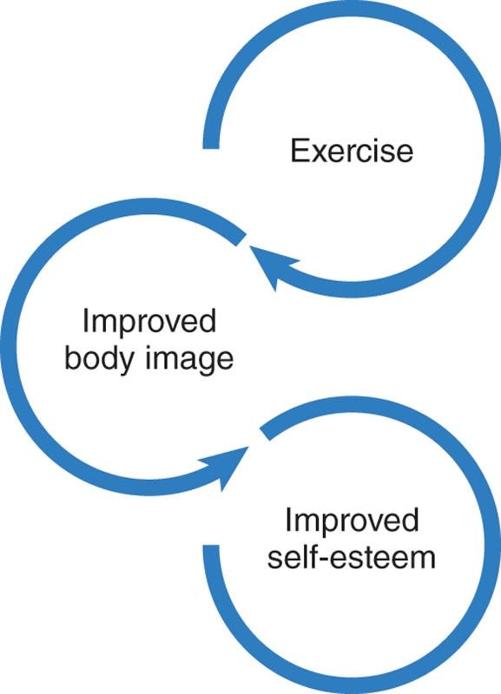

**Figure 3-3** The relationship between exercise, self-esteem, and body image

Self-esteem refers to the way someone evaluates their own self-worth; it has different domains such as physical, emotional, and social. Physical self-esteem has subdomains that include people’s self-perception of their own fitness levels, the attractiveness level of their physiques, their physical strength, and their competence level at sports (Hausenblas & Rhodes, 2017). Body image, generally defined as the way people view their physical selves, can be based on the way people visualize their bodies or how they feel in their own skins. Body image may not match reality; people may view their bodies in a negative way and evaluate themselves inaccurately (Hausenblas & Rhodes, 2017). These variables and the way they relate to fitness will vary among populations because body ideals are different for men and women and between cultures.

For example, muscular strength has historically been important for men and their self-esteem, but not as much for women (Ciccolo et al., 2016). While body image has been studied extensively, there is still some confusion within the general population, where body image is viewed only as a “women’s problem” of negativity (Bailey et al., 2017). In light of this, another study found that both aerobic and resistance training improved overall body image in women with preexisting body image concerns, which demonstrates that appropriate exercise can improve these variables (Martin Ginis et al., 2014). But regardless of biological sex, weight loss and weight management are related to both self-esteem and body image. For example, in a long-term study, both self-esteem and body image were positively influenced when previously obese adolescents lost weight in their young adult years (Watts et al., 2016).

HELPFUL HINT

Body image and self-esteem are related. In many cases, they have a mutual relationship, meaning that as body image improves, self-esteem will also likely improve. This is also true in the other direction; for example, if self-esteem decreases, body image will likely become more negative and vice versa.

**Improves sleep**

Sleep is an important part of everyone’s day in terms of how a person will function. As our most restorative tool, it is necessary for nearly every physical, physiological, and psychological function. Sleep, or lack thereof, plays a significant role in physical and mental health, overall quality of life, and even one’s safety (National Heart, Lung, and Blood Institute, 2019). Sleep has many restorative functions and is vital for proper growth, development, healing, and learning. Sleep-deficient individuals are at a greater risk of heart disease, stroke, high blood pressure, and obesity (National Heart, Lung, and Blood Institute, 2019). When someone is sleep-deprived, they are also at risk for making poor decisions and not thinking properly, which can cause problems with work or relationships.

Exercise has been shown to improve sleep. Moderate amounts of exercise, in terms of frequency, duration, and intensity, are associated with significantly lower disturbances in sleep compared to sedentary behavior. This suggests that exercise needs to reach a certain threshold to be beneficial, but excessive physical activity may not improve sleep quality (Litleskare et al., 2018). People diagnosed with chronic sleep disturbances may benefit from all types of regular exercise. In fact, increasing physical activity to at least 150 minutes per week at a moderate intensity can decrease symptoms of insomnia (Hartescu et al., 2015).

Resistance training has also been shown to improve sleep for people with chronic insomnia (D’Aurea et al., 2019). Exercise is also believed to be beneficial for people with more serious sleep disturbances. In patients being treated with exercise for sleep apnea, symptoms were shown to improve with increased physical activity (Aiello et al., 2016). Overall, the relationship between regular exercise and improving sleep is positive.

**Reduces depression and anxiety**

According to the World Health Organization, depression is a common mental health issue that afflicts approximately 300 million people worldwide (World Health Organization, 2018). Anxiety can be experienced with depression but can also occur by itself. Research on the effects of exercise on depression and anxiety has been conducted for decades and continues to be an area of interest among health professionals, including physicians, psychologists, and exercise scientists.

Much of the interest in this area surrounds exercise as a treatment option for depression. One of the challenges is that people with depression tend to participate in low levels of physical activity, and they are less likely than their nondepressed counterparts to meet current physical activity guidelines (Schuch et al., 2018). The evidence also shows that exercise may be effective in offering a preventive effect against the development of depression across all ages regardless of geographic area (Schuch et al., 2018).

The intensity of exercise may be important when addressing depression. One study showed that both moderate-intensity exercise and high-intensity exercise decreased depression; however, the high-intensity exercise also increased perceived stress, suggesting that moderate-intensity exercise may be best (Paolucci et al., 2018). For some individuals, even a simple approach to physical activity can lead to psychological improvements. For example, a monitored walking program performed three times per week resulted in reduced anxiety in a group of previously inactive overweight and obese individuals (Vancini et al., 2017). While depression and anxiety are common, a person’s mental health should always be taken seriously. The inclusion of exercise as a way to reduce or prevent symptoms has promise, but a treatment plan must always originate from a qualified healthcare provider.

CRITICAL

While exercise is known to reduce feelings of depression and anxiety, a fitness professional should never attempt to diagnose any mental illness or prescribe exercise to clients as a form of treatment. Only a licensed medical provider can diagnose illnesses and prescribe treatments. Therefore, if any mental illness is suspected, clients should be referred to their primary care physician for further evaluation.

## Introduction to behavioural coaching

Due to widespread failure to engage in, maintain, or achieve adequate amounts of physical activity, effective coaching techniques are needed to promote physical activity and structured exercise. How can successful Certified Personal Trainers work with clients to educate them on the advantages of exercise behavior and long-term adherence? To map out a successful intervention for the client, some of the essential elements include identifying the determinants of exercise behavior, understanding theory and techniques to drive behavior change, identifying client needs in the initial session, and determining the most effective style of delivery (which includes effective communication skills). This chapter explores some of the essential elements needed to help identify client needs, motivate them, and help them with self-regulatory issues to assist in exercise adoption and adherence.

**Client expectations of a Certified Personal Trainer**

Certified Personal Trainers can have a significant influence on their clients’ health. Therefore, the fitness professional has a responsibility to design programs, give effective advice, and create environments that help their clients adhere to a fitness routine.

Making a good first impression is crucial for a client to see the fitness professional as both an ally and an authority in the gym. Certified Personal Trainers should have a positive attitude and strong communication and listening skills. They should help clients feel confident and competent while preserving their autonomy to do exercises that they enjoy, while avoiding ones they do not. A good first impression typically includes:

1. Making eye contact (if culturally accepted)
2. Introducing oneself by name and asking the client’s name
3. Smiling
4. Shaking hands with the client (if culturally accepted)
5. Remembering the client’s name and using it
6. Using positive body language

If the client has completed an online application where they supplied personal interests, such as medical history or hobbies, fitness professionals should ask about them. Clients appreciate when fitness professionals show they have invested time prior to the session to get to know them. Aside from having a positive attitude and effective communication skills, fitness professionals should work hard to exhibit the following qualities to create an inclusive environment that keeps clients coming back:

1. Look professional: neat, clean, and appropriately dressed.
2. Take time to build a trusting relationship with new clients.
3. Ensure that the client feels heard and understood.
4. Ensure the client’s safety when exercising.
5. Build community by making a client’s exercise routine a collaborative effort.

**Client expectations of the environment**

The training environment includes the actual facility as well as the people inside the facility. The training environment can either hinder or foster intrinsic motivation. Staff members who are friendly, caring, and supportive of clients’ goals can have a positive impact on whether a client continues to return. Therefore, the environment that Certified Personal Trainers work in reflects who they are and will ultimately determine the type of clients they attract. For this reason, the most successful health clubs work hard to create a third space environment for their members.

A third space is considered a special, communal space that is separate from home or work. It is a place where individuals can build relationships with others while still expressing their own sense of identity. Third spaces should elicit a playful mood, helping clients to feel like they are in a home away from home. Certified Personal Trainers should strive to do their part in making the gym or fitness studio feel like a third space for clients. Before a client joins a gym, they will likely consider the following:

* Are there a variety of training options to choose from?
* Is the training environment supportive?
* Does it look like they will fit in with the club’s culture?
* What is the cost of a membership and personal training?
* How convenient is the location?
* Are the facilities clean and neat?

**Introduction to behaviour change techniques**

To improve coaching interventions that change behaviour, Certified Personal Trainers need to identify appropriate behaviour change techniques (BCTs). BCTs are the active elements for intervention strategies that affect the determinants of behaviour (Kok et al., 2014, 2016). For example, self-efficacy is a well-established determinant of exercise behaviour; therefore, to promote changes that increase exercise adherence, a behaviour change technique that influences self-efficacy should be used. Table 4-1 outlines some of the most effective behaviour change techniques commonly used by fitness professionals with their clients.

TABLE 4-1 Behaviour Change Techniques

| **Desired Outcome** | **Behaviour Change Technique** | **Definition** |
| --- | --- | --- |
| Improved self-efficacy | Set specific tasks | Break down exercises or goals into easier-to-achieve tasks. Build the stepping stones for progressively more challenging exercises or behaviours. |
| Provide instructions | Provide instructions on how to perform the behaviour. This can be in person, in writing, or in video. |
| Practice for mastery | Encourage frequent practice of challenging tasks with adequate feedback to enhance learning. |
| Communicate positively | Use positive encouragement to help clients believe they have the ability to change for the better. |
| Positive outcome expectations and attitudes | Supply information | Present foundational science on the health benefits of exercise and the consequences of sedentary behaviour. |
| Prompt anticipated regret | Help clients imagine how their life would be different by changing a behaviour compared with the consequences of not changing it. |
| Apply motivational interviewing | Use guiding questions that prompt clients to engage in critical thinking that helps resolve ambivalence about change. |
| Manage social influence | Encourage social support | Ask clients how they plan to gain social support from friends and family. |
| Foster discipline | Help clients build skills for resisting social pressure. |
| Promote self-regulation | Make a plan | Provide detailed planning on when and where clients will engage in exercise. |
| Identify coping responses | List potential barriers and make plans to overcome each one. |
| Set SMART goals | Set both short-term and long-term goals that are specific, measurable, attainable, realistic, and timely. |
| Promote self-monitoring | Encourage clients to keep records of the specific behaviour they want to change to help enhance adherence to the program. |

HELPFUL HINT

Behaviour change techniques, by nature, are generic. Self-efficacy, for example, may be enhanced with several different behaviour change techniques, which can be delivered through several different channels. Fitness professionals cannot always deliver behaviour change techniques in person. The use of technology, such as text message reminders, email lists, and social media interactions, can help considerably with adherence to a routine while a client is outside of the gym.

## Determinants of participation in exercise

Successfully changing fitness behaviours begins with a clear understanding of the contributing factors that influence whether people participate. Coaching works by changing one or more of these factors, which are called determinants of behaviour. Essentially, determinants of behaviour represent the generic modifiable variables that cause a behaviour (Kok et al., 2016). Participating in exercise has several determinants, including motivation, self-efficacy, self-regulation, exercise history, body weight, stress, social support, access, time constraints, and characteristics of the exercise behaviour (Sherwood & Jeffery, 2000). Once fitness professionals understand what contributes to participation in exercise, they need to understand the foundational theories to match BCTs to their client’s needs.

**Determinants of participation in physical activity and exercise**

Self-efficacy (i.e., self-confidence) is one of the strongest determinants of physical activity in adults (Choi et al., 2017). An individual’s stage of change and intention have also been identified as determinants of behaviour (Sherwood & Jeffery, 2000). Job strain and working hours were shown to have an inverse relationship with leisure-time physical activity (Sherwood & Jeffery, 2000). People are also more likely to engage in regular exercise when they have support from people in their home and work environments (Sherwood & Jeffery, 2000). Self-determination theory variables, including autonomous motivation and perceived competence, have also been found to be related to exercise behaviour (Teixeira et al., 2012).

Furthermore, planning—a self-regulatory strategy—has positive influences on physical activity (Belanger-Gravel et al., 2013; Karoly et al., 2005; Rovniak et al., 2002). Regular exercisers report higher levels of self-monitoring as well (Karoly et al., 2005; Rovniak et al., 2002). Additionally, one of the most recent reviews identified 40 psychological factors and 13 social factors as being related to physical activity (Choi et al., 2017). Cognitive and emotional factors, attitudes, intention, outcome expectations, stress, perceived behavioural control, and selfefficacy have all been identified as associated with physical activity as well (Choi et al., 2017).

**Determinants of participation in resistance training**

Resistance training is a unique form of exercise that is likely more challenging to start than aerobic exercise or recreational physical activity. It requires numerous participatory resources, including knowledge of how to design programs and the skills to execute complex movements.

Therefore, while many determinants are shared with exercise and physical activity, it is useful to address resistance training on its own.

There is evidence to support the relationships between resistance training participation and affective judgment, self-efficacy and perceived behavioural control, self-regulatory behaviours, and intention (Bryan & Rocheleau, 2002; Gao & Kosma, 2008). In other words, people tend to engage in resistance training when they think it feels good, believe they can do the exercises correctly and overcome barriers, can self-monitor and makes plans, and have high levels of motivation. Intention is a direct predictor of behaviour, but planning has also been shown to help translate intentions and self-efficacy to behaviour (Lubans et al., 2012; Paech & Lippke, 2017). Subjective norms also have a small, positive relationship with resistance training (Rhodes et al., 2017).

## The Stages of Change Model

The Stages of Change model (also known as the Transtheoretical Model of Behaviour Change) views change as a process that involves progression through a series of stages (Prochaska & Velicer, 1997). These stages are precontemplation, contemplation, preparation, action, and maintenance (Figure 4-1). The model was originally conceived as a means to help people quit smoking, but it can be applied to virtually any situation where a person is trying to break bad habits and form new positive ones. In regard to personal fitness, the stages of change reference a person’s readiness to begin and adhere to an exercise program:

1. Precontemplation stage: the individual does not exercise and is not planning to start exercising within the next 6 months
2. Contemplation stage: the individual does not currently exercise but is planning to start within 6 months
3. Preparation stage: the individual is planning to begin exercising soon and has taken steps toward it and may even be sporadically exercising
4. Action stage: the individual has been exercising for less than 6 months
5. Maintenance stage: the individual has been exercising consistently for 6 months or more (Glanz et al., 2008; Spencer et al., 2006)

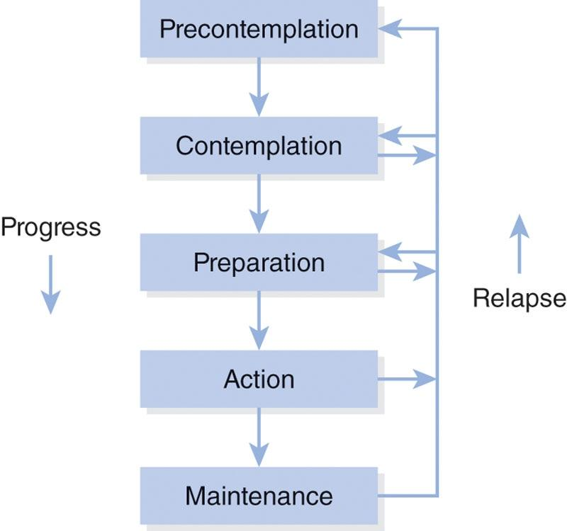

**Figure 4-1** Stages of Change model

GETTING TECHNICAL

A sixth stage of the original Transtheoretical Model, called termination (Prochaska & Velicer, 1997), also exists but has little to no application to exercise adherence. For smoking cessation, the termination phase represents the point at which an individual no longer has any desire to smoke ever again with no risk of relapse. When it comes to exercise, busy lifestyles make it virtually impossible to stick to a dedicated exercise plan forever. For that reason, even the most dedicated athletes will shift between preparation, action, and maintenance.

The Stages of Change model also includes processes of change, self-efficacy, and decisional balance. People move through the stages of change by using behavioural and cognitive processes of change strategies. For example, fitness-promoting behaviours are influenced by self-monitoring strategies, along with enhanced confidence and perceived benefits of resistance training (Cardinal & Kosma, 2004; Harada et al., 2008). Decisional balance refers to the process of weighing the positive and negative outcomes of engaging in or increasing exercise behaviour. As benefits increase and negatives decrease, people move toward the maintenance end of the stages of change continuum (Spencer et al. 2006).

Processes of change provide strategies on how to apply BCTs. In early stages, clients may apply cognitive processes to progress through stages. In later stages, they rely more on behavioural processes for progressing toward maintenance. For example, an individual in the contemplation phase may benefit more from information about the health benefits for exercise (a cognitive process) than they would from adding cues or prompts to engage in exercise (a behavioural process). Certified Personal Trainers need to work differently with clients who are in different stages of change. They will need to tailor their use of BCTs and recommendations to the clients’ readiness to make positive changes in their lives.

**Precontemplation**

Individuals may be in the precontemplation stage because they are not informed about the consequences of inactivity or they do not know about the health benefits of exercise. Alternatively, they may have tried before, failed to feel confident or maintain consistency, and have become demoralized by their inability to stick with an exercise routine in the past. These people may be categorized as being ambivalent to exercise. Cognitive strategies may be the best option for those in the precontemplation stage.

Additionally, gaining knowledge and education may be exactly what some individuals need to increase their perceived value of exercise. Certified Personal Trainers should work to understand any perceived negatives surrounding exercise and help clients dispel any myths. For example, some clients may think resistance training requires hours spent in the gym each day, so the fitness professional can teach them that only 30 to 60 minutes of focused resistance programming 2 to 4 days per week to gain significant health benefits are needed.

That said, Certified Personal Trainers will not usually work with people in the precontemplation stage as it pertains to beginning exercise from a sedentary state. The simple act of walking into the gym means a person is at least already thinking about making healthy life changes. However, a client could still be in precontemplation as it pertains to a progression in their program. For example, a potential client could be in the maintenance stage for the goal of exercising two times per week, but they could be in the precontemplation stage for a progression to exercising three times per week to better meet goals.

Similarly, a client could be in precontemplation for starting resistance training but already be in the action stage for aerobic exercise and recreational physical activity.

**Contemplation**

Because individuals in the contemplation stage are considering becoming more active, fitness professionals can have a great deal of influence on what they choose to do. Certified Personal Trainers need to be able to listen to the needs and desires of those in the contemplation stage and help them connect those goals with exercise-based solutions. People in contemplation begin to see more value in exercise participation, but misconceptions may still be present. In fact, an equal balance between benefits and negatives (i.e., being of two minds about something) may produce ambivalence. These individuals may not be ready to act immediately, so Certified Personal Trainers need to support them in any way that they can.

Similar to precontemplation, education is one of the best strategies to use with people in contemplation, because they sometimes just need more information to boost their perceived value of an exercise program. For these individuals, it is important to discuss ways to deal with their perceived negatives surrounding exercise. Individuals in this stage of change are also low in self-efficacy; they may want to do it but are not sure they can, so they hesitate to start. Small achievable goals help people in contemplation build self-efficacy and gain momentum.

**Preparation**

People in the preparation stage are working on their plan to change. They may have already joined a gym, or they may already exercise sporadically but are planning to start a formal weekly exercise plan within the next month. This is a stage where fitness professionals will most likely meet the most individuals. They know they want to start exercising, and they are making the right moves to join a club and potentially even attend a personal training consultation. Individuals in this stage may already partake in multiple forms of physical activity, just without any form of structure or consistency.

Fitness professionals can help clients plan when, where, and how to fit exercise into their schedule. The preparation stage is all about establishing a plan that clients feel confident they can follow. Building intrinsic motivation for exercise is also important for developing consistency in this group. For that reason, motivational interviewing, which is discussed later in this chapter, can be a highly beneficial BCT to use with all new potential clients, helping to uncover their underlying desires and turn a plan into action.

**Action**

Action is the stage in which clients have been consistently exercising for up to 6 months. In this stage, it is important to not allow short-term slip-ups to turn into a departure from the exercise program. Fitness professionals should continue to discuss barriers to exercise and help clients anticipate any potential roadblocks that could arise. To help with this, specific plans should be put in place in advance if a client misses a scheduled session with suggestions for maintaining progress, such as supplying preplanned “emergency” workouts that they can do from home.

TRAINING TIP

If a client happens to cancel a session, the fitness professional should do at least one of the following two things:

1. Ask the client when they would like to reschedule the session.
2. Prompt the client to make a plan for continuing to exercise in the interim, if the rescheduled session is not soon (within 24–48 hours).

**Maintenance**

Maintenance is the stage in which clients are consistently working to maintain their active lifestyle, sticking to their exercise plans for 6 months or more. These individuals do not use cognitive change processes as frequently as they would have in the action phase, and they are less tempted to relapse. At this stage, their self-efficacy levels are generally high. Individuals in the maintenance stage may use certain behavioral strategies, such as inviting other people to exercise with them or making plans to make up missed sessions, to avoid relapsing back to earlier stages.

TRY THIS

Use this worksheet to identify your client’s stage of change. Each time the client answers no, move to the next question. If they answer yes, stop there; the question you stopped at identifies the stage of change the client is currently in.

|  | **Questions** | **Client Answers No** | **Client Answers Yes** |
| --- | --- | --- | --- |
| 1 | Have you been routinely exercising for more than 6 months? | ↓ Go to next question | Maintenance stage |
| 2 | Have you been routinely exercising for less than 6 months? | ↓ Go to next question | Action stage |
| 3 | Are you making set plans to begin an exercise program within the next 6 months? | ↓ Go to next question | Preparation stage |
| 4 | Do you think you need to increase the amount you exercise? | ↓↓↓↓↓↓ | Contemplation stage |
|  |  | Precontemplation stage* |  |

*Note: If someone answers no to all questions, they would be in the precontemplation stage; however, remember that situation is extremely rare. If a person is having a conversation about fitness with a fitness professional, they are already at least in the contemplation stage.

## Importance of effective communication skills

Before considering specific techniques to improve adherence, the Certified Personal Trainer should understand that the BCTs that help improve exercise adherence are equally as important as the style of delivery used and the relationship the fitness professional has built with each client. In other words, it’s not only *what* fitness professionals say, but *how* they say it.

Effective communication skills are crucial to further understand client needs and build a trusting relationship. Good communicators should strive to do the following:

* Create a safe environment where challenging and emotional issues can be discussed.
* Clear away distractions such as cell phones and focus on the client.
* Ask questions to understand the meaning of what the person is saying.
* Observe nonverbal cues such as body language.
* Provide empathy and validation (Zenger & Folkman, 2016).

Certified Personal Trainers should strive to achieve each of these communication strategies, because their use can minimize disagreements that may make the relationship with a client uncomfortable. By maximizing support and minimizing disagreements, fitness professionals will build rapport with the client, which can help contribute to adherence to an exercise program.

**Nonverbal and verbal communication**

Nonverbal communication is the exchange of information through bodily cues other than words and can have a profound impact on social interactions. It represents the many ways in which humans communicate information without directly speaking. Nonverbal communication often occurs at the same time as verbal communication and can include posture, hand gestures, proximity to others, and facial expressions (Crane & Crane, 2010).

Facial expressions and posture are key nonverbal communicators in all interactions with others. Fitness professionals should be sure to smile and avoid frowning, as well as always stand up straight and avoid crossing arms. A slouched posture demonstrates a lack of confidence and professionalism, while crossed arms send a closed-off signal. Gaze direction also demonstrates the level of interest that someone has in what the other is saying. Certified Personal Trainers should make it a point to make eye contact when their clients are speaking and nod their heads to show that they are listening and understand what their clients are saying.

Additionally, when listening to clients, fitness professionals may want to lean in a bit closer. This demonstrates that they are intently paying attention to everything the client is saying and can bring about greater feelings of being cared for. However, proximity to a client needs to be judged on a case-by-case basis, because everyone has a different level of comfort regarding how close they like to be to others. This means that fitness professionals not only need to maintain their own positive nonverbal communication but also need to be able to read their client’s nonverbal cues and adjust accordingly.

Verbal communication is information that is conveyed by speaking. In a professional setting, it is extremely important for verbal messages to be clear so that they are received and interpreted correctly. The listener needs to clarify what they have heard from the speaker and, in turn, the speaker needs to confirm that the listener heard correctly. Sometimes people use their wording imperfectly to express what they are trying to communicate (Figure 4-2). Therefore, the Certified Personal Trainer should be sure they understand what a client means before shifting to a new topic.

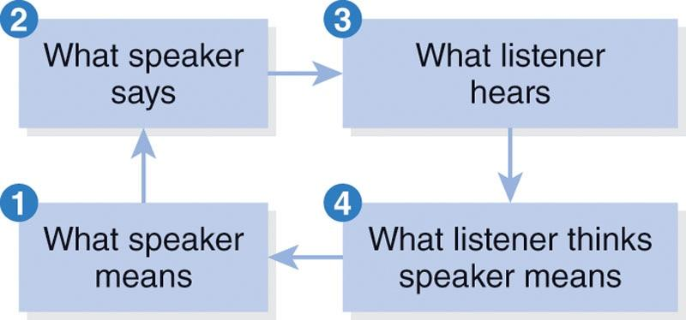

**Figure 4-2** Reflective listening

This can be accomplished with a technique known as reflective listening. Reflective listening involves making a best guess as to what the speaker means and stating it back to the speaker for confirmation.

Oftentimes, due to so many differences in language and dialects around the world, what a listener thinks a speaker means is up to interpretation. Reflective listening can eliminate that confusion, so the whole story is understood by all parties involved. When listening reflectively, fitness professionals make their best guess as to the meaning behind what the client is saying and restate that guess back to the client using similar words to make certain they understand what was said (Miller & Rollnick, 2013).

**Active listening and rapport building**

Most people think that good listening involves not talking when other people are talking, making appropriate facial gestures, and repeating back what people have said (Zenger & Folkman, 2016). Active listening, on the other hand, is about having an attitude of genuine interest in seeking a client’s perspective and understanding it on a deeper level. Active listening requires an individual to pay attention, suspend any internal dialogue, avoid distractions, look the speaker in the eye, and provide feedback at appropriate times.

Contrary to popular opinion, listening does not mean just sitting in silence. Interrupting a client is a bad idea; however, good listeners use certain techniques to take part in the conversation when appropriate to keep it moving in a positive direction. Active listening is one of the best ways to demonstrate care and help build a healthy rapport with someone. To be a good active listener, fitness professionals should incorporate the following techniques into their conversations with clients:

* Asking questions
* Reflecting
* Summarizing
* Affirming
* Asking permission.

Asking questions

There are two primary types of questions that can be used in conversation: closed-ended and open-ended. Closed-ended questions (directive) can be answered with one word; typically, just a yes or a no. Although closed-ended questions can be important—such as, What’s your name?—open-ended (nondirective) questions allow clients to give more information. Open-ended questions require clients to think critically and to form a more complex answer. Open-ended questions are important for building collaborative relationships with a client because they invite discussion and can be used to explore the client’s own perceptions and concerns. Example open-ended questions that elicit optimism for change may include the following:

* How might you go about making this change?
* What challenges do you see and how can you plan to overcome them?
* What work are you prepared to do to reach your goal?
* What have you tried in the past to reach your fitness goal? (Miller & Rollnick, 2013)

Certified Personal Trainers should use a blend of both open- and closed-ended questions to best uncover information about their clients. For example, a fitness professional can ask a client a closed-ended question of how important beginning an exercise routine is on a scale of 1 to 10. If the client says a 5, the fitness professional can ask a follow-up open-ended question to dig deeper and find out why the client gave that response.

Closed-ended questions let the fitness professional drive the conversation to get specific answers to specific questions, whereas open-ended questions let the client feel engaged in the conversation rather than being interrogated. That feeling of inclusion is one of the first steps toward building rapport, comfort, and trust.

TRY THIS

Accentuate the Positive

When first working to uncover a client’s needs, ask how important making change is on a scale of 1 to 10 (1 = lowest, 10 = highest). If the client believes change is very important (a 9 or 10), that’s great! This type of response is indicative of someone who will probably be fully committed to the fitness plan and be a relatively easy client to work with for the long term. If the client lists a low number (a 6 or below), they may need some coaching and enhanced motivation to really buy in.

To keep things moving in a positive direction, instead of asking why clients don’t feel more committed to change, try asking them why they didn’t rate their commitment even lower (a 3 or 4). This will prime them to defend and argue for their own change based on things they already see as positive in their lives.

Asking clients, Why didn’t you rate it higher? drives them to think about the things they are not doing, which can be internalized as negative and lead to feelings of self-doubt. However, asking, Why didn’t you rate it lower? makes them think about all the positive things that support their current commitment rating.

Reflecting

Reflections are conversational techniques that express the supposed meaning of what was just heard and form the basis of the previously discussed reflective listening technique. Reflections are both subtle and powerful and represent an opportunity to make sure what each person says is accurately understood; it gives clients an opportunity to ensure they said what they thought or felt. Reflections are powerful because they help clearly demonstrate that active listening is occurring.

Clients feel heard and understood when the Certified Personal Trainer takes the time to reflect and reword or paraphrase what was just said. Reflective listening is advantageous because it can emphasize why a client feels ambivalent about change, what their strengths are, and why change is important to the client (Clifford & Curtis, 2016). Creating an accurate reflection statement involves intently listening to what the client is saying and attempting to understand what they mean.

Reflections do not necessarily have to be clarifying questions either. Simple statements can go a long way to show that someone is actively listening. A properly placed “uh huh” with a head nod displays agreement, while saying “oh no” with sympathetic eyes can express concern and caring. In fact, reflection statements are one of the best ways to demonstrate empathy with a client.

Summarising

Summaries are a series of reflections. If fitness professionals have successfully reflected with their clients, then summaries should be simple. Summaries draw all the important points of the conversation together and allow clients to clarify either what they have said or how the fitness professional has interpreted what they have said. Summaries demonstrate greater depth of listening throughout an entire conversation. There are three types of summaries: collecting summaries, linking summaries, and transitional summaries (Miller & Rollnick, 2013).

Collecting summaries are short sentences that continue a client’s thoughts to keep a conversation moving along. They are used in the same way as more simple reflections during a conversation to make sure the listener is staying on track.

Linking summaries are a bit more robust and serve to tie together information presented over an entire conversation, or even multiple conversations over time. These help keep longer-term discussions, especially as they relate to changing habits, in line with the greater vision of the fitness program. And transitional summaries, as the name suggests, are summarizing statements used to wrap up one topic before moving to the next. These would be used, for example, when a client finishes discussing health concerns before moving on to talking about a potential fitness plan.

Using affirmations

Affirmations show appreciation for clients and their strengths. Fitness professionals must listen carefully to know what to affirm. Affirmations are positive statements about the client’s character strengths (Clifford & Curtis, 2016) and are different than compliments. Compliments use “I” statements (“I think you are working really hard at this”) and put attention onto the fitness professional, not the client. Affirmations (“You paid very close attention to technique today”), on the other hand, acknowledge the client’s strengths and efforts and can be used to enhance a client’s self-efficacy for change. An affirmation communicates an appreciation of clients for who they are. Some benefits of affirmation include enhancing self-efficacy, encouraging persistence, decreasing defensiveness, supporting momentum for change, and improving client’s feelings of support (Clifford & Curtis, 2016).

Asking permission

Being the expert, Certified Personal Trainers typically have more knowledge on relevant and helpful information than the client has. However, it is important to recognize that people respond best when they have the autonomy to make their own choices instead of being told what to do. While there are situations such as boot camps and certain clients who prefer a “drill instructor” style of coaching, many personal training clients—especially those new to exercise— may be intimidated and uncomfortable by this approach. This is especially true if they are new to exercise or have never used a certain piece of equipment. Asking first puts the decision in the clients’ hands and will help them to be more open to new experiences. For example, asking questions like, Do you want to try a fun new technique? or What cardio equipment would you like to use for your warm-up? can go a long way toward empowering a client’s self-efficacy.

Additionally, people do not like to be “talked at” if no desire to learn something new has been communicated. Clients are paying fitness professionals to share information with them. However, it is still highly important to ask permission to share any information the client did not ask for first. Asking for permission to share information allows clients to retain their autonomy while making it easier for them to hear what the Certified Personal Trainer has to say. The simple act of asking first honors respect, choice, collaboration, and the life experiences the client is already bringing to the encounter (Miller & Rollnick, 2013).

## Motivational interviewing

Effective communication needs to be implemented, and great Certified Personal Trainers have a certain way of engaging with people that helps make the change process smooth. They help clients understand and voice their own reasons for change. Even though motivational interviewing and the Transtheoretical Model were developed separately, the stages of change make explicit reference to concepts such as ambivalence, which is the defining feature of the contemplation phase. Motivational interviewing provides directions for how to get clients out of the contemplation phase, over their ambivalence, and ready to act.

**Introduction to motivational interviewing**

Motivational interviewing is a method of client-centric coaching that helps enhance the desire to change by resolving a client’s feelings of ambivalence (Miller & Rollnick, 2013). It is an empathetic, collaborative, nonconfrontational, goal-oriented style of communication that helps clients discover their own personal reasons for making a change in their life. Motivational interviewing recognizes that everyone has different levels of readiness for changing a behavior, so it is important to gain an understanding of why individuals would want to change and also the things that might cause them to feel ambivalent about that change. Everyone has times where they can get stuck in a state of ambivalence over something, so the ultimate goal of motivational interviewing is to help clients solidify their mind state and increase personal motivation for change (Miller & Rollnick, 2013).

Ambivalence occurs when the positives and negatives surrounding a potential change are equal with each other, creating a situation where the individual is unsure of which side of a decision is best. In a situation of ambivalence, the demands between two behaviors are essentially competing with each other. For example, a client may be excited by the prospect of making workouts part of the normal routine, but after putting in long hours at the office, the desire to visit with family and rest on the couch may be just as appealing. Ambivalence is a completely normal part of the change process and represents one of the key areas in which a Certified Personal Trainer can help a client. If a client is struggling with ambivalence, it typically means they are in the contemplation stage.

**Applying motivational interviewing**

Motivational interviewing uses targeted questions to help clients visualize their ideal state of being to develop a higher sense of intrinsic motivation to make a change in their life. During the process, statements and questions are specifically chosen to either help a client maintain a current positive behaviour or craft the thought process around changing a negative one. The proper application of motivational interviewing helps avoid arguments and, instead, works to instil feelings of being ready, willing, and able to change in the mind of the client.

Self-discrepancy

A self-discrepancy is an internal conflict between what someone thinks their ideal self should be and what the actual self is (Figure 4-3). The way that discrepancies drive behaviour can be thought of as part of a feedback loop. People take in information about their current self, and if a discrepancy is perceived between where they currently are and the ideal version of where they think they should be, they perform behaviours to reduce the discrepancy between the two states. For example, if a client’s idealized best self is a person who exercises four times per week, but, in reality, they only exercise sporadically, that realization of a discrepancy may be just the information needed to trigger an increased desire to change.

Without a perceived discrepancy, there is no motivation (Miller & Rollnick, 2013). If individuals believe they are living in what they already consider to be ideal, then the best option is to stay the same.

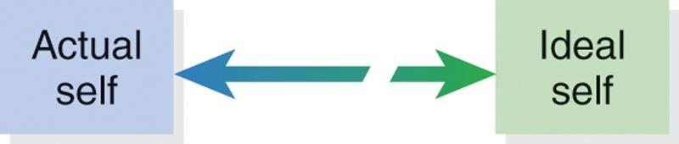

**Figure 4-3** Self-discrepancy

For this reason, questions properly framed within motivational interviewing methodology will help clients realize that their ideal self is better than their current state, boosting their motivation to make changes for the better.

Change talk and sustain talk

Another technique for using motivational interviewing with clients is to understand the difference between sustain talk and change talk in a client’s dialogue. Sustain talk encompasses statements made by clients that support current behaviours, such as physical inactivity (Clifford & Curtis, 2016). Sustain talk can be identified when a client voices advantages of the current status quo, disadvantages of changing, intention not to change, and pessimism about change. For example, a client who says something like, “My busy lifestyle makes it too hard to schedule time to work out,” is using sustain talk.

The opposite of sustain talk is change talk. Change talk signifies movement toward change and can be identified when a client voices dissatisfaction with the status quo, advantages of change, intention to change, and optimism for change (Miller & Rollnick, 2013). For example, a client who admits, “I’m afraid I may not be able to play with my kids if I don’t get into better shape,” is using change talk, whether they realize it or not.

Avoiding arguments

Fitness professionals are far less likely to induce change if they are arguing with their clients. This will push their clients to become defensive and justify current behaviour. If clients are using sustain talk in their conversations about fitness, they are expressing a resistance to change, but that resistance does not necessarily mean they are unable or unwilling to change. The clients may simply be experiencing ambivalence that makes them hesitant to commit to certain changes.

To help combat resistance while avoiding arguments, fitness professionals should present a variety of exercise options and solutions for driving change that the client can choose from until ones that are manageable and appealing are identified. Carefully wording questions is important to avoid arguments against change. Statements or questions that provoke resistance may force the client to argue for the current status quo and move away from change talk. Table 4-2 outlines some examples of questions that may provoke resistance and provides some more appropriate alternatives.

TABLE 4-2 Questions That Promote Change

| **Questions That Provoke Resistance** | **Questions That Promote Change** |
| --- | --- |
| Why don’t you want to change?  What makes you think that you’re not at risk?  Why don’t you just do this?  Why can’t you make this change to your schedule? | What might you want to change?  What do you think might happen if you didn’t make any changes?  Do you think this could work for you?  If you decided to make this change, what would be different in your life? |

Importance, confidence, and readiness

The next concept in motivational interviewing is to identify how motivated a client may be to move into the next stage. Fitness professionals can get a relative idea of their clients’ commitment level toward making a change by asking them to rate how ready they are to make it, how confident they are in thinking they can achieve it, and how important the change is to them, all on a simple scale of 1 through 10 (Figure 4-4). The answers that fitness professionals receive can help them decide what to do next with the prospective client.

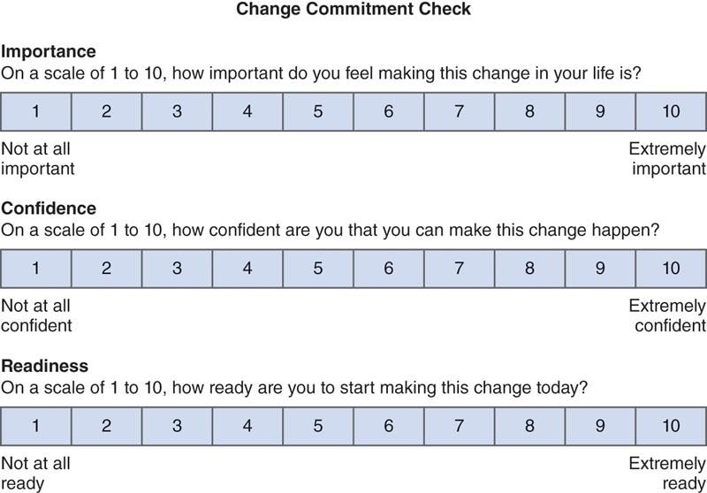

**Figure 4-4** Importance, confidence, and readiness ruler

The 10-point grading scale can be viewed similarly to the common grading scheme seen in schools. For example, a 10 being an A+, a 7 being C, and a 5 or below being a fail. With that in mind, any response of a 6 or below (a D or worse) means the client does not have a strong enough commitment surrounding that change metric. This helps to quickly identify clients who will need a bit more coaching to help them move closer to the action and maintenance stages of change. If a client rates importance, confidence, or readiness at a 7 or above, then they are in a good place to start making changes and sticking to them.

## Strategies to enhance exercise adherence

The health benefits of exercise depend on long-term commitment (Kompf & LaVaute, 2017). Purchasing a gym membership—and particularly personal training sessions—represents a strong intention to exercise. Therefore, it is safe to say that anyone who has taken the step to hire a Certified Personal Trainer has an intention to exercise (i.e., the individual is at least in the contemplation stage of change). However, good intentions do not necessarily mean that the client will stick to an exercise plan.

In fact, a substantial number of individuals who intend to exercise do not follow through (Godin & Conner, 2008). The anticipated number of visits to a gym are predictive of actual visits to the gym; however, people tend to overestimate how often they believe they will exercise. For example, one study found that gym members who predicted they would exercise more than 3 times per week ended up only exercising 1.39 times per week (Garon et al., 2015). Additionally, people with self-control–related barriers were much more likely to overestimate how often they would exercise (Garon et al., 2015). Therefore, any BCT that can help clients act on their intentions to exercise could be beneficial.

Behaviour change techniques and their application may sound technical and confusing but don’t overthink it! You are probably already using some of these techniques without knowing that you are. For example, when you enhance clients’ confidence by convincing them that they can lift a certain weight, you are already using a behaviour change technique to modify self-efficacy. When you write a program for clients and instruct them to plan where they will do it, you are using a behaviour change technique to help them improve their self-regulation.

**Behavioural strategies**

There are several different techniques that a fitness professional may use to help clients adhere to exercise. Self-regulation provides the basis for goal-directed action. Self-regulatory BCTs have previously been identified as important for helping individuals adopt exercise regimens (Rhodes et al., 2017) and are associated with positive outcomes (Belanger-Gravel et al., 2013; Samdal et al., 2017).

Fitness professionals should also focus on making the exercise experience enjoyable while enhancing the client’s self-efficacy. Self-efficacy beliefs partially determine self-regulation efforts, how much effort they give, and how long they persist when challenges arise. The appraisal of perceived abilities relative to the challenge of the task will determine whether exercise behaviour will be attainable and pursued (Bandura, 1991). Therefore, goal setting, self-efficacy, planning, and self-monitoring should be targeted.

Goal setting

Fitness professionals need to understand how to help clients set goals. Goals represent the what that sits at the crossroads of *how* and *why*, where *why* represents a client’s values and *how* represents the way the goal will be achieved. It is important for fitness professionals and clients to understand and verbalize why a goal is important. These *whys* are top-level goals.

Clients may have unrealistic goals, so it is important to help manage client expectations in an appropriate way. Many goals, as it relates to exercise, are achievable if time is considered. Unrealistic goals in short time periods lead to overly challenging exercise programs, which are difficult to adhere to for a variety of reasons. To help clients develop sound goals that they can accomplish, it is recommended for fitness professionals to incorporate SMART goal setting techniques.

Smart goals

Though SMART goals do not encompass all of the goal-setting principles, they can be very effective. The acronym SMART stands for specific, measurable, attainable, realistic, and timely (Figure 4-5).

Fitness professionals should encourage clients to match their behaviours to their goals. Goals can be broken down into subgoals that should be well-defined and trackable. For example, more global goals (i.e., complete 30 push-ups in a row) can be broken down into smaller behavioural goals that will add up to the accomplishment of the greater goal (i.e., do three sets of 10 push-ups each morning). Tracking whether three sets of 10 push-ups were completed is an easily measurable task. And to evaluate progress, fitness professionals should encourage clients to write down their goals and refer back to them frequently.



**Figure 4-5** SMART goals

A well-defined goal aims and directs action to an end state and/or standard of proficiency within a specified time limit. Goals work through four functions that include the following:

* Directing attention and effort toward relevant activities and away from counterproductive activities
* Energizing action and effort
* Influencing persistence of effort
* Leading people to seek out goal-relevant information (Locke & Latham, 2002).

As it relates to exercise, goal setting is a process that involves assessing one’s current level of fitness, creating a broad goal toward a future level of fitness, and then detailing the actions that need to be taken to achieve that goal. Initial goal-setting sessions with new clients should be focused on developing long-term goals first based on their personal values. To set overarching long-term goals, fitness professionals may ask clients some of the following questions:

* What do you want to accomplish in the next 6 months?
* What do you want to accomplish in the next year?
* What does success in fitness look like to you?

From the long-term goals that clients have expressed, the fitness professional should help the client create achievable short-term goals that provide a focused path, motivation, and confidence when each short-term goal is accomplished. Short-term goals help focus clients’ attention on the now and help them narrow down goals to the ones that are the most important and doable. This is where the concept of making a goal SMART plays a key role. The SMART goal should adhere to the following criteria:

* Specific
  + The intended goal outcome must be clearly defined. For example, “I want to lose weight” is a vague goal with no objective way to know when it will be accomplished. A specific goal says, “I want to lose 5 pounds (2.2 kg),” which precisely details that the goal will be achieved when 5 pounds are lost.
* Measurable
  + Goal progress must be objectively measured and tracked over time with hard data, not based on subjective reports. For example, regularly scheduled weigh-ins can track a weight loss goal by recording the date and the client’s scale weight each time. This data is then used to objectively track progress toward the specific outcome that is desired.
* Attainable
  + A goal must be challenging yet achievable by the client. If a goal is too easy, the client may not put in sufficient effort. Similarly, if the goal is too challenging, the client may become discouraged and stop following the fitness plan.
* Realistic
  + Realistic goals are relevant to the client’s life. Even though something may be technically possible, it may not be possible for a particular client when viewed in the context of their lifestyle. For example, it may be unrealistic for a busy business owner, who works 10 or more hours per day, to lose 100 pounds (45 kg) in 6 months. It is up to the fitness professional to make sure that client expectations are managed accordingly.
* Timely
  + To properly measure and track goals, they need to have specific timeframes with frequent check ins. The timeframe to complete a goal should be as challenging and realistic as the intended outcome. It should be short enough to build urgency, but long enough to allow for one or two slip-ups along the way.

If a goal fails to meet any of the SMART criteria, it will likely fail to meet the needs of the client, potentially leading to a lapse in exercise adherence and even the loss of a client. An example of a goal that is not SMART could be, “I want to lose some weight so that I look better on the beach this summer.” This goal has no specific outcome defined, no way to track progress or know how it will be accomplished, and a vague completion window, and depending on the beginning state of the client’s fitness, it may or may not be attainable and realistic within their lifestyle. To better serve that client, the goal could be reframed to, “I want to lose 5 pounds (2.2 kg) of body fat in 6 months, by running for 1 hour per day, 4 days per week in my free time after the workday is over.”

TRY THIS

Writing SMART goals is not an easy process and takes practice. Try setting SMART goals for yourself. To help with this process be sure all components of a SMART goal are accounted for. Examples of SMART goals include the following:

I will gain 5 pounds (2.27 kg) of muscle within 5 months, starting today, by weight lifting a minimum of 4 days per week for 1 hour each session.

I will reduce my blood pressure by five points within 6 months by walking a minimum of 30 minutes each day and reducing my daily salt intake to no more than 2,300 milligrams per day.

I will lose 10 pounds (4.53 kg) of body fat within 3 months by reducing my daily calories from 3,000 to 2,000 per day and exercising at a moderate intensity at a minimum of 150 minutes per week.

Each example above specifically details the intended outcome with objectively measurable and trackable criteria that are bound to a realistic timeframe in which the goal can be reasonably attained.

Outcome versus process goals

Outcome goals refer to goal consequences. They represent the final achievement that hard work will inevitably lead to, such as winning a race or seeing a desired weight on the scale. Process goals refer to the daily and weekly tasks that need to be done to reach that final outcome. Once an outcome goal has been set, process goals should be created that speak to how they are going to achieve that outcome.

For example, if an individual has an outcome goal of winning a 10K race competition within 1 year, a process goal to serve that final outcome could be to jog for 1 hour 3 days per week and attend two personal training sessions per week. Additionally, similar process goals would then be created to set progress milestones. The most effective goal setting will always use process goals to lead the way toward completing an outcome goal.

In the beginning stages of exercise adoption, outcome goals may seem challenging and out of reach. Process goals help clients focus on the now, rather than dwelling on a specific outcome that may take months or years to achieve. For example, a new, formerly sedentary client may have an outcome goal of completing a half marathon; however, focusing on that when they currently have trouble running 2 miles will quickly become discouraging. Concentrating on the process not only helps narrow the field of view to something much more comfortable (i.e., realistic and attainable) but also builds in the ability to achieve *small wins* much more frequently. Each small win will help a client objectively witness their progress, boosting the client’s motivation to stick to the program. Process goals increase ability, competence, and confidence and can help clients progress to a point where they can better implement their newfound abilities to reach an outcome.

For example, to help make the outcome of completing a half marathon in 6 months seem far less daunting, an initial process goal of consistently running for 20 minutes, 3 days per week, for 2 weeks could be put in place. Now, the simple act of completing six 20-minute runs gives the client a win, and the goal can be progressed to something a bit more challenging, such as running for 30 minutes, 3 days per week. At that rate, by simply adding 10 minutes of additional running to the process every 2 weeks, the client should be able to run for 2 full hours (the average half marathon completion time) after around 18 weeks of training.

HELPFUL HINT

Outcome goals focus on an end result and vary depending on the individual’s skillset and motivation. Some examples of outcome goals can be winning a state championship in softball, losing 20 pounds (9 kg) in 4 months, or earning a spot on a competitive sports team.

Process goals include daily or weekly strategies that help individuals reach their outcome goals. For example, if a client has an outcome goal of earning a spot on a competitive basketball team, an appropriate process goal could be to schedule 1 hour of practice each day after school to work on ball handling and shooting skills.

TRAINING TIP

Although following goal-setting principles is important for fitness professionals, individual differences always need to be considered because clients are different based on their unique personalities and motivations.

To help individualize goals for clients, ask open-ended questions to more clearly understand their intrinsic motivation and barriers to new lifestyle habits. Some examples include the following:

* What are your biggest concerns about your health and exercise habits?
* What work are you prepared to do to reach your goal?
* How motivated are you to reach your goal?
* What have you tried in the past to reach your goal?
* Did it succeed? Why or why not?
* What has prevented you from reaching your goal in the past?
* Have you already started making changes to your exercise or dietary habits?

Enhancing self-efficacy

Several techniques have been shown to enhance self-efficacy for physical activity, including action planning, reinforcing effort or progress toward exercise, providing instructions, self-monitoring, and social support (Olander et al., 2013; Williams & French, 2011).

Action planning and self-monitoring will be covered in subsequent sections. Giving praise to clients for their attempts at achieving goals may result in higher self-efficacy and greater levels of physical activity. This kind of positive feedback enhances confidence by focusing on small successes in the process (Williams & French, 2011).

If a client improves on any metric of fitness, it is important to give positive feedback and praise. This is particularly important in the beginning stages of behaviour change when the client has not yet achieved mastery of certain exercises or skills. Praise can help to enhance a client’s confidence in their abilities. Eliciting social support may also enhance a client’s sense of control over exercise. Feeling supported by others may help an individual cope with any setbacks or obstacles as well (Olander et al., 2013).

Planning

Planning can help translate intentions to behaviour. Engaging in exercise requires clients to plan what they are going to do and where they are going to do it. Making a personal training appointment along with a financial commitment to show up is a clear example of making plans to achieve a goal. However, clients should also be encouraged to exercise on their own; therefore, discussing planning techniques with clients is a good strategy to help foster these behaviours.

Two planning behaviour change techniques that are often used are called implementation intentions and coping plans. Implementation intentions are specific plans that drive behaviour by identifying cues toward action. By forming an implementation intention, a client connects the exercise routine with a specific event, such as during a lunch break or after work. Implementation intentions have shown to be effective at promoting exercise and physical activity.

While implementation intentions refer to when, where, and how to exercise, coping plans involve anticipating barriers and creating alternative plans (Sniehotta et al., 2005). Both action plans and coping plans have been found to have positive effects on physical activity (Belanger-Gravel et al., 2013). Yet, planning as a behaviour change technique is not effective for everyone. For example, planning does not translate good intentions into behaviour for people who have low self-efficacy (Koring et al. 2012; Lippke et al., 2009; Zhou et al., 2016). Therefore, discussion around planning might not be ideal for individuals in the contemplation stage of change. Furthermore, identifying barriers and reasons why a client cannot exercise may reduce self-efficacy by drawing attention to potential failures (Williams & French, 2011). A better approach may be to review barriers that have already arisen and collaborate on plans to work around them if they happen again, and subsequently waiting to brainstorm additional, potential barriers until higher levels of self-efficacy have been determined.

TRAINING TIP

One way for new fitness clients to develop an effective implementation intention is to encourage them to link their plan to a specific behavior that already exists during the timeframe in which they want to exercise. For example, say a client wants to start jogging in the morning and always starts the day with a few cups of coffee before going to work. You might suggest scheduling time to run after the first cup of coffee. The client’s implementation intention for this would be, “Once I am done with my first cup of coffee, I will go for a quick 20-minute jog.” Have your client repeat the specific intention three times before the end of each session as a mantra that can help them stick to the plan.

Self-monitoring

Self-monitoring provides information needed for setting realistic goals and assessing progress toward those goals. Self-monitoring allows individuals to identify external triggers that lead them to behave in certain ways (Bandura, 1991). Clients cannot influence their intentions and behaviour if they do not pay attention to their performance, the conditions that contribute to behaviour, and the effects of their behaviour. Self-monitoring provides clients the information they need to evaluate their progress toward goals. If clients can monitor their thought patterns and behaviours along with the conditions under which the behaviours may or may not occur, they may notice precursors of behaviour (Bandura, 1991). For example, clients may notice they are less likely to exercise if they plan to go after work, if they forget to pack clothes, or if they do not get a good night’s sleep. Fitness professionals can encourage clients to modify things in their lives and take notes of specific changes in behaviour.

If clients pay close attention to exercise performance, they will be more likely to notice improvements and set progressive goals. Self-monitoring is usually done in the form of a daily written record of the behavior that a client is trying to change. For example, clients who are new to exercise should keep an exercise log to both track their progress and maintain accountability to the program. Similarly, individuals on a weight loss journey will greatly benefit from keeping a food intake journal (i.e., a diet record; Figure 4-6) so they can objectively monitor their daily calories.

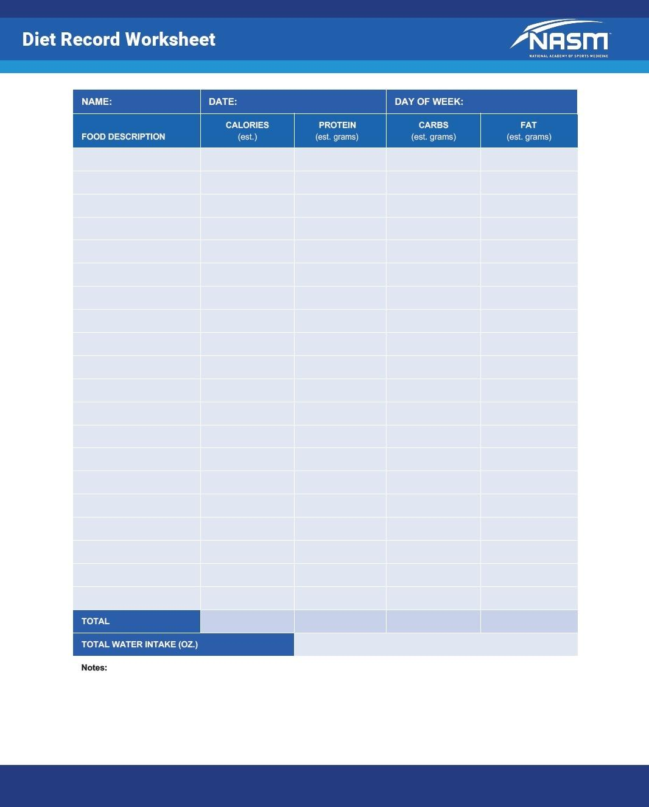

**Figure 4-6** Diet record worksheet

It is important for clients to find effective, individual methods of self-monitoring, such as journaling, making notes on a calendar, or using a fitness tracker app on their mobile device. Beyond recording the traditional sets, repetitions, weights, and exercise durations, it is also suggested that clients include when they exercised, the events that occurred before they exercised, how they felt before and after they exercised, and which exercises they enjoyed. Self-monitoring logs provide the client with several benefits, including the following:

1. Opportunity to observe progress over time, which can enhance confidence
2. Accountability if the client knows that the fitness professional is going to ask to see the log
3. Awareness of precursors to behavior, which can serve to identify barriers or facilitators of exercise

Fitness professionals can also provide some time management techniques for clients. Time management is another BCT that has had positive effects on physical activity by teaching people how to better manage their time (Williams & French, 2011). Some common time management strategies include the following:

1. Assigning priorities to daily tasks and completing the more important ones first
2. Not accepting every request for one’s time; keeping hours open for unexpected events and personal needs
3. Turning key tasks into repetitive habits
4. Scheduling buffer time between important tasks
5. Implementing systems of organization
6. Eliminating nonessential tasks
7. Limiting time spent on empty activities like scrolling through social media feeds

**Cognitive strategies**

Cognitive strategies are used to change a client’s thoughts and attitudes toward exercise and physical activity. They are intended to alter the way someone thinks about an activity to increase motivation, adherence, and sometimes even performance. These strategies include positive selftalk, psyching up, and the use of mental imagery.

Positive self-talk

For someone new to exercise, there may be a lot of negativity and negative thoughts toward exercise. Some of those thoughts include, I can’t do this, It’s too hard, It takes too much time, or It’s too painful. Certified Personal Trainers can do two specific things to help clients overcome their negativity. The first is to help them develop positive self-talk. Positive self-talk is a form of encouraging and motivating internal dialogue that increases self-efficacy.

The second is to help them move past their negative self-talk. Negative self-talk is a form of inner dialogue that critiques a person’s own abilities. Methods to reduce negative self-talk include reverse listing and the stopping technique. Reverse listing is the practice of identifying a negative inner narrative and replacing it with positive statements. Stopping is a technique of saying “stop” out loud when undesired negative thought patterns are identified. Together, stopping helps break the vicious cycle of negativity while reverse listing helps turn the thoughts into positive ones. Some examples of how fitness professionals can coach a client from a negative to a more positive state include the following:

1. Help clients become aware of their negative thought process by making a list of any negative thoughts they might have toward exercise. Keeping a log can help improve awareness of frequency and content of negative self-talk (Hardy et al., 2009).
2. Help clients come up with a list of positive thoughts they might use toward exercise. For example, I can do it, I can keep going, and I will stick with it.
3. Help clients notice negative thoughts, stop those negative thoughts, and translate those negative thoughts into something positive from the list of positive thoughts they have generated.
4. Remind clients that thoughts are just thoughts. They are simply things that pop in and out of the conscious mind and do not represent who a person is or what a person may or may not be capable of.
5. Remind clients of their goals when they demonstrate negative self-talk.

Cognitive fusion occurs when people believe the exact content of their own thoughts and can be problematic with negative self-talk. Rather than a futile debate over whether negative thoughts are true or false, fitness professionals should use motivational interviewing techniques to help the client work through mental roadblocks. For example, asking clients, “If you let this thought be true, would it help you reach your goals?” is one way to help them realize the negative value of a thought for themselves.

Imagery

Using mental imagery is the process of imagining a situation and experiences that support or enhance exercise participation. Clients can imagine themselves approaching exercise or physical activity with greater confidence. They can mentally rehearse their performances with positive feelings and outcomes, and they can imagine positive outcomes to contribute to continued motivation. Imagery may improve self-confidence, either directly or through reducing anxiety (Kossert & Munroe-Chandler, 2007). Clients who mentally picture themselves with a higher performance level can gain confidence and perform better.

Clients may use imagery as well to enhance their outcome expectancies of what they will gain from an exercise program (Kossert & Munroe-Chandler, 2007) and may use a variety of different imagery techniques.

Appearance imagery is when a client imagines appearance or health-related outcomes. Energy imagery refers to mental images used to increase energy and relieve stress (e.g., I will feel good when I exercise).

Technique imagery involves focusing on exercise technique (Giacobbi et al., 2003; Kossert & Munroe-Chandler, 2007). Clients may also use imagery to concentrate, to enhance confidence, and to regulate effort (Kossert & Munroe-Chandler, 2007). Once the fitness professional has worked with a client to develop a positive, successful piece of imagery, the best times to use it should be identified. Clients can use imagery at any time, but it is particularly effective during a time when they may not be feeling motivated or positive about exercising.

Psyching up

For someone new to exercise, motivation can be challenging. The technique of psyching up is used to help clients feel excited, positive, engaged, and energetic before exercise. Fitness professionals can give clients the knowledge and skills to develop the necessary positive energy to exercise. Psyching up develops the internal dialogue clients already use to get excited and motivated for other situations in their lives.

For example, clients may have certain types of music that excite them and get them into a positive and energetic place. Consequently, listening to that type of music before and during exercise can help clients get the most out of a session. Other examples that may psych up a client can include watching motivational videos, dancing, or implementing a specialized warm-up routine. Fitness professionals should continue having conversations with clients about those things that are most effective at making them feel psyched up. This is important to ensure that they will adhere to an exercise program.

## The initial session

Success in the fitness industry depends on building lasting relationships with clients. This requires spending time with clients and getting to understand why their goals are important. During the initial consultation, clients will often decide if they want to continue their relationship with the fitness professional. Therefore, it is crucial that clients feel that their needs will be met if they are to return after the initial session. This involves assessing their readiness for exercise, understanding their goals, listening, showing support, and collaborating with them to create an individual exercise program.

In addition to assessing a readiness for change, ask clients about their past experiences with exercise. What have they liked the most and what has worked best for them in the past? If clients have worked with Certified Personal Trainers before, ask them what they liked and did not like about working with them.

Before the end of the initial consultation, the Certified Personal Trainer should have discussed any health concerns the client may have, clarified fitness goals, covered previous exercise experiences, and finalized a plan for the client. Once the program has been designed, the Certified Personal Trainer must communicate what the process is going to look like and assess the client’s readiness to begin.

BCTs, by nature, are generic and need translation into practical application (Kok, 2014), and part of practical application is deciding on the appropriate channel of delivery (in person, text message, email, or social media posts). Therefore, the Certified Personal Trainer must know what the client wants to change before understanding how to change it. The initial client consultation is vital, because it will give the Certified Personal Trainer direction toward which BCTs may need to be implemented depending on a client’s readiness to change.

**Discussing health concerns**

Understanding client health concerns, whether a limitation caused by injury or current health status issue, is crucial for planning a future exercise program. Therefore, fitness professionals must cover health concerns as part of the initial consultation. Being able to link an exercise regimen to the client’s health concerns can be motivating and improve positive outcome expectations and attitudes for the client. Oftentimes, clients will complete a health history questionnaire prior to the first session. Although they may have already done this online or during their club membership sign-up, it is still important to review and discuss any health concerns they may have in person. Clients may also have forgotten to mention a concern, so it is always a best practice for fitness professionals to ask them if there is anything else to be aware of. The conversation about health concerns allows fitness professionals to connect with their clients, hear their concerns, and instil hope for how exercise may help.

**Clarifying fitness goals**

After establishing a good first impression and discussing health concerns, it is important to talk with clients about their fitness goals. Goals energise performance by motivating people to exert effort, to persist over time, and to direct attention to relevant behaviours and information that can help them achieve their goals (Locke & Latham, 2002). Clients may have vague or overly lofty goals in mind. Vague goals are also known as subjective goals. For these clients, expectations need to be managed with focused outcome and process goals.

It is important that each goal has a measurable objective so that clients have a clear idea of what achieving their goal would look like. Therefore, fitness professionals need to use reflections to clarify what clients mean, rather than trying to interpret what they mean. One simple trick to focus vague goals to something more specific is to ask clients what they think they would be able to accomplish if their goal was reached. For example, if one goal is to lose weight, the client should be asked what losing that weight would enable them to do. Then, that identified potential capability—such as I could run 2 miles faster—can be turned into an outcome subgoal that will help the client stay on track. In this situation, setting a goal to improve the 2-mile run time by 20 seconds provides something tangible to work for, with a set and clear end game.

Goals also need to be frequently reviewed and adjusted. Clients will all progress at different rates, so it is vital to schedule time to discuss how goals will be revisited and reevaluated. It is important to let clients know that it is okay to revise goals, add goals, or delete goals if necessary. Helping clients manage their expectations and giving frequent feedback is essential to keeping them on track.

**Reviewing previous exercise experiences**

A past experience regarding exercise can potentially influence an individual’s present opinion of exercise, for better or for worse. If an exercise plan did not work before, presenting a similar solution to a client could prove counterproductive. Therefore, it is imperative to gain an understanding of previous exercise experience to find out what clients did or did not enjoy, and what they think worked and did not work well for them. This requires talking to clients about their exercise history and what they are currently doing. They should be asked how they felt differently when they were exercising compared to now and what they hope to achieve by exercising more regularly again. Fitness professionals may ask some follow-up questions, including:

* What was the best time of the day for you to exercise?
* Were you more successful exercising alone or in a class setting?
* What was the most positive aspect of your previous exercise experience?
* What led to your quitting?

Clients may also have worked with other fitness professionals in the past. This makes it important to ask them what their previous training plans did well and what they liked most about the experience. Take in information on why previous attempts at exercising came up short and ask clients about barriers they may have run into. It is important for clients to identify barriers that may disrupt current exercise habits. By anticipating potential barriers, Certified Personal Trainers can help clients create plans to work around barriers. Barriers that people experience are likely related to the determinants of exercise, such as a perceived lack of time, lack of motivation, nonenjoyment, boredom, lack of confidence, injury, or lack of support. Each barrier the client identifies will likely necessitate an individualized approach.

**Finalising the program**

After gaining a good sense of the client’s subjective health concerns, goals, and past exercise experience, a fitness professional needs to assess the client’s fitness to determine an exercise starting point. To accomplish this, NASM recommends the use of various fitness assessments (discussed in Chapters 11 and 12) that provide clear, objective information about a client’s movement quality and fitness level. The combination of subjective and objective information will inform the design of the exercise program.

The exercise program should be designed after the initial consultation is over and presented to clients during their first official training session. With so much to accomplish during the initial session, there may not be enough time to do it then. Individualized fitness plans require careful thought and consideration, so it should be explained to the clients that their program will be personalized and waiting for them when they next arrive.

**Help clients anticipate the process**

Understanding the process and what is coming next can make exercise much less intimidating. At the end of the first meeting, the Certified Personal Trainer should speak with the client about the following topics:

1. Are they ready to continue with the exercise program?
2. Would they like any more information on anything that was discussed?
3. Do they have everything they need to exercise additionally on their own?
4. Do they have any other questions or concerns?

TRAINING TIP

During your initial session with a client, keep this checklist in mind:

1. Discuss health concerns.
2. Clarify fitness goals.
3. Review past exercise experiences.
4. Perform a comprehensive fitness assessment.

Once complete and your client leaves, design an exercise program based on all the information that was gathered. Then, present the program to your client at your next session and provide clear expectations so they can anticipate the process.

Additionally, if possible, clients should be introduced to other members of the facility. Clients will always feel more comfortable if they know more people at a health club, which helps foster a greater sense of community that will boost their motivation and keep them coming back for more.

# Basic and applied sciences and nutritional concepts

**Introduction to the Human Movement System**

Human movement is accomplished through the functional integration of three systems within the human body: the nervous system, the skeletal system, and the muscular system. These three systems are interdependent and must work together to produce human movement (Chu et al., 2016). If one component of the human movement system (HMS) is not working properly, it will affect the other systems and ultimately affect movement (Sueki et al., 2013). Therefore, it is important that fitness professionals understand how the systems work together, forming a kinetic chain to produce efficient movement.

**Expectations for the Fitness Professional**

The fitness professional must have a working knowledge of anatomy and physiology to administer an accurate fitness assessment, program safe exercises, and answer any questions the client may have regarding their fitness program. For example, the client may have questions regarding which muscles are involved in a specific exercise or the physiological benefits of cardiovascular training. To accurately answer a variety of client questions, as well as better understand why exercise techniques work the way they do, fitness professionals need a foundational understanding of the structure and function of the nervous, skeletal, and muscular systems.

HELPFUL HINT

The terms *human movement system* and *kinetic chain* are synonymous. The term kinetic chain refers to how muscles, bones and joints, and nerves are linked together (forming a chain) to create movement (kinetic). For example, during the squat, the hip, knee, ankle, and foot all move together to accomplish the motion. The fitness professional should recognize that movement at one joint can impact the motion of other joints within the kinetic chain. Similarly, a problem at one area of the body can have a “domino effect,” causing problems at other points as well.

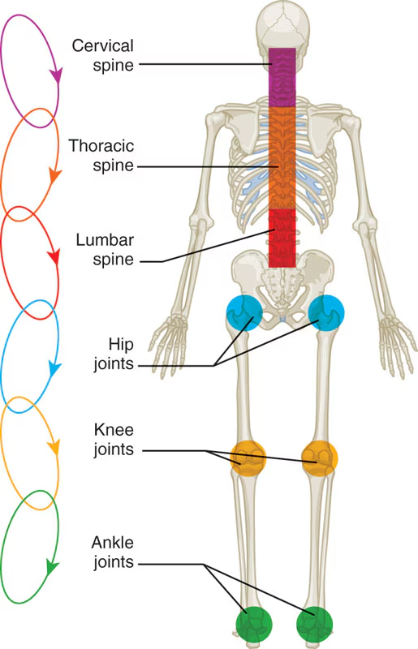

## Nervous system

The nervous system is a specialized network of nerves that transmits information within the human body. The nervous system has many functions, such as providing sensory information (e.g., pain, sight, taste) to our brain, stimulating human movement through muscle contractions, and keeping the heart and organs functioning. Essentially, the nervous system represents the wiring and operating software that run the human machine.

**Anatomy of the nervous system**

The nervous system is one of the main organ systems of the body and consists of a network of specialized cells called neurons that transmit and coordinate signals, providing a communication network within the human body (Karemaker, 2017). The neuron is a specialized cell and is often referred to as the functional unit of the nervous system (Figure 5-1). Billions of neurons make up the complex structure of the nervous system. These cells provide the nervous system with the ability to communicate with itself, as well as with the outside environment. Neurons process and transmit information through electrical and chemical signals. Neurons form the core of the nervous system, which includes the brain, spinal cord, and peripheral nerves (Wehr-wein et al., 2016).

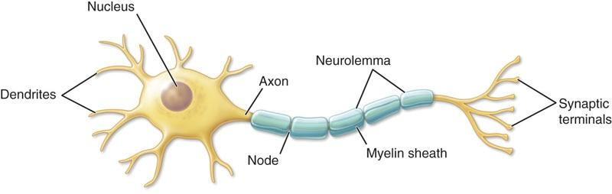

**Figure 5-1** The neuron

Collectively, the merging of many neurons together forms the nerves of the body. Neurons are composed of three main parts: cell body, axon, and dendrites. Like all cells, the cell body of a neuron contains a nucleus and other organelles, such as mitochondria. The axon is a cylindrical projection from the cell body that transmits nervous impulses to other neurons or effector sites (muscles and organs). The axon is the part of the neuron that provides communication from the brain and spinal cord to other parts of the body. The dendrites gather information from other structures and transmit it back into the neuron (Wehrwein et al., 2016).

The nervous system requires different electrolytes or minerals that have an electrical charge to help transmit nerve impulses throughout the body. The four primary electrolytes involved in this process are sodium, potassium, magnesium, and water. Adequate levels of electrolytes must be maintained to produce proper nerve function (Kenney et al., 2020).

HELPFUL HINT

Neurons are composed of three main parts:

* The cell body, which contains the nucleus and organelles
* The axon, which is a cylindrical projection extending from the cell body that carries nerve messages

1. Dendrites, which are structures that receive messages from other neurons

**Central and peripheral nervous systems**

The nervous system is composed of two interdependent divisions: the central nervous system and the peripheral nervous system. The central nervous system (CNS) consists of the brain and the spinal cord, and its primary function is to coordinate the activity of all parts of the body (Figure 5-2) (Ludwig & Varacallo, 2019). The peripheral nervous system (PNS) consists of nerves that connect the CNS to the rest of the body and the external environment. The nerves of the PNS are how the CNS receives sensory input, integrates the information, and then sends a response to the rest of the body (Ludwig & Varacallo, 2019).

The peripheral nervous system consists of 12 cranial nerves, 31 pairs of spinal nerves that branch out from the brain and spinal cord, and sensory receptors (Figure 5-3) (Kenney et al., 2020). These peripheral nerves serve two main functions. First, they provide sensory information (e.g., sight, smell, touch, taste) from the rest of the body up to the CNS via the afferent pathway (i.e., the sensory pathway).

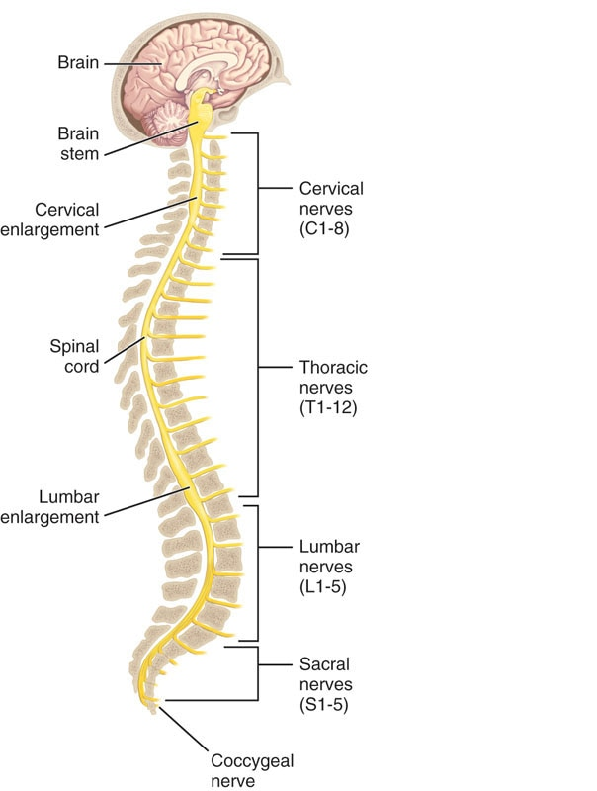

**Figure 5-2** Central nervous system

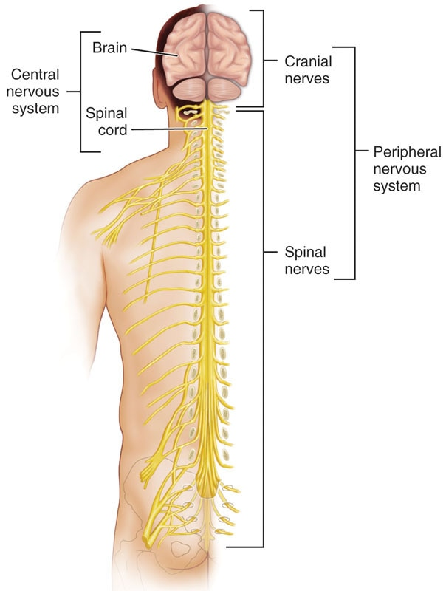

**Figure 5-3** Peripheral nervous system

Second, the peripheral nerves relay information from the CNS back down to the rest of the body via the efferent pathway (i.e., the motor pathway). Interneurons are only located within the spinal cord and the brain. They transmit impulses between the afferent and efferent neurons (Kenney et al., 2020).

Sensory receptors are specialized structures located throughout the body that convert environmental stimuli (heat, light, sound, taste, motion) into sensory information that the brain and spinal cord use to produce a response. Sensory receptors use the afferent pathway to send information to the CNS. These sensory receptors are subdivided into mechanoreceptors, nociceptors, chemoreceptors, and photoreceptors (Wade, 2019).

Mechanoreceptors respond to mechanical forces (touch and pressure), nociceptors respond to pain (pain receptors), chemoreceptors respond to chemical interaction (smell and taste), and photoreceptors respond to light (vision) (Ackerley & Watkins, 2018). Mechanoreceptors arguably relate most to the science of human movement, making them the most important for fitness professionals to understand.

#### Nervous system subdivisions

Two further subdivisions of the PNS include the somatic and autonomic nervous systems (Figure 5-4) (Waxenbaum & Varacallo, 2019). The somatic nervous system consists of nerves that serve the outer areas of the body and skeletal muscle and is largely responsible for the voluntary control of movement.

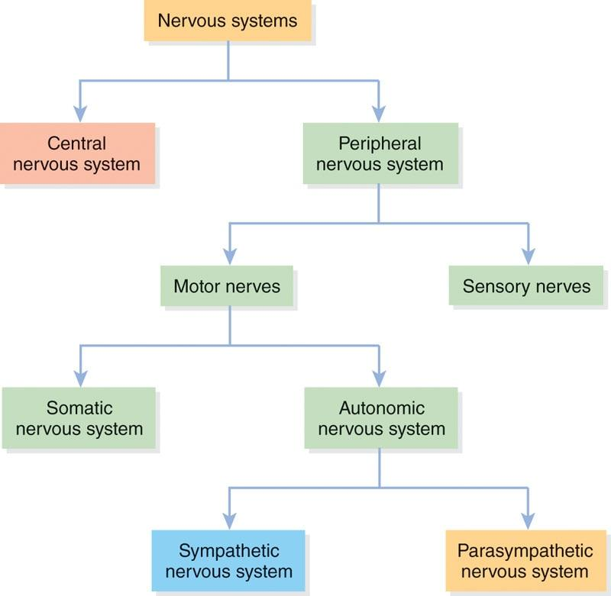

**Figure 5-4** Nervous system flowchart

STRETCH YOUR KNOWLEDGE

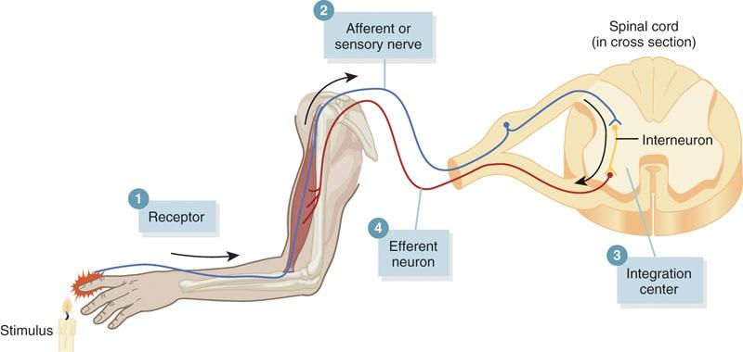

Reflexes in Action

The central and peripheral nervous systems work together to process information about the surrounding world to produce purposeful responses. Quite often, those responses happen without any conscious awareness, which is known as a reflex.

For example, when people put their finger over a hot flame, they will begin to feel the extreme heat. In response, they quickly withdraw their hand to avoid pain or possible damage to their skin. The entire loop—sensing the heat, transmitting the information to the CNS, processing that information as painful and dangerous, and then sending the command for arm muscles to contract and move the hand away from the flame—happens almost instantaneously. This example of sensory information being processed to produce a motor response is called the withdrawal reflex (Eckert & Riley, 2013).

The autonomic nervous system supplies neural input to organs that run the involuntary processes of the body (e.g., circulating blood, digesting food, producing hormones). In other words, these things happen without a person having to consciously think about them thanks to the autonomic nervous system. The autonomic system is then further subdivided into the sympathetic and parasympathetic nervous systems.

During exercise, the sympathetic nervous system works to increase neural activity and signals different endocrine organs to release hormones, such as adrenaline, that increase heart rate, breathing, and alertness. This process is often termed *fight or flight*, where the body is put into a more excited (i.e., heightened) state in anticipation of an increase in activity.

The parasympathetic nervous system has the opposite effect and works to decrease neural activity by suspending the release of excitatory hormones. This puts the body in a more relaxed state, which is often termed *rest and digest*. Both systems work together to balance bodily functions and manage interactions with the surrounding world (Waxenbaum & Varacallo, 2019).

**Functions of the nervous system**

The three primary functions of the nervous system include sensory, integrative, and motor functions. Sensory function is the ability of the nervous system to sense changes in either the internal or external environment (Ludwig & Varacallo, 2019). For example, internally, the nervous system can sense a stretch placed on a muscle; externally, the nervous system uses the primary senses—sight, smell, taste, touch, and hearing—to gather information about the environment outside of the body. Sensory feedback, both internal and external, travels from the PNS to the CNS through the afferent pathway.

A key sensory function of the human body is proprioception, which is the body’s ability to naturally sense its general orientation and the relative position of all its parts (Greenbaum-Maya, 2019). For example, when people shoot a basketball, proprioception helps them feel their arm and hand placement while focusing their attention on the basket. It is not necessary for them to look at their arms to realize that they are positioned overhead to shoot the ball; the body’s own proprioceptive abilities provide that information. Training the body’s proprioceptive abilities can improve balance, coordination, and posture and enable the body to adapt to its surroundings without consciously thinking about what movement is most appropriate for any given situation. Therefore, it becomes important to train the nervous system efficiently to ensure that proper movement patterns are being developed, which enhances performance and may decrease the risk of injury.

TRY THIS

To better understand the concept of proprioception, try the following:

1. Close your eyes.
2. Raise your left hand above your head.
3. Raise your right hand above your head.
4. Return both arms to your sides at the same time.

Think about how you were able to perform this task without using your five senses. You couldn’t see, smell, taste, hear, or touch your arms, yet somehow you knew exactly where your arms were positioned at any given time. That internal sense of body orientation is proprioception.

For a real test of your proprioceptive abilities, hold your arms out to your sides and then try touching your nose with your left and right pointer fingers with your eyes closed! Were you able to do it?

Integrative function is the ability of the CNS to analyze and interpret sensory information to allow for proper decision making, which produces an appropriate response (Ludwig & Varacallo, 2019). Recall that the CNS receives its information from the PNS via the afferent pathway. Motor function is then the body’s response (via the efferent pathway) to that integrated sensory information, such as causing a muscle to contract when stretched too far or changing one’s walking pattern when transitioning from walking on a sidewalk to walking in the sand. Figure 5-5 provides an example of sensory, integrative, and motor function working together to complete the task of reaching for a glass of water when feeling thirsty.

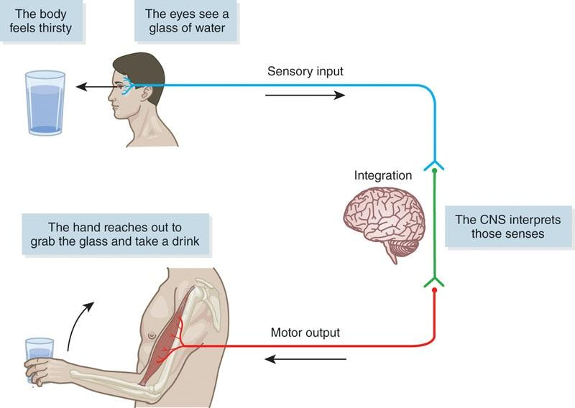

**Figure 5-5** Sensory, integrative, and motor function

**Mechanoreceptors**

Mechanoreceptors are specialized structures that respond to mechanical pressure within tissues and then transmit signals through sensory nerves (Dean et al., 2013). Mechanoreceptors respond to outside forces, such as touch, pressure, stretching, sound waves, and motion, and transmit impulses through sensory nerves, which, in turn, enable the body to detect touch and sounds and monitor the position of our muscles, bones, and joints. Mechanoreceptors are located in muscles, tendons, ligaments, and joint capsules and include the muscle spindles, Golgi tendon organs, and joint receptors (Dean et al., 2013; Karemaker, 2017).

Muscle spindles are sensory receptors within muscles that run parallel to the muscle fibres (Figure 5-6) and are sensitive to change in muscle length and rate of length change (Dean et al., 2013). When a specific muscle is stretched, the spindles within that muscle are also stretched, which in turn conveys information about its length to the CNS through sensory neurons. Once information from muscle spindles reaches the brain, it can then determine the position of various body parts.

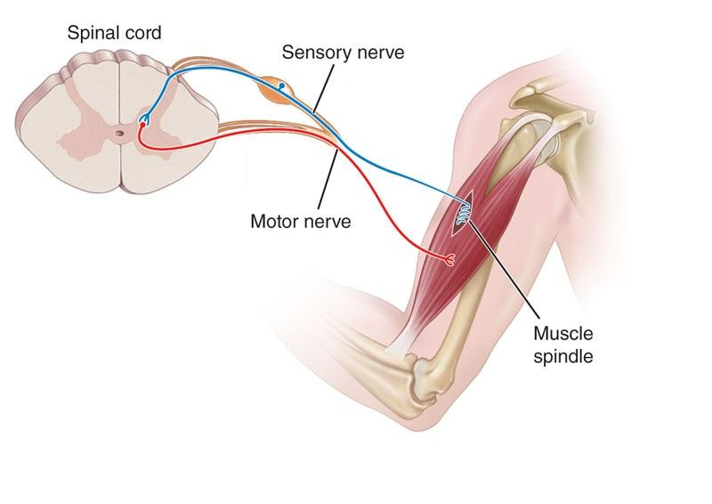

**Figure 5-6** Muscle spindle

Muscle spindles also help in regulating the contraction of muscles through the stretch reﬂex mechanism. The stretch reflex is a normal response by the body to a stretch stimulus in the muscle.

When a muscle spindle is stretched, an impulse is immediately sent to the spinal cord, and a response to contract the muscle is received within 1 to 2 milliseconds. The rapid neural response is designed as a protective mechanism to prevent overstretching and potential muscle damage (Kistemaker et al., 2013).

TRY THIS

Next time you stretch, think about what is happening in the muscle. As a stretch reaches its end limit, the feelings of tension and discomfort that tell you “don’t stretch any farther” represent the stretch reflex working to protect the muscle from lengthening too far or too fast.

Golgi tendon organs are specialized sensory receptors located at the point where skeletal muscle fibers insert into the tendons of skeletal muscle. They are sensitive to changes in muscular tension and rate of that tension change (Figure 5-7) (Lyle & Nichols, 2019). Activation of Golgi tendon organs will cause the muscle to relax, which prevents the muscle from excessive stress and possible injury (Chalmers, 2002). The functions of both the muscle spindles and Golgi tendon organs are highly important in relation to flexibility training.

Joint receptors are located in and around the joint capsule, and they respond to pressure, acceleration, and deceleration of the joint (Figure 5-8). These receptors act to signal extreme joint positions and help to prevent injury. They can also act to initiate a reflexive (automatic) inhibitory response in the surrounding muscles if there is too much stress placed on that joint (Dean et al., 2013).

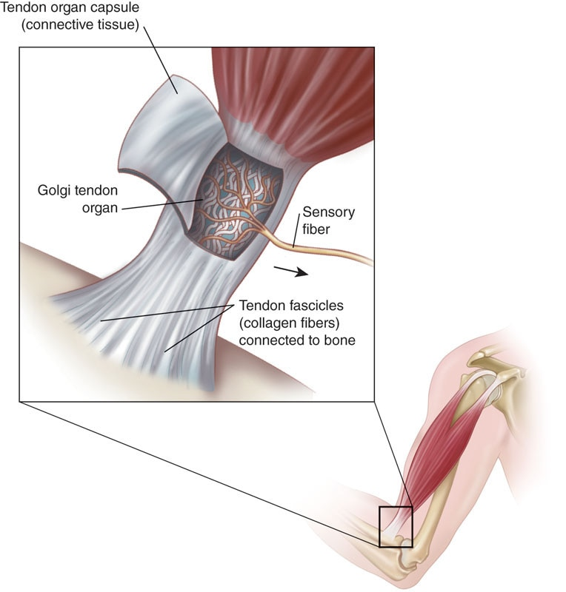

**Figure 5-7** Golgi tendon organ

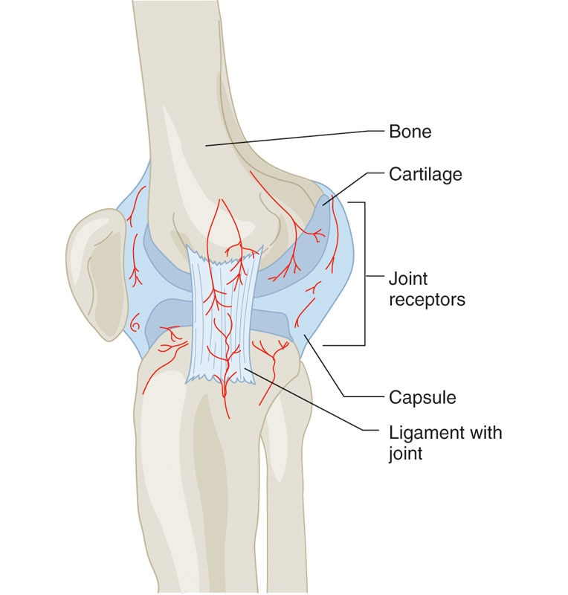

**Figure 5-8** Joint receptors

**Nervous system life course**

The nervous system develops continuously from birth through older adulthood. Through a child’s development, the body goes through a set of developmental milestones that include physical (e.g., taking first steps), mental (e.g., problem solving), social and emotional (e.g., manages emotions), and communication (e.g., speaking first words). These milestones are often used as checkpoints by healthcare professionals to determine how a child is developing (Scharf et al., 2016).

The adolescent brain continues to develop from 10 to 25 years of age. Adolescent maturation of the CNS may be influenced by several factors, such as heredity, environment, prenatal and postnatal injury, nutritional status, sleep patterns, medications, and surgical interventions during early childhood (Arain et al., 2013).

Over the course of the entire human life span, the CNS continues to develop through neuroplasticity (i.e., neuronal changes) and changes in neurocircuitry (i.e., neuronal connections), which occur with the acquisition of new skills. For example, when an adolescent child is taught how to kick a ball, their brain will stimulate specific neuronal changes and connections that allow the child to understand and replicate the newly acquired skill. This concept is highly important for fitness professionals, because it mirrors what is happening in the brain when a client becomes more skilled at an exercise and is ready to progress to more difficult challenges in the gym.

While humans can always learn new things at any stage of life, as the body gets older there is both a physical and cognitive decline. Several classic research studies have documented that neurotransmitter levels (e.g., dopamine and serotonin) decline about 10% after early adulthood; the physical weight of the brain declines 5% per decade after age 40 years; and neurocognitive issues (e.g., Alzheimer disease) are most prevalent in adults 65 years or older (Damoiseaux, 2017; Peters, 2006; Wyss-Coray, 2016). Luckily, one of the best ways to help counter the cognitive decline associated with aging is to stay physically fit (Macpherson et al., 2017).

**Physical activity and the nervous system**

The nervous system helps individuals successfully perform motor skills (i.e., movement) through the coordinated effort of the sensory and motor subsystems. To perform physical activity, motor skills must be acquired.

For example, humans are not born with fully developed coordination (babies are not born walking), and physical abilities must be developed over time. In most cases, motor skills, such as lifting weights or riding a bike, are learned and acquired through repetitive practice.

The nervous system plays a major role on how humans learn and retain new skills. The mechanisms behind motor-skill learning are related to brain development through neuroplasticity and neurocircuitry (Hötting & Röder, 2013). The development of motor skills is best under-stood as a three-stage process (Taylor & Ivry, 2012):

1. Stage 1 (cognitive): The client is just learning a skill. They understand the goals of the skill and develop movement strategies and can perform the skill but with inconsistent performance.
2. Stage 2 (associative): The client begins to understand the skill. Through practice, they refine the skill and movement strategy and can perform the skill with less error.
3. Stage 3 (autonomous): The client has mastered the skill. They perform the skill consistently with no error and independently modify the skill without error.

TRAINING TIP

The three stages of motor skill development may provide the fitness professional with a road map for teaching clients new movements or exercises.

During stage 1 (cognitive), you may need to use simple instructions and break down the skill into smaller steps so your clients will be able to understand the goals of the movement.

During stage 2 (associative), you may need to help refine your clients’ skills through practice and regular feedback.

During stage 3 (autonomous), you may be able to teach your clients new versions of the skill to further challenge them.

## Skeletal system

The skeletal system serves many important functions. It provides the shape and form for our bodies, supports and protects our internal organs, provides the structure from which movement is created, produces blood for the body, and stores minerals (Figure 5-9) (Moore et al., 2018). It is important to note that the growth, maturation, and functionality of the skeletal system may be affected by physical activity and nutrition status (Hamill et al., 2015).

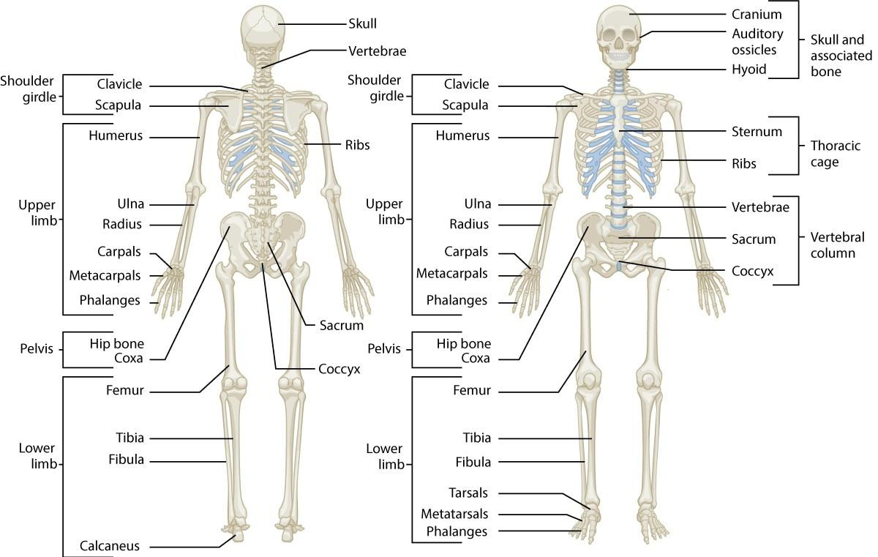

**Figure 5-9** The skeletal system

For example, poor nutrition and physical inactivity contribute to osteoporosis, which has a negative effect on skeletal health and human movement (Aspray & Hill, 2019). The skeletal system is a vital part of human movement through the interaction of the muscular and skeletal systems. Muscles are connected to bones by tendons. Bones form junctions that are connected by muscles and connective tissue. These junctions are known as joints and are the sites where movement occurs as a result of muscle contraction (Hamill et al., 2015).

**Divisions of the skeletal system**

The skeleton is divided into two parts: the axial and appendicular skeletal systems. The axial skeleton is made up of the skull, rib cage, and vertebral column. There are approximately 80 bones in the axial skeleton. The appendicular skeleton is made up of the arms, legs, and pelvic girdle. The appendicular skeleton encompasses approximately 126 bones (Hamill et al., 2015). In the human skeletal system, there are 206 bones of which approximately 177 are used in voluntary movement. The bones in the human body form more than 300 joints (Hamill et al., 2015).

**Bones**

Bones serve two vital functions in movement. First, the bones act as levers or rigid rods where muscles attach. When a muscle contracts, it pulls on its respective bone, which produces movement (Tagliaferri et al., 2015). The second primary function of bones relative to movement is to provide support. This translates into posture, which is necessary for the efficient distribution of forces acting on the body (Floyd, 2018).

Bone growth

Throughout life, bone is constantly renewed through a process called remodelling, which is a process that consists of resorption and formation of the bone structure by special cells. Osteoclasts are special cells that break down and remove old bone tissue. Osteoblasts are special cells that form and lay down new bone tissue (Rolfe et al., 2013). During childhood through adolescence, new bone is added to the skeleton faster than old bone is removed. As a result, bones become larger, heavier, and denser (Dirckx et al., 2013).

For most people, bone formation continues at a faster pace than removal until bone mass peaks, which usually occurs by the time individuals reach their thirties (Floyd, 2018). It is also worth noting that bone remodelling, known as Wolff’s law, tends to occur along the lines of stress placed on the bone (Florencio-Silva et al., 2015). For example, activities, such as walking or running, may stimulate the femur (thigh) bones to remodel throughout the whole bone due to the weight-bearing stresses introduced during the activity.

Exercise and habitual posture, therefore, have a fundamental influence on the health of the skeletal system. Incorrect exercise technique, coupled with a generally poor postural alignment, will lead to a remodelling process that may reinforce the predominating bad posture (Ailon et al., 2015).

TRAINING TIP

Weight-bearing exercise, such as walking, jogging, dancing, and jumping, helps strengthen bones through remodelling. Nonweight-bearing activities, such as cycling and swimming, while effective for improving endurance and cardiovascular health, do not strengthen bones as effectively as weight-bearing exercise. However, nonweight-bearing exercise may be preferred for individuals with orthopaedic limitations. Consequently, fitness professionals should select exercises that best fit their clients’ needs and abilities.

**Types of bones**

There are five major types of bones in the skeletal system: long, short, flat, irregular, and sesamoid (Table 5-1) (Hamill et al., 2015). The shape, size, and proportion of bone tissue determines their classification.

TABLE 5-1 Types of Bones

| **Bone Type** | **Characteristic** | **Example** |
| --- | --- | --- |
| Long | Long, cylindrical shaft with irregular or widened ends | Humerus (i.e., the upper arm bone)  Femur (i.e., the thigh bone) |
| Short | Similar in length and width and appear somewhat cubical in shape | Carpals of the wrist  Tarsals of the ankle |
| Flat | Thin, protective surfaces that provide broad surfaces for muscles to attach | Scapulae (i.e., the shoulder blades)  Sternum (i.e., the breast plate)  Ribs |
| Irregular | Unique shape and function from all other bone types | Vertebrae (i.e., the spinal column) |
| Sesamoid | Small, often round bones embedded in a joint capsule or found in locations where a tendon passes over a joint | Patella (i.e., the kneecap) |

**Long bones**

Long bones are characterized by their long cylindrical body, with irregular or widened bony ends. They are shaped much like a beam and exhibit a slight curvature that is necessary for efficient force distribution (Floyd, 2018). Long bones are composed predominantly of compact bone tissue to ensure strength and stiffness. However, they do have considerable amounts of spongy bone tissue for shock absorption. The long bones of the upper body include the clavicle (collar-bone), humerus (upper arm bone), radius and ulna (forearm bones), metacarpals, and phalanges (finger bones), whereas lower-body long bones include the femur (thigh bone) (Figure 5-10), tibia and fibula (shin bones), metatarsals, and phalanges (toe bones) (Hamill et al., 2015).

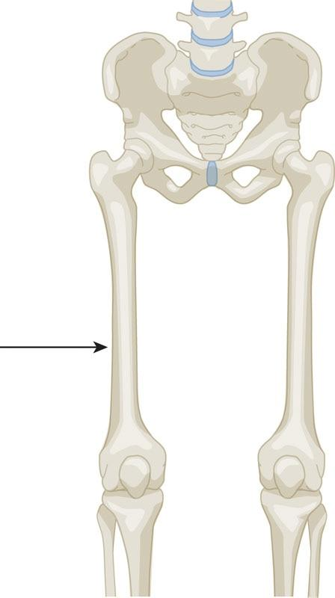

**Figure 5-10** Long bone

GETTING TECHNICAL

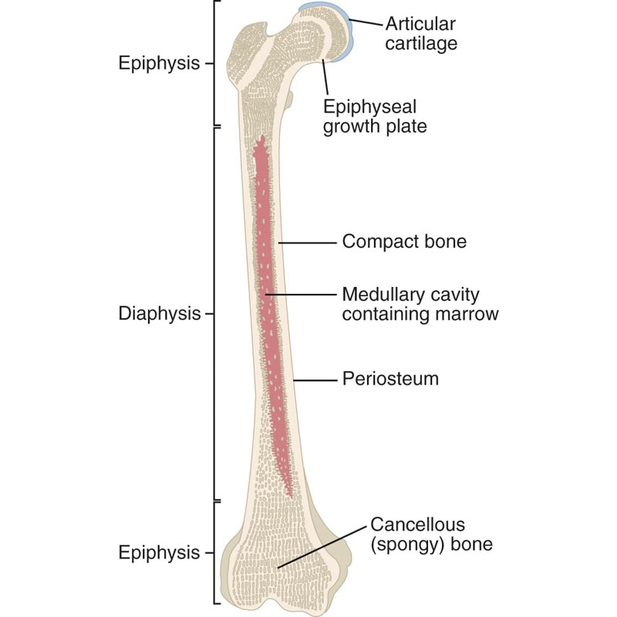

STRETCH YOUR KNOWLEDGE

Strength training in children and adolescents has long been a controversial topic among parents. One myth is that strength training can lead to growth or epiphyseal plate damage. Currently, there is no evidence that a well-designed, age-appropriate, strength-training program leads to such an injury. The existing case reports on these injuries are primarily attributed to the misuse of equipment, inappropriate weight, improper technique, or lack of qualified adult supervision (Dahab & McCambridge, 2009). In fact, many medical- and fitness-governing bodies have published position statements supporting resistance training for children and adolescents (Behm et al., 2008; Bergeron et al., 2015; Faigenbaum et al., 2009; Lloyd et al., 2014; McCambridge & Stricker, 2008).

**Short bones**

Short bones are similar in length and width and appear somewhat cubical in shape. They consist predominantly of spongy bone tissue to maximize shock absorption. The carpals of the wrists (Figure 5-11) and tarsals of the ankles fit this category of bone.

**Flat bones**

Flat bones are thin bones comprising two layers of compact bone tissue surrounding a layer of spongy bone tissue (Florencio-Silva et al., 2015). These bones protect internal structures and provide broad attachment sites for muscles. The flat bones include the sternum (breastbone), scapulae (shoulder blades) (Figure 5-12), ribs, ilium (pelvis), and cranial (skull) bones (Hamill et al., 2015).

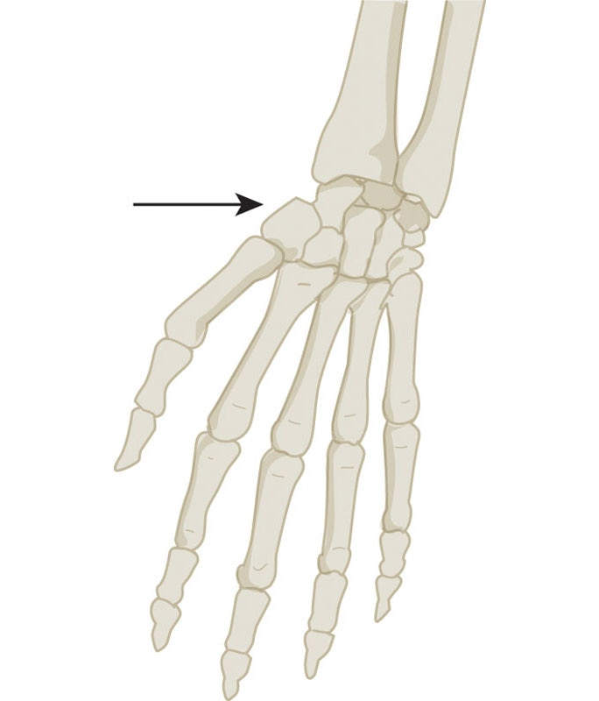

**Figure 5-11** Short bone example—carpals of the wrist

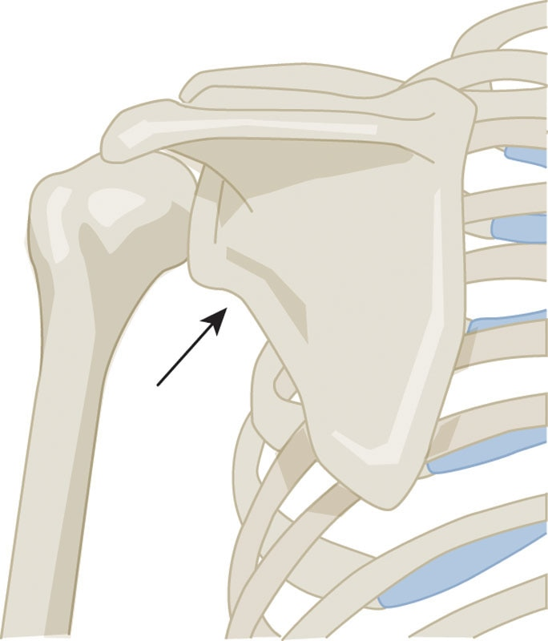

**Figure 5-12** Flat bone example—scapula

**Irregular bones**

Irregular bones are bones of unique shape and function that do not fit the characteristics of the other categories. These include the vertebrae (Figure 5-13), sacrum, coccyx (tailbone), and certain facial bones (Hamill et al., 2015).

**Sesamoid bones**

Sesamoid bones are small bones embedded in a joint capsule or found in locations where a tendon passes over a joint. A common example is the patella (kneecap) (Figure 5-14). Sesamoid bones are also found in the hands and feet. Sesamoid bones develop within particular tendons at a site of considerable friction or tension (Hamill et al., 2015). They serve to improve leverage and protect the joint from damage.

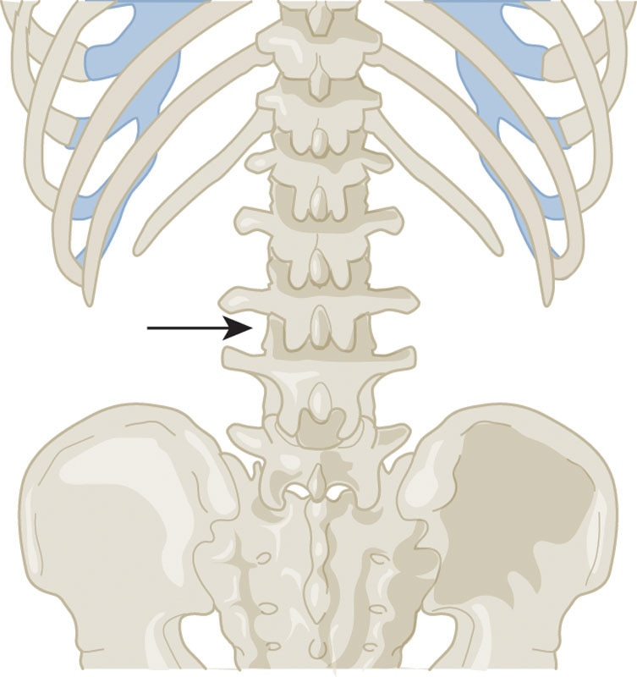

**Figure 5-13** Irregular bone example—vertebrae

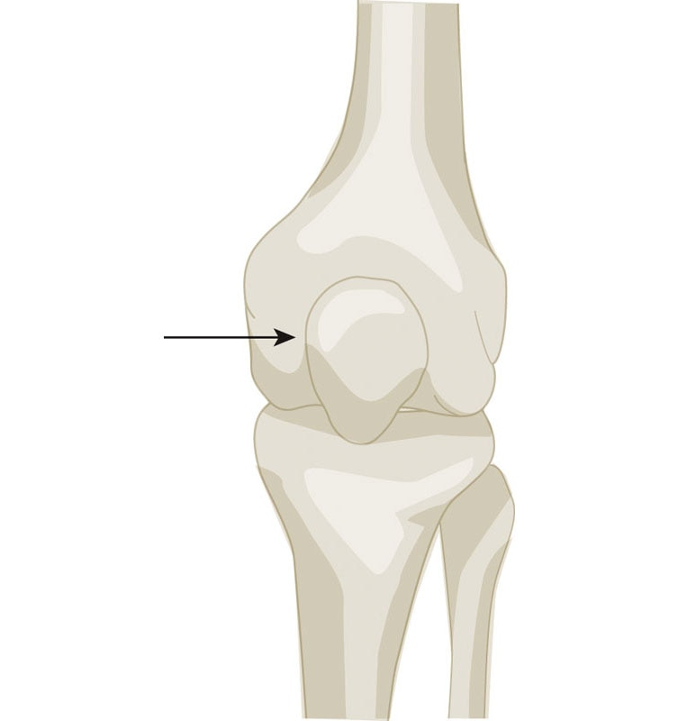

**Figure 5-14** Sesamoid bone example— patella

**Bone markings**

The majority of all bones have specific distinguishing structures known as surface markings. These structures are necessary for increasing the stability in joints as well as providing attachment sites for muscles. Bone markings can be divided into two simple categories: depressions and processes (Bandovic & Futterman, 2019).

Depressions

Depressions are flattened or indented portions of the bone. A common depression is called a fossa. An example includes the infraspinous fossa located on the scapula (shoulder blade) (Figure 5-15). This is an attachment site for the infraspinatus muscle (Hamill et al., 2015).

Another form of depression is known as a sulcus. This is simply a groove in a bone that allows soft tissue (i.e., muscle, tendons, and ligaments) to pass through. An example of this is the intertubercular sulcus located between the greater and lesser tubercles of the humerus (upper arm bone) (Figure 5-16) (Bandovic & Futterman, 2019). This is commonly known as the groove for the biceps tendon.

Processes

Processes are projections protruding from the bone to which tendons and ligaments can attach. Some of the more common processes are process, condyle, epicondyle, tubercle, and trochanter (Bandovic & Futterman, 2019). Examples of processes include the spinous processes found on the vertebrae (Figure 5-17).

Condyles are located on the inner and outer portions at the bottom of the femur (thigh bone) and top of the tibia (shin bone) to form the knee joint (Figure 5-18) (Bandovic & Futterman, 2019).

Epicondyles are located on the inner and outer portions of the humerus to help form the elbow joint (Figure 5-19) (Floyd, 2018).

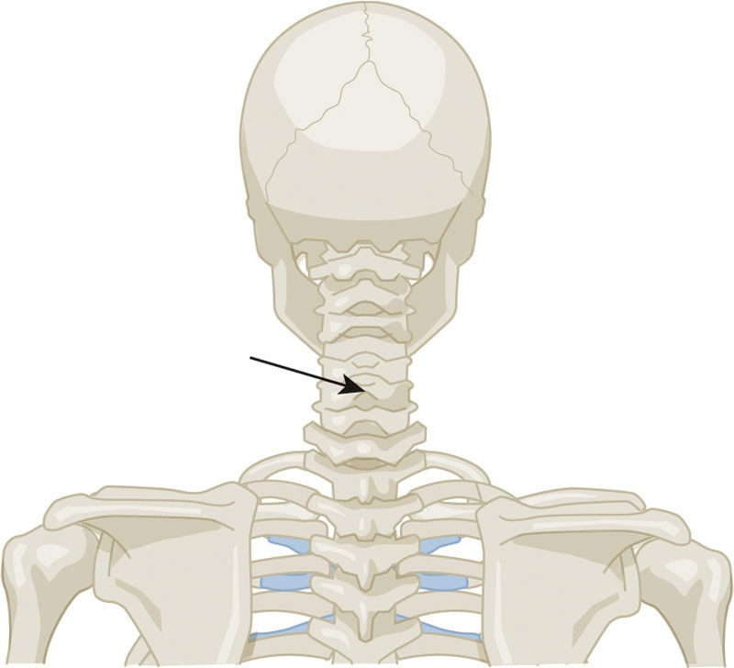

**Figure 5-17** Process example—spinous process of the vertebrae

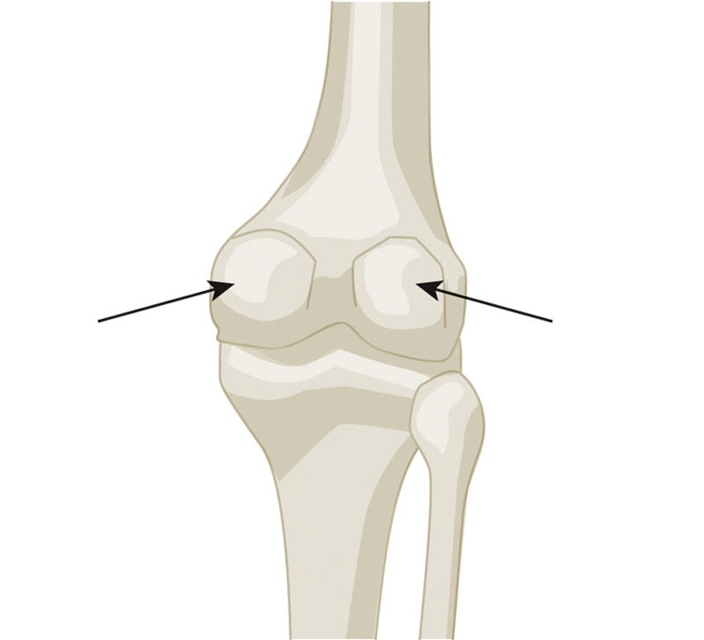

**Figure 5-18** Condyle example—bottom of the femur

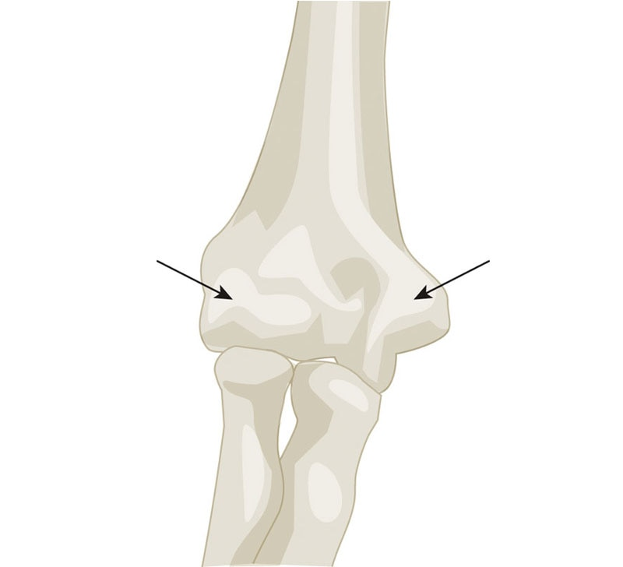

**Figure 5-19** Epicondyle example—bottom of the humerus

The tubercles are located at the top of the humerus at the glenohumeral (shoulder) joint—the greater and lesser tubercles, which are attachment sites for shoulder musculature (Figure 5-20).

Finally, the trochanters are located at the top of the femur (thigh bone) and are attachment sites for the hip musculature (Figure 5-21) (Bandovic & Futterman, 2019).

**Vertebral column**

The vertebral column (also called the spinal column) consists of a series of irregularly shaped bones called vertebrae that house and protect the bundle of nerves known as the spinal cord that, in conjunction with the brain, makes up the CNS (Figure 5-22) (Bican et al., 2013).

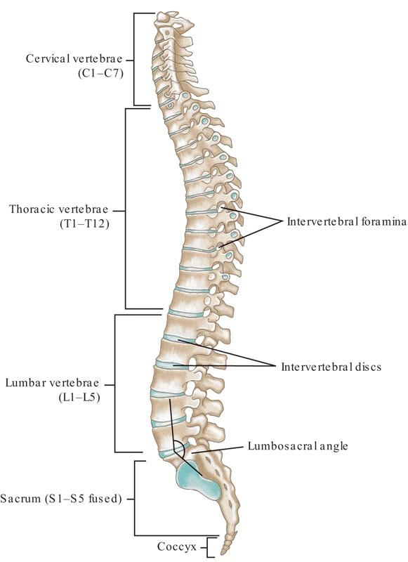

**Figure 5-22**The spine

These bones are divided into five different categories depending on where they are located in the spine (Table 5-2) (Hamill et al., 2015)

TABLE 5-2 Segments of the Vertebral Column

| **Segment** | **Description** |
| --- | --- |
| Cervical spine (C1–C7) | First seven vertebrae starting at the top of the spinal column  Form a flexible framework and provide support and motion for the head |
| Thoracic spine (T1–T12) | Twelve vertebrae located in the upper and middle back behind the ribs  Each vertebra articulates with a rib helping form the rear anchor of the rib cage  Larger than cervical vertebrae and increase in size from top to bottom |
| Lumbar spine (L1–L5) | Five vertebrae of the low-back below the thoracic spine  Largest segments in the spinal column  Support most of the body’s weight and are attached to many back muscles |
| Sacrum | Triangular bone located below the lumbar spine  Composed of five vertebrae that fuse together as the body develops into adulthood |
| Coccyx | Located below the sacrum, more commonly known as the tailbone  Composed of three to five small fused bones |

HELPFUL HINT

Use the “breakfast, lunch, and dinner” analogy to help remember structures of the spine:

Breakfast at 7:00 a.m. = 7 cervical vertebrae at the neck

Lunch at 12:00 p.m. = 12 thoracic vertebrae at the mid-back

Dinner at 5:00 p.m. = 5 lumbar vertebrae at the low-back

In between the vertebrae are intervertebral discs made of fibrous cartilage that act as shock absorbers and allow the spine to move (Newell et al., 2017). In addition to allowing humans to stand upright and maintain their balance, the vertebral column serves several other important functions. It helps support the head and arms while permitting freedom of movement. It also provides attachment sites for many muscles, the ribs, and connective tissue (Galbusera & Bassani, 2019).

When looking at the body from a side view, the spinal column has a curved shape that partially resembles the letter S. The optimal arrangement of curves is referred to as a neutral spine and represents a position in which the vertebrae and associated structures are under the least amount of load and can most optimally support functional movement (Wallden, 2009). The adult human spine has three major curvatures (Figure 5-23):

* Posterior (concave) cervical curve (hollowed or rounded inward)
* Posterior (convex) thoracic curve (curved or rounded outward)
* Posterior (concave) lumbar curve (hollowed or rounded inward)

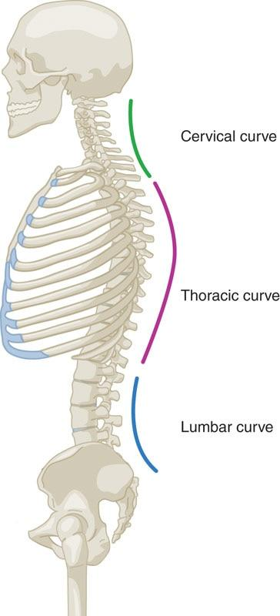

**Figure 5-23** Curvatures of the spine

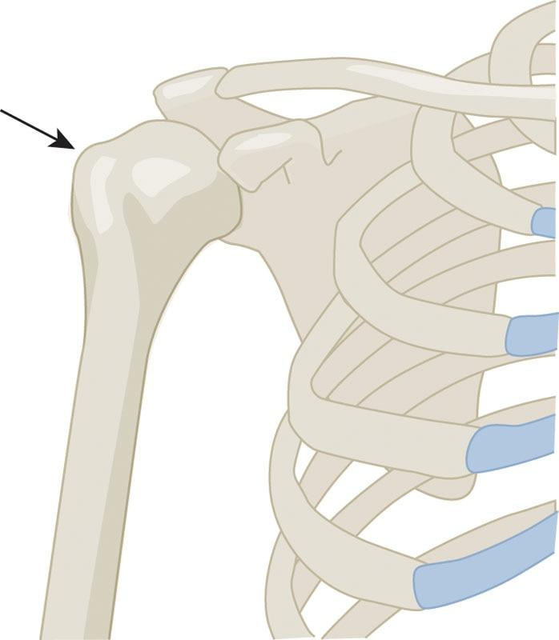

**Figure 5-20** Tubercle example—top of the humerus

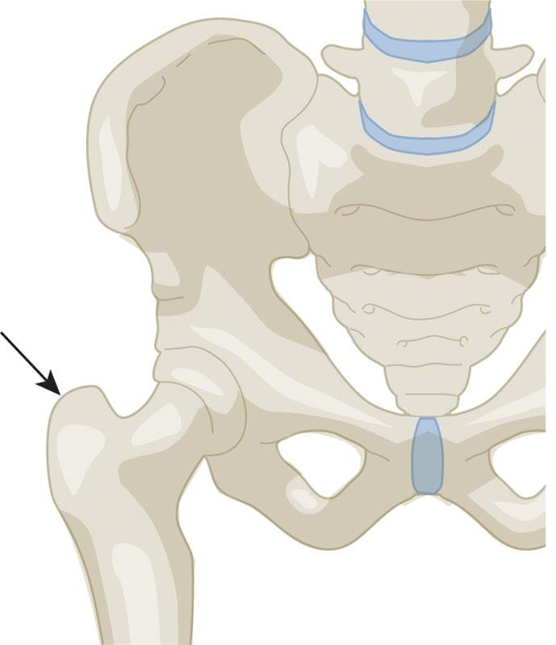

**Figure 5-21** Trochanter example—top of the femur

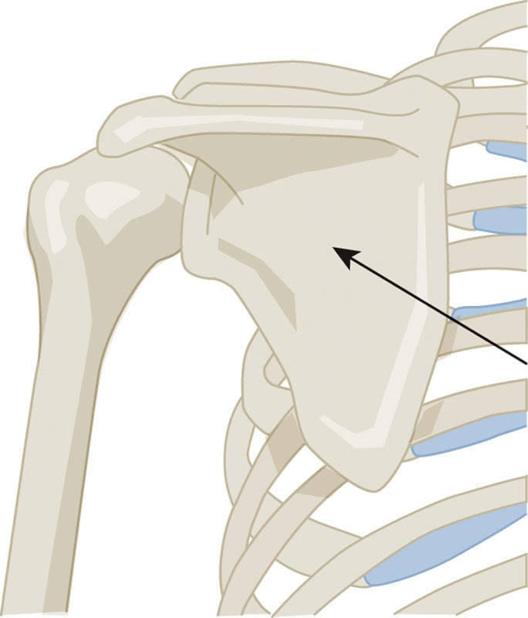

**Figure 5-15** Fossa example—infraspinous fossa of the scapula

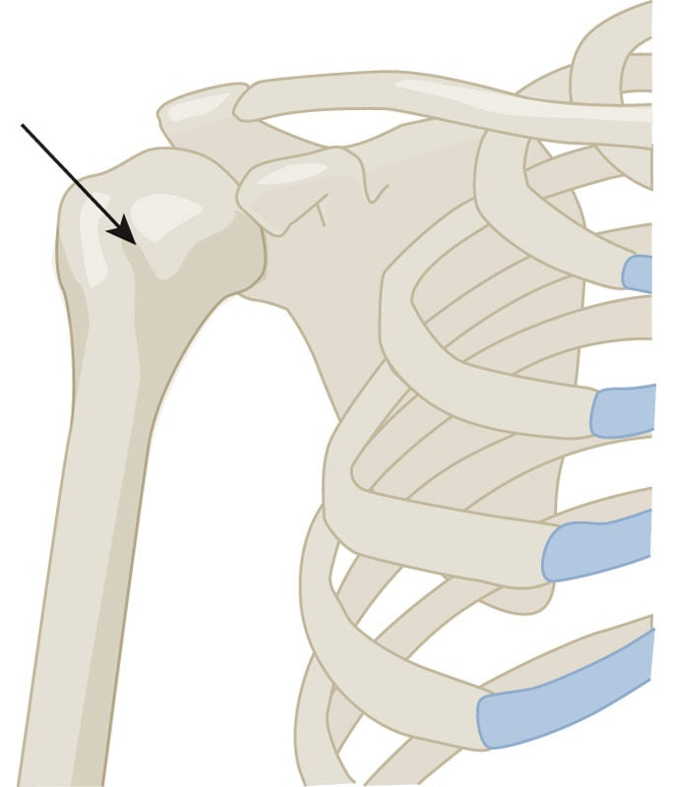

**Figure 5-16** Sulcus example—intertubercular sulcus of the humerus

**Joints**

Joints are formed when one bone articulates (joins) with another bone. Joints can be categorized by their shape, structure, and function (Hamill et al., 2015). There are two ways to describe the movement of skeletal components. Osteokinematics is the description of bone movement (e.g., flexion and extension), while arthrokinematics is the description of joint movement (i.e., the interaction between two bone surfaces) (Lee et al., 2017; Neumann, 2012). The three major types of arthrokinematics include roll, slide or glide, and spin (Neumann, 2012). It is important to note that motions rarely occur, if ever, as an isolated fashion. As is the case with the human body, variations and combinations of multiple arthrokinematics take place during various movement patterns.

In a rolling joint movement, one joint rolls across the surface of another much like the tire of a bicycle rolls on the street. An example of roll in the body is the femoral condyles (lowest ends of the thigh bone) rolling over the tibial condyles (upper ends of the shin bone) during a squat (Figure 5-24).

In a sliding movement, one joint’s surface slides across another much like the tire of a bicycle skidding across the street. An example of slide in the human body is the tibial condyles sliding across the femoral condyles during a knee extension or squat (Figure 5-25).

In a spinning movement, one joint surface rotates on another much like twisting the lid off a jar (Figure 5-26). An example of a spin movement in the human body is the head of the radius (a bone of the forearm) rotating on the end of the humerus (upper arm bone) during pronation and supination of the forearm.

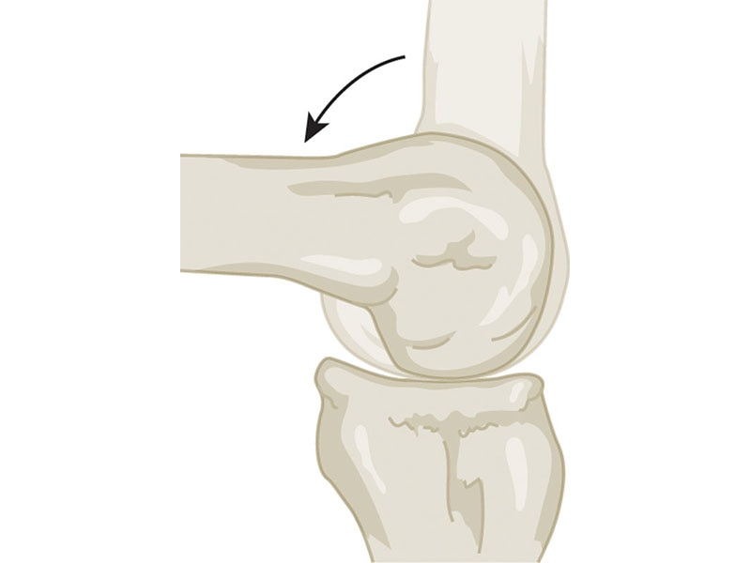

**Figure 5-24** Arthrokinematics—roll

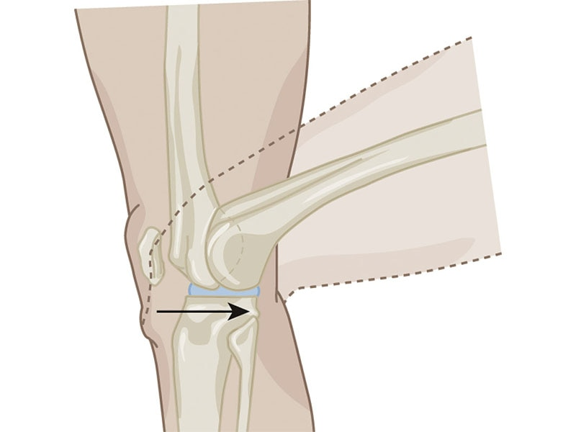

**Figure 5-25** Arthrokinematics—slide

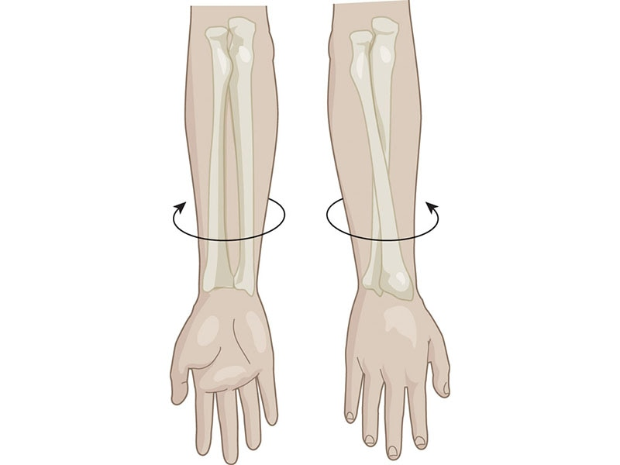

**Figure 5-26** Arthrokinematics—spin

Classifications of joints

Synovial joints are the most common joints associated with human movement. They comprise approximately 80% of all the joints in the body and have the greatest capacity for motion. Synovial joints all have a synovial capsule (a collagenous structure surrounding the entire joint), a synovial membrane (the inner layer of the capsule), and cartilage that pads the ends of the articulating bones (Tamer, 2013).

Synovial joints also have another unique quality in that they produce synovial fluid. Synovial fluid resembles egg whites and works much like engine oil. It is secreted within the joint capsule from the synovial membrane and is essential for lubricating the joint surfaces to reduce excessive wear and to provide nutrition to the joint structures within the synovial capsule (Hui et al, 2012).

There are several classifications of synovial joints in the body. They include gliding, condyloid, hinge, saddle, pivot, and ball-and-socket joints.

A gliding joint, also known as a plane joint, is a nonaxial joint that has the simplest movement of all joints. It moves either back and forth or side to side. One example includes the joints between the carpal bones of the wrist (Figure 5-27) (Hamill et al., 2015).

Condyloid joints are termed so because the condyle of one bone fits into the elliptical cavity of another bone to form the joint (Hamill et al., 2015). Due to the shape, movement predominantly occurs in one direction with minimal movement in others. An example of condyloid joints is seen in the joints of the fingers (metacarpophalangeal) (Figure 5-28) (Floyd, 2018).

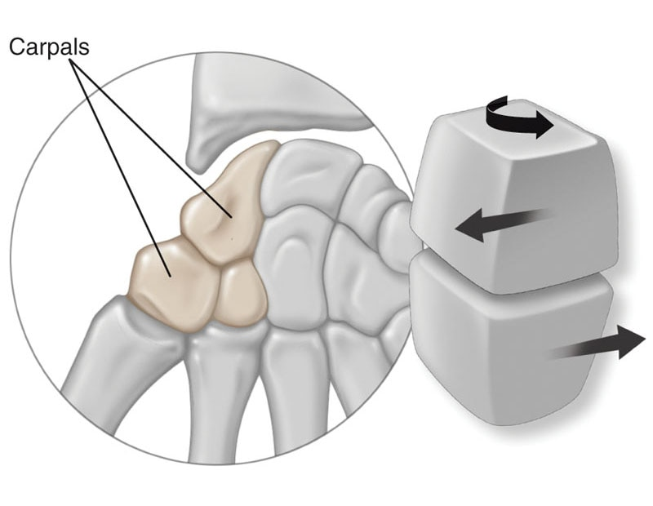

**Figure 5-27** Gliding joint example—carpals of the wrist

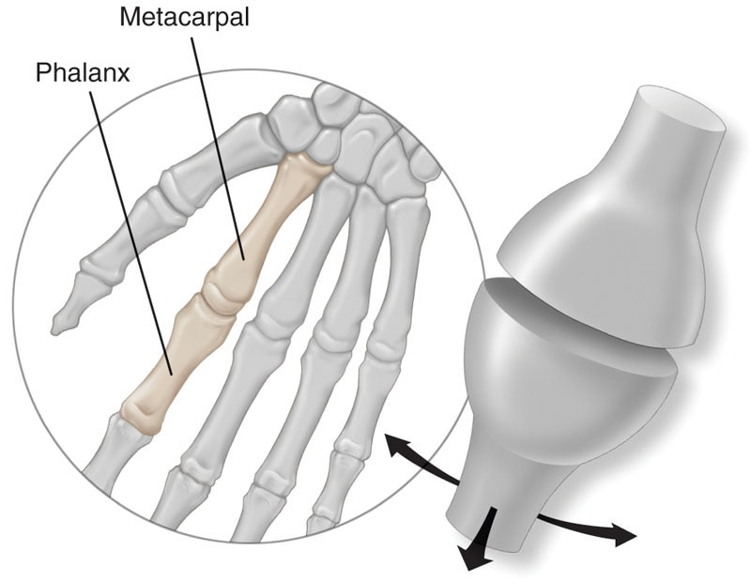

**Figure 5-28** Condyloid joint example—finger joints

The hinge joint is a uniaxial joint allowing movement predominantly in one direction. Joints such as the elbow, interphalangeal (toe), and ankle are considered hinge joints (Figure 5-29) (Floyd, 2018).

The saddle joint is named after its appearance. One bone looks like a saddle with the articulating bone straddling it like a rider. This joint is only found in the carpometacarpal joint in the thumb. Due to the shape, movement is predominantly in two directions (Figure 5-30) (Floyd, 2018; Hamill et al., 2015).

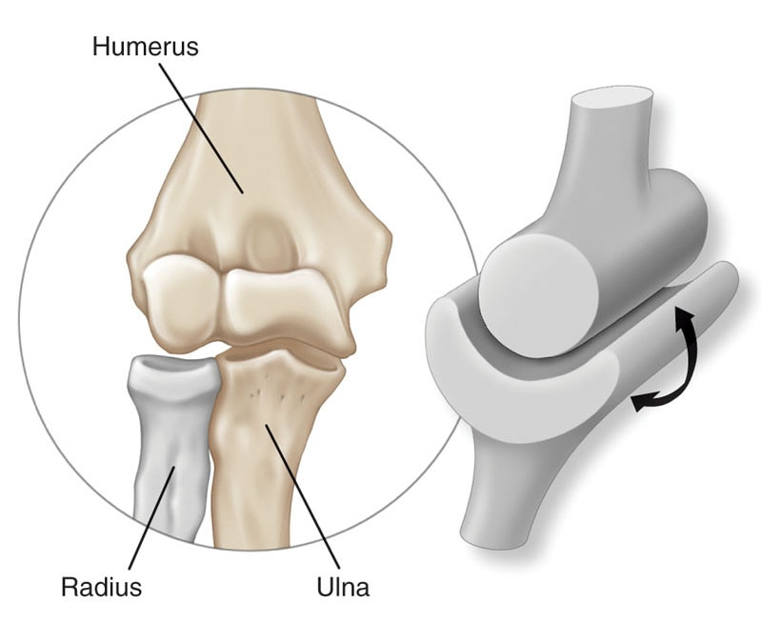

**Figure 5-29** Hinge joint example—elbow

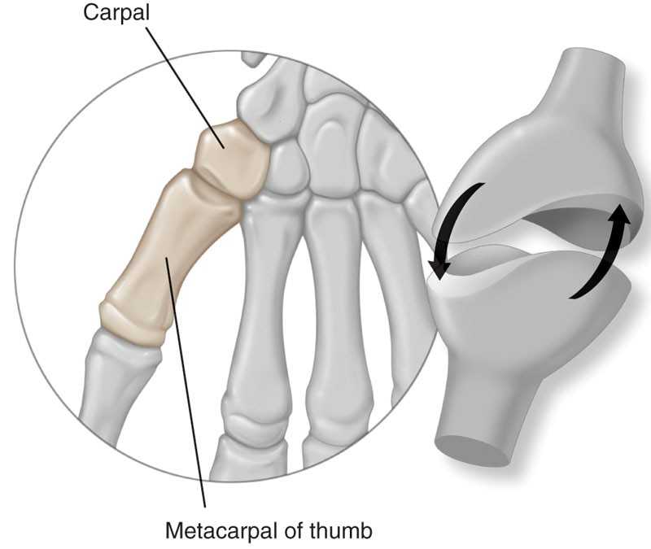

**Figure 5-30** Saddle joint example—thumb

Pivot joints allow movement in predominantly one direction. These joints are found in the atlantoaxial joint at the base of the skull (top of spine) and the proximal radioulnar joint at the elbow (Figure 5-31) (Floyd, 2018).

Ball-and-socket joints are the most mobile of the joints. They allow movement in all three directions. Examples of these joints are the shoulder and hip (Figure 5-32) (Floyd, 2018).

Nonsynovial joints are named as such because they have no joint capsule, fibrous connective tissue, or cartilage in the uniting structure. These joints exhibit little to no movement. An example of this joint includes sutures of the skull (Figure 5-33) (Hamill et al., 2015).

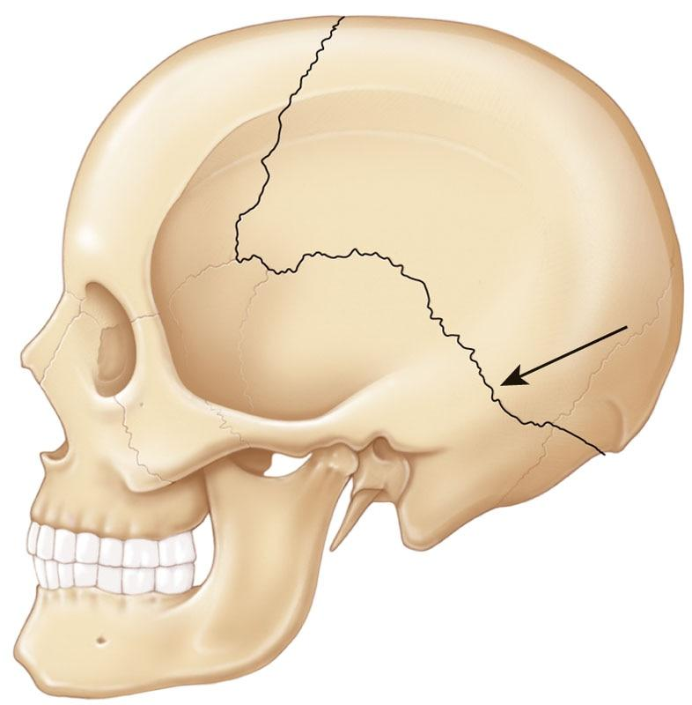

**Figure 5-33** Nonsynovial joint example—sutures of the skull

Function of joints

Joints serve numerous functional requirements of the musculoskeletal system. One of the most important functions joints serve is that they allow for motion and movement. Joints also provide stability, allowing for motion to take place without unwanted movement (Lee et al., 2017). All segments in the human body are linked together, which implies that movement of one joint directly affects the motion of others (Sueki et al., 2013). This is an essential concept for fitness professionals to understand because it creates an awareness of how the body functionally operates and is the foundational premise behind the concept of the kinetic chain (Karandikar & Vargas, 2011).

Joint connective tissue

The joints of the body have several different connective tissues that support the bone articulations of the joint. There are different tissues around a joint, such as tendons, that connect muscle to bone and ligaments that connect the articulating bones of a joint. Of particular interest to the fitness professional is the anatomy and function of ligaments in relation to musculoskeletal functioning.

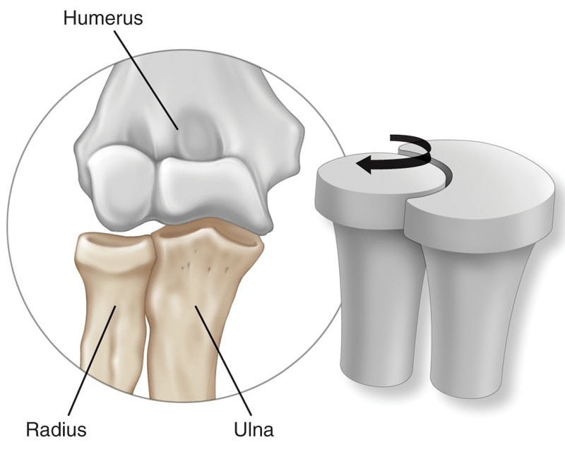

**Figure 5-31** Pivot joint example—radioulnar joint

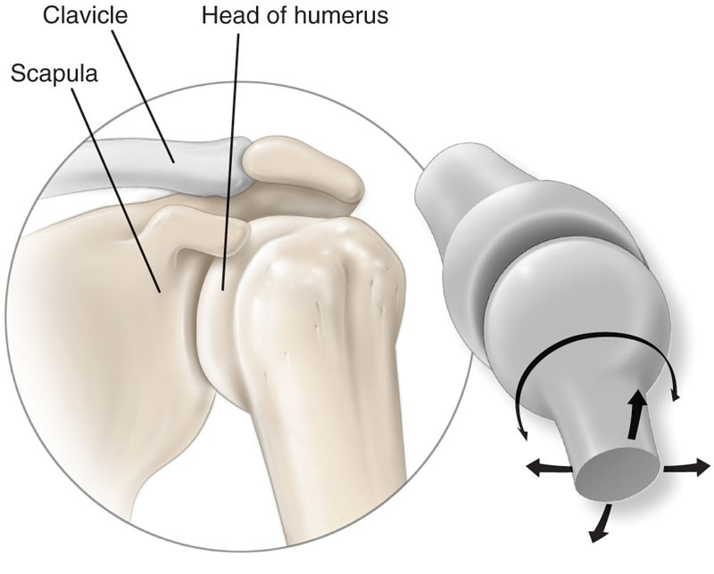

**Figure 5-32** Ball-and-socket joint example—shoulder

Ligaments are fibrous tissues that connect bone to bone and provide static and dynamic stability, as well as sensory input to the nervous system that aids proprioception (Figure 5-34) (Hamill et al., 2015). Ligaments are primarily made up of a protein called collagen with varying amounts of a second protein called elastin. Collagen fibers are situated in a more parallel fashion to the forces that are typically placed on the ligament. Thus, they provide the ligament with the ability to withstand tension (i.e., tensile strength).

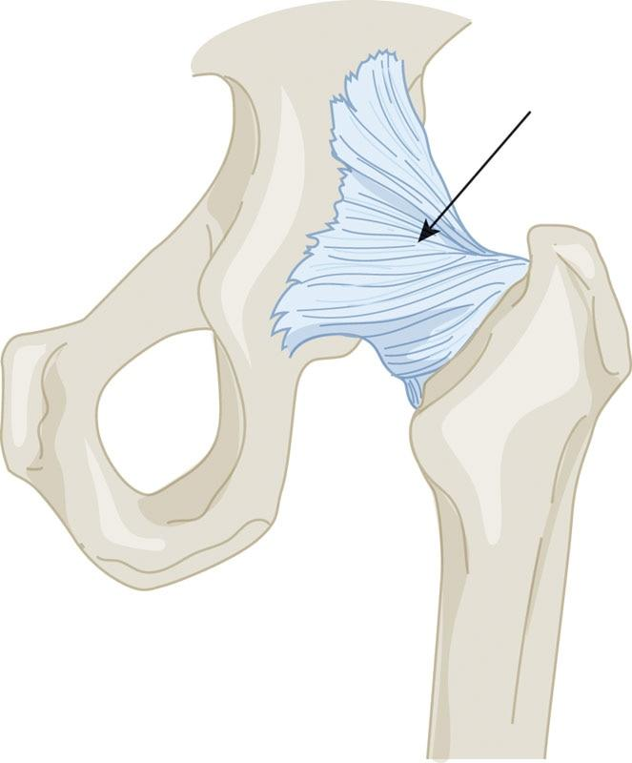

**Figure 5-34** Ligaments in the hip joint

Elastin gives a ligament some flexibility or elastic recoil to withstand the bending and twisting it may have to endure (Kenney et al., 2020). Not all ligaments will have the same amount of elastin; for example, the anterior cruciate ligament of the knee contains very little elastin and is predominantly composed of collagen. Because of this, it is much better suited for resisting strong forces and makes a good stabilizing structure of the knee. Finally, it is important to note that ligaments are characterized by having poor vascularity (or blood supply), meaning that ligaments do not heal or repair very well and may be slower to adapt to stresses placed on the body, such as stress caused by exercise (Hamill et al., 2015).

**Skeletal system life course**

During normal childhood and adolescence, the skeletal system undergoes many changes. Throughout aging, the bones get longer by way of the growth plate. The growth plate is a specialized cartilage disc located in the epiphysis that is responsible for longitudinal bone growth (i.e., bone length) (Figure 5-35).

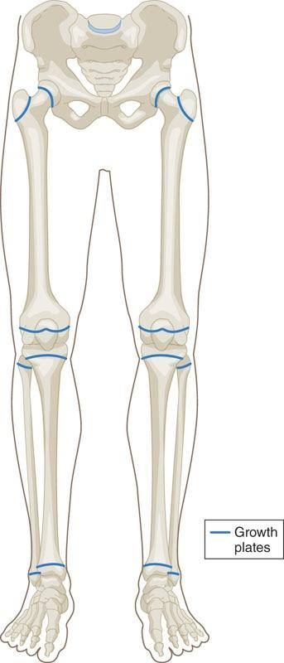

**Figure 5-35** Growth plates of the legs

Bones also get stronger and denser with age. Up to 90% of peak bone mass and size is ac-quired by age 18 years in women and age 20 years in men, with total peak bone mass being reached around age 30 years for both sexes (Lu et al., 2016). Skeletal bone mass is stable between ages 30 and 50 years with a decline after this age range.

Older individuals may be at risk for acquiring osteoporosis, which is a bone disease that causes severely low bone mass and a high risk for fractures (Lu et al., 2016). Factors affecting peak bone mass include environmental, dietary, hormonal, lifestyle, physical activity, and genetic influences (Levine, 2012).

**Exercise’s impact on bone mass**

The fitness professional can help a client with maintaining or improving bone mass through exercise, specifically resistance training and weight-bearing exercise (Qaseem et al., 2017). Current universal recommendations include regular weight-bearing and muscle-strengthening exercise to help improve agility, strength, posture, and balance. The goals are to improve bone strength and reduce the risk of falling for aging adults (Cosman et al., 2014; Qaseem et al., 2017). The fitness professional is encouraged to further research this topic using reliable sources, such as the National Osteoporosis Foundation, Osteoporosis Canada, Osteoporosis Australia, or the Royal Osteoporosis Society.

## Muscular system

The muscular system (Figure 5-36) links the nervous and skeletal systems and is responsible for generating the forces that move the human body. Muscles contract to create internal tension that, under the control of the nervous system, manipulates the bones to produce movements around the joints. The three types of muscles in the body are skeletal, cardiac, and smooth (Kenney et al., 2020). Cardiac muscle is what makes up the heart, and smooth muscle primarily makes up the tissues of internal organs. While each type is vital for the functioning of life itself, skeletal muscle holds the most importance for the fitness professional’s base of knowledge.

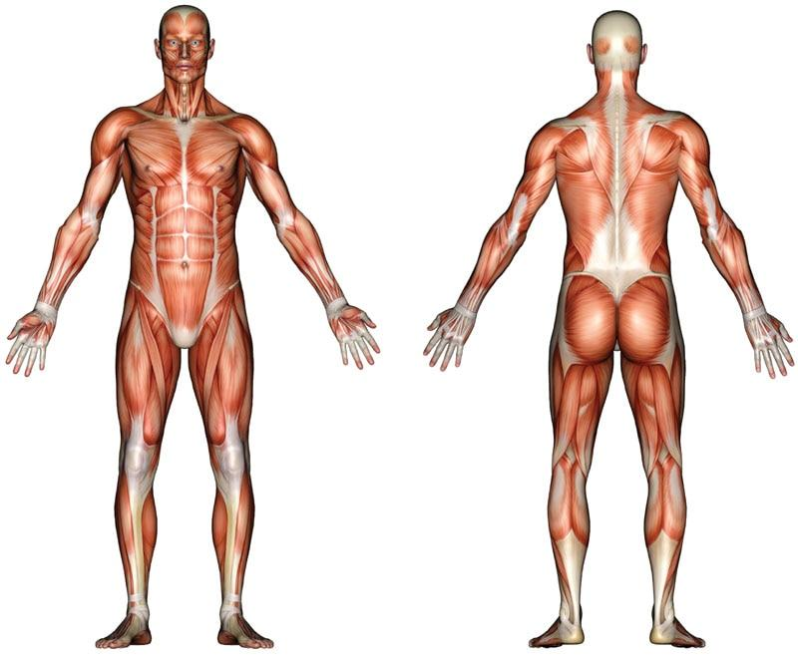

**Figure 5-36** The muscular system

**The structure of the skeletal muscle**

Skeletal muscle is made up of individual muscle fibres held together by connective tissues (Floyd, 2018; Hamill et al., 2015). The primary functions are to contract and produce movement, support the skeletal system, and assist with homeostasis of the body by producing heat. The anatomy of a muscle can be further broken down into layers from the outer surface to the innermost layer (Figure 5-37) (Frontera & Ochala, 2015).

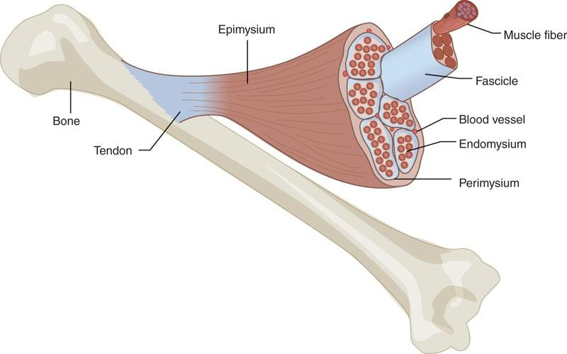

**Figure 5-37**Structures of skeletal muscle

The first layer is connective tissue called fascia. Fascia surrounds skeletal muscles and connects them to other surrounding muscles. The layer of fascia that directly surrounds an entire muscle is called the epimysium, which is also commonly referred to as the “deep fascia” (Frontera & Ochala, 2015). Within the muscle, the largest bundles of fibers are called fascicles. Similar to how epimysium wraps and contains the whole muscle, each fascicle is individually wrapped by connective tissue called perimysium. Each fascicle is made up of many individual muscle fibers that are bundled together by connective tissue called endomysium (Frontera & Ochala, 2015).

Connective tissues within the muscle play a vital role in movement. They allow the forces generated by the muscle to be transmitted from the contractile components of the muscle to the bones, creating motion. Connective tissue is what also allows muscles to work together as functional groups, such as the four quadricep muscles working together to extend the knee. Each layer of connective tissue extends the length of the muscle, coming together at the ends to help form the tendon and attach to bones (Krause et al., 2016).

HELPFUL HINT

Tendons Versus Ligaments

Tendons connect muscles to bones. Commonly discussed tendons include the Achilles tendon at the ankle and the patellar tendon of the knee. When a tendon is overstretched or torn, this is known as a strain.

Ligaments connect bones to bones. A commonly discussed ligament is the anterior cruciate ligament of the knee that connects the tibia to the femur. When a ligament is overstretched or torn, it is known as a sprain.

**Muscle fibres and their contractile elements**

Within the endomysium of the fascicles, individual muscle fibres are themselves encased by a plasma membrane known as the sarcolemma (Figure 5-38). Each individual muscle fibre contains cellular components, such as sarcoplasm, which contains glycogen, fats, minerals, and oxygen-binding myoglobin, and mitochondria, which transform energy from food into energy for the cells. Each individual muscle fibre is then made up of structures called myofibrils (Frontera & Ochala, 2015). It is within the myofibrils that the physiological processes of muscle contraction occur.

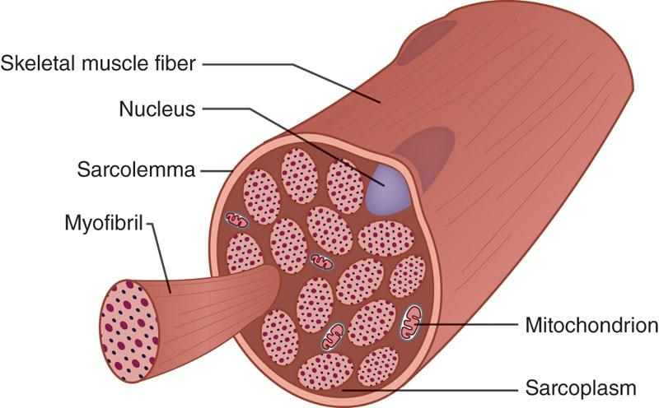

**Figure 5-38** Structure of a fascicle

Myofibrils are made up of overlapping myofilaments that are the actual contractile components of muscle tissue. These myofilaments are known as actin (thin, stringlike filaments) and myosin (thick filaments). The actin and myosin filaments form a number of repeating sections within the myofibrils. Each one of these particular repeating sections is known as a sarcomere (Figure 5-39) (Kenney et al., 2020).

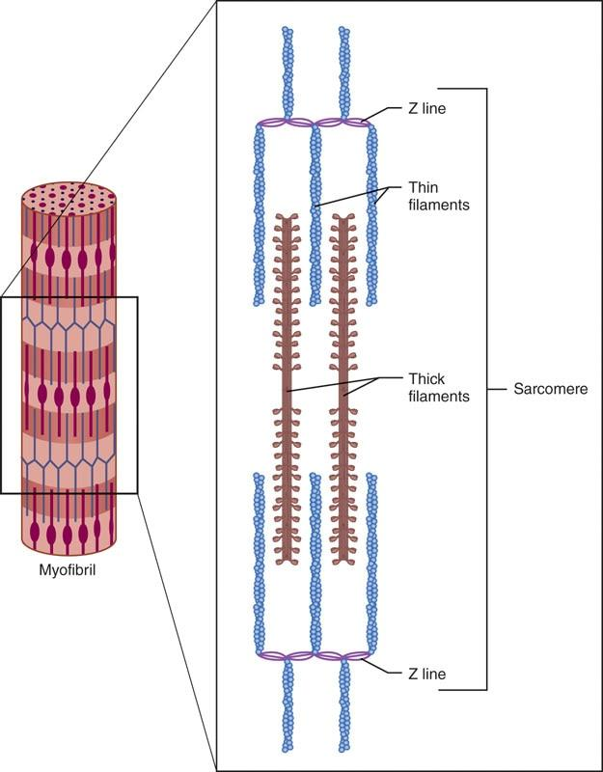

**Figure 5-39**Structure of a myofibril

A sarcomere is the functional unit of the muscular system, meaning it is the specific, physical site where muscle contraction occurs. The meeting point of each sarcomere is known as a Z-line, with each Z-line denoting another sarcomere along the myofibril (Frontera & Ochala, 2015).

HELPFUL HINT

Muscle Anatomy Flowchart

Muscle: bundle of fascicles surrounded by epimysium (deep fascia) connective tissue

↓

Fascicle: bundles of muscle fibers surrounded by perimysium connective tissue

↓

Muscle fiber: a bundle of myofibrils surrounded by endomysium connective tissue

↓

Myofibril: a collection of repeating sarcomeres that contain myofilaments (actin and myosin)

↓

Sarcomere: a section of a myofibril between two Z-lines where muscle contraction physically occurs

↓

Myofilament: the individual protein structures, actin and myosin, that make up a myofibril

GETTING TECHNICAL

Two protein structures that are also important to muscle contraction are tropomyosin and troponin. Tropomyosin is located on the actin filament and blocks myosin-binding sites located on the actin filament, keeping myosin from attaching to actin when the muscle is in a relaxed state. Troponin, also located on the actin filament, plays a role in muscle contraction by providing binding sites for both calcium and tropomyosin when a muscle needs to contract (Kenney et al., 2020).

**Neural activation**

Skeletal muscles will not contract unless they are stimulated to do so by motor neurons. Neural activation represents the communication link between the nervous system and the muscular system. The nervous system communicates with muscle fibres through a specialized site called the neuromuscular junction (Figure 5-40). This junction is actually a small gap between the motor neuron and muscle cells known as a synapse. One motor neuron and the muscle fibres it innervates with (i.e., connects to) are known as a motor unit (Kenney et al., 2020).

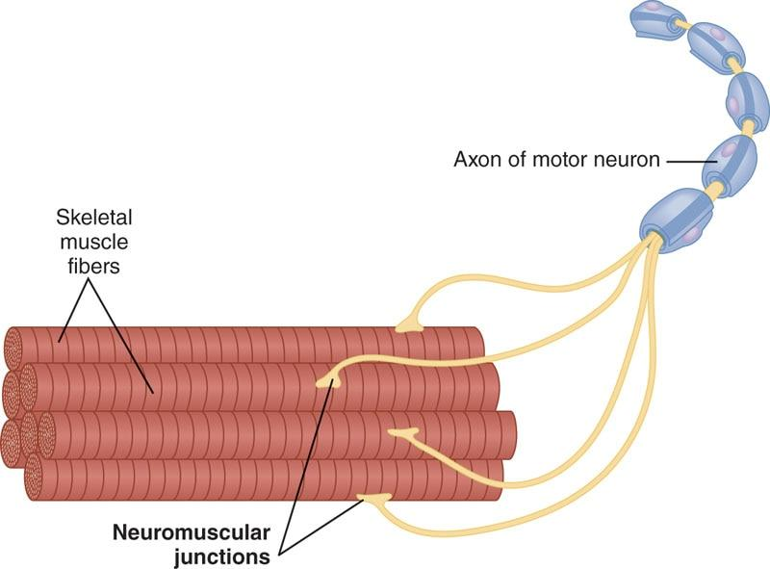

**Figure 5-40** Neuromuscular junctions

**Action potential**

The action potential is a nerve impulse that is relayed from the central nervous system, through the peripheral nervous system, and into the muscle across the neuromuscular junction. As mentioned in the prior section, the electrolytes sodium and potassium help relay the impulse down the nerves to the neuromuscular junction.

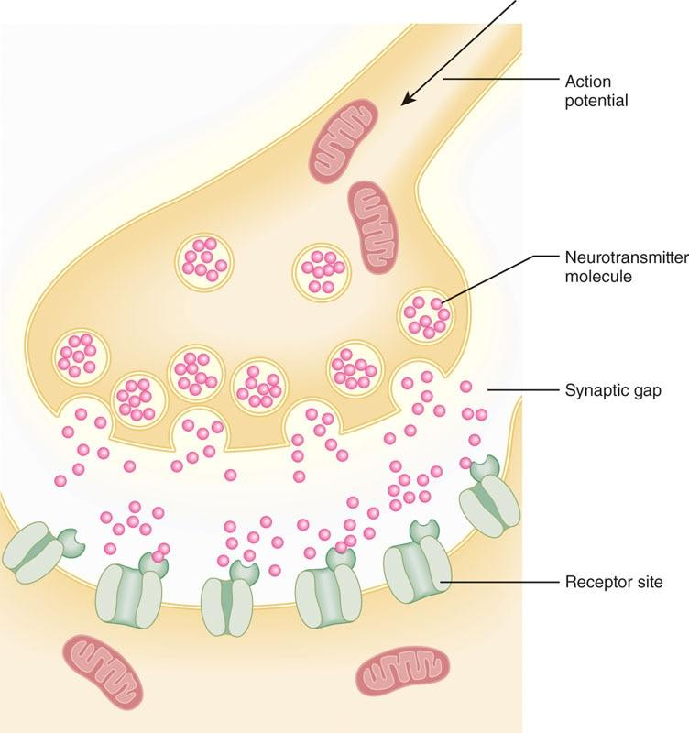

**Figure 5-41** Synapse between neuron and muscle

When that action potential reaches the junction, neurotransmitters, which are chemical messengers that cross the synapse between neuron and muscle, are released into the gap (Figure 5-41) (Raiteri et al., 2002).

Essentially, neurotransmitters represent the translation of the nervous system’s electrical message into a form the muscle cells can understand and act on. Once neurotransmitters are released, they bind with receptor sites on the muscle fibre specifically designed for their attachment. Acetylcholine (ACh) is a neurotransmitter used by the neuromuscular system. Once acetylcholine is released in the gap, it helps the action potential cross the synapse into the muscle, which initiates the steps in a muscle contraction (Mori, 2014).

**Sliding filament theory**

A muscle contraction is a shortening of the sarcomeres, which contain actin and myosin myofilaments. The sliding ﬁlament theory further describes how myosin (thick) and actin (thin) filaments slide past one another to produce a muscle contraction, shortening the entire length of the sarcomere and, concurrently, the muscle as a whole (Figure 5-42).

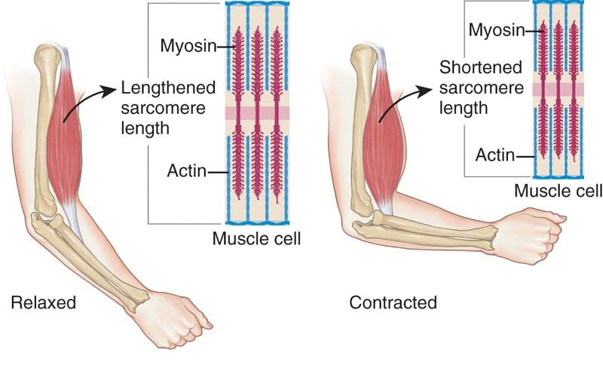

**Figure 5-42** Sliding filament theory

The steps in the muscle contraction are accomplished through a physiological process called excitation-contraction coupling (Figure 5-43) (Mackrill & Shiels, 2020).

1. The nerve impulse begins in the CNS and travels down the motor neuron, which is facilitated by sodium and potassium electrolytes, to the neuromuscular junction.
2. Acetylcholine is released into the neuromuscular junction, which then helps the nerve impulse cross the synapse into the muscle.
3. The nerve impulse travels into the muscle infrastructure stimulating a small organ called the sarcoplasmic reticulum to release the electrolyte calcium (Frontera & Ochala, 2015).
4. Calcium is then released into the muscle, stimulating a chain of events that results in the myosin heads binding to actin.
5. The myosin heads then pull the actin toward the sarcomere center, which slides the overlapping filaments past each other, shortening the entire muscle.

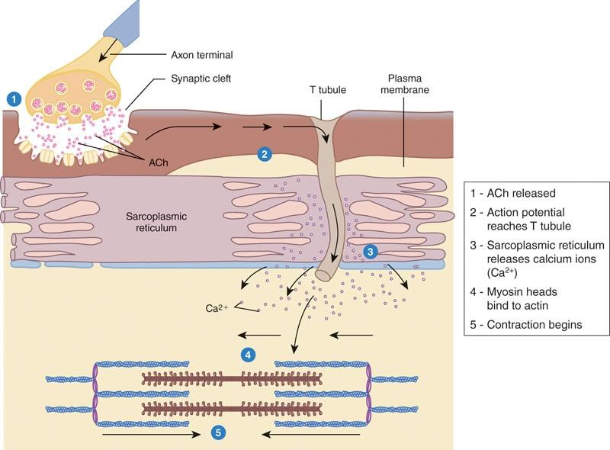

**Figure 5-43** Excitation-contraction coupling

The overlapping action of the actin and myosin filaments is called the power stroke, which uses the molecule adenosine triphosphate (ATP) to provide energy to the myosin heads. After the power stroke ends, the myosin detach and move back to their original position, known as their resting length. Once the action potential from the CNS stops, the muscle becomes relaxed and resets itself in preparation for the next impulse from the CNS (Mackrill & Shiels, 2020; Rebbeck et al., 2014).

HELPFUL HINT

The two major principles in sliding filament theory include the following:

1. A sarcomere shortens as a result of the Z-lines moving closer together (i.e., converging).
2. The Z-lines converge as the result of myosin filaments’ heads attaching to the actin filament’s heads, pulling the actin across the myosin, resulting in shortening of the muscle fiber.

STRETCH YOUR KNOWLEDGE

The body needs different electrolytes to help perform different muscle functions. The most essential electrolytes for muscle function include calcium, potassium, sodium, and water (Pollock et al., 2014). Calcium helps stimulate actin and myosin activity inside the muscle, and potassium and sodium help transmit the motor signal down the nerve axon. Water, which is electrically conductive, can be considered the main electrolyte of the body because it is involved in most scenarios of bodily function (Kenney et al., 2020). All these essential electrolytes can be found in the foods that we eat or achieved through supplementation. Electrolyte or water imbalance may lead to exercise-associated muscle cramps (Harris & Braun, 2017).

**Motor units and the all-or-nothing principle**

Recall that muscles are functionally divided into motor units, with a single motor unit consisting of one motor neuron and the muscle fibres it innervates. There are small and large motor units (Frontera & Ochala, 2015). Small motor units, which are more fatigue resistant and innervate small muscle fibers known as type I, contract slowly and generate relatively small forces. This is especially important for activities that require sustained muscle contractions, such as the maintenance of an upright posture. Smaller muscles with the primary purpose of stabilizing the body are mostly made up of type I muscle fibers.

Large motor units, which are faster to fatigue and innervate larger muscles fibres known as type II, generate more force more quickly than small motor units. This is especially important for physical activities that require large forces, such as running or jumping (Kenney et al., 2020). Big muscles that have the primary function of moving the body tend to have more type II muscle fibres than smaller muscles. These motor units are associated with specific muscle fibre types that are discussed in the next section.

If a nerve impulse is strong enough to trigger an action potential, then it will spread through the whole length of the muscle fibre. More specifically, it will spread through all the muscle fibres supplied by a single nerve. Conversely, if the stimulus is not strong enough, then there will be no action potential and no muscle contraction. This is known as the all-or-nothing principle (Pareti, 2007).

Motor units cannot vary the amount of force they generate; they either contract maximally or not at all. This is why the principle is named *all-or-nothing*. As a result of the all-or-nothing principle, the overall strength of a skeletal muscle contraction will depend on the type of motor unit recruited (i.e., whether the unit is larger or smaller) and the overall number of motor units that are activated at a given time (Pareti, 2007).

It should also be understood that the type of motor units making up a particular muscle will relate directly to the function of that muscle (Floyd, 2018). Muscles involved with fine motor control (e.g., muscles that control the eyes or the fingers) will have fewer fibres per motor unit. Conversely, muscles involved in big, powerful movements will have more fibres per motor unit (e.g., the quadriceps during a squat exercise) (Mackrill & Shiels, 2020; Rebbeck et al., 2014).

**Muscle fibre types**

The two main categories of muscle fibres—type I and type II—vary in their chemical and mechanical properties (Table 5-3) (Wilson et al., 2012). Type I muscle fibres are slower to produce maximal tension and more resistant to fatigue, which is why they are commonly referred to as “slow-twitch” muscle fibres. Conversely, type II are fast to produce tension but fatigue quickly, which is why they are commonly referred to as “fast-twitch” muscle fibres (Joumaa et al., 2015).

TABLE 5-3 Muscle Fiber Types

|  | **Characteristic** |
| --- | --- |
| Type I | More capillaries, mitochondria, and myoglobin |
| Increased oxygen delivery |
| Smaller in size |
| Less force produced |
| Slow to fatigue |
| Long-term contractions (stabilization) |
| “Slow twitch” |
| Type II | Fewer capillaries, mitochondria, and myoglobin |
| Decreased oxygen delivery |
| Larger in size |
| More force produced |
| Quick to fatigue |
| Short-term contractions (force and power) |
| “Fast twitch” |

Type I muscle fibres are smaller in size than type II but contain a large number of capillaries, mitochondria, and myoglobin, which allows for improved delivery of oxygen and leads to fatigue more slowly. Myoglobin is similar to haemoglobin—the red, oxygen-carrying pigment found in red blood cells—therefore, type I muscle fibres are often referred to as “red fibres” (Wilson et al., 2012). Type I fibres are important for muscles that need to produce long-term contractions necessary for stabilization and postural control (e.g., the deep musculature of the spine) (Moore et al., 2018; Wilson et al., 2012).

Type II muscle fibres are larger in size and produce maximal tension faster than type I fibres. Generally, type II fibres contain fewer capillaries, mitochondria, and myoglobin. Because of the limited myoglobin, they have a low oxidative capacity, are quick to fatigue, and are often referred to as “white fibres” (Wilson et al., 2012). These fibres are important for muscles that produce movements requiring high levels of force and power, such as the quadriceps when sprinting (Brunner et al., 2007).

It is important to note that all muscles have varying combinations of both type I and II fibres. Concentrations of each will vary depending on the function of the muscle and genetics. For example, within the calf complex, it has been shown that the soleus muscle is mostly made up of type I muscle fibres, whereas the gastrocnemius has a majority of type II fibres (Balius et al., 2013; Edgerton et al., 1975).

GETTING TECHNICAL

Type IIa and IIx Muscle Fibers

Type II muscle fibres are subdivided into type IIa and type IIx based on their chemical and mechanical properties. Type IIx muscle fibres have a lower oxidative capacity and fatigue very quickly. Type IIa muscle fibres have a higher oxidative capacity and fatigue more slowly than type IIx but still fatigue much faster than type I fibres (Kenney et al., 2020).

Because of this, type IIa fibres are commonly known as “intermediate fast-twitch fibres.” They can use both aerobic and anaerobic metabolism almost equally to create energy (metabolism is discussed in more detail in Chapter 8). Essentially, type IIa fibers represent the middle ground between “slow-twitch” type I fibres and “fast-twitch” type IIx fibres (Wilson et al., 2012).

**Muscular system life course**

From childhood to adolescence to adulthood, the muscular system continues to develop and grow, with peak mass, power, and strength occurring between 20 and 30 years of age (Keller & Engelhardt, 2014). Changes in muscle mass, power, and strength are small from ages 30 to 50 years. However, after age 50 years, muscle mass is lost by an average of 1–2% per year and strength is lost by about 1.5–5% per year (Keller & Engelhardt, 2014). Resistance training can be highly beneficial for combating the loss of muscle mass, power, and strength for aging adults (Fragala et al., 2019).

## The cardiorespiratory system

The cardiorespiratory system represents the functional combination of two closely related systems (Figure 6-1):

* The cardiovascular system (i.e., the heart, blood vessels, and blood)
* The respiratory system (i.e., the airways and the lungs)

These systems work together to provide the body with adequate oxygen (O2), deliver nutrients, and remove waste products, such as carbon dioxide (CO2), from cells in the body (Brooks, 2000; Fox, 2006; Reid et al., 2014; Vander et al., 2003). Efficient functioning of the cardiorespiratory system is essential for virtually every component of health and fitness, especially as it relates to exercise and athletic performance. Therefore, fitness professionals require a foundational understanding of this vital component of the body and how it works.

### The cardiovascular system

The cardiovascular system is composed of the heart, blood, and blood vessels that transport blood to and from the heart and tissues of the body (Figure 6-2). This is one of many systems that regulate the human body and all of its necessary survival functions.

**The heart**

The heart is a muscular pump that rhythmically contracts to push blood throughout the body. It is positioned obliquely in the center of the thoracic cavity, lying anteriorly (in front) to the spine and posteriorly (behind) and slightly to the left of the sternum (breastbone) (Reid et al., 2014).

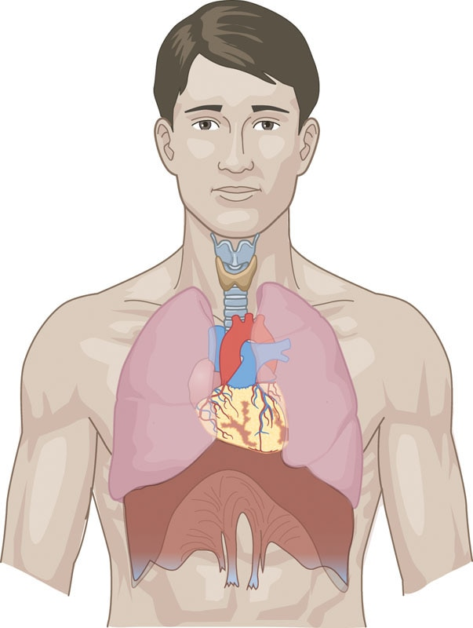

**Figure 6-1** The cardiorespiratory system

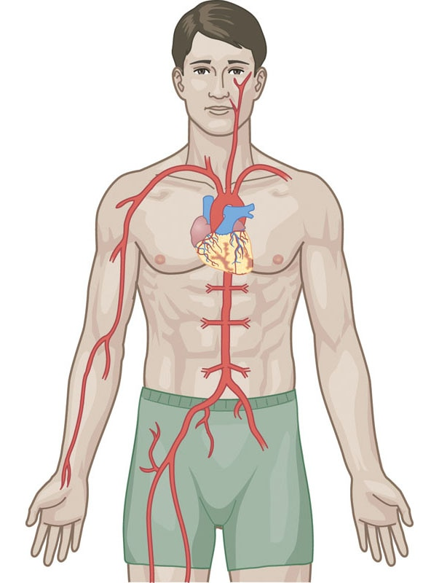

**Figure 6-2** The cardiovascular system

The left and right lungs lie on each side of the heart (Swain, 2014). The heart is contained in the area of the chest known as the mediastinum (Tortora, 2008), is approximately the size of a typical adult fist, and weighs roughly 300 grams or approximately 10 ounces (Swain, 2014; Tortora, 2008).

Cardiac muscle is one of three major types of muscle found in the human body; the other types are skeletal muscle and smooth muscle. Cardiac muscle is similar to skeletal muscle in that cardiac muscle cells contain myofibrils and sarcomeres aligned side by side, which give them their striated appearance (Brooks, 2000; Fox, 2006; Vander et al., 2003). However, while skeletal muscle is voluntary muscle, cardiac muscle is involuntary muscle, which typically cannot be consciously controlled.

Structure of the heart

The heart is composed of four hollow chambers that are delineated into two interdependent (but separate) pumps on either side. Each side of the heart has two chambers: an atrium and a ventricle (Fox, 2006; Tortora, 2008; Vander et al., 2003). The right side of the heart is referred to as the pulmonic side (*pulmonary* means “related to the lungs”) because it receives blood from the body that is low in oxygen and high in carbon dioxide—often referred to as deoxygenated blood. The deoxygenated blood is then pumped to the lungs to be saturated with oxygen.

The left side of the heart is referred to as the systemic side because it has received oxygenated blood from the lungs that is high in oxygen and low in carbon dioxide, which it then pumps out to the rest of the body. Figure 6-3 illustrates both sides of the heart, with the blue side representing the pulmonary side and the red side representing the systemic side.

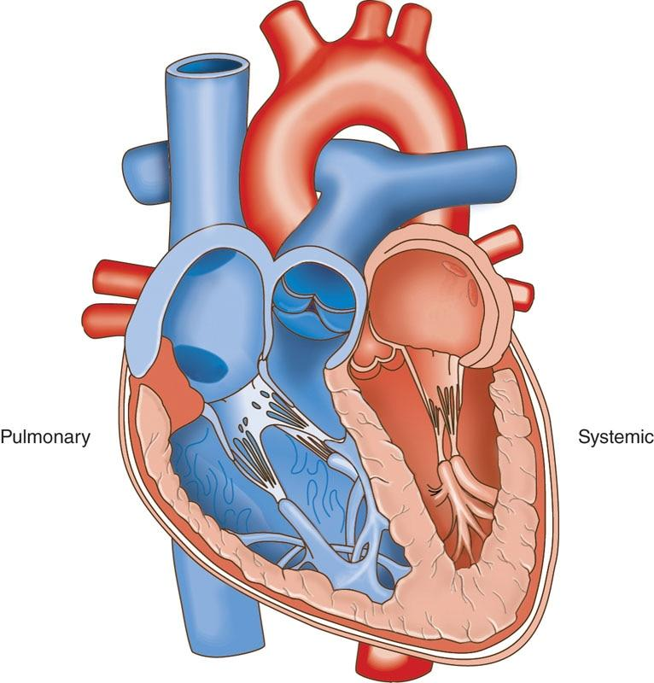

**Figure 6-3** Pulmonary and systemic sides of the heart

STRETCH YOUR KNOWLEDGE

Anatomical images are typically displayed as if the reader is looking at another person from the front, not as if the reader is looking into a mirror. For that reason, remember that the right side of an anatomy image, as it is viewed in a book or on the screen, actually represents the left side of a person’s body.

The atria are smaller chambers, located superiorly (on top) on either side of the heart. They gather blood returning to the heart and act much like a reservoir. The right atrium gathers deoxygenated blood returning to the heart from the body, whereas the left atrium gathers oxygenated blood coming to the heart from the lungs.

The ventricles are larger chambers located inferiorly (on the bottom) on either side of the heart. The right ventricle receives the deoxygenated blood from the right atrium and then pumps it to the lungs through the pulmonary artery to be saturated with incoming oxygen. The right ventricle has thin walls and pumps under low pressure because it only needs to pump blood a short distance to the lungs.

Once the lungs oxygenate the blood, it passes through the pulmonary vein to the left atrium. The left ventricle receives the oxygenated blood from the left atrium and proceeds to pump it through the entire body. The left ventricle has thicker walls and pumps under high pressure because it pumps blood a greater distance, out to the rest of the body. Each chamber of the heart is separated from one another via one-way valves to prevent a backflow or spillage of blood back into the chambers. Figure 6-4 illustrates how deoxygenated and oxygenated blood flows through the heart.

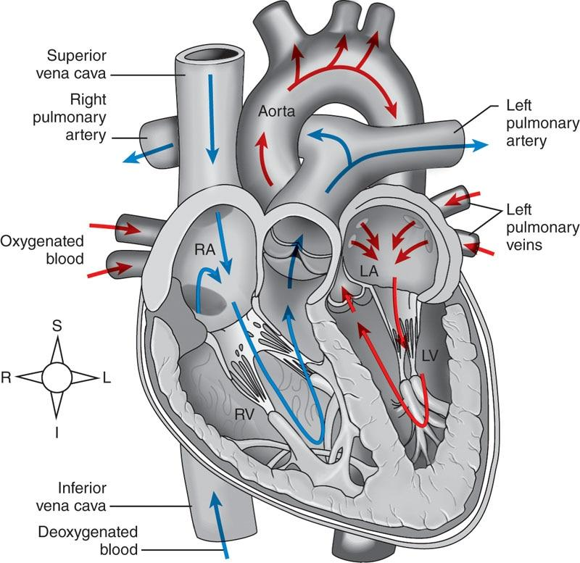

**Figure 6-4**The path of blood through the heart

HELPFUL HINT

To help remember the positioning of the heart’s chambers and the path of blood flow through them, remember the following phrases:

* “A comes before V in the alphabet”—This signifies that blood will first flow into the Atria on top, then down to the Ventricles to be pumped out to either the lungs or body.
* “Right returns and left leaves”—This signifies that the right-side chambers collect returning deoxygenated blood from the body (right atrium) and send it to the lungs (right ventricle), while the left-side chambers collect oxygenated blood that has left the lungs (left atrium) and send it out to the body (left ventricle).

Cardiac muscle contraction

Cardiac muscle fibres are shorter and more tightly connected than skeletal muscle. Another unique feature of cardiac muscle is the presence of irregularly spaced dark bands between cardiac cells called intercalated discs. Intercalated discs help hold cardiac muscle cells together during contraction and create an electrical connection between the cells, which allows the heart to contract as one functional unit.

The heart has its own built-in conduction system that rapidly sends an electrical signal throughout all the cardiac cells (Brooks, 2000; Fox, 2006; McArdle et al., 2016; Vander et al., 2003). A resting heart rate (RHR), also known as a pulse, means the number of times the heart contracts per minute while at rest. Resting heart rate ranges can vary dramatically depending on the age, size, gender, health status, and fitness level of the individual.

Generally speaking, resting heart rates for most of the population are between 60 and 100 beats per minute (Brooks, 2000; Fox, 2006; Reid et al., 2014; Tortora, 2008; Vander et al., 2003). The body will increase its heart rate in response to exercise or physical activity and will lower its heart rate during deep sleep (Naves et al., 2019; Reid et al., 2014).

GETTING TECHNICAL

Some well-conditioned athletes or clients who participate in endurance training or yoga may have a slower than normal resting heart rate (e.g., 40 to 60 beats per minute) as a result of those activities improving the heart’s ability to pump blood (Reimers et al., 2018).

The electrical conduction system of the heart consists of specialized cells that allow an electrical signal to be transmitted from the sinoatrial (SA) node through both atria and down into the ventricles (Figure 6-5). Thus, the electrical conduction system of the heart stimulates the myocardial (heart) cells to contract in a regular rhythmic pattern, often referred to as normal sinus rhythm (Brooks, 2000; Fox, 2006; Swain, 2014; Tortora, 2008; Vander et al., 2003).

The SA node, located in the right atrium, is referred to as “the pacemaker of the heart” because it initiates the electrical signal that causes the heart to beat. The internodal pathways transfer the impulse from the SA node to the atrioventricular (AV) node. The AV node is located between the atria and ventricles and delays the impulse before allowing it to move on to the ventricles. The delay in impulse allows the ventricles to fill with blood from the atria prior to contracting.

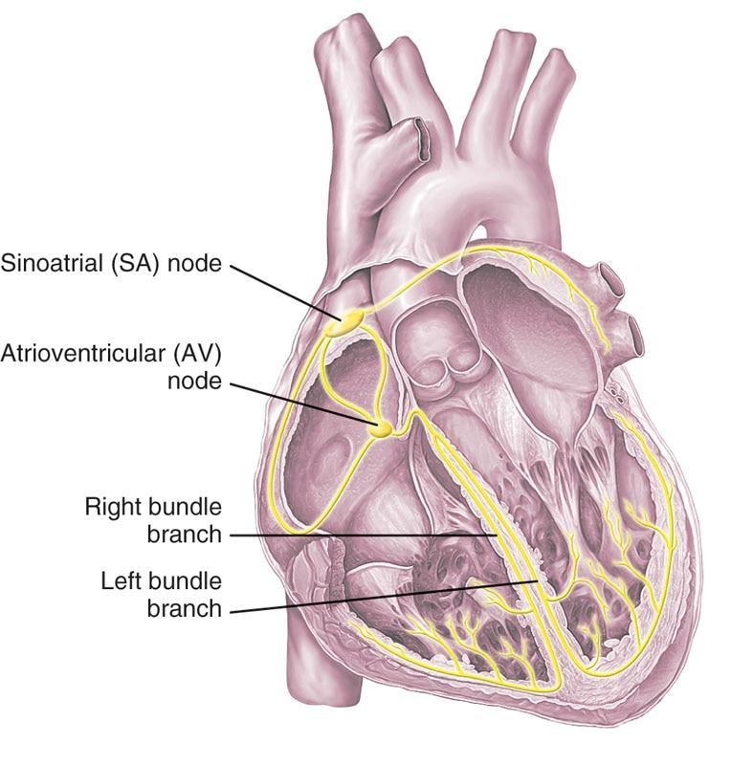

**Figure 6-5**Conduction system of the heart

STRETCH YOUR KNOWLEDGE

When the heart’s conduction system is not working properly, an electrical device called a pacemaker is surgically implanted into the chest under the skin. The pacemaker is smaller than the size of a fist and has one or more wires that control the heart’s conduction system based on the individual’s needs (Goodman & Fuller, 2015).

Function of the heart

The amount of blood pumped out of the heart with each contraction is referred to as stroke volume. The stroke volume is the difference between the ventricular end-diastolic volume and the end-systolic volume. The end-diastolic volume is the filled volume of blood in the ventricle before contraction, and the end-systolic volume is the residual volume of blood remaining in the ventricle after ejection. In a typical heart, the end-diastolic volume is about 120 mL of blood, and the end-systolic volume is about 50 mL of blood. The difference in these two volumes, 70 mL, represents the stroke volume (Brooks, 2000; Fox, 2006; Vander et al., 2003).

The rate with which the heart beats is referred to as the heart rate (HR). Recall, an average resting heart rate for an untrained adult is approximately 60 to 100 beats per minute (BPM) (Brooks, 2000; Fox, 2006; Hicks, 2000; Vander et al., 2003). Levels below 60 BPM are referred to as bradycardia and levels over 100 BPM are referred to as tachycardia (Reid et al., 2014). Cardiac output (Q) is the volume of blood pumped by the heart per minute (mL blood/min). Cardiac output is a function of heart rate and stroke volume. While cardiac output at rest is about 5 L/min, it may increase to as high as 30 L/min during vigorous exercise (Reid et al., 2014).

GETTING TECHNICAL

If an average person has a resting heart rate of 70 BPM and a resting stroke volume of 70 mL/beat, cardiac output at rest would be 70 BPM × 70 mL/beat = 4,900 mL/min (or 4.9 L/min).

The increase in cardiac output may be the result of an increase in stroke volume or heart rate. During exercise, it is likely for both heart rate and stroke volume to increase. However, a favorable adaptation to exercise seen in endurance athletes includes an increase in stroke volume over time, which allows the heart to maintain the same level of circulation at a lower heart rate. Monitoring the heart rate during exercise provides a good estimate of the amount of work the heart is doing at any given time (Brooks, 2000; Swain, 2014). Figure 6-6 illustrates the procedure for manually monitoring the heart rate.

Another common procedure used to monitor the heart rate is with a heart rate monitor, which is worn on the body and automatically derives the BPM. While these monitors are sometimes strapped around the chest, more frequently, they are integrated into smartwatches and other wearable technologies. There is even a body of evidence suggesting that smartphone apps (on devices equipped with a biometric fingertip scanner) may be a valid tool for measuring heart rate when compared with chest straps and other medical-monitoring devices (Cheatham et al., 2015; Reid, 2014). Conversely, face scan capabilities, which are currently available on some modern smartphones, have not been shown to offer accurate heart rate measurements and are not recommended for use at this time (Cheatham, 2015).

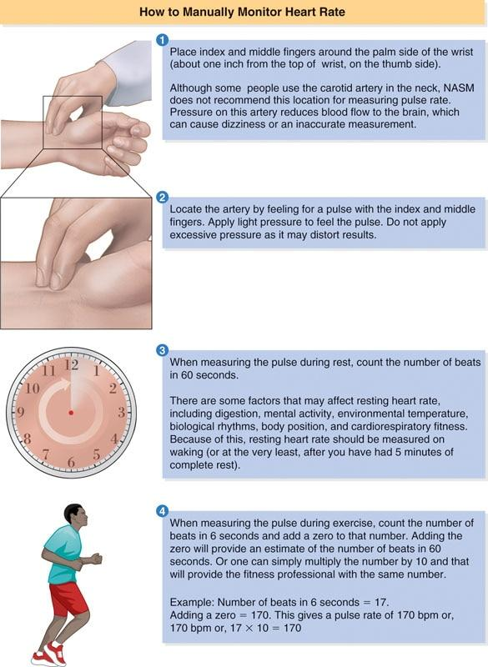

**Figure 6-6** How to manually monitor heart rate

GETTING TECHNICAL

Recall from Chapter 5 that the autonomic nervous system is divided into two subsystems: the sympathetic and parasympathetic nervous systems. The sympathetic nervous system is responsible for increasing neuromuscular activation for activity, whereas the parasympathetic nervous system is responsible for reducing neuromuscular activation needed for rest, digestion, and recovery. In that light, the heart is very similar to skeletal muscle.

During exercise, the sympathetic nervous system sends signals to the heart to increase the rate of conduction to meet the oxygen demands of the body; meanwhile, the parasympathetic nervous system is responsible for slowing the rate of conduction as activity intensity is reduced (Reid et al., 2014).

STRETCH YOUR KNOWLEDGE

Heart sounds heard through a stethoscope during a medical cardiac assessment reflect the functioning of the valves. Abnormal sounds may be referred to as a heart murmur (Reid et al., 2014).

**Blood**

Blood is a unique life-sustaining fluid that supplies the body’s organs and cells with oxygen and nutrients and helps regulate body temperature, fight infections, and remove waste products (Fox, 2006; Hicks, 2000; Vander et al., 2003). Blood consists of cells suspended in a watery liquid called plasma, which also contains nutrients such as glucose (sugar), lipids (fat), proteins, hormones, clotting agents, and other vital molecules.

There are three kinds of cells in the blood: red blood cells, white blood cells, and platelets. Red blood cells carry oxygen from the lungs throughout the body, white blood cells help fight infections, and platelets help with clotting. Platelets also contain numerous growth factors, which may be responsible for healing after an injury.

Plasma makes up about 55% of the total volume of the blood, and the remaining 45% is made up of cellular material (e.g., red blood cells, white blood cells, and platelets). The average adult holds between 4 and 6 liters of blood in his or her body (Brooks, 2000; Fox, 2006; Hicks, 2000; Vander et al., 2003). Blood is a vital support mechanism, which provides an internal transportation, regulation, and protection system for the human body (Table 6-1).

TABLE 6-1 Support Mechanisms of Blood

| **Mechanism** | **Function** |
| --- | --- |
| Transportation | Transports oxygen and nutrients to tissues |
| Transports waste products from tissues |
| Transports hormones, growth factors, and stem cells to organs and tissues |
| Carries heat throughout the body |
| Regulation | Regulates body temperature and acid balance in the body |
| Protection | Protects the body from excessive bleeding by clotting |
| Contains specialized immune cells to help fight disease and sickness |

Transportation

Blood transports life-sustaining oxygen to all bodily tissues and transports waste products to other regions of the body (Fox, 2006; Hicks, 2000; Vander et al., 2003). Blood also stores, protects, and transports hormones to parts of the body where they exert their effects.

STRETCH YOUR KNOWLEDGE

Clients who take daily aspirin or medications that are classified as blood thinners or anticoagulants may not have the same clotting ability as other clients. These clients are more likely to bruise from certain interventions, such as foam rolling or massage.

Additionally, blood transports nutrients from the gastrointestinal tract to various organs and tissues throughout the body (Fox, 2006; Hicks, 2000; Vander et al., 2003). Last but not least, blood stores and transports cells that help the body heal when injured, such as stem cells (Villaron et al., 2004).

Regulation

Blood helps regulate body temperature by transferring heat to and from the internal core and the periphery of the body as it circulates. As blood travels close to the skin, it can be either heated or cooled depending on the external environment (Brooks, 2000; Fox, 2006; Tortora, 2008; Vander et al., 2003). If the external environment is colder than circulating blood, body heat will be lost, and vice versa.

Blood is also essential in regulating pH levels (acid balance) in the body as well as maintaining the water content of body cells (Tortora, 2008). With regard to pH levels, blood is only one of the many buffering systems used by the body to maintain a normal range. Other systems that help manage the body’s pH levels include the respiratory and renal (kidney/ urinary) systems.

Protection

Blood provides protection from excessive blood loss through its clotting mechanism (e.g., platelets), which seals off damaged tissue and forms a scar (Fox, 2006; Hicks, 2000; Vander et al., 2003). It also provides specialized immune cells to fight against foreign toxins within the body, which help reduce the risk of disease and illness (Brooks, 2000; Fox, 2006; Hicks, 2000; Vander et al., 2003).

**Blood vessels**

Blood vessels form a closed circuit of hollow tubes that allows blood to be transported to and from the heart (Figure 6-7). There are three major types of blood vessels: arteries, which carry the blood away from the heart; capillaries, which are the exchange sites of water and chemicals between the blood and the tissues; and veins, which carry blood back to the heart (Fox, 2006; Swain, 2014; Tortora, 2008; Vander et al., 2003).

Arteries

The largest artery in the body is the aorta, which carries blood away from the heart (Swain, 2014; Tortora, 2008). The branches of the aorta include medium-sized arteries: the carotid artery (supplies blood to the brain via the neck), the subclavian artery (supplies blood to both arms), the mesenteric arteries (supply blood to the digestive system), the renal artery (supplies blood to both kidneys), and the iliac artery (supplies blood to pelvic and reproductive organs) (Fox, 2006; Hicks, 2000; Swain, 2014; Tortora, 2008; Vander et al., 2003).

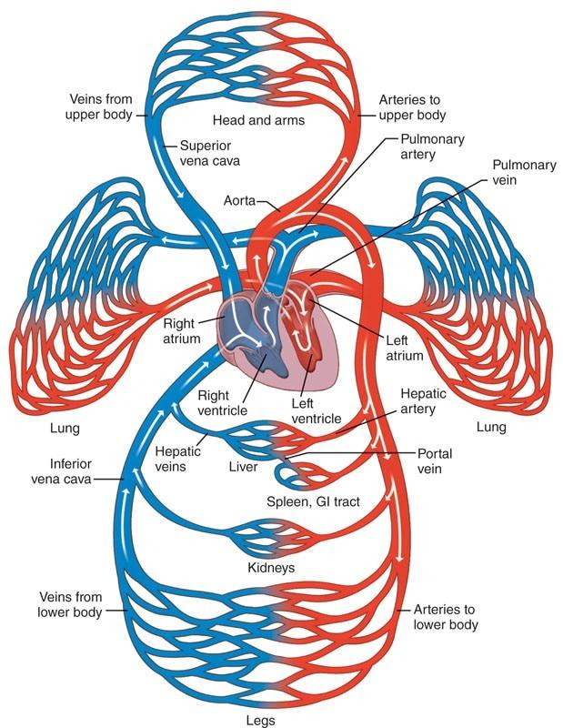

**Figure 6-7** Blood vessels

These medium-sized arteries further divide into smaller arteries that are called arterioles and eventually into microscopic vessels known as capillaries (Fox, 2006; Swain, 2014; Tortora, 2008; Vander et al., 2003).

Capillaries

Capillaries are the smallest blood vessels in the body. They serve as a connection point where arterioles transition to venules and as the sites of element exchange between the blood and the body tissues (Fox, 2006; Tortora, 2008; Vander et al., 2003). Some substances, such as water, can both enter and exit the capillaries. Other substances can only enter the capillaries from body tissues, such as carbon dioxide, and some can only exit the capillaries into body tissues, such as glucose and oxygen. The term vasculogenesis is used to describe the formation of new capillaries, whereas the term angiogenesis is used to describe the formation of new capillaries from existing vessels. Growth factors from the platelets assist with both angiogenesis and vasculogenesis (Kolber et al., 2018).

Veins

Vessels that collect blood from the capillaries are called venules (Brooks, 2000; Fox, 2006; Hicks, 2000; Tortora, 2008; Vander et al., 2003). Capillaries merge to form venules, which progressively merge to form the larger veins. Veins then transport all of the blood from the body back to the heart (Fox, 2006; Vander et al., 2003; Tortora, 2008). The walls of the veins are capable of holding large amounts of blood, and blood flow through the veins is assisted either by the contraction of skeletal muscle or by the contraction of smooth muscle along the veins (Reid et al., 2014). As blood passes from the extremity veins toward the heart, special valves prevent a backflow of blood (Goodman, 2015).

HELPFUL HINT

Arteries (large vessels) and arterioles (medium vessels) carry oxygenated blood away from the heart to the rest of the body. The exception is the pulmonary arteries, which carry deoxygenated blood from the heart to the lungs.  
  
Veins (large vessels) and venules (medium vessels) carry deoxygenated blood back to the heart from the body. The exception is the pulmonary veins, which carry oxygenated blood from the lungs to the heart.  
  
Capillaries (the smallest vessels) are the sites of nutrient, gas, and waste exchange in bodily tissues, connecting arterioles and venules.

During exercise, blood increasingly returns to the heart from the veins, which in turn leads to increased ventricular filling. The advantage of this lies in the Frank Starling Law of the Heart, which states that stroke volume increases when there is increased venous return and ventricular filling. The premise is that increased ventricular filling improves contractile force as a result of a greater stretch of the muscle fibers of the heart (Reid et al., 2014).

CRITICAL

Venous pooling is a term used to describe the accumulation of blood into the extremities due to slow blood flow through the veins (venous return) or backflow (Goodman, 2015; Reid et al., 2014). When venous return is reduced as a result of damage to the veins, such as the one-way valves not working, swelling in the extremities may accumulate and the veins of the leg become more visible (Goodman, 2015). In addition, reduced venous return reduces cardiac output and can produce a feeling of being light-headed (Reid et al., 2014). Clients experiencing venous pooling may be more likely to feel light-headed when rising from a lying to standing position too quickly (Goodman, 2015).

Blood pressure

Blood pressure (BP) is the measurement of pressure of circulating blood against the walls of arteries. Blood pressure measurement results are based on a person’s cardiac output and peripheral resistance. Peripheral resistance would be increased if the arteries were constricted and decreased if the arteries were dilated (opened). When listening to blood pressure, the systolic pressure reflects the pressure in the arteries when the heart contracts, whereas diastolic pressure reflects the arterial pressure during relaxation of the heart, when the heart fills with blood between beats.

Normal blood pressure is classified as having a systolic of less than 120 millimetres of mercury (mm Hg) and a diastolic of less than 80 mm Hg (Whelton et al., 2018).

The American Heart Association and American College of Cardiology provide guidelines for classifying someone with hypertension (high blood pressure) (Table 6-2) (Whelton et al., 2018). While these guidelines are more recent, the European Society of Cardiology and European Society of Hypertension classify a systolic blood pressure greater than 139 mm Hg and diastolic pressure greater than 89 mm Hg as being hypertensive (Brakis, 2019).

TABLE 6-2 Stages of Hypertension

| **American Heart Association Blood Pressure Classification** | **Criteria (mm Hg)** |
| --- | --- |
| Normal | Systolic <120 and diastolic <80 |
| Elevated | Systolic 120–129 and diastolic <80 |
| Stage 1 | Systolic 130–139 or diastolic 80–89 |
| Stage 2 | Systolic ≥140 or diastolic ≥90 |
| Hypertensive crisis | Systolic >180 and/or diastolic >120 |

HELPFUL HINT

When reading blood pressure, the top number always reflects systolic blood pressure, when the heart contracts, while the bottom number represents diastolic pressure, when the heart is at rest and filling up with blood.

### The respiratory system

The function of the respiratory system, also known as the pulmonary system, is to bring oxygen into the lungs from the air as it is breathed in and to expel carbon dioxide from the lungs to the outside environment. The respiratory system includes airways, lungs, and the respiratory muscles (Figure 6-8) The primary role of the respiratory system is to ensure proper cellular function (Brown, 2000; McArdle et al., 2016). The respiratory system works intimately with the cardiovascular system to accomplish optimal cellular function by transporting oxygen from the external environment into the body while removing carbon dioxide from the blood and expelling it out of the body (McArdle et al., 2016).

This entire process is accomplished through the integrated functioning of the respiratory pump to move air in and out of the body and of the respiratory passageways to channel the air into the lungs (McArdle et al., 2016). An additional function of the respiratory system is to filter the 7,000 to 9,000 liters of air we breathe every day to help eliminate foreign particles and infectious germs (Reid et al., 2014; Swain, 2014).

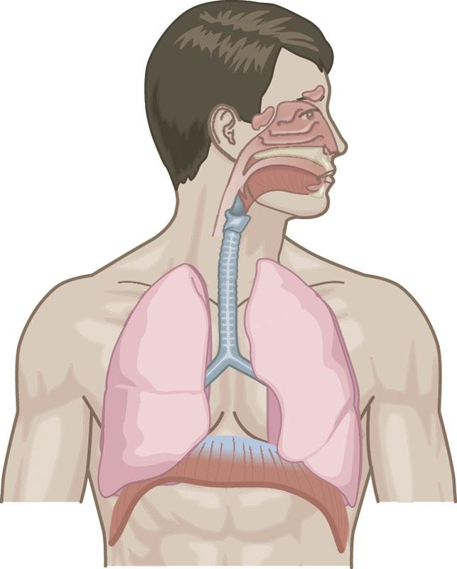

**Figure 6-8** The respiratory system

**Mechanisms of breathing**

Breathing (or ventilation) is the actual process of moving air in and out of the body; it requires optimal functioning of the respiratory pump and all its components (Table 6-3). Breathing is divided into two phases: inspiration (or inhalation) and expiration (exhalation). Inspiratory ventilation is active. This requires active contraction of inspiratory muscles to increase thoracic cavity volume, which decreases the intrapulmonary pressure (i.e., air pressure within the thoracic cavity).

TABLE 6-3 Structures of the Respiratory Pump

|  |  |
| --- | --- |
| Bones | Sternum (breastbone) |
| Ribs |
| Vertebrae (spine) |
| Inspiration Muscles | Diaphragm |
| External intercostals (muscles between individual ribs) |
| Scalenes (side of neck muscles) |
| Sternocleidomastoid (front of neck muscle) |
| Pectoralis minor (smaller chest muscle) |
| Expiration Muscles | Internal intercostals (muscles between individual ribs) |
| Abdominals |

When the intrapulmonary pressure decreases below that of the atmospheric pressure (the everyday pressure in the air), air is drawn into the lungs (Brooks, 2000; Brown, 2000; Fox, 2006; McArdle et al., 2016; Vander et al., 2003). Conversely, expiration is the process of actively or passively relaxing the inspiratory muscles to move air out of the body.

Inspiratory ventilation occurs in two forms: normal resting state (quiet) breathing and heavy (deep, forced) breathing. Normal breathing requires the use of the primary respiratory muscles (diaphragm, external intercostals), whereas heavy breathing requires the additional use of the secondary respiratory muscles, such as the scalenes, sternocleidomastoid, and pectoralis minor (Brown, 2000; Fox, 2006; Hicks, 2000; Tortora, 2008; Vander et al., 2003). A normal respiratory rate at rest is 12 to 16 breaths per minute (Reid et al., 2014).

Expiratory ventilation can be both active and passive. During normal breathing, expiratory ventilation is passive because it results from the relaxation of the contracting inspiratory muscles. During heavy or forced breathing, expiratory ventilation relies on the activity of expiratory muscles to compress the thoracic cavity and force out air (Brown, 2000; Fox, 2006; Hicks, 2000; Tortora, 2008; Vander et al., 2003). Figure 6-9 demonstrates the process of inspiration and expiration.

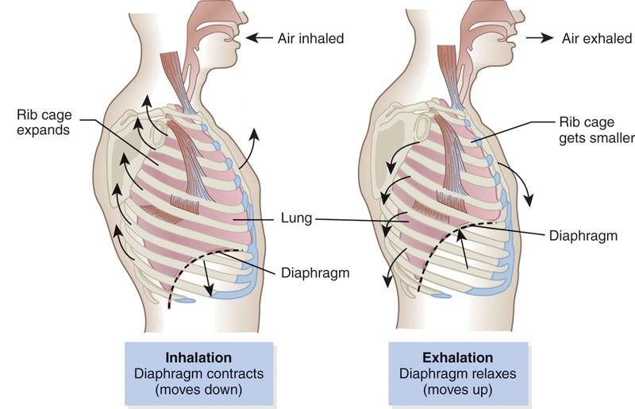

**Figure 6-9** Inspiration and expiration

Breathing also helps regulate blood flow back to the heart. The respiratory pump acts as a mechanism that helps pump blood back to the heart during inspiration; intrathoracic pressure decreases during inspiration, causing a drop in pressure in the right atrium of the heart, and helps improve the circulation of blood back to the heart. Holding in breath during exercise while contracting the abdominals, also known as the Valsalva maneuver, increases the rigidity of the spine to make it easier to support heavy loads. However, an undesirable effect is that a compressive force is exerted on the heart; this makes it more difficult for blood to return to the heart (Hackett & Chow, 2013), making it important to breathe through exercises, especially during resistance training.

CRITICAL

The Valsalva maneuver will temporarily increase blood pressure. This technique should be minimized when training a client diagnosed with high blood pressure (hypertension).

**Respiratory airway**

The purpose of ventilation is to move air in and out of the body. The respiratory passages are divided into two categories: the conducting airways and the respiratory airways. The conducting airways consist of all the structures through which air travels before entering the respiratory airways (Table 6-4). The nasal and oral cavities, mouth, pharynx, larynx, trachea, and bronchioles provide a gathering station for air and oxygen to be directed into the body (Figure 6-10). These structures also allow the incoming air to be purified, humidified (i.e., moisture added), and warmed or cooled to match body temperature (Brooks, 2000; Brown, 2000; Fox, 2006; Hicks, 2000; Swain, 2014; Vander et al., 2003).

GETTING TECHNICAL

Exercising in cool and dry climates would make breathing difficult if a client has asthma. Asthma is a respiratory condition that causes temporary shortness of breath, coughing, and a wheezing sound while attempting to breath (Reid et al., 2014). Clients with asthma should always carry along their emergency inhaler if they will be performing physical activity, especially during moderate-to-intense exercise.

TABLE 6-4 Structures of the Respiratory Passages

|  |  |
| --- | --- |
| Conducting Airways | Nasal cavity |
| Oral cavity |
| Pharynx |
| Larynx |
| Trachea |
| Right and left pulmonary bronchi |
| Bronchioles |
| Respiratory Airways | Alveoli |
| Alveolar sacs |

The respiratory airways collect the channelled air coming from the conducting airways. At the end of the bronchioles sit the alveoli, which are made up of clusters of alveolar sacs. It is here, in the alveolar sacs, that gases such as O2 and CO2 are transported in and out of the bloodstream through a process known as diffusion. This is how oxygen gets from the outside environment to the tissues of the body (Brooks, 2000; Fox, 2006; Swain, 2014; Tortora, 2008; Vander et al., 2003).

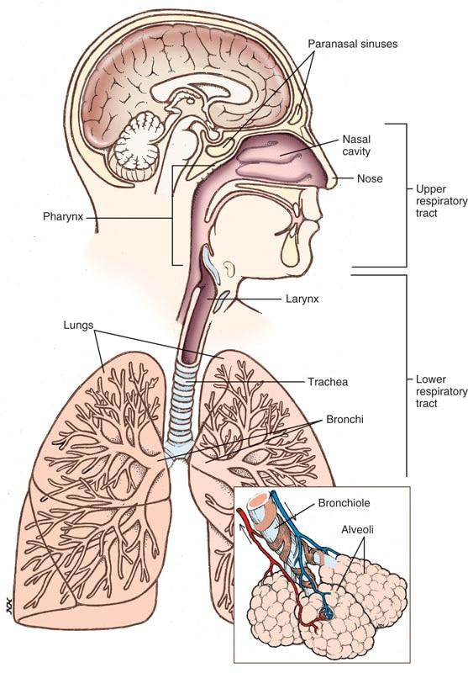

**Figure 6-10** The respiratory passages

**Cardiorespiratory system function**

An essential element to sustain life is oxygen. The respiratory system provides the means to gather oxygen from the environment and transfer it into our bodies. It is inhaled through the nose and mouth, channelled through the trachea, and then down through the bronchi, where it eventually reaches the lungs and alveolar sacs (Brooks, 2000; Fox, 2006; Hicks, 2000; Swain, 2014; Tortora, 2008; Vander et al., 2003).

Simultaneously, deoxygenated blood is pumped from the right ventricle to the lungs through the pulmonary arteries to tiny capillary vessels. Pulmonary capillaries surround the alveolar sacs, and as oxygen fills the sacs, it diffuses across the capillary membranes and into the blood (Tortora, 2008). The oxygenated blood then returns to the left atrium through the pulmonary veins, from which it is pumped into the left ventricle and out to the tissues of the body.

As the cells of the body use oxygen, they also produce carbon dioxide, which needs to be removed from the body. Carbon dioxide is transported from the tissues back to the heart, and eventually to the lungs, in the deoxygenated blood. In the alveolar sacs, carbon dioxide diffuses from the pulmonary capillaries into the alveoli (at the same time, oxygen diffuses into the blood).

The carbon dioxide is then released through exhalation (Brooks, 2000; Fox, 2006; Hicks, 2000; Swain, 2014; Tortora, 2008; Vander et al., 2003). In a simplistic overview, oxygen and carbon dioxide trade places in the tissues of the body, blood, and lungs; as one is coming in, the other is going out.

**Oxygen consumption**

The capacity to efficiently use oxygen is dependent on the respiratory system’s ability to collect oxygen, the cardiovascular system’s ability to absorb and transport it to the tissues of the body, and the tissues’ and cells’ ability to use the oxygen (Franklin, 2000). The use of oxygen by the body is known as oxygen uptake (i.e., oxygen consumption).

Certain metabolic processes require the presence of oxygen to supply the body with energy while others do not. This is an essential concept to keep in mind for weight loss clients, because fat cannot be burned (i.e., used for energy) without the presence of oxygen. As a carbon-based life form, the only way mass can be physically removed from the human body—aside from surgical procedures—is through the carbon dioxide that is exhaled with every breath.

**Abnormal breathing patterns**

A respiratory rate for an average-sized adult greater than 24 breaths per minute is considered too high (tachypnoea), whereas a rate of less than 8 breaths per minute is considered too slow (bradypnea) (Goodman, 2015; Reid et al., 2014). Any difficulty or changes to normal breathing patterns can affect the normal response to exercise (Timmons, 1994). In cases where there is an alteration of the normal biomechanical breathing function, respiration is often shallow, with compensation from the secondary respiratory muscles (e.g., scalenes and sternocleidomastoid) more predominant than the diaphragm (Vidotto et al., 2019). A rapid, shallow, upper-chest breathing pattern may occur and lead to dizziness, dyspnoea, and hyperventilation (Vidotto et al., 2019).

TRAINING TIP

During a training session, clients who are overusing secondary respiratory muscles will have visible contractions of the sternocleidomastoid, scalenes, and upper trapezius muscles (Reid et al., 2014).

The respiratory muscles also play a major postural role in the human body, all connecting directly to the cervical spine (neck vertebrae), shoulders, and cranial portions of the body. Increased activity and excessive tension of these muscles may result in headaches, lighheadedness, and dizziness. Excessive breathing (short, shallow breaths) can lead to altered carbon dioxide and oxygen blood content and to feelings of anxiety that further initiate an excessive breathing response.

Inadequate joint motion of the spine and rib cage, as a result of improper breathing, causes joints to become restricted and stiff (Mendes et al., 2019; Reid et al., 2014). Restricted movements of the spine and rib cage or a slouched spinal posture (e.g., kyphosis), which may increase with age, further limits the capacity of the respiratory system and should not be overlooked as a cause or contribution to abnormal breathing (Mendes et al., 2019; Reid et al., 2014).

TRY THIS

Sit with poor posture, making sure your spine is hunched over. While hunched over, take a deep breath in and exhale. Now, repeat this while sitting upright. Notice how much easier it is to breathe while sitting upright. Keep this in mind when working with clients.

Abnormal breathing patterns can lead to a decreased functional capacity that may result in headaches, feelings of anxiety, fatigue, poor sleep patterns, and difficulty with exercise, as well as poor circulation. However, fitness professionals should not try to diagnose these problems, because that is beyond a fitness professional’s scope of practice. If a client presents with clearly abnormal breathing patterns, they should be referred to a medical professional for assistance. However, teaching clients to breathe diaphragmatically (i.e., through the stomach) can be beneficial for exercise performance.

STRETCH YOUR KNOWLEDGE

The diaphragm is a muscle found at the base of the lungs, and similar to other muscles, it can be strengthened. Upon inhalation, the diaphragm contracts and moves downward, allowing lungs to expand. Upon exhalation, the diaphragm relaxes and moves back upward. Proper breathing, also known as diaphragmatic breathing, allows the stomach to expand while keeping the chest relatively stable during slow inhalation through the nose. Chest breathing is the opposite and does not encourage efficient oxygen exchange.

## The endocrine system

The term endocrine literally means “hormone secreting” (McArdle et al., 2016). Hormones produced by the endocrine system affect virtually all forms of human function, including triggering muscle contraction, stimulating protein and fat utilization (i.e., lipolysis), activating enzyme systems, regulating growth and metabolism, and determining the body’s physical and emotional response to stressors, such as exercise and injury (McArdle et al., 2016).

The endocrine system is a system that regulates a variety of bodily functions, including the control of mood, growth and development, tissue function, and metabolism. The endocrine system consists of host organs (known as glands), chemical messengers (hormones), and target (receptor) cells. Once a hormone is secreted from a gland, it travels through the bloodstream to target cells designed to receive its message.

The target cells have hormone-specific receptors, ensuring the hormone’s ability to bind with the cell and exert its intended action or function. As hormones travel the pathway from glands through the bloodstream, special proteins bind to some hormones, acting as both protectors and carriers (transporters) that control the amount of hormone that is available to interact with and affect the target cells (McArdle et al., 2016). The endocrine system is responsible for regulating multiple bodily functions to stabilize the body’s internal environment, much like a thermostat regulates the temperature in a room.

**Endocrine glands**

The primary endocrine glands are the hypothalamus, pineal, pancreas, thyroid, pituitary, adrenal, and reproductive glands (Figure 6-11). The hypothalamus is a key player for hormone actions because it serves to communicate messages from the body to the pituitary gland. The pituitary gland controls the functions of many other endocrine glands. The pituitary has three different sections or lobes—the anterior, intermediate, and posterior lobe— and each lobe secretes specific types of hormones. Additionally, hormones can be secreted by both the liver and the stomach.

Much of the control of hormonal activity ultimately rests with the hypothalamus and pituitary gland, which are located in the brain. Together, they represent an important link between the nervous and endocrine systems (McArdle et al., 2016). Many of the hormones produced in this region directly influence the activities of other glands; thus, the hypothalamus and, sometimes, the pituitary gland are often referred to as the master glands (McArdle et al., 2016).

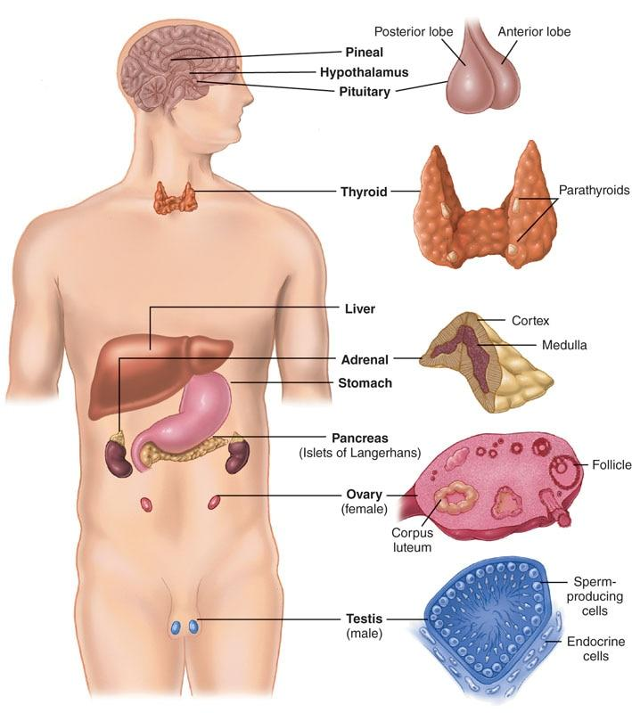

**Figure 6-11** Endocrine organs

**Insulin, glucagon, and the control of blood glucose**

Carbohydrates, specifically glucose (sugar), make up the primary energy source during vigorous exercise. Carbohydrates are one of the human body’s key sources of energy, and glucose is the principal fuel for the brain. Any extreme fluctuations in blood glucose levels can be dangerous; while too little can inhibit performance, too much can also damage the vascular system. Control of blood glucose is regulated in large part by two hormones, insulin and glucagon, which are controlled and secreted by the pancreas.

Insulin

Insulin helps regulate metabolism in the body, primarily by telling the body which substrates (e.g., fat or carbohydrates) to use for fuel and whether the body is in a fed or fasted state. After consuming a meal, glucose enters the blood at the small intestine, causing a rise in blood glucose levels. The rise of glucose triggers the pancreas to release insulin into the bloodstream. Insulin binds to receptors on the surface of muscle, liver, and fat cells, facilitating the uptake of glucose from the bloodstream into these cells. In muscle and liver cells, glucose is converted into glycogen, the storage form of glucose. The net result is a drop of blood glucose levels (Figure 6-12). Thus, insulin causes cells in the liver, muscle, and fat tissue to take up glucose from the blood (McArdle et al., 2016).

STRETCH YOUR KNOWLEDGE

The hormone insulin and the condition of diabetes are closely related. In type 1 diabetes, the pancreas is not able to produce sufficient insulin, whereas in type 2 adult onset diabetes, the cells become resistant to insulin. Insulin resistance increases blood sugar content, which can be harmful to the body.

HELPFUL HINT

Insulin functions like a train heading to specific destinations. Glucose molecules are the passengers on the train, and the bloodstream functions as the railroad tracks. Without the train (insulin) and the railroad tracks (bloodstream), the passengers (glucose) could not reach their destinations (liver, muscle, and fat cells).



**Figure 6-12** Insulin response to elevated blood sugar

Glucagon

Glucagon is one of the two hormones secreted by the pancreas that regulates blood glucose levels and is often considered as the counterpart to insulin. Glucagon primarily works to raise blood glucose levels by triggering the release of glycogen stores from the liver (Figure 6-13) (Qaid & Abderlrahman, 2016).

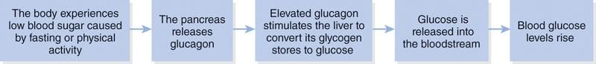

**Figure 6-13** Glucagon response to low blood sugar

Hours after a meal, or as a result of a combination of normal metabolic processes and physical activity, the body will begin to exhibit lower blood glucose levels. The drop in circulating blood glucose levels triggers the release of glucagon from the pancreas. In contrast to insulin, which has many effects, glucagon has a much more specific effect; it stimulates the liver to convert its glycogen stores back into glucose, which is then released into the bloodstream. Glucagon would, in the acute setting, have the opposite effects of insulin with respect to lipolysis (fat burning) (Qaid & Abderlrahman, 2016). However, it is unclear whether or not this effect would occur with chronic elevations of glucagon.

**The effects of exercise**

Understanding the effect of exercise is helpful in understanding the interrelationship between insulin and glucagon. As activity levels increase, glucose uptake by the body’s cells will also increase. This is the result of an increased sensitivity of the cells to insulin as well as the uptake of glucose through noninsulin-mediated mechanisms; thus, insulin levels will drop during physical activity. At the same time, glucagon secretion by the pancreas increases, thus helping to maintain a steady supply of blood glucose.

STRETCH YOUR KNOWLEDGE

Evidence suggests that exercise helps muscle cells increase their ability to use insulin to transport glucose into the cells. This effect essentially decreases insulin resistance, although primarily in the short term (Keshel & Coker, 2015). Furthermore, evidence indicates that insulin sensitivity improvements may occur independent of diet and weight loss (Bird & Hawley, 2016).

**Adrenal, pituitary, and reproductive hormones**

The adrenal and pituitary glands serve numerous bodily functions, ranging from metabolism to growth and recovery. The adrenal glands are located in the abdominal region above the kidneys and are comprised of the adrenal cortex and medulla. The adrenal glands, when stimulated, release catecholamines and cortisol.

The pituitary gland is located just below the hypothalamus in the brain; this gland is sometimes referred to as the master gland, owing to its control over many other endocrine glands. In the health and fitness profession, the pituitary gland is often recognized because it is responsible for the secretion of growth hormone. However, by way of its ability to stimulate other endocrine glands, the pituitary gland also has a major role in the reproductive hormones.

Catecholamines

The two catecholamines—epinephrine (also known as adrenaline) and norepinephrine—are hormones produced by the adrenal glands, which are situated on top of each kidney. Specifically, they are produced by the inner adrenal medulla. These hormones help prepare the body for activity; more specifically, they are part of the stress response known as the fight-or-flight response.

However, evidence suggests that their role may be related to exercise intensity. In preparation for activity, the hypothalamus(part of the brain) and the nervous system of the body triggers the adrenal medulla to secrete more epinephrine. This will have several specific physiological effects that will help sustain exercise activity, such as:

* Increase heart rate and stroke volume
* Elevate blood glucose levels
* Redistribute blood to working tissues
* Open up the airways
* Improve the body’s ability to break down and use fat for energy (McArdle et al., 2016)

STRETCH YOUR KNOWLEDGE

Due to neural stimulation from exercise, the adrenal glands can immediately produce epinephrine, which increases energy and force production during an exercise session (French et al., 2007; Kraemer & Ratamess 2005).

Cortisol

Cortisol is typically referred to as a catabolic hormone (associated with tissue breakdown). Under times of stress, such as exercise, cortisol is secreted by the adrenal cortex and serves to maintain energy supply through the breakdown of fats and protein. One of the mechanisms by which cortisol serves to maintain energy is through gluconeogenesis. Gluconeogenesis increases glucose availability by creating energy substrates from both fats and proteins. In other words, gluconeogenesis is the breakdown of noncarbohydrate sources to be used as energy.

High levels of cortisol brought about through overtraining, excessive stress, poor sleep, and inadequate nutrition can lead to significant breakdown of muscle tissue, along with other potentially harmful side effects. Evidence suggests that low blood glucose and poor sleep may stimulate an increase in cortisol (Leproult & Cauter, 2010; Qaid & Abderlrahman, 2016). Cortisol is normally elevated early in the morning with declining levels throughout the day and into early hours of sleep. When sleep time is reduced, cortisol levels are elevated in early evening hours (Leproult & Cauter, 2010).

Testosterone and estrogen

Testosterone is produced in the testes of the male body and in small amounts in the ovaries and adrenal glands of the female body. Males produce up to 10 times more testosterone than females, and it is primarily responsible for the development of the male secondary sexual characteristics, such as facial and body hair and greater muscle mass (McArdle et al., 2016).

For both males and females, testosterone plays a fundamental role in the growth and repair of tissue. Raised levels of testosterone are indicative of an anabolic (tissue-building) status. Evidence suggests that testosterone levels decline with age; however, they can increase in response to high-intensity interval training or strength training with sufficient overload, whereby large muscle masses are trained, and shorter rest periods are incorporated (Kraemer & Ratamess, 2005).

Estrogen is produced primarily in the ovaries in the female, with small amounts produced in the adrenal glands in males. Women of reproductive age have significantly higher levels of estrogen than males, which gives rise to female secondary sexual characteristics, such as breast development and regulation of the menstrual cycle. Estrogen has many functions, but in particular, it has an influence on fat deposition around the hips, buttocks, and thighs.

Hormonal changes from exercise are generally acute in nature, thus training responses are limited to these short-term changes. Acute hormone secretions also seem to be influenced to a greater degree when training larger muscles. For example, the back squat exercise, when performed for five sets of 10 repetitions at 75% intensity, has been shown to increase testosterone levels for up to 45 minutes after training; however, the bench press was shown to not alter testosterone levels to the same amount as a squat when performed at the same training intensity (Geisler et al., 2019).

With regard to age, a reduction in testosterone levels does occur; however, other factors such as overall health and exercise levels may have an effect on the degree of change (Erenpreiss et al., 2019). Among aging men, it has been shown that testosterone levels are higher among those who are healthy when compared to those who have comorbidities or chronic diseases such as hypertension (high blood pressure), arthritis, and chronic respiratory problems (Erenpreiss et al., 2019). While exercise has been shown to increase hormone levels in older men, the increases are generally smaller than in younger men (Hayes & Elliott, 2019; Negaresh et al., 2019).

GETTING TECHNICAL

The pathway for testosterone-stimulating muscle growth and recovery begins at the hypothalamus, which would be stimulated by vigorous resistance training. In response, the hypothalamus secretes gonadotropin-releasing hormone, which travels to the pituitary gland and stimulates the release of luteinizing hormone. Luteinizing hormone travels to the testes and attaches to the Leydig cells, which ultimately release testosterone.

Growth hormone

The name of this hormone has particular reference to its primary functions. Growth hormone is released from the pituitary gland in the brain and is regulated by the nearby hypothalamus. Growth hormone is stimulated by several factors, including estrogen, testosterone, deep sleep, and vigorous exercise (Kraemer & Ratamess, 2005; Leproult & Cauter, 2010). Growth hormone is primarily an anabolic hormone that is responsible for most of the growth and development during childhood up until puberty, when the primary sex hormones take over that control.

Growth hormone also increases the development of bone, muscle tissue, and protein synthesis; increases fat burning; and strengthens the immune system (McArdle et al., 2016). Evidence suggests that sleep deprivation may reduce growth hormone secretion, once again pointing to the value of getting adequate sleep (Leproult & Cauter, 2010). Growth hormone also travels to the liver and muscles to stimulate the release of insulin-like growth factor and mechano-growth factor respectively, both potent anabolic hormones (McArdle et al., 2016; Velloso, 2008).

**Thyroid hormones and insulin-like growth factors**

The thyroid gland is located in the anterior neck region and releases hormones into the bloodstream that control numerous functions in almost every organ in the body. One of the more important functions of thyroid hormones is their impact on metabolism. Similarly, the liver secretes a hormone that also helps regulate the metabolism of macronutrients and protein synthesis, known as insulin-like growth factors.

Insulin-like growth factors

Insulin-like growth factors (IGF) are a type of hormone (numerous subtypes exist) primarily responsible for anabolic functions, such as growth and development (Kraemer & Ratamess, 2005; Velosso, 2008). IGF is released from the liver and is responsible for protein synthesis, fat metabolism, growth, and development (Velosso, 2008). It is important to recognize that while hormones have specific effects on their target organs or tissues, they work collaboratively with other hormones. For example, muscle hypertrophy (muscle growth) and regeneration following exercise is thought to be the result of IGF secretion as well as other hormones, such as testosterone and growth hormones (Ahtiainen, 2011; Roberts et al., 2010; Velloso, 2008).

A unique characteristic of IGF is that is it also synthesized (made) and stored in muscles and tendons where it is referred to as mechano-growth factor (Kraemer & Ratamess, 2005; Roberts et al., 2010; Velloso, 2008). Mechano-growth factor is a potent anabolic hormone similar to IGF (Kraemer & Ratamess, 2005). As a result, mechano-growth factor is released in response to the overload of a muscle or tendon, which, in part, plays a role in growth, repair, and recovery (Ahtiainen, 2011; Kraemer & Castracane, 2015; Kraemer & Ratamess 2005; Philippou et al., 2007; Roberts et al., 2010; Velosso, 2008). An interesting finding related to IGF is that levels have been shown to increase up to 48 hours following resistance training and that local levels in muscles are not necessarily affected by age (Roberts et al., 2010).

TRAINING TIP

Evidence suggests that an emphasis on the eccentric (lowering or decelerating) phase of an exercise in which a weight is slowly returned back to the starting position will increase local IGF secretion of the muscles being overloaded (Heinemeier et al., 2007; Kraemer & Castracane, 2015; Philippou et al., 2007; Velloso, 2008).

Thyroid hormone

The thyroid gland is located at the base of the neck just below the thyroid cartilage, sometimes called the Adam’s apple. This gland releases vital hormones that are primarily responsible for numerous physiological functions involved in the regulation of heart rate, body temperature, and metabolism, among many other functions (Armstrong, 2018).

It is important that the right amounts of thyroid hormones are secreted and that levels are not too high or low. As a result, the hypothalamus and pituitary gland play a role in maintaining normal levels. For example, if thyroid hormone levels are too low, the hypothalamus signals the pituitary gland to release a certain amount of thyroid-stimulating hormone.

Thyroid hormones have been shown to be responsible for carbohydrate, protein, and fat metabolism, basal metabolic rate (BMR), protein synthesis, sensitivity to epinephrine, heart rate, breathing rate, and body temperature (Armstrong, 2019). In addition, the thyroid plays a critical role in bone mineral density because it releases an important hormone called calcitonin. Calcitonin helps the body use calcium properly to aid in maintaining bone mineral density.

Thyroid hormones tend to have a permissive effect in that they help other hormones function more effectively; in a similar way as other hormones, thyroid hormones are affected by sleep (Kessler et al., 2010). Disorders of the thyroid gland can affect almost every system in the body. Low thyroid function has become a well-recognized disorder leading to low metabolism, fatigue, depression, sensitivity to cold, and weight gain (Armstrong, 2019).

**Effects of exercise on hormonal levels**

Research has indicated that testosterone, growth hormone, and IGF levels increase after strength training as well as moderate to vigorous aerobic exercise (Goto et al., 2009; Kraemer & Ratamess, 2005; Roberts et al., 2010). The reasoning for these hormone increases has been covered in previous sections; however, it is important to recognize that these hormones increase in response to the need for recovery and adaptation.

A similar pattern also emerges for cortisol, where the presence of elevated cortisol in the bloodstream (elevated basal levels) is often taken to be indicative of overtraining (Kraemer & Ratamess, 2005). This is perhaps too simplistic, because cortisol is a necessary part of maintaining energy levels during normal exercise activity and may even facilitate recovery and repair during the postexercise period (McArdle et al., 2016).

Problems may arise, however, as a result of extremely intense or prolonged bouts of endurance training, which have been found to lower testosterone levels while raising cortisol levels. Under these circumstances, catabolism (breakdown) is likely to outstrip anabolism (build up) and give rise to symptoms of overtraining (McArdle et al., 2014). With regard to resistance training, evidence has been found to support the increase of IGF, growth hormone, and testosterone in response to overload training of high intensity and limited rest periods (Goto et al., 2009; Kraemer & Ratamess, 2005; Roberts et al., 2010).

TRAINING TIP

Evidence suggests that slowing down the speed of repetitions during resistance training (which increases time under tension) will increase growth hormone, testosterone, and epinephrine when compared to shorter contraction times, which are associated with reduced time under tension (Goto et al., 2009).

**Sleep and its effects on hormones**

Sleep is an essential physiological process that is required for all humans regardless of age or fitness level. Adequate sleep is required for normal brain functioning and development, memory, and many bodily systems, including recovery and repair. While there is a general understanding that sleep is required, the duration of sleep that constitutes a normal level, as well as the negative effects of sleep deprivation, may vary between people (Aldabal & Bahammam, 2011).

On average, most adults and adolescents sleep 5 to 6 hours per night with an estimated need for an additional 2 hours (Kessler et al., 2010; Leproult & Cauter, 2010). Sleep has been shown to directly influence hormone levels, including (but not limited to) growth hormone, thyroid hormone, and cortisol.

Specifically, a good night’s sleep leads to lower levels of cortisol throughout the day and early evening and increased levels of growth hormone through the night, as well as better control of the thyroid hormones and glucose metabolism (Aldabal & Bahammam, 2011; Chaput et al., 2007; Kessler et al., 2010; Leproult & Cauter, 2010).

With regard to glucose metabolism, evidence suggests that individuals with impaired sleep (less than 6 hours) are more likely to develop glucose intolerance when compared to individuals who sleep greater than 7 hours. Furthermore, sleep has a role in muscle recovery from exercise. The effect of sleep deprivation on muscle recovery was highlighted in an investigation that required participants to perform repeated overload exercises. In the study, IGF, cortisol, and cortisol to testosterone ratios were higher among individuals who were sleep deprived when compared to those who had normal sleep levels (Dáttilo et al., 2019).

## The digestive system

The digestive system is a complex group of anatomical structures that function to allow the food we eat and liquids we consume to be digested, processed, and absorbed (used for energy) or to make additional tissue (Patricia, 2019). An understanding of the basic physiological processes that occur in the digestive system is necessary to understand the practical elements of energy, nutrition, and recovery.

Overview of the digestive system

The digestive system may be categorized into three functional regions: (1) the head and neck, which includes the mouth, (2) the upper gastrointestinal (GI) tract, and (3) the lower GI tract (Figure 6-14). The food we eat and liquids we consume pass sequentially through the mouth into the upper GI tract, mainly composed of the stomach, and ultimately into the lower GI tract and through the rectum where the unused food and liquid is discarded as solid waste (feces).

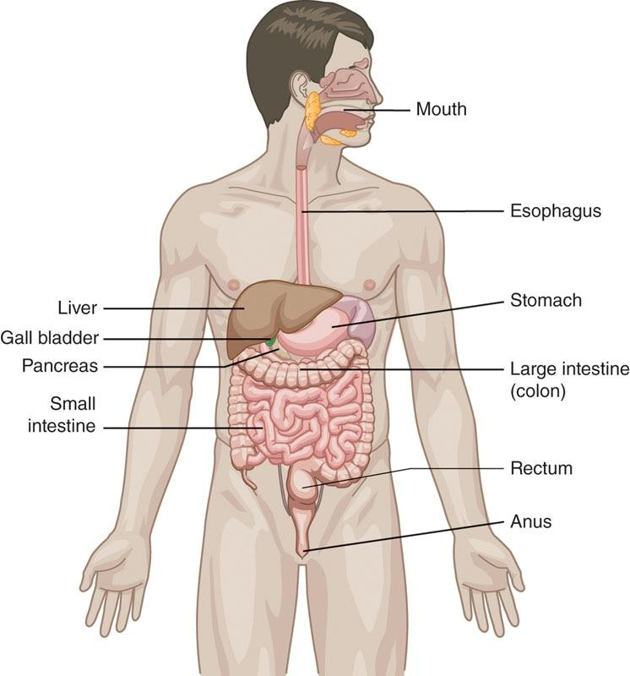

**Figure 6-14** The digestive system

Along the way, these three areas receive help from organs such as the gall bladder, liver, and pancreas, which produce enzymes and acids to help aid in the digestion of foods (Pantol, 2009; Patricia, 2019).

The actions of the digestive system generally consist of motility, which is the passage of food through the digestive tract and includes mastication (chewing), swallowing, digestion, and peristalsis. Digestion is the formal term used to describe the processing of food into a structure that can be absorbed. Absorption is the term used for the passage of already-digested food into the blood system to be processed for energy, nutrients, and tissue building (Patricia 2019). In addition to digestion and absorption of food, the GI system is the home of 70% to 80% of the body’s immune cells (Goodman & Fuller, 2015).

**Structures of the digestive system**

The structures of the digestive system include the oral cavity, upper GI tract, and lower GI tract. The head and neck are where the oral cavity resides, which processes food that is passed down the esophagus to the stomach. The esophagus and stomach are the beginning of the upper GI tract. Food from the stomach is passed through the small intestine and into the large intestine, and ultimately into the anal canal where it is excreted. Along the way, various mechanical processes, hormones, and enzymes from organs that contribute to digestion aid in the process.

Head and neck

When we eat, food is taken in from the mouth through a process called ingestion (Pandol et al., 2015). The teeth, saliva, and tongue aid with ingestion as well as breaking down the food in a process called mastication (Patricia & Dhamoon, 2019). During the chewing process, the teeth break down the food and it is mixed with saliva, which has its own enzymes that help the process of degrading the food for the next step in the process (Patricia & Dhamoon, 2019) (Figure 6-15). Food that is ingested and undergoes mastication is ultimately swallowed and will pass through the upper GI tract and eventually into the lower GI tract (Patricia & Dhamoon, 2019).

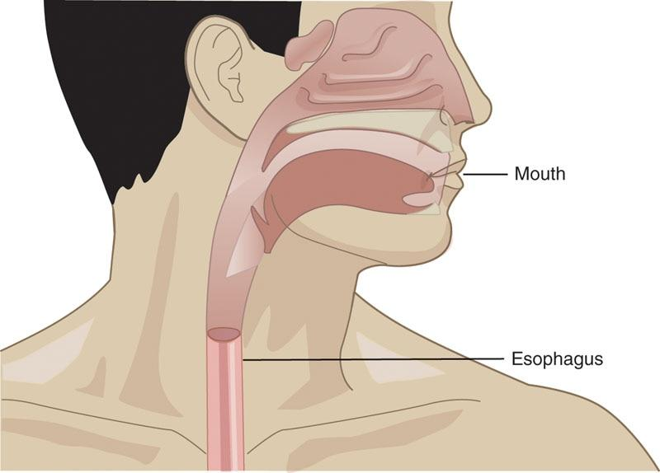

**Figure 6-15** The digestive system—head and neck

Upper GI tract

Swallowed food is passed from the esophagus, which is a muscular tube, into the stomach where there are high quantities of gastric juices that help with digestion (Pandol et al., 2015; Patricia & Dhamoon, 2019). The swallowed food is pushed through the esophagus into the stomach through muscular contractions, which are part of peristalsis (Pandol et al., 2015; Patricia & Dhamoon, 2019). The esophagus is a unique structure in that parts of it contract while others relax, which allows the passage of food. Once food passes into the stomach from the esophagus, the esophageal sphincter constricts to prevent food from the stomach from re-entering the esophagus (Goodman & Fuller, 2015).

In the stomach, food mixes with digestive juices creating chyme, and the high acidity of the stomach contents continues the digestive process and may kill bacteria (Patricia & Dhamoon, 2019). The stomach contracts when it is filled with food and gastric juices. Some of the gastric juices that are secreted include hydrochloric acid, mucus, and pepsinogen, which is used to digest protein (Pandol et al., 2015; Patricia & Dhamoon, 2019). Once the food in the stomach is thoroughly digested, contractions from the stomach push it through a valve (i.e., pyloric sphincter) into the small intestine (Patricia & Dhamoon, 2019).

STRETCH YOUR KNOWLEDGE

Although the esophageal sphincter is meant to prevent re-entering of food or gastric juices from the stomach, at times it fails and juices re-enter. Heartburn is a symptom that occurs as a result of gastric juices from the stomach entering the esophagus. These symptoms may be increased when lying flat after a meal (Goodman & Fuller, 2015).

The small intestine comprises the duodenum, jejunum, and ileum and resides between the stomach and the large intestine (Figure 6-16). It is called small, because it is relatively small compared to the large intestine. From a length perspective, the small intestine is roughly 6-7 meters (about 22 feet). Food is first passed into the duodenum, which is generally the first 10 inches. Food passes from the duodenum into the jejunum and then ultimately into the ileum. From the ileum, food passes into the large intestine.

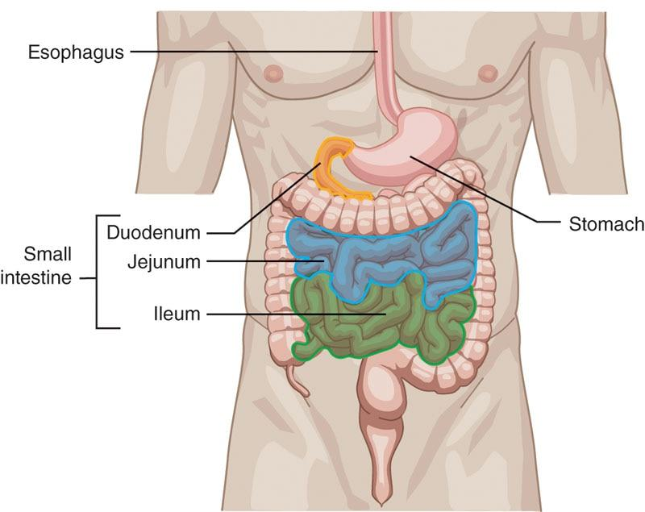

**Figure 6-16** The upper GI tract

Absorption of carbohydrates, lipids (fats), calcium, amino acids (protein), and iron occur primarily in the duodenum and jejunum (Pandol et al., 2015; Patricia & Dhamoon, 2019). Absorption of salts, vitamins, water, and electrolytes (e.g., sodium, potassium, magnesium) occurs in the ileum. In addition to absorption, many digestive enzymes are present in the small intestine. These enzymes are necessary for absorption. The pancreas, liver, and gall bladder have ducts that allow the passage of their digestive juices into the duodenum region.

Similar to the stomach and gall bladder, intestinal contractions move food through the tracts into the large intestine. Once at this stage, the macronutrients (fat, carbohydrates, and proteins) have been converted through digestion into forms that can be absorbed into the bloodstream for bodily use (Patricia & Dhamoon, 2019).

STRETCH YOUR KNOWLEDGE

The nervous system in the GI tract is known as the enteric nervous system. Within this system, there are as many nerves in the small intestine as the entire spinal cord (Goodman & Fuller, 2015). Although intestinal contractions are automatic and stimulated by food, the nervous system plays a large role in the excitability of the smooth muscles of the intestines. What is most interesting is that the enteric nervous system can work on its own without any assistance from the brain and spinal cord (Goodman & Fuller, 2015).

Lower GI tract

The large intestine (i.e., the colon) serves in part to absorb electrolytes including water, and certain vitamins (Pandol et al., 2015). The large intestine resides between the small intestine and the rectum and anal canal, where waste product is passed out of the body (Figure 6-17). From an anatomical perspective, the first area of the large intestine that receives food is the cecum (Pandol et al., 2015). The cecum receives the chyme, which is then passed in order through the ascending colon, transverse colon, descending colon, sigmoid colon, rectum, and anus (Pandol et al., 2015). It is important to note that the large intestine has little to no digestive function and serves primarily to absorb and pass waste into the rectum.

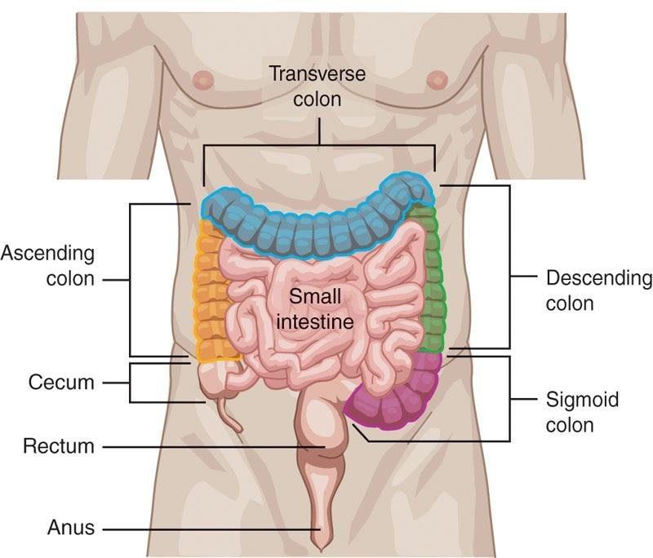

**Figure 6-17** The lower GI tract

While most of the fluids in the GI tracts are absorbed by the small intestine, the large intestine plays a role in total fluid absorption (Pandol et al., 2015). Fluids in the intestinal tracts are collected not only from what a person drinks but also from fluids secreted into the GI tracts from salivary glands (glands that produce saliva), the stomach, pancreas, liver, and gallbladder. While the small intestine absorbs much of this, the large intestine absorbs its share, and remaining fluids are excreted with feces (Pandol et al., 2015).

STRETCH YOUR KNOWLEDGE

A properly working digestive system requires adequate water consumption. Inadequate consumption may lead to an inability of food to pass through the lower GI tract and lead to constipation and discomfort.

After electrolytes, including water, have been absorbed from the large intestine, the waste material passes into the rectum and anal canal. Once in the rectum, internal pressure occurs, which relaxes the internal anal sphincter, and leads to an urge to defecate (Pandol et al., 2015). Once this occurs, the waste material passes into the anus. It is here that voluntary contraction of the rectal muscles, aided by the abdominals and other pelvic musculature, push the waste product out of the anus in a process called defecation (Pandol et al., 2015).

**Effects of exercise on the gastrointestinal system**

Evidence suggests that physical activity can improve intestinal motility and help with constipation (Goodman & Fuller, 2015; Kim et al., 2014; Song et al., 2012, 2018). The basis for this effect is that peristalsis of the intestines is activated by physical activity. The time it takes for food to pass from the stomach to the rectum is often referred to as transit time, and studies have evaluated the effects of exercise and physical activity on colon transit time. Physical activity is a broad term; however, evidence from one particular study suggests that individuals classified as having higher physical activity levels have improved colon transit time (e.g., reduced time) when compared to individuals classified as having lower physical activity levels (Song et al., 2012).

With regard to exercise, evidence suggests that both aerobic and resistance training improve colon transit time (Kim et al., 2014; Song et al., 2018). In one study, after individuals performed 60 minutes of combined resistance training and running three times per week for 12 weeks, their colon transit time improved compared with transit time prior to the study (Song et al., 2018). In another study, a 12-week aerobic exercise program was performed; while transit time improved, the results were not as good as prior studies using combined aerobic and resistance training (Kim et al., 2014; Song et al., 2018). In summary, physical activity has been shown to improve peristalsis, which offers a favorable benefit regarding the time it takes food to pass through the gastrointestinal system. While evidence exists showing that higher physical activity offers a greater benefit, a combined program of aerobic and resistance training may be most beneficial.

## Introduction to Human Movement Science

Movement represents the integrated functioning of three main systems within the human body: the nervous system, the skeletal system, and the muscular system. These collective components and structures represent the human movement system (HMS) (Figure 7-1). Although separate in structure and function, the HMS relies on a collaborative effort to form interdependent links that form a functional kinetic chain. For example, an individual’s arm, shoulder, and spine are interconnected segments that function together to perform movement.

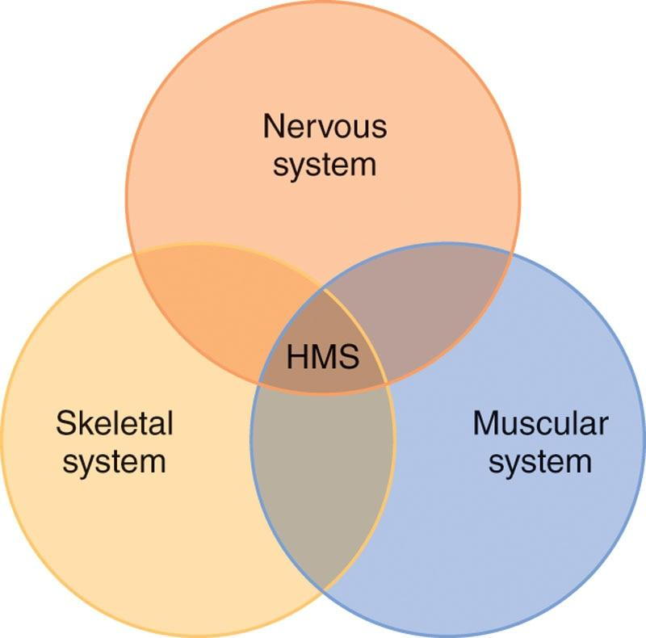

**Figure 7-1** Human movement system

If any part of the kinetic chain is injured or not functioning properly, the entire link is compromised, resulting in less than optimal performance. Body segments and their movements must be coordinated to allow for the efficient transfer of energy and power throughout the body when moving from one body segment to the next. This concept of how the functioning of one segment of the body can impact other areas is referred to as the regional interdependence model (Sueki et al., 2013). This chapter focuses on how the HMS works interdependently to learn and produce efficient human movement.

STRETCH YOUR KNOWLEDGE

Regional interdependence emphasizes the importance of integrated HMS functioning. For example, a client with normal functioning muscular and nervous systems should be able to complete a front shoulder raise through the shoulder joint’s full range of motion (ROM). However, if there was articular (joint) system stiffness, the movement may not be completed through the full ROM, despite a normally functioning muscular and nervous system. On the other hand, if the nervous system that supplies the message to the deltoid (shoulder muscle) was not working properly, a client would not be able to raise their arm despite having normal articular movement and an intact muscle.

### Biomechanics

Biomechanics is the study of mechanical laws or principles relating to movement. In other words, biomechanics uses scientific principles of physics to study how the body creates movement at the joints, especially in the context of exercise and sport. Kinesiology is another formal discipline that studies movement. While kinesiology is still concerned with the principles of biomechanics, it investigates movement further because it additionally relates to human anatomy and physiology.

The exploration of human movement science focuses on the various motions that the HMS produces and the forces that act on it (Hamill & Knutzen, 2003; Levangie et al., 2019). Fitness and sport training require a strong understanding of basic anatomical terminology, planes of motion, joint motions, muscle actions, force-couples, levers, forces, and the intramuscular relationship between force and velocity.

**Biomechanical terminology**

It is important for fitness professionals to understand the terminology used in the study of biomechanics and kinesiology. This prepares them with a better understanding of and ability to apply the scientific principles behind assessing clients’ movements and implementing exercise programs with clients.

It is important to keep in mind that biomechanical terms always refer to the body in the anatomic position (Figure 7-2). The anatomic position is when the body is in a standing posture, with the arms hanging down by the sides and palms facing forward. This position is important because it gives a universal point of reference from which all allied health professionals can accurately discuss human biomechanics.

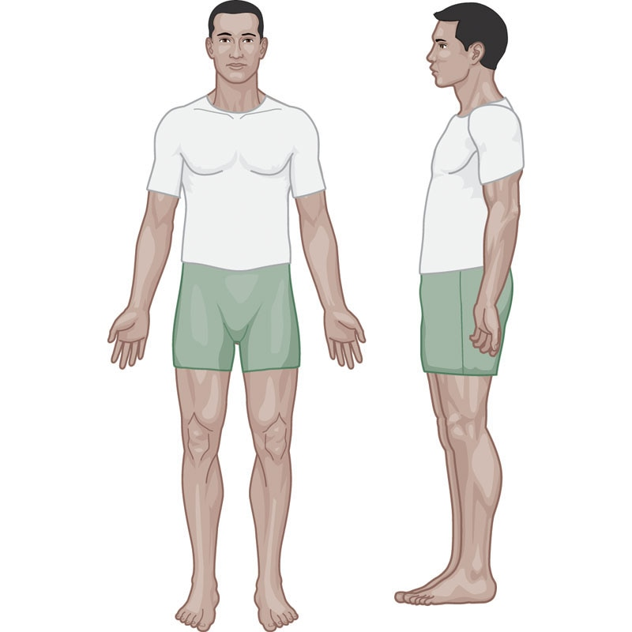

**Figure 7-2** The anatomic position

**Anatomic locations**

Anatomic locations describe the relative positioning of segments of the body. Anatomical terms commonly used in the fitness industry include *medial, lateral, contralateral, ipsilateral, anterior, posterior, proximal, distal, inferior*, and *superior* (Figure 7-3; Table 7-1). These terms are used to describe where various bodily structures are located in more specific ways than common terms such as *above* and *below* or *front* and *rear*.

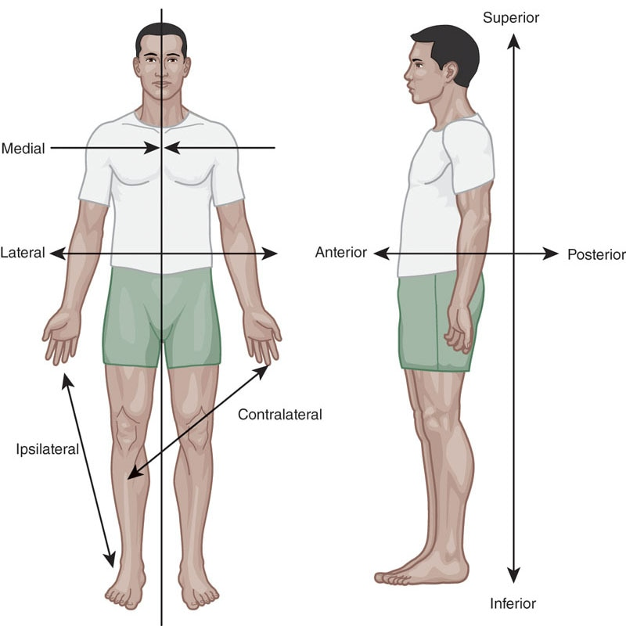

**Figure 7-3** Anatomic locations

TABLE 7-1 Anatomic Location Definitions and Examples

| **Anatomic Location** | **Definition** | **Example** |
| --- | --- | --- |
| Medial | Relatively closer to the midline of the body | The adductors (inner thigh muscles) attach to the medial side of the femur (thigh bone). |
| Lateral | Relatively farther away from the midline or toward the outside of the body | The ears are positioned laterally on the head. |
| Contralateral | Positioned on the opposite side of the body | The right foot is contralateral to the left hand. |
| Ipsilateral | Positioned on the same side of the body | The right foot is ipsilateral to the right hand. |
| Anterior | Positioned on or toward the front of the body | The quadriceps are located on the anterior aspect of the thigh. |
| Posterior | Positioned on or toward the back of the body | The hamstring complex is located on the posterior aspect of the thigh. |
| Proximal | Positioned nearest to the centre of the body or other identified reference point | The wrist is more proximal to the elbow than the fingers. |
| Distal | Positioned farthest from the centre of the body or other identified reference point | The ankle is more distal to the hip than the knee. |
| Inferior | Positioned below an identified reference point | The soleus (calf muscle) is inferior to the hamstring complex. |
| Superior | Positioned above an identified reference point | The pelvis is superior to the tibia (shin bone). |

**Planes of motion, axes, and joint motions**

The universally accepted method of describing human movement is in reference to three dimensions and is based on a system of three imaginary planes: sagittal, frontal, and transverse (Figure 7-4). These planes are positioned at right angles, so they intersect in the centre. Although movements can be dominant in a single plane of motion, it is important to remember that typical daily movement rarely occurs strictly in one plane of motion. However, movements, joint motions, and many common exercises are classified as being predominantly in a specific plane of motion if they run along that plane (i.e., parallel to it). Movement patterns that take the body through motions in more than one plane are termed *multiplanar*.

Movement in each plane occurs on an axis running perpendicular to that plane, much like the axle that a car wheel revolves around. This is known as *joint motion*. Joint motions are termed for their action in each of the three planes of motion. A more specific term used to describe the movements we can observe or see is osteokinematic, whereas the movements taking place inside the joint itself that we cannot see are referred to as arthrokinematic movement (Levangie et al., 2019). Osteo- and arthrokinematic movements are both required for normal movement to occur.

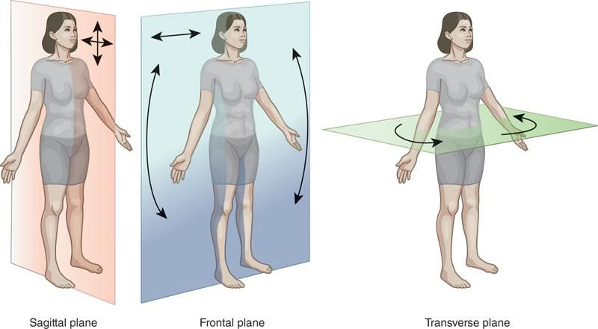

**Figure 7-4** Planes of motion

**The sagittal plane**

The sagittal plane is an imaginary line that bisects the body into right and left sides. Sagittal plane joint motion occurs around a medial-lateral axis, as is seen when bending at the knees. Movements in the sagittal plane include flexion and extension (Figure 7-5). Flexion is a bending movement in which the relative angle between two adjacent segments decreases. Extension is a straightening movement in which the relative angle between two adjacent segments increases (Hamill & Knutzen, 2003; Levangie et al., 2019).

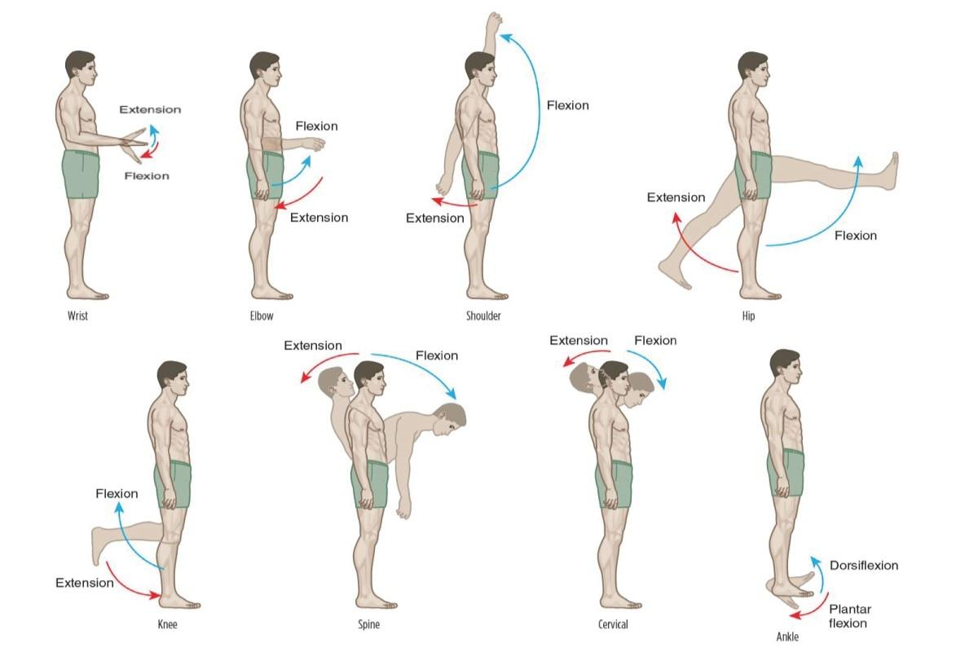

**Figure 7-5** Flexion and extension

STRETCH YOUR KNOWLEDGE

Hyperextension is the extension of a joint beyond the normal limit or ROM and may result in injury. The term *hyperextension* is reserved for movements where normal extension values have been exceeded and should not be used to describe someone who has full available extension ROM.

HELPFUL HINT

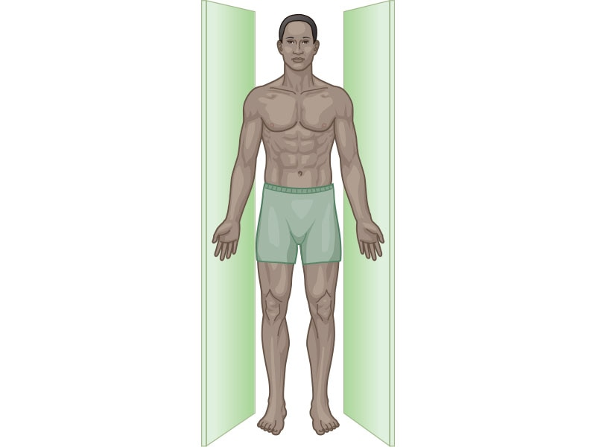

To better understand the sagittal plane, imagine being stuck in a very narrow hallway with no room to move to the left or right or to rotate in any fashion. In addition, the walls are made completely of glass, which you don’t want to break. Based on this analogy, the only available movements in our narrow sagittal plane hallway are front-to-back and up-and-down movements.

Flexion and extension occur in many joints in the body, including the spine, shoulder, elbow, wrist, hip, knee, foot, and hand. At the ankle, flexion is referred to as dorsiflexion and extension is plantar flexion (Levangie et al., 2019). Examples of predominantly sagittal plane exercises include biceps curls, triceps pushdowns, squats, front lunges, calf raises, walking, running, vertical jump, climbing stairs, and shooting a basketball.

STRETCH YOUR KNOWLEDGE

Hip Flexion in the Sagittal Plane

Hip flexion occurs when an individual decreases the angle between the femur (thigh bone) and the pelvis or lumbar spine. This can occur when an individual elevates the knee toward the abdomen (femoral-on-pelvic hip flexion). During this motion, the pelvis and spine are fixed while the femur rotates. Another version of hip flexion can occur when an individual bends forward from the trunk (as if touching their toes). In this instance, the pelvis and lumbar spine rotate together over a fixed femur (pelvic-on-femoral rotation).

HELPFUL HINT

To best remember dorsiflexion, think about the dorsal fin of a dolphin on the top side of its body. In this context, *dorsal* represents the top side of the foot and the direction it moves when the ankle flexes.

To remember plantar flexion, think about planting a garden in the ground. In this context, *plantar* represents the bottom side of the foot and the direction it moves when the ankle extends.

**The frontal plane**

The frontal plane bisects the body to create front and back halves. Frontal plane joint motion occurs around an anterior-posterior axis, like is seen at the shoulder when doing jumping jacks. Movements in the frontal plane include abduction and adduction of the limbs (relative to the trunk), lateral flexion of the spine, and eversion and inversion at the foot and ankle complex (Figure 7-6) (Hamill & Knutzen, 2003; Levangie et al., 2019).

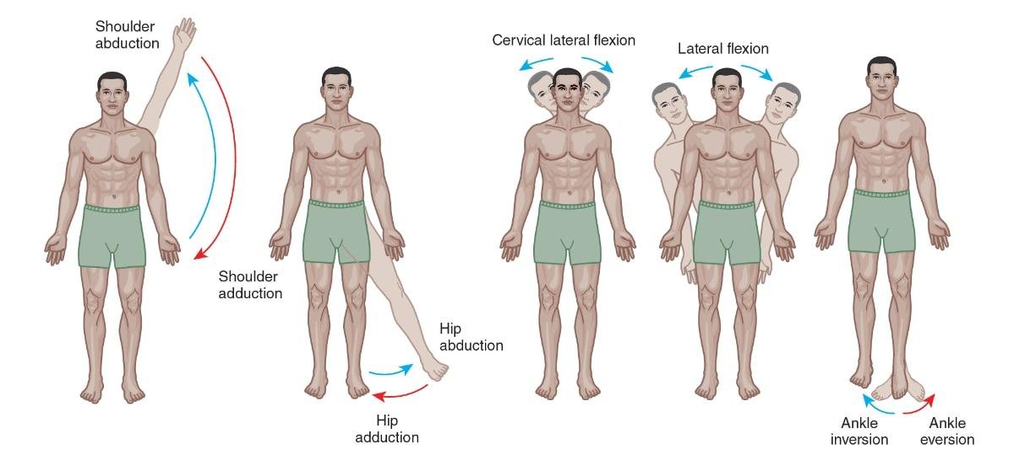

**Figure 7-6** Abduction and adduction movements

Abduction is a movement away from the midline of the body. Similar to extension, it is an increase in the angle between two adjoining segments, except in the frontal plane. Adduction is a movement of a segment toward the midline of the body. Like flexion, it is a decrease in the angle between two adjoining segments, except in the frontal plane (Hamill & Knutzen, 2003; Kendall et al., 2005; Levangie et al., 2019).

Lateral flexion is the bending of the spine from side to side in the frontal plane. Additionally, similar to flexion and extension, joint motion at the feet is termed a bit differently. Eversion and inversion follow the same principle as lateral flexion but relate specifically to the pendulum-like movement of the calcaneus (heel bone) and tarsals (ankle bones) in the frontal plane (Hamill & Knutzen, 2003; Kendall et al., 2005; Levangie et al., 2019). When a foot everts, the calcaneus swings laterally (away from the midline); when a foot inverts, the calcaneus swings medially (toward the midline). Examples of predominantly frontal plane exercises include jumping jacks, side lunges, lateral shoulder raises, and side shuffling.

HELPFUL HINT

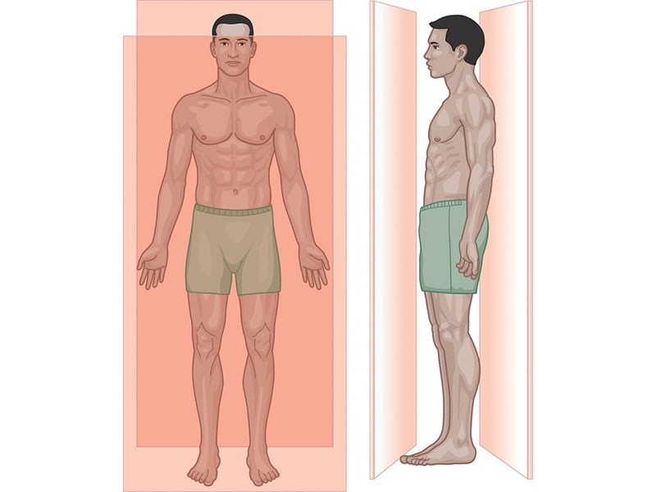

To better understand the frontal plane, imagine walls in front of and behind you, with no room to move forward or backward or to rotate. Like last time, the walls are made completely of glass, which you do not want to break. As a result, movements in the frontal plane are primarily side-to-side motions.

**The transverse plane**

The transverse plane bisects the body to create upper and lower halves. Transverse plane motion occurs around a longitudinal or vertical axis. Movements in the transverse plane include internal rotation and external rotation for the limbs, right and left rotation for the head and trunk, horizontal abduction and horizontal adduction of the limbs, and radioulnar pronation and radioulnar supination forearm rotation (Figure 7-7) (Hamill & Knutzen, 2003; Levangie et al., 2019). Examples of predominantly transverse plane exercises include performing a cable trunk rotation, a dumbbell chest fly, and swinging a bat or golf club.

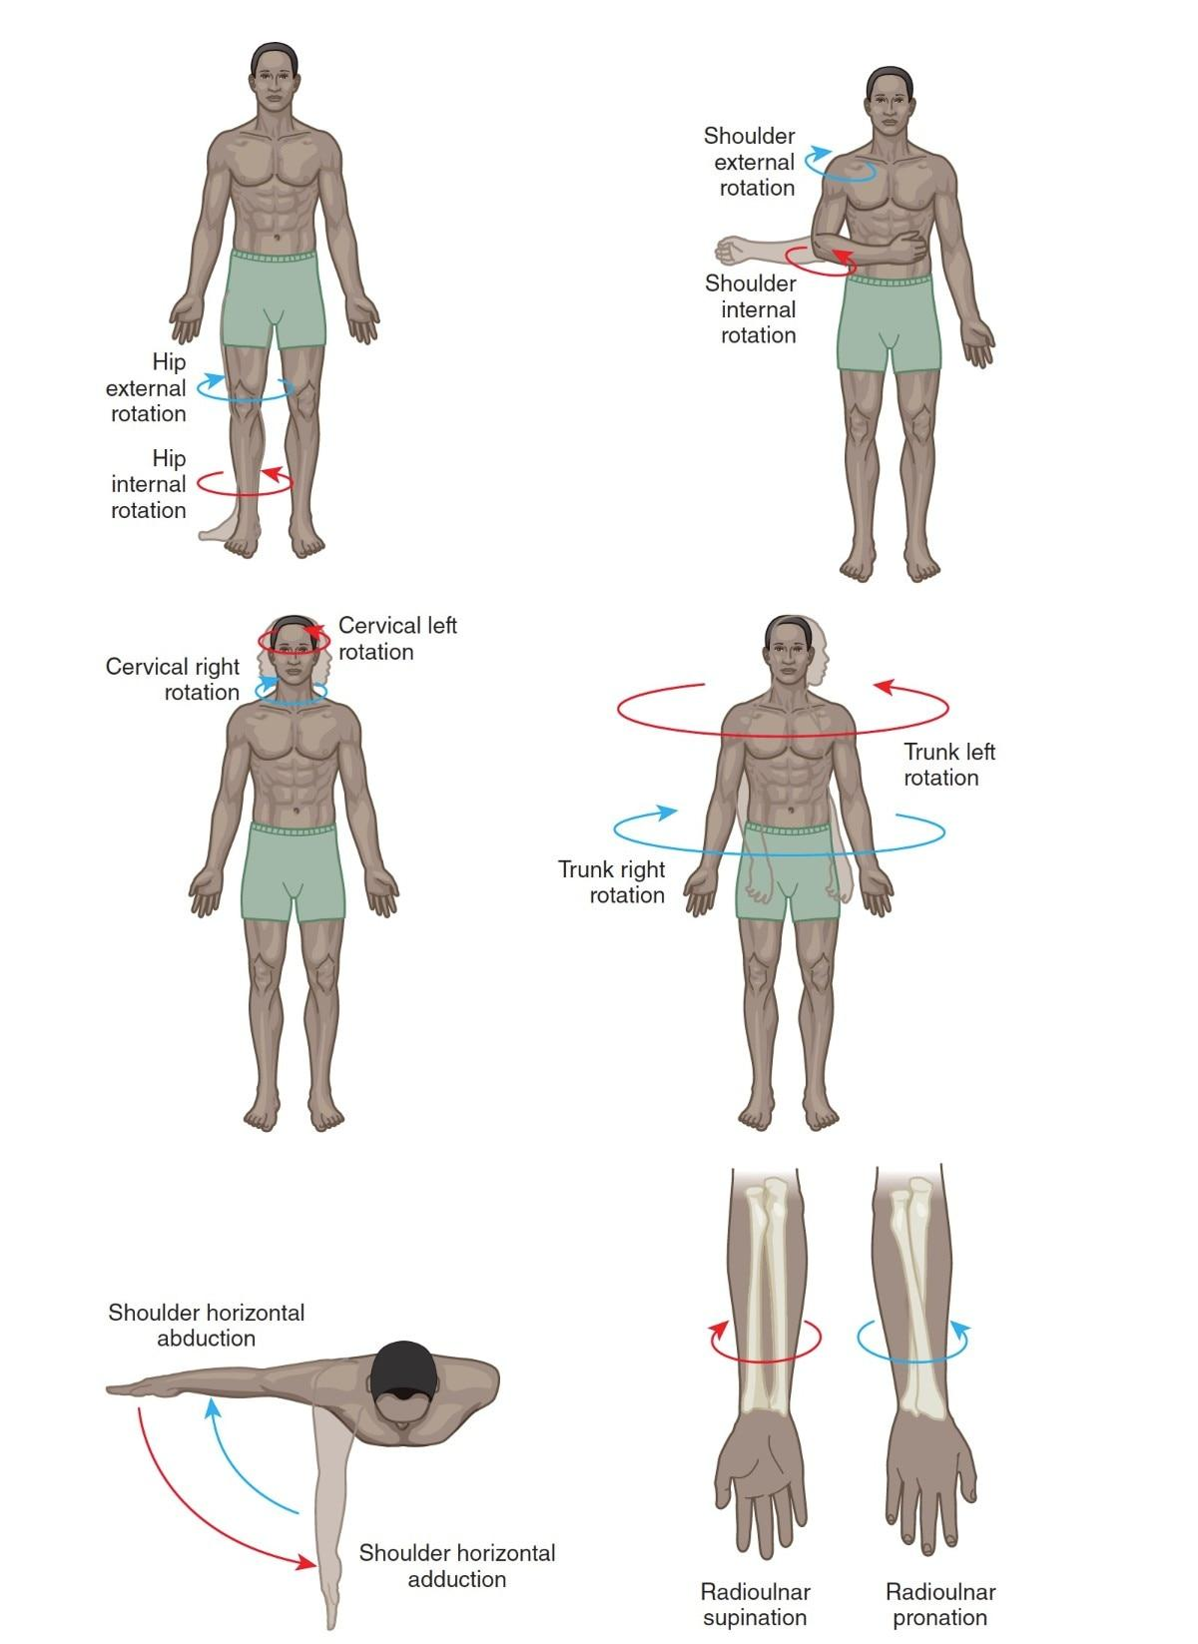

**Figure 7-7** Rotational movements

STRETCH YOUR KNOWLEDGE

The transverse plane involves rotational movement of the head, torso, arms, and legs. In addition, movement in the transverse plane involves horizontal abduction and adduction, which can occur at either the shoulders or hips. For example, a machine chest fly exercise involves horizontal abduction and adduction at the shoulder, whereas a hip abductor machine involves horizontal abduction and adduction at the hips.

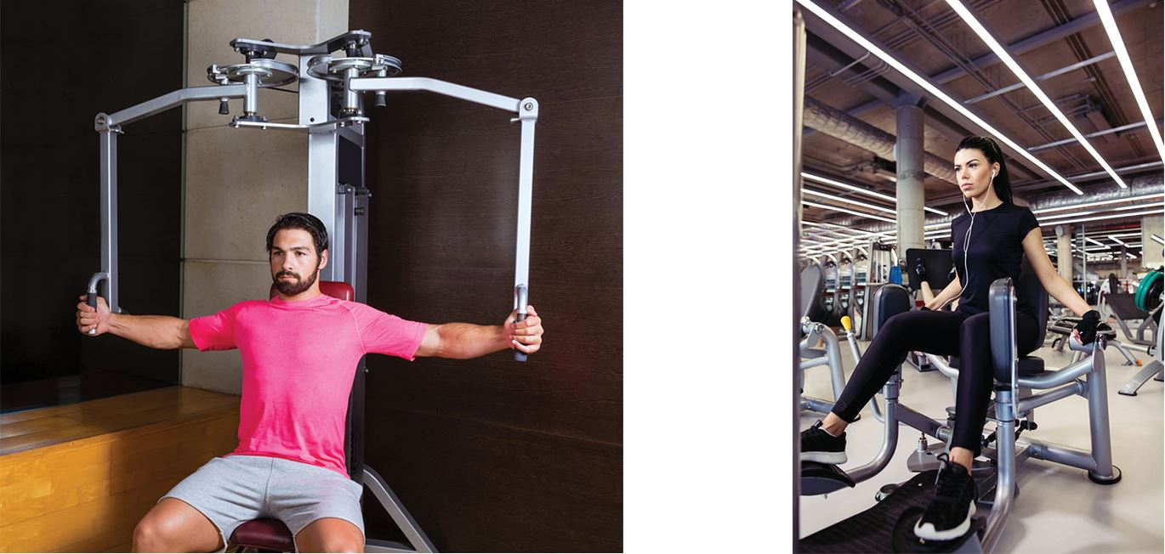l

GETTING TECHNICAL

Just like with dorsiflexion, plantar flexion, eversion, and inversion in the sagittal and frontal planes, there is unique terminology for transverse plane movement of the feet. In this context, rotating the foot outward at the ankle (with no rotation of the leg as a whole) is called abduction (toes rotating laterally), while inward rotation of the foot at the ankle is called adduction (toes pointing medially) (Hamill & Knutzen, 2003; Levangie et al., 2019).

To move the body functionally, however, the foot and ankle complex rarely performs its single plane movements in isolation. Instead, the ankle moves through its own version of pronation and supination, which is different from radioulnar pronation and supination. Pronation of the foot is a multiplanar movement consisting of the combination of eversion, dorsiflexion, and ankle abduction. Supination of the foot is then the combination of inversion, plantar flexion, and ankle adduction. During gait (walking and running), the foot and ankle complex moves between pronation during force reduction (when the foot lands) and supination during force production (when the foot pushes off the ground) with every step.

**Scapular motion**

Motions of the scapulae (i.e., the shoulder blades) are important for the fitness professional to be familiar with to ensure proper movement of the shoulder complex. Isolated scapular movements— termed *translations*, because they do not rotate around a fixed axis—are primarily retraction, protraction, elevation, and depression (Levangie et al., 2019) (Figure 7-8).

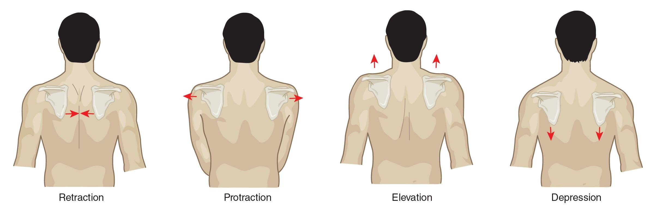

**Figure 7-8** Scapular movements

Scapular retraction occurs when the shoulder blades come closer together. Scapular protraction occurs when the shoulder blades move further away from each other. Scapular depression occurs when the shoulder blades move downward, and scapular elevation occurs when the shoulder blades move upward toward the ears (Levangie et al., 2019).

STRETCH YOUR KNOWLEDGE

Scapular retraction requires several muscles, including the middle trapezius and rhomboids. Scapular protraction primarily requires the serratus anterior muscle, with some assistance from the pectoral muscles.

**Movement attributes**

The HMS is complex and requires not only the integrative function of different systems but also cooperative efforts within the systems. Generally speaking, movement can be described in terms of the predominant movement plane and the specific motions at the joints; however, movement can also be classified as being normal or dysfunctional. Normal movement represents efficient, cooperative functioning of the skeletal, nervous, and muscular systems (Kendall et al., 2005). Normal movement requires a joint to be able to move through its full ROM, which requires normal osteo- and arthrokinematics (Levangie et al., 2019).

The amount of movement determined to be normal would depend on the activity of interest. For example, certain sports require greater joint ROMs than standard activities of daily living, as is seen in the difference between the motion of the shoulders when pitching a baseball and simply washing one’s hair. Full ROM requires normal elasticity of the capsule and ligaments surrounding the joint and normal muscle length and flexibility, as well as normally functioning neurological and muscular systems. Clients with hypermobility (excessive ROM at a joint) generally would be expected to have a lack of firm ligamentous support, whereas those with hypomobility (limited ROM at a joint) generally have restricted length of the muscular structures that cross the joint (Kendall et al., 2005).

**Isokinetic**

During isokinetic muscle actions, the muscle shortens at a constant speed over the full ROM. An isokinetic muscle action requires the use of expensive and sophisticated equipment that measures the amount of force generated by the muscles and adjusts the resistance (load) so that no matter how much muscular tension is produced, movement speed remains constant. In other words, the harder an individual pushes or pulls, the more resistance they feel. During a full isokinetic contraction, the tension in the muscle is at its maximum throughout the whole ROM, which is believed to improve strength and endurance. However, the types of movements that are able to be performed on isokinetic machines are rather limited, and these machines often are only seen in rehabilitation clinics or exercise physiology laboratories.

**The muscle action spectrum**

Because practically every exercise consists of an eccentric, isometric, and concentric muscle action to complete one repetition, the movement through those muscle actions is referred to as the muscle action spectrum. A dumbbell curl exercise is a clear example to illustrate this concept. The initial movement requires the biceps brachii to shorten to generate enough force to overcome the weight of the dumbbell in the individual’s hand (i.e., the force of gravity pulling the dumbbell’s mass toward the ground), causing the elbows to flex and the dumbbells to move up toward the front of the shoulder (Figure 7-9). This is the concentric phase of the exercise.

Once the dumbbells are raised to the front of the shoulder, the individual holds this position. Because the length of the muscle does not change while generating force to hold this position, it is considered the isometric portion of the exercise. As the individual lowers the dumbbells back to the starting position, the biceps muscles must now generate forces while lengthening to decelerate the force of the dumbbells against the pull of gravity; this is the eccentric portion of the exercise (Figure 7-10).

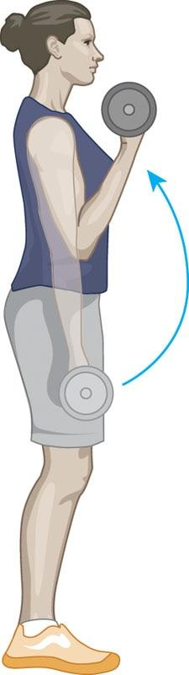 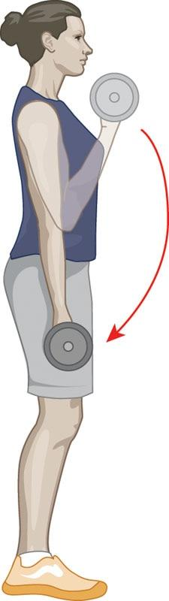

**Figure 7-9** Dumbbell biceps curl—concentric motion

**Figure 7-10** Dumbbell biceps curl—eccentric motion

GETTING TECHNICAL

When performing a biceps curl exercise with the palm facing up, the biceps brachii is the primary muscle targeted. Changing the hand position to palm down targets the brachialis to a greater degree, whereas performing the exercise with the thumb up (hammer curls) targets the brachioradialis muscle to a greater extent. During all three versions of the curl exercise, all of the elbow flexors are recruited concurrently; however, the degree of recruitment for each muscle differs with each hand and forearm position (Kendall et al., 2005; Levangie et al., 2019).

A second example to help illustrate muscle actions is the squat exercise. To initiate the squat from a standing position, the individual squats down, flexing at the hips, knees, and ankles (Figure 7-11). As the individual squats downward, the gluteal muscles and quadriceps mechanically lengthen while simultaneously decelerating the force of the individual’s bodyweight; this is the eccentric muscle action of the squat exercise. The isometric muscle action occurs when the individual pauses at the bottom position and no joint motion is visible. Lastly, the concentric muscle action occurs when the individual extends at the ankles, knees, and hips to return to the starting position, concentrically contracting the gluteal muscles and quadriceps (i.e., the lifting phase) (Figure 7-12).

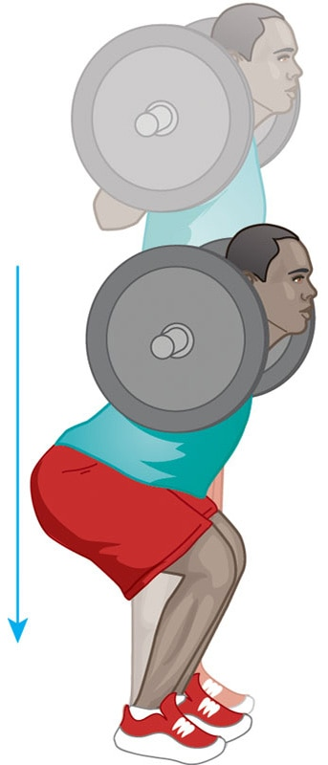 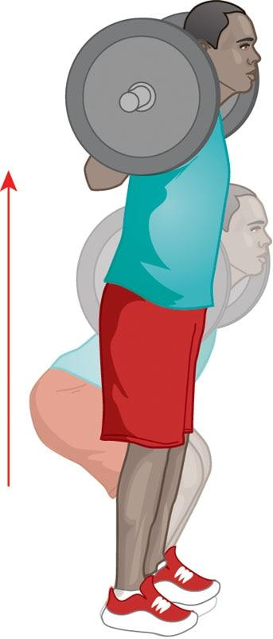

**Figure 7-11**Back squat— eccentric motion

**Figure 7-12**Back squat— concentric motion

TRAINING TIP

The integrated function of the HMS can be recognized during a squat. Clients with limited dorsiflexion of the ankle will be limited in the depth of their squat during the eccentric phase. A quick method for these individuals to gain a deeper squat ROM is to place a small board (or weight plates) under their heels. A longer-term solution would be to address the stiffness of the ankle joints by performing routine stretching (Macrum et al., 2012).

## Functional anatomy of muscles

To more effectively understand human movement and to design efficient exercise programs, it is important to view muscles’ capacities to function in all planes of motion and through the entire muscle action spectrum (eccentric, isometric, concentric). In addition, muscles can also work synergistically to produce force, stabilize the body, and reduce force under direct control of the nervous system. The more that functional anatomy is understood, the more specific an exercise program can become. To explore the muscles of the body in more detail, refer to Appendix C.

**Muscles as movers**

Muscles provide the human body with a variety of functions that allow for the manipulation of forces placed on the body to either produce, stabilize, or resist movement. During functional movements, a muscle can be categorized as either an agonist, synergist, stabilizer, or antagonist depending on the joint motion being performed.

Agonists are muscles that act as the prime movers for a joint motion; in other words, they are the muscles most responsible for generating the primary forces for a particular movement. For example, the gluteus maximus is the agonist for hip extension, the quadriceps are the agonists for knee extension, the anterior deltoid is the agonist for shoulder flexion, the biceps brachii is the agonist for elbow flexion, and the triceps brachii is the agonist for elbow extension (Kendall et al., 2005; Levangie et al., 2019).

Synergist muscles create forces to assist prime movers but are not intended as the primary force producer for a given joint motion. For example, the hamstring complex and the erector spinae (muscles of the back) are synergistic with the gluteus maximus during hip extension (Kendall et al., 2005), whereas the brachioradialis and brachialis (forearm muscles) assist the biceps brachii during a biceps curl. Additional examples include the triceps brachii assisting the pectoral muscles during a chest press and the biceps brachii assisting the latissimus dorsi during a pull-up.

Stabilizer muscles contract isometrically to support and stabilize the joints, while the prime movers and synergists move through the entire muscle action spectrum to perform a movement. For example, the transversus abdominis (a deep abdominal muscle), internal obliques, and multifidus (deep muscles of the spine) stabilize the LPHC during hip extension. Another example is the rotator cuff muscles (supraspinatus, infraspinatus, teres minor, and subscapularis), which stabilize the shoulder during upper extremity movements (Day et al., 2012).

GETTING TECHNICAL

An interesting fact regarding stabilization is that certain muscles have the ability to stabilize a joint by contracting automatically in anticipation of movement (Day et al., 2012; Masse-Alarie et al., 2012). This anticipatory stabilization effect is referred to as feed-forward activation.

Lastly, antagonist muscles perform the opposite action of the prime mover. For example, the biceps brachii (an elbow flexor) is an antagonist to the triceps brachii during elbow extension. Conversely, during elbow flexion, the triceps become the antagonist to the biceps. Another example includes how the hip flexor complex is antagonistic to the gluteus maximus during hip extension, whereas the gluteus maximus is antagonistic to the hip flexor complex during hip flexion.

STRETCH YOUR KNOWLEDGE

As previously mentioned, muscles can often take on different roles depending on the joint motion that is being performed. For example, the infraspinatus muscle of the rotator cuff takes up the role of agonist (prime mover) for shoulder external rotation, the role of synergist when abducting the shoulder to reach overhead, and the role of stabilizer during other joint motions of the shoulder (Day et al., 2012; Kisner & Colby, 2007;Levangie et al., 2019).

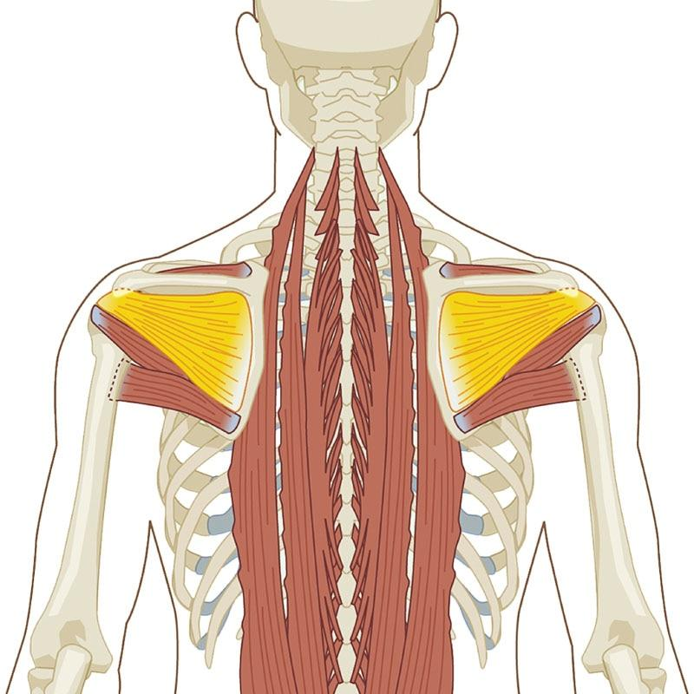

**Open- versus closed-chain movements**

In the health and fitness industry, exercises are often classified based on different load- or weight-bearing characteristics. One such classification is to describe an exercise as being either open- or closed-chain. Classifying an exercise in this manner may provide insight into muscle recruitment patterns, the degree of weight-bearing, and the number of joints involved (Kisner & Colby, 2007).

Closed-chain movements

The primary characteristic of closed-chain movements is that the distal segments, such as a person’s hands or feet, are fixed and remain in contact with a stationary surface. Additionally, closed-chain exercises often require the movement of multiple joints in a predictable manner with the contraction of multiple muscle groups (Kisner & Colby, 2007).

While not required, a majority of closed-chain activities are weight-bearing. Examples of closed-chain exercises include push-ups, squats, pull-ups, or lunges.

During a squat or lunge, the distal segments (the legs) are fixed on a stable surface and movement occurs at the hips, knees, and ankles; multiple muscles are activated, including the entire gluteal and quadriceps groups. The resistance of bodyweight or a weighted bar is applied simultaneously to all the joints of the lower extremity. The same can be said for the upper extremities during push-ups or pull-ups, with the hands fixed either on the floor or on a static bar. During these movements, the body is moving while transferring the force back into the fixed, stable surface, with multiple joints in the kinetic chain dealing with the resistance (Figure 7-13).

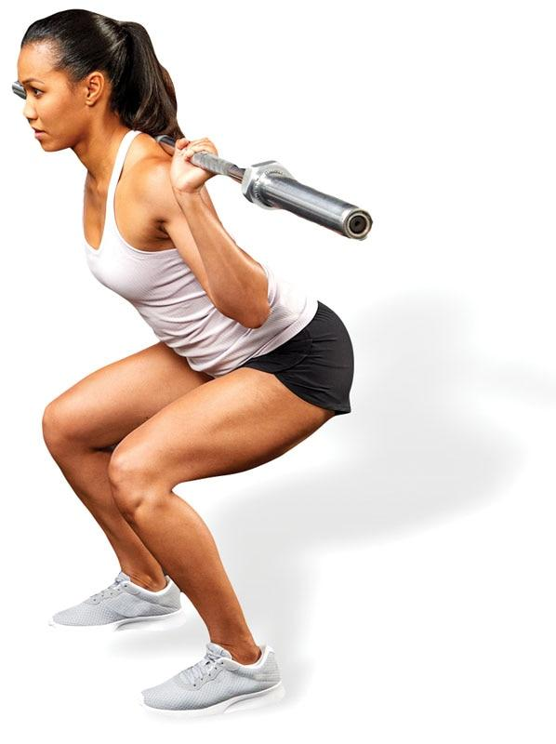 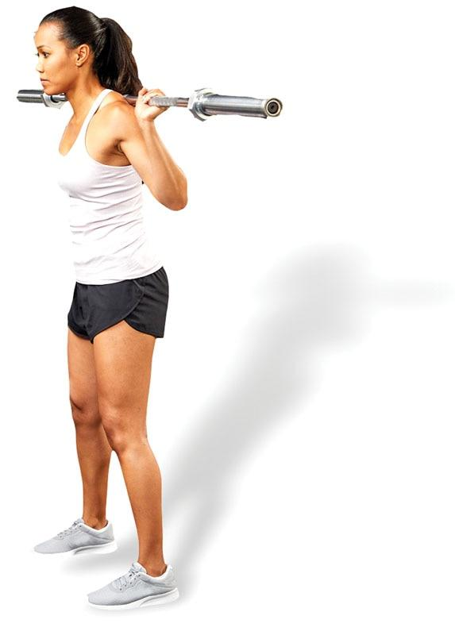

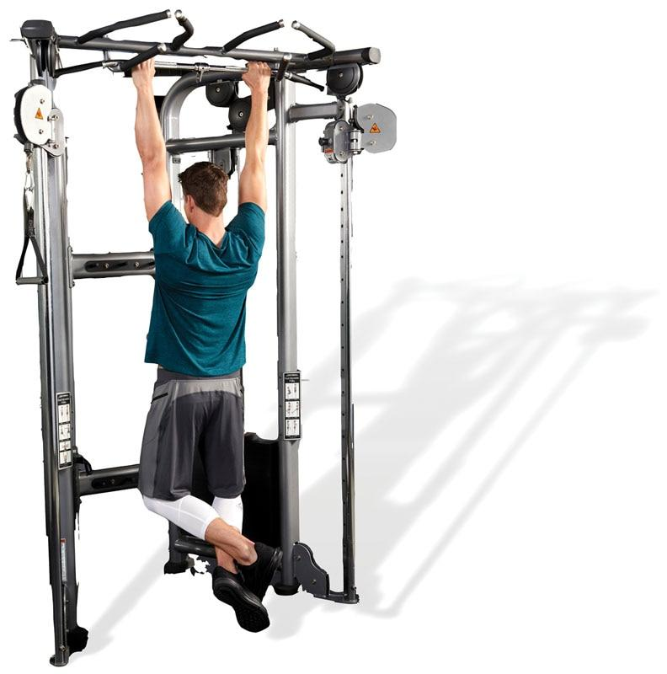 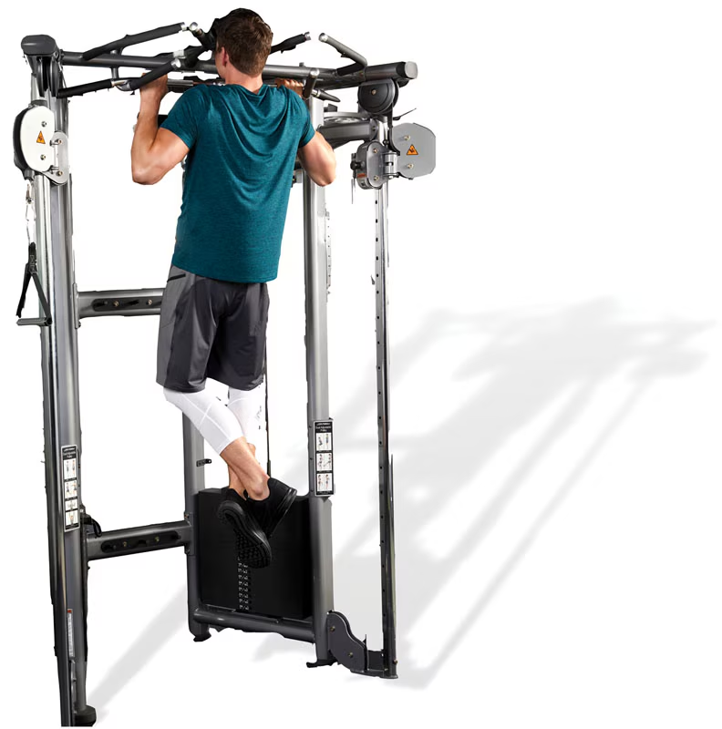

**Figure 7-13** Closed-chain exercises—back squat and pull-up

Open-chain movements

The primary characteristic of open-chain movements is that the distal segments (hands and feet) are not fixed, and they are free to move in space. Additionally, open-chain exercises have independent joint movement of only the segments distal to the moving joint itself (Kisner & Colby, 2007). While not required, a majority of open-chain activities are nonweight-bearing.

Examples of open-chain exercises include lat pulldown, biceps curl, bench press, leg curl, and leg extension exercises (Figure 7-14). Unlike closed-chain exercises, which activate multiple muscles, open-chain exercises tend to focus on isolating the prime mover muscles (Kisner & Colby, 2007).

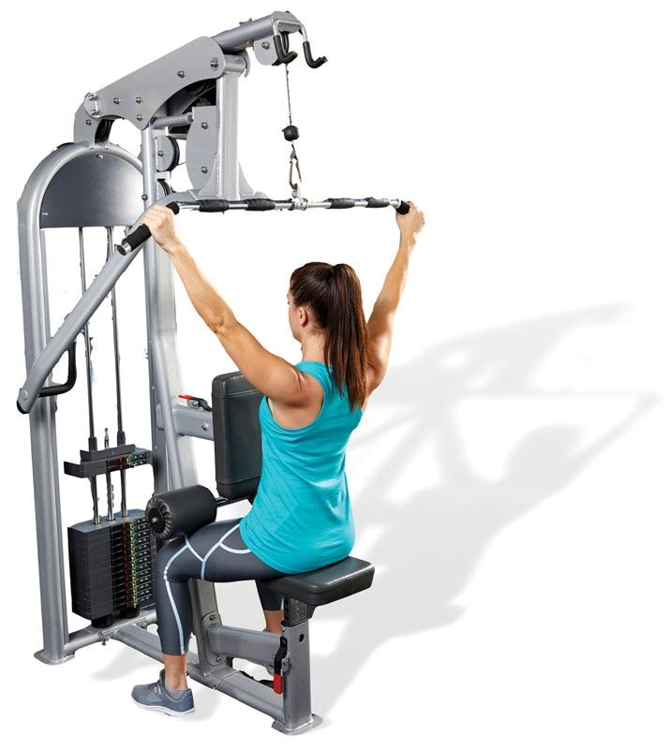 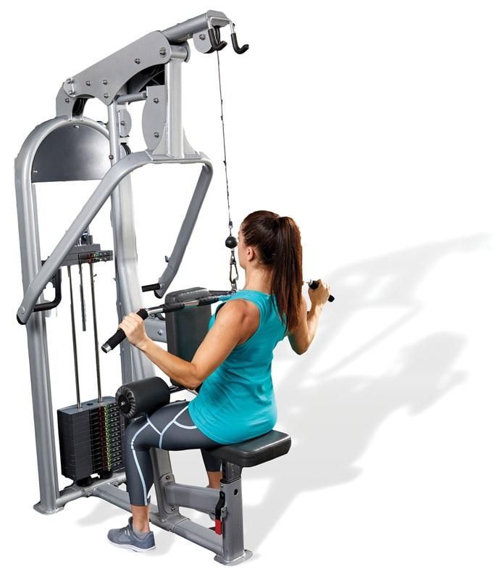

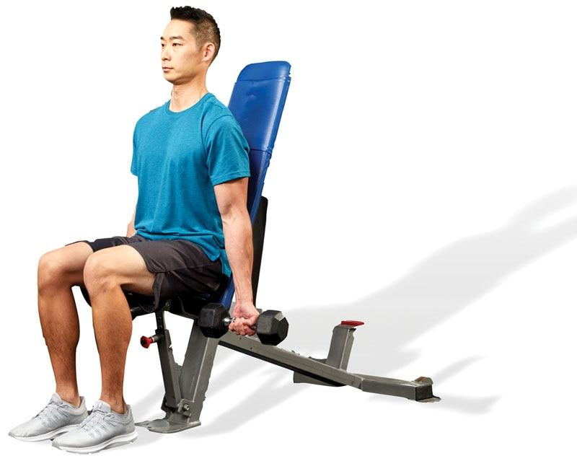 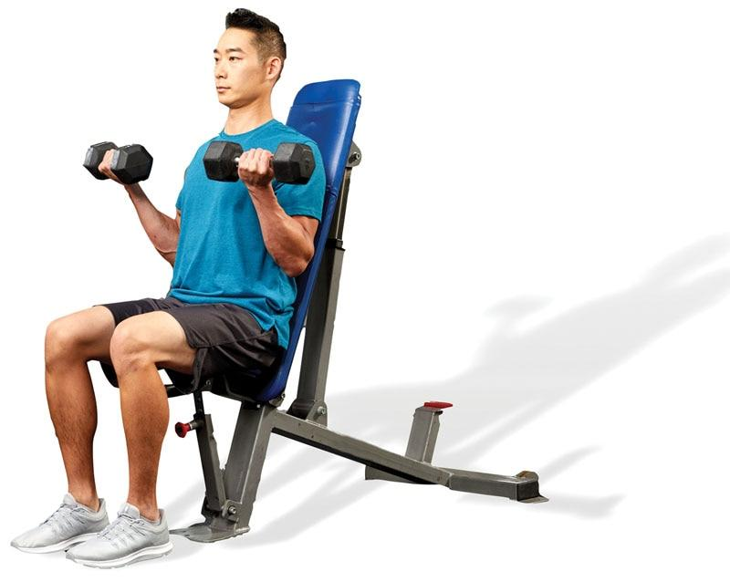

**Figure 7-14** Open-chain exercises—seated lat pulldown and seated biceps curl

Helpful Hint

Closed-chain exercises involve applying force into an immovable object, such as the floor, wall, or pull-up bar. In other words, the hands or feet are typically fixed and do not move.

Open-chain exercises involve the ability to freely move the limbs, such as the hands and feet.

For example, a pull-up is a closed-chain exercise for the back musculature, whereas the lat pulldown is an open-chain exercise for the same muscle group.

### Muscular force

Force is defined as the interaction between two entities or bodies that results in either the acceleration or deceleration of an object. Forces are characterized by magnitude (how much) and direction (which way they are moving) (Hamill & Knutzen, 2003; Levangie et al., 2019). The HMS is designed to manipulate variable forces from many directions to effectively produce movement. As such, the fitness professional must gain an understanding of some of the more pertinent forces that the HMS must deal with and how they affect motion.

**Length-tension relationships**

A length-tension relationship refers to the association between the resting length of a muscle and the amount of internal tension it can produce at that resting length (Levangie et al., 2019). Each muscle in the body has an optimal muscle length at which the actin and myosin filaments within the sarcomere have the greatest degree of overlap (Figure 7-15). At that optimal length, the ability of myosin to make a maximal amount of connections with actin results in the potential for maximal force production of that muscle.

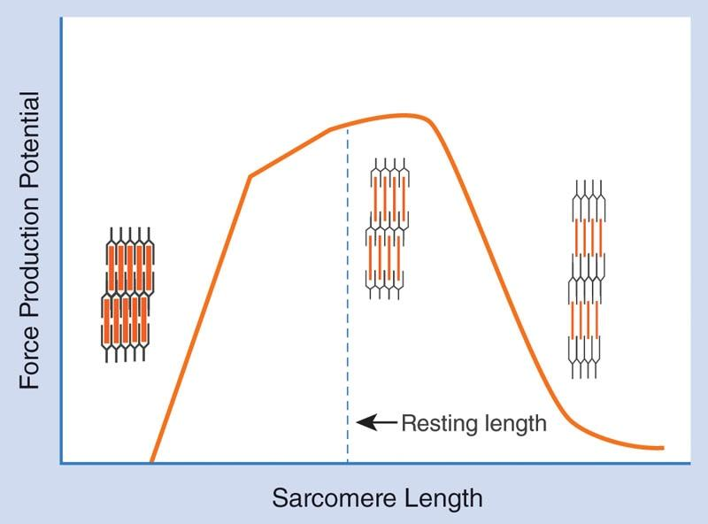

**Figure 7-15** Length-tension relationships

At both extremes of muscle shortening or lengthening there is a diminished ability to produce force. When a muscle has chronically low neural activation and is longer than it should be, there is a reduced amount of actin and myosin overlap, reducing the amount of force that can be produced at that length. When a muscle has chronically high neural activation and is regularly held in a contracted (shortened) state, it places the actin and myosin in a state of maximal overlap and allows for no further movement to occur between the filaments, also reducing its force output potential (Levangie et al., 2019).

**Muscle balance**

Length-tension relationships relate closely to the concept of muscle balance. Recall that on each side of a joint there are agonist and antagonist muscles; when one contracts and shortens, the other has to relax and lengthen if movement is to occur. When all muscles surrounding a joint have optimal length-tension relationships, neither side is pulling harder than the other, and they will hold that joint in an optimal position for the most efficient movement.

If a muscle’s resting length is either too long or too short on one side of a joint, however, it has an altered length-tension relationship. This creates imbalance around the joint, where one side is contracted and pulling more than it should be and the other side is allowing to be pulled into a lengthened state with reduced actin/myosin overlap, putting the joint into a suboptimal resting position (Figure 7-16).

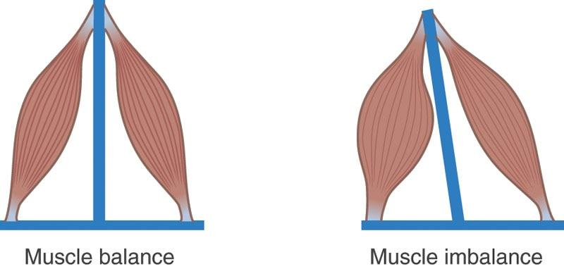

**Figure 7-16** Altered length-tension relationship (muscle imbalance)

A joint being held in a suboptimal position like this is the basis for poor posture. For example, if a person’s adductor muscles on the inside of the thighs are in a contracted/shortened position and consequently the abductor muscles on the outside of the hips (i.e., gluteus medius) are in a lengthened position, a knock-kneed posture will be created, which puts unnecessary stress on the joints and can lead to discomfort and increased risk of injury (Ford et al., 2015; Padua et al., 2012).

GETTING TECHNICAL

The scientific term that describes the nervous system’s role in the contract-relax relationship between agonists and antagonists is called reciprocal inhibition. When the agonist for a movement receives a signal (a motor neuron impulse) to contract, the central nervous system also sends a signal that inhibits the antagonist’s activation signals at the same time, causing it to relax. For example, to perform the biceps curl exercise, the biceps brachii (agonist) must contract, while simultaneously, the triceps brachii (antagonist) must relax for the movement to occur.

When muscles have altered length-tension relationships, the normal process of reciprocal inhibition becomes altered. Altered reciprocal inhibition is when an agonist muscle chronically receives an activation signal causing the functional antagonist to chronically receive the inhibitory signal.

When a muscle is chronically overactive, it is in a state of elevated neural activity, which causes the muscle to be in a constant state of contraction. When a muscle is chronically underactive, it is in a state of inhibited neural drive. In this situation, the overactive muscle pulls the joint too much in one direction, while the underactive muscle does not activate enough to resist that pull. The result is that the joint is held in a suboptimal position (poor postural alignment) due to a muscle imbalance.

Formal assessments of a client’s posture will help identify muscle imbalances. Then, flexibility techniques can be used to calm down muscle overactivity, and strengthening techniques can be used to improve the neural activation of underactive muscles. This helps restore optimal length-tension relationships within the muscles, restores balance around the joint, and allows the joint to be held in its most efficient neutral position.

### Stretch-shortening cycle

The stretch-shortening cycle is a term used to describe a loaded eccentric muscle action that prepares muscles and tendons for a rapid concentric contraction. The eccentric muscle action represents the *stretch* component, which stores elastic energy from the springlike nature of contractile tissue. The stored energy is a result of the series elastic component of muscle and tendon (mostly tendon) (Kisner & Colby, 2007).

HELPFUL HINT

The stretch-shortening cycle is similar to stretching a rubber band. Stretching the rubber band stores elastic energy. Once the rubber band is released, the elastic energy is transformed into kinetic energy, and the rubber band flies through the air. The same sort of principle applies to our body’s muscle and connective tissue. When a person needs to jump, they will first perform a shallow squat prior to initiating the jump—this is the body’s version of pulling on the rubber band.

After energy is stored, the contractile tissue releases this elastic energy during the concentric phase. The storage and release of this elastic energy increases force production if the time between the eccentric and concentric phase is rapid. Specifically, the amortization phase is used to describe this transition (Kisner & Colby, 2007). The goal of increased force production, hence, improved performance, depends on a rapid amortization phase. A rapid amortization phase requires both contractile tissue storage of energy and the neurological stretch reflex (Kisner & Colby, 2007).

Use of the stretch-shortening cycle in exercise is the basis for plyometric training, in which jump-landing tasks eccentrically load the muscles (the landing) to achieve a more explosive concentric contraction (the jump). The more rapidly a client can move through the amortization phase, the more powerful the concentric contraction will be, which is known as the integrated performance paradigm. When executed properly, this type of training helps produce the necessary neural and muscular adaptations to improve speed, power, and sport-specific improvements (McArdle et al., 2016).

For example, the appropriate implementation of a depth-jump exercise involves jumping off a box and dropping immediately into a squat position for the landing. Moving into this squat position stores elastic energy via the series elastic component, then the release of that stored elastic energy combines with the concentric contraction to more powerfully drive the jump. If the amortization phase is prolonged, stored energy will dissipate, the neurological stretch reflex will not be optimally activated, and the concentric unloading phase will be less powerful.

The concept of the stretch-shortening cycle can also be applied within the context of agility drills, which require repeated switching from deceleration to acceleration. This switch is the stretch-shortening cycle in action, requiring a rapid reversal of muscle action from eccentric (loading) to isometric (amortization) to concentric (unloading). Essentially, any time a muscle is eccentrically loaded, those elastic forces can be amortized and released to provide a more powerful concentric contraction.

STRETCH YOUR KNOWLEDGE

In the powerlifting world, athletes competing in the bench press will often rapidly lower the bar toward their chest before pressing it back up. This technique, while not recommended for everyday exercisers because it is potentially dangerous, uses the integrated performance paradigm to add a bit of extra force to the concentric phase of the lift.

**Force-velocity curve**

The force-velocity curve describes the inverse relationship between force and velocity and refers to a muscle’s ability to produce tension at differing contraction velocities. As the velocity of a concentric muscle action increases, its ability to produce force decreases, while the ability to produce force increases as the velocity of a concentric contraction decreases (Levangie et al., 2019).

For example, during a heavy barbell back squat, the muscles produce a high amount of force; however, the movement is rather slow. Conversely, during a squat jump exercise, the velocity of movement is high; however, the force output is low (when compared to a heavy barbell back squat).

During an eccentric muscle action, as the contraction velocity increases, the ability to develop force also increases. This is believed to be the result of the use of the elastic component of the connective tissue surrounding and within the muscle—similar to the loading phase of the stretch-shortening cycle (Hamill & Knutzen, 2003; Radnor et al., 2017). Simply put, the faster the eccentric contraction, the more force the muscle is capable of decelerating. When plotted on a graph, the inverse relationship between eccentric and concentric contraction velocities and the amount of force they produce displays the force-velocity curve (Figure 7-17).

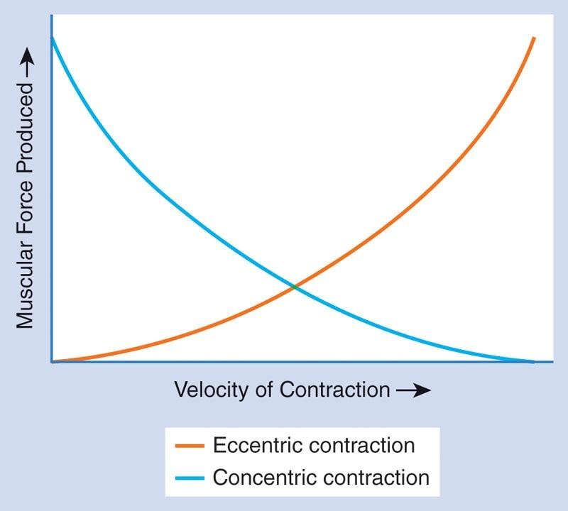

**Figure 7-17** Force-velocity curve

**Force-couple relationships**

Muscles produce a force that is transmitted to bones through their connective tissues, known as tendons. Because muscles are recruited as groups, many muscles will transmit force onto their respective bones, creating movement at the joints. This synergistic action of multiple muscles to produce movement around a joint is known as a force-couple relationship (Levangie et al., 2019).

Muscles in a force-couple provide divergent pulls on the bone or bones they connect with. That is to say, each muscle has different attachment sites, pulls at a different angle, and creates a different force on that joint. The motion that results from the combination of differing forces is dependent on the structure of the joint and the collective pull of each muscle involved (Levangie et al., 2019). For example, the middle trapezius, lower trapezius, and serratus anterior all pull on the scapula (shoulder blade) in different directions to assist with shoulder abduction (Figure 7-18).

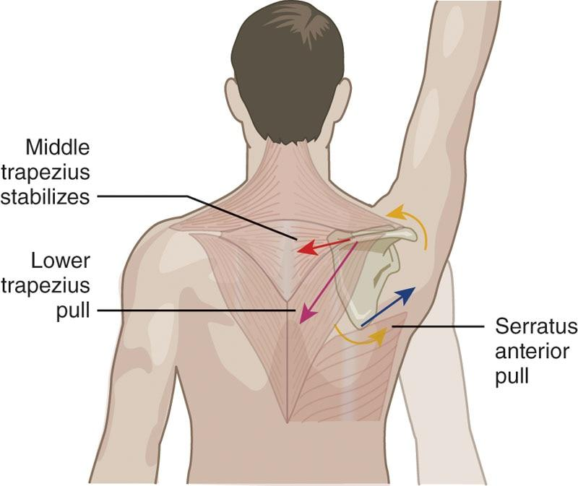

**Figure 7-18** Force-couple relationship example—shoulder abduction

CRITICAL

Muscles are connected to bones via tendons. When a muscle contracts, the muscle’s tendon pulls on its respective bone(s) to create joint motion. Muscles can only pull on their respective bones—muscles cannot actively push.

In reality, however, every movement produced must involve all muscle actions (eccentric, isometric, concentric) and all functions (agonists, synergists, stabilizers, and antagonists) to ensure proper joint motion as well as to eliminate unwanted or unnecessary motion. Thus, all muscles working in unison to produce a desired movement are said to be working in a force-couple relationship (Levangie et al., 2019).

To ensure that the HMS moves properly, it must have proper force-couple relationships around its joints, which can only happen if the muscles are at the right length-tension relationships and the joints have proper arthrokinematics. Collectively, proper length-tension relationships in the muscles allow for proper posture and motion at the joints, which in turn allow for optimal force-couple relationships that produce the most efficient movement (Levangie et al., 2019).

### Muscular systems of the body

Not only do muscles work together in force-couple relationships around the joints but they also work together throughout the body forming a network of interworking systems that work to both stabilize and create movement in all three planes of motion. There are two overarching categories of these systems, known as the local and global muscular systems.

**Local muscular system**

Local muscles generally attach on or near the vertebrae and serve the primary purpose of stabilizing the trunk of the body. The local muscular system is composed of the *inner unit* of the core and includes the rotatores, multifidus, transversus abdominis, diaphragm, pelvic floor, and quadratus lumborum. Many of these muscles can be actively contracted and may also activate automatically in anticipation of limb or trunk movements, a neurological process known as the feed-forward activation (Masse-Alarie et al., 2012; Okubo et al., 2010). The local muscular system is thought to offer a segmental stabilization effect on the spine (Okubo et al., 2010). Due to this, some commonly refer to it simply as the stabilization system of the core.

STRETCH YOUR KNOWLEDGE

Evidence has shown that the feed-forward stabilization effect from the transversus abdominis and internal oblique musculature is delayed among people with lower back pain (Masse-Alarie et al., 2012). These intrinsic, core stabilizer muscles are often underactive in individuals with overactive hip flexors, causing an anterior tilting of the pelvis and low-back arch.

It should be noted, however, that there are also stabilization force-couples working together systematically in other regions of the body, known as joint support systems. For example, the rotator cuff of the shoulder is a group of muscles functioning in a similar manner to provide stabilization support for the glenohumeral (shoulder) joint (Day et al., 2012).

**Global muscular system**

The global muscular system is comprised of larger muscles that initiate movements and tend to function across one or more joints (Okubo et al., 2010). These muscles are generally larger and act as prime movers during many functional tasks, such as pushing, pulling, squatting, and walking. Because of this, the global muscular system is commonly referred to as the movement system. Examples of global muscles include the rectus abdominis, erector spinae, and latissimus dorsi.

The global muscular system’s main interconnected function is to transfer forces through the LPHC to create the most efficient movement possible while also providing additional support to protect the trunk and spine as the body moves. To better illustrate how muscles of the movement system work together in synchrony, the global muscles can be categorized into subsystems, which include the deep longitudinal, posterior oblique, anterior oblique, and lateral subsystems. These muscular subsystems highlight the functional elements of regional interdependence, as well as the necessary extensions of force-couple relationships. Without these subsystems, normal movement would be impaired, and the risk of injury and reduced performance would increase. Each of the subsystems is mirrored on the left and right sides of the body.

**Deep longitudinal subsystem**

The deep longitudinal subsystem (DLS) includes muscles of the lower leg, hamstrings, and lower back region (Figure 7-19). Working together synergistically, these muscles create a contracting tension to absorb and control ground reaction forces during gait (walking, running). For example, during or just prior to the heel strike phase of running, the long head of the biceps femoris (hamstring) contracts eccentrically to decelerate knee extension. Because the hamstrings attach at the pelvis, forces are transmitted up to the lower back muscles (erector spinae). Thus, the regional interdependence between the lower extremity ankle musculature, the hamstrings, and lower back is highlighted.

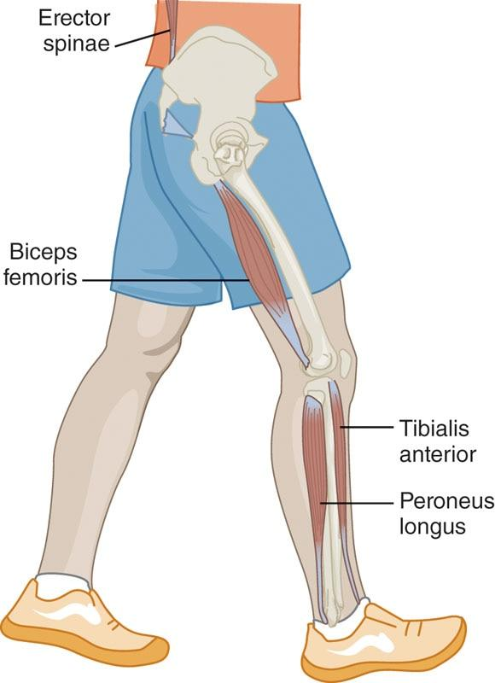

**Figure 7-19** Deep longitudinal subsystem

**Posterior oblique subsystem**

The posterior oblique subsystem (POS) is made up of the latissimus dorsi, thoracolumbar fascia (connective tissue of the low-back), and contralateral gluteus maximus. Figure 7-20 shows how the latissimus dorsi and contralateral gluteus maximus create a nearly straight line with each other across the sacroiliac joint (a joint between the sacrum and the ilium bones).

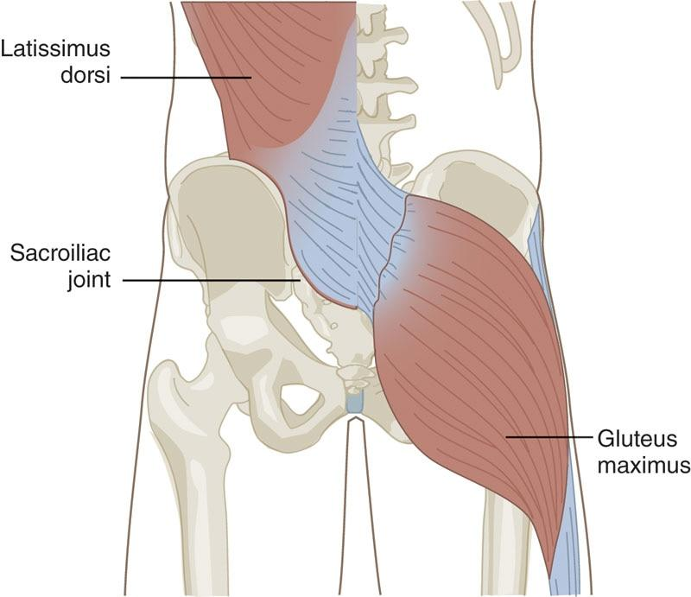

**Figure 7-20** Posterior oblique subsystem

When the muscles of the POS contract, they produce a pulling force across the thoracolumbar fascia and a stabilization force at the sacroiliac joint. When mirrored for both the left and right sides of the body, the POS can be seen to form an X across the sacroiliac joint, creating the divergent tensions that lead to its stabilization effect.

This system works together with the DLS during gait just prior to or during heel strike as the gluteus maximus and latissimus dorsi are eccentrically loaded (Levangie et al., 2019). The force-couple relationship of the gluteus maximus and latissimus dorsi are highlighted here, which together provide a functional element of stability to the LPHC as a whole. Further to this point, the regional interdependence of the LPHC, middle, and upper back is highlighted by the interaction of the POS musculature.

**Anterior oblique subsystem**

The anterior oblique subsystem (AOS) is similar to the POS, just on the anterior side of the body. The muscles include the obliques, the adductor (inner) thigh muscles, and the hip external rotators. The obliques and contralateral (opposite) adductors are the most common visualization of this subsystem because of the X pattern made across the front of the body (Figure 7-21). The AOS creates stability from the trunk, through the pelvis, and to the hips and contributes to rotational movement. The AOS and POS work together as a global force-couple in enabling rotational force production in the transverse plane.

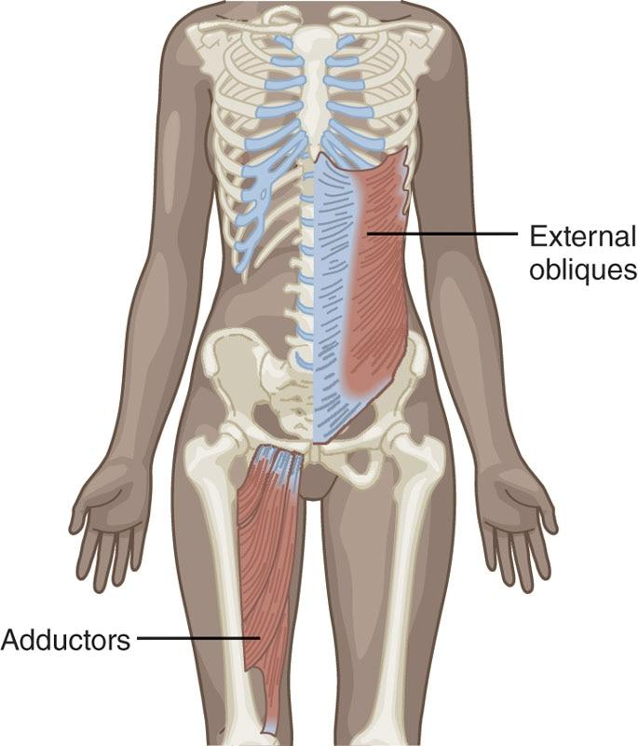

**Figure 7-21** Anterior oblique subsystem

STRETCH YOUR KNOWLEDGE

During normal walking and running, the pelvis rotates in the transverse plane to facilitate the necessary momentum for the swing phase of gait where leg and thigh are advanced forward in the sagittal plane.

**Lateral subsystem**

The lateral subsystem (LS) is made up of the lateral hip (gluteus medius) and medial thigh muscles (adductors) and the contralateral quadratus lumborum, all of which provide movement in the frontal plane (Figure 7-22). Together, these muscles are tasked with creating and maintaining frontal plane (side-to-side) stabilization of the LPHC during movement.

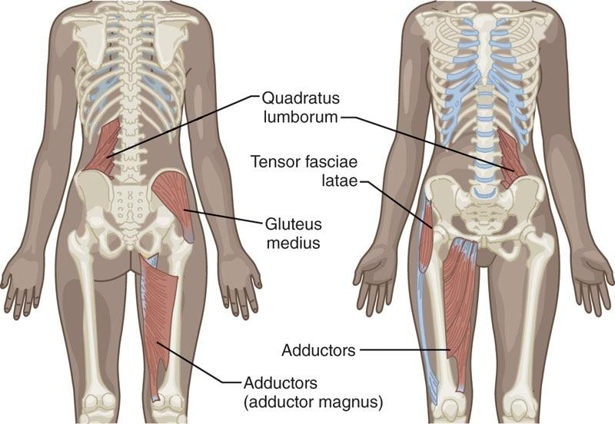

**Figure 7-22** Lateral subsystem

The LS functions during numerous activities, which include movements that require a single-leg stance phase, such as seen during gait, running, and lunges. Furthermore, the LS provides stability of the lower extremities to prevent abnormal or unwanted frontal plane movement patterns during activities. For example, the LS prevents unwanted hip and thigh adduction during the squat (Kolber et al., 2017). An improperly working LS may be evident among those individuals who are unable to maintain appropriate lower-extremity alignment in the frontal plane (knees collapsing inward during a squat) (Kolber et al., 2017).

**Subsystem coordination**

While these subsystems have been described individually, it is important to recognize their coordinated and complex actions during movements. During physical activity, the subsystems work synergistically to perform efficient movements and stabilize the spine and pelvis.

Although the subsystems have been described only in the context of muscle activity, fitness professionals must remember that all movement relies on the nervous and skeletal systems as well. A deficit in joint function or failure of the nervous system to supply the appropriate signal can potentially lead to improper movement patterns, even if all muscles in a subsystem have proper length-tension relationships.

### Muscular leverage and Arthrokinematics

The amount of force that the HMS can produce relies on not only motor unit recruitment and muscle size but also the lever system of the joint. The musculoskeletal system is composed of bones, muscles, tendons, and ligaments, all of which create a series of levers and pulleys that generate force against external objects.

Skeletal muscles are attached to bones by tendons and produce movement by bending the skeleton at movable joints. Recall that joint motion is caused by muscles pulling on bones; muscles cannot actively push. Particular attachments of muscles to bones will determine how much force the muscle is capable of generating. For example, the quadriceps muscles can produce more force than muscles of the hand.

Most motion uses the principle of levers. A lever consists of a rigid bar that pivots around a stationary pivot point (fulcrum). In the human body, the fulcrum is the joint axis, bones are the levers, muscles create the motion (effort), and resistance can be the weight of a body part, or the weight of an object (Hamill & Knutzen, 2003; Levangie et al., 2019).

Levers are classified as first, second, and third class, depending on the relations among the fulcrum, the effort, and the resistance (Figure 7-23). First-class levers have the fulcrum in the middle, like a seesaw. Nodding the head is an example of a first-class lever, with the top of the spinal column as the fulcrum (Levangie et al., 2019).

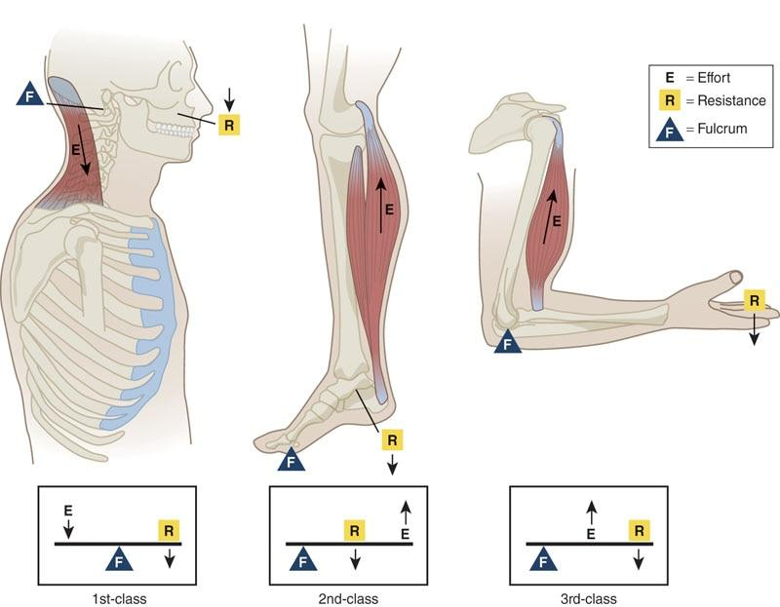

**Figure 7-23** Lever examples

Second-class levers have a resistance in the middle with the fulcrum and effort on either side, similar to a load in a wheelbarrow where the axle and wheel are the fulcrum points. The body acts as a second-class lever when one engages in a full-body push-up or calf raise. Using the calf raise exercise as an example, the ball of the foot is the fulcrum, the body weight is the resistance, and the effort is applied by the calf musculature (Levangie et al., 2019).

Third-class levers have the effort placed between the resistance and the fulcrum. The effort always travels a shorter distance and must be greater than the resistance. Most limbs of the human body operate as third-class levers. An example of a third-class lever is the human forearm; the fulcrum is the elbow, the effort is applied by the biceps brachii muscle, and the load is in the hand, such as a dumbbell when performing a biceps curl. Another example of a third-class lever is the standing hamstring curl, whereby the knee joint is the fulcrum, hamstring muscle is the effort, and resistance is at the ankle.

HELPFUL HINT

When trying to remember the levers, think of the pneumonic F-R-E-1-2-3. This means that fulcrum is in middle for a first-class lever (F, 1), resistance is in the middle for the second-class lever (R, 2), with the effort in middle for a third-class lever (E, 3).

Applying the concept of levers to the principles of the HMS, bones act as lever arms that move a load from the force applied by the muscles. This movement around an axis can be termed rotary motion and implies that the bones rotate around joints (Hamill & Knutzen, 2003; Levangie et al., 2019). This turning effect of the joint is often referred to as torque (Hamill & Knutzen, 2003; Levangie et al., 2019). Torque is a measurement of the amount of force that can cause an object to rotate around an axis. Torque relies on force, the length of the lever arm, and the angle between the force application and the lever arm.

HELPFUL HINT

An example of torque is using a wrench to loosen a bolt. The wrench serves as a lever, and torque would be a product of the force applied to the wrench and the length of the wrench’s handle. Increasing the length of the wrench’s handle would increase the torque applied to the bolt.

In resistance training, torque is applied so we can move our joints. Because the neuromuscular system is ultimately responsible for manipulating force, the amount of leverage the HMS will have (for any given movement) depends on the leverage of the muscles in relation to the resistance. The difference between the distance from the weight to the center of the joint, the muscle’s attachment, and the line of pull determines the efficiency with which the muscles manipulate the movement (Hamill & Knutzen, 2003; Levangie et al., 2019).

Because we cannot alter the attachment sites or the line of pull of our muscles through the tendon, the easiest way to alter the amount of torque generated at a joint is to move the resistance. In other words, the closer the weight is to the point of rotation, the less torque it creates (Figure 7-24). The farther away the weight is from the point of rotation, the more torque it creates. From a biomechanical perspective, the distance a weight is from the joint it is acting on directly determines the effort required of a muscle to move the weight (Levangie et al., 2019). Meaning, the farther the distance, the harder the muscle must work, thus, the greater activation of the muscle.

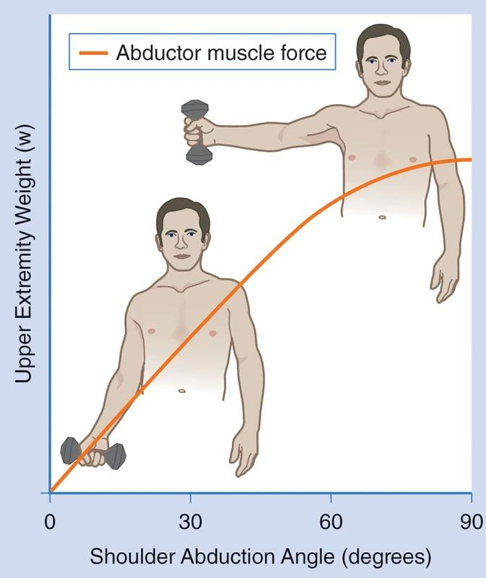

**Figure 7-24** Load and torque relationship

For example, when holding a dumbbell straight out to the side at arm’s length (shoulder abduction), the weight may be approximately 24 inches from the center of the shoulder joint. The prime mover for shoulder abduction is the deltoid muscle. If its attachment is approximately 2 inches from the joint center, there is a difference of 22 inches (11 times greater). However, if the weight is moved closer to the joint center, to the elbow, the resistance is only approximately 12 inches from the joint center. Now the difference is only 10 inches or 5 times greater. Essentially, the weight was reduced by half.

Many people performing side lateral raises with dumbbells do this inadvertently by bending their elbow and bringing the weight closer to the shoulder joint. Fitness professionals can use this principle as a regression to exercises that are too demanding by reducing the torque placed on the HMS or as a progression to increase the torque and place a greater demand on the HMS.

TRY THIS

Lie on your side with a weight wrapped around the ankle joint of your top leg and abduct your thigh. Now, repeat with the weight wrapped around your knee. Notice how much easier it was to abduct the hip when moving the resistance closer to the center of the moving joint (hip). That is because moving the weight closer to the joint reduces the amount of torque required.

## Motor behaviour

Motor behaviour is the HMS response to internal and external environmental stimuli. The study of motor behaviour examines the manner by which the nervous, skeletal, and muscular systems interact to produce skilled movement using sensory information from internal and external environments. Studying motor behaviour represents the collective study of motor control, motor learning, and motor development (Schmidt & Lee, 1999).

Motor control is the ability to initiate and correct purposeful controlled movements and involves mechanisms used by the central nervous system to assimilate and integrate sensory information with previous experiences (Newton, 2003; Rose, 1997). Motor control is concerned with the central nervous system structures that are involved with motor behaviour to produce movement (Rose, 1997).

Motor learning is the use of these processes through practice and experience, leading to a relatively permanent change in one’s capacity to produce skilled movements (Schmidt & Wrisberg, 2000). Anytime a new physical skill is learned and practiced, motor learning is occurring.

Motor development is then defined as the cumulative changes in motor behaviour, over time, throughout the life span (Gabbard, 2008). Essentially, individuals’ motor development represents every physical ability they have learned over their lifetime, from rolling over for the first time as an infant to performing complex movements for athletic competition as an adult and beyond.

**Motor control**

To move in an organized and efficient manner, the HMS must exhibit precise control over its collective segments. This segmental control is an integrated process involving neural, skeletal, and muscular components to produce appropriate motor responses. This process—and the study of these movements—is known as motor control and focuses on the involved structures and mechanisms used by the central nervous system to integrate internal and external sensory information with previous experiences to produce a skilled motor response.

Motor control is concerned with the neural structures that are involved with motor behavior and how they produce movement (Coker, 2004; Nordin et al., 2017; Rose, 1997; Schmidt & Wrisberg, 2000). Essentially, motor learning and development are required for an individual to have proper motor control. Fitness professionals play a key role in the development of their clients’ motor control through proper instruction during exercise and fitness endeavours.

**Muscle synergies**

One of the most important concepts in motor control is that muscles are recruited by the nervous system in groups, known as muscle synergies (Newton, 2003; Rose, 1997; Singh et al., 2018). There is never a time where only one single muscle is activated alone. This makes controlling movement more efficient by allowing muscles and joints to operate as functional units (Bizzi & Cheung 2013).

Muscle synergies represent the interworking relationship between agonist and synergist muscle roles for a given movement pattern. Through the practice of proper exercise technique and form, these synergies become more fluent and automated. Table 7-3 explores muscle synergies for some common gym exercises.

TABLE 7-3 Muscle Synergies for Common Exercises

| **Exercise** | **Muscle Synergies** |
| --- | --- |
| Squat | Agonists: quadriceps, gluteus maximus Synergist: hamstrings complex Stabilizer: transverse abdominis |
| Shoulder press | Agonists: deltoids Synergist: triceps brachii Stabilizers: rotator cuff |
| Bench press | Agonist: pectoralis major Synergists: triceps brachii, anterior deltoid Stabilizer: rotator cuff |
| Seated row | Agonist: latissimus dorsi Synergists: posterior deltoid, biceps brachii Stabilizers: rotator cuff |

**Proprioception**

Mechanoreceptors collectively feed the nervous system with a form of sensory information known as proprioception. Proprioception uses information from the mechanoreceptors (i.e., muscle spindles, Golgi tendon organs, and joint receptors) to provide information about body position, movement, and sensation as it pertains to muscle and joint force (Newton, 2003). Proprioception is a vital source of information that the nervous system uses to gather information about the environment to produce the most efficient and precise movement.

For example, proprioceptive input may provide a runner with a cue to contract the ankle muscles to avoid an inversion injury. Research has demonstrated that although proprioception may help prevent injury, it is altered after injury. This means that many of today’s health club members may have altered proprioception as a result of past injuries. This provides a rationale for the inclusion of both core and balance training to enhance one’s proprioceptive capabilities.

TRY THIS

Sit in a chair with your eyes closed. Next, raise your right arm above your head. Then, move your arm in a small circular motion five times. Stop and open your eyes.

How were you able to understand what your arm was doing? You couldn’t see, smell, taste, hear, or touch your right arm as it moved, but somehow you were able to internally sense what your arm was doing. This internal sensation is proprioception at work.

**Sensorimotor integration**

Sensorimotor integration is the ability of the nervous system to gather and interpret sensory information and to select and execute the proper motor response (Biedert, 2000; Drury, 2000; Janda & Va Vrova, 1996; Levangie et al., 2019; Rose, 1997). The definition implies that the nervous system ultimately dictates movement. It is important to recognize that nervous system function includes both central and peripheral nervous systems as well as their integration with the musculotendinous structures and inert tissues (ligament and capsule).

For example, during an exercise, the muscle is activated and movement occurs. Movement occurs as a result of neural input to the muscle from the nervous system. Further to this point, the movement that occurs may activate the muscle receptors as well as the receptors in the joint itself, both providing feedback to the nervous system and influencing movement.

Sensorimotor integration is effective as long as the quality of incoming sensory information is good (Janda & Va Vrova, 1996; Levangie et al., 2019). Individuals who train using improper form will develop improper sensory information delivered to the central nervous system, leading to movement compensations and potential injury. It is, therefore, important to create properly designed exercise programs and encourage clients to train with correct techniques at all times. For example, if an individual consistently performs a chest press while rounding and elevating the shoulders, it can lead to altered length-tension relationships of muscles, altered force-couple relationships, and altered arthrokinematics, ultimately leading to shoulder injury.

**Motor learning**

Motor learning is the integration of motor control processes, with practice and experience, leading to a relatively permanent change in the capacity to produce skilled movements (Levangie et al., 2019; Rose, 1997; Schmidt & Lee, 1999). The study of motor learning looks at how movements are learned and retained for future use. Motor learning occurs when practicing to ride a bike, throw a baseball, play the piano, and every other physical task the body can possibly learn to perform.

In all cases, proper practice and experience will lead to a permanent change in one’s ability to perform a movement efficiently. For a movement to occur repeatedly, sensory information and sensorimotor integration must be used to aid the HMS in the development of permanent neural representations of motor patterns, a process referred to as feedback. Essentially, the nervous system learns from repeated activity, and newer movements often take more time to be refined or mastered.

**Feedback**

Feedback is the use of sensory information and sensorimotor integration to aid the HMS in developing permanent neural representations of motor patterns. Feedback allows for efficient movement, which is achieved through two different forms of feedback: internal (or sensory) feedback and external (or augmented) feedback.

Internal feedback

Internal feedback is the process whereby the body uses sensory information to reactively monitor movement and the environment. It comes primarily from internal biological structures (mechanoreceptors) in the body relaying information via the autonomic nervous system. Internal feedback acts as a guide, steering the HMS to the proper force, speed, and amplitude of movement patterns for a given situation.

It is important to instruct clients to use proper form when exercising to ensure that the incoming sensory feedback is correct information, allowing for optimal sensorimotor integration. For example, during a hamstring stretch, the exerciser can feel when a stretch has reached a tolerable limit and chooses to stop further movement to avoid overstretching.

External feedback

External feedback refers to the information provided by an external source, including a Certified Personal Trainer, video recording, mirror, or heart rate monitor, to help supplement internal feedback to produce more efficient motor learning. External feedback provides clients with another source of information that allows them to associate whether the achieved movement pattern was “good” or “bad” with what they are feeling internally.

Two major forms of external feedback are knowledge of results and knowledge of performance (Rose, 1997; Schmidt & Lee, 1999; Schmidt & Wrisberg, 2000; Swinnen, 1996). *Knowledge of results* is used after the completion of a movement to help inform a client about the outcome of the performance. Effective use and application of knowledge of results involves both the fitness professional and the client’s participation. An example of knowledge of results is a fitness professional telling clients that their squats looked “good” followed by asking the clients whether they could “feel” or “see” their good form.

By getting clients involved with the knowledge of results, they increase their awareness and augment other forms of sensory feedback, leading to more effective exercise technique. Knowledge of results can be done after each repetition, after a few repetitions, or after the set is completed. As clients become increasingly familiar with the desired technique of a movement, knowledge of results from the fitness professional can be offered less frequently. When knowledge of results is implemented, it improves neuromuscular efficiency as well (Swinnen, 1996).

*Knowledge of performance* provides information about the quality of the movement during an exercise. An example would be noticing that a client’s feet were excessively externally rotated

and the knees were adducting during a squat, and then asking the client whether they felt or looked different during those repetitions. Knowledge of performance gets the client involved in their own sensory process. Knowledge of performance should be offered less frequently as the client becomes more proficient (Swinnen, 1996).

These forms of external feedback allow for the identification of performance errors and help improve effective performance outcomes in the future. They are also an important component of motivation. Furthermore, they provide the client supplemental sensory input to help create an awareness of the desired action. It is important that clients not become dependent on external feedback, especially from a fitness professional, because this may detract from their responsiveness to internal sensory input or internal motivation (Rose, 1997; Schmidt & Lee, 1999; Schmidt & Wrisberg, 2000; Swinnen, 1996). Excessive use of external feedback can negatively affect sensorimotor integration and motor learning and, ultimately, movement patterns.

## Introduction to exercise metabolism and bioenergetics

The human body needs a constant supply of energy to function properly. Those energy requirements can change, and exercise places unique demands on the body’s ability to supply energy. In addition to increasing energy demand, exercise also requires the body to handle additional metabolic by-products.

The food we eat contains carbohydrates, proteins, and fats, which are needed by our cells to produce energy and function properly. The energy stored in these food sources, through a series of chemical reactions, is converted to a high-energy compound called adenosine triphosphate (ATP), which serves as the main form of energy in the human body (Figure 8-1). The role of energy metabolism during exercise involves understanding how energy is supplied, which energy systems are used during exercise, how quickly energy can be supplied, and how cells generate ATP.

### Bioenergetics and metabolism

Energy metabolism, or bioenergetics, is the study of how energy is transformed through various biochemical reactions. Energy is required to sustain life, support exercise, and pro­mote recovery from physical activity or structured exercise. The term metabolism refers to all the chemical reactions that occur in the body to maintain itself. As mentioned earlier, the main sources of chemical energy for humans are carbohydrates, fats, and protein. Exercise metabolism refers to the examination of bioenergetics as it relates to the unique physiological changes and demands placed on the body during exercise.

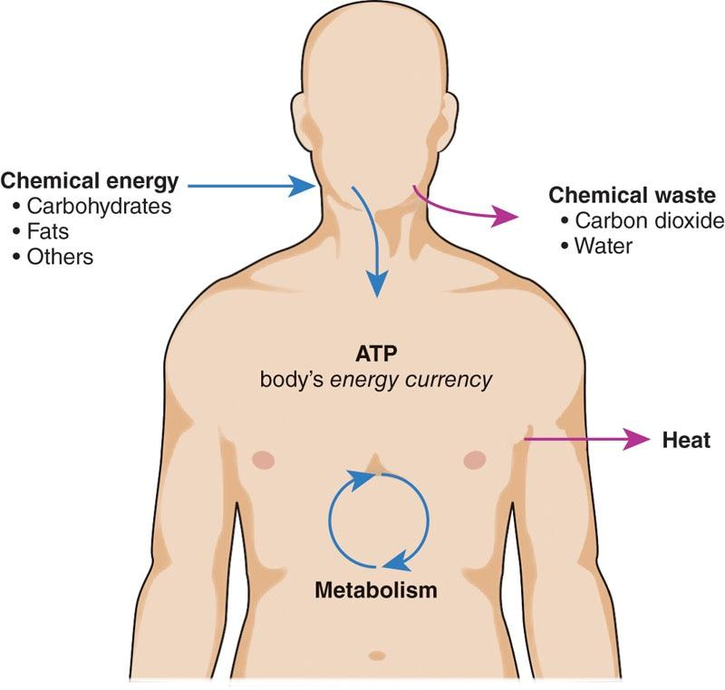

**Figure 8-1** Basic overview of energy metabolism

**Introduction to the law of thermodynamics**

The body is an intact (i.e., closed) system. Like all other systems in nature, the body must follow the first law of thermodynamics, which states that energy can neither be created nor destroyed, only recycled or converted from one form into another. In humans, this is referred to as the concept of energy balance. Put briefly, the energy entering the body in the form of macronutrients and coming out of the body is always accounted for by changes in mass (i.e., a person’s scale weight). If someone consistently expends more energy than they consume, that person will lose mass (weight). If someone consistently consumes more energy than they expend, that person will gain mass (weight). Therefore, all of the energy someone consumes is either used to perform bodily functions or stored within the body (typically as body fat).

GETTING TECHNICAL

Carbon In – Carbon Out

All life on earth is carbon-based, meaning that carbon is the element that primarily gives living things their physical mass. The “energy” contained in food is located within the molecular bonds that connect carbon and other elements in various ways to form carbohydrate, protein, and fat molecules (i.e., the edible forms of organic matter). Other elements in organic matter—such as oxygen, phosphorous, nitrogen, and hydrogen— have little to no contribution to physical mass. Water, which does contribute to a living thing’s *scale weight*, is contained *within* the physical mass (i.e., inside cells and blood); it is not part of it. When organic matter is consumed by an animal, molecular bonds are broken and reformed numerous times during metabolism—converting the source macronutrients into numerous intermediate forms of organic matter—on the way to forming the ATP molecules that muscles and organs use directly as their “energy currency” to power function.

Energy is stored in the human body in the same way it is contained within food—in the molecular bonds of carbohydrate (glucose and glycogen), fat (body fat), and protein (muscle and other soft tissues) structures. Per the first law of thermodynamics, a body’s mass increases when it consumes more energy than it uses because that energy must be physically contained within the molecular bonds of carbon-based organic matter. Simply put, if energy isn’t used, it is stored away for later, and there can be no energy stored away for later without the accompanying increase in carbon-based body mass to contain that energy.

Body mass is then lost in only one specific way. As metabolism works to convert both food and bodily stores (i.e., glycogen and fat) to ATP for use, carbon dioxide (CO2) is formed as the main waste product. Other than physically removing tissue through surgery, exhaling CO2 is the only way carbon is removed from the body. As the body exhales CO2, the energy contained within the CO2’s carbon-oxygen molecular bonds is released back into the external environment where it is taken up by plants and entered back into the greater food supply. Energy is never created or destroyed; it is just transferred from one form of carbon-based organic matter to another. In the human body’s case, energy starts as food, is then converted to various forms within the body during metabolism, and is finally released back to the environment as CO2 during exhalation.

**Fuel for energy metabolism**

Dietary food provides energy to sustain life and support physical activity, but not directly; it first must be broken down by the digestive system into smaller by-products called substrates. Proteins (more specifically, chains of amino acids), carbohydrates, and fats constitute the main substrates used to transfer metabolic energy to be used for all types of cellular activity and life (Becker & Smith, 2006; Gleeson, 2005; Kalish et al., 2012; Maughan, 2005). Since all energy substrates are forms of organic matter, many can be converted from one to the other within the body depending on what is needed. For example, the body can convert carbohydrate-based foods to fat molecules in order to store energy for later use. However, a small selection of substrates cannot be created internally in this manner and must be consumed in the diet. Those nutrients we must eat to live healthily are termed *essential*.

**Glucose and glycogen**

Glucose is one of the main sources of energy, particularly for brain function and higher-intensity activity. Glucose can be made in the body from other substrates (fats and amino acids), but a large majority of our daily glucose needs come from consuming carbohydrate-based foods. Carbohydrates are consumed and broken down into glucose through digestion. Glucose is then absorbed and transported in the blood, where it circulates until it enters cells and is either used to make ATP or is stored for later. When it is stored, it is stored as string molecules in a branched structure called glycogen. Glycogen is stored in the liver and muscle cells and can be broken down rapidly to provide energy when there is not enough free glucose in the blood.

Glucose makes a relatively small contribution to overall energy production during rest or low-intensity exercise. The brain always requires glucose to function, but fats are what primarily fuel the body when it is not active.

As the intensity of an activity increases, the body transitions from using mostly fat as fuel to using mostly glucose to provide energy. This is because glucose can be used much faster than fat and can also be metabolized without oxygen, whereas using fat for fuel always requires oxygen.

As activity intensity increases, the usage of carbohydrate as an energy source becomes 50%, and the usage of fat becomes 50%. This metabolic marker is referred to as ventilatory threshold 1 (VT1). This will be an important concept to keep in mind during cardiorespiratory assessment and programming, especially as it pertains to maximizing both fat loss goals and performance goals for clients. As exercise intensity increases further to maximal levels, ventilatory threshold 2 (VT2) is reached (Ballweg et al., 2013; Foster et al., 2008). VT2 represents the point where activity is so intense that glucose is providing virtually all of the energy for the activity, as fats metabolize too slowly to keep up with maximal demands. If the supplies of glucose and glycogen run out, a person would not be able to continue exercising at maximal intensity and he or she will have to reduce effort to a point where fat usage is once again possible, commonly referred to as hitting a wall. This is part of why some athletes use “energy gels” and other carbohydrate supplements during prolonged strenuous training and in competition.

**Free fatty acids**

An equally important source of energy are fats, also known as lipids. This energy source is particularly important during rest and lower-intensity activity (i.e., below VT1). The chemical (or substrate) form in which most fats exist in food (as well as in the body) is called triglyceride (Gleeson, 2005; Kalish et al., 2012). Triglycerides, more commonly referred to as free fatty acids when they are in the blood stream, are derived directly from fats contained in foods or are made by the body to store excess energy when more food is consumed than is needed to support activity.

Before cells can use consumed fat or stored body fat as a fuel source, it first needs to be broken down into free fatty acids. Free fatty acids are then used exclusively in the aerobic metabolic pathway to produce ATP. One of the benefits of having fat as a fuel source is that even relatively lean people still have a large supply stored on their body, which can be broken down into triglycerides and used for energy during prolonged, lower-intensity physical activity and exercise. Any time an individual is exercising at an intensity below VT1, free fatty acids are the primary fuel source.

STRETCH YOUR KNOWLEDGE

For conversion purposes, 1 lb (~0.5 kg) of body fat equals around 3,500 calories of stored energy. For example, a lean 150 lb (~68 kg) person with 10% body fat would still have roughly 15 lb (~6.8 kg) of fat stored away throughout their body. That is roughly 52,500 calories!

**Amino acids**

The third fuel source is protein, which is made up of long chains of “building block” substances called amino acids. Humans use 20 different amino acids to assemble bodily proteins. Of these 20 amino acids, nine are called essential amino acids, which means that the body cannot synthesize them on its own and they must be consumed in the diet.

The other 11 amino acids are called nonessential amino acids, which means that they can be synthesized by the body (from consumed carbohydrate or fat substrates) as long as overall nutrition intake is adequate.

When a person consumes protein, it is broken down into its component amino acids. Those amino acid building blocks will then, ideally, be used to synthesize human bodily proteins that build up muscle and repair cellular machinery. However, the amino acids from dietary protein can also supply energy for ATP production if carbohydrate and fat sources are low. This situation should happen rarely to “spare protein,” which is why adequate carbohydrate intake is important, especially after intense exercise; therefore, glycogen stores get replenished from the carbohydrate source, and amino acids can fulfill their main postexercise role: build and repair muscle.

Protein rarely supplies much energy during exercise and, in many descriptions, is ignored as a significant fuel source for energy metabolism (Mitchell et al., 2016; Phillips, 2017). During a negative energy balance, amino acids are used to assist in energy production and can come from protein that was eaten or from the breakdown of muscle tissue itself in extreme cases, like starvation or when exercising at extremely high intensities for long periods of time (for example, with Olympic marathon runners). Before amino acids can be used to make ATP, they are further broken down and then recombined into either glucose through a process called gluconeogenesis or ketone bodies through a process called ketogenesis (Maughan, 2005; McArdle et al., 2010).

**Ketone bodies**

Ketone bodies is the name collectively used to refer to three molecules—acetone, acetoacetic acid, and beta-hydroxybutyric acid—that can be anaerobically metabolized similar to glucose. These molecules are produced by the liver as a by-product of the breakdown of fatty acids or through the conversion of ketogenic amino acids. The human body does not have the ability to store these molecules, so they are only used acutely to produce energy and are not stored for later like glycogen (Miller et al., 2018). Even though the body does primarily run on free fatty acids during low-intensity activity and rest, it still needs carbohydrate substrates to properly function. So, when carbohydrate stores run low, ketone bodies are produced and used alongside gluconeogenic glucose to help make up for the deficiency. During this metabolic state, the body is said to be in ketosis. Ketone levels can increase in the human body in several ways:

* By restricting overall calories to very low levels
* By following very low-carbohydrate diets (e.g., ketogenic diet)
* By consuming exogenous ketones
* When there is a lack of insulin produced (type 1 diabetes) or substantial insulin resistance (type 2 diabetes)

In most cases, when humans engage in the previous dietary habits 1–3, their ketone levels can increase to approximately 0.5–1.5 millimoles per liter (mmol/L) of blood, which is known as nutritional ketosis. This is a different physiological state than what is known as ketoacidosis, which mostly occurs in diabetic individuals. For most people, ketones make up a small portion of the energy-producing substrates in the human body, even in nutritional ketosis. However, there is some research studying the effect of ketosis and ketone-producing diets, such as ketogenic diets, for exercise performance (LaFountain et al., 2019; Volek et al., 2016).

### Energy and mechanical work

To perform mechanical work, the body needs fuel, which is broken down through a series of chemical reactions to provide energy. Recall the first law of thermodynamics and how energy cannot be created or destroyed. The only way new energy enters the earth’s ecosystem is from the sun. Plants convert the sun’s energy to food and food provides animals (including humans) with energy to perform cellular and mechanical functions (Kalish et al., 2012; Maughan, 2005). Essentially, the human body is an organic machine that can turn chemical energy into mechanical work. Interestingly, about 40% of the energy released during metabolism is actually used for cellular work, such as a cell creating more molecules; the remainder is released as heat (McArdle et al., 2010). This is analogous to a car engine that uses gasoline (a chemical) to produce work and heat.

HELPFUL HINT

ATP for the body is like gasoline for a car, in that it is the specific fuel substrate that burns best in the engine. The food we eat is like crude oil; it contains all the necessary chemical energy, but it must be processed into a form that our “engines” (mitochondria in cells) can use. Metabolism essentially represents the body’s internal “oil refinery.” It processes the “crude” input (i.e., macronutrients) into something that can be specifically used by the cells for fuel (i.e., ATP).

**Energy systems**

Adenosine triphosphate is the primary energy-providing molecule in the human body. It is a complex molecule made up of a nitrogenous base (adenine), a sugar molecule (ribose), and three phosphate groups. Specifically, the energy that the body gets from ATP is stored in the chemical bonds that hold the three phosphates together. When these chemical bonds are broken, energy from one of the phosphates is released for mechanical work (such as performing muscle contraction), leaving behind another molecule called adenosine diphosphate (ADP) and an extra phosphate group (Figure 8-2).

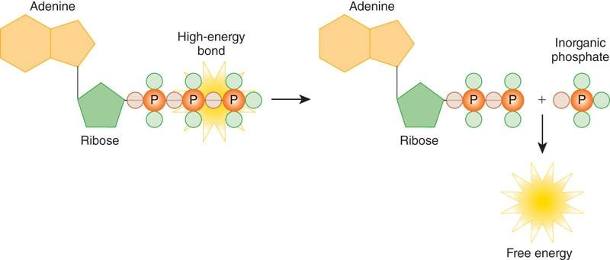

**Figure 8-2** ATP conversion to ADP

ADP is then left free in the cell, waiting to be converted back to ATP when enough energy substrates from food or bodily stores are available. Even though it takes numerous complicated physiological processes and chemical reactions to get there, all the useable energy from the food we eat and from stores in the body has the same end goal of making more available ATP.

The human body has several ways to generate ATP from ADP, which is a process called phosphorylation. The three main ways that phosphorylation is reached are known as the three metabolic pathways:

1. ATP-PC system
2. Glycolytic system (glycolysis)
3. Oxidative system (oxidative phosphorylation)

Depending on the intensity of an activity, each of the systems will shift in priority as to which is primarily supplying ATP; however, there is rarely a time where only one or another is active by itself. All three systems work together to fulfil the body’s total energy demand. The energy systems do not turn on and off in a linear fashion; rather, they operate more like dimmer switches. As the intensity of activity changes, the energy systems dynamically adjust in relation to one another to ensure energy needs are met. Even though one energy system might be contributing more than the others given a specific intensity of activity, the other two are still contributing in the background in some fashion.

This is best shown when looking at a graph of how the energy systems respond when the body is asked to perform a maximally intense activity for a long duration (Figure 8-3), such as running a few laps around a track at the fastest pace possible (hypothetically assuming the same maximal pace can be maintained for a few minutes). Recall that at rest and during low-intensity activity, free fatty acids provide most of the energy via the oxidative system. Then, when intensity increases (e.g., going from a standstill to an all-out sprint), the oxidative system cannot keep up, and the anaerobic processes kick into gear.

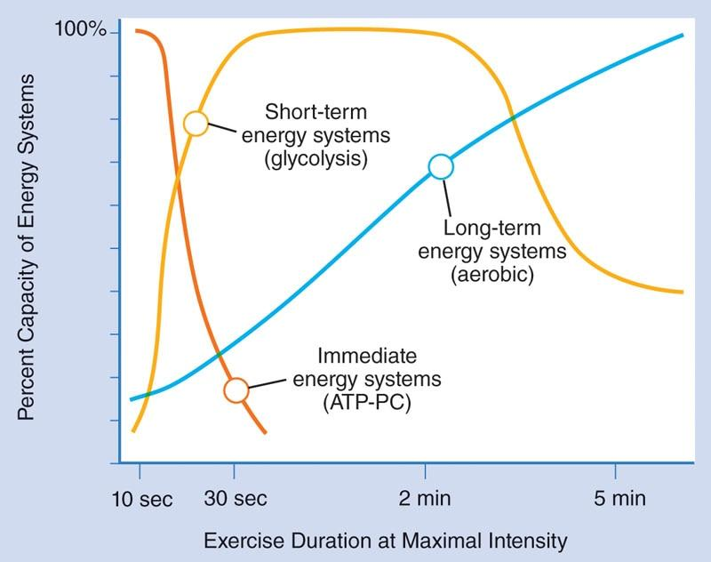

**Figure 8-3** Energy system usage during intense exercise

For the first 10–15 seconds, as the body transitions from low to high intensity, the ATP-PC system provides the most energy. As the ATP-PC begins to exhaust and taper off, glycolysis is already ramping up to take over the majority of the energy production duties, which it can support for around 2 minutes. And all the while, the oxidative system is ramping up, contributing greater and greater amounts until it eventually becomes the primary source of ATP production. The better a person’s cardiorespiratory fitness is, the more efficiently the oxidative system can support higher levels of intensity without having to rely as heavily on anaerobic processes.

When intensity continues long enough that the oxidative system can no longer support the activity, there is no other option but to slow down, rest, and recover (i.e., the point beyond VT2 commonly known as hitting a wall).

HELPFUL HINT

The contribution of all three energy systems must always add up to 100%. There is never a time where one is completely “turned off.” Even when the oxidative system is primarily supplying energy for a long-lasting intense activity, the other systems are working to replenish so they can again support increased bursts of intensity when needed.

**ATP-PC**

The first of the ATP-generating metabolic pathways is known as the ATP-PC system, or the phosphagen or the phosphocreatine system (Figure 8-4). The body naturally creates stores of phosphocreatine by breaking down and converting certain amino acids. This system is the simplest and fastest way to generate more ATP. Essentially, it works by taking ADP left over from a previous muscle contraction and adds a phosphate taken from a phosphocreatine (PC) molecule, rapidly creating available ATP at the site where it needs to be used. This process does not require oxygen, which is why the ATP-PC energy pathway is considered anaerobic.

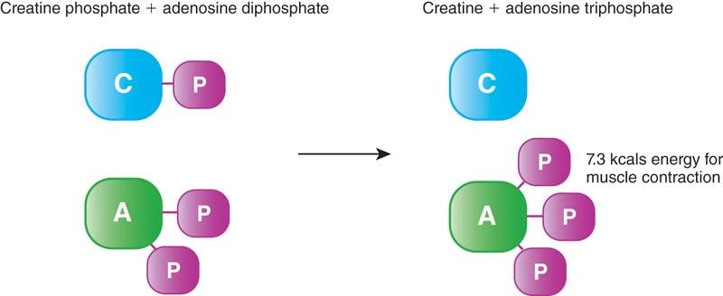

**Figure 8-4** The ATP-PC system

The ATP-PC system provides energy for primarily high-intensity, short-duration bouts of activity. This can be seen in strength and power forms of training in which very heavy loads are used with only a few repetitions or during short sprinting efforts. When activity rapidly intensifies, the small amounts of free ATP in the muscle tissue and the ATP-PC system can supply energy for only 10 to 15 seconds before running out (Wells et al., 2009). This system is activated at the onset of any increase in activity intensity because of its ability to produce energy very rapidly in comparison with the other systems. However, PC stores run out faster than they can be replenished, at which point other methods of ATP production must pick up the slack.

**Glycolysis**

As PC stores begin to exhaust, a slightly slower (but still relatively rapid) anaerobic energy system is ramping up. This is the first step in the chemical breakdown of glucose in a process referred to as glycolysis (Figure 8-5). The process of glycolysis turns free blood glucose or stored glycogen into pyruvate and ATP. Glycolysis takes place in the cytoplasm of an animal cell (Figure 8-6). This anaerobically created ATP can then be used directly the same way as the ATP created by the ATP-PC system. This system can produce a significantly greater amount of energy than the ATP-PC system, but it is a bit slower to ramp up to its full ATP production capabilities. However, it lasts longer, with a capacity of approximately 30 to 60 seconds of duration, which can be increased by several seconds through the use of high-intensity styles of training (Burke et al., 2011; Wells et al., 2009).

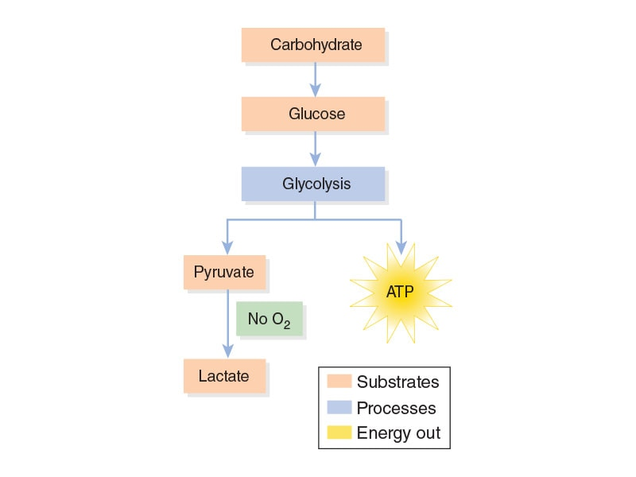

**Figure 8-5** Glycolysis

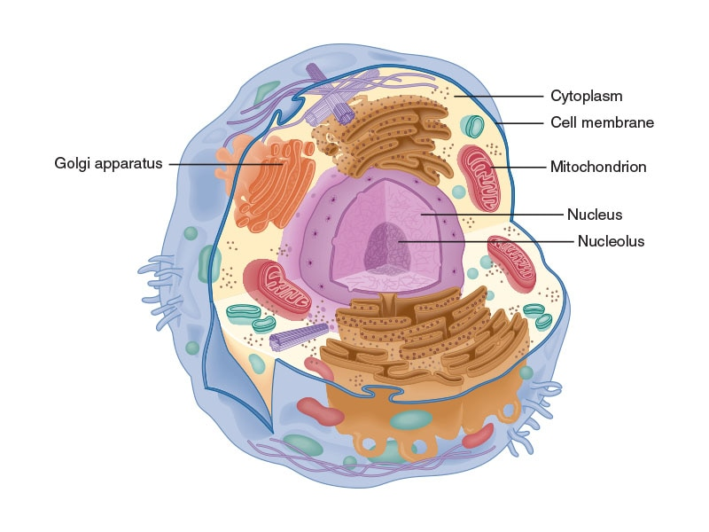

**Figure 8-6** Animal cell

Most people have enough free glucose in the blood and stored glycogen to fuel anaerobic glycolysis for many repeated bursts, such as a sprint workout or a session of high-intensity interval training (Maughan, 2005). However, for most people, those carbohydrate sources run out after around 1 hour of sustained activity, which is why carbohydrate drinks or gels are helpful to keep the body performing at its best when an event lasts longer than 60 minutes.

Glycolysis is directly linked with the oxidative system by the pyruvate by-product that is created. It can be treated in two different ways depending on whether or not there is oxygen present. If there is oxygen available, the pyruvate is further broken down, enters the oxidative system, and leads to the creation of additional ATP. If oxygen cannot be delivered fast enough, the pyruvate will be converted into a molecule called lactate, which contributes to the “burn” felt during strenuous exercise as it accumulates in muscle tissue (the accumulation of CO2 in muscle tissue at a rate faster than it can be removed also factors into the burning feeling).

GETTING TECHNICAL

What Is Lactic Acid?

During periods of high-intensity exercise, ATP is needed faster than oxygen can be delivered by the cardiorespiratory system. Therefore, the body relies mostly on the ATP-PC system and glycolysis for energy when intensities push toward maximal levels. As pyruvate accumulates in an anaerobic environment, it is quickly converted to lactate, releasing a free hydrogen ion in the process.

These hydrogen ions contribute to a decrease in muscle pH, which is known as acidosis. This acidosis can lead to some of the feelings of pain and fatigue associated with intense exercise because the hydrogen ions that lower pH can interfere with muscle contraction. Because of this, tissue pH shifts toward becoming acidic; the lactate and hydrogen ions produced during anaerobic glycolysis are often collectively termed *lactic acid*.

However, lactate is not a true “waste product” in the same way as CO2. Once it has been removed from soft tissue cells and enters the bloodstream, instead of being removed from the body, it is processed by the liver in a separate metabolic process called the Cori cycle. During the Cori cycle, ATP is used to convert lactate in the opposite direction back to pyruvate and subsequently glucose (Cori & Cori, 1929). This glucose is then released back into the bloodstream to be used again. Because of this, the Cori cycle is highly important in helping keep the body’s pH balanced.

**The oxidative system**

The most complex of the three energy systems is the oxidative system—a process that uses oxygen to convert food substrates into ATP (Figure 8-7). This process is called oxidative phosphorylation, and it is defined as an aerobic process because it needs oxygen to complete the reactions. There are three substrates that are used in the oxidative system: free fatty acids, the pyruvate created during glycolysis, and amino acids that have undergone deamination.

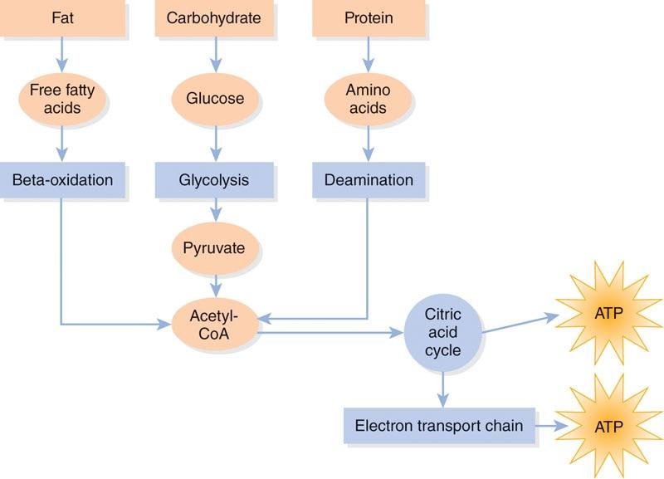

**Figure 8-7** The oxidative system

Oxidative phosphorylation uses a series of chemical reactions leading to the end result of creating ATP and carbon dioxide. This pathway includes two sets of reactions. Both sets occur in cellular organelles called the mitochondria (Figure 8-8). The first set of reactions is called the citric acid cycle (CAC), also known as the Krebs cycle, which leads to the creation of a few ATP molecules and the waste product of carbon dioxide. During this stage, electrons are freed for use in the next set of reactions known as the electron transport chain (ETC), which uses those electrons to drive a complex series of reactions that create the most ATP.

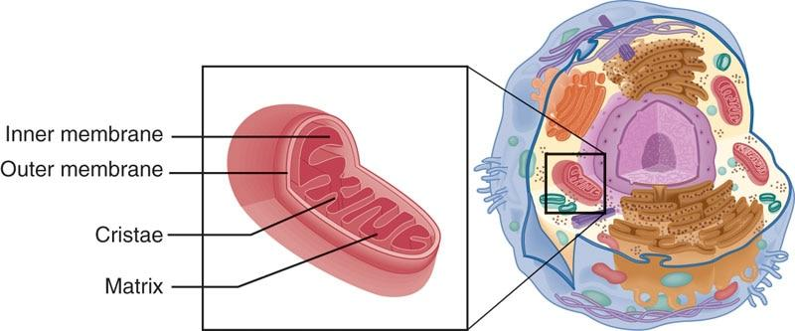

**Figure 8-8** Mitochondria

The oxidative system is what the body primarily relies on for the majority of low- to moderate-intensity activity. While anaerobic processes last anywhere from a few seconds to a few minutes, aerobic metabolism can sustain the body indefinitely, just at increasingly lower intensity levels (Kalish et al., 2012). As a person’s cardiorespiratory fitness improves (i.e., the ability to deliver oxygen to the cells), so does the oxidative energy system’s ability to support higher intensity levels without having to preferentially activate the anaerobic processes.

**Oxidative metabolism of different macronutrients**

Whether carbohydrate, fat, or protein substrates are being used, they all must be broken down to the same substance, called acetyl coenzyme A (acetyl CoA), before they can enter the CAC (Gleeson, 2005). Acetyl CoA provides a common starting point for the enzymes used in the CAC, which removes the electrons from this molecule and transports the negatively charged electrons along with positively charged hydrogen ions to the ETC. These electrons and hydrogens are stored inside the mitochondria and then used to provide the energy that converts ADP into ATP.

To use fat substrates for aerobic energy production, the fat (e.g., triglycerides) must first be converted into free fatty acids and then further broken down to acetyl CoA in a process called beta-oxidation. Fat molecules are large, energy dense, and more complex than carbohydrates, which is why fat metabolism is slower and cannot keep up with high-intensity energy demands. Even though fat oxidation is slow, one fatty acid molecule can net significantly more ATP than glucose. For example, when one molecule of the fatty acid palmitate is fully metabolized, it yields 129 ATP.

Unlike the initial anaerobic metabolism of glucose, using fat as an energy source always requires oxygen. The rate at which a person can break down fat depends on the number of mitochondria in the muscle cell and the amount of oxygen delivered by the blood (Gleeson, 2005). Athletes and well-conditioned people tend to have more mitochondria in their muscle cells than sedentary individuals and are therefore better at breaking down fat (Nielsen et al., 2016).

Finally, if there is a lot of carbohydrate (glucose) available, the body will use some of that instead, which will decrease the total amount of fat used to make ATP.

If oxidative phosphorylation is starting from a carbohydrate food source, it must first be broken down into glucose and then converted to pyruvate through glycolysis. Essentially, not only is glycolysis its own anaerobic energy system, but it is also the first step in the aerobic metabolism of glucose. When there is enough oxygen present, pyruvate is not converted to lactate. Instead, it is further broken down to acetyl CoA and enters the CAC. The complete metabolism (anaerobic and aerobic) of a single glucose molecule produces between 35 and 40 ATP (McArdle et al., 2010). Additionally, if both carbohydrates and fats are depleted to the point that amino acids are being relied on directly for energy (e.g., during extreme starvation), they are also broken down and metabolized aerobically.

GETTING TECHNICAL

Amino acids are very rarely deaminated and converted to acetyl CoA directly for oxidative phosphorylation. Most of the time, when amino acids are called on as an energy source, they are first converted to glucose or ketone bodies via gluconeogenesis and ketogenesis. Those converted substrates then enter their respective carbohydrate- or fat-based metabolic pathways.

#### Electron transport chain

The ETC is a vastly complex process that occurs in the inner mitochondrial membrane after the CAC has removed the electrons from acetyl CoA. In this process, protein complexes create a gradient of stored hydrogen ions that allow the electrons freed by the CAC to move through them. When ATP levels fall and ADP levels rise, the hydrogen gradient is “harvested” by a protein called ATP synthase to turn ADP and oxygen into ATP and water (Everman et al., 2011). As a result of this efficient handling of the molecules, the ETC can generate a relatively large amount of ATP with minimal waste products.

**Energy during exercise**

Any form of exercise can be defined by two factors: intensity and duration. These key factors are inversely related, meaning that as intensity goes up, duration must go down. Figure 8-9 illustrates the relationship of these factors; lifting weights for very a short duration with a high intensity is illustrated at point A, running 400 meters is shown at point B, while distance running for a long duration at a lower intensity is at point C. Essentially, the more intense the effort, the shorter the possible duration of the activity will be. Identifying where an exercise is located within this relationship helps define the exercise’s predominate energy system.

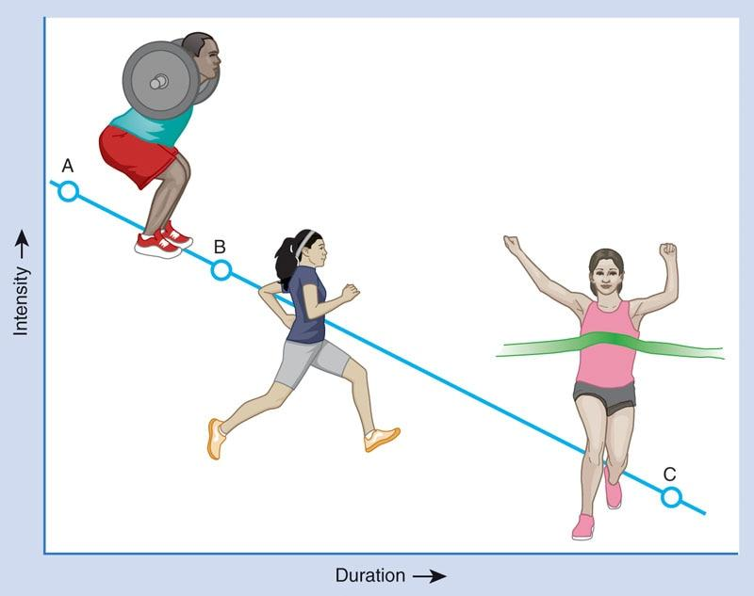

**Figure 8-9** Energy during exercise

At higher intensities (above VT1), carbohydrates will provide more of the energy to make ATP compared to fat because carbohydrates (glucose) can be broken down quickly via glycolysis. Lower-intensity activities (below VT1) will rely mostly on fat oxidation to provide ATP. As the exercise intensity increases to levels over VT1, the body will dynamically shift to relying more on blood glucose and stored glycogen (Romijn et al., 1993). Then, at any point in an activity when a quick burst of energy is needed, the ATP-PC system will provide a large contribution for the short, intense effort. Essentially, all three systems are in a constant state of flux, readily adapting to meet 100% of the body’s energy needs for the entire range of activity intensities.

**Metabolism during steady-state exercise**

The bioenergetics of exercise can be indirectly measured in a laboratory using various modes of exercise (e.g., treadmill or cycle ergometer). Other physiologic functions can be measured as well, including heart rate, blood pressure, and exercise load or work output. Measurements made for the purpose of assessing exercise metabolism are typically made during periods of steady-state. Steady-state aerobic exercise, as the term suggests, is aerobic exercise performed at a constant pace (intensity). For example, steady-state exercise could be described as walking or jogging at a consistent pace for 1 mile.

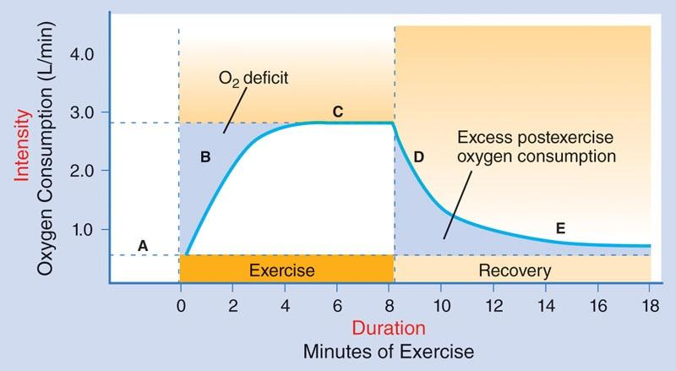

**Figure 8-10** Metabolism during steady-state exercise

The entire energy requirements of steady-state exercise is visualized in Figure 8-10. It begins with a person straddling a treadmill belt set at a steady light jogging pace (Figure 8-10, segment A). At the start of exercise (i.e., when the person jumps on the belt and goes from no activity to jogging), aerobic metabolic pathways are too slow to meet the initial demands, so the body relies on the ATP-PC cycle and glycolysis to make up the demand, known as an O2 deficit (represented by the first shaded area, Figure 8-10, segment B).

Gradually, the rate of aerobic ATP production increases, and less and less energy needs to be derived from anaerobic sources. At this point a few minutes into the steady-state effort, oxidative metabolic processes are able to catch up and take over most ATP production duties. Once that point has been reached, the energy demand of the exercise is being met through aerobic means (Figure 8-10, segment C). That primarily aerobic state would essentially continue indefinitely, limited only by the exerciser’s muscular endurance and fitness level.

Then, when the person in the example steps off the treadmill, the energy demands start falling back to baseline quickly (Figure 8-10, segment D) and then more slowly (Figure 8-10, segment E), but the oxygen consumption remains elevated for a few minutes to keep generating ATP aerobically. This shaded area is often referred to as excess postexercise oxygen consumption, or EPOC (McArdle et al., 2010; Wells et al., 2009). The purpose of EPOC is to produce additional ATP (above and beyond what is needed for recovery) to help reestablish baseline levels of ATP and PC and to assist with clearing metabolic waste products. Once the ATP and PC levels have been restored and other physiologic processes have returned to normal, oxygen consumption will have returned close to baseline, and immediate recovery will be mostly complete.

**Metabolism during intermittent work**

During intermittent exercise, this same energy production pattern as steady-state exercise occurs, just multiple times across a workout with each change in intensity. Just like the example in Figure 8-10, when an exerciser has to increase intensity, most of the energy needs come from anaerobic metabolism (Burke et al., 2011; Romijn et al., 1993; Wells et al., 2009). When intensity is decreased, there is a continued period of high, but briefly elevated, oxygen consumption in an attempt to recover quickly to be ready for the next bout of higher-intensity work. Essentially, intermittent work cycles between Figure 8-10, segments B and D, create repeated periods of EPOC without allowing the aerobic processes to fully take over as seen in Figure 8-10, segment C.

If the prior bout of high-intensity work is less than 1 minute, meaning it was primarily fueled by the ATP-PC system, the recovery period will also be about 1 minute or slightly less. If the period of high-intensity work is longer, such as in repeated interval training, the recovery period should have a similar 1-to-1 ratio of work-to-rest time (Daniels, 2014). Recovery is an aerobic event to set ATP-PC concentrations back toward normal and eliminate metabolic waste products. Therefore, even though interval training workouts and athletic competitions are quite often not steady-state efforts, participants really do need to have periods of training that address improving aerobic energy production to perform and recover optimally.

**Estimating fuel contribution during activity**

At lower intensities, the body is using primarily fat for fuel, which results in a lot of ATP being produced, some oxygen being used, and relatively less carbon dioxide being produced. As the exercise intensity increases, the rate at which ATP needs to be produced increases, so more oxygen needs to be delivered to the mitochondria. This causes an increase in breathing volume (i.e., the length and depth of breaths) and is a hallmark of reaching VT1. However, as exercise intensity continues to increase, aerobic metabolism of fat cannot be used to create ATP fast enough, so the body shifts to relying on glucose for fuel via glycolysis (Romijn et al., 1993).

This change in fuel source also means that more carbon dioxide will be produced, which needs to be exhaled. As a result, breathing rate must increase, not only to deliver more oxygen but now also to exhale the increasing amounts of carbon dioxide being produced. This point, where breathing becomes rapid enough that talking is extremely difficult to impossible, marks VT2.

In summary, at VT1, a person needs to take in more air to supply more oxygen to the mitochondria to help support the oxidative metabolism of free fatty acids. Then, at VT2, a person is relying primarily on anaerobic metabolism, and the body becomes more focused on exhaling carbon dioxide and trying to recover anaerobically, so expiration becomes more forceful making it difficult to talk. Because of this, fitness professionals can use a “talk test” to help determine if a client is working aerobically or anaerobically. This concept is discussed more in Chapter 11. Table 8-1 and Figure 8-11 outline how each of the energy systems contribute to overall energy demand.

TABLE 8-1 Characteristics of the Three Energy Systems

|  | **ATP-PC** | **Glycolysis** | **Oxidative** |
| --- | --- | --- | --- |
| Fuel Substrate | Phosphocreatine (PC) | Stored glycogen and/or blood glucose | Pyruvate and free fatty acids |
| Intensity Supported | High | Moderate to high | Low to moderate |
| Onset of Maximal ATP Production | 1 sec | 5-10 sec | 2-3 min |
| Time to Exhaustion of the System | 10-15 sec | 30-60 sec | Theoretically unlimited |
| Ultimate Limiting Factor(s) | Depletion of ATP-PC stores | Lactate and CO2 accumulation | Insufficient oxygen, heat accumulation, muscle fatigue |

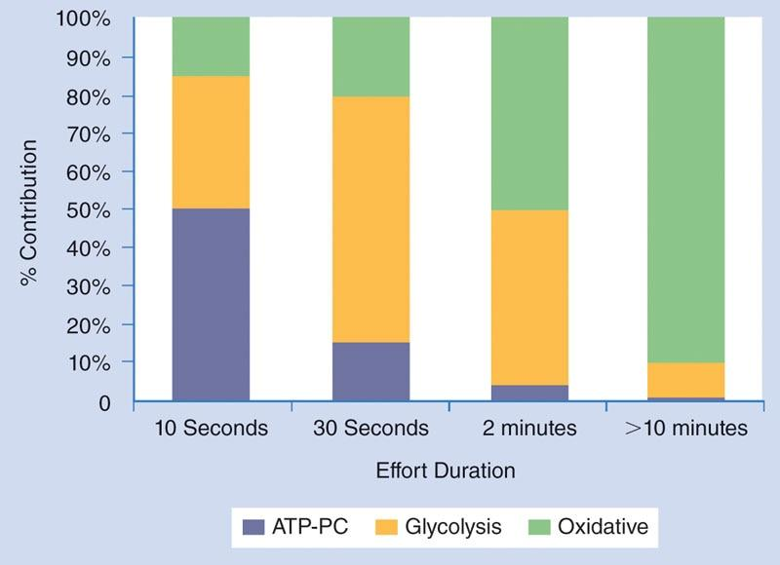

**Figure 8-11** Energy system contribution by effort duration

**The myth of the “fat-burning zone”**

There is another way of thinking about exercise intensity that has been misinterpreted: the concept of the so-called fat-burning zone. The thought is that people burn more fat at lower-intensity exercise because that easy work relies primarily on the oxidation of free fatty acids and does not require getting energy quickly from carbohydrates. Although it is true that lower-intensity activity relies more on fat as a fuel substrate than glucose, the end result is a little more complex and needs to be viewed from the perspective of a full 24-hour day.

When considering fat burning, it is important to think of both the intensity of an activity and the total duration of that activity. Lower-intensity activities do use a higher percentage of fat as a fuel, but they do not burn a lot of calories unless performed for a very long time. However, while moderate- and high-intensity activities might have a higher percentage of energy coming from carbohydrates, they are burning more total calories in a given time. Table 8-2 compares the differences in calorie expenditure between 20 minutes of exercise at low and moderate intensities. This essentially busts the myth of the fat-burning zone so often advertised on commercial cardio equipment; with 24 hours in a day, total calorie burn matters more for body composition than preferentially training the oxidative system for a short workout.

As seen in Table 8-2, the exerciser burned a higher percentage of fat (70%) when performing low-intensity work as compared to moderate-intensity exercise (50%). However, the *total* number of fat calories was greater when exercising at a moderate-intensity (60 calories) versus low-intensity exercise (42 calories).

This means that when weight loss is the goal, the average individual with only 1 hour of time per day to exercise will see better results with a moderate- to higher-intensity type of workout. He or she will burn more calories during the higher-intensity workout, which will contribute to a greater number of total daily calories burned. On the other hand, if an individual has the ability to do so, lower-intensity activity performed for many hours at a time—such as very long hikes out in nature—would, in fact, net a greater fat burn than 60 minutes of interval training performed by someone who otherwise sits at a desk all day.

TABLE 8-2 Comparing Energy Expenditures

| **Example Exercise Programs** | **Fat Calories Expended** | **Carbohydrate Calories Expended** | **Total Calories Expended** |
| --- | --- | --- | --- |
| 20 minutes, low intensity | 42 (70%) | 18 (30%) | 60 |
| 20 minutes, moderate intensity | 60 (50%) | 60 (50%) | 120 |

### Daily energy needs

When daily food intake is matched to energy needs, people are said to be in energy balance, which allows them to maintain a stable body weight. However, when energy intake is higher than needed to support the total daily energy requirements, it can lead to an increase in body weight. Similarly, if individuals eat less than they need to support their daily energy requirements, they will lose weight as the body fuels itself from its internal stores. Individuals who are over their ideal weight will need to either decrease daily energy intake and/or increase daily activity to achieve their ideal weight. Conversely, people who want to gain muscle mass need to increase their daily energy intake beyond what is being used. The amount of daily energy individuals need is also impacted by their age, sex, pregnancy, existing muscle mass, hormone function, medication use, and genetic factors. As a result, individual daily energy needs vary tremendously across the population.

**Total Daily Energy Expenditure**

The total number of calories that a person expends in a day is called the total daily energy expenditure (TDEE). Calories are the basic unit of energy that is provided by food. Scientifically speaking, 1 Calorie (also referred to as a kilocalorie (kcal)) is the amount of energy needed to raise the temperature of 1 kilogram of water by 1º Celsius. But more importantly from a health and fitness perspective, calories (as commonly written on food labels) represent the units of energy that come from the food we use to stay alive, maintain body functions, move, and exercise.

STRETCH YOUR KNOWLEDGE

A calorie (lowercase c) is a unit of energy and is defined as the amount of heat energy required to raise the temperature of 1 gram of water 1º Celsius. A kilocalorie (kcal, sometimes written as Calorie with an uppercase C) is equal to 1,000 calories. Although not scientifically correct, calories (as written on food labels) and kilocalories are used interchangeably in everyday language all around the world; however, food calories are technically kilocalories.

The number of calories that each person expends in a day varies tremendously. The calories that are burned throughout the day are used for a variety of processes besides exercise, including maintenance of the resting metabolic rate (RMR), digestion and absorption of food, and general activities ranging from walking to the mailbox to typing on a keyboard. Because heat is a by-product of processing macronutrient substrates for energy, the “burning of calories” is more specifically termed *thermogenesis*. With that in mind, energy used for exercise is called exercise activity thermogenesis (EAT), energy used to digest food is called the thermic effect of food (TEF), and energy used for all the other daily movements and activities a person performs is called nonexercise activity thermogenesis (NEAT). The combination of RMR, EAT, TEF, and NEAT combine to form TDEE.

**Resting metabolic rate**

The RMR is the number of calories that the body uses at complete rest to function (e.g., pumping blood, breathing, fueling the brain, organ functioning). Simply put, RMR is the minimum energy expenditure (i.e., number of calories needed) to keep a person alive. This number can vary considerably among individuals, but people with more muscle mass tend to have a higher RMR because muscle is a more active user of ATP than other bodily tissues. RMR accounts for around 70% of TDEE, with activity (EAT + NEAT) and TEF making up the remainder of the daily energy expenditure (Trexler et al., 2014) (Figure 8-12).

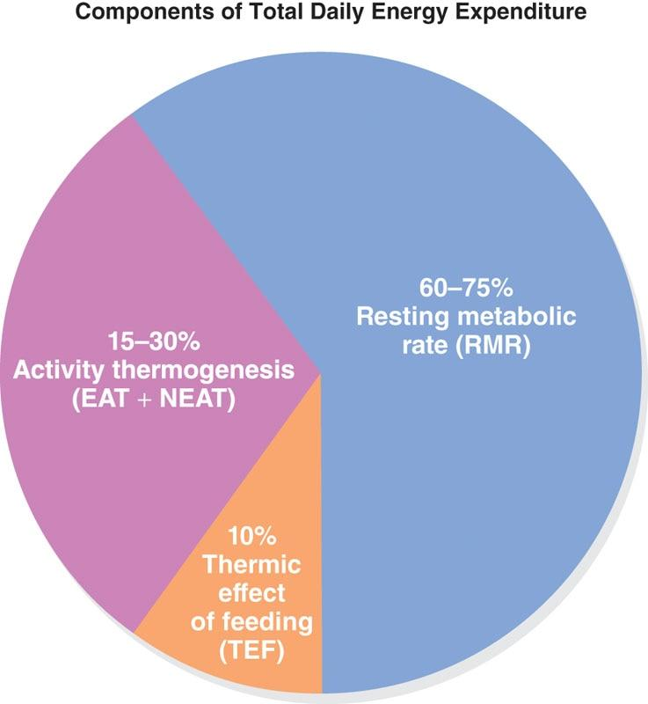

**Figure 8-12** Components of TDEE

GETTING TECHNICAL

One of the best methods to measure RMR is via indirect calorimetry, a process that uses expired gasses (CO2) to predict energy expenditure. However, the equipment to do this is not widely available, so there are several equations that can be used to estimate RMR, including the Harris-Benedict, Miflin St. Jeor, and Katch-McArdle methods. There are also many online calculators that have been developed that incorporate one or more prediction equations in an attempt to improve the accuracy.

However, when compared to measuring RMR through indirect calorimetry, all prediction equations tend to underestimate RMR, especially for muscular people and clinical populations (Joseph et al., 2017; Zanella et al., 2018). Also, prediction equations to determine RMR work poorly in people with obesity, so caution should be used when estimating RMR via a prediction equation when working with obese clients (Madden et al., 2016; Spears et al., 2009).

**Thermic effect of food**

TEF is the number of calories that are expended to break down the components of a meal (Secor, 2009). In other words, it takes energy (calories) to digest food. On average, around 7–10% of the calories contained in foods go toward their own digestion and absorption. In general, protein results in a higher TEF, meaning it takes more calories to break down protein foods compared to carbohydrates or fats.

**Energy expended during physical activity**

While most of the energy (calories) that a person burns during the day is due to the basic metabolic processes that sustain life, any type of activity or exercise also burns calories and therefore raises TDEE. Physical activity can be broken down into two categories: structured, purposeful exercise (EAT) and nonexercise activities (NEAT), such as cleaning the house or shopping for groceries. Exercise can increase energy expenditure both during the activity itself and afterward via increased metabolic rate and recovery processes.

The utilization of 1 liter of oxygen during aerobic activity requires 5 kcal (calories) of energy, so longer-duration or higher-intensity aerobic activities can burn a considerable number of calories. The physical activity level (PAL) has been quantified as the total daily energy expenditure divided by the resting energy expenditure (Westerterp, 2013). The physical activity level quantifies a person’s activity level by comparing the number of calories burned while active to the amount burned while sedentary. Some evidence suggests that the ideal physical activity level ratio for a sustainable lifestyle ranges from 1:1–2:5, which peaks during reproductive age and declines somewhat later in life (Westerterp, 2013).

GETTING TECHNICAL

Another way that activity is sometimes quantified is by metabolic equivalent (MET). One MET is equal to 3.5 mL of oxygen consumed per kilogram of body weight per minute (3.5 mL O2/kg per min), which is the average resting metabolic rate for the greater population (McArdle et al., 2010). A moderate-intensity activity might require 5 METs (5 times RMR, or 17–18 mL/kg per min), and a very high-intensity activity might require 9 or more METs (9 times RMR or >30 mL/kg per min).

**Nonexercise activity thermogenesis**

NEAT refers to the burning of calories from activity that occurs independent of structured, planned exercise. Factors like standing instead of sitting, fidgeting, shivering, and daily tasks, such as walking to the parking lot and doing household chores, are all components of NEAT. NEAT levels can vary tremendously across populations and may contribute up to 20% of TDEE in people who have nonsedentary jobs (e.g., manual labor). Some research has suggested that certain individuals have greater inherent tendency to perform NEAT—such as people who fidget more—and that higher levels of daily NEAT may be protective against obesity (Levine, 2007; Villablanca et al., 2015). While some people may be more predisposed to unconsciously engage in NEAT than others, anyone can choose to incorporate more NEAT into their day by including things like using a standing desk, parking farther away in the parking lot, pacing while on the phone, and taking the stairs instead of the elevator.

# Nutrition

Nutrition, at a basic level, can be defined as the process of acquiring nutrients through food and/or food substances to support energy needs and cellular processes, such as growth, repair and maintenance of tissues, reproduction, digestion, and respiration (Shiel, 2018). The science of nutrition is the study of the way living creatures obtain and metabolize nutrients to support growth and cellular activities, the interaction of those nutrients within the body, and the various outcomes associated with these processes. Inadequate or imbalanced nutrition, in which excesses or deficiencies in nutrient intake exist, can have profound effects on the growth and health of a living creature. Nutrition also plays a key role related to optimizing performance in exercise and sport, as well as modifying body composition, such as the increase of lean muscle mass or the loss of body fat. Certified Personal Trainers often work with individuals on perfor- mance and body composition goals, and nutrition plays a vital role in the achievement of these goals. An understanding of basic nutrition principles can help fitness professionals guide their clients regarding the importance of good nutrition practices to complement and enhance their training program.

Without proper nutrition, an individual’s training could be greatly compromised, whether the training is geared toward fat loss, muscle gain, or sports performance. This chapter provides an outline of basic nutrition concepts, including an overview of the macronutrients and micronutrients, and highlights the ways in which nutrients play an important role in maintaining both health and athletic performance. The chapter also provides a high-level overview of nutrition strategies that may be helpful for clients who have goals for fat loss, muscle gain, or improved sports performance

**Scope of practice: personal trainers and registered dietitians**

Fitness professionals should have a basic understanding of nutrition principles so that they can integrate appropriate nutrition guidelines into training protocols with their clients. However, it is also important for fitness professionals to recognize and respect their scope of practice versus that of licensed and registered dietitians (RDs) and CDNs who are legally qualified to prescribe medical nutrition therapy. Scope of practice refers to the areas, actions, and processes practitioners may undertake or perform that are within the bounds of their professional license or certification. In the United States, registered dietitians have extensive training in the field of food and nutrition through an accredited college or university with supervised coursework and fieldwork that is approved by the Accreditation Council for Education in Nutrition and Dietetics. They are required to complete 1,000 hours of supervised training prior to taking a national examination to obtain the RD credential and must complete continuing education requirements to maintain their credential. Licensed dietitians pursue a similar path to obtain their license to practice as a dietitian but may opt for a state-approved examination versus the national RD exam. Other credentials that qualify individuals to provide nutrition recommendations are provided in Table 9-1, although these are still subject to individual state regulations. Similar standards also exist for dietitians in the United Kingdom, Canada, Australia, and abroad.

TABLE 9-1 Nutrition Credentials and Qualifications

| **Nutrition Credential** | **Qualifications** |
| --- | --- |
| Registered Dietitian/ Registered Dietitian Nutritionist (RD/RDN) | Nationally recognized and credentialed in nutrition by the Commission on Dietetic Registration. Scope of practice ranges from clinical nutrition to community, food service, and nutrition education. Some RDs are board certified in Sports Dietetics (CSSD) for advanced credentialing and specialization in sports nutrition. Although nationally recognized, some states may still require RDs to obtain state licensure prior to practicing independently or in a clinical or medical setting. |
| Certified Nutritionist | It is important to determine which organization is providing the certification in nutrition and if the organization is accredited. The accredited organizations are officially recognized and authorized to provide a qualification, because they have been reviewed by other governing bodies and found to meet or exceed the minimum standards for education. |
| CISSN | Certified in Sports Nutrition by the International Society of Sports Nutrition. |
| CNS | Certified Nutrition Specialist by the Board for Certification of Nutrition Specialists. |
| CDN or LDN | State Certified Dietitian/Nutritionist or Licensed Dietitian/Nutritionist. This is a license to practice nutrition in the certifying/licensing state. This licensure may be legally required in some states, for both RDs and non-RDs, prior to providing any nutrition counseling. |

STRETCH YOUR KNOWLEDGE

In most countries, *nutritionist* is a generic term for someone who provides nutritional advice. Nutritionists are not necessarily licensed healthcare professionals and certainly should not portray themselves as such. Nutritionists may be found working in public health organizations, schools, health and fitness centers, weight-loss clinics or in a private practice. Some countries, including the United States, leave it up to consumers to do their due diligence and investigate the origin of the training nutritionists have received and which credentials make them qualified to provide nutritional advice.

The scope of practice for fitness professionals lies primarily within two areas: the field of physical assessment and the development of an appropriate exercise training program based on a client’s goals and abilities. However, nutrition is an important component in the success of this program. Therefore, although it is not strictly within the scope of practice for Certified Personal Trainers to provide specific nutrition prescriptions or dietary counseling to clients (unless the fitness professional also holds a nutrition credential listed in Table 9-1), they may provide education to clients on basic nutrition strategies and direct them to appropriate resources to help support their body composition, training, and/or performance goals.

For example, fitness professionals can inform and guide clients on of the role of nutrients in health and exercise. Fitness professionals may also help clients identify the dietary choices that may be helping or hindering their progress, guide them toward more appropriate food choices, and provide them with accountability and support during their training and implementation of any dietary changes.

TRY THIS

The following example offers two scenarios in which a fitness professional is being asked for nutrition guidance. In each case, decide if the fitness professional is acting within their scope of practice.

Scenario 1

James is a Certified Personal Trainer at a local gym; he has a new client (Julie) this morning. She is trying to lose 15 lb (6.8 kg) and build some muscle mass over the next 2 months. During training, Julie and James start to talk about her diet, and she gives James an overview of what she eats daily. James notices that her diet is heavily reliant on fast and processed foods, and she eats limited amounts of fruits and vegetables. At the end of the session, Julie asks James for some diet advice. James knows that he is not a licensed nutrition professional but that he can give her general advice. He explains that he cannot give her specific recommendations but suggests that Julie could include more vegetables and fruit in her diet in place of the fast-foods and processed snacks.

* Is James within his scope of practice in answering Julie’s question?

Scenario 2

Ingrid is a Certified Personal Trainer at a local gym. She has a regular client (Bill) who is a type 2 diabetic. Bill was given permission to start an exercise program and has successfully lost 20 lb (9 kg) since working with Ingrid. Bill now wants to change his diet and eliminate carbohydrates to accelerate his weight loss. Ingrid agrees and suggests that Bill may want to change his eating habits and consume predominantly protein and fat.

* Is Ingrid within her scope of practice to provide these recommendations to Bill?

Answers

1. Yes. James is within his scope of practice. Offering guidance on eating fruits and vegetables is within a Certified Personal Trainer’s scope of practice.
2. No. Ingrid is not practicing within her scope of practice. Bill is a type 2 diabetic and should consult a healthcare professional regarding his diet.

However, in cases where a client has medical issues that require specific dietary modifications, or if a client requests specific meal plans, a fitness professional should refer the client to a qualified nutrition professional, such as an RD or LD, for further guidance. This not only respects the scope of practice for both professions but also ensures that clients benefit from the expertise provided by qualified professionals in their own areas of practice. Table 9-2 provides some examples of nutrition topics that fitness professionals can and cannot discuss with clients.

TABLE 9-2 Scope of Practice Overview

| **Fitness Professionals CAN:** | **Fitness Professionals can NOT:** |
| --- | --- |
| Provide nutritional guidance for healthy populations.  Evaluate a client’s current eating habits and provide general guidance.  Discuss the roles and importance of protein, carbohydrates, and fat.  Explain the importance of fiber and micronutrients (vitamins and minerals).  Discuss the dangers of overconsuming calories, salt, alcohol, and added sugar.  Offer basic hydration strategies.  Dispel nutrition myths and fallacies.  Refer to the client’s personal healthcare provider when necessary.  Offer basic nutritional guidelines for anyone who wants to participate in typical athletic pursuits (i.e., 10K run).  Offer advice on eating behaviors that are known to reduce the risk of disease or slow the progression of disease.  Offer exercise and physical activity guidelines.  Demonstrate healthy portion sizes.  Help clients set realistic health and wellness goals, evaluate progress, and revise goals when necessary. | Write specific meal plans and daily menus.  Prescribe specific supplements or recommend vitamins and/or mineral dosages to treat chronic disease.  Prescribe drastic caloric restriction or very low-calorie diets.  Prescribe fasting, detoxification, or other extreme nutritional practices.  Prescribe diets that omit or severely restrict certain food groups.  Advise against recommendations of healthcare professionals.  Provide detailed nutritional plans for athletes who participate in extreme training programs (i.e., Ironman triathletes or ultramarathoners).  Prescribe dietary plans for those with chronic health conditions (e.g., diabetes or heart disease).  Provide nutrition therapy to treat acute or chronic disease.  Counsel or treat clients who have an eating disorder.  Prescribe a one-size-fits-all approach to eating. |

**Accessing credible nutrition information**

Nutrition information, education, and advice appears abundantly on the internet and various social media platforms. However, it is important to distinguish and differentiate between false or misleading nutrition claims and credible, valid nutrition information. Examples of some misleading nutrition claims that have surfaced on various social media platforms include drinking celery juice to cure all types of ailments, including high blood pressure and high cholesterol, and drinking hot lemon water in the morning to detoxify the body.

Credible nutrition information is rooted in and supported by empirical science. It is information that is presented after careful, thorough research that has been reviewed by qualified and credentialed professionals in the field. Individual testimonials or nutritional recommendations based on personal experience and success with a dietary protocol does not qualify as credible nutrition information that may be immediately extrapolated or applied to other individuals, because there are many variables and individual differences that must be accounted for.

Accessing credible nutrition information is not difficult, as long as the following guidelines are considered:

* What is the source of the information? Is it a testimonial or personal blogpost or a research-based article? Personal testimonials are not necessarily supported by research or science; these should be evaluated for scientific evidence in support of any claims.
* What qualifications are held by the individuals providing the information? Does credible research support their claims/statements?
* Is the information supported by additional peer-reviewed research?
* Has the information been reviewed by other qualified individuals?

TRAINING TIP

At times, fitness professionals may be asked by clients to provide guidance on an area of nutrition as it relates to a client’s training or goals. Although it may not be within the scope of practice for fitness professionals to provide specific meal plans, they can direct clients to credible and reliable sources for additional nutrition information and, thus, help them avoid the pitfalls of following inappropriate and possibly harmful recommendations that are not based on science or research.

Some sources of credible information include:

* Academy of Nutrition and Dietetics
* International Society of Sports Nutrition
* National Institutes of Health
* U.S. Department of Agriculture, Nutrition.gov
* Dietitians of Canada
* British Nutrition Foundation
* Nutrition Australia
* World Health Organization

**Macronutrients**

In nutrition, the term macronutrients refers to the three energy-yielding nutrients: protein, carbohydrates, and lipids (fat). The term micronutrients refers to vitamins, minerals, and phytonutrients, which are compounds found in plants that provide various health benefits, such as anti-inflammatory and antioxidant properties. The three macronutrients are energy yielding in that they provide usable energy by cells for various biological processes. Protein and carbohy- drates both provide 4 calories per gram, while lipids provide 9 calories per gram. Micronutrients do not provide usable energy by themselves, but they are important in the regulation of many energy-yielding pathways and metabolic cycle.

Table 9-3 lists the three macronutrients, as well as alcohol, with their specific energy contribution in metabolic pathways. An understanding of the macronutrients and their role in diet and exercise can help fitness professionals identify if and how clients’ diets may be affecting their training and guide them to nutrition resources and qualified professionals for assistance in addressing any dietary imbalances.

TABLE 9-3 The Macronutrients Plus Alcohol

| **Energy-Yielding Nutrient** | **Energy per Gram** |
| --- | --- |
| Protein | 4 calories |
| Carbohydrate | 4 calories |
| Lipid | 9 calories |
| Alcohol (energy yielding but not considered a macronutrient) | 7 calories |

**Protein**

Protein, one of the three macronutrients, serves a variety of important functions in the body. One of the primary functions of protein is in the synthesis and repair of cells, tissues, and structures, such as collagen, elastin, and muscle. Proteins are also required for the synthesis of hormones, enzymes, antibodies, and peptides, as well as the transport of various compounds through the body, such as lipids and minerals (e.g., calcium). In addition, proteins may be used for energy if there is a need due to inadequate caloric, carbohydrate, or fat intake.

Structure of protein

The basic building block of a protein is an amino acid, which is a compound that contains carbon, hydrogen, oxygen, and a nitrogen atom. Proteins are comprised of sequences of amino acids that are linked together by peptide bonds in polypeptide chains (Figure 9-1).

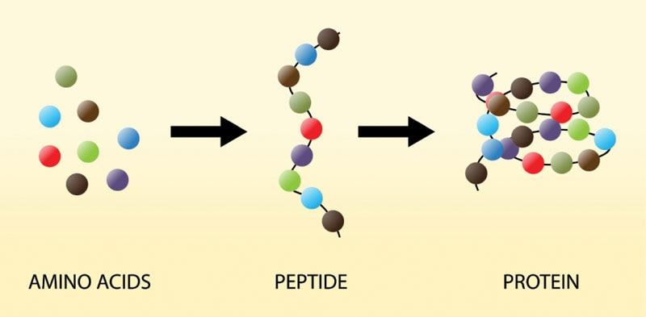©

**Figure 9-1** Amino acids, peptides, and proteins

Amino acids are often thought of as the building blocks of protein, because they are required to both synthesize and repair proteins in our body. There are 20 amino acids, of which nine are considered essential amino acids (EAAs), meaning that they must be obtained through the diet and cannot be made in the body. The other 11 amino acids are considered nonessential, since they can be made in the body as long as there are adequate essential amino acids and substrates for their synthesis. The body’s supply of amino acids is derived from two sources: protein consumption from foods and supplements or the breakdown of internal protein sources and body tissue. The process of breaking down internal proteins and recycling the component amino acids is called protein turnover, and it serves as an important source of amino acids for the synthesis of new proteins.

Dietary protein, however, provides an important contribution to the body’s amino acid pool, especially for the nine essential amino acids. Inadequate and imbalanced protein intake can compromise the availability of adequate essential amino acids for protein synthesis. Some amino acids can become conditionally essential under certain circumstances, such as growth, high-volume training, and illness and/or injury (Table 9-4). For example, arginine and histidine can become conditionally essential under high-volume training or metabolic stress. Glutamine may become conditionally essential in circumstances that involve issues in the gastrointestinal tract.

TABLE 9-4 Amino Acids

| **Essential** | **Nonessential** | **Conditionally Essential** |
| --- | --- | --- |
| * Leucine^ * Isoleucine^ * Valine^ * Methionine * Phenylalanine * Threonine * Tryptophan * Lysine * Histidine* | * Alanine * Arginine* * Aspartic acid * Asparagine * Cysteine * Glutamic acid * Glutamine* * Glycine * Proline * Serine * Tyrosine | * Histidine * Arginine * Glutamine |
| ^Branched chain amino acid *The amino acid may become conditionally essential under certain circumstances. | | |

Dietary protein

Dietary protein is protein that has been obtained through food sources. Most foods, except fruits and oils, contain some amount of protein. Meat, dairy, eggs, poultry, fish, legumes (e.g., peas, beans, lentils), soy, vegetables, and grains provide amino acids that are used to build proteins in the body. Some foods may be better sources of protein than others in that they provide all of the essential amino acids and are more easily digested and absorbed than other sources. A protein source is considered to be a complete protein if it provides all of the essential amino acids, whereas an incomplete protein is lacking in one or more of the essential amino acids. In general, proteins from animal sources (meat, poultry, fish, eggs, and dairy) as well as soy and hemp protein are considered to be complete (Hoffman & Falvo, 2004). Legumes, grains, and vegetables are considered incomplete protein sources since on their own they do not provide all the essential amino acids (Food and Drug Administration, 2018) (Table 9-5).

GETTING TECHNICAL

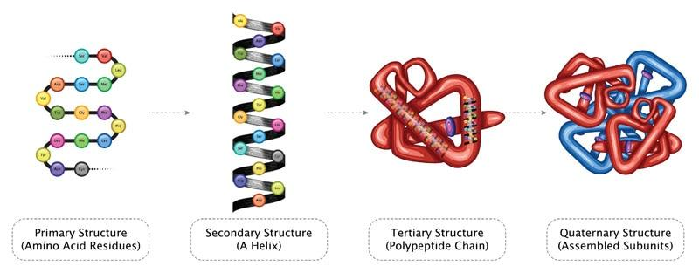

Peptides are amino acids linked together via a peptide bond. A dipeptide is the combination of two amino acids linked together by a peptide bond. A tripeptide is a sequence of three amino acids linked together by peptide bonds. A polypeptide chain is a series (often more than three) of amino acids linked together by peptide bonds.

Proteins consist of many polypeptide chains held together in various structures, such as a coil, sphere, or helix, and this is referred to as the secondary structure of the protein (the polypeptide chain is considered to be the primary structure). The tertiary structure of a protein is its three-dimensional form—or the way the coil, sphere, or helix folds in on itself.

N.Vinoth Narasingam/Shutterstock.com

TABLE 9-5 Complete and Incomplete Protein Sources

| **Examples of Complete Proteins** | **Examples of Incomplete Proteins** | |
| --- | --- | --- |
| Animal sources   * Meat * Poultry * Seafood * Eggs * Dairy   Nonanimal sources   * Soy * Hemp * Quinoa * Buckwheat * Amaranth | Legumes   * Beans * Nuts * Peas * Lentils * Seeds   Grains   * Millet * Rice * Couscous * Oatmeal | Vegetable proteins   * Spinach * Bok choy * Asparagus * Broccoli * Collard greens * Brussel sprouts * Avocado |

Individuals who eat an omnivorous diet, which includes both animal and plant foods, will easily obtain all the essential amino acids through their diet, as animal foods are complete protein sources. However, individuals who are vegan or vegetarian will need to include in their diet a diverse range of plant protein sources to obtain adequate amounts of all essential amino acids. Most vegetarian sources of protein lack one or two essential amino acids. However, an assorted range of vegetarian proteins can ensure that essential amino acids lacking in one food source are provided by another, such as combining rice and beans. This is called mutual supplementation. When working with vegan or vegetarian clients, it may be helpful to reinforce the importance of a varied and balanced diet for health and performance and for adequate protein intake. If clients express interest in learning about vegan and vegetarian protein sources and planning a balanced vegan or vegetarian diet, it may be helpful to direct them to a registered dietitian or certified nutritionist for further nutrition counseling.

STRETCH YOUR KNOWLEDGE

Grains, legumes, nuts, seeds, and vegetables are all considered to be incomplete sources of protein as they contain some but not all of the essential amino acids. However, they differ in their composition. For example, beans and vegetables are limited in methionine, nuts and seeds are limited in lysine, corn is limited in both tryptophan and lysine, and grains are limited in lysine and threonine (Mariotti & Gardner, 2019).

Eating a balanced mix of all these sources can help to ensure that all essential amino acids are provided in a vegetarian diet. Note that complementary proteins do not have to be eaten at the same meal; it is sufficient if they are eaten over the course of the same day for mutual supplementation.

Modified from Mariotti & Gardner, 2019.

Protein quality

Protein quality refers to the amino acid profile and content of a protein source and its digestibility (Hoffman & Falvo, 2004; Wolfe et al., 2016). Some proteins, such as animal-based proteins, are considered to be higher in quality because they contain all of the essential amino acids and are easily digested and absorbed by the body.

STRETCH YOUR KNOWLEDGE

Note that the term quality in this instance does not refer to the source or farming method of the animal, such as whether or not the protein source is organic, nonorganic, grass, or corn fed. Protein quality refers to the essential amino acid composition and digestibility of a protein source.

Protein quality may be an important consideration in some diets, because it may affect an individual’s total protein requirements in their diet. If an individual’s diet is comprised primarily of low biological value (LBV) proteins, then total protein requirements may be higher.

A larger amount of LBV protein may be required to provide all of the essential amino acids in adequate amounts to meet the individual’s needs. In contrast, if an individual’s diet is comprised primarily of very high biological value (HBV) proteins, then the individual may be meeting their amino acid needs with a smaller amount of total protein. Protein adequacy in a diet is an important consideration for all individuals, but it may be more so for clients who have a predominantly plant-based diet and who may need a greater amount of total protein to meet their amino acid needs (Marsh et al., 2013; Young & Pellet, 1994).

GETTING TECHNICAL

Protein quality can be assessed using various standards that evaluate proteins in terms of their digestibility, their amino acid composition, and the efficiency with which the amino acids are absorbed and used by the body (Hoffman & Falvo, 2004; Millward et al., 2008).

Protein efficiency ratio (PER): A value assigned to a protein that is based on the amount of weight gain of a subject divided by the amount ingested of that particular protein during a test period.

Biological value (BV): A measure of the digestion and absorption of the amino acids provided by a protein source. BV reflects the amount of the absorbed protein that is used in the synthesis of new proteins in the body.

Protein digestibility–corrected amino acid score (PDCAAS): Compares the amino acid composition of a food against a standard amino acid profile, with a score of 100 being the highest value possible. It also assesses the food’s digestibility (fecal digestibility) to provide an overall value for the protein’s quality.

Net protein utilization (NPU): Compares the ratio of amino acids that are turned into proteins to the ratio of amino acids provided via dietary intake.

TRY THIS

HBV Versus LBV Proteins

Egg whites, whole eggs, chicken breast, and lean beef are considered to be high-quality, complete proteins with high digestibility (PDCAAS) scores in the range of 0.90 to 1.00 (egg white). In comparison, LBV proteins, such as beans, lentils, peas, and whole wheat, have lower PDCAAS scores in the range of 0.4 to 0.7 (Food and Drug Administration, 2018). Thus, 30 grams of high-quality, usable protein with all the EAAs could be obtained by eating around 4 eggs or 4.5 ounces of chicken breast (HBV) or around 3 cups of chickpeas with brown rice, which provide more than 30 grams of total protein but are given a lower PDCAAS score.

Protein digestion, absorption, and utilization

To obtain amino acids from dietary protein, it must be broken down into smaller molecules: single amino acids, dipeptides, and tripeptides. This process takes place in the gastrointestinal tract. When a source of protein is consumed, hydrochloric acid in the stomach denatures it, which means the secondary and tertiary structures are unravelled to expose the primary structure of the protein.

his provides digestive enzymes with access to the peptide bonds in the protein’s primary structure so that they can start to clip these bonds and break up the polypeptide chain into smaller molecules or polypeptide fragments of dipeptides and tripeptides. Pepsin is one of the digestive enzymes that begins this process in the stomach. Polypeptide fragments are broken down further in the small intestine by pancreatic and intestinal enzymes before being absorbed through the intestinal wall and into the intestinal cell (enterocyte). Some amino acids, glutamine in particular, may be used by the enterocyte for fuel. The remainder exits the base of the enterocyte, enters the bloodstream, and is directed to the liver (Figure 9-2).

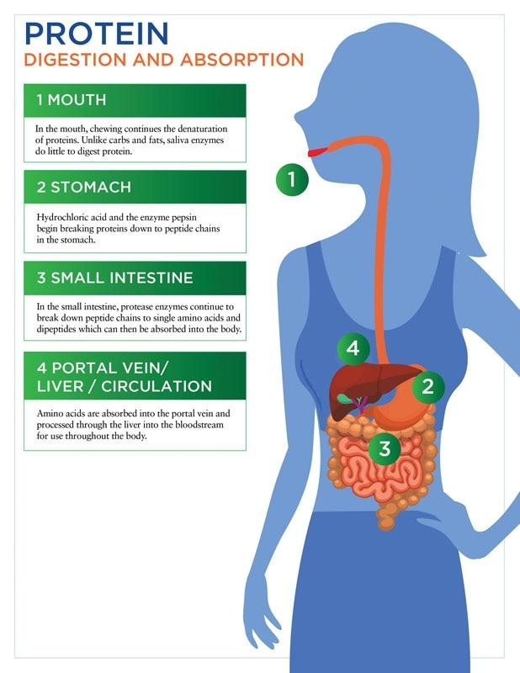

**Figure 9-2** Protein digestion and absorption

From the liver, amino acids may be directed to different tissues and used in a variety of ways:

* Synthesis of new proteins
* Repair of existing proteins
* Synthesis of nonessential amino acids
* Transamination to other nonessential amino acids (i.e., transferring an amino group from one molecule to another)
* Synthesis of nonprotein, nitrogen-containing compounds
* Usage to meet energy needs, if caloric or carbohydrate intake is inadequate.

Protein use for energy

Arguably, protein’s primary function is to synthesize new proteins and repair existing proteins. However, if an individual does not eat adequate calories to meet their energy needs, then dietary protein and/or protein from bodily tissue may be used to meet this need. In this situation, amino acids from the proteins are deaminated (i.e., the nitrogen component is removed), and the carbon, oxygen, and hydrogen components are metabolized to meet energy needs. The deaminated nitrogen component is incorporated into urea by the liver and then excreted by the kidneys in urine. Some amino acids, such as alanine and glutamine, may also be used to create glucose through a process called gluconeogenesis.

Clients seeking to build muscle through their training should understand the dual importance of adequate caloric and protein intake to optimize results from their exercise program. It may be helpful for a Certified Personal Trainer to reinforce the importance of adequate caloric and protein intake to complement training protocols. If clients are unsure of their dietary needs, then they should be referred to a nutrition or healthcare professional for further guidance.

Protein Dietary Needs

Protein needs vary for individuals and are dependent on several factors unique to the individual: age, size, caloric needs, current body composition, physical activity, sport/performance goals, body composition goals, health status, and injury status. Both clients and fitness professionals should remember that one client’s protein needs may be very different from those of another client. Consider that each client has a different goal, build, and structure and may need a different training protocol that varies in type of exercise, intensity, and duration. Their energy and macronutrient needs will also differ from other clients who have a different build, structure, goal set, and training protocol. Fitness professionals may provide clients with general guidelines on protein requirements, but for more individualized prescriptions, especially if a client has a health concern, they should be referred to an RD or other licensed nutritionist.

Recommended dietary allowance (RDA)

The recommended dietary allowance (RDA) for protein is 0.8 g/kg of body weight and is considered to be a minimum amount of protein required to maintain nitrogen balance in the body or to offset nitrogen losses that are a result of normal metabolic processes (Wolfe et al., 2017). However, protein requirements increase under several circumstances, including exercise and anabolic needs, negative energy balance, illness, or injury. Under most circumstances, the actual protein intake of most individuals falls within the range of 10% to 35% of total calories, considered the acceptable macronutrient distribution range (AMDR) for protein as a percentage of an individual’s diet (U.S. Department of Agriculture, 2015).

Exercise and anabolic needs

Exercise, both aerobic and anaerobic, can increase protein requirements for an individual, because of increased protein turnover from muscle breakdown and recovery as well as an in- crease in oxidation of amino acids to meet energy needs (Kerksick et al., 2018). Most clients will likely be consuming more than 0.8 g/kg of body weight for protein through their diet but that can vary depending on their specific needs and factors. Sports nutrition guidelines, from various authorities, provide the following recommended ranges of protein intake for strength and endurance athletes (Table 9-6).

TABLE 9-6 Recommended Protein Intake Ranges (per day)

| **Population** | **Quantity** | **Source** |
| --- | --- | --- |
| Sedentary adults | 0.8 g/kg of body weight | USDA Dietary Guidelines |
| Strength/resistance trained athletes | 1.6–1.7 g/kg of body weight | Academy of Nutrition and Dietetics (Karpinski & Rosenbloom, 2017) |
| Endurance athletes | 1.2–1.4 g/kg of body weight | Academy of Nutrition and Dietetics (Karpinski & Rosenbloom, 2017) |
| Most exercising individuals (to build and maintain muscle mass) | 1.4–2.0 g/kg of body weight | International Society of Sports Nutrition (Kerksick et al., 2018) |

GETTING TECHNICAL

Current sports nutrition recommendations for protein also vary, and the following ranges have been suggested by various sports nutrition authorities.

0.25–0.55 g/kg of body weight or 20–40 g per meal, 3–4 hours apart (Kerksick et al., 2018)

0.24 g/kg of body weight, or a range of 0.18–0.30 g/kg per meal (Moore et al., 2015; Morton et al., 2018)

0.4–0.55 g/kg protein per meal (over four meals per day) for optimal muscle building (Schoenfeld & Aragon, 2018).

The take-home message is that the RDA for protein (0.8 g/kg per body weight) is likely too low for most active individuals and athletes.

An individual client’s needs for protein will vary, depending on the client’s goals, training volume, and intensity as well as any medical or health conditions. Fitness professionals may direct clients to information on optimal protein sources and provide general recommendations. However, clients seeking specific protein-intake recommendations should be advised to work with an RD or other nutrition professional to determine their overall needs and optimal range of protein intake.

Negative energy balance

In situations where there is a planned calorie restriction for those seeking weight loss, protein requirements will increase to reduce or offset the loss of lean muscle mass. In planned caloric deficits, where carbohydrate and fat intake are reduced, amino acids may be oxidized to meet the body’s energy needs through gluconeogenesis. As a consequence, there may be a loss of lean muscle mass due to the increased demand for gluconeogenesis to meet energy needs. In other words, when individuals consume fewer calories, they tend to lose both fat and muscle. The loss of muscle may be partly offset via an increase in dietary protein intake to replenish amino acids and restore nitrogen balance.

STRETCH YOUR KNOWLEDGE

How much protein is recommended for weight- or fat-loss goals?

For clients who are seeking moderate weight or fat loss and are in a moderate calorie deficit, their protein intake should be above the RDA minimum of 0.8 g/kg body weight per day. As noted earlier, though, clients seeking individualized meal plans should be referred to a RD or other nutrition professional for further guidance.

### Trending protein research

In the past, there were some fears that higher-protein diets could place a strain on kidney function, compromise bone density, and contribute to weight and fat gain. However, updated research on protein intake shows that for healthy individuals who have no diagnosis or history of existing kidney disease, consuming a higher-protein diet does not cause kidney disease (Antonio et al., 2016). For individuals who have a medical diagnosis or history of kidney disease, a lower-protein diet may help to preserve kidney function (Ko et al., 2017).

In any situation where a medical diagnosis of a client warrants specific nutrition interventions and dietary modifications, Certified Personal Trainers should refer the client to see an RD or a licensed nutrition professional for dietary advice. This highlights the importance of asking clients about their medical history and any pertinent medical issues during the initial assessment, prior to beginning a training protocol.

Updated research has also shown that higher levels of protein intake do not appear to compromise bone density. In studies with a high-protein diet combined with resistance training, the bone mineral density of the participants actually improved (Antonio et al., 2018; Kerstetter et al., 2005, 2011).

Similarly, recent research has shown that consuming a higher-protein diet does not necessarily lead to weight or fat gain, even when protein contributes to additional calories in the overall diet (Antonio et al., 2014). In some studies, an increase in lean protein coupled with resistance training has been shown to improve body composition, with an increase in lean body mass and a decrease in body fat (Antonio et al., 2015; Jager et al., 2017; Layman et al., 2005). This observation has been attributed to the higher thermic effect of food (TEF) for protein, as compared to the other two macronutrients (Figure 9-3).

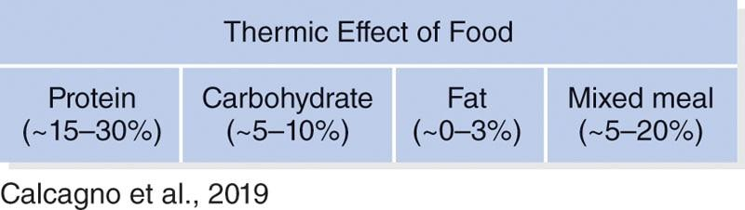

**Figure 9-3** Thermic effect of food

Protein considerations and concerns

Clients may ask two important questions: (1) How much protein is too much? (2) Is there any danger from consuming too much protein? Unless individuals have a medical diagnosis or condition that requires a limited protein intake, a higher-protein diet that provides greater than 2.2 g/kg of protein is unlikely to have an adverse effect for most healthy individuals and may help improve body composition, especially when combined with resistance training (Kerksick et al., 2018; Layman et al., 2005).

Some reported side effects of very high protein diets (protein consumption up to 2.2 g/kg of body weight) have been reported and could include the following issues:

* Constipation and gastrointestinal issues
* Increased excretion of calcium
* Increased risk of kidney stones or gout (Delimaris, 2013)

However, reports of side effects are inconsistent and may be affected by the choice of protein and possible inadequate fluid intake. Fluid intake should be increased when protein intake increases to facilitate the body’s removal of urea, a waste product from protein consumption. Protein intake in excess of 2.2 g/kg body weight may be unnecessary for healthy, active individuals seeking to improve their body composition; also, it may be undesirable if it contributes to an imbalance in the overall diet and/or a deficiency in other macronutrients and micronutrients. Optimal protein intake should support health, fitness, and performance goals without compromising the structure of an overall balanced diet that includes adequate nutrients for an individual’s needs.

**Carbohydrates**

The term carbohydrate includes a wide variety of energy-yielding compounds that contain carbon, hydrogen, and oxygen atoms. With the exception of fiber, carbohydrates yield 4 calories per gram (similar to protein) and are an important fuel source for the body, especially when the body is fueling physical activity. Of the three macronutrients, protein often becomes the primary nutrient of focus in the realm of sports and nutrient supplementation. However, carbo- hydrates remain equally important—if at times, not more so—for optimal training and sports performance. Adequate carbohydrate intake remains vital for individuals and athletes seeking to maximize the benefits from training and performance in sports (Kerksick et al., 2018). Fitness professionals may wish to highlight this to clients who are seeking to implement a rigorous training program for muscle building or performance but are limiting carbohydrates in their diet. Reinforcing the importance of both adequate carbohydrates and proteins in the diet, as well as other nutrients, may help clients optimize their results from training.

Carbohydrates are generally categorized into one of the following groups:

* Simple sugars
* Complex carbohydrates
* Glycogen
* Fiber

### Structure of Carbohydrates

Simple sugars, which most people associate with the word sugar, are comprised of monosaccharides (single sugar) and disaccharides (two sugars). Monosaccharides are the simplest form of carbohydrates: single units of sugar. They consist of glucose, fructose, and galactose (Table 9-7).

TABLE 9-7 Monosaccharides

| **Monosaccharides** | **Found In** |
| --- | --- |
| Glucose | Fruit, simple syrup |
| Fructose | Fruit, part of table sugar (sucrose) |
| Galactose | Milk/dairy |

TABLE 9-8 Disaccharides

| **Disaccharides** | **Structure** | **Found In** |
| --- | --- | --- |
| Sucrose | Glucose + Fructose | Table sugar |
| Maltose | Glucose + Glucose | Initial product of starch digestion |
| Lactose | Glucose + Galactose | Milk/dairy |

Disaccharides are two monosaccharides joined together (glucose is present in all) and include sucrose, maltose, and lactose (Table 9-8).

Polysaccharides are long chains of glucose units that are joined together to form the structures for starch, glycogen, and fiber (Table 9-9). Starch is the storage form of carbohydrate in plants, such as vegetables—especially root vegetables—fruit, grains, and seeds. Glycogen, a polysaccharide, is the storage form of carbohydrate in humans and animals; it is stored as liver glycogen and muscle glycogen. Glycogen is an important source of energy during exercise.

Fiber has a structure in which the chemical bonds between the glucose units are not easily broken down by the human digestive system. Therefore, it is not considered to be a significant source of calories in the diet. However, fiber does provide several health benefits that are highlighted in Table 9-10 and should be part of a healthy diet. U.S. Dietary Guidelines recommend approximately 25 to 28 g of fiber per day for women aged 19 to 50 years, and 30 to 34 g of fiber per day for men aged 19 to 50 years (U.S. Department of Agriculture, 2015). Fiber is subdivided into two categories: soluble and insoluble.

TABLE 9-9 Polysaccharides

| **Polysaccharides** | **Description** |
| --- | --- |
| Starch | Storage form of carbohydrates in plants. Examples include grains, potatoes, fruit, vegetables, nuts, and seeds. |
| Glycogen | Storage form of carbohydrates in humans and animals. It is stored in the liver and muscle tissue. |
| Fiber | Plant-derived food (also known as roughage) that cannot be completely broken down by the digestive system. Fiber provides several health benefits and includes two types: soluble and insoluble. |

TABLE 9-10 Soluble and Insoluble Fiber

| **Fiber Type** | **Definition** | **Good Food Sources** | **Health Benefits** |
| --- | --- | --- | --- |
| Soluble fibre | A type of dietary fibre that dissolves in water to form a gel; associated with heart health benefits and glucose control | Oats  Barley  Legumes  Most fruits (especially pears, berries)  Most vegetables  Psyllium seeds | Delays gastric emptying; may prolong satiety (feeling of fullness)  Helps to lower cholesterol  Associated with lower risk of cardiovascular disease  Promotes health of the gastrointestinal tract by promoting healthy gut flora |
| Insoluble fibre | A type of dietary fibre that does not dissolve in water; associated with promoting bowel regularity | Whole bran cereals, whole grains  Lentils, legumes  Nuts  Potatoes  Most fruit and vegetables (especially the outer skin) | Adds bulk; may help promote satiety  Improves bowel regularity and helps prevent constipation |

Carbohydrate digestion, absorption, and utilization

To be used for energy, carbohydrates must be broken down into smaller units and absorbed by the body. This process takes place in the gastrointestinal tract, primarily in the small intestine. Simple sugars are easily digested and absorbed through the intestinal lining, because they are small units of single or double sugars. Starch, however, is comprised of long polysaccharide chains that must first be broken down into smaller units by enzymes for absorption. For example, when an individual consumes a source of starch, such as grains, potatoes, or bread, the starch is physically broken into smaller pieces in the mouth and stomach and then broken down into monosaccharides and disaccharides by enzymes in the small intestine. These small units travel to the liver, which converts most fructose and galactose to glucose, and then directs glucose to other tissues and organs to be taken up by cells and used for energy. Some glucose is stored as glycogen in the liver and skeletal muscle to meet future energy requirements (Figure 9-4). Any excess carbohydrate is converted to fat and stored in the liver, muscle, and adipose tissue for future energy needs.

Glucose and blood sugar

Once carbohydrates are consumed, there is a corresponding rise in blood sugar levels as glucose enters the bloodstream. Simple carbohydrates consumed on their own, such as simple sugars found in juices, sports drinks, and candy, are absorbed more rapidly than complex carbohydrates and, therefore, lead to a rapid rise in glucose levels. Complex carbohydrates (starches in whole grains, starchy vegetables, legumes, and vegetables) are digested more slowly and are associated with a slower rise in glucose levels. A slower rate of glucose entry and a slower rise in glucose levels can provide a more sustained source of energy compared to a rapid increase.

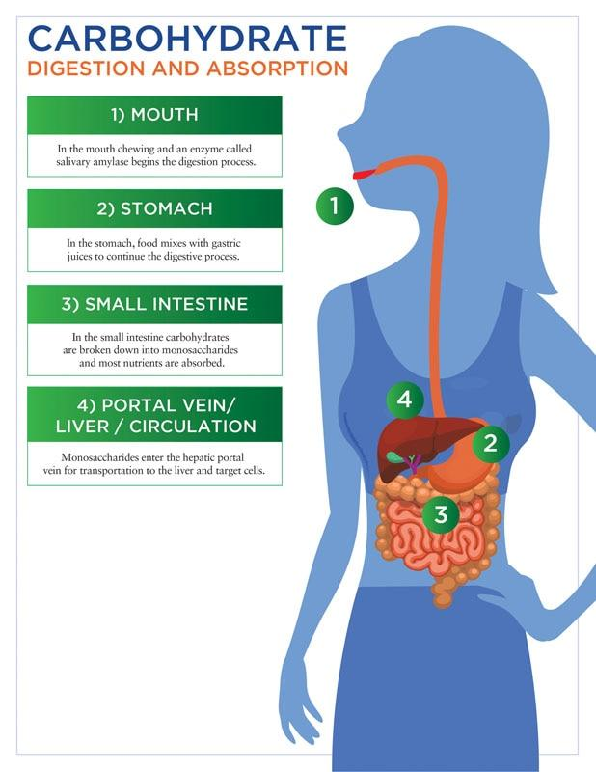

**Figure 9-4** Carbohydrate digestion and absorption

In some cases, such as posttraining and in sports where there is a need for rapid glycogen replenishment, it appears more beneficial to use easily digestible carbohydrate sources, such as simple sugars in sports rehydration drinks and low-fiber carbohydrates. Glycemic index (GI) and glycemic load (GL) are two measurements that are often used to indicate the speed and the extent to which a carbohydrate source raises blood sugar levels.

Glycemic index (GI)

The GI is a measure of how quickly a carbohydrate will raise an individual’s glucose levels when consumed on its own. On the GI scale, all carbohydrates are compared to glucose, which is given a GI value of 100 (Harvard Medical School, 2015) (Table 9-11). Carbohydrates that are higher on the GI scale, given a value of 70 or higher, can contribute to a rapid rise in blood sugar levels, whereas foods lower on the GI scale can lead to a much slower response. Simple carbohydrates, such as table sugar, juice, sweetened soda, and candy, are generally higher on the GI scale, whereas most complex carbohydrates and high-fibre foods (such as whole grains, legumes, and vegetables) are much lower. Higher GI foods may be helpful for athletes during pretraining and post training periods. Easily digestible carbohydrates provide a ready source of fuel when taken immediately prior to training, and in the post training period, they provide immediate glucose for rapid glycogen replenishment.

TABLE 9-11 Glycaemic Index

|  |  |
| --- | --- |
| **Category** | **Examples** |
| Low GI foods (55 or less) | Most non-starchy vegetables and whole grains, beans, cow’s milk |
| Medium GI foods (56–69) | Macaroni and cheese, raisins, hamburger bun, pineapple, banana |
| High GI foods (70 or above) | Glucose, hard candy, instant rice, sports drinks |

The GI value of foods may also be helpful to individuals with diabetes in managing their blood sugar levels (Harvard Medical School, 2015).

However, there are some limitations with the GI scale, because it does not account for the amount of carbohydrate eaten or other foods that may be consumed at the same time. It is simply a measure of the glycaemic response to the carbohydrate source when eaten by itself. In reality, the amount of carbohydrates eaten in conjunction with other macronutrients eaten at the same meal will affect the glycaemic response. For clients who are concerned with the glycaemic response of a carbohydrate source, a more meaningful measure may be the GL.

Glycaemic load (GL)

The GL of a carbohydrate source accounts for both the glycemic index of the food and the amount that is typically eaten as a serving. For example, popcorn has a high glycaemic index of 72. However, a 1-cup serving of popped popcorn has only 30 calories and approximately 6 g of carbohydrates, which does not provide a large amount of glucose. Thus, the GL of 1 cup of popcorn will be low. Rather than focusing on the GI alone, it is more helpful to consider the type of carbohydrate (simple vs. complex), the amount being consumed, and the presence of other macronutrients (fat and protein) to understand the overall glycemic response of a particular food. In reality, the GI and GL of carbohydrates may only be meaningful for a subset of clients and in limited situations. For example, clients who are training for a specific sport and/or those who have multiple training sessions per day may benefit from posttraining consumption of high-glycemic carbohydrates for rapid glycogen replenishment. Diabetic individuals may benefit from knowing which carbohydrates are high and low GI, although total carbohydrate intake still remains far more important. For most clients who do not have diabetes and are not in rigorous training for sports performance, these measurements may be of limited value.

Dietary carbohydrate needs

Carbohydrate needs for clients vary and depend on their size, energy needs, and level of physical activity, as well as any medical conditions, such as diabetes. Fitness professionals should be aware of this, because carbohydrate requirements will differ between clients. In addition, despite the popularity of low-carb and ketogenic diets in the mainstream media, carbohydrates remain essential for optimal performance in sports and exercise (Kerksick et al., 2018). Numerous studies have shown that reduced carbohydrate diets can impair both maximal effort during high-intensity exercise and performance in endurance sports (Burke et al., 2017; Cermak et al., 2013; Stepto et al., 2016).

Clients who are seeking to optimize sports performance and/or to build muscle will benefit from consuming adequate carbohydrates to fuel their activity. Certified Personal Trainers working with such clients may wish to reinforce the importance of adequate carbohydrate intake for effective training. If clients request or seek further guidance for assessing their individual carbohydrate requirements, then they should be directed toward a qualified nutrition professional, such as an RD or CNS, for further guidance. The AMDR suggests that 45% to 65% of calories come from carbohydrates (grains, vegetables, legumes, fruit, and dairy), with a minimum of 130 daily grams of intake based on a 2,000-calorie diet (U.S. Department of Agriculture, 2015). Carbohydrate requirements for active individuals will vary and depend on the type, duration, and intensity of activity. Table 9-12 lists the current carbohydrate recommendations for clients for different levels of intensity and duration.

TABLE 9-12 Carbohydrate Recommendations for Athletes

| **Activity** | **Recommended Carbohydrate per Day** |
| --- | --- |
| Light exercise | 3–5 g/kg of body weight |
| Moderately intense exercise: 1–2 hours per day, 5–6 days per week | 5–7 g/kg of body weight |
| Moderately high-intensity endurance exercise: 1–3 hours per day; 5–6 days per week | 6–10 g/kg of body weight |
| Moderate to high-intensity: > 3 hours per day; 2 sessions per day, 5–6 days per week | 8–10 g/kg of body weight 8–12 g/kg of body weight (ultra-endurance) |
| Source: Burke et al., 2011; Karpinski & Rosenbloom, 2017. | |

GETTING TECHNICAL

Ingested carbohydrates are broken down into glucose and then either oxidized to meet immediate energy needs or stored as glycogen in the liver and muscle. During short, high-intensity anaerobic exercise, the primary fuel source for the activity is carbohydrate—muscle glycogen and the oxidation of some plasma glucose (Cermak & Van Loon, 2013; Coyle, 1995). During longer, lower-intensity aerobic and endurance activities, muscle glycogen meets approximately half of the body’s energy needs, and the remainder is provided via a combination of free fatty acids, intramuscular triglycerides, and glucose (Coyle, 1995; Romijn et al., 1993).

STRETCH YOUR KNOWLEDGE

Adequate carbohydrate intake is essential to ensure adequate glycogen stores and carbohydrate availability to fuel activity. The majority of carbohydrates should consist of nutrient-dense carbohydrate sources that include vitamins and minerals, such as legumes, vegetables, fruit, and whole grains. However, lower-fibre and simple carbohydrates play an important role in supplying easily digestible sources of fuel immediately before sports events and for rapid glycogen replenishment during recovery (Kerksick et al., 2018).

Carbohydrates before, during, and after exercise

For active individuals, adequate carbohydrate intake before, during, and after prolonged and/ or intense activity can enhance training and performance, as well as facilitate recovery. Fitness professionals may wish to reinforce the importance of this with clients who are engaged in highly intense or endurance-based activities to ensure that they are maximizing the benefits of their training program. Carbohydrates consumed prior to intense and long-duration exercise may help replenish glycogen stores depleted during an overnight fast and ensure adequate fuel for performance. During activity that lasts more than an hour, the ingestion of carbohydrates can help maintain stable blood glucose levels and supply needed glucose to working muscles, because glycogen stores are being depleted. Various studies have shown that carbohydrate ingestion during endurance sports can increase performance and time to exhaustion (Currell & Jeukendrup, 2008; Patterson & Gray, 2007). After exercise, the ingestion of carbohydrates and protein can facilitate and optimize muscle protein synthesis, recovery, and glycogen replenishment.

For fitness professionals who work with endurance athletes and/or athletes with multiple training sessions per day, it is important to remember that training, performance, and recovery will be greatly affected by the athlete’s nutritional intake. To optimize and maximize the client’s benefits from training, fitness professionals can reinforce the importance of adequate nutrition with their clients and refer them to qualified nutrition professionals for further guidance when needed.

CRITICAL

Unless registered or licensed as a nutrition professional, it is outside the scope of practice for a fitness professional to prescribe specific meal plans for clients or athletes. It is in the client’s best interest, as well as a mark of professional courtesy, to respect the scope of practice of nutrition professionals by referring clients out appropriately when a greater degree of nutritional prescription is required.

**Lipids**

Lipids provide 9 calories per gram, compared to 4 calories per gram for carbohydrates or protein, and are considered a concentrated source of energy for active individuals. Lipids are commonly referred to as fats. However, fats are just one class of compounds within the larger family of lipids that are comprised of triglycerides, phospholipids, and sterols.

Structure of Lipids

Each lipid category (triglyceride, phospholipid, and sterol) has a slightly different structure and therefore a different role and function in the body. The triglyceride family is composed of fats and oils; it comprises 98% of the stored lipids in the body and approximately 95% of the lipids in foods. Triglycerides are comprised of a glycerol backbone with three chains of fatty acids. Phospholipids have a similar structure to triglycerides but have a phosphate molecule in place of the third fatty acid chain. Sterols have a ringlike structure that is very different from both triglycerides and phospholipids (Table 9-13).

TABLE 9-13 Lipids

| **Type of Lipid** | **Description** | **Food Sources/Found In** |
| --- | --- | --- |
| Triglycerides | Glycerol backbone with three fatty acid chains | Solid fats (animal and plant sources) and oils |
| Phospholipids | Glycerol backbone with two fatty acid chains and a phosphate molecule  Important component of cell membrane structures in the body | Egg yolks  Lean meats, fish, poultry  Soybeans  Grains  Seeds  Cell membranes (a thin layer that surrounds living cells) |
| Sterols | Ringlike structure of carbon and hydrogen atoms  Precursors to many hormones (estrogen, testosterone, androgen), bile, and vitamin D synthesis in the body  Part of cell membrane structure | Dietary cholesterol in animal fats (meat, poultry, fish, shellfish, egg yolks)  Cholesterol produced by the liver  Plant sterols (cholesterol in plants)  Cell membranes |

GETTING TECHNICAL

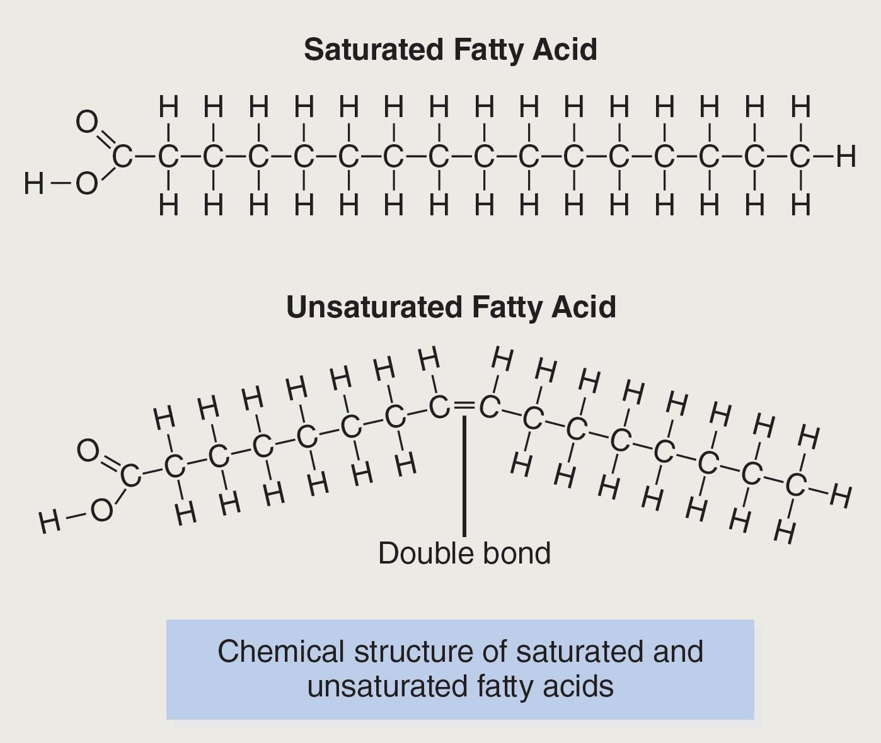

Each of the fatty acid chains in a triglyceride molecule may be saturated or unsaturated. A saturated fatty acid has no double bonds (points of unsaturation), although an unsaturated fatty acid may have one or more double bonds at any point in the chain. If a single fatty acid chain in a triglyceride molecule has a point of unsaturation (double bond), the fat is classified as an unsaturated fat. Unsaturated fats are further categorized depending on their degree of unsaturation. If an unsaturated fat has only a single point of unsaturation (double bond), it is classified as a monounsaturated fat. If there are two or more double bonds along a fatty acid chain, it is called a polyunsaturated fat.

Saturated fats were previously considered to be “artery-clogging” fats and harmful for heart health; however, recent research has shown that moderate amounts of saturated fat intake may not carry a substantial risk (Siri-Tarino et al., 2010). Currently, the cumulative evidence indicates that the overall composition and quality of an individual’s diet as well as genetic influences, rather than a single nutrient, play the most significant roles in determining the risk of cardiovascular risk and mortality. Rather than vilifying saturated fats as the culprit for heart disease, a better approach may be to consume them in moderation within the context of an overall healthy diet. Rather than focusing on a single nutrient, fitness professionals may wish to reinforce the importance of an overall balanced and healthy diet to clients.

Table 9-14 lists the different types of saturated and unsaturated fats, including their perceived roles, potential health benefits, and primary food sources.

TABLE 9-14 Monounsaturated, Omega-3, Omega-6, Saturated, and Trans Fats

| **Type of Fat** | **Role/Health Benefit** | **Food Sources** |
| --- | --- | --- |
| Monounsaturated fats | Heart healthy  Notably high in the Mediterranean diet | Olives, olive oil  Canola oil  Avocado  Peanuts |
| Polyunsaturated fats: omega-3   * Eicosapentaenoic acid (EPA) * Docosahexaenoic acid (DHA) * Alpha-linolenic acid (ALA) | Heart healthy  Lower triglycerides  Associated with improvements in high-density lipoprotein (HDL) cholesterol levels  Reduced inflammation  Associated with improved cognitive function  Associated with a reduced risk of dementia | Fatty fish (EPA and DHA): salmon, tuna, sardines, mackerel  Walnuts, flaxseed, chia seeds (ALA)  Fortified milk, fortified eggs (DHA)  Dairy from grass-fed cows (DHA, ALA)  Green vegetables (ALA) |
| Polyunsaturated fats: omega-6 | Essential for normal growth and development | Vegetable oils, nuts, seeds |
| Saturated fats | Exact health benefits remain unclear  General recommendations advise limiting excess saturated fats in the diet | Animal fats, full-fat dairy, coconut oil, palm oil |
| Trans fats | Artificial/added trans fats increase LDL cholesterol and lower HDL cholesterol. They are also associated with increased inflammation and heart disease (Harvard Medical School, 2015)  Naturally occurring trans fats are less harmful than artificial trans fat | Artificial/added trans fats are in partially hydrogenated oils and processed foods that contain these oils  Naturally occurring trans fats are found in animal fats and dairy |

STRETCH YOUR KNOWLEDGE

The optimal ratio of omega-6 to omega-3 fatty acids is somewhere near 4:1, depending on the population studied. However, the typical Western diet, with a high intake of processed foods, including vegetable oils, tends to include much higher amounts of omega-6 for a ratio closer to 10:1 or 20:1 (Simopoulous, 2003). There is some speculation that this imbalance of omega-6 to omega-3 fatty acids in the Western diet is one factor related to higher rates of inflammation and chronic disease. However, more of the evidence appears to be linked with obesity and sedentary behavior than the actual dietary ratio of omega-6 to omega-3.

Lipids are diverse in their structure and role in the body. Some clients may not be aware of the different groups of lipids or their role in diet, health, and effect on chronic disease. Fitness professionals should help their clients understand the need and importance of lipids in a healthy diet and the ways in which they support training and fitness goal attainment. Some types of lipids are associated with health-promoting properties, lower rates of inflammation, and chronic disease.

Lipid digestion, absorption, and utilization

Most lipid digestion and absorption occur in the small intestine, where pancreatic enzymes break up long-chain fatty acids into smaller molecules for absorption into enterocytes (Figure 9-5). A small amount of dietary fat is initially digested in the mouth by lingual lipases. However, the primary site of lipid digestion and absorption is accomplished by the small intestine. Lipases (fat-digesting enzymes) break up the ingested lipids into fatty acids and monoglycerides, which are absorbed into enterocytes. The enterocytes then repackage the fatty acids with other fat-soluble nutrients, such as fat-soluble vitamins, into chylomicrons and send them to the liver. The liver redistributes the triglycerides as lipoproteins (LDL and very low-density) to body tissues where the enzyme lipoprotein lipase (LPL) cuts up the triglyceride component to release fatty acids. These fatty acids are taken up by cells in muscles, organs, and adipose tissue and either stored or metabolized for energy, depending on the body’s energy needs.

Lipids, such as olives, olive oil, nuts, seeds, and fatty fish, provide important health benefits in a balanced diet. These should not be feared as additions to provide flavor and fullness in a meal, which is a great strategy to use when encouraging an overall healthy eating pattern.

STRETCH YOUR KNOWLEDGE

Cholesterol: LDL Versus HDL

Cholesterol is a type of lipid found in animal foods and in our body. There are different types of cholesterol, but the two most common types are LDL and HDL. LDL cholesterol refers to low-density lipoprotein and is considered to be less heart-healthy than HDL. HDL cholesterol refers to high-density lipoproteins, which are mostly comprised of protein and some triglycerides. They are typically considered to be heart-healthy, because they remove triglycerides from tissues and blood and transport them back to the liver for disposal.

STRETCH YOUR KNOWLEDGE

Cholesterol is not essential, since it is produced by the body, but it is an important part of cell membrane structure and required for the synthesis of bile, vitamin D, and the sex hormones estrogen and testosterone. Many animal foods (egg yolks, shellfish, meat, and poultry) contain some cholesterol, and these may be included as part of a healthy diet. Although egg yolks and shellfish are high in cholesterol, research has shown that for most healthy individuals, dietary cholesterol in foods has very little effect on serum (blood) cholesterol (Fernandez, 2012; Nakamura et al., 2007).

Clients who express a fear of eating egg yolks and shellfish because of their cholesterol content may be reassured that these foods are very nutritious and that their intake is unlikely to affect blood cholesterol levels. They should be referred to a medical professional, RD, or licensed nutritionist for further assistance on any medical and dietary concerns related to their blood cholesterol levels.

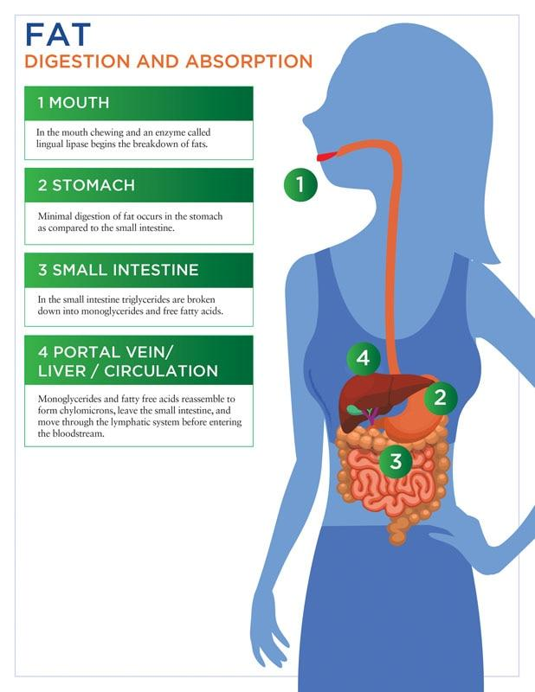

**Figure 9-5** Fat digestion and absorption

Lipid dietary needs

The AMDR for dietary fat is 20% to 35% of total calories for most healthy adults. Both the U.S. Dietary Guidelines 2015–2020 and the Australian Dietary Guidelines recommend that saturated fats be limited to 10% or fewer of total calories and that 10% to 25% of total fat calories be comprised of monounsaturated and polyunsaturated fats. The British Nutrition Foundation (2018) recommends that not more than 11% of calories should come from saturated fat. As previously noted, both omega-3 and omega-6 are essential types of dietary fat and must be obtained via diet to support metabolic functions.

Fat and satiety

Lipids are an important macronutrient in the diet, both as a source of energy and as a source of metabolites to support various physiological processes. Certain fats, such as omega-3s, are essential and must be included in the diet to support metabolic functions since they cannot be synthesized in the body. Some types of lipids, such as olive oil, are also associated with health benefits; these may improve cardiovascular health when included in a balanced diet (Nocella et al., 2018; Wongwarawipat et al., 2018). However, lipids are easily overconsumed and may contribute to an excess intake of calories for some clients when balance remains an important concept.

### Micronutrients and hydration

Micronutrients include vitamins, minerals, and phytonutrients, which are plant-based nutrients. They are not considered an energy source because they do not provide any calories, but they are important in the regulation of various metabolic processes, including energy metabolism. Inadequate intake of vitamins and minerals can contribute to micronutrient deficiencies and insufficiencies, which affect an individual’s health status. All vitamins and minerals are considered to be essential nutrients, with the exception of vitamin D, niacin, and biotin, because these essential nutrients are produced in our bodies under certain conditions. Thus, most vitamins and minerals must be obtained through the diet. A well-balanced, healthy diet of mostly minimally processed whole foods can help meet micronutrient needs of most healthy adults. However, supplementation may be helpful and necessary in cases of inadequate intakes (picky eaters), deficiencies, and/or increased nutrient needs, such as injury, illness, and high-volume or intensity training.

**Vitamins**

Vitamins may be classified into two groups: fat soluble and water soluble. The fat-soluble vitamins are vitamins A, D, E, and K. The water-soluble vitamins include vitamin C and the large group of B vitamins.

Fat-soluble vitamins

Fat-soluble vitamins require fat for digestion and absorption; they travel through the lymphatic system and circulate with other fat-soluble nutrients to the liver, where they are repackaged with lipoproteins and redistributed to other organs and tissues. Fat-soluble vitamins may be stored in the liver and adipose (fat) tissue and are not generally needed in the diet on a daily basis. Table 9-15 lists the fat-soluble vitamins, their primary functions, and good food sources of these nutrients.

TABLE 9-15 Fat-Soluble Vitamins

| **Fat-Soluble Vitamin** | **Primary Roles** | **Food Sources** |
| --- | --- | --- |
| A | Vision (preservation and health of retina)  Epithelial (outer lining of organs, blood vessels and skin) regeneration  Gene expression  Immune function  Growth | Egg yolk, liver  Orange and muddy green vegetables (carrots, pumpkin, sweet potato, butternut squash, apricots, Swiss chard, kale, collard greens) |
| D | Calcium absorption  Regulation of parathyroid hormone (a hormone that controls calcium levels)  Immune function  Gene expression | Fatty fish  Egg yolk  Dairy |
| E | Antioxidant activity (preservation of cell structure)  Prevention of oxidative damage to DNA | Nuts, seeds, and oils  Wheat germ  Canola oil  Sunflower seeds |
| K | Blood clotting  Bone health and bone resorption | Dark, leafy greens (spinach, kale, Swiss chard, collard greens, mustard greens)  Broccoli, Brussels sprouts |

Water-soluble vitamins

The water-soluble vitamins include vitamin C and the B vitamins: thiamin, riboflavin, niacin, folate, vitamin B6, vitamin B12, biotin, and pantothenic acid. Table 9-16 lists the water-soluble vitamins, their primary functions, and good food sources of these nutrients.

TABLE 9-16 Water-Soluble Vitamins

| **Water-Soluble Vitamin** | **Primary Roles** | **Food Sources** |
| --- | --- | --- |
| C | Antioxidant  Collagen synthesis  Possible immune support | Most fruits and vegetables, especially citrus fruits, kiwi, strawberries, cantaloupe, acai berries, lingonberries, and cranberries  Some vegetables (broccoli, cauliflower, red peppers, potatoes) |
| Thiamin (B1) | Energy metabolism  Prevention of beriberi disease (inflammation or degeneration of the heart and nerves) | Most meats, poultry, fish, pork (animal products)  Fortified cereal |
| Riboflavin (B2) | Energy metabolism  Prevention of cheilosis (inflammation or small cracks at the corners of the mouth) | Dairy  Most animal proteins  Fortified cereals |
| Niacin (B3) | Energy metabolism  Prevention of pellagra disease (dementia, diarrhea, and dermatitis) | Most animal proteins  Fortified cereals  Beans, legumes |
| Pyridoxine (B6) | Energy metabolism  Transamination and deamination of amino acids  Conversion of tryptophan to niacin | Most animal proteins  Fortified cereals  Beans, legumes |
| Folate (B9) | DNA and RNA synthesis  Red blood cell synthesis  Prevention of neural tube defects (brain or spinal cord birth defects)  Role in prevention of cancer  Energy metabolism | Green, leafy vegetables (spinach, Swiss chard, kale, mustard greens, collard greens), asparagus  Oranges  Orange juice |
| Cobalamin (B12) | Energy metabolism  DNA and RNA synthesis  Nerve signaling  Methylation reactions | Animal proteins (meat, poultry, fish, dairy)  Nutritional yeast |
| Biotin (B7) | Energy metabolism  Synthesis of structural proteins (nails, skin, hair) | Most foods contain small amounts |
| Pantothenic acid (B5) | Energy metabolism | Most foods contain small amounts |

The primary roles of vitamin C are that of collagen synthesis and antioxidant activity. Collagen is a type of protein found in skin, tendons, and ligaments; vitamin C is an essential component in its synthesis. Chronic deficiency of this vitamin can lead to a condition called scurvy, which is a result of collagen breakdown leading to tissue rupture. Vitamin C also functions as an antioxidant to neutralize oxidative and free radical damage to cell linings, DNA and RNA, and lipoproteins.

The B vitamins may be classified into two groups. One group plays a key role in red blood cell (RBC) synthesis and an energy-metabolism group, which has a significant role in energy-producing pathways, such as glycolysis and the Cori (Krebs) cycle. The B vitamins involved in RBC synthesis include folate and vitamins B6 and B12. Deficiencies in these vitamins can lead to different types of anemia (deficiency of hemoglobin or RBCs) due to inadequate RBC synthesis. Folate also plays an important role in DNA and RNA synthesis; it is important in the prevention of neural tube defects (birth defects in the brain or spinal cord) and certain types of cancer (Duthie, 2011). The energy metabolism group of B vitamins include thiamin, riboflavin, niacin, biotin, pantothenic acid, and vitamins B6 and B12. Derivatives and metabolites of these vitamins are involved in the metabolic pathways that facilitate the process of ATP synthesis from carbohydrates and amino acids.

Deficiencies in these B vitamins can manifest as fatigue, confusion, lethargy, and compromised athletic performance. Severe deficiencies of these vitamins can have more serious health outcomes beyond the scope of this text.

**Minerals**

Minerals are compounds that can be found in both plant and animal foods. From a nutrition perspective, minerals may be grouped into two categories: major and trace. The major minerals are present in the body in larger amounts and are also required in larger quantities in the diet as compared to the trace minerals. The major minerals include calcium, phosphorus, magnesium, sodium, potassium, chloride, and sulfur. Trace minerals, which include iron, zinc, copper, selenium, iodine, manganese, chromium, fluoride, and molybdenum, are required in much smaller quantities in the diet. Like vitamins, minerals do not provide any calories, but they are essential to structural development and the regulation of many metabolic processes (Tables 9-17 and 9-18). The daily requirements for the vitamins and minerals for various age groups, as recommended by the National Academy of Medicine, may be found at the National Academies of Sciences, Engineering, and Medicine website.

STRETCH YOUR KNOWLEDGE

Of the major minerals, calcium and phosphorus are present in the largest amounts in the human body and are primarily contained in bone and skeletal tissue. A healthy, well-balanced diet provides adequate quantities of the major and trace minerals for most people’s needs. In cases of inadequate intakes, increased needs, or impaired dietary absorption, supplementation may be necessary.

TABLE 9-17 Major Minerals

| **Major Mineral** | **Primary Functions** | **Food Sources** |
| --- | --- | --- |
| Calcium | Bone health  Muscle contraction  Nerve signalling  Blood clotting  Regulation of blood pressure  Immune function | Dairy  Fortified non-dairy milks (almond, soy, coconut, hemp, rice, oat)  Leafy greens (spinach, collard greens, mustard greens, broccoli)  Fish with bones (sardines, canned salmon with bones)  Fortified orange juice |
| Phosphorus | Bone health  Cell structure (as phospholipids)  DNA and RNA production  Acid-base balance maintenance | Animal proteins (meat, poultry, fish, dairy)  Beans, legumes  Whole grains  Cocoa  Cola |
| Magnesium | Coenzyme for many metabolic reactions  Muscle relaxation  ATP synthesis  Protein synthesis  Immune function  Nerve signalling | Green, leafy vegetables  Nuts and seeds  Avocado  Seafood  Dark chocolate |
| Sodium | Fluid and electrolyte balance  Nerve signalling  Muscle contraction | Table salt  Seafood  Naturally occurring in some vegetables  Processed, canned, or packaged foods |
| Potassium | Fluid and electrolyte balance  Nerve signalling  Muscle contraction | Dark, leafy greens  Most fruits and vegetables (higher amounts in bananas, apricots, avocado, potatoes, melon, prunes)  Small amounts in meat, dairy, grains |
| Chloride | Fluid and electrolyte balance  Hydrochloric acid production (stomach) | Table salt  Processed foods |
| Sulphur | Component in structural proteins (hair, skin, nails) | In most protein foods (eggs, meat, fish, poultry, milk, nuts, legumes) |

TABLE 9-18 Trace Minerals

| **Trace Mineral** | **Primary Functions** | **Food Sources** |
| --- | --- | --- |
| Iron | * Transport and release oxygen as part of haemoglobin in RBCs * Energy metabolism | * Animal proteins (meat, poultry, fish, clams) * Legumes, beans * Dark, leafy greens * Molasses and fortified cereals |
| Zinc | * Coenzyme for many metabolic processes, including protein and gene synthesis * Wound healing * Taste perception * Immune health * Growth, sexual maturation, foetal development | * Animal proteins (meat, poultry, fish) * Shellfish * Whole grains |
| Copper | * Coenzyme for many metabolic processes * metabolism * Role in iron absorption and metabolism | * Organ meats * Legumes, beans * Nuts and seeds (especially cashews) * Whole grains |
| Selenium | * Antioxidant activity | * Seafood * Meats * Grains |
| Iodine | * Part of thyroxine (thyroid hormone) that regulates metabolism, weight, growth, and development | * Seafood * Iodized salt * Dairy products |
| Manganese | * Coenzyme in many metabolic processes * Bone growth and development | * Legumes * Oatmeal * Whole wheat bread * Leafy, green vegetables |
| Chromium | * Regulation of glucose, in conjunction with the hormone insulin | * Whole grains * Liver * Brewer’s yeast * Nuts * Cheeses |
| Fluoride | * Bone and dental health * Helps prevent dental cavities | * Tap water * Tea * Certain seafood |
| Molybdenum | * Coenzyme in some metabolic pathways | * Most foods, especially vegetables, leafy greens, legumes, milk, liver |

**Hydration strategies**

Water is an essential nutrient and vital to sustain life. It comprises approximately 60% of most adult bodies. Women may have a slightly lower percentage, and some men may have a slightly higher percentage of body water due to higher glycogen stores. Water serves several important functions in the body, including the following:

* Regulation of body temperature
* Transport and distribution of water-soluble nutrients
* Maintenance of blood volume
* Lubrication of joints, membranes, and synovial tissue
* Shock absorption
* Removal of waste matter and toxins.

Inadequate fluid intake can impair many physiologic functions as well as cognitive processes. Even mild dehydration can lead to a decline in function and affect performance and recovery for athletes and exercisers. The recommended amount of fluid intake for most men and women is around 11.5 cups per day (2.7 L) for women and around 15.5 cups (3.7 L) for men (Institute of Medicine, 2005). Exercise and certain conditions and circumstances, such as illness, pregnancy, breast-feeding, warm weather, altitude, and dietary increases in protein and fiber, can also influence a client’s daily fluid requirements (Figure 9-6).

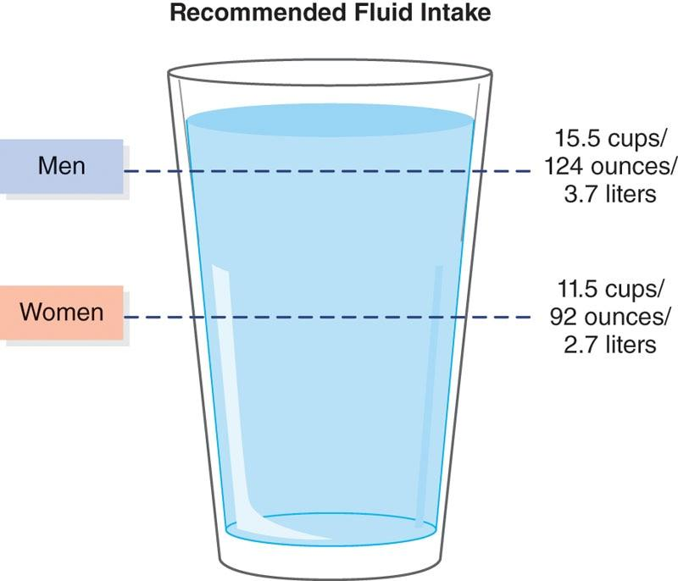

**Figure 9-6** Fluid intake recommendations

STRETCH YOUR KNOWLEDGE

While the water content in certain foods consumed may contribute to a client’s hydration status, the effort to consume these water-rich foods for the sake of hydration may require exponential effort compared to simply consuming a glass of water. Some common foods containing a minimum of 90% water include, but are not restricted to, strawberries, cantaloupe, cucumbers, lettuce, zucchini, celery, and tomatoes.

**Water and performance**

Clients lacking hydration will show signs of impaired performance due to multiple adverse effects. Inadequate hydration, and even a mild level of dehydration, can have the following negative effects on the body and on athletic performance:

1. Increased heart rate
2. Higher body temperature
3. Higher rate of perceived exertion
4. Increased use of muscle glycogen
5. Lower blood volume
6. Decreased cardiac output
7. Decreased blood flow
8. Lower rate of perspiration (and temperature regulation).

Fitness professionals should educate their clients by reinforcing the importance of adequate hydration both prior to, during, and after training. They should also be able to recognize symptoms of dehydration and adjust training to make sure fluid levels are appropriately addressed. In most healthy adults, their hydration status can be determined by the color of their urine. Urine that is a very light to pale yellow indicates adequate hydration; darker shades signify inadequate hydration or other medical issues (Figure 9-7).

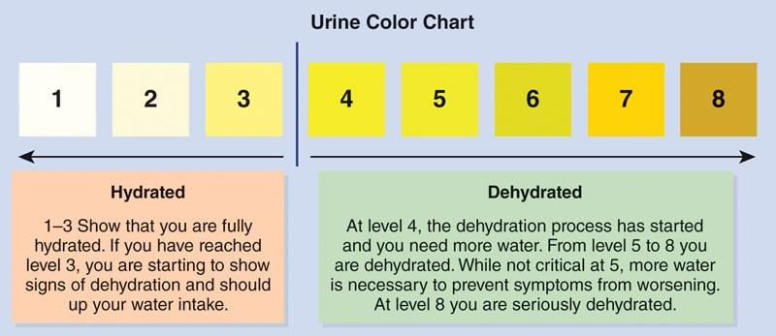

**Figure 9-7** Urine color chart

However, clients with heavy training regimens will likely need to be more cognizant of fluid losses and diligent with rehydration to avoid risk of dehydration. Fluid losses during training can compound the effects of those already experiencing dehydration. Because of this, clients should be educated on the importance of hydrating adequately prior to exercise, in addition to hydrating during and after workout sessions. During exercise, a weight loss of more than 4%, due to fluid losses, can lead to heat exhaustion, heatstroke, and death in severe cases (Maughan & Noakes, 1991). Therefore, prevention of dehydration before and during exercise remains of critical importance. Clients who engage in intense training or endurance sports should not rely on thirst as an indicator of hydration status but rather follow a recommended hydration protocol as outlined (Table 9-19).

TRY THIS

Hydration Posttraining/Postevent

Current sports nutrition guidelines recommend that fluid replenishment posttraining of an event should be in the range of 125% (1.25 times) the amount of weight lost during a training session or game.

This means that if there is a 2 lb (0.9 kg) loss in body weight from training, the athlete should consume 32 oz × 1.25 = 40 oz (1.18 L) of fluid to replenish this loss (2 lb = 32 oz).

Hydration and sports drinks

Sports drinks are often perceived as a go-to source for hydration by many clients. However, they may not be necessary for most clients who train at low-to-moderate intensities for less than an hour per day. Sports drinks are designed to replenish fluid and electrolytes and provide a source of carbohydrate during prolonged periods of intense training.

TABLE 9-19 Hydration Recommendations

| **Hydration Recommendation** | **Timing** |
| --- | --- |
| 16 oz (500 mL) of water or sports drink | Evening prior to event  Morning of an event |
| 13–20 oz (400–600 mL) | 20–30 minutes prior to event start |
| 12–16 oz of fluid | Every 10–15 minutes of exercise (especially in hot and humid climates) |
| Water | Activity <60 minutes (unless in warm temperatures and/or with heavy perspiration in which a sports drink may be necessary) |
| Sports drink or electrolyte tablets mixed with water | Exercise >90 minutes (unless in warm temperatures and/or with heavy perspiration) |
| 1.25 times the amount of weight lost during a training session or game | Postgame/training |

Some also contain stimulants, such as caffeine and green tea extract, along with various vitamins and minerals. Sports drinks are helpful in facilitating rehydration and, in some cases, help the replenishment of glycogen stores during prolonged training lasting for more than an hour. For shorter training sessions less than an hour, especially when perspiration is low or minimal, water is likely sufficient for fluid replenishment. Some sports drinks contain large amounts of sugar and may be an unnecessary source of extra calories in an individual’s diet if training volume is low.

There are many different sports drinks available on the market today with varying compositions of carbohydrate and electrolytes.

Sports drinks can be hypotonic, isotonic, or hypertonic based on the concentration of electrolytes and carbohydrates in the solution (Table 9-20). Hypotonic drinks have a lower concentration of salt and electrolytes compared to the human body. Isotonic drinks have a similar concentration of salt and electrolytes as in a human body. Hypertonic drinks have higher concentrations of salt and electrolytes; they are absorbed more quickly than isotonic or hypotonic solutions. Most sports drinks on the market are either hypotonic or isotonic solutions. However, hypertonic solutions may be appropriate under certain conditions.

Adequate hydration remains essential for optimal health, training, and performance. Fitness professionals should emphasize the importance of hydration with all clients, highlighting the physiological importance of fluid for blood flow, maintenance of body temperature, blood volume, the disposal of waste matter, and the importance for training and performance. Inadequate hydration prior to training can affect training intensity and lead to higher body temperature, a higher rate of perceived exertion, and decreased cardiac output. Clients may also find it difficult to maintain training intensity and volume. Hydration during exercise and posttraining should also be emphasized to replace fluid and electrolyte losses and enhance recovery from training sessions, particularly with clients who are engaged in high-volume exercise or training for sports performance.

TABLE 9-20 Sports Drinks

| **Type of Sports Drink** | **Most Appropriate Usage** |
| --- | --- |
| Hypotonic | Fluid replenishment is a greater priority than carbohydrate or electrolyte replacement |
| Isotonic | Activities lasting more than 60 minutes  Moderate fluid and electrolyte losses  Moderate perspiration |
| Hypertonic | High-volume and intense training lasting more than 60–90 minutes  Large fluid and electrolyte losses  Heavy perspiration  Higher priority for carbohydrate and electrolyte replacement (versus fluid replacement only) |

STRETCH YOUR KNOWLEDGE

Hypertonic sports drinks have a higher concentration of salts and electrolytes and, therefore, a higher concentration than body fluids. They are also absorbed more quickly than either isotonic or hypotonic solutions. The higher concentration and rapid rate of absorption can cause gastrointestinal upset in some individuals. If gastrointestinal upset is a concern, then using an isotonic sports drink or watering down a hypertonic sports drink may mitigate these effects.

### Nutrition strategies

Every client is different in that each has his or her own genetic profile and lifestyle that can influence various factors, including basal metabolic rate (BMR), overall body composition, height, weight, and the propensity to gain or lose weight. Some individuals may find that they can lose or gain weight more easily compared to others of the same height, weight, age, or build, and it is important to note that there are multiple factors that influence both weight and weight management.

**Factors that influence weight management**

Genetic influence is one factor that affects and influences a client’s ability to manage weight. However, their physical activity, energy intake (diet), sleep, hormones, and medications also play important roles. Fitness professionals should keep these in mind when working with clients looking to lose or gain weight. Some factors, such as diet, physical activity, and sleep, may be more easily modifiable. However, others, such as endocrine (hormonal) disorders and medications, may significantly affect weight and may require a referral to a qualified medical professional.

Law of thermodynamics

Energy intake is one of the factors that influences weight management; some might argue that it is perhaps the most important factor. Regardless, it is certainly a major component in managing weight, whether for weight gain or weight loss. The first law of thermodynamics states that energy cannot be created or destroyed in a system (Figure 9-8), it can only be converted from one form to another (Hall et al., 2012).



**Figure 9-8** Energy conversion within the body

If energy intake is less than energy expenditure, energy stored in the body will be used as fuel. Despite many proposed theories on weight loss and gain, this basic concept still holds true on a fundamental level. Weight loss requires a deficit of calories, and weight gain requires a surplus. Energy intake is primarily governed by the quantity and quality of food and beverages ingested by an individual. Some foods are calorically dense and can contribute to excess energy intake. Other foods, such as lean proteins, high-fiber whole grains, vegetables, and fruit, are not only nutritious but also less calorically dense than many hyperpalatable foods, which contain added sugars and fats. For example, an average orange has about 45 calories, whereas an orange smoothie (depending on the recipe and size) can have upwards of 200 to 500 calories.

Some studies have found that overall energy (calorie) intake on a whole-foods diet versus a processed-foods diet tends to be lower (Barr & Wright, 2010; Hall et al., 2019). Whole foods tend to be higher in fiber and protein and lower in added sugars than most processed foods, a possible reason for the difference. Whole foods, such as lean proteins, whole grains, legumes, and vegetables, may also be more satiating than many processed foods; again, this is due to the higher fiber and protein content and also likely due to flavor and freshness. Encouraging clients to choose a greater amount of whole foods while limiting highly processed foods in their diet may be one strategy to help them maintain caloric balance and avoid excess energy intake. When an individual’s total daily energy expenditure (TDEE) is equivalent to the client’s total energy intake, then body weight remains unchanged. Factors such as sleep, hormones, nonexercise, activity, and medications influence both sides of the energy equation.

**Poor sleep**

Adults between the ages of 18 to 64 years old are recommended to get between 7 and 9 hours of sleep per night (National Sleep Foundation, 2015). However, many adults fall short of these guidelines. In 2016, the Centers for Disease Control and Prevention reported that more than one-third of U.S. adults were not getting enough sleep on a regular basis (Centers for Disease Control and Prevention, 2016). Similar trends are also occurring around the globe (Stranges et al., 2012; Van de Straat & Bracke, 2015). Many studies have shown that inadequate sleep can increase the risk of many chronic diseases, such as cardiovascular disease, stroke, type 2 diabetes mellitus, and obesity (McHill & Wright, 2017).

One of the reasons sleep deprivation is associated with an increased risk of obesity is because chronic sleep deprivation adversely affects appetite and satiety hormones in the body. Several studies have shown that after several nights of inadequate sleep, levels of the satiety hormone peptide YY are lower and levels of the hunger hormone ghrelin are higher in participants (Hibi et al., 2017; Reutrakul & Van Cauter, 2018). Some studies also show that impaired sleep can contribute to greater caloric intake on the subsequent day (Al Khatib et al., 2017). Thus, poor sleep can have a detrimental effect on weight management. Encouraging clients to get the recommended 7 to 9 hours of sleep remains an important factor in helping them achieve their weight and body composition goals.

**Endocrine disorders**

Weight gain and difficulty losing weight is also influenced by several endocrine (hormonal) disorders and disruptions, which can affect any client’s weight or render it difficult for an individual to achieve weight changes. Several endocrine disorders that typically result in weight gain include hypothyroidism, Cushing’s syndrome, polycystic ovarian syndrome (PCOS), and insulinoma (a pancreatic tumor that causes the production of excess insulin) (Kokkoris & Pi-Sunyer, 2003). Treatment of the underlying medical issue usually addresses the weight gain while allowing an individual to successfully manage their weight. If a client presents with a medical issue that may be contributing to weight gain or loss, they should be referred to a medical professional and/or an RD for medical and nutritional guidance.

**Medications**

Several medications, such as antidepressants, anti-anxiety drugs, psychotropics, contraceptive pills, and steroids such as prednisone, can also affect an individual’s propensity to lose or gain weight. Weight gain and metabolic dysregulation are particularly associated with the use of psychotropic medications (De Hert et al., 2011; Hasnain & Vieweg, 2015) and some antidepressants (Himmerich et al., 2015). These medications appear to disrupt glucose and lipid metabolism and may also affect the amount of physical activity, all of which may be contributory to the weight gain.

Corticosteroids, such as prednisone, also contribute to weight gain through an increase in appetite as well as fluid retention (University of California, San Francisco, n.d.). Clients who are taking an oral contraceptive may also be susceptible to weight changes due to hormonal fluctuations. Clients who are taking any psychotropic, corticosteroid, or hormone medications and experiencing either weight gain or loss should be referred to a medical professional and/or an RD for weight management and medication review. They should also be referred to a medical professional and/or an RD for a review of their medications and diet, because an assessment of these are outside the scope of practice for a fitness professional.

**Metabolism**

Metabolism can be defined as the chemical changes in living cells by which energy is provided for vital processes and activities, and new material is assimilated (“Metabolism,” n.d.). In broader terms, it can be thought of as the cumulation of all the energy usage of an organism, such as the human body. Metabolism is often referred to as an individual’s BMR, which is the number of calories that they would burn at rest, outside of physical activity or food intake. BMR is essentially the body’s energy requirement to fuel biological processes outside of physical activity, such as respiration, digestion, cellular signaling, and mitochondrial activity. Also, it is one component of an individual’s TDEE and is usually the largest, except in cases of strenuous and prolonged physical activity or exercise, such as ultra-endurance events.

STRETCH YOUR KNOWLEDGE

The components of TDEE include BMR, physical activity, and TEF.

Energy expenditure from physical activity may be further divided into nonexercise activity thermogenesis (NEAT), which is energy expenditure through daily activities outside of structured exercise, and exercise activity thermogenesis (EAT), which is energy expenditure through structured exercise.

An individual’s BMR is largely determined by body size and is also regulated by the thyroid hormone thyroxine, as well as many other hormones. However, EAT, NEAT, and TEF are variable and can be changed through an increase or decrease in activity and a manipulation of diet composition.

Since BMR is affected by factors such as age, height, weight, amount of muscle mass, and hormones, it will vary from individual to individual and may also change as an individual gets older. Clients may ask, Can I increase my metabolism? The answer is, yes, but to a limited degree. It is possible to increase BMR through resistance training and building muscle mass, but some studies have shown that increased muscle mass may only have a marginal effect on increasing the number of calories burned when the body is at rest (Kinucan & Kravitz, n.d.). A greater effect on overall energy expenditure may be achieved through an increase in both EAT and NEAT, and fitness professionals may wish to highlight this effect to clients. Increased muscle mass does have a positive impact, because it increases the body’s energy requirements during physical activity, which in turn increases EAT and NEAT. Rather than focusing on increasing BMR, effective weight management strategies will balance calorie intake with resistance training and other physical activity (both exercise and nonexercise activities) to achieve the desired goal.

**Adaptive thermogenesis**

Adaptive thermogenesis can be defined as the metabolic adaptations and changes in energy expenditure, due to changes in energy intake (Camps et al., 2013). It is often used to explain the inability for many individuals to lose weight despite continued reductions in caloric intake (Rosenbaum & Leibel, 2010). Of note is the reduced energy expenditure that accompanies the weight loss, which appears to be greater than predicted. Several factors may contribute to this effect, but these appear to be primarily due to a decrease in physical activity and reduced caloric intake and/or reductions in body mass (Leibel et al., 1995; Rosenbaum et al., 2008; Trexler et al., 2014). Thus, a reduction in energy expenditure may be expected with weight loss due to metabolic adaptations; this may be important to explain to clients so that they adjust energy intake and/or physical activity accordingly.

TRAINING TIP

As people lose weight, their energy requirements also change. In other words, individuals will typically require fewer calories to maintain their new body weight. For example, a person weighing 250 lb (113 kg) can consume a specific range of calories to maintain their body weight. But if that same individual loses weight and now weighs 175 lb (79 kg), the individual’s calorie requirement to maintain their new body weight, at the same activity level, is typically less. This is an important consideration for individuals seeking to lose weight permanently

### Food labels

Food labels on products convey important information on ingredients and nutritional content; labels can help clients make informed decisions about the ways in which food items contribute to their nutrition and fitness goals. The ability to read and interpret a food label can help clients compare products and select healthier options. Food labels may differ slightly from country to country, but in general, each includes the following information: product name, quantity provided in the package, manufacturer’s name and address, ingredient list, and a nutrition facts label (often referred to as a nutrition information panel). The nutrition facts label displays all the nutrition information within a given product. This information can be used to compare products in addition to evaluating a product’s nutritional contribution to an individual’s diet.

**US food labels**

In the United States, the nutrition facts label on packaged foods is typically displayed on the back of the package, along with the ingredients list and a statement on any allergens included in the product: egg, dairy, wheat, soy, peanuts, etc. For consumers, the two most informative features of a food label are likely the nutrition facts label and the ingredient list.

#### Nutrition facts panel

In the United States, the nutrition facts panel on packaged foods provides nutritional information for a specified serving of the product (Figure 9-9).

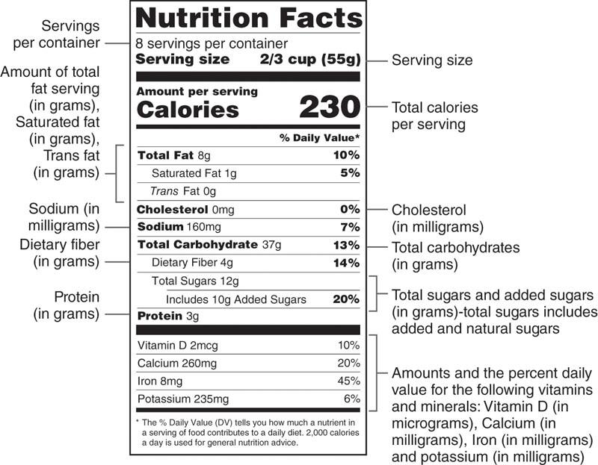

**Figure 9-9** Nutrition facts label (U.S.)

Two pieces of information that should be reviewed are the servings per container and the serving size. Servings per container indicates the number of servings of the product provided in the package, based on the specified serving size. The serving size is a reference amount based on the quantity of the product consumers are thought to typically consume at one sitting; it should be viewed as a reference amount for information, rather than a recommended amount for consumption. Individuals may consume a portion size that is more or less than the specific serving size of the product, based on their calorie and macronutrient needs, hunger levels, and preference.

Products containing between one and three servings are required to list the nutrition information for one serving and the entire container, therefore displaying a dual column nutrition facts label (Figure 9-10). This may be helpful to consumers, because packages with one to three servings may at times be consumed in a single setting. Table 9-21 (on the following page) describes key considerations for reviewing the nutrition facts label.

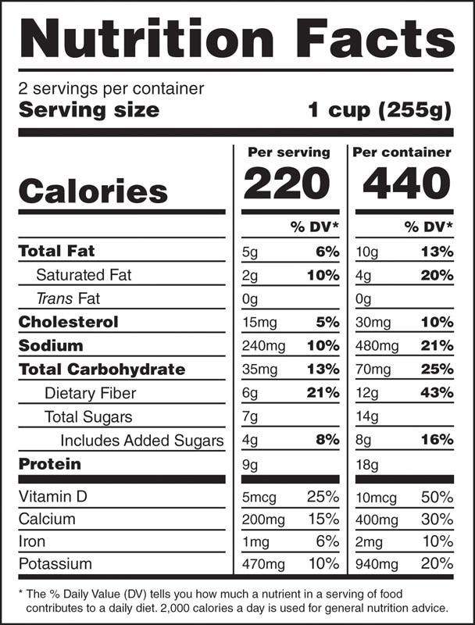

**Figure 9-10** Dual-column nutrition facts label

STRETCH YOUR KNOWLEDGE

Added sugar was not listed on the initial U.S. nutrition facts label. The current label, as established in 2016, specifies both total and added sugars for a product. Some products, such as dairy and fruit, contain naturally occurring sugars; dairy contains lactose, and fruit contains both glucose and fructose. Natural sugars should not be of excess concern for most clients, unless they are diabetic, in which case, they should be referred to a qualified medical professional. Added sugars, however, are those that have been added to a product: table sugar (sucrose), corn syrup, high-fructose corn syrup, dextrin, maltodextrin, cane syrup, and so forth. Per the U.S. Dietary Guidelines 2015–2020, adults are recommended to limit the amount of added sugar in their diet to less than 10% of total calories (U.S. Department of Agriculture, 2015).

TABLE 9-21 Considerations When Reviewing a Nutrition Facts Label

| **Nutrition Label Item** | **Key Considerations** |
| --- | --- |
| Servings per container | * How many servings are provided in the package, based on the specific serving size? |
| Serving size | * Is the serving size appropriate for me? * Do I want more or less than the specified serving? |
| Total calories | * What is the caloric contribution of the specified serving of the product? * Does it seem excessively high for the specified serving size? * How does this fit into the context of my diet, health goals, and preferences? |
| Total fat  Saturated fat | * How much fat and total fat is in a serving of the product? * How does this fit into the context of my diet, health goals, and preferences? |
| Trans fat | * Is there any trans fat in this product? |
| Cholesterol | * Note: The U.S. Dietary Guidelines for Americans no longer specifies any limitations on dietary cholesterol intake, because there is no direct correlation between heart disease and dietary cholesterol intake. |
| Sodium | * How much sodium is provided in the specified serving of the product? * Does it seem excessively high for the specified serving size? * How does this fit into the context of my diet, health, goals, and preferences? |
| Total carbohydrate | * How much carbohydrate is in a specified serving of the product? * How does this fit into the context of my diet and carbohydrate needs? |
| Dietary fibre | * How much fiber is provided in a serving of the product? * How does it contribute to my dietary needs for fiber? (Current guidelines recommend 25–28 g of fiber per day for women aged 19–50 years and 30–34 g of fiber per day for men aged 19–50 years [U.S. Department of Agriculture, 2015]) |
| Total sugars | * How many grams of sugar are in a serving of the product? * Does it seem excessively high for the specified serving size? |
| Added sugars | * How much added sugar is in a serving of this product? * Is it excessively high for the specified serving size? * How does this fit into the context of my diet and health goals? |
| Protein | * How much protein is provided in the specified serving of the product? * How does it fit into the context of my diet and carbohydrate needs? |
| Vitamin D  Calcium  Iron  Potassium | * Is this product a good source of these micronutrients? |

**Percent daily value**

The percent daily value (%DV) on a nutrition facts label is another useful tool that clients can use to compare the nutritional value of different products. These daily values are indicated for all the listed nutrients on the nutrition facts label, except trans fats, total sugars, and protein, as the Food and Drug Administration has not established recommended daily amounts for these nutrients.

GETTING TECHNICAL

Dietary guidelines recommend limiting dietary trans fats, therefore, recommended daily values have not been defined for trans fats. There is also no %DV for total sugar, as there are no defined recommendations for total sugar that should be eaten in a day. However, dietary guidelines do recommend limiting added sugar to no more than 10% of daily calories (U.S. Department of Agriculture, 2015). The %DV for protein is not listed on the nutrition facts label for most products, because most U.S. adults are not considered to be at risk for low protein intake. However, the %DV for protein is required to be listed if a specific claim about protein is made on the product (e.g., Good Source of Protein), or the product is intended for use by infants and children less than 4 years old.

The %DV indicates the percentage of the recommended daily value for a nutrient is met by the specified serving size of a food product, based on a standard 2,000-calorie diet. If an individual’s needs are greater than 2,000 calories per day, then the specified serving would provide less than their daily recommended intake for that nutrient.

These daily values can also help consumers identify if a product is high or low in certain nutrients or if it is a good source of any nutrient(s). In general, a %DV of 5 or less indicates that a product is low in that nutrient, whereas a %DV of 20 or more indicates that it is high, or a good source of that nutrient. The Academy of Nutrition and Dietetics (2019) recommends that individuals select products that provide 5% or less of total fat, saturated fat, cholesterol, and sodium and 20% or more for fiber, vitamins, and minerals.

TRY THIS

Look at the nutrition facts label for a product that you have at home, such as cereal, soup, or a protein bar. Look at the %DVs for each of the listed nutrients. Answer the following questions:

1. What is the %DV for total fat, saturated fat, carbohydrate, and fiber?
2. Is the %DV for saturated fat less than or greater than 5%? What does this tell you about the product?
3. Is the %DV for fiber less than or greater than 5%? What does this tell you about the product?

The nutrition facts label also lists the amount in micro- or milligrams and the %DV for vitamin D, calcium, iron, and potassium, since most U.S. adults do not consume these nutrients in recommended amounts. Other vitamins and minerals are not required to be listed on the panel unless they have been added to the product or if a claim is made about the nutrients, for instance, “This product is a good source of folate.”

**UK food labels**

Food labels in the United Kingdom (UK) and European Union (EU) differ in a few ways from those in the United States. One of the biggest differences is that the United States displays nutrition information for a specified serving size of a product, whereas the UK and EU nutrition information panels provide nutrient information for a standard amount of the product: 100 g of a dry product or 100 or 200 mL of a liquid product (Figure 9-11).

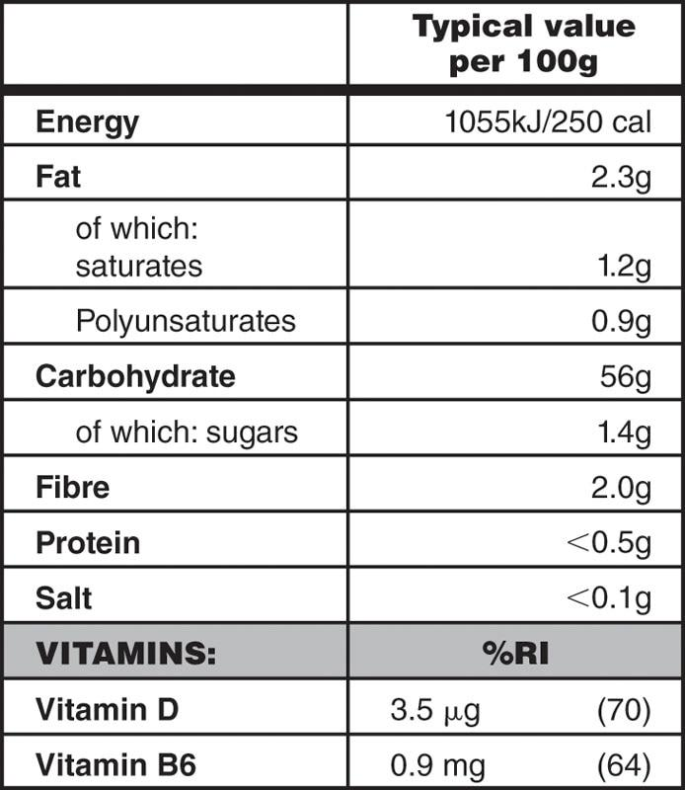

**Figure 9-11** Nutrition information panel in the United Kingdom

Like the U.S. label, the nutrition information panel in the United Kingdom and European Union provides information on the number of calories in the reference amount of the product, along with the amount of total fat, saturated fat, carbohydrate, sugar, fibre, protein and salt, and vitamins D and B6. Calories are listed as kilojoules or kilocalories, and salt content is listed in place of sodium. Vitamins and minerals that have been added to a food product must also be listed on the nutrition information panel, along with their amounts in the reference quantity (e.g., 100 g). Instead of the %DVs, food labels in the United Kingdom and European Union use percent reference intake (% RI) on the nutrition information panel. Like the U.S. %DV, the % RI enables consumers to see how a product contributes nutritionally toward their reference intake values for the listed nutrients. Both the % RI and the U.S. %DV enable consumers to make informed decisions by comparing products for their nutritional value and contribution to their diet (Figure 9-12).

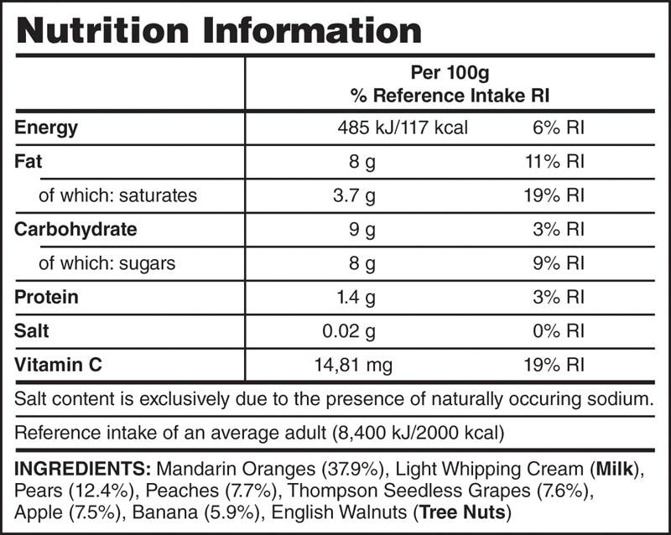

**Figure 9-12** Percent reference intake

**Colour coding on UK and EU food labels**

Most UK food labels also display a color-coded chart that displays the amount of fat, saturated fat, sugar, and salt in a product (Figure 9-13). These nutrients are highlighted using a colour scheme to help consumers quickly identify if a product contains high (red) or low (green) amounts, as dietary guidelines recommended limiting these particular nutrients in the diet. A yellow highlight indicates that the product is a “medium” source of the nutrient and that it should be consumed with caution, in moderate amounts.

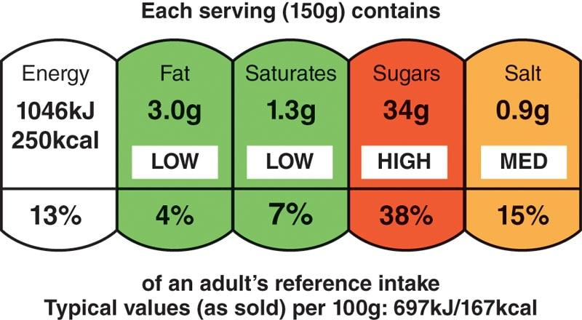

**Figure 9-13** Color coding on a food label from the United Kingdom

**Food label ingredients list**

The ingredients list on food labels is also an important source of information. In both the United States and the United Kingdom, food products must list all the ingredients included in the package, in decreasing order of prevalence. This means that the first ingredient listed is present in the largest quantity. Common food allergens must also be listed, whether they are included in the product or may have come into contact with any of the ingredients (Center for Food Safety and Applied Nutrition, 2013; Gov.UK, n.d.).

STRETCH YOUR KNOWLEDGE

Food labels in the United Kingdom must also specify the percentage of an ingredient in a product if it is included in the product name or highlighted on the food label or is an ingredient typically associated with the product (Gov.UK, n.d.). For example, a mixed berry jam in the United Kingdom would need to list the percentage of berries included in the jam since berries are noted in the name and are typically associated with the product.

Clients can also use the ingredient list to see if a product is primarily comprised of whole foods or if it is a highly processed product with many ingredients, additives, and preservatives. In general, whole food products tend to have shorter ingredient lists, with easily recognizable ingredients. The longer the ingredient list, the greater the likelihood that it contains refined ingredients and additives. The exceptions are food products that have been fortified with vitamins and minerals, because producers are required to include the added micronutrients in the ingredient list.

**Aligning with food labels and ingredient lists**

If clients have questions on how to select healthier products, then fitness professionals can direct them to the nutrition facts label and ingredients list, which are useful tools for evaluating the composition and nutritional value of food products. Clients can use the information provided in these items to assess the nutritional value of products, evaluating it in the context of their health and fitness goals. Clients with goals for weight management may benefit from choosing higher-fiber products and evaluating the calories, protein, and fat content of foods they select. Those with performance-based goals, and specific fuelling needs, may want to look at the composition of a product as well as the amount of carbohydrate, fat, and protein provided in a serving. Athletes may wish to look at the electrolyte and carbohydrate composition of sports drinks and the composition of protein bars to determine if a product meets their fuelling and performance requirements. The ingredients list and nutrition facts label on these products will enable them to make these evaluations and select products that best suit their needs and requirements.

### Goal-based nutrition strategies

Many clients engaging in exercise or sports most often have a weight or performance goal, whether it is fat loss, muscle gain, or improved performance in a sport. The accomplishment of these goals relies on an effective training program and appropriate nutrition strategies that complement each other. Specific recommendations will depend on a client’s individual characteristics: age, height, weight, training and weight history, lifestyle, occupation, and dietary preferences. However, the overall strategy for each type of goal (fat loss, muscle gain, or improved sports performance) may be similar for different clients.

CRITICAL

It is outside the scope of practice for fitness professionals to prescribe specific meal plans. If clients request more specific nutritional guidelines to meet their goals, they should be referred to an RD or certified sports nutritionist.

**Fat loss strategies**

Fat loss requires a net deficit in caloric intake, with the goal of minimizing loss of lean body mass and the adaptive thermogenic response to decrease TDEE. A caloric deficit may be achieved through either a decrease in energy intake, an increase in energy expenditure, or a combination of both (which may be more manageable and sustainable for clients).

Modifying energy intake

Drastically decreasing caloric intake is not advisable due to the associated risks of electrolyte imbalances, inadequate nutrient intake (lack of vitamins and minerals), and the loss of lean muscle mass. However, a moderate caloric reduction (e.g., 500 caloric deficit per day) may be more sustainable and minimize the loss of lean mass while also maintaining adequate caloric intake to fuel training. A moderate caloric deficit may be achieved through various methods as follows:

* Replacing high-calorie foods with leaner options (e.g., a side salad instead of fries with a sandwich)
* Choosing less processed, nutrient-dense foods in place of highly processed and high-calorie items (e.g., a whole apple versus an apple strudel as a snack)
* Incorporating higher-fibre foods (vegetables, fruits, and whole grains) in place of lower-fibre and calorie-dense foods (e.g., potato chips, French fries)
* Choosing lean proteins in place of high-fat proteins (e.g., skinless chicken breast versus fried chicken)
* Replacing high-calorie drinks with water or other calorie-free beverages (seltzer, flavoured water, tea, or black coffee)
* Limiting the frequency and portion of high-calorie foods, such as desserts and pastries

A moderate caloric deficit may also be achieved through overall portion control, eating larger portions of vegetables and lean protein, and limiting portions of higher-calorie processed foods. The USDA My Plate and the United Kingdom’s Eatwell Guide are useful tools for many clients who are unsure of appropriate portion sizes and are seeking a basic guide for reference.

Energy expenditure

Increasing energy expenditure is another tool for achieving a net calorie deficit for fat loss. As outlined earlier, the components of TDEE include BMR, physical activity, and TEF. Increasing physical activity, through both structured exercise (EAT) and nonexercise activities of daily living (NEAT), can increase TDEE. However, the contribution of EAT may be limited for individuals who participate in structured exercise for a short duration of time. An increase in EAT may also trigger compensatory increases in hunger, which can offset the contribution of EAT to TDEE. Increasing NEAT may be a more effective avenue for increasing TDEE, especially among individuals who have a sedentary lifestyle or those who do not partake in structured exercise routines (Levine et al., 2000). This may mean encouraging clients to engage in more activities outside of a structured gym environment to increase their energy expenditure: standing instead of sitting, walking, taking the stairs, cleaning the house, yardwork, gardening, and so forth. Moderate increases in energy expenditure coupled with a moderate calorie deficit may be more sustainable for clients compared to drastic changes in either or both. Ultimately, adherence to these strategies over a period of time should facilitate sustainable fat loss.

A third strategy, perhaps more useful when other strategies have already been implemented, is to maintain a slightly higher protein intake. As previously noted, maintaining a higher-protein, calorie-controlled diet has a higher TEF than a lower protein or mixed macronutrient diet, which results in lower net caloric intake, due to the higher TEF of lean protein. Protein intake in the range of 2.3–3.4 g/kg per day and higher has been shown to have favorable effects on body composition in several studies (Antonio et al., 2014, 2015). However, protein intake at these levels typically requires supplementation, as it may be difficult for individuals to achieve these amounts with food alone.

It is also important to note that protein intake at high levels requires an increase in fluid intake and should not be undertaken in the presence of any medical issues that contraindicate high-protein diets, such as kidney disease or urea cycle disorders. Despite the thermic benefits of higher-protein diets for fat loss and diet quality, overall macro- and micronutrient intake remain important for general health. Higher-protein intake at the expense of other macro- and micronutrients is not advised if it poses nutrient deficiencies and any adverse health issues. Maintaining adequate protein intake to minimize the loss of lean muscle mass while in a calorie deficit for fat loss remains important. Protein intake in the range of 1.6–2.2 g/kg of body weight per day, while in a net caloric deficit, has been shown to maintain lean body mass among athletes seeking to reduce body fat levels for competition or a physique sport (Kerksick et al., 2018) (Table 9-22).

TABLE 9-22 Fat Loss Strategies

| **Fat Loss Strategies** | **Strategy** | **Example** |
| --- | --- | --- |
| Moderate calorie deficit | Portion control | ¼ plate of pasta versus ½ plate at meals |
| Replace high-calorie foods with leaner substitutes | Side salad instead of fries or potato chips |
| Select lean proteins in place of high-fat proteins | Skinless chicken breast versus fried chicken |
| Replace highly processed and high-calorie items with whole, nutrient-dense foods | A whole apple versus an apple strudel as a snack |
| Limit the frequency and portion of high-calorie foods, such as desserts | Dessert once or twice a week versus daily |
| Select higher-fibre foods (vegetables, fruits, and whole grains) in place of lower-fiber and calorie-dense foods | Vegetables instead of macaroni and cheese as a side dish |
| Replace high-calorie drinks with water or other calorie-free beverages | Water, seltzer, flavored water, tea, or black coffee instead of sweetened sodas, juices, energy drinks, and other beverages |
| Increase energy expenditure | Increase physical activity through regular exercise (EAT) | A minimum of 150 minutes of moderate-intensity exercise per week or 75 minutes of vigorous activity per week |
| Increase physical activity through nonexercise activities of daily living (NEAT) | Walking instead of driving  Taking the stairs versus the escalator or elevator  Walking for pleasure  Gardening or yardwork  Household chores  Standing or pacing while talking on the phone |
| Increase TEF | Maintain a slightly higher protein intake to minimize loss of lean muscle mass | Include an adequate lean source of protein at each meal |

Fat loss ultimately requires adherence to a caloric deficit over a period of time. Adherence to strategies in Table 9-22 remains a key factor in achieving fat loss. Fitness professionals working with clients who have goals of fat loss/improved body composition should reinforce the idea that fat loss takes time and consistency with training and diet will be important factors for success.

**Muscle gain strategies**

Building muscle is an anabolic process that requires both the stimulation of muscle protein synthesis (MPS) and the availability of adequate fuel. Adequate caloric intake, especially adequate protein intake combined with resistance training, remains an essential element for increasing muscle mass. One study suggests that a caloric surplus is not necessary to stimulate muscle protein synthesis and an increase in fat-free mass, if protein intake is sufficiently high (Longland et al., 2016). Protein intake in the range of 1.6–2.2 g/kg of body weight appears to be optimal for muscle protein synthesis (Stokes et al., 2018), with some studies indicating that protein intake at 1.6 g/kg per day seems to be associated with the greatest increases in muscle mass (Morton et al., 2018). Intake at higher levels appears to confer no added benefit to MPS, unless in a net caloric deficit for fat loss, in which case a protein intake in the range of 2.4 g/kg of body weight has been shown to lessen the loss of fat-free mass and actually promote MPS (Longland et al., 2016). Even though a caloric surplus may not be necessary for MPS when protein intake is sufficiently high, individual factors and training history need to be considered. Bodybuilders, powerlifters, hard gainers, or athletes seeking to increase fat-free mass to support sports performance will likely benefit from a caloric surplus to support muscle hypertrophy. The specific amount of the surplus will vary from individual to individual to account for genetic differences in energy metabolism and differences in training volume and load. However, the recommended range for a caloric surplus may be in the realm of 350 to 500 calories per day to support muscle hypertrophy (Slater et al., 2019).

Macronutrient composition

As previously noted, an optimal protein intake for MPS is in the range of 1.6–2.2 g/kg per day (Stokes et al., 2018). Ideally, most of this protein should be HBV, such as dairy (whey in particular), and lean meats, such as poultry and fish, because these provide larger amounts of leucine and the other essential amino acids (Tang et al., 2009) than equivalent amounts of lower BV proteins.

The recommended range for carbohydrate intake for MPS is in the range of 4–7 g/kg per day for resistance-trained athletes (Slater et al., 2019). Athletes seeking to build muscle mass to complement sports performance are recommended to target the higher end of this range to meet both carbohydrate requirements for their sport and support MPS during resistance training (Slater et al., 2019). Given that resistance training can deplete muscle glycogen stores, a supplementary carbohydrate intake may be recommended for higher-volume training, both to fuel workload and to replenish depleted glycogen stores. Fat intake is recommended to remain in the range of 20% to 35% of total calories, as per current dietary guidelines (U.S. Department of Agriculture, 2015). Fat intake less than 15% to 20% of total calories is not generally recommended, as this may increase the risk of inadequate intake of essential fatty acids, fat-soluble vitamins, and other nutrients and adversely affect hormone levels (Wang et al., 2005). Given that fat is the most energy dense of the three macronutrients, it can facilitate achieving a caloric surplus for younger athletes and individuals who are hard gainers. However, the type of fat being used to facilitate a caloric surplus should be considered. Excess intake of saturated fats tends to be lipogenic (the metabolic formation of fat) compared to a surplus from polyunsaturated and monounsaturated fats (Rosqqvist et al., 2014). Surplus energy from omega-3 fats may also enhance muscle gain when combined with adequate protein and caloric intake (Smith et al., 2011).

Portion sizes and meal timing

A caloric surplus can be achieved through a combination of larger portion sizes and/or increased meal frequency. Optimal protein dosing for MPS has been shown to be in the range of 20–40 g per meal (or 0.25–0.40 g/kg per meal) (Kerksick et al., 2018).

Meal frequency remains a debated issue. Some research suggests that smaller, more frequent meals in the range of 5 per day, spaced every 3 to 5 hours, may be optimal for athletes seeking to increase their caloric intake and/or promote muscle gain (Erdman et al., 2013). This structure of meal timing can facilitate the ingestion of optimal protein doses at regular intervals while minimizing potential gastrointestinal issues or discomfort that may arise with larger meals (Moore et al., 2015).

Previously, an anabolic window of 30 to 45 minutes of post resistance training was expected, during which MPS would be optimized with the immediate ingestion of protein and high-glycaemic carbohydrates, to stimulate insulin release and rapid uptake of amino acids and glucose by muscle cells. The notion of an anabolic window for MPS has since been reconsidered, because the anabolic stimulus from resistance training appears to last for 24 to 48 hours post training (Kerksick et al., 2018). The optimal window for maximizing MPS is therefore much longer than 30 to 45 minutes; it essentially spans 24 hours or more (Kerksick et al., 2018). However, there is likely no benefit in delaying the ingestion of protein and carbohydrate post training, particularly if a delay compromises net protein and caloric intake, or if the athlete has multiple training sessions per day (Table 9-23).

TABLE 9-23 Muscle Gain Strategies

| **Strategy** | **Recommendations** |
| --- | --- |
| Adequate protein intake | Based on individual needs  1.6–2.2 g/kg of body weight per day  2.4 g/kg of body weight per day (if in caloric deficit) |
| Adequate caloric intake | Based on individual needs  Surplus of 350–500 calories per day may be beneficial |
| Adequate carbohydrate intake | Based on individual needs  4–7 g/kg per day for resistance trained athletes |
| Adequate fat intake | 20–35% of total calories as per USDA guidelines  Preferentially from polyunsaturated (omega-3) and monounsaturated fats |

Fitness professionals working with individuals who desire to build muscle mass should reinforce the idea that muscle gain takes time. As with fat loss, adherence to training and diet will yield results, and consistency remains a key factor. Fitness professionals can enhance their clients’ training efforts for muscle gain by reinforcing the importance of adhering to the strategies listed in Table 9-23. For specific meal plans, clients should be referred to a licensed nutrition professional for guidance, as their needs will depend on both training and personal factors, such as medical history, weight history, and biochemical data.

### Sports performance strategies

Optimal sports performance depends on a combination of factors, including genetics, training, nutrition and hydration, and adequate recovery. This section outlines some of the key sports nutrition recommendations for athletes and active individuals engaged in high-level competition. The overview provided here is a summary of key recommendations and is not designed to be a comprehensive guide, because recommendations will vary depending on individual needs and preferences, type of sport, training volume and intensity, and training history, as well as other factors, such as medical history and lifestyle.

his section provides a highlight of key nutritional guidelines for sports performance, but clients with sports performance goals should be referred to a qualified sports dietitian (CSSD) or certified sports nutritionist (CISSN) for individual guidance on their sports nutritional needs.

For athletes with sports performance versus muscle hypertrophy goals, one of the primary areas of concern is adequate caloric intake to fuel training and meet other energy requirements (Burke et al., 2006). Calorie needs for recreational athletes may be sufficient at their current intake, which may be within the range of 25–35 kcal/kg per day (Kerksick & Kulovitz, 2013). However, energy needs for competitive athletes and individuals with high-training volumes or multiple training sessions per day may have calorie requirements as high as 40–70 kcal/kg per day (Barrero et al., 2015; Loucks, 2004). For example, an athlete who weighs 150 lb (68 kg) and chooses a strategy of 40 kcal/kg per day would consume 2,720 calories each day (40 × 68 = 2,720).

For endurance athletes, adequate carbohydrate intake remains of utmost importance; they rely heavily on carbohydrates as their primary fuel source, and prolonged and intense periods of training can rapidly deplete muscle glycogen stores (Coyle, 1995). Adequate carbohydrate intake, both during training periods and prior to events, can maximize muscle and liver glycogen stores and optimize performance (Kerksick et al., 2018). The recommended amount of carbohydrate intake for endurance athletes can range from 5 to 12 g/kg per day; the higher end of the range (8 to 10 g/kg) is recommended for athletes training at moderate to high intensities for more than 12 hours per week (Riddell et al., 2003, qtd. in Kersick et al., 2018; Van Hall et al., 2000).

Nutrient timing may be of greater concern for sports and performance athletes, due to high calorie and carbohydrate requirements. For athletes focused on muscle gain, the anabolic effects of exercise last for 24 hours, so the immediate ingestion of protein may not be as important as the adequate intake of protein and essential amino acids over the course of those 24 hours. However, for athletes engaged in sports, those with multiple training sessions per day, and athletes seeking to optimize their performance, nutrient timing may be more crucial, both to optimize glycogen stores and enhance recovery from training sessions. Table 9-24 lists current sports nutrition recommendations for carbohydrate, protein, and fluid intake prior to, during, and after events for athletes performing at a high level.

TABLE 9-24 Sports Performance Strategies

| **Strategy** | **Recommendations** |
| --- | --- |
| Adequate caloric intake | Based on individual needs  May range from 25 to 30 kcal/kg per day (recreational athletes)  Range from 40 to 70 kcal/kg per day (competitive athletes, high-volume, high-intensity training, multiple sessions per day) |
| Adequate carbohydrate intake | Based on individual needs  In the range of 5–12 g/kg per day  8–10 g/kg per day for athletes training at moderate to high intensities for more than 12 hours per week |
| Adequate protein intake | Based on individual needs and sport  1.2–2.0 g/kg per day |
| Adequate fluid intake | Based on individual needs  16 oz (500 mL) of water or sports drinks (evening prior to event)  16 oz (500 mL) (morning of an event)  13–20 oz (400–600 mL) 20–30 minutes prior to event start  12–16 oz every 10–15 minutes of exercise  Fluid replacement at 1.25 times the amount of weight lost post event |
| Nutrient timing: carbohydrate | Carbohydrate intake of 1–4 g/kg, 1–4 hours (pre-event)  30–60 g carbohydrate per hour of activity for events >90 minutes  1 g/kg per hour for up to 4 hours (post-event) |
| Nutrient timing: protein | 0.3 g/kg per hour for up to 4 hours (post-event) |
| Adequate sleep | 7–9 hours at minimum  9–10 hours may be required for athletes with intense training (Bird, 2013) |

CRITICAL

Sports nutrition is a complex area, and dietary needs for athletes and highly active individuals are best assessed by qualified sports dietitians or a certified sports nutritionist (CSSD or CISSN). The guidelines provided in Table 9-24 are current sports nutrition recommendations, but individual needs will vary depending on multiple factors, such as medical history and any medical conditions, food allergies and sensitives, personal preferences, weight, age, training history, and training regimen. In the best interest of clients and professional courtesy for scope of practice, fitness professionals should refer clients with sports performance goals to a registered sports dietitians or certified sports nutritionists for a complete assessment of their needs and personalized recommendations.

Fitness professionals working with clients who have sports performance goals can help them optimize their training by reinforcing the importance of adequate nutrition, hydration, and recovery. These factors are both complementary to and crucial for enhancing the benefits of training; adequate or inadequate nutrition, hydration, or sleep can greatly affect an individual’s sports performance. As outlined earlier, if clients request specific nutrition prescriptions for nutrient intake, they should be referred to a qualified nutrition professional for further guidance.

### Supplements

Dietary supplements and the concepts of performance- and wellness-enhancing foods or substances have been around for thousands of years. Ayurvedic medicine has been practiced in India as early as 6,000 BC, whereas Roman gladiators may have consumed their own type of recovery shake, composed of plant ash, since 300 BC (Losch et al., 2014; Mackenzie & Rakel, 2006). Modern-day supplements originated in the 1940s with a multivitamin supplement, and the dietary supplement industry grew to generate $115 billion of revenue worldwide in 2018, most of which continue to be vitamin and mineral sales (Grand View Research, 2019).

Coupled with the fact that the variety of supplements offered has broadened to include a great deal of fitness-related products, it is important for the fitness professional to have a general understanding of dietary supplements and their uses, regulations, and capabilities.

STRETCH YOUR KNOWLEDGE

Carl Rehnborg developed the first multivitamin product while living in China after observing micronutrient deficiencies. His business, Nutrilite, began in California in 1939. Carl also invented the concept of multilevel marketing to help sell the product, a technique that is still used by some supplement, fitness, homecare, and cosmetic companies today.

Fitness, nutrition, and supplementation are often viewed as a package; thus, the fitness professional is frequently asked questions about supplementation by clients and others who want an expert’s opinion. In the gym setting, Certified Personal Trainers may be asked by their employer to sell supplements to clients or other members. Fitness professionals may also find opportunities as influencers for supplement companies on social media or other platforms. While supplement use may appear commonplace in the fitness community, fitness professionals must know, and stay within, their scope of practice, understanding their responsibilities and liabilities concerning dietary supplements.

**What are dietary supplements?**

What began as a product to conveniently add nutrients that may otherwise be absent or insufficient from the diet has expanded to include several other compounds. The Dietary Supplement Health and Education Act of 1994 describes a dietary supplement as a product (other than tobacco) intended to supplement the diet that bears or contains one or more of the following dietary ingredients: vitamin, mineral, herb or other botanical, amino acid; a substance used by man to supplement the diet by increasing total dietary intake; or a concentrate, metabolite, constituent, extract, or combination of any previously described ingredient.

Supplements are intended to be exactly that—supplemental. They are not a foundational component of a diet, and they are not to be represented for use as a food item. All dietary supplements are delivered orally as a capsule, powder, softgel, liquid, or other form. They may not be administered by transdermal, injection, or other means, as these administration methods are reserved for pharmaceuticals. Unlike pharmaceuticals, dietary supplements need not receive prior approval from the Food and Drug Administration (FDA) to be sold or marketed in most countries, including the United States and the United Kingdom. Without prior approval, supplements are sometimes referred to as unregulated, which is not entirely true, because regulations do exist. However, the absence of prior approval or oversight until after their release means that the quality, strength, and purity of a dietary supplement is directly and wholly in the hands of the company, which may or may not be trustworthy. Differences exist from country to country on which dietary supplement ingredients are permitted. In general, the United States and Australia are lenient, whereas Europe and Asia are less permissive.

**Rationale for the use of dietary supplements**

Dietary supplements may be used for a wide range of reasons. A 2018 survey from the Council for Responsible Nutrition (2018) reported that 75% of adults in the United States and 40% of Australians use at least one dietary supplement (Burnett et al., 2017). The reasons for their use differ between age groups. For example, younger demographics often cite their reasons for dietary supplement use as weight management, immune health, energy, and beauty, while older demographics use supplements to fill nutrient gaps and for specific health concerns, including bone, heart, and joint health.

Other reasons for dietary supplement use can include accelerating recovery from sport injury or intense exercise to enhance cognition and attention; improving performance outcomes, such as strength or endurance; or altering body composition. Others may use supplements for specific health needs, and in some cases, they are prescribed by a physician, such as after surgery, during pregnancy, or to counter drug–nutrient interactions. Despite the many reasons one may decide to use a dietary supplement, the most common reason cited is overall wellness.

The most often cited reason for supplement use is in harmony with the most common supplement used: multivitamins. Use of multivitamin supplements is associated with reduced risk of some diseases, such as cardiovascular disease and cancer (Blumberg et al., 2018). However, it is not clear whether the apparent improvement in health and wellness is a result of supplement use directly. Supplement users also tend to exercise, diet, sleep, visit their doctor, maintain a healthy weight, and resist smoking more actively than nonusers.

As some dietary supplements provide essential nutrients for human nutrition, there are use cases that are more substantial than others. For example, there is rarely a true need to use a preworkout supplement to improve health, but someone on a restricted diet may have a physiological need to add a vitamin or mineral supplement due to inadequate intakes. However, this is not to state that a preworkout supplement does not confer benefits on training capacity and desired outcomes in all cases. Some dietary supplements may also lead to toxicity if overconsumed. For these reasons, it is vital to consider the client’s overall health status when discussing dietary supplements and to refer them to their physician when it concerns significant health outcomes.

Every client will have some sort of fitness-related goal. They may want to lose weight, build muscle, enhance cardiorespiratory endurance, or improve their lifestyle habits for healthier living. Whatever their goal may be, there is likely a supplement they may consider using to help achieve that goal. The fitness professional can guide clients toward responsible and effective supplement decisions and/or refer them to their licensed health care provider (physician, registered dietitian) when necessary.

**Supplementation guidelines and labels**

Despite claims that dietary supplements are an unregulated industry, the FDA enforces guidelines for dietary supplements in the United States. The Dietary Supplement Health and Education Act of 1994 as well as the FDA’s Code of Federal Regulations are the primary laws and guidelines to which dietary supplements, their manufacturers, and their distributors must adhere. In Europe, dietary supplements are regulated by the European Food Safety Authority and the European Union (EU) general food law, specifically directive 2002/46/EC. In Australia, dietary supplements are considered complementary medicines, and they are regulated by the Therapeutic Goods Administration. In Canada, dietary supplements are referred to as natural health products, and they are regulated by the Food and Drugs Act by Health Canada.

Dietary supplements are required to be natural or, at least, present in nature. They may be synthetic, but they may only be synthetic if the synthetic material produced is a replica of a natural substance. For example, ascorbic acid (vitamin C) is naturally present in citrus fruits and other foods, but most vitamin C supplements contain a synthetically produced ascorbic acid.

**General guidelines for responsible use**

Supplements have the potential to improve health, performance, and other desirable attributes, but they also have the potential to do harm when used inappropriately. By their nature, dietary supplements are not meant to be used as substitutes for food; this includes protein powders, which are intended to help increase the protein content of the diet, not serve as a replacement source for all protein in the diet.

Not all dietary supplements may pose a serious risk when consumed in high quantities, but for the supplements with established recommended daily intakes (vitamins and minerals), there are often established tolerable upper limits. Intakes above the tolerable upper limit may result in adverse effects or toxicity (Table 10-1). Toxicity occurs when too much of a vitamin or mineral accumulates within the body, such as with hypervitaminosis A, and produces symptoms, such as altered vision, bone pain, and/or dry, cracked skin.

HELPFUL HINT

Table 10-1 is a reference tool for fitness professionals to better understand appropriate levels of nutrient intake. Fitness professionals are not expected to have all of these values memorized unless they are also a trained medical professional and specifically working with patients who require nutritional intervention.

TABLE 10-1 Recommended Daily Values (DV) and Tolerable Upper Intake Level (UL) of Micronutrients

|  |  | **Adults** | | **Pregnant and Lactating Women** | |
| --- | --- | --- | --- | --- | --- |
| Nutrient | Unit of Measure | DV | UL | DV | UL |
| Vitamin D | mcg | 20 | 100 | 15 | 100 |
| Calciuma | mg | 1,300 | 2,500 | 1300 | 2,500 |
| Iron | mg | 18 | 45 | 27 | 45 |
| Potassium | mg | 4,700 | n/a | 5100 | n/a |
| Vitamin Ab | mcg RAE | 900 | 3,000 | 1,300 | 3,000 |
| Vitamin C | mg | 90 | 2,000 | 120 | 2000 |
| Vitamin E | mg | 15 | 1,000 | 19 | 1,000 |
| Vitamin K | mcg | 120 | n/a | 90 | n/a |
| Thiamine | mg | 1.2 | n/a | 1.4 | n/a |
| Riboflavin | mg | 1.3 | n/a | 1.6 | n/a |
| Niacin | mg | 16 | 35 | 18 | 35 |
| Vitamin B6 | mg | 1.7 | 100 | 2 | 100 |
| Folatec | mcg DFE | 400 | 1,000 | 600 | 1,000 |

|  |  |  |  |  |  |
| --- | --- | --- | --- | --- | --- |
| Vitamin B12 | mcg | 2.4 | n/a | 2.8 | n/a |
| Biotin | mcg | 30 | n/a | 35 | n/a |
| Pantothenic acid | mg | 5 | n/a | 7 | n/a |
| Phosphorusa | mg | 1,250 | 4,000 | 1,250 | 4,000 |
| Iodine | mcg | 150 | 1,100 | 290 | 1,100 |
| Magnesiumd | mg | 420 | 350a | 400 | 350a |
| Zinc | mg | 11 | 40 | 13 | 40 |
| Selenium | mcg | 55 | 400 | 70 | 400 |
| Copper | mg | 0.9 | 10 | 1.3 | 10 |
| Manganese | mg | 2.3 | 11 | 2.6 | 11 |
| Chromium | mcg | 35 | n/a | 45 | n/a |
| Molybdenum | mcg | 45 | 2,000 | 50 | 2,000 |
| Chloride | mg | 2,300 | 3,600 | 2,300 | 3,600 |
| Choline | mg | 550 | 3,500 | 550 | 3,500 |

HELPFUL HINT

DV Versus DRI

When referring to supplementation values, fitness professionals will often see acronyms DV and DRI used interchangeably. Dietary reference intake (DRI) values provide consumers with information, such as adequate intake and upper intake levels of a given micronutrient. Daily value (DV) is the FDA’s intake recommendation of a given micronutrient and is similar to the National Academy of Medicine’s use of recommended dietary allowances (RDA).

In addition to vitamins and minerals, other dietary supplements may lead to adverse effects when used at higher doses than recommended. While others may not produce adverse effects, they often do not improve results when taken in greater doses than recommended. Most notable are stimulants, which walk a fine line between no effect, a positive effect, and an adverse effect. Conversely, creatine is not known to cause toxicity effects, but it also poses no greater benefit when used in greater than recommended doses (Kreider et al., 2017).

While regulations for dietary supplements do exist, supplements can be brought to market in most countries without prior government approval. This results in potential safety issues, such as containing new and untested ingredients, containing undisclosed ingredients, or containing illegal ingredients like banned stimulants or anabolic steroids. As rarely as it may occur, it is important to understand that not all dietary supplements should be trusted unconditionally. Thus, the following guidelines for responsible use are recommended:

1. Do not use or recommend dietary supplements without first checking the label and reviewing the published literature on the supplement or the supplement’s ingredients.
2. Do not exceed the recommended dose of a dietary supplement.
3. Look for supplements with a fully disclosed list of active ingredients; avoid proprietary blends until more is known about what specific ingredients the supplement contains.
4. Do not recommend supplements to those younger than 18 years, unless prescribed by a medical professional. Supplements are intended for adult use only.
5. Different dietary supplements should not be taken together or “stacked” without reasonable certainty that the supplements will not interact to produce an adverse event. Dietary supplements should not be used with medication. Nutrient–drug interactions can occur, and clients using medication should check with their physician prior to using supplements.
6. Those with a medical condition should not use dietary supplements without first asking their physician.

**Dietary supplement labels**

The ability to interpret and dissect a dietary supplement label is important for determining its quality and safety. The fitness professional must pay careful attention to the ingredients and whether the supplement facts are transparent, if claims are exaggerated, and if the product contains any allergens or other material that may have contraindications for use.

Dietary supplement label requirements

Dietary supplements have a label very similar to food labels, and all dietary supplement labels have minimum requirements for their labels. These include displaying the name of the supplement, the net quantity of contents, all ingredients, nutrition, and the name and place of the business. These labels appear quite similar to food labels but do have minor differences to allow for common exemptions. For example, while calories are a mandatory listing for food products, many supplements do not list calories, because they are not present. Supplement facts are required to list all of the following only if they are present in the product in quantities that cannot be listed as zero: total calories, total fat, saturated fat, trans fat, cholesterol, sodium, total carbohydrate, dietary fiber, total sugars, added sugars, protein, vitamin D, calcium, iron, and potassium. Nutrition facts differ from supplement facts, because they always list major nutrients, regardless of their quantity. Calories from saturated fat, polyunsaturated fat, monounsaturated fat, soluble fiber, insoluble fiber, and sugar alcohol may be declared, but they must be declared when a claim is made about them. Other ingredients must be listed somewhere, but whether to list them as an active or other ingredient is the prerogative of the supplement company, unless a claim is made (U.S. Code of Federal Regulations, 2019a).

The adjusted ruleset also allows a more prominent listing of active ingredients. However, the exact quantities of individual, nonmandatory ingredients are not required. A common tactic used by companies to preserve a trade secret or retain intellectual property is to include several active ingredients in a proprietary blend and list the total amount of the proprietary blend. As consumer education grows, more companies are choosing to avoid proprietary blends in favor of fully disclosed active ingredients, and fitness professionals can likely find any supplement they would like to try available in this format.

Unlike the active ingredients, which are required to provide an amount whether for the individual ingredients or the blend in which they are present, inactive or other ingredients only need to be listed in descending order by weight. Typically, the other ingredients are sweeteners, flavors, and/or acids used to make the product more palatable or to prevent clumping. These could include compounds, such as sucralose (a sugar substitute), natural flavors, or citric acid. The other ingredients section may be of interest for those looking to avoid artificial sweeteners or nondisclosed calories. For example, maltodextrin, a food additive, or other inexpensive carbohydrates, may be used as filler to add weight to the serving size. Other ingredients are typically used to help keep the product dry and prevent mold or bacteria growth, while many other ingredients are used to enhance taste, texture, or color.

Products containing macronutrients, such as protein, carbohydrates, fat, or micronutrients (vitamins and minerals), need to be listed at the top of the supplement facts panel in grams, milligrams, or, in some cases, micrograms. Furthermore, if a daily value (DV) is established, it must be listed as a percentage of the established DV. A complete list of the established DVs for the United States can be found in Table 10-2. Other countries tend to have recommendations similar to those of the United States, though with their own interpretations and messages. For example, the latest European Food Safety Authority guidelines broadly advise macronutrients as a percentage of energy. Although the United States does the same, the values are precalculated and based on a 2,000-calorie diet.

TABLE 10-2 Recommended Daily Values of Macronutrients

|  |  | **Adults** | **Pregnant and Lactating Women** |
| --- | --- | --- | --- |
| Nutrient | Unit of Measure (gram, milligram) | DV | DV |
| Protein | g | 50 | 71 |
| Fat | g | 78 | 78 |
| Saturated fat | g | 20 | 20 |
| Cholesterol | mg | 300 | 300 |
| Total carbohydrate | g | 275 | 275 |
| Sodium | mg | 2,300 | 2,300 |
| Dietary fiber | g | 28 | 28 |
| Added sugars | g | 50 | 50 |

Other information that may be found on a dietary supplement label includes a product description, suggested use directions, warnings, and claims. Product descriptions, suggested use, and claims are provided by the company, and they are mostly unregulated. Claims cannot be made unless there is reasonable scientific support for the claim, and this is common to most countries, including the United States, Australia, and the European Union. In the United States, all claims must carry a disclaimer that the product is not intended to treat, cure, prevent, or diagnose a disease and that claims made were not reviewed by the FDA.

Warnings may vary widely. Allergen statements are required for products containing allergens, such as whey protein containing dairy. Allergen warnings are also required if the equipment used to process the dietary supplement also processes any of the eight common allergens: peanuts, tree nuts, soy, egg, dairy, wheat (gluten), fish, and shellfish.

CRITICAL

Know the eight allergens that may be listed on a supplement facts panel or nutrition facts panel. Ensure that clients with a food allergy know to check the labels of their supplements just as they would check food items.

A general warning may be provided to indicate that the product is not to be used by individuals younger than the age of 18 years; should not be used with other supplements, medications, or by those with a known medical condition; needs to be kept cool and dry; and/or lists warnings regarding specific ingredients. One common specific ingredient warning is the total caffeine content. The contents of the general warning are determined by the dietary supplement company. The warning required by the FDA is, “These statements have not been evaluated by the Food and Drug Administration. This product is not intended to diagnose, treat, cure, or prevent any disease” (U.S. Code of Federal Regulations, 2019c), which will be found on every dietary supplement product abiding to U.S. law.

Supplement fact labels can also differ slightly depending on the supplement type. For example, Figure 10-1 is a supplement facts label from a brand of protein powder. Note the serving size, servings per container, and the amounts provided for each nutrient listed: calories, calories from fat, total fat, total carbohydrate, dietary fiber, sugars, protein, calcium, iron, and sodium. Amounts for vitamins A and C and other micronutrients are not listed because they are not present in any measurable amount. Because the supplement is a protein blend and claims to provide all the essential amino acids, the manufacturer has chosen to list all the amino acids provided on the supplement label.

In contrast, Figure 10-2 is a supplement label for a calcium and vitamin D supplement, and it only lists information for calories, calories from fat, and the amounts of vitamin D and calcium provided in one serving. Carbohydrates, sugar, fiber, protein, and vitamins A and C have been omitted due to an insignificant amount of each being present. Keep in mind, supplement labels only need to list what is present, unlike food labels, which must provide more detail, such as a listing of calories, macronutrients, and certain micronutrients.



**Figure 10-1** Dietary supplement label



**Figure 10-2** Calcium supplement label

Supplement labels in the European Union and United Kingdom are fairly similar to those in the United States. However, supplements in the European Union (and some other countries) that contain any vitamins and minerals will list the percent nutrient reference value (%NRV) instead of using the term *%DV* (Figure 10-3). Values for the NRV and RDA are essentially the same; the change in nomenclature from RDA to NRV in the European Union and United Kingdom is for EU labeling guidelines. Similar to the %DV in the United States, the %NRV indicates what percentage of the recommended amount of a vitamin or mineral is provided in the specified serving (and/or 100 g) of a dietary supplement. Consumers can use the %NRV to evaluate a dietary supplement and see how it contributes to their daily needs for a vitamin or mineral and how it may fit into the context of their diet.

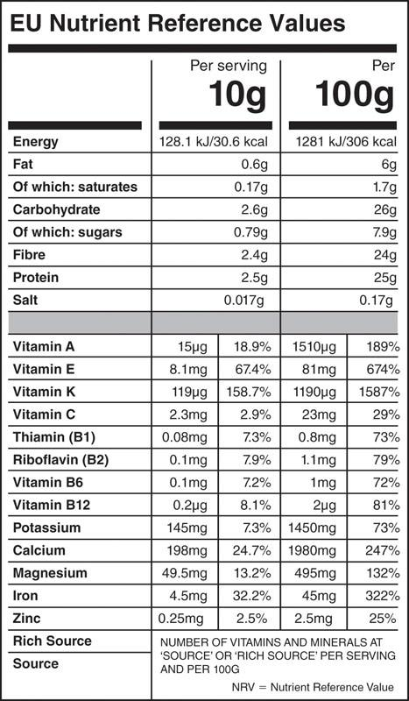

**Figure 10-3** Nutrient reference values

#### Current good manufacturing processes

Current Good Manufacturing Processes are established by the FDA in the U.S. Code of Federal Regulations Title 21 Part 111. The main purpose of this is to prevent contamination and adulteration of dietary supplement products. It provides guidelines for the personnel involved; the site of manufacture, equipment used, records maintained; and the processes used to ensure the quality and purity of the dietary supplements produced.

CRITICAL

Understand that ingredients hidden within a proprietary blend may be purposefully underdosed or dosed too high. This is not always the case, but it often means the product contains less than an optimal dose of the contents within the blend. It is generally recommended to look for dietary supplements with full disclosure or to contact the company for amounts of each ingredient.

Third-party verification

Perhaps the quickest and easiest way for the fitness professional to identify trusted supplements is to look for third-party verification on the label. Dietary supplement companies may elect to submit their products for testing by an independent party, and in return, they are permitted to use the independent party’s trademark to show that their products are trusted, quality products. However, it is important to note that third-party testing is an expense that smaller companies may not be able to afford, and therefore, the absence of independent verification does not mean that the supplement should not be trusted by that fact alone. The most common third-party entities are Informed Choice and National Sanitation Foundation (now known as NSF International).

Informed Choice caters to athletes by testing for banned substances according to the World Anti-Doping Association (WADA). To carry the Informed Choice logo, a company must have its manufacturing process audited by Informed Choice and submit a sample from every batch of product produced for banned substance testing.

NSF offers a standard certification as well as an NSF Certified for Sport certification. For standard NSF certification, a dietary supplement is tested by NSF to verify it contains exactly what is listed on the label, does not pose a health or environmental risk, and does not contain common contaminants (such as bacteria or undeclared ingredients). NSF Certified for Sport goes several steps further and includes testing for more than 270 banned substances identified by WADA, manufacturing facility auditing, and ongoing product monitoring (Table 10-3).

TABLE 10-3 Quality and Banned Substance Testing

| **Certifying Body** | **Tests for Quality** | **Tests for Banned Substances** |
| --- | --- | --- |
| Informed Choice | X | X |
| NSF | X |  |
| NSF for Sport | X | X |
| USP | X |  |
| BSCG | X | X |

United States Pharmacopeia (USP) is an organization with a verification program that evaluates the quality of dietary supplements. As part of the Verification program, USP conducts facility audits of current good manufacturing processes, a quality control and manufacturing process evaluation, and product testing, including random testing. The Banned Substance Control Group (BSCG) offers both a drug-free and a quality certification. The BSCG quality certification is comparable to the other offerings, testing for contaminants, conducting manufacturing site audits, and performing random testing to ensure supplements contain the ingredients listed. The drug-free certification tests for WADA, the National College Athletic Association (NCAA), and other major sports leagues’ banned substances as well as other pharmaceutical agents. Table 10-4 provides a list of third-party supplement testing companies.

TABLE 10-4 Third-Party Supplement Testing Companies

|  |  |  |  |
| --- | --- | --- | --- |
| U.S. Pharmacopeia (USP) | Banned Substances Control Group | Informed Choice | NSF International |

**Health supplements**

Dietary supplements can be classified into two broad categories: health supplements and performance supplements. Although performance seems to receive more attention, health supplements represent a much larger market. Among all supplement users, at least 70% are using a multivitamin, citing overall health and wellness as their reason for doing so, and this number increases to 83% for the 18- to 34-year-old age group (Council for Responsible Nutrition, 2018). Health supplements primarily include vitamins, minerals, and omega-3 supplements, because their main function is to improve well-being. In many cases, fitness clients are not competitive athletes looking to improve performance, but rather individuals looking to improve their body composition and quality of life. Therefore, the fitness professional can expect to receive questions about and be asked for their input on health supplements. In other cases, assessment of a client may suggest nutrient insufficiencies, and it may be appropriate to recommend clients seek their physicians’ opinion on adding a health supplement.

Vitamin and mineral supplements

Most of the dietary supplements currently sold are multivitamins, which contain a variety of vitamins and minerals. Individual vitamins and minerals are available as well for those who have identified specific needs. This category of dietary supplements is often used to ensure adequate vitamin and mineral intake, as micronutrient intake is typically inadequate with Western diets as well as more restrictive diets. Often overlooked, vitamins are available in both biologically active and inactive forms. In some cases, the inactive form may be converted to the active form. This is important because inactive forms are less efficient for augmenting body levels and achieving desired outcomes.

Fat-soluble vitamins

The fat-soluble vitamins are vitamins A, D, E, and K (Figure 10-4). These vitamins are stored in fat tissue instead of water, like water-soluble vitamins. Because of their solubility, they are best taken with a fat-containing meal (Dawson-Hughes et al., 2015). For this reason, fat-soluble vitamins also pose a greater risk for toxicity.



**Figure 10-4** Fat-soluble vitamins

Vitamin A is also commonly supplemented as beta-carotene, and as a fat-soluble vitamin, toxicity is a potential result of excessive supplementation

Side effects include dizziness, headache, reduced bone density, coma, congenital birth defects, and even death (Institute of Medicine, 2001). Vitamin D may be referred to as the “sunshine” vitamin because it can be naturally produced in the skin when exposed to ultraviolet light. In animals, vitamin D is produced from cholesterol following activation by sunlight.

Vitamin D plays a critical role, along with calcium, in bone health. Despite the increased interest in the health benefits of vitamin D, the medical community has yet to agree on recommended blood levels of vitamin D. Because vitamin D levels are influenced so heavily by diet and lifestyle, broad nutritional intake recommendations are difficult to prescribe accurately. Vitamin D deficiency is common in many countries, including the United States where up to 39% of the population is labelled as deficient, Europe with a 40% deficiency rate, 60% in the Middle East, 30% in Asia, and 60% in Australia (Edwards et al., 2014; Liu et al., 2018). People with vitamin D deficiency often include those with lactose intolerance, dairy allergies, irritable bowel syndrome, and other conditions causing malabsorption, as well as individuals with dark skin, those living in northern latitudes, vegetarians, and vegans (Institute of Medicine, 2011). Inadequate vitamin D status may produce rickets, weak bones, increased risk of bone fracture, and osteoporosis.

Reaching intake levels that may produce toxicity effects is likely only possible through supplementation. Excess vitamin D can cause weight loss, excessive urination, and heart arrhythmias. When supplemented with calcium, there is also an increased risk for kidney stones as well as vascular and tissue calcification (Institute of Medicine, 2011).

STRETCH YOUR KNOWLEDGE

Vitamin D levels are measured in the body as 25-hydroxy-vitamin D, which in most people is between 20 and 40 ng/mL (nanograms per milliliter). While the National Academy of Medicine considers 20 ng/mL adequate for good bone health, the Endocrine Society recommends 30 ng/mL as the minimum for good bone health and that optimal levels may be between 40 and 60 ng/mL. Per the Endocrine Society, daily vitamin D intake should be 1,500–2,000 international units (IU) per day (38–50 mcg). The tolerable upper limit is 4,000 IU per day.

Vitamin E is best known for being an antioxidant and may reduce inflammation, platelet aggregation, risk of heart disease and cancer, and immunodeficiency (Institute of Medicine, 2000). Vitamin E deficiency is rare even in those with low vitamin E intake and occurs mostly in those with other digestive diseases as a result of malabsorption. Vitamin E deficiency symptoms include peripheral neuropathy, skeletal myopathy, and compromised immune function. There have been no adverse health effects observed by consuming vitamin E from food. However, supplementing vitamin E in high doses has been observed to cause excessive bleeding (Traber, 2008).

Vitamin K is often suggested to be supplemented with vitamin D and calcium for bone health. In general, vitamin D helps deposit calcium in bones, and vitamin K helps increase bone protein content and improve strength, which also decreases risk of fracture (Bolton-Smith et al., 2007; Lanham-New, 2008). Perhaps of greater importance, vitamin K may help direct calcium deposition to bones instead of the vasculature, potentially decreasing the risk of coronary heart disease (Shea et al., 2009).

Vitamin K deficiencies are very rare and tend to only occur in infants or those with malabsorption disorders. Low vitamin K status only becomes clinically relevant when it is low enough to reduce blood clotting times and leads to excessive bleeding. Vitamin K is not known to produce toxicities, but it does have negative interactions with warfarin and other anticoagulant drugs, which can cause dangerous excessive bleeding.

Water-soluble vitamins

The water-soluble vitamins are vitamin C and the B complex vitamins (Figure 10-5). They dissolve more easily and can be readily absorbed by the body, but they are not stored and must be consumed more regularly to maintain consistent levels. The water-soluble vitamins are mostly present in dietary supplements in their bioactive form.



**Figure 10-5** Water-soluble vitamins

CRITICAL

Compared to the fat-soluble vitamins, water-soluble vitamins are more transient, which means they are less likely to produce a vitamin toxicity, and it is easier to treat acute deficiencies.

The active form of vitamin C is L-ascorbic acid. Vitamin C is required for collagen synthesis, protein metabolism, and the regeneration of glutathione, the body’s primary antioxidant. There is also some evidence to suggest that vitamin C may have effects on immune function. For example, increasing the vitamin C intake in athletes has shown about a 50% reduction in the incidence of common colds as well as shorter duration and reduced severity (Constantini et al., 2011; Peters et al., 1993; Van Straten & Josling, 2002).

While high-dose vitamin C supplementation has become fairly common, the body is proficient at regulating vitamin C absorption. At normal doses of vitamin C near the recommended DV, most is absorbed.

STRETCH YOUR KNOWLEDGE

One of vitamin C’s primary, yet lesser known, roles is in collagen formation. With collagen supplement popularity on the rise, it is interesting to note that vitamin C supplementation can also enhance rates of collagen synthesis (DePhillipo et al., 2018).

However, when the dose exceeds 1 g, absorption is reduced to less than 50%, and the remaining vitamin C is voided in the urine. Even at 200 times the recommended DV, it is estimated that body levels would only increase to approximately 4 times normal levels (Padayatty et al., 2004). Therefore, toxicity from vitamin C is unlikely, though gastrointestinal distress from high doses is possible.

True vitamin C deficiency is very rare, yet acute deficiency manifests as scurvy. The symptoms are typically mild, but if left untreated, they can be fatal. Initial symptoms of scurvy are fatigue and inflammation of the gums. This may progress to joint, bone, and capillary weakness and slow wound healing.

HELPFUL HINT

To remember the most common deficiency symptom of vitamin C, think of this joke:

Where do sailors get scurvy? They get it at sea.

The B-complex vitamins are vitamin B1 (thiamine), B2 (riboflavin), B3 (niacin), B5 (pantothenic acid), B6 (pyridoxine), B7 (biotin; also known as vitamin H), B9 (folate), and B12 (cobalamin).

The B-vitamin complex is involved in a little bit of everything. Principally, these vitamins are involved in macronutrient metabolism. A few have important functions worth discussing. Biotin is often supplemented for hair, skin, and nail health; folate is involved in gene expression and is very important as a prenatal vitamin; and B12 is vital for red blood cell production.

Toxicity resulting from excessive B vitamin intake is rare, and it is not known to occur with most B vitamins; however, toxicity is possible for niacin, vitamin B6, and folate. The side effects of excess niacin are mild and include flushing and nausea. Vitamin B6 toxicity is difficult to achieve, but the effects can be serious, producing progressive sensory neuropathy (numbness or tingling of hands and feet), ataxia (impaired coordination due to damaged nerves), sensitivity to light, and skin lesions (abnormal skin growth or appearance) (Simpson et al., 2010). One concern surrounding excess folate is that it can cover up a B12 deficiency, which often occurs simultaneously with folate deficiency. Supplementing folate to correct folate deficiencies without B12 may allow the deficiency symptoms of B12 to continue. While folate is a very important prenatal vitamin, mothers who consume more than 1,000 mcg per day while pregnant have seen their children experience slower cognitive development. About 400–600 mcg or 600–800 mcg of DFE are found in multivitamins and prenatal vitamins, respectively. One DFE is equal to 1 mcg of folate or 0.6 mcg of folic acid, which makes folic acid—a common form of folate for supplementation—more potent than folate.

Except for pantothenic acid and biotin, one can be deficient in all B vitamins. Thiamine deficiency is most notable for producing beriberi, a condition that results in peripheral neuropathy and impaired motor function that is quickly reversed with thiamine treatment.

Riboflavin deficiency is uncommon except in athletes and pregnant mothers who are also vegetarian or vegan, both of whom have increased need coupled with the potential for inadequate consumption. Deficiency symptoms often show as endocrine (hormone) disruptions, which could also cause excess weight retention.

Niacin deficiency is no longer common in developed countries, but it may occur due to an inborn metabolism error. Deficiency presents as pellagra, a disease first characterized by a skin rash, leading to digestive and mood disorders, anorexia, and death if left untreated.

Vitamin B6 deficiency is also uncommon. It tends to only occur in developed countries if there is another disease, such as kidney disease or alcoholism. If it does occur, B6 deficiency produces anemia, dermatitis, and immune disruption.

Folate deficiency can also cause anemia, but it is primarily associated with neural tube defects in newborns, such as spina bifida. Therefore, folate is one of the primary prenatal vitamins.

Finally, B12 deficiency, too, can result in anemia and may also produce fatigue, and neurological disruptions like numbness, confusion, and poor memory—the neurological symptoms present prior to detectable anemia. B12 deficiency is more common in vegetarians and older adults who have decreased intake and ability to absorb B12, respectively. Because fortified grain products are the only plant-based foods that are a good source of B12, those avoiding animal products are advised to include a B12 supplement.

Choline

Choline was once considered a B vitamin and later removed from that classification; it is now considered vitamin-like. Until 2018, the FDA did not allow companies to list choline on a nutrition facts label, but with the Food Safety and Modernization Act, a DV was set for choline at 550 mg per day, reflecting the National Academy of Medicine’s adequate intake level. Despite being overlooked, choline is a known essential nutrient for liver, neurological, and cardiovascular health.

Most Americans do not achieve adequate intake of choline. Men average a daily intake of 402 mg and women 278 mg. In fact, 90% of individuals have insufficient choline intake (Wallace & Fulgoni, 2016). Interestingly, that number is reduced to just 43% when individuals consume eggs, and egg consumers have an average intake of 525 mg daily versus 294 mg in non-consumers (Wallace & Fulgoni, 2017). The United Kingdom, Canada, China, France, Greece, Italy, and Mexico have similar intakes of 263–407 mg (Wiedeman et al., 2018).

Choline deficiency may cause muscle or liver damage, but this severity is uncommon despite observed inadequate intake. While choline deficiency may cause liver problems, excessive choline intake can cause liver toxicity as well as more mild symptoms, such as vomiting, body odour, and hypotension (low blood pressure) (Institute of Medicine, 1998).

Minerals

There are 16 essential minerals of which 14 are required on nutrition facts labels and on supplement facts if claims are made about that ingredient: calcium, iron, phosphorus, iodine, magnesium, zinc, selenium, copper, manganese, chromium, molybdenum, chloride, sodium, and potassium. The two remaining minerals are sulphur and fluoride, which are unlikely to appear on a supplement facts label. Minerals may be divided into macrominerals and trace minerals.

Macrominerals

The macrominerals are calcium, magnesium, sodium, potassium, phosphorus, chloride, and sulphur (Figure 10-6). The nomenclature is used to describe the relative quantities that are required for these minerals, which are much larger than the trace minerals. Despite being needed in large quantities, most are not typically used as supplements unless included as a small percentage of a multivitamin or, in the case of sodium and chloride, as salt.



**Figure 10-6** Macrominerals

Calcium is best known for its role in bone health. Like most mineral supplements, calcium mineral supplements come in many forms. Calcium carbonate, citrate, and phosphate are all suitable for increasing calcium levels. Calcium citrate is the most easily absorbed, but calcium carbonate has nearly double the amount of calcium per milligram of supplement, making both comparable in performance when supplemented (Harvey et al., 1990). Calcium phosphate is easily absorbed and has comparable proportions of calcium to the carbonate form, but it is often more expensive (Shires & Kessler, 1990).

STRETCH YOUR KNOWLEDGE

Calcium plays a key role in muscle contraction. At the microlevel, calcium occupies binding sites between muscle filaments. When a muscle needs to contract, calcium moves off the binding site, allowing the filaments to connect and the muscle to contract.

Those at risk of calcium deficiency include women, particularly postmenopausal, amenorrhoeic, and physically active women for their elevated risk of osteopenia and osteoporosis, and vegetarians. Lacto-ovo vegetarians have comparable calcium levels to nonvegetarians, but strict vegetarians, ovo-vegetarians, and vegans are at greater risk of insufficient calcium intake due to reduced intake as well as the *antinutrients* present in plants, which reduce calcium absorption. These groups of individuals may find benefits from supplementing calcium, but calcium also has a risk of toxicity. Hypercalcemia typically does not occur without a pre-existing thyroid disorder, though the potential exists for soft tissue calcification, constipation, and kidney stones.

STRETCH YOUR KNOWLEDGE

Antinutrients are common components of many plants. Antinutrients decrease absorption of other important nutrients, such as calcium and iron. The most common antinutrients are phytic acid, oxalic acid, and enzyme inhibitors. For example, legumes (beans, peas, and lentils) have protein-enzyme inhibitors. This contributes to incomplete digestion and eventual fermentation in the large intestine, which releases gasses into the gastrointestinal tract. Soaking beans and other plants can help reduce the antinutrient content.

In addition to providing magnesium, magnesium supplements are used to promote physical relaxation, including reduced muscle tension and vascular tension (blood pressure) (Hatzistavri et al., 2009) and improved aerobic exercise capacity (Golf et al., 1998).

True magnesium deficiency is uncommon because the kidneys naturally limit magnesium excretion as body levels become reduced. Still, magnesium deficiency is the second most common micronutrient deficiency in developed countries—about 50% in the United States (DiNicolantonio et al., 2018). When magnesium levels are low, muscle cramps and involuntary contractions may occur (Garrison et al., 2012), thus magnesium may prevent or reduce muscle cramping. Other deficiency symptoms include fatigue, vomiting, increased blood pressure, loss of appetite, numbness, and tingling.

As the kidneys regulate magnesium in the body, magnesium toxicity is unlikely, even though large doses of magnesium have been associated with diarrhea and nausea. Caution is given, however, to those with compromised kidney functions, because they might experience more severe effects from magnesium use, such as muscle weakness, irregular heartbeat, and cardiac arrest (Musso, 2009).

Sodium, potassium, and chloride are not typically supplemented for health purposes, although potassium may sometimes be supplemented to make up for insufficient intake. Endurance and team sport athletes most often supplement these electrolytes to replace the electrolytes lost in sweat as either sodium chloride (table salt) and potassium chloride. The adequate amount to ingest depends on the athlete’s sweat rate and how salty their sweat is.

STRETCH YOUR KNOWLEDGE

People with saltier sweat can be visually identified by allowing sweat to dry on dark clothes before washing. Salty sweat on clothes will form a white ring around the edge of the sweat when dry. The white ring is sodium.

Trace minerals

The trace minerals are iron, manganese, iodine, zinc, copper, selenium, cobalt, chromium, molybdenum, and fluoride (Figure 10-7). Of these, iron, zinc, iodine, and chromium are the most likely to be found in supplements (DVs provided in Table 10-1).

Iron is found in food as heme and nonheme iron. Only about 10% of nonheme iron is absorbed compared to about 25% of heme iron (Monsen, 1988). Because heme iron is only found in animal flesh—and even then, only comprises about half of the iron in the food—most of the body’s iron comes from nonheme sources for those consuming a mixed diet.



**Figure 10-7** Trace minerals

Absorption is tightly regulated, and the body is good at absorbing more iron when it is needed and absorbing less when it needs less. Most of the body’s iron is found in oxygen-carrying haemoglobin on red blood cells.

Vegetarians and vegans are more likely to have insufficient iron intake and have increased risk for anaemia (Pawlak et al., 2018), but these risks can be mitigated by either supplementing with iron or consuming iron-rich foods, such as beans, lentils, tofu, and certain nuts and seeds. Furthermore, premenopausal women have increased iron needs, particularly during pregnancy and lactation. Athletes also have greater iron needs, as impact—including such as when the foot strikes the ground (foot strike haemolysis)—can disrupt the red blood cell’s integrity and cause iron loss during red blood cell turnover. Men are less likely to experience iron insufficiency due to reduced relative needs and greater red meat consumption. Nonetheless, iron deficiency is one of the more common nutrient deficiencies in developed countries—10–20% of women have iron deficiency anaemia compared to 2% of men (Killip et al., 2007).

Iron toxicity is rare, because excess iron mostly goes unabsorbed. Large amounts of ingested iron can cause gastric distress, particularly when taken on an empty stomach. In extremely large doses, iron can cause serious organ failure, coma, and death. Iron supplementation in those with hemochromatosis is also potentially fatal. An emerging area of research is focusing on iron-induced increases in free radicals and oxidative stress as a potential cause of the correlation between red meat intake and disease (Czerwonka & Tokarz, 2017).

Iodine is used to form thyroid hormones. Iodine has been added to salt since 1924 to prevent iodine deficiency and the resulting enlarged thyroids (goiters). This is a manner of iodine supplementation, as food sources that do not come from the sea are relatively poor sources of iodine (except for dairy and eggs). Iodine is mostly found in nature in the same form as it is present in iodized salt: potassium iodine or sodium iodide. Kelp, for example, is a seaweed with high concentrations of iodine.

Iodine deficiency is uncommon in the United States and most developed countries, but it is still present in landlocked regions with iodine-deficient soil—areas containing about 2.2 billion people (Peterson, 2000). Iodine deficiency is considered the most common cause of preventable serious cognitive disability. It may reduce cognitive ability and increase the risk for attention deficit disorder. For these reasons, women who are pregnant or nursing are an important demographic to consider iodine intake.

Excess iodine intake can still cause goiter and hypothyroidism (an underactive thyroid gland), but it is not known to cause cognitive disability. Iodine taken in doses near 100 times the upper limit can cause toxicity with symptoms of nausea, vomiting, fever, weak pulse, and coma (Institute of Medicine, 2001).

Zinc catalyses many varied reactions. Zinc deficiency symptoms include slow growth, loss of appetite, hair loss, compromised immune function, and reproductive disorders. Zinc deficiency is rare, but those who are vegetarian or vegan and women who are pregnant are more likely to have insufficient zinc intake. Excess zinc consumption has mild side effects of gastric upset and headaches. Chronically, zinc toxicity can reduce immune function, cause poor blood lipid profiles, and disrupt the absorption of other minerals (Institute of Medicine, 2001).

Chromium is involved in macronutrient metabolism, and it may influence glucose tolerance, thus it has become a popular dietary supplement. Chromium supplementation, however, has only been able to help reduce blood glucose levels in those with poor chromium status and/or poor glucose control. It is likely ineffective in healthy persons with adequate chromium intake. Poor glucose tolerance is the only known symptom of chromium deficiency, and toxicity is not likely (National Academy of Medicine, 2001).

STRETCH YOUR KNOWLEDGE

The proper use of dietary supplements, particularly multivitamin and mineral formulas, has been shown to help fill common and widespread nutrient gaps (Bailey et al., 2012; Blumberg et al., 2017). Blumberg et al. (2017) analyzed the intake of 17 nutrients in nearly 11,000 adults in the United States from either food alone or food and a multivitamin and mineral supplement. Higher frequency of use eliminated inadequate intakes of all the vitamins and minerals examined, with the exception of vitamins D and E, calcium, and magnesium. Moreover, 16 out of 17 nutrient intakes were significantly improved when using the multivitamin supplement. Hence, the use of a daily multivitamin and mineral supplement to avoid common insufficiencies and meet recommended intakes based on age, gender, and life stage appears to be an effective nutritional strategy. Achieving daily requirements for minerals, such as calcium, magnesium, iron, and other essential nutrients, such as vitamin D and the omega-3 fatty acids DHA and EPA, may require separate supplementation. Although dietary supplements do not replace a healthful diet, they can help achieve recommended intakes of essential nutrients, which may play a supportive and critical role in healthy aging.

Omega-3 supplements

Omega-3 fats are one of the more thoroughly researched dietary supplements available. Often supplemented as fish oil, omega-3 supplements may be important for the prevention of cardiovascular disease, reduction of inflammatory status, and neurological development. They are the third most frequently used dietary supplement, and fitness professionals can anticipate discussing them with clients (Grand View Research, 2019).

TABLE 10-5 Omega-3 Fatty Acids

| **Omega-3 Fatty Acids** | **Sources** |
| --- | --- |
| Eicosapentaenoic acid (EPA) | Fatty fish: herring, mackerel, salmon, sardines, cod liver |
| Docosahexaenoic acid (DHA) | Fatty fish: herring, mackerel, salmon, sardines, cod liver |
| Alpha-linolenic acid (ALA) | Plants: chia seeds, walnuts, flaxseed, and their oils |

Ingesting at least 250 mg of fish oil is required to begin having positive health outcomes, such as the reduction of coronary heart disease, but fish oil may be more optimally dosed between 1 and 4 g per day (de Lorgeril et al., 1994; Harris, 1997; Mozaffarian, 2008). The ideal dose may be greater depending on the omega-6 content of the individual’s diet, as the benefits of fish oil may be due to the omega-6 to omega-3 ratio. Omega-3s are characterized as being anti-inflammatory and omega-6s proinflammatory. Therefore, if one’s diet contains a lot of omega-6 fatty acids, more omega-3 may be necessary to balance inflammation (Simopoulos, 2008). In addition to the omega-3 to omega-6 ratio, the EPA to DHA ratio is also of relevance, and while the precise ideal ratio is unknown, a 2:1 ratio of EPA to DHA is supported (Shang et al., 2017).

Many of the health benefits of fish oil concern cardiovascular disease. Fish oil is effective for reducing triglycerides (Wei & Jacobson, 2011). Fish oil may also improve other risk factors of cardiovascular disease, such as raising high-density lipoprotein (HDL) cholesterol levels and reducing inflammation (Dangardt et al., 2010; Zulyniak et al., 2013). Recall that high-density lipoprotein cholesterol is sometimes referred to as “good” cholesterol because it removes excess cholesterol from the bloodstream and transports it back to the liver. Beyond cardiovascular health, fish oil may reduce depression and symptoms of lupus (Sarris et al., 2012; Wright et al., 2008). DHA, in particular, has known benefits on brain health and protection from an absence of oxygen in body tissues (hypoxia) (Mayurasakorn et al., 2011). A study on National Collegiate Athletic Association division 1 football players supplementing with escalating doses of DHA were observed to have better protection from brain trauma, with 2 g per day appearing to be the optimal dose (Oliver et al., 2016). These effects likely extend to all athletes with a predisposed risk of head trauma. An upper limit for omega-3 has not been established, but excess bleeding has been noted with doses of 2–15 g of combined EPA and DHA (Institute of Medicine, 2005).

**Ergogenic aids**

Clients will want to know how to reach their goals as fast as possible, thus they will likely ask if an ergogenic aid will help them toward that end. Many supplements claim to improve fat loss, strength, or muscle gain, but few are rigorously substantiated. The fitness professional should be able to guide clients toward safe supplements that may yield results consistent with their goals and away from unsafe or counterproductive supplements. The fitness professional should also be prudent in recommending ergogenic aids, as clients may perceive they can use supplements as a substitute for an appropriate diet and exercise plan. For example, clients may believe they can eat extra dessert because they are taking a new fat burner, which may negate or reverse progress. Caution must also be practiced when recommending supplements, as there is a liability in doing so, and the risk is more notable with some ergogenic aids than with health supplements.

Ergogenic aids are the type of dietary supplement people think of when they think of sports supplements. The word *ergogenic* is derived of two parts: *Ergo* meaning “work,” and *genic* meaning “to produce.” From the physical perspective, increasing the body’s ability to produce work is the underlying purpose of using a supplement for performance enhancement—the athlete desires to improve some aspect of their ability to exert force, perform longer, or recover faster.

While there is a myriad of ergogenic aids available, a few have more substantiated effects than others. Any supplements left unmentioned in this chapter does not mean they are ineffective; they are simply beyond the scope of this text. The most widely supported ergogenic aids are protein and amino acids, creatine, and caffeine.

Protein

All proteins are composed of amino acids. For human nutrition, there are 20 relevant amino acids; 11 are nonessential amino acids, and nine are essential amino acids (EAAs), and of those nine, three are the branched chain amino acids (BCAAs)—leucine, isoleucine, and valine (Table 10-6). Protein and amino acids are principally used to augment muscle size and recovery by increasing rates of muscle protein synthesis (MPS).

There are two primary factors to consider for MPS to occur. First, the correct conditions and signals must be present. Second, the material must be available to assemble muscle proteins. There are a few signals that influence MPS, but the most important dietary factor is a single amino acid: leucine.

TABLE 10-6 Amino Acids

| **Essential** | **Nonessential** | **Conditionally Essential** |
| --- | --- | --- |
| Leucine^ | Alanine | Histidine |
| Isoleucine^ | Arginine* | Arginine |
| Valine^ | Aspartic acid | Glutamine |
| Methionine | Asparagine |  |
| Phenylalanine | Cysteine |  |
| Threonine | Glutamic acid |  |
| Tryptophan | Glutamine* |  |
| Lysine | Glycine |  |
| Histidine* | Proline |  |
|  | Serine |  |
|  | Tyrosine |  |

^Branched chain amino acid

*The amino acid may become conditionally essential under certain circumstances.

When comparing rates of MPS in response to whole protein, EAA, nonessential amino acids, BCAA, and the individual BCAAs, only the treatments containing leucine (protein, EAA, BCAA, and leucine alone) are capable of significantly increasing MPS (Garlick, 2005).

GETTING TECHNICAL

Although leucine increases MPS signaling, proteins cannot be formed if the requisite amino acids and energy (calories/ATP) are not available.

More recently, there has been controversy that leucine and the BCAAs do not work, which is only true if extending the phrase to include that they “don’t work in isolation.” They increase MPS as long as the other material is available to form the proteins. In the absence of other EAA and energy, BCAA supplementation may be insufficient for MPS.

The absolute quantity of leucine required to maximally increase MPS likely increases with body size. Some indications suggest doses of 0.05 g leucine per kg body weight per meal to ensure maximal MPS (Norton & Wilson, 2009), and that signal lasts for about 3 hours (Wilson et al., 2011).

As animal proteins have more leucine, they are considered better than plant proteins for muscle growth. Diets consumed for 76 days with protein coming from wheat (6.8% leucine), soy (8%), egg (9%), or whey (11%) demonstrated rates of muscle enlargement and body fat reduction in relation to the leucine content of the protein. Specifically, muscle growth and fat loss were greatest with whey, followed by egg, then soy, and finally wheat (Norton et al., 2010).

Therefore, if the goal is maximizing muscle growth (or recovery), consuming meals with adequate, high-quality proteins (or BCAA/EAA) every 3 to 4 hours may be the best approach. For clients, first focusing on the total protein amount is appropriate, followed by protein quality, then protein timing (when to consume).

Although the types of protein consumed are a significant factor, the most important consideration for clients is their total daily protein intake. Inactive individuals need less protein than active persons and athletes. Because more intense exercise causes more muscle damage, these individuals require more protein to facilitate recovery. Clients who were previously inactive and are now becoming active will have increased protein needs. In some cases, this is a large change to their lifestyle, and the client may find it difficult.

Because this quantity of protein may be more difficult to obtain through diet alone, many choose to include a protein shake. This is often the easiest way to help clients obtain more protein in their diet because it is simple and easy to implement. Protein powders are available as protein concentrates (80% protein) or isolates (90% protein). The remaining 10–20% is composed of moisture, calcium, ash, carbohydrate (lactose), and fat. Unless the individual has a strong need to tightly control carbohydrate and fat intake, a protein concentrate is the most cost-effective strategy to increase protein without increasing intake of other macronutrients. Alternatively, EAA may be supplemented in place of protein for a comparable increase in MPS for those clients needing fewer calories, with aversions to allergens, and who adhere to a special diet, and for a reduced potential for gastric distress (Wilkinson et al., 2018).

While protein shakes are often thought of as essential for postexercise recovery, the postexercise timeframe is actually larger than most realize. With the understanding that there is no reason *not* to consume protein shortly after exercise, also consider that a meta-analysis of 20 studies for muscle growth and 23 for muscle strength found no statistically significant effect of postworkout protein consumption when total daily protein intake is equal (Schoenfeld et al., 2013). Consuming protein following an exercise session is still an opportunity to contribute to total daily protein intake. Also, on the topic of timing, consumption of leucine-enriched EAA supplements during exercise may help jumpstart postexercise recovery and assist in reducing muscle catabolism (Pasiakos et al., 2011). EAA supplements typically contain disproportionately high quantities of leucine versus other EAAs—usually several grams, among 6–10 g of total EAA.

The fitness professional can appropriately guide clients toward sufficient protein intake that aligns with their fitness goals. While protein is often thought of as a muscle-building supplement, it is more of a recovery supplement (and an essential component of a client’s diet) that builds muscle when the client is consuming adequate calories and performing resistance training. Fitness professionals help their clients by translating their protein needs into portion sizes that correspond with their number of meals. For example, an 80 kg (176 lb) client requiring 120 g of protein per day and eating three meals per day can be recommended to consume 40 g per meal (equivalent to 5–6 oz of lean meat per meal). If that same client reports having trouble with that pattern, it may be best for their compliance to view a protein shake as a fourth meal and recommend four meals of 30 g each. In this scenario, the client can consume three meals of 4–5 oz of lean meat and then one protein shake after training, in the morning for breakfast, or after dinner for dessert. Individuals who do not consume meat can follow a similar plan but substitute their meals with soy and other plant-protein foods, though the exact quantities are more variable.

**Creatine supplementation**

Many clients’ fitness goals centre on building muscle size or strength. Protein and amino acids may certainly help facilitate this goal, and creatine is another supplement with substantial evidence for adding mass, strength, and fatigue resistance. Creatine supplementation is a simple way for individuals to maximize their training potential.

For those clients who are willing to push their physical limits, creatine helps them perform additional repetitions, increasing their training volume and, therefore, their stimulus for adaptation.

Creatine is a naturally produced (approximately 1 g/day) compound made from three amino acids: methionine, arginine, and glycine. It is produced by the liver and kidneys, but it is primarily stored in skeletal muscle where it is able to exert its primary function. Creatine works like a backup to ATP; it carries extra phosphagen, as creatine phosphate, which it uses to rephosphorylate ADP to ATP, allowing muscle fibres to continue strong contractions during approximately the first 15 seconds of exercise (Figure 10-8). After beginning to use creatine, clients may notice these effects manifest as greater exercise tolerance; for example, they are able to perform more repetitions at the same weight for a given exercise.

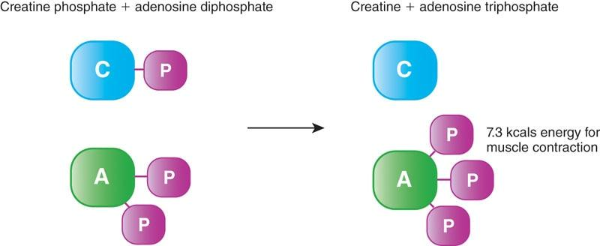

**Figure 10-8** ATP-PC system

By far, the most substantiated form of creatine is creatine monohydrate, with more than 500 investigations on the compound. There are about a dozen forms of creatine supplements available, yet none have ever demonstrated superiority to creatine monohydrate (Jager et al., 2011). The most important factor to consider with creatine supplementation is dose, as this is often the most controversial point and an area containing misinformation.

Research on creatine supports use of 5 g per day, but those with greater-than-average muscle mass may require more—up to 10 g per day. Creatine does not need to be loaded, but it will begin working sooner if it is loaded, because it will take less time for muscles to become fully saturated (Kreider et al., 2017). A common loading strategy is to supplement with 20 g of creatine per day for 5 to 7 days, followed by a maintenance dose of 5 g. Creatine does not need to be cycled (Rawson et al., 2004). It was once believed that chronic creatine supplementation would compromise endogenous production, but that has since been disproven (Kreider et al., 2017).

Creatine may be supplemented by those who want to gain muscle or weight in general, strength, power output, and tolerance for bouts of acute high-intensity exercise (Branch, 2003; Law et al., 2009; Rawson & Volek, 2003). While endurance athletes are often reluctant to use creatine for fear of weight gain, creatine supplementation has been shown to be effective for improving oxygen consumption and glycogen resynthesis with minor effects on endurance (Ayoama et al., 2003; Graef et al., 2009; van Loon et al., 2004). Those wishing to experience some benefits of creatine without significant weight gain may supplement with 2–3 g per day (specifically, 0.03 g/kg body weight) instead of 5 g (Rawson et al., 2011). It is important to highlight that the immediate weight gained from creatine can be attributed to water weight. Creatine does not rapidly cause weight gain in any other body tissue compartment, despite beneficial effects on muscle tissue over time.

A new area of creatine research is in the prevention of brain injury. While most creatine is stored in skeletal muscle, some creatine is stored in the brain, and supplementation with creatine increases brain stores as well.

During ischemic brain injury, some brain damage occurs as a result of insufficient energy, as ATP is required to keep the cells alive. Early studies in this area show that increasing creatine in brain cells reduces brain damage caused by ischemia (inadequate blood supply) (Adcock et al., 2002). However, the application of creatine in this area is beyond the scope of a fitness professional. Creatine is sometimes purported to contribute to muscle cramps and kidney damage. Creatinine is a by-product of ATP metabolism, and it is excreted by the kidneys. When blood or urine levels are high, it is assumed that the kidneys are not performing their duty of excretion. However, levels of creatinine are also correlated with muscle mass, animal protein consumption, activity, and creatine supplementation. These are idiopathic causes of increased creatinine levels that may trigger a false positive on a blood test and often cause the confusion that creatine causes kidney damage. No studies in healthy individuals have found increased kidney stress from creatine supplementation, and for those with kidney issues, doses of up to 3 g per day have been observed as safe for short-term supplementation (long-term studies are lacking) (Kreider et al., 2017). Creatine has also been reported to cause cramping, but the evidence supports either no effect or a reduced incidence of muscle cramps with creatine supplementation (Greenwood et al., 2003).

The fitness professional may use this information to educate their clients on appropriate creatine use. Clients wishing to supplement creatine should be advised that creatine monohydrate is the best creatine, they may load creatine (but it is not required), and they need not cycle creatine. Those wishing to experience some of the benefits of creatine while avoiding significant weight gain can be advised to consume half of the usual dose.

**Stimulants (caffeine)**

Caffeine is present in many products, such as coffee, tea, energy drinks, preworkout supplements, energy shots, and gum. Of all the dietary supplements discussed in this chapter, caffeine is the one most likely already being used by clients. Most will use it to combat tiredness and maintain their expected levels of daily functioning. For some, that may mean using caffeine as part of their exercise routine.

Caffeine is the world’s most popular supplement (Mitchell et al., 2014). There are a lot of stimulants available, but coffee and tea remain the most widely used delivery vehicles for caffeine. On average, a single person consumes 236 cups of tea and 132 cups of coffee per year (Infiniti Research Limited, 2018). Stimulants, including caffeine, increase physiological and metabolic activity. Caffeine is primarily used for energy and endurance and to increase metabolic rate.

Caffeine increases wakefulness, attention, and focus by chemically blocking receptors that create the sense of feeling tired. However, it also causes an adrenaline release, which increases metabolic rate and subsequently leads to more energy (ATP) being metabolized. The adrenaline release is also responsible for improving pain tolerance and mobilizing body fat stores.

It is hypothesized that the ergogenic effects of caffeine can be attributed to its improvement in pain tolerance rather than its mobilization of fatty acids (Astrup et al., 1990). Regardless of mechanism, caffeine is well supported for improving endurance performance, with some of the more favourable observations reporting improvements of 5–9% (Paton et al., 2010; Schneiker et al., 2006). Due to increasing metabolic rate, fatty acid mobilization, and satiety, caffeine is potentially beneficial for weight loss (Astrup et al., 1990; Tremblay et al., 1988). However, this may only be the case when caffeine is combined with other ingredients, such as green tea polyphenols or ephedra, as individuals become tolerant of caffeine (Astrup et al., 1992; Tabrizi et al., 2019; Westerterp-Plantenga et al., 2005). Caffeine is not well supported for improving strength performance (Goldstein et al., 2010).

Caffeine in dietary supplements is often found as caffeine anhydrous, which is nearly 100% caffeine. There may also be caffeine citrate, dicaffeine malate, or caffeine pterostilbene. These forms may offer a slower release of caffeine, reducing “crashing” after a few hours, but they contain less caffeine due to their chemical pairing and are often more expensive.

Optimal caffeine dosing is 3–6 mg/kg (1.4–2.7 mg/lb) body weight provided about 1 hour prior to exercise (Goldstein et al., 2010). Doses greater than 6 mg/kg (2.7 mg/lb) increase the potential for an adverse and impairing effect. About 85–90% of individuals respond favourably to caffeine supplementation (Pickering & Kiely, 2018).

Caffeine use is common, and in regard to fitness, it is commonly used as a preworkout supplement or fat-burning supplement. Fitness professionals should use caution when discussing stimulants, including caffeine, to clients, and they should never recommend a stimulant if their client is using any medication or has a medical condition. Always refer clients fitting this description to their physician for their recommendation on caffeine or other stimulants. Healthy clients may still engage in caffeine use if they find it beneficial for their exercise performance, energy levels, or body composition improvements. Although caffeine may release stored body fat and increase metabolic rate, Certified Personal Trainers assume some risk if they choose to recommend caffeine to their clients. Caffeine alone may not make much of an impact for fat loss unless paired with green tea or ephedra, which is a banned substance and cannot be recommended under any circumstances. Caffeine may have unwanted side effects in doses greater than 400 mg, or less in caffeine-naïve individuals and those with a predisposition to adverse effects of caffeine, and it becomes lethal near 10 g. Common side effects include restlessness, insomnia, increased heart rate (at rest), nervousness, anxiety, and gastrointestinal distress.

**Ethical and legal Issues with ergogenic aids**

With the abundance of dietary supplements available, and their route to market being left mostly unchecked until something goes wrong, there are several concerns with using ergogenic aids that the fitness professional should know and understand before educating clients on their use. The first concern is whether the supplement will work at all, which can be determined by looking for studies from reputable resources, such as PubMed or Google Scholar, or position papers from the Academy of Nutrition and Dietetics, National Athletic Trainers Association, International Society of Sports Nutrition, and other reputable organizations.

If the product is then considered worth using, the second concern is whether it is legal and safe to use. In certain situations, there is also the question of ethics, which may be regulated by organizations such as the NCAA or WADA. While supplements are often considered legal, they are not always permitted in sport due to the rules of the sports federation. The NCAA currently reserves the right to ban any substance, and WADA publishes annually a list of banned substances, which is available on its website. The NCAA or WADA may ban certain supplements because they consider that the supplements may offer an uncompetitive advantage, mask the use of other drugs, or pose a health risk. These agencies may ban a supplement during certain times of the competitive year or prohibit institutionalized provision of supplements only. Therefore, not all supplements banned by the NCAA or WADA are pertinent to the everyday client.

TRY THIS

Next time you would like to know something about a dietary supplement, look up what you would like to know in Google Scholar or PubMed. Begin with a narrative review or meta-analysis if you are unfamiliar with the topic, as these will sum up many studies at once and may offer indications of the quality of the research reviewed. For dietary supplement research, a good quality study will feature a placebo-controlled group, diet and exercise monitoring or standardization, a human population sample similar to the user group (those who may want to use the supplement), and a research-supported dose of the supplement and will not be confounded by multiple ingredients.

There is also the possibility of contamination, which is why athletes and exercisers may want to only use dietary supplements with third-party verification (Informed Choice or NSF). As much as 25% of dietary supplements may be adulterated with a banned substance (Geyer et al., 2004). The FDA maintains an online database of products that have been found to contain hidden ingredients not listed on the label, such as banned substances and prescription medications.

Banned substances

Some dietary supplements enter the market as legal but are eventually reclassified. In recent history, this has occurred with some stimulants, and further back in history, there was a time that anabolic steroids were not banned from use in competitive sports. While some banned substances by WADA or NCAA are not always dangerous, most are confined to prescription drugs and are not legal for everyday use.

Beyond caffeine, many stimulants are considered banned substances in one country or another. The United States is relatively liberal on stimulant use, allowing stimulants, such as hordenine (a chemical found in barley) and yohimbine (derived from the bark of an evergreen tree found in Africa). By contrast, Great Britain only allows caffeine in dietary supplements. Two of the more well-known stimulants banned in the United States are DMAA (dimethylamylamine) and ephedra (an herb containing ephedrine and other stimulants). DMAA and ephedra were banned following reports of serious adverse effects, including several deaths resulting from cardiovascular stimulation.

Anabolic steroids are another class of ergogenic aids. These steroids are derived from a hormone precursor, usually testosterone, and are used primarily for increasing muscle mass and strength and the loss of body fat. Some side effects of steroids can be permanent, such as gynecomastia (swollen male breast tissue) and hair loss, while others are transient, only occurring while the individual uses steroids, such as aggression (Hoffman & Ratamess, 2006). A list of side effects can be found in Table 10-7.

TABLE 10-7 Potential Adverse Effects of Anabolic Steroids

| **Men** | **Women** |
| --- | --- |
| Acne | Development of masculine features |
| Loss of head hair | Increased body and facial hair |
| Gynecomastia (development of breasts) | Deepening of voice |
| Irritability and aggression | Irritability and aggression |
| Altered sex drive (increased or decreased) | Altered sex drive (increased or decreased) |
| Sleeplessness | Fluid retention |
| Testicular atrophy | Menstruation irregularities |
| Decreased sperm count | Breast atrophy |
| Worsened cholesterol profiles | Clitoral enlargement |
| Prostate enlargement | Acne |

Dietary supplements containing banned substances typically will not state on the label that they contain the substance. Rather, the banned substance will be present in the product without being listed on the label to provide the user with a desired effect, such as strength, that is then attributed to the ingredients on the supplement’s label. Due to the sheer number of supplement companies operating, the FDA is not able to vet all dietary supplements, and it is therefore best for fitness professionals and their clients to only use dietary supplements from brands that are third-party tested and have sufficient evidence of effectiveness.

TRAINING TIP

What do you do when clients insist on using steroids or other harmful substances? The clients likely already know that what they are doing is dangerous, and they are going to expect that their Certified Personal Trainer, parents, doctor, coach, friends, and others will disapprove. Simply telling them, no, is unlikely to change their mind.

Say no, but if that fails, there is more you can do. As with many other situations, explain to them that they should still seek the advice of their medical doctor for reducing the potential for side effects and managing symptoms and recording their blood work, so they know the effects the substances are producing.

Banned substances are not to be taken lightly. This group of ingredients is the most dangerous to use, and under no circumstance is it wise to recommend their use to clients. In fact, clients wishing to use these substances should be educated on the risks involved, at least by the fitness professional and, preferably, by their doctor who can better determine an appropriate course of action if the clients choose to continue using. Dietary supplements may contain banned substances, but they are often not present on the label of the dietary supplement. For this reason, it is wise to avoid recommending supplements that are not independently tested or have anecdotal reports of results that are too good to be true.

**Supplementation and the Certified Personal Trainer**

The Certified Personal Trainer can expect to be asked many questions about dietary supplements and nutrition, and some of those questions may be beyond a fitness professional’s scope of practice. As such, every Certified Personal Trainer must understand and stay within their own scope of practice; but it is important to realize a fitness professional’s scope of practice may vary depending on the state or country in which they reside.

For example, while some supplements may be effective for weight loss and are legal in many countries, they may also be dangerous for certain individuals with preexisting conditions. It is the responsibility of the fitness professional to provide education on the topic of dietary supplements versus prescribing specific supplements. Subsequently, their clients will be able to make informed decisions and minimize associated risks.

Dietary supplements may have negative interactions with other supplements or medications, or they should not be used by individuals with specific medical problems, such as high blood pressure and conditions that use stimulants. Before taking on a client, the fitness professional should gather background information through health history questionnaires. This information can be used to more safely educate clients’ supplementation questions, but it will not protect the fitness professional in every situation. Nonetheless, some employers may require Certified Personal Trainers to recommend supplements to clients as part of the facility’s package offerings, and fitness professionals should understand these requirements prior to employment.

### Expectations of the Certified Personal Trainer

Providing nutritional or dietary supplement prescriptions is beyond the Certified Personal Trainer’s scope of practice. It is appropriate for the fitness professional to direct a client to their physician or dietitian for dietary or supplement advice. The Certified Personal Trainer may find it appropriate to recommend dietary supplements pending physician or dietitian approval as well. For example, the Certified Personal Trainer may suggest that a client ask their doctor first before trying an essential amino acid supplement. Referring a client to a physician is especially important when suggesting dietary supplements containing stimulants, as this category is the most likely to produce adverse effects.

The fitness professional may offer general advice regarding healthy eating habits but may not prescribe specific meal plans or nutritional therapy, including dietary supplements. Some examples of general advice include dispelling nutrition and supplementation myths and fallacies, teaching healthy portion sizes, instructing how to read food and supplement labels, discussing findings from peer-reviewed research about the effectiveness of supplements, and discussing the health benefits of various food groups and macronutrients.

CRITICAL

Always instruct your clients to ask their medical professional for their opinion, if not their approval, on any dietary suggestion, including dietary supplements, particularly if a client is taking medication(s) or has a disease or medical condition.

# Assessments

Structured exercises and physical activities are known to reduce an individual’s risk for mortality and morbidity, while also providing many physiological, emotional, and cognitive benefits (Department of Health and Human Services, 2018; Warburton & Bredin, 2017). While light-to-moderate intensities of exercise, such as walking or jogging, are generally considered safe for much of the population, higher-intensity activities in certain individuals may hold inherent risk of harm. For example, high-intensity interval training (HIIT) is a popular exercise format, but because of the more intense nature of the type of exercise, it might not be suitable at the outset for individuals who are deconditioned or those who have health concerns like high blood pressure or cardiovascular disease. Therefore, all new exercisers should be appropriately screened using some form of a health risk assessment (HRA) prior to initiating an exercise program to evaluate the benefits versus the risks of starting a program. An HRA is conducted to evaluate the safety of an individual participating in exercise. It differs from a fitness assessment, which measures physical parameters of fitness like aerobic capacity or body composition. Furthermore, fitness assessments can include both subjective and objective measures. Subjective measures reflect what the individual feels, experiences, or reports (e.g., low energy, back discomfort, headaches), whereas objective measures are quantified through the collection of data (blood pressure, heart rate, body fat percentage, etc.). Although both can be viewed as important, the collection of objective data is necessary to determine risk while quantifying any baseline or starting measures.

Although the general purposes of conducting physiological assessments are to collect baseline data to help fitness professionals develop personalized exercise programs, they serve many other important roles:

* Identifying individuals who are at increased risk for any cardiovascular, pulmonary, or metabolic diseases, or their signs or symptoms, and should first undergo more thorough medical evaluations
* Identifying individuals with medical contraindications who should be excluded from exercise until conditions have been corrected or are under control
* Identifying those individuals with medical contraindications who should participate in medically supervised programs
* Reducing the need for unwarranted medical evaluations prior to partaking in an exercise program for apparently healthy adults
* Providing appropriate recommendations regarding initiation or continuation of exercise or physical activity
* Educating individuals about their current physical condition
* Enabling effective program evaluation (i.e., tracking progress) using baseline and follow-up data
* Using the information to motivate individuals through realistic goal setting.

## Preparticipation screening

As indicated previously, it is necessary to always screen an individual with an HRA prior to starting any exercise regimen that involves exertion. This screening should take place prior to participation in any strenuous fitness assessments or exercise.

**The Health Risk Assessment**

Questionnaires are used to collect information regarding existing risk factors for participation in exercise and physical activity to determine the need for medical clearance beforehand. This is a vital, first step in the preparticipation screening process, but this screening procedure should always be valid, simple, and cost and time efficient, and it should also be appropriate for the target population. Remember, new exercisers may be apprehensive, both about starting exercise and the use of a long, overly detailed and time-consuming HRA, which might increase their anxieties associated with moving forward.

**Physical Activity Readiness Questionnaire (PAR-Q+)**

The Physical Activity Readiness Questionnaire (PAR-Q+) was developed in 2011, and updated in 2019, as an attempt to simplify the preparticipation screening and remove some of the unnecessary barriers for individuals seeking to adopt active behaviors, such as excessive and unnecessary doctor referrals (*Health and Fitness Journal of Canada*, 2014; Warburton et al., 2014). It is a questionnaire given to prospective clients to gain insight into their current health and wellness.

The PAR-Q+ and preparticipation process reflects these health indicators:

* An individual’s current level of physical activity
* Presence of signs or symptoms and/or known cardiovascular, pulmonary (respiratory), renal (kidney), or metabolic disease (e.g., diabetes)
* Desired exercise intensity (light, moderate, vigorous).

CRITICAL

Fitness professionals should continue to consult with medical professionals for any questions pertaining to disease or signs and symptoms found in their client’s PAR-Q+.

The criteria also provide general recommendations for medical clearance rather than a specific need for medical exams. This allows for greater discretion to the Certified Personal Trainer in the decision-making process, because exercise testing is not a uniformly recommended screening process for all individuals initiating an exercise program.

Part one of the questionnaire consists of seven questions. If the client answers no to all seven questions, then the survey is considered complete (Figure 11-1). However, if the client answers yes to any of the initial seven questions, they must complete part two of the survey (available in Appendix A).

CRITICAL

The PAR-Q+ has always been recognized as a minimal yet safe pre-exercise screening measure for low-to-moderate, but not vigorous, exercise training (Bredin et al., 2013). While the seven questions are simple to administer, its simplicity was also problematic as it offered little opportunity for interpretation of the questions asked. Unfortunately, this resulted in far too many individuals not being cleared for participation and being referred unnecessarily to their doctors for medical clearance. For example, an individual diagnosed with any pulmonary diseases (e.g., asthma) was automatically referred to their medical provider for clearance before initiating an exercise or physical activity program. In reality, these diseases do not appear to increase the risks of fatal or nonfatal cardiovascular complications during or immediately following exercise (Bredin et al., 2013).

STRETCH YOUR KNOWLEDGE

The current PAR-Q+ includes additional follow-up questions to better guide participation recommendations that were not part of the original PAR-Q for individuals who indicated yes on one or more questions. These questions aim to reduce false-positive screenings, reduce barriers to exercise initiation, and help customize pre-exercise recommendations based on relevant medical history and symptomology. This second section or follow-up inquiry consists of 10 questions, divided into multiple parts, focused on identifying signs and symptoms of any significant cardiovascular, pulmonary, or metabolic condition. Remember that signs or symptoms must be interpreted by a qualified professional within the clinical context in which they appear; Certified Personal Trainers are not qualified to make any such diagnosis. For example, if an individual complains of some occasional chest pain and tightness, the fitness professional should not make any diagnosis, assumptions, or deductions. To respect scope of practice, the fitness professional should encourage the individual to consult with their own medical provider.

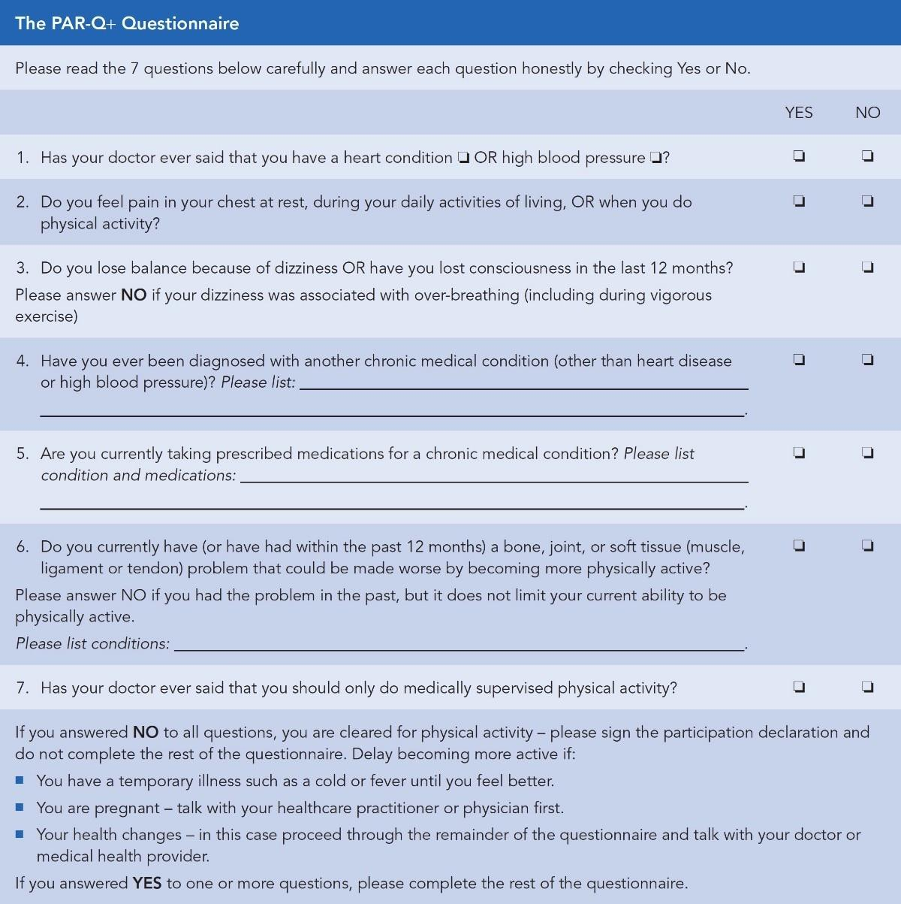**Figure 11-1** The PAR-Q+

**Health History Questionnaire (HHQ)**

A thorough pre-exercise health history questionnaire (HHQ) collects relevant information on the individual’s past and present health and serves to complement the PAR-Q+ in expanding one’s understanding of the participant’s health (see Appendix A). This questionnaire is not normally standardized to the fitness industry, but rather customized to respective facilities or organizations. In fact, a health history may be accompanied by a verbal discussion and perhaps additional questionnaires designed to gather further information regarding exercise history, eating behaviours, and general lifestyle.

An HHQ typically contains the following information about a client, which is considered private and confidential:

* Age
* Gender
* Height
* Weight
* Physician’s name and contact information
* Emergency contact information.

Any information collected about an individual during the assessment process cannot be shared without written consent from that individual; further, the information must be securely stored away from other co-workers and the public.

The questions asked within an HHQ can vary significantly, but they generally collect information about a client’s lifestyle habits, including exercise, diet, sleep, stress, occupation, and recreational pursuits. In addition, the questionnaire will include questions about medical history, including past injuries, past surgeries, chronic diseases, and medication.

**Lifestyle habits**

Understanding a client’s lifestyle is an important step before designing an exercise program. This information provides context for how a client eats, works, sleeps, and spends leisure activity. From this information, fitness professionals will be better equipped to design individualized exercise programs for their clients.

Exercise habits

Collecting exercise and physical activity information will provide an indication of a client’s fitness level. Within this area, the fitness professional should gather information on whether or not the individual is currently active and participating in any regular exercise or physical activity. If so, it’s important to know details regarding the activity: length of time (i.e., history), the nature or type, frequency, duration, and intensity.

Fitness professionals should inquire about their client’s preferred exercise activities, such as running, weight lifting, group exercise, and others. These questions will provide opportunities to learn more about an individual’s preferences and desires, which can become relevant during exercise programming. In addition, it is important to inquire about a client’s general thoughts and impressions regarding fitness testing and evaluations.

Discussions inquiring about a client’s willingness to participate in exercise programs can prove useful when developing exercise regimens. For example, a fitness professional can ask a client to rank the importance of a list of outcomes using a scale of 0 to 10, with 0 being unimportant and 10 being very important. The list of outcomes can include many items like losing weight, improving overall health, increasing muscle mass, or enhancing sports performance.

Dietary habits

While the topic of nutrition cannot be understated, considering the depth and breadth of nutritional information that can be collected, the initially gathered information should be more generalized and qualitative in nature.

For example, general eating behaviours can be collected rather than calculations of portion sizes and tracked calories. Some examples to consider include answers to the following questions:

* On a scale of 0 to 10, do you consider your overall diet to be healthy? (0 for unhealthy and 10 for very healthy).
* Are you currently following any kind of diet? If so, what diet and for what reason(s)?
* How would you rank your daily salt intake: low, medium, or high?
* How would you rank your daily sugar intake: low, medium, or high?
* How would you rank your daily fat intake: low, medium, or high?
* On a scale of 0 to 10, how effectively are you able to control your temptations for junk food (0 for easily and 10 for very difficult)?
* How many alcoholic drinks do you consume per week?
* Do you consume caffeinated beverages such as coffee, tea, soda, and/or energy drinks? How many per week?

Gathering this information helps the fitness professional, without preexisting judgment or presumptions, gain further insight into the client’s dietary habits. Over time, the client’s eating habits can be reevaluated to determine if any improvements (or setbacks) have been made. In addition, gathering this information assists the fitness professional to ascertain if the client should be referred to a registered dietitian or medical professional due to an unexpected concern.

Sleep

Sleep quality and quantity is another area of interest. Fitness professionals should inquire about their clients’ sleeping habits, including the number of hours slept each night, the quality of sleep, and even the difficulties associated with falling asleep. Sleep is necessary, and when done right, it replenishes energy stores depleted from exercise and physical activity (Dolezal et al., 2017). Conversely, chronic sleep deprivation has many health consequences, such as elevated risk for chronic disease and negative impact on cognition and mood, to name a few (Alvarez & Ayas, 2004; Dashti et al., 2015). It is important to recognize that it is out of scope for fitness professionals to perform detailed sleep evaluations or recommend clinical treatment to improve sleep quality. However, gaining basic insight into a client’s sleeping habits provides a coaching opportunity on the importance of getting a good night’s sleep.

Stress

Stress is becoming a more prominent aspect of life and can cause serious health effects, including raising the risk of chronic disease (Yaribeygi et al., 2017). Fitness professionals should inquire about their clients’ stress levels, such as using a scaling system of 0 to 10 to rate their average stress level. Conversations about stress are also relevant. Fitness professionals should investigate whether or not the individual is cognitively aware of their sources of stress, the frequency with which the individual is exposed to specific stressors, the magnitude of each stressor, and whether or not the person has identified or implemented any methods to manage these stressors.

Similar to sleep, it is beyond a fitness professional’s scope of practice to provide counselling services and mental health treatment for stress management. However, gaining a basic overview of the client’s stress levels provides a coaching opportunity. Fitness professionals can share with their client how exercise and physical activity can improve mood and disposition and reduce stress when integrated into a daily routine.

Occupation

Occupational demands and work history also provide valuable insight into potential conditions and concerns. Fitness professionals should inquire about these aspects of their client’s work:

* The nature of the client’s occupation
* Whether the job requires extended periods of time standing, sitting, or performing repetitive movements (with explanations)
* The workspace environment (e.g., office layout) and typical attire (e.g., shoes with elevated heels).

If clients are sitting for long periods throughout the day, their hips are also flexed for prolonged periods, which in turn can potentially lead to overactive hip flexors and low-back pain (Gupta et al., 2015). Moreover, if clients are sitting for prolonged periods, especially in front of a computer, there is a tendency for the shoulders and head to experience fatigue under the constant effect of gravity, which can lead to postural imbalances, including rounding of the shoulders and a forward head. In addition, prolonged periods of sitting are indicative of low energy expenditure throughout the day and potentially poor cardiorespiratory conditioning.

Wearing shoes with high heels puts the ankle complex in a plantarflexed position for extended periods, which can lead to tightness in the calf muscles and Achilles tendons, causing postural imbalance, such as decreased dorsiflexion and overpronation at the foot and ankle complex, resulting in flattening of the arch of the foot (Barnish & Barnish, 2016). This may lead to pain in the feet, knees, hips, or low-back.

Recreation and hobbies

In the context of a fitness assessment, recreation refers to a client’s physical activities outside of the work environment, also referred to as leisure time. By discovering the recreational activities that a client performs, a Certified Personal Trainer can better design an exercise program to fit the needs of their clients. For example, many clients like to dance, golf, ski, play tennis, or perform a variety of other sporting activities in their spare time. Proper exercise training must be incorporated to ensure that clients are conditioned in a manner that optimizes their physical ability, without predisposing them to injury.

Hobbies refer to activities that a client might enjoy on a regular basis but are not necessarily athletic in nature. Examples can include gardening, car repair, fishing, singing, or playing music. Many common types of hobbies do not involve vigorous physical activity, yet still need to be considered to create a properly planned exercise training program.

**Medical history**

Obtaining a client’s medical history is vitally important because it provides fitness professionals with information about known or suspected chronic diseases, such as coronary heart disease, high blood pressure, or diabetes. In addition, fitness professionals should inquire if their client smokes or uses tobacco products. Furthermore, a medical history provides information about the client’s past and current health status, as well as any past or recent injuries, surgeries, or other chronic health conditions. Gathering this information helps determine if a client is ready for a new exercise routine or if a medical referral is necessary.

Past injuries

All past or recent injuries should be recorded and discussed in enough detail to make decisions about whether exercise is recommended, or if a medical referral is necessary. Previous history of musculoskeletal injury is also a strong predictor of future injury during physical activity (Fulton et al., 2014).

The effect of injuries on the functioning of the human body is well documented, especially with regard to the following injuries:

* Ankle sprains. These have been shown to decrease muscle activation of the gluteus medius and gluteus maximus muscles. In turn, this can lead to poor control of the lower extremities during many functional activities, which can eventually lead to injury (Bullock-Saxton, 1994; Friel et al., 2006).
* Knee injuries involving ligaments. A knee injury can cause a decrease in activation to muscles that stabilize the patella (kneecap) and lead to further injury. Noncontact knee injuries are often the result of ankle or hip dysfunction because the knee is caught between the ankle and the hip. If the ankle or hip joint begins to function improperly, this results in altered movement and force distribution of the knee. Over time, this can lead to further injury (Fong et al., 2011; Shultz et al., 2015).
* Low-back injuries. These injuries can cause decreased activation to stabilizing muscles of the core, resulting in poor stabilization of the spine. This can further lead to dysfunction and pain (Hides et al., 2011; Stuber et al., 2014).
* Shoulder injuries. These injuries cause altered muscle activation of the rotator cuff muscles, which can lead to instability of the shoulder joint during functional activities (Gombera & Sekiya, 2014; Yanagawa et al., 2008).
* Other injuries. Additional injuries can include (but are not limited to) repetitive hamstring strains, groin strains, patellar tendonitis (jumper’s knee), plantar fasciitis (pain in the heel and bottom of the foot), shin splints, biceps tendonitis (shoulder pain), and headaches.

Past surgeries

Surgical procedures create trauma for the body. These procedures may produce effects similar to injuries on the functioning of the human body and the safety and efficacy of exercise. Fitness professionals frequently interact with clients who have experienced some of the following more common surgical procedures:

* Foot and ankle surgery
* Knee surgery
* Back surgery
* Shoulder surgery
* Caesarean section for birth (cutting through the abdominal wall to deliver a baby)
* Appendectomy (cutting through the abdominal wall to remove the appendix).

Chronic disease

The risk of chronic disease increases dramatically in those individuals who are physically inactive (Booth et al., 2017). Chronic diseases can include the following:

* Cardiovascular disease, coronary heart disease, coronary artery disease, or congestive heart failure
* Hypertension (high blood pressure)
* High cholesterol or other blood lipid disorders
* Stroke or peripheral artery disease
* Lung or breathing problems
* Obesity
* Diabetes mellitus
* Cancer.

Medications

Many clients seeking fitness and exercise training advice from fitness professionals will currently be under the care of a physician or another medical professional, and they may be taking one or more prescribed medications. It is not the role of the Certified Personal Trainer to administer, prescribe, or educate clients on the usage and effects of any form of legally prescribed medication by a licensed physician or other healthcare provider. Certified Personal Trainers should always consult with their client’s physician or medical professionals regarding the client’s health information and which medications they may be currently taking, if any.

**Conducting health and fitness assessments**

Once the HRA is completed, and if the individual does not require medical clearance to initiate exercise, the fitness professional should then start to consider the need and the propriety of conducting various fitness assessments. Although fitness assessments provide lots of valuable information to the Certified Personal Trainer, clients may not feel comfortable undergoing specific assessments, especially if they believe they might not be able to complete the assessment. It’s possible that they might feel embarrassed by their results. For example, if Mary is deconditioned, the notion of completing a 1.5-mile run test might be both intimidating and uncomfortable. The decision on what and when to assess is never straightforward—it requires careful consideration on the part of the fitness professional.

Assessment considerations

A fitness professional should always be able to provide good rationale for any fitness assessments that they elect to conduct on a client. This rationale often manifests itself out of the following events, which should always be considered on a case-by-case basis (Figure 11-2).

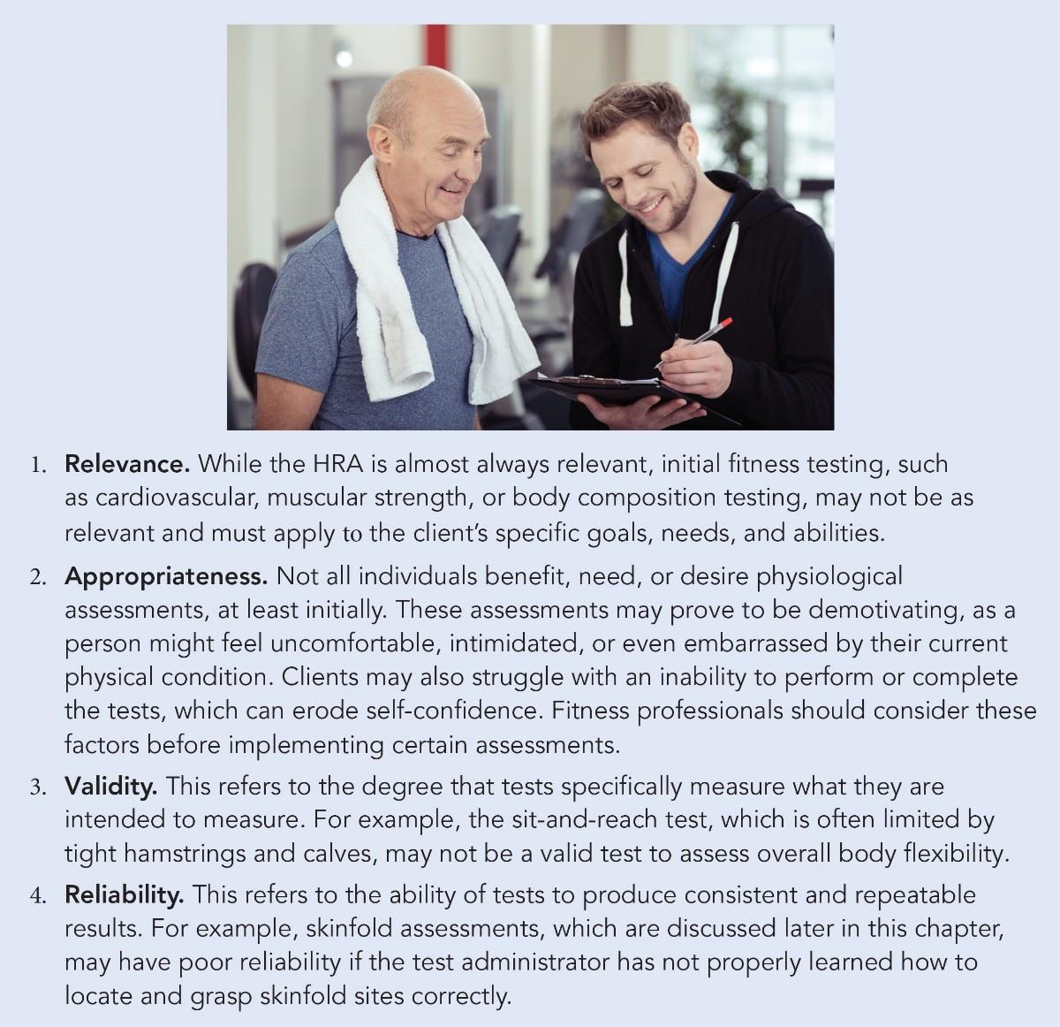**Figure 11-2** Rationale for fitness assessments

Assessment sequencing

Some assessments should be conducted prior to performing specific exercises because of the way physical exertion impacts these measurements. For example, resting heart rate (RHR), blood pressure, and skinfold body fat testing (all discussed later in this chapter) are acutely affected by physical exertion, which may skew results. On the other hand, flexibility is frequently assessed following a light cardio warm-up because at this time the body displays greater tissue extensibility.

Fitness assessments that do not require physical exertion, such as the measurement of RHR, blood pressure, or body composition, should always be conducted prior to more vigorous fitness assessments that measure aerobic fitness, strength, or power output.

GETTING TECHNICAL

Physical activity raises a person’s heart rate and blood pressure. Consequently, measurements for RHR and blood pressure should be taken while the client is at rest.

Skinfold body fat testing should also be conducted while the client is in a rested state. Thermoregulation during exercise creates peripheral vasodilation at or around the skin to help remove heat, but this can increase a skinfold body fat measurement score.

Assessment: safety and legal implications

To maximize safety and minimize legal implications, all personnel involved in exercise testing and supervision must have a current certification for cardiopulmonary resuscitation (CPR) and automated external defibrillator (AED). Within a fitness facility, the responsibilities of Certified Personal Trainers responding to emergencies should be clearly defined and documented.

CRITICAL

An established written emergency plan should be clearly posted, including emergency medical services' telephone numbers. Regularly scheduled emergency medical services response rehearsals are advised to help improve response rates and times.

**Exercise test termination criteria**

During the administration of an assessment involving physical exertion (e.g., cardiorespiratory test), the fitness professional should always be aware of signs and symptoms that merit immediate termination of the test (Figure 11-3) and a possible referral to a medical professional (Fletcher et al., 2013; Howard et al., 2012).

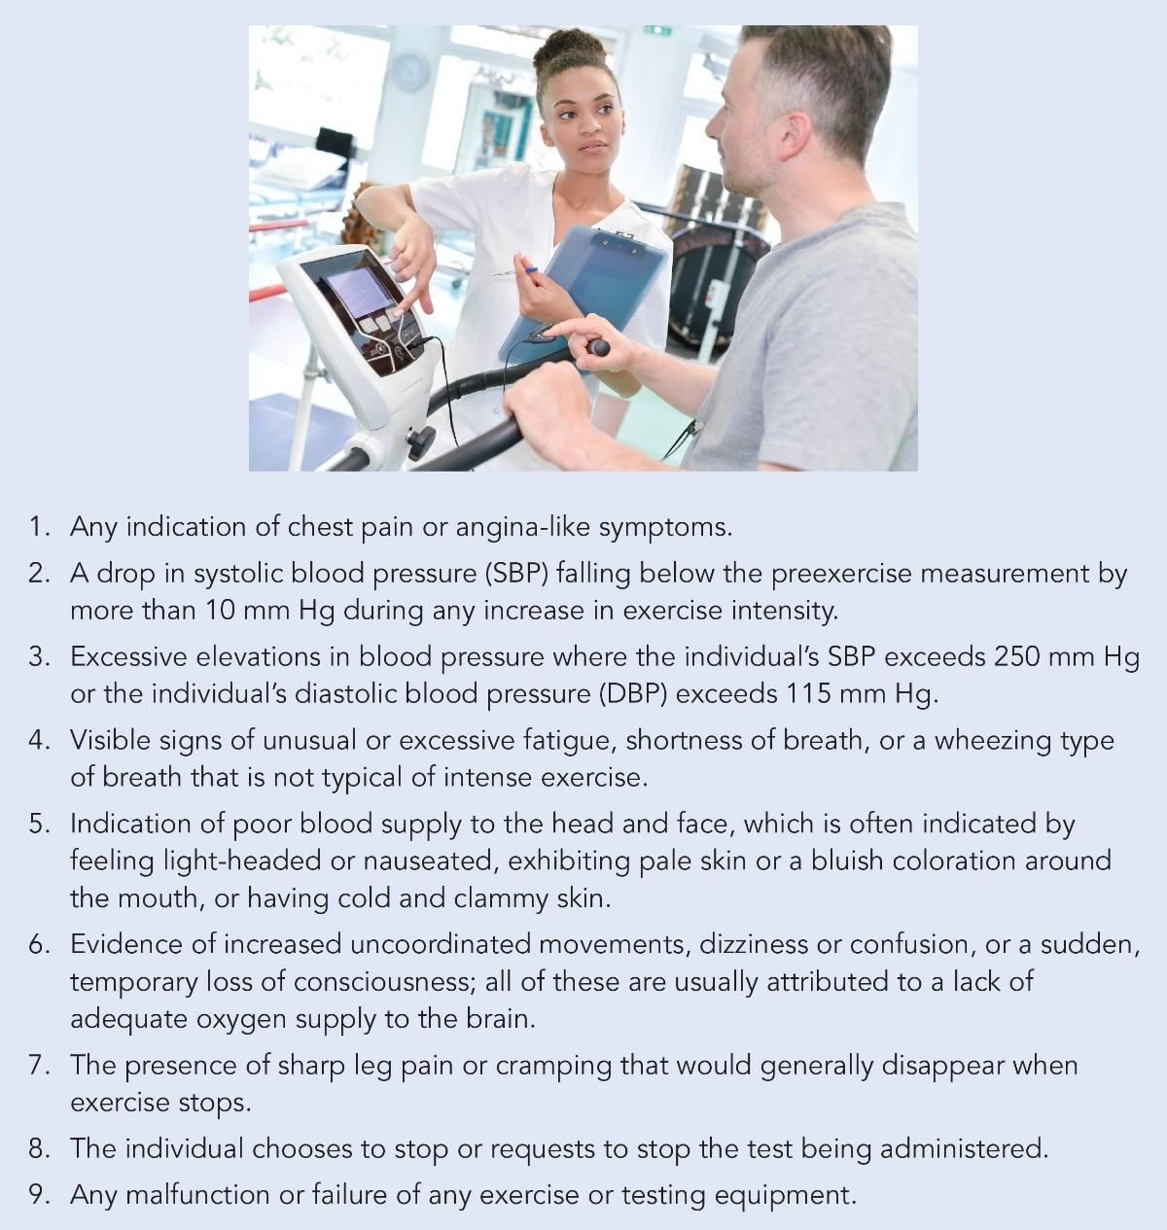

**Figure 11-3** Exercise test termination criteria

**Pre-assessment instructions**

Prior to conducting any assessment, measures should be taken to ensure individual safety and comfort. In advance, the fitness professional should provide precise and clearly defined instructions regarding preparation for testing. Clients should wear comfortable, athletic clothing and ingest plenty of fluids over the 24-hour period preceding the test to optimize hydration levels. Clients should also avoid heavy food, tobacco, alcohol, and caffeine at least 3 hours prior to testing, avoid exercise or strenuous activity the day before or the day of the test, and get adequate amounts of sleep the night before the test.

TRAINING TIP

Explaining and Demonstrating Assessments

Adopt a philosophy of briefly explaining the purpose of the test, the protocol, and expectations. However, keep your explanations short and simple and use appropriate easy-to-understand language. Because many individuals are visual learners, include demonstrations whenever possible (the explanation and demonstration can occur simultaneously). When appropriate, allow for some practice trials to facilitate learning and mastery of the physical tasks required.

## Fitness assessment protocols

Fitness assessments are an integral part of the services offered by fitness professionals to their clients. The ability to assess baseline measurements will facilitate the design and development of exercise programs while also providing a means to evaluate progress. Every fitness professional should possess the knowledge, skills, and abilities to select, administer, and interpret a variety of different physiological parameters aligned with their client’s health, fitness, or performance goals.

**Heart rate**

Heart rate (HR) is a valid indicator of work intensity or stress, both at rest and during exercise. Monitoring changes in resting HR helps to identify cardiovascular adaptations (becoming more aerobically fit) or regressions (deconditioning). Resting heart rate (RHR) lowers with improved fitness levels because the heart and lungs become more conditioned. When this occurs, the heart becomes stronger and can pump out more blood with each beat. This causes more oxygen and nutrients to be transported throughout the body. Conversely, when a person’s fitness level decreases, or they become ill, the RHR may elevate. These are important effects to understand because they provide the fitness professional with valuable physiological feedback on the training status of their client. However, it is also important to recognize that gender differences do exist in RHR, with men averaging approximately 5 to 10 fewer beats per minute than women (Porcari et al., 2015). These differences can be explained in part to the smaller sizes of the heart chambers and lower volumes of circulating blood in women, which require an elevated HR response. This means that RHR measurements for men and women should not be compared against each other to assess fitness levels. Rather, fitness professionals should gauge how an individual’s own RHR changes with training.

Measuring heart rate manually

HR can be measured at many points around the body (Figure 11-4) where an artery’s pulsation is transmitted to the body’s surface, often occurring when a blood vessel is compressed against an underlying structure, such as a bone or joint. The RHR is most accurately measured just before an individual gets out of bed in the morning.

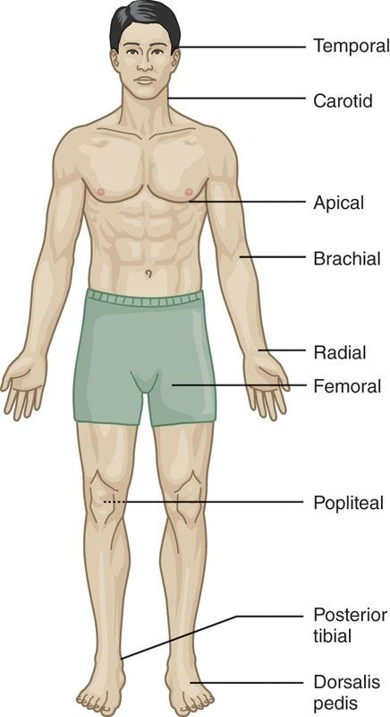

**Figure 11-4** Pulse locations

There are many anatomical locations that can be used to measure a client’s RHR. However, for accuracy, safety, and ease of administration, NASM recommends that fitness professionals measure a client’s radial pulse (Figure 11-5).

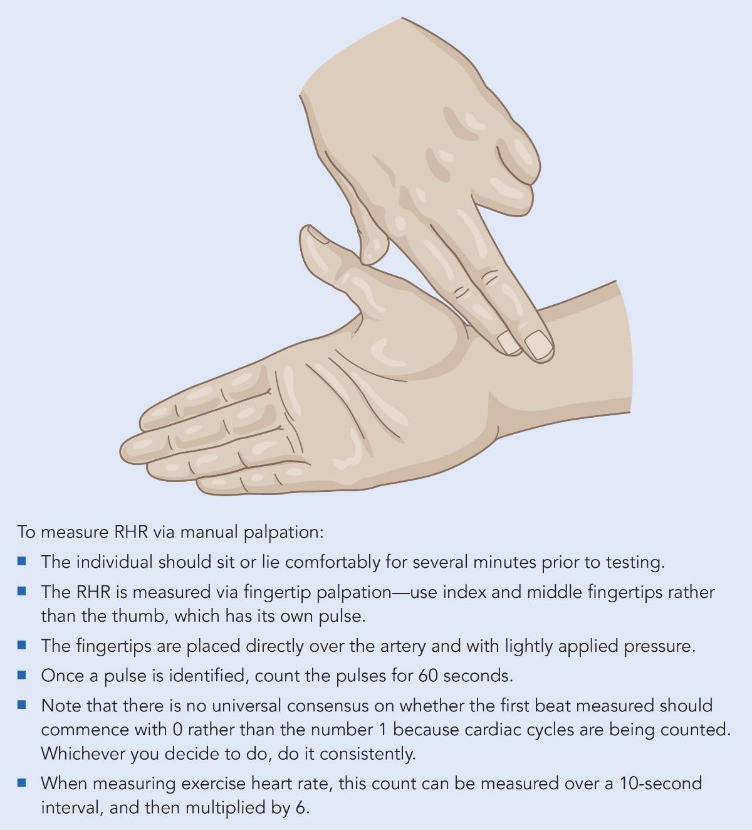

**Figure 11-5** Radial pulse

Blood pressure

Blood pressure (BP) is defined as the outward pressure exerted by blood on the arterial walls (Kenney et al., 2015) (Figure 11-6). Blood pressure is not consistent within each heart beat—the pressure fluctuates between a peak and a low pressure in the bloodstream during each beat. This explains why two numbers are measured. Both are important to score because collectively, they provide insight into the average pressure within the bloodstream.

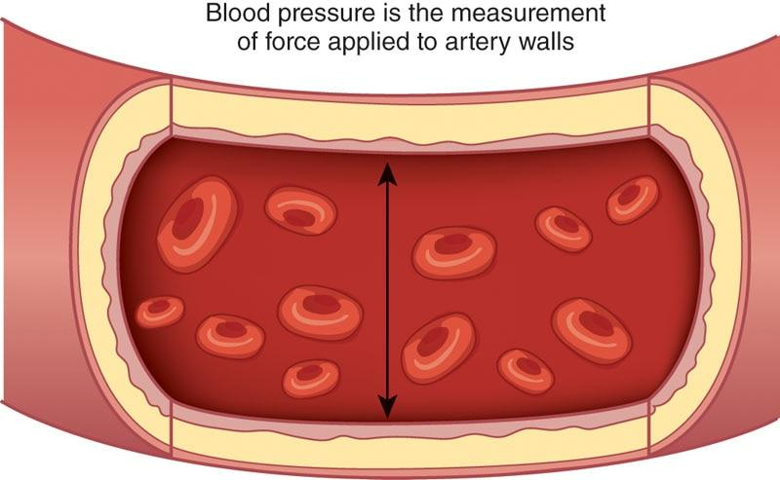

**Figure 11-6** Blood pressure

Systolic blood pressure (SBP), sometimes referred to as the top number, reflects the greatest pressure during the cardiac cycle. The SBP equals the force of blood pushing against the arterial walls when the heart is contracting and is measured in millimetres of mercury (mm Hg).

Diastolic blood pressure (DBP), sometimes referred to as the bottom number, reflects the lowest pressure during the cardiac cycle. The DBP equals the remaining force generated by the blood in the arteries while the heart is relaxed (not contracting) and is also measured in millimetres of mercury.

STRETCH YOUR KNOWLEDGE

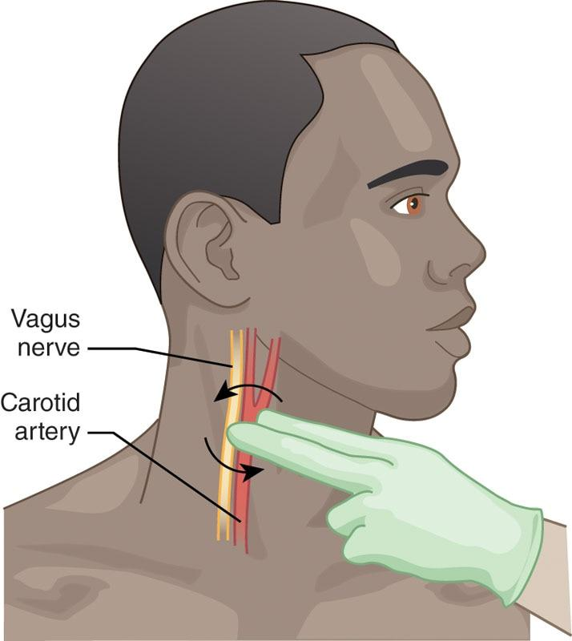

NASM recommends fitness professionals measure RHR at the radial pulse versus the carotid pulse (which is located at the neck just to the side of the larynx), because the vagus nerve lies adjacent to the carotid artery. Applying too much pressure to the vagus nerve can inadvertently slow a client’s heart rate response.

Blood pressure is measured within the arterial system while using the brachial artery as the standard site of measurement, given its ease of access and the ability to hold the arm level with the position of the heart, which increases the accuracy of measurement (Figure 11-7).

GETTING TECHNICAL

In 2017, the American College of Cardiology and American Heart Association revised the classification scores for blood pressure and the risk they pose to overall cardiovascular health (Whelton et al., 2018). New research illustrates the usefulness of DBP scores in predicting independent mortality risks in younger adults, while SBP is more important in predicting independent mortality risks in adults older than 50 years.

Blood pressure scores are important because higher scores indicate greater risks for developing cardiovascular disease, which can become life-threatening. Because both SBP and DBP represent pressure within the bloodstream, guidelines have been created that assess this degree of risk (Table 11-1).

Measuring blood pressure

Blood pressure is traditionally measured using an aneroid sphygmomanometer, which consists of an inflatable cuff, a pressure dial, a bulb with a valve, and a stethoscope; however, digital blood pressure monitors are becoming more popular.

TABLE 11-1 Blood Pressure Classification Ranges

| **Classification** | **Systolic BP** | **Diastolic BP** | **Recommendation** |
| --- | --- | --- | --- |
| Normal | <120 mm Hg | <80 mm Hg | Maintain |
| Elevated | 120–129 mm Hg | <80 mm Hg | Lifestyle changes |
| Stage 1 hypertension | 130–139 mm Hg | 80–89 mm Hg | Lifestyle changes + medical monitoring |
| Stage 2 hypertension | ≥140 mm Hg | ≥90 mm Hg | Lifestyle changes + medical monitoring + medications |
| Hypertensive crisis | >180 mm Hg | >120 mm Hg | Seek immediate medical attention |

Measuring BP takes proper guidance and practice. It is recommended that all individuals, including fitness professionals, attend a live training class to learn how to properly assess BP. The following paragraphs are generalized steps for assessing BP using an aneroid sphygmomanometer (for informational purposes only).

To record BP, instruct the client to assume a comfortable seated position and place the appropriate size cuff on the client’s arm just above the elbow. Next, either rest the arm on a supported chair, or support the arm using your own arm, and place the stethoscope over the brachial artery, using a minimal amount of pressure. Continue by rapidly inflating the cuff to 20 to 30 mm Hg above the point at which the pulse can no longer be felt at the wrist. Next, release the pressure at a rate of about 2 mm Hg per second, listening for a pulse. To determine the SBP, listen for the first observation of the pulse. Diastolic pressure is determined when the pulse fades away. For greater reliability, repeat the procedure on the opposite arm.

CRITICAL

Abnormal Readings

If abnormal readings are made during a blood pressure assessment, repeat the measurement on the opposite arm. A significant discrepancy in the readings between the arms could represent a circulatory problem, and the individual should be referred to their physician for a medical evaluation.

### Anthropometry and body composition measurements

Anthropometry is the field of study of the measurement of living humans for purposes of understanding physical variation in size, weight, and proportion. Many different anthropometric measures exist, including body fat assessments, body mass index (BMI), and circumference measurements. Although many clients have goals of weight loss, what is really implied is a loss of fat mass while retaining or perhaps gaining lean muscle mass. While scale weight can measure and monitor weight loss, it is unable to determine the relative ratios of fat and muscle mass potentially being lost.

The purpose behind body composition measurements is to quantify body compositional changes (e.g., losses of fat mass) from which an individual can be classified as healthy or unhealthy. Currently, there is no universally accepted, standard percentage of body fat for all ages and genders. In general, men’s body fat percentages are lower than those for women. These studies demonstrate that healthy body fat typically ranges from about 10% to 20% for men and about 20% to 30% for women, although these ranges can vary significantly based on the individual’s age, gender, and ethnicity (Heo et al., 2012).

**Body Mass Index**

BMI is a rough assessment based on the concept that a person’s weight should be proportional to his or her height. An elevated BMI is linked to increased risk of disease, especially if associated with a large waist circumference (Aune et al., 2016). Although this assessment is not designed to assess body fat, BMI is a quick and easy method for determining whether a person’s weight is appropriate for that person’s height.

BMI can be determined using several methods, including mathematical formulas available in both metric and imperial units and various online calculators. There are two formulas to calculate BMI. It is calculated by either dividing a person’s weight in kilograms by the square of their height in meters, or dividing their body weight in pounds by the square of their height in inches, and multiplying by 703.

* Metric formula: BMI = weight (kg) ÷ [height (m)]2
* Imperial formula: BMI = 703 × weight (lb) ÷ [height (in.)]2

TRY THIS

Calculate Mary’s BMI score using either formula if she currently weighs 160 lb (72.57 kg) and stands 5 ft 7 in. or 67 in. (1.70 m).

Answer: BMI = 25.1

The lowest risk for disease lies within a BMI range of 22 to 24.9 (Table 11-2). Scientific evidence indicates that the risk for disease increases with a BMI of 25 or greater. Even though research has shown the risk for premature death and illness does increase with a high BMI score, individuals who are underweight are also at risk (Flegal et al., 2013).

Because of its simplicity and measurement consistency, BMI is the most widely used measure to determine overweight and obesity levels. BMI is a useful tool to screen the general population, but its one weakness is that it fails to differentiate fat mass from lean body mass. Using BMI, athletes or bodybuilders with a large amount of muscle mass can mistakenly fall within the moderate- to high-risk categories.

TABLE 11-2 BMI Classification

| **BMI** | **Disease Risk** | **Classification** |
| --- | --- | --- |
| <18.5 | Increased | Underweight |
| 18.5–24.9 | Low | Healthy weight |
| 25.0–29.9 | Increased | Overweight |
| 30.0–34.9 | High | Obese |
| 35.0–39.9 | Very high | Obesity II |
| ≥40.0 | Extremely high | Obesity III |

**Circumference measures**

A circumference is a measure of the girth of body segments (e.g., arm, thigh, waist, and hip), which serves to identify body shape and changes, and acts as an important indicator of health risks for diseases such as heart disease and diabetes.

* Individuals described as android or apple-shaped are characterized as having more fat within the abdominal region of the body (i.e., more visceral fat), which is associated with elevated health risks (Després, 2012) (Figure 11-8).
* Individuals described as gynoid or pear-shaped are characterized as having more fat within the hips and thighs, which may be associated with a lower health risk when compared to an android shape (Figure 11-8).

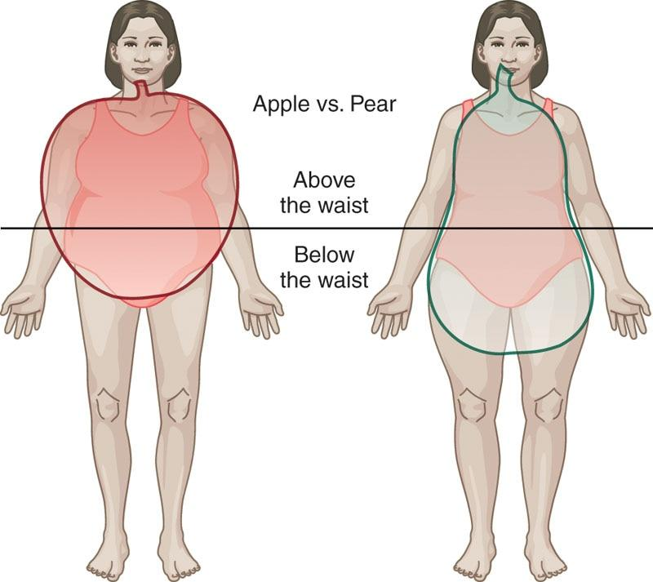

**Figure 11-8** Android (apple) versus gynoid (pear) shape

Waist circumference

The most commonly measured circumference measure is the waist circumference; as a stand alone, it can be used to assess health risk (Figure 11-9).

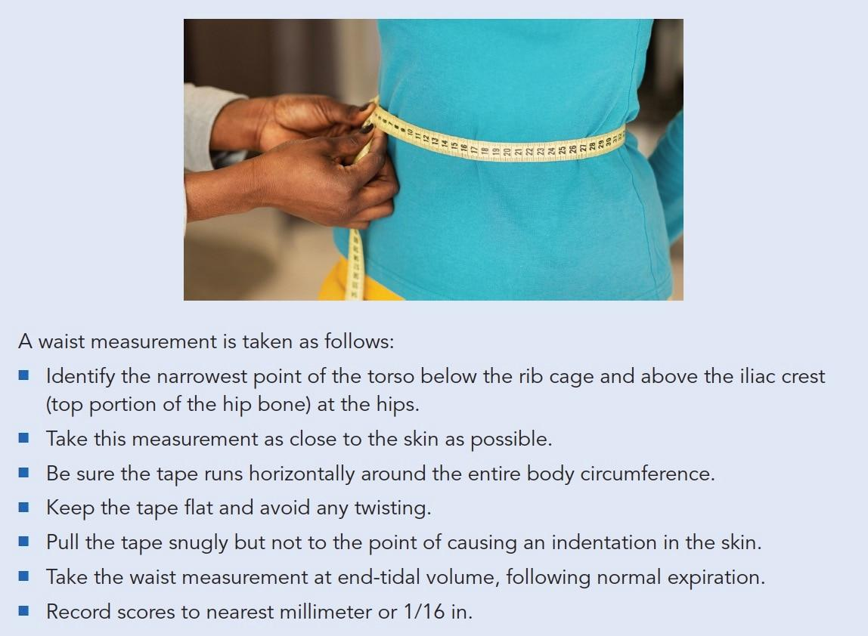

**Figure 11-9** Waist circumference

Men with a waist circumference greater than or equal to 100 cm (~40 in.) are at higher risk for developing health issues, such as cardiovascular disease or diabetes, while women with a waist circumference greater than or equal to 88 cm (~35 in.) are at higher risk for developing health issues like diabetes and cardiovascular disease (Després, 2012; Howard, 2006; Kawada, 2015). Table 11-3 illustrates health risks from various waist circumference measurements. It is important for fitness professionals to monitor each client’s waist circumference to identify health risks and track weight loss efforts. However, some clients may feel apprehensive and do not wish to have their waist measured. In these instances, fitness professionals are advised to teach their clients how to measure their own waistlines and report their findings back to the professional.

TABLE 11-3 Health Risks from Waist Circumference Measurements

| **Risk Category** | **Women** | **Men** |
| --- | --- | --- |
| Very low | <70 cm (< 27.5 in.) | <80 cm (<31.5 in.) |
| Low | 70–89 cm (27.5–35.0 in.) | 80–99 cm (31.5–38.9 in.) |
| High | 90–109 cm (35.4–42.9 in.) | 100–120 cm (39.3–47.2 in.) |
| Very high | ≥110 cm (≥43.3 in.) | >120 cm (>47.2 in.) |

Data from Bray (2004).

Waist-to-hip ratio

The waist-to-hip ratio (WHR) is another commonly used set of circumference measurements used to assess health risk by defining the shape of the body (i.e., android, gynoid). The hip circumference measures the widest circumference around the hips or buttocks region, above the gluteal fold, where the buttocks join the back of the thigh. With both measurements, a ratio can be determined using the formula provided.

WHR = Waist Measurement ÷ Hip Measurement

For the WHR, there are standard scores for men and for women, as shown in Table 11-4 (Huxley et al., 2010). A high WHR has significant health implications because individuals who are more apple-shaped and carry more fat in the abdominal region are at greater risk for developing cardiovascular and metabolic diseases, such as diabetes.

TABLE 11-4 WHR Classifications

| **Health Risk** | **Men** | **Women** |
| --- | --- | --- |
| Low | 0.95 or lower | 0.80 or lower |
| Moderate | 0.96–1.0 | 0.81–0.85 |
| High | 1.0 or higher | 0.86 or higher |

Additional circumference measures

Circumference measurements can be measured at almost any body segment, although standardized sites exist as described in Table 11-5. Some of these measurements can also be used to quantify body composition (i.e., percentage of body fat), even with significantly overweight clients, but they unfortunately correlate poorly with true body composition measurements (Porcari et. al., 2015). They are better used to assess girth changes in the body over time, rather than body fat percentage, and offer the convenience of being inexpensive and easy to administer.

Many clients might be keen to have their body composition measured, but accurate assessments of body composition are not always easy to obtain. Measuring circumference can become a good alternative, because measurements taken at various locations can provide valuable feedback to clients on their bodily transformation while they work toward achieving their fitness goals.

TABLE 11-5 Circumference Measurement Sites

| **Site** | **Description of Location** | **Image** |
| --- | --- | --- |
| Neck | Measure just below the larynx (across the Adam’s apple for men). |  |
| Chest | Measure across the fullest part of chest. |  |

| **Site** | **Description of Location** | **Image** |
| --- | --- | --- |
| Waist | Measure at the narrowest point of the waist, below the rib cage and just above the top of the hipbones. If there is no apparent narrowing of the waist, measure at the navel. |  |
| Hips | With feet together, measure circumference at the widest portion of the buttocks. |  |
| Thigh | While standing, legs 10 cm (4 in.) apart, measure the largest circumference immediately below the gluteal fold. |  |
| Calves | Measure the calf at its fullest part, taken between the ankle and the knee. |  |
| Arm | Measure the upper arm at its fullest part, taken at midpoint between the shoulder and elbow. |  |

**Skinfold measurements**

Skinfold measurements continue to remain a popular method for determining body composition, although significant skill is required in locating the skinfold sites and accurately measuring fat folds using calipers. This takes practice, and it is recommended that fitness professionals learn from a trained professional before using these techniques. Table 11-6 provides descriptions of the different locations used by various skinfold measurement protocols.

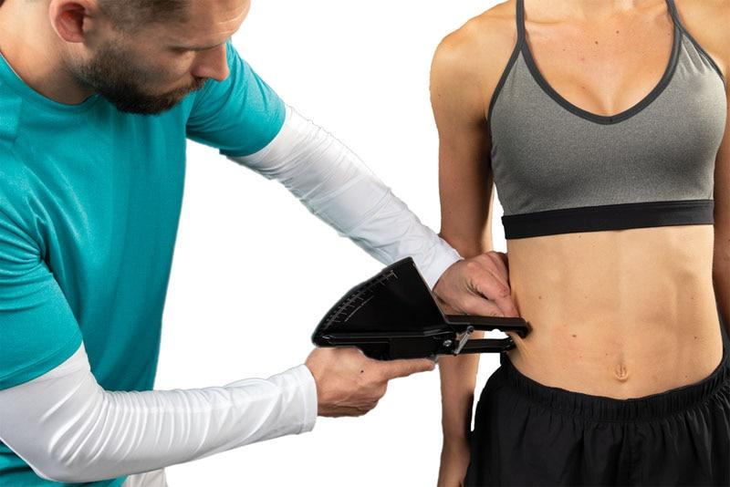

TABLE 11-6 Standardized Skinfold Sites of Measurement

|  |  |
| --- | --- |
| Triceps: A vertical fold on the back of the arm, halfway between the shoulder and elbow.  Biceps: A vertical fold on the anterior aspect over the belly of the biceps brachii muscle, 1 cm higher than the level of the triceps measurement.  Chest: Men: A diagonal skinfold taken half the distance between the anterior axillary line (armpit) and the nipple. Women: A diagonal skinfold taken one-third the distance between the anterior axillary line and the nipple.  Abdomen: A vertical skinfold taken 1 in. (2.54 cm) lateral to the umbilicus (belly button).  Mid-axillary: Vertical fold taken on the mid-axillary line at the level of the xiphoid process (which is typically just below the nipple line).  Subscapular: Diagonal fold, 1 to 2 cm below the inferior angle of the scapula.  Suprailiac: A diagonal fold taken immediately superior to and in line with the natural angle of the iliac crest (top portion of the hip bone), aligned with the anterior axillary line.  Thigh: A vertical skinfold taken midway between the hip and patella (kneecap). |  |

Calliper skills and techniques

Skinfolds (SKF) are indirect measurements of the thickness of subcutaneous adipose tissue (fat beneath the skin). The assumption is that the amount of fat present in the subcutaneous region of the body is proportional to overall body fatness, and most of the time, this is the case. Proper assessments of body composition using skinfolds include these recommendations:

* Train with an individual skilled in SKF assessment and frequently compare your results against theirs.
* Take a minimum of two measurements at each site; each site must be within 1 to 2 mm to take an average.
* Completely open the jaw of the caliper before removing from the site.
* Be meticulous when locating anatomic landmarks.
* Do not measure SKFs immediately after exercise.
* Instruct clients ahead of time regarding test protocol.
* Avoid performing SKFs on obese clients.

Jackson and Pollock seven-site protocol

The Jackson and Pollock 7-Site protocol, like all SKF methods, mandates skill and proficiency on the part of the fitness professional in measuring the skinfold sites. To perform this assessment, the sum of the averages of the acceptable measurements from each site are totalled and used to calculate body density (Jackson & Pollock, 2004). The same seven sites are used for both men and women (Table 11-7). Once the sum of the SKFs has been recorded, various online resources (e.g., tables, calculators) can be used for estimating body fat percentage.

TABLE 11-7 Jackson and Pollock Seven-Site Measurement

| **Gender** | **Sites** |
| --- | --- |
| Men | Chest, mid-axillary, subscapular, triceps, abdomen, suprailiac, thigh |
| Women | Chest, mid-axillary, subscapular, triceps, abdomen, suprailiac, thigh |

Jackson and Pollock three-site protocol

An alternative to the seven-site protocol is the Jackson and Pollock 3-Site protocol. The three-site method can be used for determining body composition in healthy populations. The chest, abdomen, and thigh locations are used for men, whereas the triceps, suprailiac, and thigh locations are used for women (Table 11-8). This protocol holds good validity and offers convenience as it only requires measurements to be taken at three locations. Like the seven-site measurement, various online resources can be used for estimating body fat percentage once the three SKFs have been calculated.

TABLE 11-8 Jackson and Pollock Three-Site Measurement

| **Gender** | **Sites** |
| --- | --- |
| Men | Chest, abdomen, thigh |
| Women | Triceps, suprailiac, thigh |

Four-site Durnin-Womersley protocol

The Four-Site Durnin–Womersley protocol is an alternative to the Jackson and Pollock formulas previously described. This formula uses a simple four-site upper body measurement process. The four sites include the biceps, triceps, subscapular, and suprailiac. The same four sites are used for both men and women (Table 11-9).

TABLE 11-9 Durnin–Womersley Four-Site Measurement

| **Gender** | **Sites** |
| --- | --- |
| Men | Biceps, triceps, subscapular, and suprailiac |
| Women | Biceps, triceps, subscapular, and suprailiac |

After the four sites have been measured, add the totals of the four sites and then find the appropriate sex and age categories for the body composition on the Durnin–Womersley body fat percentage calculation (Table 11-10). For example, a 40-year-old female client with the sum of the SKFs of 40 has a percent body fat of 28.14%, which can be rounded down to 28%.

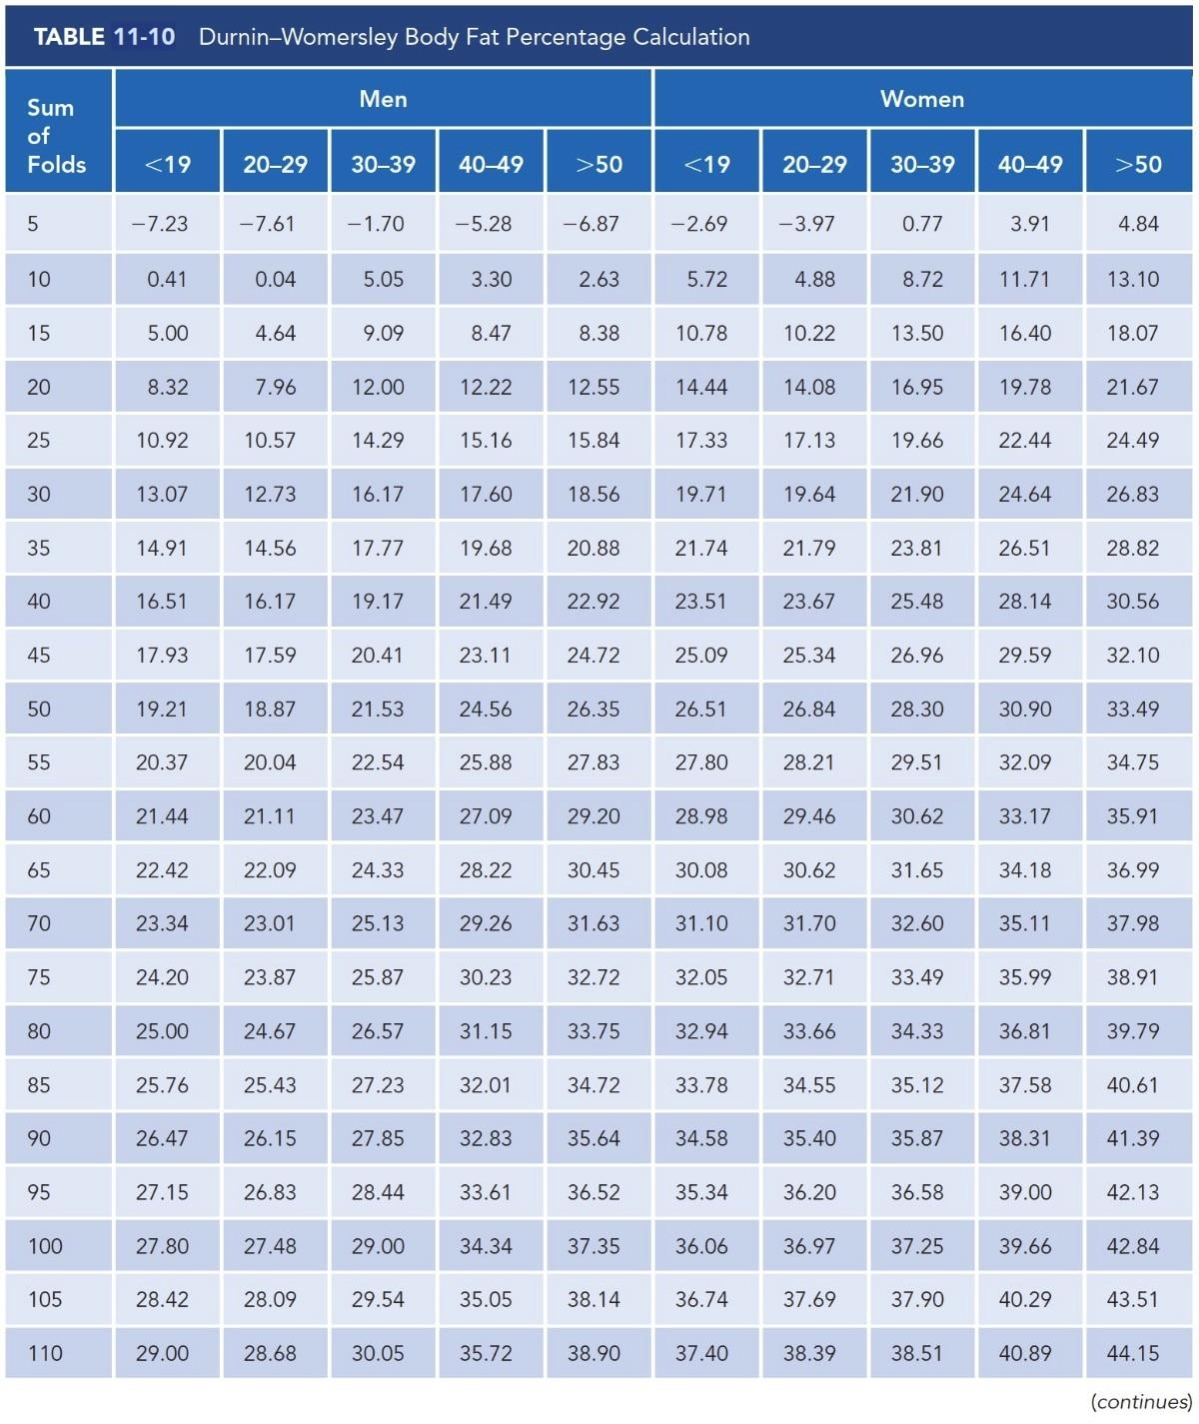

**Table 11-10** Durnin–Womersley body fat percentage calculation

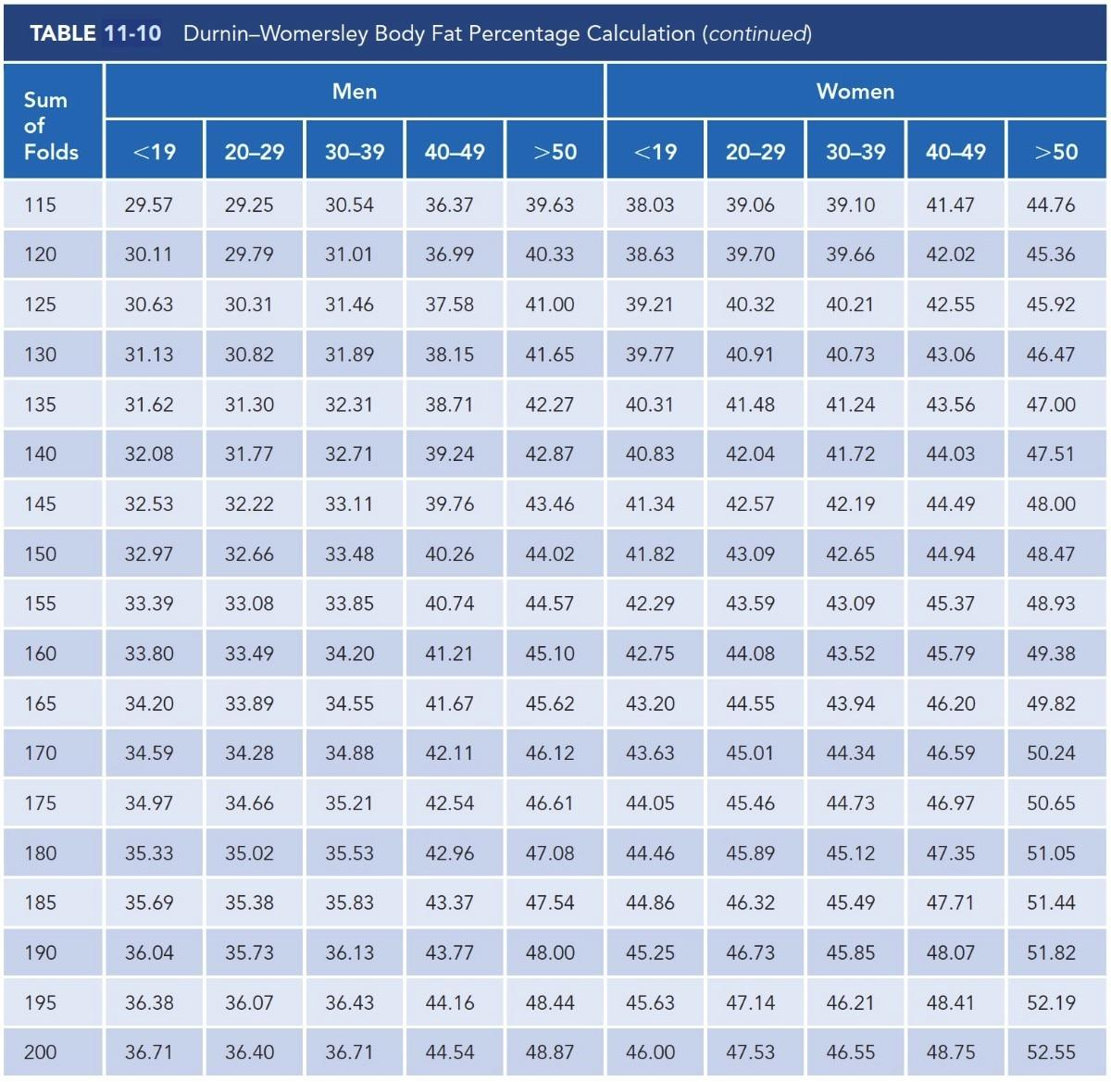

**Table 11-10** Durnin–Womersley body fat percentage calculation (continued)

Skinfold assessment considerations and concerns

The different skinfold assessment protocols as described can provide many options when assessing a client’s body fat percentage. While providing the fitness professional with options, it can also prove to be confusing about which protocol to use. Some simple guidelines can simplify the decision-making process.

* Although the seven-site method is considered the most accurate because it collects SKFs at more locations across the body, this protocol is certainly more invasive to the client. As such, it may be best used for clinical or athletic populations.
* While the Jackson and Pollock three-site protocol is perhaps not as accurate as the seven-site protocol, it is still considered valid. An advantage is that the three-site protocol is less invasive to conduct.
* The Durnin–Womersley formula is best used for individuals between the ages of 17 and 49 years of age and may not be as applicable for older adults. A potential advantage is that it only requires measurements for the upper body; it does not require an individual to wear shorts for a thigh measurement.

TRAINING TIP

Assessing body fat using skinfold calipers can be a sensitive situation. Additionally, the accuracy of the SKFs for obese individuals decreases; thus, it would be more appropriate not to use this method for assessing body fat. Instead, use bioelectrical impedance, circumference measurements, scale weight, or even the fit of clothing to evaluate one’s weight loss and body fat reduction progress.

**Bioelectrical Impedance Analysis**

Unlike a skinfold assessment, bioelectrical impedance analysis (BIA) is a very easy body fat assessment to administer that does not require additional hands-on training or tables to reference. In this technique, sensors are applied to the skin, and a weak electrical current is run through the body to estimate body fat and lean body mass. Because muscle cells can contain as much as 70% to 75% water in comparison to fat cells that contain only about 10% to 15% water, a leaner individual will experience less resistance and reactance to the electrical flow versus an individual with more body fat (Porcari et al., 2015). In other words, fat is a less efficient conductor than lean body tissue; the faster the conduction, the leaner the individual (Figure 11-10). Body weight scales with sensors, as well as handheld devices, are available to conduct this procedure.

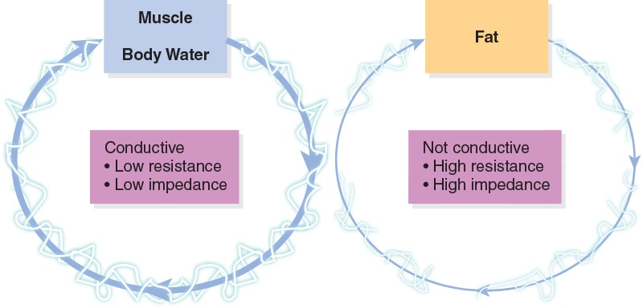

**Figure 11-10** Bioelectrical impedance conduction

Given the advances in technology in assessing body composition through BIA, and the concerns over SKF measurement (e.g., invasive nature, time investment, reliability of fitness professionals), BIA is becoming more commonly conducted in fitness settings. However, BIA does have its own limitations that can compromise the accuracy of the measurements taken. These include any event where the body either retains or loses water. Examples include fluctuating hydration levels, dehydration, extreme temperatures, heavy sweat rates, the use of diuretics, and even the presence of urine in the bladder volume. Furthermore, the quality of the BIA device is also an important consideration because lower-quality devices are more likely to produce inaccurate results versus higher-quality multi-extremity devices that measure at both extremities (i.e., hands and feet).

**Hydrostatic Underwater Weighing**

Underwater weighing (see Figure 11-11), often referred to as hydrostatic weighing, has been the most common technique used in exercise physiology labs to determine body composition. This method is founded on the principle that bone, muscle, and connective tissues are denser and heavier in comparison to fat tissue, which is less dense, lighter, and floats. In essence, a person’s weight on land is compared to their underwater weight to determine fat percentage.

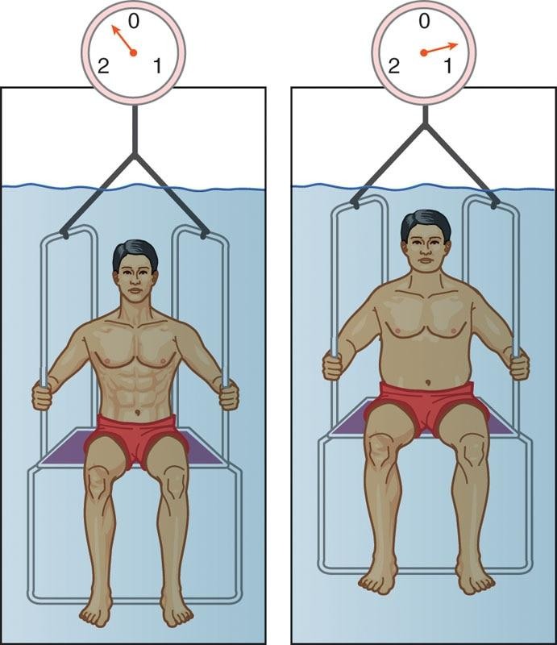

**Figure 11-11** Underwater weighing

The science behind this process is Archimedes’ principle. Archimedes’ principle is a physical law of buoyancy. Because bone and muscle are denser than water, a person with a larger percentage of lean body mass will weigh more in the water and ultimately have a lower body fat percentage versus someone with less lean body mass. A person with more body fat will make the body lighter in water and will have a higher percentage of body fat. This technique is very accurate, but for obvious reasons, it is not practical outside of a laboratory setting.

### Cardiorespiratory assessments

Cardiorespiratory fitness also commonly referred to as cardio fitness or aerobic fitness, is often assessed to evaluate a client’s capacity for performing work (Kenney et al., 2015; Porcari et al., 2015). Knowledge of this capacity is important because it serves as a significant predictor of overall health, of one’s capacity to perform physical work, and even of longevity.

Cardiorespiratory assessments can use multiple formats, such as treadmill, step machine, or bicycle, and range from simple to very complex, all depending on the client’s abilities or the fitness goals that they plan to achieve.

Cardiorespiratory assessments help the fitness professional identify starting exercise intensities that are safe and effective for clients, as well as appropriate modes of cardiorespiratory exercise.

**VO2max**

mitochondria

* A higher VO2max score reflects greater oxygen utilization and a greater capacity for physical work.
* VO2max usually peaks at around ages 25 years to the early 30s, but it is highly trainable,implying that an active person in their 40s could have a higher VO2max than during their sedentary 20s.
* VO2max decreases by approximately 5% per decade in fit individuals (an average of 0.5% per year) and around 10% per decade in unfit individuals (an average of 1.0% per year) (Kenney et al., 2015).

Conducting a VO2max assessment provides the fitness professional with an indication of the client’s overall aerobic fitness. However, it is perhaps a better marker of health, mortality, and morbidity. VO2max may be the single most effective predictor of heart function because VO2 scores reflect overall heart health (Aspenes et al., 2011). Individuals with higher VO2max scores generally have healthier hearts, have a greater capacity to perform work, and may have lower risks of developing heart disease. However, it is not always practical to measure because of equipment requirements, time involved, and the willingness of clients to perform at maximal physical capacity. Therefore, submaximal tests are often the preferred method for determining cardiorespiratory functional capacity and fitness.

**Ratings of Perceived Exertion**

A subjective rating of perceived exertion (RPE) is a technique used to express or validate how hard a client feels that they are working during exercise. When using the RPE method, a person is subjectively rating the perceived difficulty of exercise. It is based on overall physical sensations experienced by a person during physical activity, which would include increased heart rate, increased respiration rate, increased sweating, and muscle fatigue. The client’s subjective rating should be reported based on the overall feelings of how hard they are working, including an overall sense of fatigue rather than isolated areas of the body (i.e., tired legs during treadmill testing). Although the RPE scale is a subjective measure, if clients report their exertion ratings accurately, RPE does provide a good estimate of the actual heart rate during physical activity. There are two versions of RPE: the original 6 to 20 scale, and the newer 1 to 10 scale (Tables 11-11 and 11-12). For simplicity and ease of use, NASM recommends the 1 to 10 scale.

TABLE 11-11 RPE Scale, 6–20

| **Original Scale** | |
| --- | --- |
| 6 |  |
| 7 | Very, very light |
| 8 |  |
| 9 | Very light |
| 10 |  |
| 11 | Fairly light |
| 12 |  |
| 13 | Somewhat hard |
| 14 |  |
| 15 | Hard |
| 16 |  |
| 17 | Very hard |
| 18 |  |
| 19 | Very, very hard |
| 20 |  |

TABLE 11-12 RPE Scale, 1–10

| **Rating** | **Perceived Exertion Level** |
| --- | --- |
| 0 | No exertion, at rest |
| 1 | Very light |
| 2-3 | Light |
| 4-5 | Moderate, somewhat hard |
| 6-7 | High, vigorous |
| 8-9 | Very hard |
| 10 | Maximum effort, highest possible |

**YMCA 3-minute step test**

The YMCA 3-minute step test is a cardiorespiratory assessment that assesses the aerobic fitness of deconditioned clients by having them complete 3 minutes of continuous stepping on and off a 12-in. (30-cm) box. With this assessment, cardiorespiratory fitness is evaluated from the recovery heart rate (RHR) rather than from an estimate of VO2max. The YMCA 3-minute step test is considered suitable for low-risk, apparently healthy, nonathletic adults.

YMCA 3-Minute Step Test Instructions

* Briefly discuss the protocol, answer all questions satisfactorily, and allow adequate warm-up, stretching, and recovery prior to conducting the test.
* Ensure that proper athletic footwear is worn for the test.
* Terminate the test if the individual experiences any symptoms of light-headedness, dizziness, chest pain, or excessive shortness of breath.
* The client will perform 96 steps per minute. Fitness professionals can demonstrate proper step cadence by setting a metronome to 96 “clicks” per minute and allow practice trials. If the fitness professional does not have access to a metronome, they can state out loud, “up, up, down, down” to help keep the correct cadence.
* Begin the 3-minute test and maintain cadence throughout the test.
* After completing the test, the individual sits while the fitness professional quickly palpates the radial pulse (within 5 seconds) and measures the number of heartbeats over the ensuing 60 seconds.
  + Count starts at zero.
  + The individual should lightly paddle feet to maintain circulation.
  + Allow for a proper cool-down following data collection.

Test Interpretation: Once the 60-second HR count is collected, the individual’s fitness level can be categorized using Table 11-13.

The YMCA 3-minute step test is very basic and does not impose much of a cardiovascular challenge for aerobically fit adults. It is primarily intended as a protocol for deconditioned individuals or older adults who do not have any balance, joint issues, or concerns associated with stepping to measure how quickly their heart rate returns to normal after exercise.

TABLE 11-13 YMCA 3-Minute Step Test

| **Ratings for Men (age)** | **18–25** | **26–35** | **36–45** | **46–55** | **56–65** | **≥65** |
| --- | --- | --- | --- | --- | --- | --- |
| Excellent | 50–76 | 51–76 | 49–76 | 56–82 | 60–77 | 59–81 |
| Good | 79–84 | 79–85 | 80–88 | 87–93 | 86–94 | 87–92 |
| Above average | 88–93 | 88–94 | 92–88 | 95–101 | 97–100 | 94–102 |
| Average | 95–100 | 96–102 | 100–105 | 103–111 | 103–109 | 104–110 |
| Below average | 102–107 | 104–110 | 108–113 | 113–119 | 111–117 | 114–118 |
| Poor | 111–119 | 114–121 | 116–124 | 121–126 | 119–128 | 121–126 |
| Very poor | 124–157 | 126–161 | 130–163 | 131–159 | 131–154 | 130–151 |
| Ratings for Women (age) | 18-25 | 26–35 | 36–45 | 46–55 | 56–65 | ≥65 |
| Excellent | 52–81 | 58–80 | 51–84 | 63–91 | 60–92 | 70–92 |
| Good | 85–93 | 85–92 | 89–96 | 95–101 | 97–103 | 96–101 |
| Above average | 96–102 | 95–101 | 100–104 | 104–110 | 106–111 | 104–111 |
| Average | 104–110 | 104–110 | 107–112 | 113–118 | 113–118 | 116–121 |
| Below average | 113–120 | 113–119 | 115–120 | 120–124 | 119–127 | 123–126 |
| Poor | 122–131 | 122–129 | 124–132 | 126–132 | 129–135 | 128–133 |
| Very poor | 135–169 | 134–171 | 137–169 | 137–171 | 141–174 | 135–155 |

**The Rockport Walk Test**

For new exercisers who may not be very fit, a walking test is considered an appropriate cardiorespiratory assessment, providing an appropriate challenge while requiring little skill development or learning to complete the test. The Rockport walk test is a 1-mile walking test that predicts maximal oxygen consumption (VO2max) from either a timed performance or heart rate response. Fitness professionals should keep in mind that for fit individuals, this test will most likely underpredict their VO2max because it was not designed for fit individuals (Morrow et al., 2016). While the test was originally developed for outdoor use on a track, it can also be used indoors using a treadmill. Rockport Walk Test Instructions

* Briefly discuss the protocol, answer all questions satisfactorily, and allow adequate warm-up, stretching, and recovery prior to conducting the test.
* Ensure that proper athletic footwear is worn for the test.
* Terminate the test if the individual experiences any symptoms of light-headedness, dizziness, chest pain, or excessive shortness of breath.
* The goal of the test is to complete the 1-mile (1.6-km) distance as quickly as possible. Pacing may be necessary, but no running or jogging is permitted. Instead, the client will walk as quickly as possible.

Test Interpretation:

1. Use Table 11-14 to determine results of the test.

TABLE 11-14 Normative Values for the Rockport Walk Test

| **Rating** | **Males (Age 30–69 years)** | **Females (Age 30–69 years)** |
| --- | --- | --- |
| **Time (minutes:seconds)** | **Time (minutes:seconds)** |
| Excellent | <10:12 | <11:40 |
| Good | 10:13–11:42 | 11:41–13:08 |
| Above average | 11:43–13:13 | 13:09–14:36 |
| Average | 13:14–14:44 | 14:37–16:04 |
| Fair | 14:45–16:23 | 16:05–17:31 |
| Poor | >16:24 | >17:32 |
| Percentile | | |
| 90% | 11:08 | 11:45 |
| 75% | 11:42 | 12:49 |
| 50% | 12:38 | 13:15 |
| 25% | 13:38 | 14:12 |
| 10% | 14:37 | 15:03 |

**The 1.5-Mile Run Test**

For more fit population groups, the 1.5-mile (2.4 km) run test is a cardiorespiratory assessment that can be used to measure a client’s aerobic endurance. The 1.5-mile run test estimates aerobic fitness levels by either scoring the individual’s timed performance or their heart rate response, which is used to estimate VO2max (Cooper Institute, 2007). This test, much like the Rockport walk test, was originally developed as a field test (i.e., conducted on a track), but it can be administered indoors on a treadmill. 1.5-Mile Run Test Instructions

* Briefly discuss the protocol, answer all questions satisfactorily, and allow for adequate warm-up, stretching, and recovery prior to conducting the test.
* Ensure that proper athletic footwear is worn for the test.
* Terminate the test if the individual experiences any symptoms of light-headedness, dizziness, chest pain, or excessive shortness of breath.
* The goal of the test is to complete the 1.5-mile distance as quickly as possible. Pacing may be necessary.

Test Interpretation: Use Tables 11-15 and 11-16 to determine the results of the test.

TABLE 11-15 Normative Values for the 1.5 Mile Run (Men)

| **Rating** | **Time to Complete 1.5 Mile Run Rating** | | | | |
| --- | --- | --- | --- | --- | --- |
| **20–29 years** | **30–39 years** | **40–49 years** | **50–59 years** | **60–69 years** |
| Superior | 8:22–9:10 | 8:49–9:31 | 9:02–9:47 | 9:31–10:27 | 10:09–11:20 |
| Excellent | 9:34–10:08 | 9:52–10:38 | 10:09–11:09 | 11:09–12:08 | 12:10–13:25 |
| Good | 10:49–11:27 | 11:09–11:49 | 11:52–12:25 | 12:53–13:53 | 14:33–15:20 |
| Fair | 11:58–12:29 | 12:25–12:53 | 13:05–13:50 | 14:33–15:14 | 16:19–17:19 |
| Poor | 13:08–13:58 | 13:48–14:33 | 14:33–15:32 | 16:16–17:30 | 18:39–20:13 |
| Very Poor | 15:14–20:55 | 15:56–20:55 | 17:04–22:22 | 19:24–27:08 | 23:27–31:59 |

Data from The Cooper Institute (2007). *Physical fitness assessments and norms for adults and law enforcement.* Dallas, TX.

TABLE 11-16 Normative Values for the 1.5 Mile Run (Women)

| **Rating** | **Time to Complete 1.5 Mile Run Rating** | | | | |
| --- | --- | --- | --- | --- | --- |
| **20–29 years** | **30–39 years** | **40–49 years** | **50–59 years** | **60–69 years** |
| Superior | 9:23–10:20 | 9:52–11:08 | 10:09–11:35 | 11:34–13:16 | 12:25–14:28 |
| Excellent | 10:59–11:56 | 11:43–12:53 | 12:25–13:38 | 13:58–15:14 | 15:32–16:46 |
| Good | 12:51–13:25 | 13:41–14:33 | 14:33–15:17 | 16:26–17:19 | 18:05–18:52 |
| Fair | 14:15–15:05 | 15:14–15:56 | 16:13–17:11 | 18:05–19:10 | 20:08–20:55 |
| Poor | 15:56–17:11 | 16:46–18:18 | 18:26–19:43 | 20:17–21:57 | 22:34–23:55 |
| Very Poor | 18:39–25:17 | 20:13–25:10 | 21:52–27:55 | 23:55–30:34 | 26:32–33:05 |

GETTING TECHNICAL

Another popular cardiorespiratory assessment is the 1-mile (1.6-km) run test. Although this test is practically feasible, its ability to evaluate cardiorespiratory fitness across the general population is limited because its validation (i.e., research studies) was focused primarily on youth and college-aged individuals (Kayihan et al., 2014; Sharon & Liu, 1999). The 1.5-mile run test provides a more valid evaluation of aerobic fitness across a larger population group and is therefore considered a more appropriate test to use with clients. However, because the duration of this assessment is longer than the 1-mile run test, there is certainly more of a demand for experience and pacing throughout this assessment.

GETTING TECHNICAL

Perhaps the biggest limitation of the assessments discussed is that they only provide generalized estimates of aerobic fitness rather than a personalized score unique to the individual. Therefore, research and newer ideas have evolved to assess cardiorespiratory fitness and efficiency based on a person’s unique metabolism (Foster et al., 2008).

**The Talk Test**

The talk test (or continuous talk method) is an informal cardiorespiratory assessment used to gauge the intensity of the activity based on the client’s own unique metabolic markers and ability to hold a conversation. Gauging the client’s ability or inability to talk continuously during aerobic exercise has existed as a nonspecific guide for exercise intensity for many years. However, over the past 20 years, researchers have investigated this concept further and determined that intensity that disrupts talking and breathing is connected to specific metabolic events happening within the body’s energy systems (Dehart-Beverly et al., 2000; Foster et al., 2009; Jeans et al., 2011; Loose et al., 2012; Voelker et al., 2001; Zanettini et al., 2013).

**The ventilatory threshold (vt1) test**

The ventilatory threshold 1 (VT1) test is an incremental test performed on any device (e.g., treadmill, bicycle) that gradually progresses in intensity level and relies on the interpretation of the way a person talks to determine a specific event at which the body’s metabolism undergoes a significant change.

A key point for this protocol is to remember that it is an aerobic test that aims to estimate the intensity of the body’s usage of a balance of fuels (i.e., 50% fat, 50% carbohydrates). Because it is an aerobic test, steady-state (SS) heart rate must be attained before any assessment of talking is collected.

VT1 Test Considerations

* Determine the preferred exercise modality (e.g., treadmill, bicycle).
* Determine the preference for increasing workloads (e.g., speed, grade, wattage). A range of 0.5 to 1 mph increases or 1% to 2% inclines are used for treadmills; 15- to 25-watt increases are used for cycling, and 10- to 15-watt increases are used for arm ergometers.
* Determine the duration of each stage. Stages usually last between 1 and 3 minutes to ensure that SS heart rate is attained. Larger increases in intensity require longer durations to attain SS heart rate and are not recommended. Remember, SS heart rate implies a visible leveling of the client’s heart rate at each stage, rather than continuing to climb upwards.
* Conduct the continuous talk test once a steady state heart rate is attained. The continuous talk test involves speaking continuously for about 20 seconds, although the talking challenge can usually be observed within 10 seconds. The continuous talk test must be continuous and recited from memory, for example, the phonetic alphabet: “A is for apple, B is for boy, C is for cat.” Another option is to have the client share information regarding their typical morning routine, detailing the steps involved in getting ready for work or school. Just remember that the dialogue they provide needs to be continuous, as explained previously.

VT1 Test Instructions

* Briefly discuss the protocol, answer all questions, and allow adequate warm-up, stretching, and recovery before starting the test.
* Begin the test at an intensity considered light to easy and gradually progress through incremental stages, performing the continuous talk test toward the end of each stage, once an SS heart rate is attained.
* Repeat the continuous talk test until the talk test becomes challenging, but not difficult, for the client. This is a sign that the client has reached VT1. At this moment, record the client’s heart rate and speed, grade, or wattage, depending on which type of equipment is being used.
* Evaluate the challenge of continuous talking:
  + Observe the ability to speak continuously at a conversational pace (e.g., smooth, streamlined, and continuous versus choppy, interrupted, and disjointed).
  + Ask the individual to rate the challenge (e.g., an easy, small challenge, an uncomfortable/challenging task, or a difficult, nearly impossible task); VT1 is marked as uncomfortable or challenging.
  + Listen to the client’s breathing sounds; VT1 occurs when breathing becomes clearly audible with fairly visible signs of rib cage elevation.
  + Consider continuing one stage beyond the suspected VT1 stage to validate the assessment.

Ideally, this protocol should be repeated within 2 to 3 days for purposes of reliability; use the average physiological response to notate the client’s VT1.

Example VT1 test

Table 11-17 provides an example of an incrementally staged treadmill run in which VT1 is determined via the continuous talk test. In this example, 1-minute stages were selected because of the small work increments (i.e., 0.5 mph per stage), which is usually ample time to attain a SS heart rate response. At minute 9 (6.5 mph), the continuous talk test becomes challenging, which corresponds to a heart rate of 142 beats per minute (bpm) and an RPE (10-point scale) of 6.5. At 6.0 mph, breathing and continuous talking remain somewhat easy, whereas at 7.0 mph, they become difficult. As mentioned previously in the protocol instructions, the continuous talk test should ideally be conducted on two separate occasions for reliability purposes, with the average score being recorded as VT1.

TABLE 11-17 Example of a VT1 Test With 1-Minute Incremental Increases

| **Time** | **Speed** | **Talk Test** | **HR** | **RPE 1–10** |
| --- | --- | --- | --- | --- |
| Warm-up (minutes 1–4) | 4.0 mph |  |  |  |
| Minute 5 | 4.5 mph | Easy | 117 | 3.5 |
| Minute 6 | 5.0 mph | Easy | 125 | 4 |
| Minute 7 | 5.5 mph | Somewhat easy | 133 | 5 |
| Minute 8 | 6.0 mph | Somewhat easy | 138 | 6 |
| Minute 9 | 6.5 mph | Challenging | 142 | 6.5 |
| Minute 10 | 7.0 mph | Difficult | 147 | 7 |
| Cool down (minute 11–14) | 4.0 mph |  |  |  |

Proficiency in identifying VT1 depends largely on the fitness professional’s ability to accurately determine when continuous talking becomes challenging. This may take time, practice, and repetition, but once proficiency is established, this skill set will allow the fitness professional to identify an individualized and unique metabolic event where the body shifts from fat as its primary fuel to an equal mix of fat and carbohydrate fuel sources. This intensity will serve as an important intensity marker when designing cardiorespiratory exercise programs.

**VT2 talk test**

For individuals who have more performance-centric goals, their capacity to sustain high-intensity work becomes important as a predictor of success. The ventilatory threshold 2 (VT2) talk test measures the level at which the body can work at its highest sustainable steady-state intensity for more than a few minutes. At this level, the body relies heavily on the anaerobic energy systems that begin to overwhelm the blood’s lactic acid buffering capacity.

In fact, Recalde and colleagues (2002) demonstrated that VT2 corresponds with an individual’s inability to speak during exercise. In other words, at this level of intensity, the individual cannot verbally respond to a question or responds “no” to the question, Can you speak competently?

This measurement (VT2) is a critical measurement of athletic performance, because the intensity immediately below this level represents the exercise pace that an endurance athlete can sustain throughout their race or training to attain their best performance.

VT2 Test Considerations

* VT2 testing is only recommended for individuals with performance goals given the purpose, nature, and intensity required for measuring this physiological marker.
* While several standardized field tests exist (e.g., 60-minute ride, 30- or 60-minute runs), they demand a lot of time and are tedious to administer.
* A modified test, such as a 20-minute run or ride test protocol, provides a viable alternative, which is easier to conduct than the standardized 30- or 60-minute protocols.
* The test requires the subject to maintain their highest-sustainable pace for 20 minutes and the fitness professional to record the client’s heart rate and marker of performance (e.g., RPE, speed, wattage) over the last 5 minutes.

VT2 Test Instructions

* Briefly discuss the protocol, answer all questions, and allow adequate warm-up, stretching, and recovery prior to conducting the test.
* To start, increase the intensity to a predetermined pace. Some careful programming is required to determine this pace, but allow for some minor adjustments as needed during the first few minutes of the bout. Remember that the client will need to hold this pace for 20 minutes; it should be the most intense pace they can safely handle.
* Record the individual’s heart rate and marker of performance (e.g., speed, wattage, RPE) during the last 5 minutes of the bout.
* Use the average heart rates collected over the last 5 minutes, then correct that number by 95% to estimate the client’s VT2. This 5% correction is needed because a 20-minute pace is usually more intense than when a client is performing a 30- to 60-minute test.

**Example VT2 test**

As an example, Amy starts her test at 8.5 mph, then adjusts it to 8.8 mph within the first 3 minutes and sustains this pace for the remainder of the run. Her heart rate responses are as follows:

* Minute 16: HR = 176 bpm
* Minute 17: HR = 178 bpm
* Minute 18: HR = 177 bpm
* Minute 19: HR = 179 bpm
* Minute 20: HR = 179 bpm

Amy’s average HR = 177.8 bpm × 0.95 = 168.9 bpm, or 169 when rounded up.

## Postural, Movement, and Performance Assessments

Posture, movement, and performance assessments are an integral part of the intake process for all clients and will assist the fitness professional in developing customized fitness programs to enhance a client’s well-being. Static posture is the positioning of the musculoskeletal system while the body is standing still, whereas a person’s dynamic posture represents what happens to that alignment when the body is in motion. Functional movement is the means by which individuals can perform activities ranging from activities of daily living to occupational tasks to sports and recreational enjoyment. It is important that fitness professionals are proficient at recognizing optimal movement based on a foundation of anatomy and kinesiology. Further, understanding optimal postural alignment and movement strategies allows fitness professionals to identify movement impairments by conducting movement assessments, which can indicate possible muscle imbalances or mobility limitations. In addition, performance assessments can be used to assess a client’s power, strength, and muscular endurance, which are necessary for athletic endeavours. This chapter will review the rationale for posture, movement, and performance assessments; present how to perform these assessments; and discuss how to implement these assessments for the general population. In addition, modifications are provided in this chapter for several special populations.

**Importance of posture**

Optimal posture allows for an individual’s body to be aligned in a manner that decreases stress on bodily tissues and joints, whether in seated, standing, or lying positions. However, due to a lack of postural awareness as well as work environments that require excessive sitting, many individuals suffer from poor posture (Gupta et al., 2015; Park et al., 2018). This can negatively affect the length-tension of muscles and increase stress on the body throughout the day. As a result, it is important for the fitness professional to have confidence in evaluating static standing posture, which will also serve as the foundation for movement assessments (discussed later in this chapter).

When the Certified Personal Trainer works with a client for the first time, it is a good idea to first gain an understanding of their client’s static posture. Many of the postural deviations that are detected in a static postural assessment will also occur during various movement assessments. For example, if the client presents with a flattened arch of the foot, also known as pes planus, in static posture, they will typically also display altered foot and ankle mechanics during various movement assessments. When impairments are identified across multiple assessments, this is a good indication that exercise programming should address these issues.

**Muscle imbalances**

Muscle imbalances are alterations in the lengths of muscles surrounding a joint (Figure 12-1) in which some are overactive (forcing compensation to occur) and others may be underactive (allowing for the compensation to occur; Page et al., 2010; Sueki et al., 2013). In other words, muscle imbalance is a condition in which there is a lack of balance between muscles surrounding a joint (Mersmann et al., 2017). Muscle imbalance can be caused by a variety of mechanisms, including (but not limited to) repetitive movement, sedentary lifestyle, and trauma.

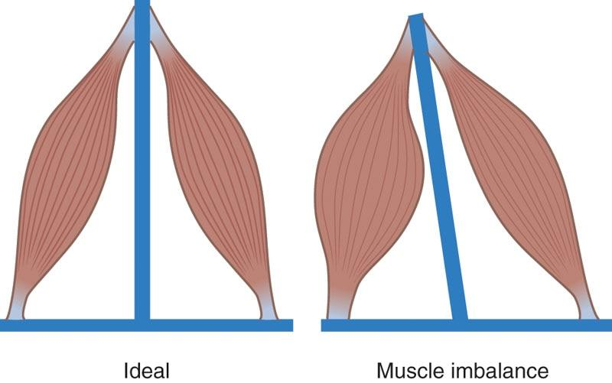

**Figure 12-1** Muscle imbalance

GETTING TECHNICAL

The terms *overactive* and *underactive* are used in this text to refer to the activity level of a muscle relative to another muscle or muscle group, not necessarily to its own normal functional capacity. When a muscle is overactive, it is in a state of elevated neural activity (compared to its antagonist muscle), which causes the muscle to be held in a chronic state of contraction. When a muscle is underactive, it is in a state of inhibited neural drive (compared to its antagonist muscle). This can cause the muscle’s functional antagonist to pull it into a chronically elongated state.

**Static postural assessment**

A static postural assessment allows the fitness professional to look for any deviations from optimal alignment of the body in a standing posture. Over time, these deviations can cause muscle imbalances or compromise joint mobility. A static postural assessment requires strong visual observation skills that are developed with time and practice, and it requires a systematic approach. Commonly, static postural assessments begin at the feet and travel upwards toward the head. The static postural assessment includes anterior, lateral, and posterior views to observe all the potential deviations from optimal posture. Leveraging the kinetic chain checkpoints enables the fitness professional to systematically view the body during stance and motion. Although each region of the body will be assessed individually, the fitness professional should think of the body as an interconnected system, where one joint or region has an impact on the others. For example, overactive hip flexors from prolonged sitting may cause an anterior pelvic tilt, which then causes lumbar (low-back) extension.

The static postural assessment administered by a fitness professional is a simplified version of a thorough evaluation that would be performed by a healthcare professional, such as a physical therapist or physician. In general, the fitness professional should look for neutral alignment, symmetry, balanced muscle tone, and common postural deviations.

The kinetic chain checkpoints refer to major joint regions of the body, including the following:

1. Feet and ankles
2. Knees
3. Lumbo-pelvic-hip complex (LPHC)
4. Shoulders
5. Head and neck

Anterior View (Figure 12-2)

1. Feet/ankles: Straight and parallel; not flattened or externally rotated
2. Knees: In line with toes; not in knee valgus (knock-kneed) or knee varus (bowlegged)
3. LPHC: Level pelvis; not rotated or hiked on one side
4. Shoulders: Level; not elevated or rounded
5. Head: Neutral position; not forward, tilted or rotated

Note: An imaginary line should begin between the feet, extending upward between the lower extremities, through the midline of the pelvis, and bisecting the trunk and skull.

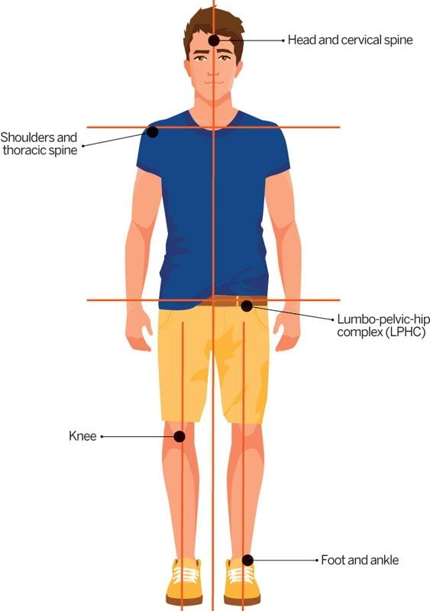

**Figure 12-2** Kinetic Chain Checkpoint Anterior View

Lateral View (Figure 12-3)

1. Feet/ankles: Leg vertical at right angle to sole of foot
2. Knees: Neutral position; not flexed or hyperextended
3. LPHC: Pelvis and lumbar spine in neutral position; not anteriorly (lumbar extension) or posteriorly tilted (lumbar flexion)
4. Shoulders: Shoulders aligned with ears; not excessively rounded
5. Head: Neutral position; not “jutting” forward

Note: An imaginary line should run through the lateral malleolus (lateral ankle bone), middle of the femur (thigh bone), center of shoulder, and middle of the ear.

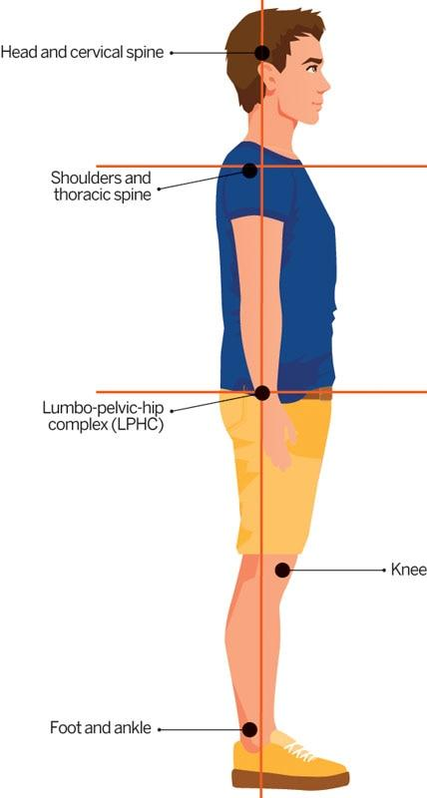

**Figure 12-3** Kinetic Chain Checkpoint Lateral View

Posterior View (Figure 12-4)

1. Foot/ankle: Heels are straight and parallel; Achilles tendon is vertical; calcaneus (heel bone) not excessively everted; weight is equally balanced between right and left sides
2. Knees: Neutral position, not in valgus or varus
3. LPHC: Pelvis is level; not rotated or hiked on one side
4. Shoulders/scapulae: Level; not elevated or protracted
5. Head: Neutral position; neither tilted nor rotated

Note: An imaginary line should begin between the feet, extending upward between the lower extremities, through the midline of the pelvis, and bisecting the trunk and skull. When examining exclusively the foot and ankle, an imaginary line should begin at the midline of the calcaneus (heel bone), extending upward along the Achilles tendon. The Achilles tendon should be vertical.

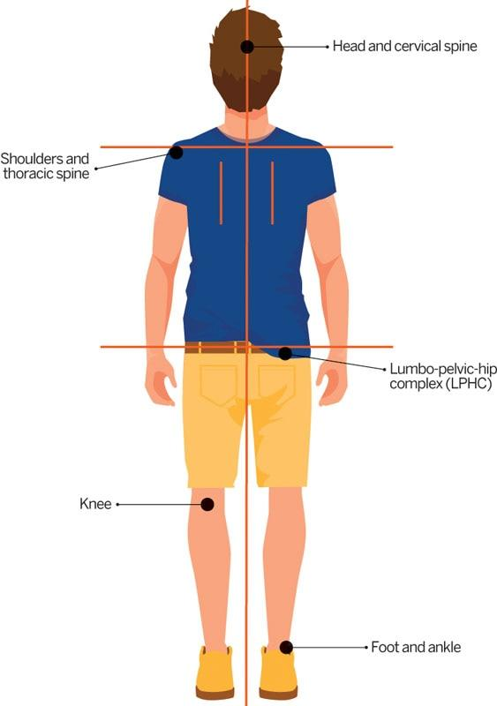

**Figure 12-4** Kinetic Chain Checkpoint Posterior View

**Common distortion patterns**

How a client presents in static stance is, in a sense, a roadmap of how they have been using their body with time. Interestingly, the body tends to compensate in observable patterns, causing predictable alterations in muscle function. For example, presentation of a forward head (head juts forward) and protracted (rounded) shoulders in static posture will typically be related to dysfunction of the muscles that surround the shoulder and neck areas and predictable patterns of muscle imbalance.

Three distortion patterns

Basic compensatory patterns were studied and described by Janda (2002) in the early 1970s. It is not to say that other compensations do not occur; he simply suggested that there was a cascading effect of deviations in static posture that would, more likely than not, present themselves in a particular pattern.

The three postural distortion patterns to be assessed during a static postural assessment include the pes planus distortion syndrome (developed by NASM) and the lower and upper crossed syndromes described by Janda.

1. Pes planus distortion syndrome: Characterized by flat feet, knee valgus, and adducted and internally rotated hips (Table 12-1)
2. Lower crossed syndrome: Characterized by an anterior pelvic tilt and excessive lordosis (extension) of the lumbar spine (Table 12-2)
3. Upper crossed syndrome: Characterized by a forward head and protracted (rounded) shoulders (Table 12-3).

TABLE 12-1 Pes Planus Distortion Syndrome

|  |  |
| --- | --- |
|  | Static Positions Ankle joints—pes planus (collapsed arch)  Knee joints—valgus and internally rotated  Hip joints—adducted and internally rotated  Potential Muscle Imbalances  Potential overactive muscles   * Gastrocnemius and soleus (calves) * Adductor complex (inner thighs) * Hip flexors (muscles near front of hips)   Potential underactive muscles   * Anterior and posterior tibialis (shin muscles) * Gluteus maximus and medius (butt muscles) |

TABLE 12-2 Lower Crossed Syndrome

|  |  |
| --- | --- |
|  | Static Positions Hip joints—flexed  Pelvis—anterior pelvic tilt  Lumbar spine—excessive lordosis (extension)  Potential Muscle Imbalances  Potential overactive muscles   * Hip flexors * Lumbar extensors (low-back muscles)   Potential underactive muscles   * Gluteus maximus and medius * Hamstring complex * Abdominals |

TABLE 12-3 Upper Crossed Syndrome

|  |  |
| --- | --- |
|  | Static Positions  Thoracic spine—excessive kyphosis (hunchback, flexed posture)  Shoulders—protracted (rounded forward) and internally rotated  Head and neck—jutted forward  Potential Muscle Imbalances  Potential overactive muscles   * Pectoralis major and minor (chest muscles) * Levator scapula and sternocleidomastoid (neck muscles) * Upper trapezius   Potential underactive muscles   * Middle and lower trapezius, rhomboids (mid-back muscles) * Deep cervical flexors (muscle deep within the neck) |

### Observing dynamic posture

Posture is often viewed as being static (without movement), but everyday posture is constantly changing to meet the demands placed on the body. Thus, once completing a static postural assessment, movement assessments (also known as dynamic postural assessments) should be performed.

The findings from the dynamic postural assessment should further reinforce the observations made during the static postural assessment. In addition, any issues not revealed during the static postural assessment may be observed during the dynamic postural observations and are often the quickest way to gain an overall impression of a client’s movement quality. Movement observations should relate to basic functions, such as squatting, balancing, pushing, and pulling. The observation process should search for any muscle imbalances or movement impairment patterns that may possibly lead to injury, both in and out of the fitness environment. With the limited time that most fitness professionals have for observation, incorporating a systematic assessment sequence is essential.

HELPFUL HINT

The faulty postures identified during a static postural assessment will likely appear during a movement assessment, but the same cannot be said in the opposite direction. When standing at rest, a client could have observably perfect posture; however, when tasked to perform a movement assessment, they may suddenly reveal movement impairments.

Like a static postural assessment, movement assessments require observation of the client’s five kinetic chain checkpoints. Although abnormal movement may be noticed at a specific joint, the cause of that impairment may be coming from a lack of mobility or stability from an adjacent region.

For example, a client may display knee valgus while squatting, but the cause of the movement impairment could be caused by hip or ankle dysfunction (or both). Each joint region has a specific biomechanical motion that it produces based on its own structure and function, as well as the joints above and below it (Janda, 2002; Nakagawa, 2012a; Powers, 2010; Sueki et al., 2013). When that specific motion deviates from its normal path, it is considered a movement impairment and can be used to presume possible muscle imbalance or joint dysfunction (Barton et al., 2013; Bolgla et al., 2008; Cichanowski et al., 2007; Nakagawa, 2012a, 2012b; Powers, 2010; Souza & Powers, 2009).

It should be noted that the term *movement impairment* is simply being used to describe a client’s abnormal movement when it deviates from optimal postural alignment while in motion. The fitness professional should be careful how they explain these movement impairments to the client to avoid embarrassing or discouraging them. Instead, the focus should remain on helping the client move more safely and efficiently.

**Overhead Squat Assessment**

The overhead squat assessment (OHSA) is typically the first movement assessment that is used for most clients. An individual’s movement quality during this assessment often provides valuable information about what areas of the body need to be addressed through focused exercise programming. The findings from this assessment can also serve as the basis for all additional movement assessments.

The overhead squat is designed to assess dynamic posture, core stability, and neuromuscular control (i.e., coordination) of the whole body during a squatting motion. Research suggests that the presence of movement impairments during squatting motions is predictive of the risk of musculoskeletal injuries in individuals who practice physical exercise (Eckard et al., 2018; Padua et al., 2018; Santos Bunn et al., 2018). Further, observational screening during the overhead squat is a valid method to identify movement impairments, such as knee valgus and limited ankle mobility (Padua et al., 2012; Post et al., 2017; Rabin & Kozol, 2017).

Recognizing movement impairments during the OHSA helps the fitness professional identify their clients’ muscle imbalances. Using this information, the fitness professional can create an exercise program that aims to correct these muscle imbalances by stretching identified overactive muscles and strengthening identified underactive muscles.

OHSA Starting Position (Figure 12-5)

1. The client stands on a flat, stable surface with the feet shoulder-width apart and pointing straight ahead.
2. The foot and ankle complex should be in a neutral position.
3. Ideally, the assessment should be performed with the shoes off to better view the client’s foot and ankle complex.
4. The client should raise their arms completely overhead with elbows fully extended.

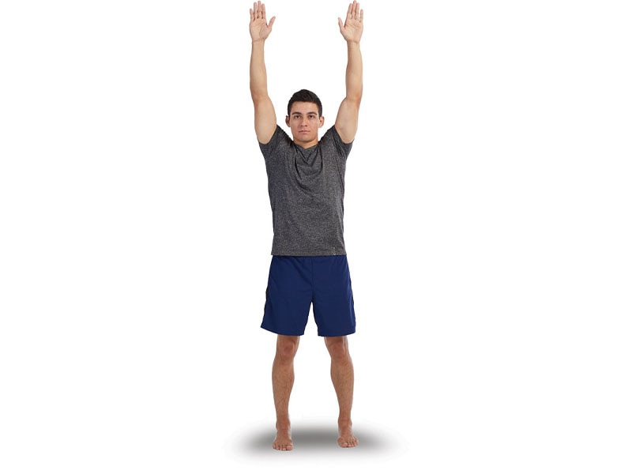 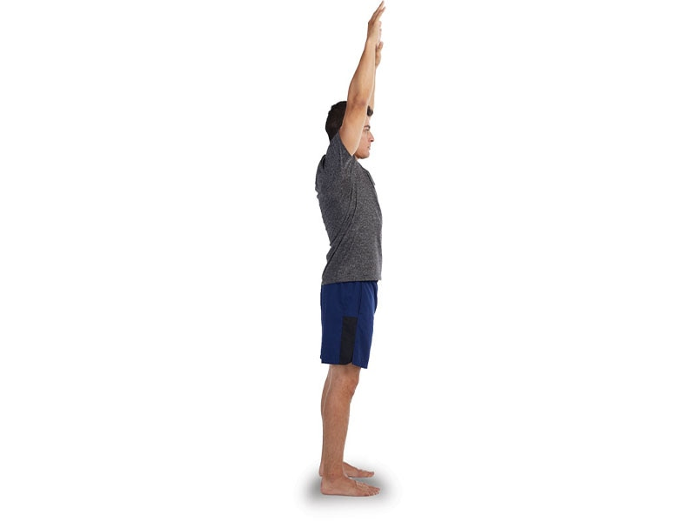

**Figure 12-5a** OHSA, starting position - anterior

**Figure 12-5b** OHSA, starting position - lateral

OHSA Movement (Figure 12-6)

1. The client should squat to a depth that brings the femur parallel to the ground (approximately chair height) and then return to the starting position. The squat depth can be reduced if the client has discomfort or is incapable of performing a squat to this depth.
2. The client will repeat the movement for approximately five repetitions, while the fitness professional views them from both the anterior and lateral vantage points.

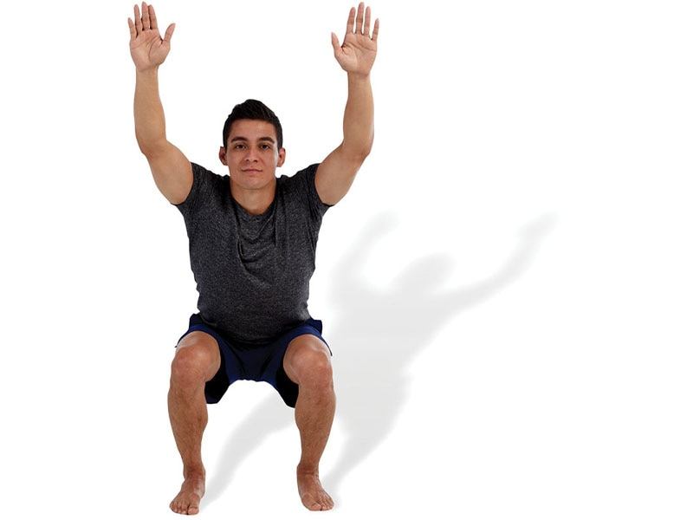 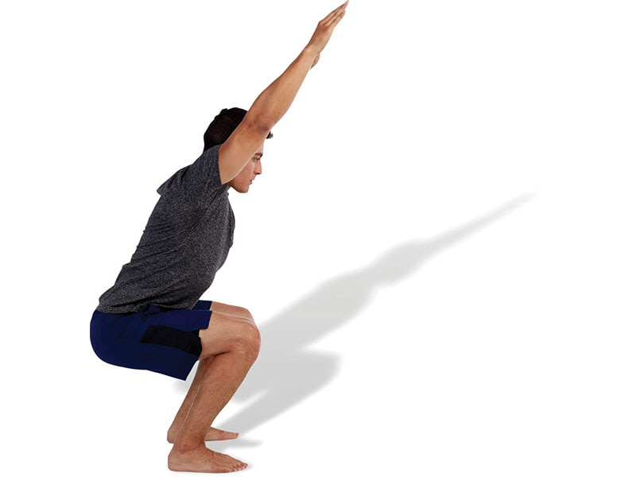

**Figure 12-6a** OHSA, movement - anterior

**Figure 12-6b** OHSA, movement - lateral

Anterior View

* Feet: View the feet and knees from the front. The feet should remain pointed straight forward, as if the client is on snow skis. A common movement impairment is the feet externally rotating (turning out) (Figure 12-7).
* Knees: The client’s knees should track straight forward and remain directly over the client’s second and third toes. A common movement impairment is knee valgus (knees caving inward) (Figure 12-8).

Lateral View

* View the LPHC and shoulders from the lateral view. Three common movement impairments observed from the lateral view include an excessive forward lean of the torso (Figure 12-9), an excessive low-back arch (Figure 12-10), or arms falling forward (Figure 12-11).

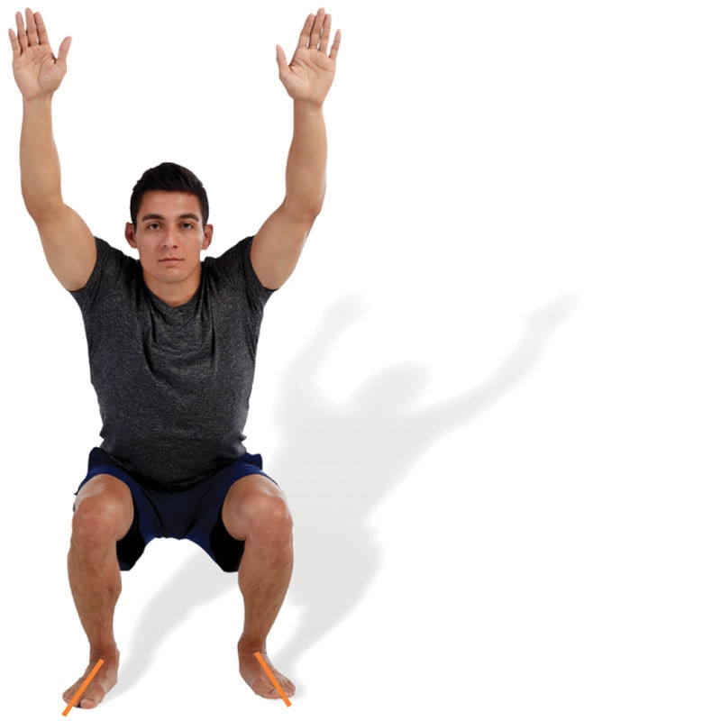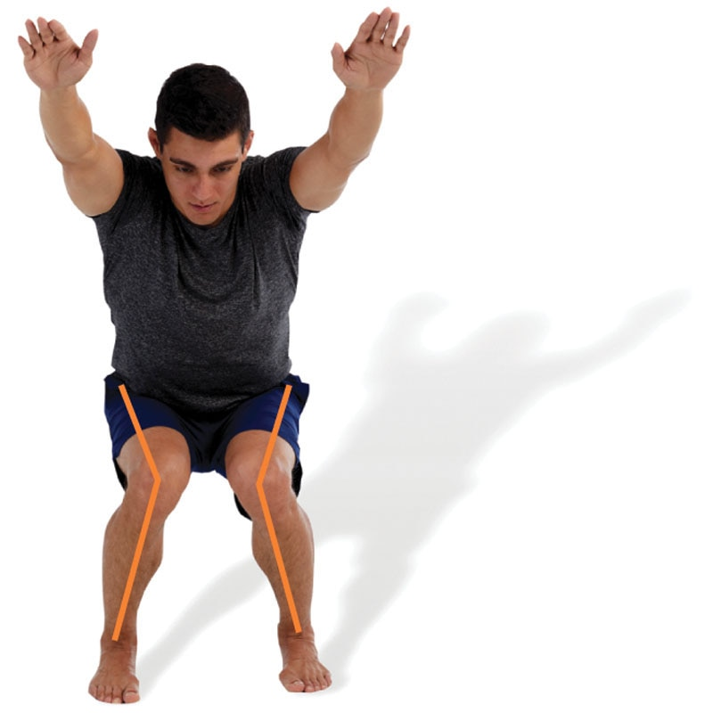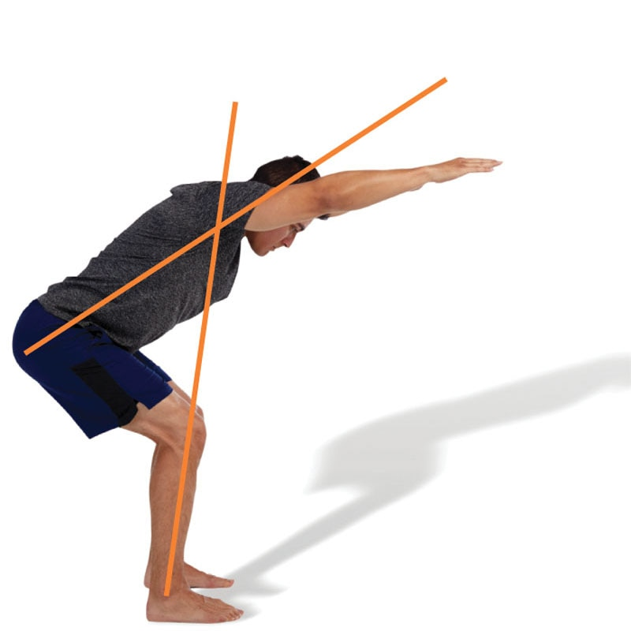

**Figure 12-7** Feet turn out

**Figure 12-8** Knees cave in

**Figure 12-9** Forward lean

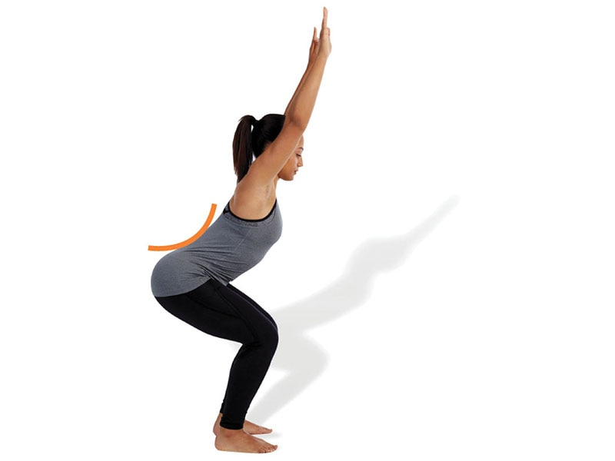 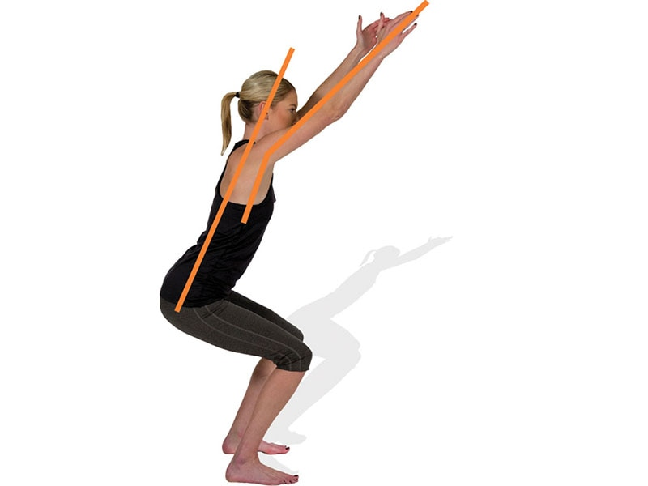

**Figure 12-10** Low-back arches

**Figure 12-11** Arms fall forward

When performing the OHSA, record all findings (Table 12-4) and then refer to Table 12-5 (on the following page) to determine potential overactive and underactive muscles that will need to be addressed through flexibility and strengthening techniques. Overactive muscles require stretching, whereas underactive muscles require additional strengthening to help correct the muscle imbalance.

TABLE 12-4 OHSA Observational Findings Sheet

| **View** | **Kinetic Chain Checkpoint** | **Movement Impairment** | **Result** |
| --- | --- | --- | --- |
| Anterior | Feet/Ankles | ❑ Turn out | ❑ Yes ❑ No |
| Knees | ❑ Valgus (knock knees) | ❑ Yes ❑ No |
| Lateral | LPHC | ❑ Forward lean of trunk | ❑ Yes ❑ No |
| LPHC | ❑ Low-back arches | ❑ Yes ❑ No |
| Shoulders | ❑ Arms fall forward | ❑ Yes ❑ No |

CRITICAL

The purpose of the OHSA is to observe a client’s movement patterns and identify movement impairments. These impairments indicate potential muscle imbalances. To correct each muscle imbalance, it is important to stretch the identified overactive muscles and strengthen the identified underactive muscles.

The overhead squat provides valuable information for the fitness professional to program mobility and strengthening exercises that are tailored to the client’s needs. This is the main reason the OHSA is recommended to screen a majority of clients during the first session and then periodically to monitor progress. Poor performance on this assessment can be discouraging for a new client, so fitness professionals should remember to keep a positive approach to explaining the benefits of addressing the various movement impairments a client may display. This assessment also provides the foundation for other assessments. The next lower-extremity assessment is the single-leg squat assessment, which is also a good test for balance.

TABLE 12-5 OHSA Solutions Chart

| **Joint** | **Viewpoint** | **Movement Impairment** | **Possible Muscle Imbalances** | **Visual Cues** |
| --- | --- | --- | --- | --- |
| Foot and ankle | Anterior | Turn out | Overactive   * Gastrocnemius/soleus (calves) * Hamstrings complex   Underactive   * Anterior and posterior tibialis (shin muscles) * Gluteus maximus and medius |  |
| Knee | Anterior | Valgus (cave in) | Overactive   * Tensor fascia latae (TFL)(muscle near front of hip) * Adductor complex (inner thigh muscles)   Underactive   * Gluteus maximus and medius * Anterior and posterior tibialis |  |
| LPHC | Lateral | Low-back arches | Overactive   * Hip flexors (rectus femoris, psoas, TFL) * Lumbar extensors (low-back muscles) * Latissimus dorsi (large back muscle)   Underactive   * Gluteus maximus * Hamstrings complex * Abdominals |  |
| Lateral | Excessive forward trunk lean | Overactive   * Hip flexors * Gastrocnemius/soleus * Rectus abdominis and external obliques (superficial abdominal muscles)   Underactive   * Gluteus maximus * Hamstrings complex * Lumbar extensors |  |
| LPHC and Shoulder | Lateral | Arms fall forward | Overactive   * Latissimus dorsi * Pectoralis major and minor (chest muscles) * Teres major (posterior shoulder muscle)   Underactive   * Middle and lower trapezius (mid-back muscle) * Rhomboids (muscles near shoulder blades) * Posterior deltoids (back of shoulder muscles) * Portions of the rotator cuff (small muscles that stabilize the shoulder) |  |

**Single-Leg Squat Assessment**

The single-leg squat assessment evaluates dynamic posture, lower-extremity strength, balance, and overall coordination in a single-limb stance. This test should be used for clients who have performed well in the OHSA, or if the fitness professional is considering single-leg exercises in their programming (single-leg squats, pistol squats, step-ups, etc.). This test is an effective assessment of an individual’s ability to balance, which is an important functional consideration for activities of daily living and exercise programming. This assessment should be avoided by clients who are at risk for falls or loss of balance or who are recovering from a lower- body injury.

The single-leg squat assessment has been shown to have strong inter- and intrarater reliability, meaning it can be evaluated consistently over time and between multiple professionals (Crossley et al., 2011; Garrick et al., 2018). Further, like the OHSA, observational screening during the single-leg squat is an accurate method to identify movement impairments, such as knee valgus (Harris-Hayes et al., 2014; Mauntel et al., 2013). The single-leg squat is observed from the anterior view.

### Single-Leg Squat Starting Position (Figure 12-12)

1. The client stands on a flat, stable surface, hands on the hips, and eyes focused forward.
2. The client lifts one foot approximately 6 in. off the floor. The stance foot, ankle and knee, and the LPHC should be in a neutral position and pointed straight ahead.

### Single-Leg Squat Movement (Figure 12-13)

1. The client squats as deep as possible (while maintaining balance) and returns to the starting position. The depth of the single-leg squat will be client dependent and will likely vary across populations.
2. The client performs up to five repetitions before switching sides.

Anterior View

* The client’s knee should track straight forward and remain directly over the client’s second and third toes. A common movement impairment is knee valgus (Figure 12-14).

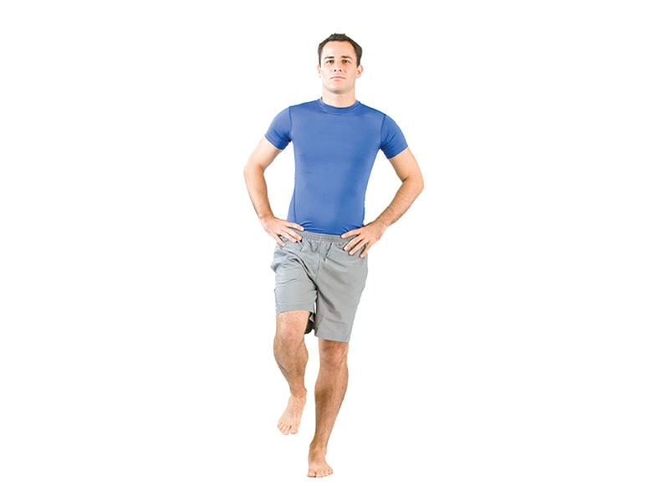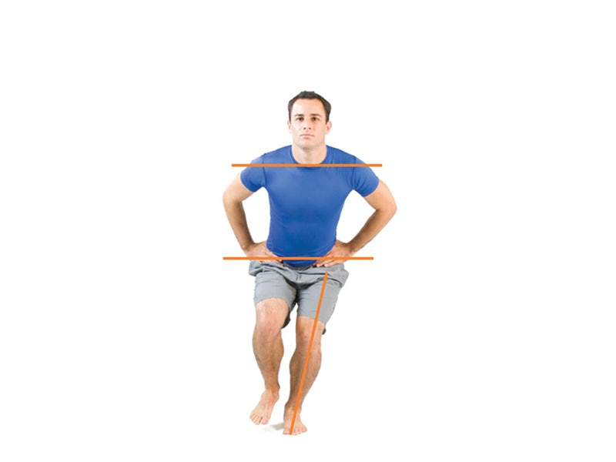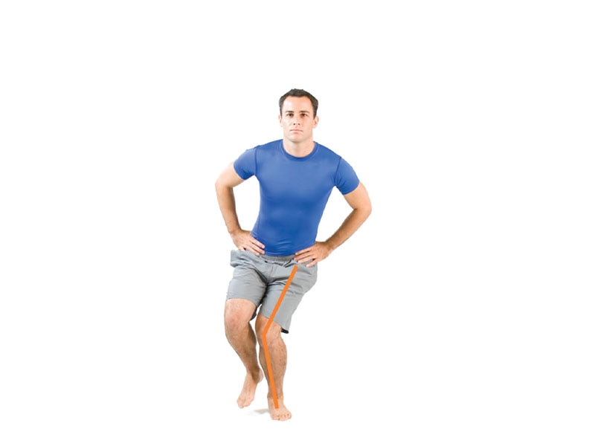

**Figure 12-12** Single-leg squat, starting position

**Figure 12-13** Single-leg squat, movement

**Figure 12-14** Single-leg squat, knee caves inward

When performing the single-leg squat assessment, fitness professionals should record all findings (Table 12-6) and then refer to Table 12-7 to determine potential overactive and underactive muscles that will need to be addressed through flexibility and strengthening techniques. Remember, overactive muscles require stretching, whereas underactive muscles require additional strengthening to help correct the muscle imbalance.

The single-leg squat assessment is much more challenging than the OHSA, but it provides valuable information for the fitness professional about the client’s ability to balance on one leg.

TABLE 12-6 Single-Leg Squat Observational Findings

| **Joint** | **Movement Impairment** | **Right or Left** |
| --- | --- | --- |
| Knee | ❑ Valgus | ❑ Right ❑ Left ❑ Both |
| Note: Mark right, left, or both based on the stance limb tested. | | |

TABLE 12-7 Single-Leg Squat Assessment Solutions Chart

| **Joint** | **Viewpoint** | **Movement Impairment** | **Possible Muscle Imbalances** | **Visual Cues** |
| --- | --- | --- | --- | --- |
| Knee | Anterior | Valgus (caves inward) | Overactive   * Tensor fascia latae (TFL) * Adductor complex   Underactive   * Gluteus maximus and medius * Anterior and posterior tibialis |  |

This assessment also requires much more strength than the overhead squat, which typically limits squat depth and stability. However, if the fitness professional plans to program single-leg exercises, it is a good idea to assess this pattern of movement first. As usual, fitness professionals should remember to only use this test if clients are stable enough to avoid falling or injuring themselves.

**Pushing assessment**

The pushing assessment is an assessment that challenges the upper extremities and trunk during a pushing movement. This type of assessment can be completed prior to a workout session or as an integrated part of the actual programming. The pushing assessment evaluates scapular and shoulder mechanics and stability of the LPHC, cervical spine, and head. The fitness professional should carefully evaluate all repetitions, because the client may demonstrate movement impairments as they become fatigued during the assessment.

Pushing assessment starting position (figure 12-15)

1. The client should stand in a narrow, split stance with the toes pointing forward and handles in each hand.
2. The fitness professional should choose a resistance that will challenge (but not exhaust) the client while executing 10 repetitions.

If the client is not able to perform a standing chest press in a narrow, split stance, use one of the following modifications:

* Option 1: The client stands in a wider split stance. This testing position still assesses the upper extremity and cervical spine and head, but it decreases the challenge to the LPHC and the client’s balance.
* Option 2: The client performs a pushing movement seated in a machine.

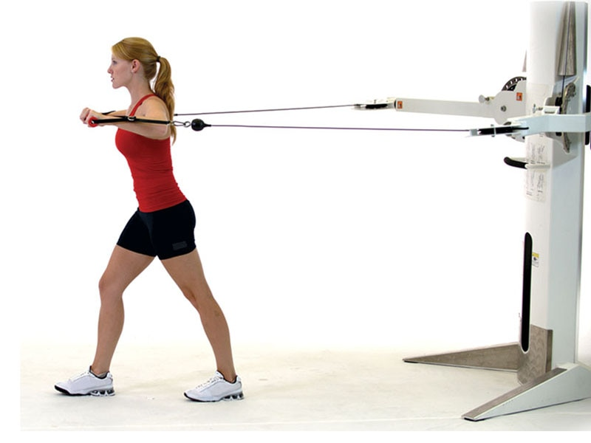

**Figure 12-15** Pushing assessment, starting position

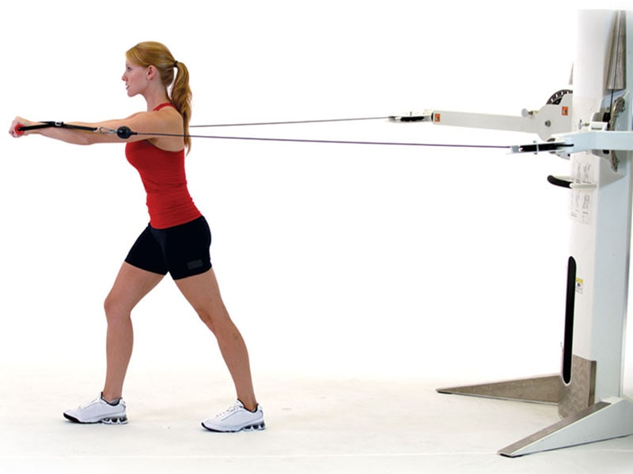

**Figure 12-16** Pushing assessment, movement

### Pushing Assessment Movement (Figure 12-16)

1. The fitness professional should instruct the client to push the handles away from their body and return to the starting position.
2. The client should use a slow repetition tempo.
3. The client should perform five repetitions in a split stance, switch legs, and then perform five additional repetitions.

Lateral View

* View the LPHC, shoulders, cervical spine, and head from the side. The lumbar and cervical spine should remain neutral while the shoulders stay level. Common movement impairments that may be observed include low-back arches (Figure 12-17), shoulder elevation (Figure 12-18), and head jutting forward (Figure 12-19).

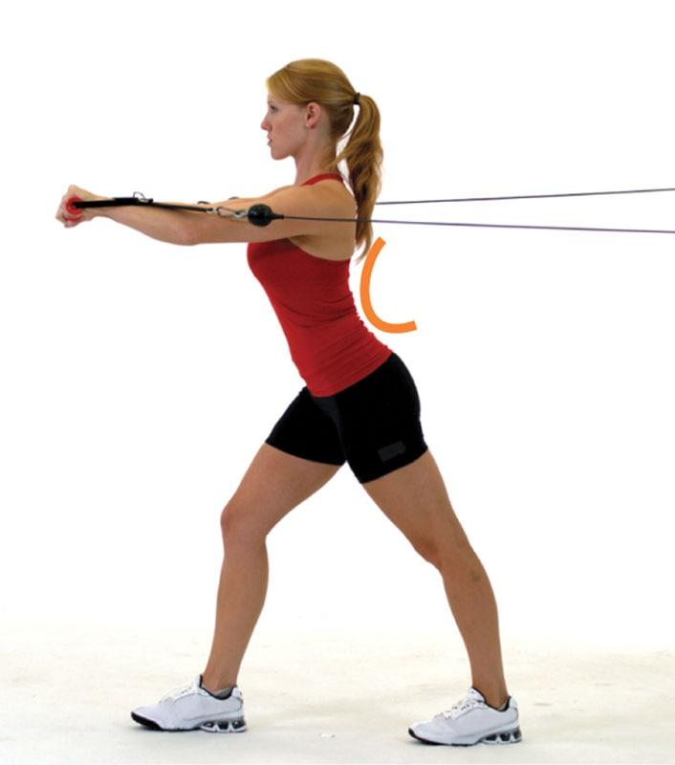

**Figure 12-17** Low-back arches

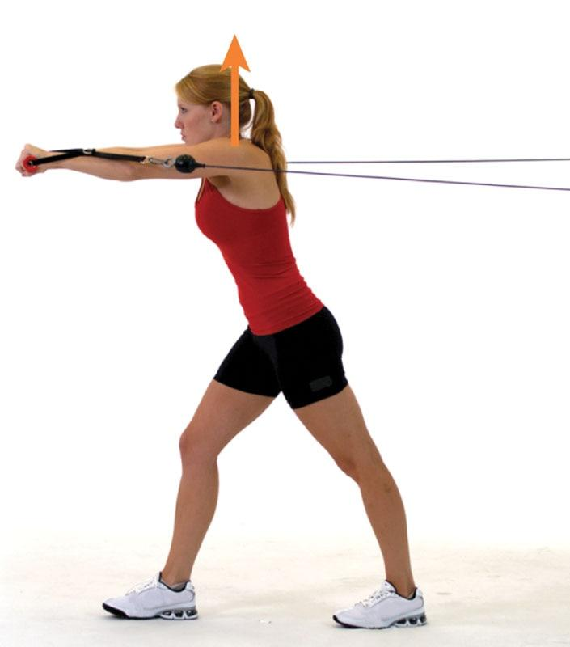

**Figure 12-18** Shoulders elevate

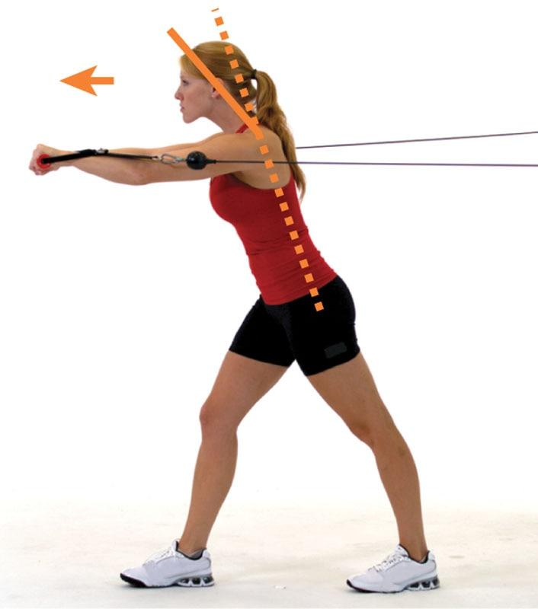

**Figure 12-19** Head juts forward

When performing the assessment, record all findings (Table 12-8) and then refer to Table 12-9 to determine potential causes of these movement impairments.

TABLE 12-8 Pushing Assessment Observational Findings

|  |  |  |
| --- | --- | --- |
| Kinetic Chain Checkpoint | Movement Impairment | Yes or No |
| LPHC | ❑ Low-back arches | ❑ Yes ❑ No |
| Shoulders | ❑ Shoulders elevate | ❑ Yes ❑ No |
| Head/Neck | ❑ Head juts forward | ❑ Yes ❑ No |

TABLE 12-9 Pushing Assessment Solutions Chart

| **Joint** | **Viewpoint** | **Movement Impairment** | **Possible Muscle Imbalances** | **Visual Cues** |
| --- | --- | --- | --- | --- |
| LPHC | Lateral | Low-back arches | Overactive   * Hip flexors (rectus femoris, psoas, TFL) * Lumbar extensors   Underactive   * Gluteus maximus * Hamstrings complex * Abdominals |  |
| Shoulder | Lateral | Scapular elevation | Overactive   * Levator scapulae (posterior neck muscles) * Upper trapezius   Underactive   * Lower trapezius |  |
| Head and neck | Lateral | Head juts forward | Overactive   * Levator scapulae * Sternocleidomastoid (anterior neck muscles)   Underactive   * Deep cervical flexors (deep neck stabilizer muscles) |  |

The pushing assessment can easily be integrated into a typical workout program, while providing useful information about the client’s shoulder mechanics and trunk stability during a pushing task. If the fitness professional plans to program pushing exercises, it is a good idea to assess this pattern of movement first.

**Pulling assessment**

The pulling assessment is an assessment that challenges the upper extremities and trunk during a pulling movement. This type of assessment can be completed prior to a workout session or as an integrated part of the actual programming. The pulling assessment evaluates upper-extremity strength, as well as stability of the LPHC, cervical spine, and head (Fenwick et al., 2009). Due to the narrow, split stance, this assessment also challenges the individual’s balance. The fitness professional should carefully evaluate all repetitions, because the client may demonstrate movement impairments as they become fatigued during the assessment.

Pulling assessment start (figure 12-20)

1. The client should stand in a narrow, split stance with toes pointing forward and handles in each hand.
2. The fitness professional should choose a resistance that will challenge (but not exhaust) the client while executing 10 repetitions.

If the client is not able to perform a standing row in a narrow, split stance, use one of the following modifications:

* Option 1: The client stands in a wider split stance to increase their base of support. This testing position still assesses the upper extremity and cervical spine and head, but it decreases the challenge to the LPHC and the client’s balance.

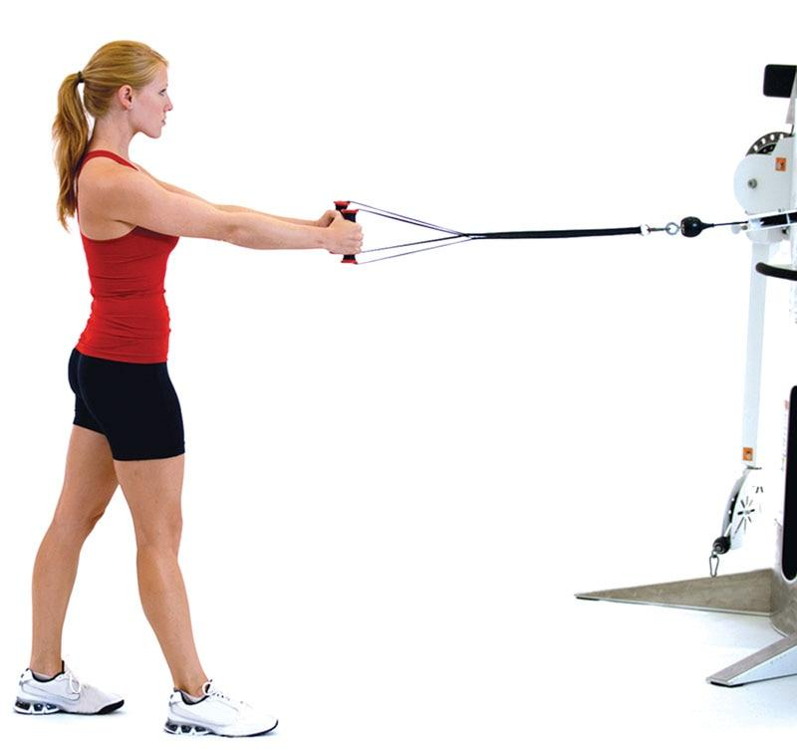

**Figure 12-20** Pulling assessment, start

* Option 2: The client performs a pulling movement seated in a machine.

Pulling assessment movement (figure 12-21)

* The client should pull the handle toward their body and return to the starting position.
* The client should use a slow repetition tempo.
* The client should perform five repetitions in a split stance, switch legs, then perform five additional repetitions.

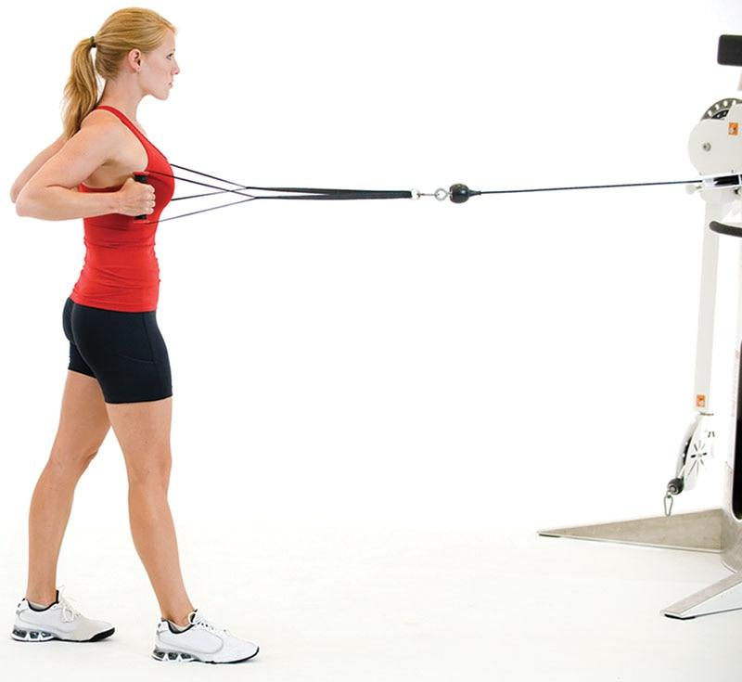

**Figure 12-21** Pulling assessment, movement

Lateral View

* View the LPHC, shoulders, cervical spine, and head from the side. The lumbar and cervical spine should remain neutral while the shoulders stay level. Common movement impairments that may be observed include low-back arches (Figure 12-22), shoulder elevation (Figure 12-23), and head jutting forward (Figure 12-24).

When performing the assessment, the fitness professional should record all findings (Table 12-10) and then refer to Table 12-11 (on the following page) to determine potential causes of these movement impairments.

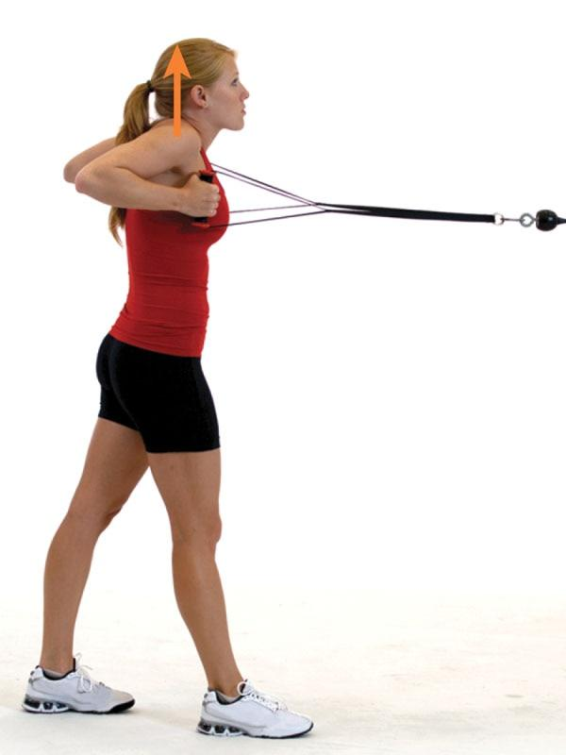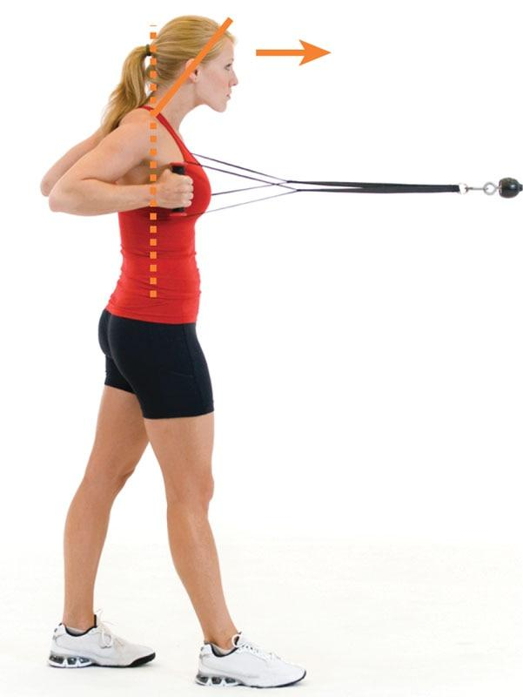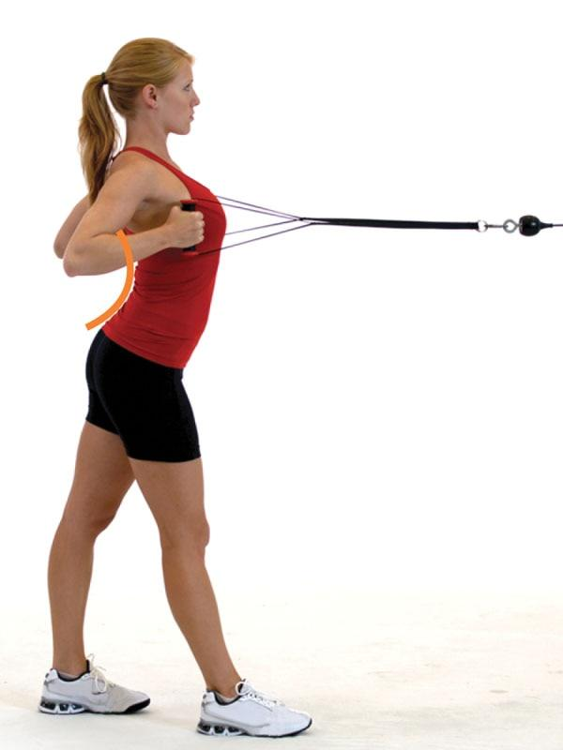

**Figure 12-23** Shoulders elevate

**Figure 12-24** Head juts forward

**Figure 12-22** Low-back arches

The pulling assessment can easily be integrated into a typical workout program, while providing useful information about the client’s shoulder mechanics and trunk stability during a pulling task. If the fitness professional plans to program pulling exercises, it is a good idea to assess this pattern of movement first.

TABLE 12-10 Pulling Assessment Observational Findings

| **Kinetic Chain Checkpoint** | **Movement Impairment** | **Yes or No** |
| --- | --- | --- |
| LPHC | ❑ Low-back arches | ❑ Yes ❑ No |
| Shoulders | ❑ Shoulders elevate | ❑ Yes ❑ No |
| Head/Neck | ❑ Head juts forward | ❑ Yes ❑ No |

TABLE 12-11 Pulling Assessment Solutions Chart

| **Joint** | **Viewpoint** | **Movement Impairment** | **Possible Muscle Imbalances** | **Visual Cues** |
| --- | --- | --- | --- | --- |
| LPHC | Lateral | Low-back arches | Overactive   * Hip flexors (rectus femoris, psoas, TFL) * Lumbar extensors   Underactive   * Gluteus maximus * Hamstrings complex * Abdominals |  |
| Shoulder | Lateral | Scapular elevation | Overactive   * Levator scapula * Upper trapezius   Underactive   * Lower trapezius |  |
| Head and neck | Lateral | Head juts forward | Overactive   * Levator scapulae * Sternocleidomastoid   Underactive   * Deep cervical flexors |  |

### Performance assessments

Performance assessments are typically used for clients looking to assess and improve athletic performance or specific fitness measures, because these assessments will measure overall strength, muscular endurance, power, and agility. However, the strength-based, performance assessments can also be used with clients who have experience with weight-lifting exercises and want to improve their strength in these movements.

To ensure these assessments are safe for clients, they should only be implemented after thorough static postural and movement assessments are completed. Further, it is important to determine if the client is ready for weighted and dynamic movements before initiating any of these assessments. Basic performance assessments include the following:

* Push-up test
* Bench press strength assessment
* Squat strength assessment
* Vertical jump
* Long (broad) jump
* Lower extremity functional test (LEFT)
* 40-yard dash
* Pro shuttle

**Push-up test**

The push-up test measures muscular endurance of the upper extremities during a pushing movement. The goal is to complete as many repetitions as possible, with good form, usually for a predetermined length of time (Fielitz et al., 2016). There are a variety of methods for performing this assessment, depending on the population being tested (e.g., older adults, youths, military). Below is information for a standard 60-second push-up test for apparently healthy adults. This test can be completed prior to a workout session or as an integrated part of the actual programming.

Push-up test position

1. The client should assume a push-up position with hands slightly outside of shoulder-width apart and elbows and knees fully extended and spine in a neutral position. If the client is not able to perform a standard push-up, the client can perform push-ups from a kneeling position.

Push-up test movement

1. The client lowers their body to achieve 90 degrees of elbow flexion before returning to the start position. They repeat this pattern for 60 seconds or until exhaustion.
2. All repetitions completed to the appropriate depth should be counted during the 60-second testing period.
3. The client should be reassessed at regular intervals (e.g., 4 to 6 weeks) to evaluate progress.

**Bench Press Strength assessment**

The bench press strength assessment is designed to assess maximal strength and estimate the one-rep maximum for the bench press exercise. This test is considered an advanced assessment for strength-specific goals and, as such, may not be suitable for all clients, especially those with limited experience with resistance training. Generally speaking, Certified Personal Trainers should not perform this assessment for clients with general fitness or weight-loss goals.

This assessment is most applicable for those seeking to assess their maximal strength capabilities. A proper warm-up is encouraged before beginning any maximal strength testing. Bench Press Strength Assessment Position

1. The client should lay on their back on a weight-lifting bench.
2. The low-back should be in a neutral position (avoid excessive arching).
3. Both feet should be firmly planted on the ground.
4. A comfortable weight should be used for the warm-up and initial repetitions of the testing.
5. The client will grasp the barbell with their hands slightly greater than shoulder-width apart.
6. Proper spotting by the Certified Personal Trainer is required during the testing.

Bench Press Strength assessment movement

1. The client, with assistance from the fitness professional, should unrack the weighted barbell, lower it to their chest, and press it back into full elbow extension. After completing three repetitions, the weight should then be re-racked.
2. The client should take a 2-minute rest.
3. Ten to twenty pounds (or 5% to 10% of initial load) should be added.
4. The client should repeat steps 1 through 3 until they are no longer comfortable adding weight or cannot complete a minimum of three repetitions.
5. The one-rep maximum estimation chart in Appendix A should be used to calculate one-repetition max.
6. The client should be reassessed at regularly scheduled intervals to measure progress.

**Squat Strength assessment**

The squat strength assessment is designed to estimate maximal strength and the one-rep maximum for the squat exercise. This test is considered an advanced assessment for strength-specific goals and, as such, may not be suitable for all clients. Certified Personal Trainers should not perform this assessment for clients with general fitness or weight-loss goals, or those with limited experience performing resistance training. This assessment is most applicable for those seeking to assess their maximal strength capabilities. A proper warm-up is encouraged before beginning any maximal strength testing.

Squat Strength assessment position

1. The client should stand with their feet approximately shoulder-width apart. The knees should be in line with the toes, and the low-back should be in a neutral position (avoid excessive arching). For safety reasons, it is important to avoid knee valgus during the duration of this assessment.
2. A comfortable weight should be used for the warm-up and initial repetitions of the testing. Clients should lower themselves under the racked barbell, placing it on their shoulders and grasping the barbell with their hands. Proper spotting by the Certified Personal Trainer is required during the testing.

Squat Strength Assessment Movement

1. The client should unrack the weighted barbell and step away from the squat rack. The client should then lower into a squatting position and return to the starting position. After completing three repetitions, the weight should then be re-racked.
2. The client should take a 2-minute rest.
3. Thirty to 40 pounds (or 10% to 20% of initial load) should be added.
4. The client should repeat steps 1 through 3 until they are no longer comfortable adding weight or cannot complete a minimum of three repetitions.
5. The one-rep maximum estimation chart in Appendix A should be used to calculate the client’s one-repetition max.
6. The client should be reassessed at regularly scheduled intervals to measure progress.

TRAINING TIP

The squat and bench press strength assessments are not recommended for most clients seeking weight loss or improvements in overall health. These assessments are typically reserved for clients seeking improvements in maximal strength, such as strength and power athletes (e.g., football linemen, powerlifters, Olympic weightlifters).

Moreover, these assessments are not required for determining appropriate training loads (weight) during resistance training exercise for the average weight-loss client. If the client has experience with resistance training, the fitness professional should ask about the weights they typically use and adjust accordingly. If the client does not have experience with resistance training, the fitness professional should use caution and select a relatively light weight that the client can safely handle while learning the movement patterns. After a few sessions, with some trial and error, appropriate training loads can be determined. An appropriate training load is a weight that can be performed for the desired number of repetitions with ideal form, with the last few repetitions a struggle to complete.

**Vertical Jump assessment**

The vertical jump assessment is designed to test maximal jump height and lower-extremity power. There are several variations of the test; however, the version discussed here requires the use of a Vertec vertical jump tester. This test is considered an advanced assessment for power and performance-specific goals and, as such, may not be suitable for all clients. Generally speaking, Certified Personal Trainers should not perform this assessment for clients with general fitness or weight-loss goals. This test is most appropriate for clients with athletic goals and seeking to assess lower-body power. A proper warm-up is encouraged before beginning any maximal performance testing.

Vertical Jump Assessment Position

1. The fitness professional should measure the standing reach of the client with one arm next to the Vertec.
2. The client should then stand in a ready position underneath the Vertec.

Vertical Jump Assessment Movement

1. The client should jump and touch the highest possible vane. No stepping, of any kind, is allowed prior to the jump.
2. The height difference between the standing reach and jumping height is calculated. Red vanes are spaced 6 inches apart, blue vanes 1 inch apart, and white vanes are spaced every 0.5 inches.
3. The client should take a 2-minute rest.
4. A second attempt should be provided. If the client increases their jump height on the second attempt, a third attempt is awarded.
5. The client should be reassessed at regularly scheduled intervals to measure progress.

**Long Jump assessment**

The long jump assessment, also known as the broad jump, is designed to test maximal jump distance and lower-extremity horizontal power. This test is considered an advanced assessment for power and performance-specific goals and, as such, may not be suitable for all clients. Generally speaking, Certified Personal Trainers should not perform this assessment for clients with general fitness or weight-loss goals. This test is most appropriate for clients with athletic goals and seeking to assess lower-body power. A proper warm-up is encouraged before beginning any maximal performance testing.

Long Jump Assessment Position

1. A tape measure should be extended along a nonslip surface, with a starting line marked with athletic tape.
2. The client should stand in a ready position behind the line.

Long Jump Assessment Movement

1. The client should jump forward as far as possible. It should be a 2-feet jump with a 2-feet landing. No stepping, of any kind, is allowed prior to or after the jump.
2. The jump distance should be measured from the starting line to the heels of the feet after landing.
3. The client should take a 2-minute rest.
4. A second attempt should be provided. If the client increases their jump distance on the second attempt, a third attempt is awarded.
5. The client should be reassessed at regularly scheduled intervals to measure progress.

**Lower extremity functional test**

The lower extremity functional test (LEFT) is designed to test lateral speed and agility (Figure 12-25). The LEFT is considered an advanced assessment for speed and performance-specific goals and, as such, may not be suitable for all clients. Generally speaking, Certified Personal Trainers should not perform this assessment for clients with general fitness or weight-loss goals. This test is most appropriate for clients with athletic goals and seeking to assess speed and agility. A proper warm-up is encouraged before beginning any maximal performance testing.

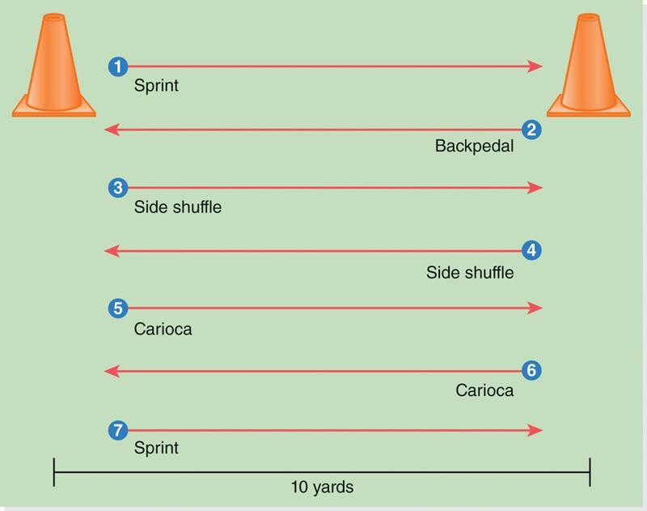

**Figure 12-25** Lower extremity functional test

LEFT Position

1. Two cones are spaced 10 yards (9.1 meters) apart on a nonslip surface.
2. The client should stand in a ready position behind cone one.

LEFT Movement

1. The client should complete the following sequence as quickly as possible.
   * Forward sprint to cone two.
   * Backpedal to cone one.
   * Side shuffle to cone two.
   * Side shuffle to cone one.
   * Carioca to cone two.
   * Carioca to cone one.
   * Forward sprint to cone two.
2. The timer should start at the first movement and end when the client runs past the final cone.
3. The client should be reassessed at regularly scheduled intervals to measure progress.

**40-Yard Dash assessment**

The 40-yard dash assessment is designed to test reaction capabilities, acceleration, and maximal sprinting speed (Figure 12-26). The 40-yard dash assessment is considered an advanced assessment for speed and performance-specific goals and, as such, may not be suitable for all clients.

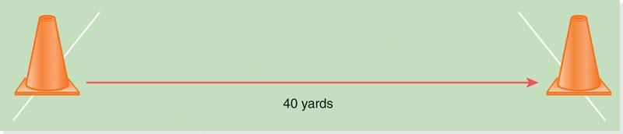

**Figure 12-26** 40-yard dash assessment

Certified Personal Trainers should not perform this assessment for clients with general fitness or weight-loss goals. This test is most appropriate for clients with athletic goals seeking to assess straight-ahead sprinting speed. A proper warm-up is encouraged before beginning any maximal performance testing.

40-Yard Dash Assessment Position

1. Two cones are spaced 40 yards (36.6 meters) apart or use an American football field with clearly indicated yard lines.
2. The client should stand in a ready position behind cone one.

40-Yard Dash Assessment Movement

1. The client should sprint as quickly as possible to the 40-yard marker.
2. The timer should start at the first movement and end when the client hits the 40-yard mark.
3. The client should be reassessed at regularly scheduled intervals to measure progress.

**Pro Shuttle assessment**

The pro shuttle (5-10-5) assessment is designed to assess acceleration, deceleration, agility, and control (Figure 12-27). This test is considered an advanced assessment for speed and performance-specific goals and, as such, may not be suitable for all clients. Generally speaking, Certified Personal Trainers should not perform this assessment for clients with general fitness or weight-loss goals. This test is most appropriate for clients with athletic goals seeking to assess agility and sprinting speed. A proper warm-up is encouraged before beginning any maximal performance testing.

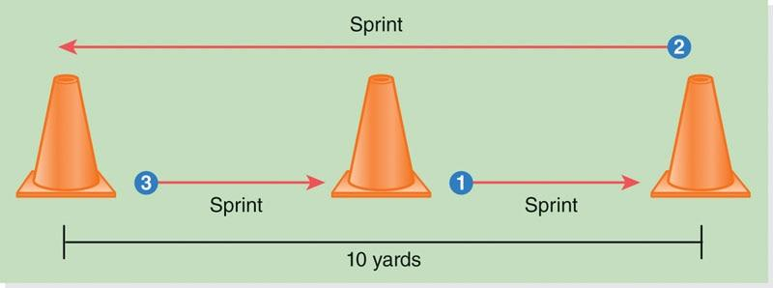

**Figure 12-27** Pro shuttle (5-10-5) assessment

Pro Shuttle Assessment Position

1. Two cones are spaced 10 yards (9.1 meters) apart, with a third cone in the middle (5 yards from other cones).
2. The client should stand in a ready position next to the middle cone.
3. The timer should stand facing the middle cone.

Pro Shuttle Test Movement

1. The client should sprint as quickly as possible in the following pattern:
   * Cone one to cone two
   * Cone two to cone three
   * Cone three to cone one
2. The timer should start at the first movement and end when the client passes the middle cone at the end of the sprint pattern.
3. The client should be reassessed at regularly scheduled intervals to measure progress.

### Implementing Fitness Assessments

After implementing a thorough health screening, administering postural, movement, and performance assessments provide an opportunity for fitness professionals to establish a baseline for their client’s functional status. Since Certified Personal Trainers will work with a wide range of clients, it is helpful to evaluate static and dynamic posture prior to designing and implementing a fitness program to help provide insight to the physical capabilities and limitations of the client. These assessments will provide a baseline level of function as well as postural and movement impairments that need to be corrected throughout the programming. This information will also help inform the selection of exercises and intensity at which an individual can perform. Lastly, performing these assessments before implementing an exercise program will provide a baseline from which to evaluate progress in static posture, movement quality, and dynamic performance. The following list describes the benefits of conducting and implementing fitness assessments:

1. Assessing a client’s static posture allows for a quick understanding of how they position their body during the day.
2. Movement and performance assessments demonstrate a baseline of the client’s functional status in a wide range of tasks.
3. Movement assessments are helpful to identify and correct movement impairments and potential muscle imbalances.
4. Strength-based assessments allow the fitness professional to accurately assess a client’s maximal strength capabilities.
5. Performance assessments allow for careful tracking of athletic performance (e.g., power, speed, agility, muscular endurance).

**Sequencing assessments**

Certified Personal Trainers can use static postural and overhead squat assessments as recruiting tools for prospective clients. By offering these assessments, often complimentary, clients are more likely to engage with the fitness professional and begin to build trust in their expertise. The fitness professional can encourage the client by telling them good things about their posture and movement, while also pointing out any impairments that they can help correct with a focused exercise program.

For example, if a client agreed to participate in a complimentary OHSA, the fitness professional may be able to identify a common pattern of excessive knee valgus during the squat. The fitness professional could then tell the client how they were impressed with their squat depth but how important it is to maintain good alignment during the squat for long-term knee health. This would then be a natural time to show some simple modifications to their technique and explain how a focused exercise plan, with proper supervision, could help the client to squat more safely and effectively.

Onboarding and sequencing assessments

All movement assessments should begin with a standing, static postural assessment. Any postural distortions can affect the length-tension of muscles and increase stress on the body throughout a person’s day. As a result, it is important for the fitness professional to have confidence in evaluating static standing posture, which will also serve as the foundation for movement and performance assessments.

Following a static postural assessment, the fitness professional should implement an OHSA to evaluate dynamic posture, core stability, and neuromuscular control. This assessment will begin to expose various movement impairments that can be addressed with an individualized fitness program. Further, a single-leg squat assessment can then be used to test single-leg balance and challenge the client with a more demanding movement.

If the fitness professional has time, they can then implement upper-extremity pushing and pulling assessments to gain more information about how the client uses their upper body while stabilizing their trunk. These tests can be administered prior to a workout session or as an integrated part of the actual programming.

As a group, static postural and movement assessments provide a good overview about how the client positions and moves their body during everyday tasks. Any postural distortions or movement impairments can then be addressed with a focused exercise program, by stretching the identified overactive muscles and strengthening the identified underactive muscles.

If the client complains of pain during any of the movement assessments, further evaluation by a medical professional is recommended.

It is not recommended to work with a client who is currently experiencing pain without proper clearance and direction by their physician.

Lastly, when working with an athletic population, it may be appropriate to implement various performance assessments. This is not common when working with the general population, but it may be necessary to help a client with athletic goals. These assessments can be selected based on the movement demands of the client’s sport. For example, a vertical jump test is commonly used with basketball athletes, whereas the pro shuttle is used with soccer athletes. These assessments help inform the exercise program design and can be used to track progress over time.

Sequencing all assessments

It is important for all assessments to be sequenced in a specific order to help guarantee accurate results (Figure 12-28). For example, the fitness professional should always begin the assessments process with a preparticipation health screening (PAR-Q+, health history questionnaire), physiological (resting heart rate and blood pressure), and body composition (BMI, circumference, body fat percentage) assessments prior to performing assessments that require physical exertion (see Chapter 11). Physical exertion can skew the results of these assessments.



**Figure 12-28** Sequencing assessments

Once these assessments have been completed, the next step is to perform static postural and movement assessments. Lastly, cardio (aerobic/VT1 and anaerobic/VT2) tests and performance assessments can be administered. The fitness professional should choose to perform cardio and performance assessments on separate days to ensure the client’s energy levels are fresh to maximize accuracy of these assessments.

However, performance assessments that cause little fatigue (e.g., vertical jump test, horizontal jump test) can be administered prior to cardio tests if sufficient rest periods are provided. If an exercise program is properly designed by the Certified Personal Trainer, the client should experience improvement in each assessment over time.

**Opportunity for rapport building**

Many clients come into the gym or training centre intimidated by all the equipment and lacking knowledge about how to properly create exercise programs. They may also be fearful that they will become injured or push too hard during an exercise session. In these cases, postural, movement, and performance assessments are excellent tools for building trust and rapport with current and potential clients. These assessments, when implemented with confidence and compassion, can display a high level of expertise by the fitness professional and help a Certified Personal Trainer stand out among the competition. They also open the door for the fitness professional to discuss potential movement impairments and opportunities for improvements in posture and movement. Further, they help the fitness professional to carefully design an exercise program that is uniquely individualized for each and every client. With regular practice, these assessments will provide a roadmap for the development and execution of quality fitness programs.

**Reassessment**

Postural, movement, and performance assessments provide an important baseline from which to measure progress. Fitness professionals should carefully document the findings from these assessments to be referred to at a later time. Depending on the environment and client’s training schedule, it is recommended to reassess the client every month, or quarterly, to measure the progress they have gained from staying consistent with their fitness plan. The following are a few positive reasons to reassess clients on a regular basis:

1. It provides positive encouragement to clients and serves as a helpful reminder for them to continue working hard toward the goals they have set.
2. It helps clients realize how the exercise programming provided by their Certified Personal Trainer is making a difference in their fitness level, which helps foster adherence to the exercise program.
3. It provides an opportunity for fitness professionals to refine or progress exercises as their clients’ abilities improve.

**Considerations and modifications**

Due to the wide range of clients a fitness professional will work with, it is important to recognize and implement assessment modifications for certain populations with movement restrictions or safety concerns. The fitness professional should always use caution when implementing movement and performance assessments and only progress them once the client demonstrates the ability to perform advanced movements.

For example, if during the OHSA the client seems very unstable or lacking enough strength to smoothly lower and raise from the squat, it would not be a good idea to progress them to a single-leg squat. The fitness professional may instead choose to implement the pulling and pushing assessments. However, rather than requiring a narrow, split stance during the pulling and pushing assessments, it might be better to use a seated chest press or rowing machine to limit the balance challenge of the task. They key is to make sure that clients are comfortable and safe during the assessments, especially if they have any conditions that may limit full participation in the various assessments.

**Overweight and obese clients**

Prior to working with overweight and obese populations, a thorough preparticipation health screening must be completed. Also, note that overweight and obese clients show a large spectrum of abilities, from highly functional and strong to significantly limited in their movement quality and confidence. Fitness professionals should not make assumptions about anyone’s ability, but rather use the results from a systematic postural and movement assessment to help inform their approach. Standing postural assessments may be more challenging due to the amount of body mass that covers bony landmarks, but this will still be the first step in the assessment process. Next, an OHSA should be used to evaluate whole body movement and stability. If the overweight or obese client appears unstable or at risk of falling, a modified overhead squat with reduced range of motion can be used instead. If the overweight or obese client performs confidently and is stable in the overhead squat, a single-leg squat may be helpful to evaluate balance, but it is not necessary and depends on the fitness professional’s evaluation.

Performance assessments are also not necessary for many overweight or obese clients, as these clients are typically seeking to improve body composition and health measures, not athletic performance. Assessment considerations for overweight and obese clients include the following:

1. Ensure a thorough preparticipation health screening is completed.
2. Avoid making assumptions about the overweight or obese client’s ability, and instead, allow results from posture and movement screening to help determine their functional status.
3. Consider limiting movements that require an overweight or obese client to get on and off the ground.

Assessment modification options for overweight and obese clients include the following:

1. Consider modifying the overhead squat with a reduced squat depth.
2. Skip the single-leg squat for overweight and obese clients, unless they show adequate strength and stability during the OHSA.
3. Perform pushing and pulling assessments in a standing position or with the use of machines for improved stability and comfort.

**Youth clients**

With increased use of technology and long hours seated in classroom environments, even youth clients will present with postural distortions. As a result, static postural assessments are recommended and should be performed before movement assessments. Overhead squat, single-leg squat, pushing, and pulling assessments should also be used to determine the client’s functional status and movement quality. In many cases, movement impairments for youth are the result of limited strength and poor motor control.

Youth clients can benefit from performance assessments, especially if the child plays sports. The most important things to consider, however, are the youth’s maturity level and goals. Is the youth seeking weight loss or improved athletic performance? This information will determine the most appropriate assessments to conduct. Note that one-repetition maximum tests (bench press and squat) would not be appropriate for most youth clients. Instead, select muscular endurance and cardiovascular assessments, unless measuring absolute strength is vitally important for the child’s goals and the child has the maturity level and exercise experience to handle such assessments.

Assessment considerations for youth include the following:

1. The OHSA should be used to begin learning about the youth client’s functional abilities and to determine if they are ready for the single-leg squat assessment.
2. Assumptions about the youth client’s ability should be avoided, and instead, results from postural and movement screenings should be used to help determine their functional status.
3. Youth clients should typically not be challenged with maximum strength testing due to their developmental stage of life and lack of maturity needed for such assessments.
4. Many movement impairments will be the result of a lack of strength or motor control in the youth populations.

Assessment modification options for youth include the following:

1. Implementation of muscular endurance assessments should be considered instead of maximum strength testing.
2. Performance assessments, such as the push-up test, LEFT, and pro shuttle assessment, may be a fun way to keep youth clients engaged, while also testing their muscular endurance, power, and agility.

**Older adult clients**

Preparticipation health screening should be conducted for older adult clients prior to any other assessments. Once it is determined that the individual can safely proceed, the goal of the assessment process is to determine the older adult’s functional status. Some of the typical movement assessments may need to be modified for this population. After a static postural assessment, a modified OHSA (limited range of motion) may need to be administered. In many cases, a single-leg squat test is not safe for this population, unless the client displays remarkably good strength and stability during the OHSA. Upper-extremity pushing and pulling assessments should typically be performed in a standing position with light resistance from a cable pulley or seated in a machine. Performance assessments are typically not appropriate for older adult clients unless they are an athlete and have specific athletic goals. Assessment considerations for older adults include the following:

1. A thorough preparticipation health screening should be completed prior to further testing.
2. Assumptions about the older adult’s ability should be avoided, and instead, results from postural and movement screenings should be used to help determine their functional status.
3. Movements that require senior clients to get on and off the ground may need to be limited depending on the client’s functional status.
4. The assessment process should be started conservatively and then progress to more challenging movements based on the client’s goals and abilities.

Assessment modification options for older adults include the following:

1. The overhead squat may need to be modified with a reduced squat depth.
2. The single-leg squat for older adult clients should be skipped, unless they show exceptional strength and stability during the OHSA.
3. Pushing and pulling assessments should be performed in a standing position or with the use of machines for improved stability and comfort.

**Prenatal clients**

The types of assessments performed for prenatal clients depend on their goals and stage of pregnancy. The most important assessment for a prenatal client is a preparticipation health screening. Medical clearance, prior to exercise, by the client’s physician is also recommended. It is presumably safe to perform most assessments with prenatal clients in their first trimester. However, precautions must be made for clients in their second and third trimesters. Performance assessments are likely not necessary for prenatal clients, unless the client is an athlete with medical clearance to continue vigorous exercise. In all cases, prone and supine positions should be avoided for prenatal clients in their second and third trimesters; instead, opt for seated or standing assessments. Assessment considerations for prenatal clients include the following:

1. Thorough preparticipation health screening and medical clearance should be obtained prior to further testing.
2. Assumptions about a prenatal client’s ability should be avoided, and instead, results from postural and movement screenings should be used to help determine her functional status.
3. The prenatal client’s concerns about movements or activities should be noted, and she should not be forced into any assessments that she is not comfortable with.
4. Movements that require a prenatal client to get on and off the ground should be limited.
5. The assessment process should start conservatively and then progress to more challenging movements based on the prenatal client’s goals and abilities.
6. Prone and supine positions should be avoided for prenatal clients in their second and third trimesters.

Assessment modification options for prenatal clients include the following:

1. The overhead squat may need to be modified with a reduced squat depth, especially for clients in their second or third trimesters.
2. Skipping the single-leg squat assessment is recommended for prenatal clients.
3. Pushing and pulling assessments should be performed in a standing position or with the use of machines for improved stability and comfort.

# Integrated Training and the OPT Model

According to the Merriam-Webster dictionary (2019), to integrate means to “form, coordinate, or blend into a functioning or unified whole.” In the world of food, a common lunch menu item is the chef salad (Figure 13-1). When we mix together or form this salad, the ingredients are as follows: lettuce as the base, hard-boiled eggs, deli ham, deli turkey, tomatoes, cucumbers, and cheese. This integrated approach to a salad shows that many ingredients can be included in this dish to provide a flavorful and enjoyable experience. At any point, this salad can be customized to the likes of the person who wants to eat it. For example, a patron who is lactose-intolerant can substitute the cheese with extra eggs or croutons, or a vegan can substitute more vegetables in replacement of eggs and deli meat.

An exercise program can follow a similar strategy. For instance, just like removing cheese from the chef salad, fitness professionals can opt out of heavy squatting to accommodate a client who was recently released from physical therapy due to a knee injury. Instead, the fitness professional can substitute core and balance drills to make that training session more tailored to their client’s needs and abilities. When fitness professionals take an integrated approach to exercise, their programs become well balanced while reducing boredom and can maximize results.

Integrated training is a concept that combines all forms of exercise into one system: flexibility; cardiorespiratory; core; balance; plyometric; speed, agility, and quickness; and resistance training. It is an all-inclusive approach to exercise that can lead to improvements in overall health, wellness, and athletic performance.

Using integrated training principles, a Certified Personal Trainer will discover many new and exciting exercises, movements, and other variables to add to their professional toolbox. As a result, fitness professionals will be able to create customized exercise programs for their clients that provide several benefits:

* Psychological benefits, such as stress relief, improved mood, and improved sleep
* Physiological benefits, such as improved cardiovascular, respiratory, and endocrine (hormone) functionality
* Body composition benefits, such as fat loss and increased lean muscle mass
* Performance benefits, such as increased flexibility, endurance, strength, and power.

A fitness professional can benefit a great deal from implementing integrated training with their clients because of the variety of exercises involved. According to DiStefano et al. (2013), integrated training programs incorporating different types of training in a multiplanar fashion are more optimal than isolated resistance training programs. Areas of improvement were found in movement quality, speed and agility, strength, endurance, flexibility, and power. This does not mean that isolated training is ineffective, but when the fitness professional intends to provide the greatest changes to their clients, integrated training improves more variables than isolated training. Research has indicated that a multidimensional, or integrated, training approach can provide a greater effectiveness to an exercise program than an isolated resistance program (Reilly et al., 2009). This indicates that if the fitness professional implements an integrated approach, the client can benefit to a higher extent by incorporating more variables aimed at creating specific results based on client goals, needs, and abilities.

However, it is important to note that integrated training principles involve more than a variety of exercises. Additional principles that must be observed include training in a systematic and progressive fashion, training fundamental movement patterns, training with optimal posture, training for optimal range of motion, training in all planes and motion, manipulating acute variables (e.g., sets, reps, and rest periods), and designing exercise programs based on assessment results.

**Training in a systematic and progressive fashion**

When a house is built, construction companies must use a systematic and progressive approach to ensure its solidity and stability, starting with the foundation. The outcome would be vastly different if a house was built directly on the ground versus a concrete slab foundation. For example, the walls and roof may become uneven or unstable, thus reducing the overall integrity of the house.

The same is true for exercise. Like a house, the body must also have a solid foundation of fitness before embarking on an intense training regimen. It is illogical and potentially dangerous for a fitness professional to recommend exercises that are too advanced or physically demanding for their clients. It may also cause frustration and reduce a client’s own self-efficacy. Fitness professionals should guide their clients to first build a solid foundation that includes appropriate levels of aerobic and muscular endurance, joint mobility and stability, and core strength. This is best accomplished by using a systematic and progressive approach to program design. If an exercise program is progressive and systematic, using a progressive overload approach, the body sufficiently adapts to the new demands placed on it and consequently becomes stronger and more resilient. Conversely, skipping steps may do more harm than good (Table 13-1).

TABLE 13-1 Skipping Steps Versus a Progressive and Systematic Plan

| **Skipping Steps** | **Progressive and Systematic** |
| --- | --- |
| 1. Possible increased risk of injury 2. Potential client frustration because of inability to correctly perform exercises 3. Client’s goals may be delayed more than expected or may not be achieved 4. Lack of measurement and tracking; unable to track client success 5. Inconsistent exercise programming | 1. Decreased risk of injury or overtraining 2. Increased client adherence to the exercise program 3. Clients more likely to achieve goals 4. Ability to track client successes and setbacks 5. Consistent exercise programming with progressive overload |

TRAINING TIP

Goal setting, constant monitoring, and assessing clients at the appropriate times provide feedback to the fitness professional, so that they can adjust and deliver a systematic approach to all exercise sessions. Without completing these tasks, the fitness professional takes the chance of not getting the appropriate feedback, which is critically important for making the necessary changes for the client to experience continuous improvement.

**Training fundamental movement patterns**

Fundamental movements patterns are a necessity for all fitness professionals to demonstrate and teach to their clients. Fitness professionals must ensure their clients’ mastery of these movement patterns to minimize injury risk and increase exercise effectiveness. Most exercises involve at least one of these movement patterns; though more movement patterns exist, and many of these patterns can be combined into a single exercise:

1. Squatting
2. Hip hinge
3. Pulling motions
4. Pushing motions
5. Vertical pressing

Categorizing exercises according to movement patterns is an effective method for assisting fitness professionals when designing exercise programs. Historically, resistance training programs were developed and implemented according to isolated body-part training. This is especially true with regards to bodybuilding and those seeking to alter their body composition. For example, the individual may choose to train their chest and triceps on Monday, back and biceps on Tuesday, legs on Wednesday, and shoulders and arms on Thursday.

While isolated body-part training is still an effective method for increasing muscular hypertrophy (Gomes et al., 2019), designing exercise programs based on movement patterns may provide enhanced adaptations when compared to isolated resistance training, such as enhancing neuromuscular coordination and athleticism. A movement pattern exercise design can include many variations. For example, the individual may choose pushing patterns on Monday, pulling patterns on Tuesday, squatting and hip hinging on Wednesdays, and vertical pressing on Thursdays. There are almost limitless possibilities.

TRY THIS

Not only should a fitness professional incorporate diverse movement patterns into their client’s training program, they should also master these movements for their own benefit. When instructing a client, fitness professionals must be able to explain, demonstrate, correct, and cue the individual. This will reduce worry and confusion for the client and subsequently elevate the fitness professional’s status as a true expert in the field of personal training.

**Training with optimal posture**

Posture is the relative disposition of the body parts in relation to the physical position, such as standing, lying down, and sitting (Kim et al., 2015). Generally speaking, posture is the way the body maintains spinal position in relationship to other body segments. Maintaining ideal posture places the client’s body in the most optimal state to perform movement patterns safely and effectively. However, maintaining ideal posture is a difficult challenge, especially as people age and have developed compensatory movement patterns and faulty static postures (Sobiech et al., 2019).

The aim of the fitness professional is to create progressive and systematic exercise programs that inherently maintain or correct posture to reduce injury risk, enhance the client’s physical health, and allow for a more enjoyable exercise experience. If a systematic and progressive approach is applied, many physical enhancements will occur, such as increased flexibility, endurance, strength, and power. Improving posture is another physical enhancement that occurs when using a systematic approach to program design.

When programming for optimal posture, the fitness professional will use appropriate flexibility and strengthening techniques to help correct muscle imbalances and include unilateral/bilateral and anterior/posterior exercises to create symmetry between right/left and front/back sides of the body (Speirs et al., 2016). Without creating a balanced attack inside of a systematic program, maintaining or improving posture will be limited. The recipe for success is an integrated approach to program design. Flexibility, core, balance, plyometric, and resistance training exercises are all useful forms of exercise to improve posture. Cardiorespiratory exercise may also prove beneficial due to changes in body composition (e.g., reduced body fat) and improvements in muscular endurance.

**Training for optimal range of motion**

Like posture, working within an optimal range of motion (ROM) allows joints to move freely. Clients are often plagued by muscle imbalance, poor posture, or joint restrictions. As a consequence, ROM at certain joints can become restricted, which limits movement and may lead to injury. For example, limitations in hip mobility have been implicated in hip, spine, and lower extremity dysfunction (Reiman & Matheson, 2013).

Conversely, complete ROM means the body is not limited or restricted. In other words, complete ROM is the ability of a joint to move freely between the open and closed portion of the joint movement (Keogh et al., 2019). This also relates to the concentric and eccentric actions of the muscles that allow the joint to open and close.

The fitness professional must understand that restrictions of a particular ROM may occur because a prior injury may have caused scar tissue to form, which changes the mechanics of the joint. Ultimately, clients may have to work within specific constraints and use caution to avoid causing further injury to that area. On the other hand, an individual who does not have a limited ROM should work through all ROMs to maximize exercise adaptations. Training for optimal ROM requires patience by both the client and fitness professional because many factors come into play when dealing with the appropriate range for every person.

**Training in all planes of motion**

Fitness professionals should develop exercise programs to require movement in all three planes of motion: sagittal, frontal, and transverse. A common mistake made in the fitness industry is to develop exercise programs that overly emphasize the sagittal plane of motion (front-to-back motions) and neglect exercises in the frontal (side-to-side motions) and transverse planes (rotational motions). The advantage to the body working in all three planes of motion is the enhancement of muscle recruitment. For example, the posterior fibers of the gluteus medius concentrically perform hip abduction and hip external rotation (Figure 13-2). As such, to effectively target all muscle fibers of the gluteus medius, the client must perform a variety of movements at the hips (abduction, external rotation). In other words, simply performing common hip extension exercises (e.g., squats, lunges) does not effectively target the gluteus medius muscles.

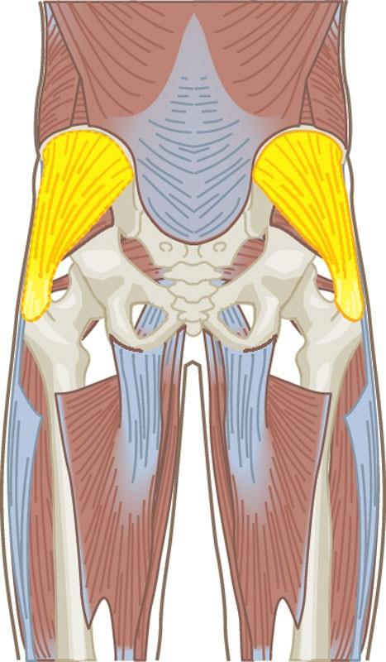

**Figure 13-2** Gluteus medius

In addition, many injuries occur in the frontal and transverse planes of motion (Barwick et al., 2012; Padua et al., 2018; Williams et al., 2008). Unfortunately, when a client does not train in all three planes of motion, the fitness professional is limiting that client’s body to move efficiently, thereby diminishing ideal movement and athleticism. Therefore, selection of a variety of exercises in all planes of motion is a critical component of a client’s training program.

### Acute variables of training

Acute variables, also known as exercise training variables, determine the amount of stress placed on the body and ultimately the physical adaptations that occur, such as increased strength, endurance, weight loss, or muscle gain. Acute variables can be viewed as all the building blocks that are used to design an exercise program, which include repetitions, sets, training intensity, repetition tempo, rest intervals, training volume, training frequency, training duration, exercise selection, and exercise order.

STRETCH YOUR KNOWLEDGE

A repetition is one complete movement of an exercise. A set is a group of consecutive repetitions. Training intensity is an individual’s level of effort compared with their maximal effort, which is usually expressed as a percentage. A rest interval is the time interval that is given between each set (Miranda et al., 2007). Training volume is the sum of the repetitions performed in a given set during each training session multiplied by the resistance used. Refer to Chapter 20 for a more detailed discussion of acute variables.

Acute variables are the most fundamental components of an integrated training program because they determine the amount of stress placed on the body during an exercise session. Properly manipulating acute variables will help the fitness professional elicit optimal performance from their clients while reducing the risk of injury (Arazi et al., 2015; Brigatto et al., 2019; Kraemer & Ratamess, 2004; Schoenfeld et al., 2016a).

**Training based on assessment results**

Programming efforts should focus on the assessments conducted by the fitness professional prior to their client’s initial workout. Appropriately conducted assessments are needed to develop a baseline value for different exercises that will be completed in the exercise program. Also, the detection of muscle imbalances, postural abnormalities, and other health concerns can reveal necessary information about a potential client. The fitness professional can then gain an accurate portrayal of the client to develop the proper movement patterns for the new exercise program.

Although this seems easy, gathering data from a fitness assessment and then accurately using that data to design exercise programs can be a difficult task.

However, this process separates generic physical activity from systematic and progressive exercise programs, which is important because a lack of assessment can lead to ineffective exercise selection and programming strategies by the Certified Personal Trainer. From this baseline starting point and constant improvement from a progressive and systematic program, fitness professionals can schedule reassessments and further their understanding of the direction in which the clients are heading. Refer to Chapters 11 and 12 for more information regarding health and fitness assessments.

**Introduction to integrated training concepts**

Recall that integrated training combines many forms of exercises into one program. Clients may be familiar with these forms of exercise, but not necessarily when used in a systematic fashion. However, integrated training can have a profound impact on a client’s health, fitness, and athletic performance. This approach is ever changing and provides a systematic and progressive framework, but only if the training is implemented correctly. The next few sections will provide a brief overview of specific components of integrated training.

**Flexibility training**

Flexibility training increases joint ROM (Junior et al., 2017). In other words, flexibility training involves different types of stretching techniques to improve tissue extensibility, which allows the body to move freely without being hindered.

The National Academy of Sports Medicine (NASM) recommends using a variety of stretching options in a systematic fashion to elicit optimal results. These stretching techniques include self-myofascial techniques, such as foam rolling, static stretching, active stretching, and dynamic stretching. Refer to Table 13-2 for more information regarding the benefits of flexibility training.

TABLE 13-2 Benefits of Flexibility Training

|  |
| --- |
| * Increased joint ROM * Possible decrease in muscle soreness * Potential for a reduction in injury risk |

*Source*: Behm et al., 2016.

**Cardiorespiratory training**

The number one cause of death around the world is heart disease (World Health Organization, 2018). To combat this issue, cardiorespiratory training is a cornerstone of improvement for heart and lung functionality (Conraads et al., 2015). Cardiorespiratory training refers to the capacity of respiratory and cardiovascular systems to provide muscles with oxygen during sustained and/or intense exercise (Lin et al., 2015). Typical forms of cardiorespiratory exercise include walking, jogging, running, cycling, biking, swimming, rowing, and sports competition. In most cases, cardiorespiratory training is a critical component of an integrated training program. However, the mode, duration, and intensity of cardiorespiratory exercise will be dependent on the client’s health, wellness, and performance goals. Refer to Table 13-3 for benefits regarding cardiorespiratory training.

TABLE 13-3 Benefits of Cardiorespiratory Training

|  |
| --- |
| Decreased resting heart rate and blood pressure  Increased stroke volume and cardiac output  Improved gas exchange, decreased airway resistance, and improved oxygen uptake  Decreased blood flow resistance and increased blood volume  Improved blood lipid profile/chemistry  Improved blood flow back to the heart via veins |

**Core training**

The core musculature includes those of the trunk and pelvis that are responsible for spinal and pelvic stability. These muscles also generate or transfer energy from the core to the extremities. Core stability is the ability to control the position and motion of the trunk over the pelvis and legs for optimal production, transfer, and control of force and motion (Manchado et al., 2017). Exercises aimed at enhancing functionality of the core musculature and core stability are considered part of core training.

Core training is sometimes misconstrued and only associated with the anterior abdominal region of the body, such as the rectus abdominis (i.e., six-pack muscle). In other words, individuals may believe crunches and sit-ups are lone core exercises. Fortunately, many movements can be completed using a variety of exercises that work all three different planes of motion as well as many muscle groups, including the obliques, low-back, and gluteal complex. Refer to Table 13-4 for benefits regarding core training.

TABLE 13-4 Benefits of Core Training

|  |
| --- |
| Enhanced posture and spinal health  Better bodily function for activities of daily living and on-the-job movements  Increased balance, stabilization, and coordination of the kinetic chain  Minimized or resolved low-back pain conditions or symptoms  Improved skill-related movements and power (i.e., swinging a racket or golf club) |

Modified from Granacher et al., 2013; Huxel Bliven & Anderson, 2013; Wang & Chen, 2014.

**Balance training**

Balance is the ability of a person to maintain, achieve, or restore a specific state of balance without falling (Callesen et al., 2018). Balance training is a method that can create better movement patterns for all clients and reduce the occurrence of falls in the elderly (Gschwind et al., 2013) and ankle sprains for athletes (Bellows & Wong, 2018; McGuine & Keene, 2006). Balance training is used for improving postural control by challenging the alignment of the body’s center of gravity with regard to the base of support (Lesinski et al., 2015).

The more control the body is able to maintain, the more opportunities abound to incorporate more challenging movements into most exercise sessions. This holds true for any age of a client, and while it does benefit the elderly immensely, it should not be diminished in those who are considered younger (Okubo et al., 2017).

Balance training can be very beneficial for the general population, experienced exercisers, and even highly skilled athletes. Refer to Table 13-5 for benefits regarding balance training.

TABLE 13-5 Benefits of Balance Training

|  |
| --- |
| Reduced risk of falls  Reduced risk of ankle sprains  Improvements in landing mechanics (which may reduce risk of anterior cruciate ligament injury)  Improvements in lower-extremity muscular strength  Improvements in proprioception and body awareness  Improvements in agility-based outcomes in athletes  Stronger hip musculature (e.g., gluteal complex) and lower extremities |

Modified from Distefano et al., 2009; Lesinski et al., 2015.

**Plyometric (reactive) training**

Plyometric training is also known as reactive or jump training. A fallacy exists that plyometric exercises are only appropriate for athletes. However, plyometric training can be a safe and effective mode of exercise for many populations, since it is a form of exercise characterized by the expression of muscular power (Mansur et al., 2018). Yet, variations of plyometric training exist to accommodate clients of differing skill and fitness levels.

Plyometric training does not require many exercises or a high amount of volume, especially if it is completed prior to a resistance training session. In addition, a plyometric training session may be completed on different days in which the volume and amount of exercises can be increased for a greater stimulus. Plyometric exercise improves the stretch-shortening cycle, which enhances a client’s ability to move explosively (Ramirez-Campillo, 2015). Refer to Table 13-6 for benefits regarding plyometric training.

TABLE 13-6 Benefits of Plyometric Training

|  |
| --- |
| Increased bone mineral density and decreased risk of bone/joint injuries  Improved soft tissue (ligaments, tendons, cartilage) strength and decreased risk of injury  Increased metabolic expenditure for improved weight management and/or weight loss  Increased strength and power for athletes and general population  Improved muscle contractions and nervous system synchronization  Improved performance or game play for athletes of all levels |

Modified from Oxfeldt et al., 2019; Slimani et al., 2016.

**Speed, Agility, and Quickness training**

Speed, agility, and quickness (SAQ) training is another form of exercise that can be misconstrued as something fit just for athletic purposes. Like plyometrics, these drills can all be modified to be beneficial for most types of clients.

SAQ training is a system of progressive exercises and instruction aimed at developing fundamental motor abilities to enhance the capability of individuals to be more skillful at faster speeds and with greater precision (Chandrakumar & Ramesh, 2015). The movement patterns used can also be of great assistance in preventing falls and increasing agility, reaction time, sprinting velocity, and lower-body power.

SAQ training is similar to explosive jump, or plyometric training, but the idea is to propel the body as quickly as possible, to accelerate and decelerate as fast as possible, or to change directions with ease and speed changes. Like plyometrics, SAQ exercises can be completed as their own workout or combined into an integrated training session. Refer to Table 13-7 for benefits regarding SAQ training.

|  |
| --- |
| Improved performance for top speed, change of direction, and rate of acceleration/deceleration  Improved health-related physical fitness  Enhanced response time to a stimulus or better reaction time  Improved technical skills in sprinting and change of direction mechanics |

Modified from Jovanovic et al., 2011; Milanovic et al., 2013.

**Resistance training**

Resistance training can promote marked increases in muscle strength and hypertrophy, with improvements in these outcome measures seen irrespective of age and gender (Schoenfeld et al., 2016b). In addition, resistance training has shown to be an effective mode of exercise to improve bone density and muscular strength and enhance cardiovascular health (Garber et al., 2011; Hart & Buck, 2019; Westcott, 2012). Moreover, resistance training plays a fundamental role in improving athletic performance and rehabilitation from musculoskeletal injury (Kristensen & Franklyn-Miller, 2012; Vesci et al., 2017). Lastly, resistance exercise is an effective method for increasing lean body mass and reducing body fat, especially when it is combined with proper dietary measures.

The role of resistance training in an integrated training program cannot be overemphasized, and fitness professionals must be well-versed in its benefits. In addition, fitness professionals must be skilled at designing and implementing resistance training protocols for a variety of clients, including youths, athletes, elderly, pre- and postnatal parents, and weight-loss clients. Refer to Table 13-8 for benefits regarding resistance training.

TABLE 13-8 Benefits of Resistance Training

|  |
| --- |
| Increased endurance, strength, and power  Increased muscular hypertrophy  Improved weight management and enhanced weight-loss efforts  Improved resting metabolic rate, resting heart rate, and blood pressure  Improved coordination and athleticism  Decreased risk of injury due to strength of all soft tissues (ligaments, tendons, cartilage, and muscle fibres) |

### The Optimum Performance Training Model

Exercise training programs are largely based on the past experiences of those designing them. For example, training programs designed by those with backgrounds in bodybuilding, powerlifting, or Olympic weightlifting tend to vary considerably from programs designed by those with experience in endurance training or group exercise, such as aerobics, dance, or Pilates. Although experience is always an important quality to have in any field, including personal training, it is not the only qualification; in some cases, it is not even the most important qualification held by a Certified Personal Trainer. Designing safe and effective exercise training programs requires a variety of skills, including knowledge of anatomy, physiology, and human movement; the ability to communicate effectively with clients; and experience in working with diverse populations.

To help Certified Personal Trainers design safe and effective training programs based on the client’s individual needs, NASM recommends using a structured, scientifically based program design model. The training program should be a methodical approach to improve physical and performance adaptations. The best way to achieve consistent, superior results is to follow a structured, periodized training program (Rhea et al., 2003; Williams et al., 2017). Evidence also exists that an integrated program that includes flexibility; core; balance; plyometric; speed, agility, and quickness; resistance; and cardiorespiratory training can decrease injury and improve performance (Distefano et al., 2013).

As such, NASM created an evidenced-based training system known as the Optimum Performance Training (OPT) model. The OPT model was conceptualized as a training program for a society that has more structural imbalances and susceptibility to injury than ever before. It is a process of programming that systematically progresses any client to any fitness or sport-performance goal. The OPT model is based on the scientific rationale of human movement science and uses the principles of integrated training discussed throughout this chapter.

The OPT model is divided into three different levels of training—stabilization, strength, and power (Figure 13-3), which are subdivided into five phases. It is imperative that fitness professionals understand the scientific rationale behind each level and each individual phase of training so they can properly use the OPT model.

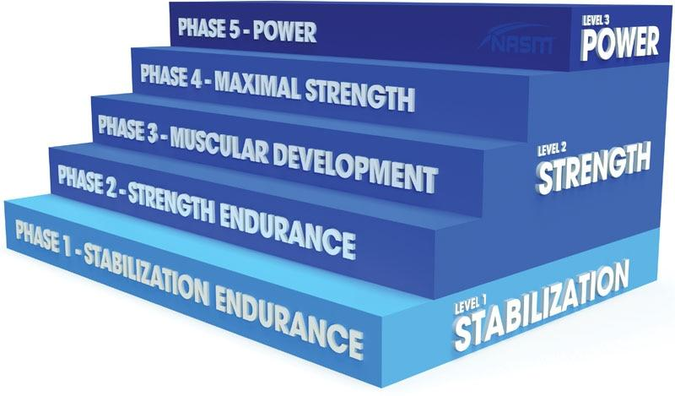

**Figure 13-3** OPT model

**Stabilization**

The first level of training in the OPT model focuses on two main adaptations: improving movement patterns and enhancing stabilization. By doing so, it prepares the body for the demands of higher levels of training that may follow. This period is crucial for all beginners (Saeterbakken et al., 2016). It is also necessary to cycle back through this level after periods of strength and power training to maintain a high degree of core and joint stability. In addition, it allows the body to actively rest from more intense bouts of training. The focus of stabilization training includes the following goals:

* Improving movement patterns and exercise technique
* Improving muscle imbalances
* Improving joint ROM and flexibility
* Improving stabilization of the core musculature and peripheral joints
* Preventing tissue overload by preparing muscles, tendons, ligaments, and joints for the upcoming imposed demands of training
* Improving overall cardiorespiratory conditioning

The stabilization level of training in the OPT model consists of one phase of training: Phase 1 Stabilization Endurance Training.

Phase 1 stabilization endurance training

Phase 1 Stabilization Endurance Training is designed to teach optimal movement patterns (e.g., pushing, pulling, pressing, squatting, hip hinging) and to help clients become familiar with various modes of exercise. In addition, this phase of training creates optimal levels of joint and core stabilization and postural control. Although this phase is the first phase of training in the OPT model, it will also be important to cycle back through this phase of training between periods of higher-intensity training seen in Phases 2 through 5. This will ensure proper recovery while maintaining high levels of stability.

Phase 1 Stabilization Endurance Training focuses on exercises and movements that enhance muscular endurance, joint ROM, joint and core stability, and muscular coordination. It requires slow and controlled movements, relatively light loads, and meticulous attention to proper posture and exercise technique.

In the early implementation of this phase, fitness professionals should focus a great deal of energy on honing and perfecting proper movement patterns and introducing clients to a variety of exercise modalities. The goal is to improve the client’s ability to move in a biomechanically correct manner to reduce the risk of injury, which may have the added benefit of increasing client adherence to the exercise program. Clients are more likely to stick with an exercise program if they feel confident in their abilities.

Once movement patterns have been addressed, exercises can be progressed by introducing a greater challenge to the balance and stabilization systems of the body versus simply increasing the load. For example, a client may begin by performing a push-up and then progress by performing the same exercise using a stability ball. This progression requires additional activation from the nervous system and the stabilizing muscles of the shoulders and trunk to maintain optimal posture while performing the exercise (Figure 13-4).

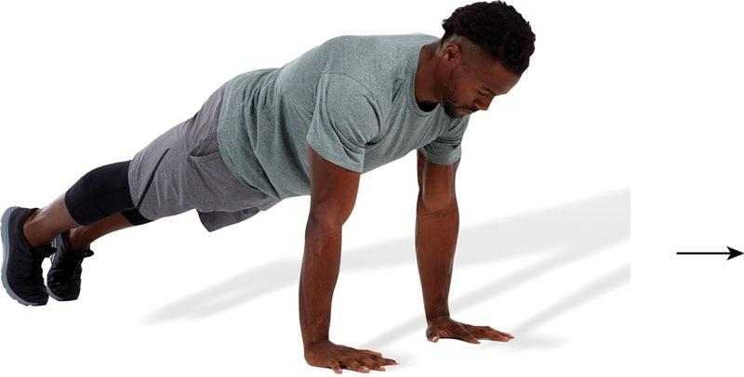 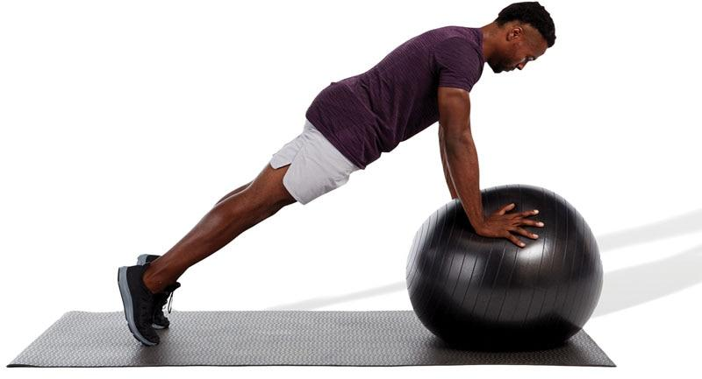

**Figure 13-4** Example push-up progression

Phase 1 Stabilization Endurance Training not only addresses the existing structural deficiencies, it may also provide a superior way to alter body composition (reduce body fat) because all the exercises can be performed in a circuit fashion, using short rest periods along with a high number of repetitions. By performing exercises in a controlled yet unstable environment, the body is forced to recruit more muscles to stabilize itself. In doing so, more calories are potentially expended, especially when performed in succession with minimal rest (Lagally et al., 2009; Ogita et al., 2000).

**Strength**

The emphasis of the strength level of training in the OPT model is to maintain stabilization endurance while increasing overall muscular strength. This is also the level of training to which an individual will progress if their goals are hypertrophy (increasing muscle size) or maximal strength (lifting heavy loads). The strength level in the OPT model consists of three phases: Phase 2 Strength Endurance Training, Phase 3 Muscular Development Training, and Phase 4 Maximal Strength Training.

Phase 2 strength endurance training

In Phase 2 Strength Endurance Training, the goal is to enhance stabilization endurance while increasing prime mover strength. These two adaptations are accomplished by performing two exercises in a superset sequence, back-to-back without rest, with similar joint dynamics (Table 13-9). The first exercise is a traditional strength exercise performed in a stable environment (such as a bench press), whereas the second exercise is a stabilization-focused exercise performed in a less stable (yet controllable) environment (such as a stability ball push-up). The principle behind this method is to predominantly work the prime movers in the first exercise to elicit prime mover strength. This is immediately followed with an exercise that challenges stability and postural control. This produces an increase in muscular endurance, joint stability, and ideal posture.

TABLE 13-9 Phase 2 Example Supersets

| **Body Part** | **Strength-Focused Exercise** | **Stabilization-Focused Exercise** |
| --- | --- | --- |
| Chest | Bench press | Push-up |
| Back | Seated cable row | Standing cable row |
| Shoulders | Shoulder press machine | Single-leg dumbbell overhead press |
| Legs | Barbell squat | Single-leg squat |

Phase 3 muscular development training

Phase 3 Muscular Development Training is designed for individuals who have the goal of maximal muscle growth (such as bodybuilders). This phase of training can use a variety of resistance training exercises and methods to elicit a maximal response in muscle growth. This form of training can also benefit those seeking to lose body fat while maintaining lean muscle mass (Cava et al., 2017). Because the goal of this phase of training is primarily muscular hypertrophy, the fitness professional will want to increase the volume (lots of sets) and intensity (using moderate to heavy weight) of the program. This phase is optional depending on the goals of the client, because some clients do not wish to achieve high levels of muscular growth, such as endurance athletes. However, this phase is very popular among fitness enthusiasts seeking to reduce body fat and improve muscle tone.

Phase 4 maximal strength training

Phase 4 Maximal Strength Training works toward the goal of maximal prime mover strength by lifting heavy loads. In other words, in this phase of training the client will opt for exclusively heavy weights when performing resistance training exercises. This phase of training is common for strength athletes, such as those who compete in powerlifting or strongman competitions and others who require maximal strength (i.e., shot-putters, rugby athletes, American football linemen).

Because the goal is to increase maximal strength capabilities, individuals must be accustomed to resistance training. This is an advanced form of exercise that is optional, depending on the goals of the client.

**Power**

The power level of training should only be entered after successful completion of the stabilization and strength levels—unless the client is well-conditioned, exhibits adequate joint and core stability, and is familiar with power forms of exercise. This level of training emphasizes the development of speed and power. This is achieved through one phase of training simply named Phase 5 Power Training.

Phase 5 power training

The goal of Phase 5 Power Training is to increase maximal strength and rate of force production. This phase of training is important for improving velocity of movement and athleticism. The premise behind this phase of training is the execution of a traditional strength exercise (with a heavy load) superset with a power-focused (high-velocity) exercise of similar joint dynamics (Table 13-10). This form of training, also known as complex training, has been shown to improve sprint and vertical jump performance (Freitas et al., 2017; Li et al., 2019).

TABLE 13-10 Phase 5 Example Supersets

| **Body Part** | **Strength-Focused Exercise** | **Power-Focused Exercise** |
| --- | --- | --- |
| Chest | Bench press | Medicine ball chest pass |
| Back | Lat pulldown | Medicine ball soccer throw |
| Shoulders | Dumbbell shoulder press | Front medicine ball oblique throw |
| Leg | Barbell squat | Squat jump |

**How to use the OPT model**

Chapters later in this text will be specifically dedicated to explaining the components of an integrated training program, which include the following:

* Flexibility training
* Cardiorespiratory training
* Core training
* Balance training
* Plyometric (reactive) training
* Speed, agility, and quickness training
* Resistance training.

Each of these chapters explains in detail how to realistically apply the information given. Because the OPT model is based on the science of integrated training, all five phases within the OPT model often use all forms of exercise previously listed. This is a far cry from traditional workouts that only incorporate generalized stretching, cardiovascular, and resistance exercise.

In addition, Chapters 21 through 23 are dedicated to program design strategies. Within these chapters, the fitness professional will learn the subtle details of the OPT model, ways to incorporate various types of exercise equipment, and how to design exercise programs for special populations (i.e., youth, seniors, pre- and postnatal parents) or clients with chronic conditions (e.g., diabetes, osteoporosis, heart disease).

In combination, this information should provide any individual with all of the tools necessary to become a skilled and well-rounded fitness professional.

## Flexibility training

Once fitness assessments are completed and all the information has been processed, the fitness professional can now design the client’s exercise program. The first step should be designing the client’s flexibility portion of the exercise program. Clients often require some type of flexibility training, which can be applied to the program’s warm-up and cool-down. This chapter focuses on foundational concepts of flexibility and how to apply various flexibility techniques with clients.

**What is flexibility?**

Flexibility is defined as the normal extensibility (ability to stretch) of all soft tissues (e.g., contractile and noncontractile) that allow the complete range of motion (ROM) of a joint. Joint ROM is dictated by the type of joint (e.g., ball-and-socket versus hinge joint), and the extensibility of muscles and surrounding soft tissues (Floyd, 2018). An important characteristic of soft tissue is that it will only achieve efficient extensibility if optimal bodily control is maintained throughout the entire joint ROM, which is often termed mobility (flexibility + joint ROM; Neumann, 2017). Flexibility has a major influence on mobility during dynamic motion.

There are various factors that can influence flexibility, which include but are not limited to the following:

* Genetics
* Myofascial (connective) tissue elasticity
* Composition of tendons or skin surrounding the joint
* Joint structure
* Strength of opposing muscle groups
* Body composition
* Sex
* Age
* Activity level
* Previous injuries or existing medical issues
* Repetitive movements (Blazevich et al., 2012; Opar et al., 2012)

Poor flexibility can lead to the development of relative flexibility (altered movement patterns), which is the process in which the human movement system (HMS) seeks the path of least resistance during functional movements (Mills et al., 2015; Morais & Cruz, 2016). A prime example of relative flexibility is seen in people who squat with their feet excessively externally rotated (Figure 14-1) because individuals may have limited ankle ROM that prevents adequate ankle dorsiflexion to perform a squat with proper mechanics (Rabin & Kozol, 2017). By widening the stance and externally rotating the feet, the amount of dorsiflexion required at the ankle to perform a squatting pattern is decreased. A second example can be seen when people perform an overhead shoulder press with excessive lumbar extension (arched low-back) (Figure 14-2). Individuals who possess limited latissimus dorsi extensibility will have decreased sagittal-plane shoulder flexion (inability to lift arms directly overhead), and as a result, they compensate for this lack of shoulder ROM by extending the lumbar spine to allow them to press the load completely above their head (Monteiro et al., 2017). Relative flexibility can also prevent the nervous system from efficiently recruiting the correct muscle patterns and contractions during the movement (Floyd, 2018).

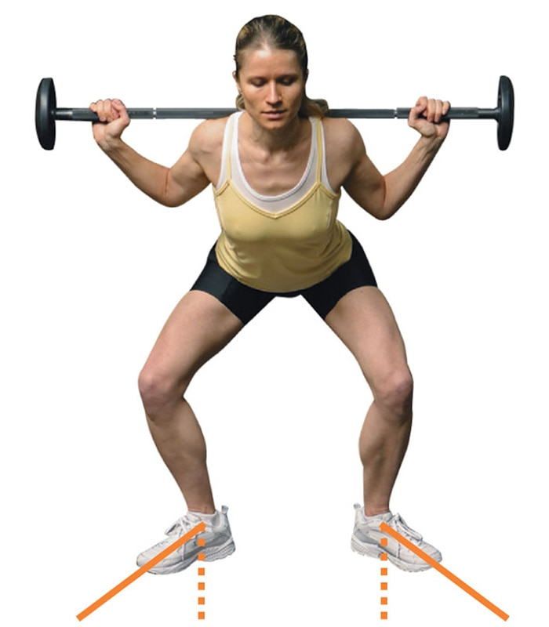 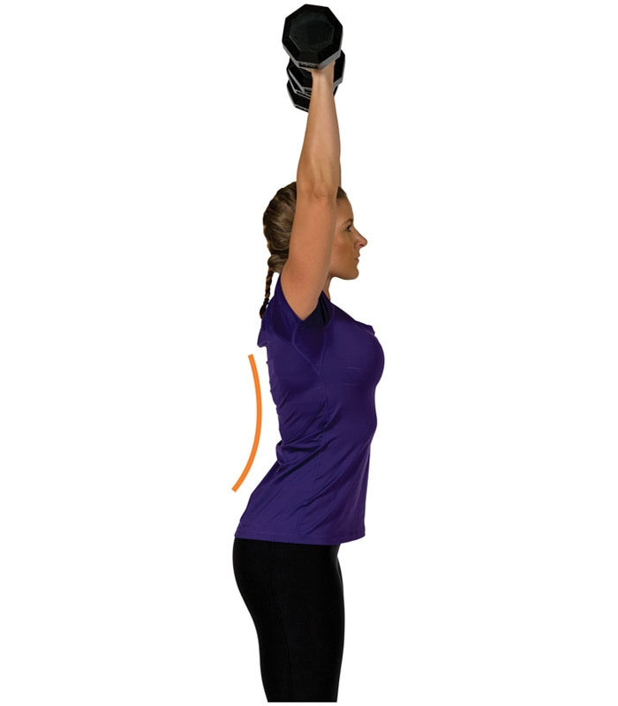

**Figure 14-1** Squat with externally rotated feet

**Figure 14-2** Overhead shoulder press with lumbar extension

Flexibility requires extensibility of all soft tissue along with acceptable bodily control. Adequate flexibility combined with joint ROM produces proper mobility of the major bodily regions (e.g., upper and lower extremities). Flexibility training requires a comprehensive approach that integrates various techniques to achieve optimal soft tissue extensibility in all planes of motion (Table 14-1). To better understand flexibility training, a few important concepts must first be reviewed, including the HMS, muscle imbalances, and neuromuscular efficiency.

TABLE 14-1 Multiplanar Flexibility

| **Muscle** | **Image** | **Plane of Motion** | **Movement** |
| --- | --- | --- | --- |
| Latissimus dorsi |  | Sagittal | Must have proper extensibility to allow for proper shoulder flexion |
| Frontal | Must have proper extensibility to allow for proper shoulder abduction |
| Transverse | Must have proper extensibility to allow for proper external shoulder rotation |
| Biceps femoris |  | Sagittal | Must have proper extensibility to allow for proper hip flexion, knee extension |
| Frontal | Must have proper extensibility to allow for proper hip adduction |
| Transverse | Must have proper extensibility to allow for proper hip and knee internal rotation |
| Gastrocnemius |  | Sagittal | Must have proper extensibility to allow for proper dorsiflexion of ankle |
| Frontal | Must have proper extensibility to allow for proper inversion of calcaneus (heel bone) |
| Transverse | Must have proper extensibility to allow for proper internal rotation of femur (thigh bone) |

**Human Movement System review**

The HMS, also known as the kinetic chain, comprises the muscular, skeletal, and nervous systems. The body’s kinetic chain can be further classified into two regional chains: upper kinetic chain (e.g., shoulder, elbow, and wrist and hand) and lower kinetic chain (e.g., hip, knee, and ankle and foot; Chu et al., 2016). When referring to movement, the fitness professional can classify the body as a complete kinetic chain or the upper and lower kinetic chains. Optimal alignment and function of each component of the HMS is the cornerstone of a sound training program. If one or more segments of the HMS are misaligned and not functioning properly, predictable patterns of dysfunction develop (Cheatham & Kreiswirth, 2014; Sueki et al., 2013). These patterns of dysfunction are referred to as postural distortion patterns, which can lead to poor posture, improper movement, and possible injury (Figure 14-3) (Page et al., 2010).

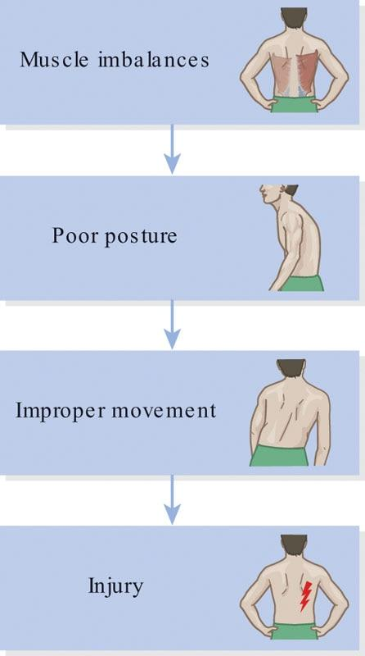

**Figure 14-3** Postural distortion patterns

Postural distortion patterns (poor static or dynamic posture) are represented by a lack of structural integrity, resulting from decreased functioning of one (or more) components of the HMS (Page et al., 2010; Sueki et al., 2013). A lack of structural integrity can result in muscle imbalance, altered force-couple relationships, and altered osteokinematics and arthrokinematics (all discussed in the following section; Neumann, 2017; Sueki et al., 2013). There are several static postural distortions and poor movement patterns that fitness professionals must be aware of and should be identified while conducting assessments with their clients (Page et al., 2010). Refer to Chapter 12 for more information about identifying static postural distortions and altered movement patterns.

**Muscle imbalances**

Muscle imbalances are alterations in the lengths of muscles surrounding a joint (Figures 14-4 and 14-5), in which some are overactive (forcing compensation to occur) and others may be underactive (allowing for the compensation to occur; Kendall et al., 2005; Page et al., 2010).

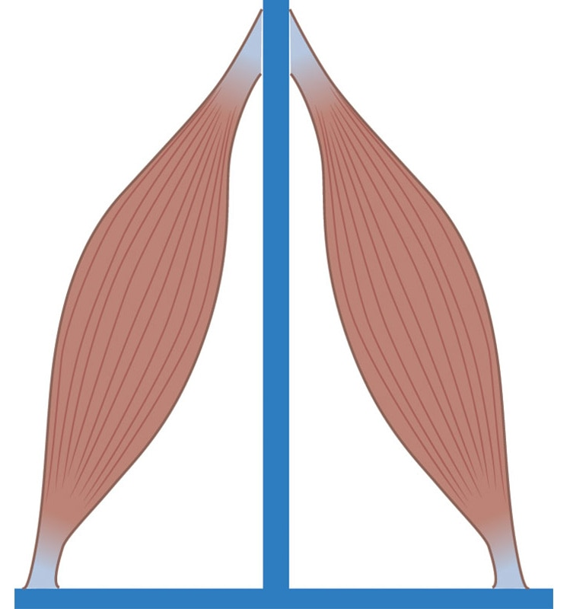 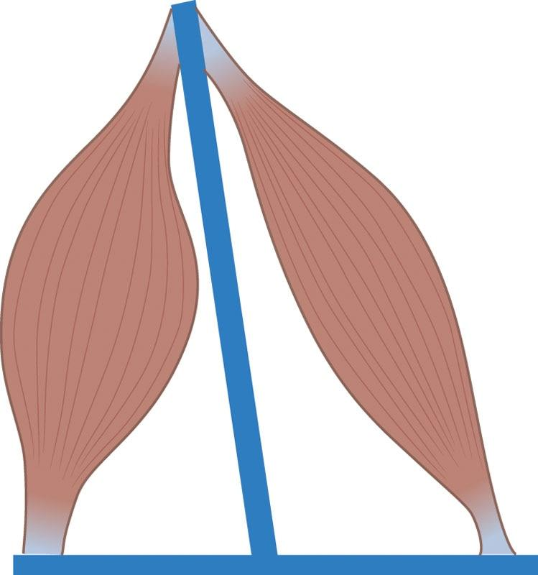

**Figure 14-4** Muscle balance

**Figure 14-5** Muscle imbalance

Muscle imbalance can be caused by a variety of mechanisms, which include but are not limited to the following:

* Postural distortions
* Repetitive movement
* Cumulative trauma
* Emotional duress
* Poor training technique
* Poor bodily control
* Biased training patterns (Page et al., 2010; Sueki et al., 2013)

Muscle imbalances may result in altered reciprocal inhibition, synergistic dominance, and osteo- and arthrokinematic dysfunction. These imbalances can negatively affect overall functioning of the HMS and potentially lead to injury (Figure 14-6).

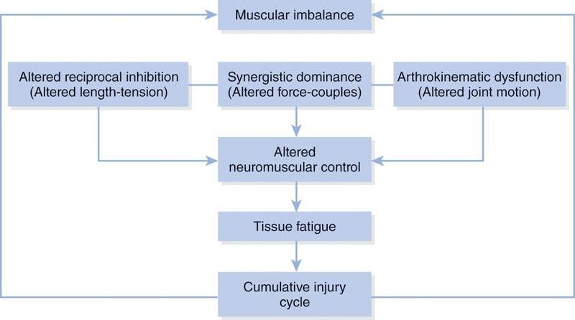

**Figure 14-6** Impact of muscle imbalance

Altered reciprocal inhibition

Reciprocal inhibition is a naturally occurring phenomenon that allows movement to take place. Reciprocal inhibition is defined as the simultaneous contraction of the agonist (prime mover) muscle and the relaxation of its antagonist (Floeter et al., 2013). For example, to perform elbow flexion during a biceps curl, the agonist biceps brachii actively contracts while the antagonist triceps brachii relaxes to allow the movement to occur.

However, altered reciprocal inhibition is an impairment of the HMS, and fitness professionals should aim to correct this phenomenon. Altered reciprocal inhibition is caused by an overactive agonist muscle decreasing the neural drive to its functional antagonist (Page et al., 2010). For example, an overactive hip flexor complex (e.g., iliopsoas, rectus femoris, tensor fascia latae) would decrease neural drive to the hip extensor complex (e.g., gluteus maximus and gluteus medius; Mills et al., 2015). In other words, the overactive muscles on the front of the hip are causing the gluteal muscles to become underactive. Another example is overactive chest muscles (e.g., pectoralis major and minor) decreasing neural drive to mid-back muscles (e.g., rhomboids, mid and lower trapezius). In this scenario, the overactive chest muscles (which are shoulder protractors) cause the mid-back muscles (which are shoulder retractors) to become underactive. Altered reciprocal inhibition changes force-couple relationships, produces synergistic dominance, and leads to the development of faulty movement patterns, poor bodily control, and joint dysfunction.

Synergistic dominance

Synergistic dominance is a neuromuscular phenomenon that occurs when synergists take over function for a weak or inhibited prime mover (agonist; Camargo & Neumann, 2019; Mills et al., 2015). For example, if the hip flexor complex is overactive, it leads to altered reciprocal inhibition of the hip extensor complex, which in turn results in increased force output of the synergists for hip extension (hamstring complex) to compensate for the weakened hip extensors (Mills et al., 2015). In other words, if the gluteal muscles are underactive and not able to produce force effectively, other muscles, such as the hamstrings, are now recruited more than usual to assist in performing hip extension. The result of synergistic dominance is faulty movement patterns leading to soft tissue and joint dysfunction and eventual injury (such as hamstring strains).

HELPFUL HINT

Synergistic dominance can be a difficult concept to understand. To help, imagine a professional basketball team who has a star player named Michael. Michael is the team’s leading scorer and the team’s best defender. His skills are unquestionably better than his teammates. Now, imagine Michael hurts his ankle and his backup is inserted into the starting lineup. His backup can do all of the things Michael can (e.g., dribble, shoot, defend), but not as well. Consequently, the team is not as productive and does not play its best basketball. The human body works in a similar fashion. For example, if overactive hip flexors decrease neural drive to the hip extensors (gluteal complex), then synergistic muscles (hamstrings) must “pick up the slack” for the inhibited glutei. In other words, the hamstrings have been inserted into the starting lineup to replace the gluteal complex to perform hip extension movements. Yet, the hamstrings are not as well equipped as the gluteal complex to perform hip extension during functional tasks.

Osteokinematic and arthrokinematic dysfunction

Osteokinematics describes how the bones and joints are moving through a ROM. In other words, osteokinematics refers to joint motions we can see, such as flexion, extension, abduction, adduction, or rotation of body segments (Neumann, 2017) (Figure 14-7). Arthrokinematics describes the motion at the joint surfaces. There are three major arthrokinematic joint motions: roll, slide or glide, and spin (Neumann, 2017) (Figure 14-8). Refer to Chapter 5 for a review of these joint motions.

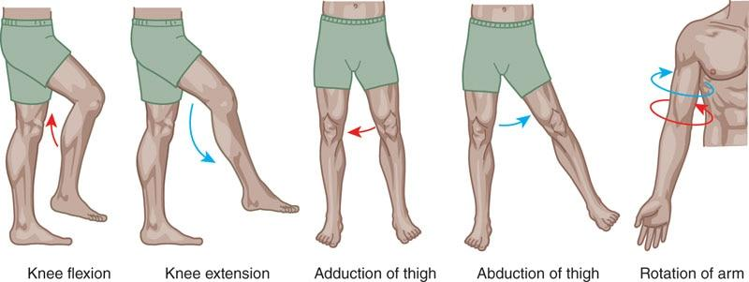

**Figure 14-7** Examples of osteokinematic movements

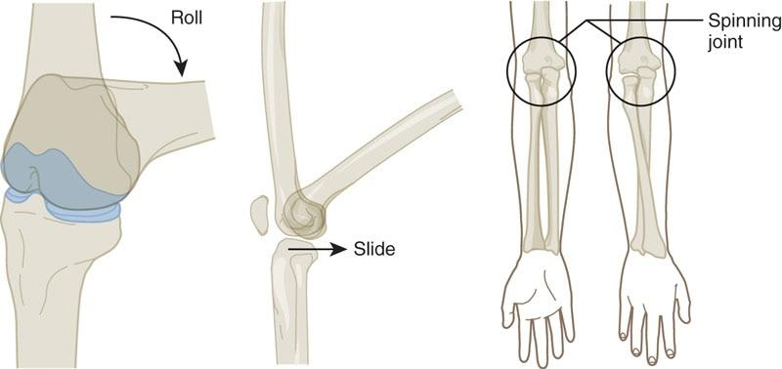

**Figure 14-8** Examples of arthrokinematic movement

Altered joint motion can be caused by altered length-tension relationships, force-couple relationships, and poor joint surface motion, which results in poor movement efficiency. To achieve efficient motion through a joint’s ROM (osteokinematic), there must be good motion at the joint surface (arthrokinematics) and soft tissue flexibility. For example, a client performs a single-leg squat exercise and demonstrates an excessive knee valgus (knee moves inward) position during the eccentric phase of the movement. The client’s knee joint is mispositioned, preventing the joint surface from moving efficiently. This results in decreased knee joint ROM, excessive biomechanical stress, potential muscle imbalances, and possible compensations at the hip or ankle as the client attempts to successfully perform the movement. Poor form on exercises can be a risk factor for injury (Dill et al., 2014; Slater & Hart, 2016).

Poor neuromuscular efficiency

Neuromuscular efficiency is the ability of the nervous system to recruit the correct muscles to produce force, reduce force, and dynamically stabilize the body’s structure in all three planes of motion (Arãgao et al., 2015; David et al., 2008).

For example, when performing a lat pulldown exercise, the latissimus dorsi (agonist) must be able to concentrically accelerate shoulder extension, adduction, and internal rotation, while the rhomboids (synergists) perform downward rotation of the scapulae (shoulder blades). At the same time, the rotator cuff musculature (stabilizers) must dynamically stabilize the glenohumeral (shoulder) joint throughout the motion. If these muscles collectively do not work efficiently together (force-couples), compensations may ensue, leading to muscle imbalances, altered joint motion, and possible injury. To allow for optimal neuromuscular efficiency, individuals must have proper flexibility in all three planes of motion. This allows for the freedom of movement needed to perform everyday activities effectively, such as bending over to tie shoes or reaching in the top cupboard for dishes.

It is important to note that the nervous system is the controlling factor behind this principle, and specific mechanoreceptors (or sensory receptors) located in the muscles and tendons— specifically the muscle spindles and Golgi tendon organ—help determine muscle balance or imbalance.

Muscle spindles

The muscle spindle is a major sensory organ of the muscle and is composed of microscopic fibers that lie parallel to the muscle fiber. When a muscle is stretched, the muscle spindle records the change in muscle length and speed (rate) of length change and sends this information to the central nervous system (CNS) (Floyd, 2018). The function of the muscle spindle is to help prevent the muscle from stretching too far or too fast. This reaction is called the stretch reflex (Figure 14-9). Thus, the more sudden the change in muscle length, the stronger the stretch reflex or muscle contraction. The muscle spindle helps maintain muscle tone and protects the body from injury (Kenney et al., 2019).

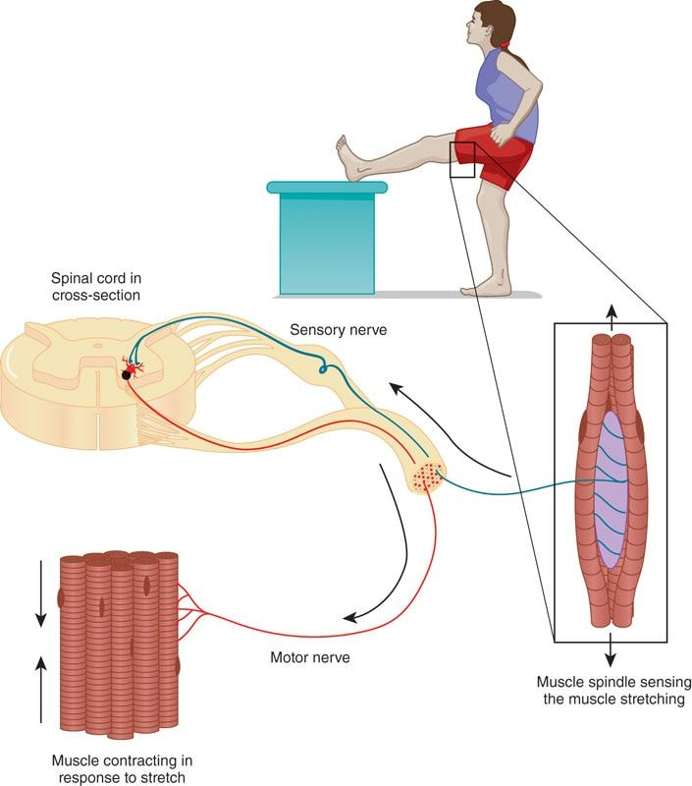

**Figure 14-9** Stretch reflex

Golgi tendon organs

The Golgi tendon organ (GTO) is located within the point where the muscle and the tendon meet (musculotendinous junction). The GTO is sensitive to changes in muscular tension and the speed (rate) of tension change (Kenney et al., 2019; Neumann, 2017) (Figure 14-10). When the GTO activates, it sends information to the CNS, causing the muscle to relax. Prolonged GTO stimulation provides an inhibitory action to muscle spindles (located within the same muscle). This neuromuscular reaction is called autogenic inhibition and occurs when the neural impulses sensing tension are greater than the impulses causing muscle contraction (Kenney et al., 2019). The GTO prevents the muscle from being placed under excessive stress, which could result in injury.

STRETCH YOUR KNOWLEDGE

Improvements in joint ROM are always due to several factors:

* Mechanical (muscle and tendon factors affecting compliance or stiffness)
* Neural (inhibition of the central nervous system to help the muscle relax)
* Psycho-physiological (stretch tolerance)

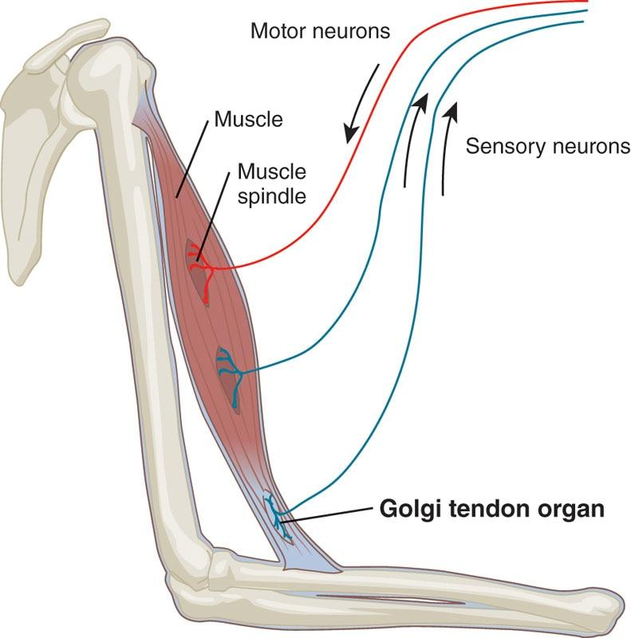

**Figure 14-10** Golgi tendon organ

**Scientific principles of flexibility**

When a muscle is lengthened, there is a cascade of neurological reactions that occurs that allows the muscle to be stretched. This is called the lengthening reaction (Kenney et al., 2019). Also, when the body is moving dynamically, there is a sequencing of muscles that are active and inhibited (i.e., as one muscle contracts, its antagonist muscle relaxes). This sequence is called reciprocal inhibition as discussed previously (Floyd, 2018; Kenney et al., 2019). These physiological reactions are important to understand since they are involved in the different flexibility exercises that are commonly done with clients.

The lengthening reaction

The lengthening reaction is a series of responses that the muscle goes through when being stretched. Often, this reaction is seen when a muscle is stretched and held for a specific amount of time. The steps in the lengthening reaction areas are as follows: (1) The muscle is lengthened (or stretched), and the muscle spindle senses the muscle’s length change; (2) the stretch reflex is activated causing the muscle to contract; (3) as the muscle is held at that position for a prolonged period, the muscle spindle's firing frequency decreases resulting in a relaxation response (Figure 14-11). The lengthening reaction is often seen with static stretching because static stretches are typically held long enough to override the muscle spindle.

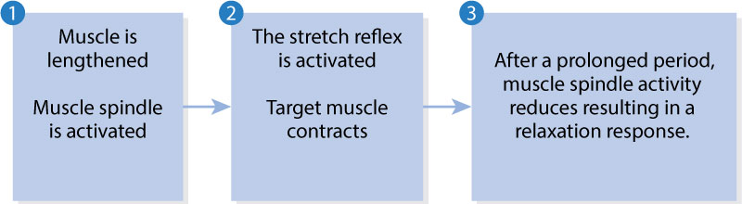

**Figure 14-11** Lengthening reaction

Reciprocal inhibition and stretching

Reciprocal inhibition is a normal neurological reaction that occurs with human movement, whereas altered reciprocal inhibition occurs when an overactive agonist muscle inhibits the antagonist (Kenney et al., 2019). For stretching, reciprocal inhibition is often involved in different stretches that involve movement, such as active and dynamic stretching. The stretches take advantage of the agonist activation and antagonist inhibition to enhance flexibility, which will be discussed in more detail in the active and dynamic stretching sections later in this chapter.

HELPFUL HINT

The fitness professional should recognize that the neuromuscular system has several mechanisms to protect muscles from overstretching and allowing for synchronized muscle contraction among different muscle groups. The stretch reflex can protect the muscle from being overstretched. The lengthening reaction allows our muscles to be lengthened or stretched. Reciprocal inhibition allows our muscles to work in synchronous patterns to perform a desired motion. The different types of stretching, such as static, active, and dynamic stretching, incorporate these reactions.

**Scientific rationale for flexibility training**

There are two potential factors that support the need to implement flexibility training: pattern overload and the cumulative injury cycle. It is not uncommon to have clients who do repetitive tasks at work or home that lead to poor flexibility and potential injury. The fitness professional plays a key role in helping correct flexibility deficits and educate the client about the hazards of pattern overload and the risk for cumulative injury.

**Pattern overload**

Muscular imbalances have become common and prevalent in society, which are often caused by pattern overload. Pattern overload is consistently repeating the same pattern of motion, such as baseball pitching, long-distance running, and specific occupations, which with time places abnormal stresses on the body (Lamprecht & Padayachy, 2019; McDonald et al., 2019; Sugimoto et al., 2019). There are also gym members who train with the same routine repetitively, which may lead to pattern overload and place abnormal stresses on the body. Pattern overload may not necessarily be directly related to exercise. For example, a loading-dock employee who has a particularly repetitive occupation lifting and loading packages all day is prone to pattern overload. Factory, assembly line, and construction workers who repeat the same movement patterns are also susceptible to pattern overload. Even sitting for long periods of time while working on a computer is a repetitive stress (Verhagen et al., 2013).

**Cumulative injury cycle**

It is essential for the fitness professional to understand that poor posture and repetitive, overuse movements can create dysfunction within the connective tissue of the human body (Iqbal & Alghadir, 2017). These dysfunctions can eventually lead to an injury and a repair response by the body termed the *cumulative injury cycle* (Figure 14-12) (Iqbal & Alghadir, 2017).

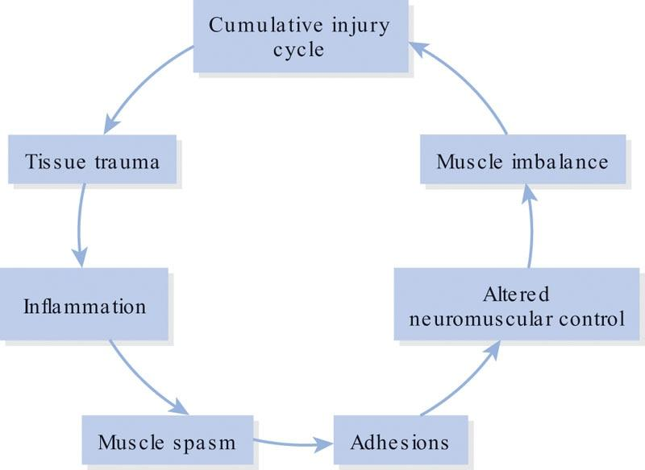

**Figure 14-12** Cumulative injury cycle

Current theory supports the idea that repetitive movements, such as long periods of poor posture, are believed to lead to tissue trauma and inflammation. Inflammation in turn activates the body’s pain response that initiates a protective mechanism, increasing muscle tension and causing muscle spasm. These muscle spasms are not like a calf cramp.

Heightened activity of the CNS and tissue mechanoreceptors and nociceptors (e.g., pain receptors) in the injured area create, in essence, a type of microspasm or tension (Jafri, 2014). As a result of the microspasm, adhesions may begin to form within the myofascial tissues (Figure 14-13). These adhesions form a weak, inelastic matrix that decreases normal mobility of the soft tissue (Money, 2017). The result is altered length-tension relationships, altered force-couple relationships, and joint dysfunction (Jafri, 2014; Zhuang et al., 2014). Left unchecked, these adhesions may begin to form structural changes in the soft tissue that are evident by Davis’s law.

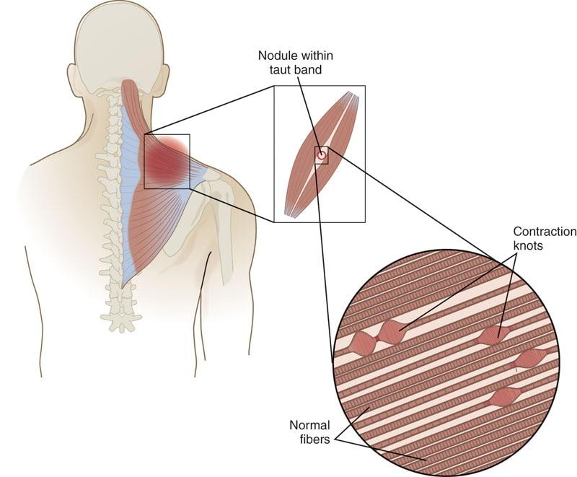

**Figure 14-13** Myofascial adhesions

Davis’s law states that soft tissue will model along the lines of stress (Cyron & Humphrey, 2017; Mueller & Maluf, 2002). Soft tissue remodels or rebuilds itself with a collagen matrix that forms in a random fashion and not in the same direction as the muscle fibers. If the myofascia is not stimulated by movement, lengthening, and broadening, these connective tissue fibers may act as a roadblock, preventing soft tissue mobility. This creates alterations in normal tissue mobility and causes relative flexibility (Iqbal & Alghadir, 2017).

**Flexibility techniques**

Flexibility training is a key component for all training programs. It is used for a variety of reasons, including correcting muscle imbalances, increasing joint ROM, improving the extensibility of the muscles, and improving neuromuscular efficiency (Floyd, 2018; Kenney et al., 2019). There are many types of flexibility training, including self-myofascial techniques, static stretching, active stretching, and dynamic stretching, and all of them can be integrated into an exercise regimen. The focus of flexibility training is to enhance tissue extensibility and joint ROM in those tissues found to be overactive during the assessment process.

STRETCH YOUR KNOWLEDGE

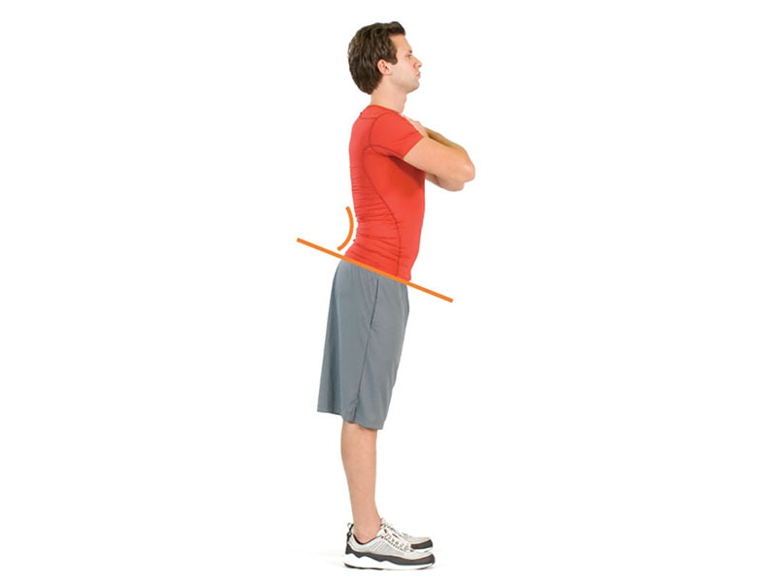

Poor posture, pattern overload, and trauma can create muscle imbalances within specific muscle groups in which certain muscles become overactive or underactive. The overactive muscles should undergo some type of flexibility exercises, whereas the underactive muscles may need to be strengthened. For example, with an anteriorly rotated pelvis, often observed in the lower crossed syndrome, overactive hip flexors help create the anterior pelvic rotation, which subsequently causes lengthening of the hamstring complex. In this case, the hamstrings do not need to be stretched because they are already in a stretched position. Instead, the hip flexors need to be stretched due to their overactive state (Page et al., 2010).

**Self-myofascial techniques**

There are many self-myofascial techniques available for fitness professionals and clients. Perhaps, the most popular is self-myofascial rolling (SMR) with a foam roller (Figure 14-14), handheld roller (Figure 14-15), or massage ball (Figure 14-16) (Cheatham et al., 2018). The foam roller seems to be the most popular among fitness and medical professionals (Cheatham 2019; Cheatham et al., 2018), and foam rollers come in many shapes, sizes, and densities.

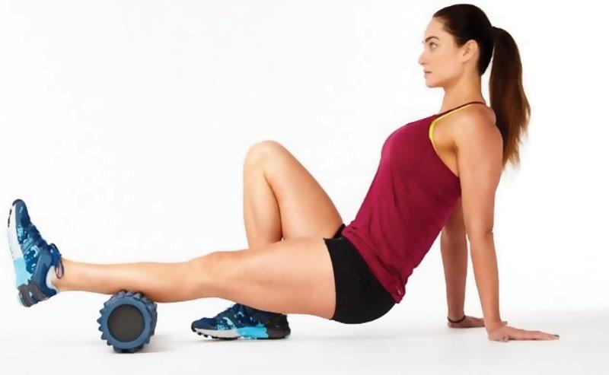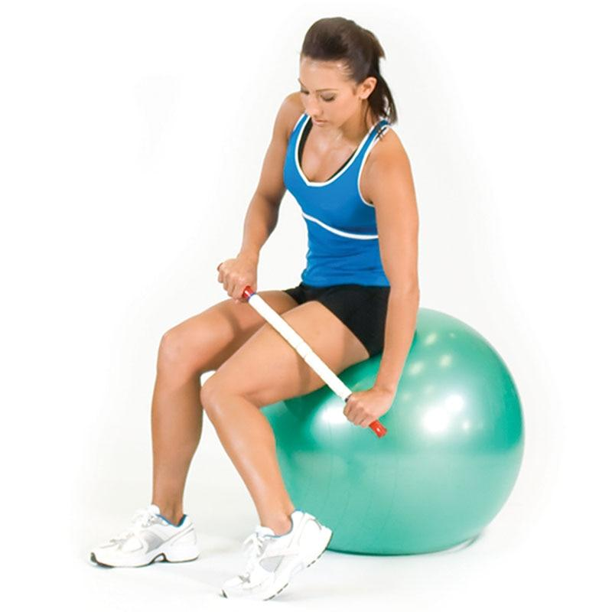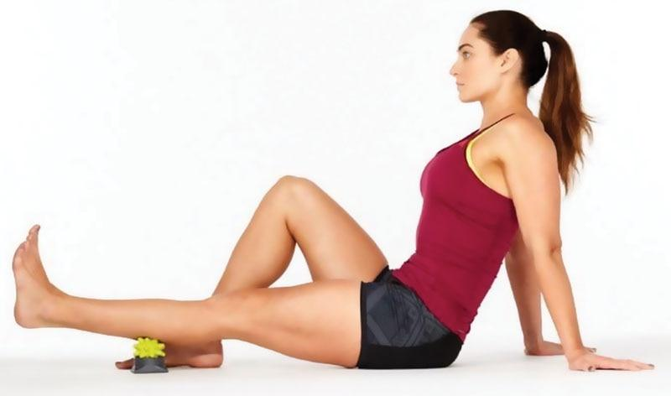

**Figure 14-14** RumbleRoller® foam roller

**Figure 14-15** The stick handheld roller

**Figure 14-16** RumbleRoller® massage ball

Myofascial rolling focuses on the nervous system and fascial system, which may produce a mechanical response and a neurophysiological response that influences tissue relaxation and pain in the local and surrounding tissues by activating sensory pathways of the CNS (Grabow et al., 2018; Young et al., 2018).

For the mechanical effect, the direct roller compression may relax the local myofascia by increasing local blood flow and reducing myofascial restriction and adhesions (Jay et al., 2014; Kelly & Beardsley, 2016). For the neurophysiological effect, the direct roller compression may influence tissue relaxation and pain in the local and surrounding tissues by stimulating local mechanoreceptors and pain receptors. These receptors send inhibitory signals to the CNS, triggering a cascade of tissue relaxation and pain blocking responses that affect the tissues being compressed by the roller (Aboodarda et al., 2015; Young et al., 2018) (Figure 14-17).

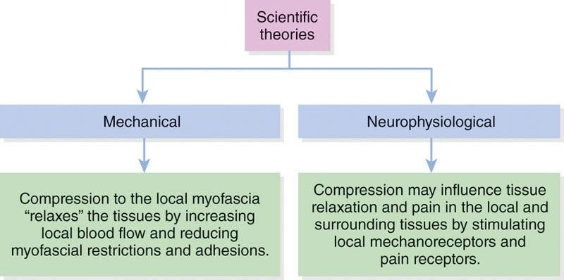

**Figure 14-17** Self-myofascial techniques proposed mechanisms

STRETCH YOUR KNOWLEDGE

Delayed-onset muscle soreness (DOMS) often occurs 24 to 72 hours after strenuous exercise, particularly movements that involve a lot of eccentric deceleration. DOMS is caused by mild damage to the muscle cells similar to a grade 1 muscle strain. Signs of DOMS may include pain, restricted movement, stiffness, reduced muscle force capacity, and compensation at other joints (Hotfiel et al., 2018). Often, the sore muscle group will send pain signals up to the brain, which are processed and translated into a specific level of pain or discomfort. Researchers postulate that myofascial rolling may provide a pain-blocking effect by stimulating other sensory receptors (e.g., mechanoreceptors), which send their own signals to the brain. These new signals may create a decreased sensation of DOMS by overriding the pain signal sent from the pain receptors involved in the sore muscle (Cheatham et al., 2015; Laffaye et al., 2019).

Self-myofascial rolling is a flexibility technique that focuses on the neural system and fascial system in the body (or the fibrous tissue that surrounds and separates muscle tissue). By applying gentle force to an adhesion, casually referred to as a knot, the elastic muscle fibers are altered from a bundled position (which causes the adhesion) into a straighter alignment with the direction of the muscle or fascia. The gentle pressure from the implement used, such as a foam roller, will stimulate the GTO and create autogenic inhibition, decreasing muscle spindle excitation and releasing the tension of the underlying musculature. In other words, gentle pressure similar to a massage helps to release unwanted muscular tension.

It is crucial to note that when a person is using a foam roller, they should find a tender spot and sustain pressure on that spot for a minimum of 30 seconds (Table 14-2), which will increase the relaxation response. It may take longer, depending on the client’s ability to consciously relax. Self-myofascial rolling is suggested before stretching because it may potentially improve the effectiveness of static stretching techniques (Škarabot et al., 2015). In addition, self-myofascial rolling can be used during the cool-down process.

TABLE 14-2 Self-Myofascial Rolling Summary

| **Type of Stretch** | **Mechanism of Action** | **Training Variables** |
| --- | --- | --- |
| Self-myofascial rolling | Autogenic inhibition | 1–3 sets  Hold each tender area for 30 seconds |

**Foam rolling exercises**

SMR: Calves

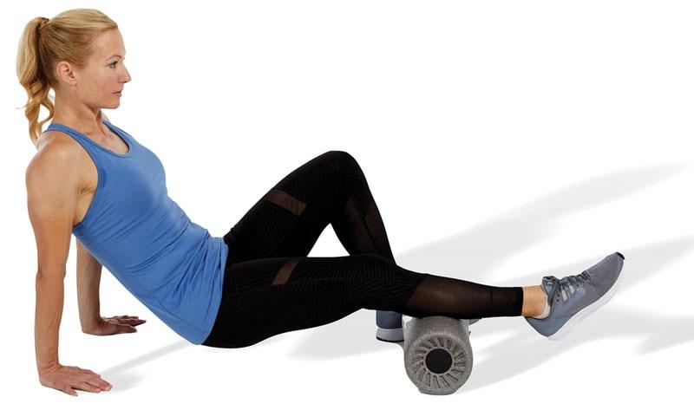

TECHNIQUE

Crossing one leg on top of the other is optional and is used to increase pressure to the calf. Roll along the length of the calf muscles.

SMR: Peroneals

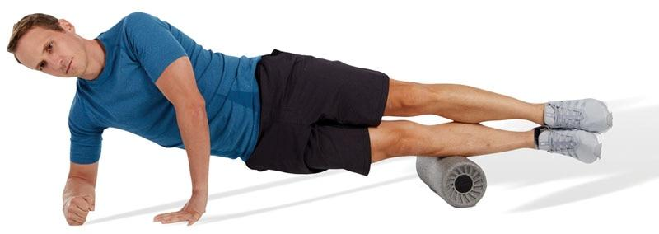

TECHNIQUE

Stacking the legs is optional and is used to increase pressure on the peroneals. Roll along the length of the muscle. Avoid rolling over the knee joint.

SMR: Hamstrings

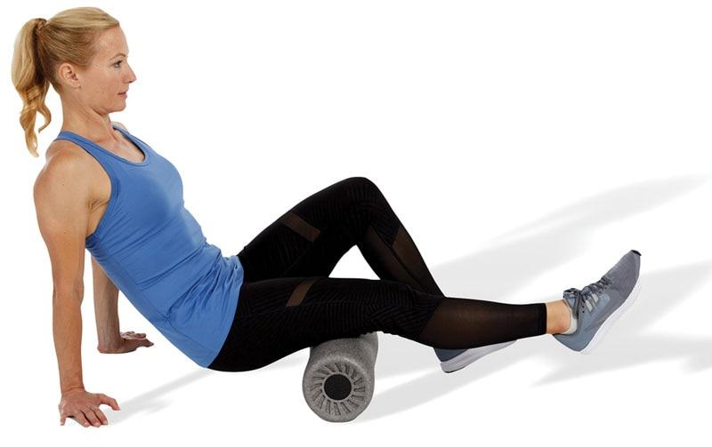

TECHNIQUE

While sitting, the target leg is straight with the roller underneath the posterior thigh, and the opposite knee is flexed. Roll along the length of the muscle. Avoid rolling over the knee joint. Using a massage ball instead of a foam roller is a progression for this exercise and can help pinpoint tender areas.

SMR: Quadriceps

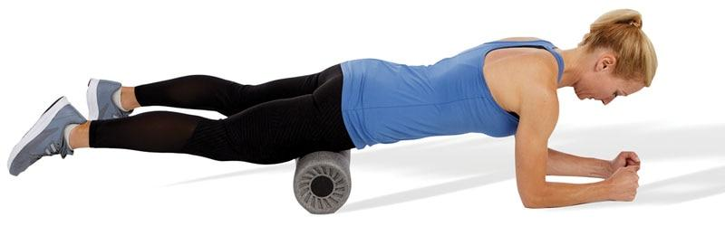

TECHNIQUE

The client is in the plank position with knees straight and roller under the quadriceps. Roll along the length of the muscle. This exercise can be performed bilaterally (both legs) or unilaterally (one leg at a time). Avoid rolling over the knee joint.

SMR: Adductors

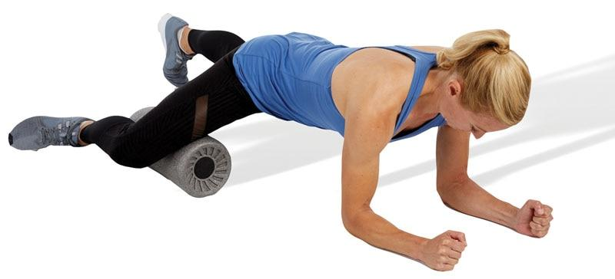

TECHNIQUE

To perform this technique correctly, the foam roller should be placed perpendicular to the inner thigh. Roll the length of the muscle. Avoid rolling over the knee joint.

SMR: Lateral Thigh

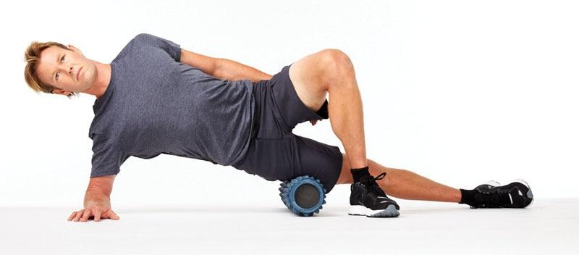

TECHNIQUE

The client is side-lying with the roller under the lateral thigh. The opposite hip and knee are bent with foot flat on the floor. Roll along the length of the lateral thigh. Avoid rolling over the hip or knee joint. This exercise can be too painful for some individuals. If this occurs, opt for a handheld roller instead.

SMR: Tensor Fascia Latae

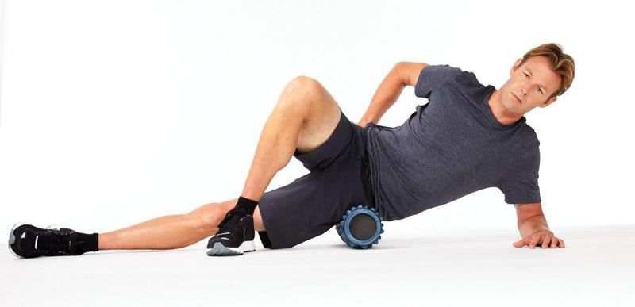

TECHNIQUE

The tensor fascia latae (TFL) is a small muscle, so this technique does not require lots of movement. To target the TFL, roll along the front and slightly lateral (outside) part of the upper thigh (just below the pelvis). Avoid rolling over the hip bone.

SMR: Piriformis

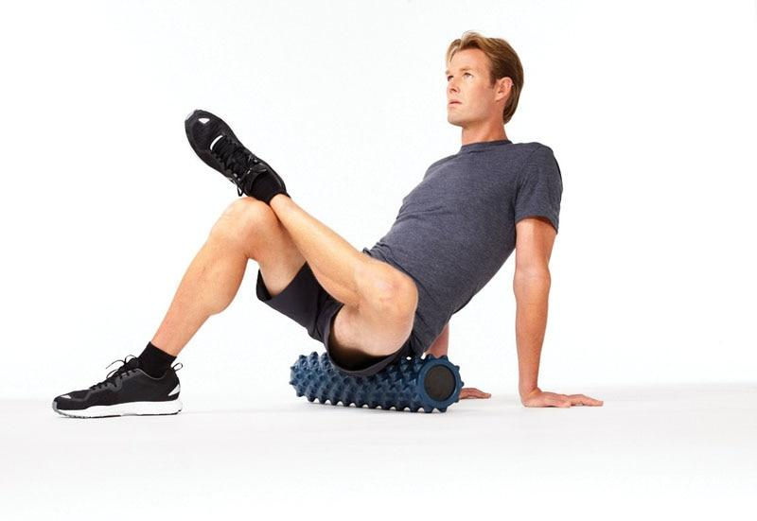

TECHNIQUE

The piriformis is a small muscle of the posterior hip that runs horizontally across the pelvis. To target the piriformis, sit on top of the foam roll, positioned on the back of the hip. Cross one foot to the opposite knee and lean into the hip of the crossed leg. Roll back and forth over the muscle. Avoid rolling over the hip bone.

SMR: Thoracic Spine

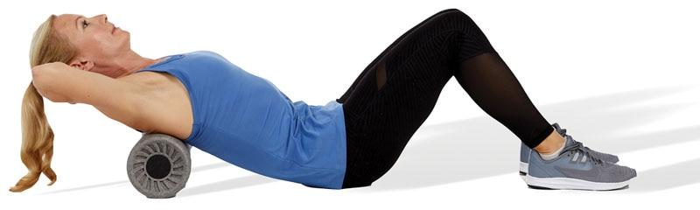

TECHNIQUE

The client keeps the bridge position and rolls along the thoracic spine. The client can choose to support their head in their hands (as shown) or cross their arms in front of their chest. This is a good technique to gain thoracic extension of the spine. Avoid rolling over the low-back (lumbar spine) and neck (cervical spine).

SMR: Latissimus Dorsi

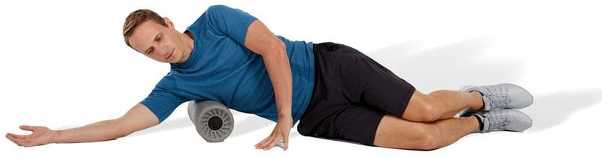

TECHNIQUE

To target the latissimus dorsi, lie on the floor on one side with the arm closest to the floor outstretched and thumb facing upward. Place the foam roller under the armpit area (axillary region) and slowly roll until a tender spot is identified.

**Precautions and contraindications**

Before programming self-myofascial techniques, fitness professionals should consider any medical precautions or contraindications. Medical precautions are any medical conditions that could be unsafe for flexibility exercise. In the presence of a medical precaution, the fitness professional may be able to modify an exercise for the client to be safe. For example, foam rolling for a client with osteopenia (a precursor to osteoporosis) is considered a precaution due to the risk of causing bone injury. As a modification, the fitness professional may choose to teach low-intensity, static stretching of the legs and arms to the client. The precautions listed in Table 14-3 are not all inclusive, as other precautions may be present with specific clients. Before recommending flexibility exercises, the fitness professional must use good judgment and communicate with the client and supervising medical professional to obtain proper clearance.

|  |  |  |
| --- | --- | --- |
| Medical Precautions | | |
| Hypertension (controlled) | Osteopenia | Pregnancy |
| Diabetes | Varicose veins | Rolling over bony prominences or regions |
| Abnormal sensations (e.g., numbness) | Sensitivity to pressure | Recent injury or surgery |
| Inability to position the body or perform the exercise correctly | Young children | Elderly |
| Scoliosis or spinal deformity | Medications that may alter client sensations | Fibromyalgia |
| Note: This list provides examples, but it is not an exhaustive list. If the client has stated a condition that is not on the list, it is important to have them consult with their physician before engaging in self-myofascial techniques. | | |

Contraindications are medical conditions that would make any type of flexibility exercise unsafe for the client to participate in. Self-myofascial techniques should not be conducted in the presence of a contraindication to ensure client safety. It is important to note that some conditions, such as pregnancy, diabetes, varicose veins, recent injury or surgery, and hypertension, may be considered either precautionary or contraindicative depending on the client’s status (Cheatham et al., 2018). The contraindications listed in this chapter are not all inclusive as others may be present with specific clients (Cheatham et al., 2018). Therefore, a medical professional should be consulted before proceeding with self-myofascial techniques in the presence of a medical contraindication (Table 14-4).

TABLE 14-4 Contraindications to Self-Myofascial Techniques

| **Medical contraindications** | | |
| --- | --- | --- |
| Skin rash, open wounds, blisters, local tissue inflammation, bruises, or tumors | Deep vein thrombosis, osteomyelitis (i.e., infection of bone tissue) | Osteoporosis |
| Bone fracture of myositis ossificans (i.e., bone forming within muscle tissue) | Cancer or malignancy | Hypertension (uncontrolled) |
| Acute or severe cardiac, liver, or kidney disease | Acute infection (viral or bacterial), fever, or contagious condition | Neurologic conditions resulting in loss or altered sensation |
| Bleeding disorders | Systemic conditions (e.g., diabetes) | Recent surgery or injury |
| Connective tissue disorders | Peripheral vascular insufficiency or disease (i.e., blood circulation disorder) | Medications that thin the blood or alter sensations |
| Direct pressure over surgical site or hardware | Chronic conditions (e.g., rheumatoid arthritis) | Direct pressure over face, eyes, arteries, veins (e.g., varicose veins), or nerves |
| Pregnancy (consult physician) | Severe scoliosis or spinal deformity | Extreme discomfort or pain felt by client |

**Static stretching**

Static stretching is the process of passively taking a muscle to the point of tension and holding the stretch for a minimum of 30 seconds (Behm & Chaouachi, 2011). This is a traditional form of stretching that is most often used in current fitness professions. It combines low force with longer duration stretch times (Thomas et al., 2018). By holding the muscle in a stretched position for a prolonged period, the muscle spindle becomes inhibited resulting in a relaxation response. This allows the muscle to relax and provides for a better lengthening reaction (Table 14-5) (Thomas et al., 2018). In fact, static stretching may impact many sensory mechanisms within the nervous system to facilitate a greater stretch tolerance. In addition, contracting the antagonistic musculature while holding the stretch can reciprocally inhibit the muscle being stretched, allowing it to relax and enhance the effectiveness of the stretch. For example, when performing the kneeling hip flexor stretch, an individual can contract the hip extensors (gluteus maximus) to reciprocally inhibit the hip flexors (psoas, rectus femoris), allowing for greater lengthening of these muscles (Lempke et al., 2018). Another example would be to contract the quadriceps when performing a hamstring stretch. Static stretching should be used to decrease the muscle spindle activity of an overactive muscle before and after activity. Various static stretching techniques are described in the following section.

TABLE 14-5 Static Stretching Summary

| **Type of Stretch** | **Mechanism of Action** | **Training Variables** |
| --- | --- | --- |
| Static stretch | Stretch tolerance and/or reciprocal inhibition (depending how stretch is performed) | 1–3 sets  Hold each stretch for 30 seconds |

STRETCH YOUR KNOWLEDGE

Does Static Stretching Impair Strength and Power?

There has been much debate in the research and sport science communities regarding the effects of static stretching on strength and athletic performance. Several studies have cited that static stretching impairs strength and power and recommend avoiding this technique prior to exercise or sport competition (Haddad et al., 2014).

Looking at the research more closely, static stretching, when performed acutely and in isolation, can temporarily impair muscular power due to its relaxation response. This is especially true when stretches are held for extended periods (2 minutes or longer) and performed in an acute fashion (every now and again) and are the only form of exercise performed prior to maximal effort (sprinting or jumping).

However, static stretches, when performed for 30 seconds or less in a chronic fashion (included prior to every workout) and followed by dynamic activities, does not impair athletic performance (Behm et al., 2016; Kay & Blazevich, 2012; Reid et al., 2018).

As such, NASM recommends performing static stretching, especially when individuals exhibit limited joint ROM or muscle imbalances. Following are some recommendations.

Static stretches:

* Should be held for 30 seconds
* Only used on muscles identified as overactive during the assessment process
* Followed by additional warm-up protocols, such as low-intensity core and balance exercises or dynamic stretching, to regain motor neuron excitability

**Static stretches**

Static Gastrocnemius Stretch

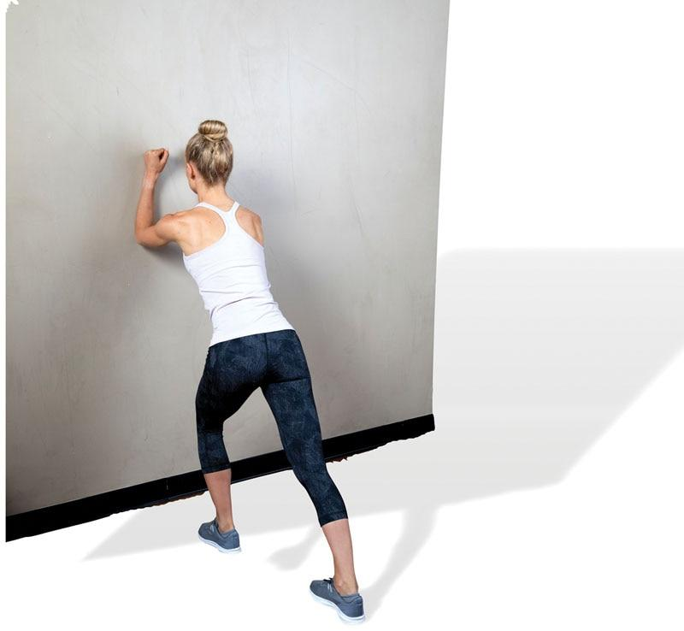

TECHNIQUE

Stand in a lunge position with both feet pointing straight forward. Make sure to keep the rear foot flat on the ground. Do not let the heel rise. Shift weight forward until a stretch is felt in the rear calf muscle.

Static Soleus Stretch

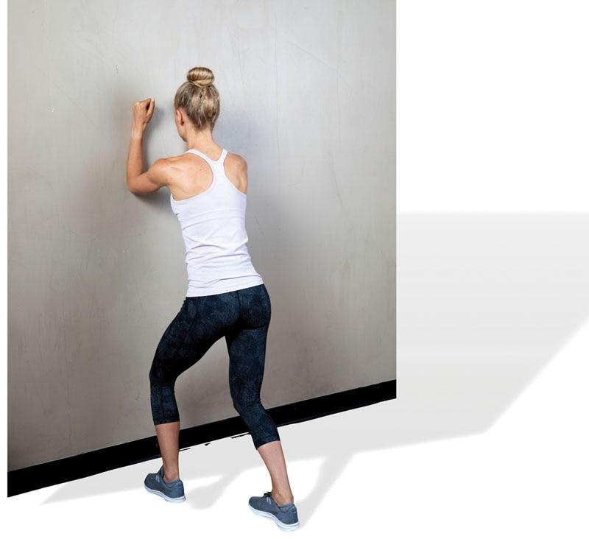

TECHNIQUE

Stand in a lunge position with both feet pointing straight forward and back knee slightly flexed. Make sure to keep the rear foot flat on the ground. Do not let the heel rise up. Shift weight forward until a stretch is felt in the rear calf muscle.

Static 90/90 Hamstring Stretch

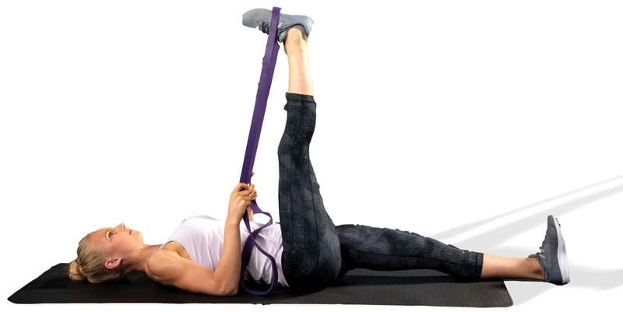

TECHNIQUE

Lie supine with one hip flexed 90 degrees (target leg) and the opposite leg straight and flat on the floor. Straighten the target leg until a mild stretch is felt in the hamstrings. The use of a rope or band is suggested. The stretch should not cause pain or extreme discomfort.

Static Supine Biceps Femoris Stretch

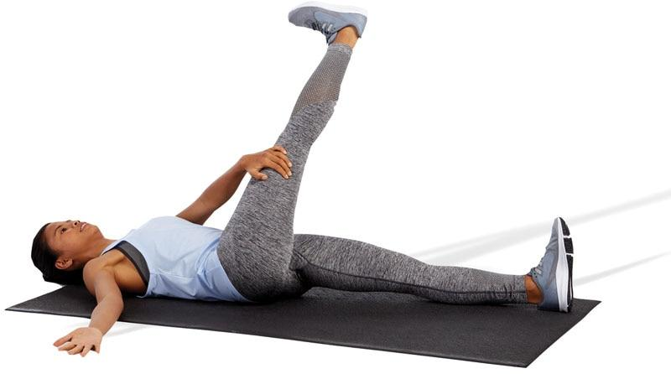

TECHNIQUE

Lie supine with one hip flexed 90 degrees (target leg) and the opposite leg straight and flat on the floor. Next, adduct the target leg across the body and extend the knee until a mild stretch is felt in the lateral hamstrings. The stretch should not cause pain or extreme discomfort. Keep both shoulders flat on the ground during this stretch. Avoid rotating the torso toward the stretched leg.

Static Standing Biceps Femoris Stretch

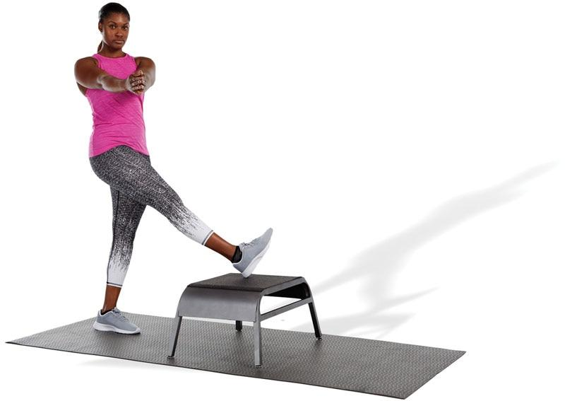

TECHNIQUE

Use a low box or step to perform this stretch. Place one leg on top of the box in an adducted and internally rotated position. Then, locking the hands together, slowly rotate the torso in the opposite direction. The stretched leg does not need to be elevated above hip height. This stretch emphasizes the lateral hamstring.

Static Seated Ball Adductor Stretch

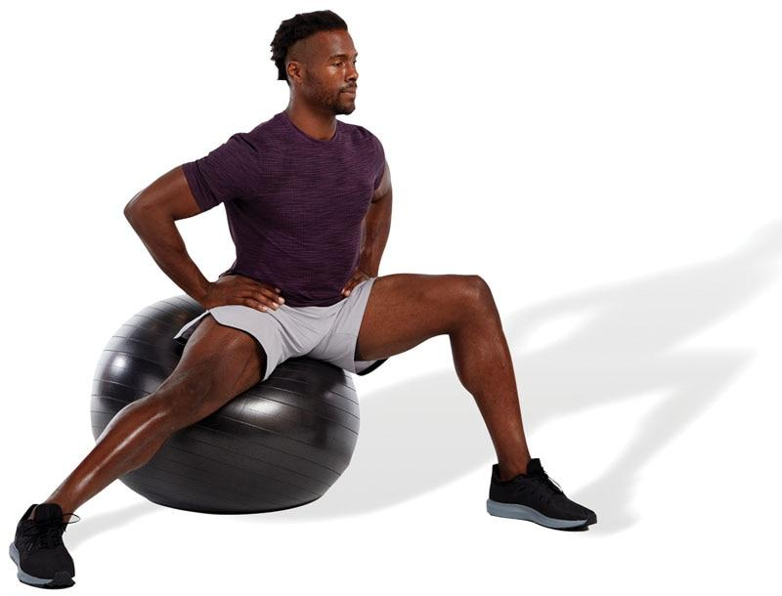

TECHNIQUE

Sit on a stability ball in a lateral lunge position until a stretch is felt in the inner thigh area. Posteriorly rotate the pelvis and draw in the abdominals when performing this stretch.

Static Standing Adductor Stretch

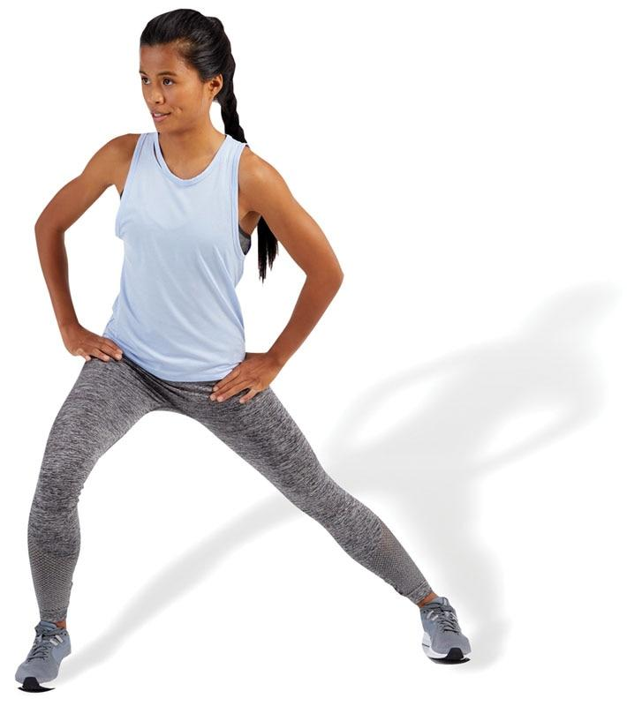

TECHNIQUE

Stand with legs apart and shift weight to one side (lateral lunge position) until a stretch is felt in the inner thigh of the target leg. Posteriorly rotate the pelvis and draw in the abdominals when performing this stretch.

Static Adductor Magnus Stretch

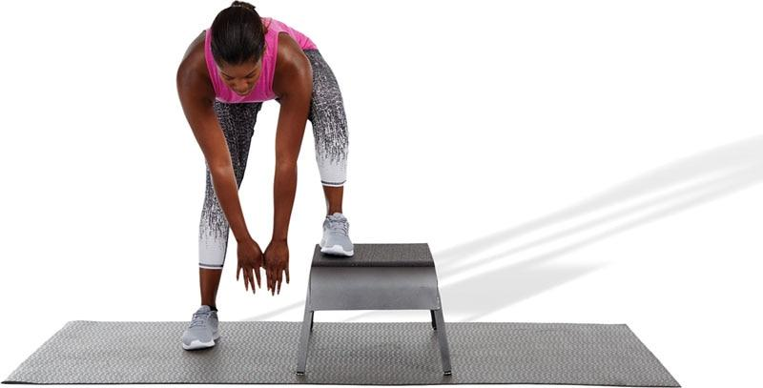

TECHNIQUE

While standing with one foot on a bench or plyo box, reach down to a comfortable position without excessively rounding the spine until a stretch is felt.

Static Standing TFL Stretch

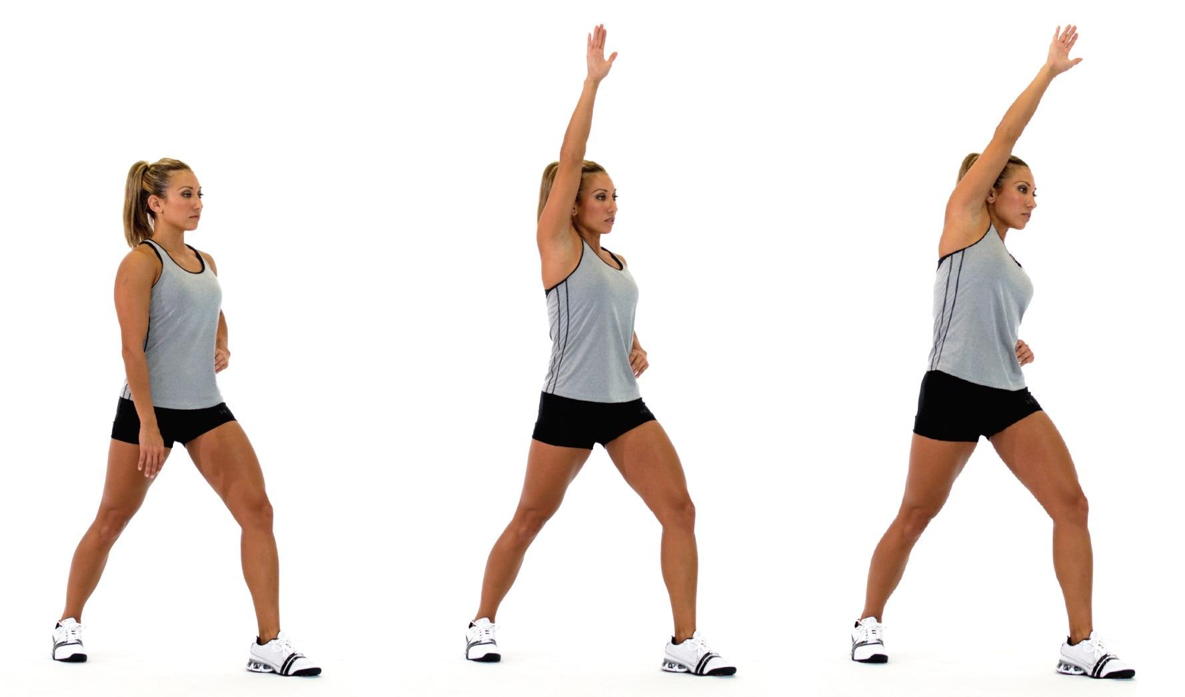

TECHNIQUE

Stand in a staggered stance with the front leg slightly bent and rear leg straight. Externally rotate the rear foot, draw in the navel, and posteriorly rotate the pelvis. Squeeze the gluteal muscles of the side being stretched. As a progression, raise the arm (on the same side as the back leg) up and over to the opposite side while maintaining pelvis position. Hold side bend position as illustrated.

Static Kneeling Hip Flexor Stretch

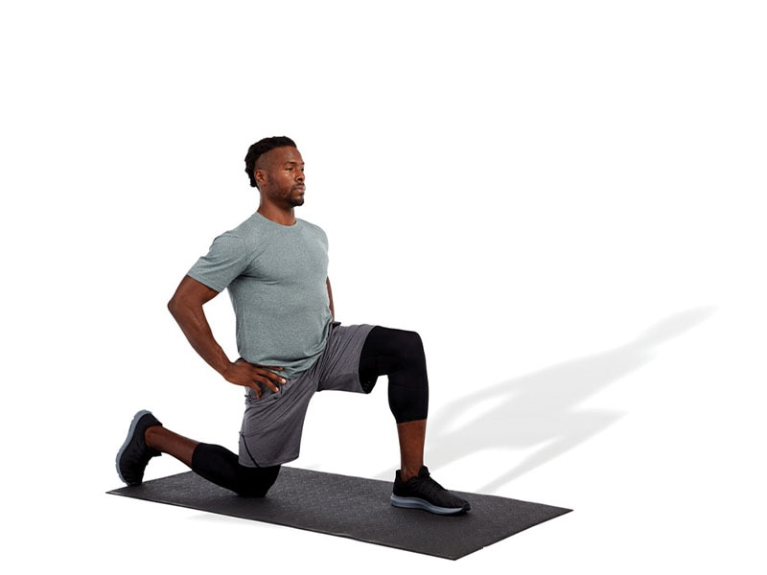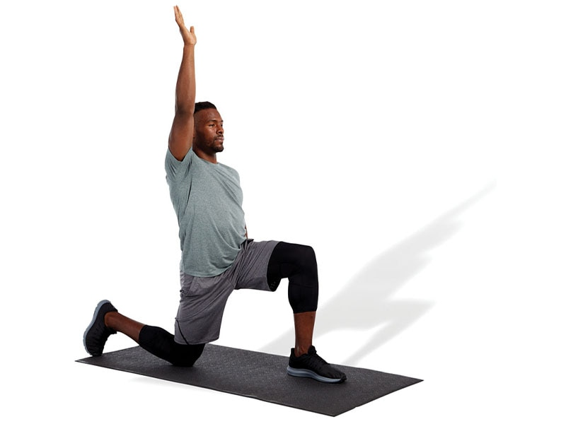

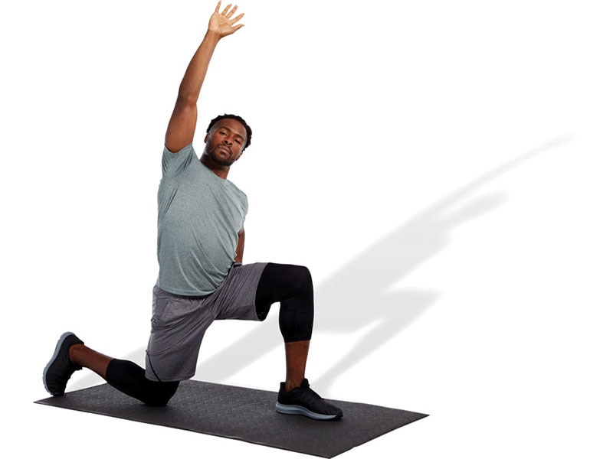 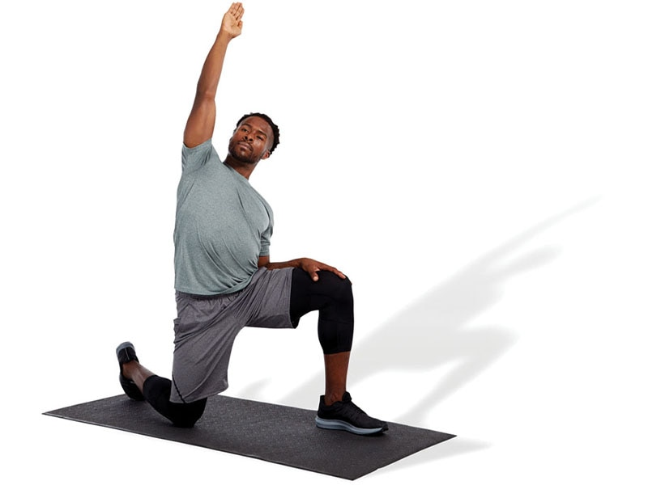

TECHNIQUE

Kneel with front and back legs flexed at a 90-degree angle. Draw in the navel and posteriorly rotate the pelvis. Squeeze the gluteal muscles of the side being stretched. As a progression, raise the arm (on the same side as the back leg) up and over to the opposite side while maintaining pelvis position. Hold side bend position and slowly rotate posteriorly as illustrated. To emphasize the TFL, externally rotate the rear leg, whereas to emphasize the psoas, internally rotate the rear leg.

Static Supine Piriformis Stretch

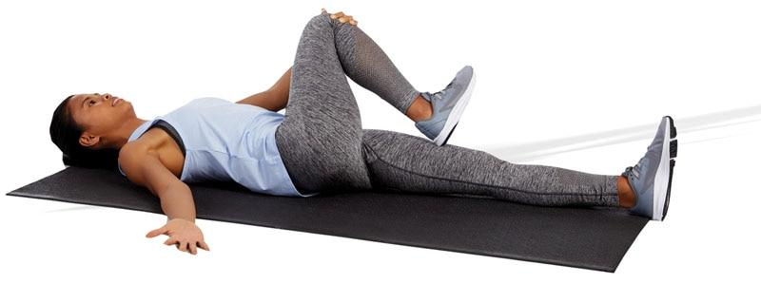

TECHNIQUE

Lie supine and cross one leg over the opposite leg that is straight. Keep the low-back in a neutral position while bringing the knee toward the opposite shoulder.

Static Erector Spinae Stretch

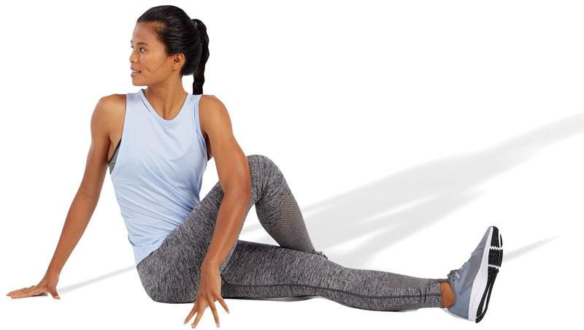

TECHNIQUE

Sit with one leg crossed over the other and opposite knee straight. Rotate the torso to the right when the right leg is crossed over the left leg. Rotate to the left when the left leg is crossed over the right leg.

Static Ball Latissimus Dorsi Stretch

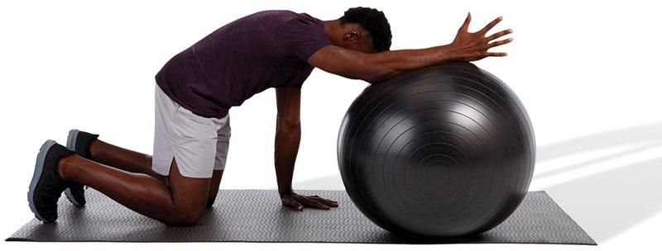

TECHNIQUE

In the quadruped position, put one arm on top of a stability ball and roll forward until a stretch is felt. Posteriorly rotate the pelvis, point the thumb up toward the sky, and draw in the abdominals when performing this stretch.

Static Pectoral Stretch

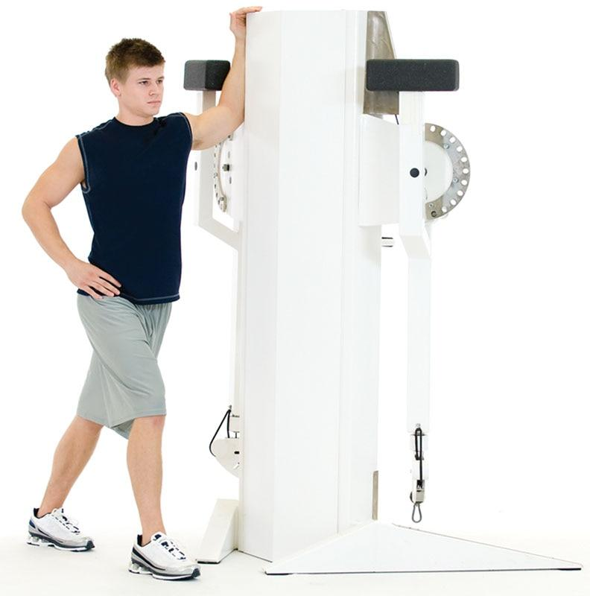

TECHNIQUE

Standing with one arm in a 90/90 arm position, lean forward until a stretch is felt in the anterior shoulder and chest area. Do not allow the shoulders to elevate (shrug) during this stretch.

Static Upper Trapezius/Scalene Stretch

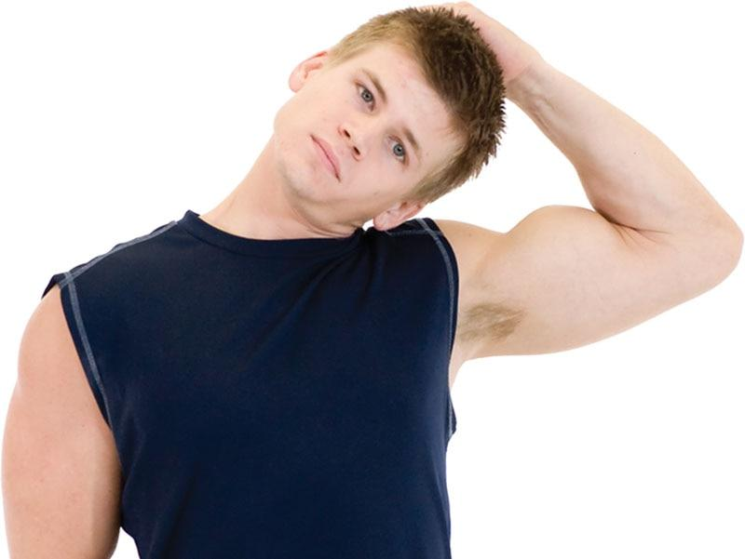

TECHNIQUE

Grasp the top of the head with one hand and laterally flex toward the same shoulder. Do not allow the chin to jut forward or shoulders to shrug during this stretch.

Static Levator Scapulae Stretch

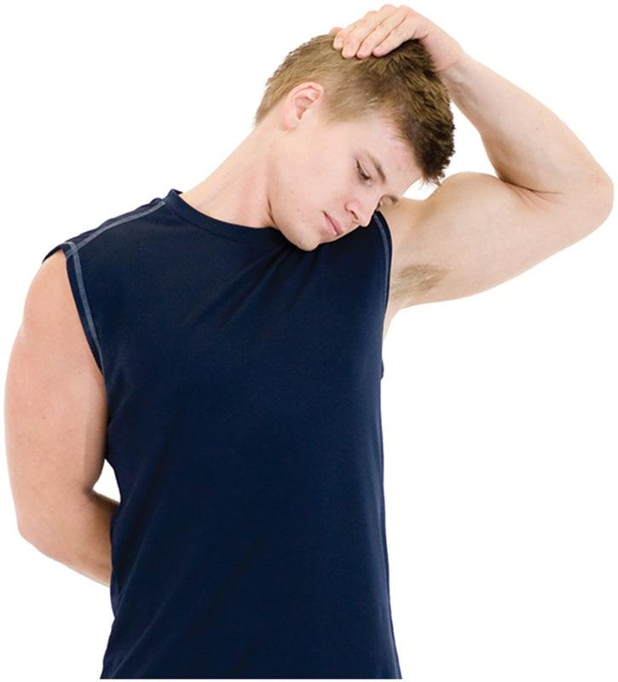

TECHNIQUE

Grasp the top of the head with one hand and laterally flex toward the same shoulder. Next, slightly rotate the head to look in the axillary (armpit) region as shown. Do not allow the chin to jut forward or shoulders to shrug during this stretch.

Static Sternocleidomastoid Stretch

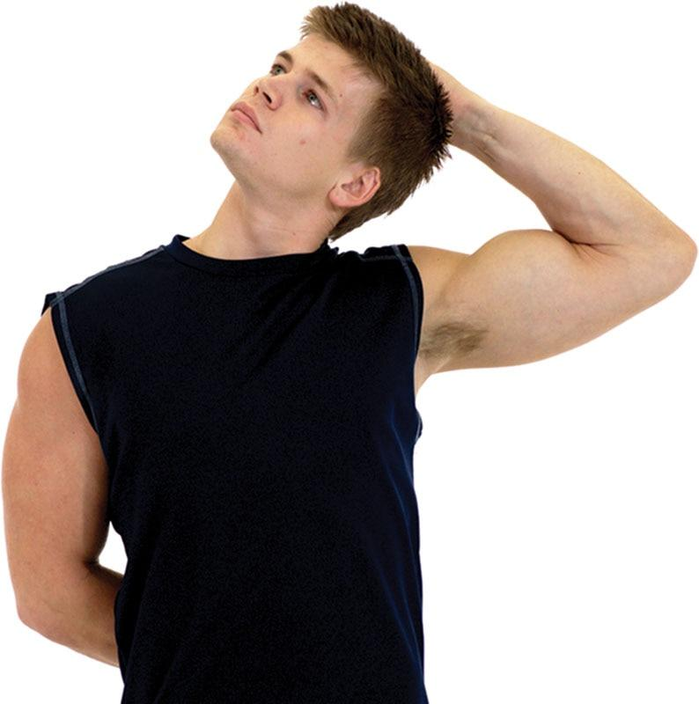

TECHNIQUE

Grasp the top of the head with one hand and laterally flex toward the same shoulder. Rotate the head up and away as shown. Only perform this stretch to the point of mild tension. Do not allow the chin to jut forward or shoulders to shrug during this stretch.

CRITICAL

When assisting clients during a stretch, the fitness professional must be careful not to overstretch the muscle. Overstretching can occur if the muscle and joint are taken beyond their physiological limits. Aggressive stretching can result in tissue and joint trauma. The general signs of overstretching include but are not limited to (1) prolonged joint pain or muscle soreness lasting more than 24 hours after stretching, (2) edema (swelling) or inflammation of the involved area, and (3) excessive muscle or joint pain during the stretch. Caution needs to be taken when conducting flexibility exercises with clients who have a current or preexisting joint or muscle injury.

**Active Stretching**

Active stretching is the process of using agonists and synergists to dynamically move the joint into a ROM (Vernetta-Santana et al., 2015). This form of stretching increases motor neuron excitability, creating reciprocal inhibition of the muscle being stretched (Kenney et al., 2019). The active supine hamstring stretch is a good example of active stretching. The quadriceps extend the knee. This enhances the stretch of the hamstrings in two ways. First, it increases the length of the hamstrings. Second, the contraction of the quadriceps causes reciprocal inhibition (decreased neural drive and muscle spindle excitation) of the hamstring complex, which allows it to elongate (Vernetta-Santana et al., 2015). Active stretches are suggested for pre-activity warm-up, such as before sports competition or high-intensity exercise. If an individual possesses muscle imbalances, active stretching should be performed after self-myofascial techniques and static stretching for muscles determined as overactive during the assessment process. Typically, 5 to 10 repetitions of each stretch are performed and held for 1 to 2 seconds each (Table 14-6). Detailed explanations of various active-isolated techniques are described in the following section.

TABLE 14-6 Active Stretching Summary

| **Type of Stretch** | **Mechanism of Action** | **Training Variables** |
| --- | --- | --- |
| Active stretch | Reciprocal inhibition | 1–3 sets  Hold each stretch for 1–2 seconds and repeat for 5–10 repetitions |

HELPFUL HINT

Static and active stretches typically require the same body position and movement patterns. However, static stretches involve holding each stretch for 30 seconds, whereas active stretches require holding the stretch for only 1 to 2 seconds and repeating the motion for 5 to 10 repetitions. Active stretching can be considered a progression from static stretching.

**Active stretches**

Active Gastrocnemius Stretch

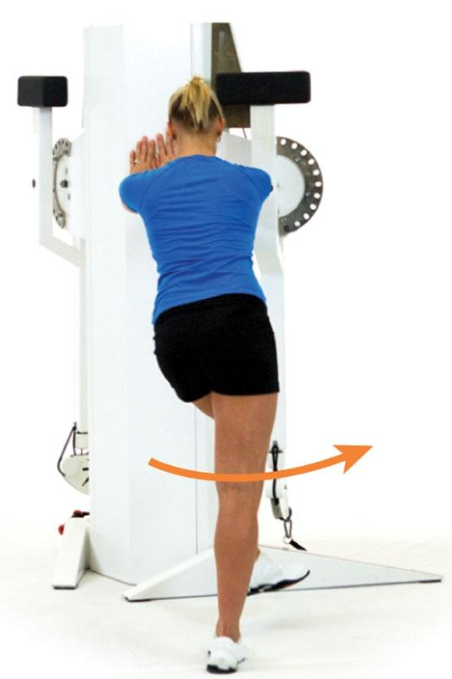 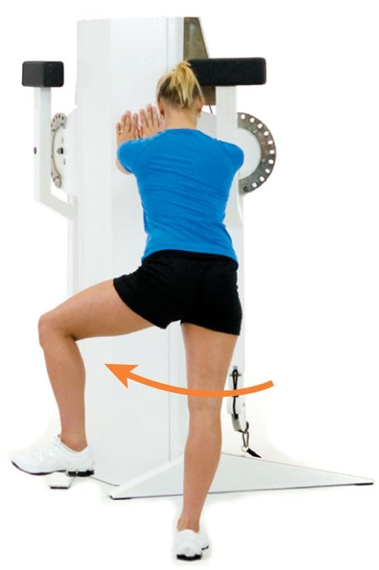 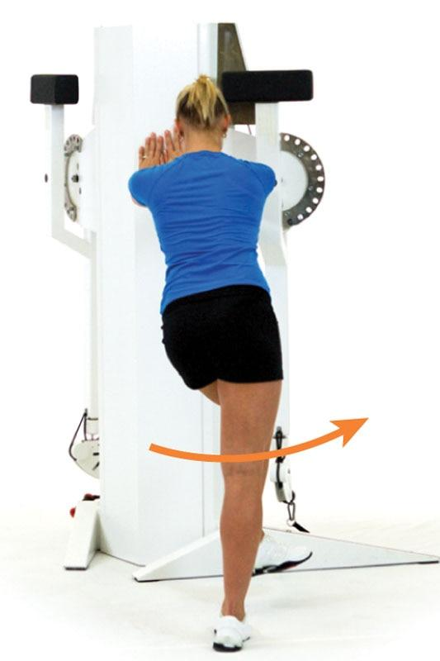

TECHNIQUE

Stand with back hip and knee straight (target leg). The opposite hip and knee are flexed and swing back and forth across the body. This motion causes rotation at the back knee and eversion and inversion of the foot and ankle. Repeat for the desired number of repetitions.

Active Soleus Stretch

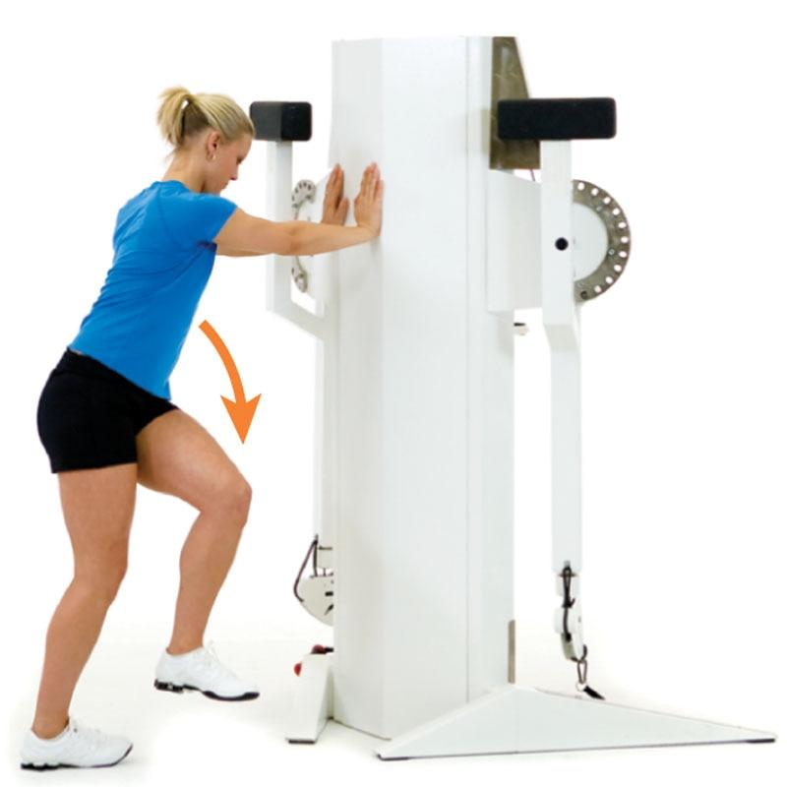 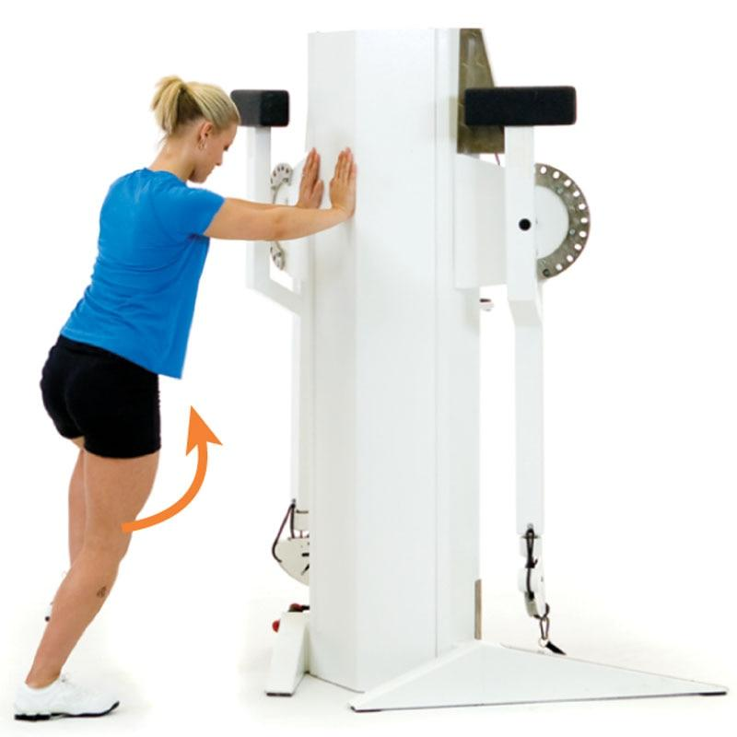 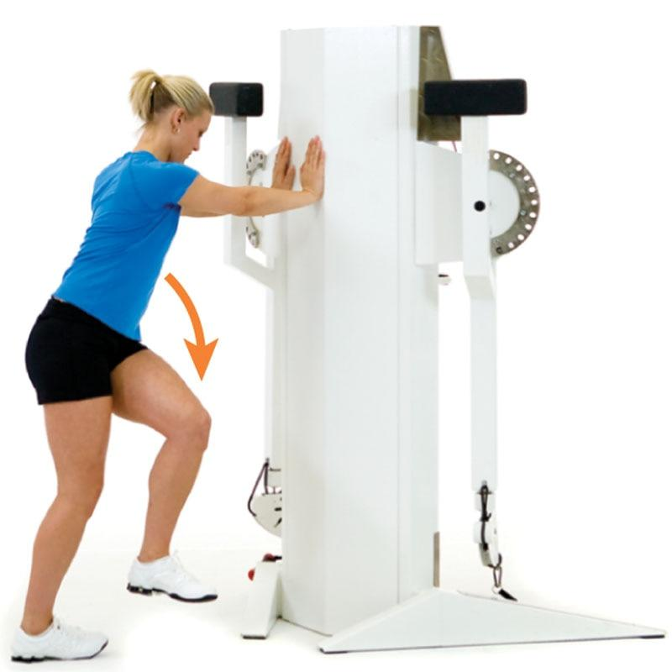

TECHNIQUE

Stand with back hip and knee slightly flexed (target leg). The opposite hip and knee are flexed and swing back and forth across the body. This motion causes rotation at the back knee and eversion and inversion of the foot and ankle. Repeat for the desired number of repetitions.

Active 90/90 Hamstring Stretch

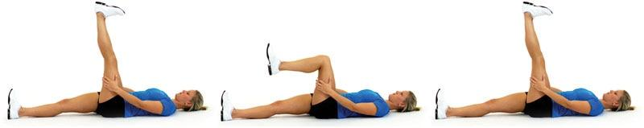

TECHNIQUE

Lie supine with one hip flexed 90 degrees (target leg). Straighten the target leg until a mild stretch is felt in the hamstrings. The stretch should not cause pain or extreme discomfort. Repeat for the desired number of repetitions.

Active Supine Biceps Femoris Stretch

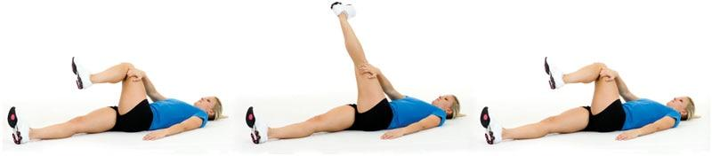

TECHNIQUE

Lie supine with one hip flexed 90 degrees (target leg) and the opposite leg straight and flat on the floor. Next, adduct the target leg across the body and extend the knee until a mild stretch is felt in the lateral hamstrings. The stretch should not cause pain or extreme discomfort. Keep both shoulders flat on the ground during this stretch. Avoid rotating the torso toward the stretched leg. Repeat for the desired number of repetitions.

Active Standing Adductor Stretch

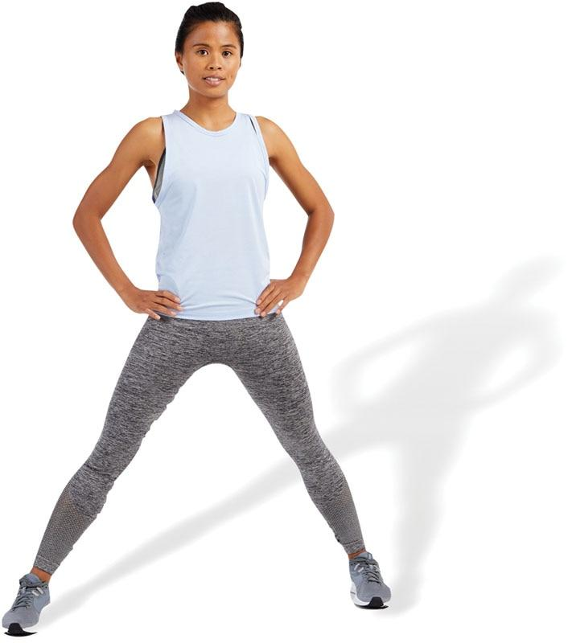 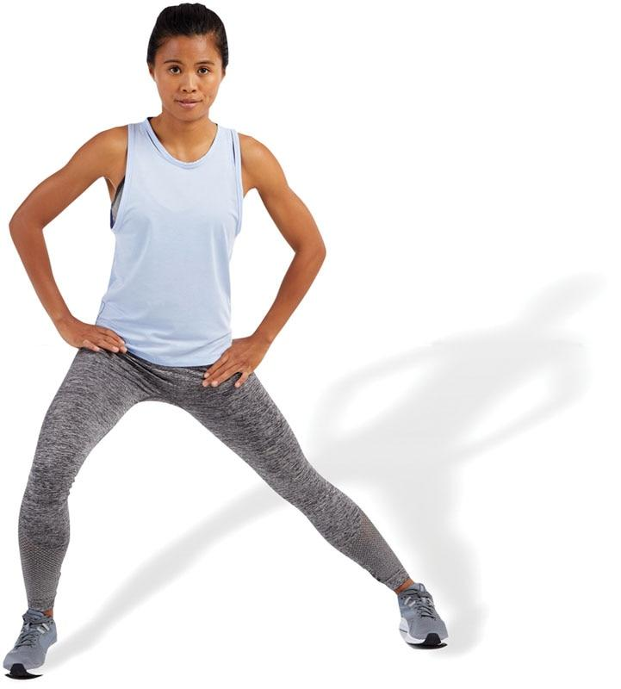

TECHNIQUE

Stand with legs spread apart and shift weight to one side (lateral lunge position) until a stretch is felt in the inner thigh area. Posteriorly rotate the pelvis and draw in the abdominals when performing this stretch. Repeat for the desired number of repetitions.

Active Ball Adductor Stretch

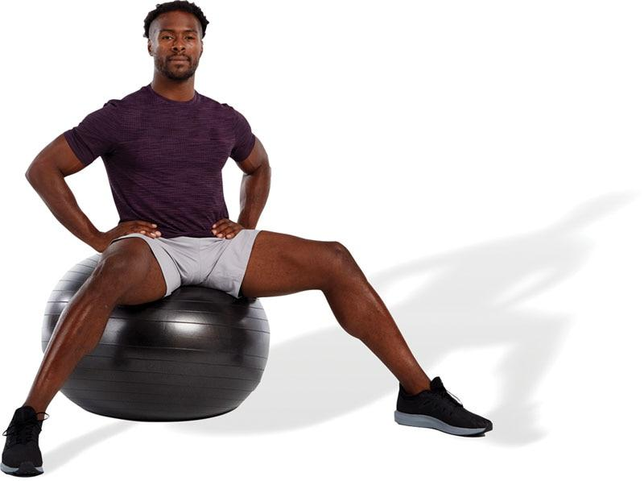 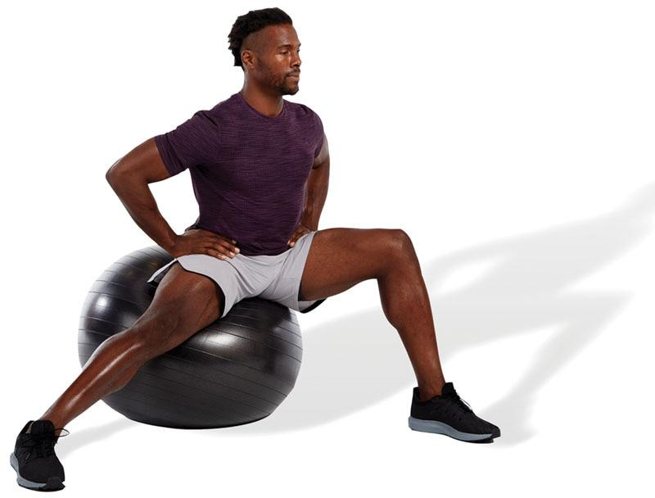 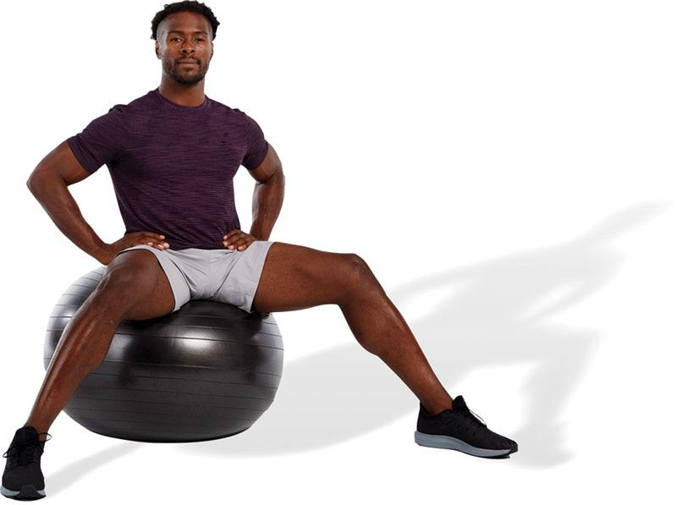

TECHNIQUE

Sit on a stability ball in a lateral lunge position until a stretch is felt in the inner thigh area. Posteriorly rotate the pelvis and draw in the abdominals when performing this stretch. Repeat for the desired number of repetitions.

Active Adductor Magnus Stretch

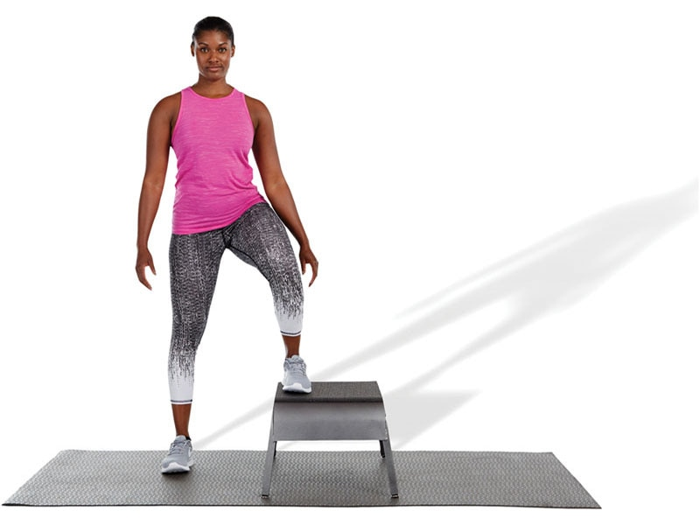 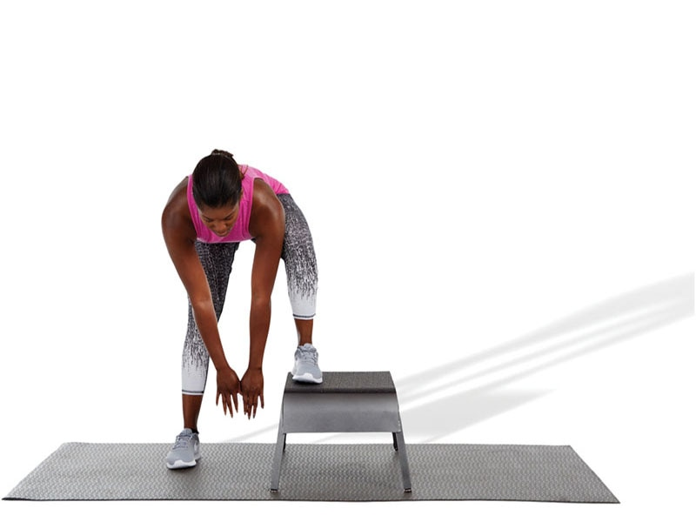 

TECHNIQUE

While standing with one foot on a bench or plyo box, reach down to a comfortable position without excessively rounding the spine until a stretch is felt. Repeat for the desired number of repetitions.

Active Standing TFL Stretch

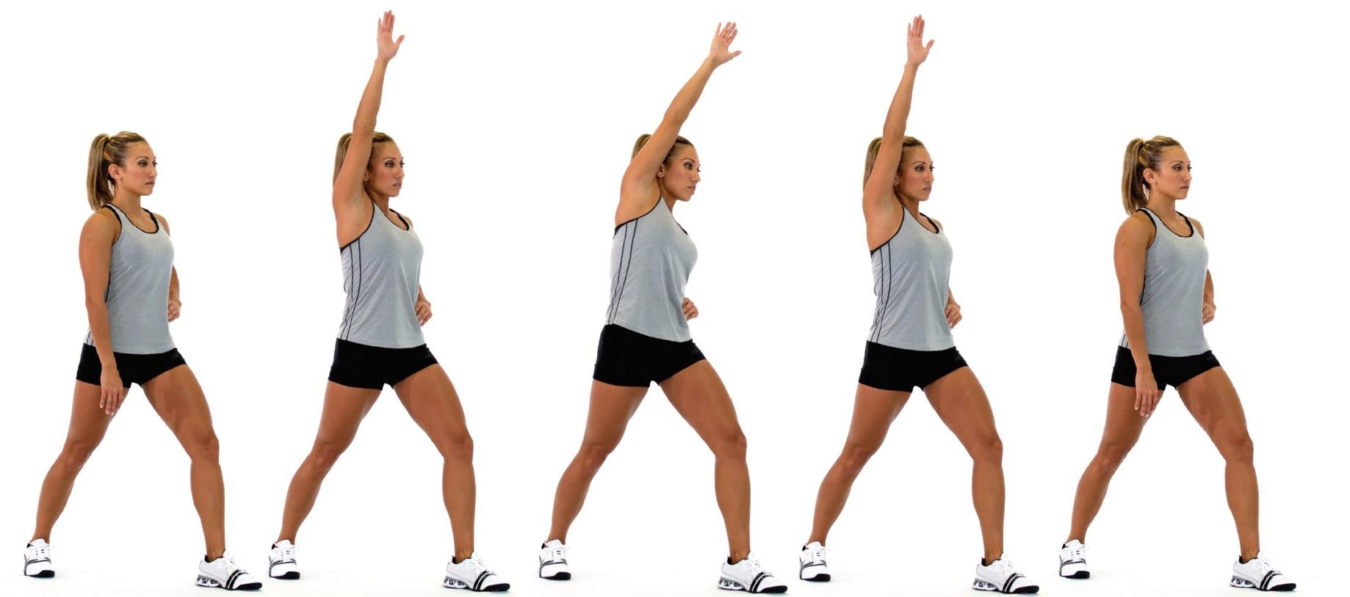

TECHNIQUE

Stand in a staggered stance with the front leg slightly bent and rear leg straight. Externally rotate the rear foot, draw in the navel, and posteriorly rotate the pelvis. Squeeze the gluteal muscles of the side being stretched. As a progression, raise the arm (on the same side as the back leg) up and over to the opposite side while maintaining pelvis position. Hold side bend position and repeat for the desired number of repetitions.

Active Kneeling Hip Flexor Stretch

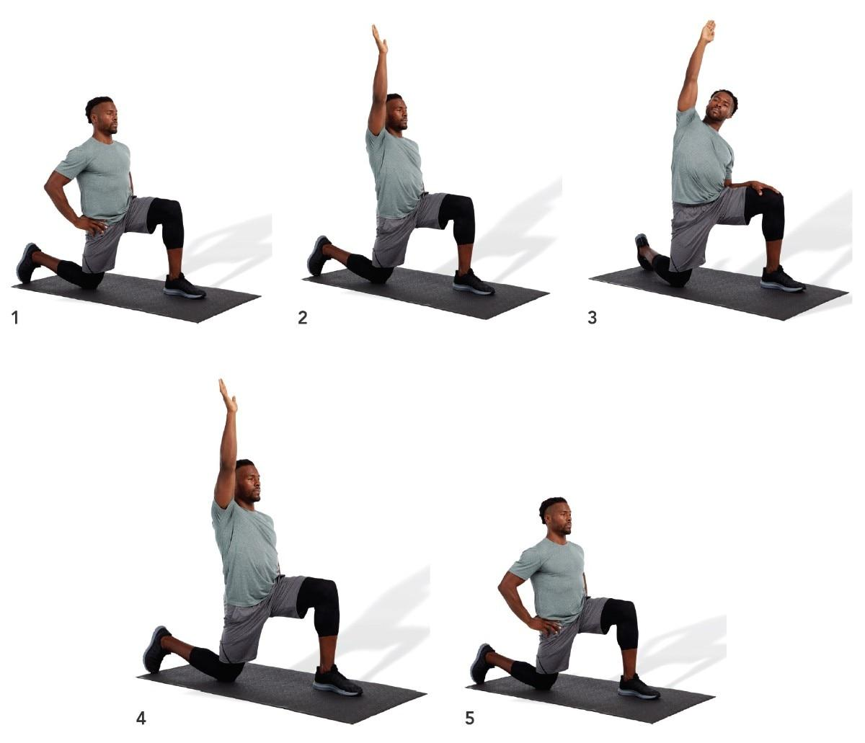

TECHNIQUE

Kneel with front and back legs flexed at a 90-degree angle. Draw in the navel and posteriorly rotate the pelvis. Squeeze the gluteal muscles of the side being stretched. As a progression, raise the arm (on the same side as the back leg) up and over to the opposite side while maintaining pelvis position. Hold side bend position and slowly rotate posteriorly as illustrated. To emphasize the TFL, externally rotate the rear leg, whereas to emphasize the psoas, internally rotate the rear leg. Repeat for the desired number of repetitions.

Active Latissimus Dorsi Ball Stretch

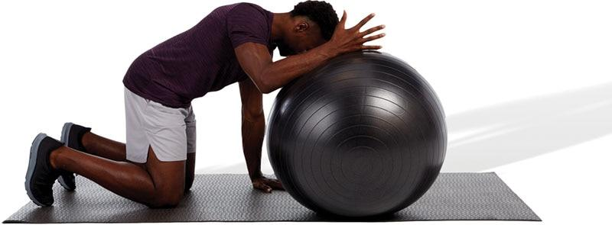

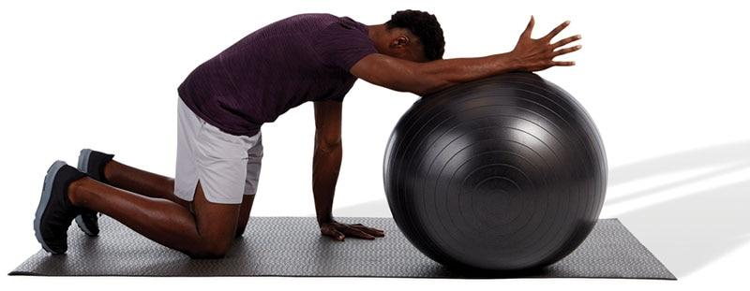



TECHNIQUE

In the quadruped position, put one arm on top of a stability ball and roll forward until a stretch is felt. Posteriorly rotate the pelvis, point the thumb up toward the sky, and draw in the abdominals when performing this stretch. Repeat for the desired number of repetitions.

Active Pectoral Stretch

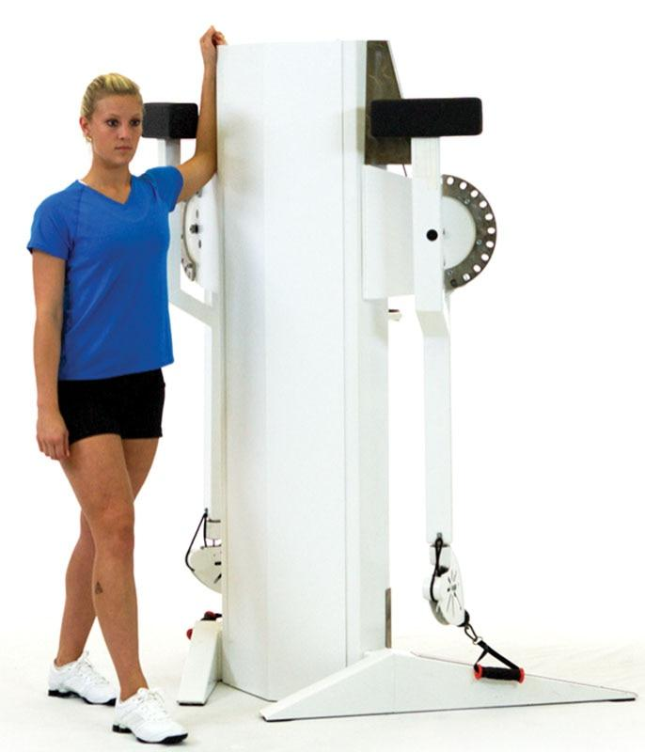 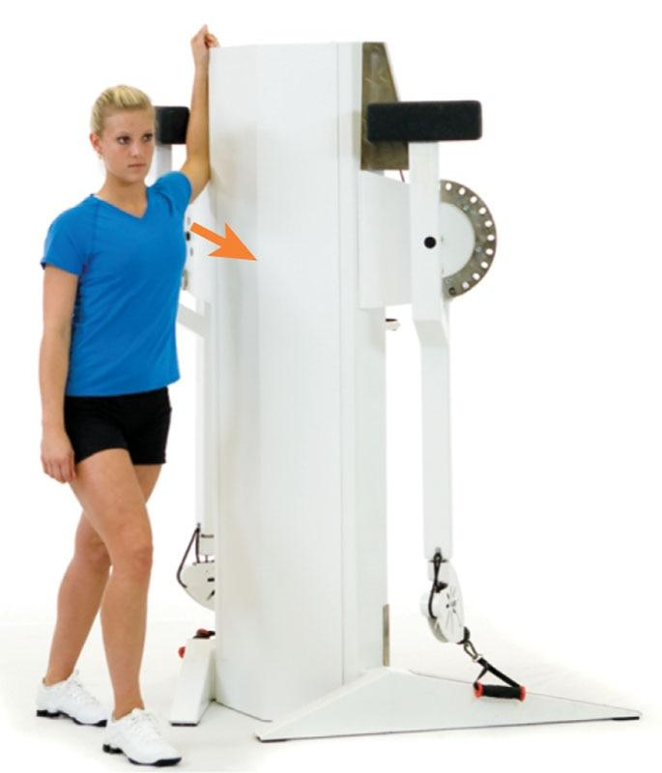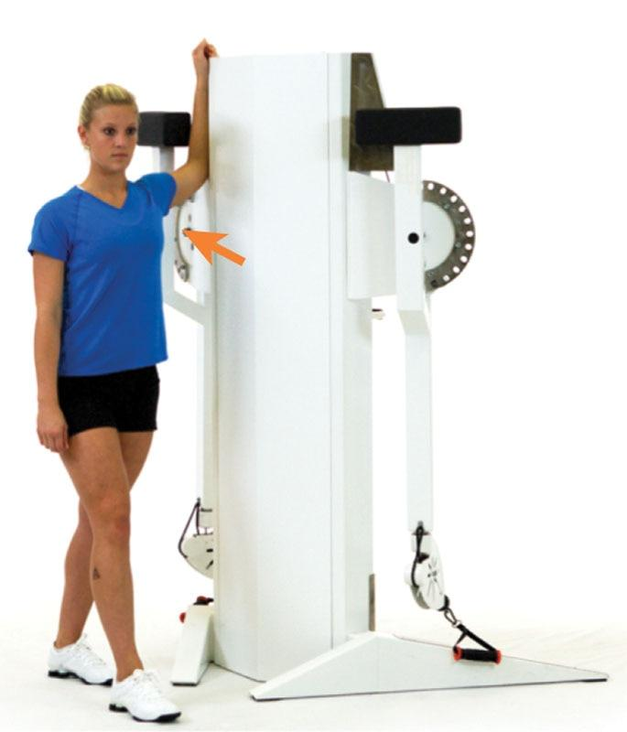

TECHNIQUE

Standing with one arm in a 90/90 arm position, lean forward until a stretch is felt in the anterior shoulder and chest area. Do not allow the shoulders to elevate (shrug) during this stretch. Repeat for the desired number of repetitions.

Active Upper Trapezius/Scalene Stretch

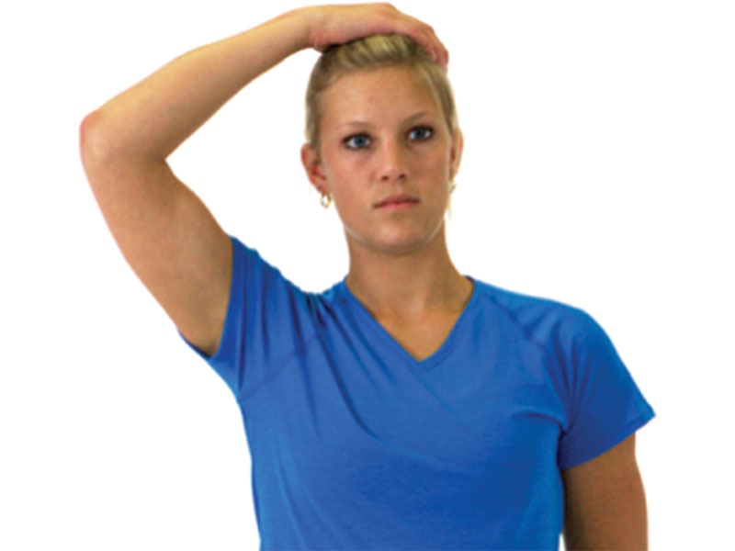 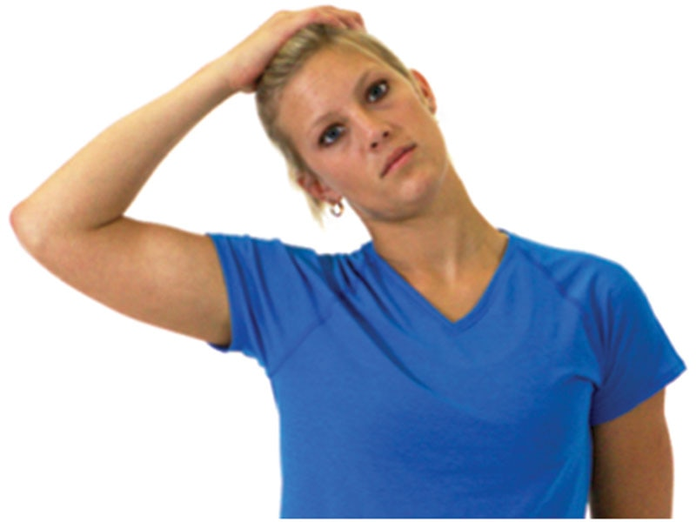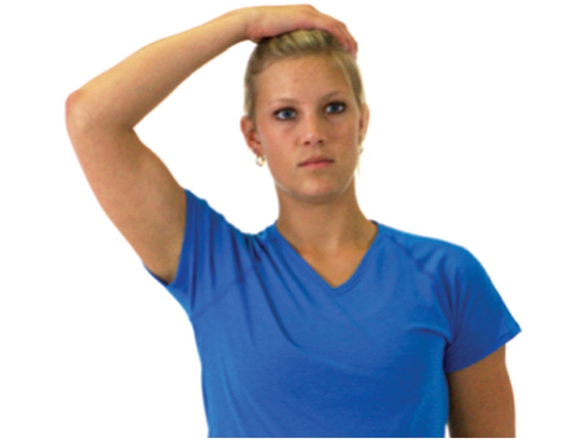

TECHNIQUE

Grasp the top of the head with one hand and laterally flex toward the same shoulder. Do not allow the chin to jut forward or shoulders to shrug during this stretch. Repeat for the desired number of repetitions.

Active Levator Scapulae Stretch

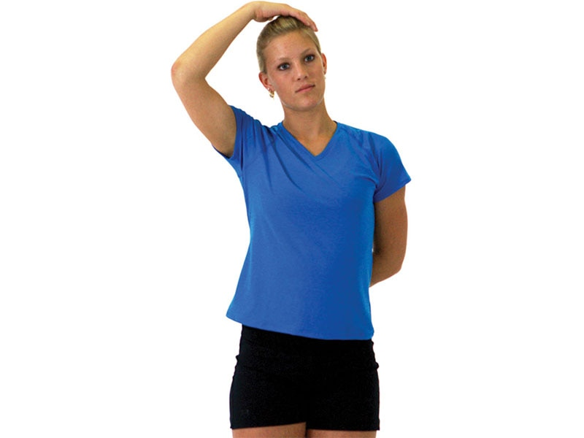 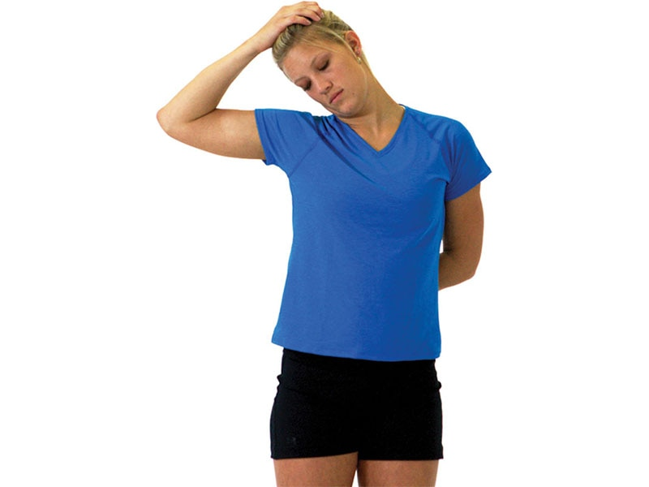 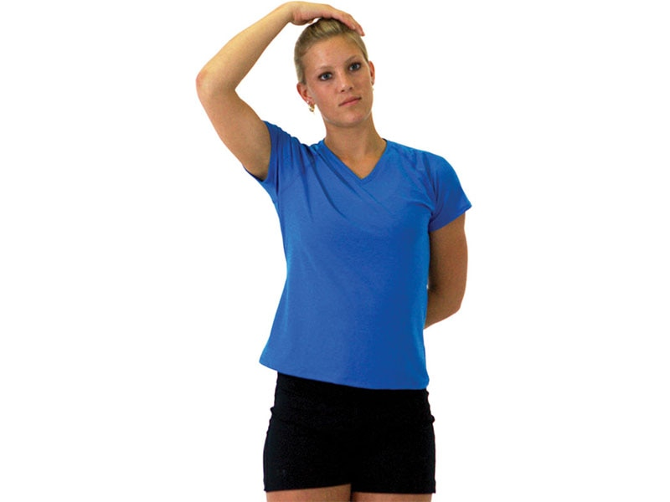

TECHNIQUE

Grasp the top of the head with one hand and laterally flex toward the same shoulder. Next, slightly rotate the head to look in the axillary (armpit) region as shown. Do not allow the chin to jut forward or shoulders to shrug during this stretch. Repeat for the desired number of repetitions.

Active Sternocleidomastoid Stretch

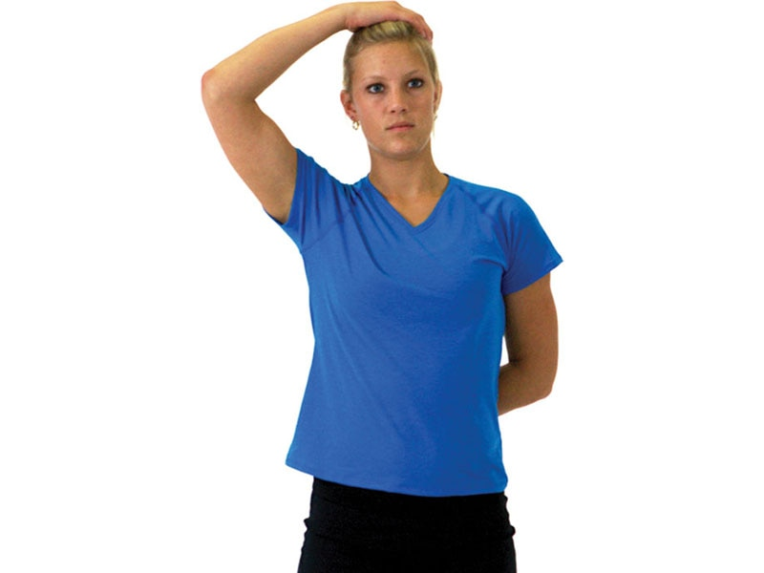 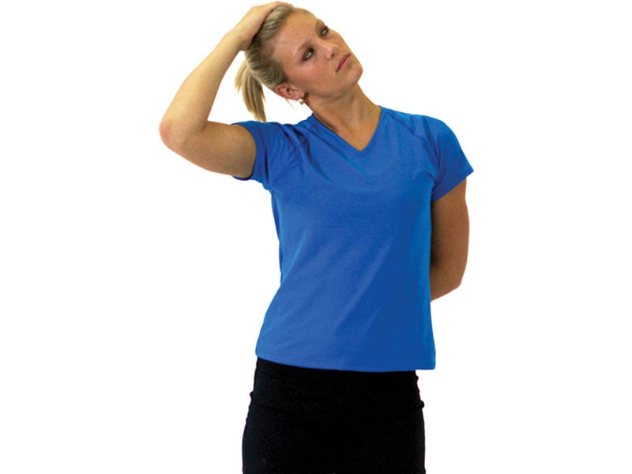 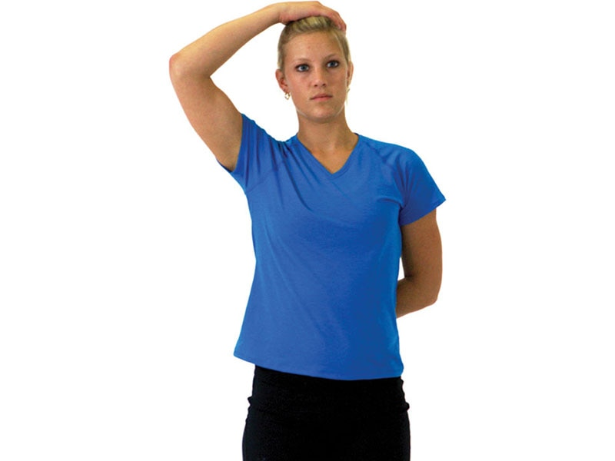

TECHNIQUE

Grasp the top of the head with one hand and laterally flex toward the same shoulder. Rotate the head up and away as shown. Only perform this stretch to the point of mild tension. Do not allow the chin to jut forward or shoulders to shrug during this stretch. Repeat for the desired number of repetitions.

TRAINING TIP

When performing static and active stretches, it is important to maintain ideal posture. This requires performing a chin tuck and keeping the head directly over the shoulders. Do not allow the head to jut forward. This position keeps the cervical spine in a neutral position. In addition, perform the drawing-in maneuver (slightly pull the navel inward) to help maintain ideal stabilization of the spine. The drawing-in manoeuvre is discussed in more detail in Chapter 16.

**Dynamic Stretching and Controversial Stretches**

Dynamic stretching uses the force production of a muscle and the body’s momentum to take a joint through the full available ROM (Behm & Chaouachi, 2011). Dynamic stretching uses the concept of reciprocal inhibition to improve soft tissue extensibility (Kenney et al., 2019). One can perform one set of 10 repetitions using 3 to 10 dynamic stretches (Table 14-7). Dynamic stretching is also suggested as a warm-up before athletic activity (Opplert & Babault, 2018). If an individual does possess muscle imbalances, self-myofascial techniques and static stretching should precede dynamic stretching for overactive muscles identified during the assessment process. It is recommended that the client has good levels of tissue extensibility, core stability, and balance capabilities before undertaking an aggressive dynamic stretching program. Detailed explanations of various dynamic stretches are presented in the following section.

TABLE 14-7 Dynamic Stretching Summary

|  |  |  |
| --- | --- | --- |
| Type of Stretch | Mechanism of Action | Training Variables |
| Dynamic stretching | Reciprocal inhibition | 1 set  10–15 repetitions  3–10 exercises |

HELPFUL HINT

Dynamic stretches are often used in a specific warm-up protocol. These stretches tend to mimic movements used during an exercise session or sport competition. For example, a fitness professional may have a client perform a series of pushups prior to initiating the bench press exercise or hip swings prior to performing squats.

When implementing dynamic stretching, it is important to adequately prepare the client for activity while simultaneously avoiding undue fatigue. The goal is to prepare the body for more intense activity rather than cause breathlessness and exhaustion.

**Dynamic stretches**

Prisoner squat

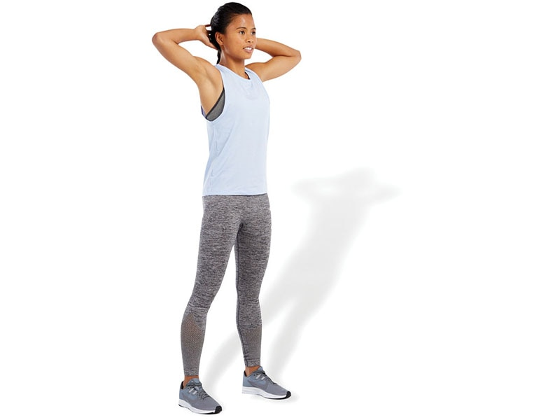 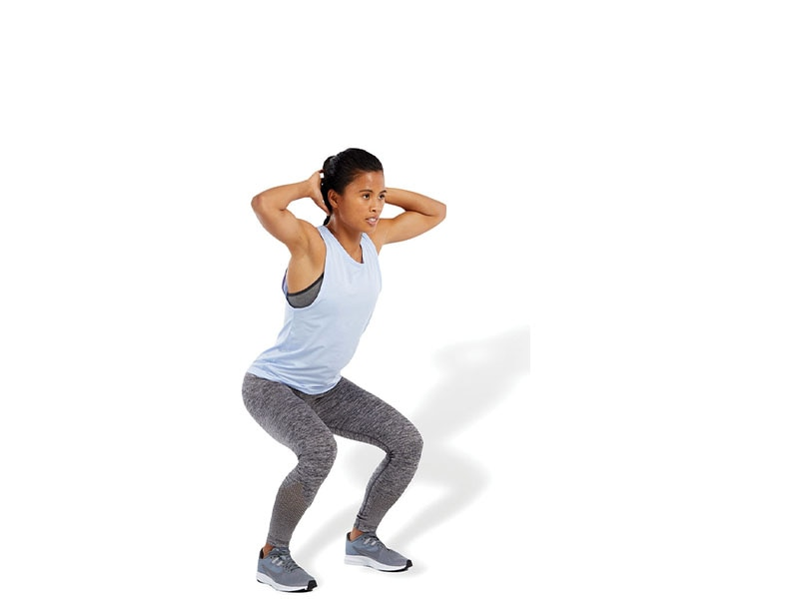

TECHNIQUE

With arms behind the head and feet approximately shoulder-width apart, perform a bodyweight squat. As a progression to this exercise, add a calf raise at the top position after performing the squat.

Multiplanar Lunge with Reach

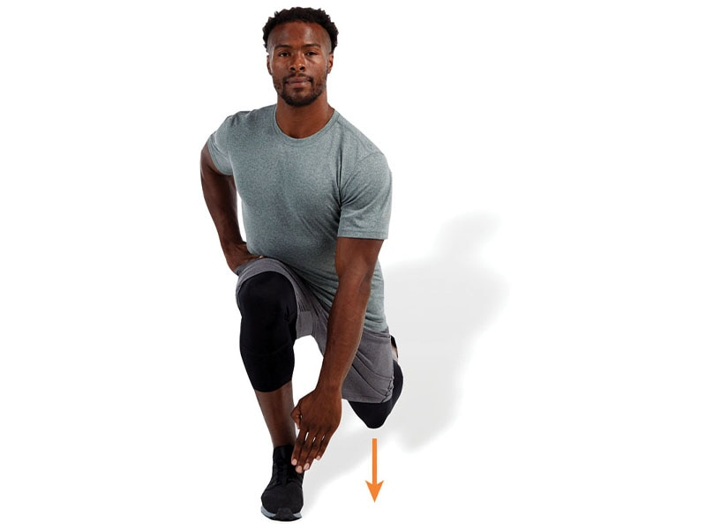 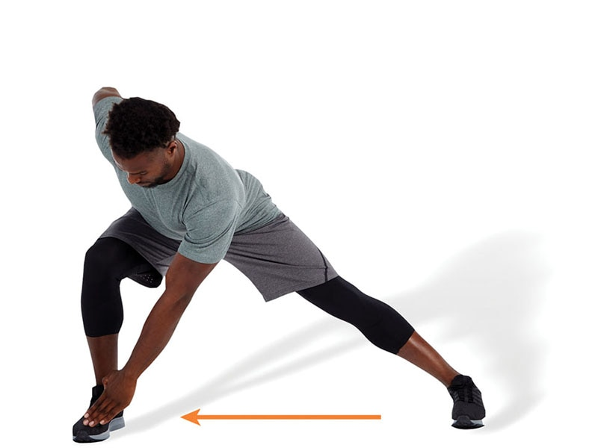 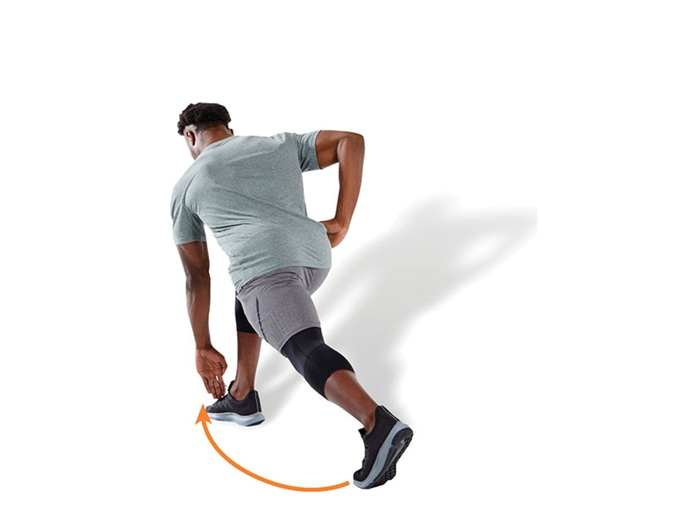

TECHNIQUE

Perform the lunge in all three planes of motion: sagittal, frontal, and transverse. In other words, perform a forward lunge, lateral lunge, and turning lunge.

Lunge with Rotation

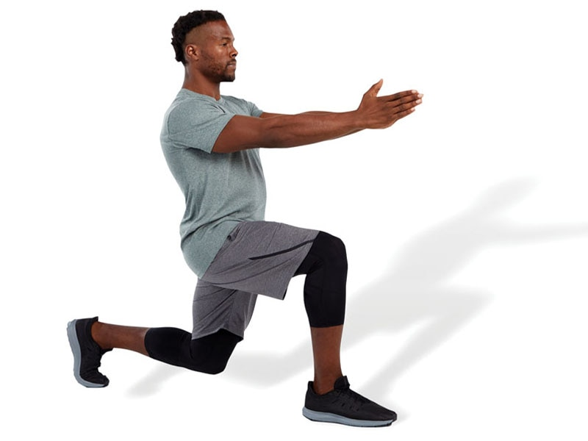 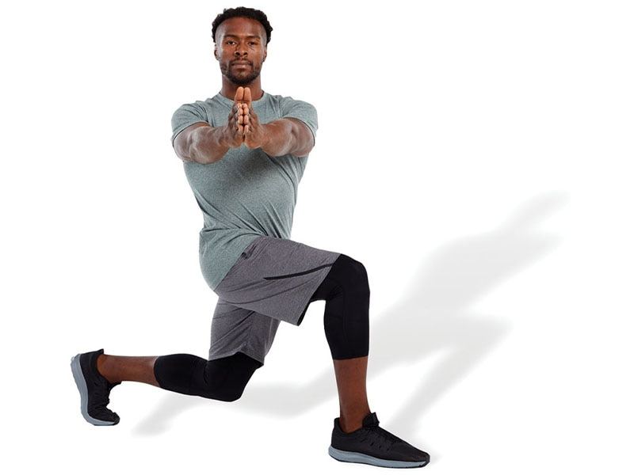

TECHNIQUE

Perform a forward lunge with trunk rotation toward the outside portion of the forward leg. This exercise can be performed with or without an external load, such as a medicine ball.

Tube Walking: Side to Side

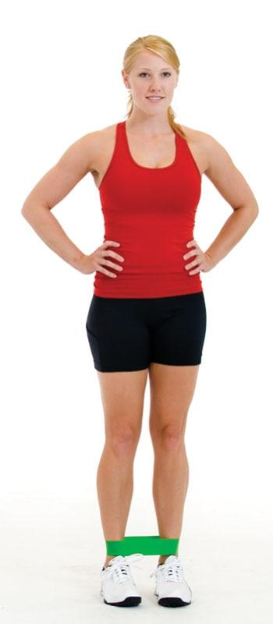 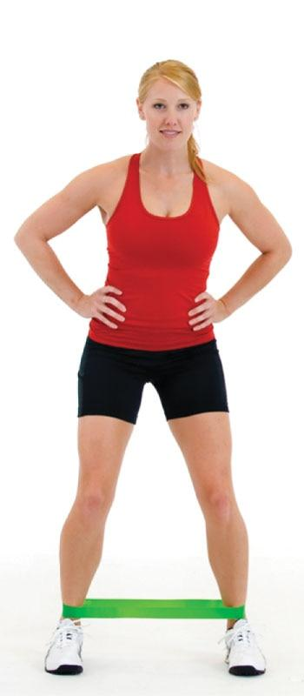 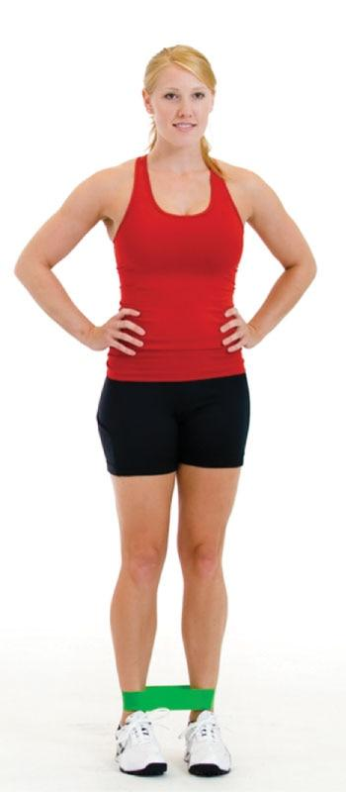

TECHNIQUE

Place elastic tubing around the knees, maintain a quarter squat position, and sidestep for the desired number of repetitions in each direction. Make sure the knees are tracking in line with the second and third toes. Do not allow the knees to cave inward. This exercise primarily targets the hip abductors, such as the gluteus medius. The band can also be placed around the ankles (as shown) as a progression to this exercise.

Leg Swings: Front to Back

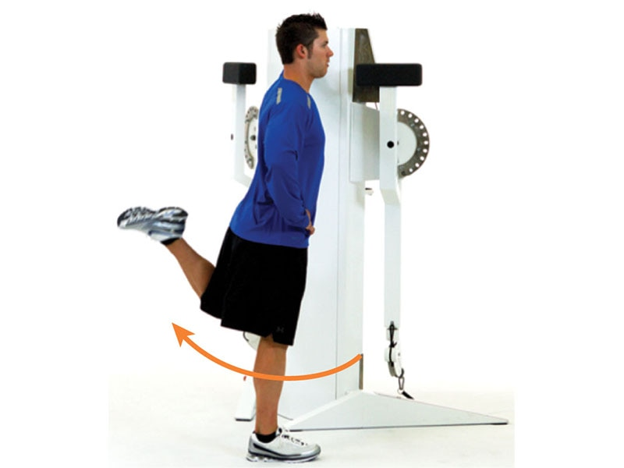 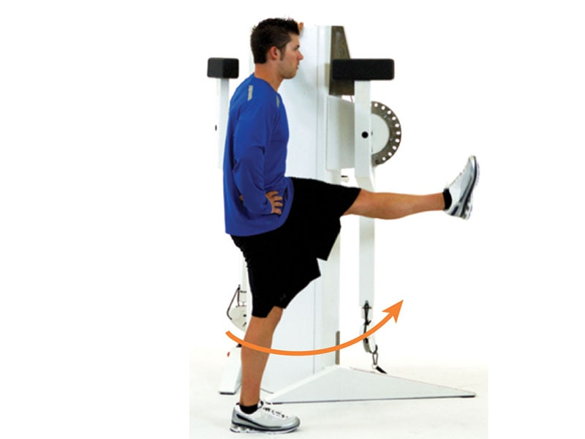

TECHNIQUE

In standing position, swing one leg in a controlled pendulum fashion to the front and back, only lifting the leg as high as can safely be controlled. Keep a tall, upright posture with the abdominals drawn in during the duration of the exercise.

Leg Swings: Side to Side

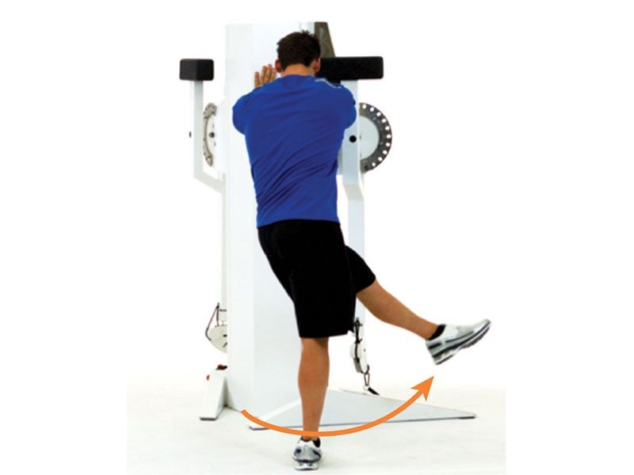 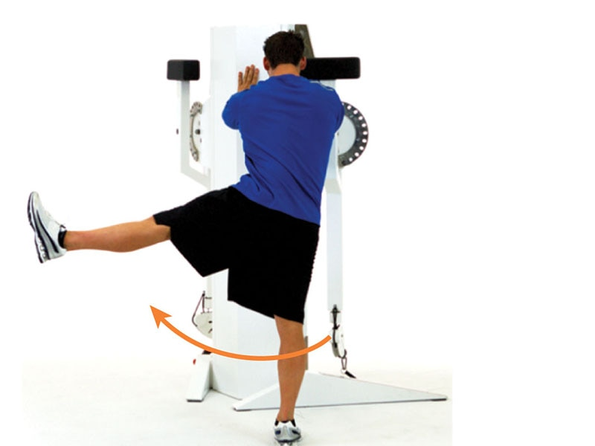

TECHNIQUE

In standing position, swing one leg in a controlled pendulum fashion from side to side. Like front to back hip swings, keep a tall, upright posture with the abdominals drawn in during the duration of the exercise.

Frankenstein

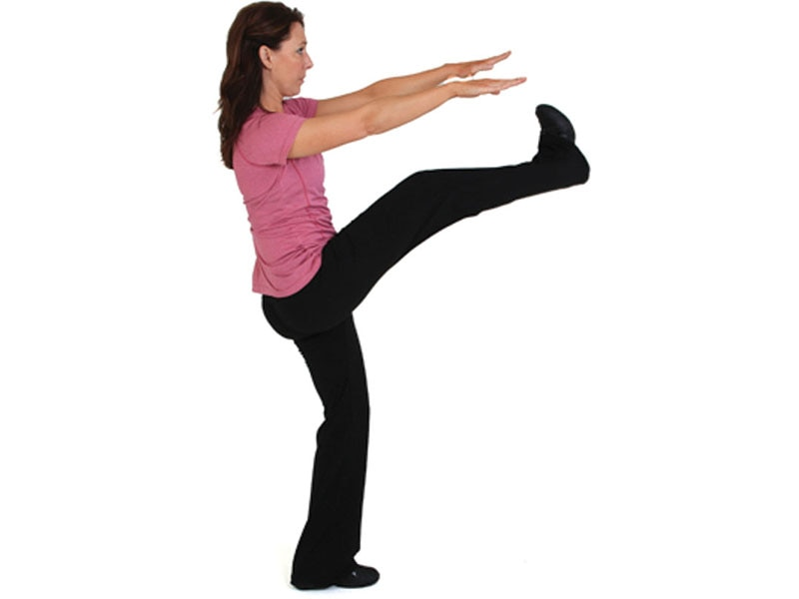 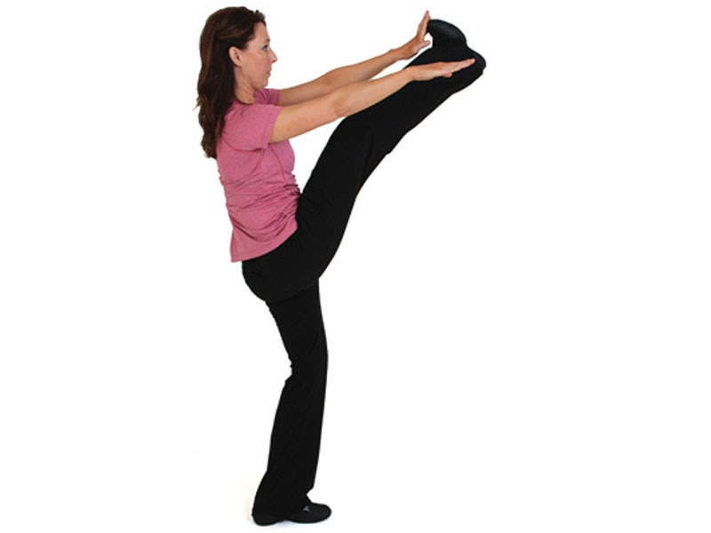

TECHNIQUE

This technique is performed while walking forward with arms stretched out away from the body. Only lift each leg as high as can be safely controlled while maintaining ideal posture. Keep a neutral back without leaning to the left or right. This exercise helps stretch the hamstrings.

High Knee

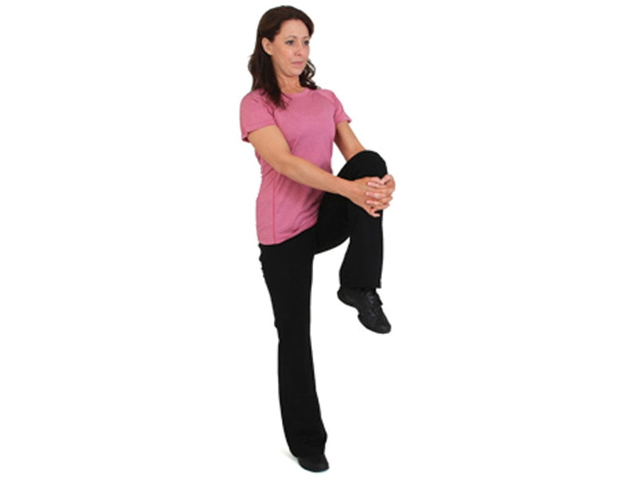 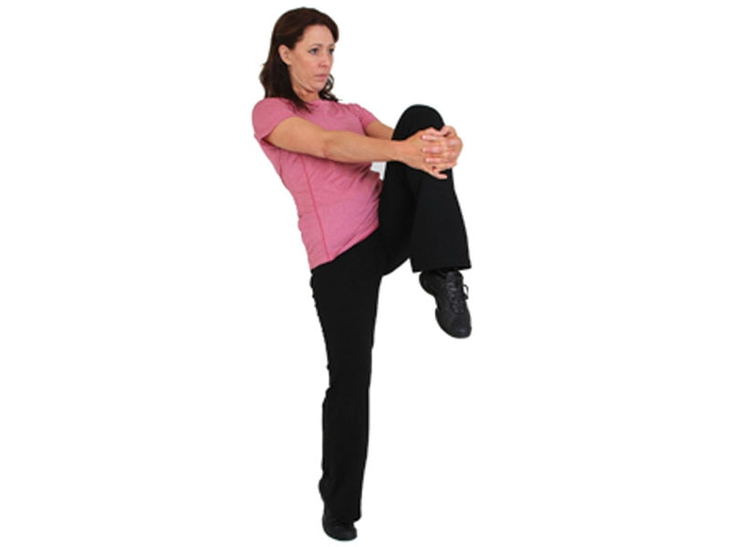

TECHNIQUE

This technique is performed while walking forward. With each step, flex the hip as high as can be controlled, grasping the knee at the top with both hands. Be sure to pause at the top and switch legs with each step.

Push-Up with Rotation

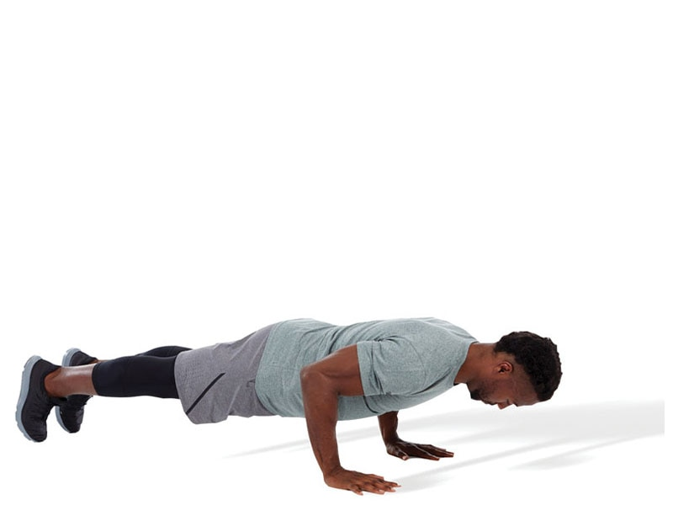 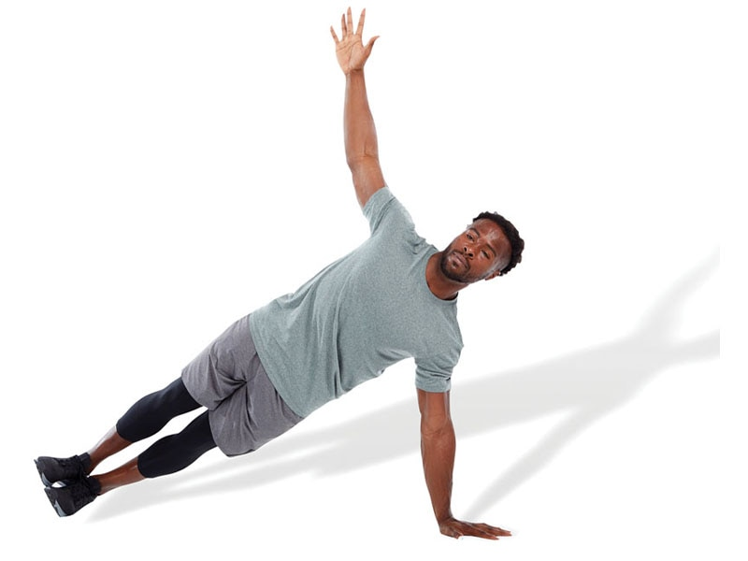

TECHNIQUE

Perform a bodyweight push-up with a trunk rotation at the top. Keep the abdominals drawn in, chin tucked, and spine in a neutral position throughout the exercise.

Ball Russian Twist

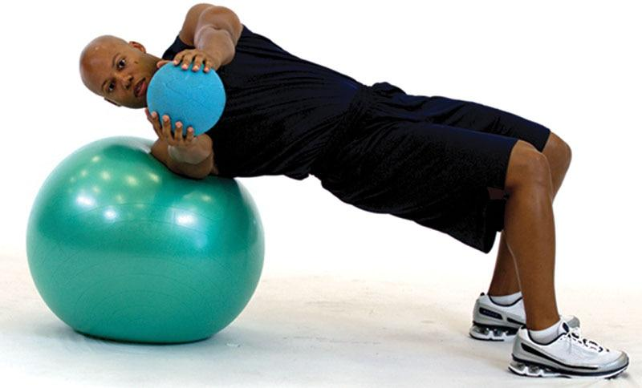 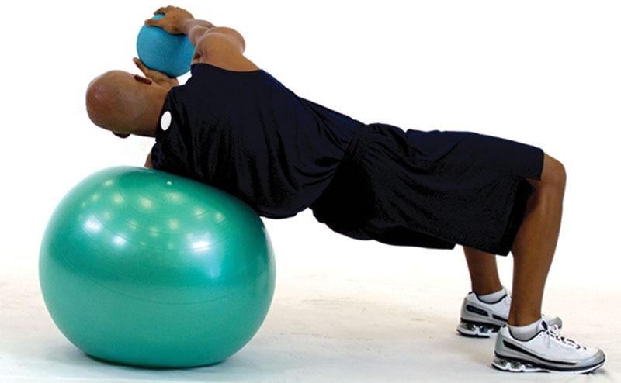

TECHNIQUE

While bridging on a stability ball, perform trunk rotation. This exercise targets the internal and external obliques in addition to the gluteus maximus because it requires the participant to maintain a bridged position. The exercise can be performed with or without external load, such as using a medicine ball.

Arm Circles

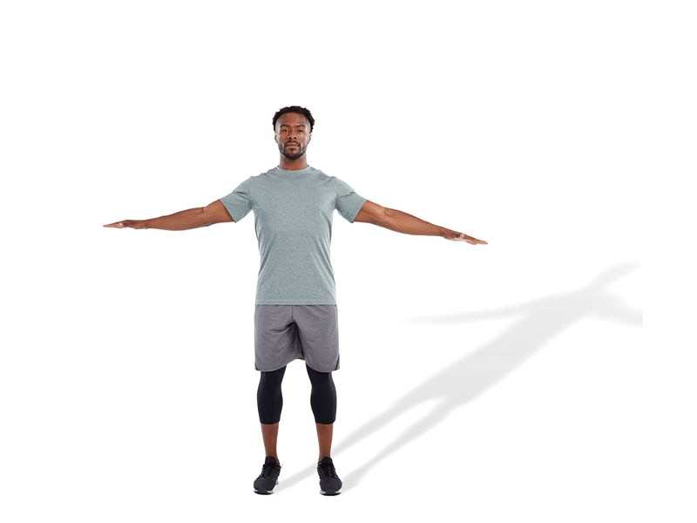 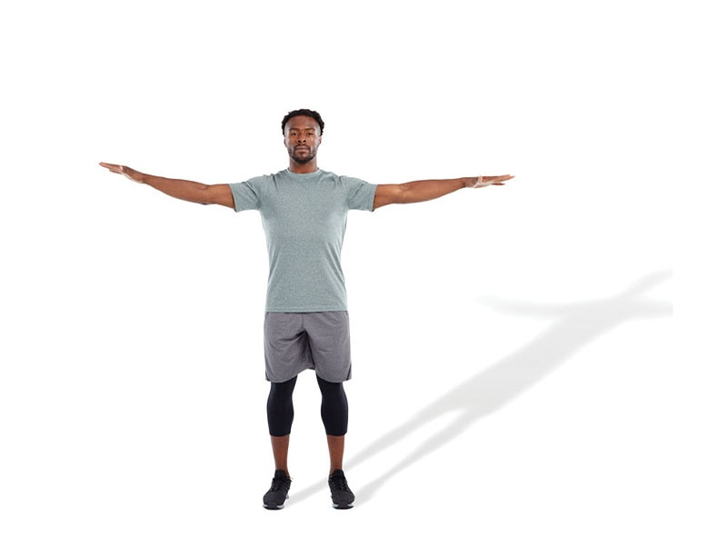

TECHNIQUE

Perform arm circles in both directions using a slow to moderate speed.

Jumping Jacks

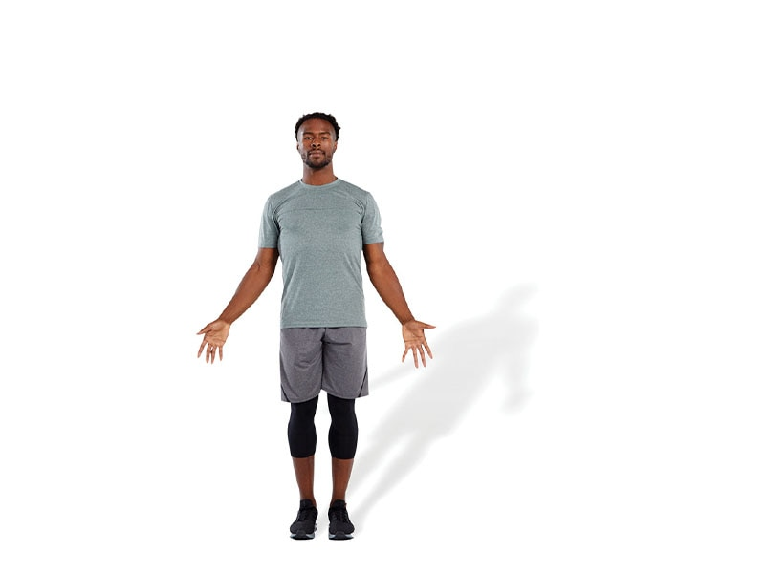 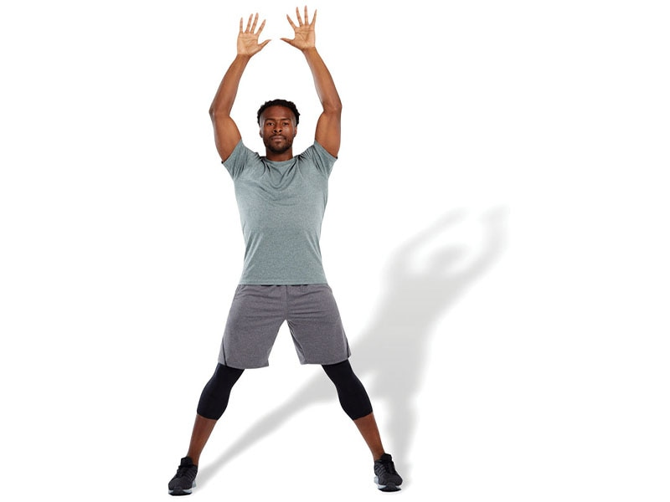

TECHNIQUE

When performing jumping jacks as a dynamic warm-up, the goal is to slightly elevate heart and respiration rates without causing undue fatigue.

Jump Rope

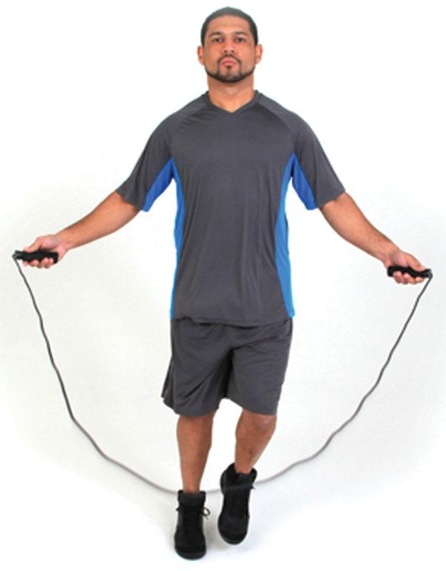 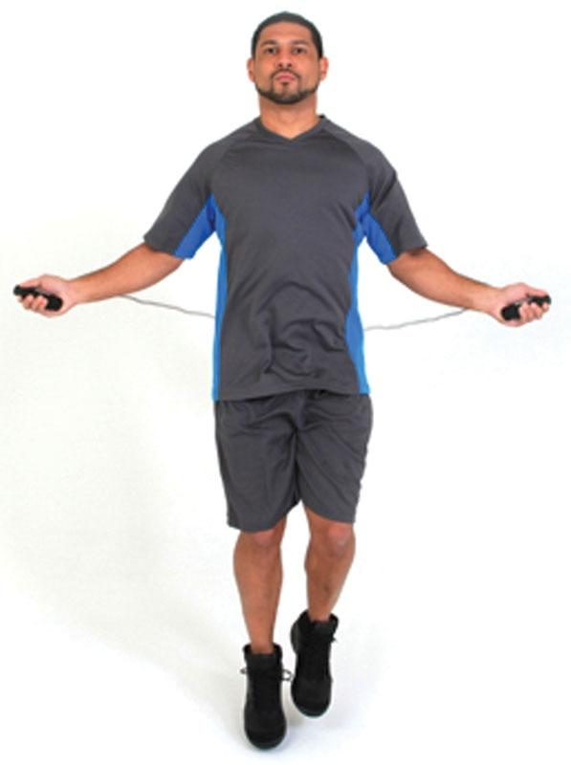

TECHNIQUE

Many movements can be performed with a jump rope. Choose movements your client can safely perform. It is also important to keep the intensity relatively low to moderate when integrating this exercise into a warm-up routine.

STRETCH YOUR KNOWLEDGE

Flexibility training is a key component to a comprehensive fitness program for clients of all levels. Often, flexibility is implemented in the warm-up or cool-down phase of a client’s workout. Depending on individual needs, a combination of flexibility exercise may provide the best results. Researchers have found that combining static and dynamic stretching reduces the risk for muscle injury and increases flexibility. This combination does not have any detrimental effects on muscle performance, which makes it ideal for a warm-up or cool-down (Behm et al., 2016). Researchers also found that short bouts of self-myofascial rolling increase flexibility, enhance pre-exercise muscle performance, and decrease postexercise soreness and fatigue (Cheatham et al., 2015). The fitness professional should consider a combination of interventions to meet individual client needs. Ideally, self-myofascial rolling and static stretching should be performed prior to active or dynamic stretching to first address restricted ROM (Fairall et al., 2017; Mohr et al., 2014; Škarabot et al., 2015).

**Controversial Stretches**

Although flexibility training has numerous benefits, performing certain types of stretches may be a risk for injury. Although most stretches are very safe when performed correctly with proper posture and technique, there are a few controversial stretches that may be potentially dangerous.

Inverted hurdler’s stretch

This stretch is thought to place high stress on the inside of the knee (medial collateral ligament) and may cause pain and stress on the patella (kneecap) (right knee in Figure 14-18). This stretch should not be performed by anyone with a history of knee or low-back pain or injury. Health professionals believe this stretch should not be performed by most patients or general wellness clients.

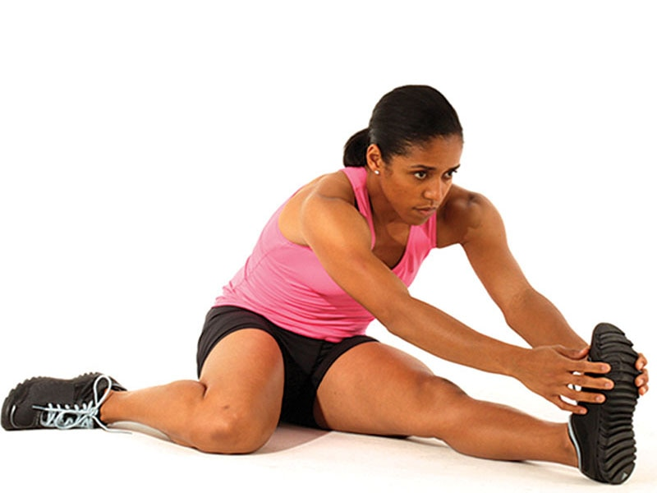

**Figure 14-18** Inverted hurdler’s stretch

Plow

The plow exercise is a common posture from yoga (Figure 14-19). Because of the inverted nature of this stretch (head is lower than the hips), this stretch places high stress on the neck and spine. If this stretch is not done with exact technique, it may place the spine at risk of injury. Clients with a history of neck or back injury should not perform this stretch owing to the high stress it places on these structures. This position should also be avoided by individuals with high blood pressure (hypertension).

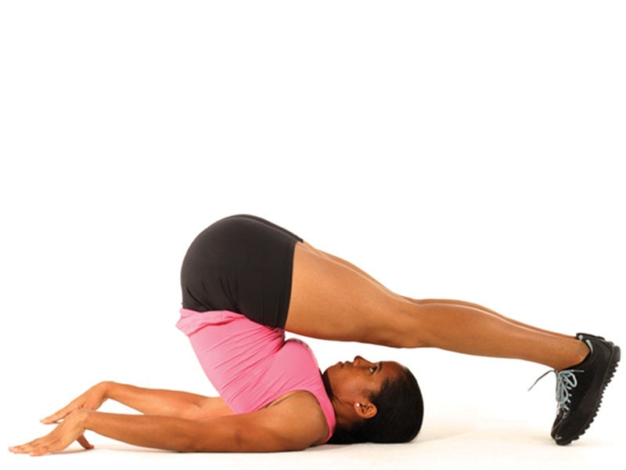

**Figure 14-19** Plow

Shoulder stand

The shoulder stand is another common posture from yoga and another inverted stretch (Figure 14-20). As with the plow, this position places high stress on the neck, shoulders, and spine. It should be avoided in patients with hypertension or any history of neck or spine injury, or if exact technique is not used.

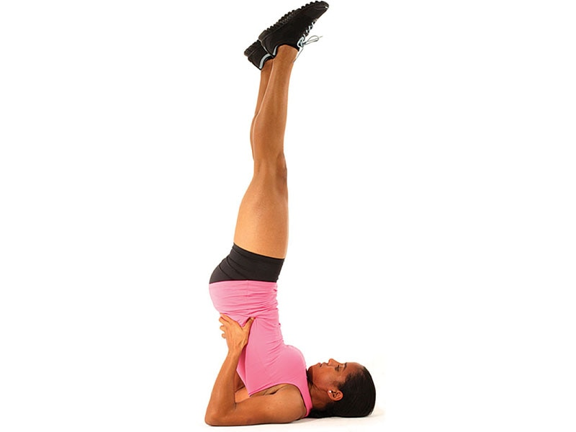

**Figure 14-20** Shoulder stand

Straight-leg toe touch

The straight-leg toe touch is one of the most common stretches for the hamstring complex (Figure 14-21). This position may place the vertebrae and the cartilage discs in the low-back under high stress. Any client or patient with a history of herniated discs or nerve pain that runs down the back of the leg should avoid this stretch. In addition, clients with poor flexibility may attempt to hyperextend the knees during this stretch, which may place high stress on the ligaments of the knee.

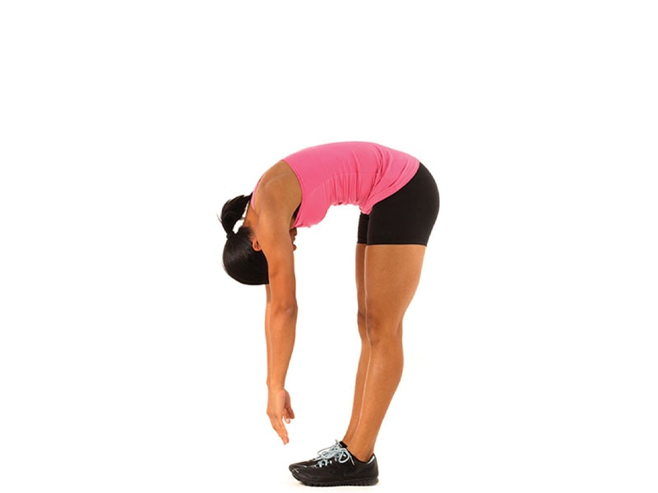

**Figure 14-21** Straight-leg toe touch

Arching quadriceps

The arching quadriceps stretch is designed to stretch the quadriceps and hip flexors (Figure 14-22). This position places very high stress on the kneecap and the other tissues on the front of the knee joint. Any client with a history of knee injury should avoid this stretch. Owing to the high stress (compression) of the kneecap into the knee during this stretch (which may cause damage to the cartilage), most healthcare professionals discourage anyone from performing this exercise.

The fitness professional must recognize that some individuals, such as athletes, may need to perform the stretches because the position is required for their sport or activity. For instance, the inverted hurdler’s stretch mimics the position of a hurdler going over a hurdle. Others are traditional positions used in martial arts, gymnastics, or yoga. However, for most clients, there are safer positions that can be used to stretch the targeted muscles. Therefore, all clients should be properly educated about stretching technique and posture, and the safest exercises should be used to meet the goals of the exercise program.

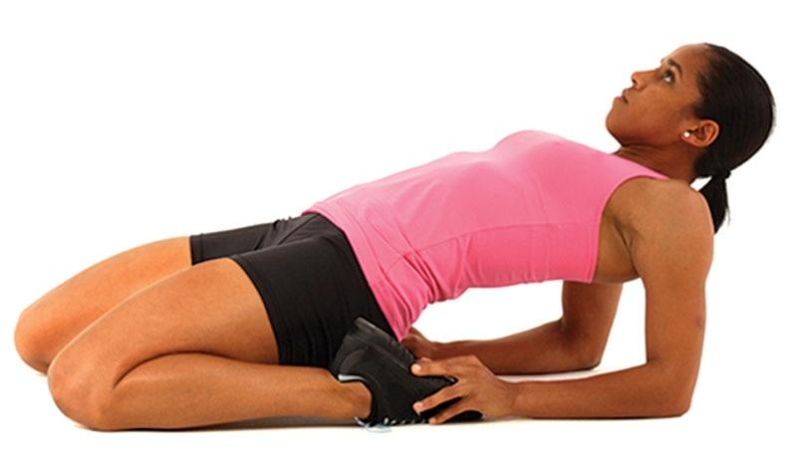

**Figure 14-22** Arching quadriceps

### Cardiorespiratory fitness training

Cardiorespiratory fitness reflects the ability of the cardiovascular and respiratory systems to supply oxygen-rich blood to skeletal muscles during sustained physical activity. Cardiorespiratory fitness is one of the five components to health-related physical fitness; the others include muscular strength, muscular endurance, flexibility, and body composition. Cardiorespiratory fitness is vitally important to health and wellness as well as to the ability to engage in normal activities of daily living (ADL) without excessive fatigue. Physical activity and exercise training programs should be designed with the intent of improving each of the key components of health-related physical fitness; however, from the standpoint of preventing chronic disease and improving health and quality of life, cardiorespiratory fitness training should always be near top priority when allocating time and resources during the design and implementation of any exercise training program because of the number of health-related benefits associated with it (Anderson et al., 2016; Thorogood et al., 2011).

HELPFUL HINT

The five components of fitness include the following:

* Cardiorespiratory (aerobic) fitness
* Muscular strength
* Muscular endurance
* Flexibility
* Body composition

Cardiorespiratory training is a way of planning training programs that systematically progress clients through various stages to achieve optimal levels of physical and performance adaptations by placing stress on the cardiorespiratory system. One of the most common errors made by fitness professionals during the planning and implementation of cardiorespiratory exercise programs is the failure to consider rate of progression. Rate of progression is critical to help clients achieve their personal health and fitness goals in the most efficient and effective use of time and energy. In addition, failure to carefully consider and monitor rate of progression of each client on an individual basis can also result in injury if progression is too fast, or in poor exercise adherence if the progression is too slow. Thus, applying proven scientific principles to the design of cardiorespiratory fitness training programs will help ensure that clients maximize their potential to achieve optimal levels of physical and performance adaptations.

**Benefits of cardiorespiratory fitness**

The benefits of regular physical activity and structured exercise are numerous. Individuals can achieve numerous health-related benefits from modest amounts of moderate-intensity exercise and even greater benefits from vigorous-intensity exercise, or a combination of both. Engaging in regular, sustained physical activity over one’s life span is one of the most reliable predictors of death and disability. In fact, research has confirmed that an individual’s cardiorespiratory fitness level is a strong predictor of morbidity and mortality (Kim et al., 2018; Lee et al., 2010). In other words, poor cardiorespiratory fitness is related to a marked increase in risk of premature death from all causes, but particularly from cardiovascular disease. Conversely, an improvement in cardiorespiratory fitness is related to a reduction in premature death from all causes (Kim et al., 2018; Lee et al., 2010).

Research demonstrates that cardiorespiratory exercise and physical activity provide many benefits that enhance health, longevity, and weight loss (Wasfy & Baggish, 2016). Individuals who are more active on a regular basis enhance their likelihood for attaining these benefits, whereas sedentary individuals may experience rapid deteriorations in their overall health and well-being.

**General guidelines for cardiorespiratory fitness training**

Fitness professionals need to understand and appreciate the fact that no two individuals will ever respond and adapt to cardiorespiratory exercise in exactly the same way. In other words, the physical and perceptual responses to exercise are highly variable, even among individuals of similar age, fitness, and health. Thus, all exercise training recommendations, including cardiorespiratory exercise, must be individually determined and should use the FITTE-VP principle (Garber et al., 2011). FITTE-VP stands for “frequency, intensity, type, time, enjoyment, volume, and progression.” Each of these concepts will be described in this chapter.

**Frequency**

Frequency refers to the number of training sessions in a given time period, usually expressed as per week. Moderate-intensity exercise (e.g., brisk walking) should be performed at least five times per week, whereas vigorous-intensity exercise (e.g., jogging or running) should be performed at least three times per week, or a combination of moderate-intensity and vigorous-intensity is also acceptable (Table 15-1) (Piercy et al., 2018; World Health Organization, 2015).

TABLE 15-1 Aerobic Activity Recommendations

| **Frequency** | **Time** | **Type** |
| --- | --- | --- |
| At least 5 days per week | 150 minutes per week | Moderate-intensity aerobic activity (i.e., brisk walking) |
| At least 3 days per week | 75 minutes per week | Vigorous-intensity aerobic activity (i.e., jogging or running) |
| 3–5 days per week | Combination of moderate and vigorous intensity: Any combination of moderate- and vigorous-intensity aerobic activities | |

**Intensity**

Intensity refers to the level of demand that a given activity places on the body. For general health requirements, such as reducing the risk of chronic disease, moderate-intensity is recommended (Piercy et al., 2018; World Health Organization, 2015). Moderate exercise typically represents an intensity range that is enough of a demand to increase heart and respiratory rate but does not cause exhaustion or breathlessness for the average untrained apparently healthy adult (Piercy et al., 2018; World Health Organization, 2015). In other words, the individual should be able to talk comfortably during exercise or physical activity. Higher intensities are generally required for improvements in overall fitness and conditioning. However, any combination of the two will also result in improved health.

Methods for assigning exercise intensity

Cardiorespiratory exercise intensity can be monitored in numerous ways. Some methods for monitoring cardiorespiratory exercise intensity include calculating VO2max, using percentages of maximal heart rate (HRmax), percentages of heart rate reserve (HRR), metabolic equivalents (METs), ratings of perceived exertion (RPE), and the talk test. Some of these methods are more practical for fitness professionals to implement with clients than others.

VO2max

The traditional gold standard measurement for cardiorespiratory fitness is VO2max, often expressed as the maximal volume of oxygen consumed per kilogram of body weight per minute (mL/kg per min). In other words, VO2max is the maximal amount of oxygen that an individual can use during intense exercise. Once VO2max is determined, a common method to establish exercise training intensity is to have clients exercise at a percentage of their VO2max.

However, accurately measuring VO2max is oftentimes impractical for fitness professionals because it requires clients to perform cardiorespiratory exercise at maximal effort and sophisticated equipment to monitor the client’s ventilation response (oxygen consumed and carbon dioxide expired). Thus, submax­imal aerobic tests have become popular for fitness professionals to estimate VO2max.

Maximal heart rate

Calculating HRmax is another method for establishing training intensity during cardiorespiratory exercise. Although measuring a client’s actual maximal heart rate is effective, it is also impractical for fitness professionals because it requires testing clients at maximal capacity. Subsequently, many mathematical formulas that estimate HRmax have been developed. Once HRmax is calculated, fitness professionals can have clients exercise at a certain percentage of their HRmax.

Arguably the most commonly used formula for estimating HRmax is 220 – age. However, this formula was never intended to be used as an instrument for designing cardiorespiratory fitness programs because maximal heart rate varies significantly among individuals of the same age. Dr. William Haskell (one of the developers of the aforementioned formula) has been quoted as saying, “The formula was never supposed to be an absolute guide to rule people’s training” (Kolata, 2001).

For this reason, more appropriate regression formulas have been developed, such as the Tanaka formula, where HRmax is determined using the following formula: 208 – (0.7 × age) (Tanaka et al., 2001). It has been shown that this formula is more accurate than Haskell’s 220 – age formula for estimating an individual’s HRmax (Roy & McCrory, 2015).

Keep in mind, fitness professionals should never use this, or any other mathematical formula, as an absolute. A person’s heart rate response to exercise is dependent on many additional factors, including genetics, medications, and stimulant use such as caffeine. However, the Tanaka formula is very simple to use and can be easily implemented as a general starting point for measuring cardiorespiratory training intensity.

Consider the following example of a 40-year-old client who is tasked at exercising at 65% of her HRmax. The formula would be solved as follows:

Tanaka formula: 208 – (0.7 × age) = HRmax

208 – (0.7 × 40) = HRmax

208 – (28) = HRmax

180 = HRmax

180 beats per minute (bpm) is the client’s estimated HRmax:

180 × 65% = 117

Thus, 117 bpm is the client’s target heart rate.

Heart rate reserve

HRR, also known as the Karvonen method, is a method of establishing a client’s target heart rate based on the difference between a client’s estimated HRmax and their resting heart rate. This formula is likely more appropriate versus only calculating a percentage of HRmax because it considers an individual’s resting heart rate, which tends to vary from person to person.

The heart rate reserve formula is defined as follows:

[(HRmax – HRrest) × desired intensity] + HRrest = Target heart rate

Consider the following example of a 25-year-old client with a desired training intensity of 85% of his HRmax. If this 25-year-old client has a resting heart rate of 50 bpm (which is considered very good), then the formula (using the Tanaka formula to determine HRmax) would be solved as follows:

[(HRmax – HRrest) × desired intensity] + HRrest = Target heart rate

208 – (0.7 × 25) = 191 HRmax

191 (HRmax) – 50 (HRrest) = 141

141 × 85% (desired intensity) = 120

120 + 50 (HRrest) = 170 bpm

Thus, 170 beats per minute is the client’s target heart rate.

Metabolic equivalent

One MET is equal to 3.5 millilitres of oxygen consumed per kilogram of body weight per minute (3.5 mL O2 · kg–1 · min–1) or the equivalent of the average resting metabolic rate for adults. In other words, this represents the amount of oxygen used by an individual at true rest. METs are used to describe the energy cost of physical activity as multiples of resting metabolic rate. MET values are used to relate exercise intensity with energy expenditure. For example, a physical activity with a MET value of 4, such as jogging at a slow pace, requires four times the energy than a person uses at rest (e.g., sitting quietly). There are many resources available for fitness professionals that describe common activities and their average MET values. However, this method is an uncommon practice within a fitness facility.

Ratings of perceived exertion method

RPE is a popular method for estimating exercise intensity. RPE is a technique used to validate how hard a client feels they are working during exercise. When using the RPE method, a person is subjectively rating the perceived difficulty of exercise and is based on the physical sensations, such as increased heart rate, increased respiration rate, increased sweating, and muscle fatigue. The client’s subjective rating should be reported based on the overall feelings of how hard they are working, including an overall sense of fatigue, and not just isolated areas of the body (i.e., tired legs during cycling). Although the RPE scale is a subjective measure, if clients report their exertion ratings accurately, RPE does provide a good estimate of exercise training intensity.

There are two versions of RPE: the original 6 to 20 scale and the newer 1 to 10 scale (Tables 15-2 and 15-3). The Borg 6 to 20 is the standard, yet it can be somewhat confusing because it starts at a score of 6 (rather than zero) and has 15 different choices. The reason behind the 6 to 20 scale is that each value corresponds to a heart rate, and most adult heart rates range between 60 bpm and 200 bpm. Subsequently, a Borg score of 6 corresponds to a heart rate of 60 bpm, whereas a Borg score of 12 corresponds to a heart rate of 120 bpm. However, for simplicity and ease of use, the National Academy of Sports Medicine (NASM) recommends fitness professionals use the 1 to 10 scale with their clients, unless their clients are familiar with the 6 to 20 Borg scale.

TABLE 15-2 RPE Scale, 6–20

| **Original Scale** | |
| --- | --- |
| 6 |  |
| 7 | Very, very light |
| 8 |  |
| 9 | Very light |
| 10 |  |
| 11 | Fairly light |
| 12 |  |
| 13 | Somewhat hard |
| 14 |  |
| 15 | Hard |
| 16 |  |
| 17 | Very hard |
| 18 |  |
| 19 | Very, very hard |
| 20 |  |

TABLE 15-3 RPE Scale, 1–10

| **Rating** | **Perceived Exertion Level** |
| --- | --- |
| 0 | No exertion, at rest |
| 1 | Very light |
| 2-3 | Light |
| 4-5 | Moderate, somewhat hard |
| 6-7 | High, vigorous |
| 8-9 | Very hard |
| 10 | Maximum effort, highest possible |

Talk test

Historically, the talk test has been an informal method used to gauge exercise training intensity during exercise. The belief has always been that if clients reach a point at which they are not able to carry on a simple conversation during exercise because they are breathing too hard, then they are probably exercising at a high-intensity level. Several studies have now confirmed that there is a correlation between the talk test, VO2, ventilatory threshold (Tvent), and heart rate during both cycle ergometer and treadmill exercise (Foster et al., 2008; Jeans et al., 2011; Persinger et al., 2004; Reed & Pipe, 2016). Thus, it appears that the talk test can help fitness professionals and clients monitor proper exercise intensity without having to rely on measuring heart rate or VO2max.

When clients can speak comfortably, they are typically exercising below the intensity of ventilatory threshold 1 (VT1). At the first point where clients can no longer speak comfortably during continuous speech (i.e., continuous talking becomes challenging), this intensity approximates VT1. This relationship between the talk test and VT1 has been demonstrated to be valid in several populations ranging from well-trained athletes to sedentary individuals and patients with cardiovascular disease (Voelker et al., 2001; Zanettini et al., 2013). The protocol for measuring VT1 is described in Chapter 11.

A summary of methods for programming cardiorespiratory exercise intensity is illustrated in Table 15-4.

TABLE 15-4 Methods for Programming Exercise Intensity

| **Method** | **Description** |
| --- | --- |
| VO2max | Target VO2max = VO2max × % intensity desired |
| Maximal heart rate (HRmax) | Tanaka HRmax formula: 208 – (0.7 × age)  Target heart rate = HRmax × % intensity desired |
| Heart rate reserve (HRR) | Target heart rate = [(HRmax – HRrest) × % intensity desired] + HRrest |
| Metabolic equivalent (MET) | One metabolic equivalent is equal to 3.5 mL O2 · kg–1 · min–1 or the equivalent of the average resting metabolic rate for adults |
| Ratings of perceived exertion (RPE) | 1 to 10 scale or 6- to 20-point scale |
| Talk test | The ability to speak during activity can identify exercise intensity and ventilatory threshold |

**Time**

Time refers to the length of time engaged in an activity or exercise training session and is typically expressed in minutes. According to the most current public health guidelines on physical activity, adults should accumulate 2 hours and 30 minutes (150 minutes) of moderate-intensity aerobic activity (i.e., brisk walking) every week or 1 hour and 15 minutes (75 minutes) of vigorous-intensity aerobic activity (i.e., jogging or running) every week, or an equivalent mix of moderate- and vigorous-intensity aerobic activity (Piercy et al., 2018; World Health Organization, 2015). The guidelines also recommend that if adults exceed 300 minutes per week of moderate-intensity activity or 150 minutes per week of vigorous-intensity activity, then they will gain even more health and fitness benefits. However, it is also important for fitness professionals to appreciate that any duration of physical activity or exercise, regardless of the individual or accumulated time, can provide some positive health benefits.

**Type**

Type refers to the mode of activity selected. It should be noted that there are three criteria that must be met for an activity or exercise to be considered “aerobic” exercise. For a mode of exercise to be considered aerobic, it should (a) be rhythmic, (b) use large muscle groups, and (c) be continuous in nature. Some examples of modes of aerobic exercise include the following:

* Jogging
* Walking
* Exercising on cardio equipment
* Swimming
* Cycling (indoors or outdoors)

In addition to recognizing modes or types of cardiorespiratory exercise, such as swimming or cycling, it is also important for fitness professionals to be familiar with various cardio formats. Many of these formats also involve stressing both aerobic and anaerobic energy pathways and include interval training, high-intensity interval training, Tabata, and Fartlek training.

Interval training

Interval training has received a great amount of research attention over the years (Batacan et al., 2016; Milanović et al., 2015). This training format involves brief periods of higher exertion efforts coupled with lower-intensity periods. The exertion efforts (i.e., intervals) can be moderate to highly intense, depending on the goals, needs, and abilities of the client.

Work-to-rest ratios can be calculated and altered to change the stress applied during each workout. Generally, ratios ranging from 1:1 to 1:5 are used to provide adequate recovery within each interval; however, work-to-rest ratios can vary dramatically depending on the client’s fitness level and the mode of exercise performed. Fitness professionals can alter both the intensity and work-to-rest ratios to vary training stress throughout the program.

Moderately intense intervals involve exercise at a medium intensity with the goal to complete a set number of programmed intervals rather than reach maximal or near-maximal effort during each iteration. Moderate intensities are best for beginning exercisers and for occasional reduction in overall training stress to avoid overtraining.

High-intensity intervals place a considerable challenge on the metabolic energy systems by pushing the client to near-maximal effort during each repetition. This type of interval training is commonly known as high-intensity interval training (HIIT).

High-intensity interval training

*HIIT* is a term commonly used today to describe shorter bouts of high-intensity work at maximal or near-maximal performance (e.g., sprinting) followed by recovery periods (e.g., slow jog or walking). Although interval training has a long-standing reputation in the realm of sports conditioning given the stop-start nature of many sports, its popularity has grown within recreational fitness due to its compressed timeframe for achieving improvements in physical fitness and health when compared to continuous exercise methods (Gaesser & Angadi, 2011).

HIIT has been shown to be an effective mode for improving cardiorespiratory fitness because it can produce comparable results in a compressed period of time and with a smaller volume of work. It also aids in weight loss and reduction of cholesterol levels and blood pressure in a similar manner to steady-state (SS) aerobic exercise (Costa et al., 2018; Viana et al., 2019; Wewege et al., 2017; Wood et al., 2019). Even though HIIT training offers a key benefit of time efficiency (i.e., less time exercising), not all clients will adhere to its strenuous demands, nor is it required to achieve most health or wellness goals.

TRAINING TIP

When designing HIIT training programs, recognize that “effort” is a subjective measure (e.g., how hard I am pushing myself), whereas “intensity” is an objective measure (e.g., sprint time, load lifted), and they are not the same. If a workout does not provide adequate recovery between intervals, then the intensity of the workout has to decrease, even if the individual’s effort is at a maximum.

Tabata training

Tabata is a type of HIIT training and was created by a Japanese scientist named Dr. Izumo Tabata (Tabata et al., 1996). The Tabata format involves performing a maximal effort interval lasting 20 seconds, followed by only 10 seconds of rest. The client performs a total of eight intervals, for a total of 4 minutes. This format has been shown to improve aerobic power and improvements in VO2max (Viana et al., 2018).

However, a true Tabata format is rarely taught in health clubs. Dr. Tabata and his team of researchers performed their study using elite cyclists as subjects in which each interval was performed at approximately 170% of VO2max. Most fitness enthusiasts are incapable of performing or sustaining exercise at this intensity. Moreover, a true Tabata workout session would only last 4 minutes. However, variations of Tabata training are popular, in which intervals are still high intensity yet the participant can successfully complete the program. It is important for fitness professionals to select interval intensities that are appropriate for their clients and consider their client’s fitness level and tolerance to intense exercise.

Fartlek training

*Fartlek* is a Swedish term that translates to “speed play.” The goals of fartlek training are highly variable, targeting many different physiological systems (i.e., aerobic and anaerobic) by combin­ing different formats into one workout. It is often performed while running, but it can also be completed while cycling or swimming. Unlike steady-state or HIIT formats, Fartlek training is unstructured and combines low-, moderate-, and high-intensity efforts into one workout. Far­tlek training helps break the monotony often associated with one format of training.

**Enjoyment**

Enjoyment refers to the amount of pleasure derived from engaging in a specific exercise or activity. Unfortunately, this component of exercise programming is often overlooked or not considered more seriously. Exercise adherence rates decline significantly when a specific mode of exercise is selected for a client before considering their personality type, previous exercise experiences, and other interests. If the mode of activity or exercise training program is not enjoyable to a client, it is highly likely that they will not adhere to the exercise program and therefore not achieve their personal health and fitness goals. A client is much more apt to continue with a program that is fun and challenging and includes a supportive environment than one that is dull and boring (Heisz et al., 2016; Rodrigues et al., 2019; Wininger & Pargman, 2003).

**Volume**

Volume of exercise represents the total amount of work performed in each timeframe, typically 1 week. As mentioned previously, public health guidelines recommend adults accumulate 150 minutes of moderate-intensity aerobic activity every week or 75 minutes of vigorous-intensity aerobic activity every week, or an equivalent mix of the two (Piercy et al., 2018; World Health Organization, 2015).

However, 150 minutes of moderate-intensity aerobic activity may only provide modest weight loss. Individuals who are seeking to lose weight will likely achieve greater benefits from the inclusion of more than 250 minutes of aerobic exercise per week (Donnelly et al., 2009). Research also reveals that for general health improvements and the prevention of weight gain, individuals should aim to expend 1,200 to 2,000 calories through physical activity per week (Donnelly et al., 2009).

STRETCH YOUR KNOWLEDGE

Because it is very difficult to expend 1,200 calories or more per week through structured exercise, experts suggest including nonstructured physical activity into one’s daily routine. Recent research has demonstrated that expending calories throughout the day through unstructured physical activity is important for health and weight loss efforts (Levine, 2007; Villablanca et al., 2015). This has shifted some attention away from structured, planned exercise a few times per week as a standalone to including nonexercise activity thermogenesis (NEAT). NEAT represents all the energy expended throughout the day that does not include eating, sleeping, or structured exercise (Levine, 2007; Villablanca et al., 2015). This energy includes calories expended through fidgeting, standing and moving around, and performing basic tasks of daily living (e.g., chores, grooming) and most often represents a greater quantity of expended calories in a day than what is accumulated through a single exercise session.

**Progression**

Progression refers to how an exercise program advances. Exercise protocols should gradually progress in intensity and/or volume to continually challenge the individual. However, the rate of progression should be specific to the individual and their needs, goals, and abilities. The client’s health status, physical abilities, and responses to exercises must be considered. For example, progression for a 21-year-old elite athlete will differ from a 65-year-old sedentary adult.

A gradual increase of exercise volume (<10% per week) appears to be a safe protocol for most apparently healthy adults. This approach may also increase adherence to the exercise pro­gram because the exerciser feels competent to perform the work and complete the program.

Fitness professionals must be careful and plan cardiorespiratory training programs accord­ing to their client’s ability level. Risk of musculoskeletal injury (e.g., sprains, strains) can occur if intensity of exercise is progressed too quickly (Garber et al., 2011).

STRETCH YOUR KNOWLEDGE

If a client is exercising for 150 minutes per week (30 minutes, 5 days per week), then a 10% increase in volume would be:

150 X 10% = 15

150 + 15 = 165 minutes per week

**Recommendations**

The most current public health guidelines on physical activity, which are based on scientific evidence, recommend adults engage in 150 minutes per week of moderate-intensity activity (i.e., brisk walking) to help improve their overall health and fitness and reduce their risk for developing numerous chronic diseases. The guidelines also recommend that if adults exceed 300 minutes per week of moderate-intensity activity or 150 minutes per week of vigorous-intensity activity, then they will gain even more health benefits.

The guidelines presented represent physical activity guidelines for all adults, especially those who are currently sedentary or have little previous experience with exercise. If clients are not able to achieve the suggested minimal guidelines for cardiorespiratory training of 150 minutes per week (or 30 minutes, five times per week) of moderate-intensity aerobic activity on at least 5 days per week, they can break it up into shorter increments, for example 10 minutes at a time, until 150 minutes per week is met.

**Components of cardiorespiratory fitness training**

Exercise training programs should be designed to meet the specific needs and goals of the individual client. Furthermore, the initial exercise program should reflect (a) the initial fitness level of the client, (b) fitness assessment results, and (c) whether the client has any significant risk factors or health limitations to exercise. Each exercise training session should also include the following phases:

* Warm-up phase
* Conditioning phase
* Cool-down phase

Cardiorespiratory Warm-Up Phase

A warm-up is generally described as preparing the body for physical activity. It can be either general in nature or more specific to the activity. A general warm-up consists of movements that do not necessarily have any movement specific to the actual activity to be performed. Ex­amples of a general warm-up include walking on a treadmill or riding a stationary bicycle before weight training. A specific warm-up consists of movements that more closely mimic those of the actual activity, often referred to as dynamic stretches. Examples of a specific warm-up include performing body-weight squats, lunges, and push-ups before weight training. The pro­posed benefits of a warm-up are outlined in Table 15-5 (Mcgowan et al., 2015; Silva et al., 2018).

TABLE 15-5 Benefits and Effects of a Warm-Up

| **Benefits** | **Effects** |
| --- | --- |
| Increased heart and respiratory rate | Increases cardiorespiratory system’s capacity to perform work  Increases blood flow to muscles  Increases the oxygen exchange capacity |
| Increased tissue temperature | Increases rate of muscle contraction  Increases metabolic rate  Increases soft tissue extensibility |
| Increased psychological preparation for bouts of exercise | Increases the mental readiness of an individual |

The cardiorespiratory portion of a warm-up period consists of whole-body, dynamic cardi­orespiratory or muscular movements (well below the anticipated training intensity threshold for conditioning). The purpose of the warm-up period is to increase heart and respiration rates, increase tissue temperature, and psychologically prepare the individual for higher training in­tensities (Mcgowan et al., 2015; Silva et al., 2018).

Suggested warm-up activities

NASM recommends that the cardiorespiratory portion of a warm-up last between 5 and 10 min­utes and be performed at a low- to moderate-intensity level. However, depending on the client’s goals and objectives, these recommendations can be modified by either extending or reducing the time allotted to the warm-up period or by modifying activities based on any known or sus­pected medical or physical limitations a client may have.

New clients who are sedentary or have medical limitations or those with limited previous exercise experience may require more of their dedicated workout time be directed to warm-up activities, at least initially.

Moreover, a comprehensive warm-up should also include a combination of flexibility techniques in addition to cardiorespiratory exercise. Flexibility exercises include self-myofascial techniques (i.e., foam rolling), static stretching, active stretching, and dynamic stretching.

It is vitally important that fitness professionals have a comprehensive understanding of safe and effective flexibility exercises. Fitness professionals should begin each training session with new clients by explaining the benefits to be gained from each new flexibility technique followed by a demonstration of each new exercise, emphasizing safety and proper technique. Once a client has demonstrated a complete understanding of flexibility techniques and operation of the cardiorespiratory equipment, they can begin performing the warm-up before the session with the fitness professional. This will then allow for increased training time in which to focus on other aspects of the training program.

TRAINING TIP

Flexibility techniques used during a client’s warm-up should target muscles that have been identified as overactive during the assessment process. Consequently, fitness professionals should conduct a comprehensive fitness evaluation, including posture and movement assessments, prior to designing a client’s exercise program. Posture and movement assessments are discussed in Chapter 12.

It should be emphasized that the warm-up period should prepare the body for activity; thus, it is important to monitor the intensity at which clients are performing selected warm-up ac­tivities to ensure they do not unduly fatigue before the workout portion of their program begins. Keeping the activity to a moderate duration and intensity level will help ensure a proper warm-up. Table 15-6 provides example warm-up activities for a new client.

TABLE 15-6 Example Warm-Up Activities

| **Components** | **Examples** | **Time** |
| --- | --- | --- |
| Self-myofascial techniques | Calves  Hip flexors  Latissimus dorsi | 30 seconds for each muscle |
| Static stretching | Calves  Hip flexors  Latissimus dorsi | 30 seconds for each muscle |
| Cardiorespiratory exercise | Treadmill | 5–10 minutes |

**Conditioning Phase**

Individuals who engage in cardiorespiratory exercise likely do so for a variety of reasons, includ­ing expending calories to lose weight, reducing stress, or improving their health, or for a host of other reasons. An important point that fitness professionals should share with their clients is that low-intensity cardiorespiratory exercise will typically result in some improvements in health and well-being but not necessarily result in significant improvements in conditioning as compared with higher-training intensities (Smolander et al., 2000).

In either scenario, cardiorespiratory exercise has a profound effect on physical and mental health as summarized in Table 15-7 (Agarwal, 2012; Garber et al., 2011; Nystoriak & Bhatnagar, 2018; Warburton et al., 2006).

TABLE 15-7 Benefits of Cardiorespiratory Exercise

|  |  |
| --- | --- |
| Stronger and more efficient heart  Improved ability to pump blood (enhanced cardiac output)  Reduced risk of heart disease  Lower resting heart rate  Lower heart rate at any given level of work  Improvement of lung ventilation (more efficient breathing)  Stronger respiratory muscles  Thicker cartilage and bones with weight-bearing aerobic exercises  Improved oxygen transport  Increase in lean body mass  Increase in metabolic rate | Reduced cholesterol levels  Reduced blood pressure  Improved blood thinning and reduced risk of clot formation  Improved fuel supply (improved ability to use fatty acids, sparing muscle glycogen stores)  Improved ability of muscles to use oxygen  Improved mental alertness  Reduced tendency for depression and anxiety  Improved ability to relax and sleep  Improved tolerance to stress  Reduced risk of obesity or diabetes mellitus |

**Cool-down phase**

A cool-down provides the body with a smooth transition from exercise back to a steady state of rest. In essence, a cool-down is the opposite of the warm-up. This portion of a workout is often overlooked and viewed as less important than the other components. However, proper use of a cool-down can have a significant impact on a client’s overall response to exercise. The overarching goal of a cool-down is to reduce heart and breathing rates, gradually cool body temperature, return muscles to their optimal resting lengths, prevent pooling of blood in the lower extremities (which may cause dizziness or possible fainting), and restore physiologic systems close to baseline. Sufficient time for a cardiorespiratory cool-down period is approximately 5 to 10 minutes. The proposed benefits of a cool-down are shown in Table 15-8 (Hooren & Peake, 2018; Koyama et al., 2000).

TABLE 15-8 Benefits of Cool-Down

|  |
| --- |
| Reduce heart and breathing rates  Gradually cool body temperature  Return muscles to their optimal resting lengths  Prevent pooling of blood in the lower extremities  Restore physiologic systems close to baseline |

**Flexibility training during a cool-down period**

Flexibility training should also be included in the cool-down period. Flexibility training, includ­ing self-myofascial techniques and static stretching, has been shown to be effective at managing muscle soreness and promoting optimal joint range of motion (Hooren & Peake, 2018).

Initially, fitness professionals should closely monitor new clients during both the warm-up and the cool-down periods to make certain that the activities being performed are appropriate, safe, and effective. It is also important for the client to understand the importance of both the warm-up and the cool-down periods. Table 15-9 provides example cool-down activities.

TABLE 15-9 Example Cool-Down Activities

| **Components** | **Examples** | **Time** |
| --- | --- | --- |
| Cardiorespiratory exercise | Treadmill | 5–10 minutes (gradually reduce speed) |
| Self-myofascial techniques | Calves  Hip flexors  Latissimus dorsi | 30 seconds for each muscle |
| Static stretching | Calves  Hip flexors  Latissimus dorsi | 30 seconds for each muscle |

TRAINING TIP

Regardless of the goal, always begin an exercise program with posture and movement assessments, such as the overhead squat, pushing, pulling, and single-leg squat tests (discussed in Chapter 12). These assessments help determine the muscles that need to be stretched during a warm-up. If a muscle is overactive, it may be impeding or altering proper movement and as such needs to be corrected to enhance movement.

1. When used in a warm-up, stretching techniques should only be used on areas that the assessments have determined are overactive.
2. During the cool-down, self-myofascial techniques and static stretching should be used to return muscles to normal resting lengths. Clients should focus on identified overactive muscles and/or the major muscles used during the workout.

**Stage training**

Cardiorespiratory training, as with any other form of training, falls under the principle of specificity. According to the principle of specificity, the body will adapt to the level of stress placed on it and will then require more or varied amounts of stress to produce a higher level of adaptation in the future. For example, a client who begins jogging for 30 minutes 5 days per week will, over time, become more aerobically fit. Consequently, this individual will need to increase the duration or intensity of each jogging session to experience continual fitness im­provements. To accomplish this goal, cardiorespiratory exercise programs should be tailored to the individual, using their own unique metabolic markers (e.g., ventilatory threshold) as a guide for proposing exercise intensities.

The purpose of stage training is to ensure that cardiorespiratory training programs progress in an organized fashion to ensure continual adaptation and minimize the risk of overtraining and injury. The five stages of cardiorespiratory training discussed in this chapter use different inten­sities (training zones). Each of the four training zones target a specific outcome while remaining customizable for clients (Table 15-10). As a result, stage training is appropriate for new exercis­ers, fitness enthusiasts, and performance athletes.

TABLE 15-10 Training Zones

| **Training Zone** | **Metabolic Marker** | **RPE (1–10 scale)** | **RPE (6–20 scale)** | **Description** |
| --- | --- | --- | --- | --- |
| Zone 1 | Below VT1 | 3–4 | 12–13 | * Light to moderate * Starting to sweat but can still carry on a conversation effortlessly |
| Zone 2 | VT1 to Midpoint* | 5–6 | 14–15 | * Challenging to hard * Noticeable sweating and using larger volumes of breath * Continual talking is becoming challenging |
| Zone 3 | Midpoint to VT2 | 7–8 | 16–17 | * Vigorous to very hard * Profuse sweating * Vigorous breathing and ability to talk is limited to short phrases |
| Zone 4 | Above VT2 | 9–10 | 18–20 | * Very hard to maximum effort * Breathing as hard as possible * Speaking is impossible or limited to grunts of single words |

Stage 1

Cardiorespiratory exercise in stage 1 is beneficial for those new to exercise who are seeking to improve health markers, such as reducing the risk of cardiovascular disease and diabetes (Nystoriak & Bhatnagar, 2018). Stage 1 represents the lowest intensities of exercise and is used to introduce individuals to exercise and improve general health and fitness and is also used as a recovery format following higher-intensity exercise sessions. Stage 1 is designed to help improve cardiorespiratory fitness levels in apparently healthy sedentary clients using a target intensity below ventilatory threshold 1 (VT1) and involves steady-state aerobic exercise. In other words, when using the talk-test method to monitor training intensity, the client should be able to easily hold a conversation during the duration of the activity. If using RPE to measure intensity, the client should feel the exercise intensity as light to moderate. The exerciser is starting to sweat, but they can still carry on a conversation effortlessly.

In stage 1, clients should start slowly and gradually work up to 30 minutes of continuous activity (Figure 15-1). Clients who can maintain a zone 1 intensity for at least 30 minutes three times per week will be ready for stage 2. However, a deconditioned client might take 2 to 3 months to meet this demand, depending on their current fitness level and how often they exercise. Goals of stage 1 training are to help clients build an appropriate aerobic base and foun­dational level of fitness. Moreover, this stage may serve as a motivation tool to help clients ad­here to a physically active lifestyle, because clients are more likely to continue with an exercise program that is moderately difficult yet achievable.

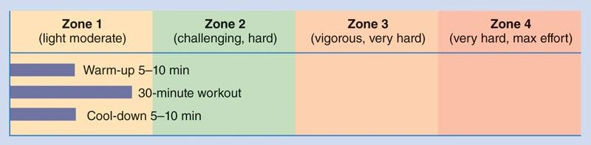

**Figure 15-1** Example stage 1 workout

As with any exercise program, rate of progression must be considered. Stage 1 workouts can be progressed by gradually adding duration to each exercise session. For example, a week 1 program may involve 15 minutes of continuous aerobic exercise, 3 days per week. Each subsequent week an additional few minutes can be added to each exercise session until the client successfully manages 30 minutes of continuous exercise three times per week. It is important not to exceed more than 10% of added volume per week to avoid overtraining or burnout.

Stage 2

Stage 2 is designed for clients with intermediate cardiorespiratory fitness levels who are ready and who desire to begin training at a slightly higher intensity. The focus of stage 2 training is on increasing the workload (e.g., speed, incline) in a way that helps clients exercise at higher intensities and achieve greater levels of aerobic fitness. Stage 2 is ideal for fitness enthusiasts who regularly engage in physical activity or recreational sport or for those seeking further improvements in cardiovascular endurance or weight loss.

Prior to initiating a stage 2 workout, fitness professionals should perform the talk test with their client to determine their client’s heart rate at VT1. Once identified, ideally this measurement would be used to monitor exercise intensity throughout the duration of the stage 2 workout.

Stage 2 is the introduction to aerobic interval training in which intensities are varied throughout the workout. A stage 2 workout consists of a mix of recovery intervals just below VT1 (or a score of “moderate to challenging” when using RPE) and work intervals performed at an intensity just above VT1 (or a score of “challenging to hard” when using RPE). Interval training in this manner will likely improve both physical fitness (e.g., increased VO2max) and health markers, such as reducing the risk of cardiovascular disease (Ito, 2019).

For example, if a client’s heart rate at VT1 is 145 bpm, they should perform exercise intervals slightly above 145 bpm and recovery intervals just below 145 bpm. However, using RPE to gauge exercise intensity is an effective alternative if a heart rate monitor is not available.

Stage 2 work intervals should start out relatively brief (e.g., 30–60 seconds) and progress in duration and intensity over time. Work-to-rest ratios of 1:3, 1:2, and 1:1 are appropriate for stage 2 training. For example, a 1:3 work-to-rest ratio involving a 1-minute interval just above VT1 would include 3 minutes of recovery below VT1. The duration and intensity of intervals should be gradually increased as the client’s fitness levels improve. For example, a 1-minute work interval can be increased to 2 or 3 minutes. In addition, work-to-rest ratios should progress in difficulty from 1:3 to 1:2 to eventually 1:1. These progressions should be based on the ability and willingness of the client to perform higher-intensity exercise.

Example stage 2 aerobic interval program: Stage 2 exercise programs should be individualized and tailored to meet the needs and goals of the client. Following is one example of a stage 2 cardiorespiratory program (Figure 15-2):

1. Start by warming up for 5–10 minutes.
2. Move into a 1-minute interval in zone 2 that is just above VT1.
3. After the 1-minute interval, return to zone 1 for 3 minutes.
4. Repeat these intervals until the duration of the exercise session is complete.
5. Cool down for 5–10 minutes.

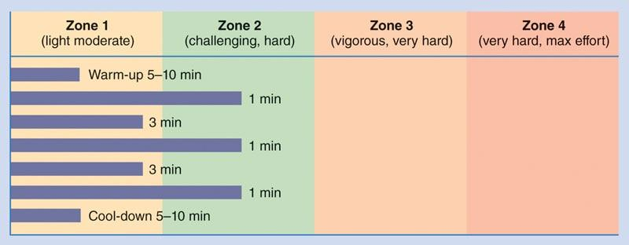

**Figure 15-2** Example stage 2 aerobic interval workout

For clients new to interval training, it is a good idea to alternate stage 1 and stage 2 workouts. For example, start with stage 1 on Monday, then move to stage 2 on Wednesday, and go back to stage 1 on Friday. The next week, start with stage 2 and so on. Rotate the stages to keep workouts balanced. This will become very important in stage 3. However, this plan is only a general guide and may be changed based on the client’s training schedule, available recovery time, and unfore­seen external stressors, such as lack of sleep.

Stage 2 steady-state aerobic exercise

Once clients become accustomed to stage 2 intervals and have shown positive signs of adapting to the physical demands, they can begin performing moderately intense steady-state cardio exercise above VT1, if desired. In other words, the client can perform aerobic conditioning in zone 2 just above VT1 for the duration of the exercise session without the use of intervals. It is important to note that stage 2 steady-state aerobic exercise is not a requirement, but rather an option for clients who prefer to perform steady-state aerobic exercise instead of intervals. Mod­erately intense aerobic activity has been proven effective for individuals seeking improvements in fitness and cardiovascular health (Haskell et al., 2007).

An example stage 2 steady-state workout can proceed as follows (Figure 15-3):

1. Start by warming up for 5–10 minutes in zone 1.
2. Increase intensity (e.g., speed, incline) until client reaches zone 2, which is just above VT1.
3. Continue the duration of the exercise session at this intensity.
4. Cool down in zone 1 for 5–10 minutes.

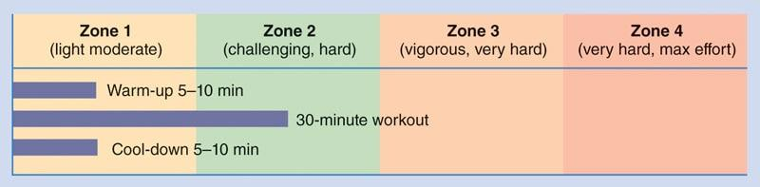

**Figure 15-3** Example stage 2 steady-state workout

CRITICAL

For most weight-loss clients and those new to exercise, stages 1 and 2 are most appropriate and effective for improving health and wellness and promoting a healthy body weight. These two stages should be top priority for the average exerciser and gym goer.

Stages 3 through 5 are most appropriate for athletes and advanced fitness enthusiasts who are seeking greater improvements in cardiorespiratory conditioning and are willing to participate in high-intensity exercise. It is not necessary for fitness professionals to implement all five stages with their clients. Cardiorespiratory exercise should be individualized based on the client’s needs, goals, abilities, and exercise preferences.

Stage 3

Stage 3 is for the moderately advanced client who has obtained a satisfactory cardiorespiratory fitness base. Stage 3 training increases the capacity of aerobic and anaerobic energy systems and is applicable for clients seeking further improvements in exercise capacity. Research demon­strates that high-intensity interval training is a time-efficient strategy to increase physical fitness (Sultana et al., 2019).

However, stage 3 is not appropriate for all clients. Clients seeking only modest improvements in cardiorespiratory fitness, those who are new to exercise, and individuals who are averse to high-intensity training can skip stage 3 training.

To accurately program stage 3 intervals, measurements of VT1 and VT2 need to be recorded. Recall, at VT1, talking becomes challenging but not difficult for the client during aerobic activity, whereas VT2 corresponds with an individual’s inability to speak more than a word or two during exercise (Chapter 11 describes VT1 and VT2 assessments).

For example, if a client’s heart rate at VT1 is 145 bpm and their heart rate at VT2 is 165 bpm, the four training zones are calculated as follows:

* Zone 1: Less than 145 bpm
* Zone 2: 145–154 bpm (VT1 to midpoint)
* Zone 3: 155–164 bpm (midpoint to VT2)
* Zone 4: 165 bpm and higher

The midpoint refers to the intensity level halfway between VT1 and VT2.

A stage 3 program includes the client moving in and out of training zones 1, 2, and 3, while always staying below zone 4. A general rule of thumb is to have a modest mix of time spent in zone 1 (moderate intensity) with brief interval periods in zones 2 (hard intensity) and 3 (vigorous, very hard intensity) to minimize overtraining while simultaneously providing enough overload to challenge energy systems needed for performance adaptations.

Zone 2 and 3 intervals should be client specific based on the client’s goals, needs, and abilities, and zone 2 intervals are typically longer than zone 3 intervals because zone 3 intervals are more intense and physically demanding. Moreover, the volume of training in stage 3 should be progressive, yet in a slow and gradual fashion.

Example stage 3 cardiorespiratory program: Like stage 2, stage 3 exercise programs should be individualized for the client based on their unique goals, needs, and abilities. Following is one example of a stage 3 program (Figure 15-4):

1. Warm up in zone 1 for up to 5–10 minutes.
2. Then, increase the workload every 60 seconds until reaching zone 3. This will require a climb through zone 2, which may take a couple of minutes.
3. After pushing for another minute in zone 3, decrease the workload back to zone 2.
4. Overload the body again by performing another zone 3 interval.
5. Repeat for the desired number of intervals.
6. Cool down for 5–10 minutes.

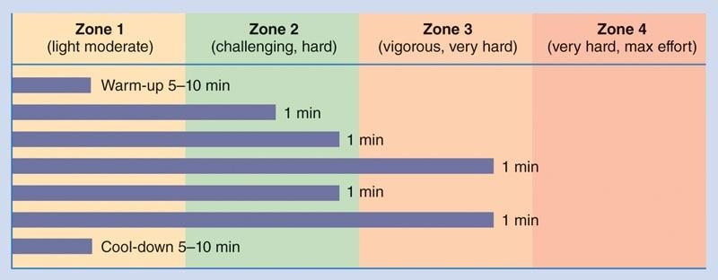

**figure 15-4** example stage 3 workout

It is vital when training at this level to rotate all three stages. There should be a low- (stage 1), medium- (stage 2), and high-intensity (stage 3) day to help minimize the risk of overtraining. The stage 1 day could be considered a recovery day following a hard stage 3 training day.

Work intervals within stage 3 should start out relatively brief, perhaps lasting 30 to 60 seconds. Once fitness and overall conditioning improve, stage 3 programs can be progressed similarly to stage 2 workouts, decreasing work-to-rest ratios and increasing the duration of high-intensity intervals. However, the frequency and duration of intervals in zones 2 and 3 should be client specific based on their goals, needs, abilities, and tolerance to intense activity.

Stage 4

Stage 4 is for the advanced client who has obtained a high-level cardiorespiratory fitness. Stage 4 training increases the capacity of the anaerobic energy system and is applicable for high-level athletes and fitness enthusiasts seeking improvements in anaerobic capacity and power.

Stage 4 is not appropriate for all clients, especially those with only modest levels of physical fitness or those averse to high-intensity conditioning. Consequently, stage 4 should be reserved for those seeking improvement in maximal anaerobic performance, such as athletes and top-end fitness competitors. Like stage 3, measurements of VT1 and VT2 need to be recorded to accu­rately program stage 4 intervals.

A stage 4 workout includes the client moving in and out of all four training zones. A general rule of thumb is to have most of the time spent in zone 1, with brief interval periods in zones 2, 3, and 4 to minimize overtraining while simultaneously providing enough overload to challenge the anaerobic energy system. Furthermore, brief intervals in zones 2, 3, and 4 ensure the client is working at maximum performance rather than maximal effort.

Intervals should be client specific based on the client’s goals, needs, and abilities. The volume of training in stage 4 should be slow and gradual. If the client exhibits signs of overtraining, such as disturbed sleep, excessive fatigue, impaired performance, loss of appetite, or mood swings, volume and intensity of stage 4 workouts should be decreased, and the client should be allowed more recovery time between exercise sessions.

HELPFUL HINT

Maximal performance refers to performing a task where a client or athlete is performing at their absolute peak ability, and work intensity is consistent across all intervals. For example, an athlete runs a 100-meter dash in an attempt to beat their best time. The athlete then sufficiently rests to restore their energy stores (ATP) before attempting another 100-meter dash. The athlete’s goal is decreasing their time in the 100-meter dash, which is a performance initiative.

Maximal effort refers to executing a task where effort is 100% but performance may dwindle due to fatigue. For example, an athlete runs repeated 100-meter dashes with only 30 seconds of rest between each attempt. Consequently, the athlete’s 100-meter times slow with each attempt even though the athlete is giving 100% effort. This format improves conditioning but may not be ideal for improving sprinting performance.

Example stage 4 cardiorespiratory program: Stage 4 exercise programs involve high-intensity exercise and should be client specific. Following is one example of implementing a stage 4 workout (Figure 15-5):

1. Warm up in zone 1 for up to 5–10 minutes.
2. Then, increase the workload every 60 seconds until reaching zone 4. This will require a climb through zones 2 and 3, which may take a couple of minutes.
3. Push for 10 seconds in zone 4 and then decrease the workload back to zone 1. This 1-minute break is an important minute to help gauge training status and improvement.
4. As improvements are made during several weeks of training, the client’s heart rate will drop more quickly. The faster the client’s heart rate drops, the more fit they are becoming.
5. If the client is not able to drop to the appropriate heart rate during the 1-minute break, assume that they are tired and about to overtrain. The solution is to stay in zone 1 for the remainder of the workout. The bottom line is that the client is not rested enough to do that type of exercise on that day (which may be because of a hard workout the day before, not enough sleep, or poor nutrition).
6. If the client’s heart rate does drop to a normal rate, then overload the body again by performing another zone 4 interval.
7. After this minute, go back to zone 1 for 5–10 minutes and repeat if desired.

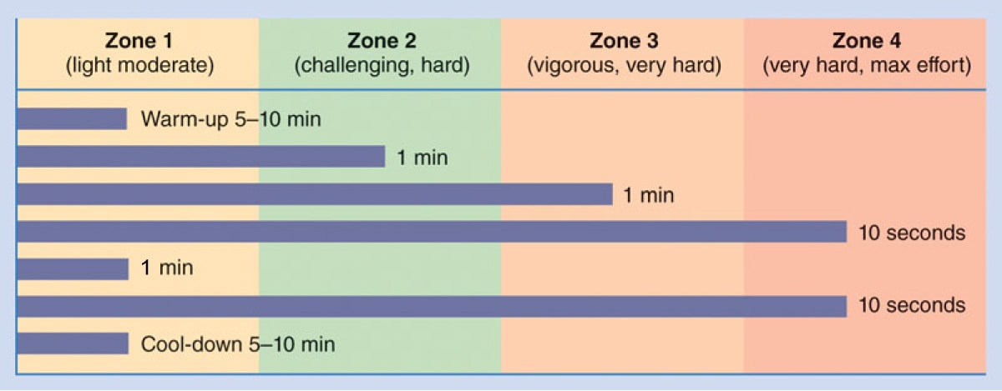

**Figure 15-5** Example stage 4 workout

When training at this level, it is imperative to rotate all four stages. There should be a low- (stage 1), medium- (stage 2), high-intensity (stage 3), and maximal-intensity (stage 4) day to help minimize the risk of overtraining.

Zone 4 intervals within a stage 4 workout should be brief: 5 to 10 seconds. Once fitness and overall conditioning improve, stage 4 programs can be progressed similarly to stage 2 and stage 3 workouts, decreasing work-to-rest ratios and increasing the frequency of high-intensity inter­vals. However, the frequency and duration of intervals should be client specific based on their goals, needs, abilities, and tolerance to intense activity.

Stage 5

Stage 5 consists of sport-specific training and is applicable for all types of athletes. It focuses on drills that help improve conditioning using linear, multidirectional, and sport-specific activities performed as conditioning and often combines high-intensity interval training with small-sided games and agility drills. This stage incorporates the movements, skills, and drills that coaches often use in practice sessions to apply a sport-related stimulus for metabolic benefits (Harrison et al., 2015; Stone & Kilding, 2009). The timing of the drills, the amount of rest provided, and the length of the session can progressively increase to more stressful, gamelike sessions as fitness improves and competition approaches.

While ventilatory testing and heart rate monitoring are not required during stage 5, the fitness professional can benefit from monitoring heart rates or RPE during specific drills to get a picture of the relative intensity of the session. Although consistent aerobic exercise is important for optimal sport preparation, caution is warranted to avoid excessive training volume at the highest intensities. Similar to stage 4 training, volume should be kept at a minimum to avoid overtraining, especially when exercise sessions involve maximal effort. Regular recovery and hydration periods should be included to ensure an optimal training response.

# **Postural considerations in cardiorespiratory training**

When prescribing cardiorespiratory training, it is important to continuously assess the client’s posture during movement. Whether the client is exhibiting poor posture while standing or in motion, it is the fitness professional’s responsibility to correct postural alignment to minimize injury risk and maximize performance. Common postural deviations that clients may exhibit while engaging in cardiorespiratory training include the following:

* Forward head and rounded shoulders
* Anterior pelvic tilt
* Adducted and internally rotated knees and pronated feet

To ensure movement quality during cardiorespiratory training, use the following observa­tion techniques for clients who exhibit these postural deviations.

Rounded shoulders and forward head posture

Rounded shoulders and a forward head posture may negatively affect ventilation and oxygen delivery to muscle cells and, subsequently, performance. The forward rounding of the shoulders theoretically limits the ability to lift the ribcage during ventilation and forcefully contract the diaphragm during inspiration. For clients exhibiting symptoms from this posture during cardiorespiratory exercise, the fitness professional must closely observe for the following postural deviations:

1. During use of stationary bicycles, treadmills, and elliptical trainers, watch closely for rounding of shoulders forward and a protruding head and cue the client to retract their shoulders and head.
2. On steppers and treadmills, watch for the grasping of the handles (with an oversupinated or overpronated hand position), which may cause elevated and protracted shoulders and a forward head. If possible, this equipment should be used without the assistance of the hands to increase the demands on the core musculature, elevating the caloric expenditure and balance requirements of the exercise.
3. In settings in which a television is present, watch for excessive cervical extension (looking upward) or rotation of the head to view the television.

Anterior Pelvic Tilt

An anterior pelvic tilt (arched lower back) may also negatively affect ventilation, oxygen delivery to muscle cells, and performance similar to clients exhibiting upper crossed syndrome. Moreover, an anteriorly rotated pelvis and arched lower back may also result in low-back pain, which can negatively impact exercise performance (Key, 2010). The fitness professional must closely observe the client for the following postural deviations:

1. Initial use of bicycles or steppers may not be warranted, or should be minimized, because the hips are placed in a constant state of flexion, adding to what may already be an overactive hip flexor complex for many clients. If they are used, emphasize flexibility techniques for the hip flexors before and after use. Additional strengthening exercises for the core and gluteal complex are also recommended.
2. Treadmill speed should be kept to a controllable pace to avoid overstriding. The hips may not be able to properly extend and may cause the low-back to overextend (arch), placing increased stress on the low-back. Flexibility for the hip flexors should be emphasized before and after use, along with strengthening exercises for the core and gluteal complex.

Adducted and Internally Rotated Knees and Pronated Feet

Individuals with this posture must be careful not to exacerbate faulty lower extremity move­ments, such as knee valgus (knock-knees). Knee valgus is a predictive factor for knee injury (Numata et al., 2017; Padua et al., 2012). The fitness professional must keep the following factors in mind:

1. Cardiorespiratory exercise that involves the lower extremities requires proper mobility at the ankle joint. Emphasize self-myofascial techniques and stretching for the calves, adductors, and hip flexors. Additional strengthening exercises for the gluteus medius and maximus are also recommended (Powers, 2010).
2. Using the treadmill and steppers that require climbing may initially be too extreme for constant repetition if clients are allowed to hold onto the rails and speed up the pace. If these modalities are used, emphasize the flexibility exercises mentioned previously and keep the pace at a controllable speed until these postures are corrected.

### Core Training

Core training is critical for improving posture (Ko & Kang, 2017; Park et al., 2016), enhancing performance (Butcher et al., 2007; Dello Iacono et al., 2016; Shinkle et al., 2012), increasing resistance to injury (Huxel Bliven & Anderson, 2013), and accelerating injury rehabilitation (Coulombe et al., 2017). A properly designed core training program can be a key component of an overall training plan used to achieve a broad range of goals. The objective of core training is the development of core stability, endurance, strength, and power. Core stability and core endurance refer to the ability of an individual to maintain proper spinal and hip posture while the extremities (i.e., arms and legs) are moving. Core strength refers to the ability to contract the torso in all directions (i.e., flexion, extension, rotation), and core power involves explosive movements of the core musculature. There are multiple muscle groups that make up the core region, which are commonly characterized as local or global musculature. To properly stabilize and strengthen the core, both local and global core muscles must work together. This chapter discusses the importance of core training and how to design and incorporate core training into a client’s overall training program. Future chapters discuss balance and plyometric training and how these additional methods can be incorporated into a training program that will enhance overall functional efficiency.

**Core musculature**

Certified Personal Trainers must have a basic understanding of functional anatomy to understand the principles of core training. The core, also known as the lumbo-pelvic-hip complex (LPHC), includes a space within the body that has the following boundaries: diaphragm superiorly, abdominal muscle anteriorly and laterally, lumbar spine and gluteal muscles posteriorly, and pelvic floor and hip musculature inferiorly (Huxel Bliven & Anderson, 2013). In simpler terms, the core region is at the body’s centre of gravity and includes (but is not limited to) the abdominals, hips, gluteal complex, and low-back area. The core musculature can be divided into two unique categories: the local muscles and the global muscles (Figures 16-1 and 16-2). To maintain optimal stability and function of the core, it is important to systematically condition all muscles of the core. Together, the local and global muscles work to stabilize the spine while producing efficient arm and leg movements. These muscles work together to produce strong, effective movements of the trunk while continuing to stabilize the spine. Optimal lengths of muscles (or length-tension relationships) and recruitment of muscles (or force-couple relationships) of the LPHC, along with coordinated joint motions, are important for producing effective and efficient movements. Table 16-1 provides examples of local and global muscles of the core (this is not an exhaustive list).

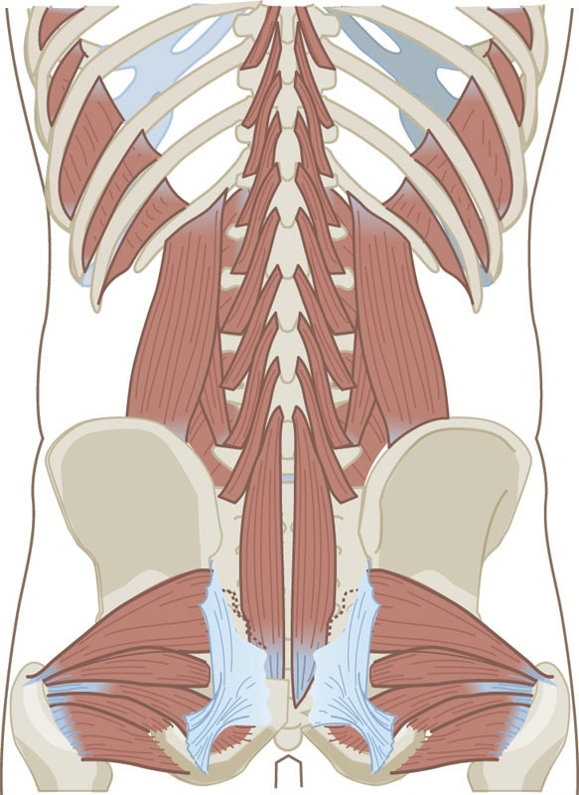 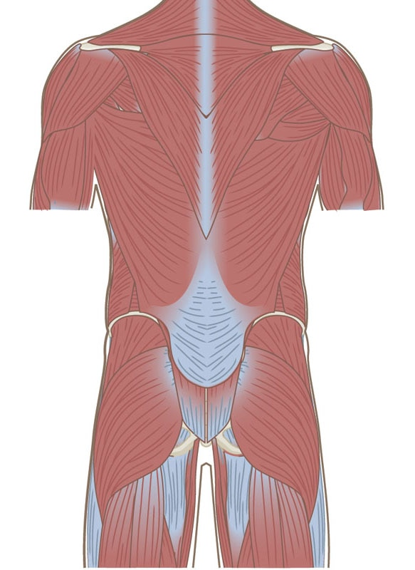

**Figure 16-1** Local core musculature

**Figure 16-2** Global core musculature

TABLE 16-1 Examples of Local and Global Core Muscles

| **Examples of Local Muscles** | **Primary Actions** | **Image** |
| --- | --- | --- |
| Rotatores | Stabilize and rotate spinal segments |  |
| Multifidus | Stabilize, extend, and rotate spine |  |
| Transverse abdominis | Increase intra-abdominal pressure |  |
| Diaphragm | Regulate inspiration |  |

| **Examples of Local Muscles** | **Primary Actions** | **Image** |
| --- | --- | --- |
| Pelvic floor musculature | Support the contents of the pelvis |  |
| Quadratus lumborum | Lateral flexion of spine; elevation of pelvis |  |
| Rectus abdominis | Trunk/spine flexion, rotation, and lateral flexion |  |

| **Examples of Global Muscles** | **Primary Actions** | **Image** |
| --- | --- | --- |
| External abdominal obliques | Spinal flexion, lateral flexion, and contralateral rotation |  |
| Internal abdominal obliques | Spinal flexion, lateral flexion, and ipsilateral rotation |  |
| Erector spinae | Trunk/spine extension, rotation, and lateral flexion |  |
| Latissimus dorsi | Trunk/spine rotation (in addition to shoulder extension, adduction, and internal rotation) |  |

| **Examples of Global Muscles** | **Primary Actions** | **Image** |
| --- | --- | --- |
| Iliopsoas (iliacus + psoas) | Hip flexion (in addition to hip adduction and external rotation) |  |
|  |

**Local muscles**

Local muscles generally attach on or near the vertebrae and often have short attachments ranging between one and two vertebrae segments. Local muscles provide dynamic control of the spinal segments that limit excessive compression, shear, and rotational forces between spinal segments. This is important for stabilizing the vertebrae and limiting strain on passive stabilizing structures, including intervertebral discs and ligaments. Local muscles consist primarily of type I (slow twitch) muscle fibers (Dickx et al., 2010), which have a high density of muscle spindles and are important for assisting in proprioception of the spine (Boyd-Clark et al., 2002). Therefore, the appropriate function of local core muscles is important for maintaining proper posture of the vertebral column during strengthening exercises and other dynamic movements.

CRITICAL

Developing movement strategies that effectively stabilize the spine by activating local muscles, prior to the initiation of extremity movements, is important for minimizing improper loading of the spine and reducing the risk of injury. These strategies are discussed later in the chapter.

Additionally, appropriate posture throughout the spine is important for ensuring proper extremity movements, thereby enhancing the performance of the entire neuromuscular system. It is important to remember that dysfunction of local core musculature can be present in individuals with strong global core musculature. Therefore, exercises that activate, strengthen, and build endurance in local core muscles should still be incorporated into all core training programs.

**Global muscles**

Global core musculature is positioned more superficial on the trunk when compared to local core musculature. The global muscles of the core act to move the trunk, transfer loads between the upper and lower extremities, and provide stability of the spine by stabilizing multiple segments together as functional units. These muscles are primarily responsible for concentric force production and eccentric deceleration during dynamic activities. The primary global muscles of the core include (but are not limited to) the rectus abdominis, external obliques, latissimus dorsi, gluteus maximus, hip flexors, and extrinsic (superficial) erector spinae.

Collectively, all of the muscles within each system provide dynamic stabilization and neuromuscular control of the entire core (LPHC; Xie & Wang, 2019). The global muscles produce force (concentric actions), attenuate force (eccentric actions), and provide stabilization in all planes of movement during dynamic activities. In isolation, global muscles do not effectively achieve stabilization of the LPHC; rather it is through their cooperative functioning with the local musculature that they enhance stability and neuromuscular control (Weber et al., 2018). To better understand how these muscles work to stabilize the LPHC, it helps to view the systems from the inside out (local muscles → global muscles). In other words, training the global muscles before training the local muscles would not be ideal from both a structural and biomechanical standpoint. Doing so could be compared to building a house without a foundation. The foundation must be developed first to provide a stable platform for the remaining components of the house to be built on. One must first be stable to move efficiently.

**Importance of properly training the core muscles**

Some active individuals have developed strength, power, and muscular endurance of the global muscles of the core, which enables them to perform dynamic activities. Few people, however, have properly trained the local muscles required for intervertebral stabilization (Hodges & Richardson, 1996). The local muscles have to function efficiently for an individual to effectively use the strength, power, and endurance that has been developed in the prime movers (i.e., arms, legs). If the global muscles are strong and the local muscles are weak, forces along the kinetic chain might not be transferred or used properly. This leads to compensation, inefficient movements, and the potential for injury. Weakness of the global and local core musculature is a fundamental problem that causes inefficient movement and can lead to poor posture, decreased athletic performance, increased risk of injury, and inability to adequately return to activity following a previous injury. For this reason, properly training local and global core musculature is essential for maintaining proper posture and improving performance, as well as increasing injury resilience and enhancing injury rehabilitation.

**Scientific rationale for core training**

When designing a core training program, it is important to incorporate exercises specific to the needs of each client. Core training has multiple benefits; therefore, core training may be considered fundamental to many overall training programs for the vast majority of clients. Scientific evidence exists to support the importance of core training for the following key areas: optimizing posture, performance, injury resistance, and rehabilitation.

Optimising posture

The human spine demonstrates naturally occurring curvatures that alternate between lordotic (inward/concave) curvatures in the cervical and lumbar spine and kyphotic (outward/convex) curvatures in the thoracic and sacral spine (Figure 16-3). These spinal curvatures develop naturally as individuals move from crawling to walking. Maintenance of these spinal curvatures throughout the life span is important for proper energy distribution throughout the spine. Proper core muscle function is critical for maintaining natural spinal curvatures, which can be increased or decreased as a result of improper core muscle balance (Hongo et al., 2012). Overactivity of the hip flexors and superficial erector spinae and underactivity of the abdominals have been correlated with increased anterior pelvic tilt (Figure 16-4), which is associated with increased lumbar (low-back) lordosis (Król et al., 2017). Conversely, overactivity of the hamstrings and rectus abdominis and underactivity of the erector spinae can rotate the pelvis posteriorly, known as a posterior pelvic tilt (Figure 16-5).

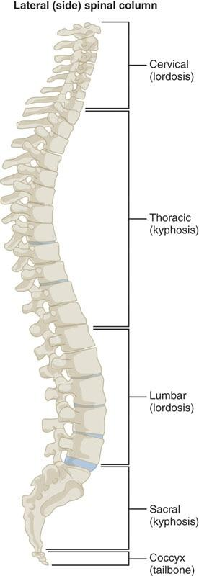

**Figure 16-3** Natural spinal curvature

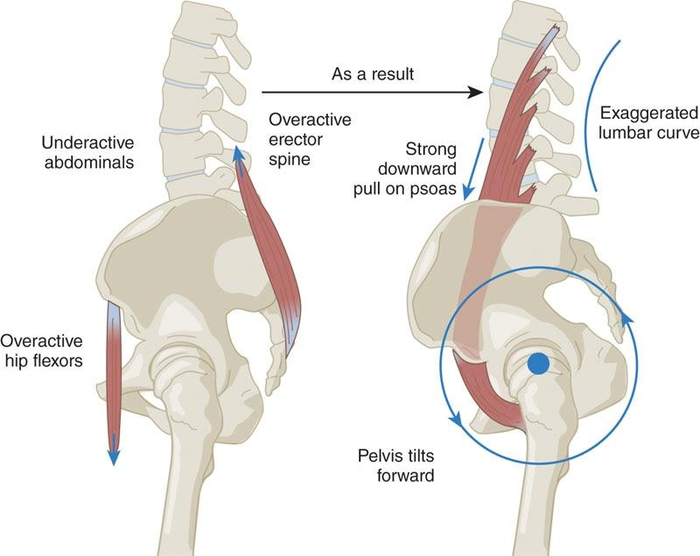

**Figure 16-4** Anterior pelvic tilt

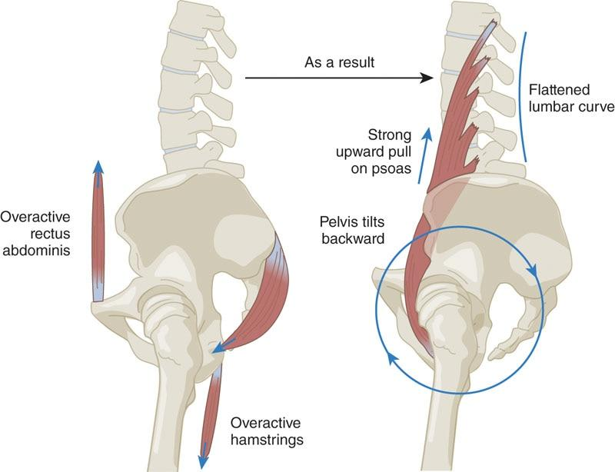

**Figure 16-5** Posterior pelvic tilt

While the spine may exhibit small deviations from midline in the frontal plane, large curvatures of the spine away from midline are considered abnormal and may be classified as scoliosis (Figure 16-6). While scoliosis can often result from altered bone shape through the spine (structural scoliosis), functional scoliosis (nonstructural scoliosis) can be influenced by muscle imbalances, particularly muscle imbalances between right and left sides of the body. This leads to altered alignment of the spine in the frontal plane (Hawes, 2003; Zapata et al., 2015). Core muscle strengthening has been found to improve spinal alignment in individuals with functional scoliosis (Ko & Kang, 2017; Park et al., 2016).

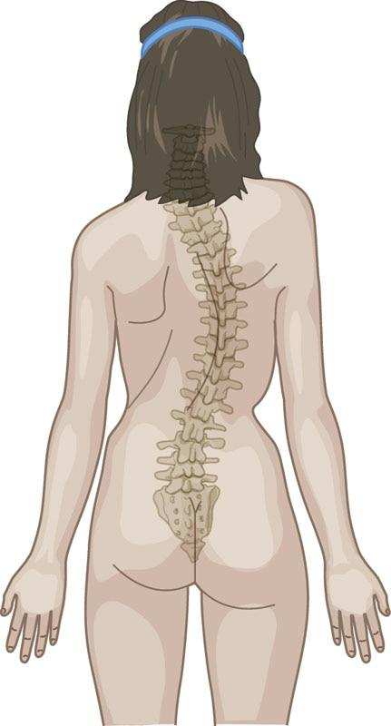

**Figure 16-6** Scoliosis

Additionally, hip musculature (e.g., gluteus medius) functions to maintain a level position of the pelvis. Improper positioning of the pelvis may result in improper postures of the spine. It is not clear if altered posture causes low-back pain (LBP) or if LBP results in altered posture (Roffey et al., 2010). Gluteus medius weakness is common in individuals with LBP and should be addressed as a way to manage the link between abnormal posture and LBP (Cooper et al., 2016). Therefore, proper core strength and stability are linked to proper posture, which is the reason maintaining proper body positioning, or form, should be emphasized while exercising as well as performing activities of daily life.

STRETCH YOUR KNOWLEDGE

Posture, Injury Prevention, and the Core

* A study by Ahearn et al. (2018) found that the young female dancers who added Pilates-based core training to typical dance class participation improved both trunk and low-back posture, as well as body awareness, compared to the dancers who took part in dance classes only.
* Buyukturan et al. (2017) found that in patients with neck pain and cervical disc herniation, 8 weeks of core training with cervical stability training was effective at relieving pain, improving muscle strength and endurance, and decreasing fear of movement (kinesiophobia).
* In healthy adults, Mesquita Montes et al. (2017) found that the highest activity within the external oblique, internal oblique, and transversus abdominis muscles during breathing activities was accomplished while in a standing position compared to sitting and kneeling postures, suggesting that the positioning of clients during core training is important for facilitating proper muscle activity.
* In a study investigating muscle activity using electromyography (EMG) of the core musculature, Calatayud et al. (2015) found that exercises involving single-leg stance with the addition of elastic resistance generated the greatest EMG values.
* Kiss et al. (2019) conducted a randomized controlled trial with 103 young kayak/canoe athletes, who are at a high risk for developing low-back pain. For the 50 athletes who underwent 6 months of preventive core muscle training, the authors found improved strength of the abdominal and back muscles, low-back motor control, and resting posture compared to those who did not complete core muscle training.

Key Takeaways

* Core training can improve trunk and low-back posture, as well as body awareness.
* Core training with cervical stability training can be effective at relieving pain and improving muscle strength and endurance.
* The positioning of clients during core training is important for facilitating proper muscle activity.
* Exercises involving unstable stances (single-leg stance) with external resistance can create greater muscle activation.
* Core training can improve abdominal/low-back strength and motor control.

### Performance

A strong and stable core is important for generating strong and explosive movements needed for optimal physical performance.

The core can be thought of as a foundation for producing and transmitting strong and controlled movements to the lower extremity and generating force production for the upper extremities (De Blaiser et al., 2018; Rivera, 2016; Willardson, 2007). Therefore, improving core performance, including strength, endurance, and coordinated muscle activation, should be viewed as a critical component of improving movements requiring upper and lower limb speed, strength, and endurance. There is evidence that core muscles activate prior to movements in the lower extremity, suggesting that proper core muscle function is essential for preparing the primary lower extremity movers to generate force (Hodges & Richardson, 1997a). Core stability and core strength are associated with increased lower extremity muscle strength (Dello Iacono et al., 2016) and increased takeoff velocity of a vertical jump (Butcher et al., 2007), as well as maximal squat performance.

Core muscle strengthening programs have been linked to improved speed and kicking performance (Lago-Fuentes et al., 2018; Prieske et al., 2016), as well as dynamic balance and jumping distance (Granacher et al., 2014; Shinkle et al., 2012). Core muscle endurance is also critical to lower extremity muscle performance (Kocahan & Akınoğlu, 2018). Previous research has demonstrated that core muscle fatigue can result in altered cycling biomechanics (Abt et al., 2007). Similarly, fatiguing the core musculature results in decreased shoulder strength (Rosemeyer et al., 2015), suggesting that core endurance is critical for upper extremity muscle performance. Preparatory trunk movements occur prior to moving the upper limb extremity, suggesting proper trunk stability is needed to maximize upper extremity performance (Hodges et al., 2000; Morris et al., 2013). Additionally, improving core strength results in increased shoulder strength (Kuhn et al., 2018). Athletes who participate in throwing activities strengthened gluteal function, which is connected to better pelvis and torso biomechanics (Oliver & Keeley, 2010; Plummer & Oliver, 2014), and sling-based core training, which involves suspension of the limbs using unstable sling or cord systems, results in improved throwing velocity (Saeterbakken et al., 2011). Core training improved 50-meter swimming sprint times (Weston et al., 2015), suggesting core training can translate to improved performance in nonweight-bearing activities that engage both upper and lower extremity function.

Injury resistance

Core muscle function is critical for proper extremity movements. Therefore, optimal core muscle function has been considered a factor that may modify injury risk. A prospective cohort study demonstrated that lower postural control, hip muscle strength, and core muscle endurance were predictive of individuals who developed overuse musculoskeletal injuries over a 1.5-year period (De Blaiser et al., 2019). Core muscle training has been found to improve balance (Aggarwal et al., 2010), and a meta-analysis concluded that core strength training was an important factor in fall prevention (Granacher et al., 2013). Core stability has become a key component of prevention programs aimed at decreasing acute lower extremity injuries, such as anterior cruciate ligament tears (Hewett et al., 2005). The ability to properly stabilize the trunk during jump landing is critical to achieving optimal landing mechanics that may decrease the risk of knee injury (Foss et al., 2018; Hewett et al., 2017). In a randomized controlled trial, 4 weeks of core stability training produces similar decreases in forces at the knee during jump landing in female high school athletes to individuals who participated in 4 weeks of plyometric training (Pfile et al., 2013).

Rehabilitation

LBP is one of the leading causes of global disability, and core muscle training is commonly used to rehabilitate patients with LBP (Vos et al., 2012). Researchers have found that individuals with chronic LBP have decreased activation of certain muscles or muscle groups, including the transverse abdominis, internal obliques, pelvic floor muscles, multifidus, diaphragm, gluteal complex, and deep erector spinae (Arab et al., 2010; Calvo-Lobo et al., 2019; Hodges & Danneels, 2019; Rose-Dulcina et al., 2019; Santos et al., 2013; Sjödahl et al., 2009). A meta-analysis evaluating more than 2,400 individuals demonstrated that core exercise is effective in improving outcomes in those with LBP (Saragiotto et al., 2016). Core stabilization exercises restore the size, activation, and endurance of the multifidus (deep spine muscle) in individuals with LBP (Hides et al., 2001). The addition of core stability exercises to traditional rehabilitation for people with LBP demonstrates improvements in pain compared to traditional rehabilitation (Akhtar et al., 2017).

CRITICAL

It is important for fitness professionals to work closely alongside healthcare providers, who are trained to diagnose and treat individuals with injuries. It is beyond the scope of practice for a Certified Personal Trainer to diagnose an injury or perform the functions of a licensed rehabilitation specialist (e.g., physical therapist, physiotherapist, chiropractor, orthopedist).

Clients with LBP can be taught to improve functionality of core muscles to improve core stability and reduce LBP. For example, performing an abdominal drawing-in maneuver increases muscle activation of the transverse abdominis. Transverse abdominis activation improves with 4 weeks of training in those with and without LBP (Selkow et al., 2017). Using proper exercise techniques can reduce pain in those with LBP. Using hyperextension exercises without proper LBP stabilization has been shown to increase pressure on the discs to dangerous levels. These unsupported exercises can cause damage to the ligaments that support the vertebrae, which may lead to a narrowing of the vertebrae openings that spinal nerves pass through (Ashmen et al., 1996; Beim et al., 1997). Therefore, it is crucial for fitness professionals to incorporate a systematic, progressive approach when training the core, ensuring the local core muscles that stabilize the spine are strengthened before or in conjunction with the global musculature that moves the spine and extremities.

HELPFUL HINT

Electromyography is a procedure that measures the electrical conducting function of nerves in muscles. An electromyography is able to identify differences in muscle or muscle group activation when performing different movements or exercises.

**Drawing-in manoeuvre**

Research has demonstrated that electromyography activity is increased during pelvic stabilization and transverse abdominis activation when an abdominal drawing-in maneuver is initiated before activity (Cresswell et al., 1992; Hides et al., 2006; Richardson et al., 2002). Research has found that the transverse abdominis, when properly activated, creates tension in the thoracolumbar fascia (connective tissue of the low-back area) (Figure 16-7), contributing to spinal stiffness, and compresses the sacroiliac joint (Figure 16-8), increasing stability (Hodges & Richardson, 1997b, 1997c). These findings have led other researchers to further understand and demonstrate the important role of the transverse abdominis on spinal stability and LBP. To perform the drawing-in maneuver, pull in the region just below the navel toward the spine and maintain the cervical spine in a neutral position. Maintaining a neutral spine, or the normal curvatures of the spine during core training helps improve posture, muscle balance, and stabilization. If a forward protruding head is noticed during the drawing-in maneuver, the sternocleidomastoid (Figure 16-9) is preferentially recruited. If the sternocleidomastoid muscle is overactive and extends the upper cervical spine, the pelvis rotates anteriorly to realign the eyes. This can lead to muscle imbalances and decreased pelvic stabilization (McGill, 2001).

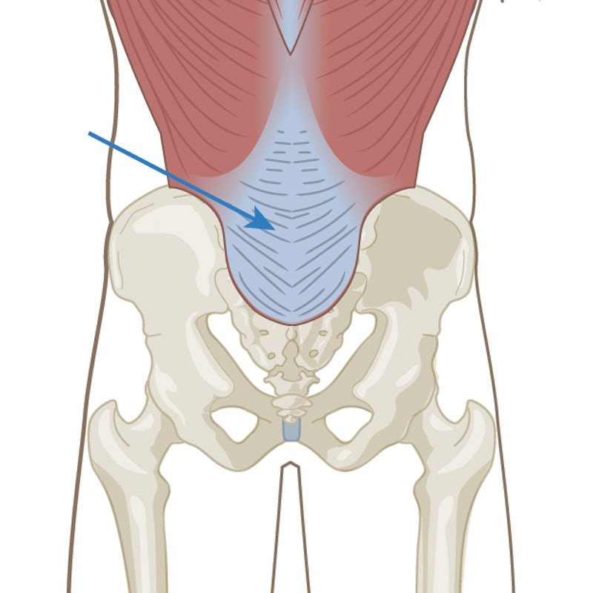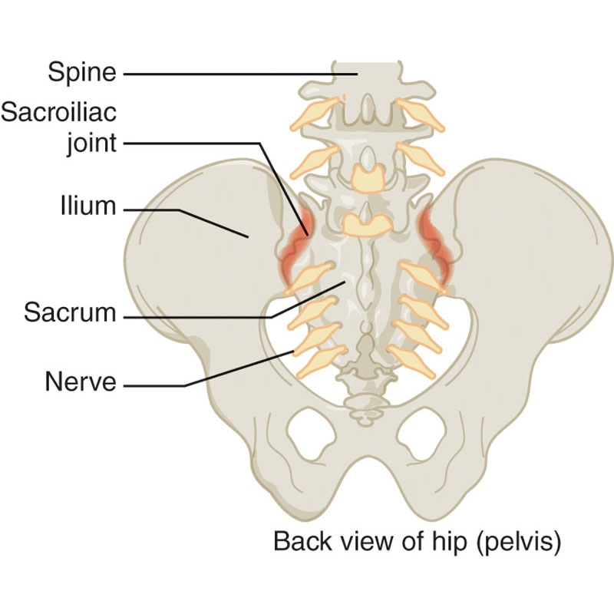

**Figure 16-7** Thoracolumbar fascia

**Figure 16-8** Sacroiliac joint

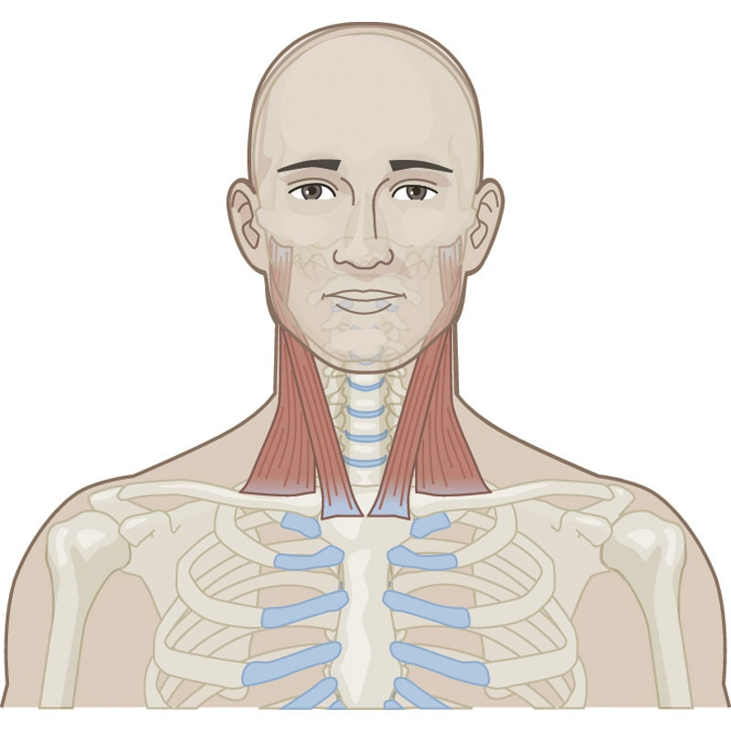

**Figure 16-9** Sternocleidomastoid

**Abdominal bracing**

Bracing is referred to as a co-contraction of global muscles, such as the rectus abdominis and external obliques. Bracing is also commonly referred to as a “bearing down” or tightening of the global muscles by consciously contracting them. Research has shown that muscular endurance of global and local musculature, when contracted together, create the most benefit for those with LBP compared with traditional LBP training methods, such as solely emphasizing range of motion at the spine (McGill, 2001). Bracing focuses on global trunk stability, not simply on segmented vertebral stability, meaning that the global muscles, given the proper endurance training, will also work to stabilize the spine.

However, both the drawing-in maneuver and bracing can be implemented in a core training program to help retrain the strength, endurance, and motor control of local and global muscular systems and movement musculature (Larivière et al., 2019; McGill, 2001). Activation of the local stabilization system and the global stabilization system (Arokoski et al., 2001; Kibler et al., 1996; Larivière et al., 2019; McGill, 2001) has been demonstrated to preferentially activate these specific muscles during core training.

**Guidelines for core training**

A comprehensive core training program should be systematic, progressive, and functional and emphasize the entire muscle action spectrum focusing on force production (concentric), force reduction (eccentric), and dynamic stabilization (isometric). A core training program should regularly manipulate planes of motion, ranges of motion, body position, speed of execution, and specific acute training variables (e.g., sets, reps, intensity, tempo, frequency) (Table 16-2).

When designing a core training program, the fitness professional should initially create a proprioceptively enriched training environment. Proprioception training offers a controlled yet unstable training environment with a selection of appropriate exercises to elicit a maximal training response and involves activities that emphasize awareness of body position in space. Core exercises performed in an unstable environment (such as with a stability ball) have been demonstrated to increase activation of the local and global stabilization system (Behm et al., 2005; Carter et al., 2006; Escamilla et al., 2016). As also outlined in Table 16-2, the core exercises must be safe and challenging and stress multiple planes in a multisensory environment derived from fundamental movement skills specific to the activity.

TRAINING TIP

The use of weight belts for apparently healthy adults engaging in a moderately intense exercise program is not recommended. Weight belts may raise an individual’s heart rate and systolic blood pressure and often give individuals a false sense of security and the misconception that they can lift heavier loads. Instead, fitness professionals need to educate their clients as to appropriate exercise technique and proper activation of the body’s natural belt: the core musculature.

TABLE 16-2 Core Training Variables

|  |  |
| --- | --- |
| Planes of motion   * Sagittal * Frontal * Transverse | Volume   * Sets   + Low   + Moderate   + High * Repetitions   + Low   + Moderate   + High |
| Range of motion   * Full * Partial * End range | Progression   * Little or no motion of spine * Controlled spinal flexion, extension, rotation * Explosive trunk movements |
| Speed of motion   * Slow * Medium * Fast * Explosive | Resistance   * Body weight * Light * Medium * Heavy |
|  | Exercise equipment   * Tubing * Cables * Medicine balls * Free weights * Balance equipment (e.g., foam pad, wobble board, balance disc) |

STRETCH YOUR KNOWLEDGE

Core Training for Rehabilitation and Sport Performance

* Linde et al. (2018) found that abdominal bracing during a single-leg squatting task led to greater activity of the global abdominal muscles in healthy females when compared to abdominal hollowing and control conditions.
* Motealleh et al. (2019) evaluated trunk postural balance on an unstable sitting platform in young women with and without patellofemoral pain syndrome (PFPS). They found impaired trunk postural control in the women with PFPS, suggesting that rehabilitation for these patients should incorporate isolated core training to improve recovery and function.
* Tsai et al. (2019) investigated whether core training through control and strength of the trunk and hip would improve landing biomechanics and muscle strength in adolescent male volleyball athletes. Following a 6-week core training program, athletes demonstrated a more controlled (upright) trunk posture during landing and improved strength of key hip and knee musculature, suggesting that core training may be important to incorporate into training programs for jumping athletes.
* Lima et al. (2018) found that adults with a history of LBP and disability who underwent a 10-week core and mobility training program, including guidelines for the most appropriate core posture during work and activities of daily living, had reduced LBP intensity perception and low-back functional disability compared to individuals who did not follow this program.
* Sung et al. (2016) demonstrated that an integrated and specialized 8-week core training and nondominant arm strength training program resulted in larger improvements in drive distance compared to golfers who did no exercise or core-only exercise for 8 weeks.

Key Takeaways

* Abdominal bracing during a single-leg squatting leads to greater activity of the global abdominal muscles.
* Rehabilitation for patients with PFPS should incorporate core training.
* Core training may improve landing mechanics after jumping.
* Core exercises can help reduce LBP.
* Core training can improve golf performance.

**Designing a core training program**

The goal of core training is to develop optimal levels of stability, muscular endurance, strength, and power. Increasing proprioceptive demand by using a multisensory environment and using multiple exercise modalities (balls, bands, balance equipment) is more important than increasing the external resistance. The quality of movement should be emphasized more than quantity, and the focus of the program should be on coordinated movement across the kinetic chain.

CRITICAL

Neural adaptations become the focus of the program instead of striving for absolute strength gains.

The following is an example of an integrated core training program. The client begins at the highest level at which they are able to maintain stability and optimal coordinated movement. The client progresses through their program after mastering the exercises in the previous level while simultaneously demonstrating intervertebral and lumbopelvic stability. To evaluate appropriate intervertebral stability, the client will be able to maintain the drawing-in position while performing various exercises. The client would have appropriate lumbopelvic stability when they are able to perform functional movement patterns, such as squats, lunges, and step-ups, without excessive spinal motion.

Core training programs must be designed to achieve the following functional outcomes. The sequence is critical for optimizing function:

1. Intervertebral stability (stabilization of individual spinal segments)
2. Lumbopelvic stability (stabilization of lumbo-pelvic-hip complex)
3. Movement efficiency (improved movement quality and force output)

**Core training progressions**

When initiating a core training program, exercises should initially focus on stabilization through the spine and pelvis without gross movement of the trunk. These exercises are designed to improve neuromuscular efficiency and intervertebral stability, focusing on drawing-in and then bracing during the exercises (Selkow et al., 2017). These exercises primarily target the local core muscles discussed earlier in the chapter. Sample exercises that follow this protocol include (but are not limited to) the following:

* Marching
* Floor bridge
* Ball bridge
* Floor cobra
* Ball cobra
* Fire hydrant
* Plank
* Side plank
* Dead bug
* Bird dog
* Pallof press
* Farmer’s carry.

The next progression is to involve more dynamic eccentric and concentric movements of the spine throughout a full range of motion. In other words, these exercises involve flexion, extension, and rotation of the trunk. It is always important for the fitness professional to communicate with a client’s healthcare provider to determine if there are any underlying medical conditions that may warrant avoiding certain exercises. In this progression, specificity, speed, and neural demands are also increased using moderate to fast repetition tempos. These exercises are designed to improve lumbopelvic stability, concentric strength (force production), eccentric strength (force reduction), and neuromuscular efficiency (coordination) of the core. Sample exercises that follow this protocol include (but are not limited to) the following:

* Floor crunch
* Ball crunch
* Back extension
* Reverse crunch
* Knee-up
* Cable rotation
* Cable lift
* Cable chop.

The last progression includes exercises that are designed to improve the rate of force production (power) and movement efficiency of the core musculature and extremities. These forms of exercise prepare an individual to dynamically stabilize and generate force at more functionally applicable (explosive) speeds (Butcher et al., 2007). Example exercises include (but are not limited to) the following:

* Medicine ball rotation chest pass
* Ball medicine ball pullover throw
* Front medicine ball oblique throw
* Side medicine ball oblique throw
* Medicine ball soccer throw
* Medicine ball woodchop throw
* Medicine ball overhead throw.

### Five kinetic chain checkpoints

As with any training method, proper form and technique must be mastered to ensure proper muscle activation and avoid injury. The skill for core training requires adequate focus and practice. Without inward focus and conscious attention to technique, injury may occur, especially as exercises become more explosive. Honing all skills with exquisite technique for each exercise is essential. Moreover, as with all exercises, improving quality should always come before increasing quantity or weight, and the five kinetic chain checkpoints should be monitored (Figure 16-10):

1. *Feet*: Approximately shoulder-width apart (when appropriate) and pointing straight ahead (when appropriate)
2. *Knees*: In line with the second and third toes (avoid allowing knees to cave inward)
3. *Hips*: Level and in a neutral position
4. *Shoulders*: Neutral position (not protracted or elevated)
5. *Head*: Cervical spine in a neutral position (chin tuck)

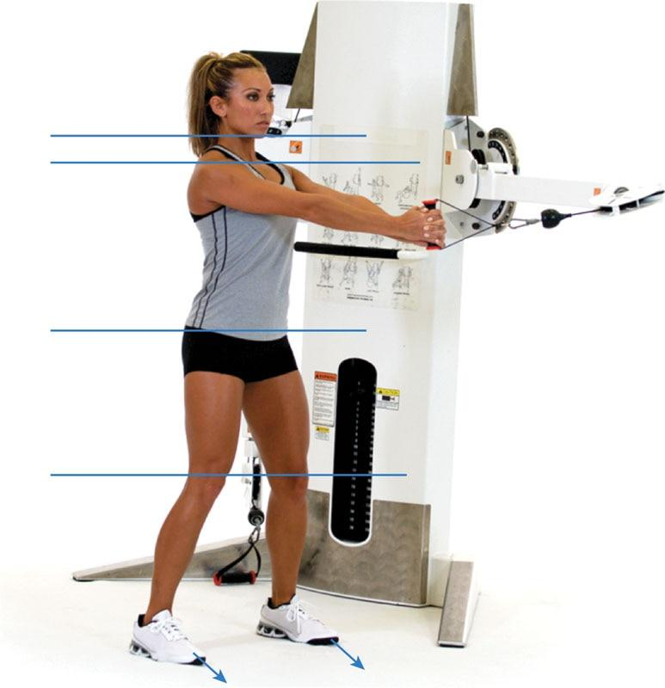

**Figure 16-10** Five kinetic chain checkpoints

**Core exercises**

Marching

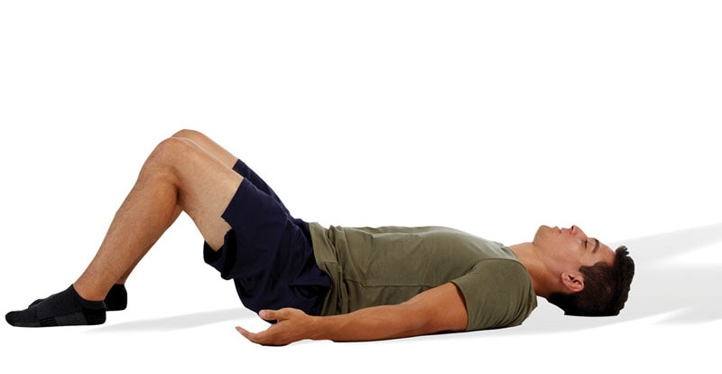 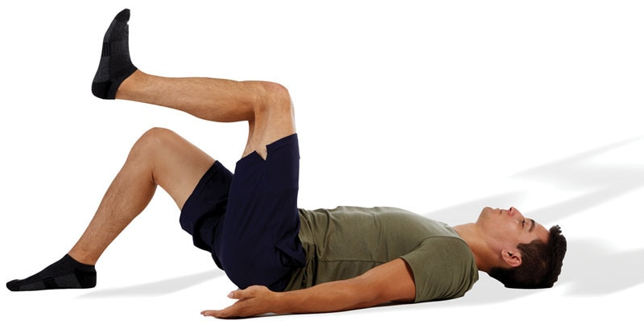

TECHNIQUE

Make sure to keep the abdominals drawn in throughout the entire exercise to target the local core muscles. Abdominal protrusion indicates poor activation of the local core.

### Floor Bridge

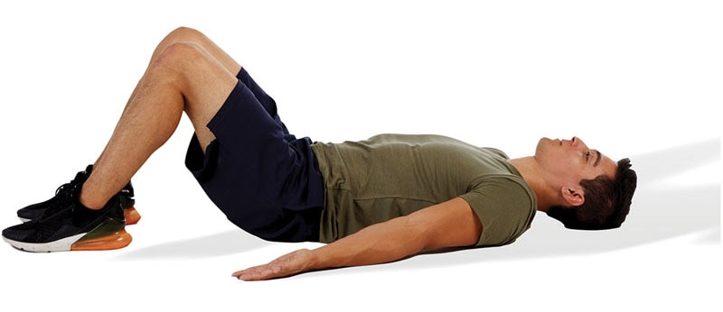 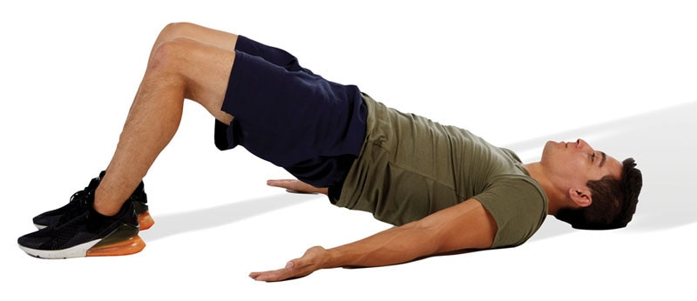

SAFETY

When performing a bridge, do not raise the hips too far off the floor (hyperextending the low-back). This places excessive stress to the lumbar spine. Make sure at the end position, the knees, hips, and shoulders are in alignment and the gluteal muscles are fully contracted.

Ball bridge

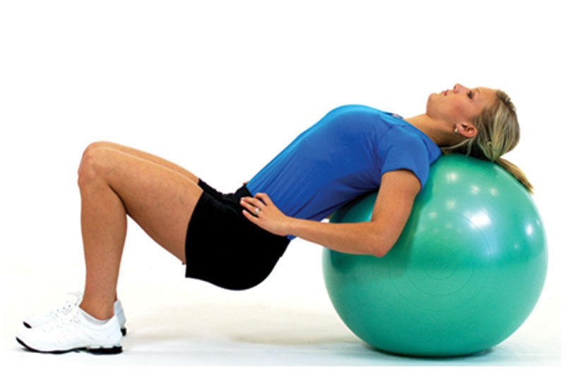 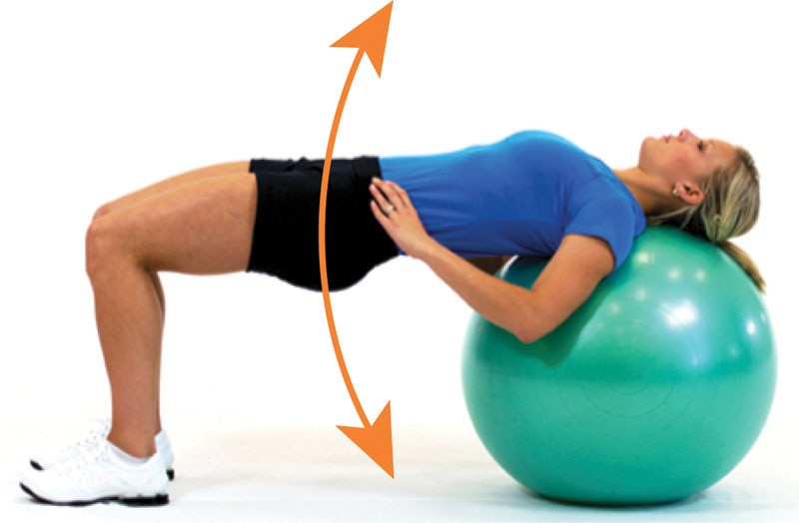

TECHNIQUE

Make sure to rest the head and shoulders on top of the stability ball to maximize comfort and reduce stress on the head and neck. Like the floor bridge, do not allow hyperextension of the low-back.

Floor Cobra

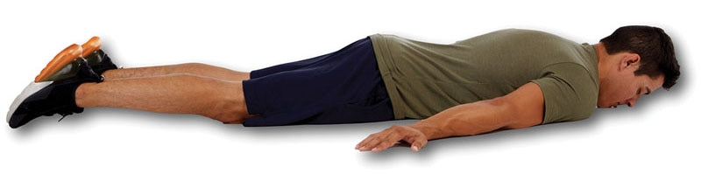 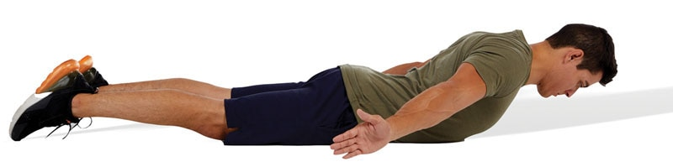

SAFETY

Like the ball bridge, do not come too high off the floor (hyperextending the low-back). The focus of the exercise is to retract and depress the shoulder blades. As such, be sure to externally rotate both arms and point the thumbs into the air.

Ball Cobra

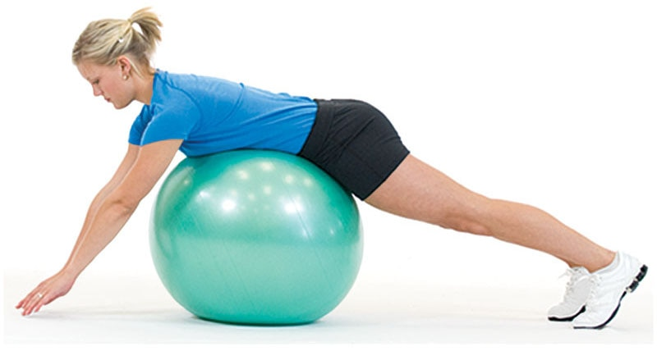 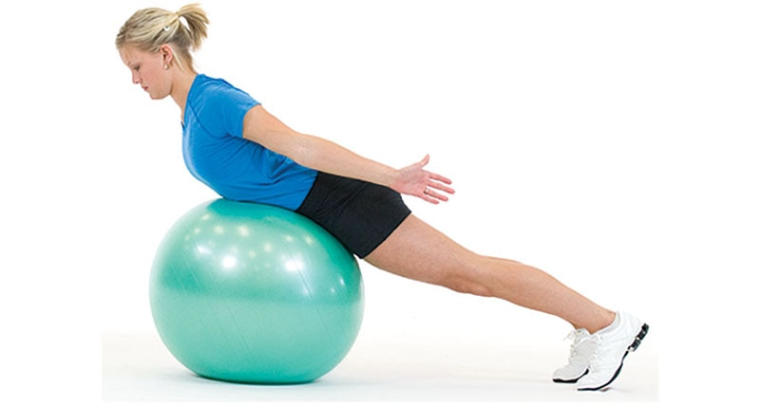

SAFETY

Perform this exercise like the floor cobra, but it is best to place the feet against a sturdy object for extra support (not shown).

Fire Hydrant

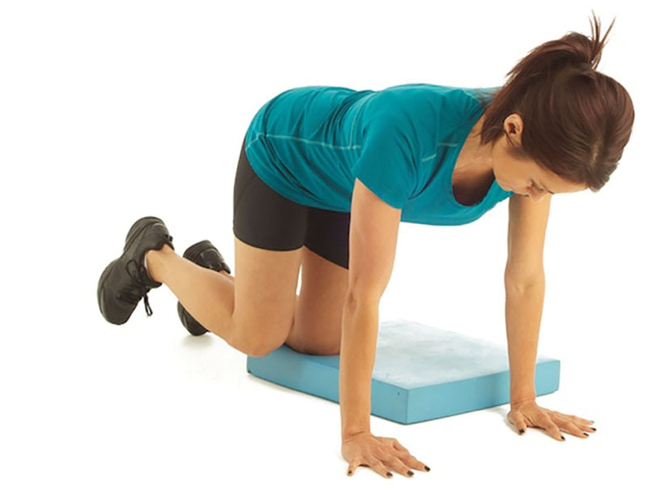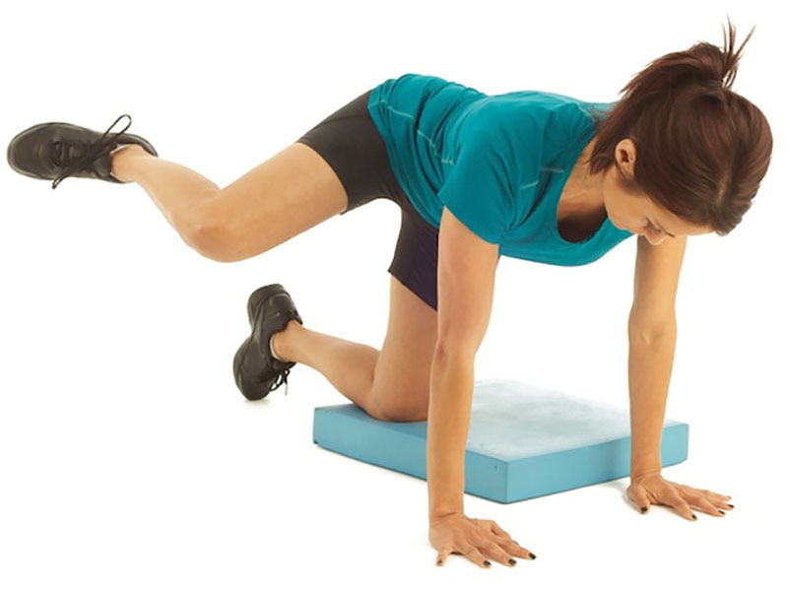

TECHNIQUE

Perform this exercise with the abdominals drawn in and head in a neutral position. This exercise helps strengthen the hip external rotators.

Plank

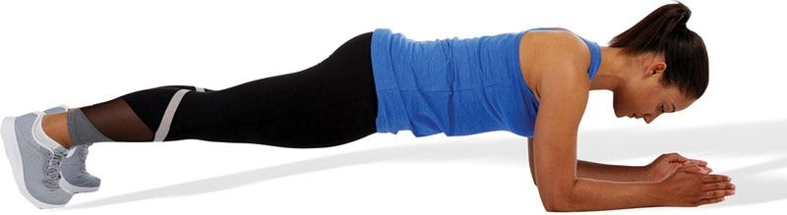

TECHNIQUE

If this version of the exercise is too difficult for a client to perform, some regression options include the following:

* Perform in a standard push-up position
* Perform in a push-up position with the knees on the floor
* Perform with the hands on a bench and the feet on the floor

Side Plank

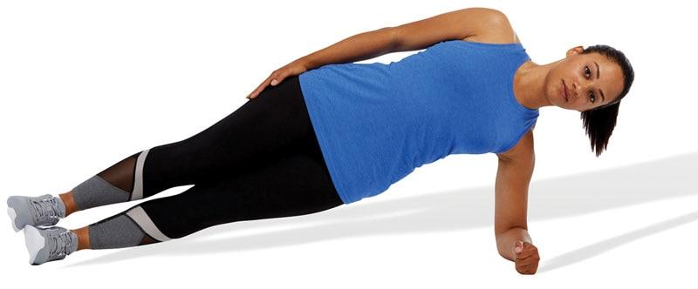

TECHNIQUE

Keep all kinetic chain checkpoints in alignment; do not allow the pelvis to drop toward the floor. This is an excellent exercise to target the transverse abdominis muscle.

Dead Bug

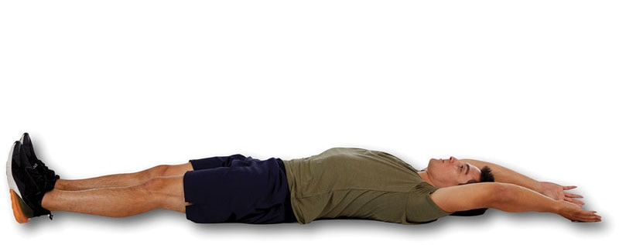 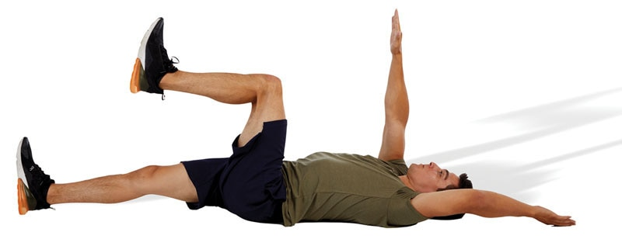

TECHNIQUE

This is another excellent exercise to target the local core muscles, but it may take some practice to coordinate all movements. As with other core exercises, maintain a neutral spine and core activation throughout the duration of the exercise.

Bird Dog

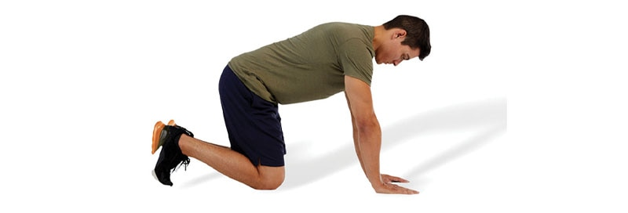 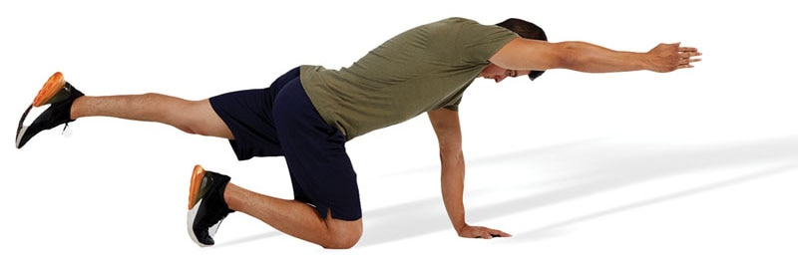

TECHNIQUE

Keep the spine in a neutral position throughout the exercise and point the thumbs straight up toward the sky. Do not allow the low-back to excessively arch.

Kneeling Palloff Press

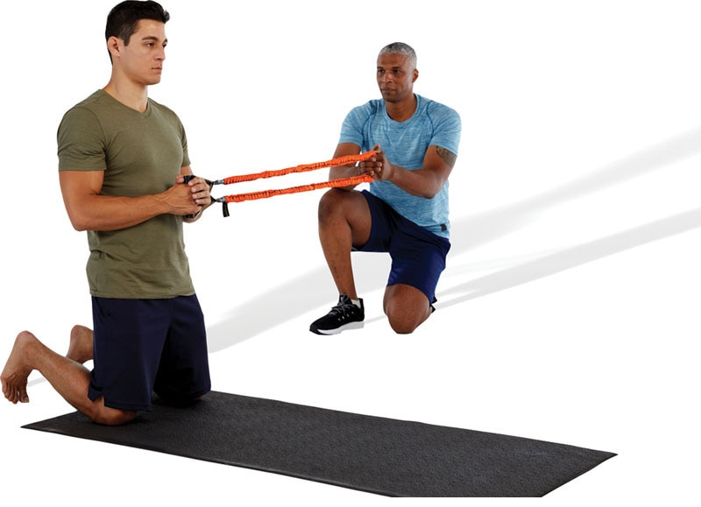 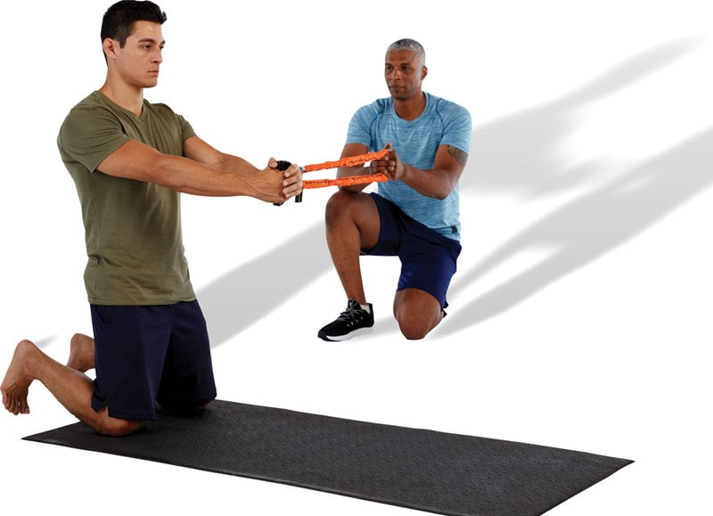

TECHNIQUE

The Pallof press is an antirotation exercise designed to target the local core muscles. Be sure to keep the hips and shoulders square and maintain all five kinetic chain checkpoints during the exercise.

Farmer’s Carry

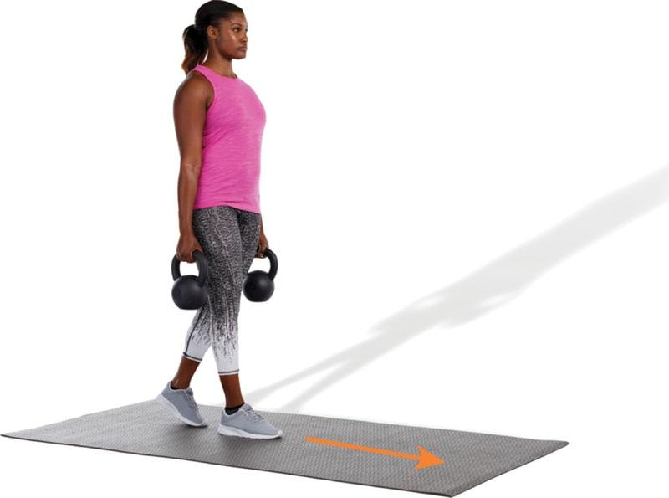

TECHNIQUE

This is an advanced exercise depending on the load (weight) used. During this exercise, it is important to brace the abdominals and avoid excessive rotation or lateral flexion of the spine. Instead, keep an upright posture.

Floor Crunch

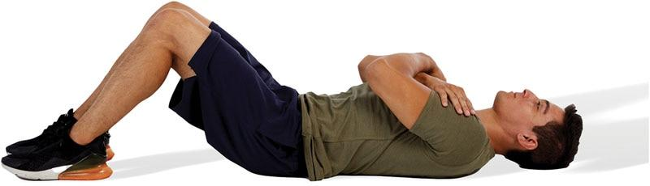 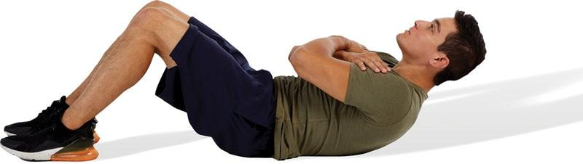

TECHNIQUE

Do not perform a full sit-up. Rather, the movement only involves lifting the shoulder blades off the floor. This limits recruitment of the hip flexor muscles and may be safer for the low-back.

Ball Crunch

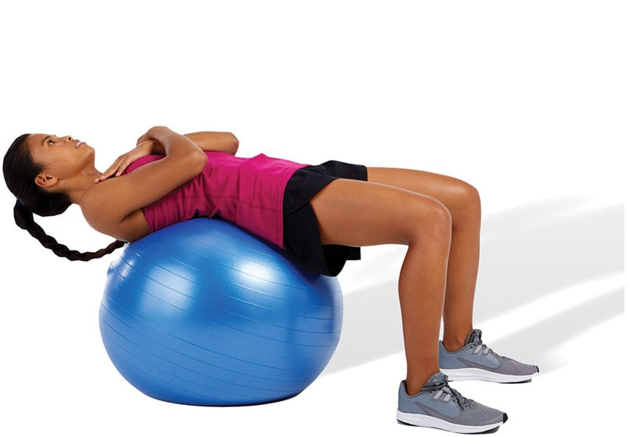 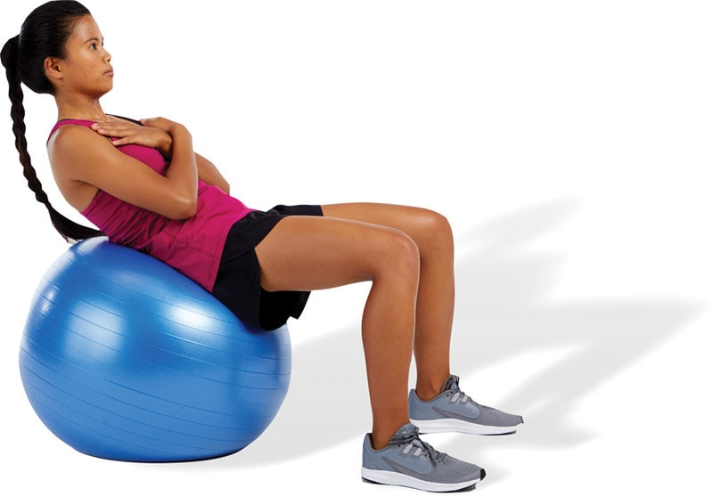

SAFETY

Make sure to keep the chin tucked while performing the exercise. This will take stress off of the muscles of the cervical spine.

Back Extension

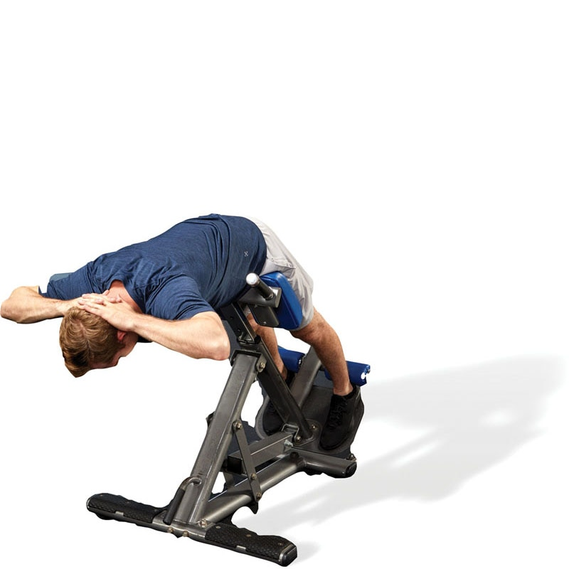 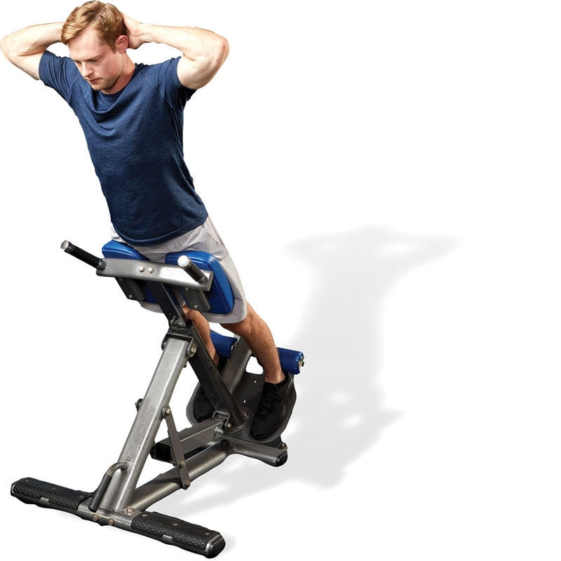

SAFETY

At the end position of the exercise, makes sure the ankles, knees, hips, shoulders, and ears are all in alignment. Do not hyperextend the low-back.

Reverse Crunch

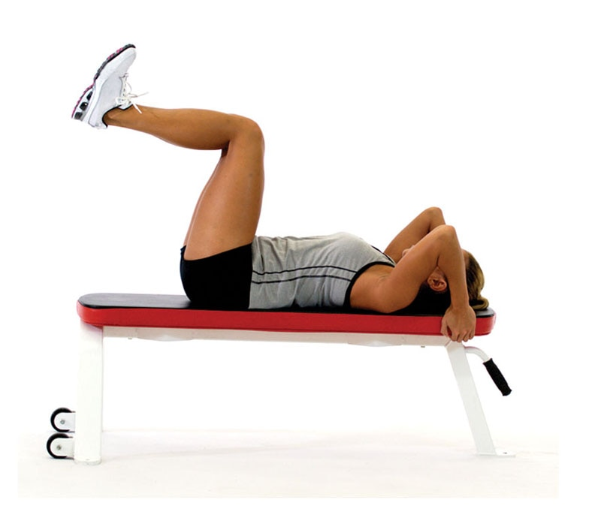 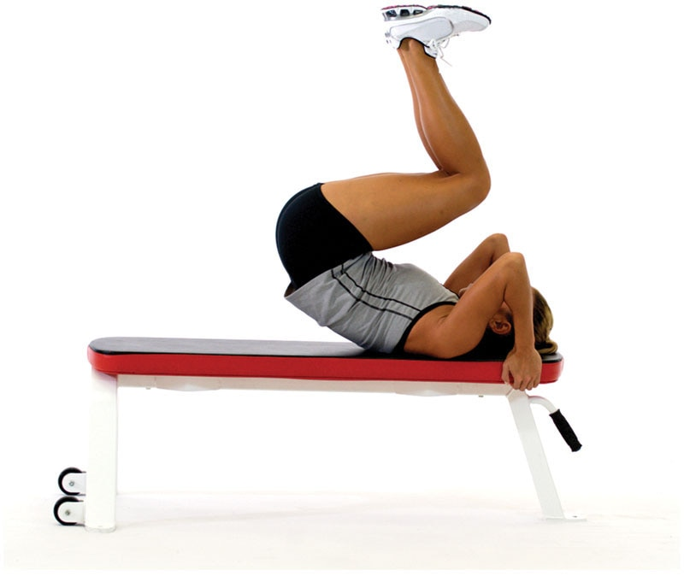

TECHNIQUE

Do not swing the legs when performing this exercise. Once you have positioned the lower extremities during the setup, they should not move during the execution of the exercise. Swinging the legs increases momentum, increasing the risk of injury and decreasing the effectiveness of the exercise.

Knee-Up

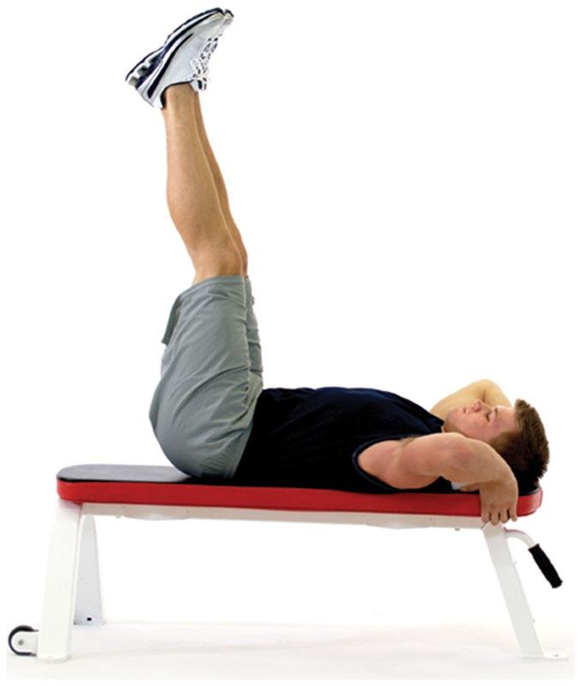 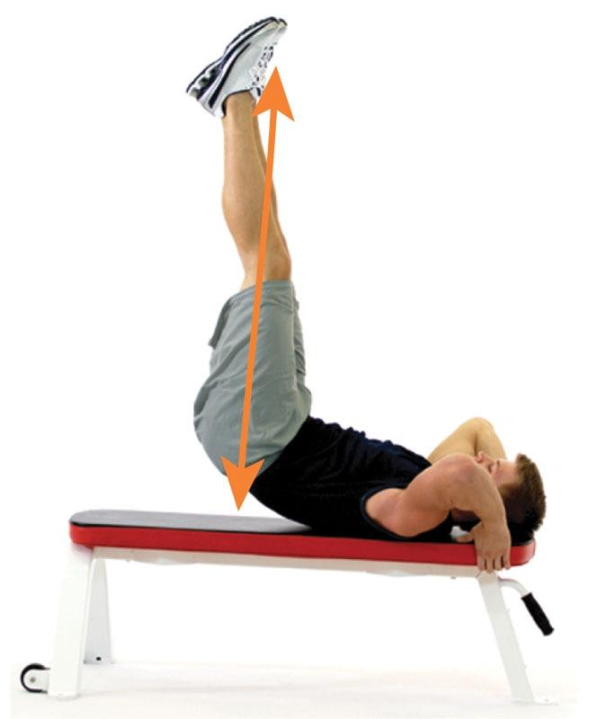

TECHNIQUE

The knee-up is performed in a similar fashion to the reverse crunch except the knees are fully extended. During the concentric phase, extend the feet toward the ceiling by lifting the hips off the bench then slowly lowering the hips back to the starting position.

Cable Rotation

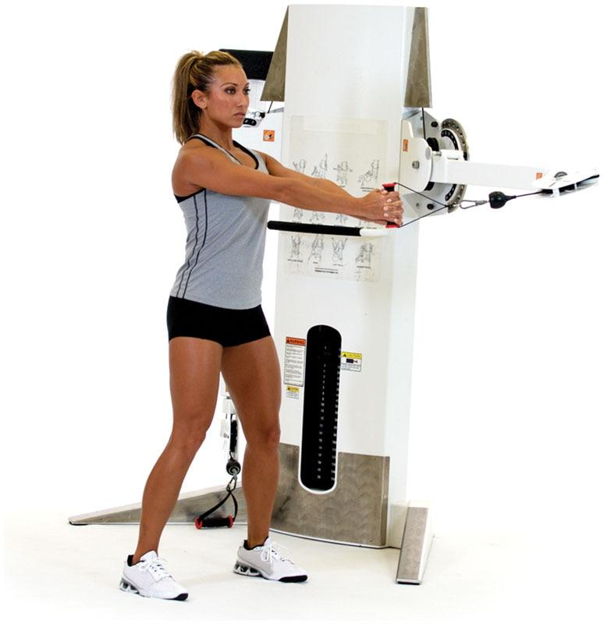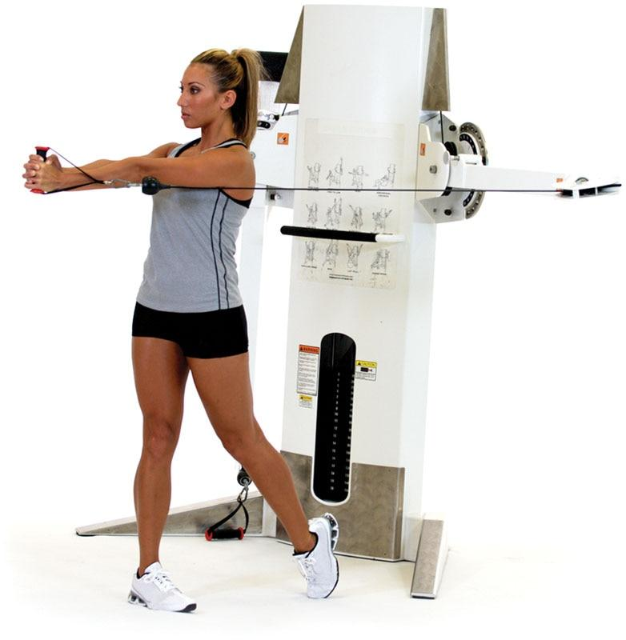

TECHNIQUE

To decrease stress to the low-back, make sure to pivot the back leg into triple extension:

* Hip extension
* Knee extension
* Ankle plantarflexion (extension)

This also ensures proper coordination of the muscles that extend the lower extremities (gluteus maximus, quadriceps, and calves).

Cable Lift

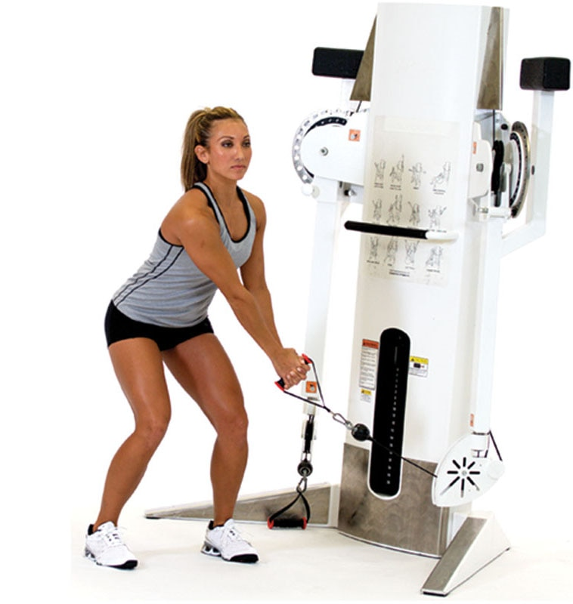 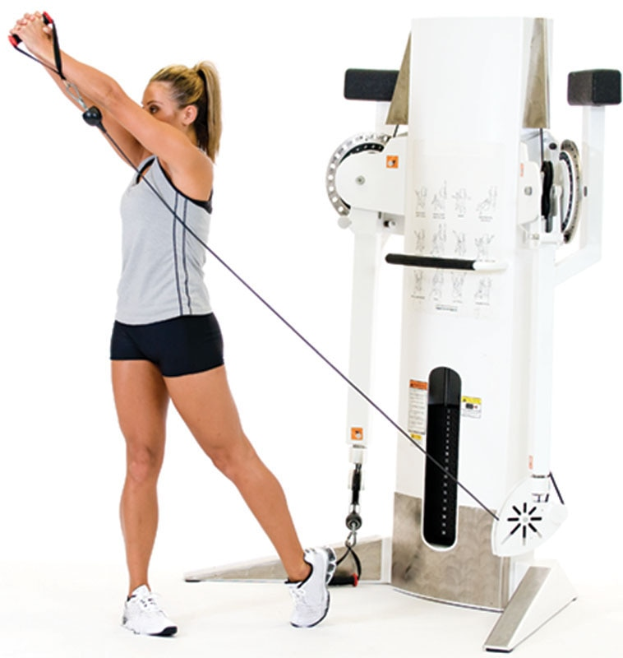

TECHNIQUE

Do not hyperextend the low-back at the top position. Keep a neutral spine throughout. Like the cable rotation, the back leg should pivot into triple extension at the end of the movement.

Cable Chop

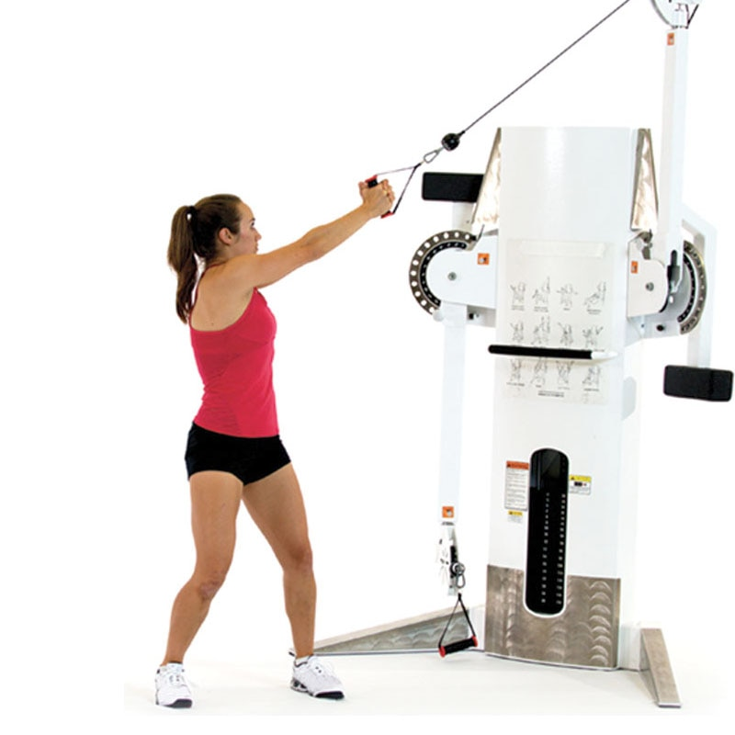 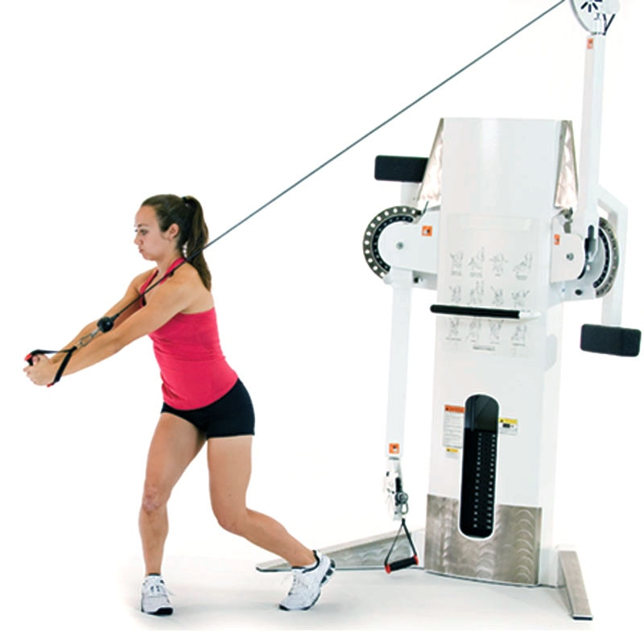

TECHNIQUE

The cable chop is an opposite motion of the cable lift exercise. This time the back leg will be in flexion rather than extension.

Medicine Ball Rotation Chest Pass

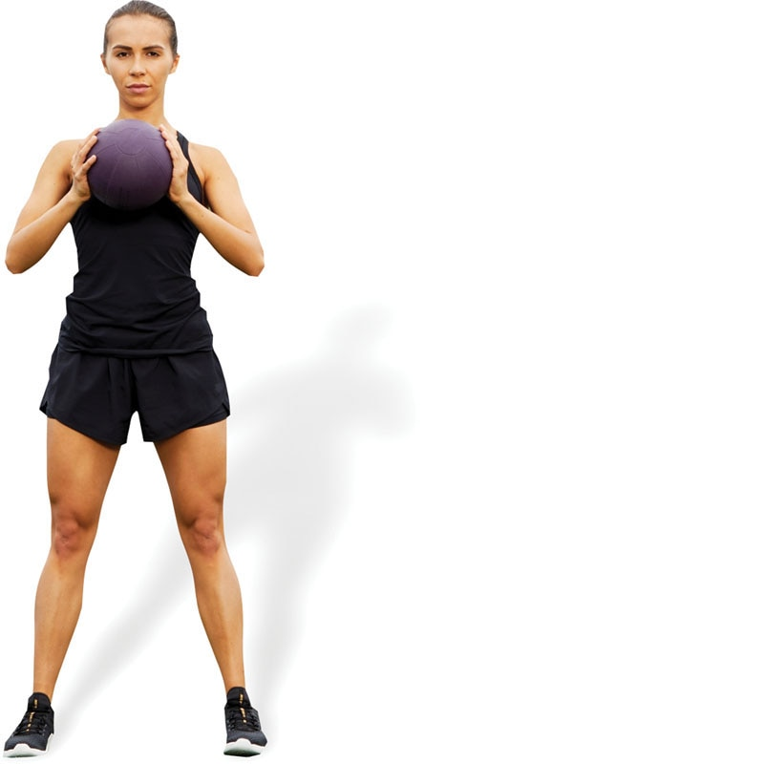 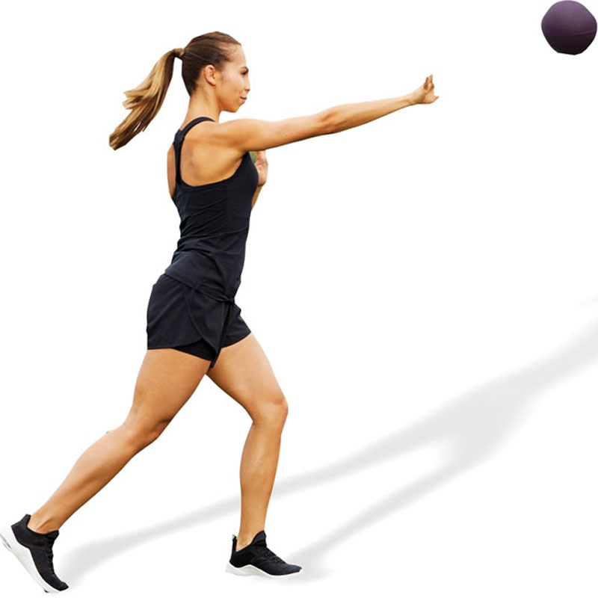

SAFETY

It is imperative that clients demonstrate proper stabilization and strength before performing explosive core exercises. Performing these exercises without proper stabilization and strength may lead to movement compensations, muscle imbalances, and injury.

Ball Medicine Ball Pullover Throw

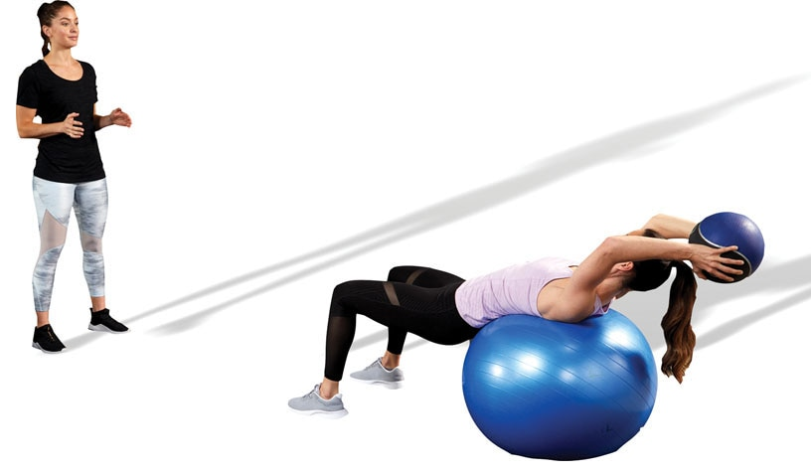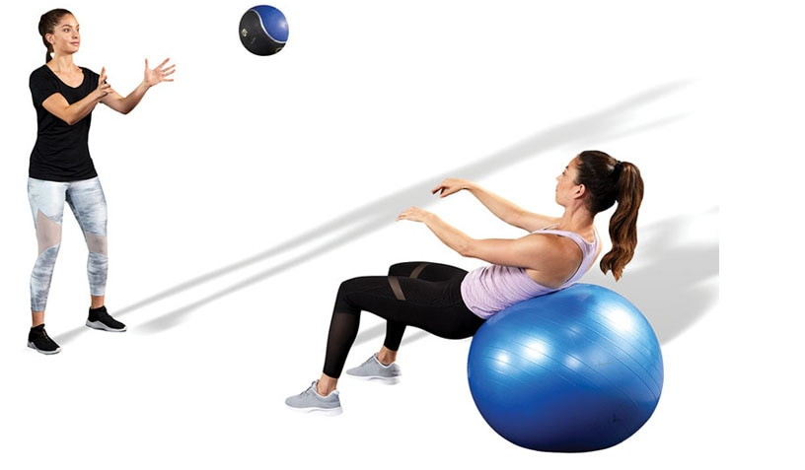

SAFETY

It is important that an individual has proper extensibility of the latissimus dorsi before performing this exercise to decrease stress to the low-back and shoulders.

Front Medicine Ball Oblique Throw

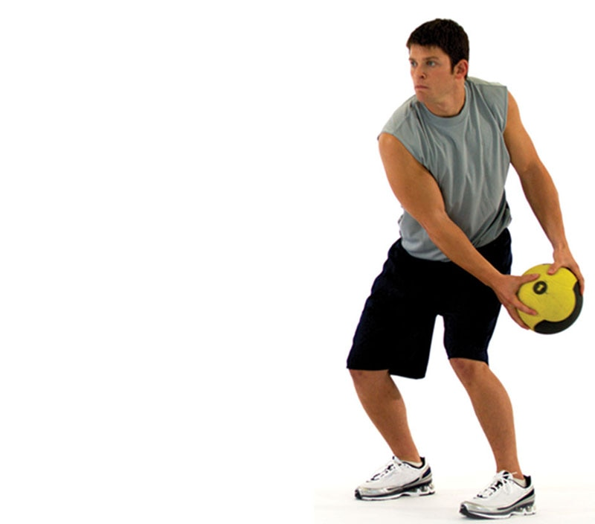 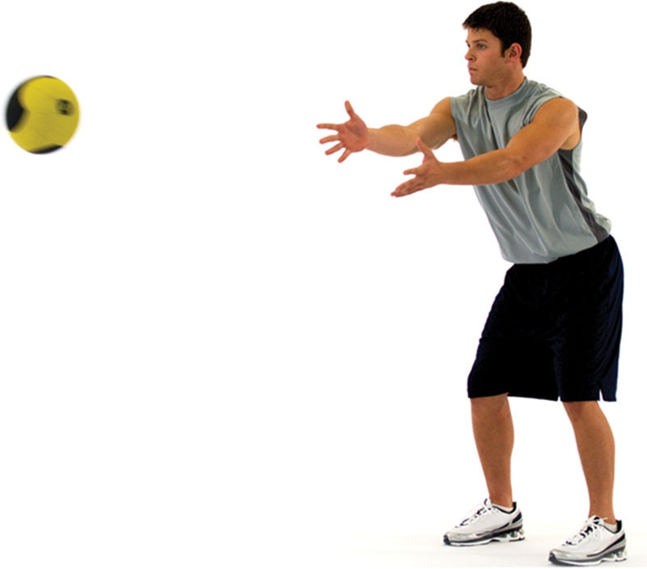

TECHNIQUE

From an athletic position, bring the medicine ball to one hip and then explosive toss the ball to a wall or partner in front of you while keeping your hips and feet pointing straight ahead. Repeat on the opposite side.

Side Medicine Ball Oblique Throw

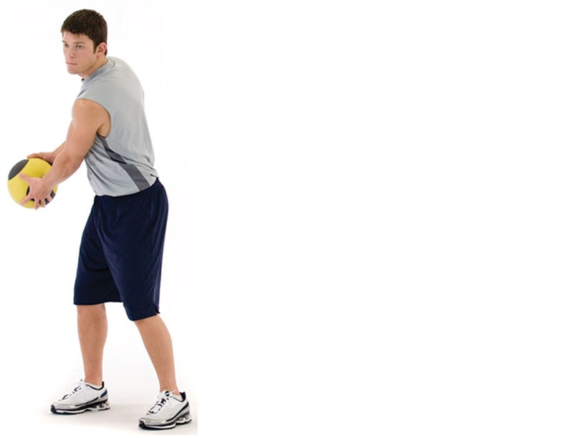 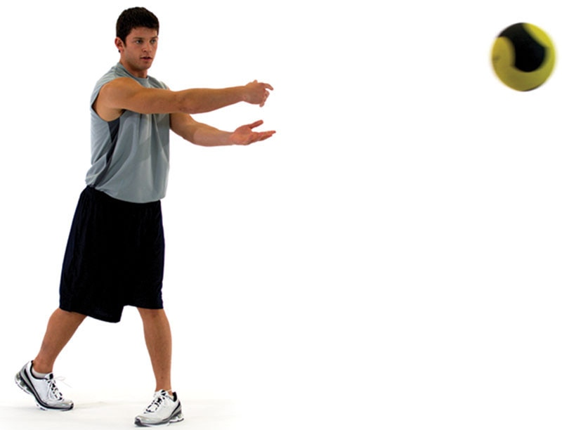

TECHNIQUE

The back leg should pivot into triple extension after tossing the medicine ball.

Medicine Ball Soccer Throw

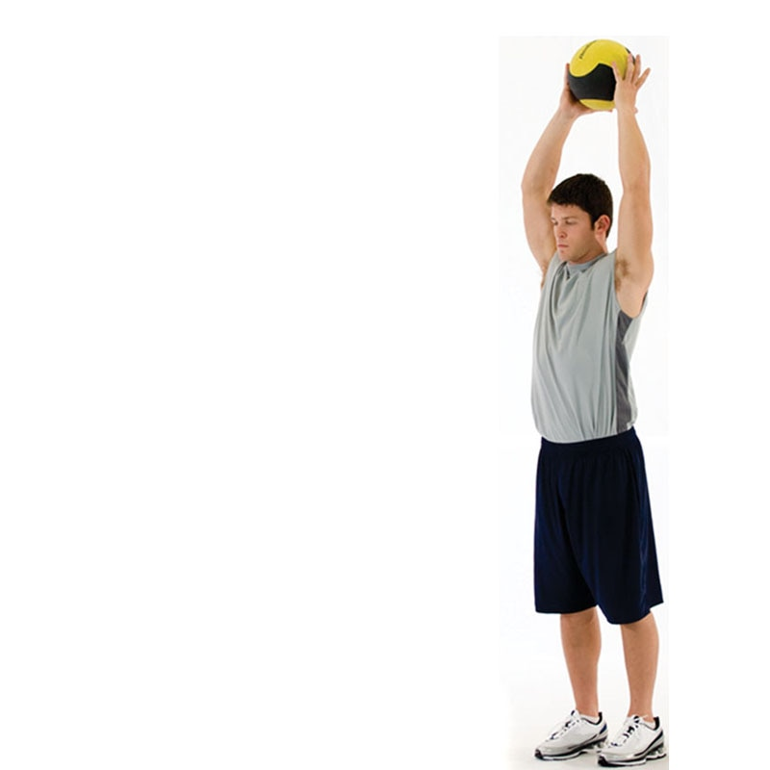 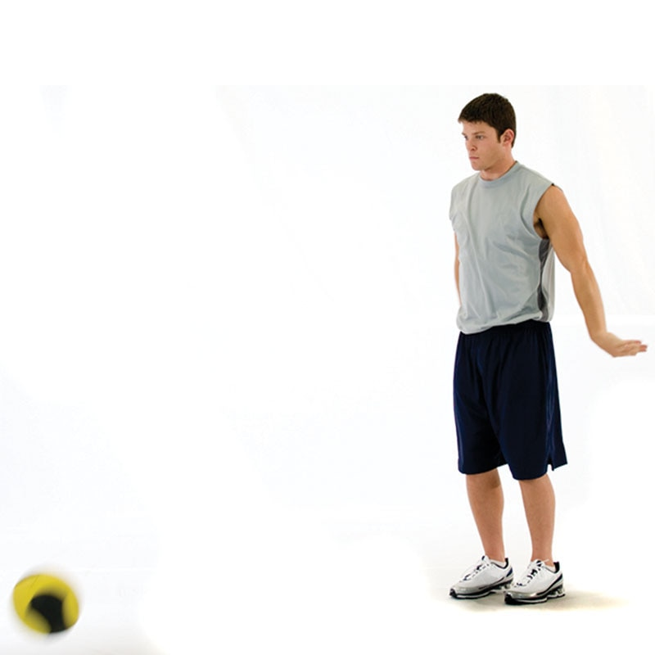

SAFETY

It may be easier to perform this exercise using a D-ball (a medicine ball that does not bounce back) or close to a wall to bounce the medicine ball off.

Medicine Ball Woodchop Throw

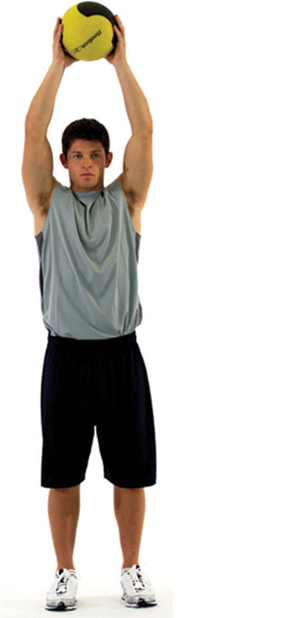 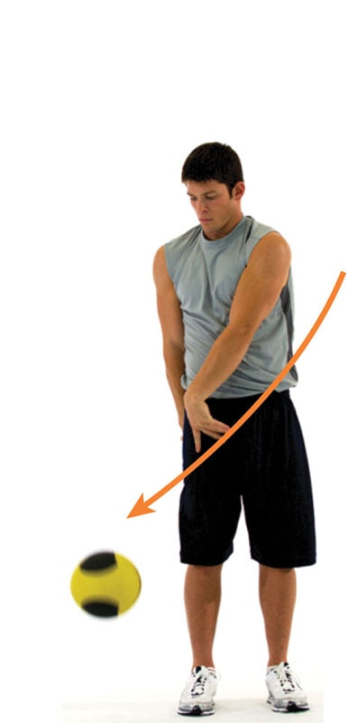

SAFETY

In most cases, do not use an overly heavy medicine ball. The goal of this exercise is to increase the rate of core force production versus absolute strength.

Medicine Ball Back Extension Throw

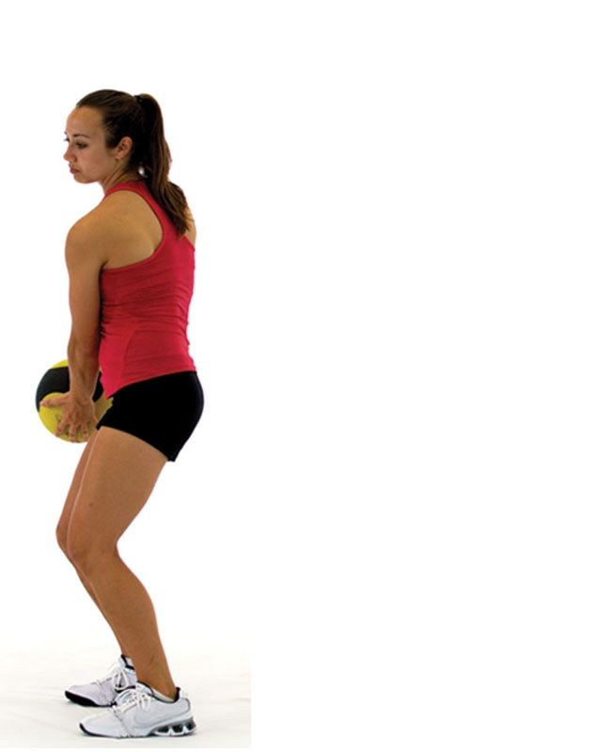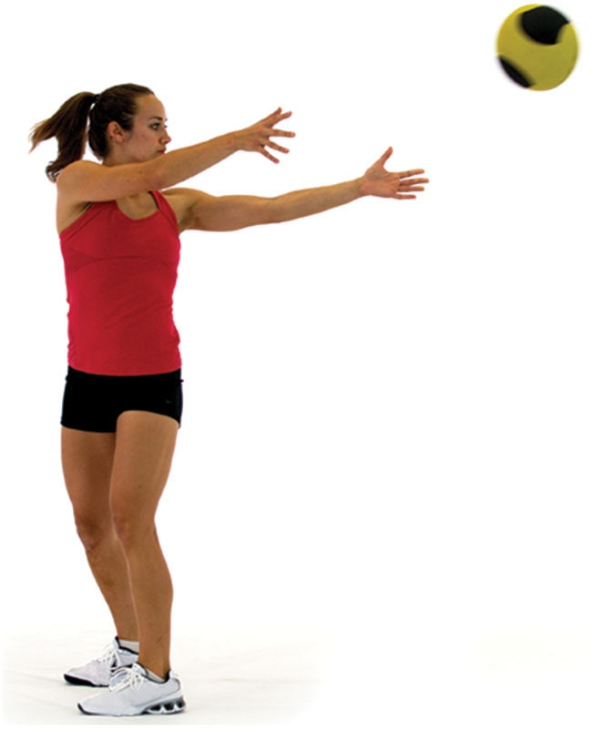

SAFETY

Most of the rotational motion should come from the thoracic spine instead of the lumbar spine.

### Essential concepts of balance

The ability to maintain postural control or balance is a fundamental component of performance, injury resistance, and rehabilitation that follows an injury. Technically, balance can be defined as the ability to maintain one’s center of gravity within that person’s base of support (Pollock et al., 2000). The center of gravity is the approximate midpoint of the body; while the location may vary between individuals, it is typically located at the midportion of the trunk. The base of support represents the area beneath a person that consists of every point of contact made between the body and the support surface (i.e., the floor). For example, the width between the feet of a standing individual would define the base of support. If an individual is standing still, the center of gravity can move within the limits of stability, as found within the base of support (Figure 17-1). The limits of stability mean the area within which an individual can move one’s center of gravity without changing the base of support (i.e., moving the feet) without falling (Pollock et al., 2000).

Balance can be classified into static, semi-dynamic, and dynamic. Static balance applies to situations when an individual seeks to maintain postural control within a stationary position; for example, the individual is standing still on one foot. Semi-dynamic balance refers to instances when an individual seeks to maintain balance within a stationary limit of stability, yet the base supporting the body is in movement (e.g., individual riding on a skateboard). Dynamic balance occurs when a person seeks to maintain their center of mass over an ever-changing limit of stability; for example, the individual is running on uneven surfaces.

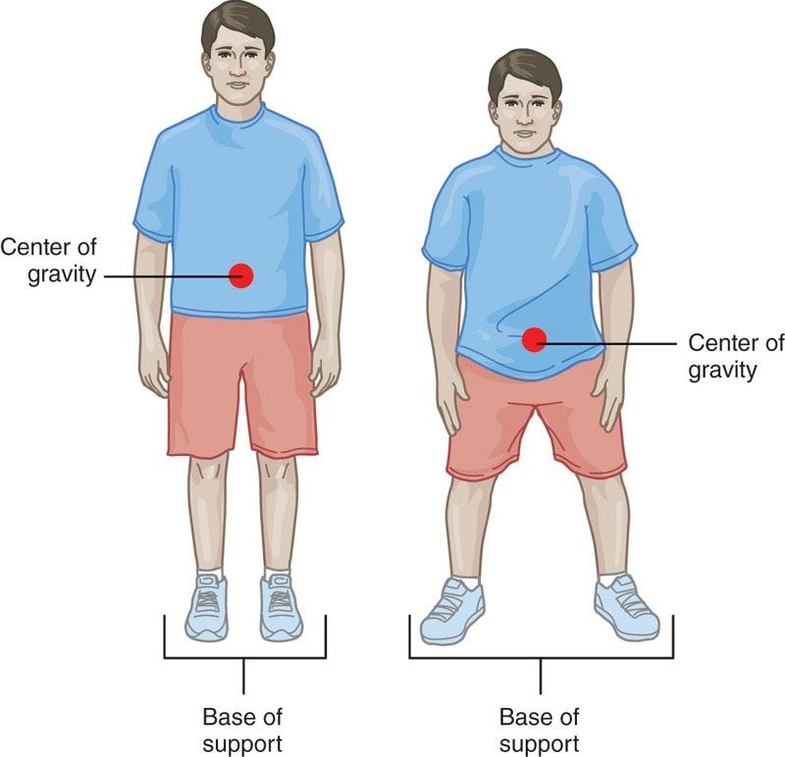

**Figure 17-1** Center of gravity and base of support

Maintaining balance in these various conditions requires integration of multiple systems, including vision, vestibular, and somatosensory systems, as well as properly timed muscle contractions, to maintain the center of mass within the limits of stability. The ability to maintain balance during various conditions is important for optimizing performance, reducing injury risk, and enhancing rehabilitation efforts. Thus, it is important for fitness professionals to understand the mechanisms and benefits of balance training as a vital component of care for all clients.

There may be many reasons why an individual has impaired balance. In general, an individual with a musculoskeletal injury (i.e., a ligament sprain or a muscle pull) or an alteration of sensorimotor function (i.e., due to a concussion or the normal process of aging) may have deficits in balance and likely benefits from balance training programs (Frankel et al., 2006; Lecci et al., 2019; Park et al., 2019; Terada et al., 2019). The fitness professional can improve clients’ functionality across the spectrum of health and wellness by using individualized, comprehensive, and systematic balance training programs.

**Mechanisms of balance**

The ability to feel that the center of mass (COM) is moving toward a person’s limits of stability is a product of three sense-based systems: vision, vestibular, and somatosensation (Michael Selzer et al., 2006; Shumway-Cook & Woollacott, 2016) (Figure 17-2). Vision is typically used to provide information to the central nervous system about the body’s location in space (Kwon, 2018). Balance may be more difficult when an individual’s eyes are closed, because this person is no longer able to use vision to determine bodily position in space. Individuals may use vision to determine the best foot placement to maintain balance when moving over unstable surfaces (Logan et al., 2010). The vestibular system is controlled by sensory receptors in the inner ear and provide the brain information about spatial orientation and the movement of the head in space (Valovich McLeod & Hale, 2015).

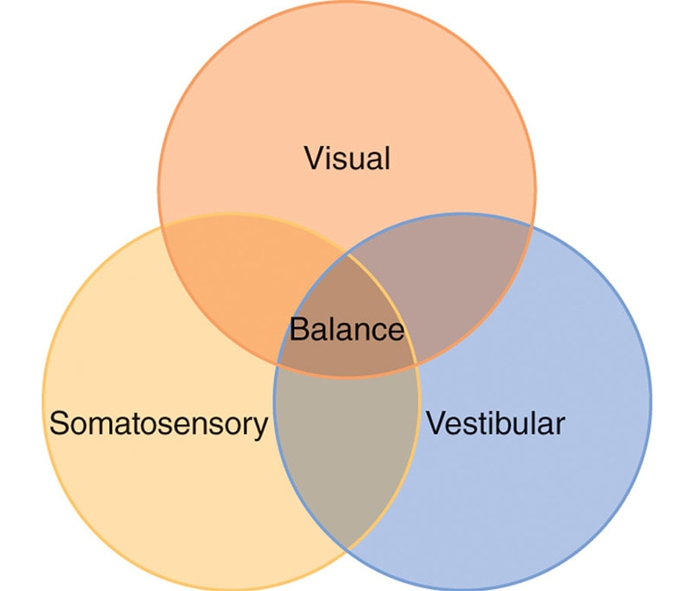

**Figure 17-2** The components of the balance system

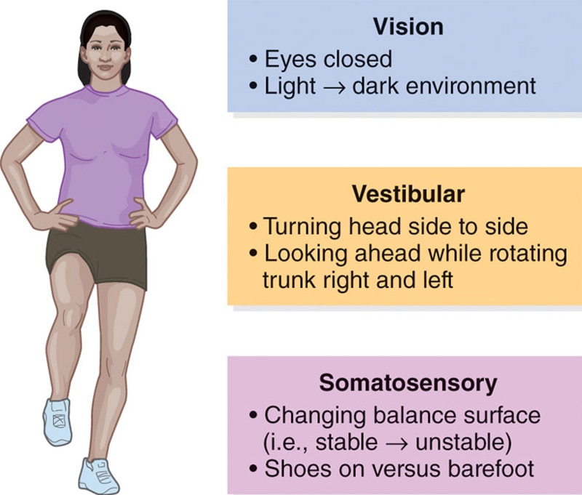

**Figure 17-3** Integrating visual, vestibular, and somatosensory systems

Vestibular receptors are important for maintaining balance while bending over, as well as dynamic movements, like hopping or squatting. Somatosensation refers to the ability to feel changes in pressure on the skin, muscle length, and joint angles. Somatosensation is critically important for balancing on unstable surfaces and tasks that involve dynamic balance. It is possible that individuals may prioritize information gained from one sense over the other two (Wikstrom et al., 2017). Therefore, fitness professionals should incorporate balance training techniques that stress each of these senses to ensure their clients’ capability in attending to sensory information that arises from each of these three critical senses (Figure 17-3).

**Scientific rationale for balance training**

Researchers have shown that balance training can be effective at optimizing performance, improving resistance to injury, and enhancing rehabilitation. It is important for fitness professionals to understand the scientific basis for balance, ways to design a balance routine catering to the needs of the client, and methods to effectively communicate and efficiently implement a balance training program.

Performance

Several studies have demonstrated successful improvement in balance ability after healthy, physically active individuals have completed a balance training program. A systematic review found that 10-minute balance training programs, in which children performed three times per week for 4 weeks, appear to improve both their static and dynamic balance ability (DiStefano et al., 2009). Balance training has been shown successful in improving motor function of muscles in the lower extremity (Sefton et al., 2011), as well as neuromuscular control, especially for those who have suffered from chronic ankle sprains (Zech et al., 2010). Individuals with musculoskeletal injuries can improve their ability to maintain their center of mass within their limits of stability by specifically engaging in balance training (Wortmann & Docherty, 2013).

Balance training should be incorporated into overall training programs, because balance training may improve additional performance metrics important to clients. For example, adding balance training to a resistance-training program can enhance lower extremity muscle strength gains, indicating that resistance-training regimens should include balance training to optimize strength gains (Heitkamp et al., 2001).

In older individuals, balance training can improve functionality when applied to activities of daily living (e.g., chores, shopping, grooming, bathing), which may decrease their overall disability (Roaldsen et al., 2014).

Furthermore, balance training tends to improve vertical jump performance in youth basketball players when compared to isometric strength training (Boccolini et al., 2013). Similarly, performing balance training along with agility exercises may improve dynamic balance during eyes-open and eyes-closed conditions, as well as improve agility-based outcomes and reaction time (Zemková & Hamar, 2010). Therefore, balance training should be considered as an important component of improving performance (Table 17-1).

TABLE 17-1 Balance Training for Performance

|  |
| --- |
| Improves static and dynamic balance  Improves neuromuscular control in the lower extremities  Improves balance after injury  Improves lower extremity muscular strength (especially when combined with resistance training)  Improves ability to participate in activities of daily living and decreases self-reported disability in older adults  Improves agility-based outcomes in athletes |

TRAINING TIP

Balance training has been shown to improve balance and coordination, which are necessary components in the process of becoming a well-rounded athlete. For safety reasons, balance exercises and equipment (e.g., foam pad, balance disc, wobble board) should not be used in conjunction with heavy loads, such as maximal or near maximal lifts (Brachman et al., 2017).

Injury resistance

Balance training is an important component to emphasize when developing a program to improve injury resistance, whether the fitness professional is working with an athlete participating in a sport or a client whose goal is to perform daily living activities without falling.

Balance exercises are commonly included in lower extremity programs, referred to as injury prevention programs, for athletes to bolster resistance to injury. When designing injury prevention programs, these components are typically incorporated: stretching, strength, plyometric, and balance activities. Comprehensive injury prevention programs that include balance training have been shown to improve landing mechanics, which may decrease the risk of lower extremity injuries (Padua et al., 2012). Youth soccer athletes who participated in a 9-week injury prevention program demonstrated improvements in time-to-stabilization (a measure of balance ability), as well as vertical jump height (DiStefano et al., 2010). Female basketball athletes who participated in a 5-week balance training program improved landing movement mechanics and muscle activation during a single-limb landing, which may reduce the risk of certain lower extremity injuries, like an anterior cruciate ligament (ACL) injury (Nagano et al., 2011). In fact, a study by DuPrey and colleagues (2016) found that collegiate athletes with poor balance during landing tasks were at an increased risk of ACL rupture. A systematic review demonstrated that athletes undergoing balance training reduced the risk of suffering an ankle sprain by 46% when compared to athletes lacking any balance training (Bellows & Wong, 2018).

The fitness professional can also tailor balance activities to be sport specific; for example, a basketball athlete can balance on one leg while passing the basketball back and forth. When incorporating balance training into an injury prevention program for athletes, ensuring activity performance in the sports environment with minimal equipment may improve compliance and overall adherence across a season.

Balance training is also beneficial for older adults. Falls are one of the leading causes of injuries and health-related complications in older adults. While both external (i.e., environmental) and internal (i.e., muscle strength) factors may influence the risk of falling, the body’s balance system plays a critical role in allowing an individual to maintain control over their own body’s placement and prevent a fall. In exercise programs that include balance training, research has shown up to a 20% reduction in the risk of falls in older healthy adults (Gillespie et al., 2012; Sherrington et al., 2008).

Balance training is a recommended intervention to be included in multifactorial training programs, which also include stretching and strengthening, for adults older than 65 years of age with a history of falling (Frankel et al., 2006; Moncada, 2011). Physical exercise interventions, including balance training that challenges posture in different positions, have been shown to reduce the number of falls in healthy older adults (Hamed et al., 2018). A comprehensive 8-week exercise program that included progressively challenging balance activities showed older adults’ improvement in both physical performance and psychological confidence (Rimland et al., 2016; Shubert et al., 2018). When working with an older adult, it is important to ask the client if they have complaints of imbalances, such as feelings of unsteadiness or fear of falling, because individuals with these perceptions show a higher rate of falls (Criter & Honaker, 2016). This information will help the fitness professional to properly incorporate balance training activities into the training plan (Table 17-2).

TABLE 17-2 Balance Training to Bolster Resistance to Injury

|  |
| --- |
| Improves landing mechanics, which may reduce lower extremity injury, such as ACL injury and ankle sprains  Improves performance in athletes, such as vertical jump height  Reduces risk of falling in older adults  Improves physical performance and overall confidence during activities of daily living in older adults |

CRITICAL

When working with an older adult client, make sure to conduct a thorough preparticipation health screening and identify if your client is capable of performing balance training exercises. Some clients may need clearance by their healthcare provider to take part in a balance training program. Fitness professionals must ensure they are informed of any medical conditions that may influence the ability to balance, from a safety standpoint.

Rehabilitation

Balance training has been shown to enhance rehabilitation for various individuals following lower extremity injuries, such as ankle sprains and ACL injuries. Because some clients may have decreased balance, it is imperative to understand balance and how to design a balance routine that caters to the needs of the client.

High school athletes with chronic ankle instability who completed a 4-week balance training program during rehabilitation using a biomechanical ankle platform system board significantly improved both static and dynamic single-limb balance compared to those who did not do balance training as a part of their rehabilitation (Cain et al., 2017). Using either a traditional single-limb balance program (single-limb stance, single-limb stance with ball toss and kicking, step-down with single-limb stance) or a progressive hop-to-stabilization balance program (various single-limb hop-to-stabilization exercises) improved self-reported function, semi-dynamic balance, and joint position sense in athletes with chronic ankle instability (Anguish & Sandrey, 2018).

Deficits in balance ability may persist for an extended period following an injury. A recent study found that individuals following an ACL reconstruction demonstrated worse semi-dynamic balance on both injured and uninjured limbs as far as 1 year postsurgery compared to healthy controls (Hatton et al., 2017). Therefore, athletes with a prior knee injury will benefit from balance training programs for both limbs when working with a Certified Personal Trainer.

Additionally, balance training is important to enhance rehabilitation of individuals at risk for a fall or after a fall. A recent study by Gerards et al. (2017) found that using perturbation-based balance training in a safe and controlled environment significantly reduced the incidence of falls in older adults. A perturbation is a mechanism where a postural disturbance is added to a task (i.e., lightly pushing on a client’s shoulders as they are balancing), which causes the client to learn to maintain or recover balance. Table 17-3 summarizes how balance training impacts rehabilitation efforts.

TABLE 17-3 Balance Training for Rehabilitation

|  |
| --- |
| Improves performance during single-limb activities  Improves proprioception and self-reported function in athletes with ankle instability  Enhances rehabilitation outcomes for both limbs in athletes who suffer an ACL injury and surgery on one limb  Enhances rehabilitation outcomes that focus on decreasing the risk of falls in older adults |

CRITICAL

Certified Personal Trainers are not qualified to diagnose an injury or perform medical rehabilitation, as it is beyond their scope of practice. However, once the client has been cleared by a medical professional (i.e., physician, physical therapist), fitness professionals play an important role in helping balance-impaired individuals regain and continue to improve functionality, whether for simple activities of daily living or high-level sports. Consistent, clear communication between medical and fitness professionals is critical to ensure safety for the client and optimize the exercise program to help the client achieve personal goals.

**Importance of properly training the balance system**

An effective balance training program should challenge the threshold of an individual’s limit of stability. This threshold must be stressed in a multiplanar, proprioceptively enriched environment, using functional movement patterns to improve static, semi-dynamic, and dynamic balance.

Training in a proprioceptively enriched environment with appropriate types of balance equipment (i.e., floor, balance beam, half-foam roll, foam pad, balance disc, wobble board), correct technique, and at varying speeds facilitates maximal sensory input to the central nervous system. It also prepares the body for various scenarios that it may encounter in the real world, such as landing from a jump for an athlete or stepping off a curb for an older adult.

Fitness professionals are encouraged to implement progressive, systematic training programs to develop consistent, long-term changes in their clients. Training program designs that only focus on strength training protocols often deliver incomplete results, because the training program does not challenge the balance mechanisms of the human body. Balance training fills this gap by focusing on functional movement patterns in a multisensory, unstable environment (DiStefano et al., 2009; Zech et al., 2010). The design and implementation of balance exercises into a training program is critical for developing, improving, and restoring the synergy of muscle firing patterns required for dynamic balance and coordinated movement (Guskiewicz & Perrin, 1996; Tippet & Voight, 1995; Voight, 1996).

STRETCH YOUR KNOWLEDGE

Improving Injury Resistance

* Bellows and Wong (2018) found that competitive athletes who performed balance training exercises reduced the risk of an ankle sprain by 46% compared to athletes who didn’t perform balance training exercises.
* Nagano et al. (2011) evaluated the effect of a 5-week jump and balance program on lower extremity biomechanics and muscle activation in female basketball athletes. They found that the athletes demonstrated greater knee flexion motion and hamstring activation during landing, which may reduce the risk of ACL injury.
* Hamed et al. (2018) demonstrated that physical exercise interventions, specifically involving exercises that challenge balance and posture, have the potential to significantly reduce fall risk in healthy older adults.
* Sakata et al. (2019) demonstrated that youth baseball players who participated in an injury prevention program (including stretching and balance exercises) had significantly fewer shoulder and elbow injuries and improved parameters of pitching performance compared to players in the control group.
* DiStefano et al. (2010) implemented an integrated injury prevention program that included static and dynamic balance exercises for 10-year-old soccer athletes and found these youth athletes were able to improve their dynamic balance ability.
* Soligard et al. (2009) demonstrated that an integrated injury prevention program with balance exercises could reduce the risk of overuse injuries and severe injuries in adolescent female soccer athletes.

Key Takeaways

* Balance training can reduce the risk of injury in competitive athletes.
* When designing preseason and in-season injury prevention programs, balance training should be incorporated to improve performance and injury resistance.
* Balance training is effective at decreasing the risk of falls in healthy older adults.

**Guidelines for balance training**

Balance exercises are a vital component of any integrated training program, because they help ensure optimal muscle recruitment and coordinated movement. Balance training exercises must be systematic and progressive. Fitness professionals should follow specific program guidelines, including proper exercise selection criteria and milestones for progression (Table 17-4). Balance is improved through repetitive exposure to a variety of proprioceptively enriched environments (Conradsson & Halvarsson, 2019; Thomas et al., 2019; Zhang et al., 2019).

TABLE 17-4 Balance Training Parameters

| **Exercise Selection** | **Variables** |
| --- | --- |
| * Safe * Progressive   + Easy to hard   + Simple to complex   + Stable to unstable   + Static to dynamic   + Slow to fast   + Eyes open to eyes closed   + Known to unknown (cognitive task)   + Single task to dual task * Balance equipment examples   + Floor   + Balance beam   + Half-foam roll   + Foam pad*   + Balance disc*   + Wobble board* | * Plane of motion   + Sagittal   + Frontal   + Transverse * Lower-body progressions   + Two-legs/stable (e.g., standing on the floor)     - Wide stance → Narrow stance → Tandem stance (heel-to-toe)   + Single-leg/stable (e.g., standing one-legged on the floor)   + Two-legs/unstable (e.g., standing two-legged on a balance modality)   + Single-leg/unstable (e.g., standing one-legged on a balance modality) * Perturbation   + Mild to moderate (e.g., gentle push in one direction → gentle push in multiple directions) |

*These modalities come in many shapes and sizes that will dictate proper progression.

The main goal of balance training is to continually increase the client’s awareness of their limit of stability by increasing the proprioceptive demands of the exercise. An example of challenging the proprioceptive demand could range from having a 65-year-old client balance on the floor in a tandem stance (heel-to-toe posture) to having a 25-year-old athlete balance on one foot while standing on a balance disc.

**Designing a balance training program**

A proper balance training program should be systematic and progressive. Exercises can be progressed or regressed by changing the requirements for surface, visual condition, and body position or movement. Surfaces will change in difficulty as an individual moves from a stable surface (floor) to an unstable surface (e.g., half-foam roll, foam pad, or balance disc). Keeping the eyes open during an exercise is easier than having the eyes closed (visual input), moving the head around to look at various objects (vestibular input), or performing a cognitive task simultaneously (dual-task condition). Moving the contralateral (opposite) leg, trunk, or arms also makes a balance exercise more challenging, whereas standing on two legs (versus a single leg) simplifies the exercise. Caution should be used to change only one variable at a time. Following this strategy of progressions will enable the fitness professional to easily adapt exercises for each individual client, regardless of age or level of fitness.

Balance training progressions

When introducing balance exercises into an exercise program, the exercises should initially involve little joint motion of the balance leg. These entry-level balance exercises are designed to improve reflexive (automatic) muscle contractions to increase joint stability. Using this protocol, the body is placed in an unstable environment, so it learns to react by contracting the right muscles at the right time to maintain balance.

TRAINING TIP

The market currently offers several training modalities (i.e., types of equipment) that challenge one’s balance, and they can be very useful tools. However, to ensure the safety and effectiveness of balance training, individuals must start in an environment they can safely control and go through a systematic progression (i.e., floor, balance beam, half-foam roll, foam pad, and balance disc). Wobble boards can also be included in the progression, but the type of structure of the wobble board will dictate proper progression. Failing to follow the proper progression can cause movement compensations and improper executions of the exercise, decreasing the effectiveness of the exercise and increasing the risk for injury.

These types of exercises should be mastered before moving to more difficult forms of balance training. Sample exercises that follow this protocol include (but are not limited to) the following:

* Tandem stance
* Single-leg balance
* Single-leg balance reach
* Single-leg hip internal and external rotation
* Single-leg lift and chop
* Single-leg arm and leg motion
* Single-leg windmill
* Single-leg throw and catch

The next progression involves dynamic eccentric and concentric movement of the balance leg through a full range of motion. Movements require dynamic control in the mid-range of motion, with isometric stabilization at the end-range of motion. The speed and neural demands of each exercise are progressed. Sample exercises following this protocol include (but are not limited to) the following:

* Single-leg squat
* Single-leg squat touchdown
* Single-leg Romanian deadlift
* Multiplanar step-up to balance
* Multiplanar lunge to balance.

The last progression includes exercises that are designed to develop proper deceleration ability to move the body from a dynamic state to a controlled stationary position. In other words, these exercises combine hopping motions with a single-leg stance landing (holding the landing position for 3–5 seconds). Exercises in this level include (but are not limited to) the following:

* Multiplanar hop with stabilization
* Multiplanar single-leg box hop-up with stabilization
* Multiplanar single-leg box hop-down with stabilization.

The preceding paragraphs described methods for progressing balance exercises by increasing demands to body position and limb movement.

To reiterate:

Progression 1. Exercises should initially involve little joint motion of the balance leg.

Once these types of exercises have been mastered, a fitness professional can choose to make these exercises more challenging (if deemed appropriate) by integrating the following:

1. Balance modalities (e.g., balance beam, half-foam roll, foam pad, balance disc, wobble board)
2. Cognitive, dual-task scenarios (e.g., naming the months of the year while balancing on one limb)
3. Closing eye tasks
4. Head or eye movement

Progression 2. Exercises should involve movement of the balance leg through a full range of motion.

Once these types of exercises have been mastered, a fitness professional can again choose to make these exercises more challenging (if deemed appropriate) by integrating the following:

* Balance modalities
* Cognitive, dual-task scenarios
* Closing eye tasks
* Head or eye movement

Progression 3. Exercises should combine hopping motions with a single-leg stance landing, and holding the balance position for 3–5 seconds.

Once these types of exercises have been mastered, a fitness professional can again choose to make these exercises more challenging (if deemed appropriate) by integrating the following:

* Balance modalities
* Cognitive, dual-task scenarios
* Closing eye tasks
* Head or eye movement

It is important to plan exercise progressions to challenge the balance system by manipulating one variable at a time. The progressions implemented should be client-specific based on their own unique physical capabilities.

**Five kinetic chain checkpoints**

As with any training method, proper form and technique must be mastered to ensure proper muscle activation and to avoid injury. The skill required for balance training requires adequate focus and conscious attention during regular practice, especially to minimize the risk of falls while ensuring the lower limbs and trunk remain in ideal posture. As with all exercises, quality should always come before quantity or weight progression, and the five kinetic chain checkpoints should be monitored (see Figure 17-4):

1. *Feet* pointing straight ahead
2. *Knees* in line with the second and third toes (avoid allowing knees to cave inward)
3. *Hips* level and in a neutral position
4. *Shoulders* in a neutral position (not protracted or elevated)
5. *Head* with cervical spine in a neutral position (chin tuck)

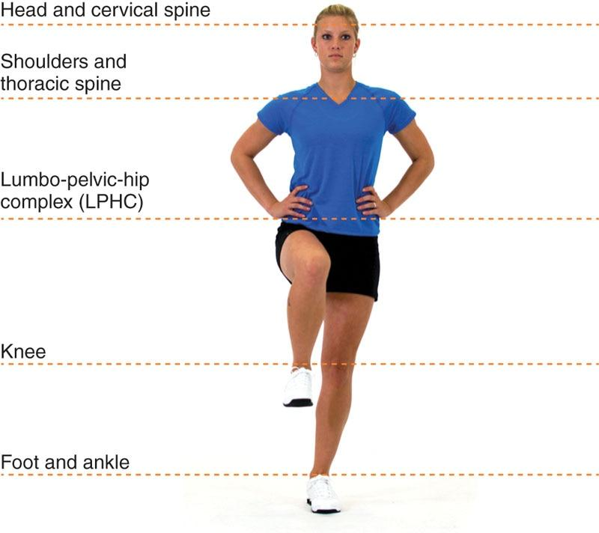

**Figure 17-4** Five kinetic chain checkpoints

**Balance exercises**

Tandem Stance

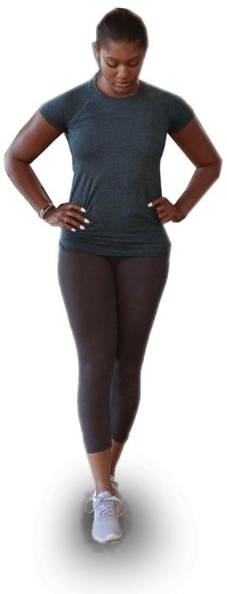

SAFETY

If necessary, position client next to a sturdy object that they can hold on to in case they lose their balance.

Single-Leg Balance

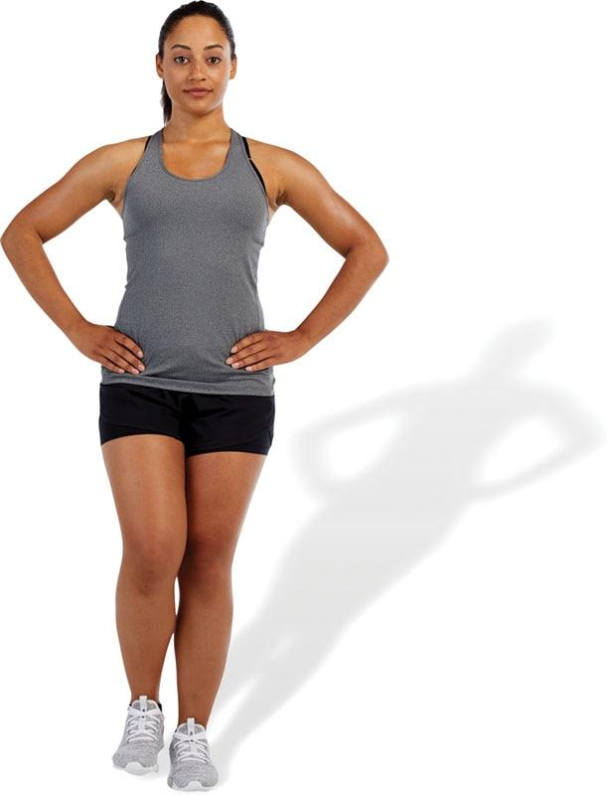

TECHNIQUE

Make sure the gluteal musculature of the balance leg remains contracted while performing this and all balance exercises to help stabilize the lower extremity.

Single-Leg Balance Reach

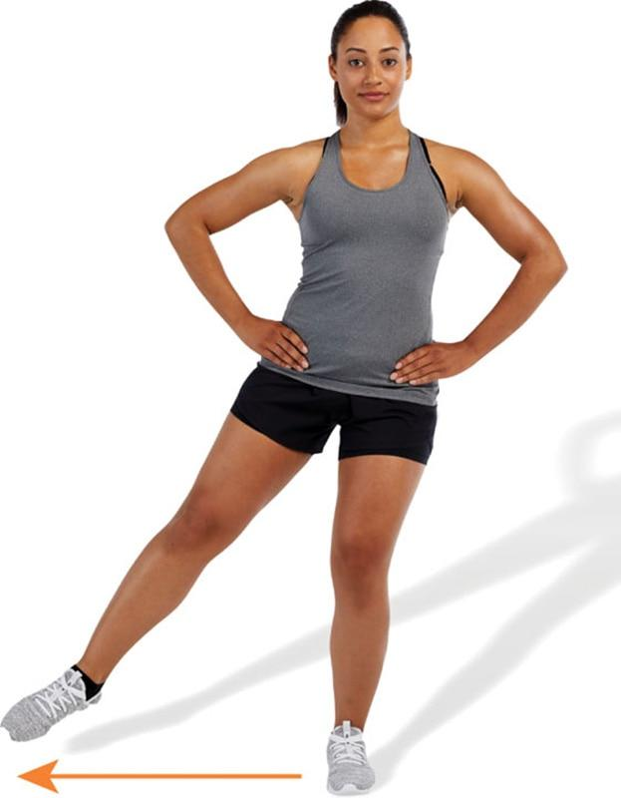 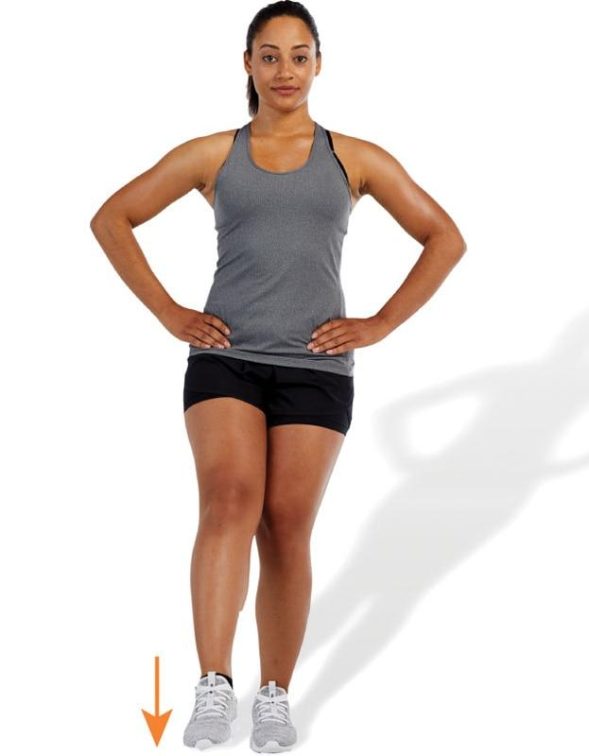 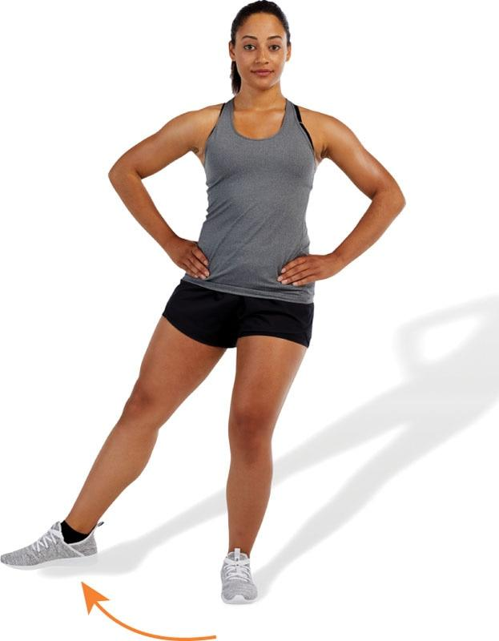

TECHNIQUE

Keep the hips level when performing balance exercises. This will improve balance and decrease stress to the low-back.

Single-Leg Hip Rotation

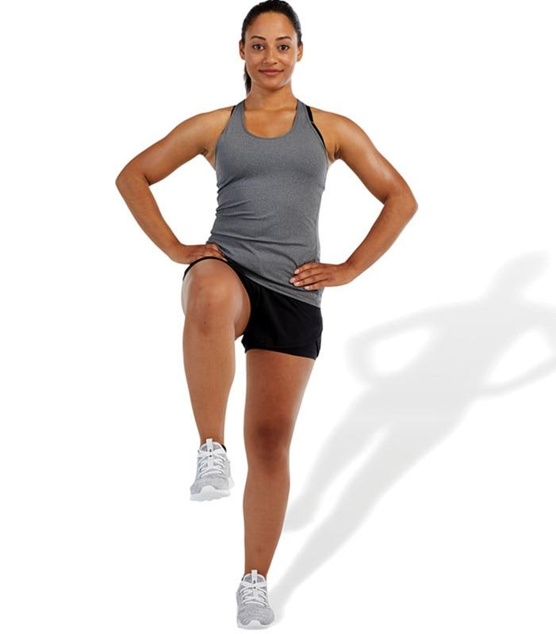 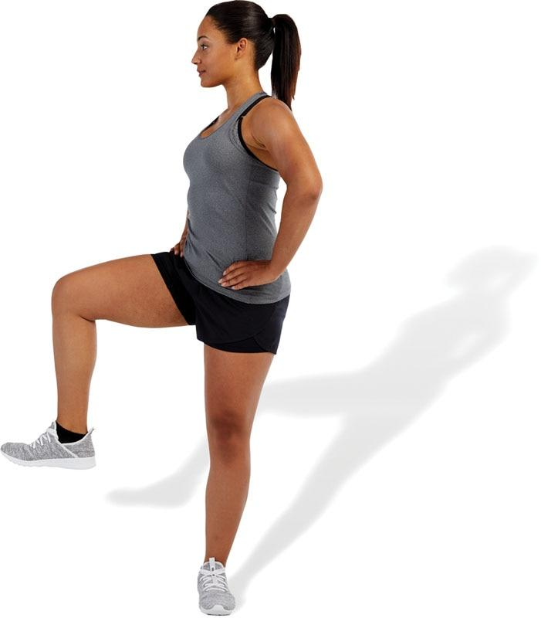

TECHNIQUE

Make sure when performing this exercise to rotate through the hip of the balance leg versus the spine. This will decrease stress to the spine and enhance control of the core.

Single-Leg Lift and Chop

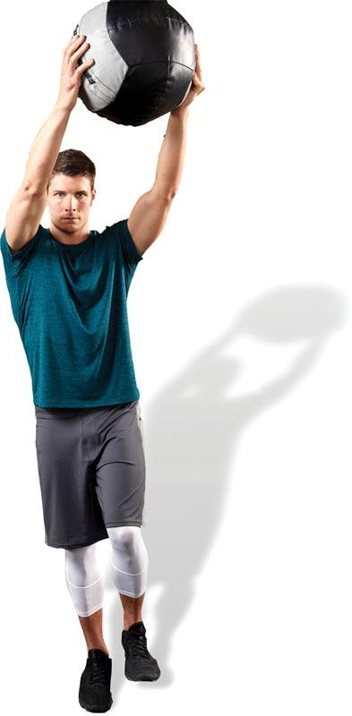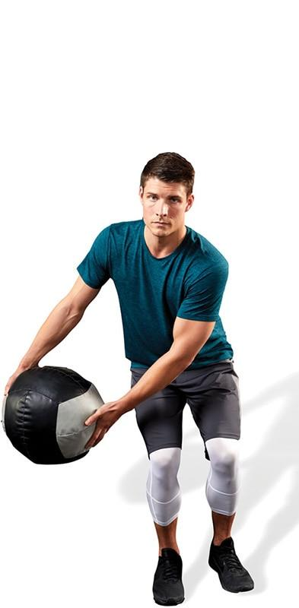

TECHNIQUE

When performing balance exercises, make sure the knee of the balance leg always remains aligned with the toes.

Single-Leg Arm and Leg Motion

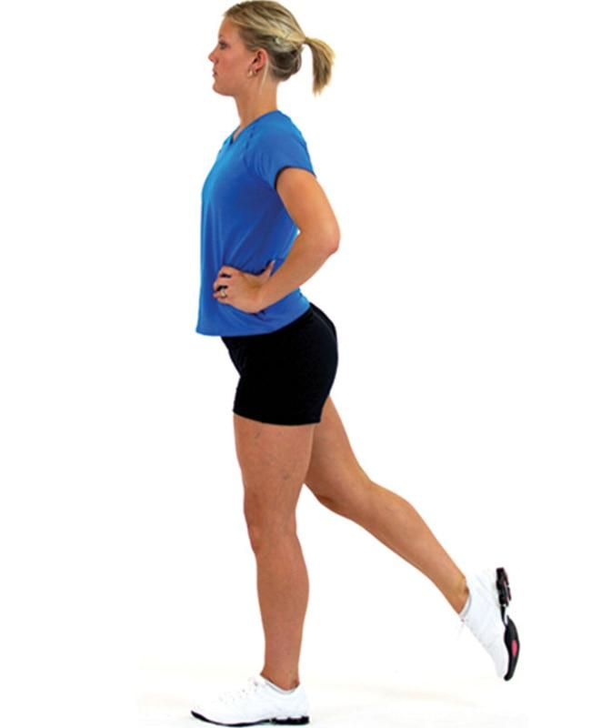 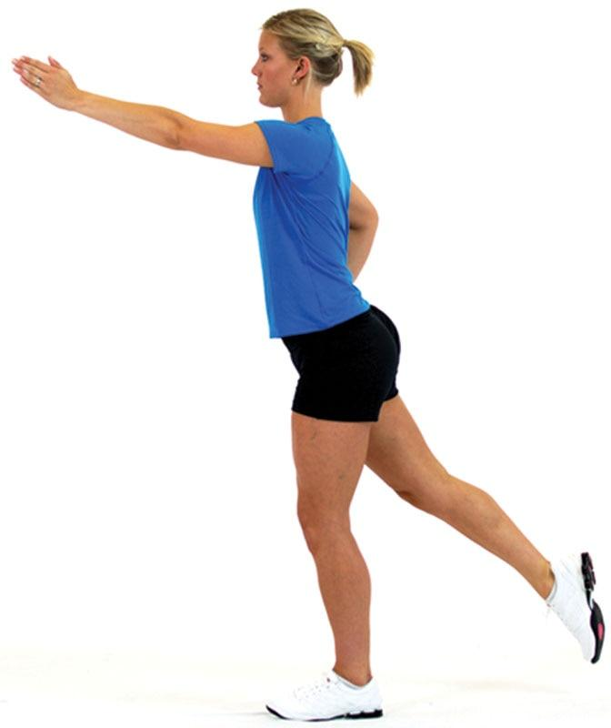

TECHNIQUE

Move the contralateral limbs in a range of motion that can be safely performed while maintaining ideal posture.

Single-Leg Windmill

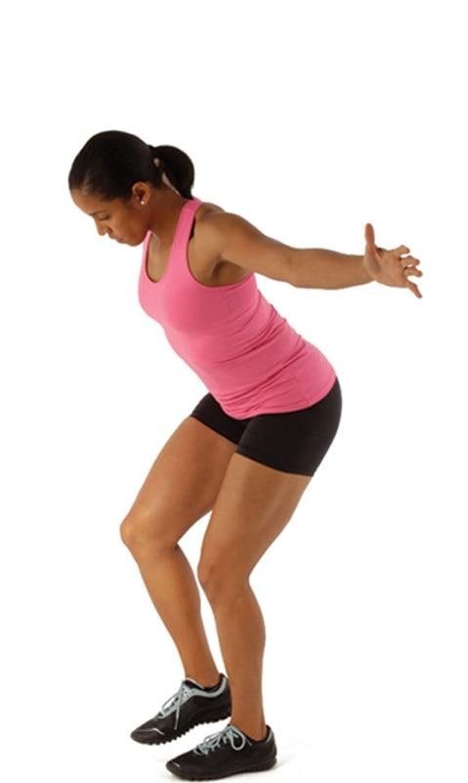 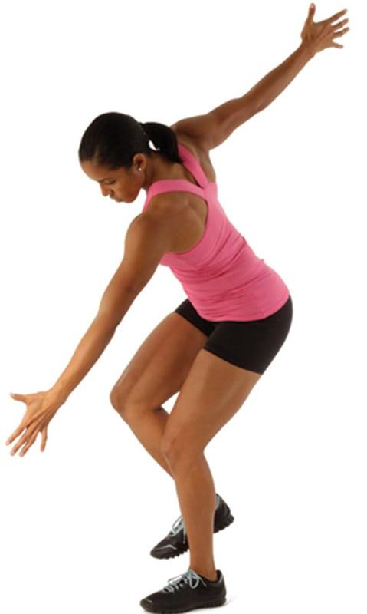 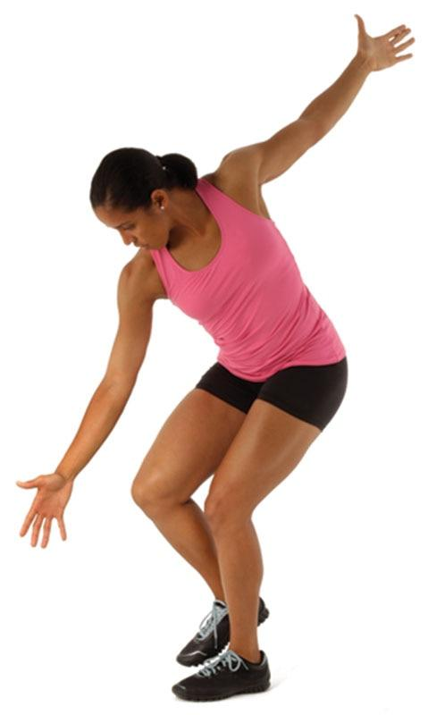

TECHNIQUE

Move the trunk through a range of motions that can be safely performed while maintaining ideal posture. This requires adequate core stabilization in addition to maintaining balance.

Single-Leg Throw and Catch

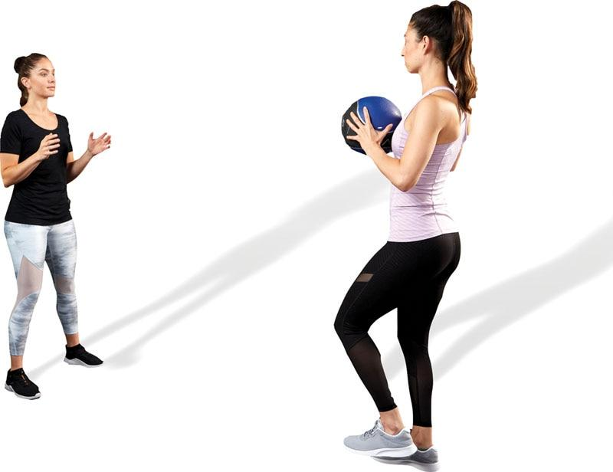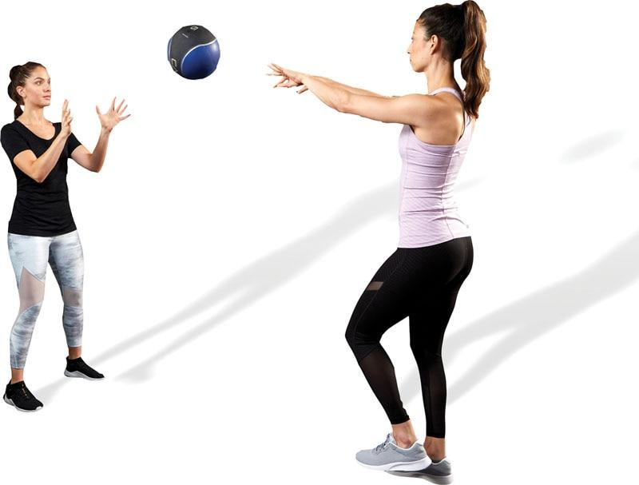

TECHNIQUE

The fitness professional can use several methods to increase the demand of this exercise:

* Toss the medicine ball at various heights and across the body
* Increase the distance between both individuals
* Increase velocity of each throw

Single-Leg Squat

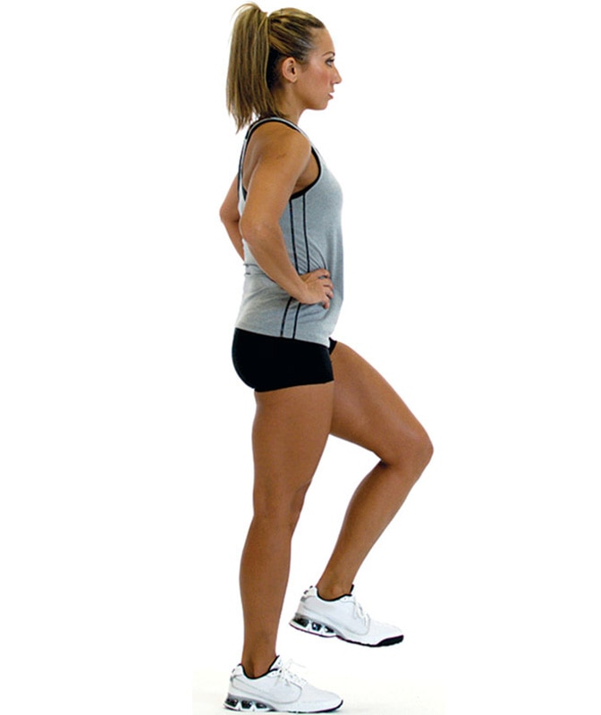 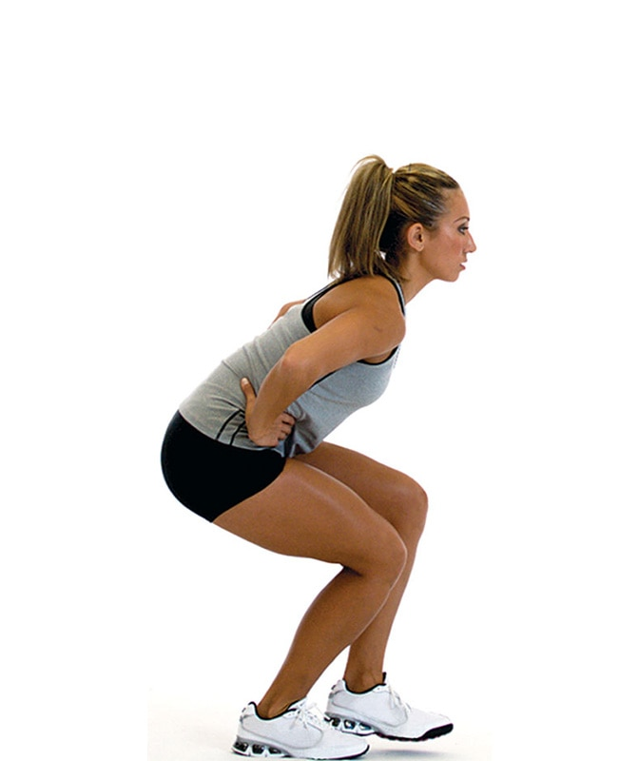

TECHNIQUE

As mentioned earlier, make sure the knee always remains aligned with the toes without moving inside or outside the second and third toes. This will decrease stress to the knee.

Single-Leg Squat Touchdown

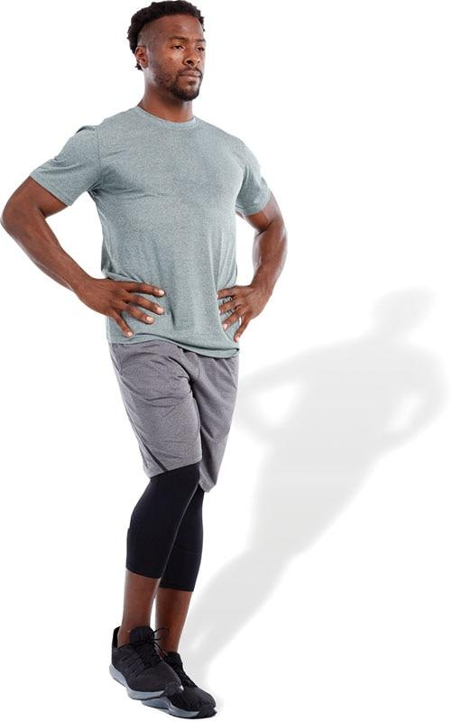 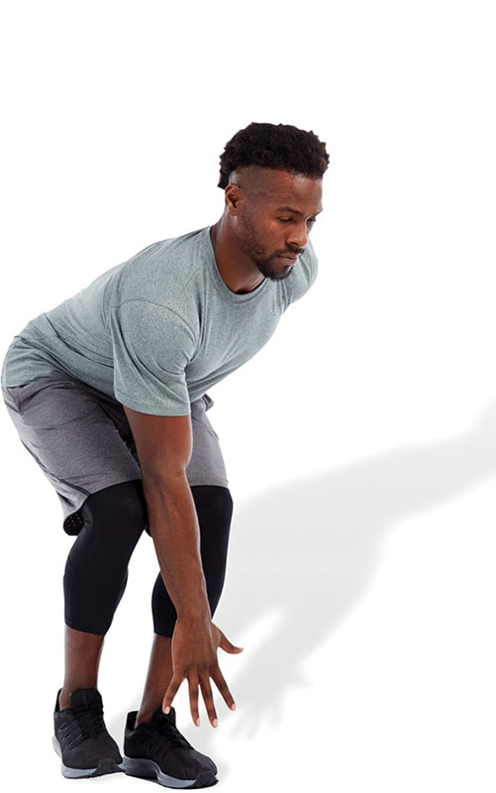

TECHNIQUE

If the client cannot touch their foot, have them first work on reaching to their knee, next to their shin, and finally to their foot.

Single-Leg Romanian Deadlift

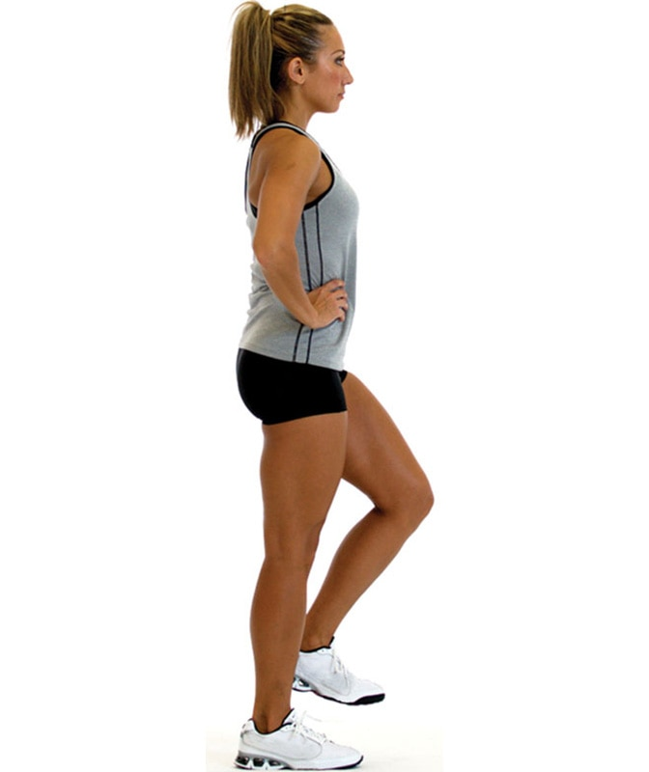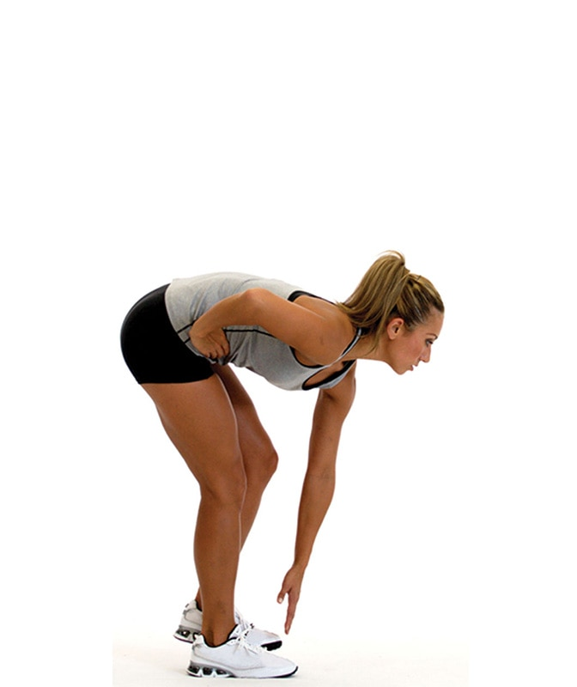

TECHNIQUE

Use the same progression with this exercise as performed in the single-leg squat touchdown:

1. Reach to the knee
2. Reach to the shin
3. Reach to the foot

Multiplanar Step-Up to Balance

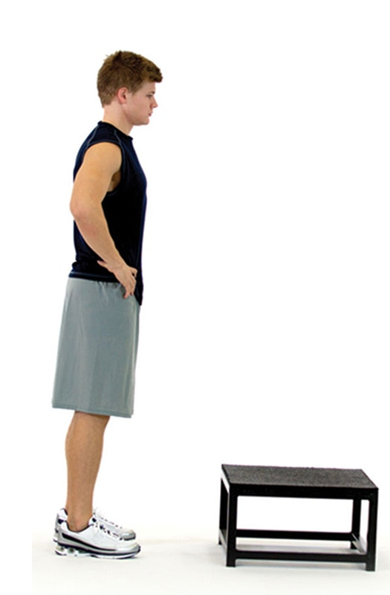 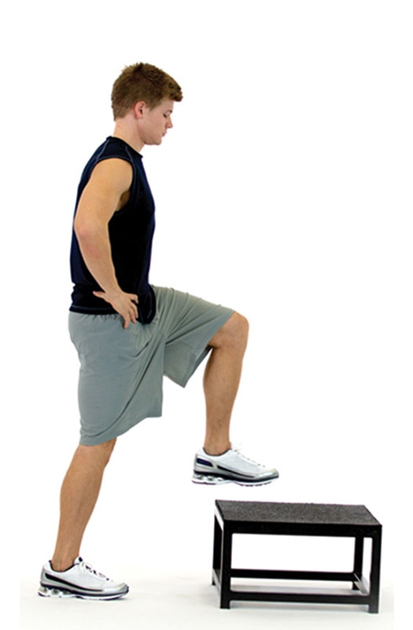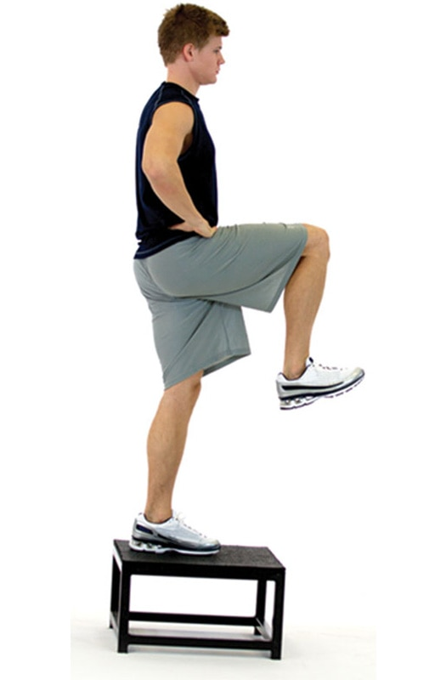

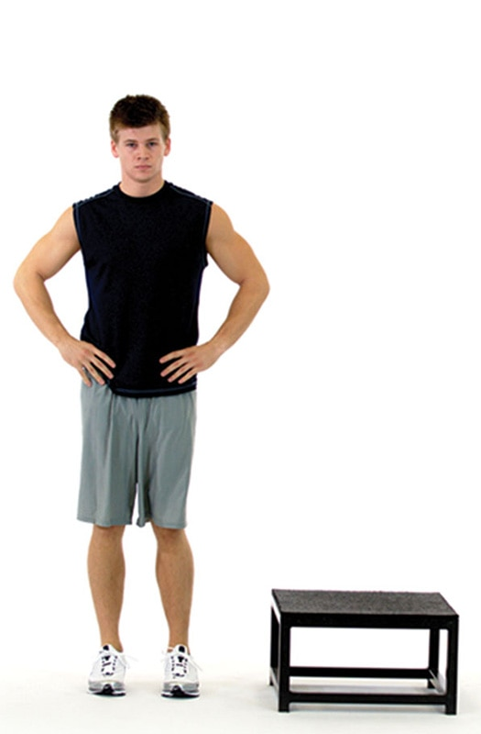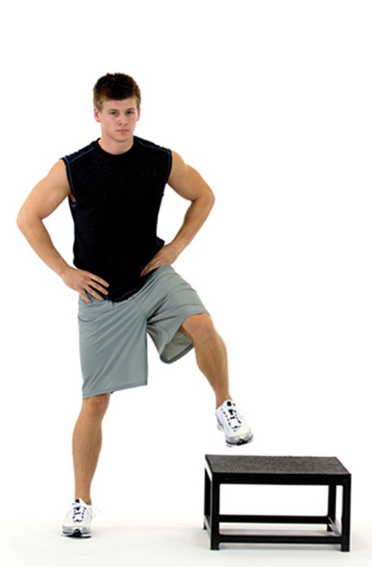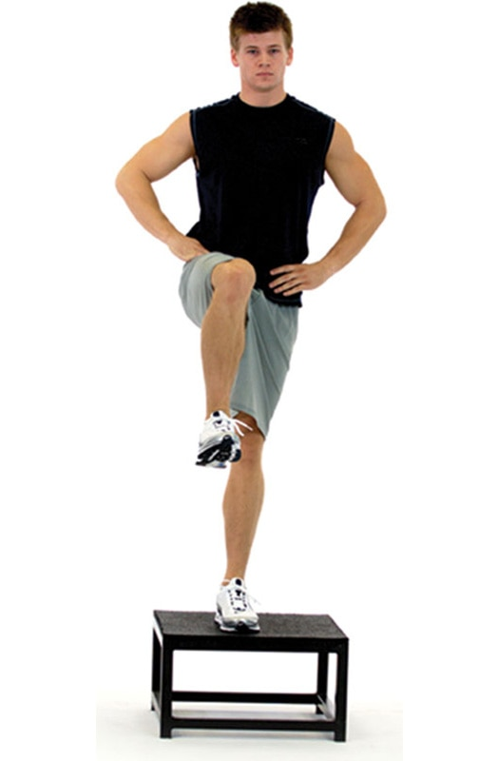

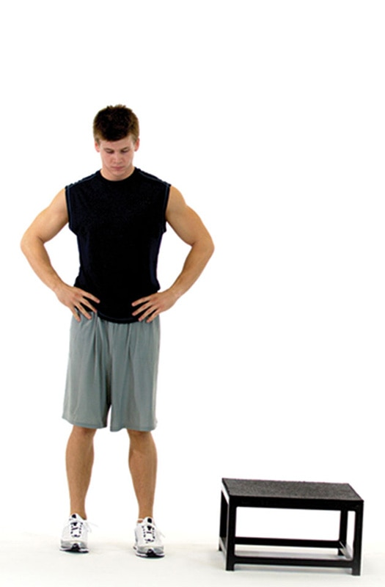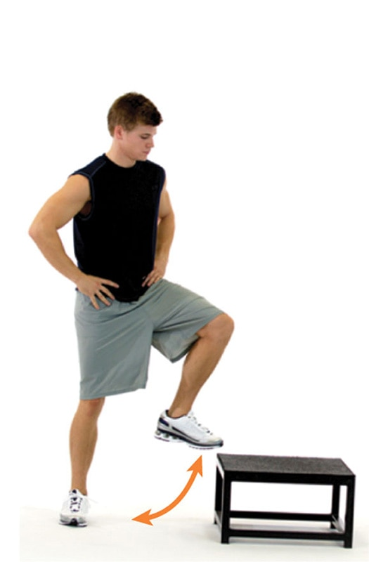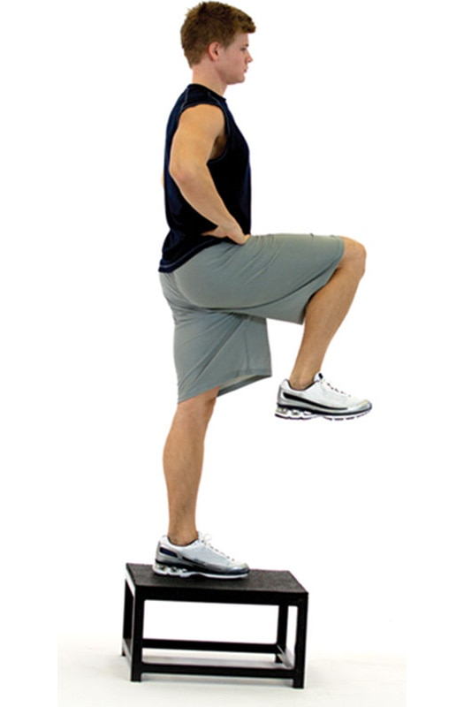

TECHNIQUE

At the end position, make sure that the hip of the balance leg is in full extension for maximal recruitment of the gluteal musculature.

Multiplanar Lunge to Balance

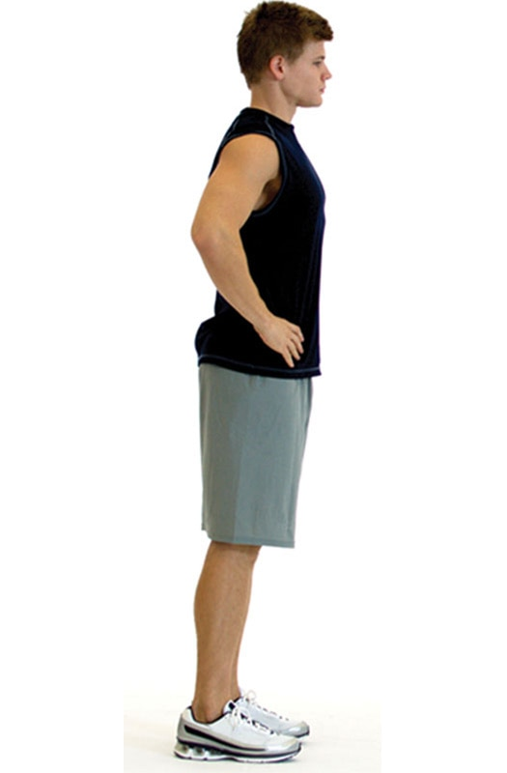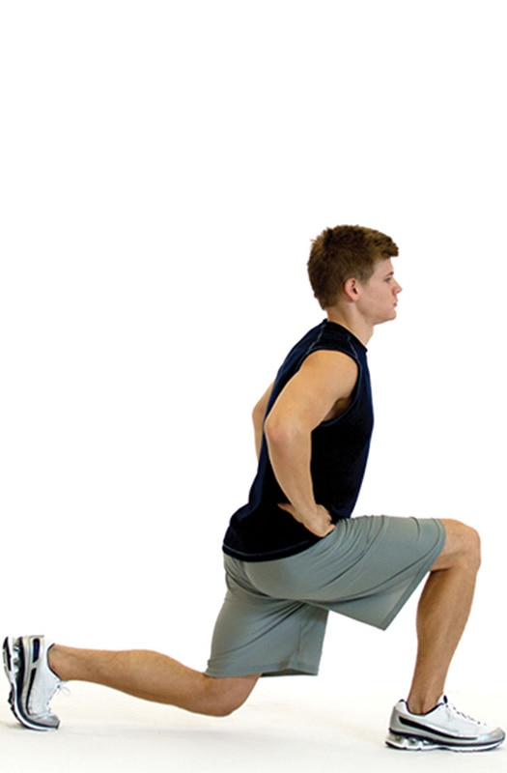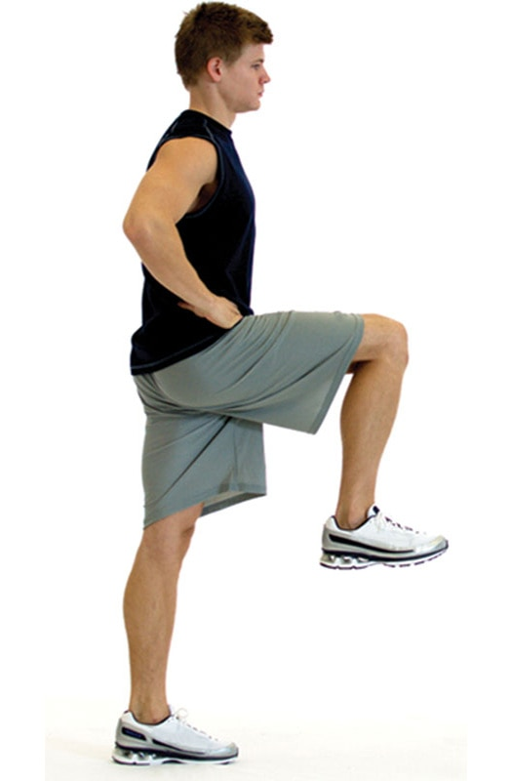

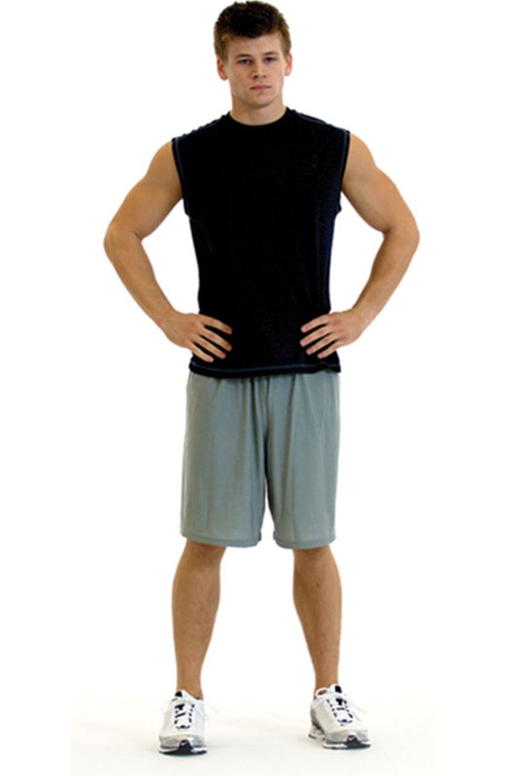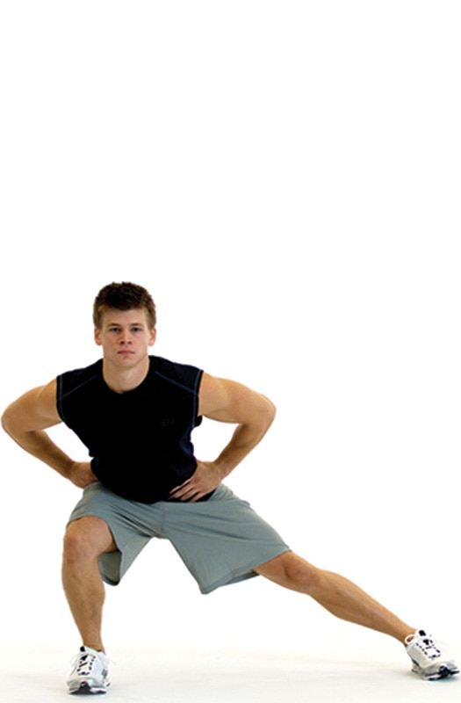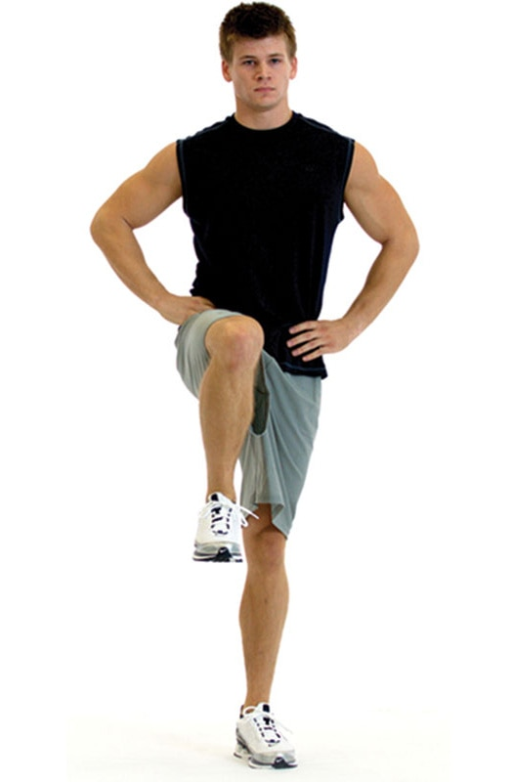

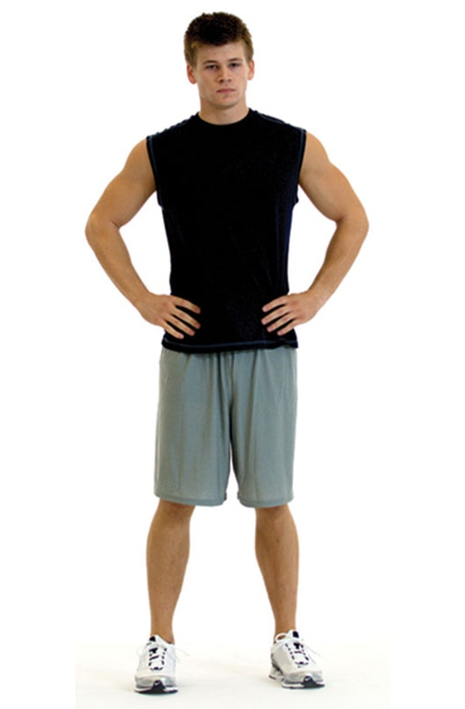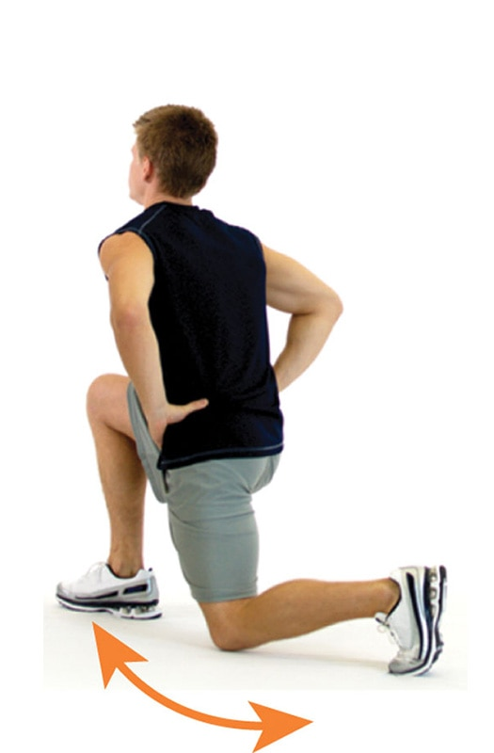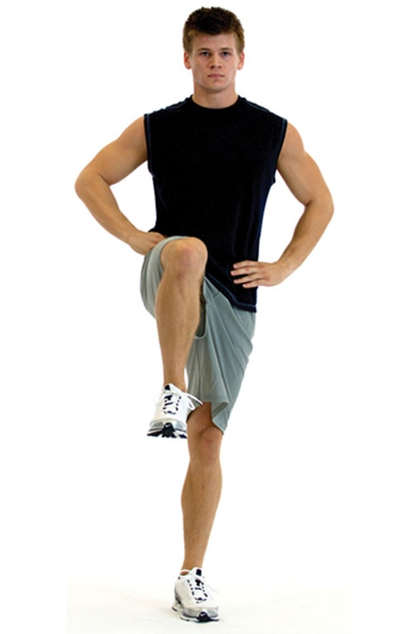

TECHNIQUE

When performing a lunge, make sure the stride length is not too large, particularly if one has tight hip flexors. This can force the lumbar spine into excessive extension, increasing stress to the lower back.

Multiplanar Hop with Stabilization

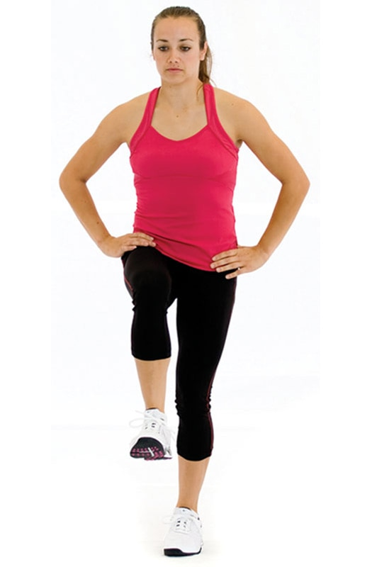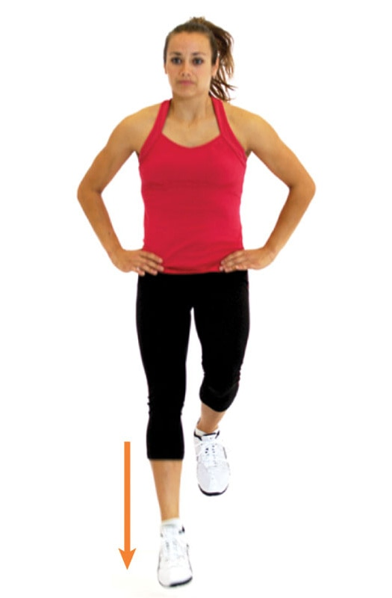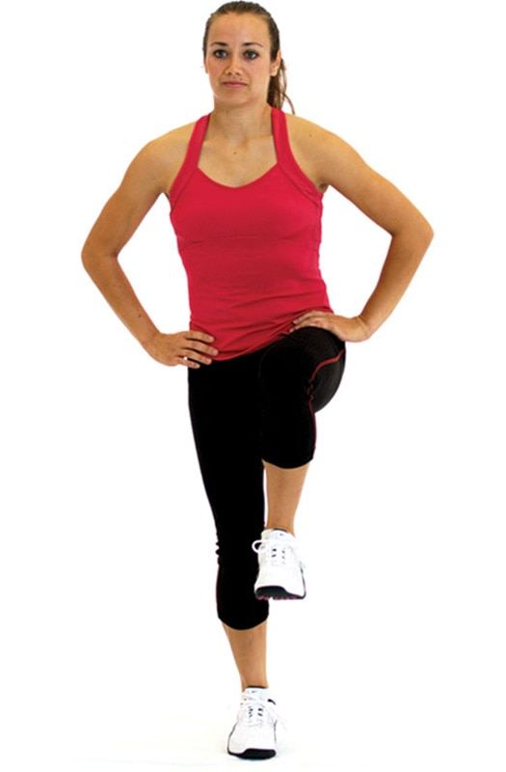

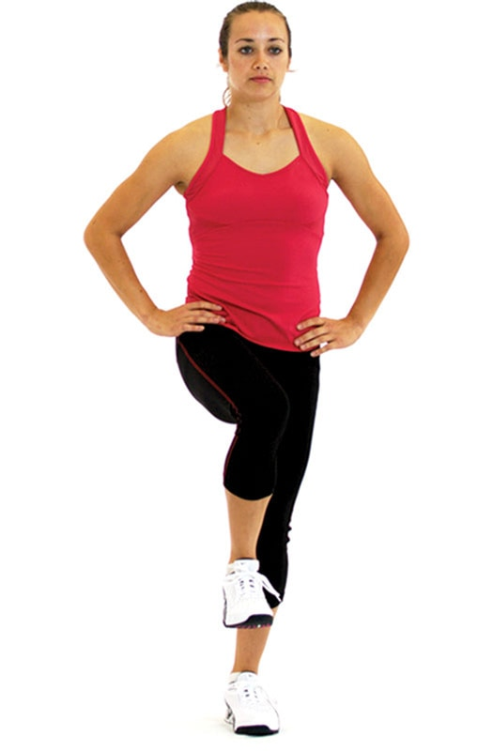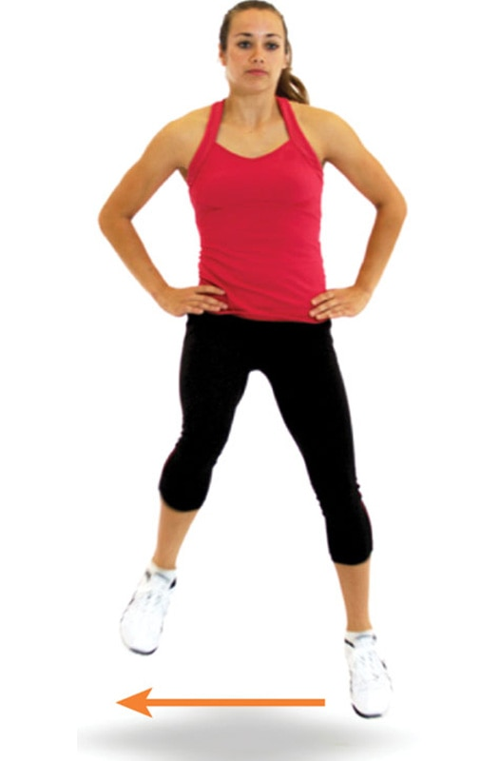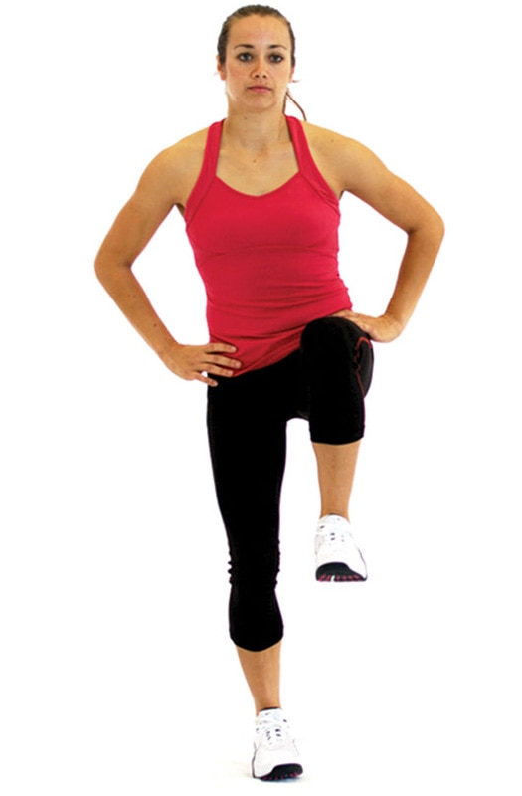

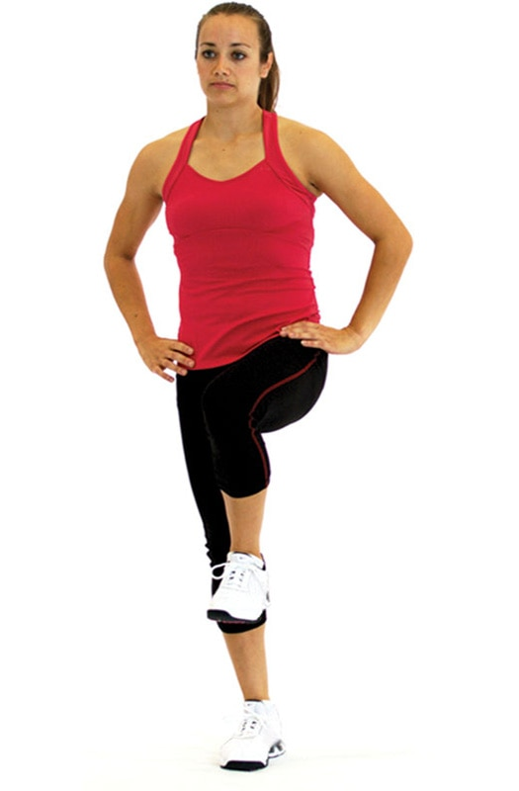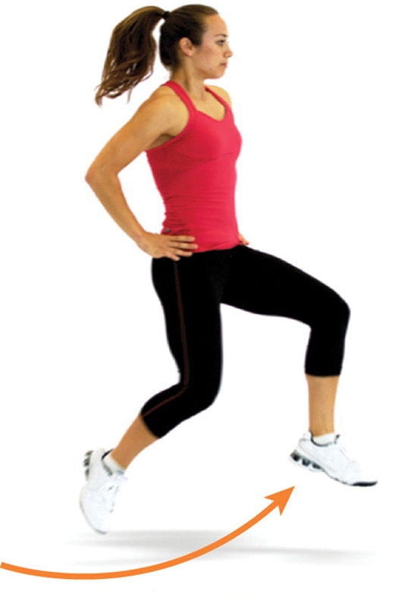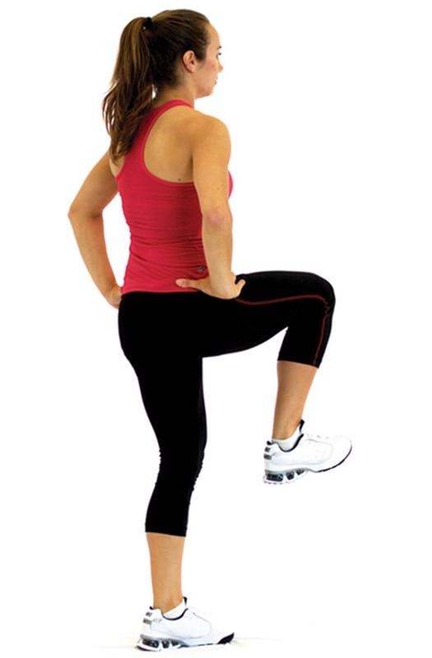

TECHNIQUE

Make sure the landing is soft and quiet to ensure efficient acceptance of forces through the tissues, and keep the knee aligned with the second and third toes.

Multiplanar Single-Leg Box Hop-Up with Stabilization

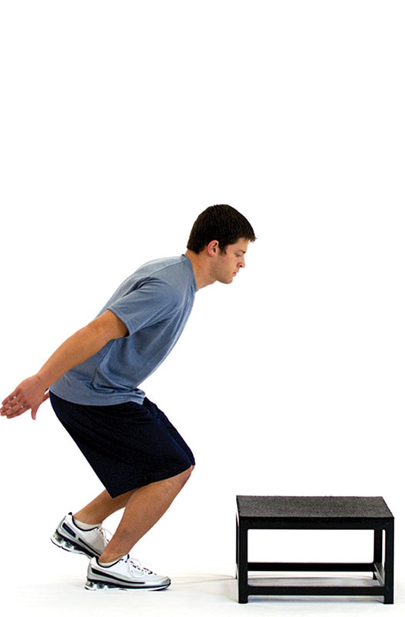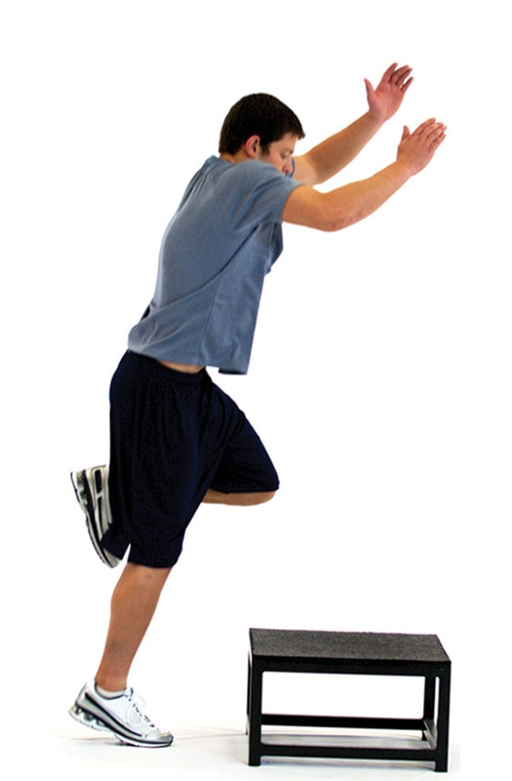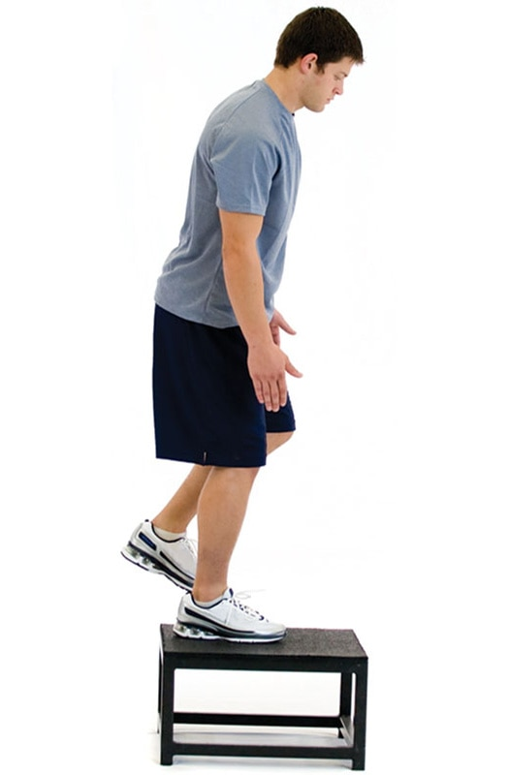

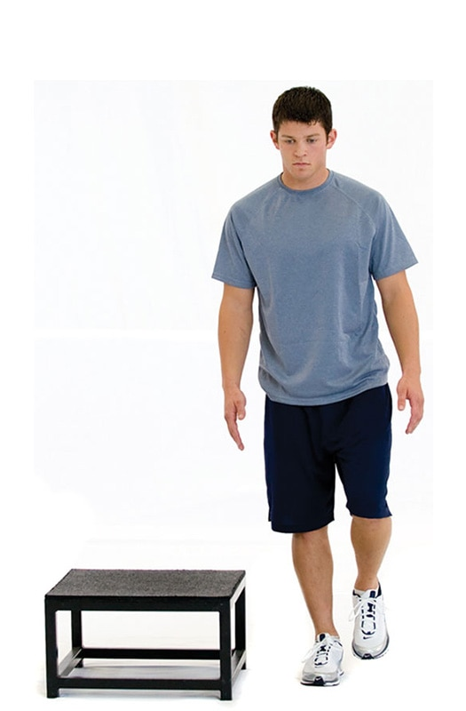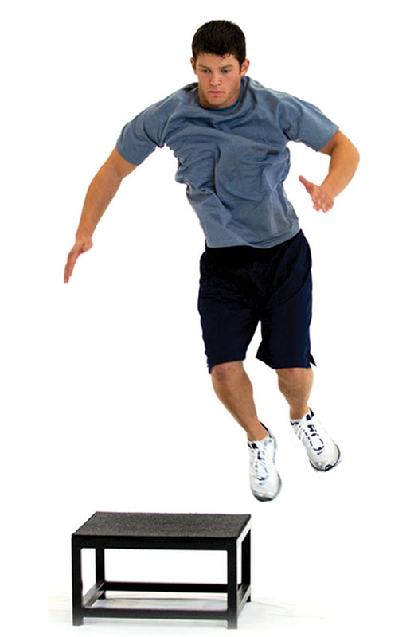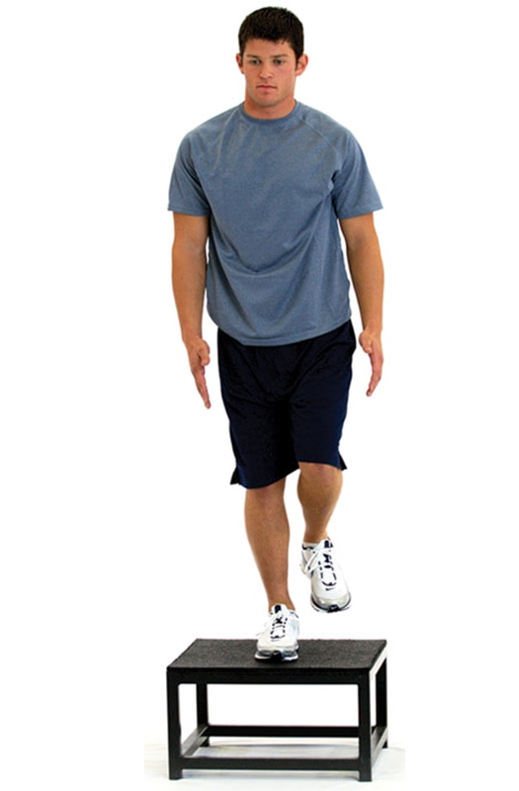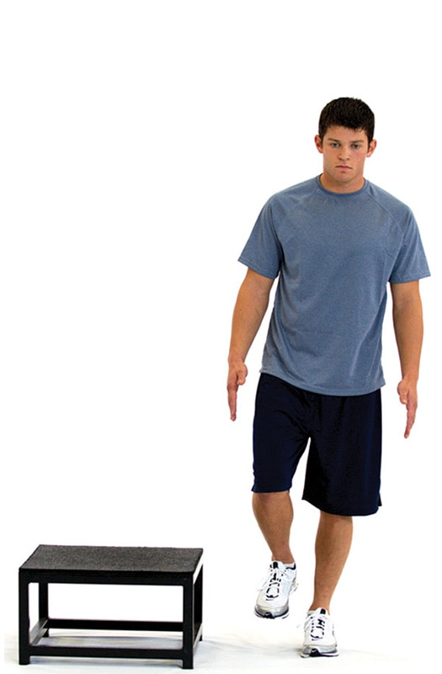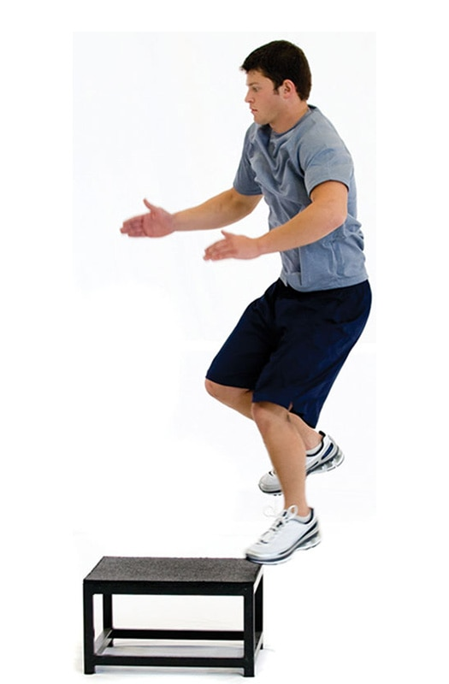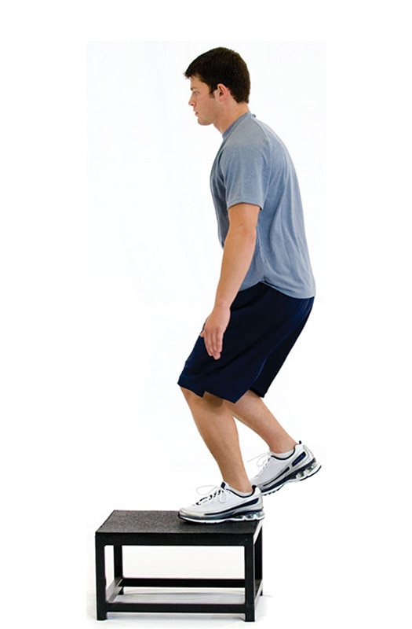

SAFETY

Choose a box or platform with a height suitable for the client’s ability level.

Multiplanar Single-Leg Box Hop-Down with Stabilization

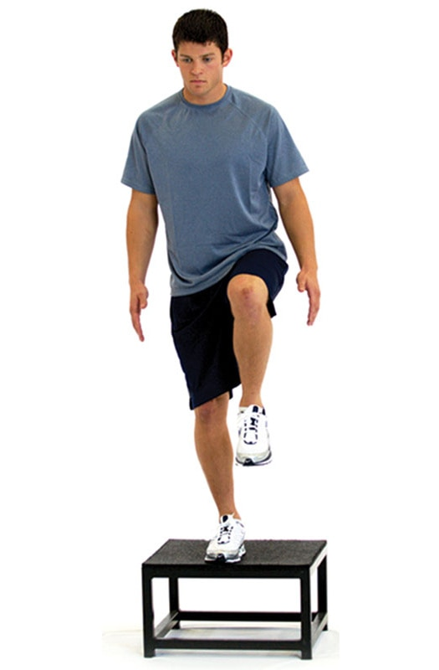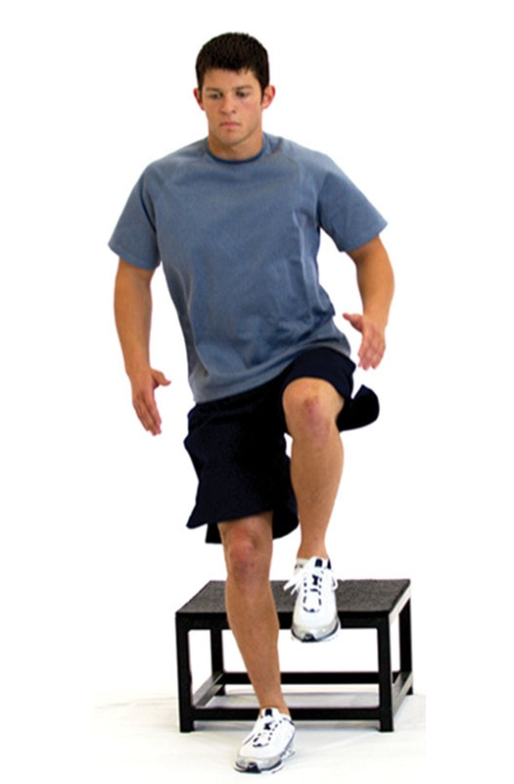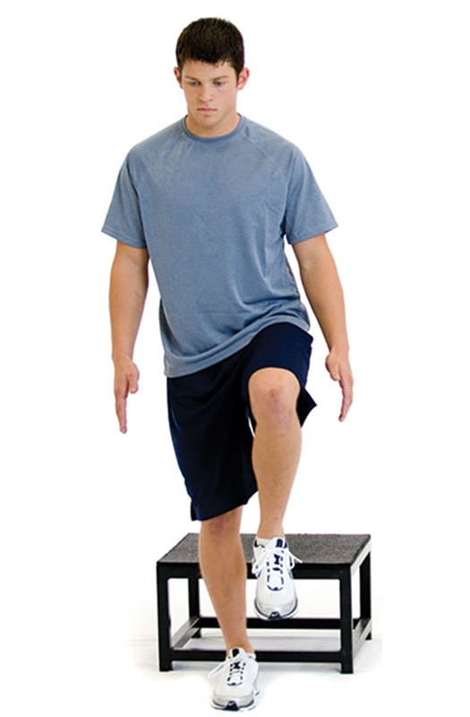

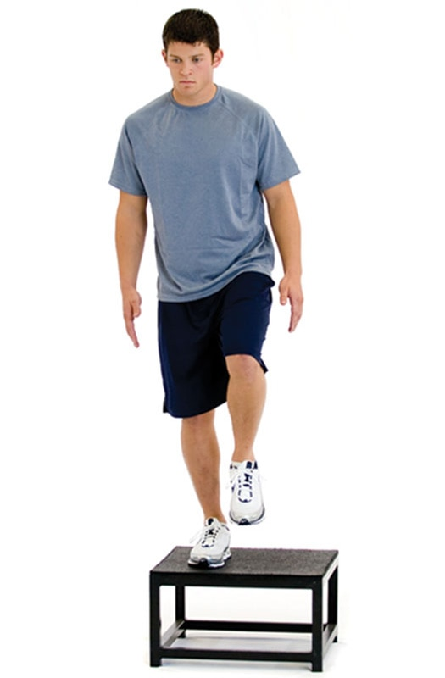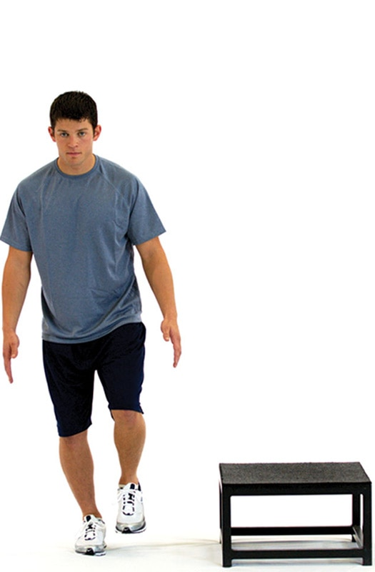

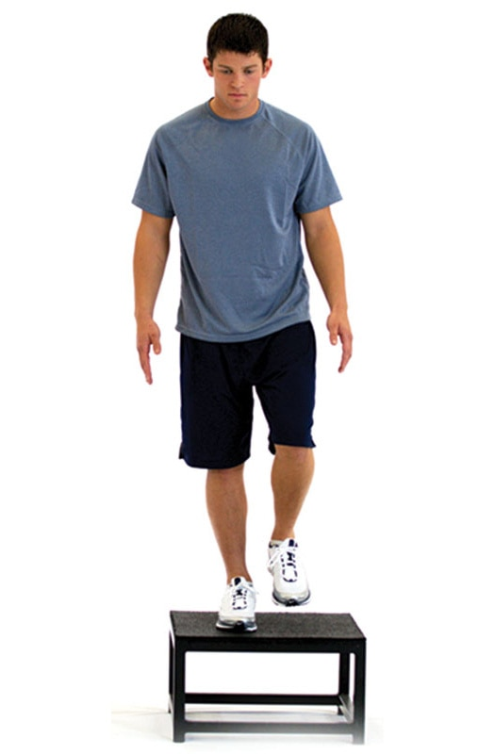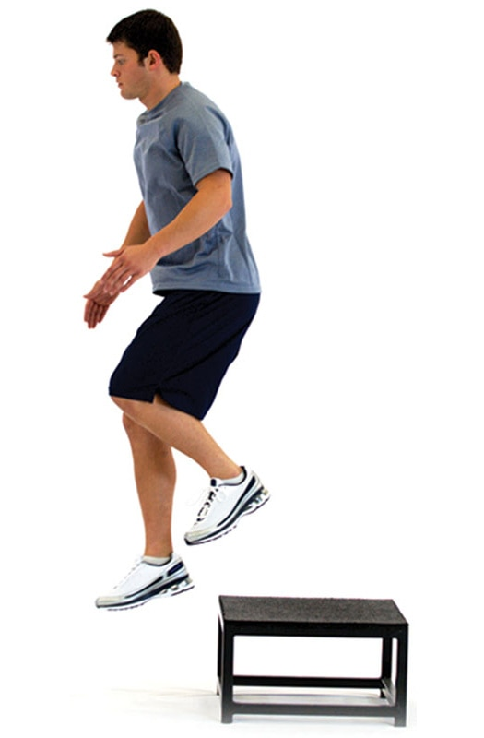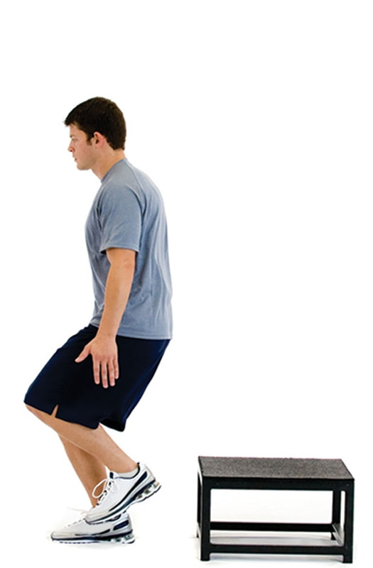

TECHNIQUE

Once again, keep the knee in line with the toes when landing, and land as softly as possible.

### Plyometric training

Plyometric training, also known as jump or reactive training, is a form of exercise that uses explosive movements, such as bounding, jumping, or forceful upper body movements, to develop muscular power. Employing plyometric training develops efficient control and production of ground reaction forces, which can be used to project the body with greater velocity or speed of movement. The term *reactive training* refers to the reaction stimulus clients encounter during plyometric training, which is the ground surface in this case. Therefore, reactive and plyometric training are used interchangeably throughout this chapter.

It is important for the fitness professional to understand that individual clients must possess adequate core strength, joint stability, and range of motion and have the ability to balance efficiently prior to performing explosive plyometric exercises. Plyometric training may not be an appropriate form of training for individuals with select chronic diseases or other functional limitations. However, the practice of plyometric training is very important considering the numerous injuries that occur as a result of an individual’s inability to control decelerative force and that it is often used in latter stages of physical rehabilitation (Hill & Leiszler, 2011). The purpose of this chapter is to discuss the importance of plyometric training and the physiology and methodology involved in designing and implementing plyometric training into a client’s existing exercise program.

**What Is plyometric training?**

The ability to generate force as quickly as possible is known as rate of force production (Maffiuletti et al., 2016). Success in everyday activities and sport depends on the speed at which muscular force is generated. Research demonstrates that resistance training combined with plyometric exercises significantly increase muscle force production, facilitating increases in strength and power (Mckinlay et al., 2018; Oxfeldt et al., 2019; Peitz et al., 2018).

Plyometric training involves exercises that generate quick, powerful movements involving an explosive concentric muscle contraction preceded by an eccentric muscle action (Slimani et al., 2016). In other words, there is a “cocking” or loading phase described as an eccentric muscle action that dampens or slows the downward movement of the body (deceleration) followed immediately by an explosive concentric muscle contraction (Slimani et al., 2016).

These types of explosive muscular contractions can be seen in practical instances, such as rebounding a basketball. Trained basketball players prepare to jump up for a loose ball by lowering their body slightly by flexing at the ankles, knees, and hips; this is eccentric loading. Players may even drop their arms to assist in takeoff. At a fairly shallow point, players will reverse this downward motion and rapidly project themselves up from the ground extending their ankles, knees, hips, and arms upward, which is the concentric contraction. The overall height of their jump is determined by their vertical velocity, or how fast they leave the ground.

This is the essence of a plyometric exercise and uses a characteristic of muscle known as the stretch-shortening cycle. The stretch-shortening cycle improves the elastic properties of connective tissue and muscle fibers by enhancing stored elastic energy through the eccentric phase and releasing it during the concentric phase to increase force production. (Slimani et al., 2016). In fact, the integrated performance paradigm states that to move with precision, forces must be eccentrically loaded, isometrically stabilized, and then unloaded or concentrically accelerated (Figure 18-1).

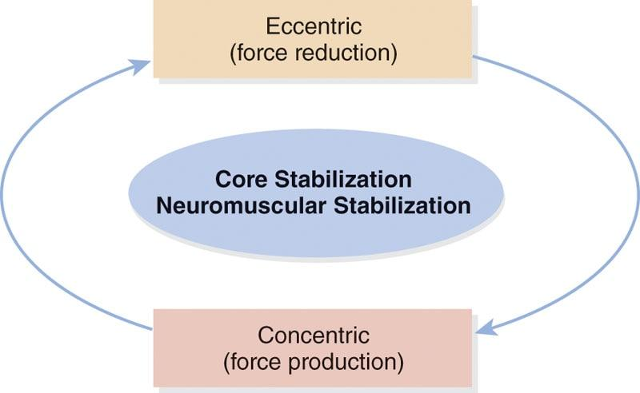

**Figure 18-1** Integrated performance paradigm

**Three phases of plyometric exercise**

There are three distinct phases of the stretch-shortening cycle involved in a plyometric exercise: the eccentric or loading phase, the amortization phase or transition phase, and the concentric or unloading phase (Chmielewski et al., 2006).

The eccentric phase

The first phase of a plyometric movement can be classified as the eccentric phase (deceleration), which describes the preloading or stretching of the agonist muscle. During the eccentric phase, elastic energy is stored, and muscle spindles are stimulated, which sends signals to the central nervous system (Davies et al., 2015; Slimani et al., 2016).

Potential energy is stored in the elastic components of the muscle during this loading phase much like stretching a rubber band. This eccentric phase is predicated on three stretch variables: magnitude of the stretch, rate of the stretch, and duration of the stretch (Davies et al., 2015). Any manipulation of these key variables can enhance the amount of energy stored during the eccentric prestretch action.

The amortization phase

The next phase is known as the amortization phase, also referred to as the transition period or phase, which represents the time between the eccentric phase and the initiation of the concentric contraction (discussed next). In other words, the amortization phase is the period of time from which the eccentric phase ends to the time when the concentric muscle contraction begins (Slimani et al., 2016). The amortization phase is also referred to as the electromechanical delay, which describes that space in time during which the muscle must switch from overcoming force to imparting force in the intended direction (Davies et al., 2015). This phase is critical to plyometric performance, because the shorter the amortization phase is, the more effective and powerful the subsequent plyometric movement will be, as the stored elastic energy is used efficiently in the transition. If the amortization phase is prolonged, the stored elastic energy is dissipated as heat, and the stretch reflex is not fully used, which results in significantly less concentric force output (Davies et al., 2015). One of the primary objectives of plyometric training is to reduce the time in the amortization phase. Therefore, a rapid switch from an eccentric loading phase to a concentric contraction leads to a more powerful response (Davies et al., 2015; Slimani et al., 2016).

The concentric phase

The final phase is the concentric phase, which represents the body’s response to the events that occurred during the eccentric and amortization phases. The concentric phase uses the stored elastic energy from the eccentric phase to either enhance muscle force production or dissipate the energy as heat. For example, during a half movement in a basketball jump shot, as soon as the upward movement begins, the concentric phase has initiated, and the amortization phase has ended. Together, the stretch-shortening cycle describes an eccentric phase in which the muscle is stretched, followed by an amortization phase where the muscle is in a stabilizing, isometric transitional period, which leads to a concentric phase that uses the stored energy in the muscle to deliver an explosive action (Table 18-1) (Oxfeldt et al., 2019; Slimani et al., 2016).

TABLE 18-1 Components of the Stretch-Shortening Cycle

| **Phase** | **Physiological Event** | **Action** |
| --- | --- | --- |
| Eccentric | Stored elastic energy; stimulation of muscle spindles, signal sent to spinal cord | Stretch of agonist muscle |
| Amortization | Nerves meet synapse in spinal cord, signal sent to stretched muscle | Time between the eccentric and concentric phases |
| Concentric | Elastic energy release, enhanced muscle force production | Shortening of agonist muscle |

HELPFUL HINT

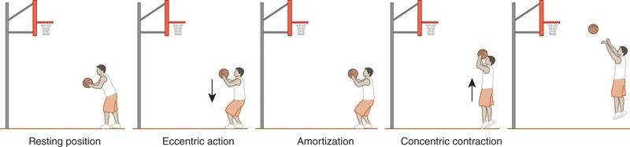

To better understand the stretch-shortening cycle, imagine holding a rubber band. To shoot that rubber band, the first step is to stretch it. Stretching the rubber band creates stored elastic energy that is waiting to be released. The next step is to release the rubber band, which uses the stored elastic energy to propel the rubber band through the air.

Human muscles work in a similar fashion. To jump upwards with maximal velocity, the first action is to quickly perform a shallow squat—an eccentric action. Performing the shallow squat stretches the gluteal complex, quadriceps, and calves. Consequently, these muscles are now storing elastic energy that is waiting to be released. Now, with the stored elastic energy, the jump will be more forceful—a concentric contraction.

**Importance of plyometric training**

Plyometric exercises increase rate of force production (power) and motor unit recruitment (Ebben et al., 2008, 2011). These training exercises are a progression that can be incorporated once a client has achieved an overall strength base, proper core stability, and balance capabilities. Adequate isometric stabilization strength that is developed through core, balance, and resistance exercises decreases the time between the eccentric muscle action and concentric contraction, resulting in shorter ground contact times. This may result in a decrease of both tissue overload and potential injury when performing plyometric training (DiStefano et al., 2010, 2016).

Many movement patterns that occur during functional activities involve a series of repetitive stretch-shortening cycles. Stretch-shortening cycles require the neuromuscular system to react quickly and efficiently after an eccentric muscle action to produce a concentric contraction and impart the necessary force (or acceleration) in the appropriate direction. Therefore, improving functional movements, such as cutting or change of direction, may require exercise routines that emphasize plyometric training (Asadi et al., 2016).

Plyometric training provides the ability to train specific movement patterns in a biomechanically correct manner at a more functionally appropriate speed. This provides strengthening of the muscles and connective tissue to meet the demands of everyday activities and sport (Cherni et al., 2019; Hirayama et al., 2017). The ultimate goal of plyometric training is to maximize function as described by the integrated performance paradigm (Davies et al., 2015). This also results in increased speed of movement for the individual.

The speed of muscular exertion is limited by neuromuscular coordination. Plyometric training improves neuromuscular efficiency and improves the range of speed set by the central nervous system (Davies et al., 2015; Silva et al., 2019). Optimal reactive performance of any activity depends on the speed at which muscular forces can be generated.

Plyometric training is often perceived by many to be too dangerous, potentially increasing the risk of injury. However, plyometric training has a systematic progression sequence that allows a client to begin with less demanding exercises and progress to more demanding exercises as they adapt.

This is no different than any other form of training. If exercises that are too advanced for the client are assigned to their exercise plan, they will not have the ability to perform them correctly and they will compensate. This may lead to faulty movement patterns and increased risk of injury. When placed within a well-designed programming scheme with proper progressions, plyometric training can be a vital component to achieving optimal performance of any activity at any level of ability.

For example, a 65-year-old woman and a 25-year-old male professional athlete may not both need to train for maximal strength. However, they do need stabilization, strength, and endurance as well as the ability to produce force quickly to perform daily activities efficiently. Therefore, it is imperative that both can react and produce sufficient force: for the 65-year-woman to avoid a fall or for the 25-year-old athlete to avoid an opponent. Plyometric exercises are performed with a faster tempo, similar to movements seen in daily life or sport-related activities.

STRETCH YOUR KNOWLEDGE

Evidence to Support the Use of Plyometric Training for Injury Prevention and Performance Enhancement

* Enginsu et al. (2014) examined 36 female volleyball players who carried out a plyometric training for 12 weeks and a control group that carried out no physical training. After 12 weeks, only the plyometric training group significantly improved lower limb movement patterns. It was concluded that plyometric training improves lower limb kinematics and functional performance, suggesting the incorporation of these exercises in preventive programs for anterior cruciate ligament injuries.
* Franchi et al. (2019) concluded that plyometric exercise is an effective exercise method in counteracting the functional effects of sarcopenia (loss of muscle tissue). A training period of only 6 weeks for both young and older individuals achieved similar increases in muscle size and power through plyometric exercise.
* Ozbar (2015) examined 10-week plyometric training in elite female soccer players. Twenty adult players were divided into a plyometric group and a control group. Both groups performed technical and tactical training and matches together. It was found that sprint, counter-movement jump, standing broad jump, peak power, and kicking speed test values were all significantly improved in the plyometric group versus the control group. The results indicated that plyometrics can be useful to strength and conditioning coaches for improving their athlete’s power.
* Vetrovsky et al. (2019) performed a systematic review of plyometric training and its impact on physical function for older adults. Eighteen papers were included in the review, and the authors concluded that plyometric training is a feasible and safe training option for older adults to improve performance, function, and health-related outcomes.

Key Takeaways

* Plyometric training can reduce the risk of injury in competitive athletes.
* Plyometric training increases muscle size and limits the effects of sarcopenia.
* Plyometric training increases muscular power and athleticism.
* Plyometric training is a safe option for older adults to improve function.

**Guidelines for plyometric training**

Plyometric exercises can be an important component of an exercise or sports performance training program to enhance an individual’s movement quality, landing mechanics, and power development. However, plyometric training exercises must be implemented in a systematic and progressive fashion to ensure safety and minimize the chances of injury.

A thorough analysis of a client’s training history, age, and injury history may help distinguish clients who may or may not be prepared for plyometric training.

Assessing movement quality using movement assessments—as discussed in Chapter 12—is also a useful screening tool. To enhance performance while reducing the likelihood of injury, clients must recognize the importance of quality and proper plyometric technique while acquiring adequate base levels of strength and motor control. While all exercise includes some risk, the explosive actions of plyometrics suggest that Certified Personal Trainers should take a measured and progressive approach when using it with athletes and clients (Davies et al., 2015).

**Designing a plyometric training program**

A client must exhibit basic levels of total body strength, core strength, and balance before progressing into plyometric training. Fitness professionals must follow specific program guidelines, proper exercise selection criteria, and detailed program variables, such as intensity, volume, frequency, and progressions. Moreover, plyometric training should only be performed by individuals wearing supportive shoes and on a proper training surface, such as a grass field, basketball court, or tartan track. The training surface can have a profound effect on exercise performance when performing plyometric drills (Ramírez-Campillo et al., 2013).

When designing effective plyometric programs, it is helpful to remember many key concepts. First, plyometric exercises should progress from simple, to intermediate, to advanced movements and from low intensity to medium intensity to high intensity. As a general rule, clients should practice plyometric skills comprising dual-foot drills before progressing to single-foot drills.

Intensity

Plyometric intensity describes the distance covered and the amount of effort or stress applied by the muscles, connective tissue, and joints during plyometric drills (Davies et al., 2015; Oxfeldt et al., 2019). Intensity should be programmed based on the client’s ability to execute the exercise while maintaining adequate training technique. If technique is lost, the intensity should be lowered until proper technique is achieved. It is always better to start off conservatively, because the fitness professional can always increase the intensity of the exercises once the client masters the movement pattern. Moreover, it is important for clients to feel confident and display adequate movement competency during their exercise routine. If exercises are too difficult, clients may express feelings of shame, and consequently, their adherence to the exercise program may become compromised.

Volume

Plyometric volume is expressed as the number of foot contacts, throws, or catches. An example would be the completion of three sets of five squat jumps, equating to a volume of 15 total squat jumps (3 × 5). The volume in plyometric training is determined by the choice of exercise and intensity of movement. As with other forms of exercise training, an increase in intensity is often paired with a decrease in training volume.

Training frequency and recovery

Training frequency is determined by the client’s fitness level, current training program, training history, injury history, and training goals. A general recommendation is to allow at least 1 day between intense plyometric training sessions. At least 48 to 72 hours between sessions is the recommended guideline when implementing plyometrics for novice individuals. Research suggests that recovery between workouts must be sufficient to prevent overtraining and injury (Davies et al., 2015). Most apparently healthy clients will be able to perform one to three plyometric training sessions per week.

Essentially, the higher intensity the drill, the more rest is needed between sets. By not providing a sufficient recovery period between sets, adequate recovery may not occur and thus will negate potential benefits. As a general rule, recovery times of 60 to 120 seconds between drills should be sufficient for full recovery, but this is strictly determined by the client’s fitness level. See Table 18-2 for a list of plyometric training guidelines.

TABLE 18-2 Plyometric Training Guidelines

| **Plyometric Training Variables** | |
| --- | --- |
| Planes of motion   1. Sagittal 2. Frontal 3. Transverse | Volume   * Sets   + Low   + Moderate   + High * Repetitions   + Low   + Moderate   + High |
| Speed of motion   1. Slow 2. Medium 3. Fast 4. Explosive | Safety   * Performed with supportive shoes * Performed on a proper training surface   + Grass field   + Basketball court   + Tartan track surface   + Rubber track surface * Performed with proper supervision |
| Progressive   1. Easy to hard 2. Low to high amplitude 3. Simple to complex 4. Known to unknown 5. Body weight to loaded 6. Activity specific | Recovery   * Allow at least 24 hours between plyometric training sessions   + 48–72 hours for new or deconditioned clients |

**Plyometric training progressions**

When introducing plyometric exercises, especially to new or beginner clients, the movements should initially involve small jumps (lower amplitude) to best learn the movement pattern. They are designed to establish optimal landing mechanics, postural alignment, and eccentric strength (ability to decelerate). When an individual lands during these exercises, they should hold the landing position (or stabilize) for 3–5 seconds. During this time, individuals should make any adjustments necessary to correct faulty postures before performing the next jump. Example exercises using this protocol include (but are not limited to) the following:

* Squat jump with stabilization
* Box jump-up with stabilization
* Box jump-down with stabilization
* Multiplanar jump with stabilization.

The next progression involves jumps with more amplitude and dynamic motion. The speed of the jumps is also progressed. These exercises are intended to improve dynamic joint stabilization, eccentric strength, rate of force production, and coordination of the entire human body. These exercises are performed in a repetitive fashion, spending a relatively short amount of time on the ground before repeating the drill. In other words, the client will no longer hold the landing position for 3–5 seconds but instead initiate another jump upon landing using a moderate (repeating) tempo. Some example exercises using this protocol include (but are not limited to) the following:

* Squat jump
* Tuck jump
* Butt kick
* Power step-up.

The last progression includes exercises that involve explosive, powerful movements. These exercises are designed to further improve rate of force production, eccentric strength, and reactive joint stabilization. These exercises are performed as fast and as explosively as possible. Some example exercises using this protocol include (but are not limited to) the following:

* Ice skaters (also known as skater jumps)
* Single-leg power step-up
* Proprioceptive plyometrics
* Depth jump.

**Plyometric Exercises**

Squat Jump with Stabilization

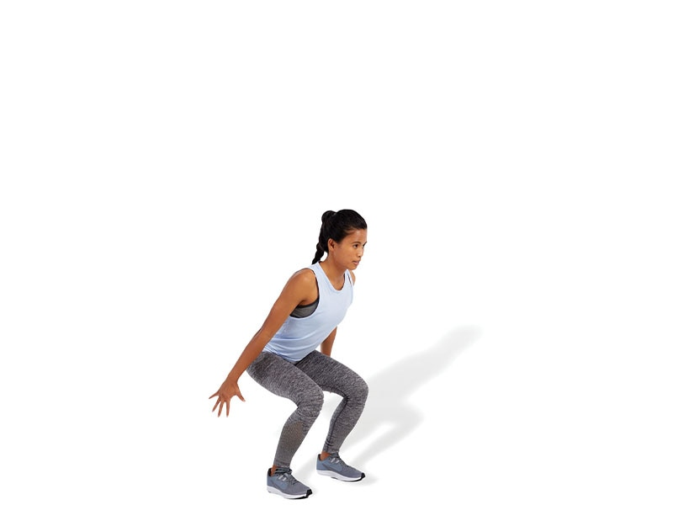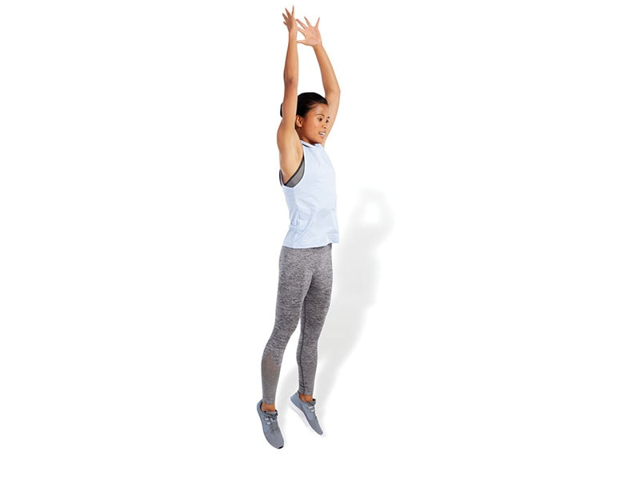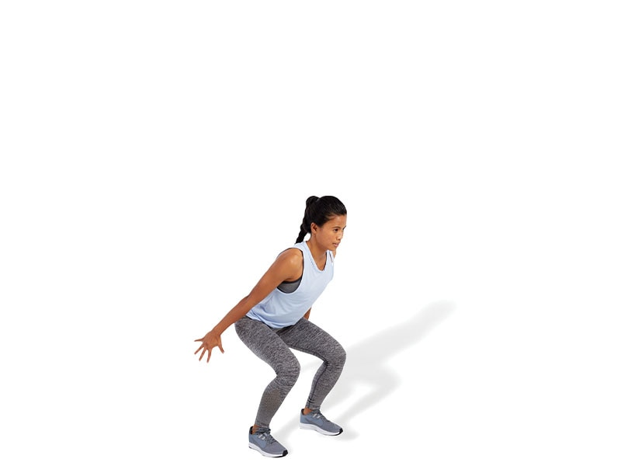

TECHNIQUE

Make sure the knees always stay in line with the toes, both before jumping and on landing. Do not allow feet to excessively turn outward or knees to cave inward.

Multiplanar Box Jump-Up with Stabilization

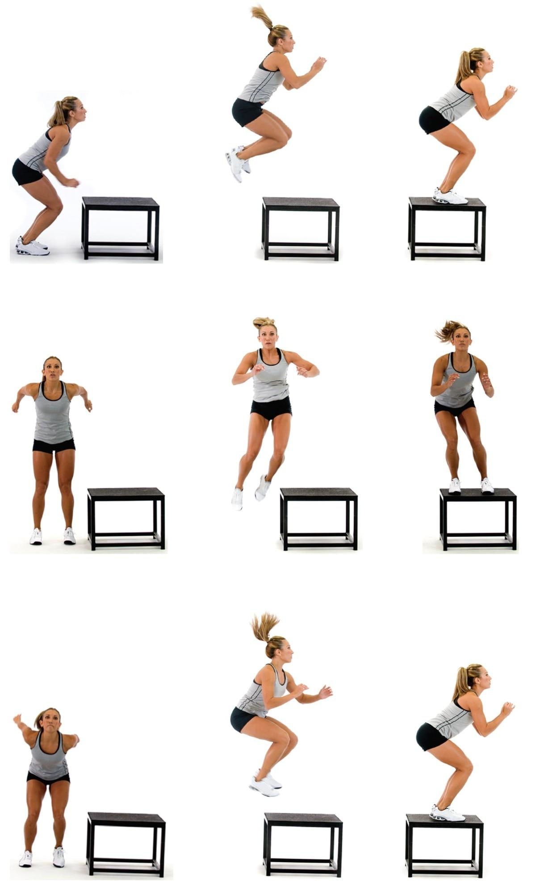

SAFETY

Select a box height that is consistent with the physical capabilities of the client performing the exercise.

Multiplanar Box Jump-Down with Stabilization

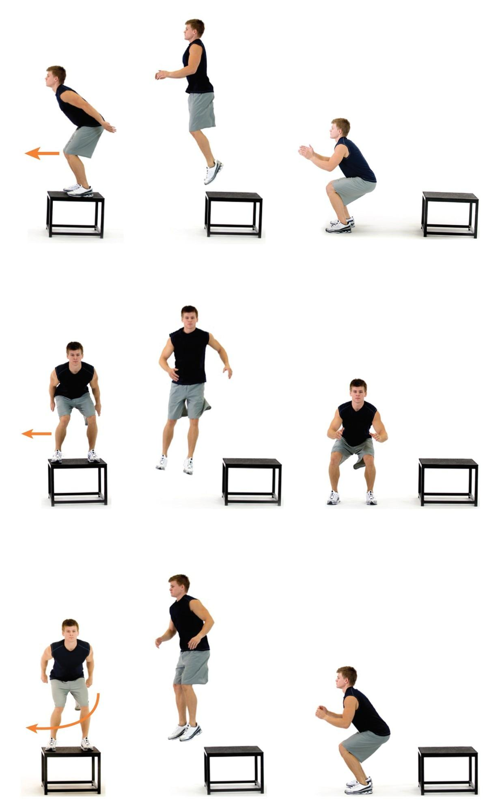

TECHNIQUE

Make sure the client steps off and drops from the prescribed height when initially attempting this exercise. Jumping from the box presents different variables and levels of load or intensity of the exercise and can be used as a progression. Make sure the client lands softly and quietly on the ground to ensure proper force transmission through the tissues of the body. Do not let the client land with legs straight.

Multiplanar Jump with Stabilization

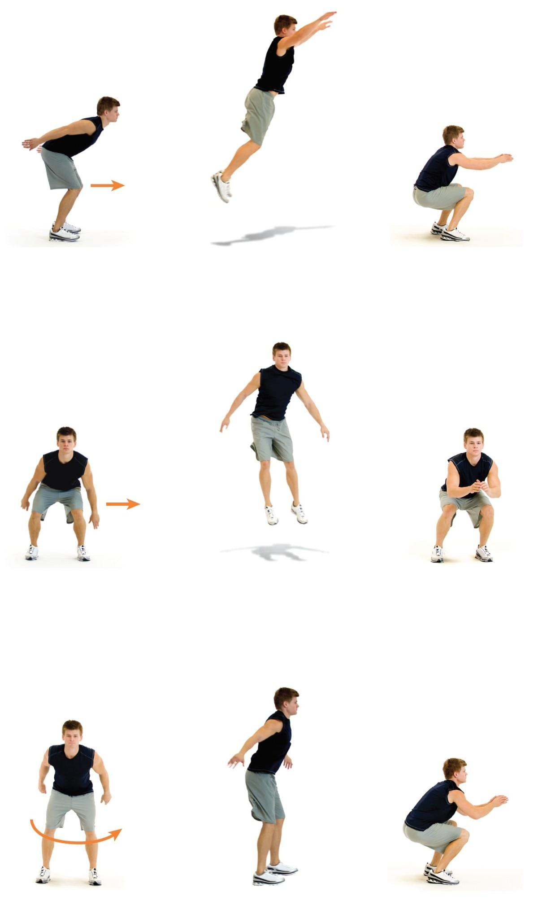

SAFETY

Injuries often occur when rotating or moving laterally, which is why it is important for clients to learn how to accelerate, decelerate, and stabilize in all planes of motion.

Squat Jump

 

TECHNIQUE

Make sure to land with the ankles, knees, and hips flexed and pointed straight ahead, which becomes the takeoff position as well. This will ensure optimal joint mechanics and muscle recruitment. Perform the exercise with a repetitive (medium) tempo.

Lunge Jump

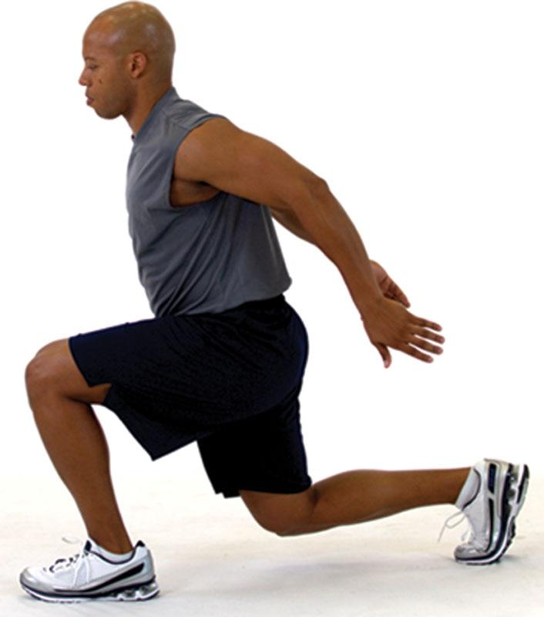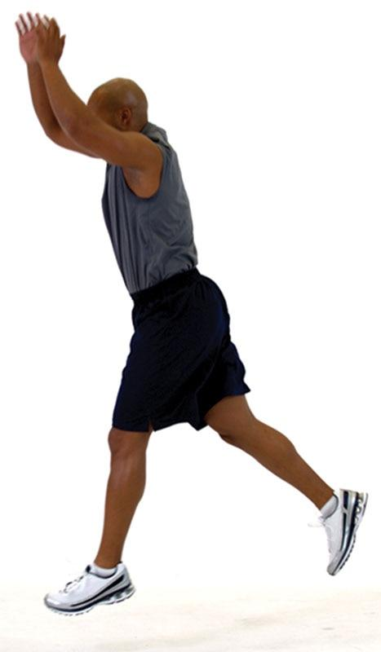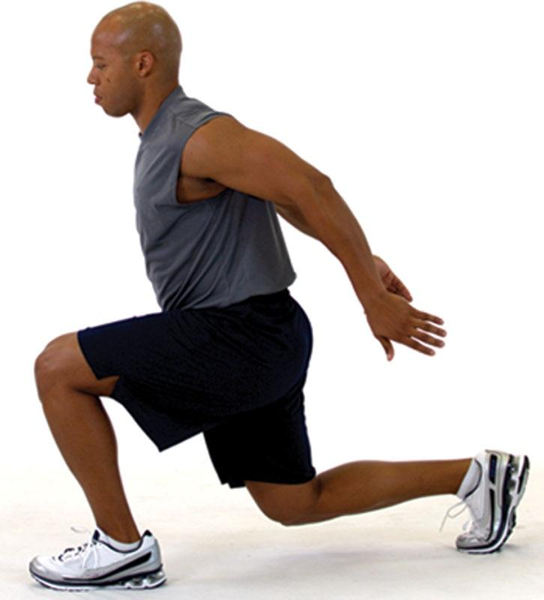

TECHNIQUE

Make sure to keep the front foot pointed straight ahead during takeoff and landing. Do not allow the front foot to externally or internally rotate. Also, keep the front knee pointed straight. Do not allow the front knee to cave inward during the landing, as this can cause stress to the connective tissue within the knee.

Tuck Jump

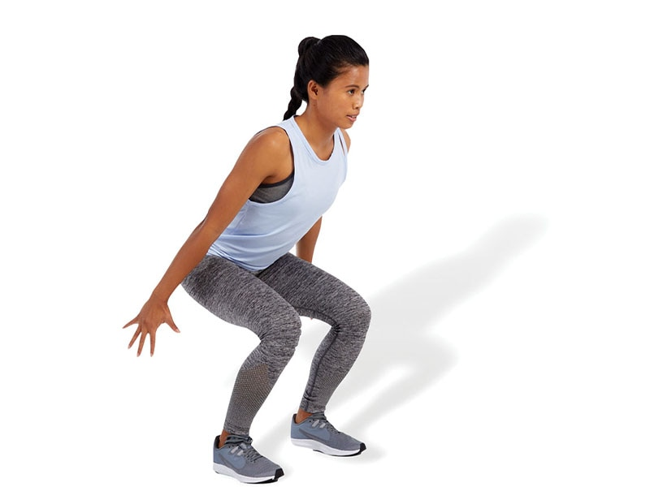 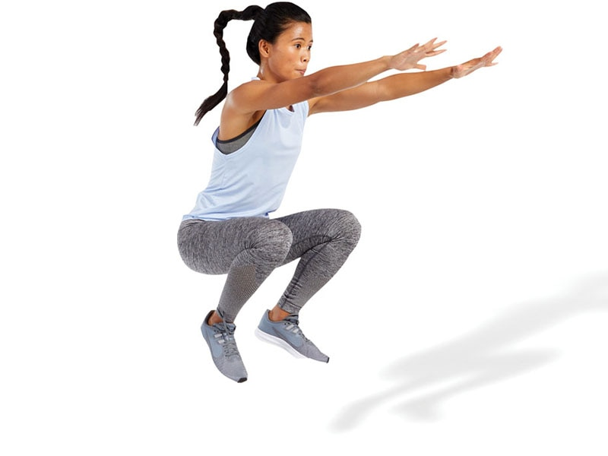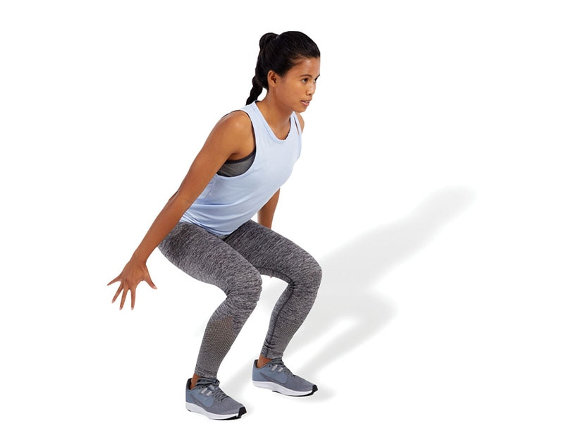

SAFETY

Now that the exercises are becoming more dynamic, proper alignment and landing mechanics will be even more important to maximize force production and prevent injury.

Butt Kick

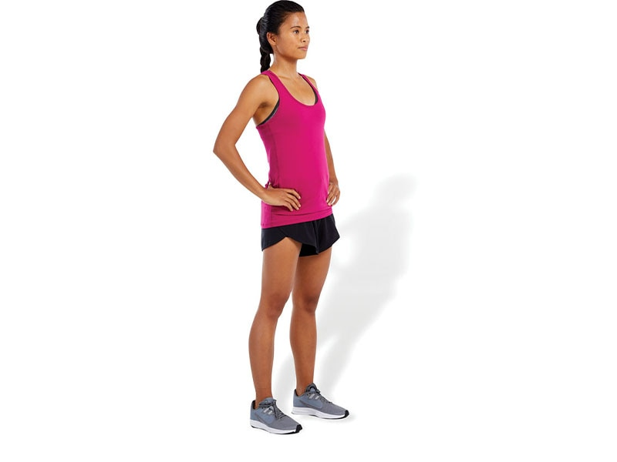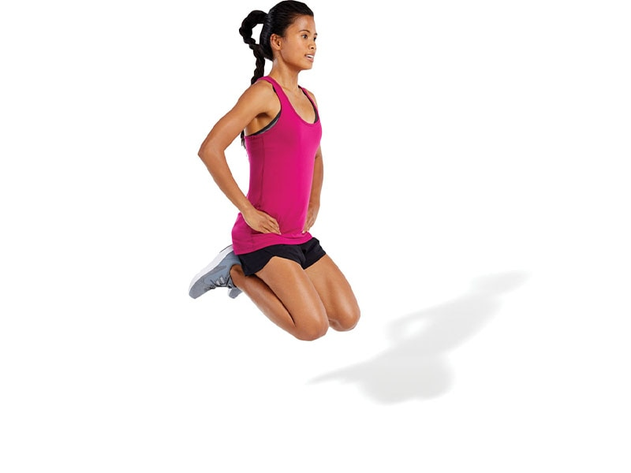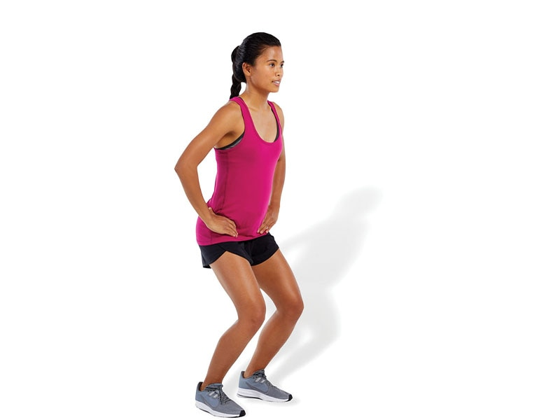

SAFETY

It is important that the client has ample amounts of flexibility of the quadriceps to ensure proper execution. Tight quadriceps may cause a client to arch their lower back when bringing their heels toward the gluteal muscles.

Repeat Box Jumps

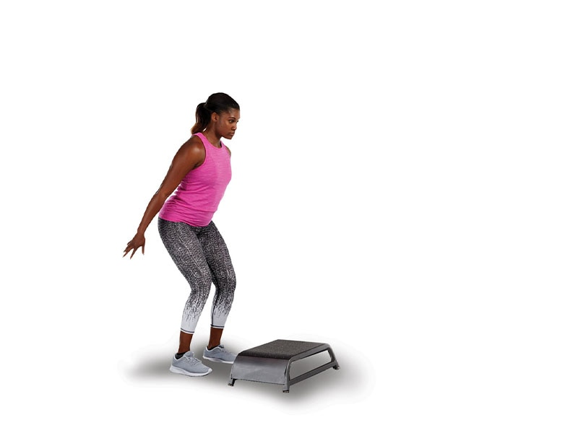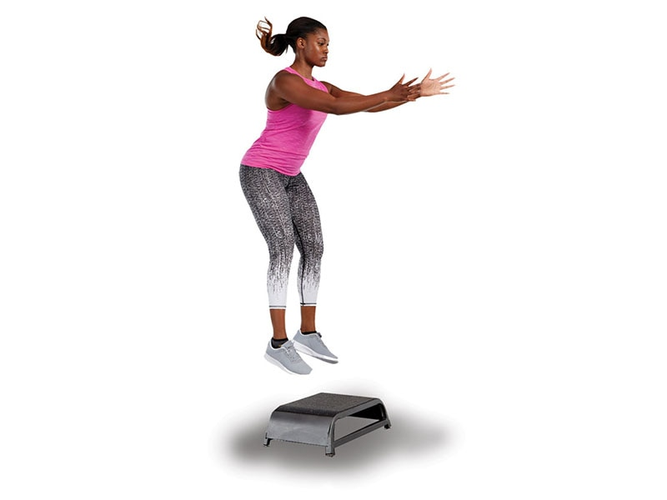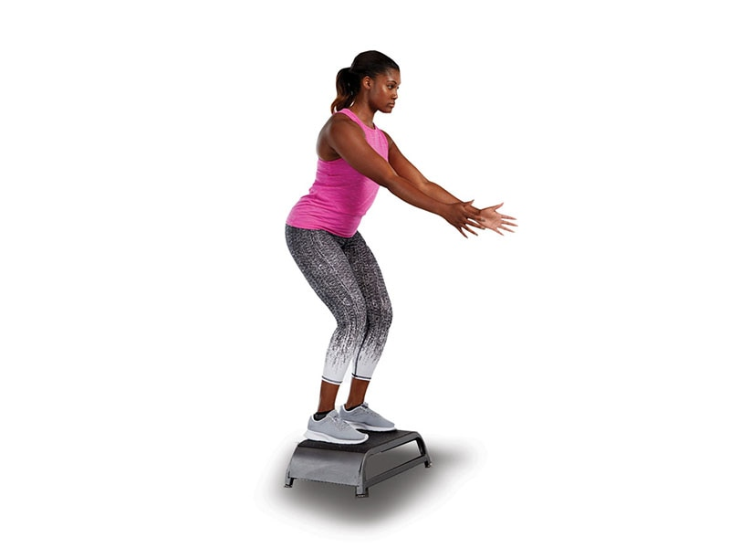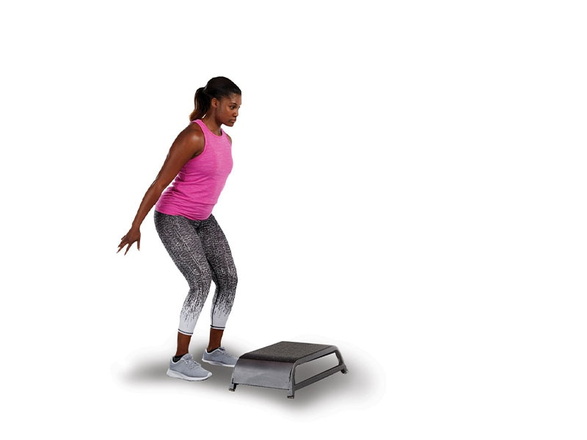

SAFETY

Choose a box height that is appropriate for your client. Tripping on the box is a potential hazard.

Power Step-Up

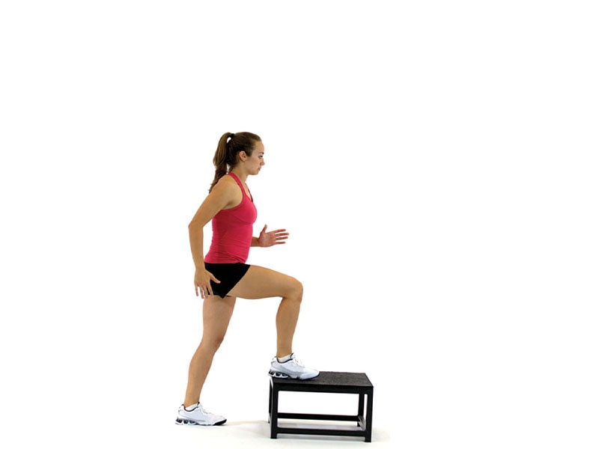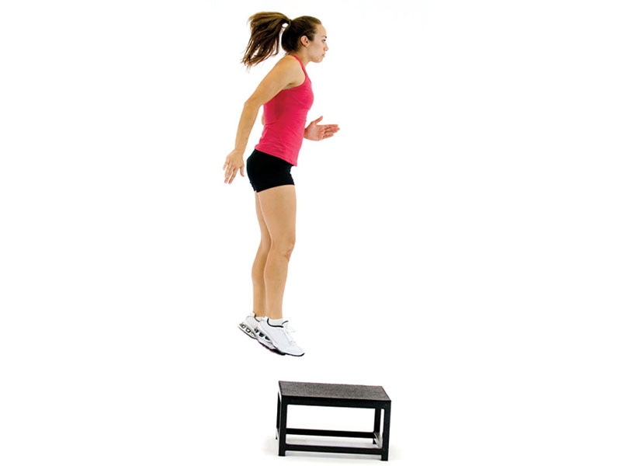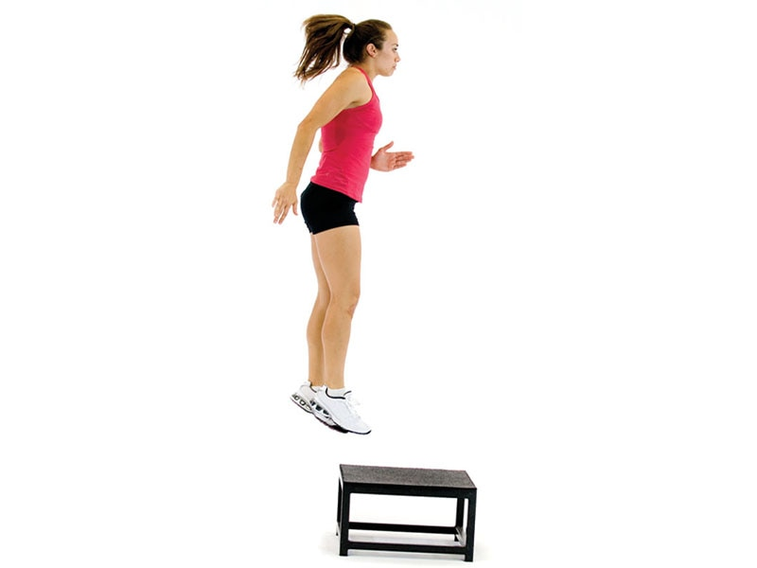

TECHNIQUE

Make sure the knees always stay in line with the toes throughout the jumping phases of takeoff and landing.

Ice Skaters (aka Skater Jumps)

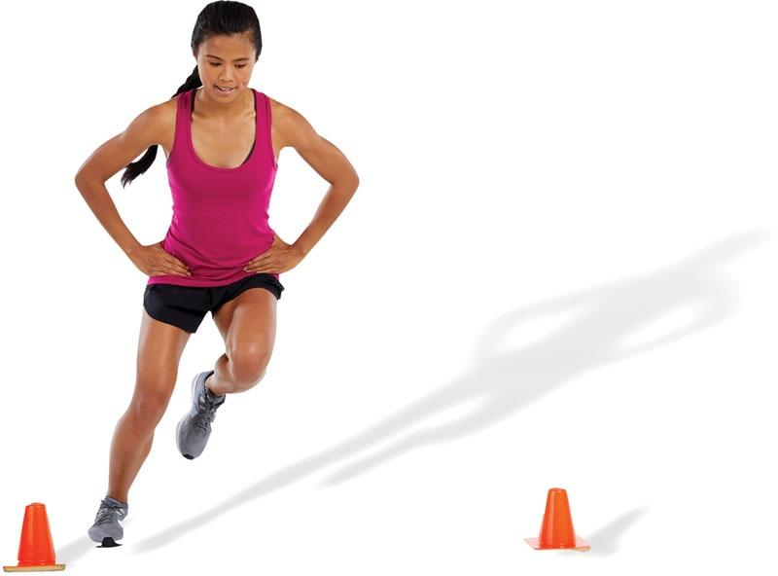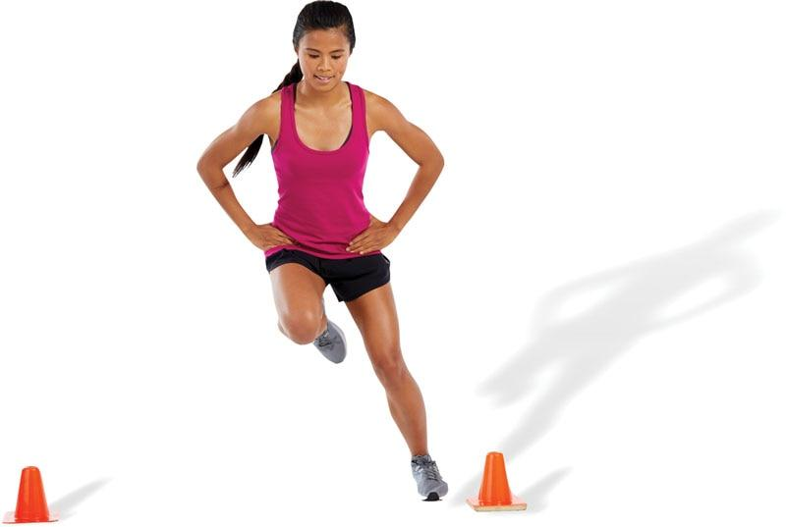

TECHNIQUE

The client can start by hopping side to side from one foot to the other as fast as possible and then progress by adding a reach with the opposite hand to make it more integrated (skating action).

Single-Leg Power Step-Up

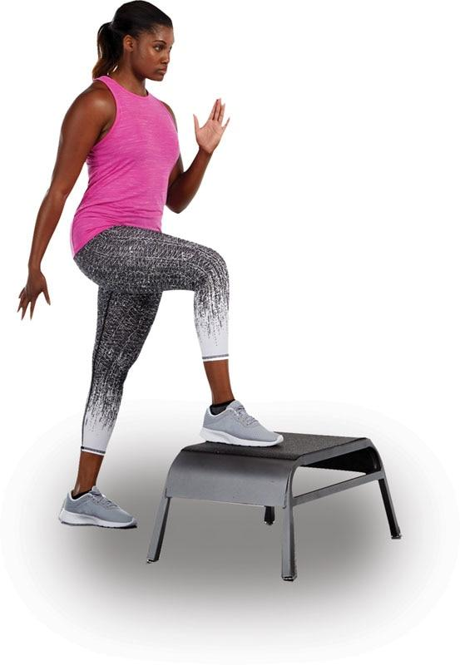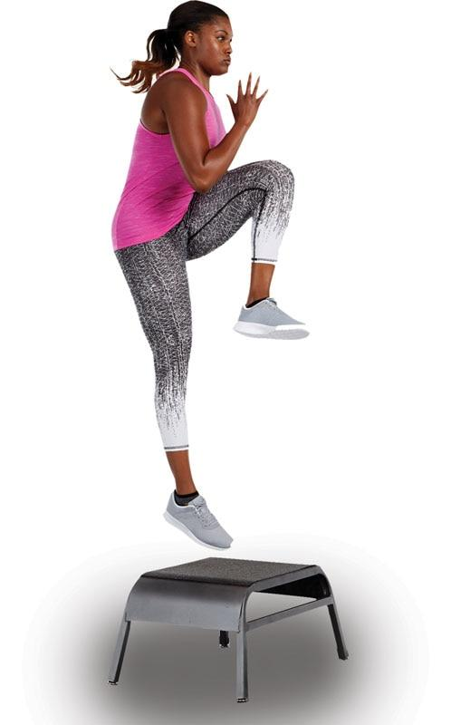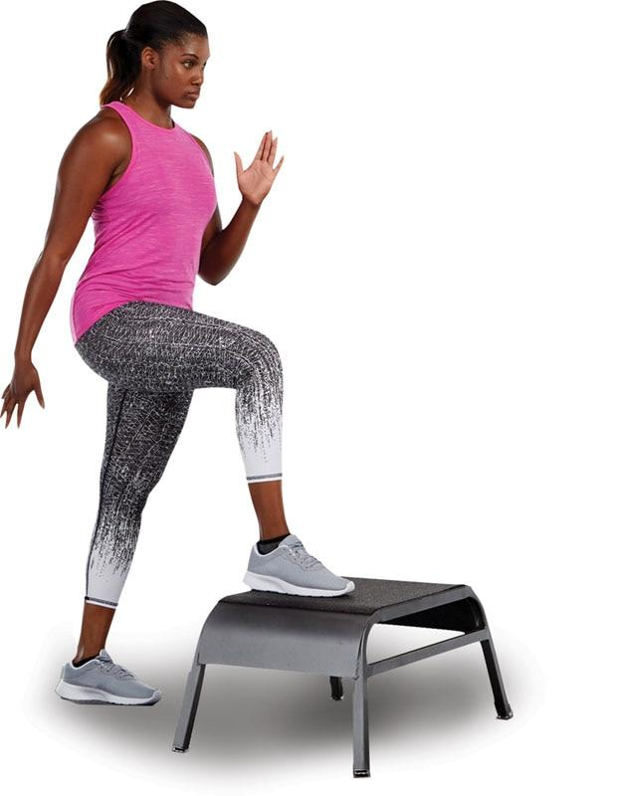

SAFETY

Clients must be made aware that one foot will land on the box and the other will continue to the ground so that the legs will be offset during the landing phase. Therefore, they must be mentally prepared to absorb the landing in this unique position.

Proprioceptive Plyometrics

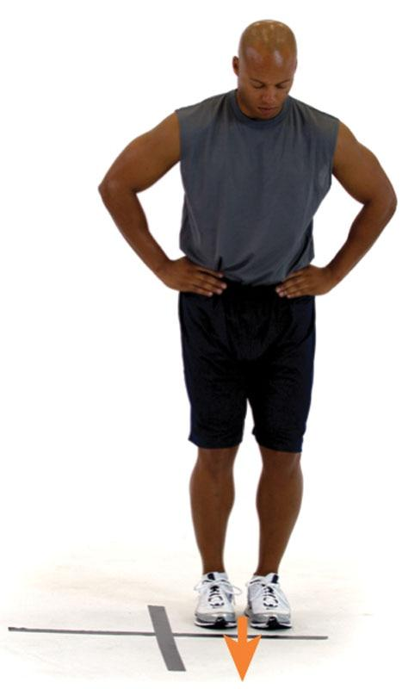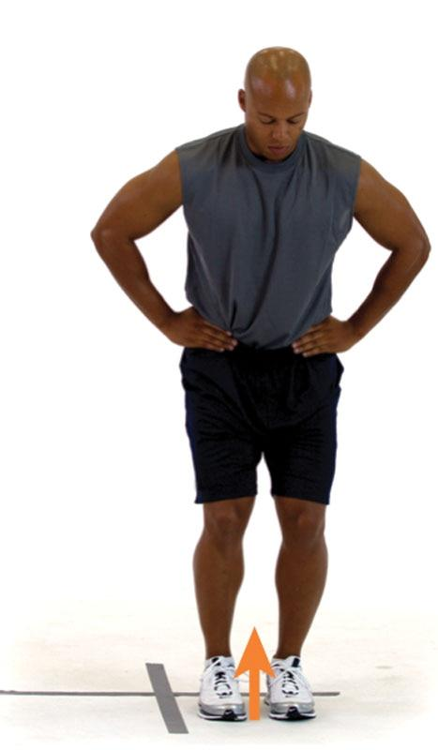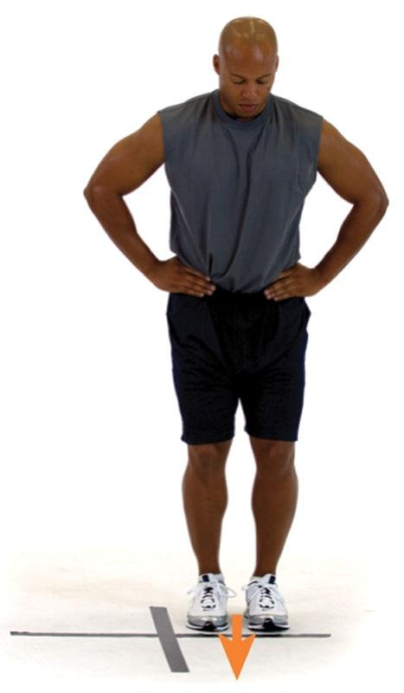

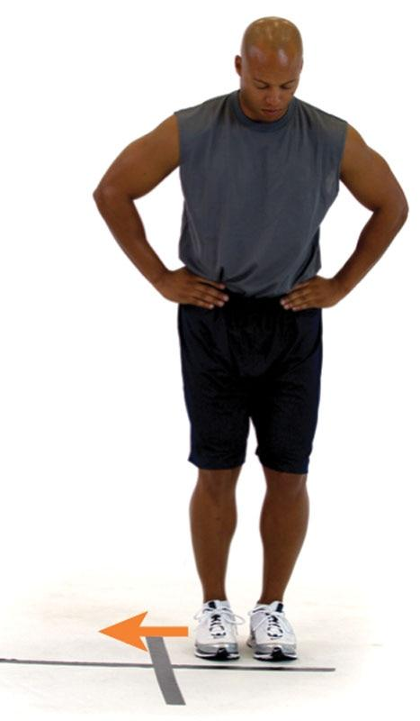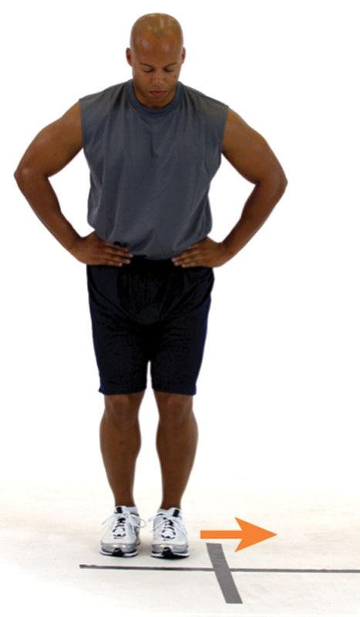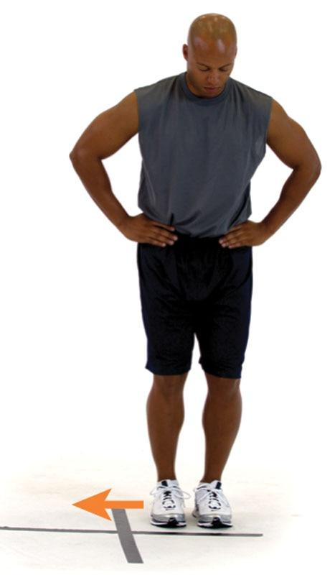

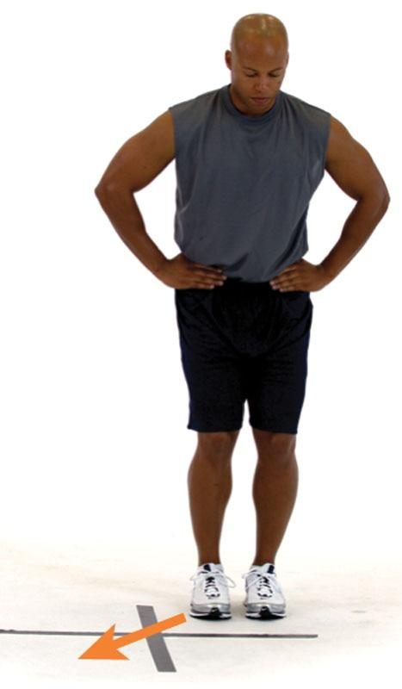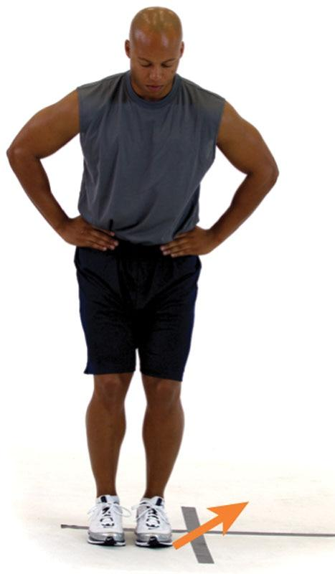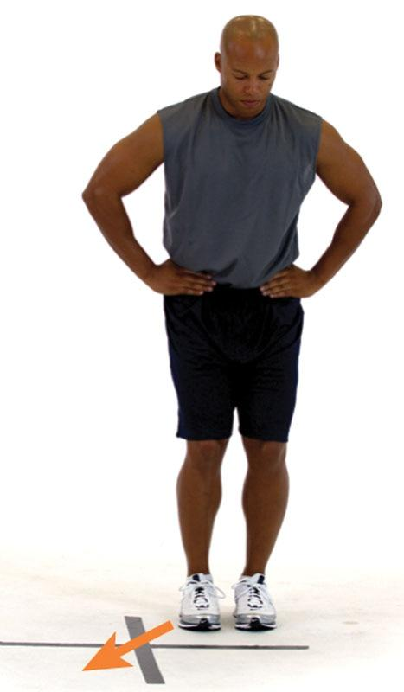

TECHNIQUE

This exercise can be performed with cones or hurdles to increase the intensity of the exercise. If cones or hurdles are not available, the fitness professional can also place tape on the floor in the form of an X and perform the exercise by jumping in different quadrants.

Depth Jump

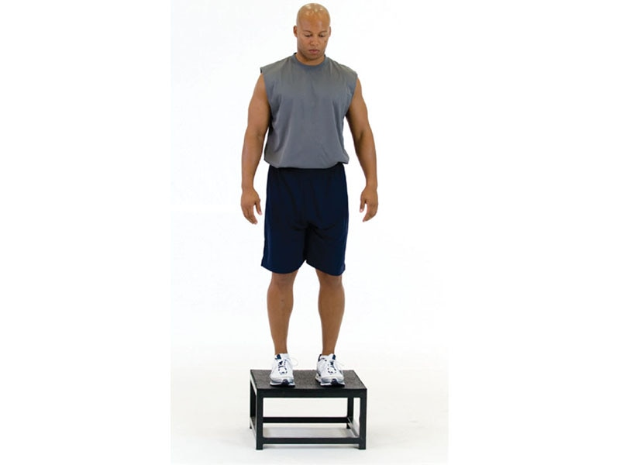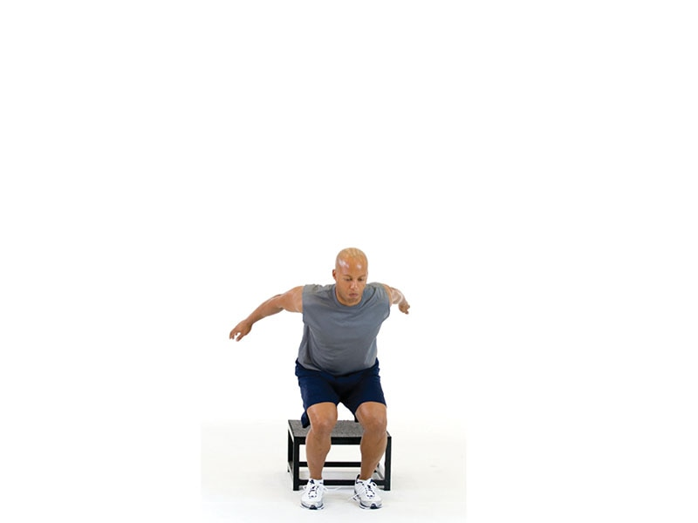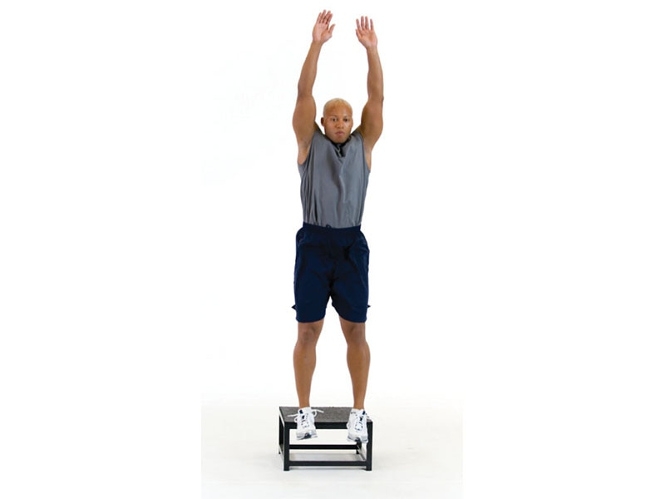

TECHNIQUE

Land from the box softly with both knees pointed straight ahead before initiating the jump from the ground. The depth jump is an advanced plyometric exercise that requires precise technique.

Plyometric Push-Up

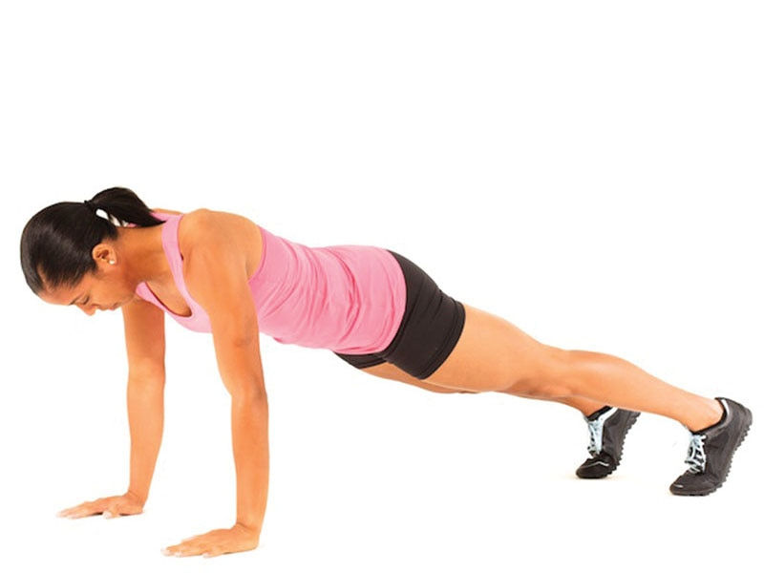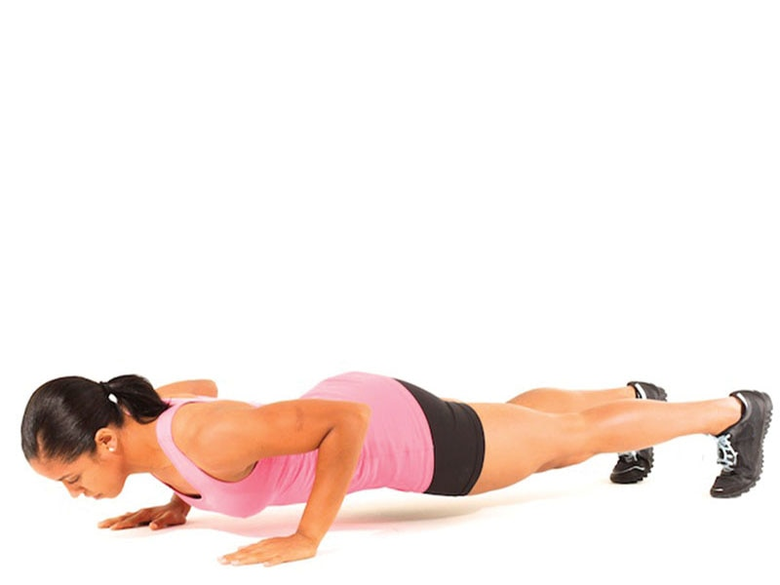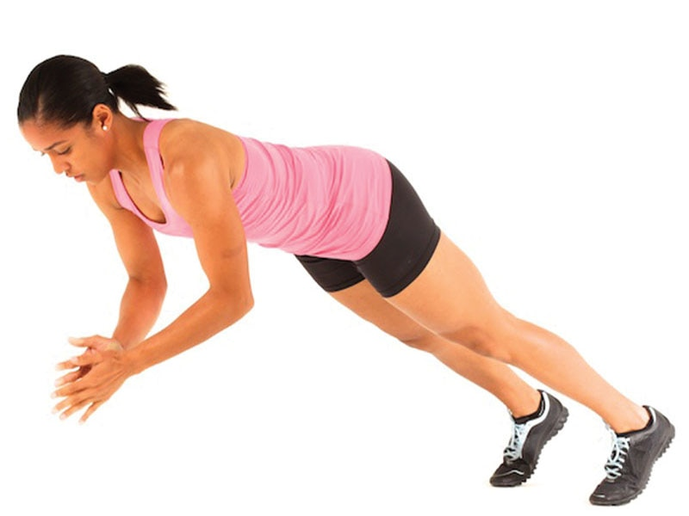

SAFETY

Avoid this exercise if the client experiences hand or wrist pain.

### Speed, Agility, and Quickness training

Speed, agility, and quickness (SAQ) training is a useful and effective method of fitness training that stimulates muscular, neurological, connective tissue, and even cardiovascular fitness adaptations (Simonek et al., 2016; Young et al., 2015). SAQ exercises present the body with numerous scenarios requiring coordinated movements, reaction to various stimuli, and quick bursts of speed. These challenges can promote improvements in physical performance and sustain youthful movement throughout life. When clients are properly prepared, and SAQ training is done appropriately, it can be a valuable addition to any fitness-training regimen.

The term speed, as it is used throughout this text, refers to straight-ahead velocity and is measured as distance covered, then divided by time (distance ÷ time). Agility requires the ability to sprint in multiple directions (running and cutting) while maintaining postural control and oftentimes requires reacting to a stimulus. Quickness refers to the ability to react to a stimulus (i.e., reaction time) and appropriately change the motion of the body in response to that stimulus (such as hitting a baseball).

SAQ training improves a client’s ability to accelerate, decelerate, and dynamically stabilize the entire body during high-velocity movements in all planes of motion (such as running and cutting). In addition, SAQ training stimulates the nervous system to respond more efficiently to demands placed on it and enhances muscular recruitment and coordination when performed with correct mechanics (Simonek et al., 2016; Young, et al., 2015).

It is important to note that agility and change of direction (COD) are separate, although both of these related concepts fit underneath the umbrella of agility training. Agility involves reacting to a signal, or stimulus and then changing the body’s sprinting direction in response to that stimulus. A good example of this concept is of a coach instructing an athlete to run in various directions (e.g., shuffle left, shuffle right, forward, backward) in no discernable order, by pointing in various directions. This requires the athlete to react to the coach’s cues and respond accordingly. Conversely, COD does not involve reacting to a signal, but it still requires an individual to accelerate, decelerate, and change directions, such as an athlete running through a predetermined obstacle course (Young et al., 2015). This differentiation is important as fitness professionals design agility drills, which should involve a response to a signal versus only working on COD.

HELPFUL HINT

Change of direction (COD) requires a client or athlete to run in all directions at maximum speeds. As such, it requires optimal body control and coordination. Examples of COD include running through an obstacle course or performing predetermined cone drills.

Agility combines COD with unpredictability. In other words, it requires a client or athlete to react to a stimulus and sprint accordingly in the proper direction. An example would be a group of school children playing a game of tag.

**Speed**

Speed is the ability to move the body in one direction as fast as possible. It is the product of stride rate and stride length (Bailey et al., 2017; Barnes & Kilding, 2015; Moore, 2016; Van Oeveren et al., 2017). Stride rate is the number of strides taken in a given amount of time (or distance). Stride length is the distance covered in one stride, during running. Although certain aspects of speed are dependent on genetic factors, it is a skill that can be learned through an integrated training program (Salonikidis & Zafeiridis, 2008). Not every client needs to run as fast as an elite athlete, but speed improvements among athletic and nonathletic clients can have both performance and health-related advantages. Speed-specific exercises (i.e., sprinting drills) stimulate muscle tissue and nerves in ways that other training methods do not and thus can stimulate health and performance adaptations that will be missed if it is not included in a fitness training program.

**Proper sprint mechanics**

Proper running mechanics enable the client to maximize force generation through biomechanical efficiency, allowing maximal movement velocity to be achieved in the shortest time possible. Two important aspects of sprint technique are frontside and backside mechanics. Frontside mechanics involve *triple flexion*, which includes the synchronized movement of ankle dorsiflexion, knee flexion, and hip flexion. Improved frontside mechanics are associated with better stability, less braking force, and increased forward driving force. Proper frontside mechanics align the lead leg to optimally apply force into the ground to help propel the body forward. Backside mechanics involve *triple extension*, which includes the synchronized movement of ankle plantar flexion, knee extension, and hip extension.

Improved backside mechanics are associated with a stronger push phase, including hip-knee extension, gluteal contraction, and backside arm drive. Frontside and backside mechanics work in synchrony to apply force to the ground, recover from a stride cycle, and propel the body forward effectively. When executing either frontside or backside mechanics drills, it is essential to keep the pelvis in a neutral position to facilitate proper range of motion and force production (Table 19-1).

HELPFUL HINT

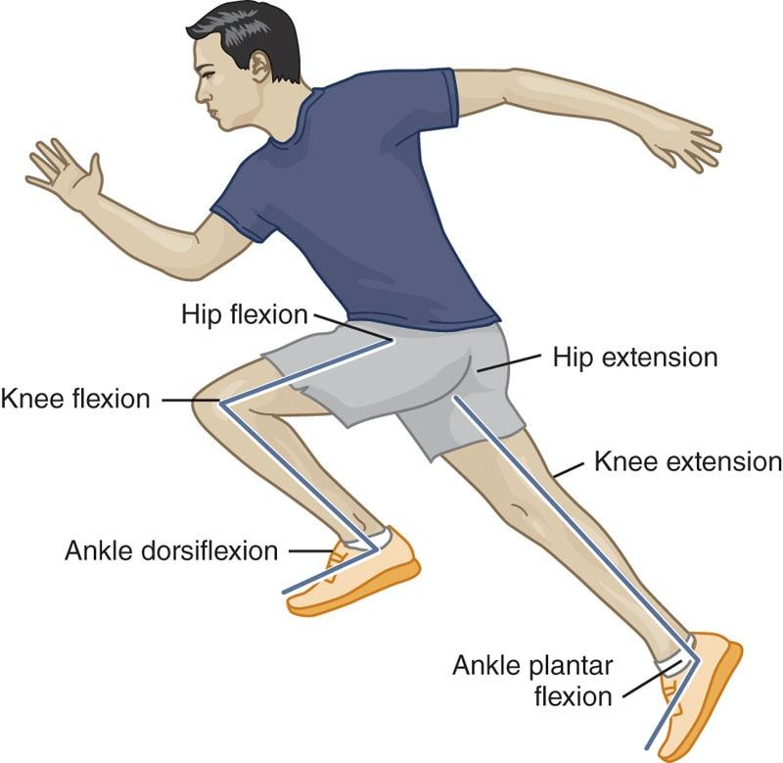

Triple flexion includes ankle dorsiflexion, knee flexion, and hip flexion; the lead leg while sprinting. Triple extension includes ankle plantar flexion, knee extension, and hip extension; the rear leg while sprinting.

TABLE 19-1 Kinetic Chain Checkpoints During Running Movements

| **Body Position** | **Comments** |
| --- | --- |
| Foot/ankle complex | While sprinting forward, the foot and ankle should be pointing straight ahead in a dorsiflexed position when it hits the ground. Slight deviations (e.g., foot external rotation) are expected during multidirectional running and lateral shuffles. |
| Excessive flattening or external rotation of the foot will create abnormal stress throughout the rest of the body and decrease overall performance. |
| Knee complex | The knees must remain straight ahead. Avoid excessive knee valgus (i.e., knock knees). |
| If the athlete demonstrates excessive adduction and internal rotation of the femur during the stance phase, it decreases force production and may lead to overuse injuries. |

|  |  |
| --- | --- |
| Lumbo-pelvic-hip complex (LPHC) | The body should have a slight forward torso lean during acceleration. |
| During maximal velocity, the LPHC should be fairly neutral, without excessive extension or flexion, unless to reach for an object. |
| Head | The head should remain in line with the LPHC, and the LPHC should be in line with the legs. |
| The head should not compensate and jut excessively forward, unless necessary to track an object (such as a ball), as this can affect the position of the LPHC (known as the pelvo-ocular reflex). |

**Agility**

Agility necessitates the ability to start (or accelerate), stop (or decelerate and stabilize), and change direction while maintaining postural control (Hojka et al., 2016; Lockie et al., 2019). Agility requires high levels of coordination to be able to maintain one’s center of gravity over their base of support while changing directions at various speeds. Agility training can enhance deceleration capabilities, dynamic flexibility, postural control, core strength, and proprioception (Trecroci et al., 2016). Proper agility training can also help reduce the risk of injury by enhancing the body’s ability to effectively control eccentric (deceleration) forces in all planes of motion as well as by improving the structural integrity of connective tissue (e.g., tendons and ligaments) during uncontrolled and reactive situations. Proper technique for agility drills should follow the guidelines in Table 19-1.

**Quickness**

Quickness is the ability to react and change body position with maximal rate of force production, in all planes of motion and from all body positions, during dynamic activities. Quickness involves the ability to assess visual, auditory, or kinesthetic stimuli and to provide the appropriate physical response as fast as possible (such as hitting a baseball, returning a tennis serve, or swerving to avoid a car accident).

HELPFUL HINT

Agility often requires an individual or athlete to react to a stimulus and respond accordingly, such as a basketball player running in various directions to avoid a defender.

Quickness also requires an individual to react to a stimulus; however, the response does not require ambulation (e.g., running or sprinting). An example of this would be a hockey goalkeeper defending against a penalty shot.

**Speed, Agility, and Quickness for nonathletic Ppopulations**

Although speed, agility, and quickness training is a widely used and accepted improvement method for sports performance in athletes, components of an SAQ program can also significantly improve the physical health profile of apparently healthy sedentary adults and those with medical or health limitations (Bohrer et al., 2019; Galpin et al., 2008; Zhao et al., 2017). Many recreational activities, such as softball, golf, tennis, hiking, running, skiing, and water sports, require a combination of coordination, power, reaction time, and agility (Ceylan & Saygin, 2015; Cherappurath & Elayaraja, 2017). These activities may become more challenging with age or sedentary living, preventing some from enjoying these activities throughout life. By contrast, the increased physical demands of SAQ training can improve athleticism and movement proficiency and aid in injury prevention (Polman et al., 2009; Simonek et al., 2016; Young et al., 2015) when applied safely and effectively. In addition, individuals from a variety of populations find SAQ training fun and invigorating while increasing exercise compliance, adherence, and effectiveness.

Unlike the more common steady-state, moderate-intensity cardiovascular forms of exercise (such as treadmill walking) often prescribed for nonathletic populations, SAQ drills require greater integration with a variety of the body’s biologic systems. An individual must be able to accelerate, decelerate, and change direction in response to a variety of both predictable and unpredictable stimuli at a relatively high rate of speed. Thus, SAQ training provides a unique challenge to the biologic systems of nonathletic individuals, facilitating constant responses and adaptation. Such rapid adaptation to SAQ training is critical in the development, maintenance, and improvement of physical function from childhood through a person’s senior years.

Because of the elevated intensity of SAQ protocols, it is essential that fitness professionals perform extensive client assessments examining exercise experience, movement quality, health history, and injury profile before beginning an SAQ training program. Moreover, SAQ training should always follow a comprehensive warm-up protocol. Prior to beginning SAQ training, clients should have a good base of fitness that incorporates flexibility (including mobility in the ankles, hips, and thoracic spine), muscular endurance, cardiovascular endurance, and strength. Establishing a solid base of fitness in these components can help nonathletic populations avoid injury when SAQ training is introduced. Once introduced, SAQ drills should progress from slow and simple to fast and complex over an extended period of time. The initial focus during these exercises should be technique rather than speed to ensure that exercises are performed properly and that a client is adequately prepared for these demands before progressing to speed-focused performance.

**SAQ training programs for youth**

From birth, children are programmed to develop progressively higher neuromuscular capabilities in line with their physical and mental maturation. Much of this development is innate at very early stages; for example, crawling progresses to standing, standing progresses to walking, and walking progresses to running. Once a child has developed basic ambulation, the rate and magnitude at which they progress beyond that point often depend on an external interaction with the environment (Drabik, 1996). To continue developing effectively, the environment must challenge children’s biologic systems; in other words, they must learn how to adapt and apply appropriate movement patterns through external measures.

SAQ training for youth is an effective way of providing a variety of exposures to various physiologic, neuromuscular, and biomechanical demands, resulting in the further development of physical ability (Hammami et al., 2017). The majority of youth today spend little time, if any, performing generalized, unstructured physical activity (play time) that facilitates the development of SAQ skills (Belton et al., 2014; Sokolove, 2008). Subsequently, fitness professionals can use play-style activities as a form of SAQ training. SAQ programs for youth have been found to decrease the likelihood of athletic injury (Drabik, 1996; Etty Griffin, 2003; Olsen et al., 2005; Ortega et al., 2008; Sokolove, 2008), increase the likelihood of exercise participation later in life (Janz et al., 2002; Wrotniak et al., 2006), and improve physical fitness (Balciunas et al., 2006; Ruiz et al., 2006).

Based on several research studies (Alp & Baydemir, 2019; Hammami et al., 2017; Ochi & Kovacs, 2016; Trecroci et al., 2016; Yankov, 2016), young athletes can perform SAQ training one to three times per week with four to eight drills per workout; one to four sets of each drill, with three to five repetitions and 15–60 seconds of rest is appropriate for most younger athletes (Table 19-2). Training should start at the lower end of these ranges with a primary focus on exercise technique; over many months, there should be a gradual progression to greater amounts of work with a focus on speed and technique. As with any fitness program, the quantity, frequency, and intensity of SAQ exercises should be appropriate and adjusted accordingly, based on the child’s physical fitness capabilities and maturity level.

TABLE 19-2 SAQ Training for Youths

|  |  |  |  |  |
| --- | --- | --- | --- | --- |
| Frequency/Week | No. of Drills | Sets | Repetitions | Rest Periods |
| 1–3 | 4–8 | 1–4 | 3–5 | 15–60 seconds |

TRAINING TIP

In the beginning stages of training, children should be taught proper exercise technique and be allowed to practice SAQ drills. Once they become accustomed to completing four to five simple exercises once or twice per week, progression to more exercises accomplished two to three times per week can be incorporated over a few months. Shorter rest periods can be included as the child’s fitness improves, if speed and technique are maintained.

Example SAQ drills for youth populations

Red Light, Green Light

1. Participants line up shoulder to shoulder along the base of a designated field, 20 yards (18 meters) long or longer.
2. One participant is chosen as the “stop light” and begins at the opposite end of the field.
3. The stop light turns their back to the other participants and calls “Green light.”
4. On calling green light, the participants all move as quickly as possible toward the stop light.
5. Still with their back to the group, the stop light yells “Red light!” and then immediately turns around.
6. On hearing “red light,” the participants are to stop movement and remain motionless, freezing with perfect stature, form, and control.
7. If the stop light sees anyone move, they call them to start over at the base of the field.
8. This is repeated at arbitrary intervals until a participant is able to reach and touch the stop light.
9. This participant then becomes the new stop light.

Follow the Snake

1. The instructor lays 5 to 10 jump ropes (or one long rope) on the ground in a random S-type pattern.
2. Participants line up on one side of the ropes; keeping a foot on each side of the rope, they follow the pattern of the rope first forward to the end, then backward to the beginning.
3. Participants can be timed to create a competition.

**SAQ training for weight loss**

Interval training in which participants exhibit short, repeated bouts of high-intensity activity has been found to be highly effective in improving a variety of health-related factors. High-intensity, short-duration programs have been found to match (and sometimes surpass) results for functional capacity, muscular power, fat and weight loss, and other metabolic adaptations when compared with moderate-intensity, long-duration exercise protocols, such as jogging (Gibala et al., 2006; Iaia et al., 2009; Schmidt et al., 2001; Talanian et al., 2007; Tjønna et al., 2008; Trembley et al., 1994; Wewege et al., 2017). The high-intensity, short bouts of SAQ drills make them a valid choice for interval training modalities with appropriate nonathletic populations. The variety of exercises provided through the incorporation of SAQ training can increase participants’ adherence by making a program fun and engaging (Jakicic et al., 1995). Although athletes use these drills to improve their sport-specific abilities (Cherappurath & Elayaraja, 2017), weight-loss clients can also benefit from the increased exercise intensity and variety of movements, as long as the client is capable of performing the exercise safely and at a high enough intensity throughout an extended workout. This can be done by creating a small circuit of appropriately challenging SAQ exercises.

STRETCH YOUR KNOWLEDGE

High-intensity interval training can burn more subcutaneous fat than long-duration, low- to moderate-intensity endurance training (Trembley et al., 1994; Viana et al., 2019).

When designing SAQ programs for weight loss, the primary focus of the program is to keep heart and respiration rates appropriately elevated to increase caloric expenditure. It is critically important to administer a thorough fitness assessment before beginning an SAQ protocol with a weight-loss client and to maintain appropriate levels of exercise intensities based on the client’s abilities and fitness level. Fitness professionals should gradually introduce SAQ training to avoid excessive impact, muscle soreness, and joint stress, with SAQ exercises included in one to two workouts per week. Technique must be mastered in each exercise used, allowing clients to perform each exercise at a comfortable speed. Gradually, the quantity of exercises can be increased as a client’s fitness improves.

TRAINING TIP

As a weight-loss client’s fitness improves, the volume of SAQ exercises can increase. One strategy is to include SAQ exercises in two to three workouts per week, doing three to four sets of three to five repetitions, and 15 to 60 seconds of rest between repetitions. To maintain or increase a high metabolic demand, less rest is given between repetitions, but use caution to avoid improper execution of an exercise.

**SAQ circuits for weight-loss populations**

Circuit 1

1. Jump rope: 30 seconds (using various foot patterns)
2. Rest for 20 to 60 seconds depending on the client’s ability to maintain intensity.
3. Cone Shuffles: 30 seconds

* Place eight cones in a line about 30 inches (76 centimeters) apart.
* The client lines up facing the line of cones.
* The client lowers their center of gravity and side shuffles in and out of the cones without hitting them.
* The client first performs this facing forward and then facing backward.
* This is repeated for the duration of the station.
* Other foot patterns can be used as well, such as forward, backward, and stepping over the cones.

1. Rest 20 seconds.
2. Any three ladder drills: 30 seconds (see Agility Ladder Drills)

Circuit 2

1. 5-10-5 Drill: 30 seconds (see 5-10-5 Drill)
2. Rest 20 seconds.
3. Modified Box Drill: 30 seconds (see Modified Box Drill)
4. Rest 20 seconds.
5. Partner Mirror Drill: 30 seconds

* Place two cones 10 yards apart.
* Two clients stand in between the cones, facing one another.
* One partner is designated the leader; the other is designated the mirror.
* Staying in between the cones, the leader moves in a variety of patterns, shuffling, jumping, dropping to the ground, turning around, and so forth.
* The mirror mimics the motion of the leader without falling behind.
* The leader and the mirror switch each time the drill is done.

**SAQ training for older adults**

SAQ training for seniors may help prevent age-related decreases in bone density, coordinative ability, and muscular power (Bean et al., 2002; Liu-Ambrose et al., 2005). This aids in the prevention of injury and an increase in quality of life (Bean et al., 2002; Galpin et al., 2008; Liu-Ambrose et al., 2005; Sobolewski et al., 2018). Although some loss of physical function is an inevitability of the aging process, recent research has determined that these losses can be minimized by appropriate exercise interventions. Osteopenia, or loss of bone density and a precursor to osteoporosis, is often related to the aging process, particularly in women. This increases the likelihood for bone fractures and other acute and chronic skeletal disorders, such as osteoporosis. Research has determined that properly administered programs requiring an elevated degree of load on the skeletal system (e.g., weight-bearing exercise), such as those found in SAQ protocols, are safe and effective in slowing and potentially reversing osteopenia in older adults (Heinonen et al., 1996; Iwamoto et al., 2001).

STRETCH YOUR KNOWLEDGE

A 10% loss of bone density at the hip can result in a 2.5 times greater risk for hip fracture (West et al., 2015).

The confidence and ability to sit, stand, bend, twist, and walk are essential in older adult populations to aid in the prevention of falls and maintain daily life activities. The abilities required for safe, effective movement often decline with age primarily because they are underused (Laroche et al., 2007). To maintain and improve these abilities, it is essential that older populations practice coordinative skills on a regular basis. SAQ-based programs have been found to improve coordination and movement confidence, decreasing the likelihood of falling or other movement-related injuries (Bohrer et al., 2019; Jessen & Lund, 2017; Liu-Ambrose et al., 2004; Sundstrup et al., 2010; Zhao et al., 2017).

Sarcopenia, or age-related loss of skeletal muscle mass, can be detrimental to maintaining functional capacity in older adults. Resistance training as well as SAQ-based interventions has been found to help slow and reverse this process. Slowing and reversing sarcopenia has particular relevance with interventions requiring increased speed of movement and rate of force production, similar to those found in SAQ protocols (Bean et al., 2004; Bibiloni et al., 2018; Newton et al., 2002; Porter, 2006).

When designing an SAQ program for older adults, the fitness professional must take special care when ensuring safety for participants. Drills should focus around activities the individuals will need for daily life, such as standing up from a chair and navigating ground obstacles. Fitness professionals should consider the clients’ readiness for SAQ exercise before beginning these drills. Prior to beginning SAQ drills, fitness professionals must ensure that older clients are able to perform common activities of daily living, such as rising from a chair, maintaining balance while walking and maneuvering, comfortably moving up and down stairs, squatting, lunging, and bending. As adults age, visual tracking and vestibular (balance) performance also decrease, increasing the risk of missteps and falls.

While SAQ training can have positive impacts, the risk of falls must be considered prior to introducing SAQ training. A foundation of strength and flexibility is very important to ensure that older clients can safely perform SAQ exercises and gain the value offered by these exercises. A gradual progression over several months, from simple to more complex exercises, is important to allow clients plenty of time to learn different exercises at an appropriately challenging level.

TRAINING TIP

Initially, low volume (i.e., one to two sets of one to two drills) is sufficient to improve fitness among older adults, and progression to more volume should occur slowly, avoiding large increases in volume from one week to the next.

**SAQ drills for seniors**

Varied Size Cone/Hurdle Step-Overs

1. In a line 10 to 15 yards (9 to 14 meters) long, place various size cones, hurdles, and other objects about 24 inches (61 centimeters) apart.
2. The client lines up, facing sideways to the line of objects; as they step over each object, they move down the line and then back to the start.
3. The client can be timed.

Stand-Up to Figure 8

1. The client begins seated in a chair.
2. Two cones are placed directly in front of the chair, with the first placed 10 to 15 feet (3 to 4.5 meters) away; the second is placed 20 to 25 feet (6 to 7.6 meters) away, directly behind it.
3. On the instructor’s command, the client stands up from the chair as quickly as possible.
4. As quickly as possible, they move to the left of the first cone, then to the right of the second cone while turning around, to come back to the chair to complete a “figure 8” around the cones.
5. The client then repeats the figure 8 in the opposite direction and finishes by sitting in the chair.
6. The client is timed.

**SAQ drills and programming strategies**

SAQ exercises should be integrated carefully into a client’s overall training program. It should be emphasized that the programming guidelines presented in Table 19-3 are only meant to be suggestions and should be gauged on the total volume of training for all components (cardio, core, balance, plyometric, and resistance) in a workout. As the demands for movement speed and reactivity increase, so do the risks of injury. The safety and success of an SAQ program is dependent on the physical capabilities and fitness level of the client. The better a fitness professional can match drills appropriate to a client’s capabilities, the safer and more effective the program will be. All exercises should be performed with precise technique to minimize risk of injury.

TABLE 19-3 SAQ Program Design for Apparently Healthy Adults

| **Client Experience Level** | **SAQ Exercise** | **Sets** | **Reps** | **Rest** |
| --- | --- | --- | --- | --- |
| Beginner | 4–6 drills with limited inertia and unpredictability, such as Cone Shuffles and Agility Ladder Drills | 1–2 | 2–3 | 15–60 seconds |
| Intermediate | 6–8 drills allowing greater horizontal inertia but limited unpredictability, such as 5-10-5, T-Drill, Box Drill, and Stand-Up to Figure 8 | 3–4 | 3–5 | 0–60 seconds |
| Advanced | 6–10 drills allowing maximal inertia and unpredictability, such as Modified Box Drill, Partner Mirror Drill, and timed drills | 3–5 | 3–5 | 0–90 seconds |

**SAQ Speed Ladder Drills**

One-Ins and Two-Ins

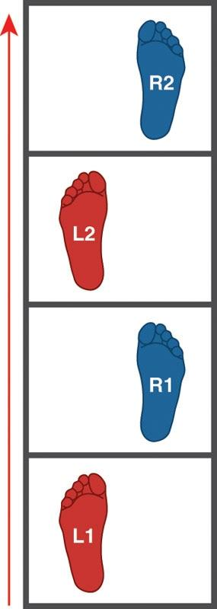

One-ins

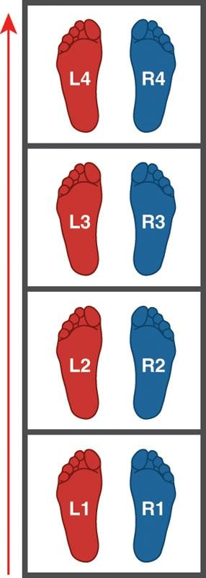

Two-ins

In-In-Out-Out and In-In-Out (Zig Zag)

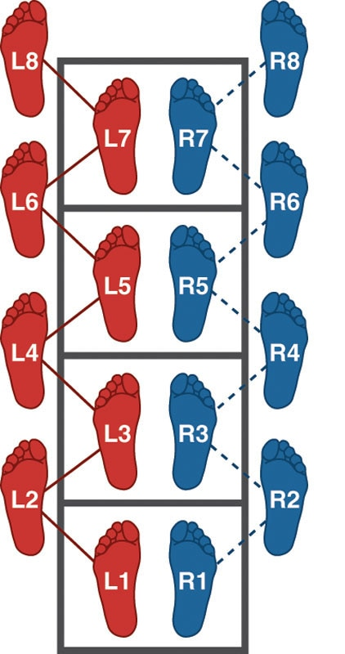

In-In-Out-Out

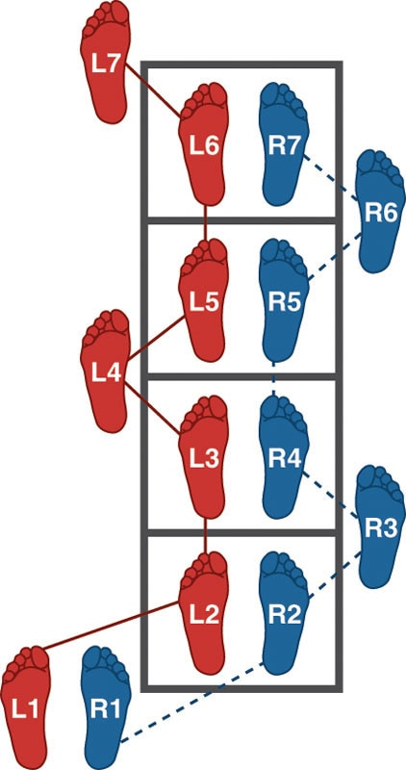

In-In-Out (Zig Zag)

Side Shuffle and Ali Shuffle

Side Shuffle

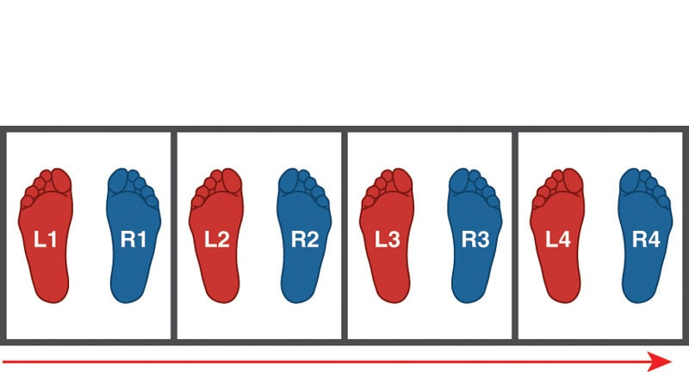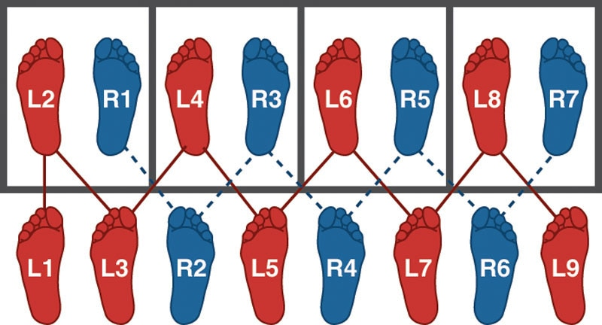

Ali Shuffle

SAQ Cone Drills

5-10-5 Drill

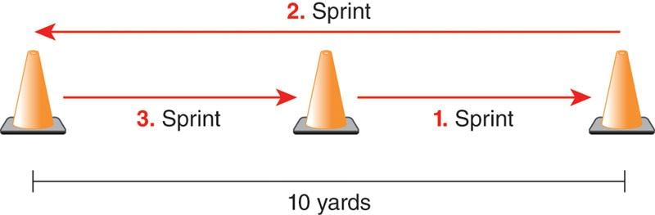

Modified Box Drill

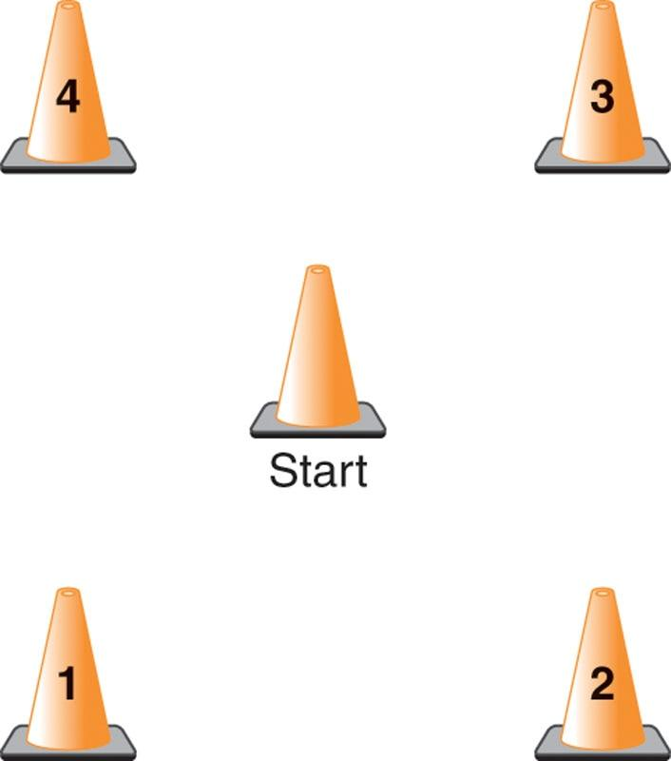

TECHNIQUE

For this drill, the client begins at the middle cone. The fitness professional then calls out a cone number. The client moves to the appropriate cone and returns to the middle to wait for the fitness professional to call another number.

T-Drill

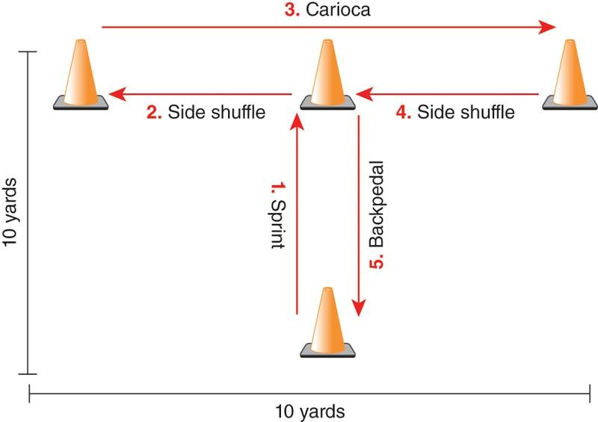

Box Drill

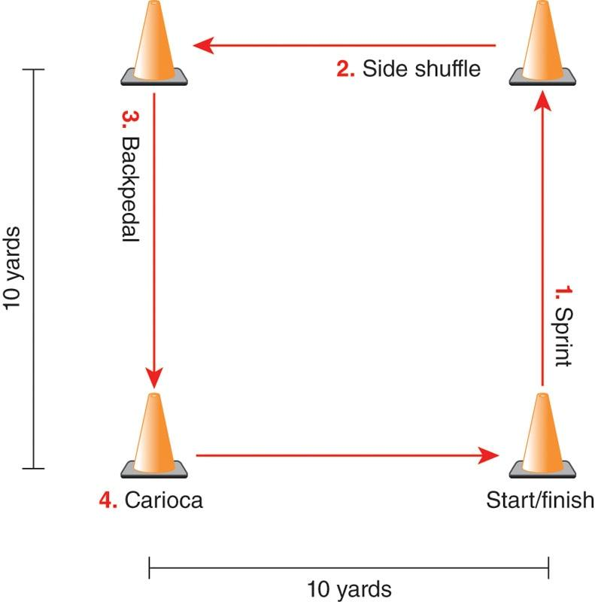

LEFT Drill

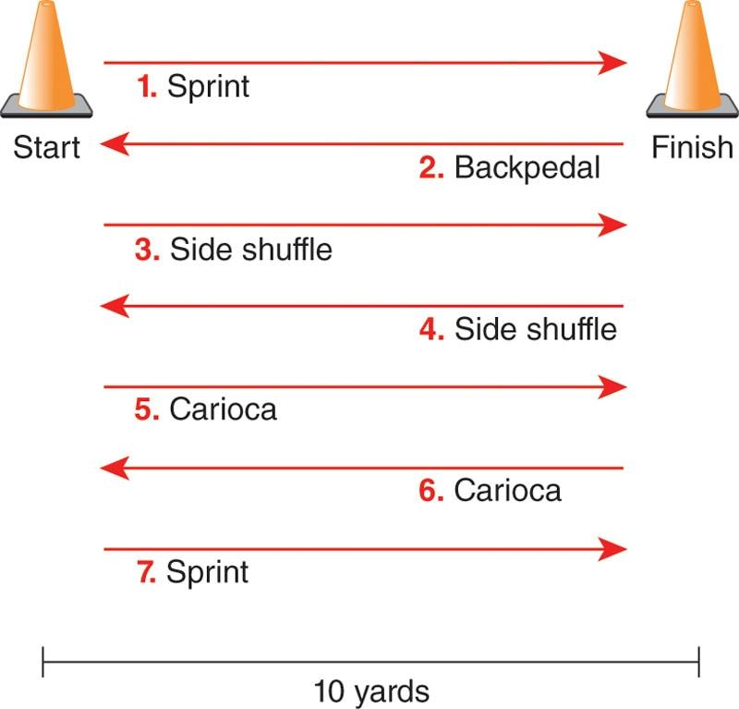

## Resistance training

Creating a well-designed, strategic, safe, and effective training program can be a complicated process that is often required for Certified Personal Trainers before they are able to assist their clients in meeting their needs and goals. Careful consideration must be taken to adequately meet the many facets of exercise principles, including any manipulation of training variables throughout the planned program. By adhering to certain fundamental principles, the fitness professional needs to ensure that workout programs produce the desired outcomes. A variety of essential training principles should guide the development of effective training programs, especially resistance training. Programs that fail to address these fundamental principles may be at risk for lower exercise adherence and increased risk of injury.

Fitness professionals must understand the fundamental principles, scientific nature, and application of resistance training to be an effective guide toward their client’s results. It is with these principles and application that designing safe, customized, and individualized training will govern appropriate and obtainable workouts. This chapter explores many critical resistance training concepts involved in designing and implementing strength training programs for all abled populations. The primary focus of this chapter includes principles of adaptation, progressive overload, principles of specificity, characteristics of strength development, and various types of training systems, implementation, and exercise progressions.

**Principle of adaptation**

One of the more unique features and traits of the human body is its ability to adapt under various conditions, including stress, environmental changes, and functional capacities. Resistance training also elicits physical adaptations (Figure 20-1). Regardless of the primary goal of the client, whether it is related to aesthetics or sports performance, resistance training has been shown to exhibit significant favorable outcomes (Duchateau et al., 2006; Gabriel et al., 2006) Table 20-1.

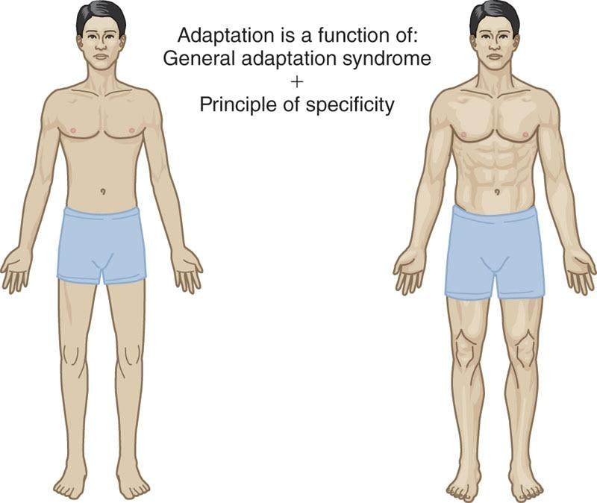

**Figure 20-1** Resistance training principle of adaptation

TABLE 20-1 Adaptive Benefits of Resistance Training

| **Physical and Performance Benefits** | |
| --- | --- |
| Improved cardiovascular efficiency  Improved endocrine (hormone) and cholesterol adaptations  Increased muscular hypertrophy (larger muscles)  Increased bone density  Increased metabolism  Decreased body fat | Increased neuromuscular control (coordination)  Increased connective tissue (tendons, ligaments) strength  Increased muscular endurance  Increased muscular strength  Increased power |

**General Adaptation Syndrome**

The general adaptation syndrome (GAS) is the central theory governing overall adaptation to training responses. GAS was first proposed in 1936 by Hans Selye, a Canadian physician. It is used to describe the process of how an organism adapts when it is exposed to an acute, or even damaging stimulus (Selye, 1936).

According to this early model, damaging agents included excessive muscular exercise, cold shock, or sublethal drug doses. However, within the context of resistance exercise, the stress placed on the body is the weight used during resistance training. This can be considered a good form of stress called *eustress*, which helps the body adapt over time and become better accustomed to resistance exercise. For adaptation to occur, over time the body must be repeatedly confronted with a stressor, or stimulus, creating the desired outcome for the response. The GAS model outlines three stages of response to stress (Cunanan et al., 2018):

1. Alarm reaction
2. Resistance development
3. Exhaustion.

Alarm reaction stage

The first stage is known as the alarm reaction stage, which is the initial reaction to a stressor. These reactions can include fatigue, joint stiffness, or delayed-onset muscle soreness (DOMS). The alarm reaction stage typically occurs 6 to 48 hours after initial injury to the neuromuscular system (Cunanan et al., 2018). Over the course of 24 to 72 hours, when a person begins a new training routine or unaccustomed exercise, muscles may exhibit classic DOMS (Franchi et al., 2017). During this period of DOMS, any attempt at replicating or advancing the soreness-inducing exercise will be limited by the factors contributing to the soreness. It is noteworthy to mention that research indicates soreness as poorly correlated with the magnitude of muscle damage (Mike et al., 2017). Specifically, it may provide a general indication that muscle damage has occurred; however, it cannot be used as a sole determinate of the extent of muscle damage. It is important for fitness professionals to note that all types of muscle contractions and various exercise programs induce aspects of muscle damage, particularly in untrained individuals, especially when developing resistance training programs for new or beginning clients. Therefore, it is important to minimize DOMS by introducing resistance exercises in a gradual and systematic fashion.

The alarm reaction stage stimulates several physiological processes within the body, including an increase in oxygen and blood supply, neural recruitment to working muscles, bone formation, increased joint load and tolerance, and connective tissue strengthening. It is believed that if small doses of damaging stimuli were to persist, the injured organism would develop a large resistance to the stimulus, and the body’s appearance and function would return to homeostasis. As such, fitness professionals should apply the principle of progressive overload to assist the body in overcoming unaccustomed stressors (Cunanan et al., 2018).

Resistance development stage

During the resistance development stage, numerous physiological changes occur that ultimately lead to training adaptations that promote increases in performance (Cunanan et al., 2018). After repeated training sessions, the human body will increase its capability to efficiently recruit muscle fibers and distribute oxygen and blood to the proper areas in the body. As previously mentioned, applying the principle of progressive overload, the body will increase its ability to meet the demands being placed on it as a response to an additional stimulus (Cunanan et al., 2018).

It is imperative that fitness professionals understand this adaptation response. However, it must be emphasized that increasing load (i.e., the amount of weight lifted) is only one example to increase the intensity of an exercise program; many additional methods are used to increase intensity, as discussed later in this chapter.

In the previous example of unaccustomed exercise, once DOMS has decreased from the initial training session, subsequent soreness is reduced, thereby enhancing repair and regeneration of muscle tissue, resulting in the advancement of performance. Performance will continue to improve until some new performance plateau is reached and will be maintained if training is maintained.

Exhaustion stage

Prolonged stress or intolerable amounts of stress can lead to exhaustion or distress. This can result in several negative consequences such as the following:

* Stress fractures
* Muscle strains and ligament sprains
* Joint pain
* Emotional fatigue (Cunanan et al., 2018)

Although many of these types of injuries can develop independently, they can also lead to a combination of accumulated injury. Table 20-2 provides a review of GAS.

TABLE 20-2 General Adaptation Syndrome

|  |  |
| --- | --- |
| **Stage** | **Reaction** |
| Alarm reaction | An initial reaction to stressor, such as fatigue, joint stiffness, or DOMS |
| Resistance development | Increased functional capacity to adapt to a stressor, such as increasing recruitment of muscle fibers |
| Exhaustion | A prolonged intolerable stressor that produces fatigue and leads to injury or a breakdown in the system |

Resistance training, in addition to other forms of exercise, must be cycled through different stages that increase stress placed on the body but also allow for sufficient repair and regeneration to avoid the exhaustion stage. Periodization is described as macromanagement, or planned manipulation of training variables in an organized fashion to improve performance over time (Evans, 2019). In other words, periodization is a training program that is divided into smaller, progressive stages (i.e., training cycles). There is large variability between the lengths of each training cycle because clients have unique physical abilities, goals, and training schedules.

STRETCH YOUR KNOWLEDGE

*Overtraining* syndrome is a condition in which an athlete or fitness client experiences fatigue, declining performance, and burnout. This is a chronic condition and occurs primarily because of overly aggressive training schedules; more particularly, it is a sequence of training bouts that is abruptly increased, exists for an extended period, or entails high-volume or high-intensity exercise with inadequate recovery and regeneration (Meeusen et al., 2006, 2013).

*Overreaching* is more of a temporary condition when compared to overtraining syndrome. Like overtraining syndrome, overreaching also involves decrements in performance, often as a result of fatigue (Meeusen et al., 2006, 2013). If overreaching is not identified, it can lead to overtraining syndrome. While these terms may sound the same, the subtle difference has to do with the amount of time for performance restoration, not the type of duration of training stress.

**The Principle of Specificity: the SAID Principle**

The principle of specificity, often referred to as the SAID (specific adaptation to imposed demands) principle, describes the body’s responses and adaptations to exercise and training. The body’s adaptations are specific to the type of exercise and muscle group(s) involved. For example, if someone repeatedly lifts heavy weights, that person will produce higher levels of maximal strength. Conversely, if a person repeatedly lifts lighter weights for many repetitions, that person will develop higher levels of muscular endurance. Some types of specificity include the following:

* Specificity of energy systems (anaerobic and aerobic)
* Specificity of mode of training
* Specificity of muscle groups and movement patterns
* Posture specificity.

This principle infers that one should aim to keep all training as specific as possible. The fitness professional can use this principle and apply it to training certain muscle groups, specific energy systems, functional movement patterns, velocity of movement, or even particular muscle actions (e.g., eccentric, concentric, isometric). One of the biggest and most effective ways to apply specificity of training is to identify specific movement patterns. Those sports that require high velocity of movement should emphasize exercise movements that integrate these patterns, such as plyometrics or power-based resistance exercises. Overall, the more similarity that exists from the training program to movement patterns, the greater can be the effect and transfer to sport-related activities.

An exception to this rule occurs when specific movement patterns elevate risk of injury or exacerbate dysfunctional movements. When these situations arise, exercises should be kept as specific as possible while mitigating the risk of injury. For example, an athlete may require high levels of power, but perhaps this same athlete lacks eccentric control and displays poor landing mechanics when performing jump-landing tasks. As such, the fitness professional must train the athlete in a systematic fashion, first emphasizing eccentric control and proper landing mechanics before progressing toward explosive movement patterns that are necessary for their sport.

TRAINING TIP

Remember that type I muscle fibers function differently than type II muscle fibers. Type I (e.g., slow-twitch) muscle fibers are important for muscles that need to produce long-term contractions necessary for joint stabilization, endurance, and postural control. Type II (fast-twitch) muscle fibers are larger in size, quick to produce maximal tension, and fatigue more quickly than type I fibers. These fibers are important for muscles producing movements requiring force and power, such as performing a sprint. To train with higher intensities, proper postural stabilization is required, and therefore, tissues need to be trained differently to prepare them for higher levels of training. This emphasizes the need for exercise programs to be both systematic and progressive based on the ability level of the client, in addition to following the principle of specificity.

**Mechanical, neuromuscular, and metabolic specificity**

The previous section briefly discussed common types of specificity. This section aims to provide more detail concerning mechanical, neuromuscular, and metabolic specificity and how these specificities relate to an exercise training program.

The degree of adaptation applied during training is directly related to the mechanical, neuromuscular, and metabolic specificity of the training program (Evans, 2019). To effectively achieve program goals for clients, fitness professionals need to consistently evaluate and manipulate exercise routines to meet training goals.

* Mechanical specificity refers to the weight and movements placed on the body (Schoenfeld, 2011). For example, the development of muscular endurance of the legs requires light weights and high repetitions when performing leg-related exercises. To develop maximal strength in the chest, the fitness professional must include the use of heavy weights during chest-related exercises.
* Neuromuscular specificity refers to the speed of contraction and exercise selection (Duchateau et al., 2006; Gabriel et al., 2006). To develop higher levels of stability while pushing, chest exercises will need to be performed with controlled, unstable exercises and at slower speeds (Figure 20-2). To develop higher levels of strength, exercises should be performed in more stable environments with heavier loads to place more of an emphasis on strengthening the prime movers (Figure 20-3). Low-weight, high-velocity movements can develop higher levels of power (Figure 20-4).
* Metabolic specificity refers to the energy demand placed on the body. To develop aerobic endurance, resistance training will require prolonged bouts of exercise, with minimal rest periods between sets. Endurance training primarily uses aerobic pathways to supply energy for the body. To develop maximal strength or power, resistance training programs require longer rest periods to replenish adenosine triphosphate (ATP), so the intensity of each exercise can remain high. Energy will be supplied primarily via the anaerobic pathways (Duchateau et al., 2006; Gabriel et al., 2006).

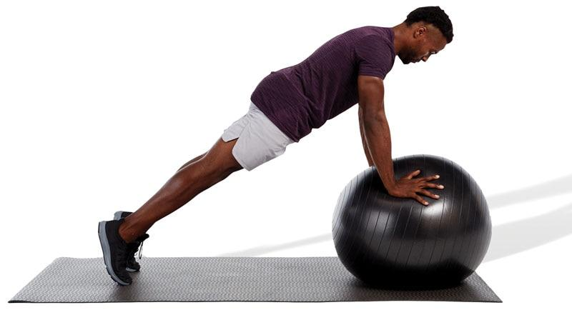 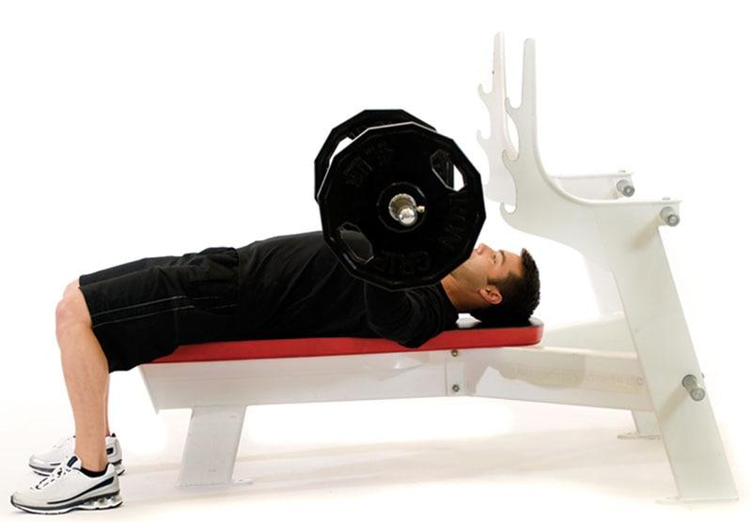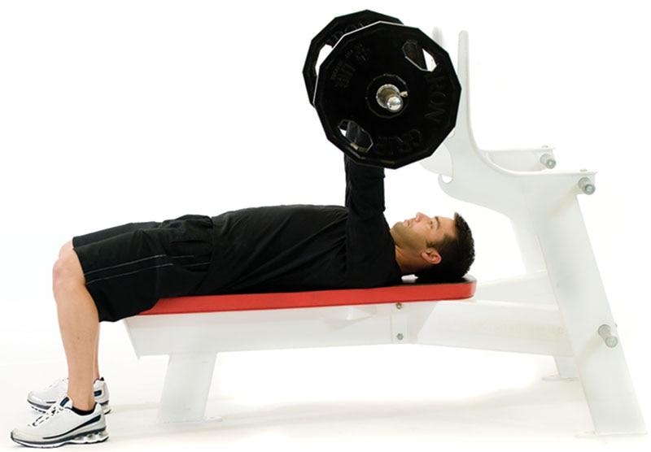

**Figure 20-2** Training for stability

**Figure 20-3**Training for strength

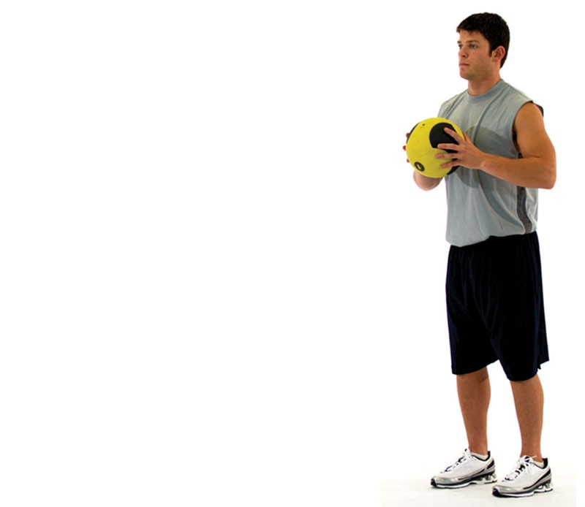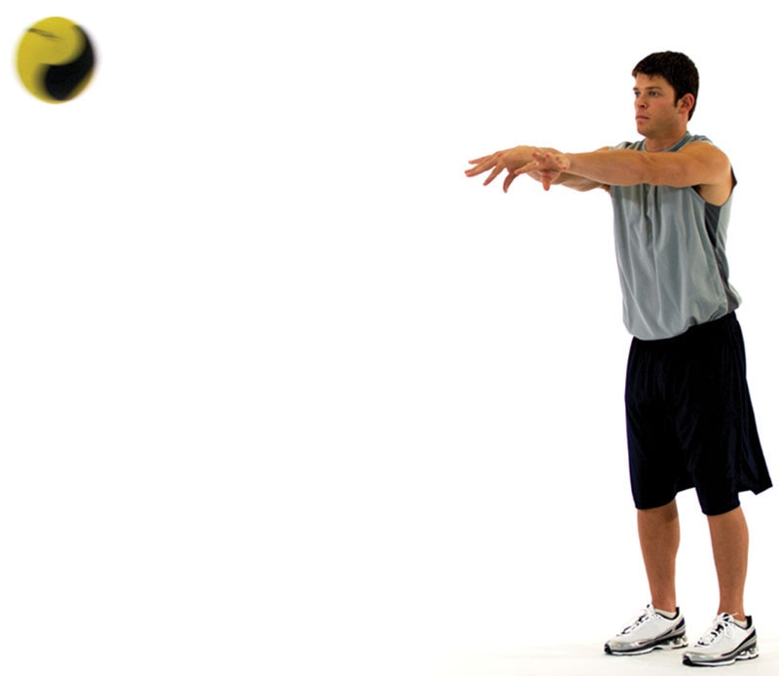

**Figure 20-4** Training for power

It is important for fitness professionals to remember that a client’s training program should be designed to meet the specific demands of their daily life, health, and wellness goals. The following example applies the concept of specificity to a client whose goal is body fat reduction.

1. Mechanically, the body burns more calories when movements are performed while standing, versus a seated or lying position, and using moderate weights (Duchateau et al., 2006; Gabriel et al., 2006). An example would be performing standing cable rows versus seated machine rows.
2. From a neuromuscular standpoint, the body burns more calories when more muscles are in use for longer periods in controlled, unstable environments. An example would be performing a standing dumbbell shoulder press versus a seated machine shoulder press.
3. Metabolically, the body burns more calories when rest periods are short to minimize full recuperation. An example would be to have clients perform resistance training exercises in a circuit fashion with little to no rest between sets.

When applying the principles of specificity to a training program for weight loss, the client should perform most exercises while standing and using moderate weights. The client should also recruit and use as many muscles as possible during each exercise and carefully monitor rest periods for greater caloric expenditure.

**Progressive adaptations from resistance training**

The concept of adaptation makes it clear that some type of change will occur based on the stresses placed on the body. Resistance training programs are designed to produce changes that result in various adaptations. Whether the goal is to increase muscular endurance, strength, hypertrophy, or power or to reduce body fat and improve overall health, the use of resistance training is an important component of any fitness program. This will help ensure optimal health and longevity for the client. As clients develop greater strength and endurance, they can train for longer periods before reaching the exhaustion stage (e.g., GAS), which leads to greater degrees of change and adaptation realized over time. The main adaptations that occur from resistance training include stabilization, muscular endurance, hypertrophy, strength, and power.

**Stabilization**

Stabilization is the body’s ability to provide optimal dynamic joint support to maintain correct posture during all movements. In other words, stabilization is getting the right muscles to fire, with the right amount of force, in the proper plane of motion, and at the right time to support our joints and spine. This requires high levels of muscular endurance for optimal recruitment of prime movers to increase concentric force production and reduce eccentric force. Repeatedly training with controlled, unstable exercises increases the body’s ability to stabilize and balance itself (Coulombe et al., 2017; Lesinski et al., 2015). Conversely, if training is not performed with controlled unstable exercises, clients may not gain the same level of stability, and their joint stability may even worsen (Behm et al., 2010; Lesinski et al., 2015). Research shows that improper stabilization can negatively affect a muscle’s force production (Behm et al., 2010; Brachman et al., 2017; Rivera et al., 2017). Stability is an important training adaptation because it increases the ability of the body to stabilize the core and joints during movement, thus allowing the arms and legs to work more efficiently (Huxel Bliven & Anderson, 2013).

TRAINING TIP

Stabilization-focused resistance exercises are unstable in nature and typically require a standing, single-leg stance, or use of a balance modality. In other words, the client must support their spine and posture with their core and joint stabilizers versus relying on artificial support, such as a bench or machine. It is important to note that the amount of instability should be client specific based on their physical capabilities. This cannot be overemphasized: stabilization-focused exercises should only introduce an amount of instability that can be safely controlled by the client. The client must be able to perform the exercises while maintaining ideal posture.

Additionally, stabilization-focused resistance exercises are not ideal for developing muscular hypertrophy or maximal strength because heavier loads are required, which necessitate a stable environment due to safety concerns (Behm et al., 2010). But stabilization-focused resistance exercises lay a solid foundation of core and joint stability, prior to client attempts at advanced forms of strength training, and play an integral role in a periodized training plan.

**Muscular endurance**

Muscular endurance is the ability to produce and maintain force production for prolonged periods of time. Developing and improving muscular endurance is an integral component of all fitness programs; it helps increase core and joint stabilization, which is the foundation on which hypertrophy, strength, and power are built. Training for muscular endurance of the core focuses on the recruitment of muscles responsible for postural stability—namely, type I muscle fibres.

Research has shown that resistance training protocols using high repetitions are the most effective means of improving muscular endurance. In addition, a periodization training program can enhance local muscular endurance as well, and after an initial training effect in previously untrained individuals, multiple sets of periodized training may prove superior to single-set training for improving muscle endurance (Evans, 2019). Previous position statements by Ratamess and colleagues (2009) found that a relationship exists between increases in strength and local muscular endurance, indicating that strength training alone may improve endurance to a certain extent. However, specificity of training produces the greatest improvements. Training to increase muscular endurance implies that the individual performs many repetitions, which increases a muscle’s time under tension, and/or minimizes rest periods between sets (Evans, 2019; Schoenfeld, 2011; Schoenfeld, Grgic, et al., 2017).

**Muscular hypertrophy**

Muscular hypertrophy is the enlargement of skeletal muscle fibres in response to being recruited to develop increased levels of tension, as seen in resistance training (Schoenfeld, 2010). Muscle hypertrophy is characterized by an increase in the cross-sectional area of individual muscle fibres resulting from an increase in myofibril proteins, which are referenced in detail in Chapter 5, along with muscle fibre anatomy and function. Although the visible signs of hypertrophy may not be apparent for 4 to 8 weeks in an untrained client, the process begins in the early stages of training, regardless of the intensity of training used (Gabriel et al., 2006; Schoenfeld, Grgic, et al., 2017; Schoenfeld, Ogborn, et al., 2017).

Resistance training protocols that use a variety of repetition ranges, with progressive overload, lead to muscular hypertrophy. Structured progressive resistance training programs that use multiple sets lead to increased muscular hypertrophy in both younger and older men and women alike (Borde et al., 2015; Lasevicius et al., 2018; Schoenfeld, Ogborn, et al., 2016, 2017). Kraemer and colleagues (2004) demonstrated that 24 weeks of training for 3 days per week, with three sets of 8 to 12 repetitions per exercise, improved muscle hypertrophy and body composition. Thus, progressive resistance training programs using a variety of repetition protocols, with progressively higher loads and sets, will result in increased hypertrophy in adults.

**Strength**

Strength is the ability of the neuromuscular system to produce internal tension, specifically in the muscles and connective tissues that pull on the bones, to overcome an external force. Whether the external force demands the neuromuscular system to produce stability, endurance, maximal strength, or power, internal tension within the muscles is what leads to force production. The degree of internal tension produced is the result of strength adaptations. The specific form of strength or internal tension, which is produced from training, is based on the type and intensity of training used by the client; this refers back to the principle of specificity.

It can be argued that resistance training programs have traditionally focused on developing maximal strength in individual muscles, emphasizing one plane of motion, typically the sagittal plane. Because all muscles function eccentrically, isometrically, and concentrically in all three planes of motion (sagittal, frontal, and transverse) and at different speeds, training programs should be designed using a progressive approach. This approach emphasizes appropriate exercise selection, multiple planes of motion, all muscle actions, and repetition tempos.

Because muscle operates under the control of the central nervous system, strength needs to be considered, not as a function of muscle but as a result of activating the neuromuscular (muscular + nervous) system. Strength gains can occur rapidly in beginning clients and can increase with a structured, progressive resistance training program. One factor in increased strength is an increase in the number of motor units recruited, especially early in a training program (Duchateau et al., 2006; Gabriel, 2006). Resistance training increases the neural demand and recruitment of more muscle fibers until a recruitment plateau is reached, after which further increases in strength are a result of muscle fiber hypertrophy (Evans, 2019; Lasevicius et al., 2018; Schoenfeld, 2010).

Strength cannot be thought of in isolation. Strength is built on the foundation of stabilization requiring muscles, tendons, and ligaments to be prepared for the load that will be required to increase strength beyond the initial stages of training. Whereas stabilization-focused resistance training is designed with the characteristics of type I slow-twitch muscle fibers in mind (slow-contracting, low-tension output, and resistant to fatigue), strength-focused resistance training is designed to match the characteristics of type II muscle fibers (quick-contracting, high-tension output, prone to fatigue). Thus, resistance training variables (sets, reps, intensities) are manipulated to take advantage of the specific characteristics of each fiber type. The majority of strength increases will occur during the first 12 weeks of resistance training from increased neural recruitment and muscle hypertrophy (Duchateau et al., 2006; Evans, 2019; Schoenfeld, 2010; Schoenfeld et al., 2015). Intermediate and advanced lifters will find it necessary to carry out a more demanding program in terms of training volume and intensity by following a sound periodized schedule.

**Power**

Power is the ability of the neuromuscular system to produce the greatest possible force in the shortest possible time. This is represented by the simple equation of force multiplied by velocity (force × velocity). Power adaptations build on stabilization and strength adaptations and then apply them at more realistic speeds and forces seen in everyday life and sporting activities. The focus of power-resistance training lies in getting the neuromuscular system to generate force as quickly as possible (rate of force production).

An increase in either force or velocity will produce an increase in power. Training for power can be achieved by increasing the weight (force), as seen in the strength adaptations, or increasing the speed with which weight is moved (velocity). Power training allows for increased rate of force production by increasing the number of motor units activated, the synchronization between them, and the speed at which they are activated (Maffiuletti et al., 2016; Tredrea, 2017). The GAS and principle of specificity both dictate that to maximize training for this type of adaptation, both heavy and light loads must be moved as fast as possible, yet in a safe fashion. Thus, using both training methods in a superset fashion can create the necessary adaptations to enhance the body’s ability to recruit a large number of motor units and increase the rate (speed) of activation (Hermassi et al., 2019; Maffiuletti et al., 2016; Pichardo et al., 2019; Rhea & Alderman, 2004).

GETTING TECHNICAL

As mentioned previously, power can be defined as force × velocity. However, another equation exists for power and is often used by sport scientists and engineers.

Power is defined as the rate at which work is performed. It is calculated by dividing the amount of work performed by the length of time to perform that work.

Work ÷ Time

Power can be measured in many forms (such as horsepower), but in the context of human performance, the most common method of measurement is watts.

**Acute variables**

Acute variables, also known as exercise training variables, provide the foundation of any exercise program. They determine the amount of stress placed on the body and, ultimately, the physical adaptations that occur. The information presented in this section further details all acute variables and guides the fitness professional in the development of a resistance training program. Acute variables include repetitions, sets, training intensity, repetition tempo, rest intervals, training volume, training frequency, training duration, exercise selection, and exercise order.

HELPFUL HINT

Acute variables include the following:

* Repetitions
* Sets
* Training intensity
* Repetition tempo
* Rest intervals
* Training volume
* Training frequency
* Training duration
* Exercise selection
* Exercise order

For continued adaptations and improvement, the fitness professional must consider a periodized training approach and proper manipulation of acute variables to reduce potential injury or overtraining while facilitating sustained progress. Resistance training programs are often designed through the lens of many disciplines: bodybuilding, powerlifting, Olympic weightlifting, strength and conditioning, and physical therapy. Moreover, resistance training programs vary considerably by professionals in these categories. While the overall breadth and depth of training experiences will largely dictate how well a program is developed and executed, it is not the sole determinate of client success. Designing a safe and effective resistance training program requires a variety of skills, including knowledge gained through continued education, personal interest in exercise, effective communication, buy-in and relationship building, and working with a variety of clientele.

It is imperative for the Certified Personal Trainer to develop the correct application and combination of exercise training knowledge, experience, and skills to be competent at designing resistance training programs for a variety of clients. At a minimum, fitness professionals should be able to answer the following questions with confidence for all their clients:

1. Which exercises are most appropriate for my client?
2. Which exercises are contraindicated for my client (i.e., should not be used)?
3. Which exercise intensities are appropriate for my client?
4. How many exercises are appropriate for my client?
5. How many sets and repetitions should my client perform?
6. How many days per week should my client train?

Without possessing the appropriate knowledge and education to answer these questions, the fitness professional may design inappropriate, ineffective, or even unsafe programs for their clients.

### Acute variables of training

Acute variables are the most fundamental components of designing a training program, including resistance exercise. They determine the specific demands placed on the body over the course of exercise training. When applied during an exercise program, the acute variables dictate these demands and the adaptations achieved. Properly manipulating acute variables fosters structured and systematic program planning to elicit optimal performance (Ciolac & Rodrigues-Da-Silva, 2016; Duchateau et al., 2006; Evans, 2019; Mike et al., 2017; Schoenfeld et al., 2015; Schoenfeld, Ogborn, et al., 2017; Wilk, Stastny, et al., 2018). To ensure proper development and progression of a resistance training program, fitness professionals must understand the acute training variables. Each of the acute variables are thoroughly explained in this chapter.

**Repetitions**

Repetition refers to the number of times an exercise is completed, for example, performing 15 repetitions of a biceps curl involves curling the weight upward for a total of 15 times. Repetitions are inversely related to the load lifted. For example, the heavier the load, the lower number of repetitions can be achieved. Repetitions can be categorized as low (1 to 5), moderate (6 to 12), and high (12+).

**Sets**

A set describes a group of repetitions that are performed consecutively. The quantities of the other acute variables (i.e., repetitions and training intensity), as well as the fitness level of the client, determine the number of sets that an individual will perform.

There is an inverse relationship between sets, repetitions, and intensity. The individual usually performs fewer sets when performing higher repetitions at a lower intensity (lighter weight) and more sets when performing lower repetitions at a higher intensity (heavier weight).

**Training intensity**

Training intensity (i.e., load), as it relates to resistance training, has been shown to substantially influence muscle hypertrophy and is often argued as the single most important exercise variable for stimulating muscle mass (Schoenfeld, Grgic, et al., 2017). Although intensity can be described as simply the degree of effort involved with training, it is commonly expressed as a percentage of one repetition maximum (1RM) and equates to the number of repetitions that can be performed with a given weight.

A client’s physical capabilities, fitness level, nutritional status, and goals determine the quantity of repetitions, sets, and training intensity (Table 20-3).

TABLE 20-3 Suggested Repetitions, Sets, and Training Intensity

| **Training Adaptation** | **Suggested Acute Variables\*** |
| --- | --- |
| Stabilization and muscular endurance | Moderate to high repetitions: ~12–20 or higher  Low to moderate sets: ~1–3 sets  Low to moderate training intensities: ~50–70% 1RM |
| Muscular hypertrophy† | Low to moderate repetitions: ~6–12 or higher  Moderate to high sets: ~3–6 sets  Moderate to high training intensities: ~75–85% 1RM |
| Maximal strength | Low repetitions: ~1–5  High sets: ~4–6 sets  High training intensities: ~85–100% 1RM |
| Power | Low to moderate repetitions: ~1–10  Moderate to high sets: ~3–6  Low training intensities: ~10% of bodyweight (when using a medicine ball) or ~30–45% (when using weights) |

*The acute variables listed in this table are not absolutes. A client’s training program, goals, and fitness level dictate appropriate acute variable selection.

† Muscle hypertrophy adaptations can be attained with various repetition, set, and intensity schemes depending on the total volume of training and the client’s fitness level (Borde et al., 2015; Lasevicius et al., 2018).

HELPFUL HINT

Intensities (amount of weight) are generally expressed as a percentage of a one-repetition maximum (1RM), but 1RM testing can be challenging to do accurately. However, most repetition ranges for the fitness adaptation are inversely related to %1RM intensities.

For example, for stabilization and muscle endurance (50-70% 1RM intensity), if you can complete 20 reps, with the final rep being challenging, you can assume you are near 50% of your 1RM at that weight. On the other hand, if form begins to break down at 12 reps, then you can assume the weight is at or near 70% of your 1RM for that exercise.

So to keep things simple, you may often see intensity expressed as something like "12 RM" to reflect the rep range that equates to the desired intensity. To begin, find a weight you can comfortably do the lift at for 12 repetitions, then progress accordingly from there.

**Repetition tempo**

Repetition tempo relates to the rate at which each repetition is performed. Studies have analyzed the effects of movement tempo on adaptive processes in terms of strength, muscle power, or muscle hypertrophy (Golas et al., 2016; Wilk, Golas, et al., 2018; Wilk, Stastny, et al. 2018). Each of the forms of resistance training has been shown to lead to hypertrophy or an increase in muscle strength (Schoenfeld, Grgic, et al., 2017). A slower movement cadence is often used to stimulate muscle hypertrophy since faster uncontrolled speeds are typically employed to develop strength and power. Slower tempos are also used for the development of stabilization and muscular endurance.

The following practical example will help the fitness professional understand how to read and interpret repetition tempo. A repetition tempo uses a four-number system. Each number corresponds to the length of time (in seconds) to perform a specific muscle action (eccentric, isometric, concentric). The numbers are also listed in the following named order regardless of the way in which the exercise is performed: eccentric/isometric/concentric/isometric. For example, a push-up using a 4-2-1-1 tempo involves the following:

1. Lowering the body toward the floor for 4 seconds (eccentric action)
2. Pausing the body with the chest slightly above the floor for 2 seconds (isometric contraction)
3. Pushing upwards and returning to the top position in 1 second (concentric contraction)
4. Pausing at the top position for 1 second before repeating the next repetition (isometric contraction)

A barbell biceps curl using a 3-0-1-2 tempo involves the following:

1. Curling up the barbell for 1 second (concentric contraction)
2. Pausing at the top for 2 seconds (isometric contraction)
3. Lowering the barbell for 3 seconds (eccentric action)
4. Pausing at the bottom position for 0 seconds before repeating the next repetition (isometric contraction)

HELPFUL HINT

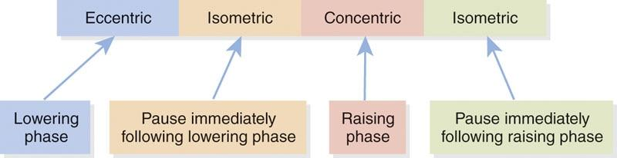

Repetition tempos use the same four-numbered sequence no matter if the exercise first starts with an eccentric movement, like a squat or bench press, or a concentric movement, like a biceps curl or shoulder press.

**Rest interval**

A certain amount of rest is needed throughout a resistance training session to optimize recovery between sets. The rest interval is the time taken to recuperate between sets or exercises and has a dramatic effect on the outcome of the training program. Each performed exercise requires energy. The primary type of energy used during training, whether it is anaerobic or aerobic, depends on the quantity, intensity of the exercise, and the fitness level of the client.

Muscular endurance is best described as the ability to maintain repeated muscular contractions for a given period. As mentioned previously, muscular endurance is best achieved when combining relatively low to moderate loads (light to medium weight) with a moderate to high number of repetitions (e.g., 12 to 20). The general rest recommendation for muscular endurance is approximately 30 to 60 seconds between sets. But depending on the client’s physical fitness level, rest periods can be adjusted. It is important to point out that it is sometimes difficult to maintain a given intensity when performing this type of training. In such a case, the load should be reduced to allow the appropriate repetition range to be performed for muscular endurance adaptations to occur.

Muscle hypertrophy occurs when the size or quantity of muscle cells increases. The general recommendation for hypertrophy training is to have moderate to high loads with wide ranging rest periods between sets—approximately 0 to 180 seconds (Grgic et. al., 2017). Due to the interaction of load and rest interval length, individuals may find it challenging to maintain a given intensity while performing a series of hypertrophy sets. If this occurs, it is suggested that the fitness professional should reduce the load to allow a specific amount of repetitions to be performed.

Maximal strength adaptations are best achieved with relatively long rest periods, depending on the client’s level of fitness and intensity of the exercises. Research provides insight that 3- to 5-minute rest period lengths are perhaps more effective and safer, especially when using multijoint movements (e.g., back squat, bench press, deadlift, or overhead press; Grgic et al., 2017; Schoenfeld, Pope, et al., 2016).

Power adaptations also require relatively long rest periods. When training for power performance, the rest interval between sets should correspond with the time needed for ATP replenishment. According to research, this rest period is approximately 4 minutes long (Grgic et al., 2017). Using this research as a general guideline, because everyone is different, resting for 3 to 5 minutes between sets seems logical and can allow for the preservation of force and power production over multiple sets and reps. By following these guidelines for power development, individuals may minimize the effects of fatigue.

**Training volume**

Although volume is not a part of the five components of fitness, it heavily interacts with many other variables of training and thus deserves to be addressed. Training volume is the sum of the repetitions performed in a given set during each training session multiplied by the resistance used. A set can be defined as the number of repetitions performed repeatedly without rest, whereas exercise volume is the product of total repetitions, sets, and load performed in a training session (Schoenfeld, Ogborn, et al., 2017; Schoenfeld et al., 2019). It is often seen simply as a formula: reps × sets × weight. It has been reported that higher-volume, multiple-set protocols have consistently proven their superiority over single-set protocols with respect to increased muscle hypertrophy and strength (Schoenfeld, Ogborn, et al., 2017; Schoenfeld et al., 2019).

STRETCH YOUR KNOWLEDGE

The five components of fitness include the following:

1. Cardiovascular endurance
2. Muscular strength
3. Muscular endurance
4. Flexibility
5. Body composition

One key characteristic of training volume is that volume and intensity must be strategically and systematically increased throughout all training programs to avoid training plateaus and necessitate continued progress. Training volume can be changed by altering the number of exercises performed, repetitions performed, or sets performed for each training session. Another key aspect of training volume is that volume and intensity have an inverse relationship. As intensity increases, volume usually decreases. As volume increases, intensity is often reduced. This is frequently observed in variations and models of periodization.

**Training frequency**

Training frequency usually describes the total number of weekly training sessions. Frequency is directly related to duration and intensity of training and can vary depending on the client’s goals, preferences, and time limitations. There are numerous factors influencing training frequency. These may include the type of exercise performed, total involvement of muscle groups, the client’s training status, and overall structure of the program, with specific focus on intensity and volume (Ochi et al., 2018; Schoenfeld et al., 2015; Schoenfeld, Ogborn, et al., 2016; Yue et al., 2018). In addition, the general lifestyle and social habits of the client will also be an influential factor in frequency and its implementation in the program. Fitness professionals may accidentally implement a wide variety of training without considering the way each factor stresses the client’s workload. Therefore, consideration of the workload must take precedence. A general recommendation is to allow at least 1 day of rest between resistance training sessions that stress identical muscle groups. Specific recommendations are dependent on the client’s overall training status: beginner, intermediate, or advanced (Table 20-4).

TABLE 20-4 General Recommendations for Training Frequency

| **Resistance Training Status** | **Recommended Frequency (Sessions per Week)** |
| --- | --- |
| Beginning or novice | 2–3 |
| Intermediate | 3 if using total body training sessions  4 if using a split regimen (i.e., training different muscle groups each session) |
| Advanced | 4–6; these individuals may perform many sessions in a single day |

**Training duration**

Training duration describes the length of a training session (Borde et al., 2015; Wilk, Golas, et al., 2018). It is important for the fitness professional to understand that duration and intensity have an inverse relationship. Specifically, as the intensity of an exercise session increases, the duration session will decrease. Like many facets of training, there are other factors involved with duration, such as client health status, training level, and program goals. Volume and specific types of training are also key factors. In most fitness-related scenarios, exercise sessions typically last between 30 and 90 minutes.

**Exercise selection**

Exercise selection is of considerable importance when designing resistance training programs. Exercise selection is often influenced by these factors: specificity of training, availability of equipment, training history, dedication to training, and time availability. For example, performing multijoint exercises takes considerably more effort than performing single-joint exercises (e.g., leg extension or bicep curls). When employing exercise selection, the first factor to consider is establishing the correct exercise technique. Regarding novice clients with unaccustomed training technique or faulty movement patterns, the fitness professional is mandated to provide excellent technique demonstration and explanation and even allow an adequate adjustment period for proper technique sequencing. This is often a good opportunity for the Certified Personal Trainer to modify an exercise or teach a movement pattern, to help build a solid foundation of exercise technique prior to forthcoming programs. After careful review of these factors, the fitness professional can offer exercise selections that maximize training adaptations that address the client’s specific training goals and reduce the likelihood of injury.

It is a well-accepted practice of performing large-muscle-mass exercises prior to small-musclemass exercises during resistance training (Simao et al., 2005). The justification behind this training recommendation is twofold. First, muscle force production for the entire training session becomes significantly greater when multijoint or compound exercises are performed before small-muscle groups. Second, when single-joint exercises are performed first, the force production for larger muscle mass exercises is reduced.

In addition, multijoint exercises require greater stabilization of the body compared to single-joint exercises. In contrast, single-joint exercises allow for a greater focus on individual muscles. The use of single-joint exercises can be used to selectively target any underdeveloped musculature and can enhance muscular symmetry. Ordering resistance exercises in this specific way may result in greater strength improvements.

**Exercise order**

The arrangement of exercise order both describes the way in which exercises are performed during the workout and is influenced by factors including the potential goals of the client, the fatigue response of the exercise, and the specific types of exercise, such as multijoint or single-joint (Cardozo et al., 2019; Simao et al., 2005). The main method of exercise order is to first arrange them in order of priority. Specifically, the client will first perform the exercises that emphasize their specific goals in the workout and then implement the less specific goals toward the end of the training session. Reducing the element of fatigue is the primary justification for placing the priority exercise first. The other method of exercise order is according to the type of exercise: multijoint or single-joint. Multijoint, also known as compound exercises, involves engagement of large muscle mass that involves two or more primary joints. Single-joint, also known as an assistance exercise, typically recruits smaller muscle mass and the use of single-joint exercises (e.g., bicep curls or triceps extensions). The fitness professional should have the ability to choose from a multitude of exercises, for both multijoint and single-joint exercises.

This exact organization of exercise order allows the client to perform compound exercises under low fatigue while also maximizing excellent technique. Therefore, the fitness professional should be able to optimize the training loads and tolerance levels for all clients by arranging them in an ideal way to best reduce fatigue.

**Resistance training systems**

Originally, most resistance training programs were designed by powerlifters, Olympic weightlifters, and bodybuilders. Many of these styles of resistance training programs remain popular today because of good marketing or “gym science,” not because they have been proven to be scientifically superior to other forms of training programs that bring about increases in stabilization, strength, and power. Research has shown that following a systematic, integrated training program and manipulating key training variables can help clients achieve optimal gains in muscular endurance, strength, hypertrophy, and performance (Garber et al., 2011; Grgic et al., 2017; Schoenfeld, Grgic, et al., 2017; Schoenfeld, Ogborn, et al., 2016).

Numerous training systems can be used to structure resistance training programs for a variety of effects. Several of the most common training systems currently used in the fitness industry are presented in this chapter (see Table 20-5).

TABLE 20-5 Resistance Training Systems

| **Type** | **Definition** |
| --- | --- |
| Warm-up set | 1–2 sets at a low intensity to psychologically and physiologically prepare for the resistance training exercise |
| Single set | Performing one set of each exercise |
| Multiple set | Performing a multiple number of sets for each exercise |
| Pyramid | Increasing (or decreasing) weight with each set |
| Superset | Performing two exercises in rapid succession with minimal rest |
| Complex training | Performing a multijoint or compound exercise, with a heavy load, immediately followed by an explosive movement (e.g., a barbell squat then a vertical jump) |
| Drop set | Performing a set to failure, then removing a small percentage of the load and continuing with the set |
| Giant set | Performing four or more exercises in rotation with as little rest as possible between sets |
| Rest pause | Incorporating a slight pause between repetitions within a series of sets |
| Circuit training | Performing a series of exercises, one after the other, with minimal rest |
| Peripheral heart action | A variation of circuit training that alternates upper and lower body exercises throughout the set |
| Split routine | A resistance training routine that trains different body parts on separate days |
| Vertical loading | A form of training in which strength training exercises are performed in rapid succession, starting with the upper body and working down to the lower body (i.e., total-body → chest → back → shoulders → biceps → triceps → legs) |
| Horizontal loading | Performing all sets of an exercise (or body part) before moving on to the next exercise (or body part) |

Warm-up set

The fitness professional should regularly perform preparatory movements with their clients, prior to undergoing vigorous exercise, which includes resistance training. Warm-up sets require performing one to two sets at a low intensity prior to increasing the load. The purpose of a warm-up set is to psychologically and physiologically prepare the individual for the work to be performed (McGowan et al., 2015). For example, a client may perform one or two sets of a bench press exercise using light weights prior to increasing the load and finishing the remainder of their set; typically, 10 to 15 repetitions are enough for a warm-up set. It is important that the load selected during a warm-up set does not cause undue fatigue and compromise a client’s performance for their remaining sets.

The Single-Set System

As the name suggests, the single-set system uses one set per exercise. It is usually recommended that single-set workouts be performed two times per week to promote sufficient development and maintenance of muscle mass (Schoenfeld, 2011; Yu et al., 2018). Although multiple-set training is promoted as being more beneficial for strength and hypertrophy gains in advanced clients, the single-set system can be beneficial, especially for beginning-level clients (Androulakis-Korakakis et al., 2019; Cunha et al., 2018; Ralston et al., 2017).

Fitness professionals are encouraged to explore the benefits and options of single-set workouts to further customize individual program design options. Single-set training systems are often negatively perceived for not providing enough stimuli for adaptation. However, when reviewing the physiology of the human body and how it operates, this notion may not be true (Garber et al., 2011). In fact, many beginning clients could follow a single-set program to allow for proper adaptive responses of the connective tissue and nervous system before engaging in more rigorous training systems. By encouraging clients to avoid lifting more than they can handle, injury can be avoided.

The Multiple-Set System

The multiple-set system, on the other hand, consists of performing multiple numbers of sets for each exercise. The resistance (load), sets, and repetitions performed are selected according to the goals and needs of the client (Cunha et al., 2018; Ralston et al., 2017). While multiple-set training can be appropriate for both novice and advanced clients, it has been shown to be superior to single-set training for more advanced clients (Cunha et al., 2018; Ralston et al., 2017; Schoenfeld, Grgic, et al., 2017). The increased volume (sets, reps, and intensity) is necessary for further improvement but must be administered appropriately to avoid overtraining.

The Pyramid System

The pyramid system involves a progressive or regressive step approach that either increases weight with each set or decreases weight with each set (Figure 20-5). In the light to heavy system, the individual typically performs 10 to 12 repetitions with a light load and increases the load for each following set, until the individual can perform 1 or 2 repetitions, usually in four to six sets. This system can also be used for workouts that involve only two to four sets or higher repetition schemes of 12 to 20 repetitions. The heavy to light system works in the opposite direction, in which the individual warms up and then begins with a heavy load for 1 to 2 repetitions, then decreases the load and increases the repetitions for four to six sets.

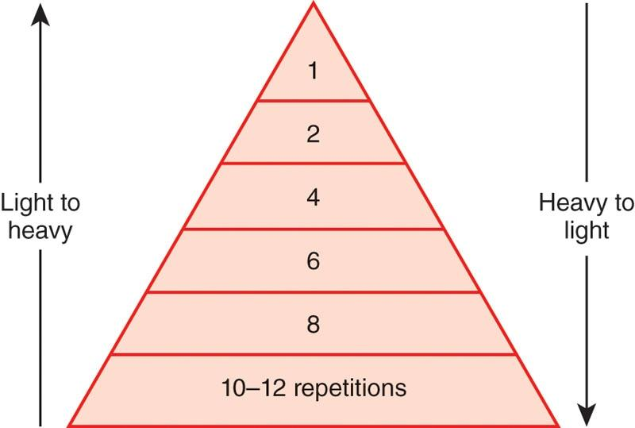

**Figure 20-5** The pyramid system

The Superset System

The superset system uses two exercises performed in rapid succession, one after another. There are multiple variations of the superset system.

The first variation includes performing two exercises for the same muscle group back to back. For example, an individual may perform the bench press exercise, immediately followed by push-ups, to fatigue the chest musculature. Completing two exercises in this manner will improve muscular endurance and hypertrophy because the volume of work performed is relatively high. This style of superset can use two, three (termed a *triset*), or more (termed a *giant set*) exercises for the target muscle group. The greater the number of exercises used, the greater the degree of fatigue experienced and demands on muscular endurance.

The second variation consists of performing two exercises back to back that involve opposing muscle groups, such as the chest and back or quadriceps and hamstring complex. Performing supersets in this manner allows a significant load to be placed on the target muscle during each set. This is possible because while the agonist (prime mover) is working, the antagonist is recovering, and vice versa.

Supersetting typically involves sets of 8 to 12 repetitions with no rest between sets or exercises; however, any number of repetitions can be used. The superset system is popular among bodybuilders and athletes and may be beneficial for muscular endurance, muscular hypertrophy, or power, depending on the exercises used.

Complex training

Complex training is an effective, time-efficient training method for enhancing strength and power, which alternates heavy resistance exercise with an explosive power exercise that is biomechanically similar in movement (Freitas et al., 2017; Scott et al., 2017). This provides the fitness professional an opportunity to train both sides of the force-velocity equation in one session. Specifically, the fitness professional can train their client on both the force end with heavy loads (e.g., squats) coupled with a higher-velocity movement (e.g., squat jumps). The premise behind complex training is that the client or athlete can perform the power or plyometric exercise more explosively due to the previous heavy-load exercise (Tredrea, 2017).

The explanation for this phenomenon is known as post-activation potentiation (PAP) and is the primary method on which complex training is based. Post-activation potentiation refers to the condition by which acute muscle-force generation is increased as a result of the inner contractions of the muscle. In other words, a person displays an increase in muscular force that is caused by the excitation of the nervous system, which was created by the heavy loads lifted (Alves et al., 2019; Conrado de Freitas et al., 2018).

Complex training is volume dependent, meaning that it is necessary to complete sufficient sets to stimulate the neuromuscular system (e.g., three to five sets or more). Due to the high-stress nature of complex training, the neuromuscular system needs about 72 hours for complete recovery. Considering this, Certified Personal Trainers should consider limiting the implementation of complex training to two to four sessions per week, depending on their client’s training split.

Drop sets

A drop set is a resistance training system that is popular among bodybuilders and strength athletes. It is a system that enables an individual to continue a set past the point at which it would usually terminate. Drop sets involve performing a set to failure, then removing a small percentage of the load (typically 5–20%) and continuing with the set, completing a small number of repetitions (usually 2–4). This procedure can be repeated several times (typically 2–3 drops per set). A set to failure followed by three successive load decrements performed with no rest would be referred to as a triple drop. Drop sets are considered an advanced form of resistance training suitable for experienced lifters.

Giant set

Giant sets, while very similar to supersets, are comprised of four or more exercises completed in succession. When performing giant sets, it is best for the Certified Personal Trainer to focus on one muscle group at a time, with three or more exercises corresponding to 8 to 12 repetitions. The rest interval is fairly short with approximately 5 to 15 seconds between exercises and several minutes (e.g., 2–5) between giant sets. It is important to note that the fitness professional might not be working the muscle in the exact same manner, variation, or angle; therefore, it is best to choose a weight that is challenging while allowing the individual to complete the necessary repetitions. For example, a chest giant set might consist of 10 repetitions of flat dumbbell chest presses, 10 repetitions of incline dumbbell presses, 10 repetitions of decline bench presses, and 10 repetitions of dumbbell pec flys. The Certified Personal Trainer should customize the giant set to their client’s goals and ability level. Giant sets have been shown to improve the weight lifted during one-rep maximum, peak, and shuttle-run performances, as well as improve lean muscle mass (Alcaraz et al., 2011).

Rest-pause set

Rest-pause training is a popular style that typically employs moderate to heavy loading with a short rest interval, allowing clients to develop as much of a stimulus as possible in minimal time. Rest-pause is a productive method of training to increase time under tension and metabolic stress, especially in recreationally trained persons (Prestes et al., 2019).

To perform a rest-pause set, the fitness professional would instruct their client to engage in the following sequence:

1. Perform a set for a specific amount of repetitions.
2. Set the weight down and take several deep breaths, then complete the subsequent repetitions to muscular failure.
3. Complete the second step as many times as possible.

The amount of rest and load used during each set is dependent on the client’s goals and fitness level. Heavier loads and slightly longer rest periods are recommended for clients seeking maximal strength, whereas moderate loads and shorter rest periods are ideal for clients seeking muscular endurance or body composition changes.

The circuit-training system

The circuit-training system consists of a series of exercises that an individual performs one after the other, with minimal rest between each exercise (Figure 20-6). The typical training variables for a circuit-training program include a low to moderate number of sets (1–3), with moderate to high repetitions (8–20) and minimal rest periods between exercises; however, these variables can be manipulated to enhance the desired effect (Alcaraz et al., 2011; Harber et al., 2004). Circuit training is a great training system for individuals with limited time and for those who want to alter body composition (Alcaraz et al., 2011; Harber et al., 2004).

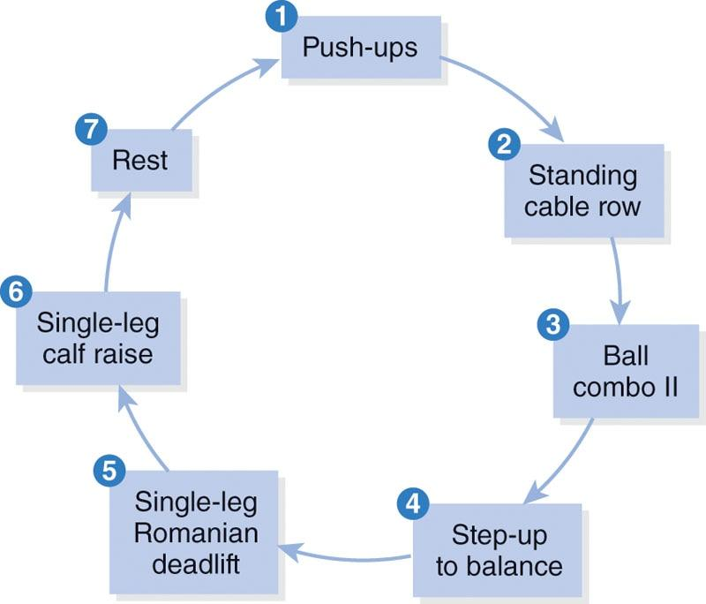

**Figure 20-6** Example circuit

The peripheral heart action system

The peripheral heart action system is another variation of circuit training that alternates upper body and lower body exercises throughout the circuit. This system of training distributes blood flow between the upper and lower extremities, potentially improving circulation. The number of exercises per sequence varies with the program’s goal. The individual typically performs 8 to 20 repetitions per exercise, depending on their desired adaptation and fitness level. This system is very beneficial for incorporating an integrated, multidimensional program and for altering body composition and improving health outcomes (Piras et al., 2015). An example of a peripheral heart action system using common resistance training exercises can be seen in Table 20-6.

TABLE 20-6 Example Peripheral Heart Action System

| **Resistance Training Exercises** |
| --- |
| Dumbbell chest press |
| Dumbbell squat |
| Seated machine row |
| Dumbbell Romanian deadlift |
| Standing dumbbell shoulder press |

The Split-Routine System

A split-routine system involves breaking up the body into parts to be trained on separate days. Many bodybuilders and mass-dominant and strength athletes (American football, shot put, etc.) use the split-routine system. Bodybuilders typically perform numerous exercises on the same day for the same body part to bring about optimal muscular hypertrophy. By breaking up the body into parts that can be trained on different days, more work can be performed for the allotted time per workout, which can increase muscular hypertrophy (Schoenfeld et al., 2015). Examples of several different split routines are shown in Table 20-7. Any variation of these outlined routines can be used, but the important issue in some of these routines is recovery time. When training each body part more than once per week, fitness professionals should account for volume and intensity.

TABLE 20-7 Split-Routine System: Sample Workouts

| **Routine** | **Day(s) Performed** | **Body Parts Trained** |
| --- | --- | --- |
| 2-day | Monday | Upper body |
|  | Thursday | Lower body |
| 3-day | Monday | Chest, shoulders, triceps |
|  | Wednesday | Legs |
|  | Friday | Back, biceps |
| 4-day | Monday | Chest, triceps |
|  | Tuesday | Back, biceps |
|  | Thursday | Legs |
|  | Friday | Shoulders |
| 5-day | Monday | Chest |
|  | Tuesday | Legs |
|  | Wednesday | Back |
|  | Thursday | Shoulders |
|  | Friday | Arms |
| 6-day | Monday and Friday | Chest, shoulders, triceps |
|  | Tuesday and Saturday | Legs |
|  | Wednesday and Sunday | Back, biceps |

**Vertical Loading and Horizontal Loading**

Vertical loading is a resistance training system that moves a workout vertically down the workout template by alternating body parts trained from set to set (Table 20-8). It is a form of training in which strength-training exercises are performed in rapid succession, starting with the upper body and working down to the lower body:

1. Total-body
2. Chest
3. Back
4. Shoulders
5. Biceps Triceps
6. Legs

TABLE 20-8 Vertical Loading

| **Exercise** | **Sets** | **Reps** | **Tempo** | **Rest** | **Coaching Tip** |
| --- | --- | --- | --- | --- | --- |
| Total body | ↓ |  |  |  | Complete exercises for each body part before beginning the next set |
| Chest | ↓ |  |  |  |  |
| Back | ↓ |  |  |  |  |
| Shoulders | ↓ |  |  |  |  |
| Biceps | ↓ |  |  |  |  |
| Triceps | ↓ |  |  |  |  |
| Legs | ↓ |  |  |  |  |

In a vertically loaded workout, the client would perform the first exercise (total-body) for the required repetitions and then move on to the chest exercise for the next set of repetitions. After the chest exercise, the client would move on to the back exercise and so forth, until all exercises have been completed. Once completed, the client would return to the first total-body exercise and run through the exercises again for the desired amount of sets. This can also be done in a circuit style, by minimizing the rest periods between exercises.

This vertical loading system of training can be very beneficial for allowing maximal recovery to each body part while minimizing the amount of time wasted on rest. For example, if it takes 1 minute to perform each exercise, by the time the client returns to the chest exercise, 7 to 10 minutes could have passed, which should be sufficient time to allow for adequate recovery. Even though 7 to 10 minutes have passed, the client has been constantly moving and has performed one set of every exercise in their workout.

Horizontal loading refers to performing all sets of an exercise or body part before moving on to the next exercise or body part, as shown in Table 20-9. For example, if performing three sets of a chest exercise and three sets of a back exercise, the client would perform all three sets of the chest exercise before moving to the back exercise. The progression of exercises is therefore said to be horizontal across the template. This is the method most commonly used in health club environments and is appropriate for hypertrophy, maximal strength, and power training (Grgic et al., 2017; Schoenfeld, 2011; Schoenfeld, Pope, et al., 2016).

TABLE 20-9 Horizontal Loading

| **Exercise** | **Sets** | **Reps** | **Tempo** | **Rest** | **Coaching Tip** |
| --- | --- | --- | --- | --- | --- |
| Total body | → | → | → | → | Complete all sets before moving to the next exercise |
| Legs |  |  |  |  |  |
| Chest |  |  |  |  |  |
| Back |  |  |  |  |  |
| Shoulders |  |  |  |  |  |
| Biceps |  |  |  |  |  |
| Triceps |  |  |  |  |  |

The drawback to the horizontal loading system is the amount of time typically spent resting, which can often be more time than the actual workout itself. Horizontal loading can be a metabolic progression if rest periods are monitored and limited to 30 to 90 seconds between sets. If the same muscle groups are forced to work with minimal recovery, it can lead to faster development of metabolic and hypertrophy-related adaptations in the muscle (Grgic et al., 2017; Schoenfeld, 2011; Schoenfeld, Pope, et al., 2016; Wilk, Stastny, et al., 2018).

**Safety**

The most important objective and goal for the Certified Personal Trainer is to commit to doing no harm to their clients. Like all athletic activities, the susceptibility to injury is always present. However, the fitness professional should use all measures of risk management to keep injury risk to a minimum while maximizing client results. When the Certified Personal Trainer increases knowledge through science and application, awareness is enhanced and the risk of client injury due to poor judgment and negligence is decreased.

Maintaining a safe environment

The fitness professional’s scope of practice involves the responsibility of interviewing potential clients to gather relevant information regarding their personal health history, lifestyle, and willingness and ability to exercise. Much of their centered care is concentrated on instructing, demonstrating, teaching, evaluating, and providing extensive education to their clients. The Certified Personal Trainer must effectively create and endorse the use of safe and efficient exercise programming through appropriate client consultation, screening, and comprehensive evaluation. Certified Personal Trainers should also be able to respond appropriately in emergency situations if and when they arise.

Proper equipment setup

Equipment should be grouped and placed according to specific categories, including free weights, resistance training machines, plyometrics, and warm-up areas. Proper setup ensures adequate flow throughout the gym and weight room, reducing congestion and maximizing the use of space. Fitness professionals should be cognizant of the specific equipment used during their sessions and return all equipment to its original place. This helps maintain the condition of equipment and potentially reduces the risk of injury because unkempt or untidy equipment can become a tripping hazard. Fitness professionals should never use damaged equipment in the facility, such as frayed cables and missing or unstable pieces. All equipment should be repaired or replaced if broken. Current and existing equipment should be regularly cleaned and upgraded over time.

Spotting techniques

The Certified Personal Trainer must teach and model proper technique during exercise, perform proper spotting, and monitor all exercise movements until safe execution has been mastered. It is critical for fitness professionals to exhibit large degrees of confidence and experience with respect to spotting technique to provide maximum safety and high-quality coaching for every session. Compound exercises, such as a barbell back squat, bench press, or dumbbell shoulder press, require a spotter to reduce injury risk, especially when using heavier loads. Research has indicated that a decrease in injuries occurs through proper spotting techniques (Lombardi & Troxel, 2003).

The following checklist should be used by the fitness professional during spotting activities:

1. The spotter should regulate the number of total repetitions performed by the client prior to the beginning of each set.
2. The spotter should stand and maintain a stable, wide-stance body position to increase maximal safety of the corresponding exercise.
3. An experienced spotter delivers adequate and ample support for the client to successfully execute the lift, especially when lifting through the sticking point.
4. The Certified Personal Trainer is encouraged to spot at the client’s wrists instead of the elbows when using dumbbells (i.e., in a dumbbell shoulder press). Spotting at the wrist provides better support for the lifter and eliminates the elbows collapsing inward.
5. During the barbell squat exercise, the spotter should be positioned behind the lifter and place their upper arms underneath the lifter’s armpits. This provides maximum spotting security between the spotter and the lifter.
6. The Certified Personal Trainer is encouraged to use an additional spotter for exercises when the load surpasses what a single spotter can successfully manage on their own. For example, two spotters will stand on opposite sides of the barbell during a heavy barbell back squat exercise (Figure 20-7). When and if needed, the spotters will assist the client in accomplishing the movements by lifting the ends of the barbell until they are able to complete the exercise.
7. It is not recommended for fitness professionals to spot machine-based or cable-based exercises by placing their hands underneath the weight stack. This increases risk of injury to the spotter and the lifter.

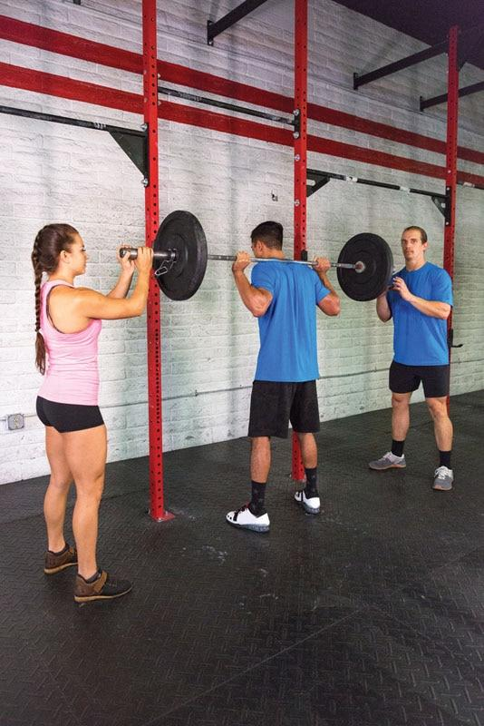

**Figure 20-7** Two people spotting a barbell squat

Monitoring exercise

Fitness professionals should closely monitor their clients during an exercise session, including monitoring exercise intensity and exercise technique. Monitoring exercise intensity can be performed in many fashions, such as tracking heart rate or ratings of perceived exertion, which is a subjective ratings scale from 1 to 10 in which clients subjectively rate their level of effort during exercise based on physical markers, such as breathlessness, fatigue, sweat rate, and muscle soreness (Muyor, 2013) (Table 20-10). A lower score indicates light effort, whereas scores closer to 10 indicate intense effort.

TABLE 20-10 Rating of Perceived Exertion

| **Rating** | **Perceived Exertion Level** |
| --- | --- |
| 0 | No exertion, at rest |
| 1 | Very light |
| 2–3 | Light |
| 4–5 | Moderate, somewhat hard |
| 6–7 | High, vigorous |
| 8–9 | Very hard |
| 10 | Maximum effort, highest possible |

**Five kinetic chain checkpoints**

In addition to tracking exercise intensity, fitness professionals must be proficient at teaching and correcting proper exercise technique. In other words, fitness professionals must be diligent and meticulous when monitoring their client’s movements and provide the appropriate corrections and cueing to ensure that their clients perform exercises correctly. This minimizes injury risk and maximizes muscle recruitment. As with all exercises, quality should always come before quantity or weight progression, and the five kinetic chain checkpoints should always be monitored (Figure 20-8).

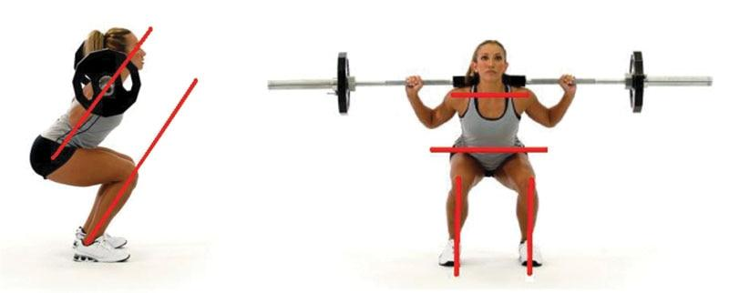

**Figure 20-8** Five kinetic chain checkpoints

1. Feet: Approximately shoulder-width apart and pointing straight ahead (unless the exercise requires a different foot position)
2. Knees: In line with the second and third toes (avoid allowing knees to cave inward)
3. Hips: Level and in a neutral position
4. Shoulders: In a neutral position (avoid protracting or elevating the shoulders, unless the exercise requires these positions)
5. Head: Cervical spine in a neutral position

**Proper breathing technique**

Although breathing is regulated and coordinated by the autonomic nervous system, proper breathing is not automatic. Breathing influences muscular function and posture because the habitual use of breathing muscles during respiration affects the ways in which these muscles are used (Courtney, 2009).

Especially during resistance training, fitness professionals need to teach their clients proper breathing techniques to maximize performance and minimize injury risk. During the concentric phase of an exercise, the client should breathe out (exhalation), preferably through the mouth, whereas during the eccentric portion of the lift, the client should breathe in (inhalation).

When discussing breathing technique, the Valsalva maneuver can be a useful strategy, particularly when performing maximal or near-maximal lifts to ensure spinal stability (Hackett & Chow, 2013). This process involves expiring against a closed glottis, creating additional intra-abdominal pressure and spinal stability. In turn, this reduces the associative compressive forces on the spinal discs during lifting. Keeping the spine stable requires individuals to brace the trunk, using many abdominal muscles, including the transverse abdominis, rectus abdominis, the external and internal obliques, and the diaphragm, thus generating large amounts of intra-abdominal pressure, which is critically important when lifting heavy loads (Kroell & Mike, 2017).

However, the Valsalva maneuver is also potentially dangerous because it can cause lightheadedness and dizziness, impede the return of venous blood to the heart, and raise an individual’s heart rate and blood pressure. Using the Valsalva maneuver is generally not recommended for clients presenting with hypertension and other forms of heart disease (Looga, 2005). Considering that a large majority of fitness clients are seeking weight loss and improved health measures as opposed to maximal strength, the use of the Valsalva maneuver in many cases is not necessary, unless the client is physically healthy and seeking maximal performance measures in strength.

**Guidelines for resistance training**

Resistance exercises are an integral component of any exercise training program because they help ensure optimal joint stability, muscular endurance, strength, power, and coordinated movement. Moreover, resistance exercises can be an effective mode meant for increasing lean muscle mass, reducing body fat, enhancing athletic performance, and improving numerous health markers (Ciolac & Rodrigues-Da-Silva, 2016; Schoenfeld, Ogborn, et al., 2016; Westcott, 2012). Programming resistance training exercises must be systematic and progressive. As such, fitness professionals should follow specific program guidelines, including proper exercise selection criteria and milestones for progression (Table 20-11).

TABLE 20-11 Resistance Training Parameters

| **Resistance Training Variables** | |
| --- | --- |
| Progressive   * Easy to hard * Simple to complex * Static to dynamic * Slow to fast * Stabilization → strength → power | Volume   * Sets   + Low   + Moderate   + High * Repetitions   + Low   + Moderate   + High |
| Range of motion   * Full * Partial * End range * Mixed ranges | Planes of motion   * Sagittal * Frontal * Transverse * Multiplanar |
| Speed of motion   * Slow * Medium * Fast * Explosive | Resistance   * Body weight * Light * Medium * Heavy |

**Resistance training progressions**

When introducing resistance exercises into an exercise program, the exercises should initially focus on optimizing ideal movement patterns. These patterns include (but are not limited to) squatting, pushing, pulling, vertical pressing, and hip hinging. Clients should become familiar with these basic movement patterns before a fitness professional introduces intricate or advanced forms of exercise. In addition, a focus on acquiring basic exercise skills, such as the proper use of exercise machines, free weights, and other types of exercise equipment, is paramount. This is especially important to minimize injury risk for new or deconditioned clients.

Once a client displays adequate movement competency, resistance exercises can progress. The National Academy of Sports Medicine (NASM) recommends progressing resistance training in a systematic fashion, using these three steps: (1) stabilization-focused exercises, (2) strength-focused exercises, and (3) power-focused exercises. The sequence is critically important.

Stabilization-focused exercises

First, clients should focus on the adaptations of stability and muscular endurance. This provides an adequate foundation of core and joint stability and prepares connective tissue (tendons, ligaments) for higher demands of training. In addition, the client will obtain greater levels of muscular endurance and strengthen type 1 muscle fibers necessary for maintaining ideal posture and spine stability, especially during more advanced forms of exercises that use heavier loads. This form of resistance training should provide greater demands on core stability and proprioception by progressing from bilateral to unilateral movements, using slow repetition tempos and high repetition schemes. For example, the standing cable row can be progressed from two-arm movements to alternating-arm movements to one-arm movements, providing greater variety in one exercise (Figure 20-9).

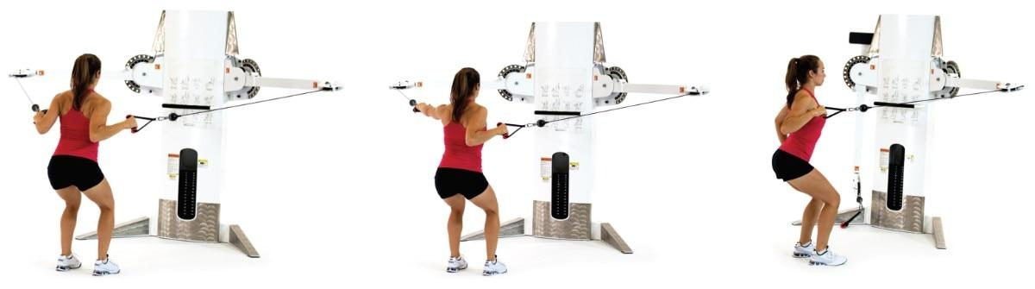

**Figure 20-9** Standing cable row progression

Exercises can also be progressed in this category by decreasing one’s base of support. For example, the same cable row sequence (two-arm, alternating-arm, one-arm) can be advanced to a single-leg stance to further challenge the client’s posture, balance, and joint stability (Figure 20-10).

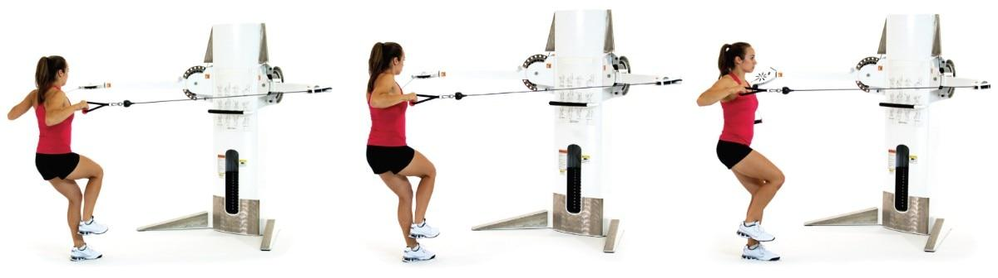

**Figure 20-10** Single-leg cable row progression

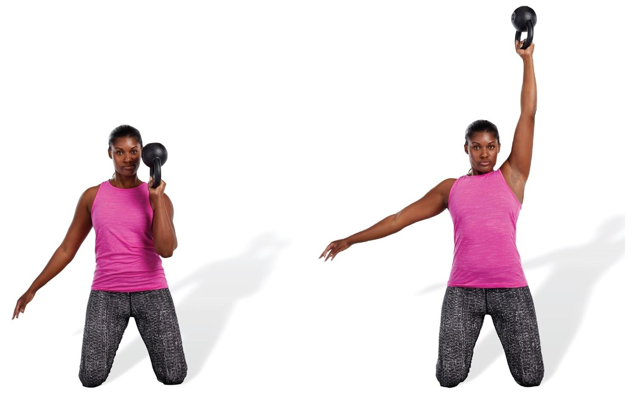

**Figure 20-11** Kneeling kettlebell bottoms-up exercise

Lastly, stabilization-focused resistance exercises can be progressed to increase stabilization demands of the upper extremities by using unique loading patterns and specialized equipment. For example, the kettlebell bottoms-up exercise is a unique loading pattern that challenges both core and shoulder stability (Figure 20-11), whereas the Earthquake Bar is a unique tool that simultaneously challenges upper-extremity stability and strength (Figure 20-12).

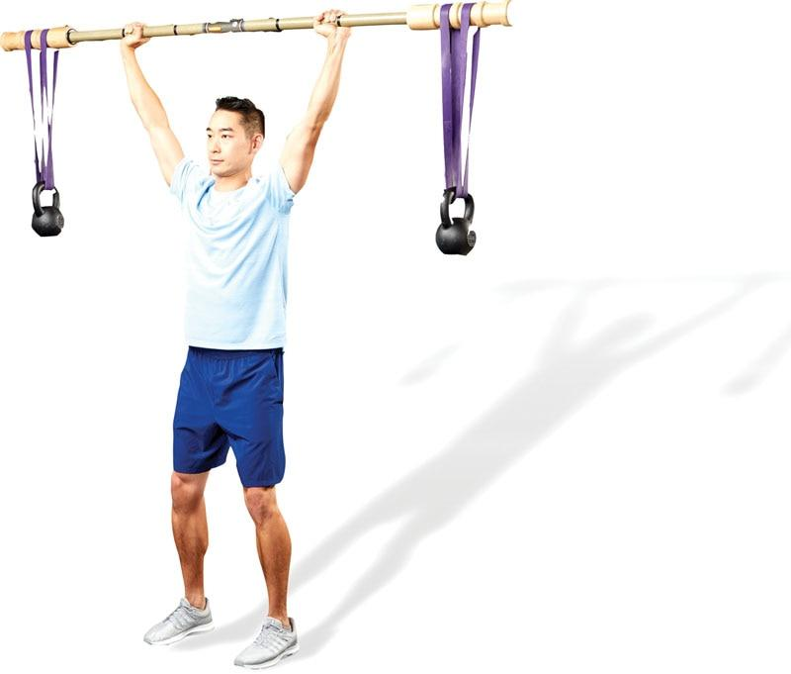

**Figure 20-12** Earthquake Bar

CRITICAL

Stabilization-focused resistance exercises should use a slow repetition tempo, a high amount of repetitions (typically 12–20), and a few sets (1–3). This form of training enhances muscular endurance, posture, and joint stability.

However, exercises must be tailored to the client’s own ability level. For example, a highly skilled athlete may be able to perform advanced forms of stability training, such as performing lifts on a single leg, or use unique loading schemes seen with implements like an Earthquake Bar or kettlebell.

Conversely, an older adult unaccustomed to exercise will likely need to start with less advanced forms of stability training. In this instance, the use of elastic bands in a seated position may be the most unstable position that this client can safely handle. Over time, with practice and improved conditioning, the older adult can graduate toward more advanced forms of stability training.

Strength-focused exercises

After clients have obtained sufficient movement competency, stability, and muscular endurance, it is safe to progress toward strength-focused resistance exercises. These exercises focus on the adaptations of strength and muscular hypertrophy and typically require heavier loads than stabilization-focused resistance exercises. The goal is to increase the amount of stress placed on the body for increased muscle size and strength. This period of training is a necessary progression from stabilization for anyone who desires to increase muscle size, muscle strength, and bone mineral density. Common exercises in this category include squats, Romanian deadlifts, bench presses, and other common weightlifting exercises (Figure 20-13).

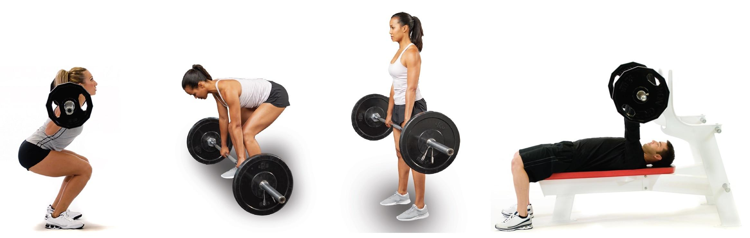

**Figure 20-13** Strength-focused resistance exercises

Power-focused exercises

The last progression focuses on the adaptation of muscular power. Power-focused resistance exercises are designed to increase the rate of force production (or speed of muscle contraction). This form of training uses the adaptations of stabilization and strength acquired previously and applies them with more realistic speeds and forces that the body will encounter in everyday life and in sports.

Power training is not a common or usual practice in the fitness environment, but it has a very viable and purposeful place in a properly planned training program. Examples of power-focused resistance exercise can include (but are not limited to) explosive movements, such as medicine ball throws and explosive plyometrics (Figure 20-14).

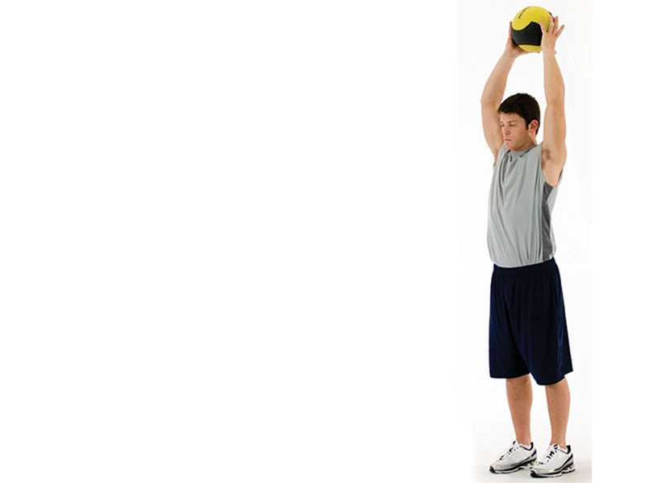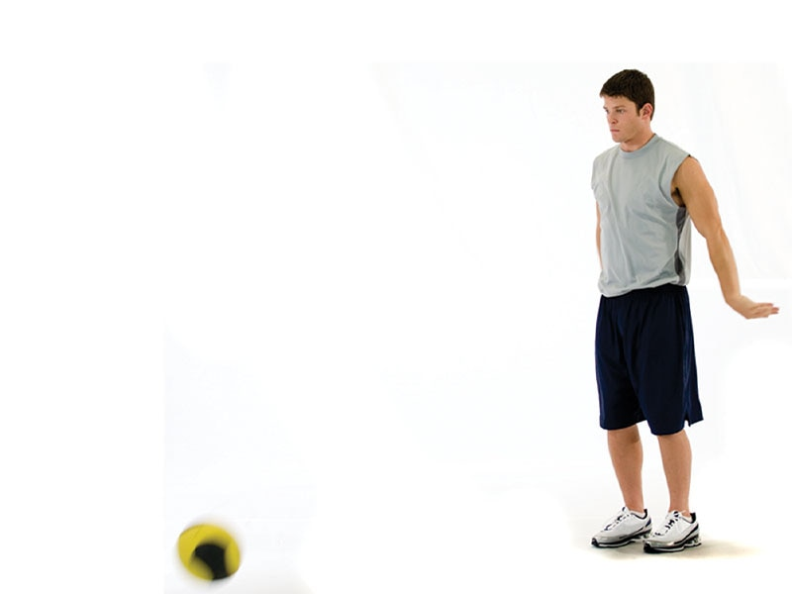

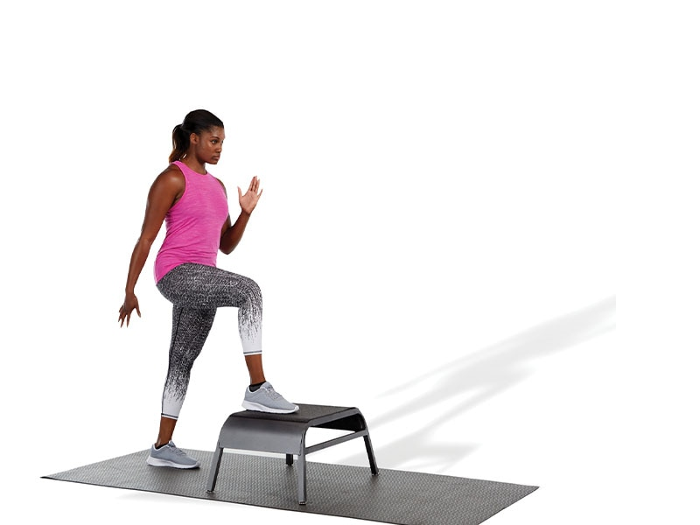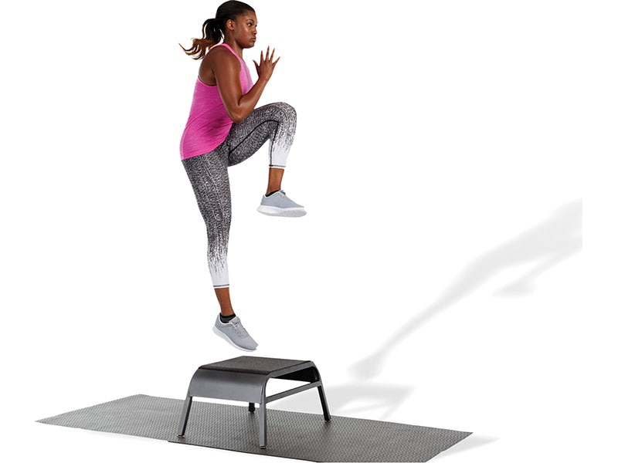

**Figure 20-14** Power-focused resistance exercises

**Resistance training exercises**

The following is a list of common stabilization-focused, strength-focused, and power-focused resistance training exercises. However, this is not an exhaustive list.

Total-Body Exercise Descriptions

Ball Squat, Curl to Press

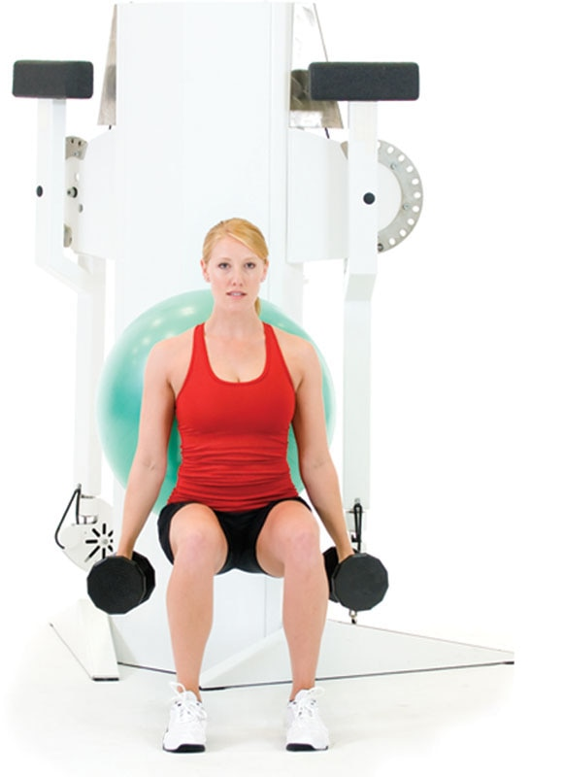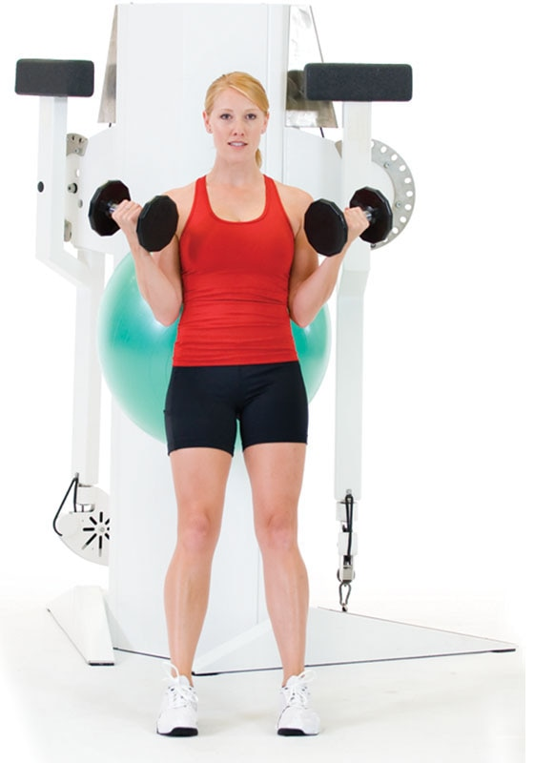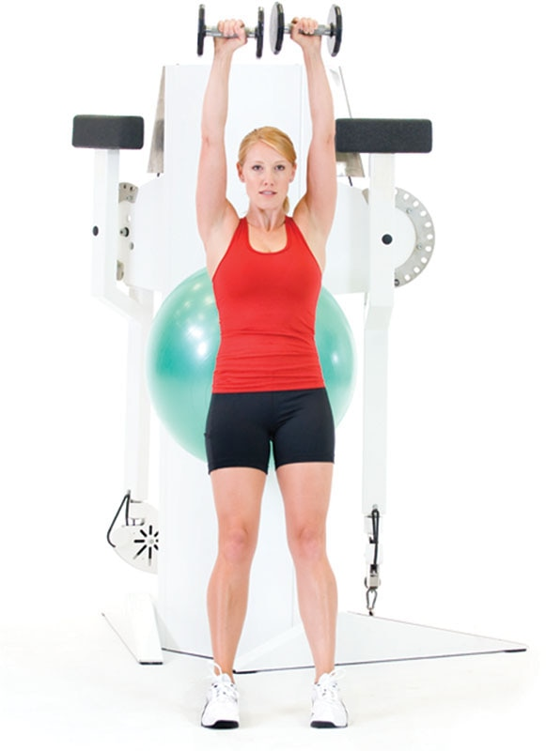

TECHNIQUE

When performing any form of a ball squat, try to use the ball to guide one through the squatting motion (sitting in a chair) versus relying on the ball for support (leaning back on the ball).

Multiplanar Step-Up, Balance, Curl to Overhead Press

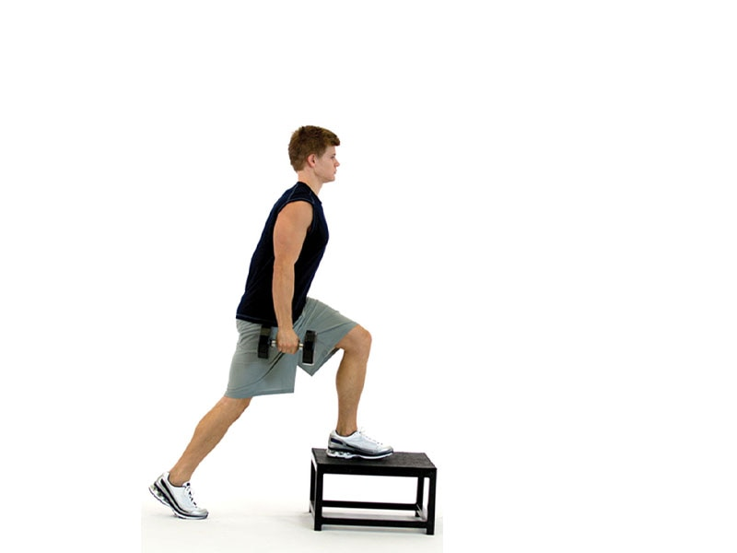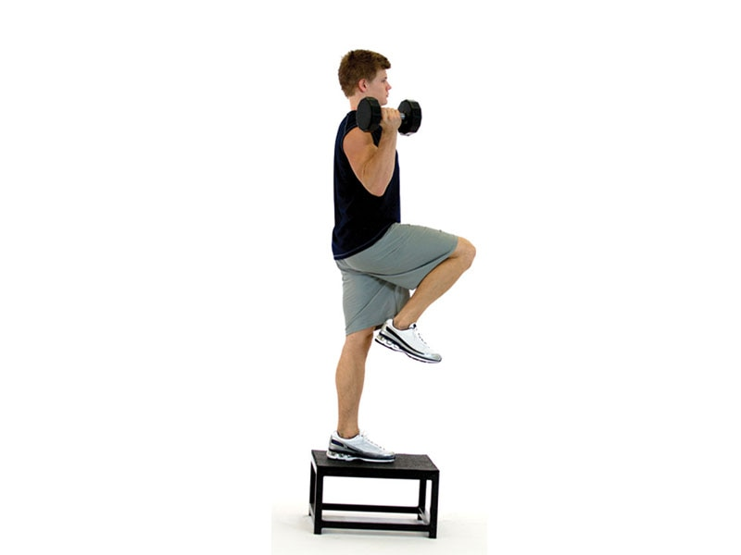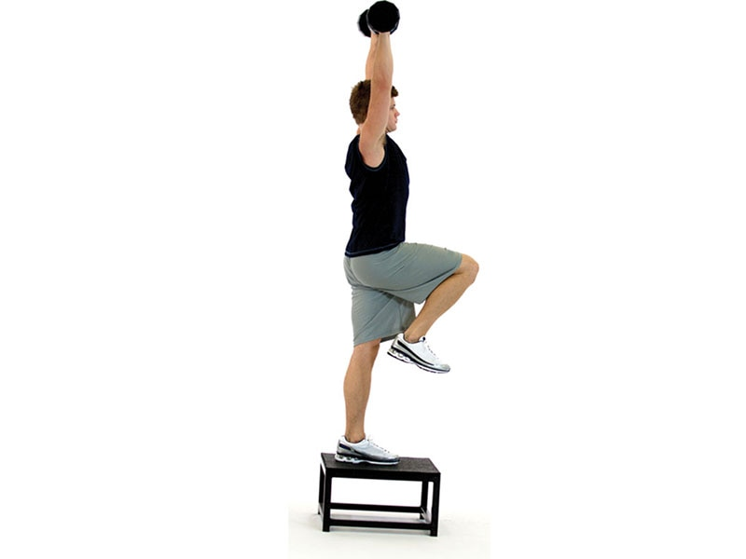

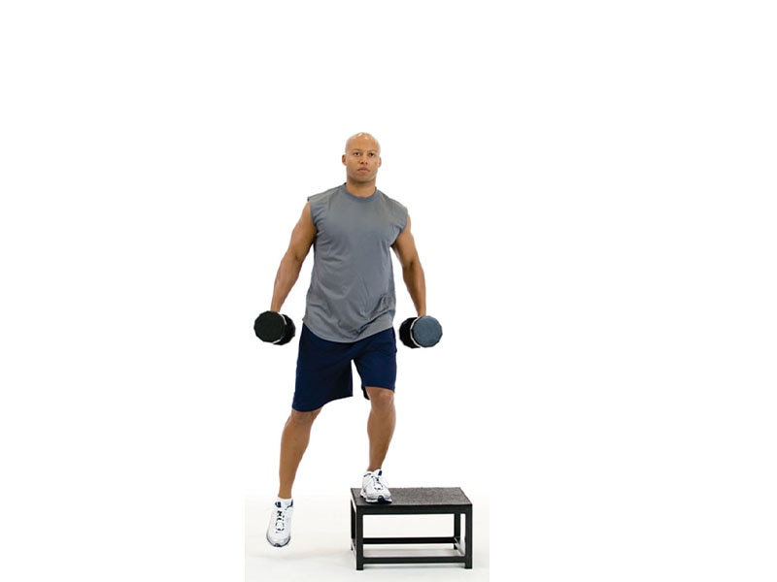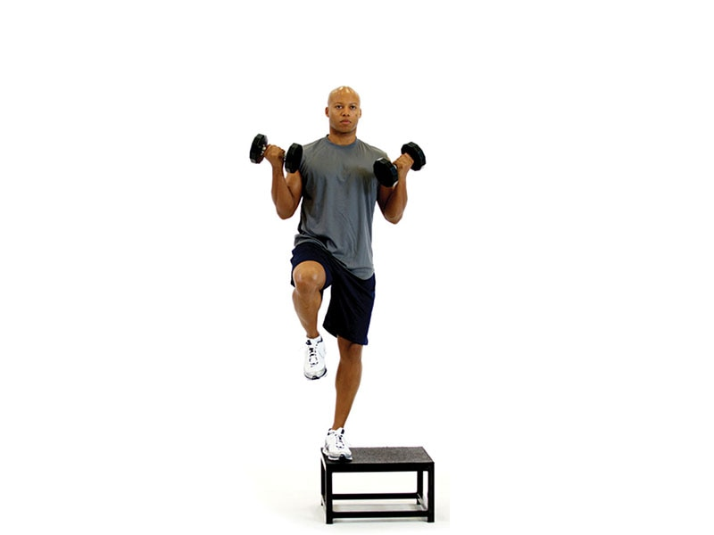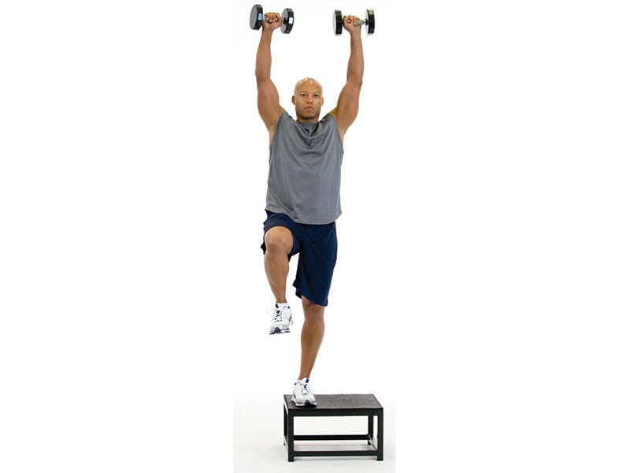

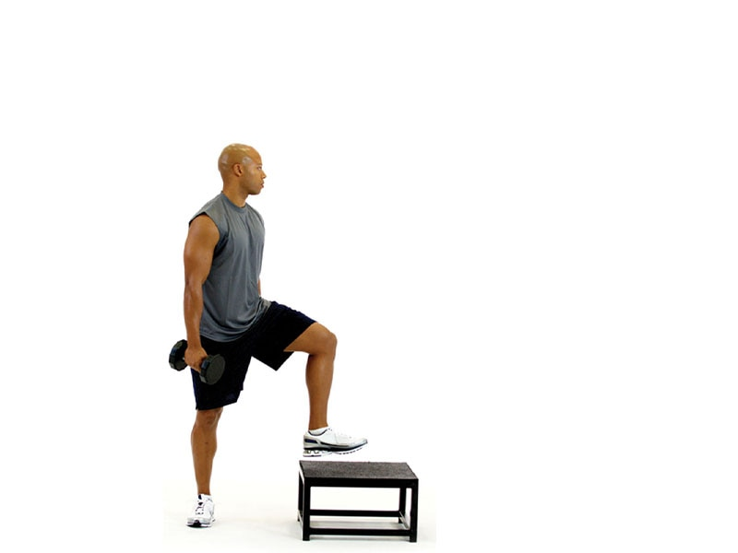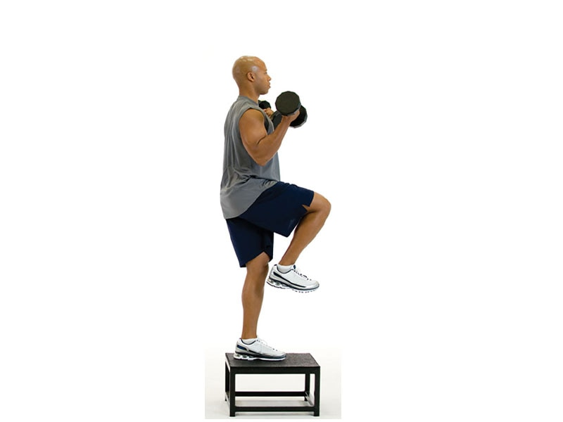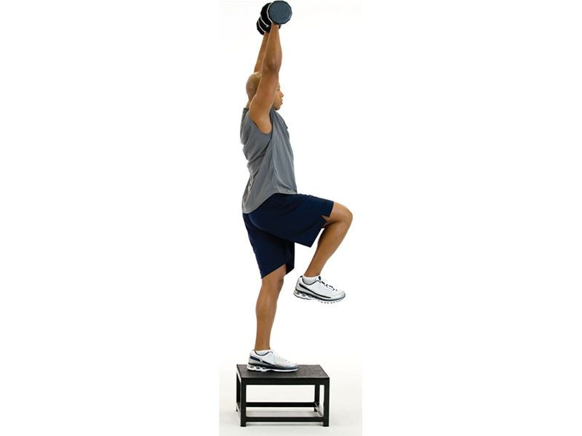

TECHNIQUE

When pressing overhead, make sure the low-back does not arch. This may indicate overactivity of the latissimus dorsi and underactivity of the abdominals.

Single-Leg Squat, Curl to Overhead Press

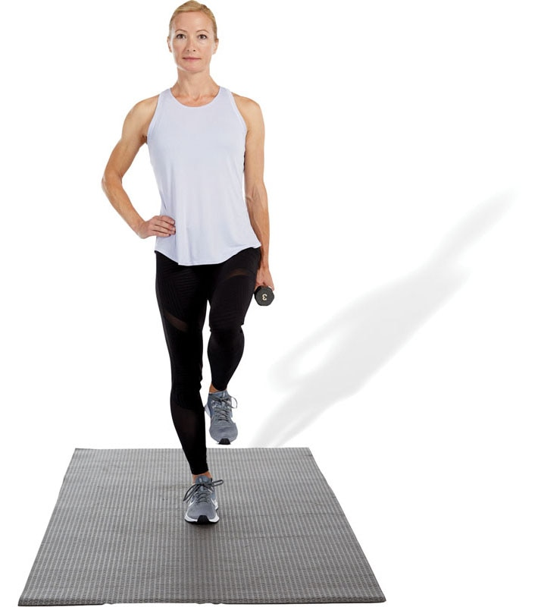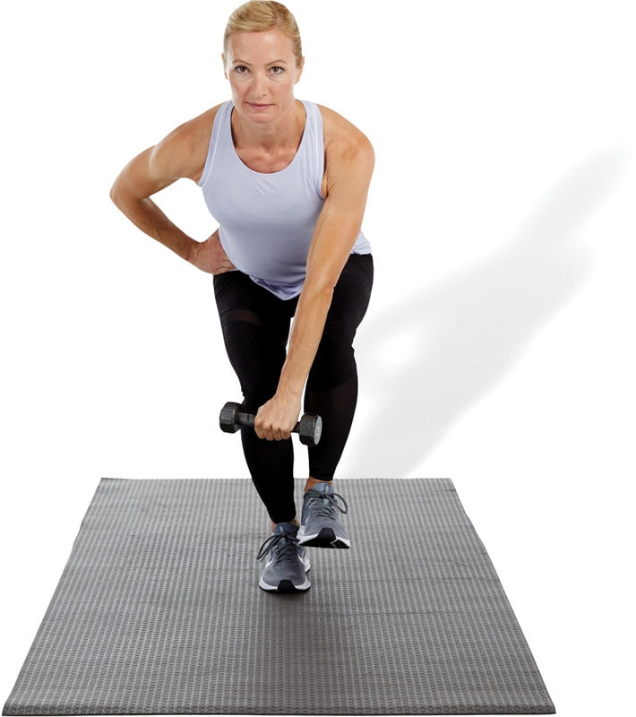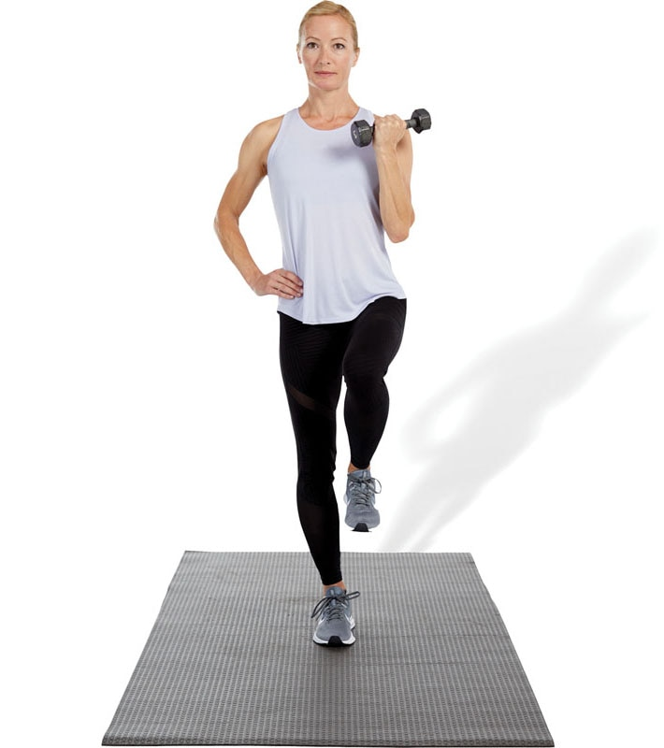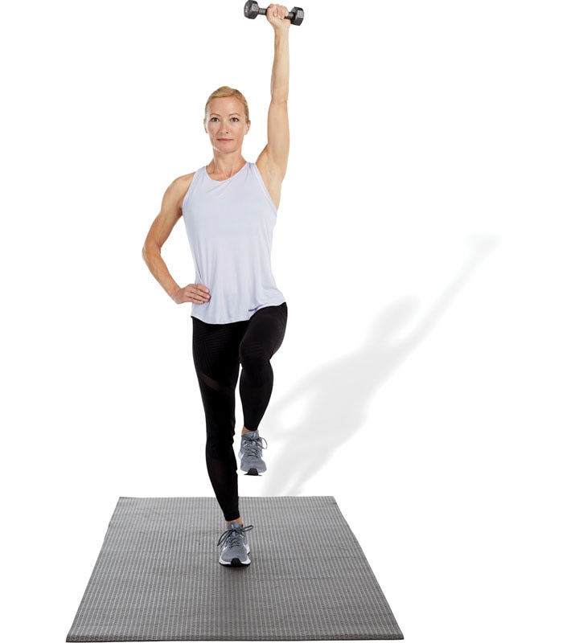

TECHNIQUE

When performing any version of a single-leg squat, only squat to the depth that can be safely controlled while maintaining ideal posture.

Single-Leg Squat to Row

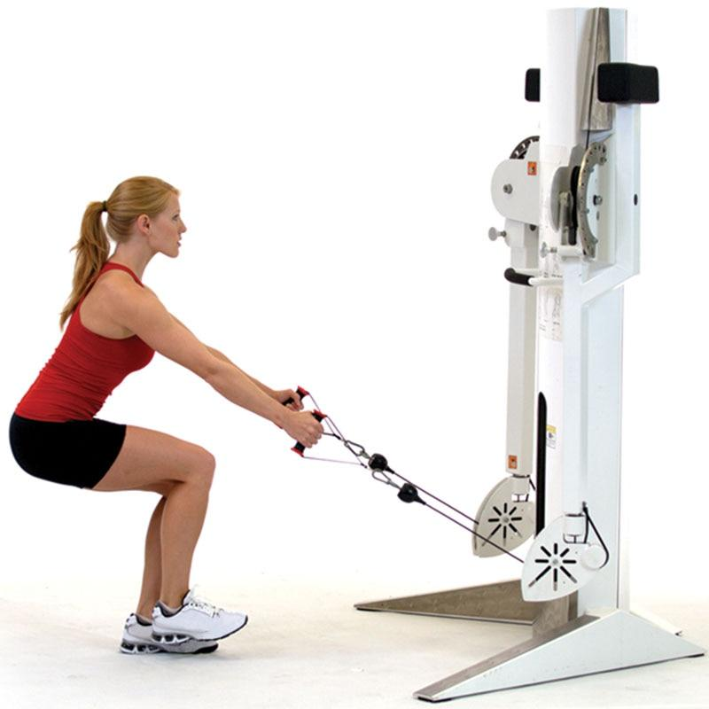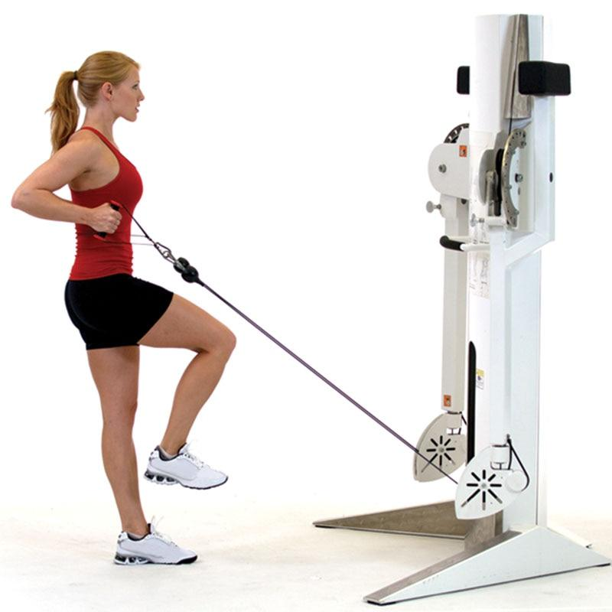

TECHNIQUE

This total-body exercise targets many muscles of the posterior chain, including the gluteus maximus and shoulder retractors, such as the posterior deltoids and rhomboids.

Multiplanar Lunge to Two-Arm Dumbbell Press

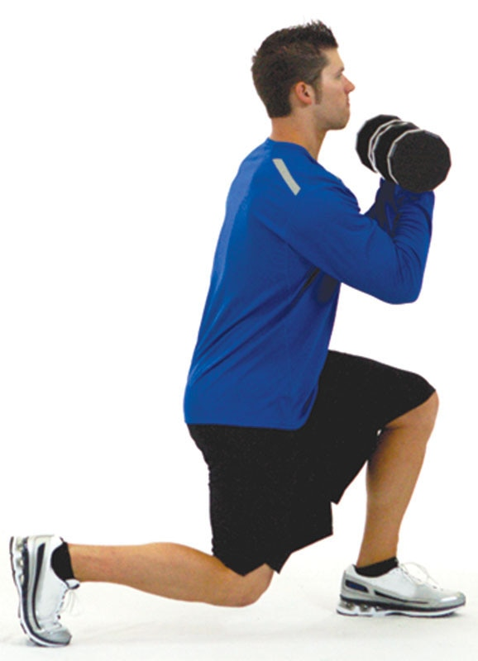 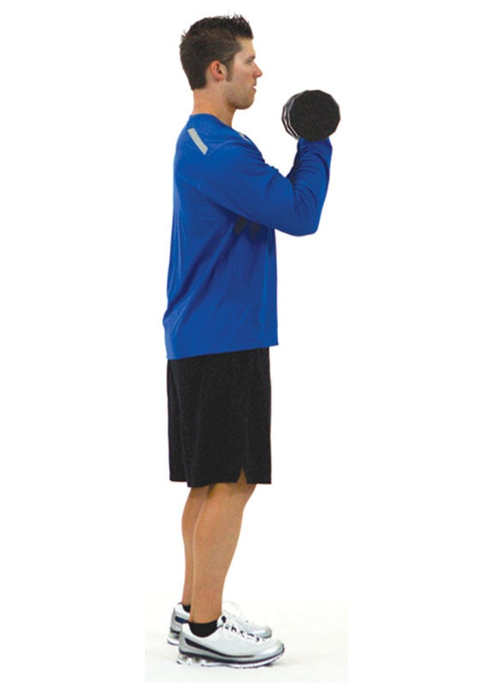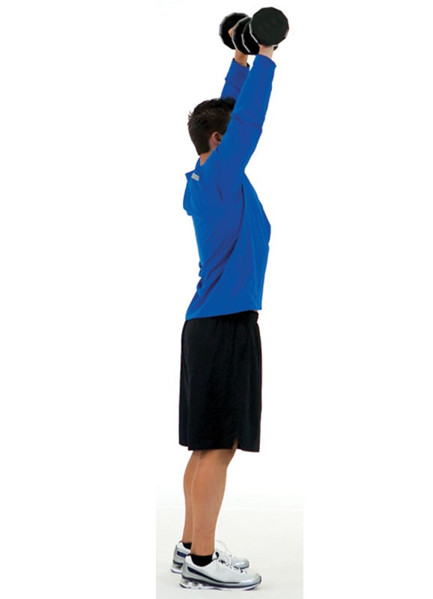

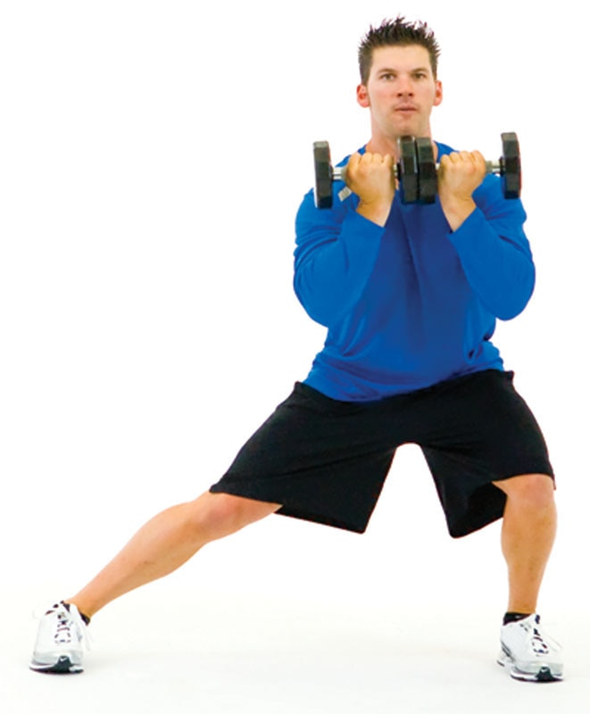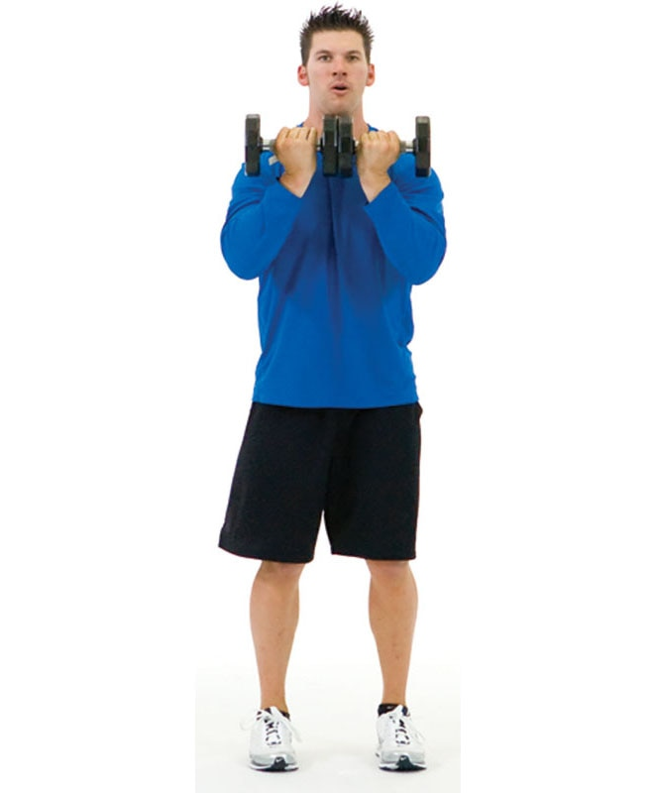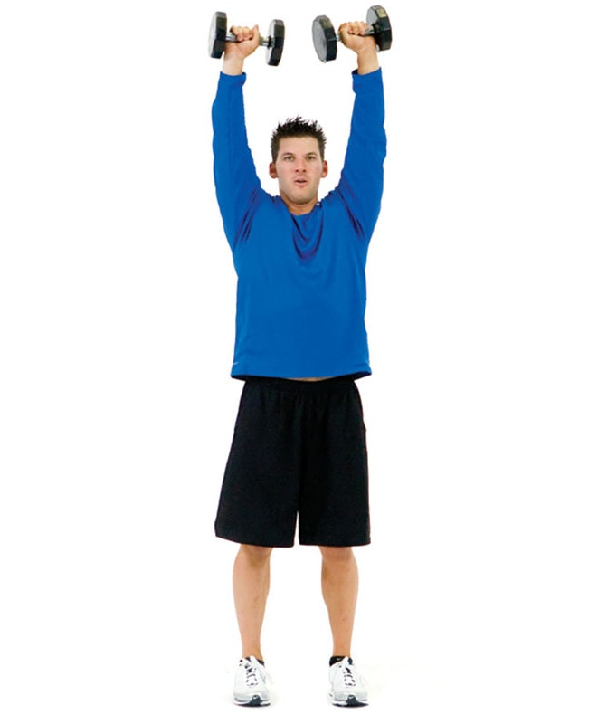

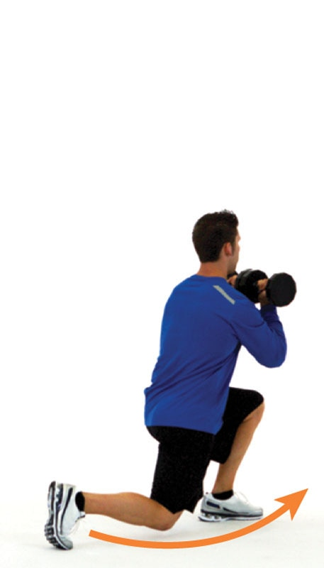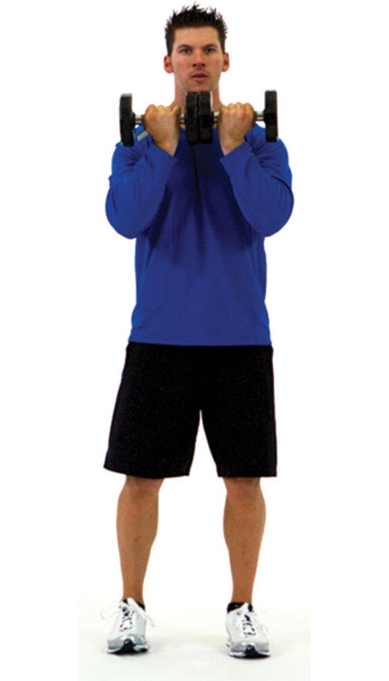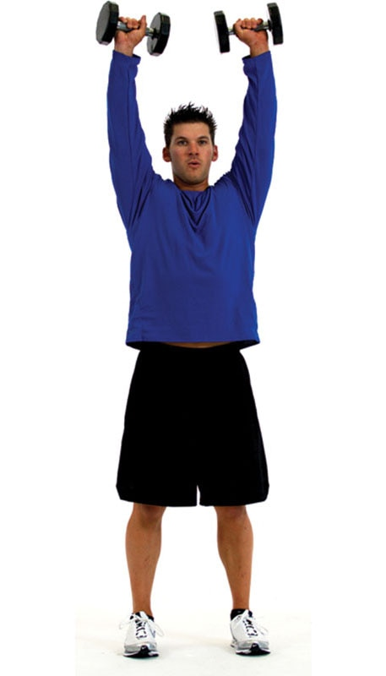

When performing any squatting or lunging motion, keep the foot straight and align the knees with the second and third toes. This ensures proper joint mechanics and optimal force generation, increasing the benefit of the exercise while decreasing its risk.

Squat, Curl to Two-Arm Press

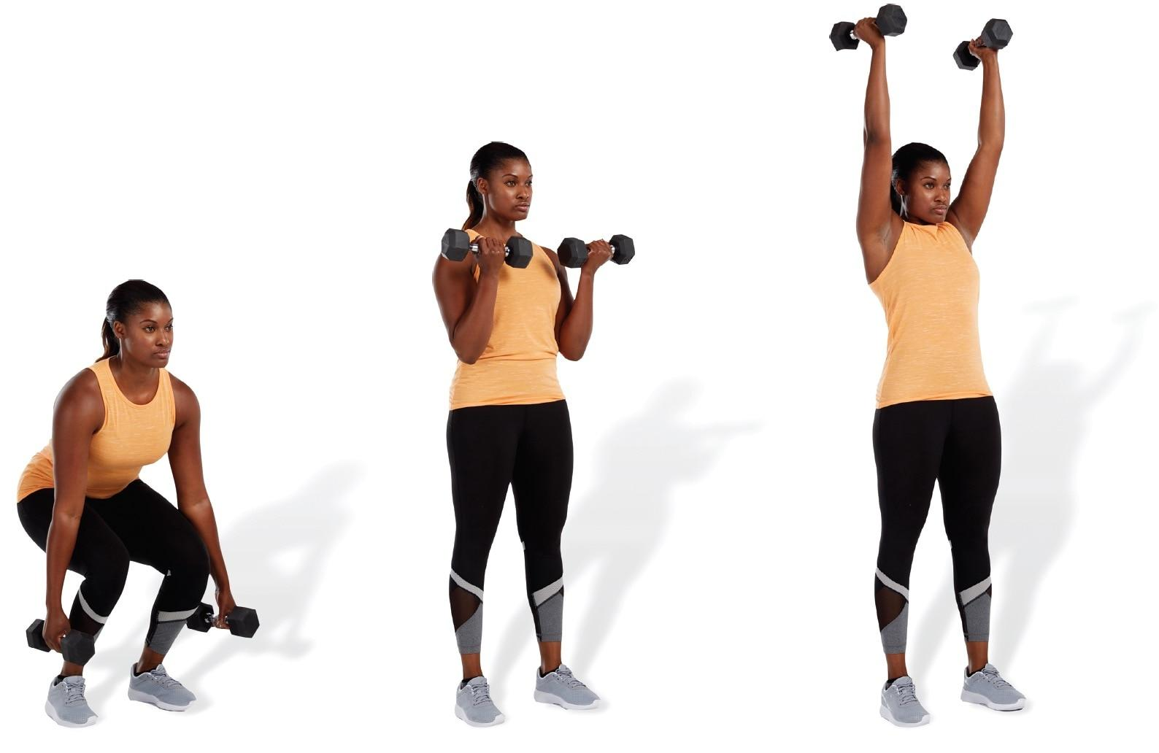

TECHNIQUE

Choose a load that enables the client to perform the biceps curl and overhead press with ideal form. The upper body will likely fatigue before the lower body when performing this exercise.

Deadlift, Shrug to Calf Raise

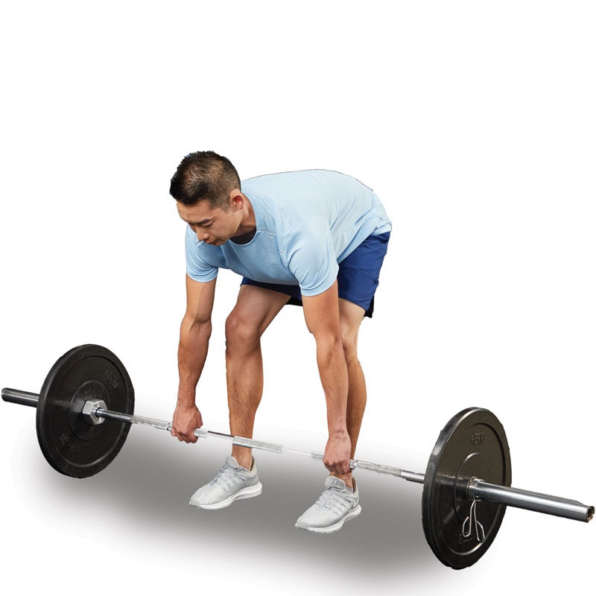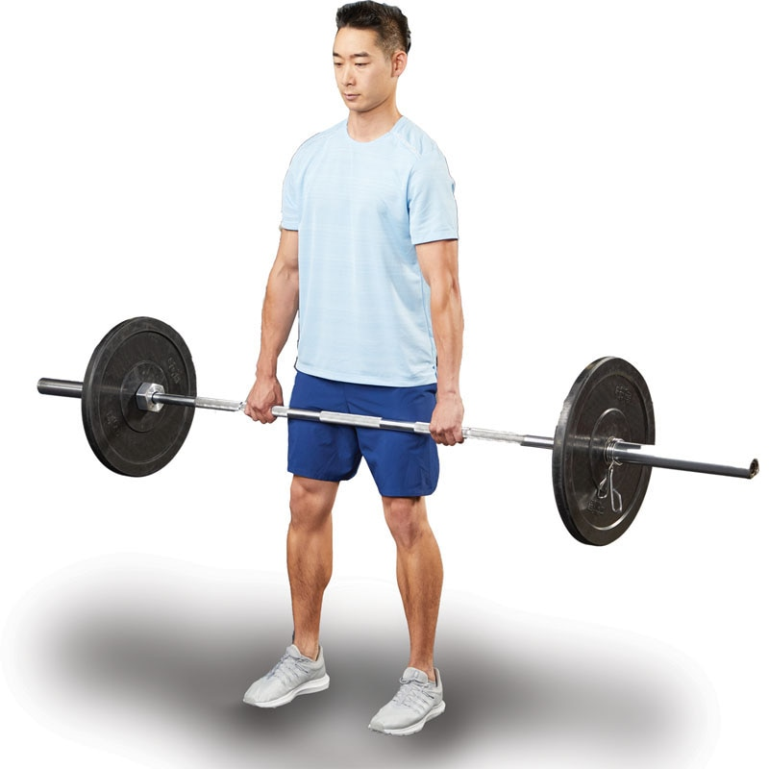

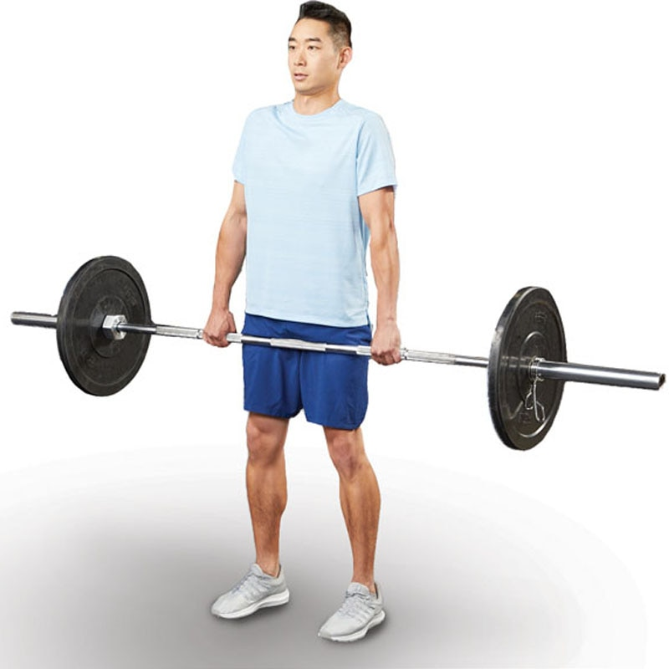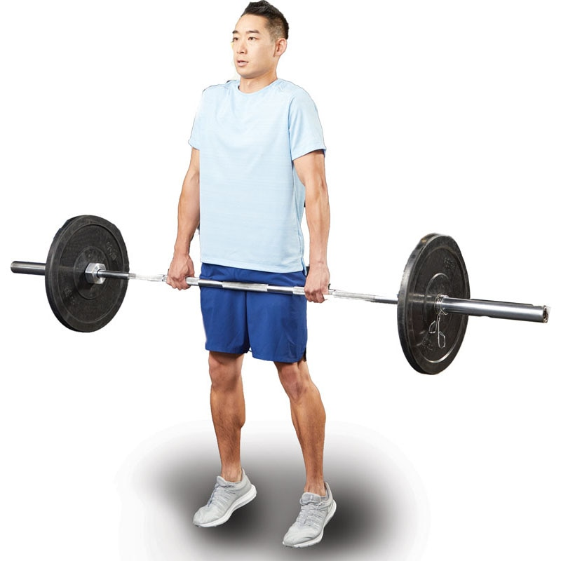

TECHNIQUE

This exercise can typically be done using heavy loads; it is a complementary exercise for those who perform Olympic weightlifting.

Two-Arm Push Press

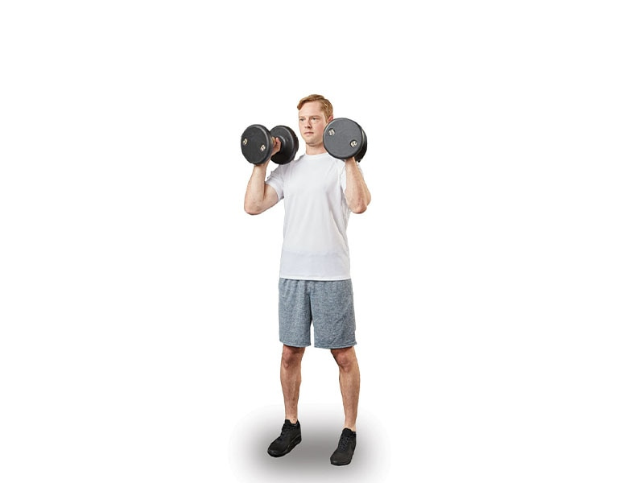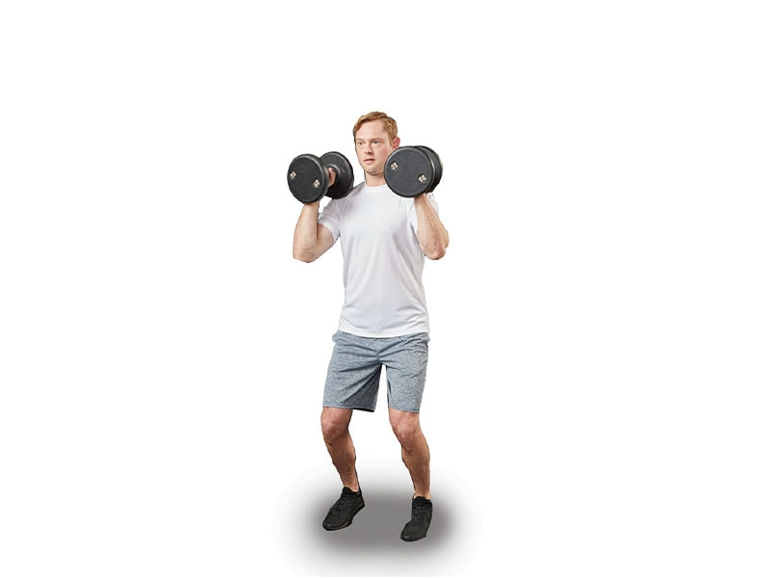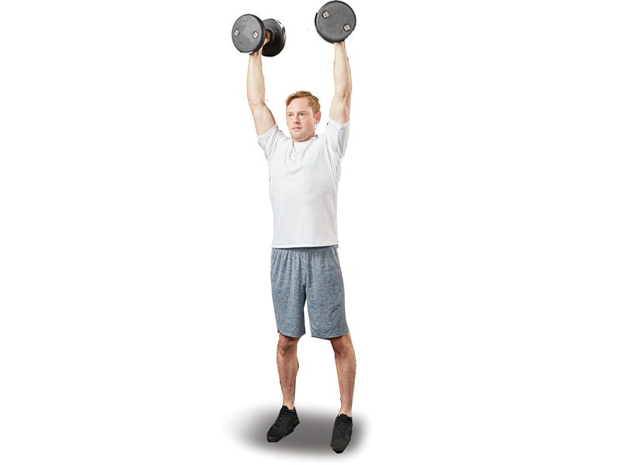

SAFETY

This is a power-focused resistance exercise. Clients are encouraged to first establish proper movement patterns, stability, and strength before attempting this exercise.

Barbell Clean

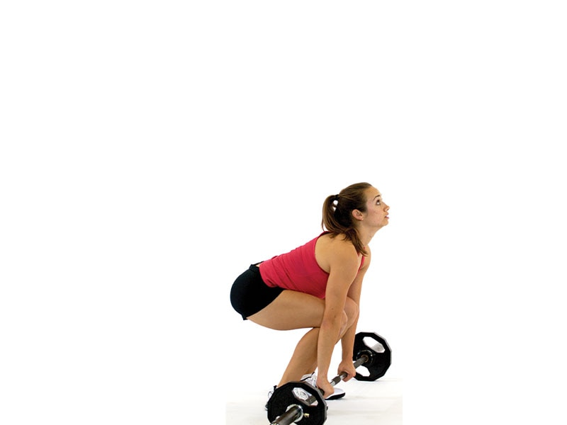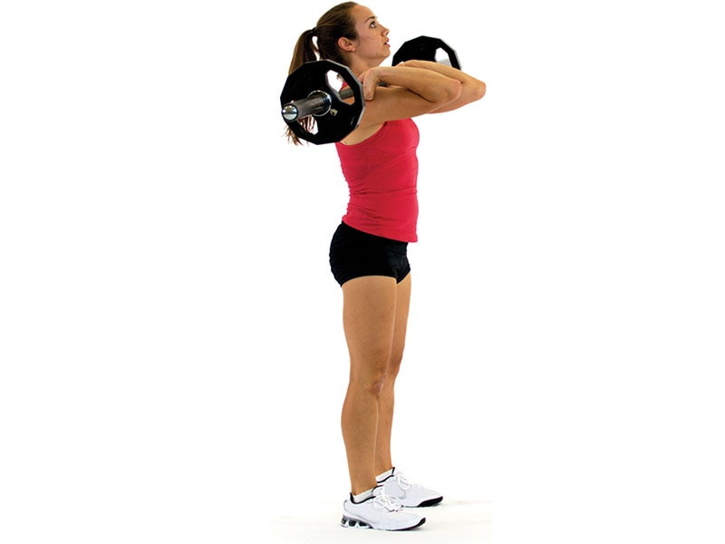

SAFETY

This is a simplified illustration of performing the barbell clean. This is an advanced power exercise that requires proper instruction before attempting.

The following is a list of common stabilization-focused, strength-focused, and power-focused resistance training exercises. However, this is not an exhaustive list.

Chest / Pushing Exercise Descriptions

Push-Up

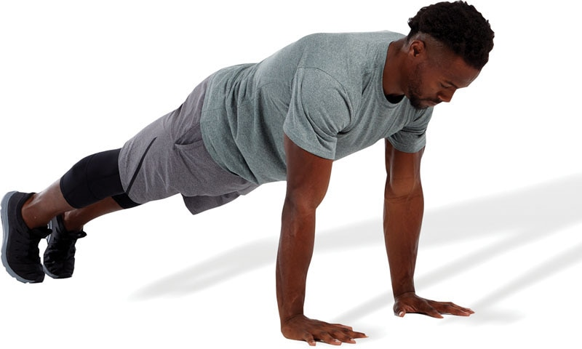 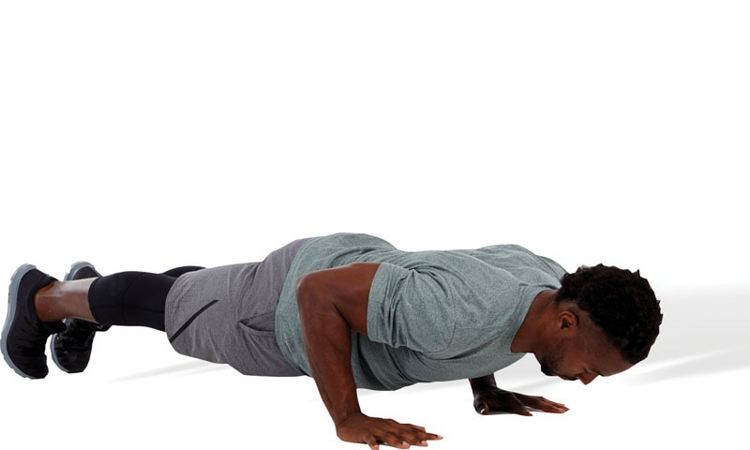

SAFETY

A common compensation that occurs when performing a push-up is arching of the low-back as the hips fall toward the ground. This is an indicator that the individual possesses underactive abdominals and the exercise must be regressed.

Push-Up: Hands on Ball

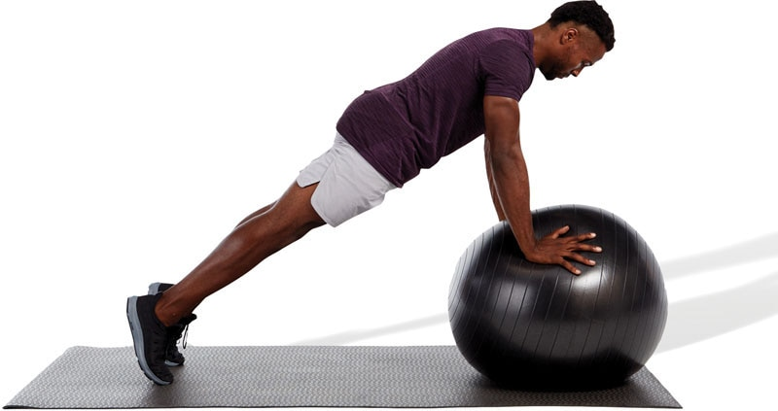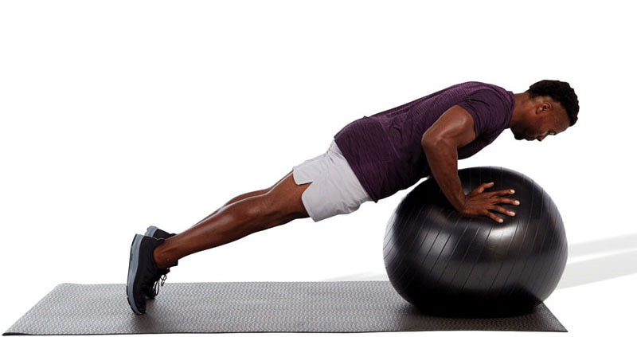

SAFETY

If using a stability ball is too advanced, regress the exercise to a traditional floor push-up.

Standing Cable Chest Press

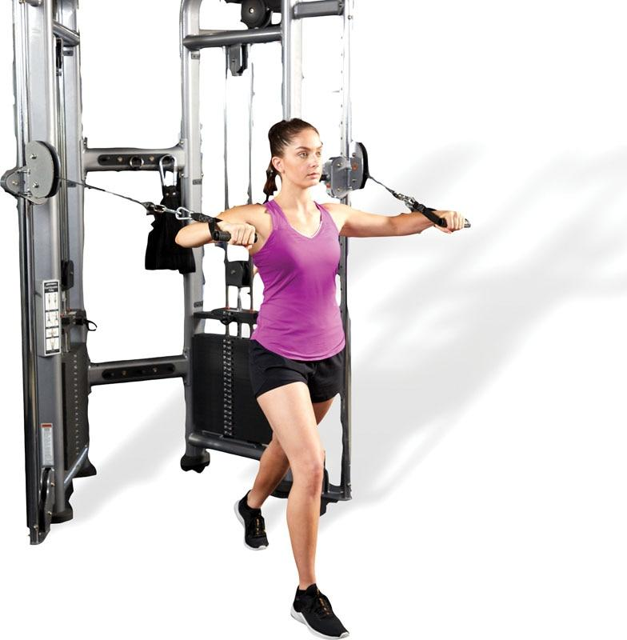 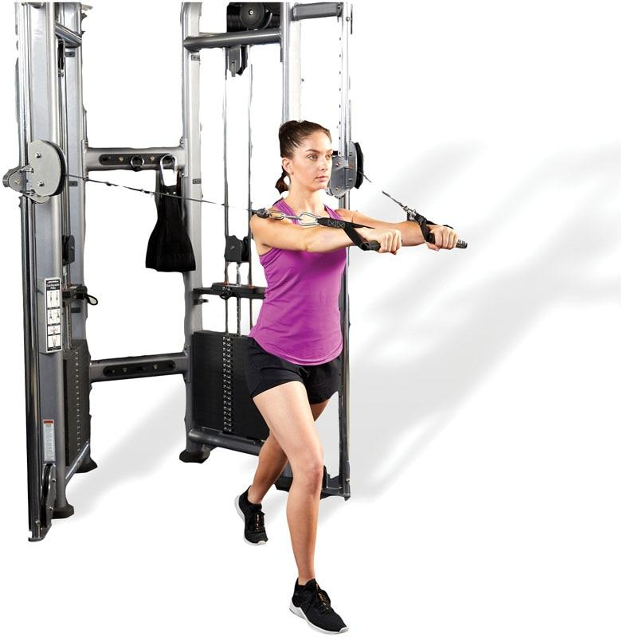

TECHNIQUE

The shoulder shrug is a common compensation that occurs when performing a standing cable chest press. This can indicate overactive upper trapezius muscles, which would require additional stretching.

Flat Dumbbell Chest Press

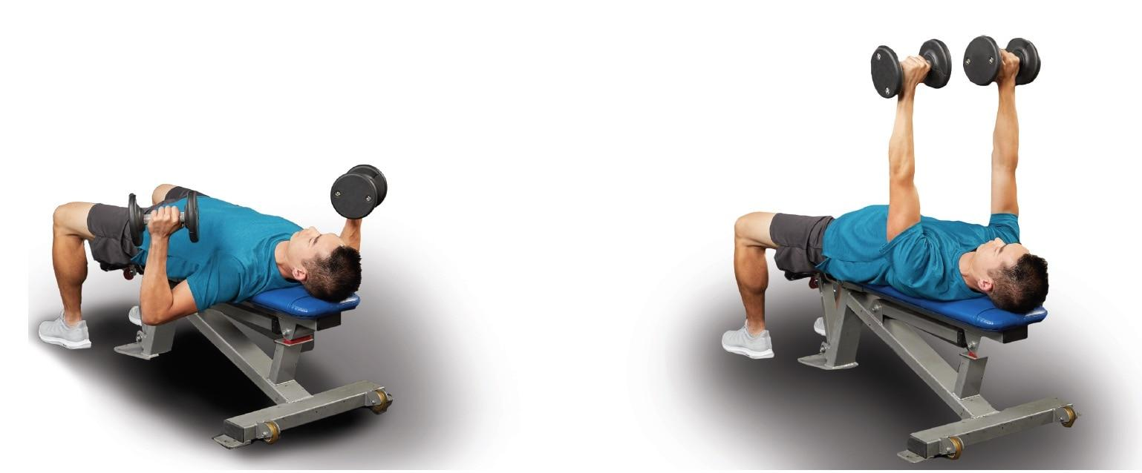

TECHNIQUE

When performing chest presses, the range of motion at the shoulder joint, which is indicated by how far the elbows go down, will be determined by the load one is lifting (control) and tissue extensibility. The key is only to go as far as one can control without compensating.

Barbell Bench Press

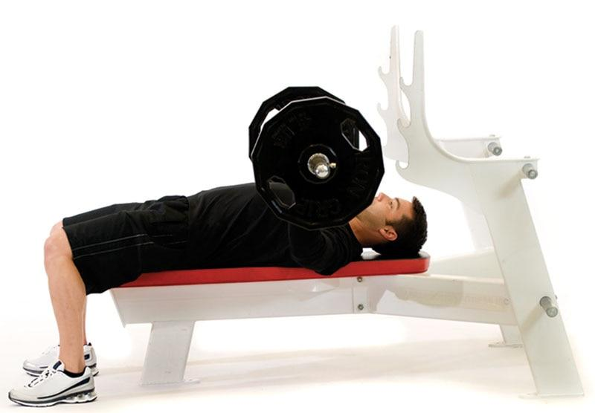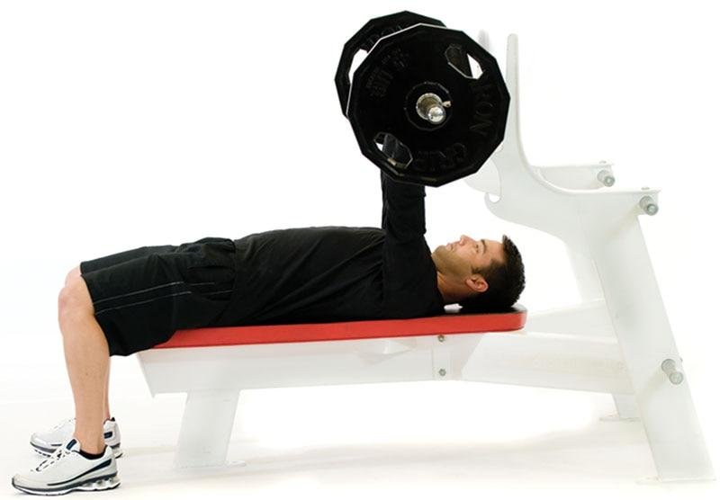

TECHNIQUE

During this exercise, the feet should remain in contact with the floor, whereas the buttocks, shoulders, and head must remain in contact with the bench. The use of weight plates underneath the feet is acceptable if the client cannot reach the floor, due to height limitations.

Medicine Ball Chest Pass

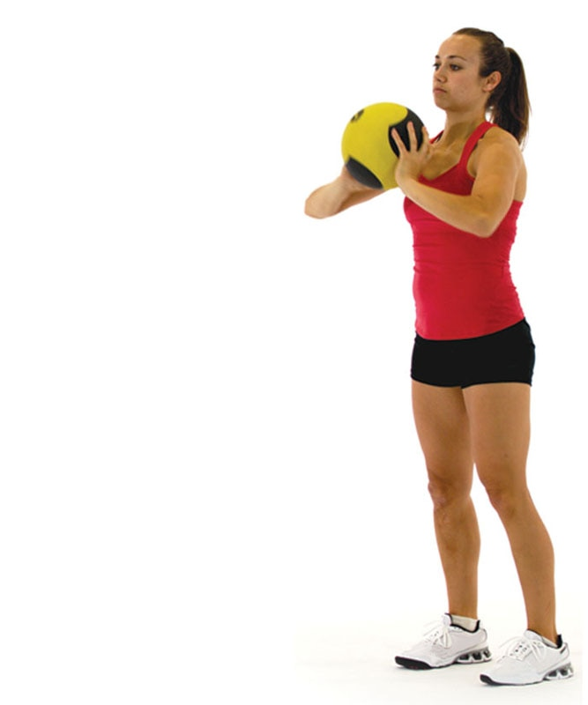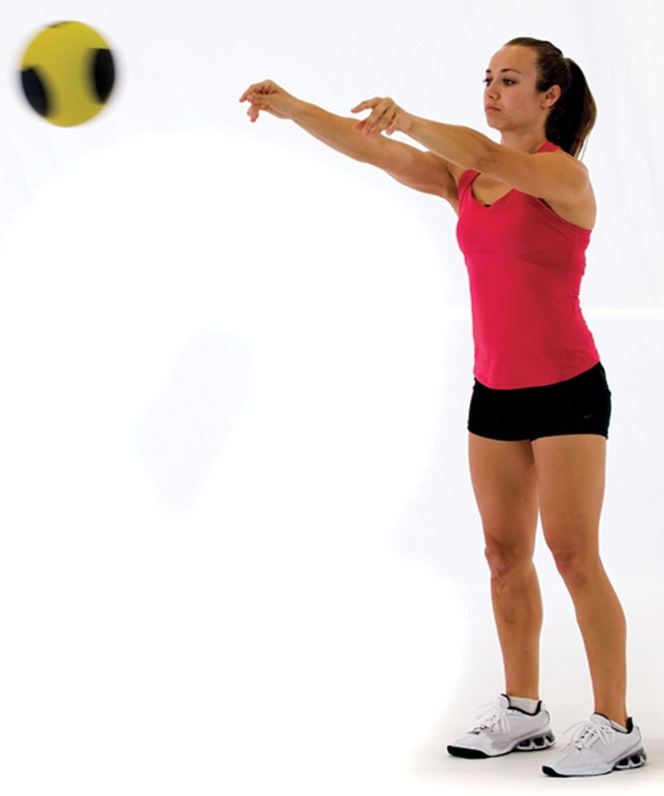

TECHNIQUE

If the ability to perform power exercises with a medicine ball is not an option, because of equipment or facility limitations, this exercise can also be done using tubing or a cable apparatus. Make sure to adjust the weight or resistance accordingly, so the client can still perform the movement quickly and under control without compensation.

Medicine Ball Rotation Chest Pass

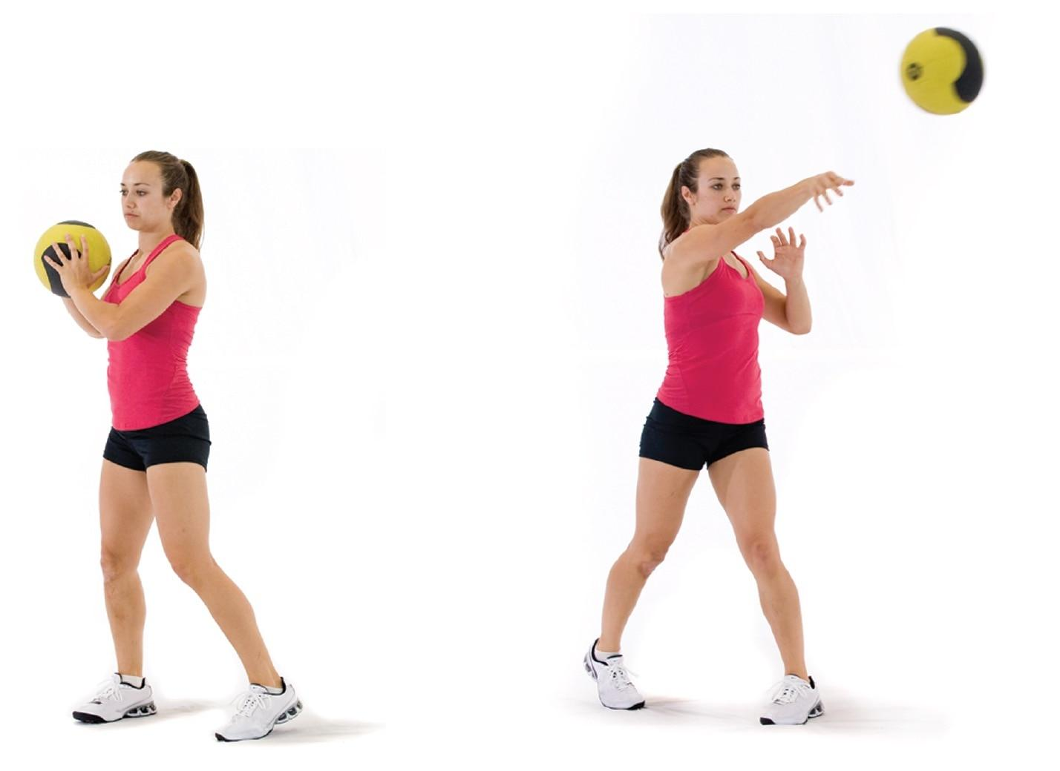

TECHNIQUE

A client can either throw the ball to their Certified Personal Trainer or toward a wall. If throwing toward a wall, instruct the client to be prepared to catch the ball on the rebound.

The following is a list of common stabilization-focused, strength-focused, and power-focused resistance training exercises. However, this is not an exhaustive list.

Back/Pulling Exercise Descriptions

Ball Cobra

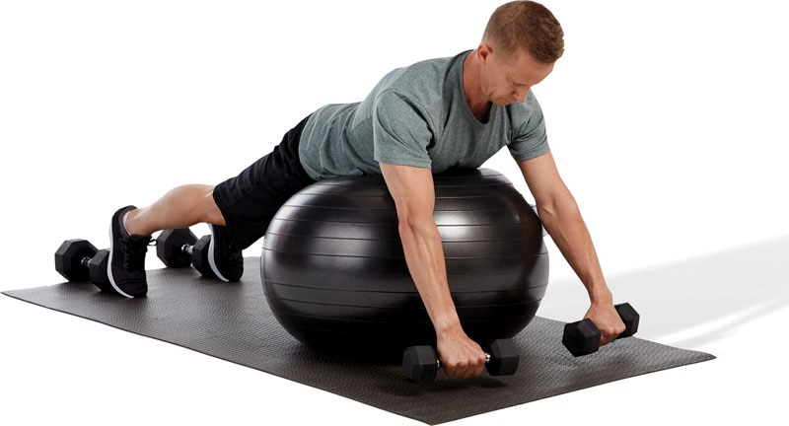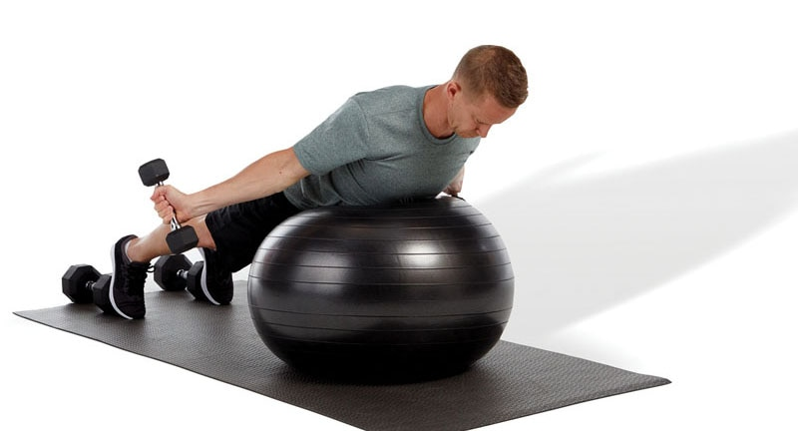

TECHNIQUE

Externally rotate the arms during this exercise so the thumbs are pointing up toward the sky.

Ball Dumbbell Row

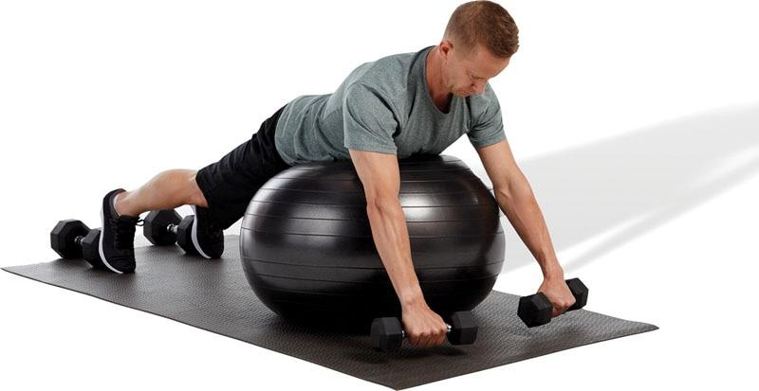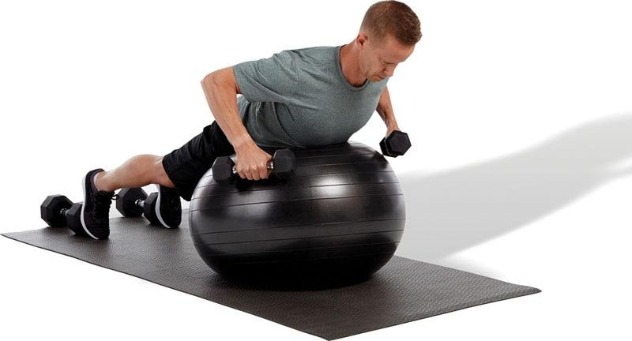

TECHNIQUE

Performing exercises in a prone position can be uncomfortable. When working with overweight individuals, it may be more appropriate to perform this exercise using a machine or from a standing, hip-hinged position.

Standing Cable Row

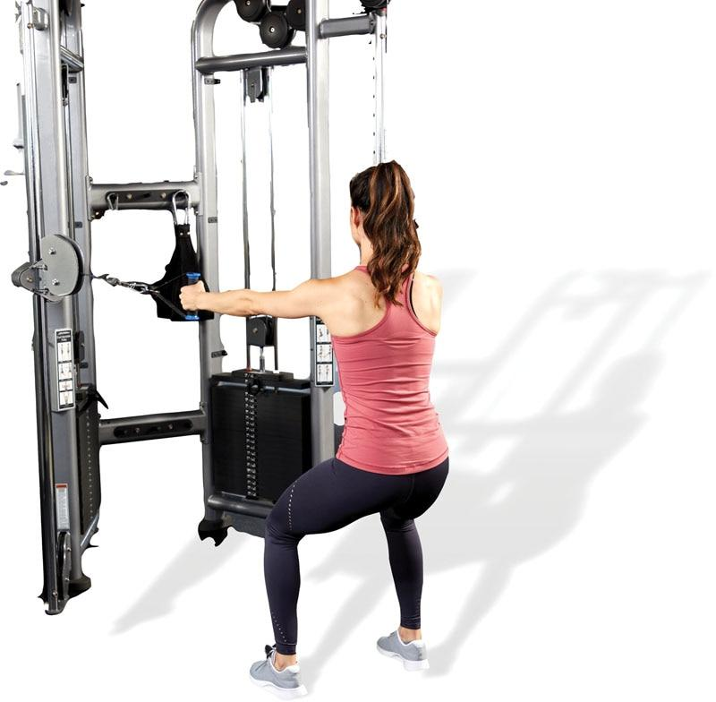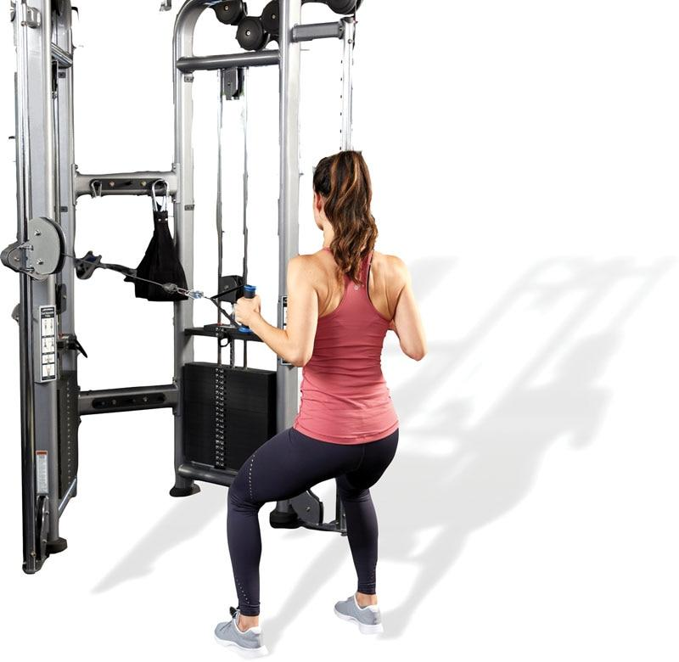

TECHNIQUE

When performing rows, initiate the movement by retracting and depressing the shoulder blades (scapulae). Do not allow the shoulders to elevate.

Seated Cable Row

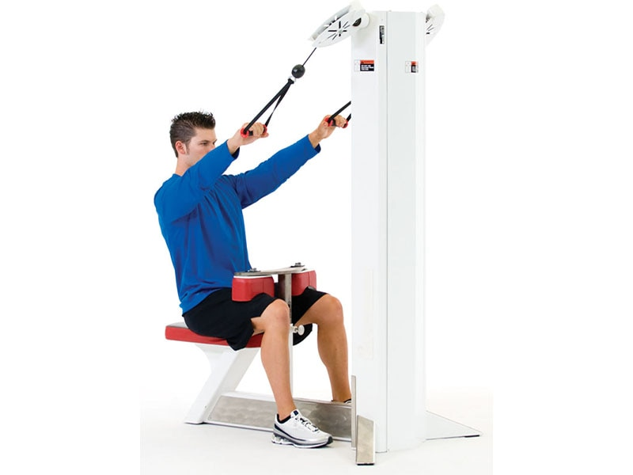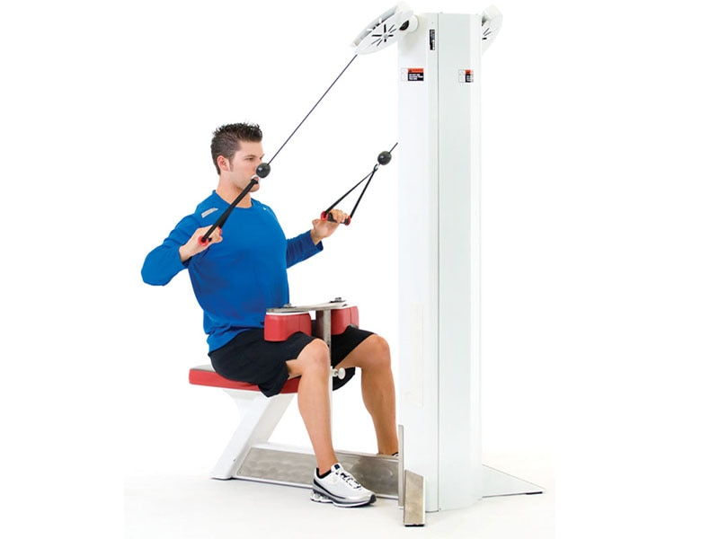

TECHNIQUE

To increase the effectiveness of the exercise and decrease the risk of injury, keep the torso stationary throughout the execution of the exercise. Flexing and extending the torso while performing the row creates momentum, which decreases the effectiveness of the exercise and may place stress on the low-back.

Seated Lat Pulldown

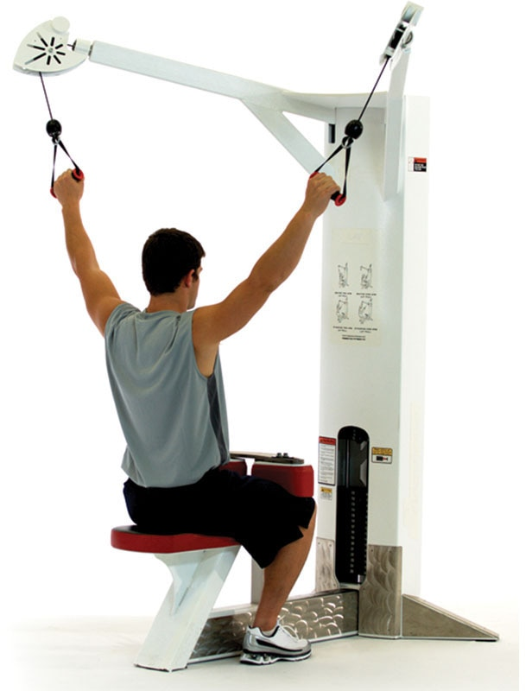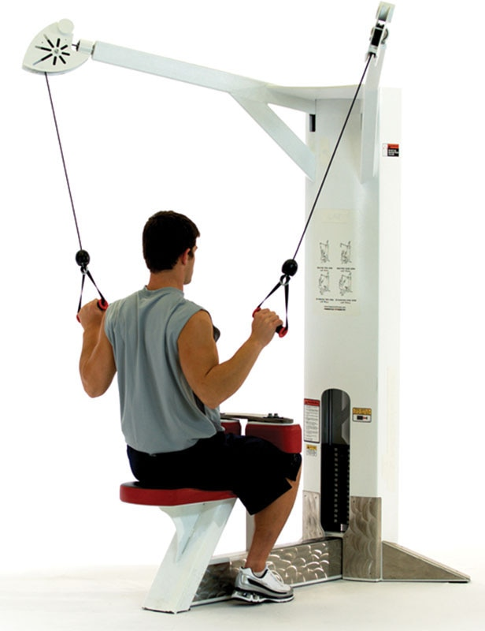

SAFETY

Performing lat pulldowns with a bar behind the neck is not advised, because this places stress on the shoulder joints and cervical spine. If performing the lat pulldown exercise with a bar, the bar should pass in front of the face, to approximately shoulder height.

Medicine Ball Pullover Throw

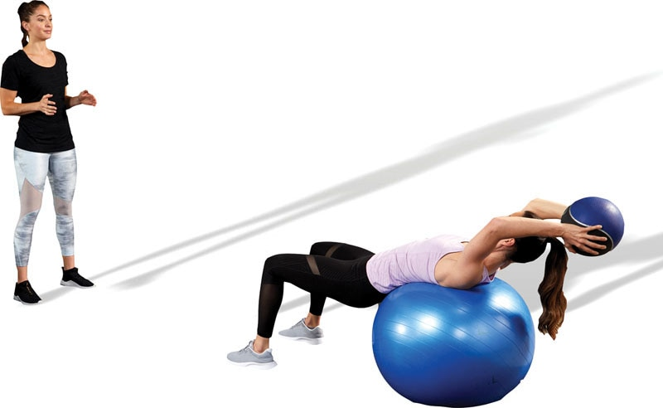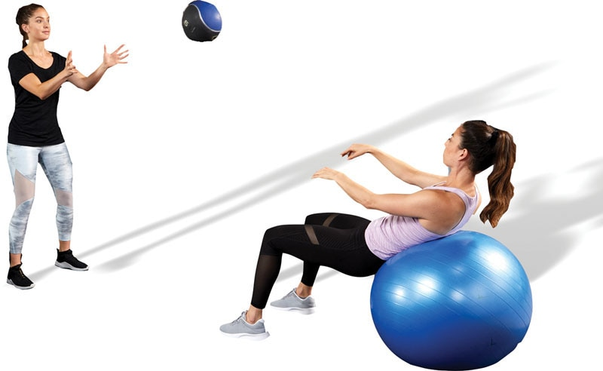

SAFETY

To decrease stress to the shoulder and low-back, it will be important for the client to have optimal extensibility through the latissimus dorsi musculature before performing this exercise.

Soccer Throw

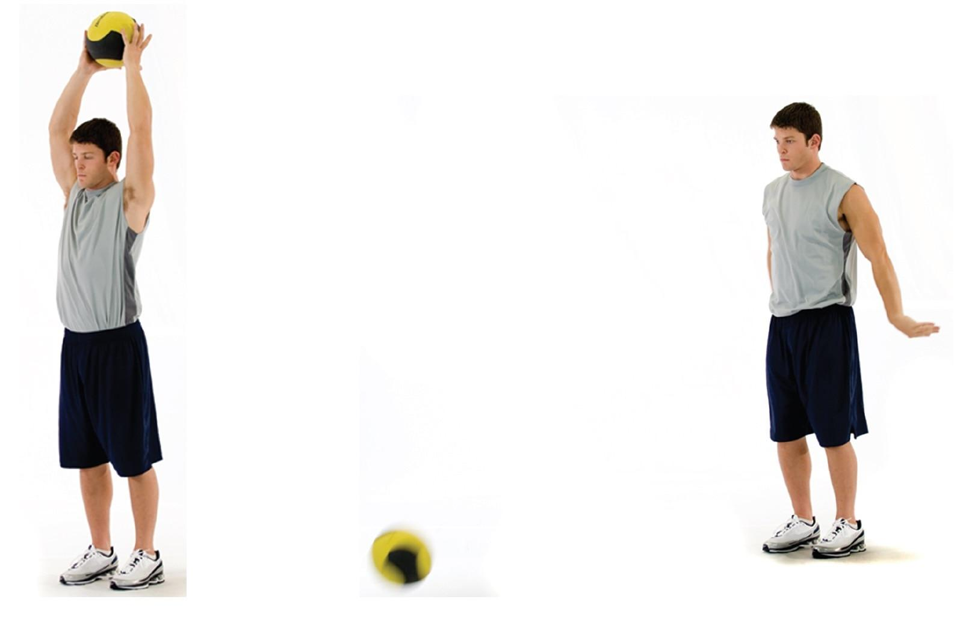

TECHNIQUE

Use a medicine ball that is no more than 10% body weight. The goal is to throw the ball as hard as possible to maximize power production.

The following is a list of common stabilization-focused, strength-focused, and power-focused resistance training exercises. However, this is not an exhaustive list.

Shoulder / Vertical Pressing Exercise Descriptions

Tubing External Rotation

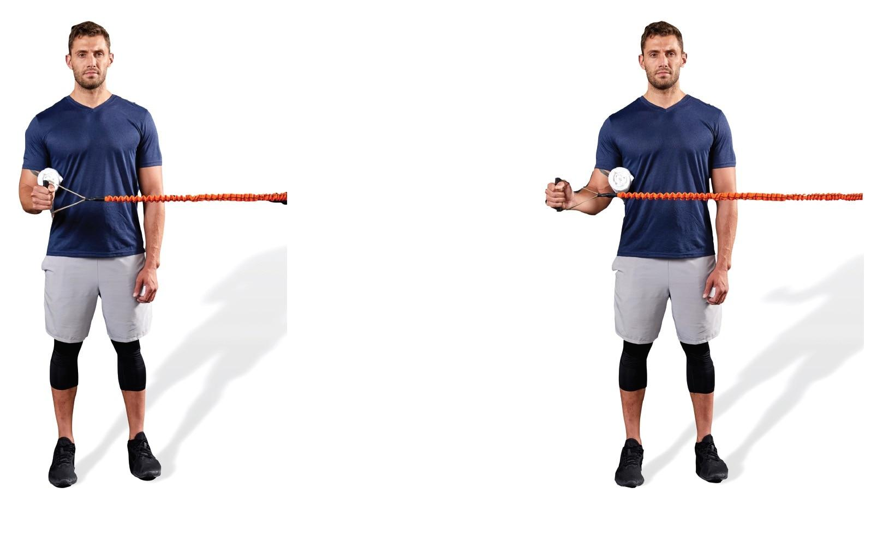

TECHNIQUE

This exercise helps strengthen muscles of the rotator cuff, such as the infraspinatus and teres minor. These two muscles externally rotate the shoulder.

Tubing Internal Rotation

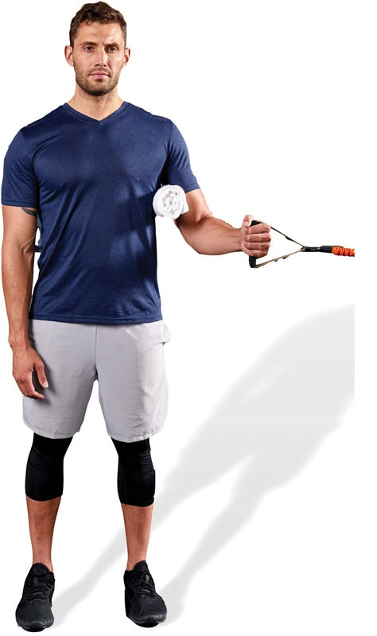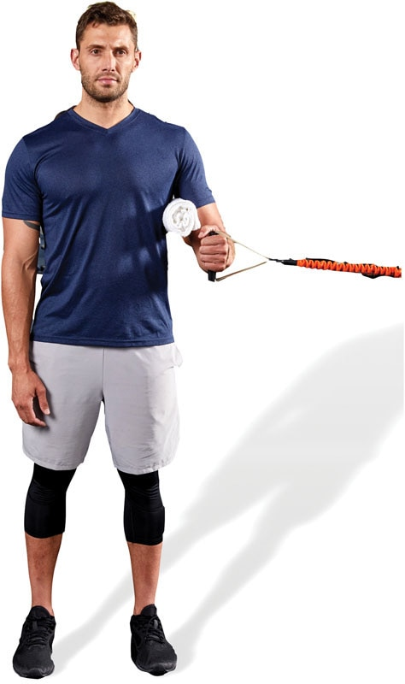

TECHNIQUE

This exercise helps strengthen the subscapularis, one of the four rotator cuff muscles. This muscle internally rotates the shoulder.

Single-Leg Dumbbell Scaption

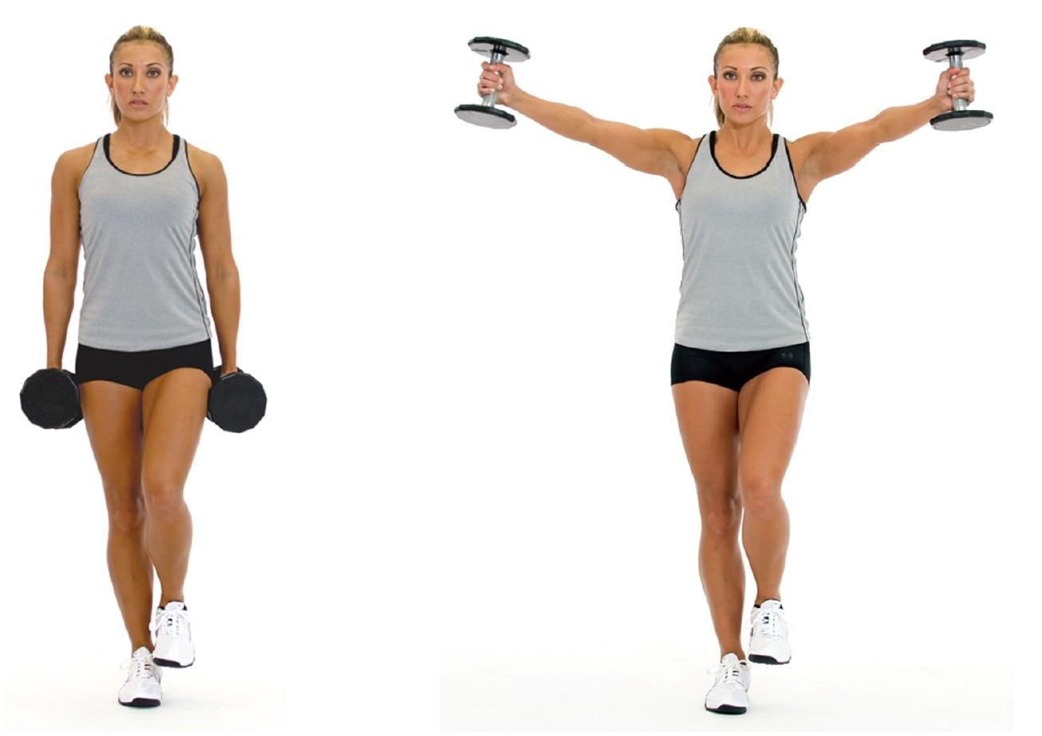

TECHNIQUE

Performing shoulder exercises in the scapular plane, with arms out at a 45-degree angle, decreases the risk of the supraspinatus muscle becoming impinged within the shoulder. If standing on one leg is too difficult, regress this exercise to a bilateral stance.

Ball Combo I

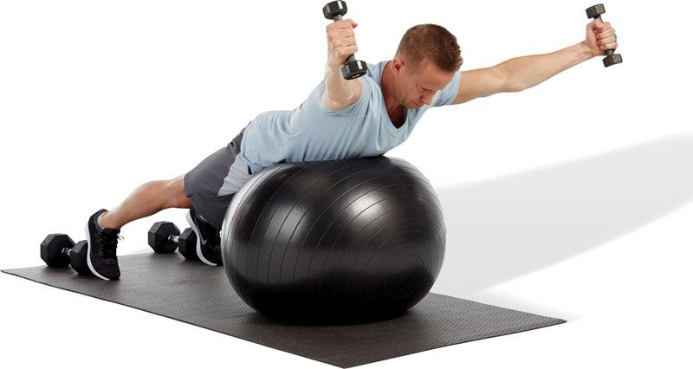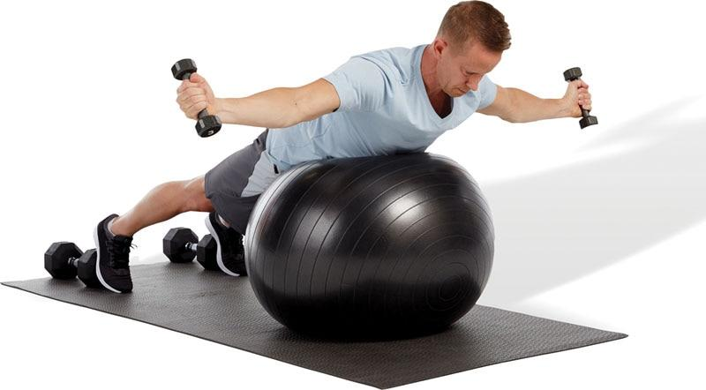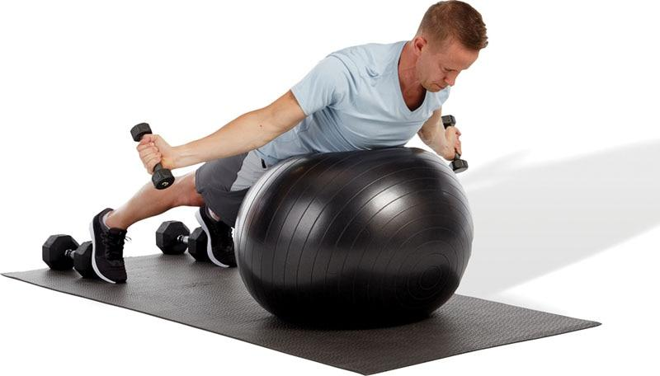

TECHNIQUE

This exercise consists of three parts. First, the client will perform a Y (scaption) position, then a T (shoulder abduction) position, and lastly an A (cobra) position.

Ball Combo II

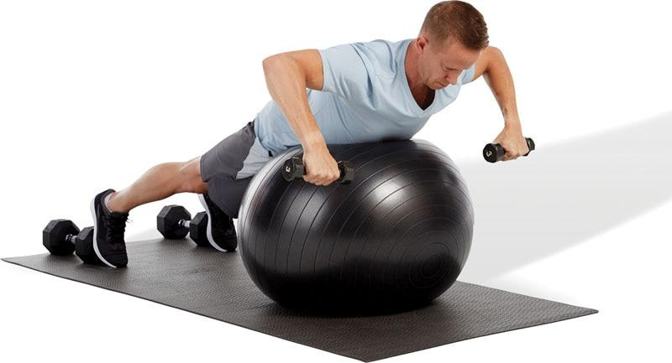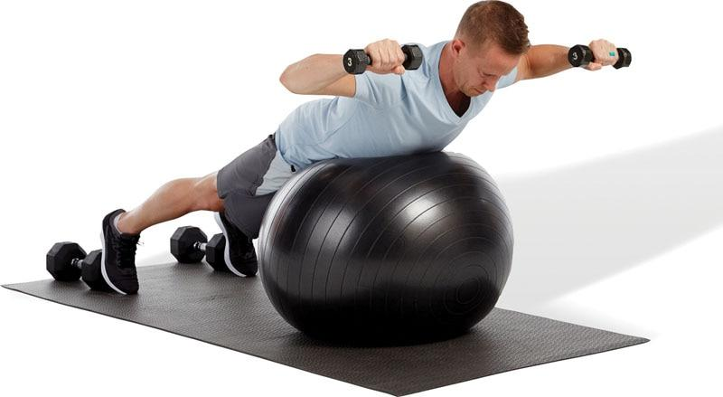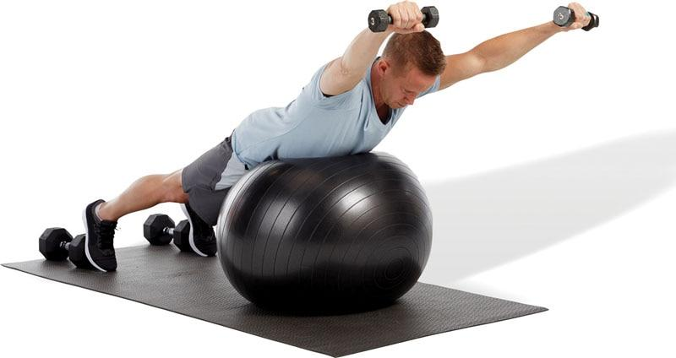

TECHNIQUE

Like ball combo I, this exercise also consists of three parts: a dumbbell row, shoulder external rotation, and a prone shoulder press.

Standing Dumbbell Shoulder Press

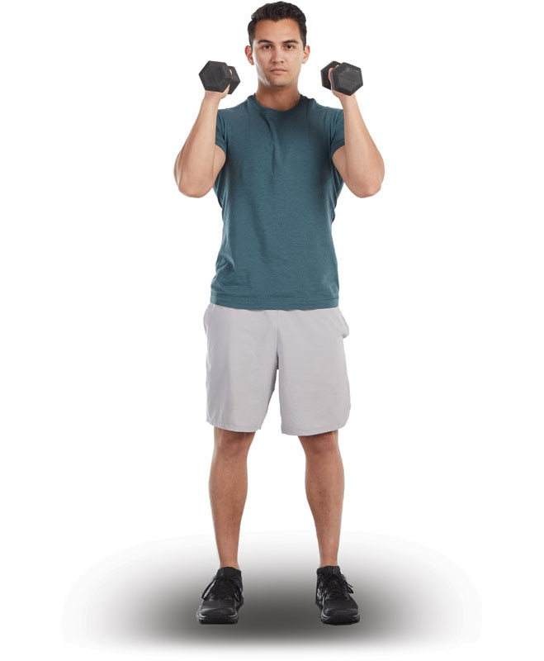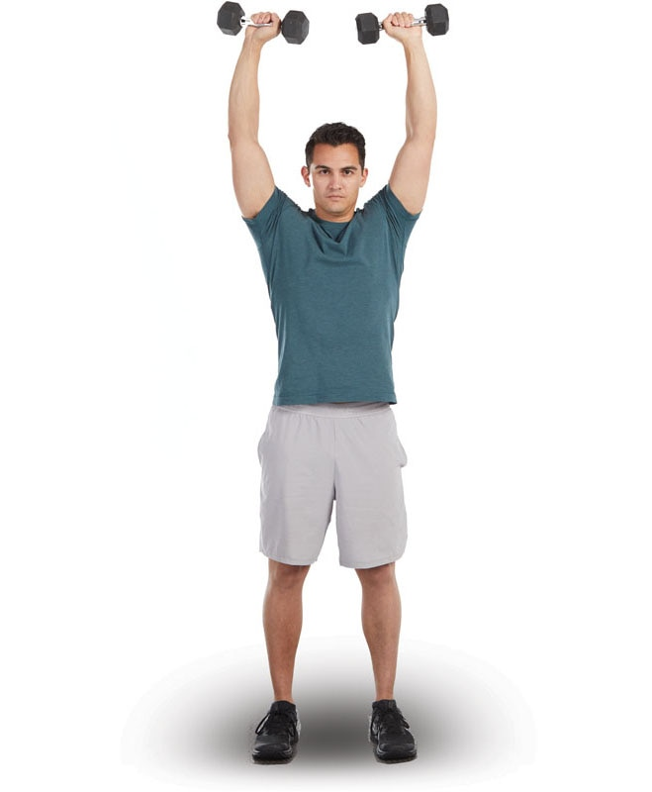

SAFETY

Proper core activation is important during all overhead pressing exercises, so as to minimize injury to the low-back area.

Standing Dumbbell Lateral Raise

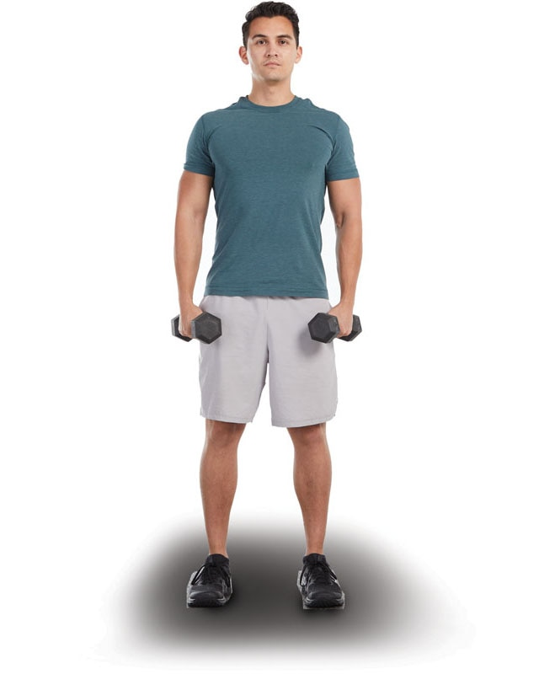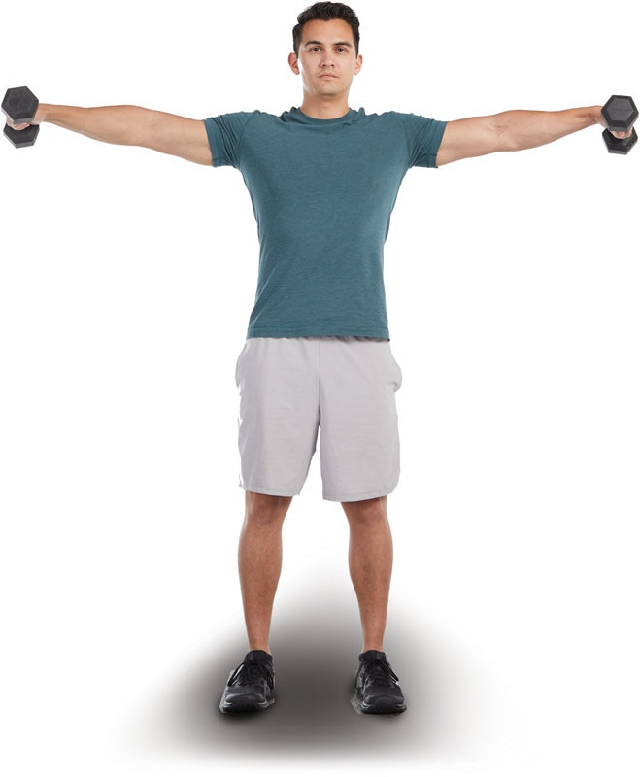

TECHNIQUE

This exercise helps strengthen the middle deltoid. Remember, the deltoids consist of three segments: anterior deltoid, middle deltoid, and posterior deltoid.

Seated Dumbbell Shoulder Press

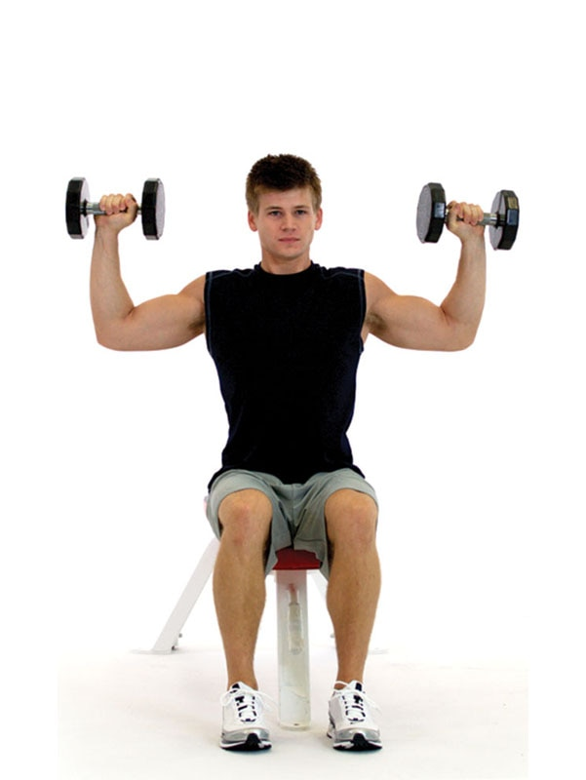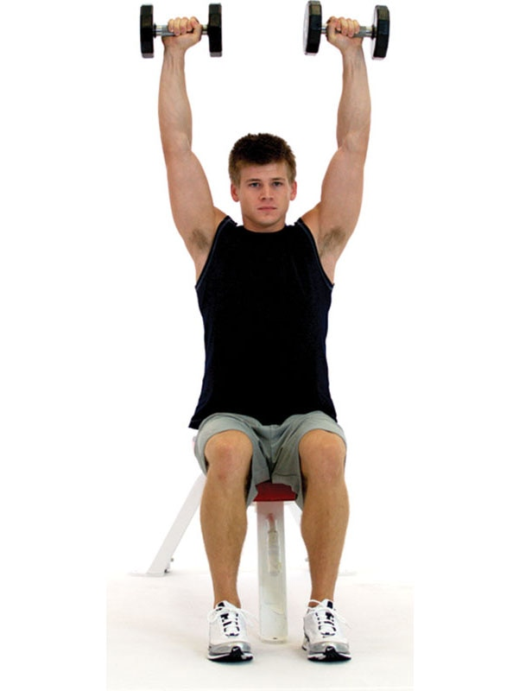

SAFETY

When performing overhead presses, make sure the cervical spine stays neutral, so the head is drawn back. Do not allow the head to migrate forward, because this places excessive stress on the posterior neck muscles and cervical spine.

Seated Shoulder Press Machine

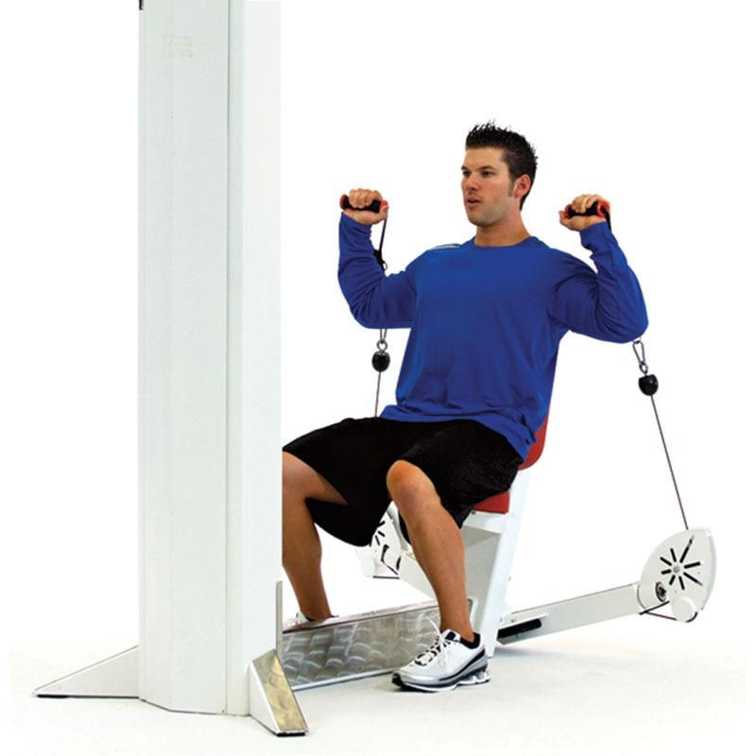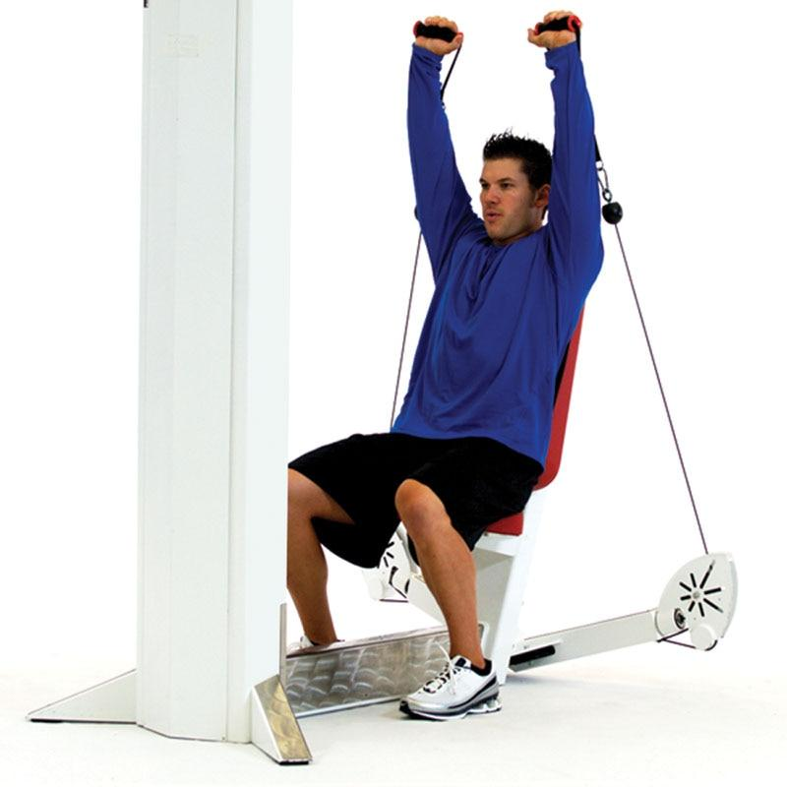

TECHNIQUE

Ensure that the client is properly positioned on the machine with their feet flat on the floor.

Front Medicine Ball Oblique Throw

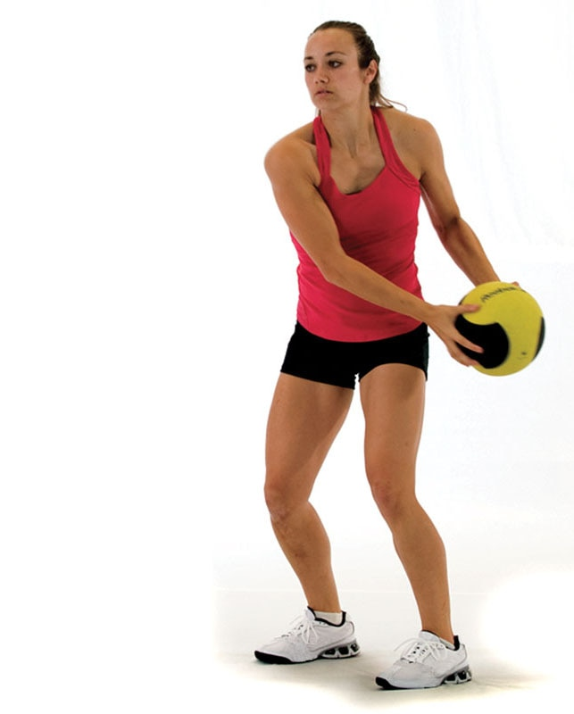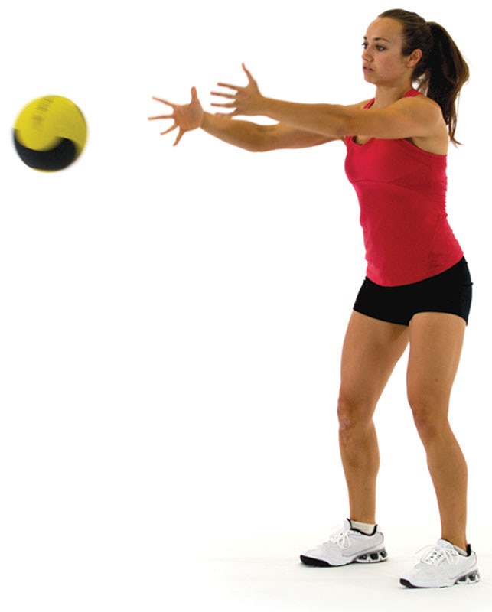

TECHNIQUE

If a partner is unavailable, this exercise can be performed by tossing the medicine ball against a wall.

Overhead Medicine Ball Throw

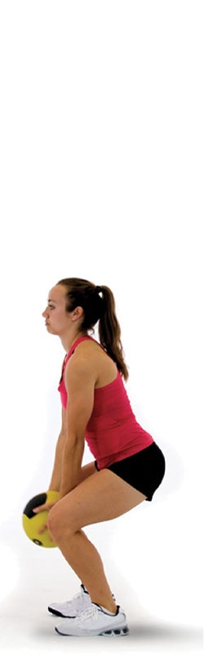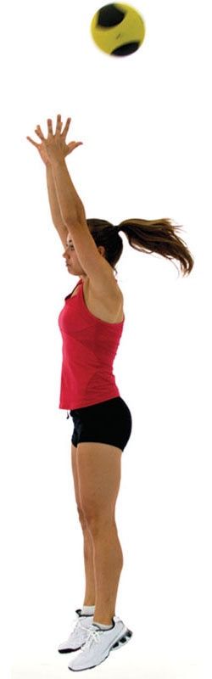

SAFETY

This exercise is best performed outside to avoid hitting overhead lights or the ceiling.

The following is a list of common stabilization-focused, strength-focused, and power-focused resistance training exercises. However, this is not an exhaustive list.

Biceps Exercise Descriptions

Single-Leg Dumbbell Curl

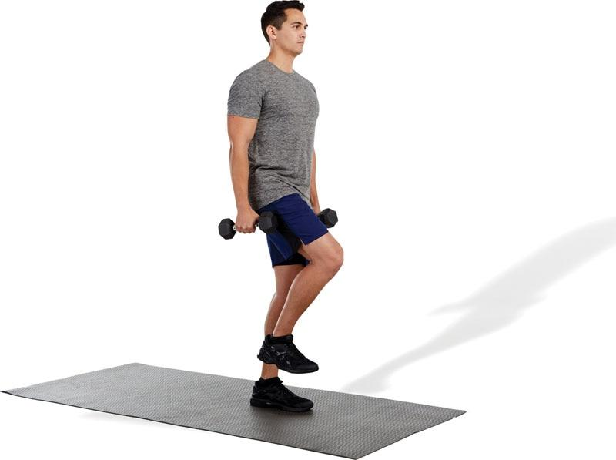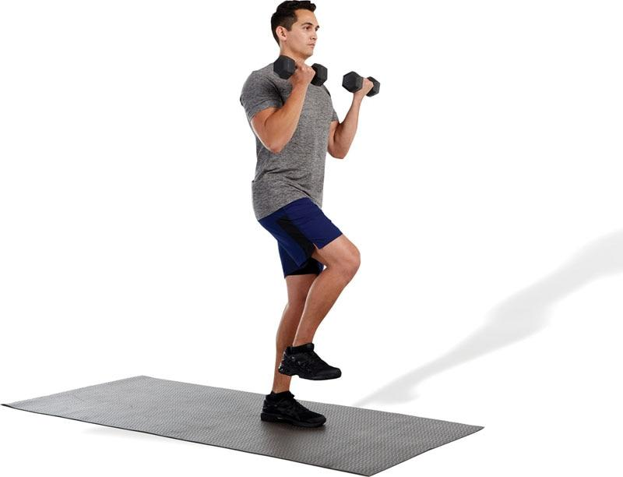

TECHNIQUE

Keeping the scapulae retracted during the exercise ensures proper scapular stability, placing more of an emphasis on the bicep’s musculature.

Standing Dumbbell Curl

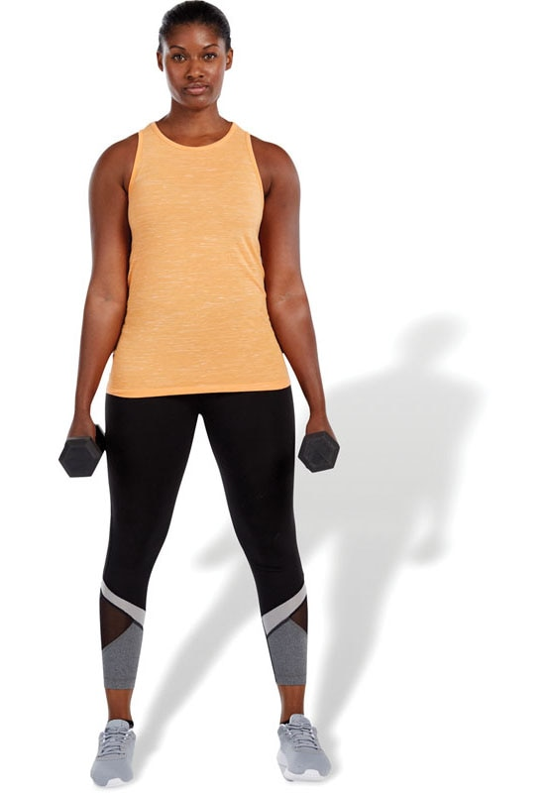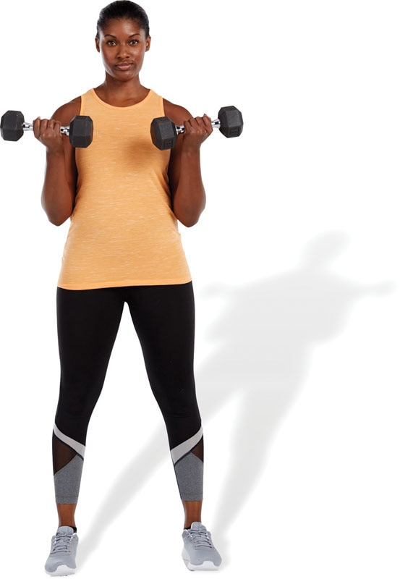

TECHNIQUE

This exercise is performed in the same manner as the single-leg dumbbell curl. Instruct your clients to avoid using momentum to curl the weight upwards.

Standing Barbell Curl

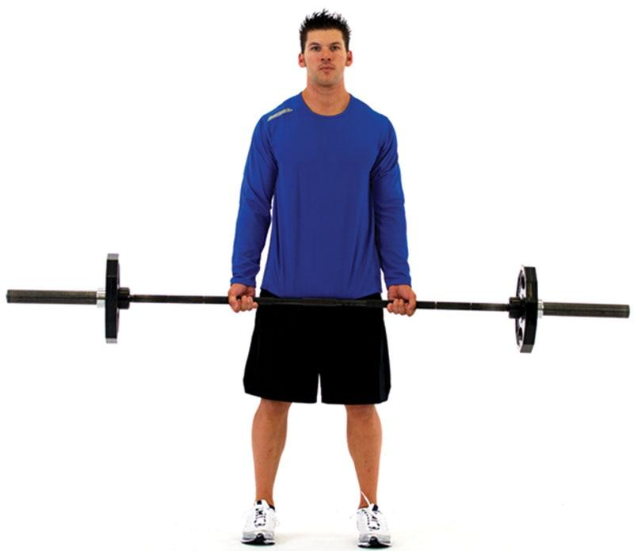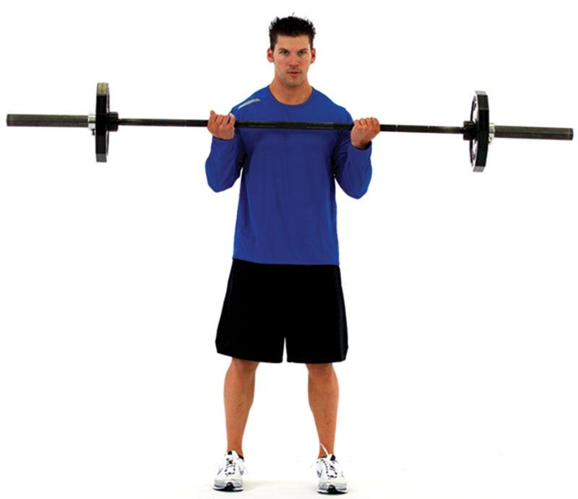

SAFETY

To decrease stress on the elbow, do not grip too close or too wide on the bar. To determine grip width, clients should extend their elbows so their hands fall naturally to their sides, palms facing forward. This is the position where they should be when they grip the bar.

Standing Hammer Curl

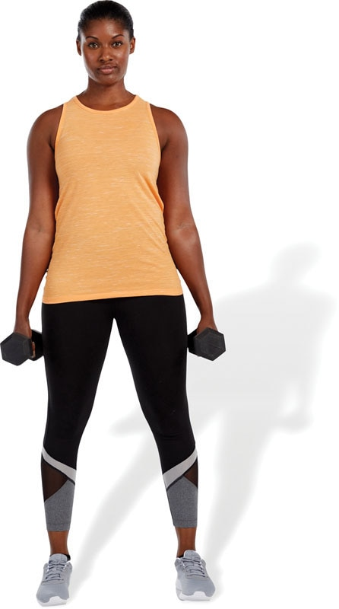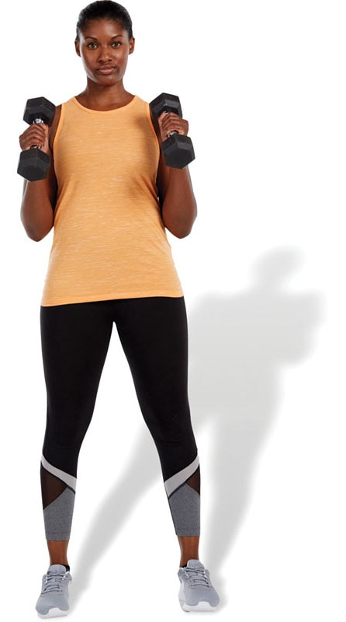

TECHNIQUE

Palms should face each other throughout the duration of the movement. This exercise also strengthens forearm muscles in addition to the biceps brachii.

Seated Two-Arm Dumbbell Biceps Curl

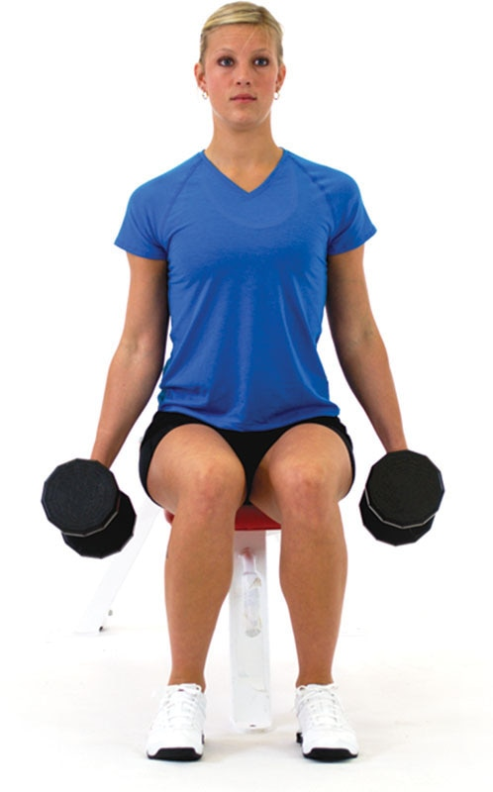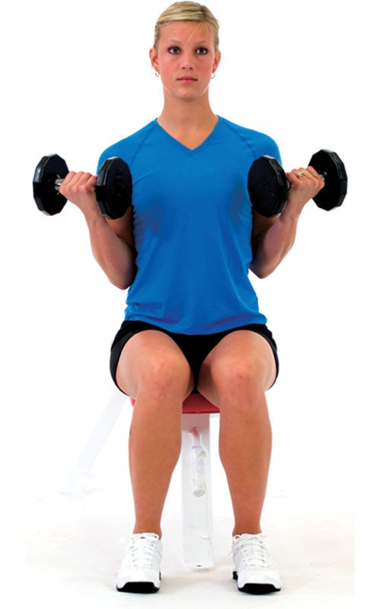

TECHNIQUE

This exercise can also be performed with either alternating arms or one arm at a time.

Biceps Curl Machine

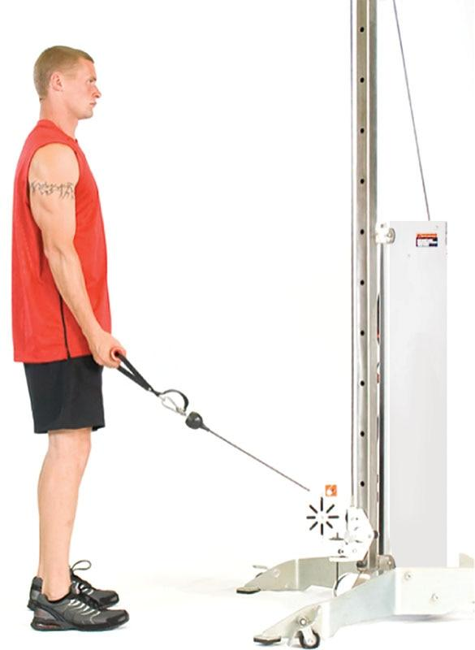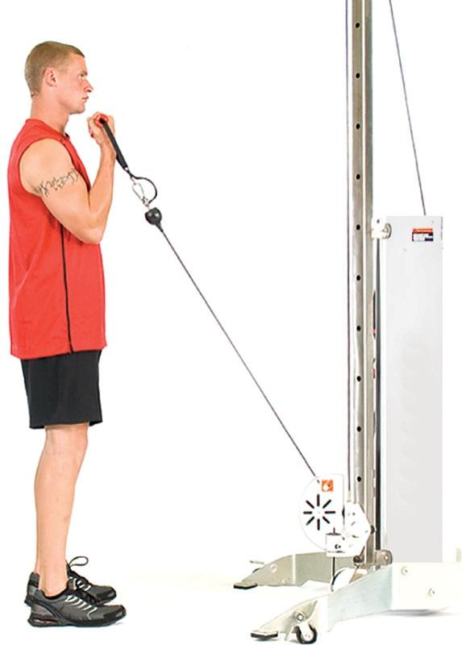

TECHNIQUE

When performing biceps curls, it is important to keep an upright posture. Do not allow your client’s torso to excessively flex or extend to cheat the movement.

The following is a list of common stabilization-focused, strength-focused, and power-focused resistance training exercises. However, this is not an exhaustive list.

Triceps Exercise Descriptions

Supine Ball Dumbbell Triceps Extensions (Dumbbell Skull Crushers)

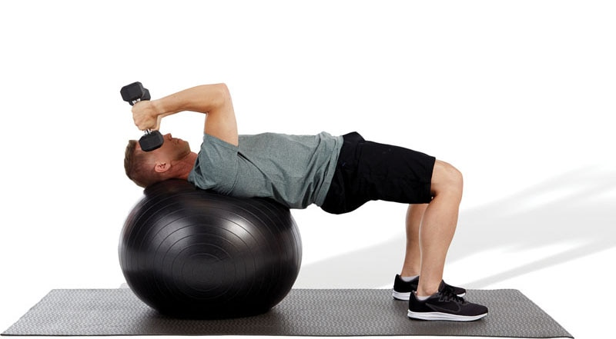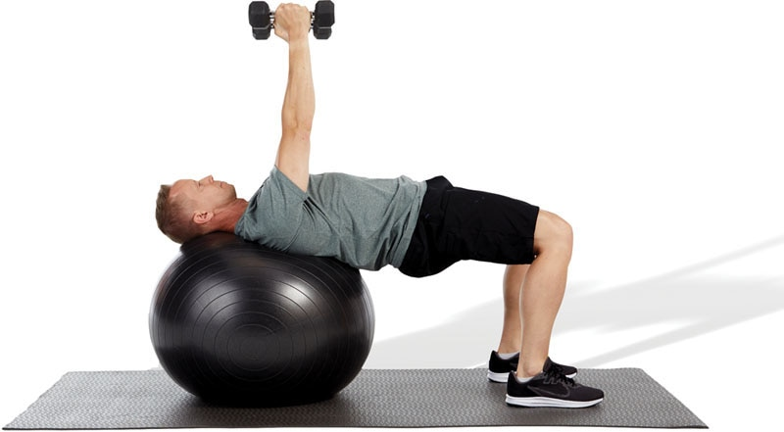

SAFETY

When performing stability ball exercises in a supine position, the head should comfortably rest on the ball. This will decrease stress to the cervical spine.

Prone Ball Dumbbell Triceps Extensions

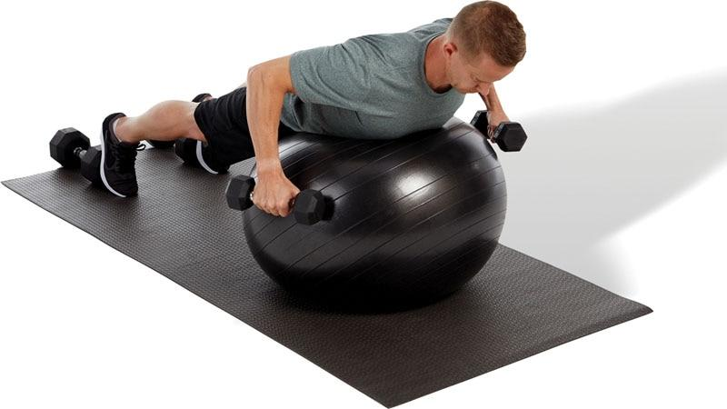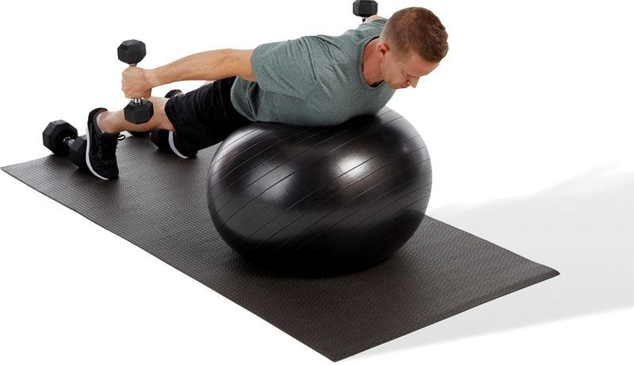

TECHNIQUE

To ensure optimal alignment, make sure the ankles, knees, hips, shoulders, and ears are all in alignment and maintained throughout the exercise.

Cable Pushdown

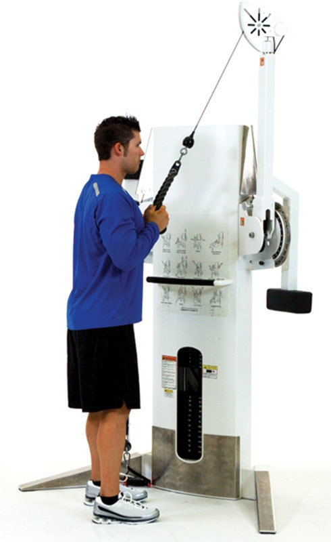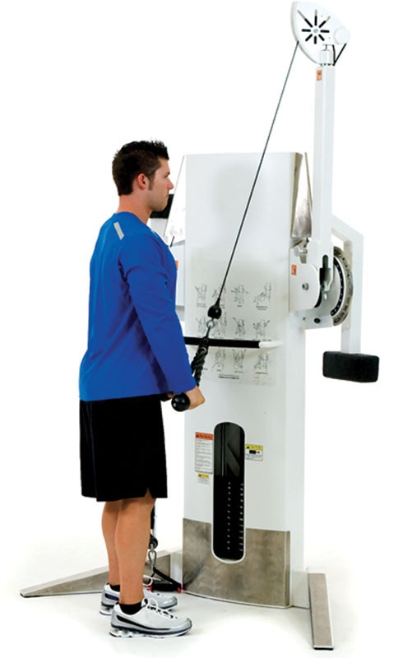

TECHNIQUE

Using a rope when performing cable pushdowns will allow the elbows to track through their natural path of motion versus having the hands closely fixed on a bar. This may help decrease the risk of elbow pain.

Supine Bench Barbell Triceps Extensions (Barbell Skull Crushers)

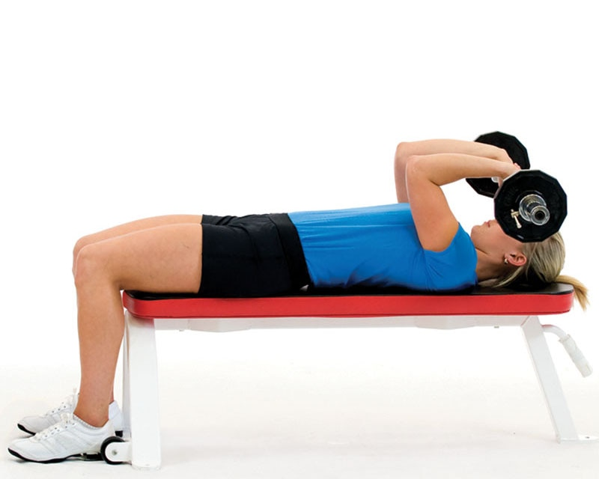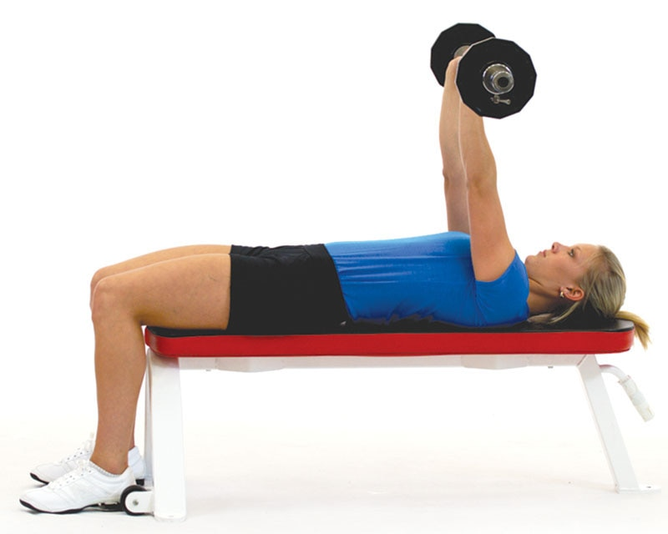

SAFETY

As with barbell curls, keeping the hands too close on the bar can increase stress on the elbow. Placing hands closer to shoulder-width apart can decrease stress on the elbow.

Close Grip Bench Press

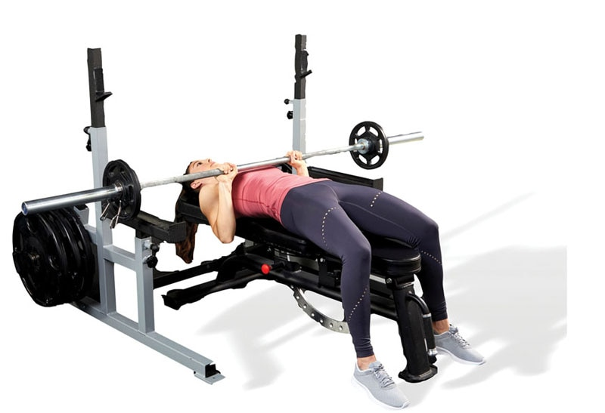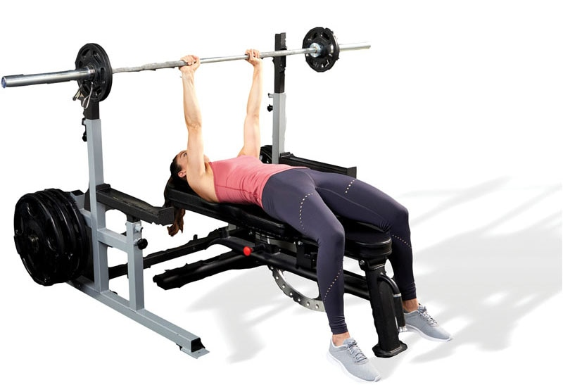

TECHNIQUE

The proper hand position should be slightly inside shoulder-width apart during this exercise. Moving the hands inward places more emphasis on the triceps musculature, but the anterior shoulders and chest are still involved with this exercise.

The following is a list of common stabilization-focused, strength-focused, and power-focused resistance training exercises. However, this is not an exhaustive list.

Leg Exercise Descriptions

Ball Squat

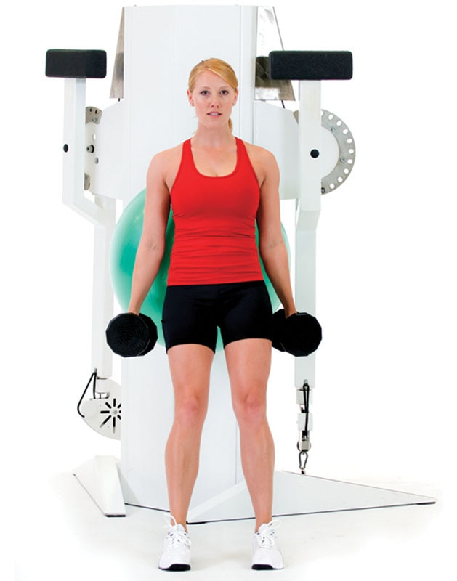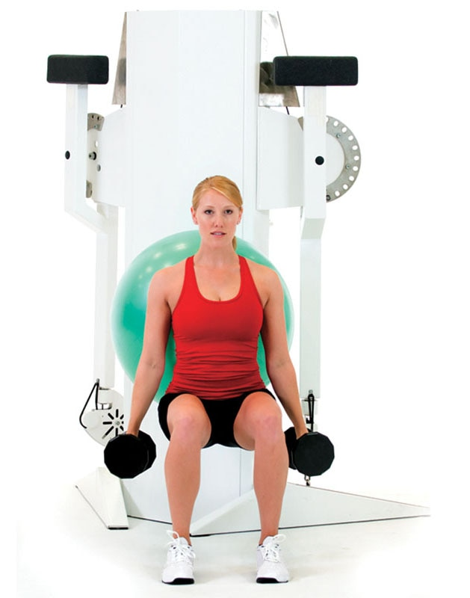

SAFETY

Ball squats are a great way to teach individuals how to squat properly. The goal is to have them eventually progress to squats without the stability ball.

Single-Leg Squat

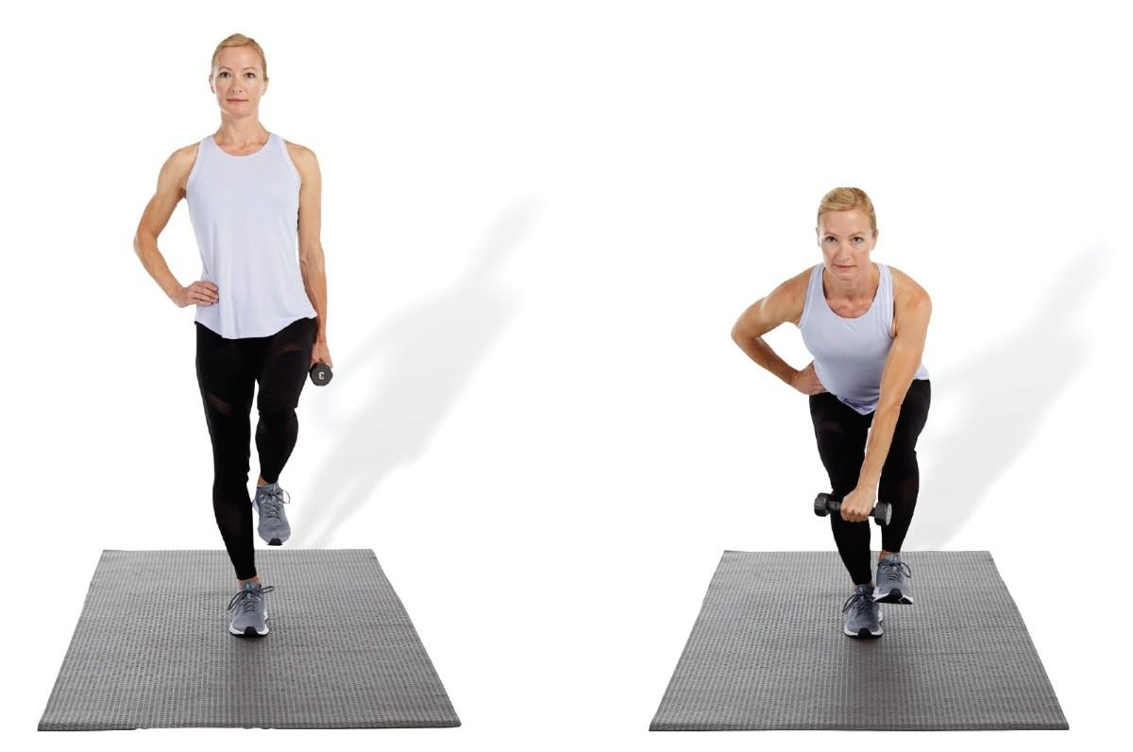

SAFETY

This is an advanced stabilization-focused leg exercise. The client should only squat as low as they can safely control.

Single-Leg Romanian Deadlift

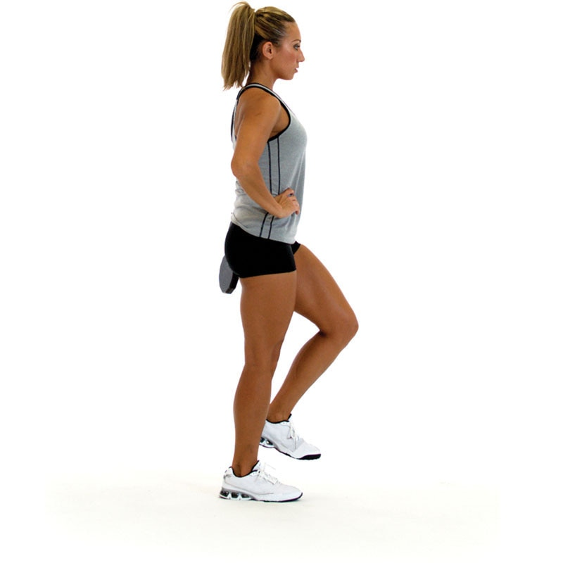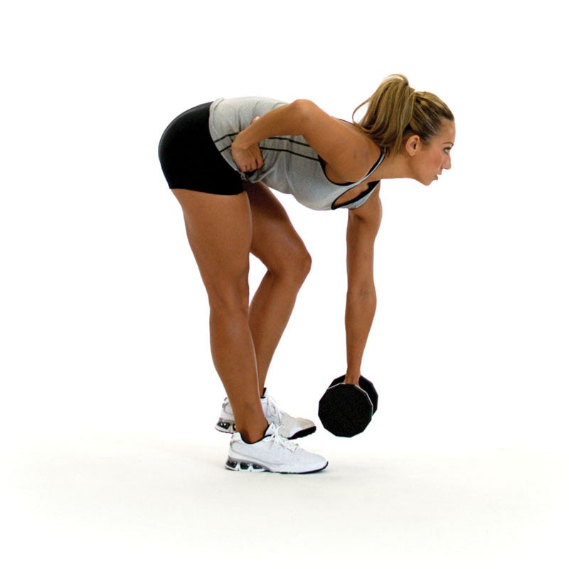

TECHNIQUE

This exercise strengthens many muscles of the posterior chain including the hamstrings, gluteal complex, and lumbar erector spinae (low-back muscles).

Calf Raise

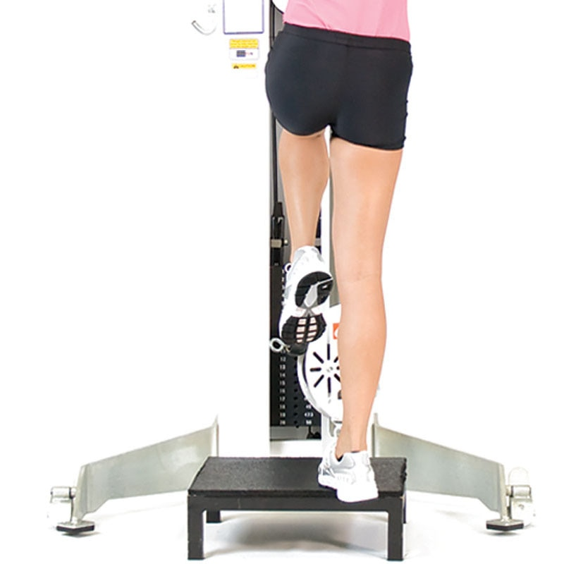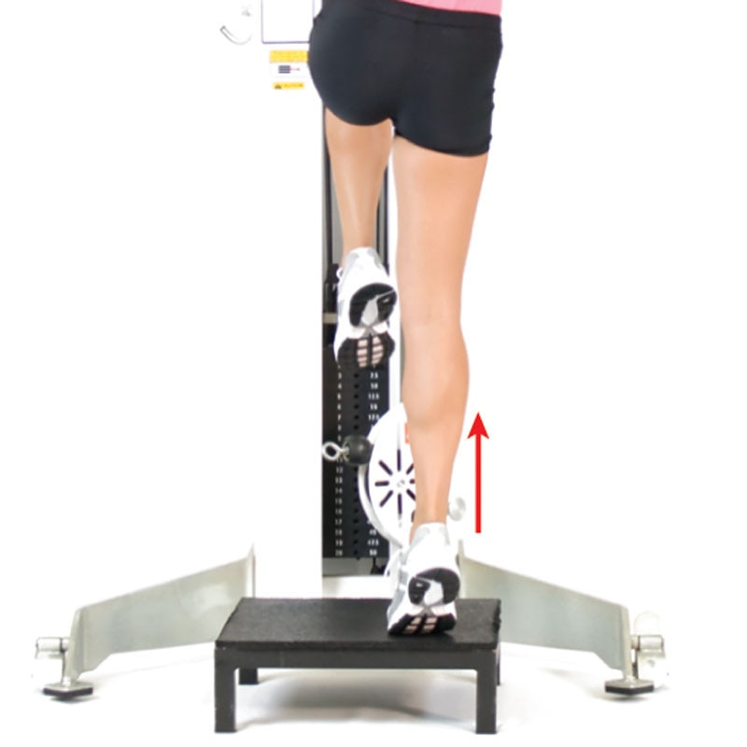

TECHNIQUE

This exercise helps strengthen the gastrocnemius, soleus, and other plantar flexor muscles of the lower leg.

Multiplanar Step-Up

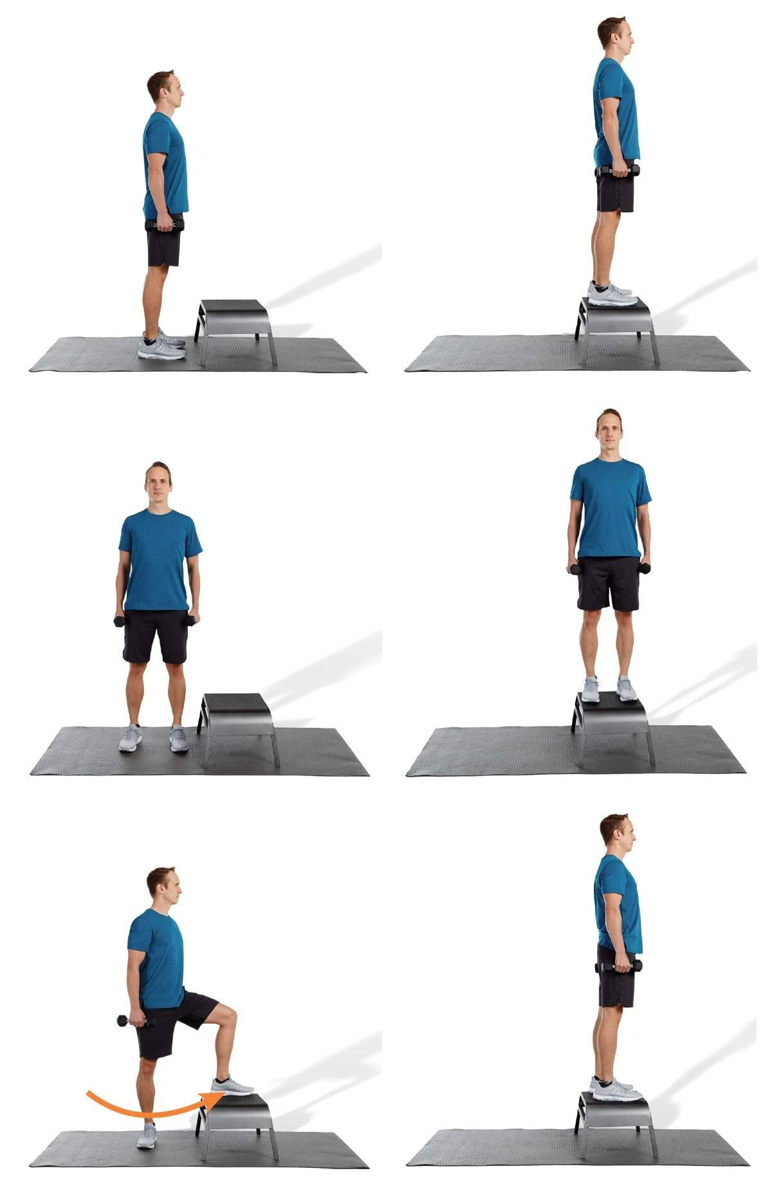

TECHNIQUE

Lunges are excellent lower extremity strengthening exercises; however, many individuals lack the flexibility and stabilization requirements to execute the exercise properly. Step-ups are a great way to regress the lunge until your client develops proper flexibility and stabilization capabilities to perform the lunge correctly.

Multiplanar Lunge

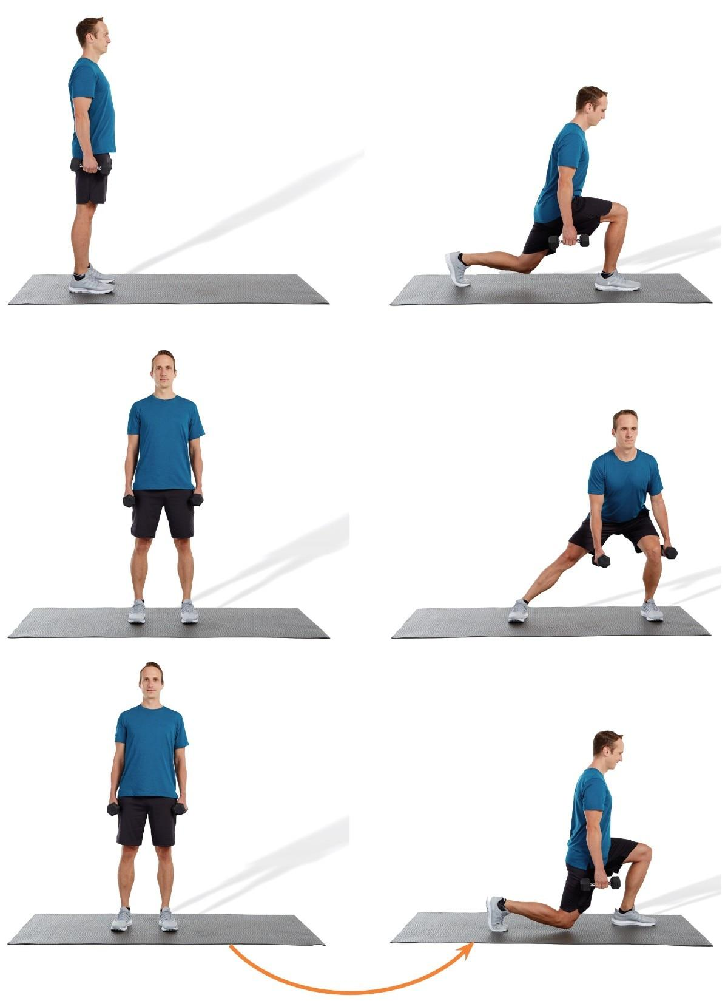

TECHNIQUE

Lunges can be performed in all directions, including front lunges, lateral lunges, and turning lunges. Reverse lunges are also an option.

Dumbbell Squat

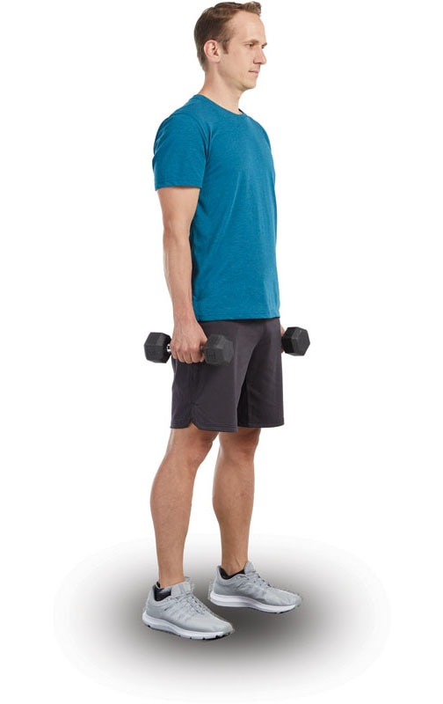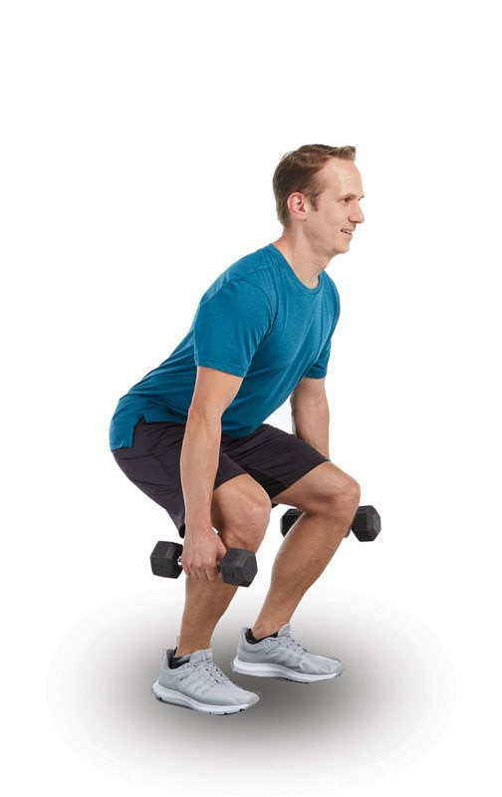

TECHNIQUE

Make sure the feet are positioned shoulderwidth apart, the toes are pointed straight, and the knees are aligned with the second and third toes. Avoiding knee valgus (knees caving inward) is important to minimize unwanted stress to the knee ligaments.

Leg Press (Hip Sled)

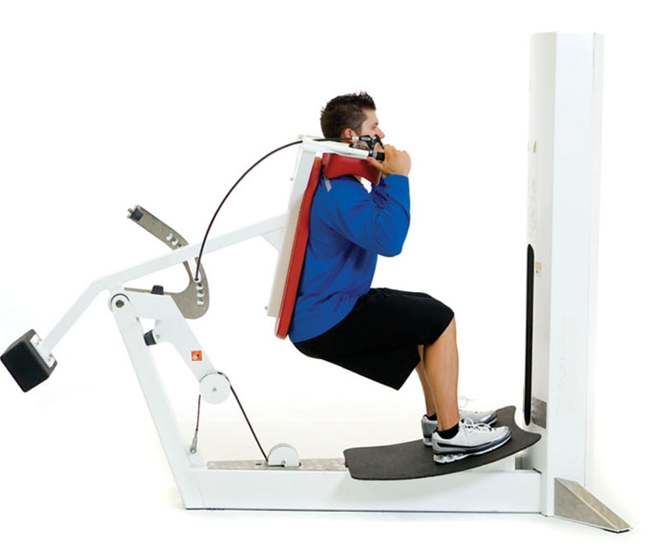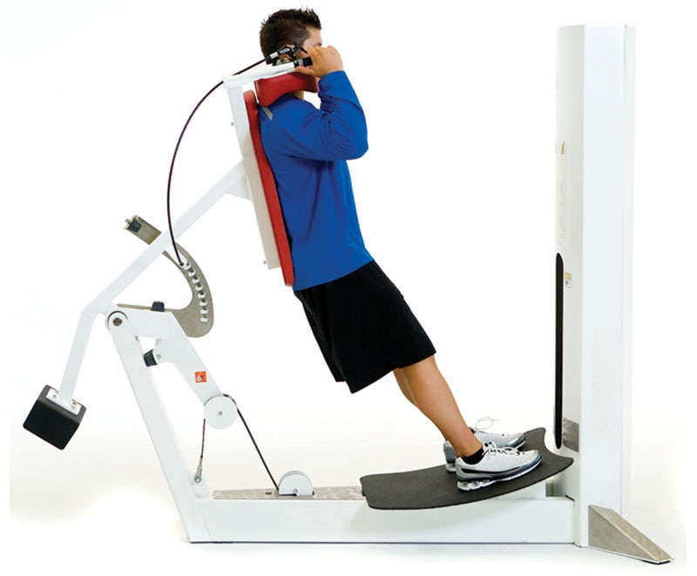

TECHNIQUE

Make sure the feet are positioned on the platform shoulder-width apart, the toes are pointed straight, and the knees are aligned with the second and third toes. This will decrease stress to the knees, hips, and low-back.

Barbell Squat

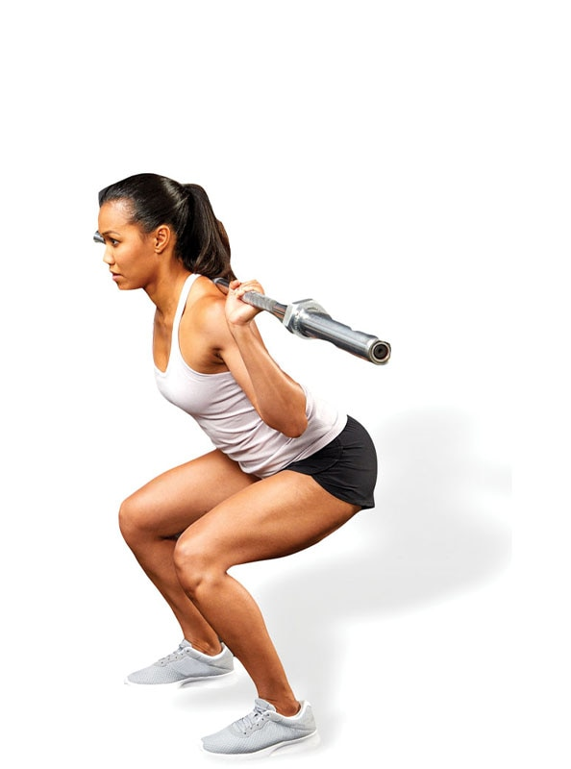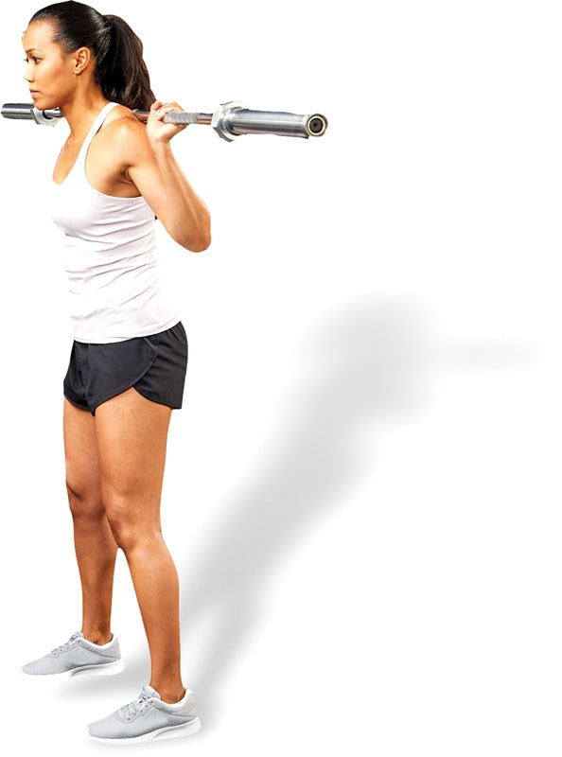

SAFETY

“How far down should your client squat?” The answer is, “Only as far as can be controlled without compensating.” As your client develops more flexibility and stabilization strength, the range of motion can be increased, assuming no compensations occur.

Deadlift

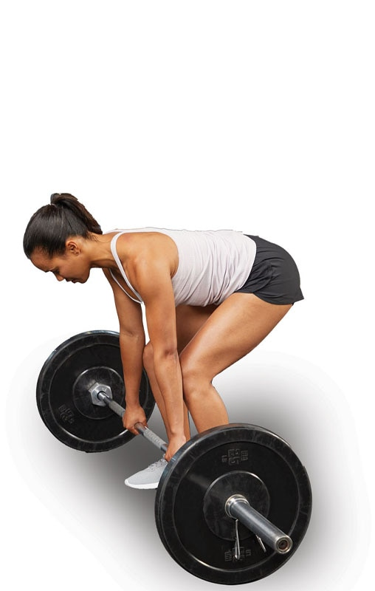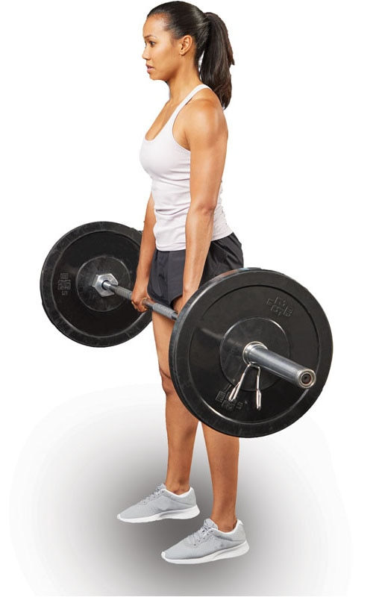

TECHNIQUE

Monitor all five kinetic chain checkpoints throughout the duration of the exercise, especially your client’s spine position. The spine should remain neutral rather than rounded and hunched over.

Squat Jump

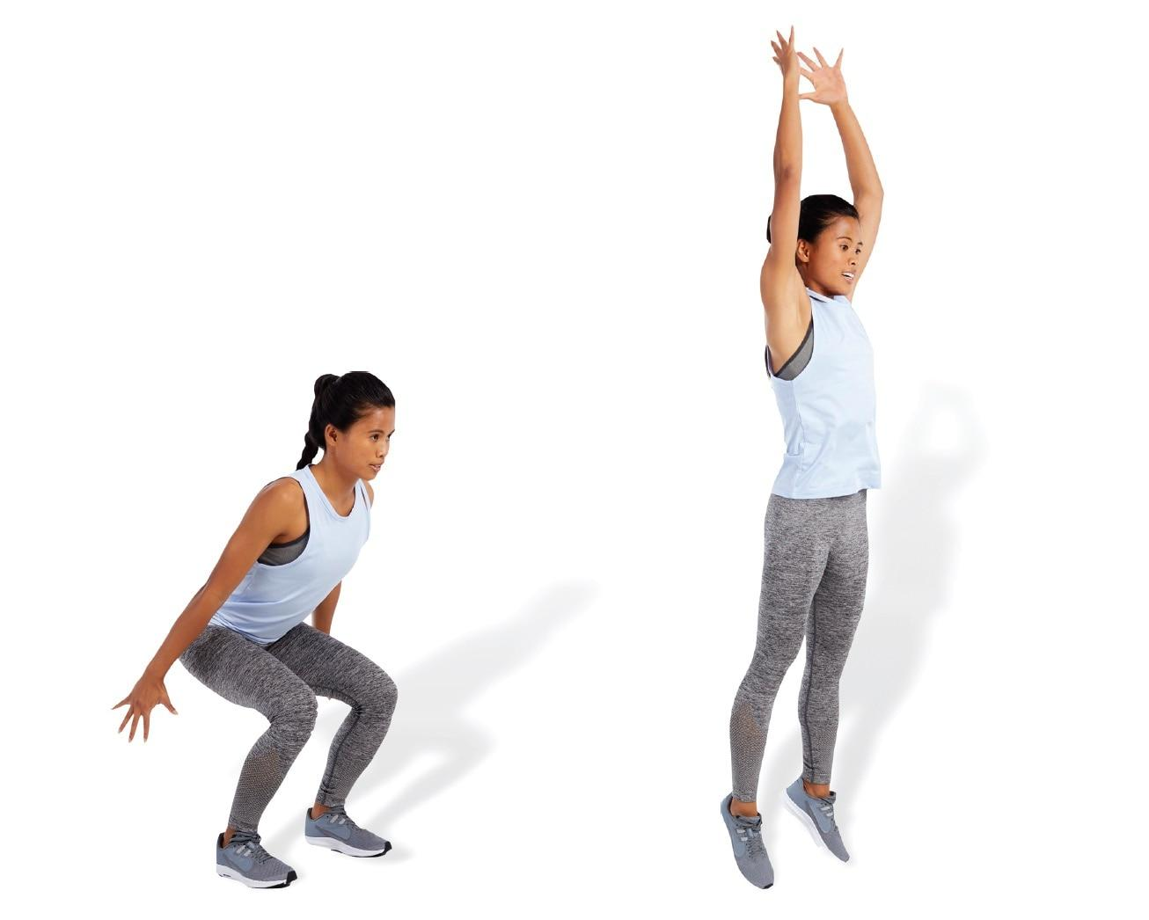

SAFETY

Landing with the knees caved inward is dangerous and can lead to pain and injury. Make sure your clients display optimal landing mechanics, with their feet pointed straight ahead and knees tracking over the second and third toes.

### Tuck Jump

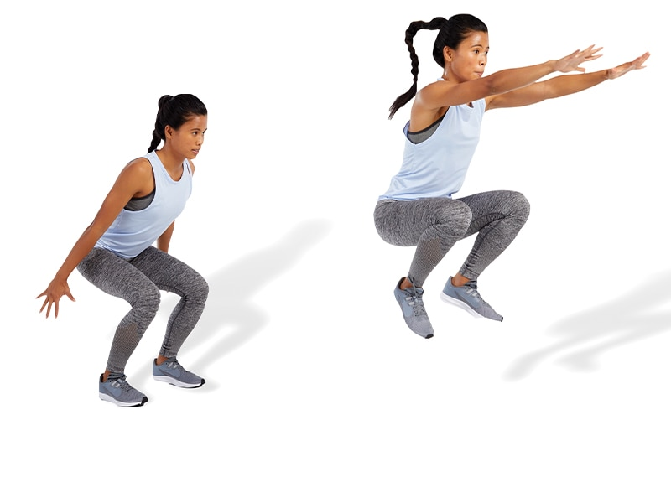

TECHNIQUE

When performing jumping exercises, make sure your clients land just behind the ball of their foot, rather than on the ball of the foot or on the heel. This will ensure proper force distribution through the foot and lower extremities, thus improving force production capabilities

**Program design**

Creating and modifying exercise programs for clients can be a complicated process because there are many variables to consider, including the client’s goals, their tolerance for exercise, and their unique physical abilities and medical history. Moreover, fitness professionals have a multitude of different exercise formats to choose from, which can potentially cause confusion and frustration during the program design process. Keeping these concerns in mind, arguably the most important factor when creating an exercise program is to ensure it is adopted and adhered to by the client. Whether programs are developed for beginning exercisers, avid fitness enthusiasts, or experienced athletes, exercise programs need individuality and uniqueness to make them impactful and meaningful for clients. This increases commitment and helps affirm a client’s success toward reaching their health, wellness, and fitness goals.

In addition, it is vitally important for fitness professionals to design and implement exercise programs that are individualized for each client based on their needs, goals, and abilities. Exercise programs based on a client’s assessment results, attitudes, and fitness level help guarantee continued success and long-term adherence to the exercise program.

To assist in this process, fitness professionals must be able to answer specific questions that are related to the appropriateness of exercise programming:

1. What are my client’s needs, goals, and abilities?
2. Does my client have any concerns or contraindications for exercise due to previous injuries or medical conditions?
3. What are the results from my client’s fitness assessment? Does my client exhibit muscle imbalances, poor posture, or limited mobility?
4. Which forms of exercise does my client like and dislike? Am I integrating liked exercises for my client to foster a positive environment?
5. What exercise variables, such as sets, repetitions, or rest periods, should I use that best match my client’s abilities, goals, and phase of training?
6. What exercise modalities, such as free weights, elastic bands, or machines, are appropriate for my client based on my client’s goals and fitness level?
7. What is the appropriate frequency (days per week) and duration (time per session) of exercise sessions that should be used?

If the fitness professional can answer these questions consistently, it is likely the client is in good hands to reach their fitness goals in a safe and effective manner. If not, the fitness professional is possibly creating an inappropriate exercise program, which may cause injury or undue fatigue that could lead to overtraining or burnout (Walters et al., 2018). Conversely, by following specified protocols, risk factors can be mitigated, and the client can exercise in a safe and positive environment that is set up for success.

Fitness programming takes practice, but, as with anything, the more experience obtained working with a wide range of exercisers, the less challenging it becomes. The goal is to create unique exercise programs that are systematic and progressive so that consistent overload can occur and fitness goals can be met.

Additionally, it is recommended that the fitness professional adopt an integrated approach to program design that includes multiple forms of training, such as flexibility; cardiorespiratory; core; balance; plyometric; speed, agility, and quickness (SAQ); and resistance training (Bennell et al., 2012; Bhagyalakshmi et al., 2007; DiStefano et al., 2013; Eriksen et al., 2002; Ng et al., 2012). Using an integrated approach to program design can increase consistency and progression and minimize the risk of injury (Faude et al., 2018; Hislop et al., 2017; Padua et al., 2018).

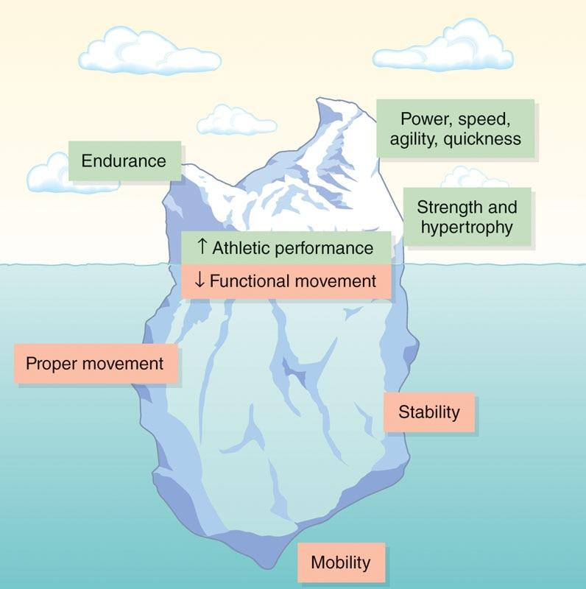

**Figure 21-1** Iceberg effect

In some instances, clients and fitness professionals may be tempted to use an overly simplistic approach to program design. For example, exercise programs may overemphasize particular factors, such as expending maximal calories for fat-loss goals or the development of speed and power to improve athletic performance. However, a well-rounded exercise program must be progressive and systematic and consider many variables, such as teaching proper movement patterns, improving mobility and stability of the kinetic chain, enhancing muscular and aerobic endurance, and reducing the likelihood of injury. In other words, exercise programming involves more than what we see at the surface, such as reducing body fat, gaining muscle mass, or increasing strength and power (Teyhen et al., 2014). This is known as the “iceberg effect” (Figure 21-1).

### Program design

Program design is an organizational structure of exercises with appropriate volume and intensity to attain a specific fitness or performance goal (Lorenz & Morrison, 2015). In other words, the fitness professional provides a road map and vital step-by-step processes, modifications, and parameters to follow based on client capabilities, limitations, and goals. To be successful in program design, the fitness professional must have a clear understanding of training plans and periodization.

**Training plans**

To accomplish objectives, training programs should be organized into a plan that involves using long-term and short-term goals. A training plan is a specific outline that a fitness professional uses to help meet the client’s goal.

It determines the forms of training to be used, how long it will take, how often it will change, and what specific exercises will be performed. Training plans are unique to each client, and fitness professionals are discouraged from using cookie-cutter exercise programs or plans. Understanding the importance of designing safe and effective programs using acute variable manipulation is essential information for all fitness professionals to possess.

**Periodization fundamentals**

Fitness and sport-performance programming are based on the concept of periodization. Periodization (or planned fitness training) is a systematic approach to program design that exploits the general adaptation syndrome and principle of specificity (discussed in Chapter 20) to vary the amount and type of stress placed on the body to produce adaptation and prevent injury. Periodization varies the focus of a training program at regularly planned periods of time to encourage optimal adaptation (Evans, 2019; Lorenz et al., 2010). Periodization involves two primary objectives:

1. Dividing the training program into distinct periods (or phases) of training: annual training plan (macrocycle), monthly training plan (mesocycle), and weekly or daily training plan (microcycle)
2. Training different forms of strength in each period (or phase) to control training volume and to prevent injury

Annual plan (macrocycle)

An annual training plan, or macrocycle, shows how the training program will progress for the long term, from month to month, to meet the desired goal. It outlines specified training schedules, projected fitness evaluation sessions, and planned recovery periods (Williams et al., 2017). In other words, macrocycles provide a bird’s-eye view of the entire year’s training regimen. This gives the client a clear representation of how the fitness professional plans to get the client to their goal.

In the realm of sports conditioning, macrocycles are typically divided into preparatory, competitive, and transition periods (i.e., preseason, in-season, or off-season) that are spread out over a year’s time (Figure 21-2) (Kostiukevych et al., 2019; Nuell et al., 2019).

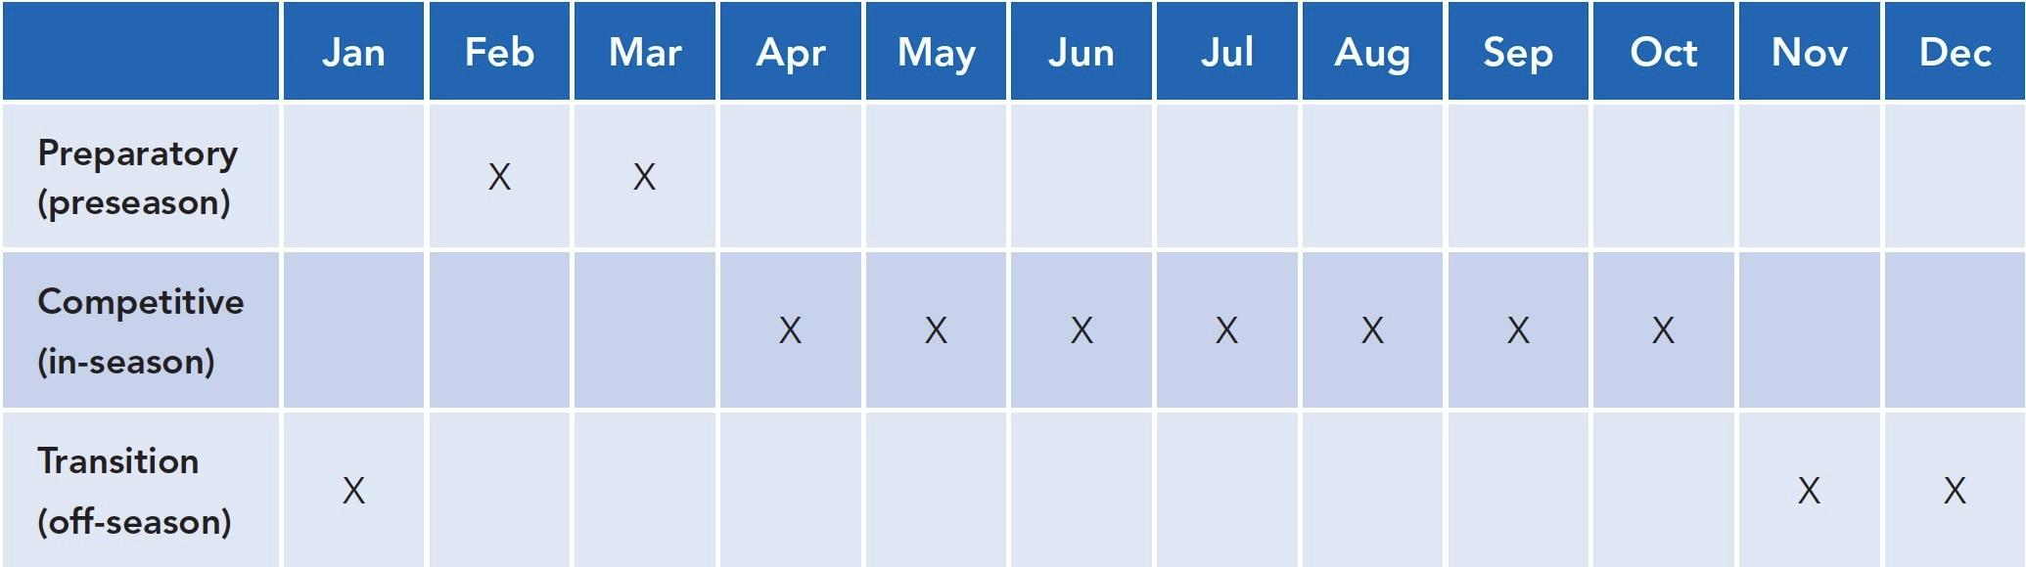

**Figure 21-2** Example annual training plan

Monthly plan (mesocycle)

A monthly training plan, or mesocycle, divides a training plan into specified monthly cycles (Aoki et al., 2017; Owen et al., 2017). The monthly plan details the specific days of each workout and the style of training used (Figure 21-3). This enables clients to see their training schedule on a smaller scale, and it provides more detail than the annual plan (macrocycle).

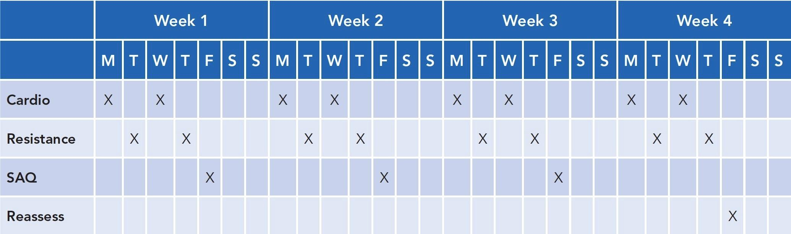

**Figure 21-3** Example monthly training plan

While typically 4 weeks long, it is important to note that mesocycles do not have to be 1 month in duration in all instances. For example, a bodybuilder may follow a 3-week fat-loss mesocycle in preparation for a contest, whereas a baseball pitcher may use a 6-week off-season mesocycle program to build arm strength and increase throwing velocity.

Weekly plan (microcycle)

A weekly plan, or microcycle, details the specific workouts for the week (Figure 21-4). Many clients appreciate this plan the most, but without first developing the annual or monthly training plans, weekly plans can lack purpose, focus, and direction. Microcycles are usually 7 days, but, depending on the client’s schedule, a microcycle could expand to 10 days, if desired (Dolci et al., 2020; Schneider et al., 2019).



**Figure 21-4** Example weekly training plan

In most cases, three to six microcycles form a mesocycle, depending on the client’s training schedule and goals.

A more in-depth discussion regarding the integration of the OPT model into macrocycles, mesocycles, and microcycles will be provided later in this chapter.

**Linear and Undulating Periodization**

Periodization has been shown to be an effective method of program design for many fitness-related goals, and yet, to date, it is not a common practice among all fitness professionals. Periodization provides for the repeated use of different forms of training, at specific times, to elicit different adaptations in the body, such as muscular endurance, strength, and power (Evans, 2019; Lorenz et al., 2010). Periodization also aims to properly manage training more effectively, create a peak period for competition, and reduce the risk of injury and overtraining (Conlon et al., 2016; Raiola & D’Isanto, 2016; Rønnestad et al., 2019; Strohacker et al., 2015).

GETTING TECHNICAL

Periodization’s origins stem from athletics because athletes compete during specific times of the year. As such, strength and sport coaches use periodization to ensure athletes reach peak performance according to the athlete’s competition schedule.

Periodization can be divided into three distinct phases that lead up to competition: preparatory, competitive, and transition. The preparatory phase aims to gradually increase volume and intensity of training to peak levels prior to the competitive season. The competitive phase is the competition (in-season) period, and the aim is to keep athletes in top condition while minimizing overtraining and burnout. The transition phase (off-season) is the point where a competitive phase ends, and the athlete begins to incorporate active rest and tapers down the intensity of workouts (Lyakh et al., 2016).

Linear periodization

Linear periodization is a traditional method of program design that aims to gradually increase the intensity of the training load while simultaneously decreasing volume over a set period of time (da Silva et al., 2016; Mattocks et al., 2016; Pitta et al., 2019). Linear periodization is consistent in its approach and often uses predetermined timelines or protocols for exercise progression. For example, one approach uses light loads for the first 4 weeks to develop muscular endurance and joint stability prior to performing 4 weeks with moderate loads and, finally, performing 4 weeks using heavy loads to develop muscular hypertrophy and maximal strength, respectively. Figure 21-5 shows how the progression occurs over time.

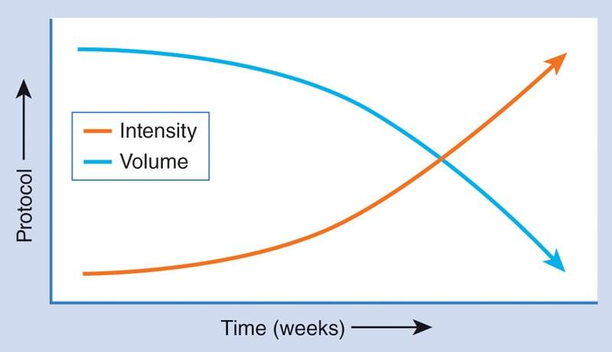

**Figure 21-5** Linear periodization

The fitness professional can use this method with new or experienced exercisers because it is simple and easy to follow. With this approach, the load and intensities used within the program increase in a systematic fashion. Table 21-1 provides one example of using linear periodization to progressively increase training loads; however, many variations exist.

TABLE 21-1 Example Linear Load Progression

| **Timeframe** | **Intensity: 1-Repetition Maximum (1RM)** |
| --- | --- |
| Weeks 1 to 4: Stability and muscular endurance | Light to moderate loads: 60–70% of 1RM |
| Weeks 5 to 8: Hypertrophy and strength | Moderate to heavy loads: 70–85% of 1RM |
| Weeks 9 to 12: Maximal strength | Heavy to maximal loads: 85–100% 1RM |

It is important to recognize that linear periodization schemes can modify more than load/intensity and can also manipulate exercise selection, rest periods, and volume (sets + reps) to progress exercise programs. This is an important consideration for those with goals other than strength and hypertrophy, such as those seeking weight loss or endurance athletes seeking improvements in aerobic capacity.

Undulating periodization

Undulating periodization, or nonlinear periodization, uses changes in volume, intensity, and exercise selection to provide loading differences on a daily or weekly basis (Caldas et al., 2016; Painter et al., 2018; Ullrich et al., 2016). This form of periodization is mentally beneficial because the workouts do not become stale or boring. Fitness professionals can also be a little more creative in their approach because multiple training protocols can be used all in the same week. For example, a fitness professional can assign a muscular endurance–focused workout on Monday, a power-focused workout on Wednesday, and a hypertrophy-focused workout on Friday. Using this method, multiple styles of training are performed within the same week (Table 21-2). Because of these daily changes, the stress on the body is constantly varied, which limits the client’s ability to plateau in their performance (Jaimes et al., 2019).

Both linear and undulating periodization will be discussed in terms of the OPT model later in this chapter.

TABLE 21-2 Example Undulating Periodization

|  |  |  |  |  |
| --- | --- | --- | --- | --- |
| **Monday** | **Tuesday** | **Wednesday** | **Thursday** | **Friday** |
| Muscular endurance–focused workout |  | Power-focused workout |  | Hypertrophy-focused workout |

# The Optimum Performance Training Model

The National Academy of Sports Medicine (NASM) designed the OPT model as a planned, systematic, and periodized training program (Figure 21-6). The OPT model was developed to simultaneously improve all physical abilities, such as flexibility, muscular and aerobic endurance, core stabilization, balance, muscular strength, coordination, and power. In addition, the OPT model is extremely successful in helping clients and athletes from diverse populations reduce their body fat, increase lean muscle mass, and improve athletic performance and overall health. It is an evidence-based model, meaning it has been tested and validated both in a laboratory setting and with real-life clients and athletes (DiStefano et al., 2013).

The different periods of training seen in a traditional periodized exercise model include a preparatory (introductory) period, a hypertrophy period, a maximal strength period, and a power period. The OPT model simplifies these periods into three distinct levels: stabilization, strength, and power. However, the OPT model takes exercise programming one step further, in which the three levels are subdivided into five unique phases of training (Table 21-3 on the following page).

The OPT model should be thought of as a staircase, guiding clients through different levels of physical adaptation. This journey will involve going up and down the stairs, stopping at different steps, and moving to various heights, depending on the client’s goals, needs, and abilities.

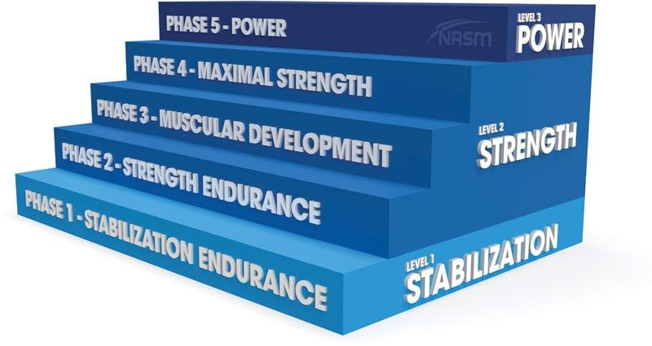

**Figure 21-6** The OPT model

TABLE 21-3 Summary Chart of OPT Model

| **Level** | **Phase** | **Primary Adaptations** | **Primary Methods of Progression** |
| --- | --- | --- | --- |
| Stabilization | 1. Stabilization Endurance Training | Mobility and flexibility  Core and joint stabilization  Postural alignment and control  Muscular and aerobic endurance | Master basic movement patterns.  Progress exercises proprioceptively (controlled, yet unstable) once basic movement patterns are established.  Increase the complexity of exercises once basic movement patterns have been established. |
| Strength | 2. Strength Endurance Training | Core strength and joint stabilization  Muscular endurance and prime mover strength | Decrease rest periods.  Increase the volume of exercises (reps + sets).  Increase the load (weight) of resistance training exercises.  Increase the complexity of resistance training exercises. |
| 3. Muscular Development Training | Core strength  Muscular strength and hypertrophy | Increase the volume of exercises.  Increase the load of resistance training exercises.  Increase the complexity of resistance training exercises. |
| 4. Maximal Strength Training | Core strength  Maximal muscular strength | Increase the load of resistance training exercises.  Increase the sets of resistance training exercises. |
| Power | 5. Power Training | Core strength  Maximal muscular strength  Rate of force production | Increase the load of resistance training exercises.  Increase the speed (repetition tempo) of exercises.  Increase the sets of exercises. |

The workout template is structured to take the client from a warm-up through cool-down and is divided into six parts: Warm-Up, Activation, Skill Development, Resistance Training, Client’s Choice, and Cool-Down.

**OPT Daily Workout Template**

The OPT model uses a specific workout template to help organize daily exercise routines in a safe, systematic, and progressive fashion. No matter which of the five phases of training are being used, the same template is always followed; the only differences are the acute variables and exercises selected (Figure 21-7). The workout template is structured to take the client from a warm-up through cool-down and is divided into six parts: Warm-Up, Activation, Skill Development, Resistance Training, Client’s Choice, and Cool-Down.

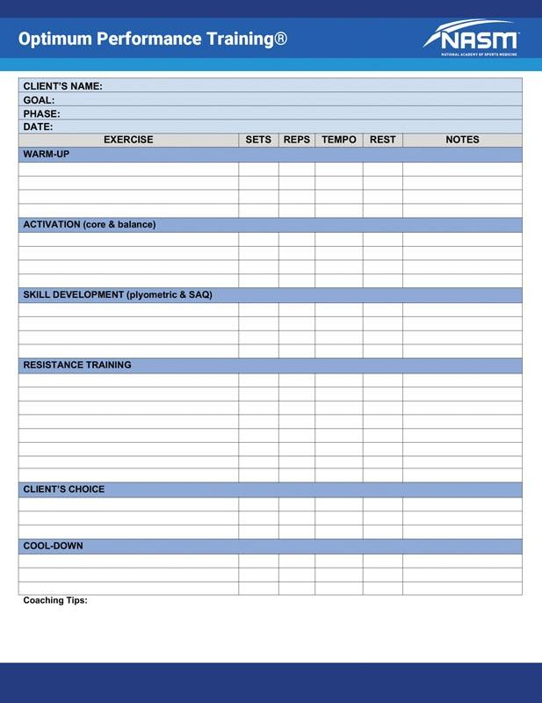

**Figure 12-7** OPT workout template

**Warm-up**

The first section of the exercise template is titled Warm-Up and consists of flexibility training and optional cardiorespiratory exercise. Flexibility training, like any other form of exercise, should follow a systematic progression and have a clear purpose. Flexibility techniques are used to increase joint range of motion and tissue extensibility and assist in correcting muscle imbalances. They are used as part of an integrated warm-up process to help prepare the body for physical activity and will be selected based on client assessment results, type of training, and unique requirements of the workout. Moreover, stretching techniques, like static stretching, should only be performed on tissues that have been identified as overactive during the assessment process.

The cardiorespiratory portion of a warm-up period typically lasts between 5 and 10 minutes. The purpose of the warm-up period is to increase heart and respiration rates and tissue temperature and psychologically prepare the individual for higher training intensities (McGowan et al., 2015; Silva et al., 2018).

**Activation**

The next section of the OPT programming template is Activation. Activation includes core and balance exercises. This section of the template is a continuation of the client’s overall warm-up. In the preceding section, the client addressed overactive muscles by performing a variety of flexibility techniques. The next logical step is to strengthen underactive muscles identified during the assessment process, which will help reestablish ideal joint alignment, stability, and control. This can be accomplished by completing a short series of core and balance exercises.

Core training is critical for improving posture (Ko & Kang, 2017; Park et al., 2016), enhancing performance (Butcher et al., 2007; Dello Iacono et al., 2016; Shinkle et al., 2012), increasing resistance to injury (Huxel Bliven & Anderson, 2013), and accelerating injury rehabilitation (Coulombe et al., 2017).

Balance training is an important component of injury prevention programs and has been proven to help reduce the incidence of lower extremity injuries, such as ankle sprains and anterior cruciate ligament tears (Dargo et al., 2017; Nessler et al., 2017; Rivera et al., 2017). Furthermore, balance training is an effective mode of exercise for enhancing athletic performance and posture (Brachman et al., 2017). As such, core and balance training, when paired, can be an effective warm-up strategy following flexibility techniques.

GETTING TECHNICAL

Individuals knowledgeable and skilled in corrective exercise may substitute other forms of activation techniques in this section, such as isolated strengthening techniques. To learn more about corrective exercise, refer to NASM’s Corrective Exercise Specialist course.

**Skill development**

The Skill Development section is an optional portion of the workout, but it can be valuable for many clients and athletes, depending on their goals and fitness level. Within this section, the fitness professional will assign plyometric and SAQ exercises. These forms of exercise further develop an individual’s agility, reaction time, and overall athleticism (Makhlouf et al., 2018; Oxfeldt et al., 2019). In addition, plyometric and SAQ training are effective modes of exercise to improve aerobic capacity and can serve as a substitute for traditional steady-state cardiorespiratory exercise, if desired.

Fitness professionals also have the option of foregoing plyometric and SAQ exercises, choosing to substitute specialized instruction for skill acquisition. For example, clients new to exercise should be instructed on how to perfect basic movement patterns, such as pushing, pulling, pressing, squatting, hip hinging, and multiplanar movements. Instruction for exercise equipment can also be included in this section of the workout template.

For more advanced clients, this portion of the workout can be used to introduce advanced forms of exercise like Olympic weightlifting or martial arts drills. It is important to note, this section is dedicated to the instruction and practice of new skills, not high-intensity work. Clients new to Olympic weightlifting, for example, can practice with a dowel rod or a similar implement until they learn the basic movement patterns. Clients new to martial arts will be able to practice punching and kicking drills with proper form before using these techniques in a high-intensity fashion later in their programming.

**Resistance training**

Resistance exercises are an essential component of any exercise training program. Resistance training is beneficial for developing joint and core stability, muscular endurance, hypertrophy, strength, power, and athleticism. In addition, resistance exercises can be an effective mode for increasing lean muscle mass, reducing body fat, and improving numerous health markers (Ciolac & Rodrigues-da-Silva, 2016; Schoenfeld et al., 2016; Westcott, 2012).

Programming resistance training exercises must be purposeful and progressive. Consequently, fitness professionals should follow specific program guidelines, including proper exercise selection criteria and milestones for progression. The OPT model has specific parameters for each phase of training, including the types of resistance exercise selected and appropriate acute variables, which will be discussed later in this chapter.

**Client's choice**

Arguably the most important consideration when developing exercise programs is to ensure client adherence. Fitness professionals can have a significant influence on their client’s health, body composition, and athletic performance. Therefore, the fitness professional has a responsibility to create an environment that helps the client adhere to a fitness routine. They should help clients feel confident and competent while preserving their autonomy to do exercises that they enjoy. Self-efficacy is a well-established determinant of exercise behavior, so to promote changes that increase exercise adherence, a behavior change technique that influences self-efficacy should be used. This is the basis for the Client’s Choice section of the workout template.

In this section, the client chooses a few of their favorite exercises to include in the program. Some clients may choose to perform strength-training exercises for their arms for aesthetic purposes. Other clients may opt for additional abdominal exercises or accessory lifts depending on their likes and dislikes. Fitness professionals should encourage clients to choose a few (typically one or two) of their favourite exercises and only intervene if the chosen exercise is unsafe.

**Cool-down**

A cool-down provides the body with a smooth transition from exercise back to a steady state of rest. The goal of a cool-down is to reduce heart and breathing rates, gradually cool body temperature, return muscles to their optimal resting lengths, prevent pooling of blood in the lower extremities, and restore body systems close to baseline.

Light cardiorespiratory exercise is an optional component of the cool-down. When implementing cardio, the client should gradually reduce speed and intensity until they are walking at a comfortable pace. A cardiorespiratory cool-down typically lasts for 5 to 10 minutes.

Once complete, the client should perform self-myofascial techniques and static stretching to reset muscles back to their normal length-tension relationships. Flexibility techniques are an important component of a cool-down and should not be overlooked or skipped as they can reduce effects associated with delayed-onset muscle soreness, enhance recovery from exercise, and set up the body for enhanced performance in subsequent training sessions (Pearcey et al., 2015).

## Stabilization level of the OPT model

The first level of training in the OPT model focuses on two main adaptations: (1) development of proper movement patterns and (2) mobility and stability of the entire kinetic chain. This level of the OPT model is also designed to prepare the body for the demands of higher levels of training that follow. This period is crucial for all beginners to help instil confidence and promote adherence to an exercise program while minimizing stress experienced at higher intensities of training that could ultimately lead to burnout or injury. It is also necessary to cycle back through this level after periods focused on strength and power training to maintain a high degree of core and joint stability.

In addition, this level allows the body to actively rest and recover from more intense bouts of training. The stabilization level focuses on the following:

1. Developing proper movement patterns: squat, push, pull, press, hip hinge, and multiplanar movement
2. Acquiring basic exercise skills and proper use of exercise machines, free weights, and cardio equipment
3. Correcting muscle imbalances
4. Improving activation of the core musculature and stabilization of the spine and pelvis
5. Enhancing balance, coordination, and postural control during physical activity, exercise, and sport
6. Preventing tissue overload by preparing muscles, tendons, ligaments, and joints for the upcoming imposed demands of training
7. Improving cardiorespiratory and muscular endurance
8. Promoting client confidence and adherence to exercise

The stabilization level of training in the OPT model consists of one phase of training: Phase 1 Stabilization Endurance Training.

### Phase 1 Stabilization Endurance Training

Phase 1 Stabilization Endurance Training is designed to teach clients how to perform proper movement patterns, including pushing, pulling, pressing, squatting, hip hinging, and overall movement competency. In addition, Phase 1 places a focus on acquiring basic exercise skills, such as the proper use of exercise machines, free weights, and other types of exercise equipment like balance modalities and foam rollers. This is especially important to minimize injury risk for deconditioned clients or clients new to exercise. During this phase of training, fitness professionals will assist their clients in correcting muscle imbalances, improving joint range of motion, and increasing stability of the core and peripheral joints. This introductory period may take anywhere from 2 to 6 weeks, depending on the physical capabilities and experience level of the client when performing structured exercise. Progression out of this phase should be client specific based on their ability level and movement competency.

**Training fundamental movement patterns**

Fundamental movement patterns are a necessity for all fitness professionals to demonstrate and teach to their clients. Fitness professionals must ensure their clients’ mastery of these movement patterns to minimize injury risk and increase exercise effectiveness. Most exercises involve at least one of these movement patterns, though multiple movement patterns can be combined into a single exercise:

1. Squatting
2. Hip hinge
3. Pulling motions
4. Pushing motions
5. Pressing
6. Multiplanar movement

Squat

Whether trying to pick something up off the floor, getting low to help tie a child’s shoe, or simply sitting down and standing up from a chair, the squat movement pattern (Figure 21-8) will be used in many cases throughout activities of daily living (ADL).

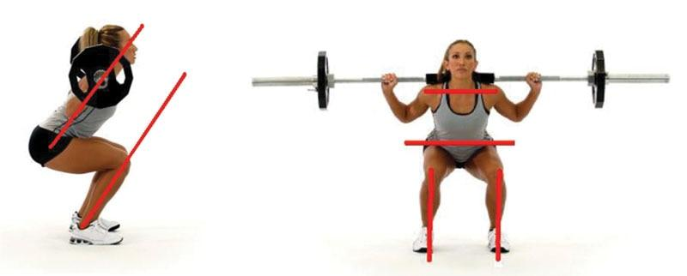

**Figure 21-8** Barbell squat

The squat is a compound (multijoint) movement pattern due to the several joints involved (ankles, knees, and hips) and the large amount of musculature used. As a result, the squat has many benefits, such as improving muscular endurance, hypertrophy, strength, and power of the quadriceps and gluteus maximus muscles (Clark et al., 2012; Schoenfeld, 2010). The squat and its variations should be a staple in many exercise programs. Further, studies suggest that proper squat technique is necessary to reduce the risk of injury to the knees and back (Comfort et al., 2018; Fry et al., 2003). As such, fitness professionals must be competent and proficient in teaching the squat movement pattern to their clients (Table 21-4).

TABLE 21-4 Squat

| **Category** | **Description** |
| --- | --- |
| Musculature | Quadriceps, gluteal complex, hamstrings, and calves |
| Primary joint actions | Ankle, knee, and hip flexion and extension |
| Daily examples | Sit to stand, getting in and out of the car, and climbing stairs |
| Exercise examples | Back squat, front squat, overhead squat, leg press, and step-ups |

Proper squatting techniques include the following:

1. Keeping the feet straight ahead and avoiding overpronation of the foot and ankle complex
2. Tracking the knees over the second and third toes; do not allow the knees to cave inward (known as knee valgus)
3. Ensuring a neutral pelvis and spine
4. Equally flexing at the ankles and hips; keep the torso and shin angles parallel, which provides equal weight distribution between the ankles, knees, and hips
5. Maintaining head and shoulders in a neutral position.

Hip hinge

Like the squat, the hip hinge will be used during many movements that are incorporated into activities of daily living like gardening, housework, or the simple act of putting on pants (Table 21-5).

TABLE 21-5 Hip Hinge

| **Category** | **Description** |
| --- | --- |
| Musculature | Hamstrings, gluteal complex, low-back, and abdominals |
| Primary joint actions | Hip flexion and extension |
| Daily examples | Bending over to put on pants, reaching down and grabbing a box off the floor, cleaning, and gardening |
| Exercise examples | Romanian deadlifts, back extensions, good mornings, kettlebell swings, and Olympic weightlifting |

The hip hinge requires an individual to perform hip flexion and extension from a standing position with relatively little motion through the knees or ankles, like a kettlebell swing (Figure 21-9) or stiff-legged deadlift (McGill & Marshall, 2012). Most of the motion comes from the hips; however, this is different from spinal flexion, which involves rounding the spine into kyphosis, also known as a hunchback posture.

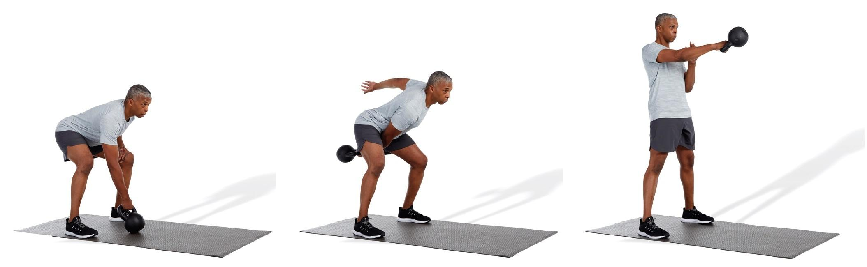

**Figure 21-9** Kettlebell swing

Although similar, there are noticeable differences between a squat movement pattern and the hip hinge, specifically related to ankle, knee, and hip motions. The squat pattern requires more ankle dorsiflexion and plantarflexion and knee flexion and extension, whereas the hip hinge requires increased hip flexion and extension with relatively motionless knees (the knees will have a soft bend).

As long as the client does not have specific orthopedic limitations, the hip hinge can be useful to strengthen both the anterior (rectus abdominis) and posterior core (erector spinae and gluteal complex) musculature in addition to the posterior chain leg musculature (hamstrings).

Pulling motion

Like other motions, pulling is an important lifting variation and can be used to enhance all modes of exercise programming for muscular endurance, hypertrophy, strength, and power (Table 21-6). The fitness professional should incorporate pulling exercises into an exercise program to promote balance between anterior and posterior musculature. Moreover, pulling exercises for the upper body can help correct faulty postures, such as rounded shoulders and a forward head (Bae et al., 2016).

TABLE 21-6 Pulling Movement Patterns

| **Category** | **Description** |
| --- | --- |
| Musculature | Upper body: latissimus dorsi, teres major, rhomboids, trapezius, biceps brachii, and posterior deltoids |
| Concentric joint actions | Shoulders: scapular retraction, shoulder extension, and shoulder horizontal abduction Arms: elbow flexion |
| Daily examples | Opening doors, climbing objects, and raking leaves |
| Exercise examples | Pull-ups, chin-ups, lat pulldowns, rows, and cobras |

Pulling motions involve a variety of muscles, including the biceps brachii, forearms, and back musculature. Common pulling exercises include chin-ups, pull-up variations, cobras, lat pulldowns, and rowing variations (Figure 21-10).

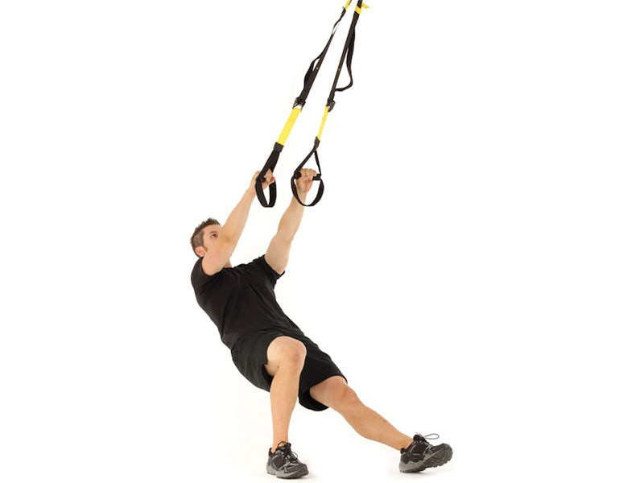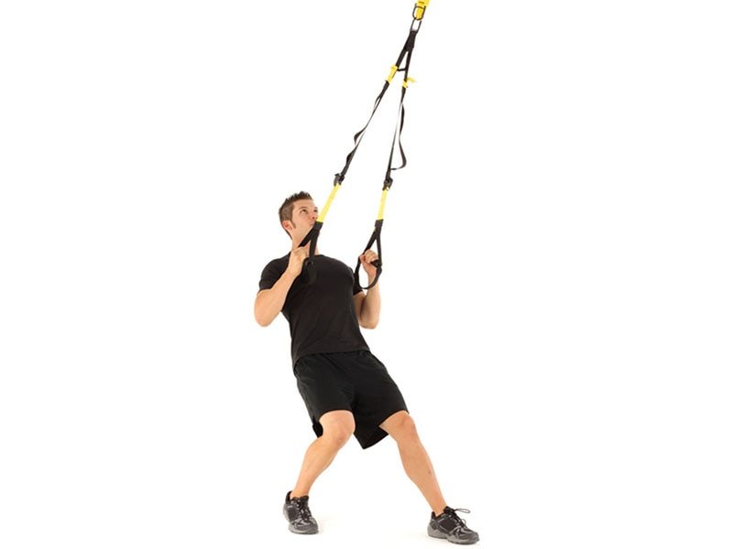

**Figure 21-10** TRX row

Pushing motion

Pushing motions are the counterbalance to pulling motions. Most pushing motions are associated with the upper body. Example exercises that involve upper body pushing include a barbell bench press (Figure 21-11), dumbbell chest press, or push-ups. Concentric joint motions at the upper body include a combination of scapulae protraction, shoulder flexion, shoulder horizontal adduction, and elbow extension. The chest musculature is the prime mover for most upper body pushing exercises, whereas the triceps brachii and anterior deltoids act as synergists throughout the movement pattern. Table 21-7 provides more details regarding pushing movements.

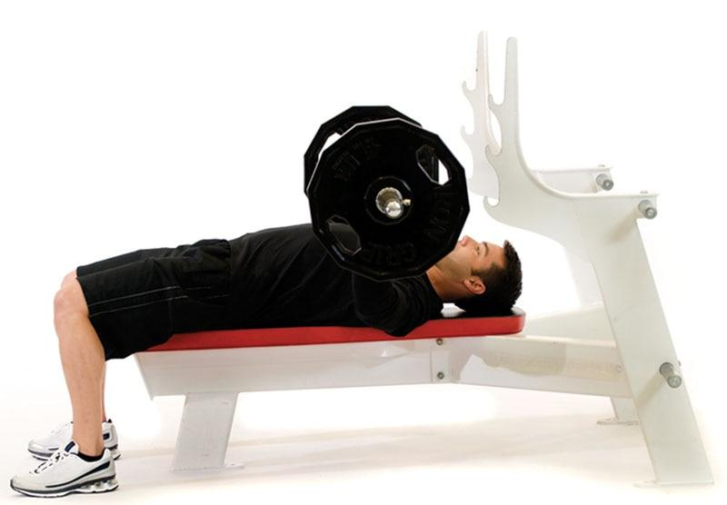 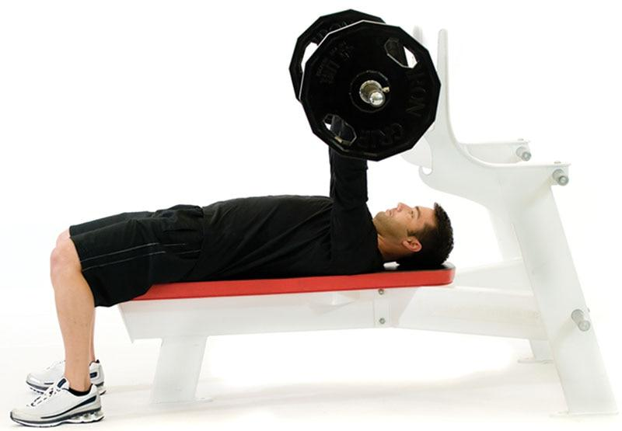

**Figure 21-11** Barbell bench press

TABLE 21-7 Pushing Movements Patterns

| **Category** | **Description** |
| --- | --- |
| Musculature | Upper body: pectoralis major, anterior deltoid, and triceps brachii |
| Concentric joint actions | Shoulders: scapulae protraction, shoulder flexion, and horizontal adduction  Arms: elbow extension |
| Daily examples | Pushing a grocery cart and pushing a door open |
| Exercise examples | Push-ups, bench press, dumbbell chest press, close-grip bench press, and close-grip push-ups |

STRETCH YOUR KNOWLEDGE

Do not assume that push-and-pull exercises need to be separated; they can be seamlessly integrated into a single workout. Alternating push-and-pull exercises provides a different stimulus than if you did pushing motions on one day and pulling motions on another day.

Pressing

Pressing motions are sometimes categorized as pushing motions; however, pressing typically refers to movements that are oriented more vertically, such as lifting or reaching overhead. Pressing encompasses a broad spectrum of movements but, most notably, motions that involve shoulder flexion combined with elbow extension (Figure 21-12). Sample exercises include the dumbbell shoulder press, barbell shoulder press, push press, and Arnold press. This movement pattern places a large emphasis on the shoulder musculature, including the deltoids and trapezius muscles (Table 21-8). In addition, the rotator cuff musculature must properly stabilize the glenohumeral (shoulder) joint during pressing movement patterns. Consequently, the rotator cuff, deltoids, and trapezius musculature must work together to ensure proper motion of the scapulae (shoulder blades; Lugo et al., 2008). Individuals may develop shoulder dysfunction due to many factors, such as age, work environment, exercise habits, and health status (Burbank et al., 2008; Meislin et al., 2005). As such, fitness professionals must ensure their clients’ ability to safely perform overhead pressing motions through a full range of motion that is free of pain.

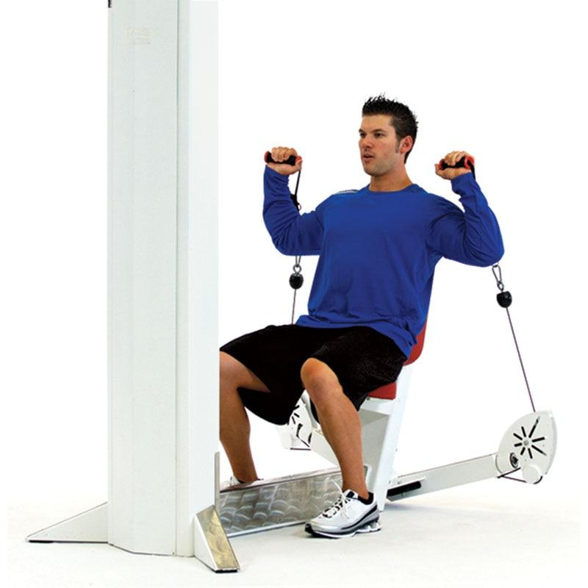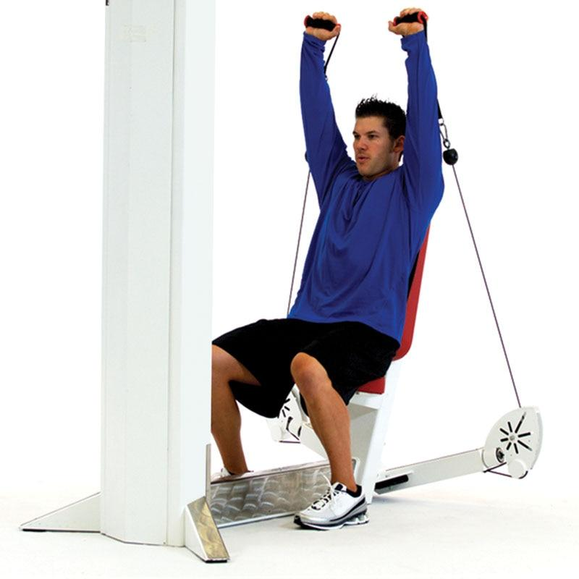

**Figure 21-12** Seated machine shoulder press

TABLE 21-8 Pressing Movement Patterns

| **Category** | **Description** |
| --- | --- |
| Musculature | Deltoids, trapezius, triceps brachii, and rotator cuff |
| Concentric joint actions | Shoulders: shoulder flexion  Arms: elbow extension |
| Daily examples | Lifting objects overhead and reaching for objects in high areas |
| Exercise examples | Dumbbell shoulder press, barbell shoulder press, push press, and Arnold press |

Multiplanar movement

Activities of daily living and sport activities occur in all three planes of motion: sagittal, frontal, and transverse. However, the majority of traditional fitness programs overemphasize exercises in the sagittal plane with a primary emphasis on concentric force production. If everyday movement and sport is multiplanar, then fitness professionals should integrate multiplanar exercises to maximize the transfer-of-training effect. In other words, the more similarity that exists from the training program to movement patterns, the greater the effect and transfer to sport-related and daily-living activities. Training only in the sagittal plane will not provide clients with the motor learning opportunities to effectively move in all planes of motion.

In addition, many lower-extremity non contact injuries occur in the frontal and transverse planes of motion (Padua et al., 2018; Quatman et al., 2010). Therefore, programming a variety of exercises in all planes of motion is a critical component of a client’s training program to reduce the likelihood of injury.

**Increasing proprioceptive demands**

After a client acquires basic movement proficiency and has become accustomed to various exercise equipment, the focus of a Phase 1 program shifts to improving a client’s core and joint stability and posture. This is accomplished by increasing the proprioceptive demand of exercises. In other words, exercise progressions require greater focus on maintaining ideal postural control and balance rather than increasing external load. A common example is a client progressing from using selectorized machines to barbells, dumbbells, and other forms of free weights.

Another example includes progressing exercises from a stable seated position to a standing position or even a single-leg stance. This form of progression requires clients to stabilize their trunk and peripheral joints (ankles, knees, hips, and shoulders) while performing functional movement patterns. Consequently, this creates a greater demand on the core musculature and balance mechanisms during exercise (Behm et al., 2002, 2010; Behm & Anderson, 2006; Willardson, 2007). Proprioceptive (unstable, yet controllable) training has been shown in research as an effective form of exercise to reduce the risk of injury (de Vasconcelos et al., 2018; Riva et al., 2016, Rivera et al., 2017; Verhagen et al., 2004). It is important to note that the level of instability should be client specific, and fitness professionals should always err on the side of caution when increasing the proprioceptive demand of exercises.

Although this is the first phase of training in the OPT model, it will also be important to cycle back through this phase between periods of higher-intensity training seen in Phases 2 through 5. This will allow for proper recovery and maintenance of high levels of stability that will ensure optimal adaptations for strength or power or both.

In addition to increasing proprioceptive demand, acute variables can be progressed by increasing the volume (sets or reps) and intensity (load, exercise selection, or planes of motion) and by decreasing rest periods based on client’s rating of perceived exertion. It is important to keep in mind that the intensity and difficulty of exercises should be client specific. Fitness professionals need to design exercise programs that match their client’s current capabilities and fitness level.

To recap, Phase 1 Stabilization Endurance Training focuses on the following:

1. Teaching ideal movement patterns and exercise skills
2. Increasing flexibility and joint mobility
3. Correcting identified muscle imbalances based on assessment results
4. Increasing joint and core stability
5. Improving muscular endurance and aerobic capacity
6. Enhancing proprioception, balance, and overall coordination
7. Promoting client confidence and adherence to exercise.

**Designing a Phase 1 Stabilization Endurance Training Program**

As a reminder, daily OPT exercise programs include several sections: Warm-Up, Activation, Skill Development, Resistance Training, Client’s Choice, and Cool-Down. Each section is included in the workout to elicit a specific physical, neurological, or psychological adaptation. Note that not all sections must be included in a client’s workout, especially when limited time is a factor. It is up to the fitness professional’s discretion as to which sections are most important based on the client’s goals, needs, and abilities.

**Stabilization level warm-up**

The flexibility techniques used within Phase 1 Stabilization Endurance Training include (1) self-myofascial techniques, such as foam rolling; (2), static stretching; and (3) optional dynamic stretching.

When performing self-myofascial techniques, choose one to three muscle groups to target and hold on each tender area for a minimum of 30 seconds to elicit an optimal relaxation response. Refer to Chapter 14 Flexibility Training Concepts for more information on how to perform self-myofascial techniques.

After completing self-myofascial techniques, the next step is to perform one to three static stretches. In most cases, it is best to statically stretch the same muscles targeted during self-myofascial techniques because the combination of both techniques provokes a greater relaxation and range of motion response (Fairall et al., 2017; Mohr et al., 2014; Škarabot et al., 2015). When performing static stretching, it is important to hold the stretched position for a minimum of 30 seconds to elicit optimal increases in range of motion (Behm et al., 2016; Kay & Blazevich, 2012).

Dynamic stretching is optional during a Phase 1 program; however, the inclusion of dynamic stretching within a flexibility routine is promising (Behm & Chaouachi, 2011; Behm et al., 2016; Kallerud & Gleeson, 2013; Opplert & Babault, 2018). The addition of dynamic stretches may further increase joint range of motion while also increasing the potential expression of strength and power output. If opting to include dynamic stretching, choose one set of 3 to 10 dynamic stretches using a repetition range of 10 to 15.

Similar to dynamic stretching, the inclusion of cardiorespiratory exercise is also optional. For example, if the fitness professional programs a circuit of dynamic stretches, the addition of cardiorespiratory exercise is not necessary.

CRITICAL

The flexibility techniques used in a Phase 1 Stabilization Endurance Training Program include (1) self-myofascial techniques, (2) static stretching, and (3) optional dynamic stretching.

Self-myofascial techniques and static stretching should focus on areas that have been determined as overactive during the assessment process.

**Stabilization level activation**

The activation techniques used within Phase 1 Stabilization Endurance Training include core and balance exercises. When choosing core exercises for a Phase 1 program, it is important to choose exercises that emphasize core stabilization and intervertebral stability. These exercises primarily target the local core muscles, such as the rotatores, multifidus, transverse abdominis, and diaphragm (refer to Chapter 16 Core Training Concepts for a review of local core muscles). To accomplish this, core exercises in this phase of training should focus on isometric contractions or use slow repetition tempos that involve little motion of the spine, depending on the nature of the exercise. An example of a slow repetition tempo is 4-2-1-1 (4-second eccentric action; 2-second isometric hold; 1-second concentric contraction; 1-second isometric hold). A review of repetition tempo is provided in Chapter 20. The volume and intensity of core exercises in this phase of training should be relatively low because the goal is to activate, versus exhaust, the local core musculature prior to more intense exercise. Choose between one and four core exercises with a repetition range of 12 to 20 and one to three sets. Using a low volume of core exercises helps promote muscle activation and prepares the body for further work without inducing undue muscular fatigue or exhaustion.

TRAINING TIP

Core exercises that emphasize core stabilization and intervertebral stability typically involve little motion of the spine. Examples include (but are not limited to) marching, floor bridge, ball bridge, floor prone cobra, ball cobra, plank, side plank, bird dog, Pallof press, and dead bugs.

Similar to core training, balance training exercises must be systematic and progressive. Fitness professionals should follow specific program guidelines, proper exercise selection criteria, and detailed program variables. The main goal of balance training is to continually increase the client’s awareness of their limit of stability by creating controlled instability. Not following the proper progression can cause movement compensations and improper execution of the exercise, decreasing the effectiveness of the exercise and increasing the risk for injury.

When introducing balance exercises into a Phase 1 exercise program, the exercises should initially involve little joint motion of the balance leg. These entry-level balance exercises are designed to improve reflexive (automatic) joint stabilization contractions to increase joint stability. Like core training, choose between one and four balance exercises with a repetition range of 12 to 20 (6 to 10 repetitions on each leg) using a slow repetition tempo and one to three sets.

TRAINING TIP

Balance exercises that involve little joint motion of the balance leg and are ideal for a Phase 1 program include (but are not limited to) the following: tandem stance, single-leg balance, single-leg balance reach, single-leg hip internal and external rotation, single-leg lift and chop, single-leg arm and leg motion, single-leg windmill, and single-leg throw and catch. Balance exercises do not require the use of a balance modality (i.e., balance disc, foam pad, or wobble board) to provide adequate stimulus. However, these modalities can be a viable option for more advanced clients.

**Stabilization level skill development**

During the skill development section, the fitness professional can either program plyometric and SAQ exercises or provide instruction for basic movement patterns and how to use exercise equipment. This choice is dependent on the skill and fitness level of the client and is up to the fitness professional’s discretion.

Clients with modest fitness experience can safely perform plyometric and SAQ exercises; however, these exercises are optional. When introducing plyometric exercises, the movements should initially involve small jumps (lower amplitude) to best learn the movement pattern. When a client lands, they should hold the landing position for 3 to 5 seconds. During this time, the client should make any adjustments necessary to correct faulty postures before performing the next jump. Choose between one and three plyometric exercises with a repetition range of five to eight and perform for one to three sets.

TRAINING TIP

Example exercises using this protocol include (but are not limited to) the following: squat jump with stabilization, box jump-up with stabilization, box jump-down with stabilization, and multiplanar jump with stabilization.

Like plyometric training, the safety and success of SAQ exercises is dependent on the physical capabilities and fitness level of the client. The better a fitness professional can match drills appropriate to a client’s capabilities, the safer and more effective the program will be. All exercises should be performed with precise technique to minimize risk of injury. Choose between four and six SAQ exercises, such as ladder drills and cone drills, with a repetition range of two to three for one to two sets.

TRAINING TIP

Example exercises using this protocol include (but are not limited to) the following: speed ladder drills, such as one-ins, two-ins, side shuffle, in-in-out-out, zig-zag, and Ali shuffle. Cone drills, such as a 5-10-5 drill, T-drill, box drill, modified box drill, and LEFT drill are also appropriate.

**Stabilization level resistance training**

The resistance training techniques used in Phase 1 should focus on improving the movement patterns previously discussed. In addition, resistance training in this phase should aim to increase postural control, mobility and stability of the core and peripheral joints, and overall muscular endurance. This requires the use of strength-training exercises performed in a controlled, yet progressively unstable, environment.

Acute variables include performing one to three sets for 12 to 20 repetitions with a slow repetition tempo for each exercise. Like core and balance exercises, an example slow repetition tempo during resistance training is 4-2-1-1 (4-second eccentric action; 2-second isometric hold; 1-second concentric contraction; 1-second isometric hold). The aim of Phase 1 resistance training exercises is to adequately prepare muscles, tendons, ligaments, and joints for higher loads used later in the OPT model and to promote ideal joint stability, muscular endurance, and neuromuscular efficiency.

TRAINING TIP

Stabilization-focused resistance exercises require clients to support their posture with their core and joint stabilizers versus relying on artificial support, such as a bench or machine. This typically takes form as standing or single-leg stance exercises. Balance modalities, such as the inclusion of stability balls and other implements, are also an option. However, the amount of instability should be client specific based on their physical capabilities.

**Stabilization level client's choice**

In this section of the workout, clients are allowed to choose their own exercises. In most cases, one or two client-choice exercises will suffice. This portion of the workout provides a unique and fun characteristic to the exercise program. The aim is to increase exercise adherence and self-efficacy for clients. Any type of exercise is permitted in this section as long as it is deemed safe and appropriate.

**Stabilization level cool-down**

The cool-down portion should last between 5 and 10 minutes and include, in the following order, (1) optional cardiorespiratory exercise, (2) self-myofascial techniques, and (3) static stretching. When executing self-myofascial techniques, such as foam rolling, choose 1 to 3 muscle groups and hold on each tender area for a minimum of 30 seconds to elicit an optimal relaxation response. This will be followed by static stretching for the same muscle groups.

**Phase 1 Stabilization Endurance Training Synopsis**

Table 21-9 provides a complete overview of Phase 1 Stabilization Endurance Training. Note that cardiorespiratory exercise is not included in the chart but can be integrated anytime within an OPT workout or performed separately.

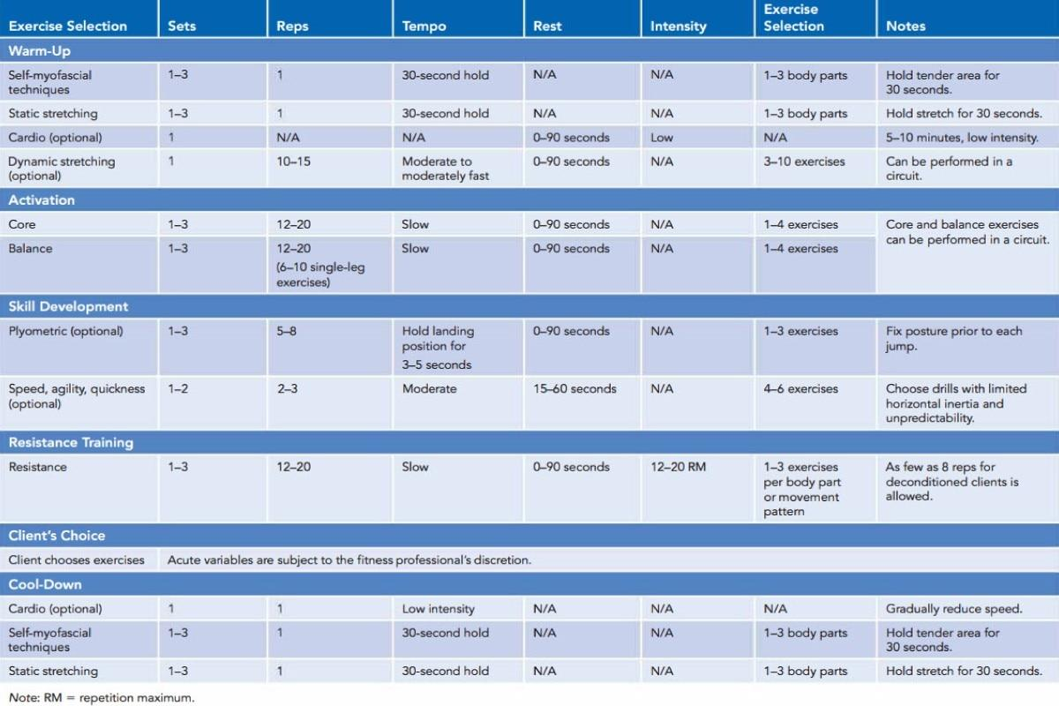

## Strength level of OPT model

The second level of training in the OPT model focuses on the main adaptation of strength. While there are many types of strength, the OPT model emphasizes improvements in strength endurance, muscular development, and maximal strength. It is designed to maintain stability while increasing the amount of stress placed on the body for increased muscle size, strength, and work capacity. This period of training is a necessary progression from stabilization for anyone who desires to increase caloric expenditure, muscle size, muscle strength, and bone mineral density. The strength level of training focuses on the following:

1. Increasing the ability of the core musculature to stabilize the pelvis and spine under heavier loads, through greater ranges of motion
2. Increasing the load-bearing capabilities of muscles, tendons, ligaments, and joints
3. Increasing the volume of training
4. Increasing metabolic demand by taxing the phosphocreatine (ATP-PC) and glycolytic energy systems to induce cellular changes in muscle
5. Increasing recruitment of more motor units to overcome an external load (maximal strength)

The strength level of training in the OPT model consists of three phases: Phase 2 Strength Endurance Training, Phase 3 Muscular Development Training, and Phase 4 Maximal Strength Training.

### Phase 2 Strength Endurance Training

Phase 2 Strength Endurance Training is a hybrid form of training that promotes increased stabilization endurance, hypertrophy, and strength. The unique aspect of this phase of training is that it entails the use of superset techniques in which a more strength-focused exercise (such as a bench press) is immediately followed with a stabilization-focused exercise with similar biomechanical motions (such as a push-up). Thus, for every set of an exercise performed, there are actually two exercises being completed. High amounts of volume can be generated in this phase of training.

Similar to Phase 1, Phase 2 acute variables can be progressed by increasing proprioceptive demand (instability), volume (sets or reps), and intensity (load, exercise selection, or planes of motion) and by decreasing rest periods. Clients can spend anywhere from 2 to 6 weeks in this phase of training, depending on their goals, fitness level, and training schedule.

### Phase 3 Muscular Development Training

Phase 3 Muscular Development Training is specific for the adaptation of maximal muscle growth, focusing on high levels of volume to force cellular changes that result in an overall increase in muscle size.

Because the goal of this phase of training is primarily hypertrophy, the fitness professional will want to increase volume and intensity of the program. A client in this category will generally stay in this phase of training for a 2- to 6-week duration before cycling back through Phase 1 or 2 or progressing on to Phase 4 or 5.

Some clients may not wish to increase muscular hypertrophy, such as endurance athletes, and, therefore, this phase is optional. However, Phase 3 can be used to meet many goals beyond hypertrophy because the acute variables can be manipulated to increase stress on aerobic and anaerobic energy systems. For example, a Phase 3 program can limit rest periods, so the workout becomes more metabolically demanding, which is ideal for weight loss and cardiorespiratory conditioning.

### Phase 4 Maximal Strength Training

Phase 4 Maximal Strength Training focuses on increasing the load placed on the tissues of the body. In other words, Phase 4 requires the exerciser to lift progressively heavier loads near or at maximal intensity. Maximal intensity improves recruitment of more motor units and rate of force production.

While this can be viewed as an optional phase for some clients, maximal strength training has also been shown to help increase the benefits of power training used in Phase 5. Because the goal of this phase of training is primarily maximal strength, the fitness professional will want to increase intensity (load) and the number of sets performed for each exercise. As the client trains with heavier loads, repetition ranges will decrease, and rest periods will likely need to increase to help ensure full restoration of ATP. A client in this category will generally stay in this phase of training for a 2- to 6-week duration before cycling back through earlier phases or progressing on to Phase 5. This phase is optional because some clients may not seek maximal strength adaptations.

**Designing Strength Level Programs**

Phases 2 through 4 of the OPT model use the same workout template as Phase 1; yet, the acute training variables will be different, and exercise selections are more advanced.

**Strength level warm-up**

The flexibility techniques used in Phases 2 through 4 include (1) self-myofascial techniques, such as foam rolling; (2) active stretching; and (3) optional dynamic stretching. When performing self-myofascial techniques, choose one to three muscle groups to target, and hold on each tender area for a minimum of 30 seconds to elicit an optimal relaxation response. After completing self-myofascial techniques, the next step is to perform one to three active stretches. Active stretches require 5 to 10 repetitions in which the stretched position is only held for 1 to 2 seconds. If opting to include dynamic stretching, choose one set of 3 to 10 dynamic stretches using a repetition range of 10 to 15.

Similar to Phase 1, cardiorespiratory exercise is an optional component of a client’s warm-up. If including cardiorespiratory exercise, the intensity should be rather low and last between 5 and 10 minutes.

HELPFUL HINT

A Phase 1 flexibility routine involves self-myofascial techniques, static stretching, and optional dynamic stretching. However, in Phases 2 through 4, the flexibility routine is progressed, and flexibility techniques include self-myofascial techniques, active stretching, and optional dynamic stretching.

**Strength level activation**

Similar to Phase 1, the activation techniques used within Phases 2 through 4 include core and balance exercises. However, the exercises should ideally be a progression from those used previously. To accomplish this, core exercises should involve more dynamic eccentric and concentric movements of the spine throughout a full range of motion. In other words, these exercises involve flexion, extension, and rotation of the trunk with slightly faster tempos. Choose between one and four core exercises, using a repetition range of 8 to 12 and two to four sets using a moderate repetition tempo.

An example of a moderate repetition tempo is 2-0-2-0 (2-second eccentric action; 0-second isometric hold; 2-second concentric contraction; 0-second isometric hold).

While it is recommended to incorporate more progressive exercises in these phases, the fitness professional has the discretion to include core exercises used in Phase 1, if deemed important and appropriate, such as the client needing additional work to improve intervertebral stability.

TRAINING TIP

Core exercises that involve flexion, extension, and rotation of the spine that are appropriate for this level of training include (but are not limited to) floor crunches, ball crunches, back extensions, reverse crunches, knee-ups, cable rotations, cable lifts, and cable chops.

The next progression for balance exercises is to involve dynamic eccentric and concentric movement of the balance leg, through a full range of motion. Movements require dynamic control in the midrange of motion, with isometric stabilization at the end range of motion. The speed and neural demand of each exercise are also progressed. Choose between one and four balance exercises using a repetition range of 8 to 12 using a moderate repetition tempo and two to four sets. However, the fitness professional has the discretion to include balance exercises used in Phase 1, if deemed important and appropriate, such as the client needing additional work to maintain proper lower extremity and trunk alignment and control while on a single leg.

TRAINING TIP

Sample balance exercises following this protocol include (but are not limited to) single-leg squat, single-leg squat touchdown, single-leg Romanian deadlift, multiplanar step-up to balance, and multiplanar lunge to balance.

**Strength level skill development**

During the skill development section, fitness professionals can choose to either program plyometric and SAQ exercises or provide instruction for alternative forms of exercise, such as Olympic weightlifting, powerlifting, or martial arts drills. This choice is dependent on the expertise of the fitness professional and goals of the client.

If implementing plyometric training, the exercises should be a progression from Phase 1 and involve jumps with more amplitude and dynamic motion. These exercises are performed in a repetitive fashion, spending a relatively short amount of time on the ground before repeating the drill. In other words, the client will no longer hold the landing position for 3 to 5 seconds but instead initiate another jump on landing. Select between one and four plyometric exercises with a repetition range of 8 to 12 and perform for two to four sets.

However, the fitness professional has the discretion to include or substitute plyometric exercises used in Phase 1, if deemed important, particularly if the client is having difficulty performing more advanced forms of plyometric training and needs more practice.

Like plyometric training, SAQ exercises are dependent on the physical capabilities and goals of the client. SAQ exercises are optional during the strength level of the OPT model, but they can be a valuable mode of exercise for those seeking improvements in speed, reaction time, coordination, and anaerobic conditioning.

TRAINING TIP

Sample plyometric exercises following this protocol include (but are not limited to) squat jumps, tuck jumps, butt kicks, and power step-ups.

All exercises should be performed with precise technique to minimize the risk of injury. Choose between six and eight SAQ exercises with a repetition range of three to five and perform for three to four sets.

**Strength level resistance training**

Each phase within the strength level of the OPT model has specific resistance training protocols to elicit a specific physical adaptation.

**Phase 2 resistance training protocol**

Phase 2 is a hybrid form of training and can be considered a bridge between stability-focused training performed in Phase 1 and muscular hypertrophy-focused training used in Phase 3. Phase 2 requires the use of supersets in which the first exercise is a traditional strength-training exercise immediately followed by a stability-focused exercise for the same body part. For example, a client can perform a traditional bench press exercise, which is a traditional strength-focused exercise for the chest, immediately followed by a push-up, which is an exercise that places a greater emphasis on postural control, stability, and muscular endurance. Table 21-10 lists common supersets that can be performed using this style of training, but the possibilities are nearly limitless. Choose between one and two supersets for each body part with a repetition range of 8 to 12 and two to four sets. The first exercise in the superset will be performed using a moderate 2-0-2-0 tempo, and the second exercise will involve a slow 4-2-1-1 repetition tempo.

TABLE 21-10 Example Phase 2 Supersets

| **Strength-Focused Exercise** | **Stability-Focused Exercise** |
| --- | --- |
| Bench press | Push-up |
| Machine chest press | Single-leg cable press |
| Machine lat pulldown | Standing lat pulldown |
| Machine cable row | Standing cable row |
| Machine shoulder press | Standing bottoms-up kettlebell press |
| Seated dumbbell shoulder press | Single-leg dumbbell shoulder press |
| Barbell squat | Single-leg squat |
| Romanian deadlift | Single-leg Romanian deadlift |
| Machine calf raise | Single-leg calf raise |

**Phase 3 resistance training protocol**

Resistance training for Phase 3 is specific for the adaptation of muscular development; however, training in this phase has many benefits that align with common fitness goals, such as improvements in body composition. Clients seeking to obtain greater muscle mass and improvements in weight management and metabolism can benefit from this form of training. In fact, resistance training is an important protocol during a client’s weight-loss journey to preserve lean muscle mass (Cava et al., 2017). Because the goal of this phase of training is primarily hypertrophy, the fitness professional will want to increase volume and intensity of the program. Choose between three and six sets with 6 to 12 repetitions using a moderate 2-0-2-0 tempo and two to four exercises per body part. However, fitness professionals have the option of choosing a repetition scheme greater than 12, such as 12 to 20, if additional muscular endurance is desired (Schoenfeld et al., 2015, 2019).

**Phase 4 resistance training protocol**

Resistance training for Phase 4 is specific for the adaptation of maximal strength. Clients, such as strength athletes seeking optimal strength enhancements, will benefit from this form of training as will those looking to enhance muscle hypertrophy. This is an advanced form of training and only recommended for experienced lifters and exercisers who have worked their way up to this phase of the model.

Choose between four and six sets with one to five repetitions using an explosive repetition tempo (notated as X-X-X-X) and two to four exercises per body part. However, fitness professionals have the option of choosing more than six sets for advanced clients that require additional volume. Moreover, not every client who has progressed through the first three phases of the OPT model is seeking to increase their maximal strength capabilities. As such, this is an optional phase of the OPT model.

**Strength level client's choice**

Identical to Phase 1, clients are allowed to choose their own exercises in this section of the workout. Any type of exercise is permitted in this section as long as it is deemed safe.

**Strength level cool-down**

The cool-down portion is identical in all five phases of the OPT model and should last between 5 and 10 minutes. It includes, in the following order, cardiorespiratory exercise (optional), self-myofascial techniques, and static stretching. When executing self-myofascial techniques, such as foam rolling, choose one to three muscle groups and hold on each tender area for a minimum of 30 seconds to elicit an optimal relaxation response. This will be followed by static stretching for the same muscle groups.

**Phase 2 Strength Endurance Training Synopsis**

Table 21-11 provides a complete overview of Phase 2 Strength Endurance Training. Note that cardiorespiratory exercise is not included in the chart but can be integrated anytime within an OPT workout or performed separately.

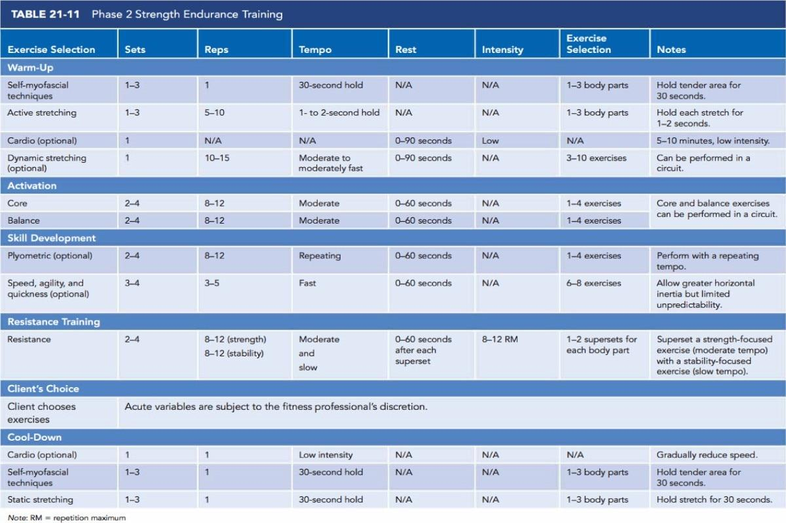

**Phase 3 Muscular Development Training Synopsis**

Table 21-12 provides a complete overview of Phase 3 Muscular Development Training. Note that cardiorespiratory exercise is not included in the chart but can be performed anytime within an OPT workout or performed separately.

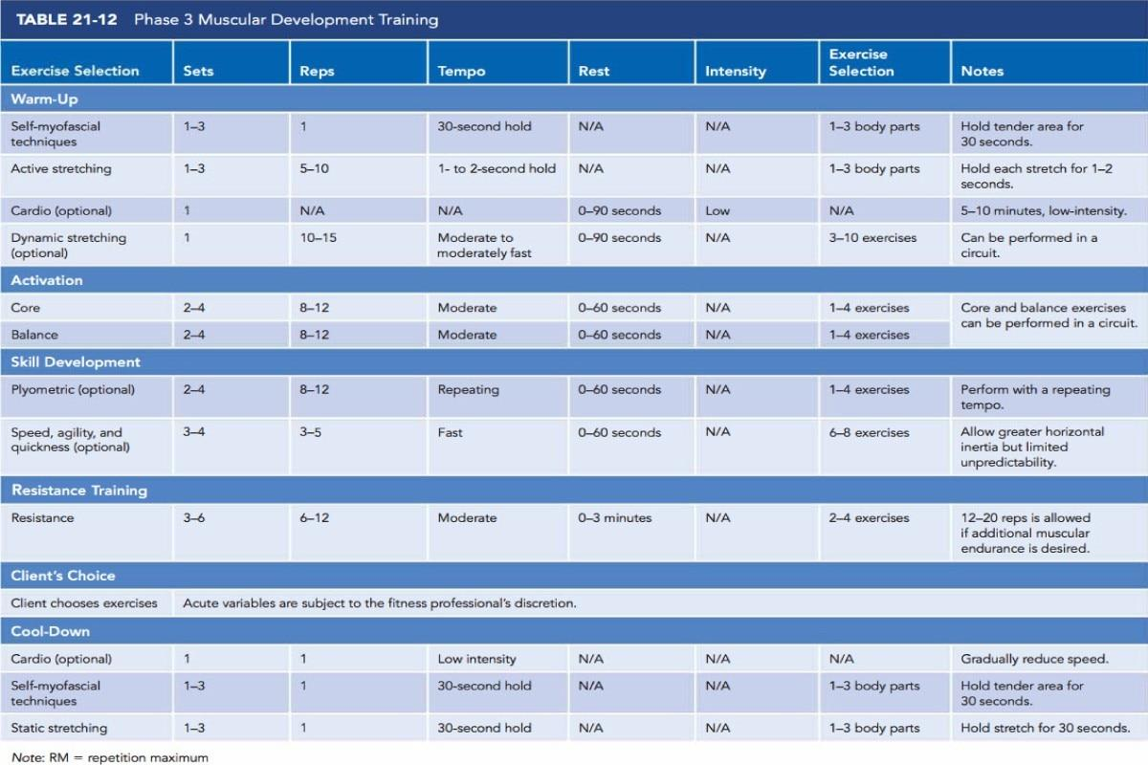

**Phase 4 Maximal Strength Training Synopsis**

Table 21-13 provides a complete overview of Phase 4 Maximal Strength Training. Note that cardiorespiratory exercise is not included in the chart but can be performed anytime within an OPT workout or performed separately.

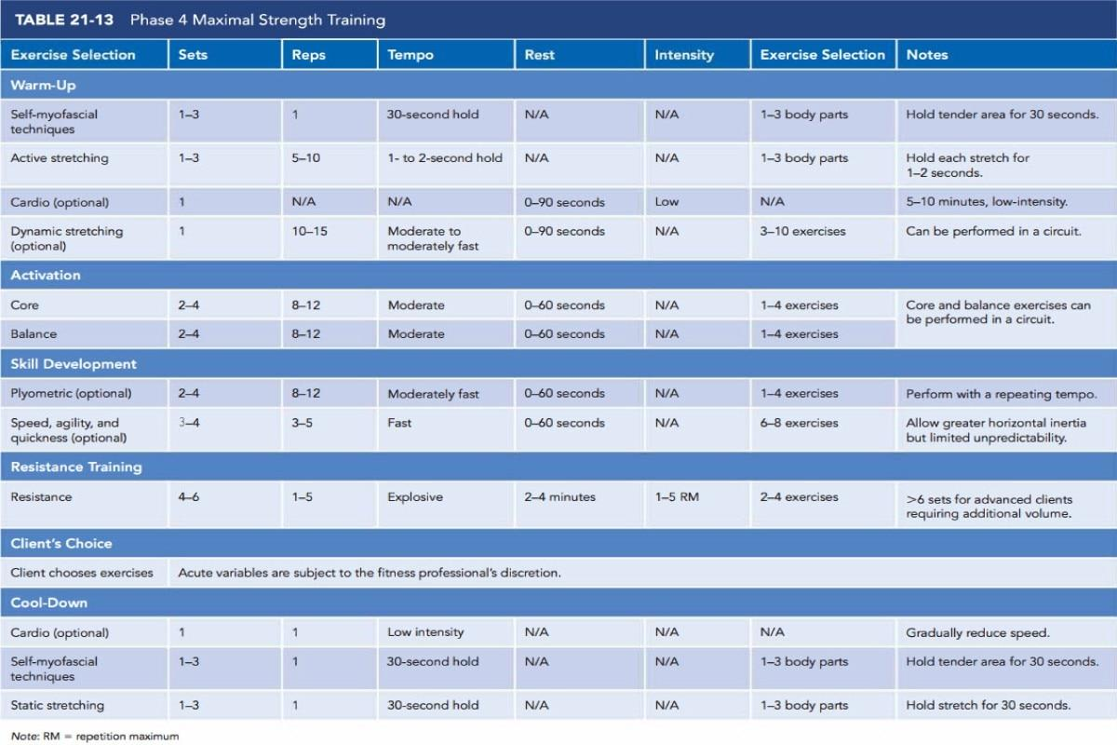

## Power

The third level of the OPT model, power, is designed to increase the rate of force production (or speed of muscle contraction). This form of training uses the adaptations of stabilization and strength acquired in the previous phases of training and applies them at more realistic speeds and forces that the body will encounter in everyday life and in sports.

Power training is usually not a common practice in the fitness environment, but it has a viable and purposeful place in a properly planned training program. Power is defined as force multiplied by velocity (*P = F × V*). Therefore, any increase in either force or velocity will produce an increase in power. This is accomplished by either increasing the load (or force) as in progressive strength training or increasing the speed with which a load is moved (or velocity). The combined effect is a better rate of force production in both daily and sporting activities.

To develop optimal levels of power, individuals should train with both heavy loads (85% to 100% intensity or one to five repetition maximum [RM]) and light loads (30% to 45% intensity or 8 to 10 RM) at high speeds. The focus of power training is to increase the rate of force production by increasing the number of motor units activated, the synchrony between them, and the speed at which they are excited (Freitas et al., 2017; Li et al., 2019; Santos & Janeira, 2008). A client in this category will generally stay in this phase of training for a 2- to 6-week duration before cycling back through earlier phases, but this is highly dependent on the client’s training goals or athletic competitive schedule.

The power level of the OPT model consists of one phase of training: Phase 5 Power Training.

**Designing Power Level Programs**

Like previous phases of the OPT model, Phase 5 uses the same workout template; yet, the acute training variables and exercise selections focus on enhancing muscular power.

**Power level warm-up**

The flexibility techniques used in Phase 5 include self-myofascial techniques and dynamic stretching. Choose one to three muscle groups and hold on each tender area for a minimum of 30 seconds when performing self-myofascial techniques. After completing self-myofascial techniques, the next step is to perform dynamic stretching. Choose between 3 and 10 dynamic stretches using a repetition range of 10 to 15.

Cardiorespiratory exercise is not needed during a Phase 5 warm-up because dynamic stretching serves as a specific warm-up and adequately prepares tissues for the upcoming demands of the workout.

HELPFUL HINT

A Phase 5 flexibility routine does not typically involve static or active stretching. Instead, only self-myofascial techniques and dynamic stretching are performed. However, if a client or athlete displays limited mobility or muscle imbalances, static or active stretching can be included prior to performing dynamic stretching.

**Power level activation**

Like the stabilization and strength levels of the OPT model, the activation techniques used in Phase 5 include core and balance exercises. However, because most of these exercises can be programmed during the resistance training section of the workout, core and balance exercises are optional during the activation section.

If core exercises are programmed, they should involve explosive movements designed to increase rate of force production of the core musculature through a full range of motion. Choose between one and two core exercises using a repetition range of 8 to 12 with an explosive tempo and one to three sets. However, the fitness professional has the discretion to include or substitute core exercises used in previous phases, if deemed important and appropriate, such as the client needing additional work to improve intervertebral stability or rotational core strength.

TRAINING TIP

The last progression includes core exercises that are designed to improve power of the core musculature. Example exercises include (but are not limited to) medicine ball rotation chest pass, ball medicine ball pullover throw, front medicine ball oblique throw, side medicine ball oblique throw, medicine ball soccer throw, medicine ball overhead throw, and medicine ball woodchop throw.

Balance exercises used in Phase 5 are a progression from previous phases and are designed to develop proper deceleration ability to move the body from a dynamic state to a controlled stationary position. In other words, these exercises combine hopping motions with a single-leg stance landing. The landing position is held for 3 to 5 seconds.

TRAINING TIP

Example balance exercises that focus on eccentric control and deceleration include (but are not limited to) multiplanar hop with stabilization, multiplanar single-leg box hop-up with stabilization, and multiplanar single-leg box hop-down with stabilization.

**Power level skill development**

Similar to previous phases of the OPT model, the skill development section is reserved for either plyometric and SAQ exercises or providing instruction for alternative forms of exercise. The decision should be based on the goals, needs, and abilities of the client. In addition, because power-based movements are performed during the resistance training portion of the workout, plyometric and SAQ exercises are optional in this section of the workout.

If implementing plyometric training, the exercises should be a progression from Phases 2 through 4 and involve explosive, powerful movements. These exercises are designed to further improve the rate of force production and eccentric strength of the entire kinetic chain. Choose between one and four plyometric exercises with a repetition range of 8 to 12 and three to five sets. However, the fitness professional has the discretion to include or substitute plyometric exercises used in earlier phases, if deemed important and appropriate.

Similar to plyometric training, SAQ exercises are dependent on the physical capabilities and goals of the client. SAQ exercises are optional during a Phase 5 workout, but they are a valuable mode of exercise for those seeking improvements in speed, power, and overall enhanced athleticism.

TRAINING TIP

Plyometric exercises used in Phase 5 are performed as fast and as explosively as possible. Some example exercises using this protocol include (but are not limited to) ice skaters, single-leg power step-ups, proprioceptive plyometrics, and depth jumps.

Because of their importance, fitness professionals can choose to program SAQ exercises on nonresistance training days. Choose between six and ten SAQ exercises with a repetition range of three to five for three to five sets.

**Power level resistance training**

The power training phase focuses on both high force and velocity to increase power. This is accomplished by supersetting a strength-focused exercise with a power-focused exercise for each body part (such as performing a heavy barbell bench press superset with an explosive medicine ball chest pass). This form of training is also known as *complex training* and *contrast training*.

The range of training intensities is important to stimulate different physiologic changes. The first exercise uses a heavy load, one to five RM, which is approximately 85% to 100% of a client’s 1RM. In other words, the first exercise in the superset is a heavy lift that challenges the body to generate high amounts of force. These exercises and loads increase power by increasing the *force* side of the power equation (force × velocity).

The second exercise in the superset focuses on the development of speed and velocity by using explosive movements with light loads. Implements, such as medicine balls, tubing, and weight vests, are common when performing these exercises. However, body weight is also common for many power-based plyometric drills. Light loads (30% to 45% intensity or 8 to 10 RM) at high speeds are appropriate intensities. However, when using a medicine ball, opt for a weighted ball that is no more than 10% of a client’s body weight. These exercises affect the *velocity* side of the power equation (force × velocity).

By supersetting strength and power-based exercises, power outputs can be enhanced (Cormier et al., 2020; Freitas et al., 2017; Li et al., 2019; Santos & Janeira, 2008). Because the goal of this phase of training is primarily power, the fitness professional will want to progress by increasing the number of sets, intensity (load), and velocity of movement.

**Power level client's choice**

Identical to earlier phases of the OPT model, clients can pick their own exercises in this section of the workout. All types of exercises are permitted in this section as long as they are deemed safe and fit within the capabilities of the client.

**Power level cool-down**

As mentioned previously, the cool-down portion is identical in all five phases of the OPT model. It should last between 5 and 10 minutes and include a mixture of the following exercises in order: cardiorespiratory exercise (optional), self-myofascial techniques, and static stretching.

**Phase 5 Power Training Synopsis**

Table 21-14 provides a complete overview of Phase 5 Power Training. Note that cardiorespiratory exercise is not included in the chart but can be performed anytime within an OPT workout or performed separately.

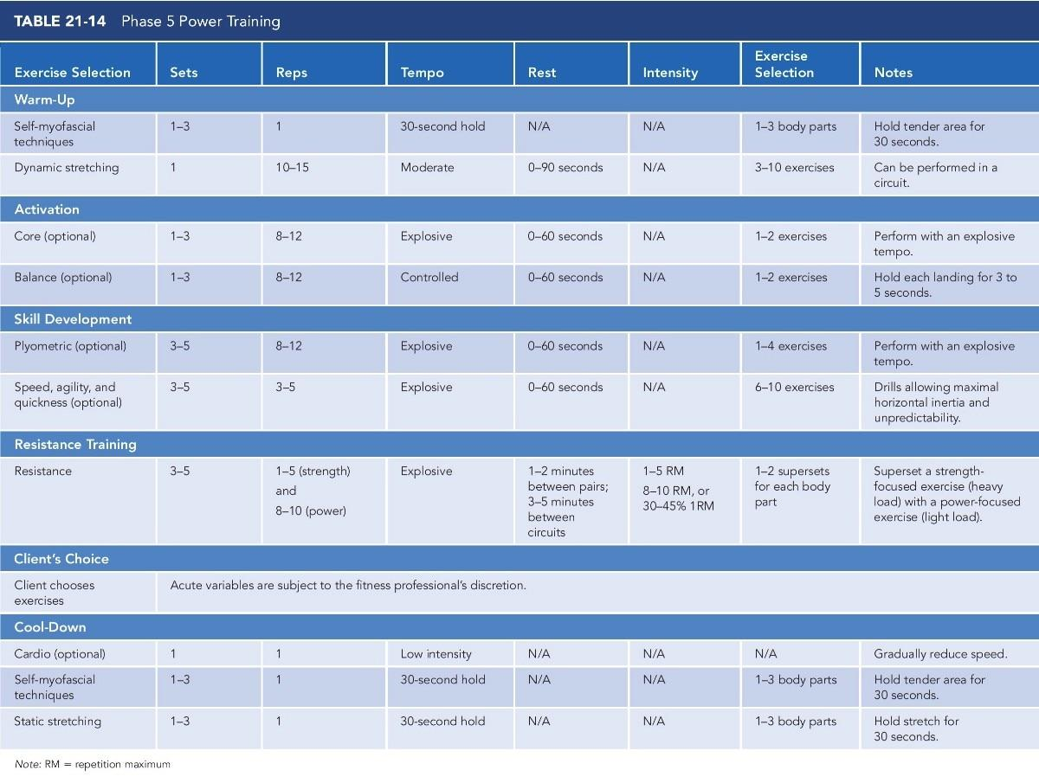

### Applying the OPT model

The concepts of program design, periodization, and the OPT model have all been described. Program design was defined as creating a purposeful system or plan to achieve a goal. Periodization is the scientific basis that allows fitness professionals to strategically plan and design programs to produce optimal adaptation while minimizing risk of placing improper and irrecoverable stresses on the body. The OPT model is a proven, easy-to-use system of periodization that can be used to create programs for clients with various goals and abilities. Although the understanding of these concepts is paramount, what matters most is the ability to apply the information in multiple situations with a variety of clients. This section will demonstrate how to specifically apply the OPT model for the goals of fat loss, increased lean body mass, and general sports performance. Refer to Appendix B for sample programs for the goals of body fat reduction, lean body mass gain, and general performance.

**Applying the OPT model for the goal of body fat reduction**

The goal of reducing body fat requires clients to expend more calories than they consume. The best way to increase the calories burned is to move more through structured exercise and daily physical activity. Resistance training provides an extremely potent stimulus to burn calories by maintaining, or even increasing, lean muscle tissue. More activity and greater amounts of lean body mass result in more calories expended during exercise and throughout the day. Resistance training also provides the added benefit of increased muscle strength.

The following program is a general representation of how the OPT model can be used for clients with the goal of body fat reduction. Figure 21-13 shows a sample annual plan. Because the goal does not include maximal strength or power, the client only needs to be cycled through the first three phases of the OPT model. The client will start in January in Phase 1 to ensure proper muscle balance and endurance of the stabilization muscles. They will remain there for approximately 4 weeks before moving on to Phase 2 in February and then Phase 3 in March. This pattern will continue through the month of June. From July through December, the client will perform undulating periodization in which all three phases are performed concurrently each month to minimize boredom and continually improve on all three adaptations (stabilization, strength endurance, and muscular hypertrophy) at the same time.

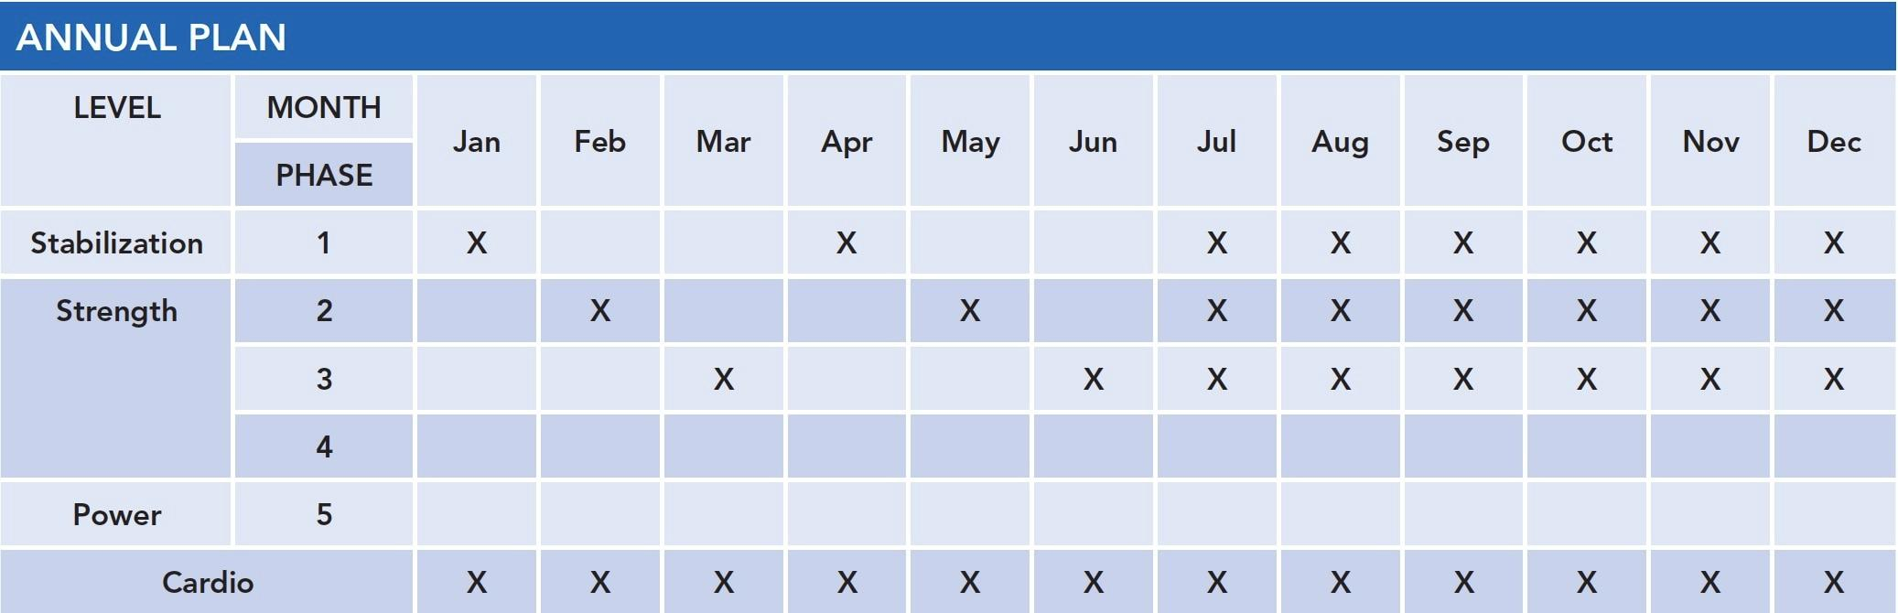

**Figure 21-13** Annual plan for the goal of body fat reduction

In addition, cardiorespiratory training will be used in conjunction with the OPT model to help weight-loss clients expend additional calories and improve health and overall fitness. Cardiorespiratory training should be performed each month and can be done on the workout days (or any other day during the week, depending on the client’s schedule).

Figure 21-14 illustrates the monthly plan for January. This plan demonstrates a 3-day-per-week workout plan, with scheduled workouts on Mondays, Wednesdays, and Fridays. However, this monthly plan can easily be performed twice or four or more times per week depending on the client’s schedule and commitment to exercise.

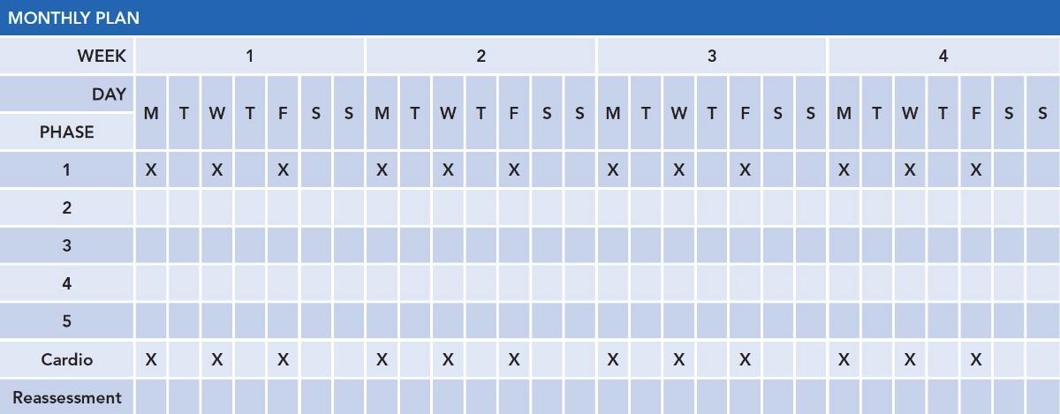

**Figure 21-14** Fat loss monthly plan: January

Figure 21-15 illustrates the monthly plan for July, the start of undulating periodization, in which the client performs the first three phases of the OPT model simultaneously. As with the previous months, this plan demonstrates a 3-day-per-week workout plan with scheduled workouts on Mondays, Wednesdays, and Fridays. Cardiorespiratory exercise can be done on the workout days (or any other day during the week depending on the client’s schedule).

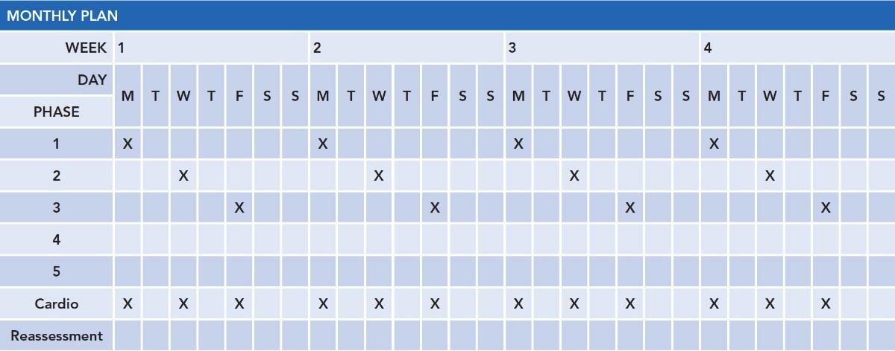

**Figure 21-15** Fat loss monthly plan: July

**Applying the OPT model for increasing lean body mass**

Muscle hypertrophy can be simply defined as the chronic enlargement of muscles. To accomplish this goal, training programs need to be progressed with higher volumes (more sets, reps, and intensity) to force muscles to regenerate their cellular makeup and produce increased size. The following program is a general representation of how the OPT model is used for clients with the goal of increased lean body mass. With the goal of hypertrophy, the client can be cycled through the first four phases of the OPT model, depending on the needs and wants of the client.

Figure 21-16 shows an example annual plan. The client will start January in Phase 1 to ensure proper muscle balance and endurance of the stabilization muscles. Clients will remain there for approximately 4 weeks before moving into Phase 2. Phase 1 is vital for this client, as it will prepare the connective tissues and muscles for the higher demands of training required for this goal. Without proper preparation, injury may occur. The remainder of the annual plan shows the client cycling through Phases 2 through 4. Phase 2 will promote greater strength endurance and more volume to prepare the client for the greater demands of Phases 3 and 4.

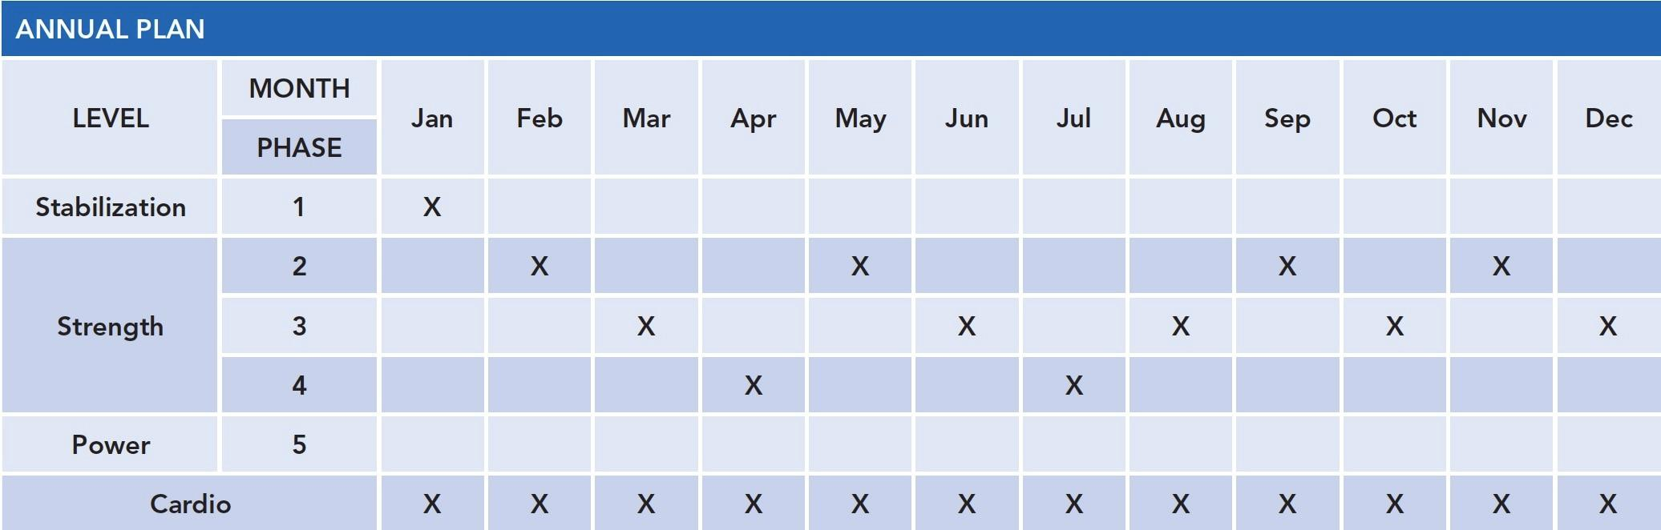

**Figure 21-16** Annual plan for the goal of muscle gain

Phase 3 is specific for maximal hypertrophy and will place larger volumes of stress through the body to force cellular changes that result in muscle hypertrophy. Phase 4 is used to increase the strength capacity to allow the client to train with heavier weights in the future. This will equate to higher volumes of training and greater hypertrophy. Cardiorespiratory training should be performed each month to ensure the cardiorespiratory system is efficient and to promote optimal tissue recovery.

Figure 21-17 illustrates the monthly plan for January (Phase 1). This plan demonstrates a 4-day-per-week workout plan, with scheduled workouts on Mondays, Tuesdays, Thursdays, and Fridays, using a split routine for body parts. Cardio can be done on the workout days (or any other day during the week, depending on the client’s schedule).

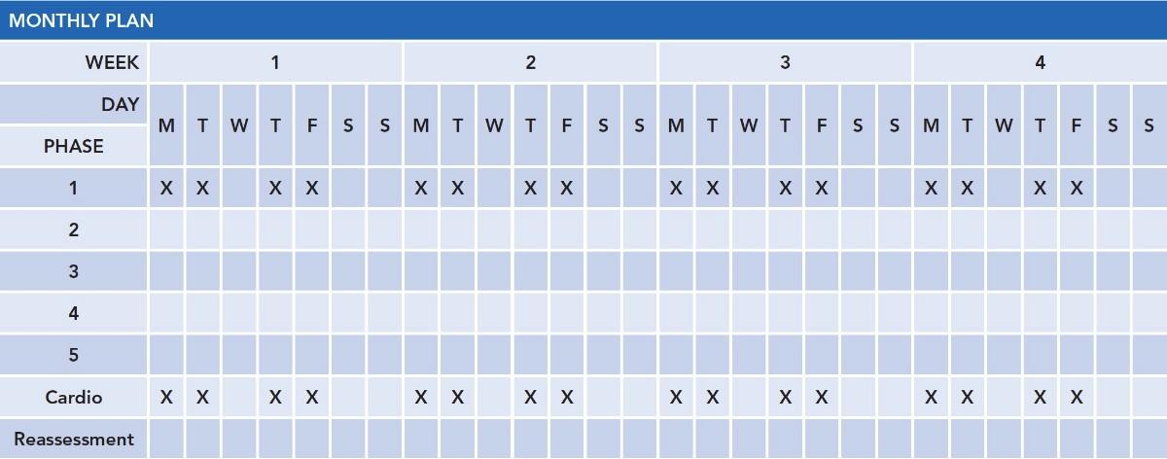

**Figure 21-17** Muscle gain monthly plan: January

Figures 21-18, 21-19, and 21-20 illustrate the monthly plans for February through April. As with the previous months, these plans demonstrate a 4-day-per-week workout plan, with scheduled workouts on Mondays, Tuesdays, Thursdays, and Fridays, using a split routine for body parts. Cardio can be done on the workout days (or any other day during the week, depending on the client’s schedule).

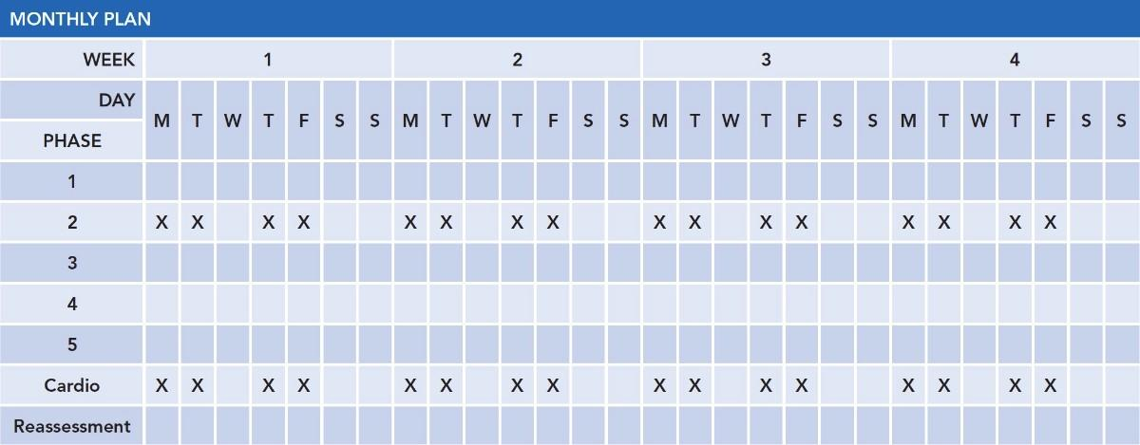

**Figure 21-18** Muscle gain monthly plan: February

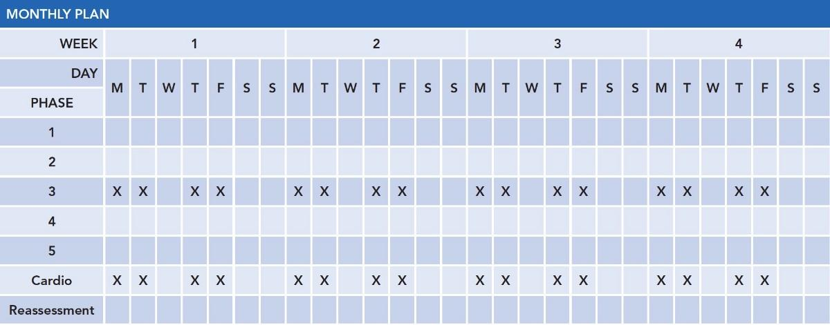

**Figure 21-19** Muscle gain monthly plan: March

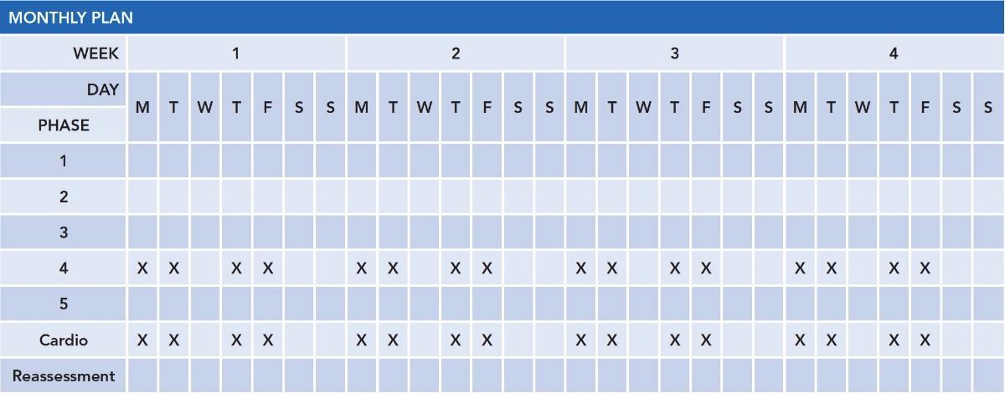

**Figure 21-20** Muscle gain monthly plan: April

**Applying the OPT model for improving general sports performance**

The goal of improving general sports performance requires the client to increase overall endurance, strength, and power output. The training will need to be progressed from stabilization through the power phase of training. The following program is a general representation of how the OPT model is used for clients with the goal of improving general performance. The client can be cycled through the entire OPT model, depending on their needs and wants. However, for the typical client, Phases 1, 2, and 5 will be the most important and relevant. Because Phase 3 is dedicated to maximal hypertrophy, it may not be necessary for the goal of improving general performance. Phase 4 can be used in moderation to help increase the initial strength levels required to optimize the adaptation in Phase 5, if necessary.

Figure 21-21 shows the annual plan. The client will start January in Phase 1 to ensure proper muscle balance and endurance of the stabilization muscles. The client will remain there for approximately 4 weeks before moving on to Phase 2. Phase 1 is vital for this client because it will prepare the connective tissues and muscles for the higher demands of training to follow. Without proper preparation, the chance of injury for the athletic client increases.

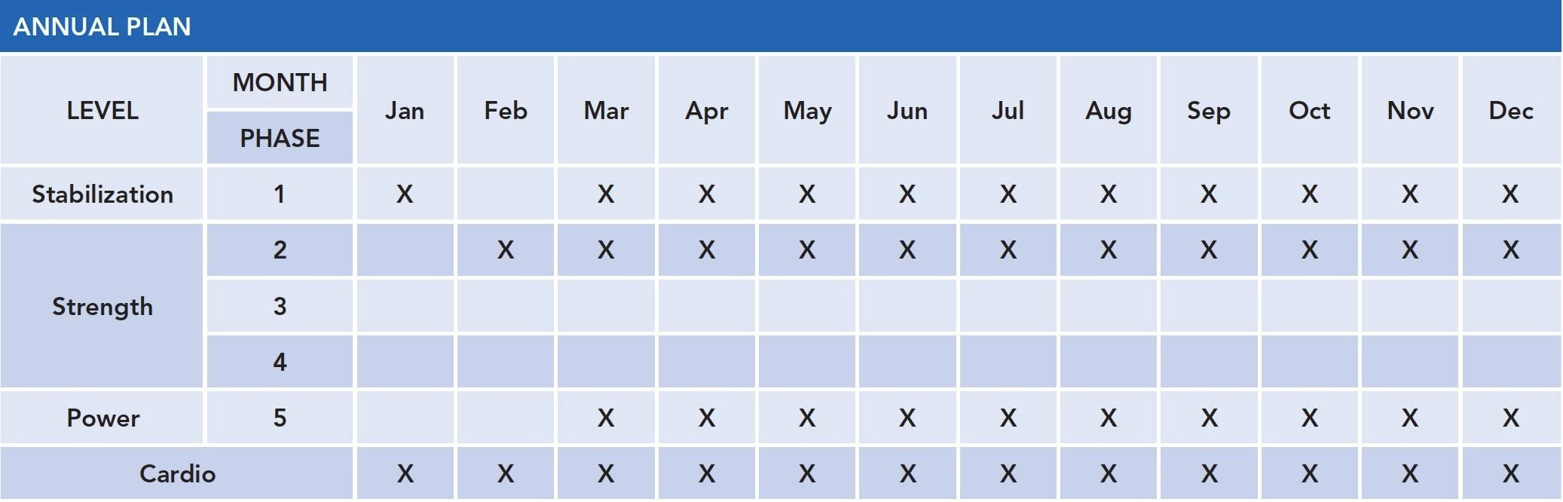

**Figure 21-21** Annual plan for the goal of general performance

The remainder of the annual plan shows the client cycling through Phases 1, 2, and 5. Phase 2 will promote greater overall strength endurance to prepare the client for the greater demands of Phase 5. As previously mentioned, Phase 4 can be used to increase the strength capacity of the client, but it is not vitally necessary for general performance, unless the client needs to express maximal strength capabilities. Phase 5 promotes increases in muscular strength and power, which is ideal for the expression of force in most sports.

From March on, Phases 1, 2, and 5 are used in the same month and week. Undulating periodization allows the client to train at various intensities during the course of a week, eliciting multiple adaptations once a certain level of fitness is achieved (Grgic et al., 2017). In this program, stabilization (Phase 1), strength (Phase 2), and power (Phase 5) are all being trained together. Cardio can be done on the workout days (or any other day during the week, depending on the client’s schedule). It is important not to perform high-intensity cardiorespiratory exercise the same day as a high-intensity OPT workout. Rather a high-intensity OPT workout (Phase 5) should be paired with a low-intensity cardio program. Conversely, a high-intensity cardio program should be paired with a low-intensity OPT workout (Phase 1).

Figure 21-22 illustrates the monthly plan for January. This plan demonstrates a 3-day-per-week workout plan with scheduled total-body workouts on Mondays, Wednesdays, and Fridays. Cardio can be done on the workout days (or any other day during the week, depending on the client’s schedule).

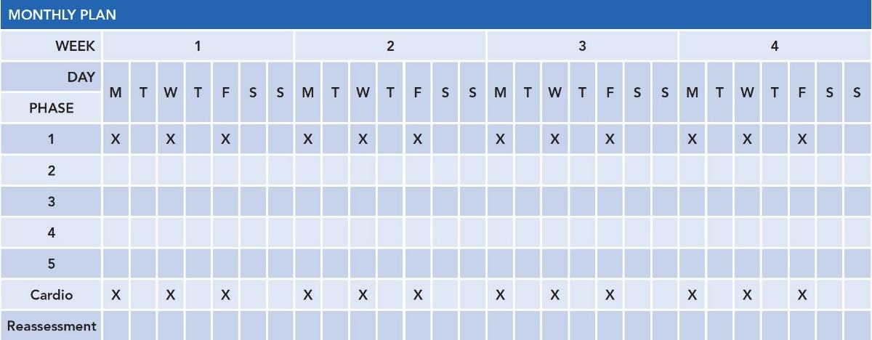

**Figure 21-22** General performance monthly plan: January

Figure 21-23 illustrates the monthly plan for February. As with the previous month, this plan demonstrates a 3-day-per-week workout plan with scheduled total-body workouts on Mondays, Wednesdays, and Fridays. This monthly plan could easily be four times per week with a split routine for the body parts. Cardio can be done on the workout days (or any other day during the week, depending on the client’s schedule).

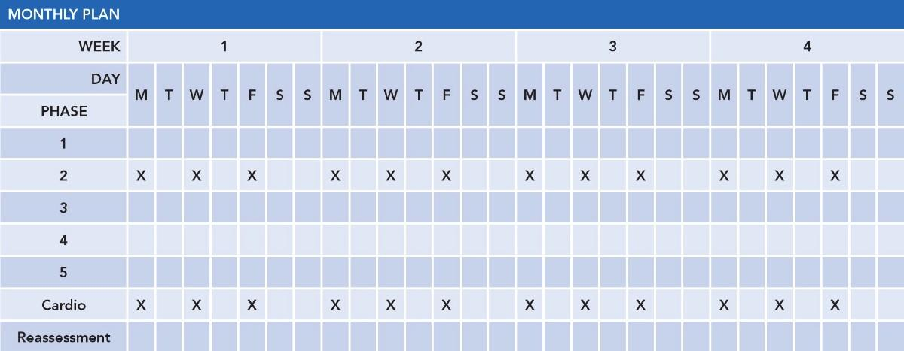

**Figure 21-23** General performance monthly plan: February

Figure 21-24 illustrates the monthly plan for March. As with the previous month, this plan demonstrates a 3-day-per-week workout plan with scheduled total-body workouts on Mondays, Wednesdays, and Fridays. In this month, however, Phases 1, 2, and 5 are performed in the same week. This helps introduce power training at a slower, more moderate pace with low weekly volumes while ensuring optimal levels of stabilization and strength necessary to increase power. Cardio can be done on the workout days (or any other day during the week, depending on the client’s schedule).

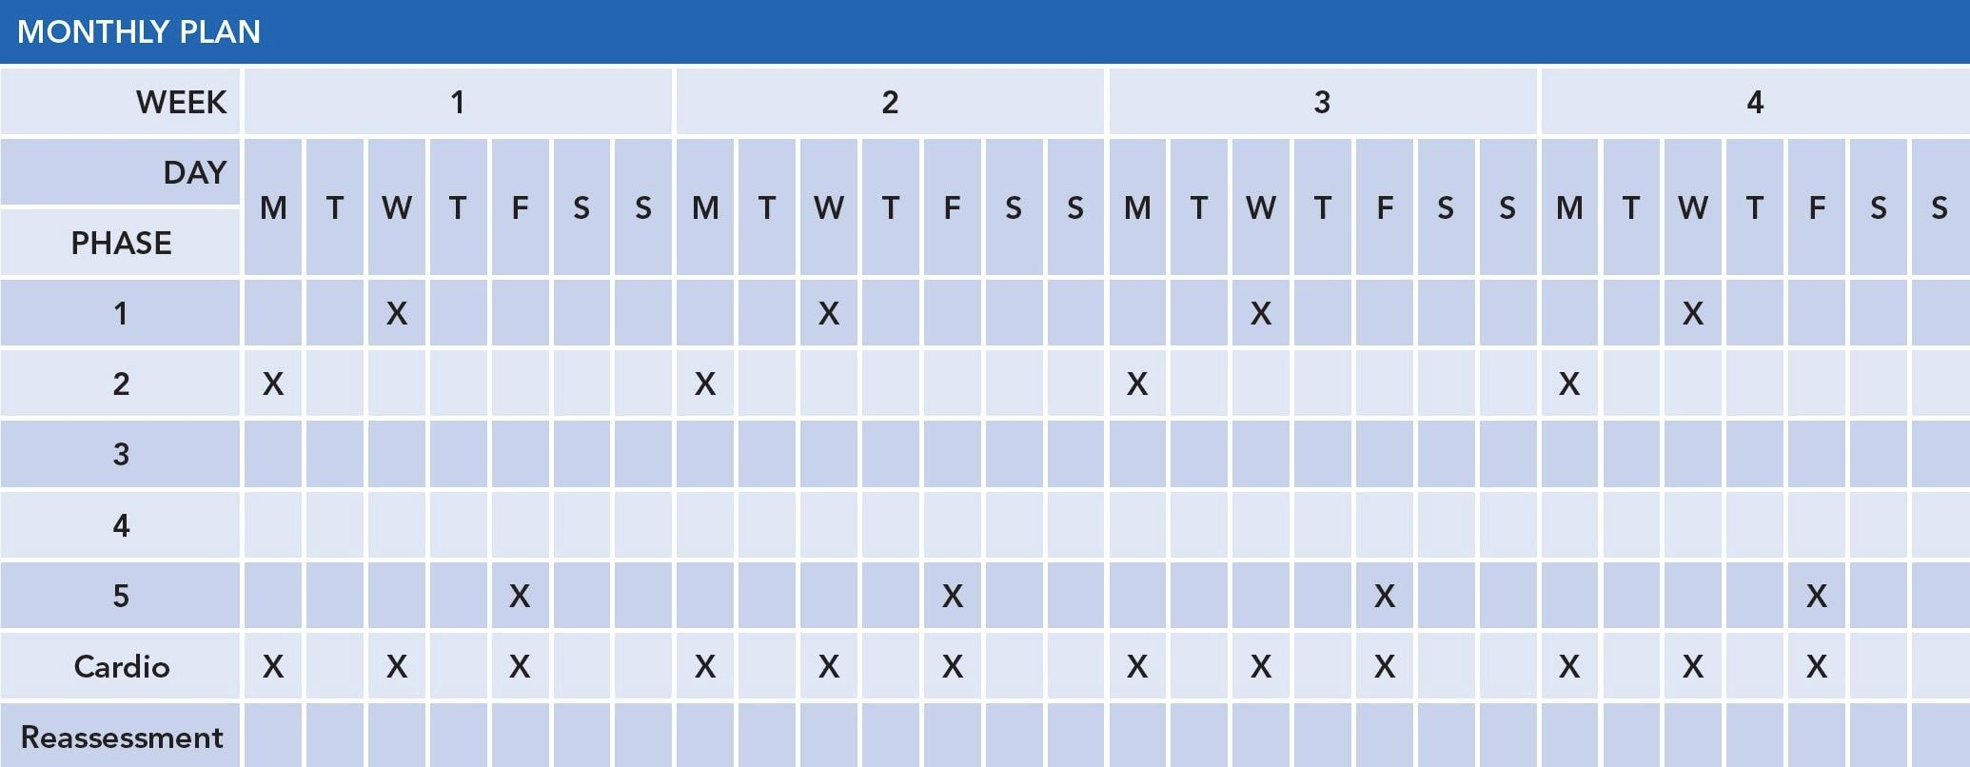

**Figure 21-24** General performance monthly plan: March

### Resistance training modalities

Certified Personal Trainers, their clients, and health club members are always searching for new or more effective ways to train and stay motivated. Thus, it is important for fitness professionals to learn how to effectively incorporate the use of various exercise training modalities to help clients stay motivated and achieve their personal health and fitness goals. There are a variety of resistance training modalities that can be used to develop strength. The most common form of resistance used in strength training programs is actual load in the form of free weights (e.g., dumbbells, barbells), body weight, selectorized machines, and cable apparatuses. Resistance can also come in the form of elasticity through the use of tubing and bands. This section presents foundational information on popular resistance training modalities, including their benefits and applications. A more detailed discussion of resistance training, including additional resistance training exercises, can be found in Chapter 20, Resistance Training Concepts.

**Risk versus Reward**

Over the past several years, fitness equipment manufacturers have assisted in the development of new fitness equipment and technological devices that allow for increased accountability and tracking. When used correctly, this has enabled fitness professionals to provide more relevant and effective coaching. While new fitness modalities can offer numerous benefits, some precautions must be addressed prior to introducing a new fitness modality into an exercise program. Safety and effectiveness must be top of mind when choosing the best training modalities to use and when to integrate them into a program.

It is the responsibility of the fitness professional to evaluate their client’s physical capabilities before introducing a new exercise modality or advanced forms of exercise. There are certain instances where the risk can outweigh the rewards:

1. Never compromise form over function.Regardless of the modality, sacrificing proper exercise technique is never recommended. Fitness professionals should only introduce new modalities or advanced forms of exercise after clients have exhibited competency in basic movement patterns.
2. Always use caution when training on an unstable surface. Balance exercises are an integral part of the Optimum Performance Training® (OPT™) model and should be introduced by Certified Personal Trainers to their clients. However, fitness professionals should take a slow and measured approach using balance modalities that are appropriate based on the client’s functional capabilities and goals. For example, lifting heavy weights as one tries to balance on a balance training device can be extremely dangerous and is not recommended. Balance exercises and modalities have been shown to improve balance, ankle stability, and coordination but, for safety reasons, should not be used to perform maximal or near maximal lifts (Brachman et al., 2017; Linens et al., 2016; Wortmann & Docherty, 2013). While there is an increase in the recruitment of stabilizing muscles of the joints and the core musculature, research has shown there are limited prime mover strength benefits to be found when lifting from an unstable surface (Cressey et al., 2007). Consequently, balance modalities should be reserved to improve balance, coordination, and joint stability rather than aiming to increase maximal strength or power.
3. Recognize limitations of fitness apps. Fitness apps are downloadable applications that can be used with most smartphones and are designed to help users obtain certain fitness goals. However, fitness trackers are not always 100% accurate (Evenson et al., 2015). This could lead to miscalculations of actual exercise effort and output and potentially lead to overexertion. Some fitness apps contain content that can be contraindicated for some individuals, especially if the client has suffered a past injury or is dealing with a chronic condition. Caution needs to be addressed so that gimmicky or dangerous movements are not attempted.

Thus, strength-training machines are commonly used by novice lifters to perform supersets and circuit-training workouts. Additionally, selectorized strength-training machines do not require the use of a spotter.

Although strength-training machines are sometimes less intimidating, they do have their share of disadvantages. Strength machines are thought of as inferior to free weights for improving core stability and muscular coordination because they offer artificial support versus using one’s core musculature to provide the stability (Stone et al., 2002; Vinstrup et al., 2015). Machines oftentimes fail to accommodate total-body movements that can incorporate the use of both the upper and lower extremities simultaneously (Stone et al., 2002). Moreover, not all strength-training machines are designed to fit all body types, which can limit the effectiveness of the exercise and possibly create more stress to joints. Lastly, selectorized strength-training machines primarily work in one plane of motion and can limit one’s ability to develop strength in all planes of motion (Saeterbakken & Fimland, 2012).

HELPFUL HINT

It is important for the Certified Personal Trainer to understand the limitations of selectorized strength-training machines when working with those who are obese, short, or very tall in stature or physically unable to properly use the equipment as intended.

During the initial stages of training, the use of selectorized strength-training machines by apparently healthy adults may be necessary to offer a less intimidating environment and to provide a strength-training option that meets their current physical capabilities. Eventually, through proper instruction and education, fitness professionals should strive to progress individuals into more proprioceptively enriched environments to improve joint mobility and stability and movement patterns. For example, a client may begin by using a machine to perform a shoulder press exercise during their initial week of training before progressing to using dumbbells to perform a seated shoulder press exercise and eventually a standing shoulder press (Figure 22-1).

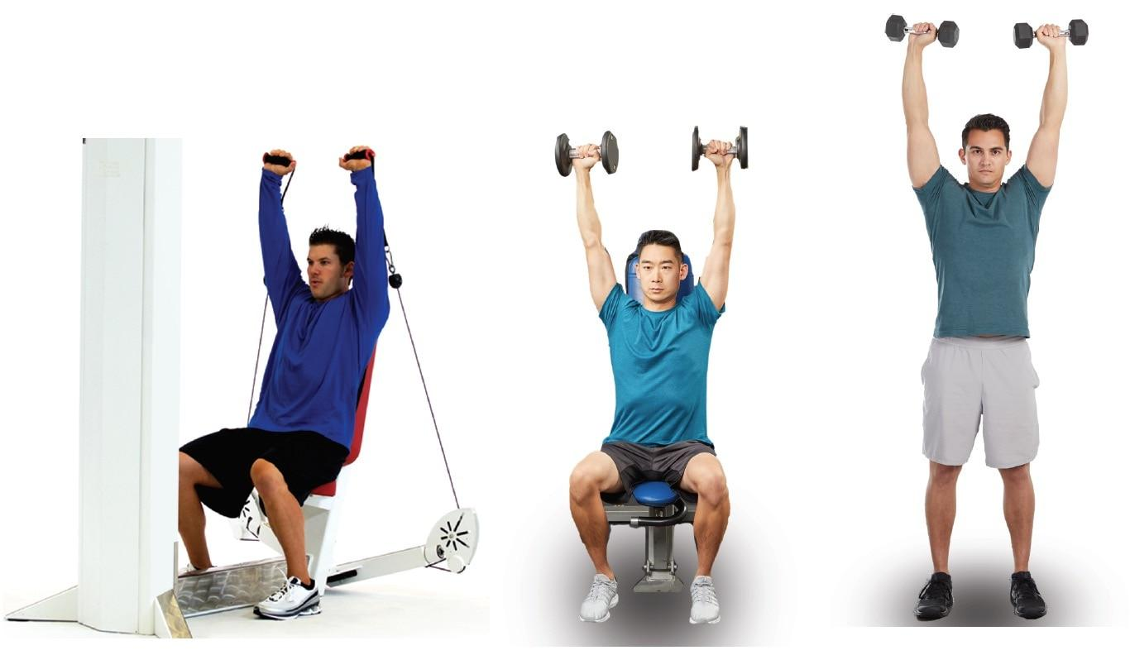

**Figure 22-1** Progression from shoulder press machine

TABLE 22-1 Pros and Cons of Strength Machines

| **Pros** | **Cons** |
| --- | --- |
| May be less intimidating for certain clients | Many machines do not allow the user to perform total-body exercises |
| Can emphasize certain muscle groups for rehabilitation or bodybuilding purposes | Moves primarily in one plane of motion |
| Various intensities (load) provided in one weight stack | Does little to provide challenge to the core stabilization system |
| Does not require a spotter | May not be ideal for improving athletic performance |
| Provides extra support for clients with special needs | Machines do not fit all body types (short, tall, or obese clients may have a hard time adjusting the machine) |
| Keeps the client in a fixed plane of motion, which may limit excessive ranges of motion | Expensive in comparison to other strength-training modalities |

The use of dumbbells requires the individual to stabilize through their core muscles, as well as create greater demand on shoulder stability to handle the load. It is vital that the exercise modality used be specific to the client’s goals, needs, and abilities. The pros and cons of selectorized strength-training machines are illustrated in Table 22-1. Because strength-training machines can be used for many goals and by varied populations, they can be effectively used in all exercise programs and phases of the OPT model.

**Free Weights (Barbells and Dumbbells)**

Free weights, such as dumbbells and barbells, can be used by a variety of populations to meet fitness, wellness, and sports performance goals. Free weights allow individuals to perform exercises in all planes of motion (i.e., sagittal, frontal, transverse) with various degrees of ranges of motion consistent with those experienced in daily life and sport. Combining all of these motions enhances motor learning and improves muscular coordination and performance (Saeterbakken & Fimland, 2012). Moreover, many free-weight exercises can be easily progressed to provide greater demands on core stability and proprioception by progressing from bilateral to unilateral movements. For example, the dumbbell chest press exercise can be progressed from two arms, to alternating arms, to one arm, providing great variety in one exercise (Figure 22-2). Free-weight exercises also allow clients to perform multijoint (complex) movements incorporating the entire body. Performing complex exercises requires more energy, enabling individuals to expend more calories in a shorter period (Viana et al., 2019). This is ideal for individuals seeking alterations in body composition, such as fat loss.

Although free weights can offer many benefits, such as improving postural stability, strength, and muscle size and power, they can be potentially dangerous for novice exercisers until proper exercise technique, namely, control and stability, is mastered. If certain exercises are too difficult to perform using free weights, one may need to regress to a strength-training machine until baseline levels of strength and coordination are met. After this period, free-weight exercises can be reintroduced into the exercise program to further enhance stability, strength, and power. In addition, many free-weight exercises, especially overhead lifts, often require a spotter to ensure proper exercise technique and safety.

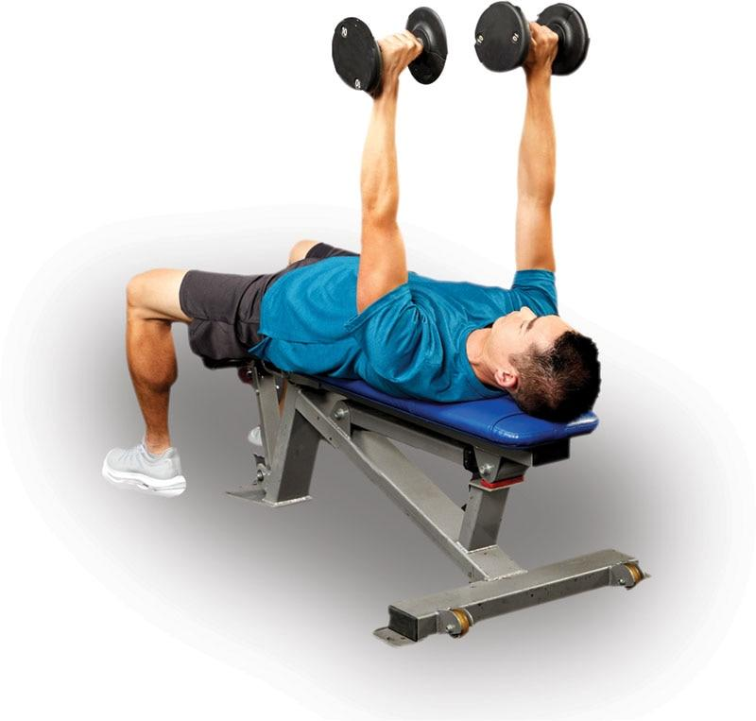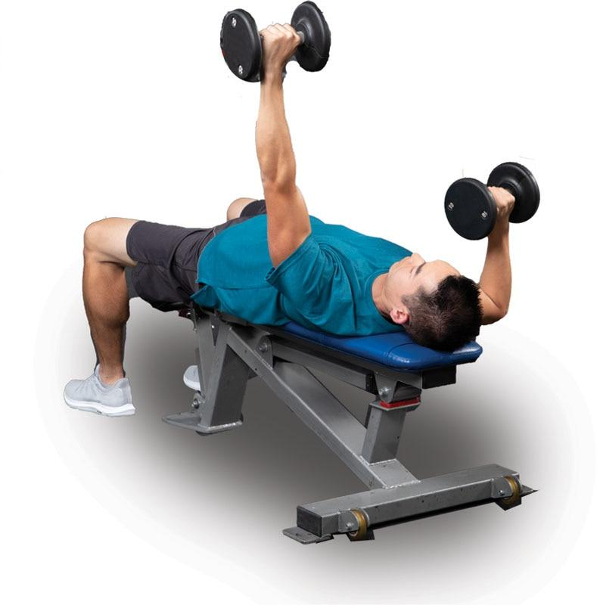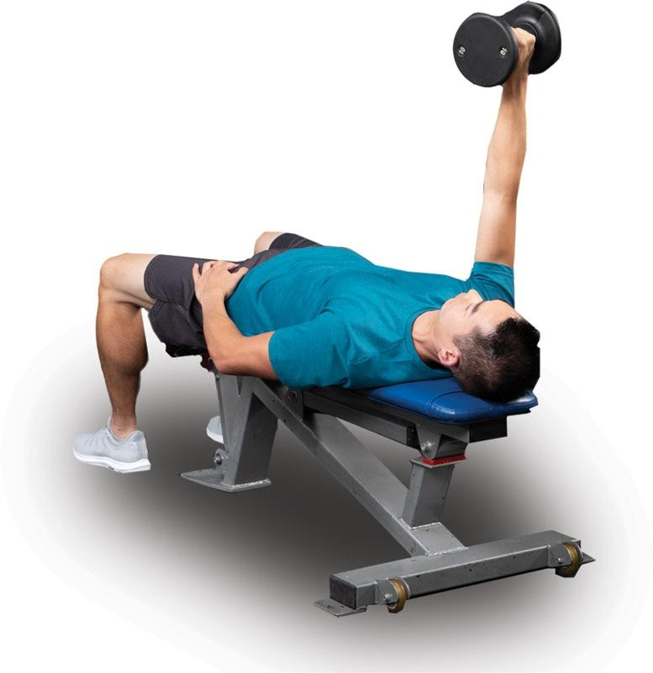

**Figure 22-2** Dumbbell chest press progression

TABLE 22-2 Pros and Cons of Free Weights

| **Pros** | **Cons** |
| --- | --- |
| Can be used to emphasize certain muscle groups or target multiple muscle groups | May require a spotter |
| Can improve athletic performance | May be too difficult for beginning clients to perform until exercise technique is mastered |
| Can challenge the core stabilization system | Requires multiple dumbbells or barbells to change intensity (load) |
| May improve dynamic joint stabilization and proprioception | Potentially more dangerous |
| Allows individuals to move in multiple planes of motion | Intimidating for certain individuals |

The pros and cons of free weights are illustrated in Table 22-2. Because free weights can be used in a variety of fashions, for many goals, and by virtually all populations, they can be effectively used in all phases of the OPT model.

**Cable Machines**

Cable machines offer a variety of fitness and sports performance benefits in that they allow similar freedom of movement as free weights yet provide similar security as strength training machines because they do not require a spotter. Cable machines can be adapted to offer resistance for all body parts and are effective for developing stability, muscular endurance, hypertrophy (increased muscle size), strength, and power. Studies have also shown that cable machines can provide greater ranges of motion when compared to selectorized strength equipment (Signorile et al., 2017). Cable machines are also an excellent option to challenge the core while having individuals perform exercises in a standing position versus seated as seen in many machine exercises, and they have proven beneficial for older adults (Balachandran et al., 2016).

When using a cable machine, it is important to align the angle of resistance (line of pull) of the cable with the line of pull of the muscle being worked. Remember that joint motion is caused by muscles pulling on bones; muscles cannot actively push.

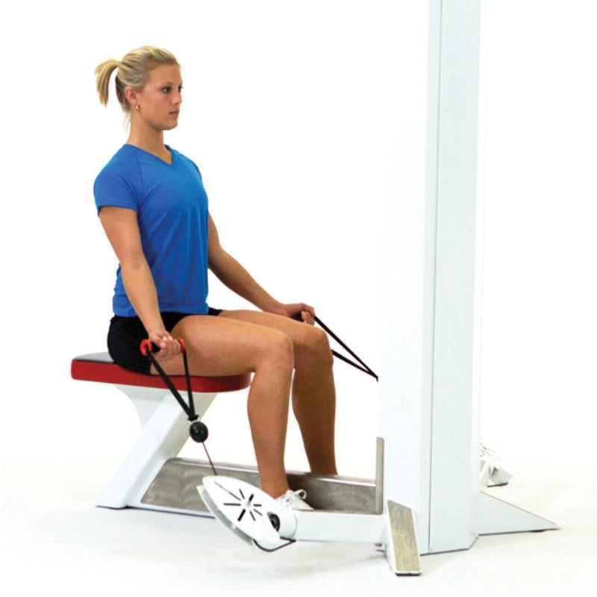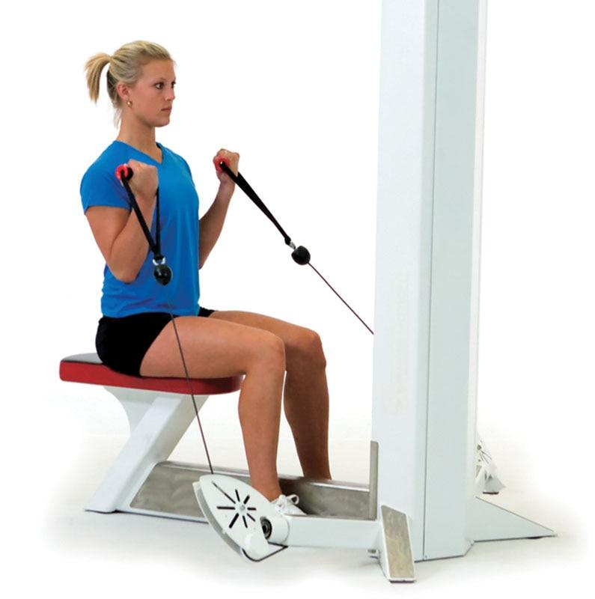

**Figure 22-3** Cable biceps curl

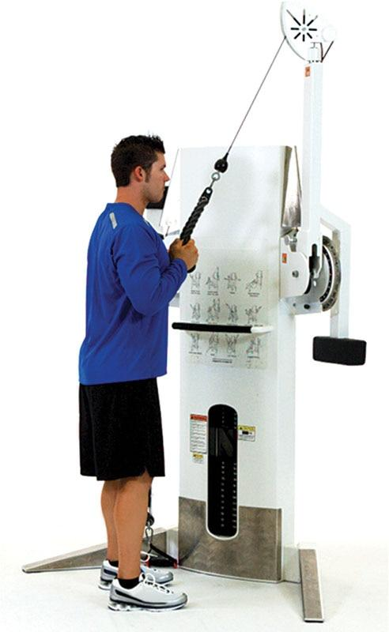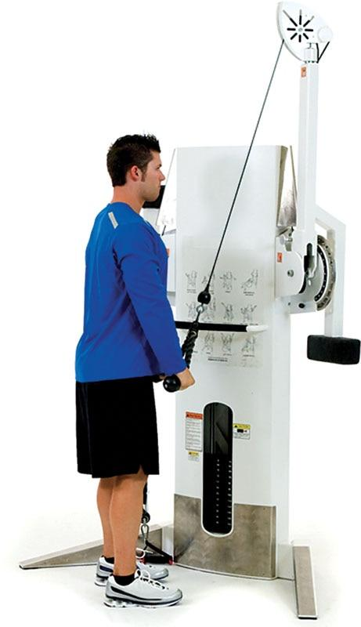

**Figure 22-4** Standing triceps extension

Therefore, each cable exercise must match the muscle’s natural line of pull. For example, when performing a biceps curl (elbow flexion), the cable should be positioned to offer resistance in a vertical motion against elbow flexion (pulling the elbow into extension) (Figure 22-3). However, with a standing triceps extension exercise (Figure 22-4), the resistance must be placed in such a way to resist elbow extension (pulling the elbow into flexion). During a standing cable row that requires shoulder extension and scapular retraction, the resistance should be positioned to pull the shoulders into flexion and scapular protraction (Figure 22-5). During the standing cable chest press (shoulder horizontal adduction), the resistance should be positioned to pull the shoulders into horizontal abduction (Figure 22-6).

Because cable machines can be used in a variety of fashions similar to free weights and by virtually all populations, they can be effectively used in all phases of the OPT model.

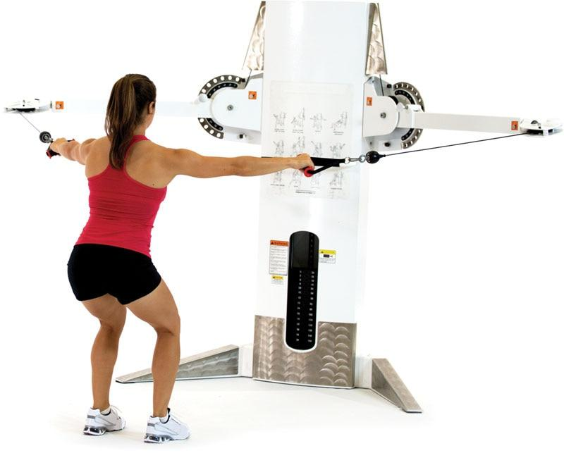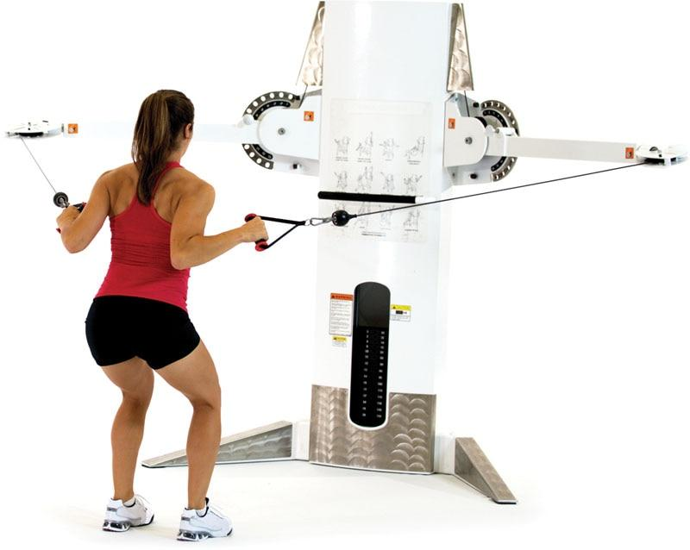

**Figure 22- 5**Standing cable row

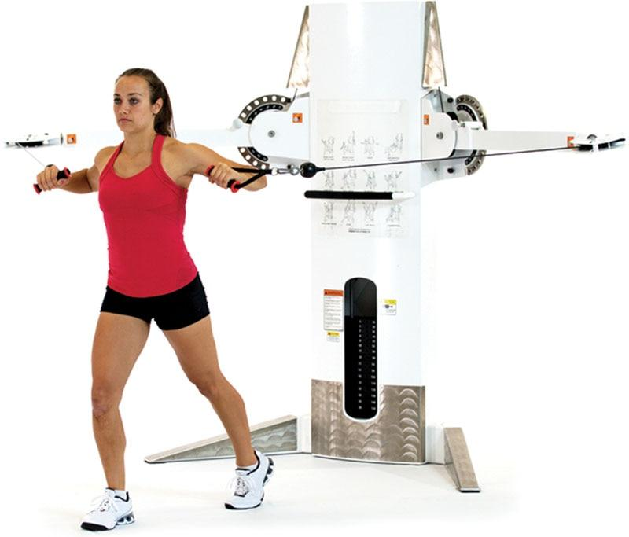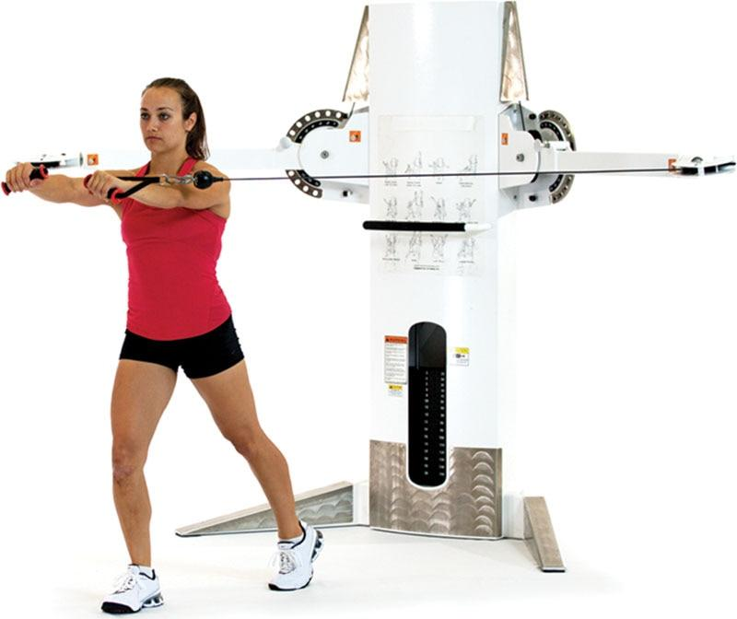

**Figure 22-6** Standing cable chest press

**Elastic resistance**

Elastic resistance training is an inexpensive alternative to free weights or machines. Various forms of elastic resistance training can be used to help improve coordination, muscular endurance, and joint stabilization. Elastic resistance training may not be ideal for improving maximal strength or muscular hypertrophy, but it has been shown to be very beneficial to help improve muscular strength and endurance for fitness and rehabilitative purposes (Andersen et al., 2010; Colado et al., 2010).

Elastic resistance training techniques allow clients to move in multiple planes of motion and oftentimes achieve a greater ROM during training than using selectorized strength-training machines. Clients can also adjust the line of pull by moving the fixed point higher or lower and combine several exercises seamlessly. Elastic bands and tubing also allow clients to perform resistance exercises that mimic sport-specific movements, such as a golf swing or tennis forehand.

Elastic bands come in a variety of colors, shapes, and thicknesses. A color-coding system is used to identify differences in the thickness of rubber and thus the resistance of elastic tubing and bands. Elastic resistance works like a rubber band—the greater the thickness of the tubing, the more resistant it will be to stretch, thus greater force will be required to stretch it. Rarely should the elastic band be stretched longer than 250% of its resting length (Page & Ellenbecker, 2003). If the resistance provided by the elastic band is not enough, then the individual will need to progress to either a thicker band or use two pieces of tubing of the same medium resistance. It is important to note that thicker tubing will reach its elastic limit sooner in the movement than thinner or medium thickness tubing. This can affect one’s ability to perform the movement in a full range of motion. This may also cause too much stress at certain joint positions. Thus, in some cases, using two pieces of medium resistance may be a better solution as a progression.

One of the problems with elastic tubing or bands is that the resistance in rubber changes as it is being stretched through a full range of motion. For example, the amount of resistance from the start of a tubing biceps curl compared with the end of a tubing biceps curl can vary significantly, meaning the resistance is not constant (Figure 22-7). The mechanical stretch properties of elastic tubing vary according to its thickness, age, how often it is used, and how quickly the rubber is stretched. Consequently, it is difficult to know the exact resistance of each elastic tube or band used. Although precise quantification of resistance using color-coded bands is not possible in a fitness setting, research studies have accurately developed linear equations to predict force at different stages of elongation (Thomas et al., 2005). It should be noted that each manufacturer of elastic tubing and bands uses different color-coding systems, so it is important to review the color-coding system when using different brands of elastic resistance training equipment to ensure the correct resistance is selected. It should also be noted that studies have shown that there are inconsistencies in band tension from manufacturer to manufacturer (Fuentes et al., 2019).

Because elastic resistance is so versatile, fitness professionals frequently use elastic resistance with their clients in a variety of settings, including health clubs, boot camps, athletic performance centers, and rehabilitation clinics.

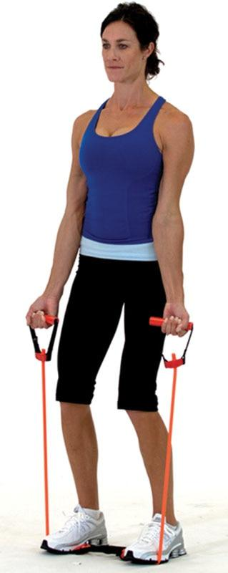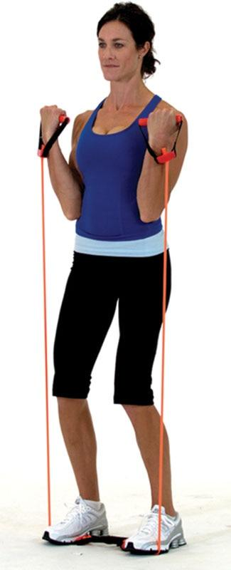

**Figure 22-7** Tubing biceps curl

In addition to its versatility, one of the greatest advantages of elastic resistance over free weights is its low cost and portability. Elastic resistance bands are lightweight and can be taken anywhere. For example, traveling business people, vacationers, and in-home personal trainers can all benefit from the rewards elastic resistance offers.

Elastic resistance can be used in a variety of fashions, by virtually all populations, and effectively in all phases of the OPT model. However, as stated earlier, elastic resistance may not be the ideal modality when performing resistance training exercises for individuals seeking hypertrophy or maximal strength because high intensities (heavy loads) are required to overload the musculoskeletal system. In Phase 5 of the OPT model, elastic tubing can provide resistance during power exercises requiring explosive movement, such as a tubing speed squat (Figure 22-8).

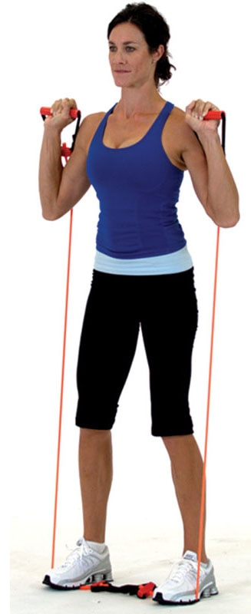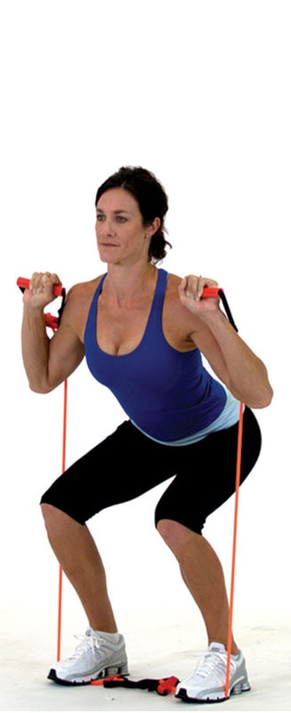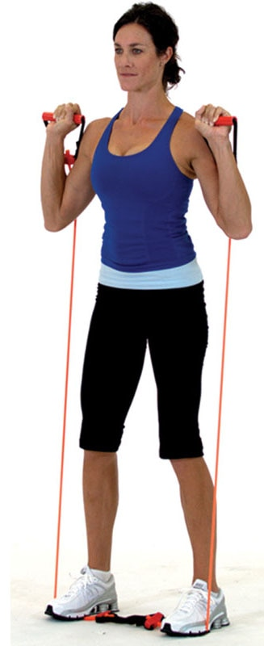

**Figure 22-8** Tubing speed squat

CRITICAL

Because elastic bands can break, potentially causing injury to both the fitness professional or their client, it is imperative to check all bands prior to each workout to ensure there are no cracks, tears, or excessive wear areas on the bands. Never use a questionable band regardless of the exercise.

**TRX Rip Trainer**

The TRX® Rip Trainer is another form of resistance band training but uses a lever bar that is attached to one end of a nylon-covered resistance band (Figure 22-9). Like elastic bands, the TRX Rip Trainer has various resistance levels. Lighter cords equate to less resistance, whereas heavier cords offer greater resistance. The ability to modify band resistance while training with the TRX Rip Trainer makes it a versatile tool for both novice and experienced fitness enthusiasts or athletes.

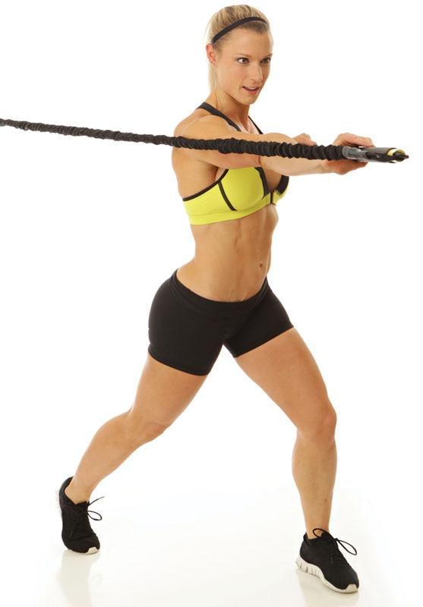

**Figure 22-9** TRX Rip Trainer

This form of resistance is designed to engage the core by integrating torso rotational movements and antirotational exercises, via asymmetrical resistance loading. Training in this manner has been shown to be beneficial to strengthen the core, balance, stability, power, and coordination (Kibler et al., 2006).

Rotational movements involve a controlled twisting motion of the torso that targets several muscles of the core, including (but not limited to) the internal obliques, external obliques, and hip rotators. Conversely antirotational exercises are performed from a stationary trunk position. These exercises target the deep muscles of the core and stabilize the lumbar spine and are often unilateral in nature.

As with any other modality, proper form should never be compromised, especially when using external load resistance. Similar to elastic bands and tubing, the TRX Rip Trainer can be used in all phases of the OPT model, but it may not be the ideal modality when heavy loads are required.

GETTING TECHNICAL

The thoracic spine, not the lumbar spine, is where most trunk rotation should take place. The overall range of motion of the lumbar spine is about 12–13 degrees in a healthy individual, whereas the thoracic spine has a range of motion of nearly 70 degrees of rotation, 35 degrees in each direction (Johnson et al., 2012).

**Medicine balls**

Medicine balls are weighted balls that come in an assortment of weights and sizes, and they are made with a variety of materials. They are one of the oldest means of resistance training dating back to the Greeks and Egyptians nearly 3,000 years ago. The name *medicine ball* came from early use by physicians who used them in the rehabilitation process.

For hundreds of years, medicine balls have been considered one of the Four Horsemen of Fitness next to the Indian club, the dumbbell, and the wand (Jespersen & Potvin, 2002). Medicine balls are still popular today because they can be thrown, caught, and used to provide resistance for a variety of movements, in a variety of planes of motion, and at a variety of velocities. Medicine balls can be used like any other resistance implement to add load, such as the medicine ball squat (Figure 22-10), or instability to an exercise, such as the medicine ball push-up (Figure 22-11).

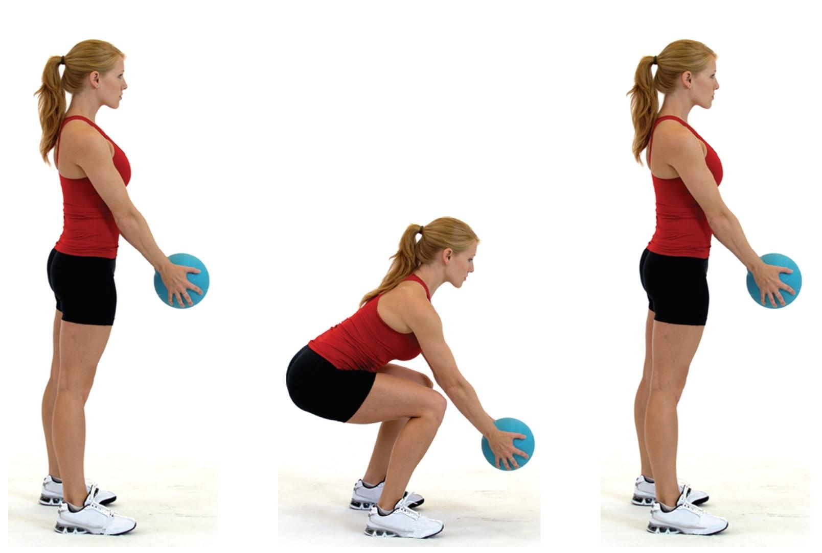

**Figure 22-10** Medicine ball squat

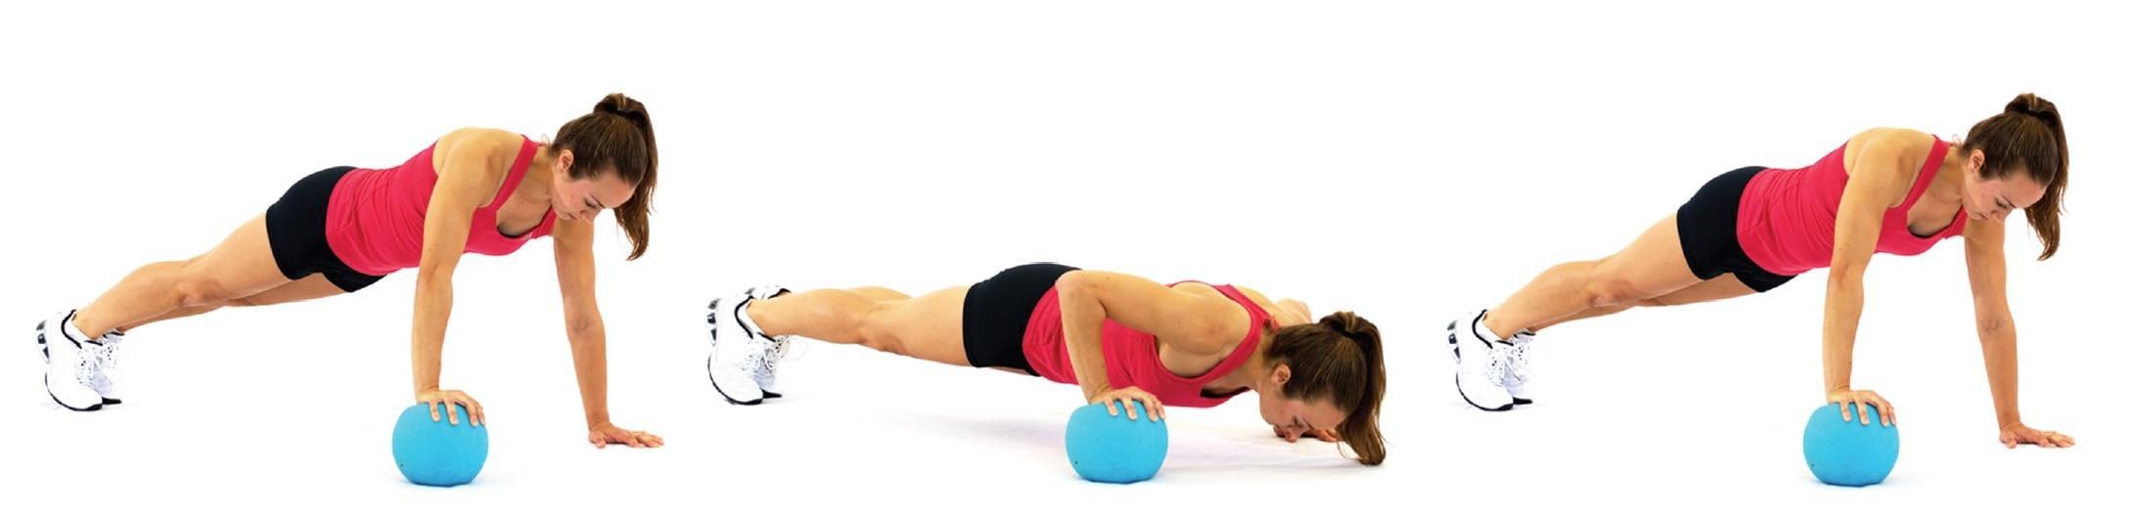

**Figure 22-11** Medicine ball push-up

Medicine balls can be used with a variety of populations as part of a program to increase muscular strength, endurance, and power or, in some cases, to help rehabilitate from injury (Faigenbaum & Mediate, 2006, 2008). Personal training clients enjoy the versatility of medicine balls, whereas athletes often benefit from the dynamic power opportunities afforded by their ability to be thrown and caught. The ability to develop explosive power is one of the unique benefits of training with medicine balls because velocity of movement is critical to developing power.

In an ideal training environment, maximal movement velocity should be attained to increase power capabilities, particularly for sports performance (Hermassi et al., 2015; Ignjatovic et al., 2012). The medicine ball is a very useful modality because it allows movements to occur as explosively as possible without the need for eccentric deceleration. For example, when performing a kneeling medicine ball chest pass, a client can release the medicine ball at the end of the movement, thus allowing for full concentric power development (Figure 22-12). Most free-weight exercises performed in an explosive fashion, such as a speed bench press, require the individual to decelerate the load near the end of the movement to avoid throwing the weight through the air. This does not allow for full expression of power through the entire range of motion. Explosive medicine ball movements in conjunction with resistance training have been found effective in improving movement velocity and other factors influencing sports performance (Fletcher & Hartwell, 2004; Ignjatovic et al., 2012; Szymanski et al., 2007).

When using medicine balls for their explosive power capabilities, it is important to assess their intended use and choose one that safely and effectively accomplishes the desired goal. Medicine balls can be made of hard rubber, leather, or other leather-like materials. They often weigh between 1 lb and 30 lb (0.4–14 kg). High-velocity movements will require a lighter ball, generally less than 10% of an individual’s body weight. Rubber medicine balls are best used for rebounding activities, such as bouncing or throwing the ball against a wall. It is important for fitness professionals to assess their client, training environment, and their own level of expertise with medicine ball training before implementing programs in which medicine balls are thrown and caught.

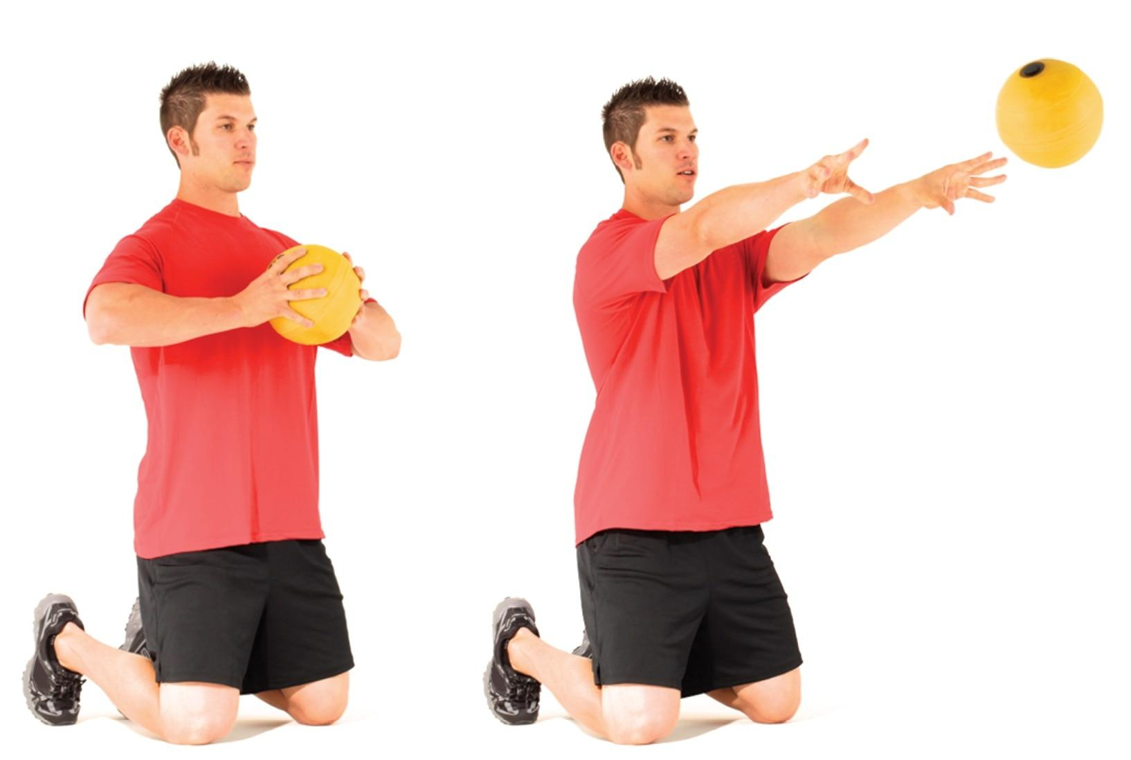

**Figure 22-12** Kneeling medicine ball chest pass

**Kettlebell training**

A kettlebell is a flat-bottomed cast iron ball with a handle. It was first used as a unit of measurement on market and farming scales and later used in the Russian military for conditioning and strength. The giyra, Russian for kettlebell, ranges from very low weight (e.g., 5 lb), to competition style weight, more than 140 lb (64 kg), and higher weights exist. A kettlebell differs from a dumbbell, barbell, or medicine ball in that the center of mass is away from the handle, which may require more strength and coordination, as well as increased recruitment from stabilizers and prime movers simultaneously during particular movements. This is especially true of swing-type movements, the foundation for all kettlebell training (Figure 22-13). Whether using a two-handed, single-arm, hand-to-hand grip or release-and-catch movement, the variety of positions and movement options allows for increased skill, coordination, strength, and power. All variations permit the user to transform dynamic force reduction into powerful force production for a fun, challenging, and effective workout.

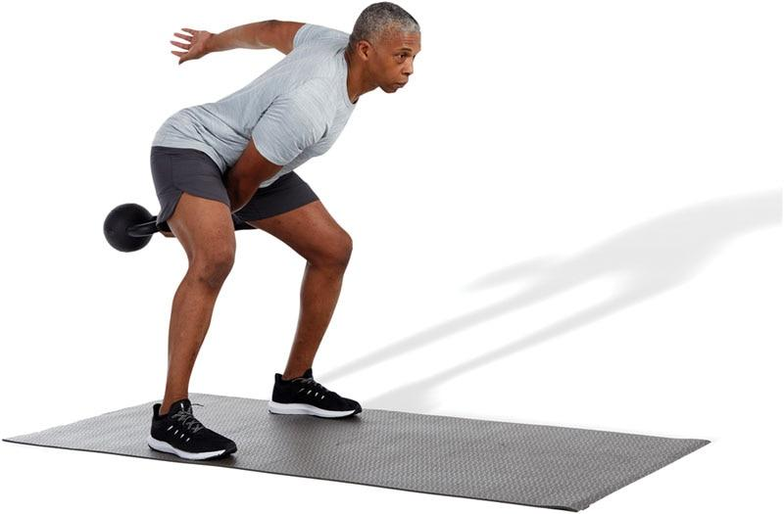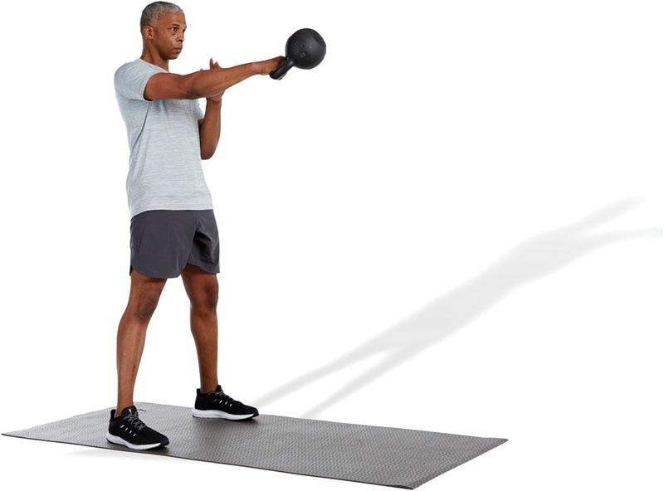

**Figure 22-13** Single-arm kettlebell swing

Benefits of kettlebell training

The benefits of kettlebell training are numerous and applicable for individuals who wish to increase all aspects of health and fitness and for professional and Olympic athletes. Such benefits include the following:

1. Enhanced athleticism, coordination, and balance
2. Increased mental focus and physical stamina
3. Increased oxygen uptake
4. Increased total body conditioning versus isolation training
5. Recruitment of the posterior chain (calves, hamstring complex, gluteal muscles, spinal erectors)
6. Increased core stability and muscular endurance
7. Increased strength and power
8. Improved grip strength
9. Increased metabolic demands and caloric expenditure (Chen et al., 2018; Falatic et al., 2015; Manocchia et al., 2010).

STRETCH YOUR KNOWLEDGE

The high metabolic cost of throwing, catching, decelerating, and accelerating kettlebells can develop unprecedented stamina. By working many fitness components at the same time, workout demands are intensely increased, equating to further caloric expenditure. This cardiovascular demand can be felt during the foundational swing exercise (Vancini et al., 2019).

Kettlebell program design strategies

As with any training method, proper form and technique must be mastered to avoid injury. The skill required for kettlebell training requires meticulous focused practice, starting with instruction from a qualified kettlebell instructor. Most kettlebell exercises incorporate multiple joint motions and muscle groups, from stabilizers to prime movers, that build both muscular endurance and mental fortitude. Without inward focus and conscious attention to technique, injury may occur, thus, honing all skills with exquisite technique per exercise is mandatory. The emphasis on the posterior chain, working from the ground up and keeping perfect form throughout each repetition, must take priority. Practicing appropriate skills of gluteal and latissimus dorsi contraction along with abdominal hollowing and bracing must be continued and progressed carefully. Because one must be qualified to perform many kettlebell movements, this modality might not be appropriate for all populations.

Moreover—as with all exercises—quality should always come before quantity or weight progression, and the five kinetic chain checkpoints should be monitored (Figure 22-14):

1. *Feet*: approximately shoulders-width apart and pointing straight ahead (when appropriate, depending on the exercise)
2. *Knees*: in line with the second and third toes (avoid valgus or varus motions)
3. *Hips*: level with lumbar spine in a neutral position
4. *Shoulders*: neutral position or depressed and slightly retracted to activate scapulae stabilizers (depending on the exercise)
5. *Head*: cervical spine in a neutral position (chin tuck)

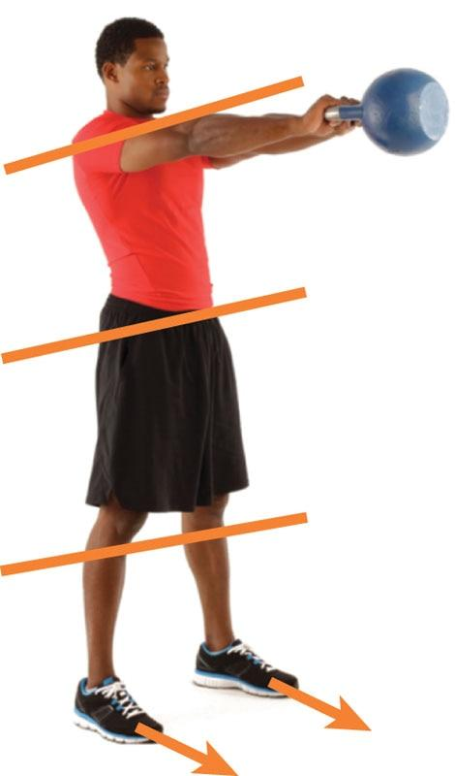

**Figure 22-14** Kettlebell five kinetic chain checkpoints

Additional guidelines for further safety and proper form include using a good quality chalk to protect the hands, having plenty of space available with rubber flooring or using an outdoor area, and excluding the use of gloves.

Kettlebells can be effectively integrated into all phases of the OPT model. For example, the renegade row is a kettlebell exercise that can be used in Phase 1 to improve stability and back strength (Figure 22-15). In Phase 2, a client can superset a seated cable row with a renegade row (Figure 22-16). In Phase 5, a client may superset a squat to overhead press with a kettlebell snatch (Figure 22-17).

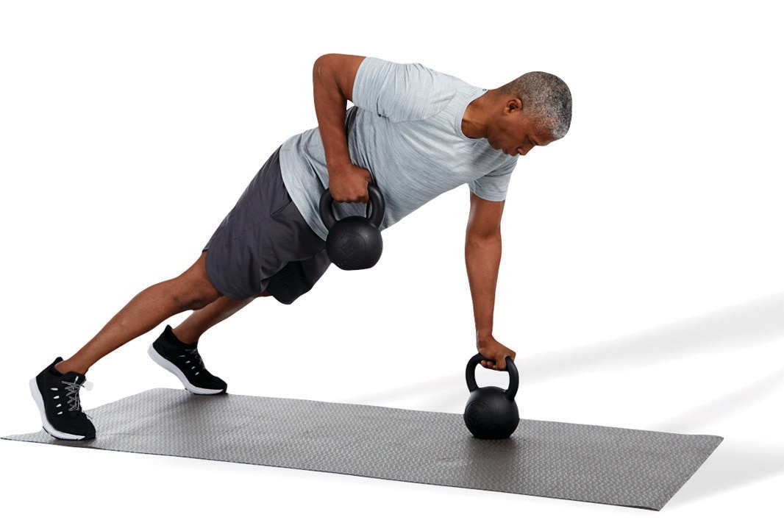

**Figure 22-15** Kettlebell renegade row

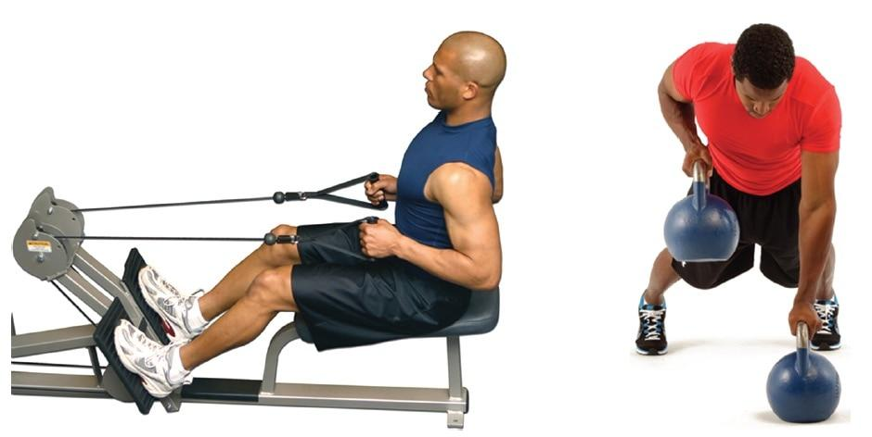

**Figure 22-16** Cable row superset with kettlebell renegade row

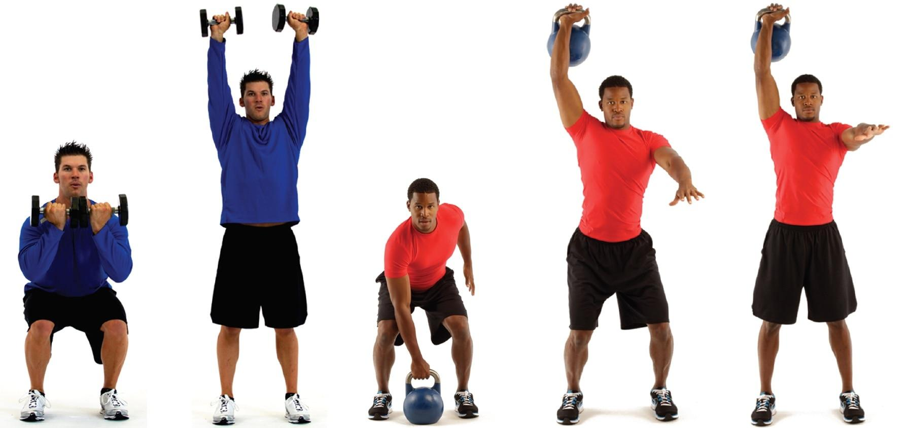

**Figure 22-17** Squat to overhead press superset with kettlebell snatch

**Bodyweight training**

Bodyweight exercises use an individual’s own body weight along with gravity to provide resistance for the movement. These exercises that do not require an additional load, such as dumbbells, or strength-training machines. Common bodyweight strength exercises include push-ups, pull-ups, bodyweight squats, and sit-ups. Bodyweight exercises are often used for core, balance, and plyometric training as well (see Chapters 16–18).

By performing bodyweight training exercises, individuals can learn how to train in all planes of motion and may acquire greater kinesthetic awareness. This is partially true because most bodyweight training exercises are closed-chain exercises. Closed-chain exercises may result in greater muscle activation when compared with open-chain exercises (Augustsson et al., 1998; Brindle et al., 2002; Pozzi et al., 2019). Moreover, bodyweight training makes workouts portable, an added benefit for people who travel frequently or for those who do not enjoy the health club environment.

STRETCH YOUR KNOWLEDGE

Closed-chain exercises involve movements in which the distal extremities (hands or feet) are in a constant fixed position, and the force applied by an individual is not great enough to overcome the resistance (such as the ground or an immovable object). Examples of closed-chain exercises include push-ups, pull-ups, and squats.

Open-chain exercises involve movements in which the distal extremities are not in a fixed position, and the force applied by the body is great enough to overcome the resistance (such as barbells or dumbbells). Examples of open-chain exercises include the bench press, lat pulldown, and the machine leg extension exercise.

**Suspended bodyweight training**

Suspended bodyweight training is an innovative approach to bodyweight fitness training that uses a system of ropes and webbing allowing the user to work against their own body weight while performing various exercises. Suspended bodyweight trainers are a unique concept in that they allow fitness professionals to modify exercises to meet the needs of virtually any client. Suspension movements are distinguished from traditional exercises in that either the user’s hands or feet are supported by a single anchor point, while the opposite end of the body is in contact with the ground, enabling the loading and unloading of movements to meet individual needs and goals (Figure 22-18). They permit individuals to manipulate body position and stability to provide multiplanar, multijoint exercises in a proprioceptively enriched environment (Gaedtke & Morat, 2015).

Some of the physiologic benefits that come with suspended bodyweight training include:

1. Increased core muscle activation
2. Low compressive loads to the spine
3. Increased balance
4. Potential increase in caloric expenditure
5. Increased flexibility and joint mobility (Cugliari & Boccia, 2017; Dudgeon et al., 2010; Mok et al., 2015; Scheett et al., 2010)

When the Certified Personal Trainer is properly educated on how to safely set up and instruct clients, suspended bodyweight exercises become a powerful way to teach proper movement patterns, enhance stability and core strength, and gain metabolic benefits.

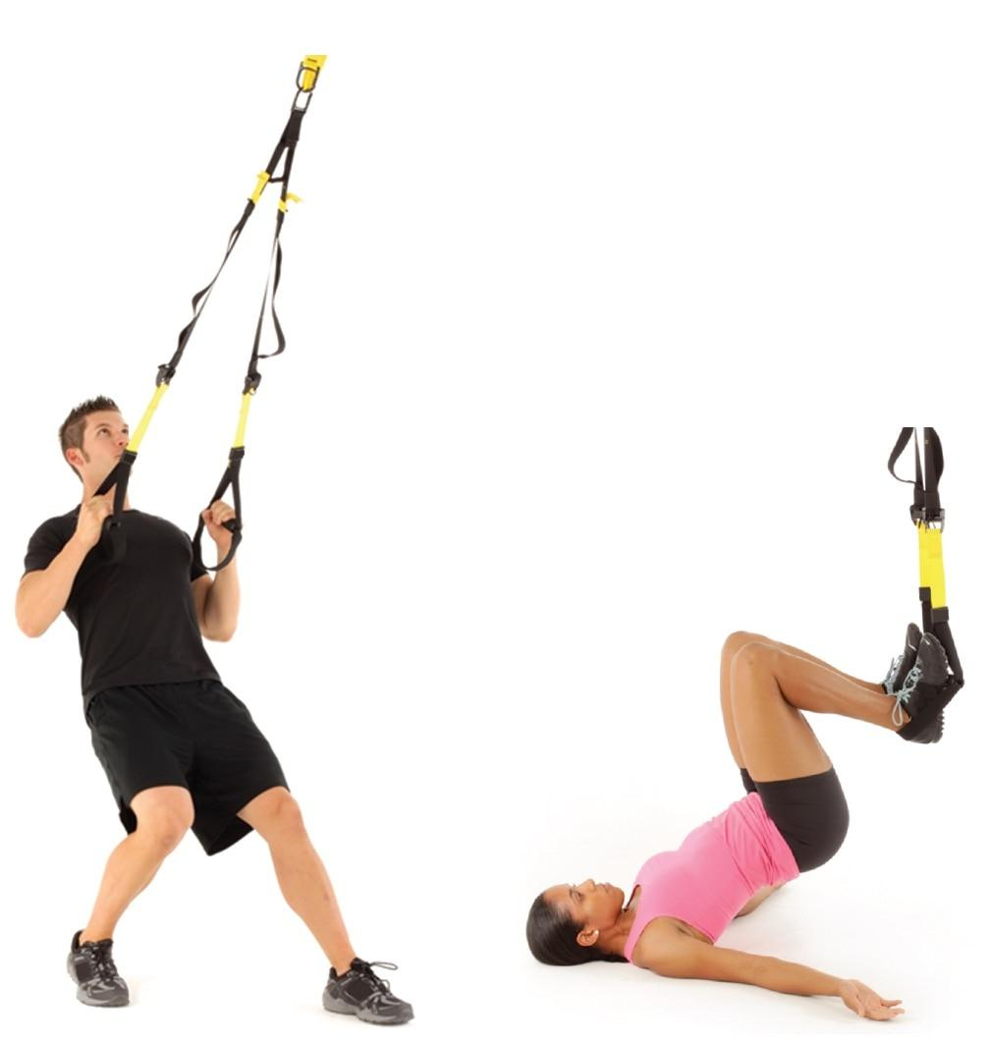

**Figure 22-18** TRX suspension trainer

Because of the stabilization requirements of the mode of training, suspended bodyweight exercises are ideal in Phases 1 and 2 of the OPT model, but they can be integrated in all phases, especially during core and balance training. For example, in Phase 1 Stabilization Endurance Training, a client may use suspended push-ups as a chest exercise (Figure 22-19). In Phase 2 Strength Endurance Training, clients may superset this same exercise after performing a barbell bench press (Figure 22-20).

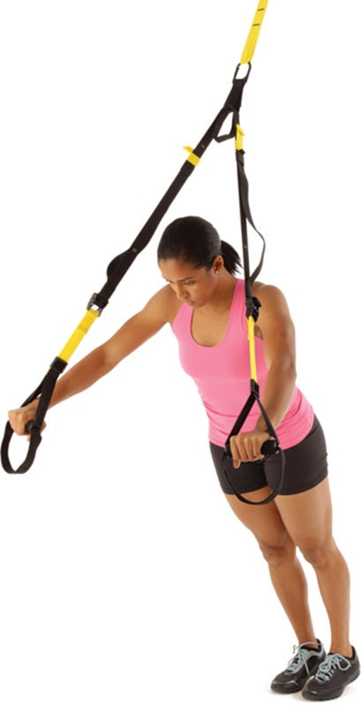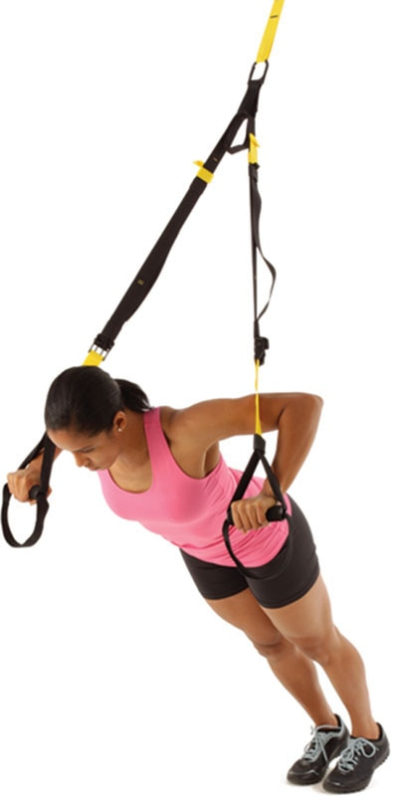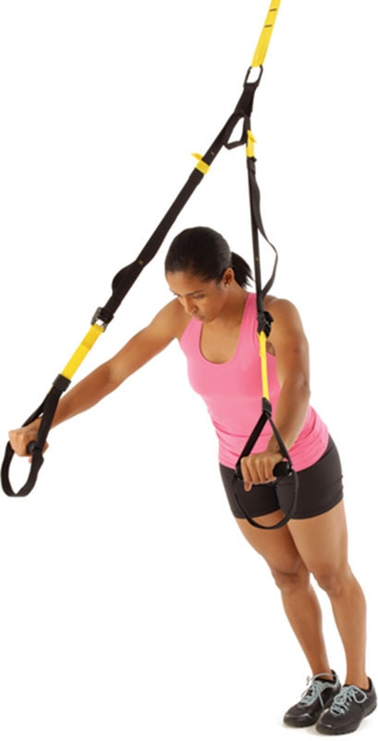

**Figure 22-19** TRX suspension push-up

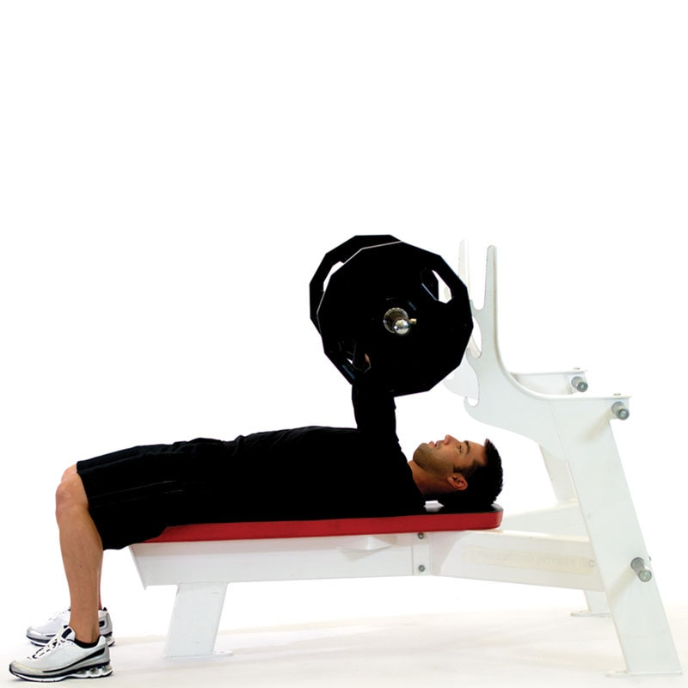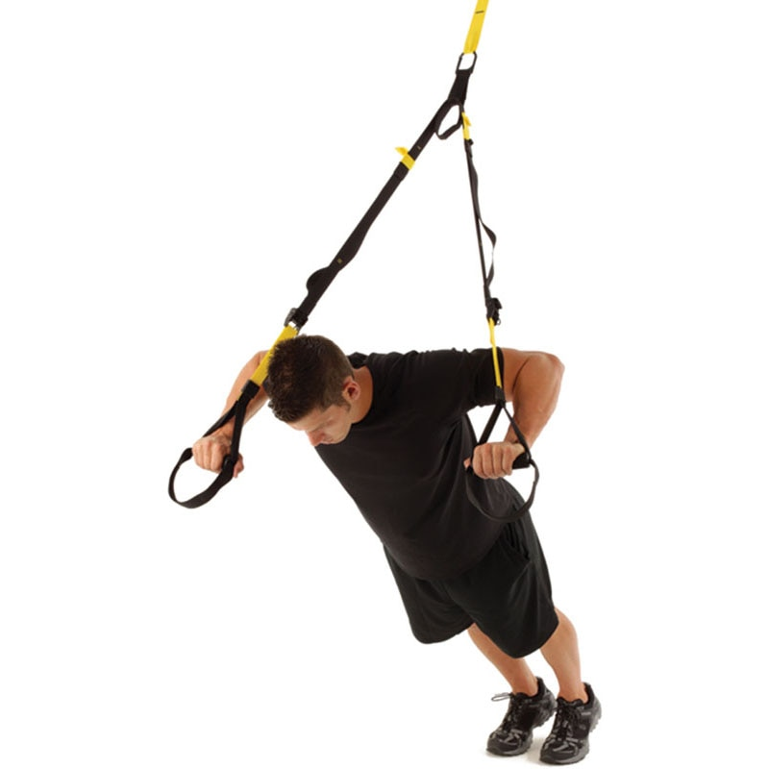

**Figure 22-20** Bench press superset with TRX suspension push-up

**Sandbags**

Sandbags provide the fitness professional a unique and versatile way to train their clients. Sandbags are designed to be carried, lifted, thrown, and pulled and most come with several handles to easily change grips (Figure 22-21). Once viewed as a conditioning tool used for athletes, military personnel, first responders, or those who compete in strongman events, sandbag training has proven to be a highly effective and functional training tool that can be used by most fitness enthusiasts. Because sandbags are portable, they make an ideal tool for indoor and outdoor bootcamp classes as well as within a circuit or high-intensity interval training (HIIT) program. Unlike barbells, dumbbells, and selectorized machines, the sand within the bag is constantly shifting, providing continuous instability. It is this instability, combined with movement in multiple planes of motion, that actively engages muscles of the core and stabilizing joints more dynamically than isolated exercises (McGill et al., 2009).

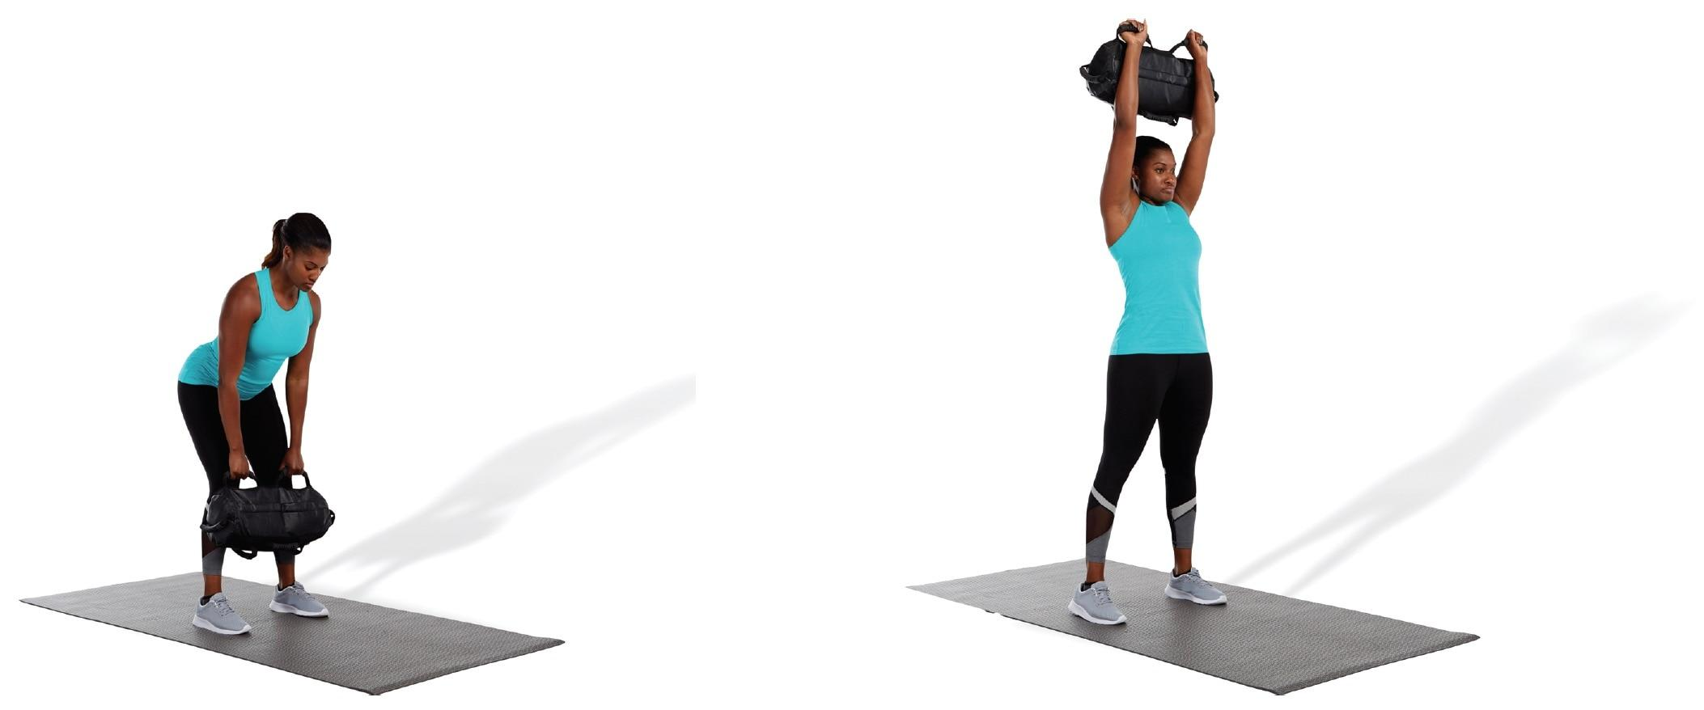

**Figure 22-21** Sandbag exercises

Sandbags provide a pliable weighted resistance that can be applied to most movements and exercises including asymmetrically loaded and rotational movements. Placing clients in real-world training environments where they are bending, kneeling, squatting, twisting, and exploding with additional load increases overall metabolic activity (Delvecchio, 2018; McGill et al., 2009). Sandbags range in weight from 15 lb (6.8 kg) to excess of 160 lb (72.5 kg) and make an excellent choice for all phases of the OPT model.

HELPFUL HINT

Sandbags can be messy. Sand will need to be purchased from a DIY store. Fill the filler bags outside and remove any sand residue before placing into shell.

**ViPR**

ViPR is an acronym for vitality, performance and reconditioning. The ViPR product is a cylindrical tube constructed of hardened rubber with ergonomically placed handles and openings on both ends (Figure 22-22). It is designed to be dragged, tossed, lifted, pulled, pressed, and carried. This design provides the fitness professional the ability to perform multidirectional, full-body exercises with external load resistance.

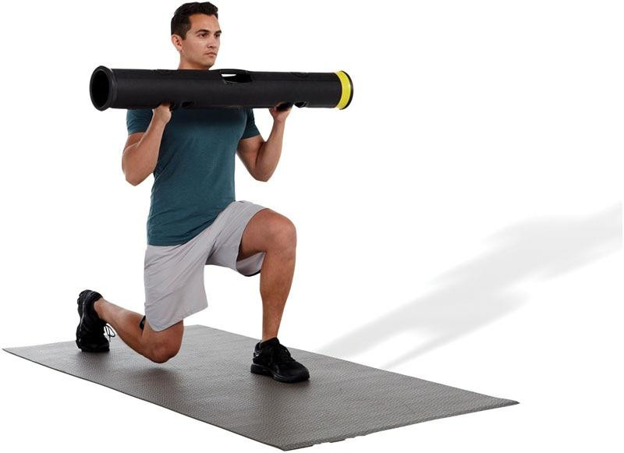

**Figure 22-22** ViPR

It ranges from 2 kg to 26 kg with 9 different weights (2 kg, 4 kg, 6 kg, 8 kg, 10 kg, 12 kg, 20 kg, and 26 kg). This versatility provides ample variations in weight for everyone from beginner or deconditioned individuals all the way to professional athletes.

ViPR uses loaded movement training, which is uniquely different as compared to traditional resistance exercises (ViPR, n.d.). Many dumbbell and barbell movements are performed in the sagittal plane. The ViPR, however, is not restricted to movements in a singular plane and allows for resistance to be experienced in all three planes of motion. The ViPR promotes the development of core stability through rotational movements. The goal is to better utilize the musculature of the core and hips to transfer power from the ground to the upper body (Gamble, 2007). ViPR exercises are particularly good for baseball, lacrosse, hockey, golf, tennis, and any other sport that requires explosive rotational strength. Another advantage to the ViPR is that movements can be made in a slow, controlled motion or can be performed explosively depending on the goals and desires of the client. Due to its versatility, the ViPR can be used in all phases of the OPT model.

**Battle ropes**

Another tool that has gained popularity within fitness are battle ropes (Figure 22-23). Often referred to as fitness ropes or training ropes, battle ropes can provide a high-intensity workout, delivering full-body conditioning while increasing overall cardiovascular benefits (Fountaine & Schmidt, 2015). Battle ropes are made of heavy-duty nylon and come in a variety of lengths and thickness, the most common sizes being 1.0, 1.5, and 2 in. (2.5– 5 cm) in diameter and lengths of 30, 40, and 50 ft (9, 12, 15 m). Rope weight will vary depending on the thickness and length of the ropes. Fifty-foot ropes are arguably the most common length. Thinner diameter ropes weigh less and are recommended for those new to exercise, smaller in stature, or have smaller hands or weaker grip strength. Larger ropes are heavier and are ideal for experienced individuals or for those seeking development of strength and power.

Battle rope exercises are considered a low-impact activity, which means they provide minimal impact on the joints. Battle ropes require activation of the prime movers, require engagement of the stabilizing musculature and core, and increase metabolic demands. Battle ropes also allow the user to perform unilateral and bilateral movements (Calatayud et. al, 2015).

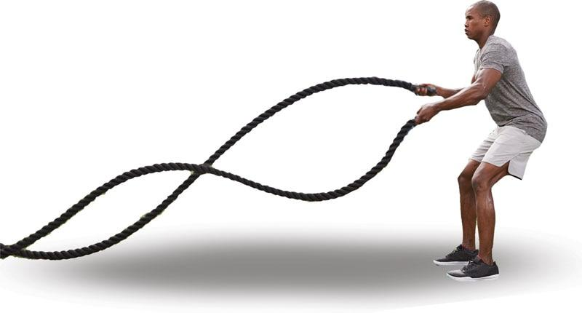

**Figure 22-23** Battle rope

TRAINING TIP

Smaller ropes (1.0–1.5 in. in diameter) are used primarily for aerobic and muscular endurance adaptations in which exercises are performed for 30 seconds or more. Heavier ropes (2 in. in diameter) are best used for strength, power, and anaerobic adaptations in which exercises are performed for 30 seconds or less.

## Proprioceptive modalities

Proprioception is the ability to sense body position and limb movements and is an important component of balance. A fundamental component of proprioception is the ability to maintain postural control or balance to help reduce the risk of injury and increase performance measures. Balance and stability training using a variety of proprioceptive modalities can be an effective strategy for optimizing movement patterns, joint stability, and performance (Willardson, 2004).

**Stability balls**

Stability balls, also known as Swiss balls, are frequently used in a variety of training facilities with a wide range of populations. The Swiss physical therapist Dr. Susanne Klein-Vogelbach (1990) popularized the use of stability balls for adults with a variety of orthopedic problems. American physical therapists began to observe and apply these techniques, referring to the training implements as Swiss balls (Carrière, 1998). These balls are most often made of soft polyvinylchloride and can come in a variety of sizes (Table 22-3). Their primary use is to increase the demand for stability in an exercise, but they can also be used to reinforce proper posture during squatting movements.

TABLE 22-3 Stability Ball Size Chart

| **Height** | **Suggested Size\*** |
| --- | --- |
| ≤5'0" tall | 45 cm |
| 5'1" to 5'7" | 55 cm |
| 5'8" to 6' | 65 cm |
| >6' | 75 cm |
| *These are suggested sizes. Individuals should select a ball size that allows them to comfortably sit on top of the ball with their hips and knees bent at a 90-degree angle and their feet flat on the floor. | |

Proper use of stability balls allows for the increase in strength and stability of the core musculature when substituted for more stable surfaces, such as exercise benches, chairs, and the floor (Behm & Colado, 2012; Carter et al., 2006; Stanton et al., 2004; Sternlich et al., 2007; Willardson, 2004). The spherical shape of the ball creates an unstable base of support, forcing users to constantly adjust their body position to the subtle movements of the ball. The most popular use of stability balls involves using it in place of traditional benches during the performance of a variety of prone (Figure 22-24) and supine exercises (Figure 22-25) using light loads or body weight. However, stability balls can be dangerous if one does not possess good balance or control, so it is important to evaluate the risk versus reward for the individual involved and follow all safety guidelines (Table 22-4). Standing on a stability ball is never recommended.

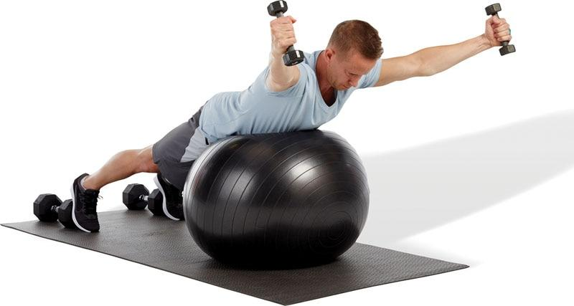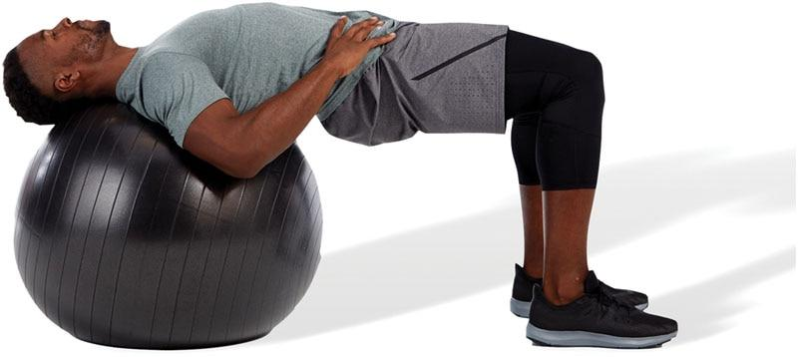

**Figure 22-24** Prone position

**Figure 22-25** Supine position

TABLE 22-4 Stability Ball Safety Guidelines

|  |  |
| --- | --- |
| Inspection Process Before Use | Inspect stability ball for any damage, tears, worn spots, etc. |
| Make sure the stability ball is fully inflated (should feel firm). |
| Opt for a burst-resistant stability ball. |
| Inspect and do not exceed suggested weight capacity. |
| Proper Use of Stability Ball | Only use a stability ball in an open space away from exercise machines, furniture, or other equipment. |
| Keep the ball away from direct heat sources, such as prolonged sun exposure, heaters, and fireplaces. |
| Do not wear sharp objects that could puncture the ball, such as jewelry. |
| Do not perform any standing exercises on the stability ball. |
| For first-time users, fitness professionals may need to hold the ball for added stability to ensure proper exercise technique and relieve user apprehension of falling. |
| Children should only use a stability ball with proper adult supervision. |
| Maintain proper posture using the five kinetic chain checkpoints during all exercises. |
| Do not perform near maximal or maximal lifts on the stability ball. |

Stability balls are best used with clients who demonstrate a need for increased overload of stability. As with any exercise technique, a proper progression from stable to unstable surfaces should be observed. For example, if a client can hold a plank position on a stable surface, such as the floor or bench, a stability ball can increase the intensity and difficulty of the exercise (Figure 22-26). Moreover, because of the spherical shape of a stability ball, greater ranges of motion can occur during certain exercises, such as the stability ball crunch versus the traditional floor crunch exercise (Figure 22-27). The contour of the ball allows users to perform crunches that go further into spinal extension than when performing this exercise on the floor, thus increasing abdominal strength through a greater range of motion (Sternlicht et al., 2007). For clients with limitations, such as low-back pain, the contouring nature of the ball allows for greater comfort and support during upright activities, most notably observed during ball wall squats (Figure 22-28). Performing a ball wall squat can help individuals learn proper movement patterns and gain the necessary stability and strength required for squatting motions.

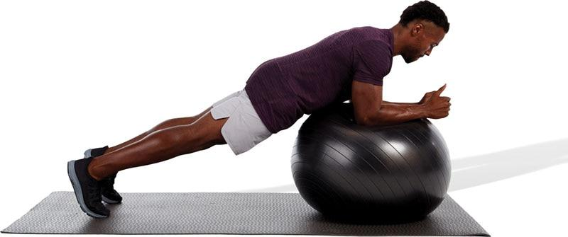

**Figure 22-2 6**Stability ball plank

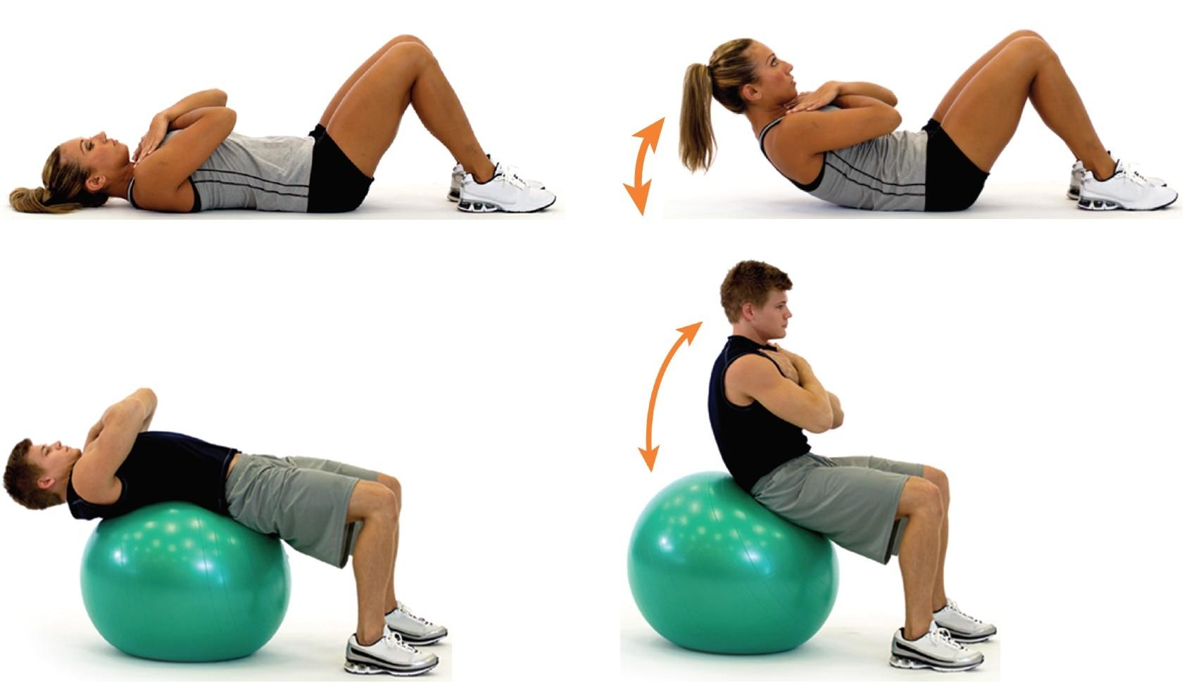

**Figure 22-27** Floor crunch versus stability ball crunch

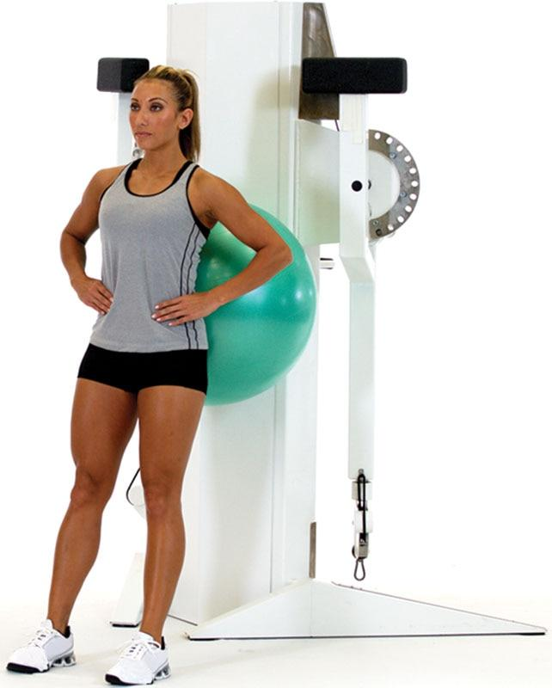

**Figure 22-28** Ball wall squat

Unless there is an orthopedic limitation that using the stability ball would alleviate, it is recommended that novice exercisers with poor balance first attain proficiency at performing exercises on a stable surface and progress to a more unstable environment, such as a stability ball, particularly during Phase 1 of the OPT model.

As mentioned earlier, the unstable nature of the ball can create a falling hazard for individuals with poor balance. In addition, using a stability ball as a base of support is not recommended for individuals aiming to create maximal force during an exercise; thus, stability ball training is not recommended during maximal lifts using heavy loads (85–100% of 1RM) (Anderson & Behm, 2005).

**BOSU balls**

The BOSU ball is an inflated rubber hemisphere attached to a solid plastic surface. It looks like a stability ball cut in half. The name BOSU is an acronym for “both sides utilized” referring to the ability to use the device with either side up. When the flat side is down, the dome offers a surface similar to a stability ball, providing a stability challenge, yet stable enough to stand on (Figure 22-29). When the dome is down, the hemisphere on the ground provides an unstable surface with the flat bottom on top offering a platform on which the hands can be placed to perform upper body exercises (Figure 22-30).

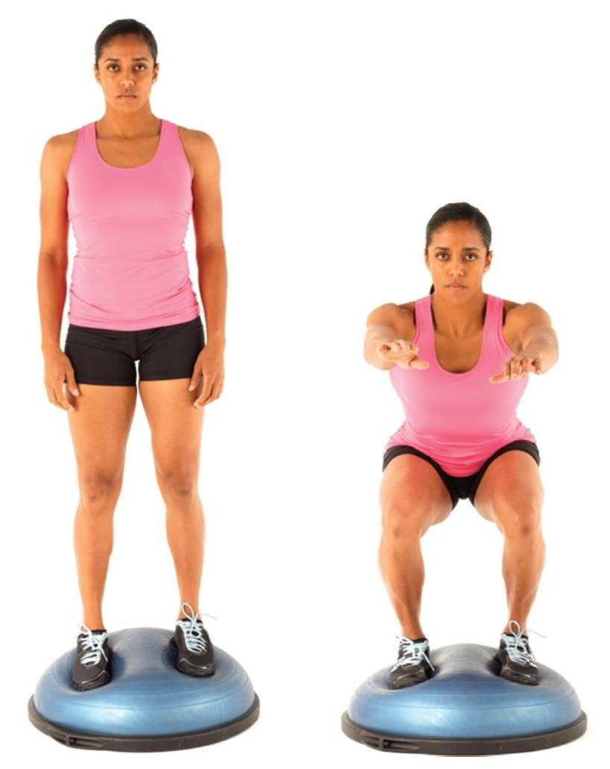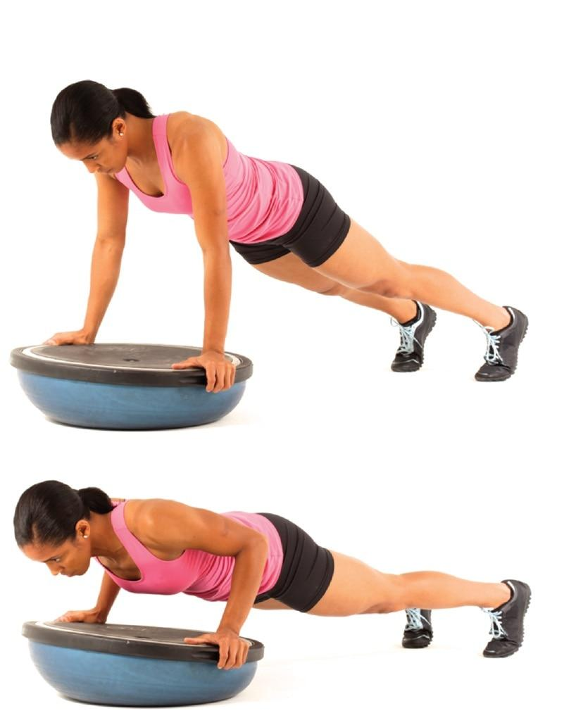

**Figure 22-29** BOSU ball squats (round surface)

**Figure 22-30** BOSU ball push-up (flat surface)

CRITICAL

Although both sides of a BOSU ball can be used, standing on the flat side (dome down), is not recommended by the manufacturer.

Training with the BOSU ball offers the ability to increase the intensity of an exercise by decreasing the stability. Unlike the stability ball, the dome side of the BOSU ball is relatively safe to stand on, so it is a practical device to train with to target lower limb balance and stability. Training while standing on an unstable surface has been found to increase neuromuscular activity when compared with standing on a stable surface, which can have implications for increasing balance, stability, and strength, particularly for injury prevention and during rehabilitation (Anderson & Behm, 2005; Behm & Colado, 2012; Fitzgerald et al., 2000; Myer et al., 2006).

Because of the BOSU ball’s unique shape and functionality, it offers a wide variety of exercises that can be performed by a wide range of clients. Like using a stability ball, proper progression from a stable, supported environment to the more unstable BOSU ball should be observed to ensure safety. Because of its stabilization demands, BOSU balls are ideal modalities to use in Phases 1 and 2 of the OPT model yet can be used in all phases, particularly when performing core and balance exercises.

**Terra-Core**

The Terra-Core is comprised of an inflatable rubber bladder and hard-surfaced backing. However, the rectangular shape of the Terra-Core provides a larger overall footprint that measures 45 in. (114 cm) long by 17 in. (43 cm) wide by 10 in. (25 cm) high. Similar to a stability or BOSU ball, when an individual places their body weight on the device, the displaced air inside the bladder provides perturbations, which forces the user to actively engage their core musculature and supporting joints to achieve balance and stability.

Because the Terra-Core is portable, weighing only 31 lb (14 kg), like many of the other tools in this category, it is ideal for bootcamps, small groups, and 1-on-1 personal training and can even be used in rehabilitation and physical therapy settings. In addition, unlike stability balls, it is safe to perform several resistance training exercises, such as a dumbbell chest press while lying supine on the Terra-Core. In addition, the Terra-Core includes handles, side bars, and resistance bands when using the underside of the modality for added variety (Figure 22-31).

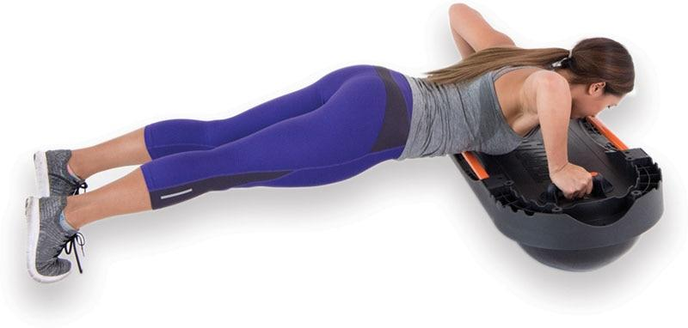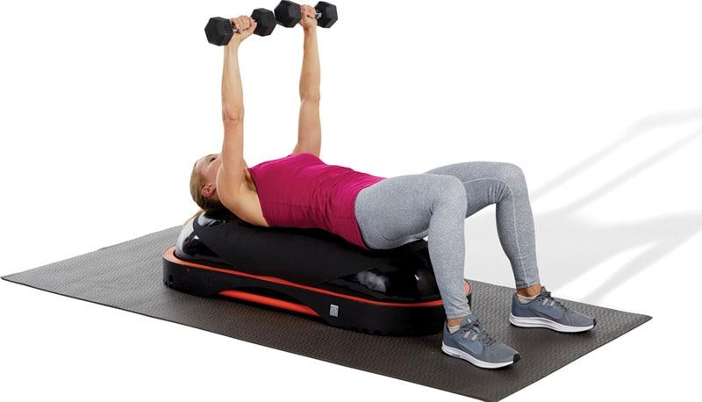

**Figure 22-31** Terra-core

CRITICAL

It is the fitness professional’s responsibility to ensure any movement on an unstable surface is performed with full competency with body weight before considering adding additional resistance.

**Trackers**

Fitness (activity) trackers have proven to be valuable assets within the fitness industry and will likely continue to grow in popularity. Fitness trackers are electronic wearable devices that enable users to track their activity levels (Figure 22-32) and come in many forms, such as watches, bands, rings, heart rate monitors, and pedometers. Ease of use and intrinsic motivation are key factors for continued use of fitness trackers among those who purchase them (Kim, 2104; Munson & Consolvo, 2012).



**Figure 22-32** Fitness trackers

**Fitness Trackers**

Prices for fitness trackers range considerably, so it is advisable for users to do their homework before deciding which product best fits their needs. Prior to purchasing a fitness tracker, users should ask the following questions:

* What do I really want to track?
  + Steps
  + Heart rate
  + Calories
* How much am I willing to spend?
* What is my ultimate goal?
  + Weight loss
  + Training for an event or group activity
  + Health or medical purposes

Once these questions have been answered, it will be much easier for an individual to decide on a fitness tracker. Fitness trackers offer a variety of features as discussed in Table 22-5.

TABLE 22-5 Fitness Tracker Features

| **Features** |
| --- |
| Brand–compatibility (iOS or Android)  Step counters/distance  Calorie counter  Movement reminder  Heart rate monitor  GPS  Sleep tracking  Battery life  Waterproof  Activity recognition: swimming, cycling, running, jogging, walking, weightlifting |

There are many benefits to using a fitness tracker; however, motivation, accountability, accuracy, and medical purposes seem to be the primary reasons why people decide to purchase these devices.

**Motivation**

Many fitness trackers are equipped with personalized program reminders, such as calendars, alarms, or daily motivational messages, that are designed to constantly remind the user of their goals. This can be especially powerful for those who exercise alone.

Some research suggests that approximately 50% of those who begin a fitness program will quit within the first 6 months (Henriksen et al., 2018). Wearing a fitness tracker may encourage an increase in physical activities.

The ability to store and record workouts and activities seems to positively affect users and, in some cases, may negatively affect them, if they don’t like the effort they’re putting forth.

Fitness trackers provide the user conformational feedback. Physical results, such as weight or inches lost, may not be noticeable to the individual on a daily basis. However, the tracking device can provide a monitored record of effort for the user to enhance motivation.

**Accountability**

In some instances, an individual may be part of a group (e.g., weight-loss group) and the fitness tracker provides a way to ensure each member is holding up to their commitment to the team. Members of the team can compare and track their results and help hold each other accountable.

**Accuracy**

Unfortunately, fitness trackers are not 100% accurate, and this level of accuracy varies across makes and models. Regardless, fitness trackers still provide a good estimate of a person’s activity level and act as a helpful tool to set goals and track results.

**Medical purposes**

For those individuals with medical conditions, such as high blood pressure, heart disease, or diabetes, fitness trackers can serve as a helpful reminder tool when to take medications, when to eat, or even when to exercise.

Tracking a patient’s personal history can be very advantageous to physicians when treating certain diseases. In some instances, using a fitness tracker may be lifesaving.

**Fitness and nutrition Apps**

With smartphone technology, the ability to monitor our nutritional habits as well as access fitness programming is literally at one’s fingertips. The variety and ease of use of these applications (apps) has given people the ability to take command of their nutrition and fitness goals. Nutrition and fitness apps provide a road map to obtaining one’s health objectives much easier than in the past. The advent of fitness and nutrition apps provides users with personalized programming designed to help them achieve their health and fitness goals.

Nutritional apps

While tracking nutritional intake has numerous benefits, many of the new apps do much more than simply count calories.

This can be especially important for those who are trying to lose weight, build muscle, or improve athletic performance.

Nutritional apps are beneficial for the following reasons:

* Meal planning
* Understanding and counting calories
* Reading and understanding food labels
* Tracking macronutrient intake (protein, carbohydrates, fat)
* Tracking nutritional content (e.g., vitamins, minerals, fiber)
* Making healthier food choices
* Fueling workouts
* Finding recipes
* Forming positive eating habits.

STRETCH YOUR KNOWLEDGE

Not all nutritional bars are nutritious for you. Some have more sugar and fat than many candy bars.

Fitness apps

Fitness apps are downloadable applications that can be used on nearly any mobile device and designed to help users obtain certain fitness goals. A fitness app is an inexpensive and convenient way for fitness enthusiasts to take their workouts with them and include a variety of exercise formats, including high-intensity interval-training, strength training, yoga, and Pilates. The benefits of fitness apps include the following:

* Access to exercise routines anytime or anywhere with a computer, tablet, or smartphone
* Personalized fitness programs based on the user’s goals and exercise preferences
* Access to exercise programs that do not require equipment
* Tracking completed workouts and time spent exercising
* Daily, weekly, and monthly reminders to complete workout routines
* Simulation of 1-on-1 or group training
* Tracking steps taken each day
* Tracking calories expended from physical activity
* Tracking fitness achievements like miles run or weight lifted
* Instructing proper exercise technique

There are several fitness apps on the market today, and many have free trial periods. Individuals can test several applications to determine which app best fits their needs. It is important to remember that individuals with chronic disease may need medical clearance before starting a new exercise routine. In addition, performing exercise routines without supervision can be dangerous, especially for those new to exercise.

Heart Rate Monitors

Heart rate monitors (HRM) have become very popular within the fitness industry. Traditionally, they were used by endurance athletes, such as runners and triathletes, to monitor training levels. However, HRMs have become more widely used within mainstream fitness.

In fact, some boutique and large-scale gyms require attendees to wear HRMs while taking classes. While this is done to ensure safety, it is also used to monitor exertion levels during class. Using a HRM provides objective and quantifiable data regarding a person’s heart response to exercise. HRMs also provide information regarding a person’s recovery heart rate following exercise.

HRMs measure the amount of times the heart beats in a 1-minute cycle. A faster heart rate indicates a higher level of physical exertion. As such, individuals can use HRMs to objectively measure their own level of effort. The most common types of HRMs are chest strap monitors and wristband/watch with built in optical LED sensors (Figure 22-33).

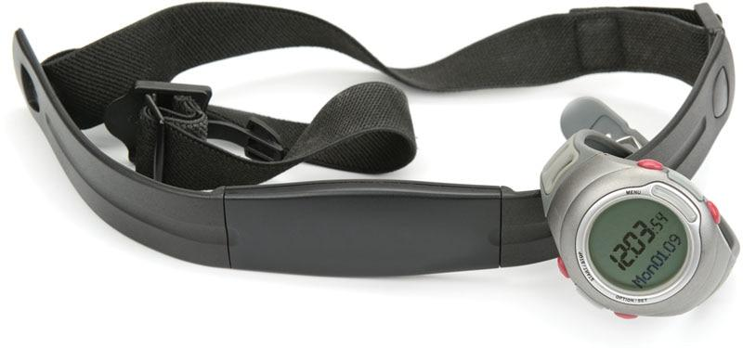

**Figure 22-23** Heart rate monitor

Although wristband/watches are the most convenient and most widely used HRM, chest strap monitors provide the most accurate readings. Furthermore, wrist-worn devices are less accurate when the user is performing higher-intensity activities and may be prone to more inaccurate readings when performing upper body movements (Cadmus-Bertram et al., 2017).

CRITICAL

How quickly a person’s heart rate drops in the first minute after vigorous exercise is a good indicator of heart health. An abnormally slow return to a resting heart rate is a predictor of poor heart health.

Like fitness trackers, heart rate monitors range in price considerably depending on the quality of the HRM and the additional features offered. It is recommended for shoppers to do their homework to ensure they are getting a monitor that best suits their personal needs.

TRAINING TIP

The Centers for Disease Control and Prevention and World Health Organization recommend 150 minutes of moderate intensity aerobic activity or 75 minutes of vigorous aerobic activity per week for optimal health.

# Chronic health conditions and special populations

The information presented up to this point in the text has focused on exercise considerations for apparently healthy adults. This chapter covers important information and recommendations for assessing and designing exercise programs for clients with selected chronic health conditions or functional limitations.

While this chapter provides only a brief overview of selected chronic health conditions and functional limitations common in clients seeking personal training services, additional resources on exercise considerations for individuals with chronic health conditions and physical or functional limitations are available.

## Age considerations

Participation in organized youth sports is declining in certain areas, and youths as a whole are becoming more sedentary. Some of the possible reasons for a decline in sport participation may include high costs and demands on parents, lots of travel, and concerns over injury (Merkel, 2013). Consequently, there is a significant need for increased awareness and access to fitness training for youth year-round, not just during one or more sport seasons.

The term *youth* refers to children and adolescents between the ages of 6 and 20 years. Although a group of children or adolescents may be the same age, their response to exercise can vary considerably as a result of individual differences in growth, development, and physical maturation.

Published guidelines on youth fitness and exercise have previously focused on sport-specific training. However, given the increase in childhood obesity and diabetes, current youth fitness guidelines now focus on promoting healthy lifestyles and health-related physical fitness (U.S. Department of Health and Human Services, 2018). Current recommendations state that children and adolescents should get 60 minutes (1 hour) or more of moderate to vigorous physical activity daily. Unfortunately, there is a youth physical inactivity crisis, especially in many Western countries. For example, in the United States, only 25% of youth participate in the minimum guidelines necessary for improving and maintaining overall health and well-being (Katzmarzyk et al., 2016). Children and adolescents should engage in daily aerobic, muscle-strengthening, and bone-strengthening activities to improve their health and reduce their risk of developing chronic disease. In response to the growing problem of obesity and diabetes in children, the World Health Organization (2010), in conjunction with leading physical education and public health organizations, has developed a new statement on physical activity for children and youth. The World Health Organization (2010) recommends that children ages 5 to 17 years get 60 minutes of moderate to vigorous physical activity and exercise daily.

**Physiologic differences between children and adults**

There are fundamental physiological differences between children and adults. Although youth may experience similar effects of exercise training as adults, they do not respond, adapt, or progress the same. Youth exercise training programs should progress specific to their physiologic capabilities. Fitness professionals should be aware of important physiologic differences between youth and adults that impact their response and adaptation to exercise. These include the following (Table 23-1) (Michael & Saltarelli, 2019):

1. Peak oxygen uptake: Because children do not typically exhibit a plateau in oxygen uptake at maximal exercise, the term *peak oxygen uptake* is a more appropriate term than VO2max or maximal oxygen uptake. Adjusted for body weight, peak oxygen consumption is similar for young and adult males and slightly higher for young females (compared with adult females). A similar relationship also exists for force production or strength.
2. Submaximal oxygen demand (or economy of movement): Children are less efficient and tend to exercise at a higher percentage of their peak oxygen uptake during submaximal exercise compared with adults.
3. Children do not produce sufficient levels of glycolytic enzymes to be able to sustain bouts of high-intensity exercise.
4. Children have immature thermoregulatory systems, including both a delayed response and limited ability to sweat in response to hot, humid environments.

TABLE 23-1 Physiologic and Training Considerations for Youth

| **Physiologic Considerations** | **Implication of Exercise Compared with Adults** | **Considerations for Health and Fitness** | **Considerations in Sport and Athletic Training** |
| --- | --- | --- | --- |
| Peak oxygen uptake is similar to adults when adjusted for body weight. | Able to perform endurance tasks relatively well | Physical activity of 60 minutes on most or all days of the week, emphasizing developmentally appropriate activities | Progression of aerobic training volume should not exceed 10% per period of adaptation (if 200 minutes per week, increase to 220 minutes before increasing intensity). |
| Submaximal oxygen demand is higher compared with adults for walking and running. | Greater chance of fatigue and heat production in sustained higher-intensity tasks | Moderate to vigorous physical activity for adolescents, for a total of 60 minutes 3 or more days of the week or 3 days per week if vigorous | Intensive anaerobic exercise (greater than 90% HRmax) exceeding 10 seconds is not well tolerated; provide sufficient rest and recovery intervals between intense bouts of training. |
| Glycolytic enzymes are lower than adults. | Decreased ability to perform longer-duration (10–90 seconds), high-intensity tasks | Resistance exercise for muscular fitness:  1–2 sets of 8–10 exercises  8–12 reps per exercise | Resistance exercise should emphasize balance, skill, and controlled movements.  Repetitions should not exceed 6–8 per set for strength development or 20 for enhanced muscular endurance. |
| Sweating rate | Decreased tolerance to environmental extremes, particularly heat and humidity | 2–3 days per week, duration of 30 minutes, with added time for warm-up and cool-down | 2–3 days per week, with increases in overload occurring through increases in reps first, then resistance. |

Because of their relatively high peak oxygen uptake levels, children can perform endurance activities fairly well. However, children do not tolerate exercise in hot, humid environments because they have higher submaximal oxygen demands and a lower absolute sweating rate when compared with adults. Vigorous exercise in hot, humid environments should be restricted to less than 30 minutes for children, including frequent rest periods. As with adults, adequate hydration before, during, and after exercise is very important for youth. Unlike adults with sustained low-intensity endurance activities, children are at a disadvantage when participating in short-duration (10 to 90 seconds), high-intensity anaerobic activities because they produce less glycolytic enzymes that are required to support sustained anaerobic power. For safety and training considerations, children should have planned rest intervals when training at high-intensity levels.

**Resistance training for youth**

Research has demonstrated that resistance training is both safe and effective in children and adolescents (Lloyd et al., 2014). Resistance training for health and fitness conditioning in youth also results in a lower risk of injury when compared with many popular sports, including soccer, football, and basketball (Faigenbaum & Myer, 2009; U.S. Consumer Product Safety Commission, 2019). The most common injuries associated with resistance training in youth are injury to ligaments (sprains) and injury to tendons or muscles (strains), which are usually attributable to a lack of qualified supervision, poor technique, and improper progression (Lloyd et al., 2014). Injuries can and do occur in youth participating in any activity or sport, including resistance training; however, no injuries have ever been reported in well-designed scientific studies looking at the effect of resistance training in youth (Lloyd et al., 2014).

Furthermore, the majority of published research on the subject has reported that both children and adolescents can gain significant levels of strength as a result of resistance training beyond that which is normally associated with growth and development (Myers et al., 2017).

Untrained children can improve their strength by an average of 30% to 40% or more after 8 weeks of progressive resistance training (Lloyd et al., 2014). Resistance training in youth has also been shown to improve motor skills, such as sprinting and jumping, body composition, and bone mineral density (Dahab & McCambridge, 2009; Lloyd et al., 2014; Roberts et al., 2008). Improvements in strength and performance after a resistance training program in youth seem to be due to neural adaptations versus muscular hypertrophy. Neural adaptations include better coordination between agonist and antagonist muscles, increased motor unit recruitment, and higher neural signaling to muscles during activation (Lloyd et al., 2014).

When designing an exercise training program for a youth client, it is important to assess for any movement deficiencies using a variety of movement assessments discussed in Chapter 12. Information from the movement assessments will help the fitness professional design an individualized program. Exercise progressions should be determined based on the youth client’s maturity level, dynamic postural control (flexibility and stability), and response to training up to this point. One of the most important aspects to consider when designing and implementing exercise training programs for youth is to make it safe and fun. Recommendations for youth fitness training are presented in Table 23-2.

TABLE 23-2 Basic Exercise Guidelines for Youth Training

| **Mode** | **Walking, jogging, running, games, activities, sports, water activity, resistance training** |
| --- | --- |
| Frequency | 5–7 days per week |
| Intensity | Moderate to vigorous cardiorespiratory exercise training |
| Duration | 60 minutes per day |
| Fitness Assignments | Overhead squat assessment  Push-up assessment  Cardiorespiratory assessments |
| Flexibility | Self-myofascial techniques; static, active, and dynamic stretching |
| Resistance Training | 1–2 sets of 8–12 repetitions at 40–70% intensity, 2–3 days per week  Progression of exercise programs should be reserved for mature adolescents, based on dynamic postural control and physical capabilities |
| Special Considerations | Progression for the youth population should be based on postural control and not on the amount of weight that can be used  Make exercising fun |

**Older adults**

By the middle of this century, it is estimated that 87 million people—or roughly 21% of the entire U.S. population—will be 65 years of age or older (Ortman et al., 2014). Globally, the number of people aged 60 years or older is approximately 962 million, more than twice the number when compared to 1980 (Department of Economic and Social Affairs, 2017). As populations age, dealing with issues such as mortality, longevity, and quality of life becomes a greater focus. The upward drift in average age has significant implications for fitness professionals as well. As the role of exercise to help improve and maintain functional independence becomes more widely known and accepted, opportunities for Certified Personal Trainers will continue to increase.

Aging is synonymous with degeneration and loss of functional ability in older adults. Typical forms of degeneration associated with aging include osteoporosis, arthritis, degenerative low-back pain, and obesity (Demontiero et al., 2012). Special considerations for those chronic conditions associated with aging will be addressed later; however, considerations for apparently healthy older adults help provide the fitness professional with the fundamental knowledge to effectively evaluate and design programs for this population.

It is vital to note that various physiologic changes are considered normal with aging, and some are considered pathologic, meaning related to disease. For example, blood pressure tends to be higher at rest and during exercise, which can be the result of either natural causes, as a result of disease, or a combination of both. Arteriosclerosis is a normal physiologic process of aging that results in arteries that are less elastic and pliable, which in turn leads to greater resistance to blood flow and thus higher blood pressure (hypertension), which will be discussed later in this chapter. On the other hand, atherosclerosis—caused largely by poor lifestyle choices—restricts blood flow as a result of plaque buildup within the walls of arteries thus leading to increased resistance and blood pressure.

Another disease-related cause of hypertension is peripheral vascular disease, which refers to plaques that form in any peripheral artery, typically those of the lower leg. Individuals with diagnosed hypertension should be carefully monitored and referred to a physician if their blood pressure continues to rise or if they have other risk factors for heart disease. All individuals— regardless of their age—who are hypertensive should be referred to a physician for further evaluation. The American College of Cardiology and the American Heart Association have updated blood pressure guidelines to state normal blood pressure to be less than 120/80 mm Hg. Elevated blood pressure is 120–129 mm Hg systolic and less than 80 mm Hg diastolic. Stage 1 hypertension is now 130 to 139 mm Hg systolic or 80 to 89 mm Hg diastolic, whereas stage 2 hypertension is now 140 mm Hg or higher (systolic) or 90 mmHg or higher (diastolic). A hypertensive crisis involves a systolic reading greater than 180 mm Hg and/or a diastolic reading greater than 120 mm Hg. All blood pressure measurements should be obtained on at least two different occasions by a knowledgeable health professional (American College of Cardiology, 2017).

Despite the normal decline in physiologic functioning associated with aging, older adults— with and without other chronic health conditions—can and do respond to exercise much in the same manner as apparently healthy younger adults. Some of the normal physiologic and functional changes associated with aging include reductions in the following:

* Maximum attainable heart rate
* Cardiac output
* Muscle mass
* Balance
* Coordination (neuromuscular efficiency)
* Connective tissue elasticity
* Bone mineral density
* Anabolic hormones.

Both normal physiologic and abnormal pathologic changes associated with aging affect the response to exercise training. Degenerative processes associated with aging can lead to a decrease in the functional capacity of older adults, including potentially significant reductions in muscular strength and endurance, range of motion or mobility, cardiorespiratory fitness, and proprioception (Colon-Emeric et al., 2013; Moore et al., 2016). One of the most important and fundamental functional activities affected by degenerative aging is walking. The decreased ability to move freely in one’s own environment not only reduces the physical and emotional independence of an individual but also can lead to an increase in the degenerative cycle (Hertling & Kessler, 2006). The ability or inability to perform normal activities of daily living—such as bathing, eating, housekeeping, and leisure activities—can be measured to help determine the functional status of an individual.

Individuals with one or more of these chronic or degenerative conditions may tend to avoid engaging in activities such as resistance or aerobic training because of a fear of injury or feelings of inadequacy (Fragala et al., 2019). However, research has shown that musculoskeletal degeneration may not be entirely age-related and that certain measures can be taken to prevent loss of muscle strength and functional immobility with aging (Fragala et al., 2019; Hong & Kim, 2018). It has also been demonstrated that many of the structural deficits responsible for decreased functional capacity in older adults, including loss of muscle strength and proprioception, can be slowed and even reversed by participating in routine physical activity and exercise (Giallauria et al., 2016; Law et al., 2016).

Certified Personal Trainers can make a dramatic impact on the overall health and well-being of older adults. Before initiating any exercise training, older adults must complete a Physical Activity Readiness Questionnaire Plus (PAR-Q+). It is also recommended that older adults complete a health history questionnaire and appropriate fitness and movement assessments (discussed in Chapters 11 and 12). Assessments such as those included in the senior fitness test (e.g., sit to stand test, back scratch test, stand up and go) help provide information about an individual’s quality of movement as well as the ability to perform activities of daily living. Fitness professionals interested in working with active older adults should seek out advanced education regarding these assessments.

Flexibility assessment and training are also important considerations with older adults because they tend to lose the elasticity of their connective tissue, which reduces movement and increases the risk of injury. Self-myofascial techniques, as discussed in Chapter 14, are advised for this population, provided there is sufficient ability and tolerance to perform the necessary movement, and the client does not have varicose veins or other types of contraindications. Static stretching is also advised if well tolerated. Otherwise, simple forms of active or dynamic stretching are recommended to help get the client to start moving their joints during the warm-up period.

Low- to moderate-intensity cardiorespiratory training is recommended for this population. However, older adults taking certain prescribed medications and those with other chronic health conditions must be carefully monitored. Exercise training should be progressed slowly—with an emphasis on executing ideal movement patterns and enhancing stabilization using appropriate core, balance, and resistance exercises—before moving on to more advanced forms of exercise. When designing an exercise program for older adults, the fitness professional must take specialized care in ensuring safety for the participants. The better a fitness professional can match exercises appropriate to the clients’ capabilities, the safer and more effective the program will be. All exercises should be performed with precise technique and control to minimize risk of injury. As always, fitness professionals are encouraged to consult with a licensed physician whenever questions arise regarding older adult clients.

Physiologic considerations and their implications for training apparently healthy older adults are listed in Tables 23-3 and 23-4 (Moore et al., 2016; Riebe et al., 2018; Thompson, 2019).

TABLE 23-3 Physiologic and Training Considerations for Older Adults

| **Physiologic Considerations** | **Implications of Health and Fitness Training** |
| --- | --- |
| Maximal oxygen uptake, maximal exercise heart rate, and measures of pulmonary (lung) function will all decrease with increasing age. | Initial exercise workloads should be low and progressed more gradually to 3–5 days per week.  Duration = 20–45 minutes  Intensity = 45–80% of VO2 peak |
| Percentage of body fat will increase, and both bone and lean body mass will decrease with increasing age. | Resistance exercise is recommended, with lower initial weights and slower progression (e.g., 1–3 sets of 8–10 exercises, 8–20 reps, session length equals 20–30 minutes). |
| Balance, walking mechanics, and neuromuscular coordination may be impaired. | Exercise modalities should be chosen and progressed to safeguard against falls.  Cardio options include stationary or recumbent cycling, aquatic exercise, or treadmill with handrail support.  Resistance options include seated machines, progressing to standing exercises. |
| There is a higher rate of both diagnosed and undetected heart disease in the elderly. | Knowledge of pulse assessment during exercise is critical, as is monitoring for chronic disease signs and symptoms. |
| Pulse irregularity is more frequent. | Consult with client’s physician or healthcare provider regarding possible exercise side effects, especially if the client is taking medication. |

TABLE 23-4 Basic Exercise Guidelines for Older Adults

| **Mode** | **Stationary or recumbent cycling, aquatic exercise, or treadmill with handrail support** |
| --- | --- |
| Frequency | 3–5 days per week of moderate-intensity activities or 3 days per week of vigorous-intensity activities |
| Intensity | 40–85% of VO2 peak |
| Duration | 30–60 minutes per day or 8- to 10-minute bouts |
| Movement Assessment | Pushing assessment  Pulling assessment  Overhead squat (if tolerated) |
| Flexibility | Self-myofascial techniques using a handheld roller (if tolerated), static stretching, slow and controlled active or dynamic movement |
| Resistance Training | 1–3 sets of 8–20 repetitions at 40–80% intensity, 3–5 days per week  Exercise training should be progressed slowly, with an emphasis on executing ideal movement patterns and enhancing stabilization using appropriate core, balance, and resistance exercises, before moving on to more advanced forms of exercise. |
| Special Considerations | Progression should be slow, well monitored, and based on postural control.  Exercises should be progressed if possible, toward free sitting (no support) or standing.  Make sure the client is breathing in a normal manner and avoids holding their breath, as in a Valsalva maneuver.  If the client cannot tolerate self-myofascial techniques or static stretches, they can opt for slow and controlled active and dynamic stretches. |

## Obesity

Obesity is the fastest growing health problem in America and in most all other industrialized countries. In fact, obesity has nearly tripled worldwide since 1975 (World Health Organization, 2018b). At present, 72% of Americans older than the age of 20 years are either overweight or obese. Approximately 40% of Americans aged 20 years and older are obese (Hruby & Hu, 2015). Obesity is a complex disease and can be associated with a variety of chronic health conditions as well as emotional and social problems.

**Body Mass Index**

Body mass index (BMI) is used to estimate healthy body-weight ranges based on a person’s height. Because it is simple to measure and calculate, it is the most widely used assessment tool to identify individuals who are underweight, overweight, and obese. BMI is defined as total body weight in kilograms divided by the height in meters squared. For example, a client with a body weight of 200 lb (91 kg) and height of 70 in. (178 cm, or 3.16 m2) would have a BMI of 28.79 (91 kg/3.16 m2). Because BMI does not actually measure body fat percentage, other techniques, such as bioelectrical impedance or circumference measurements, may be performed to assist in developing realistic weight-loss goals and to help provide feedback to clients. These techniques, however, may need to be avoided for obese individuals because assessing body fat can be a sensitive situation. Although BMI is not a perfect measurement, it does provide reliable values for comparison and for reasonable goal setting. For example, once BMI is calculated, realistic goals can be set to achieve a weight associated with a lower BMI. A BMI of 18.5 to 24.9 is considered within normal limits, 25 to 29.9 is considered overweight, and a BMI of 30 or greater is obese (Table 23-5). The risk of chronic disease increases in proportion to the rise in BMI in both adults and adolescents.

TABLE 23-5 Body Mass Index

| **BMI** | **Disease Risk** | **Classification** |
| --- | --- | --- |
| <18.5 | Increased | Underweight |
| 18.5–24.9 | Low | Healthy weight |
| 25.0–29.9 | Increased | Overweight |
| 30–34.9 | High | Obese |
| 35.0–39.9 | Very high | Obesity II |
| ≥40 | Extremely high | Obesity III |

**Causes of obesity**

Although the causes of obesity are complex and varied, few disagree that the primary physiological problem is energy balance (too many calories consumed and too few expended). Because obesity is such a complex medical problem, it is important for fitness professionals to work closely with a registered dietitian (or other qualified licensed professional) who can provide accurate and achievable dietary recommendations.

It has been suggested that adults who remain sedentary throughout their life span will lose approximately 5 lb of muscle per decade, while simultaneously adding 15 lb of fat per decade (Mozaffarian et al., 2011). In addition, the average adult will experience a 15% reduction in fat-free mass between the ages of 30 and 80 years. When age-related fat gain was investigated, it was determined that body fat is not an age-related problem but instead relates to the number of hours individuals spend exercising per week (Maciejczyk et al., 2014). It has also been shown in sedentary individuals that daily activity levels account for more than 75% of the variability of body-fat storage in men (Drewnowski & Darmon, 2005).

**Obesity and exercise training**

Regular physical activity and exercise is one of the most important factors related to long-term successful weight loss. It is important to note that obese and morbidly obese clients have unique problems associated with exercise. For example, research has also shown a correlation between body weight and the mechanics of their gait (walking pattern), in that obese individuals modify their gait pattern both during walking and at maximal speeds when compared to nonobese individuals (Ko et al., 2010). Exercise training for obese clients should focus primarily on energy expenditure, through a combination of core, balance, cardiorespiratory, and resistance training, to help them expend calories and improve their balance and gait mechanics. In doing so, more calories are potentially expended (Benito et al., 2016; Lagally et al., 2009).

For effective weight loss, obese clients should expend 200–300 kcal (calories) per exercise session, with a minimum weekly goal of 1,200 kcal of energy expenditure from combined physical activity and exercise. The initial exercise energy expenditure goal should be progressively increased to 2,000 kcal per week (Donnelly et al., 2009). Resistance training should gradually be added to any exercise program designed to promote weight loss, but sustained, long-term aerobic endurance activities are also a priority. Research suggests circuit-style resistance training, when compared with walking at a fast pace, produces nearly identical caloric expenditure rates in the same given time span (Catenacci et al., 2011). Resistance training is an important component of any weight-loss program because it helps maintain, or even increase, lean body mass, which eventually results in a higher metabolic rate and improved body composition. The same exercise training guidelines for apparently healthy adults can be used when designing aerobic and resistance training programs for obese clients. Health and movement assessments should always be performed to establish initial program design goals and parameters (Moore et al., 2016). Some of the fitness assessments presented in Chapter 12 can be used with this population, for example, using pushing, pulling, and modified squatting assessments. Resistance training exercises for assessment or training may be best performed with cables, exercise tubing, or body weight from a standing or seated position for obese clients. Flexibility exercises should also be performed from a standing or seated position. For example, using the standing hip flexor (rather than the kneeling hip flexor stretch), standing or seated hamstring stretch, wall calf stretches, and seated adductor stretch would be advised. Self-myofascial techniques should be used with caution and may need to be avoided or performed at home (discussed next in Psychosocial Aspects of Working with Obese Clients).

Core and balance training are also important for this population because they tend to lack balance and walking speed, both of which are important for exercise. Fitness professionals must use caution when placing an obese client in a prone (on stomach) or supine (on back) position because they are susceptible to both hypotensive (low blood pressure) and hypertensive (high blood pressure) responses to exercise. Having obese clients perform exercises in a standing position may be more appropriate and more comfortable for them. For example, performing a plank exercise on an incline (Figure 23-1) or a standing medicine ball rotation (Figure 23-2) may be best suited for certain obese clients versus supine crunches performed on the floor. Resistance training exercises may need to be started in a seated position and progressed to a standing position.

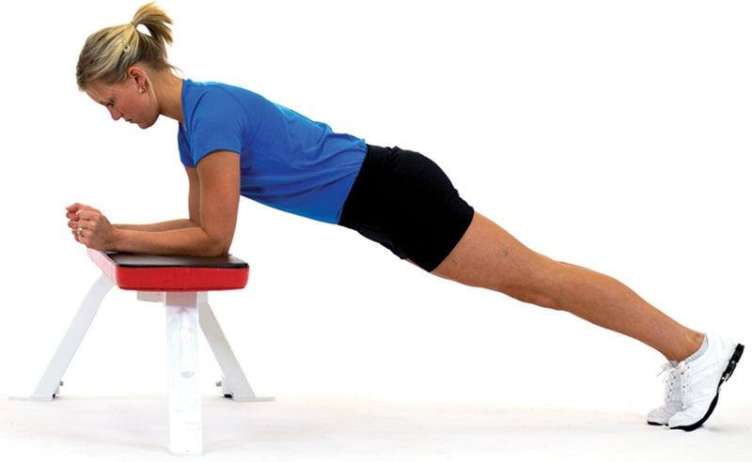

**Figure 23-1** Incline plank

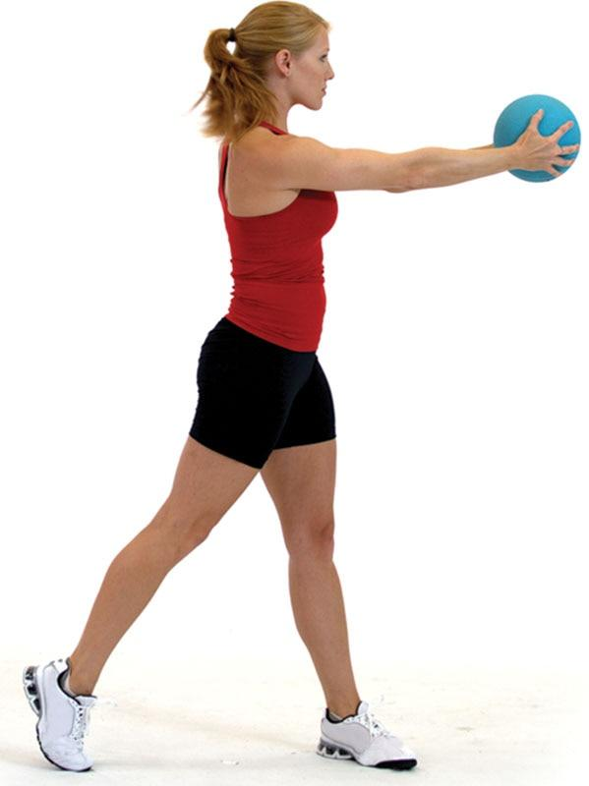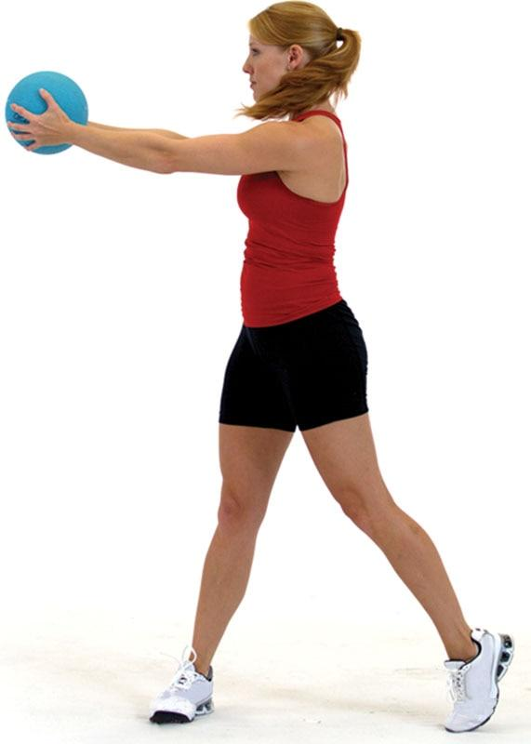

**Figure 23-2** Standing medicine ball rotations

Fitness professionals should ensure that the client is breathing correctly during resistance training exercises and avoids straining during exercise or squeezing exercise bars too tightly, which can cause an increase in blood pressure.

**Psychosocial aspects of working with obese clients**

Obesity is a unique chronic disease because it may also affect a person’s sense of emotional well-being and self-esteem (Beck, 2016). Obesity can alter the emotional and social aspects of a person’s life as much as it does the physical aspects. Fitness professionals must be very aware of the psychosocial aspects of obesity when training obese clients to ensure that the client feels socially and emotionally safe. Such attention to their emotional and physical well-being will help create trust between the client and fitness professional and assist the client in adhering to a weight-loss and exercise program.

Proper exercise selections and positions are very important to the client’s sense of well-being. For example, machines are often not designed for obese individuals and may require a significant amount of mobility to get in and out of. Dumbbells, cables, or exercise tubing exercises work quite well instead of machines. The use of self-myofascial techniques performed on the floor should be done with caution, or avoided altogether, as some obese clients may not feel comfortable performing these flexibility techniques. It may be a good idea to recommend that certain exercises be performed in the privacy of their own home or in a location within a health club that offers privacy if the client communicates issues of confidence. In addition, it is recommended that obese clients engage in weight-supported exercise (such as cycling or swimming) to decrease orthopedic (joint) stress. However, walking is often both a preferred activity for many obese clients and one that is easily engaged in and adhered to. Thus, if the benefits of walking, particularly adherence, exceed the observed or perceived risk of an orthopedic injury, walking may be a primary exercise recommendation. When working with this population, fitness professionals must make sure of all the situations in which the obese client will exercise, including positions, locations in the training facility that offer greater privacy, and choice of exercise equipment. Exercise considerations for obese clients are given in Tables 23-6 and 23-7.

TABLE 23-6 Physiologic and Training Considerations for Individuals Who Are Overweight or Obese

| **Physiologic Considerations** | **Considerations for Health and Fitness** |
| --- | --- |
| May have other comorbidities (diagnosed or undiagnosed), including hypertension, cardiovascular disease, or diabetes. | Initial screening should clarify the presence of potential undiagnosed comorbidities. |
| Maximal oxygen uptake and ventilatory (anaerobic) threshold is typically reduced. | Consider testing and training modalities that are weight supported (such as cycle ergometer, swimming, water aerobics).  If a client does not have these limitations, consider a walking program to improve compliance. |
| Coexisting diets may hamper exercise ability and result in significant loss of lean body mass.. | Initial programming should emphasize low intensity, with a progression in exercise duration (up to 60 minutes as tolerable) and frequency (5–7 days per week), before increases are made in intensity of exercise.  Exercise intensity should be no greater than 60–80% of work capacity, with weekly caloric volume a minimum of 1,200 kcal per week and a progression to 2,000, as tolerable. |
| Measures of body composition may not accurately reflect degree of overweight or obesity | BMI, scale weight, hip-to-waist or circumference measurements are recommended measures of weight loss. |

TABLE 23-7 Basic Exercise Guidelines for Individuals Who Are Overweight or Obese

| **Mode** | **Low-impact (such as treadmill walking, rowing, stationary cycling, and water activity)** |
| --- | --- |
| Frequency | At least 5 days per week |
| Intensity | 60–80% of maximum heart rate  Intensities may be altered to 40–70% of maximal heart rate if needed.  Using the *talk test can be helpful to determine exercise intensity. |
| Duration | 40–60 minutes per day, or 20- to 30-minute sessions twice each day |
| Assessment | Pushing assessment  Pulling assessment  Overhead squat assessment (if tolerated) |
| Flexibility | Self-myofascial techniques (only if comfortable to client)  Static, active, and dynamic stretches |
| Resistance Training | 1–3 sets of 10–15 repetitions on 2–3 days per week  Exercises performed in a circuit-training manner, with higher repetitions, such as 20, may be used if tolerated by the individual. |
| Special Considerations | Make sure client is comfortable—be aware of positions and locations in the facility your client is in.  Exercises should be performed in a standing or seated position.  Clients may have other chronic diseases; in such cases, a medical release should be obtained from the individual’s physician. |

\**Note*: The talk test is a method of measuring intensity. If the client can comfortably carry on a conversation while exercising, they are probably at the lower ranges of training heart rate. If the client is having difficulty finishing a sentence, the intensity is probably at the high range. Depending on the individual’s response and exercise status, adjust intensity accordingly.

## Diabetes

Diabetes is a metabolic disorder in which the body does not produce enough insulin (type 1) or the body cannot respond normally to the insulin that is made (type 2). An estimated 23.6 million children and adults in the United States (9.4% of the population) have diabetes (Bullard et al., 2018). Diabetes is the seventh leading cause of death worldwide and is associated with a greater risk for heart disease, hypertension, and adult-onset blindness (Bullard et al., 2018). Worldwide, the occurrence of diabetes has risen from 108 million in 1980 to 422 million in 2014 (World Health Organization, 2018a). It has been shown that people who develop diabetes before the age of 30 years are 20 times more likely to die by the age of 40 years than those who do not have diabetes (Thent et al., 2013).

There are two primary forms of diabetes: type 1 (insulin-dependent diabetes) and type 2 (noninsulin-dependent diabetes). Although type 2 is referred to as noninsulin-dependent diabetes, some individuals with type 2 diabetes cannot manage their blood glucose levels and do require additional insulin. Type 2 diabetes is strongly associated with an increase in childhood and adult-onset obesity.

Type 1 diabetes is typically diagnosed in children, teenagers, or young adults. With type 1 diabetes, specialized cells in the pancreas called beta cells stop producing insulin, causing blood sugar levels to rise, resulting in hyperglycemia (high levels of blood sugar). To control this hyperglycemia, the individual with type 1 diabetes must inject insulin to compensate for what the pancreas cannot produce. Exercise increases the rate at which cells use glucose, which may mean that insulin levels may need to be adjusted with exercise. If the individual with type 1 diabetes does not control their blood glucose levels before, during, and after exercise, blood sugar levels can drop rapidly and cause a condition called hypoglycemia (low blood sugar), leading to weakness, dizziness, and fainting. Although insulin, proper diet, and exercise are the primary components prescribed for individuals with type 1 diabetes, these individuals must still be monitored throughout exercise to ensure safety.

Type 2 diabetes is associated with obesity, particularly abdominal obesity (Caspard et al., 2017). The incidence and prevalence of adult type 2 diabetes across the globe has increased sharply in recent years. There is a significant public health concern about the rising incidence of type 2 diabetes in children, associated with both the increase in abdominal obesity and decrease in voluntary physical activity. Individuals with type 2 diabetes usually produce adequate amounts of insulin; however, their cells are resistant to the insulin, meaning that the insulin present cannot transfer adequate amounts of blood sugar into the cell. This condition can lead to hyperglycemia. Chronic hyperglycemia is linked with a number of diseases associated with damage to the kidneys, heart, nerves, eyes, and circulatory system. Although individuals with type 2 diabetes do not experience the same fluctuations in blood sugar as those with type 1, it is still important to be aware of the symptoms, particularly for individuals with type 2 diabetes who use insulin medications.

**Exercise and diabetes**

The most important goal of exercise for individuals with either type of diabetes is glucose control, and for those with type 2 diabetes, weight loss and energy expenditure. Exercise training is effective for both goals because it has a similar action to insulin, enhancing the uptake of circulating glucose by exercising skeletal muscle. Research has shown that exercise improves a variety of glucose measures, including tissue sensitivity, glucose tolerance, and insulin requirements (Moore et al., 2016; Thent et al., 2013). Thus, exercise has been shown to have a substantial positive effect on the treatment and prevention of type 2 diabetes.

Specific exercise guidelines and recommendations can be followed when working with a diabetic population, including strategies to prevent hypoglycemic and hyperglycemic events during or after exercise as well as when to defer exercise based on resting blood glucose levels or symptoms. In most cases, excluding other health-related problems, the exercise management goals for individuals with diabetes are similar to those for physical inactivity and excess body weight. In contrast to walking being a highly preferred form of exercise for obese clients, care must be taken when recommending walking to clients with diabetes to prevent blisters and foot microtrauma that could result in foot infection. Special care should also be taken with respect to giving advice to clients with diabetes regarding carbohydrate intake and insulin use, not only before exercise but also afterward, to reduce the risk of a hypoglycemic or hyperglycemic event.

Exercise guidelines for clients with diabetes are similar to those advised for obese adults, as many clients with type 2 diabetes are obese. In such cases, daily exercise is recommended for more stable glucose management and maximal caloric expenditure (Tables 23-8 and 23-9). Low-impact exercise activities can reduce the risk of injury, whereas resistance training is advised as part of an overall exercise plan for health and fitness.

TABLE 23-8 Physiologic and Training Considerations for Individuals with Diabetes

| **Physiologic Considerations** | **Considerations for Health and Fitness** | **Considerations in Sport and Athletic Training** |
| --- | --- | --- |
| Frequently associated with comorbidities (including cardiovascular disease, obesity, and hypertension) | Type 2 diabetes exercise program should target a weekly caloric goal of expending 1,000–2,000 kcal, progressing as tolerable, to maximize weight loss and cardio protection. | Screening for comorbidities (presence of two chronic diseases) is important. |
| Exercise exerts an effect similar to that of insulin. | Physical exertion increases risk of exercise-induced hypoglycemia.. | Be aware of signs and symptoms of hypoglycemia. |
| Hypoglycemia may occur several hours after exercise, as well as during exercise. | For those recently diagnosed, glucose should be measured before, during, and after exercise | Restoration of glucose after the event may be necessary to prevent nocturnal hypoglycemia. |

|  |  |  |
| --- | --- | --- |
| Clients taking beta-blocking medications may be unable to recognize signs and symptoms of hypoglycemia. | Some reduction in insulin and increase in carbohydrate intake may be necessary and proportionate to exercise intensity and duration. | Substantial insulin dose reduction may be necessary before exercise.  Carbohydrate intake before and during exercise may be necessary. |
| Exercise in excessive heat may mask signs of hypoglycemia. | Postexercise carbohydrate consumption is advisable. | Initial exercise programming should emphasize low intensity, with a progression in exercise duration (up to 60 minutes as tolerable) and frequency (5–7 days per week). for consistent glucose control.  Intensity should be no greater than 50–90% of work capacity to start with. |
| Increased risk for retinopathy (damage to retina of the eyes). | Be cognizant of signs and symptoms of hypoglycemia. | Resistance training guidelines may follow those for normal-weight, healthy adults. |
| Peripheral neuropathy (weakness, numbness, or pain usually in the feet or hands) may increase risk for gait abnormalities and infection from foot blisters that may go unnoticed. | Use weight-bearing exercise cautiously and wear appropriate footwear. | Check daily for blisters or skin injury and appropriate footwear. |

TABLE 23-9 Basic Exercise Guidelines for Individuals with Diabetes

| **Mode** | **Low-impact activities (such as cycling, treadmill walking, swimming)** |
| --- | --- |
| Frequency | 4–7 days per week |
| Intensity | 50–90% of maximum heart rate  Cardiorespiratory training (may be adjusted to 40–70% of maximal heart rate if needed) |
| Duration | 20–60 minutes |
| Assessment | Pushing assessment  Pulling assessment  Overhead squat (if tolerated) |
| Flexibility | Static, active, or dynamic stretches |
| Resistance Training | 1–3 sets of 10–15 repetitions, 2–3 days per week  Higher repetitions, such as 20, may be used. |
| Special Considerations | Make sure client has appropriate footwear, and have client or physician check feet for blisters or abnormal wear patterns.  Advise client or class participant to keep a snack (quick source of carbohydrate) available during exercise to avoid sudden hypoglycemia.  Avoid excessive plyometric training, and higher-intensity training is not recommended for clients with diabetes.  Self-myofascial techniques may be contraindicated; a physician’s approval is recommended. |

Assessment procedures should follow those outlined in Chapters 11 and 12. Flexibility exercises can be used as suggested; however, special care should be given to self-myofascial techniques, and this may be contraindicated for anyone with neuropathy (i.e., a loss of protective sensation in feet and legs). Advice from a licensed physician concerning self-myofascial techniques should be obtained as well as from a certified diabetes educator if clients are under the care of one, as it may be contraindicated. Integrated training programs are appropriate for this population; however, the use of plyometric training may be inappropriate.

TRAINING TIP

Blood glucose levels can vary throughout the day, especially right before and right after eating a meal. Blood glucose levels are usually less than 100 mg/dL when fasting and less than 140 mg/dL 2 hours after eating.

Hypoglycemia is a condition that occurs when blood glucose becomes too low to support normal physiological functioning. Symptoms of hypoglycemia generally occur when blood glucose levels fall below 70 mg/dL. Identifying signs and symptoms of hypoglycemia is the first step to help correct a hypoglycemic event. Symptoms of hypoglycemia may include the following:

* Fatigue
* Pale clammy skin
* Irregular heart rate
* Sweating
* Shaky, unstable feeling
* Extreme hunger

If hypoglycemia symptoms worsen, signs and symptoms may include the following:

* Confusion
* Blurred vision
* Possibility of seizures
* Extreme irritability

Initial treatment of hypoglycemia is to consume simple sugar, such as juice, soda, or hard candy. If symptoms do not improve, the client should contact their physician or seek medical attention.

## Hypertension

Blood pressure is defined as the pressure exerted by the blood against the walls of the blood vessels, especially the arteries. It varies with the strength of the heartbeat, the elasticity of the arterial walls, the volume and viscosity of the blood, and a person’s health, age, and physical condition. Hypertension, or high blood pressure, is a common medical disorder in which arterial blood pressure is above 120 mm Hg for systolic and 80 mm Hg for diastolic. A client is considered to have hypertension if their blood pressure measurements, obtained on at least 2 different occasions, are above normal or if they are currently taking medication to control blood pressure. The American College of Cardiology and the American Heart Association recently released updated blood pressure guidelines (American College of Cardiology, 2017). The revised guidelines state the following:

* Normal blood pressure is less than 120/80 mm Hg.
* Elevated blood pressure is 120–129 mm Hg (systolic) and less than 80 mm Hg (diastolic).
* Stage 1 hypertension is 130–139 mm Hg (systolic) or 80–89 mm Hg (diastolic).
* Stage 2 hypertension is 140 mm Hg or higher (systolic) or 90 mm Hg or higher (diastolic).
* A hypertensive crisis is greater than 180 mm Hg (systolic) and/or 120 mm Hg or higher (diastolic).

Some of the most common causes of hypertension include smoking, sedentary living, alcohol abuse, and excess weight. The health risks of hypertension are well known and include increased risk for stroke, cardiovascular disease, heart failure, and kidney failure.

One of the most common and traditional methods of controlling hypertension is through antihypertensive medications (Khera et al., 2018). Although medications have been shown to be highly effective, comprehensive lifestyle changes, including regular physical activity, healthy eating, and smoking cessation, have also been shown to reduce blood pressure, potentially eliminating the need for medications or lending to reduced dosing (Ghadieh & Saab, 2015).

Research has shown that exercise can have a modest impact on lowering elevated blood pressure by an average of 10–20 mm Hg for both systolic and diastolic blood pressure (Börjesson et al., 2015). Exercise may help the body produce more appropriate responses to physical activity or other physiologic stressors. The changes appear modest, but any lowering of blood pressure conveys a lowered overall health risk, which is important. Low to moderately intense cardiorespiratory exercise has been shown to be just as effective as high-intensity activity in reducing blood pressure (Costa et al., 2018). This is important for elderly or obese individuals with high blood pressure and who are not physically capable of performing high-intensity cardiorespiratory exercise.

It is also important to emphasize the importance of an overall plan to reduce blood pressure that includes exercise, diet, weight loss (if appropriate), and most important, compliance with any medical treatment plans if clients are under the care of a physician. Fitness professionals are encouraged to stress to all of their clients the importance of taking any prescribed medications.

Fitness professionals should evaluate their client’s heart rate response to exercise, as measured during a submaximal exercise test or even during a simple assessment of heart rate during a comfortable exercise load. Individuals with hypertension frequently take medications that can alter the heart rate response to exercise, in most cases blunting the heart rate response to exercise, thus invalidating prediction equations or estimates of training heart rate. Fitness professionals are also encouraged to learn how to accurately assess both resting and exercise blood pressure with all of their clients but especially those clients with hypertension. Classes to learn how to take blood pressure measurements are available through local healthcare organizations or hospitals.

It is important to monitor the body position of clients with hypertension at all times throughout an exercise training session. As with obese and diabetic clients, body position can have a dramatic effect on blood pressure response before, during, and after exercise in clients with hypertension. Supine or prone positions (especially when the head is lower in elevation than the heart) can often increase blood pressure, and as such, these positions may be contraindicated. For example, a standing cable hip extension (Figure 23-3) exercise may be more appropriate than a floor bridge (Figure 23-4) for strengthening the gluteals. It is important to note that both hypotensive and hypertensive responses to exercise are possible in clients with hypertension, especially when taking into account the effects of medication, body position, and exercise selection.

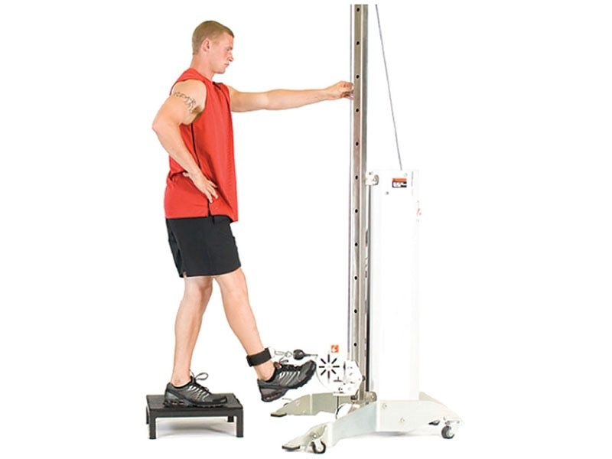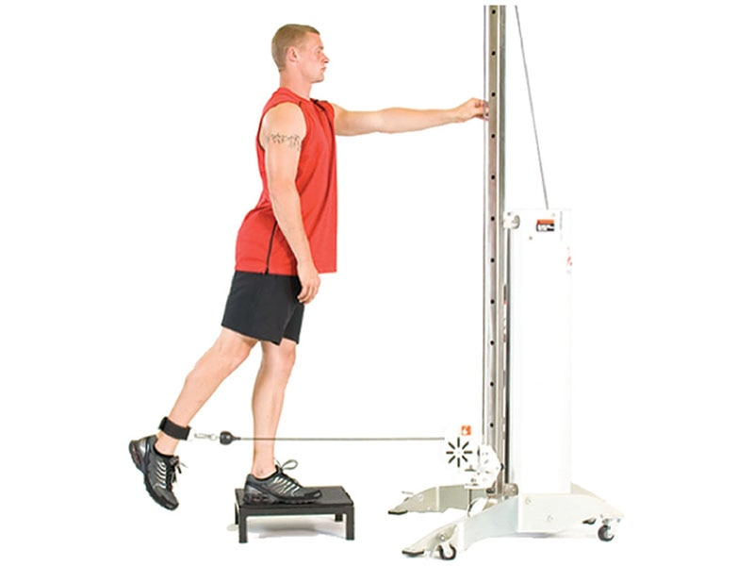

**Figure 23-3** Standing cable hip extension

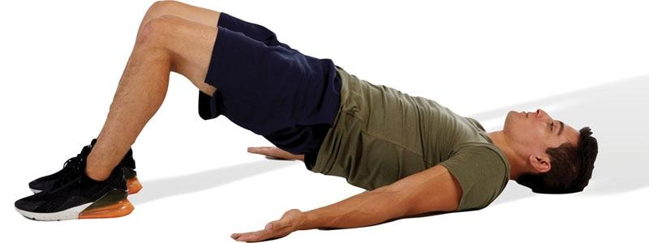

**Figure 23-4** Floor bridge

When assessing clients with hypertension, fitness professionals should follow the guidelines in Chapters 11 and 12. Moreover, exercises should be performed primarily in a seated or standing position (Tables 23-10 and 23-11). While clients may use a variety of flexibility techniques, static and active stretching may be the easiest and safest. Foam rolling performed on the floor may be contraindicated because it requires lying down. A cardiorespiratory program of continuous, lower-intensity (50–85% of work capacity) aerobic exercise is initially recommended and should progress only after a physician’s approval.

TABLE 23-10 Physiologic and Training Considerations for Individuals with Hypertension

| **Physiologic Considerations** | **Considerations for Health and Fitness, Sport, and Athletic Training** |
| --- | --- |
| Blood pressure response to exercise may be variable and exaggerated, depending on the mode and level of intensity. | A program of continuous, lower-intensity (50–85% of work capacity) aerobic exercise is initially recommended.  Frequency and duration parameters should be at a minimum 3–5 days per week, 20–45 minutes per day, with additional increases in overall volume of exercise if weight loss is also desired. |
| Despite medication, clients may arrive with pre-exercise hypertension. | Resistance exercise should consist of a peripheral heart action or circuit-training style.  Avoid Valsalva maneuvers (holding breath), emphasize rhythmic breathing and a program design for muscular fitness (e.g., 1–3 sets of 8–10 exercises, 10–20 reps, 2–3 days per week). |
| Hypertension frequently is associated with other comorbidities, including obesity, cardiovascular disease, and diabetes. | Screening for comorbidities is important.  Exercise should target a weekly caloric goal of 1,500–2,000 kcal, progressing as tolerable, to maximize weight loss and cardio protection. |
| Some medications for hypertension, such as beta-blockers, will decrease the heart rate at rest and its response to exercise. | For clients taking medications that will influence heart rate, do not use predicted maximal heart rate formulas.  Use actual heart rate response or the talk test.  Accepted blood pressure contraindications for exercise include an SBP of 200 mm Hg and a DBP of 115 mm Hg. Always check with any other guidelines the fitness facility may have in place (Riebe et al., 2018). |

*Note*: SBP, systolic blood pressure; DBP, diastolic blood pressure.

TABLE 23-11 Basic Exercise Guidelines for Individuals with Hypertension

| **Mode** | **Stationary cycling, treadmill walking, rowers** |
| --- | --- |
| Frequency | 3–7 days per week |
| Intensity | 50–85% of maximal heart rate  Cardiorespiratory training can start as low as 40% of HRmax, if needed, and be progressed as tolerated. |
| Duration | 30–60 minutes |
| Assessment | Pushing assessment  Pulling assessment  Overhead squat assessment  Single-leg squat assessment (if tolerated) |
| Flexibility | Static and active in a standing or seated position |
| Resistance Training | 1–3 sets of 10–20 repetitions, 2–3 days per week  Tempo should not exceed 1 second for isometric and concentric portions of the lift.  Use circuit or peripheral heart action system (PHA) weight training as an option, with appropriate rest intervals. |
| Special Considerations | Avoid heavy lifting and Valsalva manoeuvres—make sure client breathes normally.  Do not let client overgrip weights or clench fists when training.  Modify tempo to avoid extended isometric and concentric muscle actions.  Perform exercises in a standing or seated position.  Allow client to stand up slowly to avoid possible dizziness.  Progress client slowly. |

Core exercises in the standing position are preferred over supine core exercises. Some examples include performing standing cable iso-rotations (Figure 23-5) or cobras in a standing position (Figure 23-6). Use plyometric training with care for this population.

Resistance training should be performed primarily in a seated or standing position as well. Exercise training programs should be progressed slowly and performed in a circuit-style or peripheral heart action training system (see Chapter 20) to distribute blood flow between the upper and lower extremities. Fitness professionals should always ensure that clients with hypertension try to breathe normally and avoid the Valsalva manoeuvre or overgripping (squeezing too tightly) when using exercise equipment, as this can dramatically increase blood pressure. Fitness professionals should also monitor clients with hypertension carefully when rising from a seated or lying position, as they may experience dizziness.

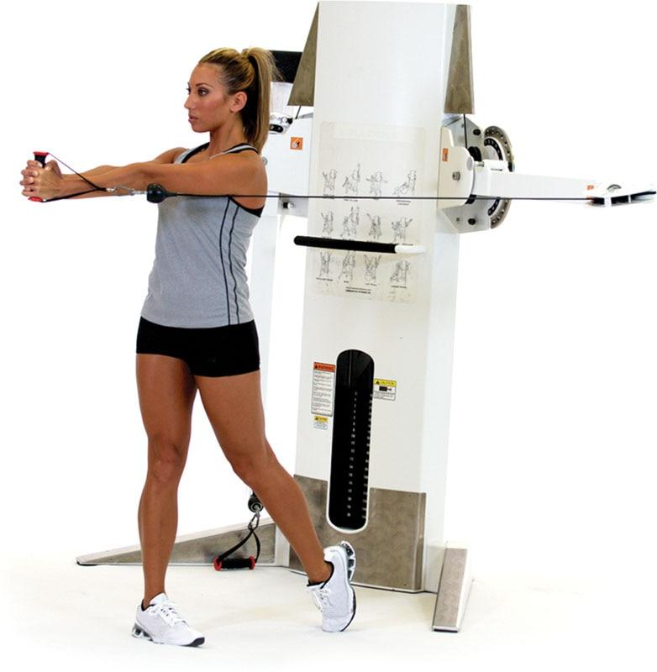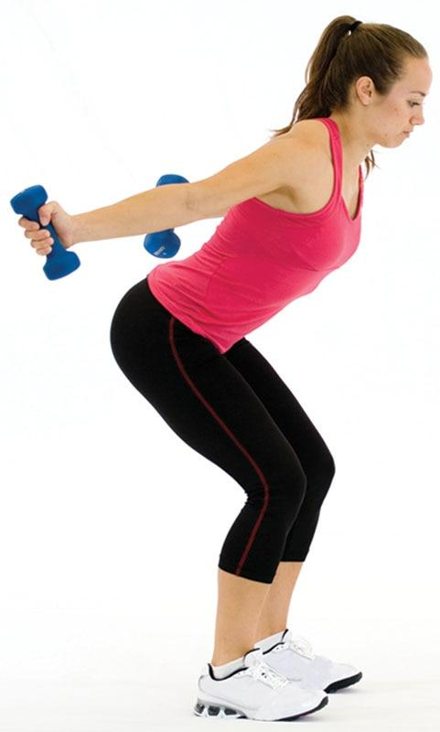

**Figure 23-5** Standing cable iso-rotation

**Figure 23-6** Standing cobra

## Coronary Heart Disease

Coronary heart disease (CHD) remains the leading cause of death and disability for both men and women despite a significant reduction in death rates from CHD in recent years (Mensah et al., 2017). CHD is caused by atherosclerosis (plaque formation), which leads to narrowing of the coronary arteries and ultimately angina pectoris (chest pain), myocardial infarction (heart attack), or both (Triposkiadis et al., 2007). The primary cause of CHD is poor lifestyle choices—primarily cigarette smoking, poor diet, and physical inactivity (Esselstyn, 2017). From a medical standpoint, the emphasis on treating CHD is centered on improving the health of the internal lining of the coronary artery, called plaque stabilization. The other primary focus on the treatment of CHD is through medical management, including pharmaceuticals, as well as aggressive lifestyle intervention, including healthier food choices, more exercise, smoking cessation, and stress reduction.Increasing numbers of individuals with diagnosed, and undiagnosed, heart disease are seeking the advice of fitness professionals on appropriate exercise training. The risk of serious cardiovascular complications, even death, is low in exercise programs that include clients with CHD. The risk of exercise for clients with CHD is likely low because they should be well screened and monitored by their physician and fitness staff. Nonetheless, fitness professionals must be aware of the presence of clients with heart disease and help design effective exercise programs with the knowledge that exercise can pose a risk for clients with heart disease (Table 23-12).

TABLE 23-12 Physiologic and Training Considerations for Individuals with Coronary Heart Disease

| **Physiologic Considerations** | **Considerations for Health and Fitness, Sport, and Athletic Training** |
| --- | --- |
| The nature of heart disease may result in a specific level of exercise that would be dangerous to go beyond. | The safe upper limit of exercise, preferably by heart rate, must be obtained.  Heart rate should never be estimated from existing prediction formulas for clients with heart disease; consult their physician. |
| Clients with heart disease may not have angina or other warning signs. | Clients must be able to monitor pulse rate or use an accurate monitor to stay below the safe upper limit of exercise. |
| Between underlying disease and medication use, the heart rate response to exercise will nearly always vary considerably from age-predicted formulas and will almost always be lower. | Although symptoms should always supersede anything else as a sign to decrease or stop exercising, some clients may not have this warning system, so monitoring heart rate becomes increasingly important. |
| Clients may have other comorbidities, such as diabetes, hypertension, peripheral vascular disease, or obesity. | Screening for comorbidities is important so that modifications to exercise may be made based on these diagnoses. |
| Peak oxygen uptake (as well as ventilatory threshold) is often reduced because of the compromised cardiac pump and peripheral muscle deconditioning. | The exercise program should be low intensity, to start, and based on recommendations provided by a certified exercise physiologist or physical therapist with specialty training.  Aerobic training guidelines should follow, at minimum, 20–30 minutes 3–5 days per week at 40–85% of maximal capacity but below the safe upper limits prescribed by the physician.  A weekly caloric goal of 1,500–2,000 kcal is usually recommended, progressing as tolerable, to maximize cardio protection.  Resistance training may be started after the patient has been exercising asymptomatically and comfortably for more than 3 months in the aerobic exercise program.  A circuit-training format is recommended: 8–10 exercises, 1–3 sets of 10–20 reps per exercise, emphasizing breathing control and rest as needed between sets. |

In some cases, clients with CHD will begin a fitness program after completing a cardiac rehabilitation program. Regardless of whether a client with CHD has completed a cardiac rehabilitation program or not, fitness professionals must have a clear understanding about the client’s disease, medication use, and most importantly, the safe upper limit of exercise—and any other restrictions—imposed by the client’s physician. Fitness professionals must not compromise on obtaining this information, and client participation must not proceed until the information is received. In many cases, the client can facilitate obtaining this information.

Clients should be able to find and monitor their own pulse rate or use an accurate heart rate monitor to stay below their safe upper limit of exercise. In addition, clients should be instructed on other signs and symptoms of tolerance to exercise, including shortness of breath, dizziness, and excessive fatigue. It is important to note that the heart rate response to exercise in this population can vary considerably from age-predicted formulas and will often be lower. Although signs and symptoms should always supersede all else as a sign to decrease or stop exercising, signs and symptoms vary greatly among individuals with CHD, so careful monitoring of heart rate and signs of worsening CHD, like angina, become increasingly important. Other useful tools to assess exercise intensity are rating of perceived exertion (Table 23-13) or the talk test, which allows fitness professionals to gauge the intensity of the exercise without having to assess heart rate.

TABLE 23-13 Rating of Perceived Exertion

| **Rating** | **Perceived Exertion Level** |
| --- | --- |
| 0 | No exertion, at rest |
| 1 | Very light |
| 2-3 | Light |
| 4-5 | Moderate, somewhat hard |
| 6-7 | High, vigorous |
| 8-9 | Very hard |
| 10 | Maximum effort, highest possible |

Clients with stable coronary artery disease—especially those who have participated in a cardiac rehabilitation program—should know or be taught information on the importance and benefits of exercise, which include a lower risk of mortality, increased exercise tolerance, muscle strength, reduction in angina and heart failure symptoms, and improved psychological status and social adjustment. There is also evidence that heart disease may be slowed (or even reversed) when a multifactor intervention program of intensive education, exercise, counseling, and lipid-lowering medications is used, as appropriate (Maruthur et al., 2009; Pischkeet al., 2008).

Fitness professionals must be careful not to overstate the benefits of exercise as a singular intervention and must emphasize to clients the importance of a multidisciplinary approach to heart disease. Exercise, however, is critically important and can be safely conducted in most health and fitness settings (Table 23-14). Fitness professionals should follow the guidelines in Chapters 11 and 12 for assessment of clients with CHD. If possible, exercises should be performed in a seated or standing position. Clients should stay with static and active stretching in a standing or seated position because they may be the easiest and safest to perform. Consult with a licensed physician for specific recommendations concerning self-myofascial techniques. Cardiorespiratory training should focus on moderate-intensity exercise (40–75% HRmax) and only progress with the physician’s advice.

TABLE 23-14 Basic Exercise Guidelines for Individuals with Coronary Heart Disease

| **Mode** | **Large muscle group activities, such as stationary cycling, treadmill walking, or rowing** |
| --- | --- |
| Frequency | 3–5 days per week |
| Intensity | Moderate-intensity exercise, 40% to 75% HRmax, and only progress with the physician’s advice  The talk test may also be more appropriate as medications may affect heart rate. |
| Duration | 5–10 minutes warm-up, followed by 20–40 minutes of exercise, followed by a 5- to 10-minute cool-down |
| Assessment | Pushing assessment  Pulling assessment  Overhead squat assessment (if tolerated) |
| Flexibility | Static and active stretching in a standing or seated position |
| Resistance Training | 1–3 sets of 10–20 repetitions, 2–3 days per week  Tempo should not exceed 1 second for isometric and concentric portions.  Use circuit or PHA weight training as an option, with appropriate rest intervals. |
| Special Considerations | Be aware that clients may have other diseases to consider as well, such as diabetes, hypertension, peripheral vascular disease, or obesity.  Modify tempo or pace to avoid extended isometric and concentric muscle actions.  Avoid heavy lifting and Valsalva maneuvers—make sure client breathes normally.  Do not let client overgrip weights or clench fists when training.  Perform exercises in a standing or seated position.  Progress exercise slowly. |

Core exercises in a standing position are preferred. Some examples include performing planks on an incline, standing cable iso-rotations, or cobras in a standing position. Plyometric and isometric training would not be recommended for this population in the initial months of training.

Resistance training should ideally be performed in a seated or standing position as well. Low-intensity resistance training is appropriate for this population. Ideally, programs should be performed in a circuit-style or peripheral heart action (PHA) training system (see Chapter 20), with sufficient rest as needed by the client. The fitness professional should always ensure that the client is breathing normally and is not straining to exercise or overgripping (squeezing too tightly) the exercise equipment, as this can increase blood pressure.

## Osteoporosis

Osteopenia is a condition in which bone mineral density (BMD) is lower than normal and is considered a precursor to osteoporosis, whereas osteoporosis is a disease of bones in which BMD is reduced, bone microstructure is disrupted, and the actual proteins in bone are altered (Figure 23-7). There are two types or classes of osteoporosis: type 1 (primary) and type 2 (secondary). Primary osteoporosis is associated with normal aging and is attributable to a lower production of estrogen and progesterone, both of which are involved with regulating the rate at which bone is lost. Secondary osteoporosis is caused by specific medical conditions or medications that can disrupt normal bone reformation, including alcohol abuse, smoking, specific dis- eases, or particular medications. Both types of osteoporosis are treatable and can occur in both men and women. Fitness professionals are encountering an increase in the number of clients with osteopenia and osteoporosis as they seek out help in trying to slow or reverse the effects of these conditions through exercise. Although the vast majority of clients will be women, men can have either of these diseases.

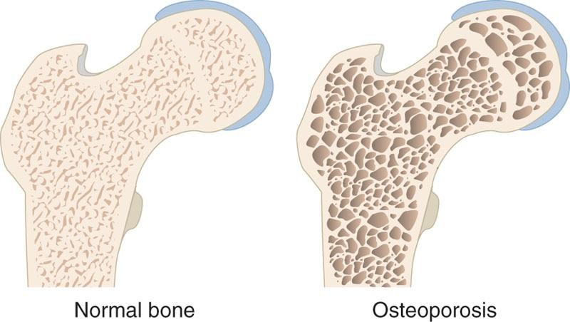

**Figure 23-7** Osteoporosis

Type 1 osteoporosis is most prevalent in postmenopausal women because of a deficiency in estrogen, usually secondary to menopause. The disease is characterized by an increase in bone resorption (removal of old bone) with a decrease in bone remodeling (formation of new bone), which leads to a decrease in bone mineral density.

Osteoporosis commonly affects the neck of the femur (thigh bone) and the lumbar (low-back) vertebrae. These structures are considered part of the core and are located in the region of the body where the majority of all forces come together. Thus, a decrease in BMD places the core in a weakened state, making it more susceptible to injury, such as a fracture. Research has shown that the risk of hip fractures doubles every 5 years in postmenopausal women older than the age of 50 years (Sullivan et al., 2017; Svejme et al., 2012). Osteoporosis affects approximately 75 million people in the United States, Japan, and Europe (International Osteoporosis Foundation, 2019). Both diet and exercise are considered vital strategies for the prevention and treatment of osteoporosis (Akkawi & Zmerly, 2018; International Osteoporosis Foundation, 2019).

There are a variety of risk factors that influence osteoporosis. One of the most important is peak bone mass. Peak bone mass is the highest amount of bone mass a person is able to achieve during their lifetime. Bone remodeling occurs as the result of stress placed on the musculoskeletal system.

To maintain consistent bone remodeling, people must remain active enough to ensure adequate stress is being placed on their bodies. This is especially important for adolescents and young adults trying to reach peak bone mass.

Other risk factors include a lack of physical activity, smoking, excess alcohol consumption, and low dietary calcium intake (Akkawi & Zmerly, 2018; International Osteoporosis Foundation, 2019). The key for fitness professionals is to recognize that these factors can be positively influenced through a comprehensive health and fitness program (Table 23-15). In addition to exercise programs, clients should be encouraged to increase dietary intake of calcium and vitamin D, decrease alcohol intake, and cease smoking (Akkawi & Zmerly, 2018; International Osteoporosis Foundation, 2019).

TABLE 23-15 Physiologic and Training Considerations for Individuals with Osteoporosis

| **Physiologic Considerations** | **Considerations for Health and Fitness, Sport, and Athletic Training** |
| --- | --- |
| Maximal oxygen uptake and ventilatory threshold is frequently lower as a result of chronic deconditioning. | Typical exercise loads prescribed are consistent with fitness standards: 40–70% of maximum work capacity, 3–5 days per week, approximately 20–30 minutes per session. |
| Gait and balance may be negatively affected. | Physiologic and physical limitations point to low-intensity, weight-supported exercise programs that emphasize balance training. |
| Chronic vertebral fractures may result in significant low-back pain. | For clients with osteopenia (and no contraindications to exercise), resistance training is recommended to build bone mass.  Caution is advised to avoid dynamic flexion exercises at the spine.  Loads greater than 75% of 1RM have been shown to improve bone density, but clients must be properly progressed to be able to handle these loads.  A circuit-training format is recommended, 8–10 exercises, 1 set of 8–12 reps per exercise, with rest as needed between sets. |
| Age, disease, physical stature, and deconditioning may place the client at risk for falls. | For clients with severe osteoporosis, exercise modality should be shifted to water exercise to reduce risk of loading fracture.  If aquatic exercise is not feasible, use other weight-supported exercise, such as cycling, and monitor signs and symptoms.  Reinforce other lifestyle behaviors that will optimize bone health, including smoking cessation, reduced alcohol intake, and increased dietary calcium and vitamin D intake. |

With respect to physical activity, whether a client has osteopenia or osteoporosis, it is important to determine to what degree the client may engage in weight-bearing activities (walking, jogging, dancing, stair climbing, etc.) or resistance training. For example, there is a balance between the benefit of providing exercises that are designed to increase bone mass through the provision of bone stress (weight-bearing exercises or heavier resistance exercises) and the risk of fracture that might be precipitated by advanced osteoporosis. It has been demonstrated that individuals who participate in resistance training have a higher BMD than those who do not (Hong & Kim, 2018).

Resistance training, however, has been shown to improve BMD by no more than a few percent, and some researchers believe that this does not represent a high enough increase to prevent fractures from occurring. In fact, it has been estimated that a 20% increase in BMD is necessary to offset fractures. Thus, it has been suggested that training focused on the prevention of falls, rather than strength alone, is more advantageous for the elderly. Therefore, exercise regimens that combine resistance training to increase BMD with flexibility; core; and balance training to enhance body awareness, coordination, and balance might better facilitate the needs of this population (Table 23-16).

TABLE 23-16 Basic Exercise Guidelines for Individuals with Osteoporosis

| **Mode** | **Treadmill with handrail support** |
| --- | --- |
| Frequency | 2–5 days per week |
| Intensity | Cardiorespiratory training should start at a moderate intensity level (40% to 65% HRmax) and progress as tolerated |
| Duration | 20–60 minutes per day or 8- to 10-minute bouts |
| Assessment | Pushing assessment  Pulling assessment  Overhead squat assessment (if tolerated) |
| Flexibility | Static and active stretching |
| Resistance Training | 1–3 sets of 8–20 repetitions, 2–3 days per week |
| Special Considerations | Progression should be slow, well monitored, and based on postural control. See additional references for specifics on reducing kyphosis (Katzman et al., 2017).  Exercises should be progressed, if possible, toward free sitting (no support) or standing.  Focus exercises on hips, thighs, back, and arms.  Avoid excessive spinal loading on squat and leg press exercises.  Make sure the client is breathing in normal manner and avoids holding their breath, as in a Valsalva maneuver. |

When implementing exercise programs, fitness professionals must follow some precautionary measures; for example, if the client demonstrates the ability to move fairly well without assistance, movement assessments may be followed. If the client is not able to get around very well, it is a good idea to use more stable, machine-based equipment during the assessment process and oftentimes during the exercise program. Fitness professionals should follow the kinetic chain checkpoints as closely as possible with this population but realize that there may be degenerative changes in their posture that cannot be corrected. Fitness professionals should try to get clients to their own ideal position, not a general ideal position, and remember to have clients from this population exercise while seated or in a standing position.

Flexibility should be limited to static and active stretching and aim to improve posture and limit thoracic kyphosis (hunchback posture). The use of self-myofascial techniques may be contraindicated for this population. Cardiorespiratory training should begin at a moderate intensity level (40% to 65% HRmax), with a walking program, and should be based on physician’s advice and the client’s ability to tolerate exercise. Weight-bearing activities (e.g., walking or jogging) can be more beneficial to increasing BMD than nonweight-bearing activities (e.g., cycling, swimming). However, the client must be capable of performing these activities safely; otherwise, the client should opt for aquatic or cycling activities due to safety concerns.

Example core exercises in the standing position would include performing planks on an incline or cobras in a standing position. Other examples include performing a standing cable rotation or medicine ball rotations. Care should be taken with crunches or movements with a lot of spinal flexion. Monitor range of motion and check with a licensed physician. Plyometric training is not typically recommended for this population.

Resistance training should be performed in a seated or standing position as well. Research has indicated that higher intensities (75–85%) are needed to stimulate bone formation. Furthermore, it appears that the load (rather than the number of repetitions) is the determining factor in bone formation (Hong & Kim, 2018). However, to ensure proper kinetic chain preparation for these higher intensities, the fitness professional should progress clients slowly. Stabilization-focused resistance training is also important to counter a lack of balance that can lead to falls and hip fractures. It generally takes about 6 months of consistent exercise at relatively high intensities before any effect on bone mass is realized. If clients within this population are not progressed appropriately, they may get injured and have a setback in their progress. Exercise training programs for clients in this population may be performed in a circuit-style or PHA training system (see Chapter 20), focusing on hips, thighs, back, and arms. Progressing exercises to the standing position will help increase stress to the hips, thighs, and back as well as increase the demand for balance. Both components are necessary to overcome the effects of osteoporosis.

## Arthritis

Arthritis is an inflammatory condition that mainly affects the joints of the body. Arthritis is the leading cause of disability among U.S. adults and is also associated with significant activity limitation, work disability, reduced quality of life, and high healthcare costs (Hootman et al., 2016). Two of the most common types of arthritis are osteoarthritis and rheumatoid arthritis.

Osteoarthritis is caused by degeneration of cartilage within joints. This lack of cartilage creates a wearing on the surfaces of articulating bones and irregular new bone growth (osteophytosis), causing inflammation and pain at the joint. Some of the most commonly affected joints are in the hands, knees, hips, and spine.

Rheumatoid arthritis is a joint disease in which the body’s immune system mistakenly attacks its own tissue (in this case, tissue in the joint or organs). This can cause an inflammatory response in multiple joints, leading to pain and stiffness. The condition is systemic and may affect both a variety of joints and organ systems. Joints most commonly affected by this condition include the hands, feet, wrists, and knees. It is usually characterized by morning stiffness, lasting more than a half hour, which can be both acute and chronic, with eventual loss of joint integrity, increased joint pain, and decreased mobility and overall functional capacity.

It is important for fitness professionals to understand the difference between rheumatoid arthritis and osteoarthritis and be aware of the signs and symptoms of an acute rheumatoid arthritis exacerbation. In the presence of an arthritic flare-up, even flexibility exercises may need to be postponed (Table 23-17).

TABLE 23-17 Physiologic and Training Considerations for Individuals with Arthritis

| **Physiologic Considerations** | **Considerations for Health and Fitness, Sport, and Athletic Training** |
| --- | --- |
| Maximal oxygen uptake and ventilatory threshold are frequently lower as a result of decreased exercise associated with pain and joint inflammation. | Multiple sessions or a circuit format, using treadmill, elliptical trainer, or arm and leg cycles, are a better alternative than higher-intensity, single-modality exercise formats.  The usual principles for aerobic exercise training apply (60–80% peak work capacity, 3–5 days per week).  Duration of exercise should be an accumulated 30 minutes, following an intermittent or circuit format, 3–5 days per week. |
| Medications may significantly influence bone and muscle health. | Incorporate functional activities in the exercise program whenever possible. |
| Tolerance to exercise may be influenced by acute arthritic flare-ups. | Awareness of the signs and symptoms that may be associated with acute arthritic flare-ups should dictate a cessation or alteration of training, and joint pain persisting for more than 1 hour should result in an altered exercise format. |
| Arthritis can result in early morning stiffness. | Avoid early morning exercise for clients with arthritis. |
| Evaluate for presence of comorbidities, particularly osteopenia and osteoporosis. | Resistance training is recommended, as tolerable, using pain as a guide.  Start with a very low number of repetitions and gradually increase to the number usually associated with improved muscular fitness (e.g., 10–12 reps, before increasing weight, 1 set of 8–10 exercises, 2–3 days per week). |

Fitness professionals should also monitor the progress of clients with arthritis to assess the effects of the exercise program on joint pain. Pain persisting for more than 1 hour after exercise is an indication that the exercise should be modified or eliminated from the routine. Moreover, exercises of higher intensity or involving high repetitions should be avoided to decrease joint aggravation. In that regard, a low-volume circuit program or multiple session format is suitable for clients with arthritis (Table 23-18).

TABLE 23-18 Basic Exercise Guidelines for Individuals with Arthritis

| **Mode** | **Treadmill walking, stationary cycling, rowers, and low-impact or step aerobics** |
| --- | --- |
| Frequency | 3–5 days per week |
| Intensity | Low to moderate intensity (40% to 65% HRmax) and progress as tolerated depending on the client’s capabilities |
| Duration | 30 minutes |
| Assessment | Pushing assessment  Pulling assessment  Overhead squat assessment (if tolerated) |
| Flexibility | Static, active, and controlled dynamic stretches |
| Resistance Training | 1–3 sets of 10–12 repetitions, 2–3 days per week  May use a circuit or PHA training system |
| Special Considerations | Avoid heavy lifting and high repetitions. However, high repetitions with low load may be appropriate.  Stay in pain-free ranges of motion.  Start out with only 5 minutes of exercise, if needed, and progressively increase, depending on the severity of conditions. |

Fitness professionals need to be aware of the medications being taken by clients with arthritis. Clients taking oral corticosteroids, particularly over time, may have osteoporosis, increased body mass, and if there is a history of gastrointestinal bleeding, anemia (low number of red blood cells). Corticosteroids also increase fracture risk. Research indicates that people with osteoarthritis have a decrease in strength, proprioception, and mobility. Research has shown that individuals with arthritis have a decreased ability to balance while standing and that a loss in knee-extensor strength is a strong predictor of osteoarthritis (Glass et al., 2013). Furthermore, researchers have shown that patients with osteoarthritis exhibit increased muscle inhibition of knee extensors (quadriceps) and were not able to effectively activate their knee-extensor musculature to optimal levels (Ahmed, 2011; Hu et al., 2018; Kim et al., 2018). Balance and muscle strength are vital components of walking, and therefore any deficit in these areas could potentially have a negative effect on one’s ability to exercise and perform activities of daily living. This claim was supported by a study that showed a significant decrease in dynamic balance for elderly people who had a history of falling (Rice et al., 2014).

It used to be common practice for arthritic patients to avoid exercise; however, research on the effects of training on the symptoms of arthritis has led to a shift in that thinking (Ahmed, 2011; Kim et al., 2018). Some research shows that strength-training programs provide relief from arthritic symptoms, whereas others have shown decreased muscle inhibition and increased muscle strength in patients with moderate muscle inhibition (Messier et al., 2013). Therefore, individuals with arthritis are advised to participate in a regular exercise program for increasing stabilization and strength while also increasing activities of daily living. In spite of the risks associated with exercise in clients with arthritis, it is very important in restoring functional mobility and endurance in a deconditioned client who has joint limitations secondary to arthritis. Symptoms of arthritis (such as joint pain and stiffness) are heightened through inactivity as a result of muscle atrophy and lack of tissue flexibility. Progressing exercises so that they are performed in the seated position (without support) and standing position will increase functional capacity and balance of clients.

A methodical approach is important in the assessment and activity recommendations to reduce symptoms of flare-ups. Follow the guidelines for assessment in Chapters 11 and 12 and note the pain-free range of motion that clients exhibit during these assessments. Improving muscle strength and enhancing flexibility through exercise can assist in decreasing symptoms associated with arthritis. Static and active forms of stretching can be used and may be better tolerated from a seated or standing position. The use of self-myofascial techniques can be used if tolerated. Cardiorespiratory training should begin at a moderate level (40–65% HRmax) and progress as tolerated depending on the client’s capabilities and a physician’s advice. Core and balance exercises will be very important for this population to increase levels of joint stability and balance. Plyometric training is not recommended for arthritic clients. Light resistance training with modified repetitions (10 to 12), to avoid heavy, repetitive joint loading that increases stress to the affected joints, is appropriate.

## Cancer

Cancer is one of the leading causes of death in the United States and worldwide. It has been estimated that approximately 38.4% of men and women will be diagnosed with cancer during their lifetimes (Siegel et al., 2019).

Because of better detection and treatment strategies, those living with cancer have improved quality of life and life spans. In recent years, there has been a variety of studies that have documented the positive benefits of exercise in the treatment of cancer, including improved aerobic and muscular fitness, retention of lean body mass, less fatigue, improved quality of life, and positive effects on mood and self-concept (Segal et al., 2017). Because cancer is not a single disease, but a collection of diseases that share the same description (with respect to cell division, accumulation, and death), its signs and symptoms vary widely. This section is only meant to serve as a brief overview of the role of exercise in the prevention and treatment of cancer.

Medications used by clients with cancer can result in substantial adverse effects, including peripheral nerve damage, cardiac and pulmonary problems, skeletal muscle myopathy (muscle weakness and wasting), anemia, and frequent nausea. In addition, the combination of the disease and its treatments frequently result in a diminished quality of life. Fitness professionals must have knowledge of and appreciation for the varied adverse effects of cancer treatments, as they can be substantially greater than the treatments prescribed for most other chronic diseases (Table 23-19).

TABLE 23-19 Physiologic and Training Considerations for Individuals with Cancer

| **Physiologic Considerations** | **Considerations for Health and Fitness, Sport, and Athletic Training** |
| --- | --- |
| Fatigue and weakness is common. | Aerobic exercise should be done at low to moderate intensity (40–50% of peak capacity), 3–5 days per week, using typical aerobic modes (treadmill, elliptical trainer, cycle, depending on patient preference). In particular, avoid higher-intensity training during periods of cancer treatment. |
| Excessive fatigue may result in overall diminished activity. | Use intermittent bouts of exercise to accumulate 20–30 minutes of total aerobic exercise. |
| Cancer may lead to diminished immune function. | Resistance training can be performed (1 set of 8–10 exercises, 10–15 repetitions to fatigue, 2–3 days per week).  Private sessions or less crowded areas are recommended due to immune compromise. |
| Cancer may lead to decreased lean muscle mass. | Assess and provide intervention for decreased range of motion and balance. |

Exercise is an important intervention for clients recovering from cancer. It can improve exercise tolerance, reduce the cellular risks associated with cancer, and improve quality of life (Segal et al., 2017). Specifically, exercise at low to moderate intensities for moderate durations appears to have a more positive effect on the immune system (when compared with higher intensities for longer durations; Brown et al., 2012). Research also indicates that moderate to high levels of physical activity seem to be associated with decreased incidence and mortality rates for certain forms of cancer (Schwartz et al., 2017).

Exercise programs for this population should follow specific guidelines (Table 23-20). Assessment procedures for individuals with cancer can follow the guidelines in Chapters 11 and 12.

TABLE 23-20 Basic Exercise Guidelines for Individuals with Cancer

|  |  |
| --- | --- |
| Mode | Treadmill walking, stationary cycling, rowers, low-impact or step aerobics |
| Frequency | 3–5 days per week |
| Intensity | Cardiorespiratory training should start out at a moderate level (40–70% HRmax) and progress as tolerated. |
| Duration | 15–30 minutes per session (may only start with 5 minutes) |
| Assessment | Pushing assessment  Pulling assessment  Overhead squat assessment (if tolerated) |
| Flexibility | Static and active stretching |
| Resistance Training | 1–3 sets of 10–15 repetitions, 2–3 days per week  May use a circuit or PHA training system. |
| Special Considerations | Avoid heavy lifting in initial stages of training.  Allow for adequate rest intervals, and progress client slowly.  There may be a need to start with only 5 minutes of exercise and progressively increase, depending on the severity of conditions and fatigue. |

The specific pushing, pulling, and overhead squat assessments should be representative of the client’s ability level and may need to be omitted. Flexibility should include static and active stretching. Self-myofascial techniques can be used if no complications exist that would prevent its use. Check with a physician if there is any question. Self-myofascial techniques are not recommended for clients receiving chemotherapy or radiation treatments. Cardiorespiratory training for this population is very important but may have to start with 5 minutes of light aerobic exercise, progressing up to 30 minutes, 3 to 5 days per week. Higher-intensity aerobic training may be used if the client’s physician agrees.

Core and balance exercises are essential for this population, as they will help in regaining stabilization necessary for activities of daily living that may have been lost due to the lack of activity caused by treatments. Clients should be progressed slowly and according to their physical ability. Resistance training for this population will include one to three sets of 10 to 15 repetitions.

## Exercise and pregnancy

The physiologic differences during exercise between men and women have been well documented. The majority of observed disparities in athletic performance between men and women are explained by differences in body structure, muscle mass, lean to fat body mass ratio, and, to a lesser extent, blood chemistry. When measures are adjusted for body composition, both physiologic and performance parameters narrow considerably or completely vanish. However, special care must be taken if a woman is pregnant (Table 23-21).

TABLE 23-21 Physiologic and Training Considerations for Women and Pregnancy

| **Physiologic Considerations** | **Considerations for Health and Fitness, Sport, and Athletic Training** |
| --- | --- |
| Contraindications include (but are not limited to) persistent bleeding during second to third trimester, medical documentation of pregnancy-induced hypertension, or preterm labor during current or prior pregnancy. | Screen carefully for potential contraindications to exercise. |
| Decreased oxygen available for aerobic exercise. | Low to moderate intensity aerobic exercise (40–50% of peak work capacity) should be performed 3–5 days per week, emphasizing nonweight-bearing exercise (e.g., swimming, cycling), although certain treadmill or elliptical training modes may be preferred and are appropriate. |
| Posture can affect blood flow to uterus during vigorous exercise. | Avoid prone and supine exercise, particularly after the first trimester.  An alternate position is lying on the back with the head and trunk raised to between 15 and 45 degrees. |
| Even in the absence of exercise, pregnancy may increase metabolic demand by 300 kcal per day to maintain energy balance. | Advise adequate caloric intake to offset exercise effect. |
| High-risk pregnancy considerations include individuals older than the age of 35 years, history of miscarriage, diabetes, thyroid disorder, anemia, obesity, and a sedentary lifestyle. | There are no published guidelines for resistance, flexibility, or balance training specific to pregnancy exercise.  Provided exercise intensity is below the aerobic prescription of 40–50% of peak work capacity, with careful attention to special considerations and contraindications described; adding these components may be helpful.  For resistance training, if cleared by the physician, a circuit-training format is recommended, 1–3 sets of 12–15 reps per exercise, emphasizing breathing control and rest, as needed, between sets.  Advise to wear clothing that will dissipate heat easily during exercise.  Postpartum exercise should be similar to pregnancy guidelines, as physiologic changes that occur during pregnancy may persist for up to 6 weeks. |

There has been substantial research documenting the beneficial effects of exercise during pregnancy on the physiology and health of both the mother and developing fetus (Hinman et al., 2015; Szumilewicz et al., 2018). Fears that the fetus may be harmed by increased blood circulation, thermoregulatory changes, or decreased oxygen supply can be minimized with ap- propriate precautions (Hinman et al., 2015; Szumilewicz et al., 2018). The general consensus is that most recreational pursuits are appropriate for all pregnant women. Those already engaged in an exercise program before pregnancy may continue with moderate levels of exercise until the third trimester, when a logical reduction in activity is recommended (American College of Obstetricians and Gynecologists, 2015).

The gradual growth of the fetus can alter the posture of pregnant women, making flexibility and core training important, particularly core exercises to improve strength of the pelvic floor musculature. As the mother-to-be progresses to the more advanced stages of pregnancy (second and third trimesters, or after 12 weeks), performing exercises in a prone (on stomach) or supine (on back) position, as well as uncontrolled twisting motions of the torso, is not advised. Moreover, certain resistance exercises, such as hip abduction, and hip adduction machines are not advised (American College of Obstetricians and Gynecologists, 2015; Szumilewicz et al., 2018). Changes also occur in the cardiovascular system, decreasing work capacity and leading to necessary alterations in the cardiorespiratory program and the increased importance of proper hydration during aerobic activity. Lastly, fitness professionals should be aware that women in the childbearing period are vulnerable to nausea, dizziness, and fainting. Pregnant women should immediately stop exercising if they experience any of these symptoms along with any abdominal pain (or contractions), excessive shortness of breath, or bleeding or leakage of amniotic fluid (American College of Obstetricians and Gynecologists, 2015; Szumilewicz et al., 2018).

During the postpartum period, there may be a tendency to rush an exercise program in an effort to return to prepregnancy fitness and body composition status. Fitness professionals must be careful to advise clients that the changes that occurred during pregnancy may persist for a month to a month and a half. Ideally, postnatal women should be encouraged to reeducate posture, joint alignment, stability, motor skills, and recruitment of the deep core stabilizers, such as the transverse abdominis, internal obliques, and pelvic floor musculature. A return to a more vigorous program should be deferred and entered into gradually.

STRETCH YOUR KNOWLEDGE

A pregnancy can be divided into three segments, or trimesters:

* First trimester: weeks 1 to 13
* Second trimester: weeks 14 to 26
* Third trimester: week 27 to end of pregnancy

Fitness professionals should follow the assessment guidelines in Chapters 11 and 12, using seated and standing assessments when applicable (Table 23-22). Flexibility exercises should be performed in seated and standing positions, especially in the second and third trimesters. Static and active stretching should be used, and self-myofascial techniques may also be used as tolerated. However, self-myofascial techniques should not be performed on varicose veins that are sore or on areas where there is swelling (such as the calves). During the second and third trimesters, performing self-myofascial techniques in prone or supine positions is not advised. Cardiorespiratory training should consist primarily of moderate-intensity exercise (40–70% HRmax) and progressed as tolerated or by a physician’s advice. Women who have not exercised before pregnancy can begin with 15 minutes of continuous aerobic activity and gradually progress to 30 minutes of low to moderate aerobic activity. Plyometric training is not advised for this population after the first trimester. Moderate- to high-intensity resistance exercise may be used in the first trimester if the individual is accustomed to exercise; however, in the second and third trimesters, lower-intensity exercise programs are advised.

TABLE 23-22 Basic Exercise Guidelines for Women and Pregnancy

|  |  |
| --- | --- |
| Mode | Low-impact or step aerobics that avoids jarring motions, treadmill walking, stationary cycling, and water activity |
| Frequency | 3–5 days per week |
| Intensity | Moderate intensity (40–70% HRmax), increase as tolerated or based on a physician’s advice |
| Duration | 15–30 minutes per day. There may be a need to start out with only 5 minutes of exercise and progressively increase to 30 minutes, depending on the severity of conditions. |
| Assessment | Pushing assessment  Pulling assessment  Overhead squat assessment (if tolerated) |
| Flexibility | Self-myofascial techniques, static and active stretching |
| Resistance Training | 2–3 days per week, using light loads at 12–15 repetitions  Moderate- to high-intensity resistance exercise may be used in the first trimester if the client is accustomed to exercise; however, in the second and third trimesters, lower-intensity exercise programs are advised. |
| Special Considerations | Avoid exercises in a prone (on stomach) or supine (on back) position after 12 weeks of pregnancy.  Avoid self-myofascial techniques on varicose veins and areas of swelling.  Plyometric training is not advised in the second and third trimesters. |

## Chronic lung disease

Smoking has progressively declined during the last few decades; however, it is still one of the leading preventable causes of death and a primary risk factor for the development of chronic lung diseases. Chronic lung disease is largely broken into two major categories: obstructive and restrictive. In restrictive lung disease or disorders, lung tissue may be fibrotic and, thus, dysfunctional—as in the case of pulmonary fibrosis or asbestosis. In restrictive lung disease, the ability to expand the lungs may be decreased as a result of any number of causes, such as fractured ribs, a neuromuscular disease, or even obesity. In chronic obstructive lung disease, the lung tissue may be normal, but airflow is restricted. The major obstructive lung diseases include asthma, chronic bronchitis, and emphysema. These diseases are characterized by chronic inflammation (caused primarily by smoking, although asthma may be caused by environmental irritants) and airway obstruction due to mucus production. Fitness professionals might encounter clients with cystic fibrosis. While cystic fibrosis is a disease that affects the lungs by excessive mucus production, it is not specific to the lungs and is categorized as a genetic disorder.

The impairments during exercise are similar with regard to both restrictive and obstructive lung disease (Table 23-23). Problems include decreased ventilation and decreased gas exchange ability that result in decreased aerobic capacity and endurance and in oxygen desaturation. Clients with lung disease experience fatigue at low levels of exercise and often have dyspnea, or shortness of breath. Those with emphysema are frequently underweight and may exhibit overall muscle wasting with hypertrophied neck muscles, which are excessively used to assist in labored breathing. Those with chronic bronchitis may be the opposite of those with emphysema: overweight and barrel chested.

TABLE 23-23 Physiologic and Training Considerations for Individuals with Lung Disease

| **Physiologic Considerations** | **Considerations for Health and Fitness, Sport, and Athletic Training** |
| --- | --- |
| Lung disease is frequently associated with other comorbidities, including cardiovascular disease. | Screen for presence of other comorbidities. |
| A decrease in the ability to exchange gas in the lungs may result in oxygen desaturation and marked dyspnea at low workloads. | If possible and properly trained, ascertain the level of oxygen saturation using a pulse oximeter.  Pulse oximetry values should be above 90% and certainly above 85%.  Values below this level are a contraindication to continued exercise, regardless of symptoms. |
| Chronic deconditioning results in low aerobic fitness and decreased muscular performance. | The aerobic exercise program should be guided by the client’s shortness of breath.  Workloads of 40–60% of peak work capacity, 3–5 days per week, 20–45 minutes as tolerable; may be achievable.  Intermittent exercise with frequent rest breaks may be necessary to achieve sufficient overall exercise duration. |
| Upper-extremity exercise may result in earlier onset of dyspnea and fatigue than expected, when compared with lower-extremity exercise. | Upper-extremity exercise should be programmed carefully and modified, based on fatigue.  Resistance training can be helpful; use conservative guidelines.  Circuit training in a PHA format is recommended (8–10 exercises, 1 set of 8–15 reps per exercise), emphasizing breathing control and rest as needed between sets. |
| Clients may have significant muscle wasting and be of low body weight (with a BMI < 18). | If the client is very thin, be certain to recommend adequate caloric intake to offset exercise effects. |
| Clients may be using supplemental oxygen. | Fitness professionals may not adjust oxygen flow during exercise; it is considered a medication.  If a client experiences unusual dyspnea or has evidence of oxygen desaturation during exercise, stop exercise and consult with the client’s physician.  Many of these individuals will have rescue or other therapeutic inhalers.  Fitness professionals should ask their clients what medications they currently use and which ones must be kept with them at all times. |

In general, exercise for these clients is similar to what would be appropriate for the general population (Table 23-24). Exercise can improve functional capacity and decrease the symptoms of dyspnea in this population, among many other physiologic and psychological benefits (Ries et al., 2007). The use of lower-body cardiorespiratory and resistance training exercises seems to be best tolerated. Upper-extremity exercises place an increased stress on the secondary respiratory muscles that are involved in stabilizing the upper extremities during exercise (American Association of Cardiovascular and Pulmonary Rehabilitation, 2019). Therefore, caution should be used when designing programs for this population to ensure adequate rest intervals. The use of the PHA training system would be advised.

TABLE 23-24 Basic Exercise Guidelines for Individuals with Lung Disease

|  |  |
| --- | --- |
| Mode | Treadmill walking, stationary cycling, steppers, and elliptical trainers |
| Frequency | 3–5 days per week |
| Intensity | 40–60% of peak work capacity |
| Duration | Work up to 20–45 minutes |
| Assessment | Pushing assessment (if tolerated)  Pulling assessment (if tolerated)  Overhead squat assessment (if tolerated) |
| Flexibility | Static and active stretching  Self-myofascial techniques (if tolerated) |
| Resistance Training | 1 set of 8–15 repetitions, 2–3 days per week  PHA training system is recommended. |
| Special Considerations | Upper-body exercises cause increased dyspnoea and must be monitored.  Allow for sufficient rest between exercises. |

In some clients, inspiratory muscle training can specifically improve the work associated with breathing. Fitness professionals working with clients who have lung disease should inquire about this intervention to see whether it might augment the general exercise program. For more information, read the comprehensive guidelines regarding the exercise assessment and training of individuals with lung disease published by the American Association of Cardiovascular and Pulmonary Rehabilitation (2019).

## Intermittent claudication and peripheral arterial disease

Intermittent claudication is the name for the manifestation of the symptoms caused by peripheral arterial disease—sometimes referred to as peripheral vascular disease. Intermittent claudication is characterized by limping, lameness, or pain in the lower leg during mild exercise that is a result of decreased blood supply to the lower extremities. Peripheral arterial disease (PAD) is characterized by the narrowing of major arteries that are responsible for supplying blood to the lower extremities (Figure 23-8).

The primary limiting factor for exercise in the client with PAD is leg pain. One of the problems facing fitness professionals is the ability to differentiate between those who are limited by symptoms of true intermittent claudication versus similar leg complaints (such as tightness, cramping, and pain) that might simply be associated with deconditioning (Table 23-25).

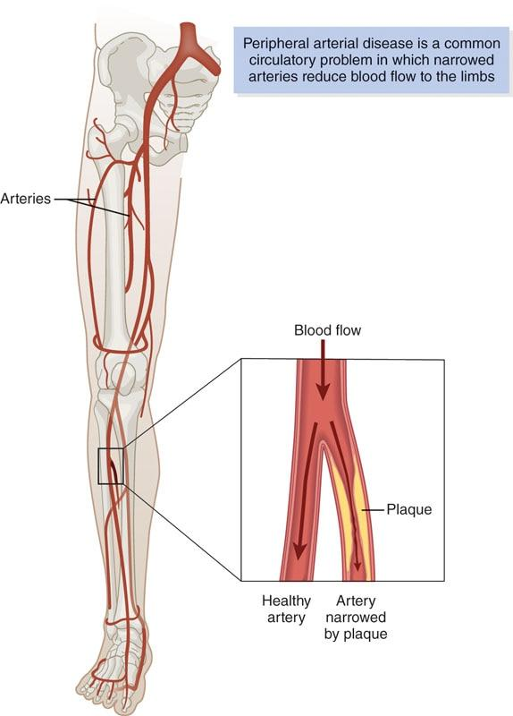

**Figure 23-8** Peripheral arterial disease

TABLE 23-25 Physiologic and Training Considerations for Individuals with Intermittent Claudication or PAD

| **Physiologic Considerations** | **Considerations for Health and Fitness, Sport, and Athletic Training** |
| --- | --- |
| Individuals with PAD frequently have coexisting coronary artery disease or diabetes. | For clients with coexisting coronary artery disease, do not exceed established heart rate upper limit (usually, this limit is established from a walking test, in which leg pain is the limiting factor).  Switching modalities so that leg pain will not limit exercise may result in a higher—and possibly inappropriate—cardiac workload.  If possible, a continuous format of exercise using walking is preferred.  Exercise duration should strive to be 20–30 total minutes, with continuous bouts of 10 minutes or greater, 3–5 days per week working up to 7 days. |

| **Physiologic Considerations** | **Considerations for Health and Fitness, Sport, and Athletic Training** |
| --- | --- |
| Smoking significantly worsens PAD and exercise tolerance. | Strongly recommend smoking cessation. If a client continues to smoke, do not allow smoking for at least 1 hour before exercise. |
| PAD frequently results in decreased aerobic capacity and endurance. | Focus on aerobic exercise activities, with an emphasis on walking. |
| Resistance training may improve overall physical function but may not address limitations of PAD. | Resistance exercise should be complementary to but not substituted for aerobic exercise.  A circuit-training format is recommended (e.g., 8–10 exercises, 1–3 sets of 8–12 reps per exercise, progressing up to 12–20 reps).  An intermittent format of exercise may be necessary, with intensity guided by pain tolerance. Typical guidelines suggest exercise into moderate to severe discomfort, rest until subsided, and repeat until total exercise time is achieved (20–30 minutes).  Always screen for comorbidities. |

If the client has a diagnosis of PAD, the symptoms are likely to be accurate for intermittent claudication, although they still could be associated with deconditioning (Hamburg & Balady, 2011). The client’s physician should be consulted concerning the condition. If pain continues during exercise, the fitness professional must refer the client to a licensed physician immediately.

Although experience will improve the ability of the fitness professional to differentiate between disease and deconditioning, in many respects it does not really matter. The fitness professional should still develop a training regimen that attempts to improve physical function in the face of limiting factors (Hamburg & Balady, 2011). In the case of PAD or deconditioning, the use of an intermittent format of exercise, with rest as necessary between exercise bouts, is similar (Table 23-26). Because PAD is associated with coronary heart disease and diabetes, fitness professionals should be aware of other existing comorbidities and be suspicious that these comorbidities may still exist, undiagnosed. Thus, physician clearance for exercise is necessary for the client with PAD.

TABLE 23-26 Basic Exercise Guidelines for Individuals with Intermittent Claudication or PAD

|  |  |
| --- | --- |
| Mode | Treadmill walking is preferred, also stationary cycling, steppers, and elliptical trainers |
| Frequency | 3–5 days per week working up to every day |
| Intensity | 50–85% of HRmax |
| Duration | Work up to 20–30 minutes |
| Assessment | Pushing assessment  Pulling assessment  Overhead squat assessment (if tolerated) |
| Flexibility | Static and active stretching |
| Resistance Training | A circuit-training format is recommended (e.g., 8–10 exercises, 1–3 sets of 8–12 reps per exercise, progressing up to 12–20 reps). |
| Special Considerations | Allow for sufficient rest between exercises.  Workout may start with 5–10 minutes of activity.  Slowly progress client. |

Systematic and integrated exercise programming, using the suggested assessment processes in Chapters 11 and 12, is advised. The number of repetitions for movement assessments may have to be decreased depending on the client’s abilities. It will be important to make clients feel comfortable and competent with this process to ensure compliance. Static and active stretching should be used for this population. Guidelines for self-myofascial techniques are not known at this time, and it is suggested that it not be used in this population, unless approved by a licensed physician. During resistance training, repetitions may need to start at 8 to 12 and slowly progress to 12 to 20. Exercise bouts may initially start with 5 to 10 minutes of activity and progress slowly to 20 to 30 minutes.